Original Research Article

Kelch-13 Polymorphism in Plasmodium Species from Children with Febrile Cases in Nasarawa State, Nigeria

.
ABSTRACT

Aim: This study investigated Kelch-13 polymorphism in Plasmodium species from Children with febrile cases in Secondary and Tertiary Health Facilities, in Nasarawa-South Senatorial District, Nigeria
Study design: Cross sectional study.
Place and Duration of Study: Department of Microbiology, Nasarawa State University, between December 2024 and May 2025.
Methodology: This study utilized a subset of fifty archived, malaria-positive blood samples collected from febrile children, of age 1 to 12, at secondary and tertiary health facilities within the Nasarawa-South senatorial zone, Nigeria, during previous studies. Plasmodium species identification and the detection of the Kelch-13 gene were performed using polymerase chain reaction (PCR). The Kelch-13 gene was subsequently screened for polymorphisms via Restriction Fragment Length Polymorphism (RFLP) analysis.
Results: The Plasmodium species namely; Plasmodium falciparum (P. falciparum) and Plasmodium ovale (P. ovale) were identified from the seropositive samples with P. falciparum (28; 56.0%) having the highest prevalence. The prevalence of Kelch-13 gene found to be highest in P. falciparum (6/28; 21.4%) than in P. ovale (1/6; 16.7%). The percentage proportion of non-anonymous polymorphism in the PfK13 gene (4/6; 66.7) due to non-digestion with XbaI restriction enzyme was found to be higher than the anonymous polymorphism in the Kelch-13 gene (2/6; 33.3%). The Kelch-13 gene in P. falciparum without anonymous mutation were more frequently detected among the children with suspected cases of febrile in the study area.
Conclusion: This study confirms the high prevalence of P. falciparum among febrile children in the region. Notably, a significant proportion of isolates featured K13 gene mutations, dominated by non-synonymous polymorphisms. This suggests the presence of artemisinin resistance-linked mutations in the study area, underscoring the need for robust surveillance and review of current treatment protocols.

Keywords: Plasmodium, children, artermisinin, resistance, Malaria, Polymorphism

1. INTRODUCTION

Malaria, a vector-borne disease caused by Plasmodium parasites, remains a major public health challenge in Sub-Saharan Africa [1]. In 2019, Nigeria bore the highest global burden, accounting for 27% of all malaria cases and 23% of malaria-related deaths worldwide (1). This disease is a leading cause of illness and mortality, particularly among children and pregnant women in the region (2, 3).
Children are highly vulnerable to malaria due to their immunologically naive status against the parasite (4). Globally, malaria is responsible for up to 10% of all childhood deaths. Common complications of severe malaria in children include severe anemia, respiratory distress, and cerebral impairment (4).
A variety of antimalarial drugs, including chloroquine, artemether-lumefantrine, artesunate-amodiaquine, dihydroartemisinin-piperaquine, and sulfadoxine-pyrimethamine—are widely used to treat malaria caused by Plasmodium species (5). However, the emergence of strains resistant to these drugs has been reported (7). This resistance to first-line treatments poses a major challenge to malaria control in Sub-Saharan Africa, leading to increased disease burden, higher mortality, and greater treatment costs.
The P. falciparum chloroquine resistance transporter gene (Pfcrt) has been associated with resistance to artemisinin-based combination therapy partner drugs, including piperaquine, amodiaquine, lumefantrine, and mefloquine (7). Furthermore, polymorphisms in the Kelch-13 propeller domain of Plasmodium species have been identified as a molecular marker for partial artemisinin resistance (6). Surveillance of the genetic variability of artemisinin resistance is crucial in the study area to assess the distribution of resistant parasites. This is particularly important as malaria causes over 90% of global malaria deaths in Africa, primarily due to P. falciparum (8). Therefore, the focus of our present study is to speciate Plasmodium and evaluate polymorphisms in the Kelch-13 gene among isolates from children with febrile illness in the Nasarawa-South Senatorial Zone, Nasarawa State, Nigeria.
2. material and methods
2.1 Blood collections
A total of fifty (50) malaria-positive dry blood spot (DBS) samples were obtained from previous studies of children with febrile illness in secondary and tertiary health facilities within the Nasarawa-South senatorial zone, Nigeria (9). Using a Pasteur pipette, blood was spotted onto DBS cards, generating five spots per sample. The cards were air-dried at room temperature, triple-packaged in transparent polythene nylons with silica gel, and stored at room temperature until DNA extraction.
2.2 Molecular Speciation, Detection of Kel-13 gene/Polymorphism
2.2.1 DNA Extraction
Genomic DNA was extracted from the dry blood spots using the Quick-DNA Miniprep Plus Kit (Zymo Research, supplied by Inqaba West Africa) according to the manufacturer's instructions, with minor modifications. Briefly, chopped portions of the dried blotted paper were immersed in buffer, vortexed, and 400 µL of this buffer was transferred to a new 1.5 mL tube. Then, 20 µL of Proteinase K and 400 µL of Biofluid (red) solution were added to the tube. The mixture was vortexed and incubated at 55°C for 20 minutes.
Following incubation, 420 µL of Genomic Binding Buffer was added and mixed thoroughly by vortexing. The resulting mixture was transferred to a Zymo-Spin IIC-XLR column seated in a collection tube and centrifuged at 12,000 × g for 1 minute. The flow-through was discarded. The column was then placed in a new collection tube, and 400 µL of DNA Pre-Wash Buffer was added before centrifuging again at 12,000 × g. Next, 500 µL of DNA Wash Buffer was added to the column and centrifuged at 12,000 × g.
For the final wash, the column was transferred to another clean collection tube, and 200 µL of DNA Wash Buffer was added and centrifuged at 12,000 × g for 1 minute. Finally, the column was transferred to a sterile 1.5 mL microcentrifuge tube, and 50 µL of DNA Elution Buffer was added directly to the column matrix. After a 1-minute incubation at room temperature, the tube was centrifuged at top speed (>12,000 × g) for 1 minute to elute the DNA. The extracted DNA was stored at -20°C prior to quantification and downstream amplification.
2.2.2 DNA Quantification
The extracted genomic DNA was quantified using the Nanodrop 1000 spectrophotometer. The software of the equipment was launched by double clicking on the Nanodrop icon. The equipment was initialized with 2 ul of sterile distilled water and blanked using normal saline. Two microlitre of the extracted DNA was loaded onto the lower pedestal, the upper pedestal was brought down to contact the extracted DNA on the lower pedestal. The DNA concentration was measured by clicking on the “measure” button.
2.2.3 Amplification of 18s rRNA of Malaria Parasites
Amplification of the Plasmodium 18s rRNA gene was performed on an ABI 9700 thermal cycler using a nested PCR approach. The reaction mixture for the primary amplification consisted of 1X DreamTaq Master Mix (Inqaba, South Africa; containing Taq polymerase, dNTPs, and MgCl₂), 0.4 µM of each primer (rPLU5: 5′-CCTGTTGTTGCCTTAAACTTC-3′ and rPLU6: 5′-TTAAAATTGTTGCAGTTAAAACG-3′), and approximately 50 ng of template DNA in a total volume of 25 µL. The thermocycling conditions were: initial denaturation at 95°C for 5 min; 35 cycles of denaturation at 95°C for 30 s, annealing at 56°C for 40 s, and extension at 72°C for 50 s; followed by a final extension at 72°C for 5 min. The secondary amplification used 1 µL of the primary PCR product as template. The reaction composition was identical, except for the use of species-specific primer sets. The annealing temperatures were optimized for each species: 55°C for P. falciparum, 57°C for P. ovale, 52°C for P. vivax, and 55°C for P. malariae. All other cycling parameters remained unchanged.
PCR products were resolved by electrophoresis on a 1.5% agarose gel at 120 V for 25 minutes and visualized under UV light.

Table 1. Primers and their sequences
Species | Primer Name | Sequence (5' → 3')
P. falciparum | rFAL F | CTTTTGAGAGGTTTTGTTACTTTGAGTAA
 | rFAL R | TATTCCATGCTGTAGTATTCAAACAAAA
P. ovale | rOVA F | TTTTGAAGAATACATTAGGATACAATTAATG
 | rOVA R | CATCGTTCCTCTAAGAAGCTTTACCCT
P. vivax | rVIV F | ACGCTTCTAGCTTAATCCACATAACT
 | rVIV R | ATTTACTCAAAGTAACAAGGACTTCCAAGC
P. malariae | rMAL F | ATAACATAGTTGTACGTTAAGAATAACCGC
 | rMAL R | AAAATTCCCATGCATAAAAAATTATACAAA
2.2.4 Amplification of Kelch-13 gene
The Kelch-13 gene of the parasites was amplified in a nested approach using FW-Ope1 5’ GGA AGA GGT TAT TAA GAA TGC-3’ and RV-Ope2 5’-GCT TCA ACA TTT CCT TCA TC-3’. For secondary PCR amplification the primers are FW-Ope3 5’-TAT TAG ATA TGA AAC ATA AAA ATC-3 and RV-Ope4 5’-GGA GTT TTA TTA CCA ACA CTC AAT TCA-3primers. The 25 ul PCR mix included: the X2 Dream Taq Master mix supplied by Inqaba, South Africa (Taq polymerase, DNTPs, MgCl), the primers at a concentration of 0.4M and the extracted DNA as template. The cycling parameters used an initial denaturation step at 94 ºC for 5 min; followed by 40 cycles of denaturation at 94 ºC for 30s, annealing at 53 ºC and 50 ºC for 30s respectively, and extension at 72 C for 1 min; followed by a final extension at 72 ºC for 5 min. The product was resolved on a 1% agarose gel at 120V for 15 minutes and visualized on a UV transilluminator.
2.2.5 Restriction fragment length polymorphism for the detection of Pk13A623E
The secondary amplicons were digested using XbaI restriction enzyme supplied by Thermo Fisher. To 5ul of the amplicons, 1ul of the enzyme and 9ul of buffer was added and incubated for 60mins at 72 ºC. The product was resolved on 1% agarose gel electrophoresis.

3. results and discussion
3.1 Speciation of Genus Plasmodium
The genus Plasmodium from the seropositive malaria parasite positive samples were speciated using the polymerase chain reaction method of which two species namely; P. falciparum and P. ovale were identified as shown in Plate 1 and 2. Most notably, the prevalence of the Plasmodium species amongst the febrile children in the study centres was determined by use of a descriptive statistics of which, the prevalence P. falciparum (28; 56.0%) out of the 50 seropositive malaria positive samples was found to be higher than P. ovale (6; 12.0%) as shown in Figure 1 but other species such as P. malariae and P. vivax were not prevalent amongst the febrile children in the study centre.
3.2 Prevalence of Kelch-13/Polymorphism
The prevalence of Kelch-13 gene among the P. falciparum and P. ovale is as shown in Figure 2. The prevalence of Kelch-13 gene found to be highest in P. falciparum (6/28; 75.0%) than in P. ovale (1/6; 16.7%). To determine the polymorphism in the Kelch-13 gene, the amplified Kelch-13 gene were digested with XbaI restriction enzyme and separated in agarose gel as shown in Plate 4. Most notably, the percentage non-anonymous polymorphism in the P. falciparum Kelch-13 gene (4/6; 66.7) due to non-digestion with XbaI restriction enzyme was found to be higher than the anonymous polymorphism (2/6; 33.3%). Finally, Kelch-13 positive P. ovale had non-anonymous polymorphism in the Kelch-13 gene.

Figure 1: Prevalence of Plasmodium species among children with febrile cases in Secondary and Tertiary Healthcare Centres in Nasarawa South Senatorial District, Nigeria

Figure 2: Prevalence of Kelch-13 gene among P. falciparum and P. ovale from children with febrile cases in Secondary and Tertiary Healthcare Centres in Nasarawa South Senatorial District, Nigeria

1 2 3 4 5 6 7 8 9 10 11 12 L 13 14 15161718 19 20 2122 23 24
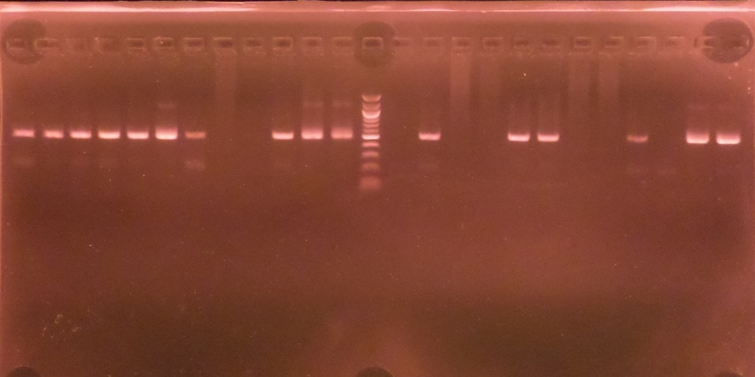
P. f (500bp)
100bp
Plate1: Agarose gel electrophoresis showing the amplified 18srRNA of the Plasmodium falciparum at 500bp. Lane L represents the 100bp molecular ladder

1 2 3 4 L 5 6 7

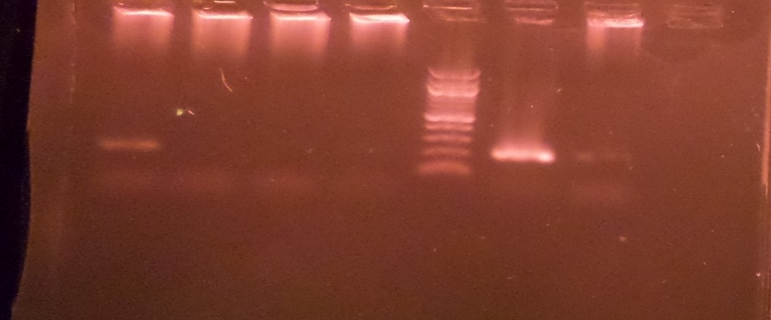
P. ovale(200bp)
500bp
Plate 2: Agarose gel electrophoresis showing the amplified 18srRNA of the Plasmodium ovale at 200bp. Lane L represents the 100bp molecular ladder

1 2 3 4 5 6 7 L

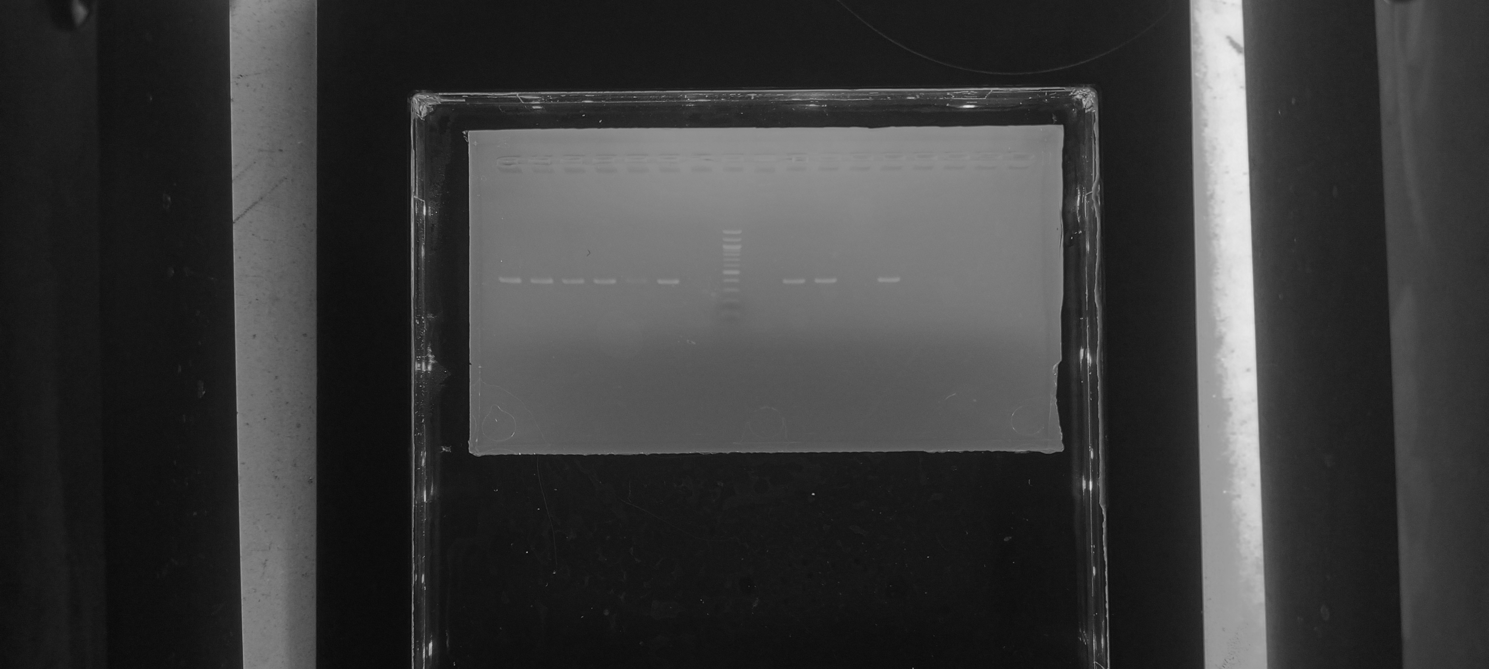
Kelch-13 (400bp)
500bp
Plate 3: Agarose gel electrophoresis showing the amplified Kelch-13 gene bands. Lane 1 – 6 represent the Kelch-13 gene bands at 400bp while lane L represents the 100bp molecular ladder

1u 1d 2u 2d 3u 3d M

Plate 4: agarose gel electrophoresis showing the digested and the undigested of some selected amplicons of Kelch 13 gene. *u represent the undigested amplicons, *d represent the digested amplicons. Lane L represent the 200bp molecular ladder
This study confirms a high prevalence of Plasmodium falciparum among febrile children in the Nasarawa-South senatorial zone, establishing it as the dominant malaria species in the region. The detection of P. ovale, while less frequent, indicates a co-endemicity of multiple Plasmodium species, though P. falciparum is the primary driver of malaria morbidity in this paediatric population. This finding aligns with the well-established status of P. falciparum as the predominant and most virulent malaria parasite across sub-Saharan Africa, accounting for the majority of global cases and mortality (3, 10, 11). Our observed prevalence of 56.0% for P. falciparum is notably higher than the 31.2% previously reported by Agu et al. (12), a discrepancy that may be attributed to differences in geographical focus, seasonal transmission dynamics, or the sensitivity of the diagnostic methods employed.
A central and concerning finding of this research is the significant detection of the Kelch-13 gene, a molecular marker for artemisinin resistance, in over 21% of P. falciparum isolates. This suggests that artemisinin-based combination therapy (ACT) resistance could be emerging in this area, a possibility that poses a severe threat to malaria control efforts. This observation is consistent with other reports from the region documenting a high prevalence of Kelch-13 polymorphisms (13, 14).
Further analysis revealed that non-synonymous mutations in the Kelch-13 gene were more frequent (66.7%) than synonymous (silent) mutations. This is a unique distinction, as non-synonymous mutations result in an amino acid change in the K13 propeller protein and are empirically linked to delayed parasite clearance in patients and artemisinin resistance in vitro. The higher prevalence of these functionally significant mutations underscores a potential shift towards resistant phenotypes. This finding corroborates the work of Ajogbasile et al. (15), who also reported a preponderance of non-synonymous mutations in their study population.
The co-detection of both synonymous and non-synonymous mutations within the study population indicates that the genetic background for resistance is present and evolving. It is well-established that non-synonymous mutations in specific loci of the Kelch-13 propeller domain are the primary mediators of resistance. Therefore, the high frequency of these mutations, rather than silent polymorphisms, is the most plausible explanation for any observed clinical or parasitological treatment failures related to ACT in this region.

4. Conclusion
This study concluded that P. falciparum was the predominant species among febrile children, compared to P. ovale. The majority of isolates from both species were found to carry the Kelch-13 gene, with a high frequency of non-synonymous polymorphisms. The high prevalence of P. falciparum with these mutations suggests potential artemisinin resistance; it is crucial to search for a more potent anti-malaria, and temporarily suspend the use of Artemisinine based combination as the first line drug in treatment of malaria, on this part of the globe. There is also a critical need for robust public health interventions to control and prevent the further spread of resistant parasites.

Ethical approval

Appropriate ethical committee approval was obtained prior to start of the research and is available for review.

Consent
As per international standards, parental written consent has been collected and preserved by the author(s).
Disclaimer (Artificial intelligence)
Author(s) hereby declare that NO generative AI technologies such as Large Language Models (ChatGPT, COPILOT, etc.) and text-to-image generators have been used during the writing or editing of this manuscript

References

1. Kogan, F. (2020). Malaria burden. In Remote sensing for malaria: Monitoring and predicting malaria from operational satellites (pp. 15-41). Cham: Springer International Publishing.
2. Simon-Oke, I. A., Obimakinde, E. T., & Afolabi, O. J. (2018). Prevalence and distribution of malaria, Pfcrt and Pfmdr 1 genes in patients attending FUT Health Centre, Akure, Nigeria. Beni-Suef University Journal of Basic and Applied Sciences, 7(1), 98-103.
3. Oluwafemi, R. O., Afolabi, O. J., & Oniya, M. O. (2024). Prevalence of malaria among under-5 children in a secondary care level, Ondo State, Nigeria. European Journal of Clinical Medicine, 5(2), 8-13.
4. Debash, H., Bisetegn, H., Ebrahim, H., Feleke, D. G., Gedefie, A., Tilahun, M., Shibabaw, A., Ebrahim, E., Fiseha, M, & Abeje, G. (2022). Prevalence and associated risk factors of malaria among febrile under-five children visiting health facilities in Ziquala district, Northeast Ethiopia: A multicenter cross-sectional study. Plos one, 17(10), e0276899.
5. Zhao, D., Zhang, H., Ji, P., Li, S., Yang, C., Liu, Y., Qian, D., Deng, Y., Wang, H., Lu, D. & Zhao, Y. (2021). Surveillance of antimalarial drug-resistance genes in imported Plasmodium falciparum isolates from Nigeria in Henan, China, 2012–2019. Frontiers in cellular and infection microbiology, 11, 644576.
6. Ariey, F., Witkowski, B., Amaratunga, C., Beghain, J., Langlois, A. C., Khim, N., N., Kim, S., Duru, V., Bouchier, C., Ma, & Ménard, D. (2014). A molecular marker of artemisinin-resistant Plasmodium falciparum malaria. Nature, 505(7481), 50-55.
7. Tang, T., Xu, Y., Cao, L., Tian, P., Shao, J., Deng, Y., Zhou, H. & Xiao, B. (2021). Ten-Year molecular surveillance of drug-resistant Plasmodium spp. isolated from the China–Myanmar border. Frontiers in Cellular and Infection Microbiology, 11, 733788.
8. Usman-Yamman, H., Abubakar, A., Eke, S., & Otuu, C. A. (2021). Genetic diversity of plasmodium falciparum isolates in Minna, North Central Nigeria inferred by PCR genotyping of Merozoite surface protein 1 and 2. Infection, Genetics and Evolution, 96, 105143.
9. Imokhe GA, Ngwai YB, Nkene IH, Ishaleku D, Okpalaeke NB, Danjuma J, Bolarinwa OF, Tama SC and Ignawua IN (2025). Prevalence of malaria parasite among febrile children attending secondary and tertiary Health facilities in Nasarawa South Senatorial district, Nigeria. GSC Biological and Pharmaceutical Sciences, 31(03):143-149.
10. World Health Organization. (2022). World malaria report 2022. World Health Organization.
11. Dunga, K. (2020). Fever Cases Associated with Plasmodium falciparum Malaria Infection among Children Attending a Tertiary Health Facility in Imo State, Nigeria. International Journal of Tropical Disease & Health.
12. Agu, O. P., Ugwu, K., & Agu, I. C. (2022). Prevalence of Plasmodium falciparum among infants in Nsukka Metropolis, South East Nigeria and to ascertain reliability of available diagnostic techniques.
13. Afolabi, O. J., Oluwafemi, O. R., & Oniya, M. O. (2023). P fmdr 1 and kelch 13 genes distribution among children that are 5 years and below in Akure, Nigeria. Journal of Parasitic Diseases, 47(1), 59-67.
14. Muhammad, I., Sale, P. M., & Midala, A. L. (2022). Absence of Biomakers of Resistance in K13 Propeller Gene of Plasmodium falciparum from Gombe LGA of Gombe State, Nigeria. Advances, 3(1), 25-33.
15. Ajogbasile, F. V., Kayode, A. T., Oluniyi, P. E., Akano, K. O., Uwanibe, J. N., Adegboyega, B. B., Philip, C., John, O.G., Eromon, P.J., Emechebe, G. & Happi, C. T. (2021). Genetic diversity and population structure of Plasmodium falciparum in Nigeria: insights from microsatellite loci analysis. Malaria Journal, 20(1), 236.

