FINANCIAL KNOWLEDGE, SAVING HABITS AND SPENDING HABITS AMONG FOURTH YEAR STUDENTS IN THE UNIVERSITY OF EASTERN PHILIPPINES COLLEGE OF EDUCATION

ABSTRACT

This study aimed to examine the financial literacy and spending habits of fourth-year students from the College of Education at the University of Eastern Philippines – Main Campus, and to determine the correlation between the two variables. A descriptive-correlational research design was utilized, employing a standardized 21-item questionnaire divided into three sections: Spending Habits, Saving Habits, and Financial Knowledge. The study surveyed 359 students selected through simple random sampling from a total population of 423. Data were collected through both printed and online questionnaires and analyzed using descriptive statistics and correlational analysis with Excel’s Data Analysis Toolpak.Findings revealed that students exhibited moderate financial literacy and a combination of prudent and impulsive spending behaviors. While most respondents practiced basic budgeting and saving, few engaged in structured financial planning. A significant negative correlation (r = -0.12, p = 0.03) was found between financial literacy and spending habits, indicating that higher financial literacy is linked to more responsible spending. Among the demographic factors examined, only sex showed a significant relationship with financial literacy. The study concludes that while students demonstrate a general awareness of financial management, there remains a need to strengthen structured budgeting practices and deepen their understanding of financial tools to further improve financial literacy and decision-making.

___________________________________________________________________________

Keywords: Financial literacy, spending habits, fourth-year students.
INTRODUCTION
Financial literacy is all about the ability to navigate personal financial experiences, which means being able to manage one’s own financial situation. For instance, students must learn how to budget their allowance to cover daily needs, as most of them have limited financial resources. This involves making decisions on how much to spend on non-essential items such as snacks, clothing, or leisure activities. Conversely, a lack of financial literacy can lead to poor financial management, increased debt, and financial stress. This is especially true in university life, where financial crises are among the most common problems. A lack of knowledge and skills in managing finances and making sound financial decisions can worsen these challenges.
Despite limited resources, students find ways to save money and cope with financial stress when their budgets fall short. Saving and budgeting are choices that can ease financial burdens and help monitor spending habits. Tracking expenses makes sense, as it allows students to become more aware of where their money goes, encouraging them to prioritize needs over wants and develop responsible financial behavior.
Aspiring educators often begin borrowing money once they start working in public schools after graduation and passing the board exam. This borrowing, when unmanaged, becomes a burden. According to Casingal and Ancho (2021), teachers unconsciously practice informal debt, which leads to uncontrolled borrowing. Without proper knowledge and education in financial literacy, borrowing money becomes a lifestyle for many teachers in the country. The researchers believe that equipping students with financial knowledge while still in college can prepare them to be financially literate individuals in the future.
In the Philippines, inflation rates are very high. The country’s inflation rate in February 2024 reached 4.2 percent (Baring, 2025). This situation can affect students' studies and may even force them to work part-time jobs that interfere with their academics or, worse, cause them to drop subjects due to financial constraints. These challenges impact their ability to afford education and make it more difficult for them to graduate (Team Asia, 2025). This highlights the importance of financial literacy in managing money efficiently.
According to the Australian Securities and Investments Commission (ASIC), financial literacy is a combination of financial knowledge, skills, attitudes, and behaviors necessary to make sound financial decisions based on one’s personal circumstances to improve financial well-being (ASIC, 2022). These skills are essential for today’s youth to face real-life challenges. However, there remains a gap in the Philippine educational system. For example, in higher education, financial literacy is typically taught only in business-related courses such as Business Administration. As a result, students from other fields often receive little to no formal education on financial management. This lack of access is a key reason why many young Filipinos are unprepared for real-world financial challenges.
One reason financial education is limited in schools is the overcrowded curriculum, which makes it difficult for financial literacy to be integrated despite its clear benefits (Cobb Global Outreach, 2024). Additionally, many schools lack the resources, time, or staff to implement such courses effectively. In 2022, the Bangko Sentral ng Pilipinas cited a global financial literacy study by Standard & Poor’s (S&P Global Ratings), which revealed that the Philippines ranked among the bottom 30 of 144 countries, with only 25% of Filipino adults considered financially literate. This means that 75% of Filipinos lack sufficient financial knowledge (Nicolas, 2024).
In this context, the limited financial knowledge among the youth has become a widespread problem, particularly among university students. College life is often seen as a time of newfound independence—especially in handling financial responsibilities. Managing finances becomes one of the most pressing challenges.
In 2023, the poverty incidence in Northern Samar worsened, rising from 19.3% to 21.8%, with Catarman—the capital—being part of this trend (Meniano, 2024). Poverty creates financial difficulties, limiting students' ability to focus on their studies. Many students are forced to become working students, balancing academics with jobs just to meet basic needs. In university life, survival skills are crucial both academically and financially. Managing one’s spending habits is key—learning to track expenses, think before spending, and prioritize needs over wants. In short, students must learn to control impulsive spending and practice mindful financial decision-making.
Moreover, the low enrollment rate of 26.9% in Region VIII (Eastern Visayas) indicates that only about 1 in 4 college-age individuals in the region were enrolled in higher education in 2020 (Magsambol, 2025). This rate is significantly lower compared to other regions and suggests barriers to access, including financial difficulties, lack of educational institutions, or personal constraints.
A study conducted at the University of Eastern Philippines (UEP) revealed that while students tend to be academically prepared, they receive less guidance in financial literacy. The results showed that parental guidance has a strong influence on students’ financial knowledge (Lalosa, 2020). Even though the government is trying to instill financial literacy in schools, the issue persists—especially for students from marginalized families with limited allowances and insufficient financial management knowledge.
Therefore, there is a need for strong policy interventions that promote financial literacy and responsible spending among students. These efforts will help students improve their financial well-being, develop better money management skills, and become responsible consumers. All of these can be achieved through robust financial education.

This study was intended to explore how financial literacy and spending habits affect the financial well-being of fourth-year students at the University of Eastern Philippines College of Education.
Specifically, the study aims to answer the following objectives:
1. Describe the demographic profile of College of Education students in terms of:
1.1 Age
1.2 Sex
1.3 Field of Specialization
1.4 Commuter or Non-Commuter Status
1.5 Scholarship Status
1.6Boarding Status (Staying in a dormitory or boarding house)
1.7 Employment Status (Working student or not)
1.8 Estimated Monthly Allowance.

2. To Determine the level of financial literacy of a college of Education in the following areas:
2.1 spending habits
2.2 saving or budgeting practice
2.3 financial knowledge

3. To find out the relationship between demographic profiles towards Financial Literacy among students.

4. To assess the relationship between financial literacy and spending habits among students.

MATERIALS AND METHODS
This study was conducted at the College of Education, University of Eastern Philippines (UEP) – Main Campus, located in the University Town, Catarman, Northern Samar.
This study used a descriptive-correlational method of research, which employed the analysis of data by correlating the variables in this study, where the questionnaire was the principal instrument in data gathering.
In determining the target population of the respondents for this research, the researcher used simple random probability sampling. The target population consisted of 423 fourth-year students from the College of Education. A sample size of 359 was determined by taking 85% of the total population. Using a random selection process, each student had an equal chance of being chosen. All 359 selected students were included as respondents in the study. This method was used to ensure fairness, reduce bias, and increase the representativeness of the sample.
For data collection, this study used a survey questionnaire, both printed and online through Google Forms. The completion of the form was taken as consent pursuant to Republic Act (R.A.) 10173, otherwise known as the Data Privacy Act of 2012. The researcher used the survey questionnaire in gathering the data. The questionnaire was taken from (Binobo et al. 2019), titled "Level of Financial Literacy of Senior High School Students from Private Schools of Bacolod City." The questionnaire was standardized and comprised three sections, where each segment consisted of seven (7) questions, totaling twenty-one (21) items. The sections were classified as follows: Spending Habits, Saving Habits, and Financial Knowledge. The interpretation of the data used a 5-point Likert scale.
Prior to data collection, a formal request letter was sent to the Dean of the College of Education to secure permission to conduct the study and to access the list of fourth-year students. Additionally, approval was sought from subject professors to administer the questionnaires after their class hours.
Data gathered were encoded, tallied, and analyzed using the Data Analysis Toolpak in Microsoft Excel. Descriptive statistics such as frequency counts, percentages, and weighted means were used to summarize the data. Furthermore, correlational analyses were employed to address the study’s objectives and test the research hypotheses.

RESULTS AND DISCUSSION
This section presents the findings and discussions based on the data gathered. Tables 1, 2, and 3 present the demographic profile of the respondents. Meanwhile, Tables 4, 5, and 6 are organized into three sections: first, the spending habits of the students; second, the level of saving habits and budgeting practices; and third, the financial knowledge of the students. In addition, Tables 5 and 6 show the results of the correlation analysis on the demographic profile of students in relation to financial literacy, and financial literacy in relation to spending habits.
Fig 1- Age distribution
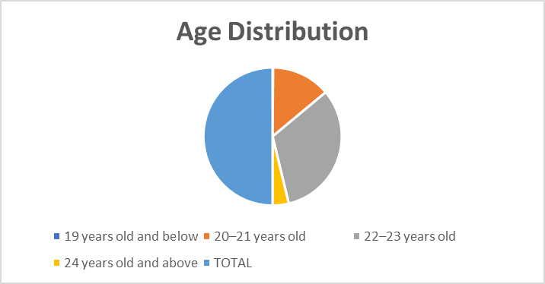
Table 1 shows the distribution of the demographic profile of the respondents. The data present the age of the respondents. Out of 359 fourth-year students, 232 or 64.63% were between 22–23 years old; 99 or 27.58% were 20–21 years old; and 27 or 7.53% were 24 years old and above. Meanwhile, the fewest number of students, 1 respondent or 0.28%, was 19 years old and below. This indicates that most fourth-year students at the College of Education belong to the average age group, while only a few belong to the youngest age group.
This supports the study of (Bugheanu and Străchinaru, 2020), which found a positive correlation between spending behavior and age; as individuals get older, spending behavior tends to occupy a more prominent role in their lives. This suggests that as people age, their spending behavior becomes more significant due to increased financial responsibilities and decision-making maturity. However, several studies, including that of (Nguyen et al.,2022), have confirmed that the lowest level of financial literacy is found among the youngest and oldest age groups. These findings are relevant to the present study, as they help explain the observed differences in spending behavior and financial literacy among fourth-year students in terms of age.

Fig 2- Sex distribution

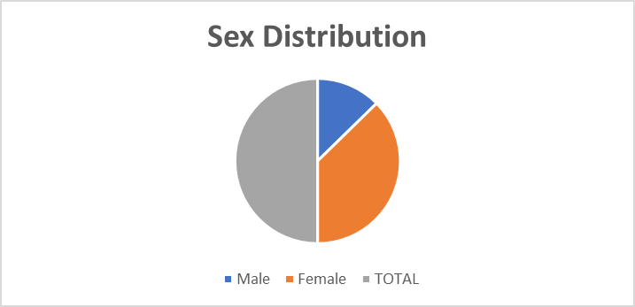
Furthermore, the data revealed that most of the respondents were female, with a total of 268 individuals or 74.66% of the population. In contrast, male respondents numbered only 91, making up 25.35% of the total.
According to (Bağcı and Şahraman , 2020), in their study on the effect of gender on financial literacy, financial literacy varies according to gender, with men showing higher levels of financial literacy than women. Their study suggests that men are more skillful in making financial decisions and more eager to learn about financial matters than women. These findings may help in interpreting the disparities in financial literacy and spending behaviors across gender lines in the present study and provide an underlying basis to consider gender as a potential influencing factor.
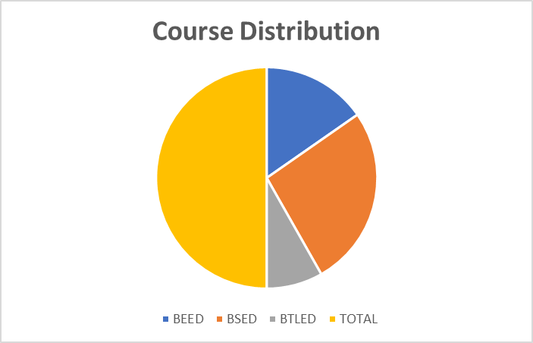
Fig 3- Course distribution
Likewise, among the academic programs, the Bachelor of Secondary Education (BSED) accounted for the largest proportion of respondents, with 190 students or 52.93%, followed by the Bachelor of Elementary Education (BEED) with 110 or 30.65%, and the Bachelor of Technology and Livelihood Education (BTLED) with 59 or 16.44%. These figures demonstrate that BSED is the most populated program among fourth-year students in the College.
In terms of field of specialization, the most common major was Physical Education, with 63 respondents or 25.72%. Other majors with fewer representations included Science and Mathematics with 25 respondents or 10.21%; English and BTLED-HE with 23 respondents each or 9.39%; Social Studies and BTLED-AFA with the same total of 21 respondents or 8.58%; followed by Values Education with 17 respondents or 6.94%; Filipino with 16 or 6.54%; and BTLED-IA with 11 or 4.49%.
These results indicate a diverse range of specializations pursued by the respondents, with notable concentrations in Physical Education, Mathematics, and Sciences.
In accordance with the study of (Elomina and Buama, 2021), it was found that there was no significant difference in financial literacy when respondents were classified according to their demographic profile. Similarly, in the present study involving fourth-year students from the College of Education, results showed that financial literacy levels did not significantly differ across demographic categories. This suggests that financial literacy is not inherently gained through academic exposure in teaching education programs.
In contrast, the study highlights that business majors tend to demonstrate greater knowledge in areas like finance, unsurprising, since the curriculum for business degrees often provides more opportunities to take courses in finance and related subjects (Chen and Volpe, 2024). Likewise, research by (Okicic et al.,2021) found a positive association between financial knowledge and financial behaviors (such as saving, investing, and insurance) among Business Administration students at the KNUST (Kwame Nkrumah University of Science and Technology) School of Business. This is consistent with the study by (Aydin and Akben Selcuk, 2019), who found that positive financial attitudes and behaviors among students are significantly related.

Fig 4- Commuting distribution
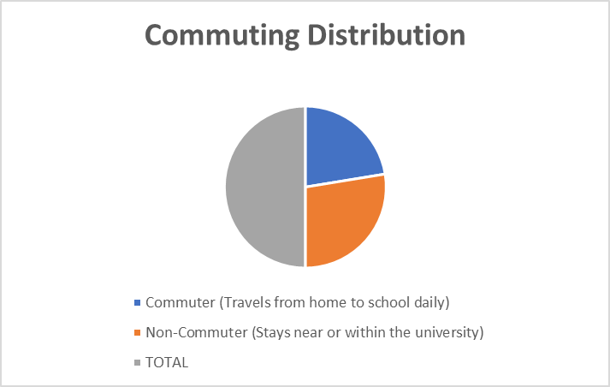
Furthermore, a slight majority of respondents — 198 or 55.16% — identified as non-commuters, indicating that they reside either on or near the university campus. Conversely, 44.85% or 161 were classified as commuters, reflecting a nearly balanced distribution between commuting and non-commuting students. In terms of financial support, more than half of the respondents — 191 or 53.21% — reported having no scholarship, while a substantial number — 159 or 44.29% — were government-funded scholars. A minimal portion of 9 or 2.51% received private scholarship assistance. This suggests that while a significant number of students benefit from government assistance, the majority rely on personal or familial financial resources.
Fig 5- Scholarship distribution
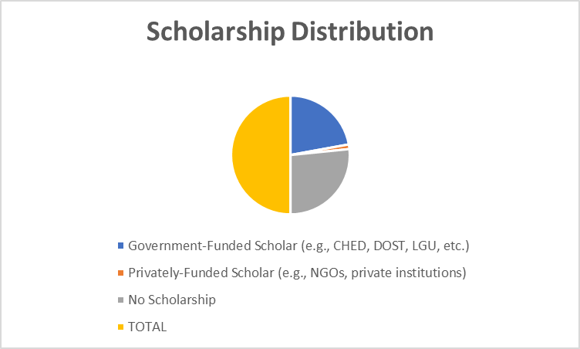
However, according to the study of (Biggs, 2023), having a scholarship can help individuals ease their financial burden and learn to manage their finances effectively. According to this article, scholarships can teach financial management skills such as budgeting, saving, and investing by providing a sum of money that the recipient is responsible for allocating toward their education and living expenses. This means that although most respondents in this study had limited access to scholarship programs, providing adequate financial support can boost their financial literacy and help them reach their full potential.
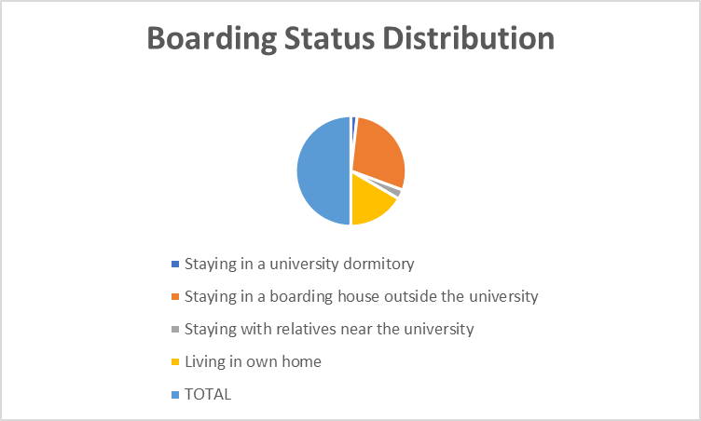
Fig 6- Boarding status distribution
Regarding their place of residence, most respondents—a total of 207 or 57.67%—resided in boarding houses outside the university premises, while 119 or 33.15% lived in their own homes. A small percentage, 20 or 5.58%, stayed with relatives near the university, and only a few, 13 or 3.63%, resided in university dormitories. These findings imply that most students live independently off-campus, which may have implications for their daily routines and financial management. This confirms the study of (Lubiyansyah, 2020), which found that students living in boarding houses spend more on daily food needs compared to those living with their parents. This means that needs such as eating and drinking are covered by the parents when students live at home. In this study, consumption or spending habits vary according to the student’s type of living. For example, living in a boarding house away from home depends on how students strategically manage their allowance and control their spending. Generally, those students who lived in cheaper dormitories tended to spend less than those in more expensive ones (Aseng, 2020). Thus, managing finances effectively depends largely on the student’s skills.
Fig 7- Employment status distribution
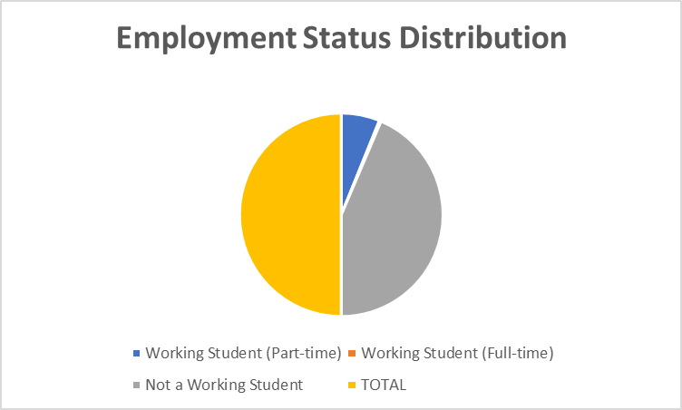
Moreover, the employment status of respondents revealed that the majority—313 or 87.19%—were not working, suggesting that they are focused primarily on academic responsibilities. Meanwhile, a small portion—44 or 12.26%—were employed as part-time working students, while only 2 respondents or 0.56% reported being full-time working students. Conversely, employed students have an extra source of income compared to non-working students.
A study by (Anupriya and Moorthy, 2024) indicated that part-time students are more financially literate and demonstrate greater financial responsibility than those who are not working. Their study explored the spending patterns of college students in Sivakasi who engaged in part-time jobs. It revealed that most respondents spent the income they earned primarily on personal needs such as transportation and college fees. A significant portion also used their earnings to settle family debts and make small investments for future security. This means being financially responsible and learning healthy spending habits help shape how students manage their money well.

Fig 8- Estimated Monthly allowance distribution
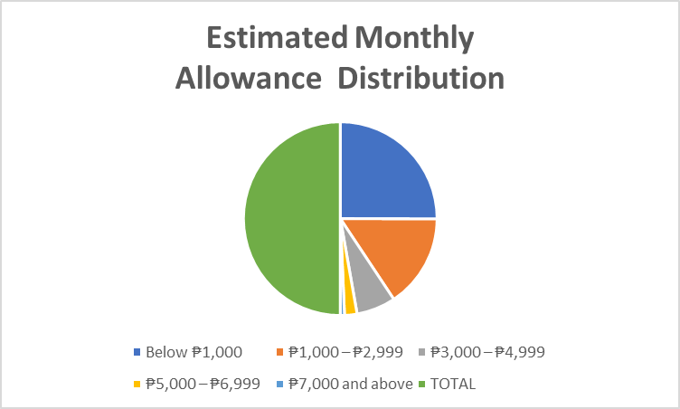
Lastly, half of the respondents—180 or 50.14%—reported having an estimated monthly allowance below ₱1,000, indicating limited financial capacity. Meanwhile, 112 students or 31.20% had a monthly allowance ranging from ₱1,000 to ₱2,999, and 47 students or 13.10% received ₱3,000 to ₱4,999. Only a few respondents reported higher monthly allowances: 15 or 4.18% had ₱5,000 to ₱6,999, and 5 or 1.40% received ₱7,000 and above. These figures underscore the financial limitations experienced by the majority of students.
According to the study of (Hassan and Wahid, 2023), there is no significant relationship between the amount of monthly allowance and daily spending. They found that most students received monthly allowances from their parents and spent most of it on food and transportation. In relation to this study, these findings indicate that there is no significant association between the amount of allowance received and how students manage their spending habits.
Further analysis was done by grouping and calculating individual frequency counts, percentages, mean scores, and standard deviations to determine the level of financial literacy in terms of spending habits, saving or budgeting practices, and financial knowledge. These results are illustrated in Tables 5 to 7.

Table 1 Spending Habits by Fourth Year Students

ITEMS | SD | D | N | A | SA | MEAN | Std. Deviation
I tend to buy things on impulse. | 39 (10.9%) | 98 (27.3%) | 152 (24.3%) | 59 (16.4) | 11  (3.1%) | 2.74 | .96
The money I spend is greater when I have just received my allowance or any source of cash. | 40 (11.1%) | 113 (31.5%) | 117 (32.6%) | 73 (20.3%) | 16 (4.5%) | 2.75 | 1.04
I treat people often/ I spend money on others. | 62 (17.3%) | 146 (40.7%) | 115 (32%) | 33 (9.2%) | 3 (0.8%) | 2.36 | 0.9
I spend more on my wants compared to needs. | 94 (26.2%) | 151 (42.1%) | 83 (23.1%) | 28 (7.8%) | 3 (0.8%) | 2.15 | 0.93
I wait for sales before I buy my wants. | 12 (3.3%) | 30 (8.4%) | 112 (31.2%) | 160 (44.6%) | 45 (12.5%) | 3.55 | 0.93
I spend money using a card. | 197 (54.9%) | 129 (35.9%) | 24 (6.7%) | 5 (1.4%) | 4 (1.1%) | 1.58 | 0.77
I spend more on branded items compared to non-branded ones. | 148 (41.2%) | 120 (33.45) | 67 (18.7%) | 17 (4.7%) | 7 (1.9%) | 1.93 | 0.98
Average | 2.44  Disagree.  Low spending habits
(Binobo et al. 2019 ) Legend of Mean Scores (Likert Scale Interpretation):
4.24–5.04 – Strongly Agree 3.43–4.23 – Agree 2.62–3.42 – Neutral 1.81–2.61 – Disagree 1.00–1.80 – Strongly Disagree

Table 1 describes the spending habits of the fourth-year students, interpreted using a Likert scale based on their mean scores and frequency percentages. The data reveal varied spending behaviors among fourth-year students.
The data show that 152 or 42.3% of the students expressed neutrality, suggesting a degree of uncertainty or situational impulsivity in their spending behavior. On the other hand, a smaller portion disagreed (16.4%) or strongly disagreed (3.1%), indicating fewer students who consistently avoid impulse buying. The mean score of 2.74, with a standard deviation of 0.96, further supports the tendency toward moderate impulsivity among the respondents. This finding implies that impulse buying is a prevalent behavior among fourth-year education students. Conversely, the higher a student's financial literacy, the lower the impulse buying behavior (Anisa, 2020). Whereas, the lower a student's financial literacy, the higher the impulse buying behavior. In this study, this inverse relationship highlights the significant role that financial literacy plays in shaping students’ spending habits.
A significant portion of respondents (117 or 32.6%) remained neutral when asked if their spending increased after receiving their allowance, while 73 or 20.3% agreed. This means that not everyone spends more money after receiving cash. Some choose to save or spend carefully, showing different financial habits. Meanwhile, the mean = 2.75 (Neutral) and standard deviation = 1.04 indicate that respondents were neutral on whether their spending increases after receiving money.
On treating others, 146 students (40.7%) disagreed, and 115 (32%) remained neutral, suggesting that most students are cautious in spending money on others. Mean score = 2.36 (Disagree) with a standard deviation of 0.9, meaning students tend to disagree with this statement, suggesting that most of them do not frequently spend money on others, likely prioritizing personal expenses. The findings above support the study of (Yoganandham, 2025), which urges integration of financial planning that saves from debt or burden. These basic concepts can transform individuals into financial stability and independence. His research suggests education and awareness in mastering financial sources, tackling budgeting, savings, early investing, debt management, and the transformative power of financial planning. In relation to my study, it is important that those students who are uncertain about the way they spend their allowance, with the help of these concepts, can make sound economic decisions in terms of financial knowledge and effectively manage money.
When it comes to prioritizing wants over needs, the majority also disagreed—151 or 42.1%—or strongly disagreed—94 or 26.2%—showing a tendency to spend more wisely. Mean = 2.15 (Disagree) with a standard deviation of 0.93, meaning the majority of respondents disagree, indicating that students generally prioritize needs over wants. This suggests a level of financial discipline among the group.
Interestingly, 160 students (44.6%) agreed that they wait for sales before buying wants, demonstrating a strategic and budget-conscious approach to spending. Meanwhile, 112 participants (31.2%) expressed uncertainty regarding this behavior. Mean = 3.55 (Agree) with a standard deviation of 0.93, indicating students agree with waiting for sales, showing a tendency toward being strategic and practical in spending, especially on non-essential items. The findings above are anchored in Abraham Maslow’s Hierarchy of Needs theory. Maslow’s theory is often presented as a pyramid with physiological needs at the foundation—a person must meet these needs on their journey to become a complete, happy, and satisfied individual (Jones and Hartzell, 2023). In the context of this study, this hierarchy relates to how students spend money based on their priorities, focusing most likely on basic needs such as food, transportation, and shelter. Without financial knowledge, they may struggle to manage their money. In other words, Maslow’s Hierarchy of Needs helps explain how students manage money based on priorities, helping them avoid financial crises and secure a better future. Further findings support this theory.
In terms of payment method, a majority—54.9% or 197—strongly disagreed, and 35.9% or 129 disagreed with using cards, implying that cash is still the primary mode of transaction among students. This is supported by the mean = 1.58 and standard deviation = 0.77, interpreted as strongly disagreeing, meaning they rarely use credit or debit cards for purchases. (Ludlum et al., 2012), in their study “Financial Literacy and Credit Cards: A Multi-Campus Survey,” revealed that many college students do not have enough knowledge about how to properly use credit cards, which often leads them to debt.
When asked about preference for branded items, 148 or 41.2% strongly disagreed and 120 or 33.45% disagreed, showing that most students choose practicality and affordability rather than branded items. The mean = 1.93 (Disagree) confirms this. These findings support the study of (Fernandez et al., 2021), which surveyed 116 respondents from PHINMA Araullo University at Barangay Bitas, Cabanatuan City, Nueva Ecija, Philippines. Results revealed that the respondents had good financial literacy and were good spenders of their money on food, personal, and academic needs. This indicates that students are practical, preferring non-branded or more affordable items over branded products.
Overall, the findings suggest that the fourth-year students display financially aware and prudent spending behaviors, often prioritizing needs over wants and choosing to spend wisely.
Analysis of the level of financial literacy in terms of saving habits or budgeting practice was analyzed as captured in Table 2.

Table 2 Saving Habits or Budgeting Practice by Fourth year Students

ITEMS | SD | D | N | A | SA | MEAN | Std. Deviation
I am able to allocate my budget to match with my budget to match with my spendings. | 10 (2.8%) | 12  (3.3%) | 102 (28.4%) | 191 (53.2%) | 44  (12.3%) | 3.69 | 0.83
I see to it that I would always have weekly or monthly savings | 5 (1.4%) | 2 7  (7.5%) | 119 (33.1%) | 171 (47.6%) | 37 (10.3%) | 3.58 | 0.83
I am able to determine what should be prioritized before and during buying an item/s. | 9 (2.5%) | 3  (0.8) | 58 (16.250 | 180 (50.1%) | 109 (30.4%) | 4.05 | 0.85
I do written or electronic budget planning/preparation. | 1 5  (4.2%) | 59 (16.4%) | 144 (40.15) | 115 (32%) | 26 (7.2%) | 3.22 | 0.95
I keep receipts and bills to be conscious of my spendings. | 14 (3.9%) | 52 (14.5%) | 104 (29%) | 14 (41.5%) | 40 (11.1%) | 3.42 | 1
I use my personal money (savings) for my wants and needs. | 6 (1.7%) | 2 4 (6.7%) | 106 (29.5%) | 179 (49.9%) | 4 4  (12.3%) | 3.64 | 0.84
I set aside money for the Lord before budgeting for my needs and wants. | 8  (2.2%) | 25  (7%) | 160 (44.6%) | 143 (39.8%) | 23 (6.4%) | 3.41 | 0.8
Average | 3.43  Agree or  High Saving habits
(Binobo et al. 2019 Legend of Mean Scores (Likert Scale Interpretation):
4.24–5.04 – Strongly Agree 3.43–4.23 – Agree 2.62–3.42 – Neutral 1.81–2.61 – Disagree 1.00–1.80 – Strongly Disagree

Table 2 indicates that most fourth-year College of Education students exhibit responsible saving and budgeting behaviors. A large percentage, 53.2% or 191, agreed that they can allocate their budget according to their spending, showing a high level of financial self-management. However, several students, a total of 102 or 28.4%, were undecided. Overall, the mean of 3.69 (Agree) and standard deviation of 0.83 reflect a strong sense of budget awareness and financial control. Similarly, nearly half—47.6% or 171—agreed that they maintain weekly or monthly savings, reflecting a conscious effort to build financial reserves. This is confirmed by the mean score of 3.58 (Agree), indicating good saving habits and financial literacy among many respondents.
However, the study of (Fiergbor, 2020) indicates that the majority of college students do not save due to contributory factors such as meager salaries and economic hardships. This aligns with (Sridhar, 2023), whose findings reveal that college students struggle to manage their finances and have a low degree of financial literacy. In my study, students must develop effective money management skills and strong financial habits. By creating a budget and monitoring their expenses, college students can manage their finances more efficiently and avoid costly mistakes.
Notably, 180 or 50.1% agreed and 109 or 30.4% strongly agreed that they can identify priorities before making purchases, highlighting strong financial decision-making skills. With a mean score of 4.05 (Agree), this item received one of the highest scores. Students show maturity in knowing their priorities when spending. On the other hand, when it comes to formal budgeting through written or electronic planning, only 115 or 32% agreed and 26 or 7.2% strongly agreed, while 144 or 40.15% remained neutral. This suggests that while many students budget mentally or informally, fewer engage in written or electronic financial planning. The mean score of 3.22 (Neutral) and standard deviation of 0.95 indicate many remain neutral or do not engage in this practice. This reflects room for improvement in developing systematic budgeting habits.
Many studies support electronic financial planning as an innovative way to track spending, budgeting, and saving. For example, (Koskelainen et al.,2023) proposed a framework for digital financial literacy and financial capability, highlighting digital innovation as a positive force transforming financial services and consumer behavior. In this study, students can benefit from electronic financial planning since most are knowledgeable about technology.
When asked about keeping receipts and bills, 149 or 41.5% agreed and 40 or 11.1% strongly agreed, yet a notable number were neutral (104 or 29%) or disagreed (52 or 14.5%). The mean score of 3.42 (Neutral) and standard deviation of 1 indicate that this habit is not consistently practiced. It is important to keep receipts and bills organized because it helps track how much money is spent on certain items and how often, which is useful for budgeting or saving for future purchases (Garcia, 2022).
Furthermore, most students—179 or 49.9% agreed and 44 or 12.3% strongly agreed—reported using their savings for both needs and wants, demonstrating active use of their personal funds. Meanwhile, 106 students or 29.5% were undecided on this statement. Overall, the mean score of 3.64 (Agree) and standard deviation of 0.84 show a positive relationship, indicating that personal savings serve as a primary financial resource.
Lastly, when asked if they set aside money for the Lord before budgeting for other expenses, responses were more varied: 160 or 44.6% were undecided, while a sizable portion, 25 or 7%, disagreed and 8 or 2.2% strongly disagreed. Meanwhile, 143 or 39.8% agreed with this statement. This is reflected in the mean score of 3.41 (Neutral). Generally, the students demonstrate positive saving and budgeting practices; however, areas such as formal budget tracking, receipt-keeping, and personal or religious financial commitments are less consistently practiced. This suggests a need for further financial education or encouragement to develop more structured money management strategies.
These findings concur with the article from the (College of Southern Maryland , 2025), which states that budgeting allows you to cover living costs, afford important things, and plan toward short- and long-term goals. This means that in this study, effective budgeting helps students learn how to prioritize money for personal needs or faith-based services. Additionally, (Henson, 2020) describes budgeting as a spiritual discipline, an exercise that helps us live in the present and the transforming reality of the kingdom of God.
Moreover, financial literacy and financial behavior moderated by religiosity simultaneously have a significant effect on investment decisions. This means that the higher the student's religiosity, the stronger the moderating effect of religiosity on financial literacy and financial behavior in investment decisions (Al Hakim et al., 2023). In this study, it implies that financial literacy and responsible spending habits can be guided and strengthened by spiritual and moral values. However, contrasting with these findings, a majority of students remain uncertain when it comes to balancing budgets between religious financial commitments.
Analysis of the level of financial literacy in terms of financial knowledge practice is presented in Table 3.

Table 3 Financial Knowledge Practice By Fourth Year Students

ITEMS | SD | D | N | A | SA | MEAN |  | Std. Deviation
I feel confident in my knowledge and ability to manage my own finances. | 3  (0.8%) | 18  (5%) | 118 (32.9) | 18 0  (50.1%) | 40 (11.1) | 3.66 | 0.77
I consider myself to be financially literate (able to maximize present money in order to gain financial stability). | 4  (1.1%) | 14  (3.9%) | 112 (31.2%) | 194  (54%) | 35  (9.7%) | 3.67 | 0.75
I am aware of the exchange rate of peso. | 6  (1.7%) | 18  (5%) | 97  (27%) | 191  (53.2%) | 47  (13.1%) | 3.71 | 0.82
I am aware of the of inflation rate in the Philippines | 5  (1.4%) | 13  (3.6%) | 79  (22%) | 179  (49.9%) | 83 (23.1%) | 3.92 | 0.84
I read and understand a contract/s especially involving money before signing. | 4  (1.1%) | 5  (1.4%) | 59 (16.4) | 202  (56.3%) | 89 (24.8) | 4.02 | 0.75
I learn financial management and obtain financial knowledge through my parents. | 5  (1.4%) | 6  (1.7%) | 75  (209%) | 200  (55.7%) | 73  (20.3%) | 3.92 | 0.77
I obtain financial knowledge and learn financial management on my own. | 4  (1.1%) | 13  (3.6%) | 104  (29%) | 188  (52.4%) | 50  (13.9%) | 3.74 | 0.78
Average | 3.81  Agree or  High Financial Knowledge
(Binobo et al. 2019) Legend of Mean Scores (Likert Scale Interpretation):
4.24–5.04 – Strongly Agree 3.43–4.23 – Agree 2.62–3.42 – Neutral 1.81–2.61 – Disagree 1.00–1.80 – Strongly Disagree

The findings show that a majority of fourth-year students exhibit strong confidence and awareness regarding their financial knowledge and practices. Half of the respondents, 180 or 50.1%, agreed and 40 or 11.1% strongly agreed that they feel confident managing their own finances, but a percentage tend to be neutral—118 or 32.9%. Similarly, 194 or 54% agreed and 35 or 9.7% strongly agreed that they consider themselves financially literate and capable of maximizing money for financial stability, indicating a generally high level of self-assessed financial capability. The mean scores of 3.66 and 3.67 fall within the range of 3.43–4.23, which corresponds to "Agree" on the Likert scale. This indicates that the respondents generally agree that they consider themselves financially literate and manage their own money correctly, wherein they believe they can maximize their current financial resources to work toward financial stability.
However, this contrasts with the study of (Montalbo et al., 2017) about “Financial Literacy of Professional and Pre-Service Teachers in the Philippines,” where findings revealed that both professional and pre-service teachers have very low basic and sophisticated financial literacy skills. Thus, financial illiteracy is common among educators, which reflects their students’ financial literacy skills and the economic condition of most Filipino people. This is supported by the study of (Barotilla et al.,2024), which found that pre-service teachers often face challenges in managing their finances, especially as they juggle various obligations. According to this, they felt tension because of the responsibilities they had to fulfill before going to their respective schools, where they are employed.
In the international context, individuals in the U.S., on average, have relatively large amounts of money about which they must make decisions, but they do not have commensurate levels of financial literacy (Faulkner, 2021). This indicates that many individuals in the U.S. possess considerable financial resources yet lack adequate financial literacy—something both concerning and thought-provoking. In this study, although students perceive themselves as financially literate and capable, contrasting studies indicate that many educators—and potentially students—lack essential financial skills.
Awareness of economic concepts such as the peso exchange rate and inflation rate also appears strong. More than half—191 or 53.2%—agreed and 47 or 13.1% strongly agreed that they are aware of the exchange rate, while 179 or 49.9% agreed and 83 or 23.1% strongly agreed that they are familiar with inflation trends in the Philippines. This aligns with their mean scores of 3.71 and 3.9, and standard deviations of 0.82 and 0.84, respectively—both within the "Agree" range—suggesting a solid awareness of broader financial contexts in the current economic conditions of the country.
Moreover, most students (56.3% agreed; 24.8% strongly agreed) reported that they read and understand contracts involving money before signing, reflecting sound judgment in financial decisions. A study found a positive correlation between inflation crisis awareness and financial literacy. The results indicate that the level of inflation crisis awareness among the respondents was high, while the level of financial literacy was moderately high (Balgo et al., 2025). In this study, students' awareness of today's economic trends is a sign that they are already prudent in spending and managing their budgets effectively.
Furthermore, the role of parents in financial education is evident, with 55.7% agreeing and 20.3% strongly agreeing that they learn financial management through their parents. Additionally, a large portion (52.4% agreed; 13.9% strongly agreed) also indicated that they gain financial knowledge through self-learning, which reflects initiative and independence in understanding financial matters. On average, across OECD (Organization for Economic Co-operation and Development) countries and economies, 83% of students reported talking to their parents at least once a month about money for things they want to buy, and 76% about their own spending decisions (Baron, 2025).
These claims support another study which found that parents’ financial teaching positively influences their children’s financial attitude and behavior by increasing their self-esteem (Noh, 2022). In this study, these insights suggest that early and consistent parental guidance not only enhances students' financial decision-making but also builds their confidence in handling personal finances.
Overall, positive results of mean scores—4.02 (SD = 0.75), 3.92 (SD = 0.77), and 3.74 (SD = 0.78)—indicate a favorable outlook and behavior toward financial awareness and education among the respondents.
Table 4 shows the results of correlation analysis on the demographic profile of students toward financial literacy.

Table 4 Correlation Analysis on the Demographic Profile of Students Towards Financial Literacy
Variable | Pearson r | P-value  (2-tailed) | Decision on Ho | Interpretation
Age | -0.10 | P =.07 | Fail to reject Ho | Insignificant
Sex | 0.13 | P =.01 | Reject Ho | Significant
Course | 0.07 | P =.19 | Fail to reject Ho | Insignificant
Commuting Status | -0.02 | P =.78 | Fail to reject Ho | Insignificant
Scholarship Status | 0.00 | P =.99 | Fail to reject Ho | Insignificant
Boarding Status | -0.08 | P =.13 | Fail to reject Ho | Insignificant
Employment Status | 0.04 | P =.45 | Fail to reject Ho | Insignificant
Estimated Monthly Allowance | 0.07 | P =.21 | Fail to reject Ho | Insignificant
NOTE ONLY: (If the p-value is less than or equal to the significance level (α), we reject the null hypothesis (Ho). This means there is a statistically significant relationship).

Table 4 At α = 0.05 level of significance, the result shows that there was no significant relationship between demographic characteristics such as age, course, commuting status, scholarship status, boarding status, employment, and estimated monthly allowance—with correlation coefficients as follows: age (r = -0.10, p = .07), course (r = 0.07, p = .19), commuting status (r = -0.02, p = .78), scholarship status (r = 0.00, p = .99), boarding status (r = -0.08, p = .13), employment status (r = 0.04, p = .45), and estimated monthly allowance (r = 0.07, p = .21).
The evidence above failed to reject the null hypothesis of no significant relationship between students' demographic characteristics and financial literacy. However, the results found that only one of the demographic profiles has a significant relationship—which is the sex of the respondents (r = 0.13, p = .01)—towards financial literacy. This suggests that male and female students may exhibit different levels of financial understanding, which could influence their financial decision-making and spending behaviors.
This is confirmed by the study of (Lusardi and Hasler, 2017), where many papers show that women display lower financial literacy and confidence than men, leaving them at a potential disadvantage. In my study, this may reflect that young female students tend to display lower financial literacy due to limited real-world practice and lower financial self-confidence, since the majority of them do not have jobs and are currently focused on their academic responsibilities.
However, this claim is contrary to the article published in a 2021 study by the Global Financial Literacy Excellence Center, which suggested that a large portion of the financial knowledge gap comes down to a lack of confidence rather than a lack of knowledge (Rhoades, 2024). In relation to my study, this suggests that financial literacy is not necessarily determined by gender; rather, it is influenced by individual experiences, exposure, and self-confidence—regardless of whether the student is male or female.
Table 5 shows the results of the Correlation Analysis on Financial Literacy Towards Spending Habits.

Table 5 Correlation Analysis on the Financial Literacy Towards Spending Habits
Variable | Pearson’s r | P value (2-tailed) | Decision on Ho | Interpretation
Spending Habits | -0.12 | P = .03 | Reject | Significant
NOTE ONLY: (If the p-value is less than or equal to the significance level (α), we reject the null hypothesis (Ho). This means there is a statistically significant relationship)

The results of the correlation analysis in Table 5 reveal a statistically significant relationship between financial literacy and spending habits, as indicated by a Pearson’s r value of -0.12 and a p-value of 0.03. Since the p-value is less than the significance level (α = 0.05), the null hypothesis is rejected, meaning that there is a significant, though weak, negative correlation between the two variables. This suggests that as students' financial literacy increases, their spending habits tend to become more cautious or responsible—implying that students with better financial knowledge may be more mindful of how they manage their money.
The results above support the study of (Ahmad et al., 2024), which tested the relationship and showed that there is a positive relationship between students' habits of spending and financial literacy—implying that when students learn more about money, they are more likely to make good financial choices. Furthermore, (Saripada et al., 2024) reported results that showed a high level of significant relationship between financial literacy and spending habits. This means that when students' financial literacy increases, their spending habits become more informed and responsible. These studies support the findings of the present research, highlighting the importance of financial knowledge in helping students manage their money better.

CONCLUSION
In conclusion, the study reveals that fourth-year College of Education students possess a moderate to high level of financial literacy, characterized by a mix of responsible and impulsive spending behaviors. While many students show awareness of basic financial management concepts, there remains a clear need for improvement in specific areas, such as structured budgeting and the responsible use of financial tools, including credit cards. The findings also highlight a notable influence of gender on financial literacy, with female students exhibiting comparatively lower financial knowledge than their male counterparts.
To address these gaps, it is recommended that educational institutions incorporate more structured and practical financial management training into the curriculum, particularly focusing on budgeting, saving, and the proper use of financial instruments. This would help the students think critically as well the future educators and overall the communities. Likewise, to the policy makers through mandates and curriculum reforms, they ensure that financial education becomes a standard component of basic and higher education. Additionally, promoting financial literacy workshops and peer-based learning activities could help bridge the knowledge gap, especially among female students, and foster more informed and responsible financial behavior.
While the findings of this study offer valuable insights, they are limited by their focus solely on students from the College of Education. Future research should include respondents from other colleges to improve the generalizability of the results. Employing a qualitative or mixed-methods approach may also yield deeper understanding of students’ financial attitudes, behaviors, and the underlying factors influencing their financial decisions.

Disclaimer (Artificial intelligence)
Option 1:
Author(s) hereby declare that NO generative AI technologies such as Large Language Models (ChatGPT, COPILOT, etc.) and text-to-image generators have been used during the writing or editing of this manuscript.
Option 2:
Author(s) hereby declare that generative AI technologies such as Large Language Models, etc. have been used during the writing or editing of manuscripts. This explanation will include the name, version, model, and source of the generative AI technology and as well as all input prompts provided to the generative AI technology
Details of the AI usage are given below:
1.
2.
3.

References
1. Ahmad, N., Hamat, M., Astifar Alias, F., Mohamed, S. A., & Afizi Shuaib, N. (2024). Understanding the Relationship Between Financial Literacy and Spending Habits in University Students. International Journal of Academic Research in Business and Social Sciences, 14(9). Accessed 01 April 2025. Available: https://doi.org/10.6007/ijarbss/v14-i9/22785
2.Anisa, N. A., Arifin, S., Setyowati, L., Hidayah, N., & Megasari, A. D. (2020). Financial Literacy on Impulsive Buying Behavior in Y Generation. Quantitative Economics and Management Studies, 1(1), 70–75. Accessed 09 April 2025.Available: https://doi.org/10.35877/454ri.qems80
3.Anupriya, C., & Ganesha Moorthy, K. (2024). Spending Pattern Of Part Time Job Goers Among College Students In Sivakasi. International Journal of Creative Research Thoughts, 12(2320-2882), 2320–2882. Accessed 15 April 2025.Available: https://www.ijcrt.org/papers/IJCRT2408396.pdf
4.Aseng, A. C. (2020). Consumption Patterns of Dormitory Students in a Private University. ResearchGate, 21(1), 93–101. Accessed 12 April 2025. Available:https://www.researchgate.net/publication/340778044_Consumption_Patterns_of_Dormitory_Students_in_a_Private_University.
5.Asia, T. (2023). How Does Inflation Affect Students in the Philippines? Https://Shoeboxcampaign.teamasia.com/How-Inflation-Affects-Students-In-The-Philippines/; TeamAsia.com. Accessed 20 April 2025. Available:https://shoeboxcampaign.teamasia.com/how-inflation-affects-students-in-the-philippines/
6.Australian Securities and Investments Commission . (2022). What is Financial Literacy? Financialeducatorscouncil.org/What-Is-Financial-Literacy/. Accessed 20 April 2025. Available:https://www.financialeducatorscouncil.org/what-is-financial-literacy/
7.Aydin, A. E., & Akben Selcuk, E. (2019). An investigation of financial literacy, money ethics and time preferences among college students. International Journal of Bank Marketing, 37(3), 880–900. Accessed 12 April 2025. Available: https://doi.org/10.1108/ijbm-05-2018-0120
8.BAĞCI, H., & KAHRAMAN, Y. E. (2020). THE EFFECT OF GENDER ON FINANCIAL LITERACY. Finans Ekonomi ve Sosyal Araştırmalar Dergisi, 2602 – 2486. Accessed 13 April 2025. Available: https://doi.org/10.29106/fesa.615866
9. Baring, E. (2025). Summary Inflation Report in Negros Oriental Consumer Price Index for Bottom 30% Income Households (2018=100) February 2025 | Philippine Statistics Authority - Central Visayas. Psa.gov.ph. Accessed 13 April 2025. Available:https://rsso07.psa.gov.ph/content/summary-inflation-report-negros-oriental-consumer-price-index-bottom-30-income-households-0
10.Barotilla, H., Barotilla, J., Bermudez, M., Daub, M., Roy, K., Torres, A., & Pugado, R. (2024). MONEY CRISIS: THE CRY OF PRE-SERVICE TEACHERS IN HANDLING FINANCES PSYCHOLOGY AND EDUCATION: A MULTIDISCIPLINARY JOURNAL Money Crisis: The Cry of Pre-service Teachers in Handling Finances. Psych Educ, 2024(8), 893–898. Accessed 20 April 2025. Available:https://doi.org/10.5281/zenodo.12689446
11.Biggs, C. (2023). How Scholarships Boost Financial Literacy Among Students - Cody Biggs STEM Scholarship. Cody Biggs STEM Scholarship. Accessed 15 April 2025. Available:https://codybiggsstemscholarship.com/how-scholarships-boost-financial-literacy-among-students/
12.Bonz Magsambol. (2025). 4 in 10 Filipino college students dropping out despite free tuition law. RAPPLER. Accessed 12 April 2025. Available:https://www.rappler.com/philippines/rate-college-students-dropping-out-edcom-2-report/
13.Bugheanu, A.-M., & Străchinaru, A. (2020). Financial Spending Behavior Patterns Based on Education, Gender and Age. Studies in Business and Economics, 15(2), 62–68.Accessed 20 April 2025. Available:https://doi.org/10.2478/sbe-2020-0025
14.Casingal, C., & Ancho, I. (2021). FINANCIAL LITERACY CHALLENGES: THE CASE OF FILIPINO PUBLIC-SCHOOL TEACHERS20. Accessed 23 April 2025. Available:https://www.researchgate.net/publication/356893174_FINANCIAL_LITERACY_CHALLENGES_THE_CASE_OF_FILIPINO_PUBLIC-SCHOOL_TEACHERS
15.CHEN, H., & Volpe, R. (1998). An analysis of personal financial literacy among college students. Financial Services Review, 7(2), 107–128. Accessed 24 April 2025. Available:https://doi.org/10.1016/s1057-0810(99)80006-7
16.Cobb, C. global outreach. (2024). Why Financial Literacy Is Not Taught In Schools (And How We Can Change That) - Cobb Global Outreach, Inc. Cobb Global Outreach, Inc. Accessed 17 April 2025. Available: https://cobbglobaloutreachinc.com/why-financial-literacy-is-not-taught-in-schools-and-how-we-can-change-that/
17.College of Southern Maryland. (2025). Financial Literacy and Budgeting. Www.csmd.edu. Accessed 15 April 2025. Available: https://www.csmd.edu/costs-aid/financial-literacy/index.html
18.Cook, A. (2020). Why is budgeting important for christians? Christian Wealth. Accessed 09 May 2025. Available: https://christianwealth.com/why-is-budgeting-important-for-christians/
19.Elomina, J. B., & Buama, C. (2021). Financial Literacy, Management Practices of Public Elementary School Teachers: An Input to Teacher Financial Management Plan. Turkish Journal of Computer and Mathematics Education (TURCOMAT), 12(10), 4323–4325. Accessed 15 May 2025. Available:https://doi.org/10.17762/turcomat.v12i10.5165

20.Faulkner, A. (2021). Financial literacy around the world: What we can learn from the national strategies and contexts of the top ten most financially literate nations. The Reference Librarian, 63(1-2), 1–28. Accessed 20 May 2025. Available:https://doi.org/10.1080/02763877.2021.2009955
21.Fernandez, R., Ignacio, A. J., Cruz, J. M. M. G., Santarina, A. L., Canlapan, M., & Simangan, R. (2021). Financial literacy and spending habits of Bachelor of Science in Accounting Information System (BSAIS) students. International Journal of Advanced Engineering, Management and Science, 7(6), 81–84. Accessed 20 May 2025. Available:https://doi.org/10.22161/ijaems.76.10
22.Fiergbor, D. (2022). The Habit of Savings among College students. ResearchGate. Accessed 17 April 2025. Available: https://www.researchgate.net/search?context=publicSearchHeader&q=
23.Garcia, A. (2022). 4 reasons you should Always Keep Your Receipts. Www.dvphilippines.com. Accessed 05 May 2025. Available:https://www.dvphilippines.com/blog/reasons-you-should-always-keep-your-receipts
24. Hartzell, S., & Jones, J. (2023, November 21). The Needs Theory: Motivating Employees with Maslow’s Hierarchy of Needs - Video & Lesson Transcript | Study.com. Study.com. https://study.com/academy/lesson/the-needs-theory-motivating-employees-with-maslows-hierarchy-of-needs.html
25. Hasler, A., & Lusardi, A. (2017). The Gender Gap in Financial Literacy: A Global Perspective | 1 The Gender Gap in Financial Literacy: A Global Perspective Introduction 2. In https://gflec.org/wp-content/uploads/2017/07/The-Gender-Gap-in-Financial-Literacy-A-Global-Perspective-Report.pdf. https://gflec.org/wp-content/uploads/2017/07/The-Gender-Gap-in-Financial-Literacy-A-Global-Perspective-Report.pdf
26.Koskelainen, T., Kalmi, P., Scornavacca, E., & Vartiainen, T. (2023). Financial literacy in the digital age—A research agenda. Journal of Consumer Affairs, 57(1), 507–528. https://doi.org/10.1111/joca.12510
27. Lalosa, D. A. A. (2020). Contributing Factors of Student’s Financial Literacy in a State University in Eastern Philippines. Zenodo, Journal of Social Studies Education Research, 187, 1-9. https://doi.org/10.5281/zenodo.4454545
28.Lionelle Rei Balgos, FLAUTA, A. A., LOBO, G., PHIA MARIELLE TALADOC, & RIC LAURENCE DELCANO. (2025). INFLATION CRISIS AWARENESS AND FINANCIAL LITERACY OF SENIOR HIGH SCHOOL ABM STUDENTS . SSRN Electronic Journal. https://doi.org/10.2139/ssrn.5161123

29.Lubiyansyah, R. A. (2020, June). Consumption patterns of boarding students. Researchgate.net; Indonesian Journal of Social Sciences. https://www.researchgate.net/publication/346705636_Consumption_patterns_of_boarding_students

30.Ludlum, M., Tilker, K., Ritter, D., Cowart, T. W., Xu, W., & Smith, B. C. (2017). Financial Literacy and Credit Cards: A Multi-Campus Survey. Scholar Works at UT Tyler. https://scholarworks.uttyler.edu/accounting_fac/2/

31. Meniano, S. (2024). Eastern visayas logs 1.9% drop in poverty incidence | philippine news agency. Pna.gov.ph. https://www.pna.gov.ph/articles/1235482

32.Montalbo Calapre Imelda, Angeline Mag-aso Pogoy, Gwendelina Av, & Genalen MP. (2017). Financial literacy of professional and pre-service teachers in the philippines. ResearchGate; Unknown. Accessed 19 April 2025. Available:
https://www.researchgate.net/publication/3223756

33.Mughni Al Hakim, I. S., Jihadi, M., & Warsono. (2023). The Effect of Financial Literacy and Financial Behavior on Religiosity Moderated by Investment Decisions. Jamanika (Jurnal Manajemen Bisnis Dan Kewirausahaan), 3(02), 186–195. Accessed 28 April 2025. Available:
https://doi.org/10.22219/jamanika.v3i02.27365

34. Nicolas, J. (2024). Improved financial literacy still needed among Filipinos. BusinessWorld Online. Accessed 12 May 2025. Available:
https://www.bworldonline.com/economy/2024/05/16/595655/improved-financial-literacy-still-needed-among-filipinos/

35.Noh, M. (2022). Effect of parental financial teaching on college students’ financial attitude and behavior: The mediating role of self-esteem. Journal of Business Research, 143, 298–304. Accessed 20 May 2025. Available:
https://doi.org/10.1016/j.jbusres.2022.01.054

36.OECD. (2023). Shaping students’ financial literacy: The role of parents and socio-economic backgrounds.Https://Www.oecd.org/Content/Dam/Oecd/En/Publications/Reports/2024/06/Shaping-Students-Financial-Literacy_197a8f87/C3f3dc74-En. pdf. PISA 2022 Results (Volume I): The State of Learning and Equity in Education, PISA, OECD Publishing, Paris, Accessed 17 May 2025. Available:
https://doi.org/10.1787/53f23881-en.

37.Okicic, J., Kokorovic Jukan, M., & Heric, M. (2021). Some Insights Into Financial Literacy Among Undergraduate Students: A Case of Bosnia and Herzegovina. International Journal of Financial Research, 12(3), 103.Accessed 01 April 2025. Available:
https://doi.org/10.5430/ijfr.v12n3p103

38.Pondang, K., Nor-Ain Saripada, Fatmah Alnirah Balindong, & May Blossom Tuazon. (2024, May 5). Financial literacy and spending habits among senior high school students. ResearchGate; International Research Journal of Modernization in Engineering Technology and Science. Accessed 20 May 2025. Available:
https://www.researchgate.net/publication/383206321_Financial_Literacy_and_Spending_Habits_among_Senior_High_School_Students

39.Rhoades, A. (2024). There’s a financial literacy gender gap. Here’s how to combat it. N26.com. Accessed 16 May 2025. Available:
https://n26.com/en-eu/blog/women-and-financial-literacy-closing-the-gender-gap

40.Sridhar, S. (2023). Saving Habits and Financial Management among College students -A Study. International Journal of Creative Research Thoughts (IJCRT), 11(2320-2882), 2320–2882. Accessed 02 May 2025. Available:
https://ijcrt.org/papers/IJCRT2305500.pdf

41.Van Nguyen, H., Ha, G. H., Nguyen, D. N., Doan, A. H., & Phan, H. T. (2022). Understanding financial literacy and associated factors among adult population in a low-middle income country. Heliyon, 8(6), e09638. Accessed 19 May 2025. Available:
https://doi.org/10.1016/j.heliyon.2022.e09638

42.Yoganandham Govindharaj. (2025). MASTERING ECONOMIC AND FINANCIAL SOURCES WITH REFERENCE TO BUDGETING, SAVINGS, EARLY INVESTING, DEBT MANAGEMENT AND THE POWER OF FINANCIAL PLANNING -A COMPREHENSIVE ANALYSIS. Degrees Journal, 10(01), 19–33. Accessed 20 April 2025. Available:
https://www.researchgate.net/publication/387799240_MASTERING_ECONOMIC_AND_FINANCIAL_SOURCES_WITH_REFERENCE_TO_BUDGETING_SAVINGS_EARLY_INVESTING_DEBT_MANAGEMENT_AND_THE_POWER_OF_FINANCIAL_PLANNING_-A_COMPREHENSIVE_ANALYSIS

