Review Article

Downy mildew disease in crops: A comprehensive review

ABSTRACT
Downy mildew is one of the destructive plant diseases caused by obligate biotrophic oomycetes belonging primarily to the families Peronosporaceae and Albuginaceae. It affects a wide range of economically significant crops, including grapes, cucurbits, Brassicas, spinach, and ornamentals, leading to considerable yield and quality losses worldwide. This comprehensive review explains the taxonomy, life cycle, symptoms, and environmental conditions that favor the development of the disease. Emphasis is placed on the mechanism of underlying pathogenicity, symptoms, pathogens biology and recent advances in disease detection and diagnosis, in addition to current management strategies, including chemical control, cultural practices, and biological control. There is no proper method to eradicate 100% infection; resistant cultivars do not show full resistance to downy mildew, and fungicide applications can minimize the disease severity, but total eradication of the disease does not happen. Therefore, the development of organic fungicides is crucial for promoting environmentally friendly agriculture. Additionally, the use of biocontrol agents should be increased in the future to enhance disease control. The review also highlights future directions for sustainable downy mildew management in the context of climate change and integrated disease management systems. Recent advances emphasize the increasing role of biological control agents and genomics-driven breeding for durable resistance. Growers majorly face challenges like fungicide resistance, evolving pathogen populations, and limitations on resistance genes. Today’s need is to develop more resistant varieties by genomic editing to generate long-term downy mildew management. With that, downy management requires sustained research, integrated pest management, and grower education to adaptively combine cultural, chemical, and biological tools for sustainable crop protection. To overcome the problem it is mandatory that to develop more resistant varieties and to develop more environmentally friendly disease management strategies to maintain crop quality while maintaining quantity.
Key words: Downy mildew, disease management, biocontrol agents, chemical control, fungicides.
Introduction
Downy mildew disease is induced by organisms belonging to the family Peronosporaceae, the predominant obligate pathogenic group within the phylum Oomycota belongs to a group of plant diseases caused by obligate oomycetes. These are pathogens that infect a wide range of crops and ornamental plants, leading to significant economic losses worldwide. Downy mildews are highly specialized and biotrophic and they deploy unique virulence proteins to infect plants (oomycetes proliferate rapidly in humid conditions, generally known as water molds). It exists in thousands of distinct forms of water molds, with downy mildew being the most common. Many downy mildews are restricted to specific plant species or groups. Downy mildew may survive on plant debris, on weeds, and in seeds, even though it can't live long without a living host. They infect a significant variety of flowering plants, including both monocotyledonous and dicotyledonous species (Thines and Choi, 2016). Symptoms of this pathogen vary somewhat among hosts. These pathogens thrive in humid conditions, producing characteristic symptoms like yellowish or necrotic lesions on upper leaf surfaces and white-grayish fungal growth on the undersides. Nevertheless, they all form yellow spots on the upper surface of the leaves between the veins. These regions are everywhere, excluding the veins, and eventually turn brown. The yellow or brown lesions inhibit the plant's ability to photosynthesize effectively. When a leaf becomes brown, it falls. A plant will die if it sheds an excessive number of leaves. When a plant gets infected, the disease spreads quickly and makes new spores within 4-7 days. If the disease is not controlled well, it can cause a big impact on the yield of important crops.
Several of the plant's fruit rot due to mildew or suffer from sunburn, preventing growth since the leaves no longer generate sufficient shade. Downy mildew emerges in particular crops when seedlings are affected. Systemic growth is inhibited, leading to abnormalities and discoloration. A common symptom is the appearance of downy growth (sporangiophores and sporangia) predominantly on the lower side of the leaves. Spores are generally white, lavender, or gray. Pale yellow to necrotic lesions or black speckles appear on the upper surface of specific plant leaves. Some regions are angular and delimited by veins. In perennial hosts like roses, it affects the young apical shoots, causing bending, stunting, and stem cracks. Key causal agents include Plasmopara viticola, responsible for grapevine downy mildew. Pseudoperonospora cubensis, which affects cucurbits such as cucumber, melon, and squash, and Peronospora destructor in onions. Peronospora effusa is found in spinach. In cereal crops like maize and millets, downy mildew pathogens like Plasmopara viticola in grapevines and Hyaloperonospora species in Brassica can cause major losses in both the amount and quality of many crops around the world. The pathogens reproduce via spores that spread in moist, humid conditions, leading to rapid disease outbreaks.
Taxonomy
- Kingdom: Straminipila (also called Chromista)
- Phylum: Oomycota
- Class: Oomycetes
- Order: Peronosporales
- Family: Peronosporaceae
- Genera: Common genera include Peronospora-: A common genus, often responsible for downy mildew in nurseries and specific hosts like Roses and Brassicas.
- Plasmopara- Notable for species like Plasmopara viticola, the causal agent of grapevine downy mildew.
- Bremia: Bremia lactucae causes downy mildew on lettuce.
- Pseudoperonospora: Pseudoperonospora cubensis, which affects cucurbits
- Hyaloperonospora: Causes downy mildew in plants like Arabidopsis.
- Sclerospora: affects monocots, including maize.

Host | Causal organism
Grapes | Plasmopara viticola
Peas | Peronospora viciae
Ornamentals | Peronospora spp., Plasmopara spp.
Cabbage and crucifers | Hyaloperonospora brassicae
Sunflowers | Plasmopara halstedii
Spinach | Peronospora farinosa f. sp. Spinaciae
Hops | Pseudoperonospora humuli
Lettuce | Bremia lactucae
Soybeans | Peronospora manshurica
Cucurbits | Pseudoperonospora cubensis
Allium (Onion) | Perenospora destructo
Beta (Silver beet) | Perenospora farinosa
Rheum (Rhubarb) | Perenospora jaapiana
Antirrhinum | Perenospora antirrhini
Eustoma | Perenospora chlorae
Papaver (Poppy) | Perenospora arborescens
Ranunculus | Perenospora anemonse
Rosa (rose) | Perenospora sparsa
Matthiola (stock) | Perenospora parasitica
Lobularia (alyssum) | Perenospora parasitica
Helichrysum | Bremia lactucae
Impatience | Plasmopara obducens
Primula | Perenospora oerteliana
Pearl millet | Pennisetum glaucum

Table 1 - shows Pathogen and it’s Hosts list

Grape downy mildew

One of the most harmful diseases impacting viticulture worldwide is grapevine downy mildew, which is caused by Plasmopara viticola (Berk. & M. A. Curtis; Berl. & De Toni).This disease has been identified in North America since the middle of the 1800s. In the late 1870s, it was brought to Europe, most likely by the introduction of phylloxera-resistant American rootstocks. The disease quickly spread from Europe to other locations, such as the Mediterranean basin, and finally to the majority of grape-growing countries globally, causing substantial economic losses, especially in warm, humid climates.

On vineyard surfaces, P. viticola overwinters as thick-walled oospores in leaf litter. Oospores germinate to produce sporangia during springtime rainy days. Wind or rain splashes spread the sporangia, which release tiny swimming zoospores. Rain splashing onto grape tissues spreads zoospores, which then swim to the stomata. Infection occurs when zoospores develop germ tubes and enter plant tissues through stomatal apertures. Any green, actively growing portion of the vine with mature, functional stomata is susceptible to infection by the pathogen. Depending on the temperature and humidity level, visible lesions may appear 5–7 days after infection. During nighttime with high humidity and temperatures above 55°F, the pathogen generates sporangia, which are zoospore-containing capsules that can cause secondary infections. The peculiar downy appearance on the leaf is caused by the production of these sporangia on a large number of branched structures that emerge through stomata. When flowers, fruits, and shoots are affected disease directly reduces yield. Premature defoliation affects fruit quality, makes vines more vulnerable to winter damage, and lowers fruit set the next season, all of which lead to indirect losses known as “oil spots.” Early in the season, diseased leaves develop yellowish-green lesions on their upper surfaces that can appear shiny. The diseased areas become mottled or brown (necrotic) as the lesions enlarge. Leaves from severely infected vines may curl and fall off too soon. In late summer and fall, the disease also attacks older leaves, resulting in a mosaic of tiny, angular, yellow to red-brown patches on the upper surface of the leaf that eventually turn necrotic. Usually, leaf veins enclose lesions. The disease is a distinct, white, downy, fungal-like growth caused by the pathogens. Usually, leaf veins enclose lesions. The disease's distinct white, downy, fungal-like growth is caused by the pathogens sporulating on the underside of foliar lesions. Infected green fruit turns light brown to purple, shrivels, and detaches easily. White, downy sporulation is abundant on diseased berries during humid weather. Diseased berries are easily detached from their pedicels, leaving a dry stem scar. Fruit becomes resistant to downy mildew infection about 3 to 4 weeks after bloom, but cluster stems (rachis), fruit stems (pedicels), and leaves remain susceptible throughout the growing season. When young shoots, petioles, tendrils, or cluster stems are infected, they frequently become distorted, thickened, or curled. White, downy sporulation can be abundant on the surface of infected areas. Eventually, these tissues wither and die. The green fruit that is infected shrinks turns light brown to purple, and separates easily. In humid conditions, infected berries exhibit extensive white, downy sporulation. A dried stem wound is left behind when diseased berries are readily separated from their pedicels. About three to four weeks after bloom, the fruit begins to resist the downy mildew infection, but leaves, fruit stems (pedicels), and cluster stems (rachises) remain disease-prone throughout the growth season. Infected juvenile shoots, petioles, tendrils, or cluster stems often grow swollen, twisted, or deformed. On the surface of infected areas, white, downy sporulation may be widespread. These tissues eventually degrade and die.

Plasmopara viticola is a pathogen that generates both sexual oospores and asexual biflagellate zoospores. It has an aseptate mycelium. It belongs to the Peronosporales order of oomycetes. This category also includes organisms from the genera Bremia, Peronospora, and Sclerospora, all of which are known to cause significant downy mildew diseases. The majority of taxonomists has reclassified oomycetes in the kingdom Chromista and no longer includes them in phylogenetic groups that include ascomycetes or basidiomycetes. Oomycetes and fungal plant diseases share many biological, ecological, and epidemiological traits, despite phylogenetic considerations. The pathogen is an obligate parasite that absorbs nutrients from the living host tissue through globose haustoria. The hyphae primarily exist within the host's internal structures. Sexual reproduction takes place via the fusion of antheridia and oogonia within the host tissue. The resultant sexual spore is an oospore, serving as the survival and resting phase of the pathogen. Oospores serve as the primary source of inoculum and can survive the winter in leaf litter or may be released into the soil as leaves decompose or are buried by detritivores. Germination typically occurs in substantial quantities soon after the grape's bud break, and in certain growing areas, oospore populations may persist in germinating throughout the entire growing season. Oospores develop a singular germ tube that culminates in a sporangium. Spores develop inside the sporangia and subsequently are released. Zoospores germinate and infiltrate the plant exclusively through active stomata, meaning they only target green host tissue. Sporangia and zoospores are highly susceptible to moisture loss. They die within 2 to 3 hours of exposure to low humidity and sunlight, leading to the majority of infections occurring shortly after their release. Nevertheless, they may remain on leaf surfaces for over 24 hours in cool, humid environments.

Sporangia serve as a means for the secondary spread of the pathogen. Treelike sporangiophores, which carry white, lemon-shaped sporangia, develop from a mycelial mat located within the host tissue and subsequently emerge through the stomata. Sporangia are spread through the actions of wind and rain splash. Zoospores that are released from the sporangia travel through free water on the surface of the grapevine and encyst nearby to stomata. Zoospores subsequently germinate and infiltrate through a stoma via the formation of a germ tube. Oospores develop in infected host material as the season draws to a close. The resulting oospores possess thick walls, functioning not only as survival spores throughout the intercrop period but also serving as a source of genetic variation. Environmental conditions, such as moderate temperatures and increased humidity, influence how these symptoms develop. Precipitation or dew on plants provides enough moisture for the pathogen to sporulate and spread. The symptoms can become more severe as the disease grows; causing significant damage to grapevine crops.

Taxonomy

Domain : Eukaryota

Kingdom: Chromista

Phylum: Oomycota

Class: Oomycetes

Order: Peronosporales
Family: Peronosporaceae
Genus: Plasmopara
Species: Plasmopara viticola

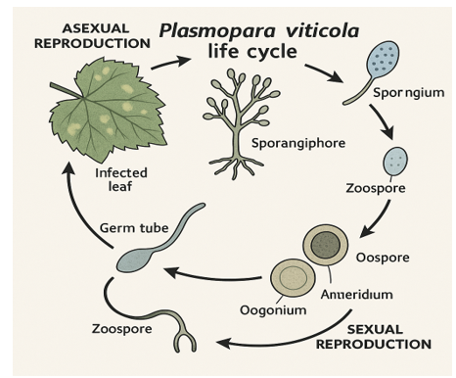
Fig 1. Life cycle of Plasmopara viticola

Cucurbit
Pseudoperonospora cubensis. This pathogen is an obligatory parasite, necessitating a living host for survival. This pathogen infects the majority of species within the Cucurbitaceae family. The family encompasses crops including pumpkins, gourds, melons, and squash. Members of the Cucurbitaceae family exhibit similar symptoms, although only the leaves of the watermelon show curling. This disease develops as leaf spots that show an angular shape and are delineated by the leaf V pattern. This pattern is especially evident in the cucumber. The pathogen thrives in chilly, humid environments; however, it can endure a diverse array of conditions. Symptoms present four to twelve days post-infection. An elevated moisture level offers an optimal environment for the pathogen. The pathogen exhibits a cluster of spores known as sporangia. Subsequently, these sporangia germinate and disseminate infection on the foliage. The best conditions for sporulation occur at 15°C with 6-12 hours of moisture, which is usually provided by morning dew. While high daytime temperatures of 35°C might not be suitable for pathogens, cooler nighttime temperatures could be beneficial. Approximately 20 taxa within the Cucurbitaceae family are recognized as hosts for P. cubensis. Downy mildew affecting the Cucumis genus, including cucumbers and melons, has been observed in 70 countries and exhibits the broadest spread within the genus Cucumis. Downy mildew of cucurbits is prevalent in North America, the Pacific area, and Australia and is less frequently observed in Africa and Asia. Recent investigations indicate the potential existence of additional pathotypes, with host specialization exhibiting greater variability and dynamism.
TAXONOMY
Kingdom : Straminipila
Phylum : Oomycota
Class: Oomycetes
Order: Peronosporales
Family: Peronosporaceae
Genus: Pseudoperonospora
Species: Pseudoperonospora cubensis
Sporulation on the underside of leaves results in the production of sporangia that are dispersed by wind. On arrival on a susceptible host, sporangia germinate in free water on the leaf surface, producing biflagellate zoospores that swim to and encyst on stomata, where they form germ tubes. An appressorium is produced and forms a penetration hypha, which enters the leaf tissue through the stomata. Hyphae grow through the mesophyll and establish haustoria, specialized structures for the transfer of nutrients and signals between host and pathogen.
.
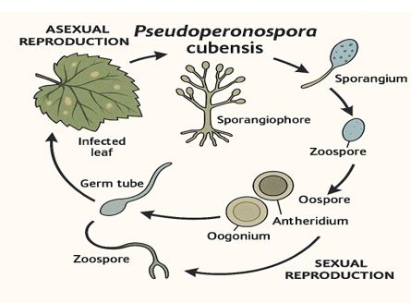
Fig 2-Life cycle of P. cubensis
Brassica Downy mildew
“Downy mildew is a disease caused by Hyaloperospora parasitica, which was formerly known as Peronospora parasitica. Disease Occurs worldwide where Brassica crops are grown. Among the twenty genera of this family, Hyaloperonospora comprises approximately 50 species, most of which are specialized to a particular host genus or species within the Brassicaceae and allied families”.(Choi et al., 2010, 2017; Göker et al., 2004, 2009; Lee et al., 2017). “The infamous species Hyaloperonospora brassicae causes destructive damage to Brassica, Raphanus, and Sinapis species, including many economically relevant crops such as broccoli, cabbage, radish, rape, tatsoi, and wasabi” (Thines and Choi, 2016).
Kingdom: Chromista,
Phylum : Oomycota,
Order : Peronosporales,
Family : Peronosporaceae
Genus : Hyaloperonospora
Species: parasitica
Downy mildew is common on broccoli, cabbage, Chinese cabbage, turnips, Brussels sprouts, cauliflower, kohlrabi, marrow-stem, kale, turnip rape, oilseed rape, rutabaga, brown mustard, black mustard, and Abyssinian mustard. Most severely affected young seedlings succumb to the disease and die. Infection can occur at a later stage, and while it may not be severe, it still reduces yield. Generally, all aerial parts of the host plants may become infected; symptoms appear primarily on leaves and inflorescences. If cotyledons become infected, it results in necrotic lesions. Infection occurs on leaves results in small, angular lesions, which later enlarge and develop into irregular orange or yellow necrotic patches. When leaves become infected, they first develop tiny, angular lesions that eventually grow into asymmetrical orange or yellow necrotic patches. Sporangiophores (conidiophores) and sporangia (conidia) grow on the lower surface of leaves, which is important for the identification of downy mildew. The pathogen also infects the curds of cauliflower, broccoli, and cabbage heads, leading to pale brown or greyish discoloration on the surface of the curd or head, along with the development of greyish or black spots and streaks on the stem. Sporulation may be visible on the curd or head surface, or it may develop after incubation under humid conditions.
Disease cycle
H. parasitica is an obligate parasite. The pathogen produces sporangiophores (conidiophores) and sporangia (conidia). Conidiophores are produced singly or in groups. Conidia are hyaline and spherical at first but later become ellipsoidal. H. parasitica also produces sexual spores (oospores). Mature oospores are thick-walled, yellow-brown, and spherical. Oospores are produced in plant residues and can be carried on the seeds. Seedlings can be infected by oospores from plant residues or on the seed. In temperate climates, H. parasitica overwinters on winter-sown crops or survives between seasons in other biennial or perennial crucifer hosts. Infection of leaves and other aerial plant parts occur from airborne sporangia (conidia) produced on living host plant tissues. After infection and a period of vegetative growth, conidiophores emerge through stomata to produce conidia. These conidia are a source of secondary spread and infection. Wind-borne conidia typically infect leaves. Conidia survive for only a few days on leaves under typical field conditions. The disease is most prevalent under cool, moist conditions. A temperature around 15°C (60°F) is most favorable for the development and epidemic of downy mildew.
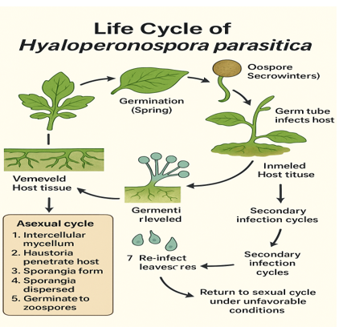
Fig 3-Life-cycle of Hyloperenospora parasitica
Sunflower Downy mildew
Downy mildew of sunflower (Plasmopara halstedii) is a foliar pathogen that affects sunflowers and related species in the Asteraceae (daisy) plant family. This pathogen was first discovered in the United States in the 1920s However, it has since been found in most countries that produce sunflowers, except Australia. The pathogen causes leaf symptoms, stunting and is capable of causing yield losses of up to 39% overseas. All parts of living and dead infected plants can carry the long-lived spores of this fungus. Nursery stock, soil, potting mix, and particularly seeds (including weed seeds and illegal imports of sunflower seeds) are all likely modes of entry, while wind-borne spores are able to spread the disease only in local areas under wet and windy conditions. Infected seedlings may experience “damping off” (sudden death) or develop white fungal growth, which appears downy and produces spores. Young plants show chlorotic mottling with downy fungal growth on the underside of leaves. The leaves may become thickened, curl downwards, and die. Infection of older plants results in stunting, thin stems, small horizontal seed heads, and chlorotic leaf mottling. Infected plants have reduced oil and seed yield and poor seed viability. Latent infections show no obvious symptoms.
Kingdom: Stramenopila
Phylum: Oomycota
Class: Oomycetes
Order: Peronosporales
Family: Peronosporaceae
Genus: Plasmopara
Species: Plasmopara halstedii

The spores for this type of mildew stay in the soil for years. Systemic infections produce two spore types: short-lived asexual zoospores from the underside of leaves and long-lived sexual oospores in the roots, stem, leaves, and seeds. Most infections are from the long-lived soil-borne or seed-borne oospores, while some in-crop infections result from the short-lived airborne zoospores. Seed-borne infections usually result in latent infections that have no obvious symptoms but still produce spores, continuing the pathogen's life cycle. The long-lived soil-borne spores (viable for up to 10 years) and the reported pathotypes of the fungus make this disease very difficult to control. Distribution is present almost worldwide where sunflowers are grown, including Africa, Europe, Asia, and the Americas except Australia.
Signs and Symptoms
Downy mildew can be characterized broadly by two different types of symptoms: systemic and secondary. Systemic symptoms occur when seedlings are infected through the developing roots, and the disease usually kills plants, causing a reduction in stands and sometimes resulting in sizeable blank spots in the field. If infected seedlings do survive, symptoms of systemic infection may be first witnessed on the cotyledons or the first true leaves and are characterized by a thickening and yellowing (chlorosis) of leaves. Chlorosis usually borders the veins of the leaves but can be present on the whole leaf. White cottony masses (fungal mycelium and spores) appear on the underside of infected leaves and are a valid diagnostic sign of the disease. Plants infected systemically typically exhibit severe dwarfism, leading to a reduction in seed production upon reaching maturity. Sunflower fields can also witness rare delayed systemic infections. These plants (six- to eight-leaf stage) will be moderately stunted and display typical downy mildew symptoms on the upper leaves but have no symptoms on the lower leaves. Secondary infection results when windblown zoospores from infected leaves land on sunflower leave. Symptoms include small, angular lesions that are chlorotic on the upper leaf surface and are often referred to as “local lesions.” Signs of secondary infections are white, cottony masses that appear on the underside of the angular lesions. Secondary infections rarely cause systemic symptoms or yield loss.
Disease Cycle
Plasmopara halstedii survives for up to 10 years in soil as sexual, thick-walled oospores. Oospores are produced just beneath the epidermis of infected plants and are more common in roots than leaves. When soils are cool and water-saturated, oospores will germinate and form zoosporangia, which give rise to asexual, motile zoospores. Systemic infection results when zoospores infect the sunflower seedling before the root reaches 2 inches in length. Sunflower plants that survive this initial infection produce white zoosporangia on the underside of the chlorotic areas of leaves. When windborne zoosporangia land on sunflower leaves, secondary infections may occur. Secondary infection is most common when sunflower leaves remain wet for prolonged periods of time. Plants are susceptible to secondary infection for a much longer period than to systemic infection via root infection. Damping-off, or seedling blight, occurs when seedlings are exposed to a high concentration of inoculum in the soil combined with cool (54-57°F), damp soils.
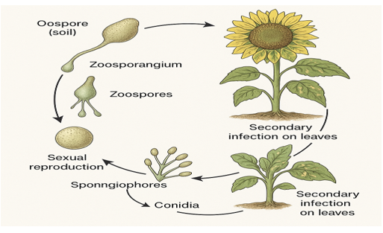
Fig 4 - Life-cycle of Plasmopara halstedii
Spinach downy mildew
“Spinach, a leafy vegetable, is native to Central and Western Asia. It is of the order Caryophyllales, family Amaranthaceae, and subfamily Chenopodioideae. Spinach is cultivated in over 60 countries worldwide; notable producers include China, the U.S.A., Iran, Japan, Turkey, and Indonesia. Spinach is typically grown for its dark green leaves. Spinach leaves have tender and soft textures and contain high amounts of vitamins A and C, carotenoids, and antioxidant compounds” (Eriksen et al., 2017; Tang et al., 2005).
Its leaves are a common vegetable consumed either fresh or after storage, using preservation techniques by canning, freezing, or dehydration. It may be eaten cooked or raw, and the taste differs considerably; the high oxalate content may be reduced by steaming. Since 2014, several farms in the northeastern U.S. have discovered downy mildew in spinach. Before this, there were no reports for about 15 years. This disease has been a major production constraint in California and Arizona. They are similarly able to produce an abundance of wind-dispersed spores capable of moving long distances, do not need leaves to be wet to infect (high humidity is sufficient), and can devastate crops. Spinach downy mildew is caused by an obligate. The oomycete pathogen, Peronospora effusa, was formerly known as Peronospora farinosa f. sp. spinaciae. Downy mildew spreads through airborne sporangia produced on infected leaves, which are dispersed by wind and water. Oospores, formed through sexual reproduction, can be seedborne and contribute to the disease cycle.
kingdom :Chromista,
Phylum :Oomycota,
class :Oomycetes
order: Peronosporales
family: Peronosporaceae
Genus: Peronospora
Species: effusa

Symptoms
Downy mildew spreads through airborne sporangia produced on infected leaves, which are dispersed by wind and water. Oospores, formed through sexual reproduction, can be seedborne and contribute to the disease cycle. The causal agent of spinach down mildew is Peronospora effusa (previously known as P.farinosa f.sp. spinaciae). The pathogen typically grows in purplish-grey,fuzzy form on the underside of leaves. Infection spread overnight, and during the day, spores are dispersed by air currents. On the upper side of leaves tissue will be yellow, initially dull, becoming brighter and larger with time. Subsequently affected tissue will become dry and tan.
Disease Cycle
“P. effusa has both asexual and sexual reproductive phases in its disease cycle. Sporangia are appearing on branched sporangiophores that emerge from stomata, mostly on the abaxial surface of leaves, during asexual reproduction. These sporangia are then released into the environment after being dislodged by wind or splashes of rain. To infect spinach, sporangia land on receptive foliar tissue. When nighttime temperatures and humidity favor the excessive dew formation on leaves, symptoms may start at the cotyledon stage and advance quickly in true leaves. High relative humidity, cool temperatures, and moisture on leaf surfaces promote sporangial infection and germination” (Choudhury et al., 2016). At night, grey to brown sporangial masses form, which during the day become airborne and disperses. Following either short- or long-distance dispersal, each sporangium can cause fresh leaf infections on plants 7 to 10 days after inoculation, the lower side of the leaf exhibits masses of sporangia and sporangiophores, as well as symptoms of irregular chlorotic spots. Plants with symptoms should not be sold fresh, and plants with no symptoms, where the pathogen is still dormant (Subbarao et al. 2018), may exhibit tissue damage or sporulation when stored after harvest.
Sexual reproduction
Sexual reproduction requires two distinct mating types. Sexual recombination results in thick-walled oospores, visible in infected leaves and seeds. Oospores are formed by fertilizing oogonia by antheridia, the female and male gametangia, respectively. The mature oospores have an average diameter of approximately 37 μm and are chocolate brown (Choi et al., 2007; Kunjeti et al., 2016). Oospores are not visible to the naked eye, like asexually produced spore masses seen on leaf surfaces. A pathogen population can experience significant genetic variation due to sexual recombination.
Oospores are crucial as the main inoculum for initiating disease in the field and for promoting genetic diversity within pathogen populations. (Correll et al., 2011) reported “the exponential appearance of new P. effusa races over the past years, a condition that is likely exacerbated by sexual recombination that has taken place in P. effusa populations. Furthermore, the rapidly evolving populations of P. effusa have been recently documented in California and Arizona, the two major spinach production sites in the U.S.” (Lyon et al. 2016). “Asexual reproduction Sporangiophores come out of the stomata of infected leaves and look like a gray to light brown mass on the surface of the leaves. Mycelia and sporangiophores are hyaline, and the latter have a branching pattern that looks like a single stem. Sporangia are oval and ranges in size from 21 to 33 μm long and 18 to 23 μm wide” (Choi et al., 2007). “Other oomycetes and similar species suggest that the sporangia don't last long. The sporangia thrive in conditions of 15 to 20°C and 40 to 80% relative humidity (RH). The sporangial survival rate was highest at 10°C and 53 to 95% RH and lowest at 33°C and 33% RH. After being exposed to these conditions for 6 hours, the half-life of P. destructor and P. tabacina sporangia dropped from 83% to 68% on cloudy days and from 46% to 0% on sunny days. Furthermore, the sporangial germination of Pseudoperonospora cubensis (the pathogen that causes cucurbit downy mildew) went down more on sunny days than on cloudy days” (Kanetis et al., 2010). Sporangia of P. effusa can grow at a wide range of temperatures (5 to 25°C), but the rate of germination goes down as the temperature goes up (Choudhury and McRoberts, 2018). When viable sporangia of P. effusa land on the wet surfaces of spinach leaves, they germinate right away, and germ tubes go straight through healthy leaves. Like P. effusa, the sporangia of other Peronosporaceae members do not release zoospores (Thines and Choi 2016). This behavior is different from other oomycetes (Gascuel et al., 2015). “Sporangia from infected lesions are released into the air and spread locally within their originating field or possibly to other fields” (Choudhury et al., 2017). Sporangia that are carried by the wind can cause multiple secondary infections in commercial fields with spinach downy mildew.
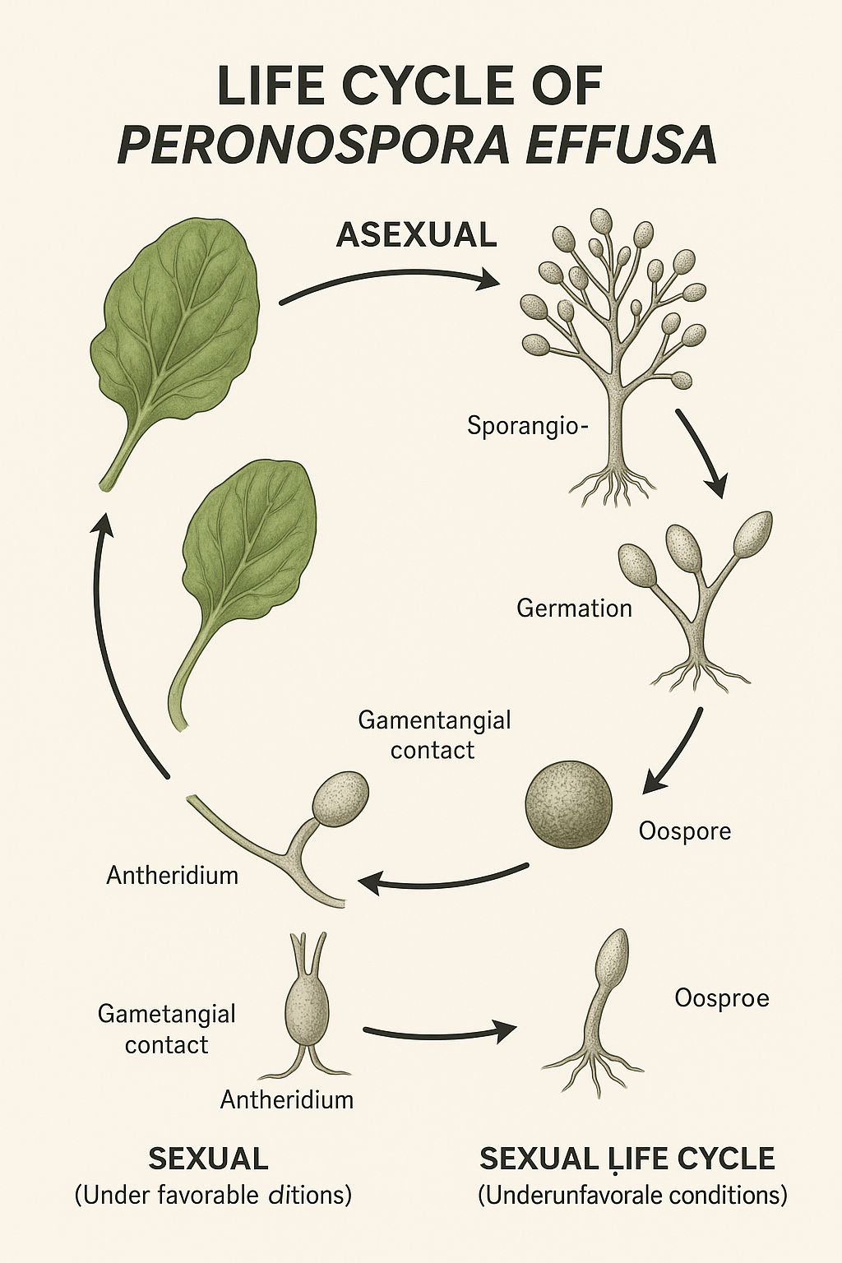
Fig 5-Life-cycle of Perenospora effusa

Rose downy mildew
“One of the most devastating diseases that can affect roses is downy mildew. The disease, first described in England in 1862, has now been reported throughout Europe and the USA and is known to occur in Canada, China, New Zealand, and South Africa.It can attack all kinds of roses in greenhouses, nurseries, and landscapes. Peronospora sparsa is the pathogen that causes downy mildew, which makes roses' leaves and stems have purple-red or brown spots. Rose downy mildew doesn't infect other ornamental plants, but Peronospora sparsa can infect other types of Rubus plants, like blackberries, raspberries, and boysenberries. Infection can spread to the plant's stems, leaves, sepals, calyces, and peduncles. The plant primarily displays the symptoms in its stems and leaves” (Baysal-Gurel, F., 2017). Infected canes and roots can stay alive during the winter, and spores can quickly grow on wet leaves.
Early symptoms include yellow spots or lesions on the upper area of the leaf. The spots or lesions may turn purple, red, or black over time and will border along the veins of the leaf. Downy mildew can infect leaves, stems, flower stalks, and flowers. Leaf symptoms are the most common and are mainly found on young growth. Infected leaves develop purplish-red to dark brown, irregularly shaped spots and blotches seen most clearly on the upper surface. Downy mildew can easily be confused with a black spot; however, lesions tend to begin near or at the bottom of the infected plant, whereas in downy mildew, the infection will begin to show symptoms around the top part of the plant. Defoliation may occur before the lesions become visible on the leaves. Lesions may also become necrotic in dry conditions. The lesions usually have clearly defined edges. Leaf lesions are often angular in appearance as a result of their rarely spreading across major leaf veins. However, downy mildew lesions can sometimes have less well-defined margins; microscopic examination of lesions for the fungal structures typical of downy mildew and black spot should be undertaken if there is doubt about the cause of spotting. Affected leaves may turn yellow, and the disease can result in a rapid and severe defoliation of plants. Even apparently healthy leaves may fall prematurely. Although black spot can also result in leaf drop, usually this symptom is less severe than that caused by downy mildew. Sporulation of downy mildew occurs on the undersurface of leaves but can be difficult to see; it appears as a sparse, white to light grey downy growth. More abundant sporulation is observed under prolonged humid conditions. During the later stages of infection, leaves may become necrotic. Infection of the flower bud or flower results in retarded and distorted growth. Black or brown dead areas form on the petals. The calyx can also be affected. Infection of the flower stalks or stems results in reddish-brown, elongate lesions. Occasionally, young shoots become so heavily infected that they die back.
Kingdom: Chromista
Phylum: Oomycota
Class: Oomycetes
Order: Peronosporales
Family: Peronosporaceae
Genus: Peronospora
Species: sparsa
Disease cycle
The sporangia can usually be found on the undersides of the leaves. The sporangia can spread by air currents and water splashing from an infected plant onto a nearby healthy plant. The ideal temperature for the spread of the rose downy mildew pathogen is cool, wet weather (between 59° and 64°F) and high humidity around 85% or greater. Symptoms usually occur rapidly after infection, depending on environmental conditions. This period can last anywhere from a few days to weeks before symptoms are seen.

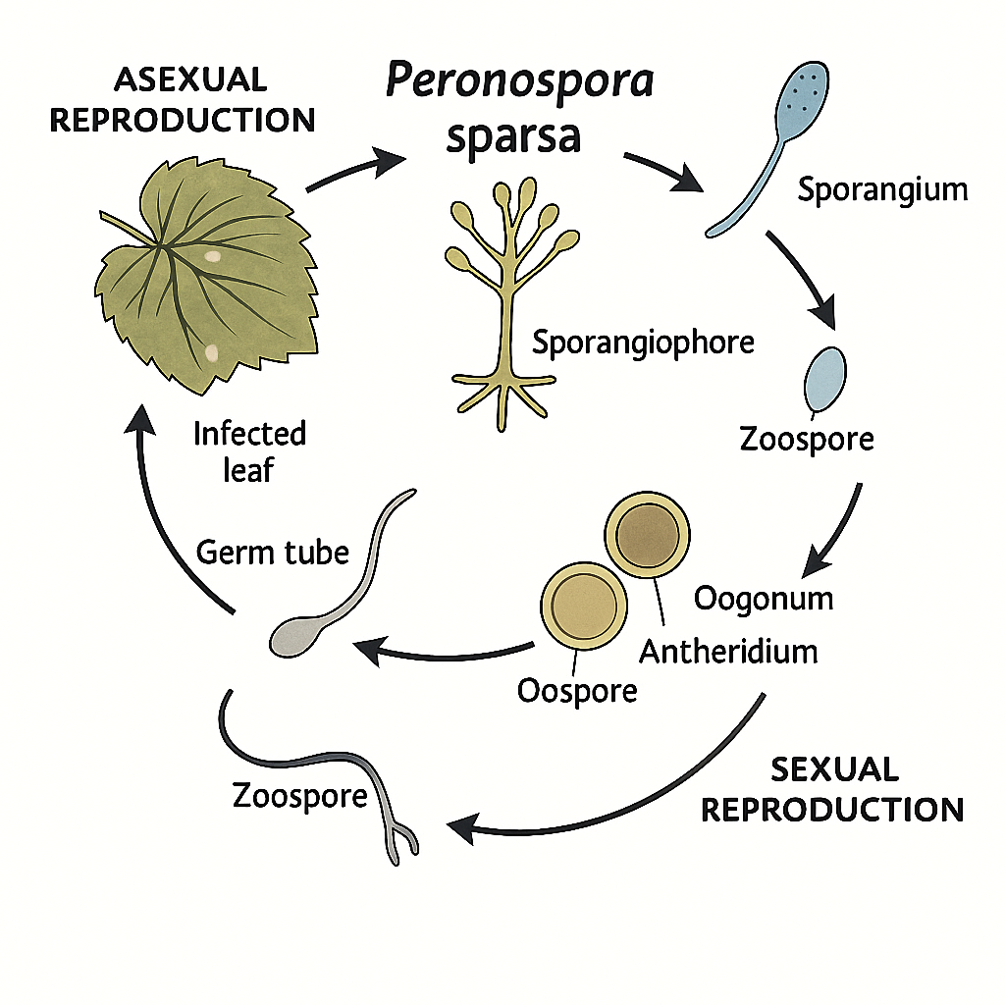
Fig 6-Life cycle of Perenospora sparsa

Pearl millet Downy mildew
The downy mildew disease of pearl millet [Pennisetum glaucum (L) R. Br.], sometimes referred to as ‘green ear’ disease, is caused by Sclerospora graminicola, which is the type species of the genus Sclerospora. It is the most widespread and destructive disease of pearl millet in India and Western Africa .This disease, first reported in India, is present in more than 20 countries and is a major factor limiting the full exploitation of the high yield potential of hybrids in India.
Kingdom: Chromista
Phylum :Oomycota,
Class: Oomycetes,
Order :Peronosporales,
Family :Peronosporaceae
Genus: Sclerospora
Species: graminicola
Symptoms
Downy mildew disease causes a reduction in the plant height, number of leaves, and nodes in susceptible cultivars. As a result, grain and fodder yields are reduced. Symptoms often vary according to host, time of expression, and ambient conditions. Both systemic and localized infections occur. Infection is mainly systemic, and symptoms appear on leaves and inflorescences. The downy mildew stage is prominent on the leaves (caused by sporangia), and the green ear stage affects the inflorescence/ear (caused by oospores). The green ear stage is more prominent, since the strain of the pathogen occurring in India produces more oospores than sporangia. The initial symptoms appear in seedlings at the three- to four-leaf stage of the plant. Symptoms can be observed in two phases: one is the downy mildew phase that appears on the leaves, and the other is the green ear phase that appears on the ear head. Soil-borne spores cause systemic infection of the young seedlings. The affected leaves show patches of light green to light yellow color on the upper surface, and the corresponding lower surface bears white downy growth of the fungus consisting of sporangiophores and sporangia. Infected leaves show greyish-white downy fungal growth on the lower leaf surface and white downy growth under high relative humidity (greater than 95%) and moderate temperature (20-22°C). Initial symptoms of the systemic infection are expressed as chlorosis, or yellowing of the lower leaves, that progressively spread to the upper leaves and the whole plant. The infection is systemic, and 7- to 10-day-old seedlings show downy mildew symptoms as chlorosis on the upper surface and whitish sporangial growth on the lower surface of the leaf. Subsequently, the leaves turn reddish brown due to oospore production and ultimately dry up. The sporangia can cause further localized infection. Often, the lower half of a leaf shows symptoms while its upper half remains symptomless. This is known as the ‘half leaf’ symptom. Severely infected plants are generally stunted and do not produce panicles.
Epidemiology
Oospores, which are the source of primary inoculum, remain in the soil and infect the underground parts of plants, mostly at the seedling stage. After penetration, the pathogen soon colonizes the growing point. After the invasion of the growing point, systemic symptoms appear in leaves and panicles produced by the growing point. Although the appearance of disease symptoms may depend to a large degree on the environment, under field conditions, systemic infection has been observed within 6 to 11 days after sowing. Infected plants produce oospores, which are transmitted on the seed surface, in soil, by wind, or by water. Under humid conditions, systemically infected leaves produce abundant sporangia on the abaxial surface. Sporangia are important for the secondary spread of the disease. These sporangia germinate and produce zoospores, which, in turn, germinate and cause infection. Germ tubes generally penetrate the epidermis between cells, but they can enter through the stomata. Sporangial infectivity is limited by seedling age, with the greatest susceptibility from the time of seed germination to the 1-2 leaf stage. Thereafter, the susceptibility decreases sharply. Inoculation of plants at the coleoptiles stage produces systemic symptoms in young leaves 4-7 days later. If the environment is suitable, infected leaves continue to produce sporangia until the tissues become necrotic or senesce. Oospores are produced in infected leaves when compatible mating types of S. graminicola are present in the same tissue or when homothallism is operative. Oospores are not always found in systemically infected leaf tissue, presumably because only one mating type is present and homothallism is inoperative. Oospores remain in the soil along with infected leaf residue and cause primary infection in the following years.
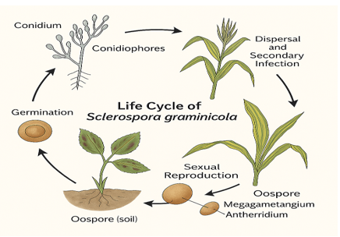
Fig 7-Life cycle of Sclerospora graminicola
Disease Management strategies against Downy mildew
Crop rotation is an effective disease management strategy. Removal and complete destruction of infected plant material is important to avoid the secondary spread of the disease. Hence, growers should identify the early disease symptoms and destroy the infected plant materials. Management traditionally relies on cultural practices, resistant cultivars, and fungicides, especially copper-based compounds, but resistance to chemicals and environmental concerns have driven the search for sustainable alternatives, such as biocontrol agents and integrated disease management. Genetic resistance is an effective method for controlling many plant diseases. Combined with timely and integrated management, it is crucial to minimize crop losses and ensure sustainable production. Early and accurate identification of the specific causal agent is crucial for effective disease control and the development of resistant crop varieties.
Disease management in Grapes
“For Grape disease management, soil should be well drained and fertilized according to soil testing. Eliminate infected and fallen leaves, as they can serve as a reservoir for overwintering inoculum. Prune out the ends of infected shoots. Rotation of crops, if possible, after every 2-4 years, can reduce the soil-borne inoculum. Enough space is required to promote airflow and to reduce humidity and leaf wetness. Avoid overhead watering in the morning when spores are released. Use of the drip irrigation method during the daytime keeps foliage dry. Ensure the infected plant material is removed and destroyed. Fungicides should be applied to susceptible cultivars. Application should be done just before the bloom, 7 to 10 days later (usually at the end of bloom), 10 to 14 days after that, and finally, 3 weeks after the third application. For cultivars very susceptible to downy mildew or where the disease was severe the previous season, an additional application is suggested about 2 weeks before the first blossom opens. Pesticides registered for use include captan, copper, fosetyl-Al, mancozeb, and ziram. Selection of plant-resistant cultivars is crucial. In India, a novel fungicide combination called Oxathiapiprolin 48g + Amisulbrom 240 g/L SE works well against downy mildew in grapes grown in fields. In comparison to single fungicide treatments and untreated controls, the study discovered that this combination, particularly at doses of 312.5 ml/ha and 375 ml/ha, significantly decreased disease incidence and increased grape yield. This combination fungicide is a suggested choice for controlling grape downy mildew, it provides excellent disease control and yield benefits without having any phytotoxic effects”. (Pharate et al., 2023)
Disease management in Cucurbit
“The disease management for cucurbits requires resistant cultivars in conjunction with fungicide applications, and an aggressive fungicide program, with sprays every 5-7 days for cucumber and every 7-10 days for other cucurbits, has been necessary to control outbreaks and to prevent crop loss. Effective disease control incorporates timely fungicide application, selection of less susceptible cultivars when feasible, and sanitation practices that lower initial inoculum and alter the environment to be less conducive to disease” (Gent et al., 2015) Fungicide applications are most effective when used in combination with disease-resistant varieties and other methods of control. Many fungicides are available for controlling downy mildew, including both protectant and eradicant fungicides. Protectant fungicides, including copper-based compounds, chlorothalonil, and mancozeb, can be used alone to protect plants from infection early in the season. To prevent or delay the infection, it is recommended (or required) that eradicant fungicides that have different modes of action be used.
Disease management in Brassica
Apply preventative fungicides like copper, mancozeb, chlorothalonil, or oxathiapiprolin, particularly in favorable weather conditions. Rotate fungicides from various chemical classes to halt the development of resistance. Use of Brassica cultivars with known resistance or tolerance to downy mildew can minimize the losses. Use fungicides such as copper, mancozeb, and chlorothalonil. Apply oxathiapiprolin, particularly in favorable weather conditions. Ensure that sprays cover both surfaces, as spores reside on both sides. Utilizing microorganisms such as Trichoderma harzianum and Bacillus subtilis can suppress pathogen growth and induce plant resistance, providing an environmentally friendly complement or alternative to chemical treatments.

Disease management in Spinach
Careful monitoring of oospore infestations in commercial spinach seed lots and the creation of seed sanitation methods could help stop the pathogen from spreading too much through contaminated seeds. Also, the most important thing for managing downy mildew will continue to be research on genes or mechanisms that make plants resistant to infection, sources of inoculum, how long inoculum lasts, and better fungicides. Seed companies, growers, and researchers will work together to find long-lasting ways to control downy mildew on spinach.
“Effective fungicides are available to control the disease, and they are applied before the appearance of symptoms” (Subbarao et al. 2018). “Traditional spinach production systems depend on the early symptoms, and effective detection can be used for fungicide sprays, which can stop the early infection process and may eliminate the impending epidemics. Hence, recent efforts have focused attention also on spore trapping and quantification of pathogen DNA to advise growers on conditions optimal for increased airborne inoculum loads” (Choudhury et al. 2016, 2017; Klosterman et al. 2014). “To limit infections and symptom development, the reduction of wetness in leaf canopies is important; for that, the use of minimal overhead irrigation is helpful” (Choudhury et al. 2016; Klosterman 2016). Furthermore, early morning irrigation may allow sufficient time during the day to dehydrate the leaf boundary layer.

Disease management in Sunflower
Metalaxyl is a common and effective fungicide for controlling downy mildew in Sunflowers. Application of metalaxyl to seed treatments like to protect seedlings from early infection. This is particularly important when establishing crops in fields with a history of downy mildew. Regularly monitor sunflower fields for signs of downy mildew and take appropriate action if it appears.

Disease management in Rose
Use of resistant cultivars and early plantation can also be helpful for disease prevention. Use of fungicides before the flowering is crucial. The application of fungicides is done when environmental conditions are favorable for disease development. Fungicide sprays should be applied at intervals of 7 to 14 days, depending on the severity of the disease. The use of protectant and eradicant fungicides is recommended during the disease management process.
Disease management in Pearl millet
“S. graminicola oospores present in the soil are the primary source of inoculum. Crop rotation is an effective disease management strategy. Removal and complete destruction of infected plant material is important to avoid the secondary spread of the disease. Hence, growers should identify the early disease symptoms and destroy the infected plant materials. Pearl millet downy mildew can be managed by using bioagents like Pseudomonas fluorescens, Bacillus species, and Trichoderma harzianum. Among several biocontrol agents, Bacillus pumilus SE 34, Trichoderma harzianum Th UOM 1, Pseudomonas fluorescens UOM SAR 14, and Bacillus pumilus INR 7 are the most effective agents. The positive correlation between nitrogen fertilizer and the incidence of downy mildew was observed in grape, camelina, and pearl millet” (Jiang and Caldwell, 2016; Zarafi et al., 2005). Nitrogen fertilizers often boost lush vegetative growth, which may create an environment conducive to higher downy mildew sporulation and infection. Therefore, the timing and dose of nitrogen fertilizers may also be an important consideration to manage downy mildew.

Future Aspects
Soil-borne oospores are also considered a major cause of downy mildew in cucumbers (Zhang et al., 2012). P. sparsa, the fungus that causes rose downy mildew, has been discussed in terms of how oospores can be a source of primary inoculum for the disease to spread (Salgado-Salazar et al., 2018). Some downy mildew pathogens can spread through seeds. Further research is needed to determine the importance of these factors for the spread of the disease, including how quickly it spreads from infected seeds, how long oospores can remain dormant, and how they contribute to the spread of epidemics. Although some downy mildew pathogens can spread through seeds, more research is needed to determine the importance of this phenomenon for the spread of the disease, including how quickly it spreads from infected seeds, how long oospores can remain dormant, and how they contribute to the spread of epidemics.
Airborne spores spread many plant diseases. It is valuable to know how spores released into the air move through space and time to create a system that can predict disease outbreaks (Neufeld et al., 2018; Schmale and Ross, 2015). An early warning system that tells how much airborne inoculum there is could help you use preventative fungicides before a disease starts or plan when to use fungicides to stop diseases from spreading. Early detection systems may help figure out when and where to use fungicides, which saves money in the long run (Gent et al., 2013; Klosterman et al., 2014). The IPMPIPE (integrated pest management information-pest information platform for education and extension) system has been used to keep an eye on environmental factors, map the path of spore transport and deposit, predict the spread of diseases, and keep track of how often diseases occur in different places (Schwartz et al., 2014; VanKirk et al., 2012). Impaction spore samplers (also called spore traps) and molecular assays have been used to find and count airborne spores of downy mildew in hop orchards (Gent et al., 2009) and downy mildew of lettuce and spinach (Choudhury et al., 2017, 2018; Klosterman et al., 2014; Kunjeti et al., 2016). Different IPMPIPE systems use the dispersal or migration routes of pathogen propagules or insect vectors at the regional and continental scales (Isard et al., 2006; Ojiambo et al., 2015; VanKirk et al., 2012). While the cucurbit downy mildew's similar IPMPIPE may not be effective in predicting spinach downy mildew, monitoring spinach fields and environmental factors, along with using spore samplers to detect airborne spores, may aid in forecasting the risk of disease outbreaks. Over the past two decades, significant progress has been made in the field of molecular detection of plant pathogens. Molecular methods are more precise and can process more samples at once than traditional methods. It is possible to identify and separate the downy mildew pathogens (Crandall et al., 2018; Kunjeti et al., 2016a) by amplifying and quantifying different parts of the nuclear or mitochondrial genomes in vitro.
Researchers developed methods to find airborne spores of P. effusa by using a combination of spore traps and quantitative amplification of pathogen DNA (Klosterman et al., 2014). There was a strong link between the number of physical spores and the number of DNA copies in this test. No widely planted cultivars are resistant to the disease, although resistance varies quantitatively among cultivars. Additionally, the environmental circumstances of the geographic area where the crop is grown determine the necessary degree of resistance (Gent et al., 2015; Henning et al., 2015). Effective disease control incorporates timely fungicide application, selection of less susceptible cultivars when feasible, and sanitation practices that lower initial inoculum and alter the environment to be less conducive to disease (Gent et al., 2015). No widely planted cultivars are resistant to the disease, although resistance varies quantitatively among cultivars. Additionally, the environmental circumstances of the geographic area where the crop is grown determine the necessary degree of resistance (Gent et al., 2015; Henning et al., 2015).
Conclusion
As downy mildew disease is the most devastating for crops, today’s need is to develop more resistant varieties to resist the disease and to develop more environmentally friendly disease management strategies to maintain crop quality while maintaining quantity.
Conflict of interest

The authors declare no conflicts of interest.

Disclaimer
Disclaimer (Artificial intelligence)
Author(s) hereby declare that generative AI technologies such as chatGpt have been used during the writing or editing of manuscripts. This explanation will include the name, version, model, and source of the generative AI technology and as well as all input prompts provided to the generative AI technology
Details of the AI usage are given below:
  - Life cycles Images (1,2,3,4,5,6,7) of different Downy mildew pathogens
References
- Agrios, G.N. (1997) Plant pathology .4th edn. San Deigo: Academic press.
- Bavaresco, L. and Eibach, R. (1987) ‘Investigations on the influence of N fertilizer on resistance to powdery mildew (Oidium tuckeri), downy mildew (Plasmopara viticola) and on phytoalexins synthesis in different grapevine varieties’, Vitis, 26, pp. 192-200.
- Baysal-Gurel, F. (2017) ‘Research helps guide downy mildew management on roses’, Tennessee Greentimes, 18(4), pp.8-10.
- Baysal-Gurel, F. and Simpsons, T. (2017) ‘Evaluation of fungicide drench applications for the control of downy mildew of knockout roses’, Plant disease management Reports, 11, OT011.
- Bhatnagar, A. (1988) studies on mode of penetration by Sclerospora graminicola (Sacc.) Schroet. In pearl millet (Pennisetum americanum (L.) Leeke) leaves. Masters thesis, Andhra Pradesh agricultural university, Rajendranagar, Andhra Pradesh, India.
- Boso, S. et al. (2023) ’Variation in susceptibility to downy mildew infection in Spanish minority vine varieties’, Plants, 12 (14), 2638.
- Butler, E.J. (1907) ‘Some diseases of cereals caused by Sclerospora graminicola’, Memoirs of the Department of Agriculture in India, Botanical series, 2, pp.1-24.
- Callan, B.E. and Carris, L.M. (2004) ‘Fungi on living plant substrata, including fruits’, in Elsevier eBooks. pp. 105-126.
- Choi, Y., Hong, S. and Shin, H. (2005) ‘A re-consideration of Pseudoperenospora cubensis and P. humuli based on Molecular and morphological data’, Mycological Research, 109 (7), pp. 841-848.
- Choi, Y., Kruse, J. and Thines, M. (2017) ‘ Hyloprenospora erucae sp. Nov. ( Perenosporaceae; Oomycota), the downy mildew pathogen of arugula ( Eruca sativa)’, European Journal of Plant pathology, 151(2), pp. 549-555.
- Choi, Y., Shin, H. and Voglmayr, H. (2010) ‘ reclassification of two Perenospora species parasitic on draba in Hyaloperenospora based on morphological and molecular phylogenetic data’, Mycopathologia, 171 (2), pp. 151-159.
- Choudhury, R.A. and McRoberts, N. (2018) ‘Temperature and light effects on germination of Perenospora effusa sporangia’, Tropical Plant Pathology, 43, pp. 572-576.
- Choudhury, R.A., Garrett, K.A., Klosterman, S.J., Subbarao, K.V. and Mc Roberts, N. (2017) ‘A framework for optimizing phytosanitary thresholds in seed systems’, Phytopathology, 107, pp. 1219-1228.
- Choudhury, R.A., Koike, S.T., Fox, A.D., Anchieta, A., Subbarao, K.V., Klosterman, S.J. and McRoberts, N. (2016) ‘Season-long dynamics of spinach downy mildew determined by spore trapping and disease incidence’, Phytopathology, 106, pp. 1311–1318.
- Coley-Smith, J.R. (1962)’ Overwinteing of hop downy mildew Pseudoperenospora humuli ( Mif. & Tak.) Wilson’, Annals of Applied Biology, 50, pp. 235-243.
- Coley-Smith, J.R. (1964) ‘Persistence and identification of downy mildew Pseudoperenospora humuli ( Mif. and Tak.) Wilson in hop rootstocks’, Annals of Applied Biology, 53, pp. 129-132.
- Coley-Smith, J.R. (1965) ‘Infection of hop rootstocks by downy mildew Pseudoperenospora humuli ( Miy. Amd tak.) Wilson and its control by early –season dusts’, Annals of Applied Biology, 56, pp.381-388.
- Corell, J.C., Bluhm, B.H., Feng, C., Lamour, K., du Toit, L.J. and Koike, S.T. (2011) ‘Spinach: Better management of downy mildew and white rust through genomics’, European Journal of Plant Pathology, 129, pp. 193–205.
- Crandall, S.G., Rahman, A., Quesada-Ocampo, L.M., Martin, F.N., Bilodeau, G.J. and Miles, T.D. (2018) ‘Advances in diagnostics of downy mildew: Lessons learned from oomycetes and future challenges’, Plant Disease, 102, pp. 265-275.
- D, J.J.F. and Zambrano, A. (2014) ‘Temperature effect on rose downy mildew development under environmental controlled conditions’, Agronomía Colombiana, 32(1), pp. 29–35.
- Delahaut, K. & Stevenson, W. (2004) Vine crops disorder: angular leaf spot. Madison, WI: Board of Reagents of the University of Wisconsin System, University of Wisconsin- Extension, Cooperative Extension Publications.
- El-Sharkawy, H., Rashad, Y., El-Kenawy, M. and Galilah, D. (2022) ‘Magnesium carbonate elicits defense-related genes in King Ruby grapevines against downy mildew and improves its growth, yield, and berry quality’, Pesticide Biochemistry and Physiology, 184, Article 105075.
- Eriksen, J.N., Madsen, P.L., Dragsted, L.O. and Arrigoni, E. (2016) ‘Optimized, fast-throughput UHPLC-DAD based method for carotenoid quantification in spinach, serum, chylomicrons, and feces’, Journal of Agricultural and Food Chemistry, 65(4), pp. 973–980.
- Fletcher, K. and Michelmore, R. (2023) ‘Genome-enabled insights into downy mildew biology and evolution’, Annual Review of Phytopathology, 61, pp.165-183.
- Fry, W.E. and Goodwin, S.B. (1997) ‘Re-emergence of potato and tomato late blight in the United states’, Plant Disease, 81 (12),pp.1349- 1357.
- Gascuel, Q., Martinez, Y., Boniface, M.C., Vear, F., Pichon, M. and Godiard, L. (2015) ‘The sunflower downy mildew pathogen Plasmopara halstedii’, Molecular Plant Pathology, 16 (2), pp. 109-122.
- Gent, D.H. and Ocamb, C.M. (2009) ‘Predicting infection risk of hop Pseudoperonospora humuli’, Phytopathology, 99 (10),pp.1190-1198.
- Gent, D.H., Cohen, Y. and Runge, F. (2017) ‘Homothallism in Pseudoperonospora humuli’, Plant Pathology, 66(9), pp. 1508–1516.
- Gent, D.H., Johnson, D.A., Gevens, A.J., Hausbeck, M.K., O’Neal, S.B. and Walsh, D.B. (2015) Field guide for integrated pest management in hops. Pullman, WA: Oregon State University, University of Idaho, USDA Agricultural Research Service, and Washington State University, pp. 15–21.
- Gent, D.H., Mahaffee, W.F., McRoberts, N. and Pfender, W.F. (2013) ‘The use and role of predictive systems in disease management’, Annual review of Phytopathology,51, pp. 267-289.
- Gent, D.H., Ocamb, C.M. and Farnsworth, J.L. (2010) ‘Forecasting and management of hop downy mildew’, Plant Disease, 94, pp.425-431.
- Göker, M., Riethmüller, A., Voglmayr, H., Weiss, M. and Oberwinkler, F. (2004) ‘Phylogeny of Hyaloperonospora based on nuclear ribosomal internal transcribed spacer sequences’, Mycological Progress, 3, pp. 83–94.
- Göker, M., Voglmayr, H., Blázquez, G.G. and Oberwinkler, F. (2009) ‘Species delimitation in downy mildews: The case of Hyloperenospora in the light of nuclear ribosomal ITS and LSU sequences’, Mycological Research, 113, pp. 308–325.
- Goossens, P., Spooren, J., Baremans, K., Andel, A., Lapin, D., Echobardo, N., Pieterse, C., van den Ackerveken, G. and Berendsen, R. (2023) ‘Obligate biotroph downy mildew consistently induces near-identical protective microbiomes in Arabidopsis thaliana’, Nature Microbiology, 8,pp. 2349-2364.
- Henning, J.A., Gent, D.H., Twomey, M.C., Townsend, M.S., Pitra, N.J. and Matthews, P.D. (2015) ‘Precision QTL mapping of downy mildew resistance in hop ( Humulus lipulus L.)’, Euphytica, 202,pp. 487-498.
- Hernández, I., Gutiérrez, S. and Tardáguila, J. (2024) ‘Image analysis with deep learning for early detection of downy mildew in grapevine’, Scientia Horticulturae. doi:10.1016/j.scienta.2014.113155.
- Hess, D.E., Thakur, R.P., Hash, C.T., Sérémé, P. and Magill, C.W. (2002) ‘Pearl millet downy mildew: Problems and control strategies for a new millennium’, in Leslie, J.F. (ed.) Sorghum and millets diseases. Ames, Iowa, USA: Iowa State Press, pp. 37–42.
- Isard, S.A., Russo, J.M. and DeWolf, E.D. (2006) ‘The establishment of a national pest information platform for extension and education’, Plant Health Progress.
- Jiang, Y. and Caldwell, C.D. (2016) ‘Effect of nitrogen fertilization on Camelina seed yield, yield components, and downy mildew infection’, Canadian Journal of Plant Science, 96, pp.17-26.
- Johnson, D.A. and Skotland, C.B. (1985) ‘Effects of temperature and relative humidity on sporangium production of Pseudoperonospora humuli on hop’, Phytopathology, 75, pp. 127–129.
- Johnson, D.A., Engelhard, B. and Gent, D.H. (2009) ‘Downy mildew’, in Mahaffee, W.M., Pethybridge, S.J. and Gent, D.H. (eds.) Compendium of hop diseases and pests. St Paul, MN: American Phytopathological Society, pp. 18–22.
- Kandel, S.L. et al. (2019) ‘Spinach downy mildew: Advances in our understanding of the disease cycle and prospects for disease management’, Plant Disease, 103 (5).
- Kanetis, S.L., Holmes, G.J. and Ojiambo, P.S. (2010) ‘Survival of Pseudoperonospora cubensis sporangia exposed to solar radiation’, Plant Pathology, 59, pp.313-323.
- Klosterman, S.J. (2016) ‘Spinach downy mildew: Threat, prevention and control’, Crop Consult, 1, pp.13-15.
- Klosterman, S.J., Anchieta, A., McRoberts, N., Koike, S.T., Subbarao, K.V., Voglmayr, H., Choi, Y.-J., Thines, M. and Martin, F.N. (2014) ‘Coupling spore traps and quantitative PCR assays for detection of the downy mildew pathogens of spinach (Peronospora effusa) and beet (P. schachtii)’, Phytopathology, 104, pp. 1349–1359.
- Koledenkova, K., et al. (2022) ‘Plasmopara viticola the causal agent of downy mildew of grapevine: From its taxonomy to disease management’, Frontiers in Microbiology, 13. doi:10.3389/fmicb.2022.889472.
- Kunjeti, S.G., Anchieta, A., Subbarao, K., Koike, S.T. and Klosterman, S.J. (2016) ‘Plasmolysis and vital staining reveal viable oospores of Perenospora effusa in spinach seed lots’, Plant Disease, 100,pp.59-65.
- Lee, J.S., Lee, H.B., Shin, H.-D. and Choi, Y.-J. (2017) ‘Diversity, phylogeny, and host-specialization of Hyaloperonospora species in Korea’, Mycobiology, 45, pp. 139–149.
- Lyon, R., Corell, J., Feng, C., Bluhm, B., Shrestha, S., Shri, A. and Lamour, K. (2016) ‘Population structure of Peronospora effusa in the southwestern United States’, PLOS ONE, 11, e0148385.
- Mitchell, M.N., Ocamb, C.M., Grünwald, N.J., Mancino, L.E. and Gent, D.H. (2011) ‘Genetic and pathogenic relatedness of Pseudoperonospora cubensis and P. humuli’, Phytopathology, 101, pp. 805–818.
- Natsume, S., Takagi, H., Shiraishi, A., Murata, J., Toyonaga, H., Patzak, J. et al. (2015) ‘The draft genome of hop (Humulus lupulus), an essence for brewing’, Plant and Cell Physiology, 56, pp. 428–441.
- Neufeld, K.N., Keinath, A.P., Gugino, B.K., McGrath, M.T., Sikora, E.J., Miller, S.A., Ivey, M.L., Langston, D.B., Dutta, B., Keever, T. and Sims, A. (2018) ‘Predicting the risk of cucurbit downy mildew in the eastern United States using an integrated aerobiological model’, Journal of Biometeorology, 62, pp. 655–668.
- Ojiambo, P.S., Gent, D.H., Quesada-Ocampo, L.M., Hausbeck, M.K. and Holmes, G.J. (2015) ‘Epidemiology and population biology of Pseudoperonospora cubensis: A model system for management of downy mildews’, Annual Review of Phytopathology, 53, pp. 223–246.
- Parker, T. (2007) Investigation of hop downy mildew through association mapping and observations of the oospore. Ph.D. thesis. Oregon State University..
- Purayannur, S., Gent, D., Miles, T., Radišek, S. and Quesada-Ocampo, L. (2021) ‘The hop downy mildew pathogen Pseudoperonospora humuli’, Molecular Plant Pathology, 22,pp. 755-768. doi:10.1111/mpp.13063.
- Purayannur, S., Miles, T.D., Gent, D.H., Pigg, S. and Quesada-Ocampo, L.M. (2020) ‘Hop downy mildew caused by Pseudoperonospora humuli: A diagnostic guide’, Plant Health Progress Journal, 21, pp. 173–179.
- Rachie, K.O. and Majmudar, J.V. (1980) Pearl millet. University Park, Pennsylvania: Pennsylvania State University Press.
- Rachie, K.O. and Majmudar, J.V. (1980) Pearl millet. University Park, Pennsylvania: Pennsylvania State University Press.
- Richards, M.C. (1939) Downy mildew of spinach and its control. Agricultural Experiment Station Bulletin, 718, pp. 1–30.
- Royle, D.J. (1970) ‘Infection periods in relation to the natural development of hop downy mildew (Pseudoperonospora humuli)’, Annals of Applied Biology, 66, pp. 281–291.
- Royle, D.J. (1973) ‘Quantitative relationships between infection by the hop downy mildew pathogen, Pseudoperonospora humuli, and weather and inoculum factors’, Annals of Applied Biology, 73, pp. 19–30.
- Royle, D.J. and Kremheller, H.T. (1981) ‘Downy mildew of the hop’, in Spencer, D.M. (ed.) Downy mildews. New York: Academic Press, pp. 395–419
- Royle, D.J. and Thomas, G.G. (1971a) ‘The influence of stomatal opening on the infection of hop leaves by Pseudoperonospora humuli’, Physiological Plant Pathology, 1, pp. 329–343.
- Royle, D.J. and Thomas, G.G. (1971b) ‘Observations with the scanning electron microscope on the early stages of hop leaf infection by Pseudoperonospora humuli’, Physiological Plant Pathology, 1, pp. 345–349.
- Sakamoto, K. and Konings, W.N. (2003) ‘Beer spoilage bacteria and hop resistance’, International Journal of Food Microbiology, 89, pp. 105–124.
- Salcedo, A., Hausbeck, M., Pigg, S. and Quesada-Ocampo, L.M. (2020) ‘Diagnostic guide for cucurbit downy mildew’, Plant Health Progress, 21, pp. 166–172.
- Salcedo, A.F. et al. (2021) ‘Fantastic downy mildew pathogens and how to find: Advances in detection and diagnostics’, Plants, 10(3), Article 435. doi:10.3390/plants10030435.
- Salgado-Salazar, C., Salamanca, L., Romberg, M., Davis, W., McConnell, M., Havan, A. and Hand, P. (2025) ‘Where flowers bloom, so do downy mildews: New species and new records of Hyaloperonospora, Peronospora and Plasmopara species on ornamental and wild plants in the United States’, Plant Health Progress. doi:10.1094/php-10-24-0100-rs.
- Salgado-Salazar, C., Shishkoff, N., Daughtrey, M.L., Palmer, C. and Crouch, J.A. (2018) ‘Downy mildew: A serious disease threat to rose health worldwide’, Plant Disease, 102, pp. 1873–1882.
- Schmale, D.G. III and Ross, S.D. (2015) ‘Highways in the sky: Scales of atmospheric transport of plant pathogens’, Annual Review of Phytopathology, 53, pp. 591–611.
- Schwartz, H.F., Alston, D., Alwang, J., Bartolo, M., Blunt, T., Boateng, C.O., Bunn, B., Cramer, C.S., Cranshaw, W., Davidson, J. and Derie, M. (2014) ‘Onion IPM PIPE: A coordinated effort to improve the management of onion thrips and Iris yellow spot virus for the US onion industry’, Plant Health Progress, 15, pp. 172–183.
- Singh, S.D. (1995) ‘Downy mildew of pearl millet’, Plant Disease, 79, pp. 545–550.
- Singh, S.D. and Gopinath, R. (1985) ‘A seedling inoculation technique for detecting downy mildew resistance in pearl millet’, Plant Disease, 69, pp. 582–584.
- Singh, S.D. and Williams, R.J. (1980) ‘The role of sporangia in the epidemiology of pearl millet downy mildew’, Phytopathology, 70, pp. 1187–1190.
- Skotland, C.B. (1961) ‘Infection of hop crowns and roots by Pseudoperonospora humuli and its relation to crown and root rot and overwintering of the pathogen’, Phytopathology, 51, pp. 241–244.
- Subbarao, C.S., Anchieta, A., Ochoa, L., Dhar, N., Kunjeti, S.G., Subbarao, K.V. and Klosterman, S.J. (2018) ‘Detection of latent Peronospora effusa infections in spinach’, Plant Disease, 102, pp. 1766–1771.
- Tang, G., Qin, J., Dolnikowski, G.G., Russell, R.M. and Grusak, M.A. (2005) ‘Spinach or carrots can supply significant amounts of vitamin A as assessed by feeding with intrinsically deuterated vegetables’, American Journal of Clinical Nutrition, 82, pp. 821–828.
- Thakur, R. and Mathur, K. (2002) ‘Downy mildews of India’, Crop Protection, 21, pp. 333–345. doi:10.1016/S0261-2194(01)00097-7.
- Thakur, R.P. (1998) ‘Disease management in pearl millet’, in Thind, T.S. (ed.) Diseases of field crops and their management. Ludhiana, Punjab: National Agricultural Technology Information Centre, pp. 53–76.
- Thakur, R.P. (2008) ‘Pearl millet’, in Lodha, S., Mawar, R. and Rathore, B.S. (eds.) Disease management in arid land crops. Jodhpur, India: Scientific Publishers (India), pp. 21–41.
- Thakur, R.P., Shetty, H.S. and Khairwal, I.S. (2006) ‘Pearl millet downy mildew research in India: Progress and perspectives’, International Sorghum and Millets Newsletter, 47, pp. 125–130.
- Thines, M. and Choi, Y.J. (2016) ‘Evolution, diversity, and taxonomy of the Peronosporaceae, with focus on the genus Peronospora’, Phytopathology, 106(1), pp. 6–18. doi:10.1094/PHYTO-05-15-0127-RVW.
- Tör, M. et al. (2023) ‘Recent developments in plant–downy mildew interactions’, Seminars in Cell and Developmental Biology, 148–149, pp. 42–50. doi:10.1016/j.semcdb.2023.01.010.
- Tör, M., Wood, T., Webb, A., Göl, D. and McDowell, J. (2023) ‘Recent developments in plant–downy mildew interactions’, Seminars in Cell and Developmental Biology. doi:10.1016/j.semcdb.2023.01.010.
- VanKirk, J.R., Isard, S.A., Cardwell, K.F. and Draper, M.A. (2012) ‘The IPM PIPE: Overview, lessons, opportunities, and challenges’, Journal of Integrated Pest Management, 3, C1–C7.
- Wang, Y. et al. (2024) ‘Cucumber downy mildew disease prediction using a CNN–LSTM approach’, Agriculture, 14(7), Article 1155. doi:10.3390/agriculture14071155.
- Windham, M. and Windham, A. (2014) ‘Downy mildew of rose’, American Nurseryman, 214(5).
- Woods, J.L. and Gent, D.H. (2016) ‘Susceptibility of hop cultivars to downy mildew: Associations with chemical characteristics and region of origin’, Plant Health Progress, 17, pp. 42–48.
- Zarafi, A.B., Emechebe, A.M., Akpa, A.D. and Alabi, O. (2005) ‘Effect of fertilizer levels on grain yield, incidence and severity of downy mildew in pearl millet’, Archives of Phytopathology and Plant Protection, 38, pp. 11–17.
- Zhang, Y.J., Pu, Z.J., Qin, Z.W., Zhou, X.Y., Liu, D., Dai, L.T. and Wang, W.B. (2012) ‘A study on the overwintering of cucumber downy mildew oospores in China’, Journal of Phytopathology, 160, pp. 469–474.
- Zhang, Z., Qiao, Y., Guo, Y. and He, D. (2022) ‘Deep learning based automatic grape downy mildew detection’, Frontiers in Plant Science, 13.
- Zing (2017) ‘Photosanitary thresholds in seed systems’, Phytopathology, 107, pp. 1219–1228.
- (2025) Figures. AI-generated illustrations life cycles of different Downy mildew pathogens created using ChatGpt AI.

