**Sustainability Analysis of Livestock Agribusiness Area Development in Sukabumi Regency**

.

ABSTRACT

|  |
| --- |
| This studi aims to analysize the sustainable index and status of the livestock agribusiness area in Sukabumi Regency based on five dimension of sustainability. This studi was contucted in sub-district designated as Livestock Agribusiness Areas (Kagrisnak) in 2012, with the research undertaken from June to December 2019. Some of the advantages of making beef cattle a source of regional economic growth include not demanding high-quality labor, income-elastic products, and employment opportunities. However, the sustainability of the area is necessary to ensure that the commodity contributes to regional economic growth. The result of study showed that the sustainability analysis revealed that the ecological dimension was moderately sustainable (52,77), while the economic dimension was poor (25,17). The socio-cultural (45,06), technological and infrastructural (34,71), as well as legal and institutional (32,63) dimensions were categorized as low. Of the 54 attributes analyzed, 20 were identified as priority attributes due to their sensitivity in influencing the improvement of the sustainability index and status at a 95 % confidence level.  Keywords : Livestock agribusiness area, regional economic, sustainability index |

1. INTRODUCTION

Sukabumi Regency is the largest regency in West Java with an area of 4,145.7 km2. Geographically, 69 % of Sukabumi Regency is a rural area thar relies on the agricultural sector as a source of income. In the GDRP structure of Sukabumi Regency the contribution of the agricultural sector ranked first with value of 22.56 % in 2019. (BPS, 2020)

In order to improve the welfare of the community, the Sukabumi Regency government makes an effort to improve the utilization of existing resources. Beef cattle development was chosen as one of the bases for economic activities by utilizing forage (HMT) from agricultural waste and grazing land. Agricultural land that produces HMT account for 20 % of the total area of Sukabumi Regency. In 2012, the government of Sukabumi Regency established a livestock agribusiness area (Kawasan Agribisnis peternakan/KAGRISNAK) involving 13 sub-districts. (Perda No 22 Tahun 2012 Tentang RTRW Kabupaten Sukabumi 2012-2032, 2012)

The development of beef cattle as a source of economic growth in rural areas has several advantages, including not requiring high-quality labor, having flexibility and technology that is broad and flexible; the products produced are elastic to income (if income rises, demand will also rise); opening employment and business opportunities ranging from upstream agribusiness sub-systems, cultivation, downstream agribusiness, and related service activities (transportation, banking, and others) (Saragih, 2001). Another advantage of farming beef cattle is the ability to increase the added value of agricultural waste utilization as feed, and vice versa, agriculture can utilize fertilizers to increase production.

The market for beef cattle products is very potential considering the demand for beef continues to increase from year to year. During the period 2010-2017, beef consumption per capita increased by an average of 7.31% per year(BPS, 2017). Beef is also a strategic commodity in the National Medium-Term Development Plan (RPJMN) 2015-2019, where the target of RPJMN 2015-2019 is to improve and strengthen food sovereignty, namely to strengthen food security towards food self-sufficiency by increasing production of staple foods, especially strategic commodities such as rice, corn, soybeans, sugar, and beef. At the macro level, investment in beef cattle farming provides a multiplier effect on income for all sectors of 1.3 (Sarmila & Mulatsih, 2013).

On the other hand, the development of beef cattle farming faces many problems. Since its establishment as Kagrisnak in 2012, Sukabumi Regency has experienced an increase in beef cattle population. In 2013, the population was 16,673 head; and in 2019, it was 20,374 head (BPS, 2020). However, such an increase (an average of 3.42% per year) is still below the national population increase which reached 5.24% during the same period.

Some of the problems encountered in the development of beef cattle were mentioned by several researchers. Among them are the lack of grazing land and feed (Amam, 2020; Devendra & Sevilla, 2002;), the high cost of producing feeder cattle (Nuhung, 2015), livestock farming by smallholder farmers who are not business-oriented (Ardhani, 2009; Indrayani et al., 2012; Mansyur et al., 2012; Nuhung, 2015), lack of coordination between agencies (Nuhung, 2015), and fluctuating selling prices (Amam, 2020). These problems are a threat to the sustainability of beef cattle farming areas. Efforts to increase meat production and improve farmers' income can be carried out through an agribusiness system (Putri, BRT, Suparta IN, Sudano IB, 2014) The beef cattle agribusiness system can also alleviate poverty and create employment opportunities in rural areas (Sarma, 2014). Based on that, this study aims to examine the sustainability of livestock agribusiness area development in Sukabumi.

2. material and methods

Method and Location of Research

The research employed a survey methodology, which was carried out through interviews and direct observations involving cattle farmers. The research was conducted in the agribusiness area of beef cattle farming in Sukabumi Regency, West Java Province, which covers 13 subdistricts, namely Pabuaran, Purabaya, Nyalindung, Sagaranten, Tegalbuleud, Cidolog, Cibitung, Surade, Ciracap, Curugkembar, Jampangtengah, Gegerbitung, and Ciemas.

Type and Source of Data

This study uses secondary data and primary data. Secondary data is data that at the time of collection is not for the research needs currently conducted by researchers (Juanda, 2009). Secondary data were obtained from BPS publications, laws and regulations, local regulations, the Livestock Service Office, Bappeda (regional planning agency), and related literature. Primary data was obtained through observation, distributing questionnaires to beef cattle farmers, and in-depth interviews.

In-depth interviews were conducted with institutional stakeholders involved in livestock area development, including government, business actors, farmers, financial institutions, academics, and non-governmental organizations (NGOs); each represented by 2 people. The determination of respondents was based on data needs and the respondent's mastery (expert) related to the research problem.

Expert respondents were purposively sampled with the criteria of having an understanding in accordance with the field studied. Considerations for determining expert respondents were (1) having experience in beef cattle farming; (2) having the reputation and position to make decisions related to the development of livestock areas; (3) having credibility and being willing to be interviewed.

Data Analysis Method

The sustainability of livestock agribusiness areas was analyzed using the Rapfish ordination method which was modified into Rap-farm. The Rapfish method is an analytical technique developed by a team from the University of British Columbia Fisheries Center to determine the sustainability of fisheries (Fauzi, 2019; Fauzi & Anna, 2002).

The Rap-farm principle is a multi-criteria principle with a Multidimensional Scaling (MDS) algorithm. In principle, MDS maps the perceived distance between one unit and another by scaling. MDS was chosen to be used in Rap-farm because the results obtained are more stable than other multivariate analysis methods (Pitcher, TJ. and Preikshot, 2001). In the use of MDS, the observed object or point is mapped into two or three-dimensional space so that the object or point is sought to exist as close as possible to the origin. The ordination technique (determination of distance) in MDS is based on the Euclidian distance which in n-dimensional space can be written as equation (1) (Fauzi & Anna, 2002).

d=√((|x1-x2|2+|y1-y2|2+|z1-z2|2+⋯…))…………………..(1)

The point is then rounded off by regressing the Euclidean distance (dij) from point i to point j with the origin (dij) by equation (2) as follows:

dij=a+βδij+ε………(2)

An alternating least squared technique, which is based on the root of the Euclidian Distance (squared distance) or called the ALSCAL algorithm, is used to regress the equation with the principle of making an iteration of the regression process so as to produce the smallest error value. Refering to the explanation of Kavanagh (2004) as cited by (Ramadhan et al., 2014) The ALSCAL algorithm optimizes the squared distance (squared distance = dijk) to squared data (origin = 0ijk) in three dimensions (i, j, k), written in a formula called Stress as shown in equation (3) below.

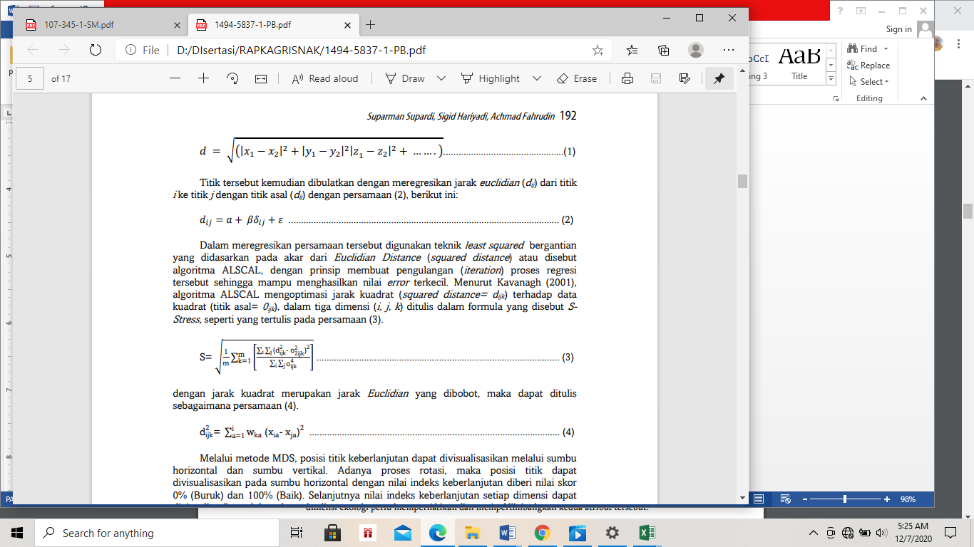

With the squared distance as the weighted Euclidian distance, then equation (4) can be written as follows:



By using the MDS method, the position of the sustainability point can be visualized through the horizontal and vertical axes. Through the rotation process, the position of the point can be visualized on the horizontal axis with a sustainability index value score of 0% (Bad) and 100% (Good). Furthermore, the sustainability index value of each dimension can be visualized in the form of a kite diagram. Although Rapfish was originally intended to measure sustainability in fisheries, the principle of MDS can also be used to measure sustainability in other fields, such as beef cattle farming.

In principle, Rapfish can be used when facing the following situations (Fauzi, 2019):

1. The analysis is multidimensional, consisting of ecological, economic, socio-cultural, technological, institutional, and other dimensions
2. The condition of recognizing the sustainability status of a system or economic activities
3. Analyze to determine the relative position of a unit of analysis in one dimension to another in the context of sustainability
4. Wish for several variables that can be used as levers of sustainability
5. If the sustainability assessment is carried out through “judgment” based on existing information or data (quick judgment)
6. When the data owned in the form of data source documentation is quite complete but has not been compiled into a data series or panel

Analysis with sustainability measures in Rapfish is based on the ordination or position of units on a scale of "bad" to "good" sustainability so that the determination of the ordination must comply with the following rules (Pitcher, TJ. and Preikshot, 2001):

1. Determination of attributes or indicators that are in accordance with the dimensions. This means that indicators related to the economy must be in the economic dimension, not in other dimensions, such as social
2. Good attributes or indicators in each dimension should be in the range of 9-12 to produce good ordination
3. The number of units analyzed should be at least equal to the number of attributes. The best number is 2-3 times the number of attributes to avoid outliers that can affect ordination
4. The selected attributes can be easily and objectively ranked
5. The selected attributes allow for extreme “good” dan “bad” (poor) score
6. Scoring must be documented (basis for determination)
7. Goodness of fit through stress of MDS indicators should be ≤ 0.25

The Rapfish ordination is placed on a two-dimensional curve, where only the horizontal dimension (x-axis) has significance in ordination. The Y axis only provides variations in the attributes (indicators) and has nothing to do with the degree of sustainability.

Rapfish analysis is complemented by leveraging and Monte Carlo. Leveraging principally detects dominant attributes; it is an analysis that describes the sensitivity of each attribute to sustainability values and is used to identify sensitive attributes.(Hidayanto, M. Supiandi S, 2009). Leveraging calculation allows researchers to see changes in ordination (bad-good position) when attributes are removed one by one. In Rapfish, leveraging values range from 2% to 6% as measured by Root Mean Square (RMS) changes. The larger the RMS change, the more sensitive the attribute is to sustainability.

Monte Carlo analysis was performed to detect sources of error in the variance. This analysis was used to test the confidence level of the index values of each dimension with a 95% confidence level. In sustainability analysis, Monte Carlo analysis helps to see the influence of scoring errors on each attribute caused by procedural errors or understanding of attributes and scoring variations due to differences in opinion or judgment by researchers, stability of the MDS analysis process, data entry errors or missing data, and stress values that are too high (Fauzi & Anna, 2002). The stages of analysis are shown in Figure 1.

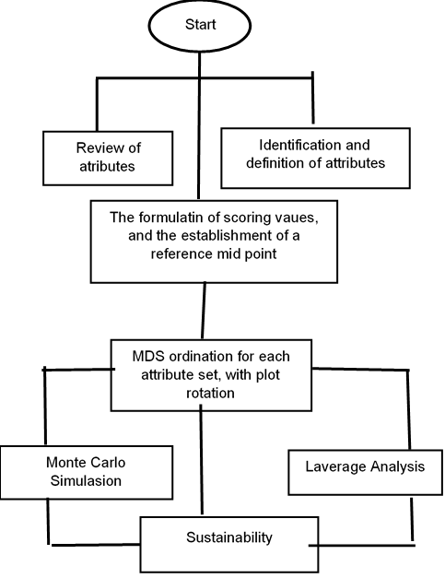

Figure 1. Stages of MDS Analysis

Source: (Pratama, Aulia Rahman, 2020)

3. results and discussion

The sustainability status of beef cattle farming agribusiness areas in Sukabumi Regency is measured through sustainability analysis with five dimensions, namely ecological, economic, socio-cultural, technology and infrastructure as well as legal and institutional dimensions. By knowing the sustainability status of the area from these five dimensions, improvements for attributes that are sensitive to influence the improvement of sustainability status will be easier, especially on sustainability dimensions with lower status in supporting the further development of livestock agribusiness areas.

The analysis of the sustainability of livestock agribusiness area development was carried out using the Multidimensional Scaling (MDS) approach called the rapid appraisal approach as a development of Rapfish used to assess the sustainability status of capture fisheries. The results of the analysis are expressed in the sustainability index of the livestock agribusiness area.

The analysis was conducted through several stages as follows:

a. Determine the attributes of livestock agribusiness areas that are expected to be sustainable through an assessment of five dimensions: ecological, economic, socio-cultural, technological, legal and institutional.

b. Assessment of each attribute on a scale based on the sustainability criteria of each dimension, and

c. Compilation of index and status of sustainability of livestock agribusiness area development

The attributes studied in the ecological dimension are as follows:

1. Utilization of livestock waste for organic fertilizer

2. Utilization of agricultural waste for animal feed

3. Beef cattle rearing system

4. Agroclimate

5. Feed carrying capacity

6. Cage cleanliness

7. Type of animal feed

8. Availability of land for fodder (king grass and elephant grass)

9. Quantity of livestock waste

10. Distance of livestock business location from residential areas

11. Occurrence of drought

12. Frequency of flooding

13. Rainfall

14. Condition of farm road infrastructure

15. Condition of village road infrastructure

The attributes studied in the economic dimension are as follows:

1. Profit from beef cattle farming

2. Contribution to GRDP

3. Contribution to local own-source revenue (PAD) for agriculture

4. Average income of livestock farmers relative to West Java minimum wage

5. Profit transfer

6. Availability of livestock market/agribusiness sub-terminal

7. Places for farmers to sell their livestock

8. Financial feasibility of beef cattle business

9. Price of livestock commodities

10. Number of agricultural laborers

11. Type of superior commodity

12. Level of consumer dependency

The attributes studied in the socio-cultural dimension are as follows:

1. Work is carried out individually or in groups

2. Knowledge of the environment

3. Frequency of conflicts related to livestock farming

4. Family participation in livestock agribusiness

5. The role of the community in livestock business

6. Frequency of counseling and training

7. Agricultural labor absorption rate

8. Alternative businesses other than livestock agribusiness

9. Time allocation used for livestock agribusiness

10. Number of villages with people working in the agricultural sector

The attributes studied in the technology and infrastructure dimensions areas follows:

1. Dispersion of Poskeswan (Animal Health Post) sites

2. Dispersion of artificial insemination (IB) service center

3. The use of vitamins and probiotics to promote livestock growth

4. Feed technology

5. Livestock waste processing technology/livestock agro-industry

6. Livestock product processing technology

7. Availability of agribusiness facilities and infrastructure

8. Availability of public facilities and infrastructure

9. Level of mastery of livestock farming technology

10. Availability of livestock information technology

The attributes studied in the legal and institutional dimensions are as follows:

1.Farmers’ training and extension center

2.Cooperation agreements with other regions on livestock farming

3.Synchronization of central and regional policies

4.Livestock farmer groups

5.Availability of social institutions

6.Microfinance institutions (banks/ credit or loans)

7.Agricultural Extension Institute (BPP)

The attributes in each dimension were scored based on standard scores derived from expert estimates, in this case, business actors, academics, and the livestock service office. The score range of the state of each attribute varies, depending heavily on the condition of each which is translated from the lowest (bad) to the highest (good). (Pratama, Aulia Rahman, 2020). The respective scores were analyzed multidimensionally to determine one or more points that illustrate the location of the livestock agribusiness area sustainability index. The index was assessed for its relative position to two reference points, namely bad and good points. Index values between 0-25.99 indicate unsustainable (bad) conditions, index values 26-50.99 indicate less sustainable areas, index values 51-74.99 indicate moderately sustainable areas, and index values 75-100 indicate sustainable areas. The score values that indicate the sustainability index position of each dimension can be seen in Table 1.

Table 1. Category of Sustainability Status of Livestock Agribusiness Areas Based on the Index Value of the Analysis Results

No Index Value Category

1 0 – 25,99 Bad (unsustainable)

2 26 – 50,99 Deficient (less sustainable)

3 51 – 74,99 Moderate (moderately sustainable)

4 75 – 100 Good (sustainable)

Source : (Mukhlisi, I.B, Hendrarto,&Purweni, 2014)

The sustainability index value of each dimension is visualized in the form of a kite diagram to see the index value of each dimension of sustainability combined. Thus, the sustainability index of the livestock agribusiness area can be assessed, and policies can also be taken immediately and prioritize the leverage of sensitive attributes that affect the sustainability of the area.

Based on the results of the rapid assessment analysis, which is a development of Rapfish, the sustainability index value for the ecological dimension is 52.77 with moderate sustainability status; the sustainability index value for the economic dimension is 25.17 with bad sustainability status; the sustainability index value for the socio-cultural dimension is 45.06 with deficient/less sustainable status; the sustainability index value for the technology and infrastructure dimension is 34.71 with deficient/less sustainable status; and the sustainability index value for the legal and institutional dimension is 32.63 with deficient/less sustainable status (Figure 2).

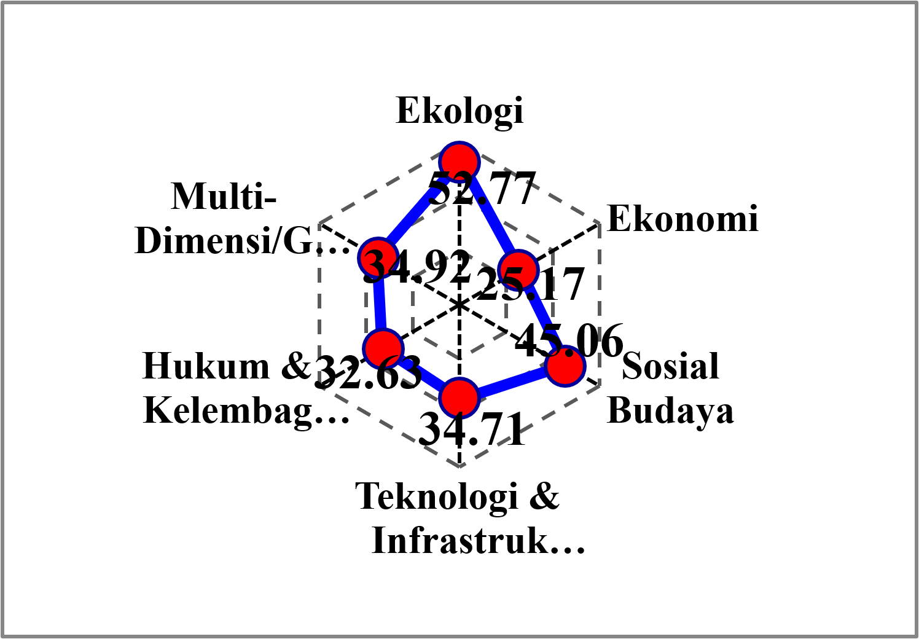

Figure 2. Kite Diagram of Sustainability Index Value of Livestock Agribusiness Area

The index value in the future can be increased by improving the attributes that most sensitively affect the index value. To find out the most sensitive attributes that contribute to the sustainability index of livestock agribusiness area development, a sensitivity analysis is conducted by looking at the change in root mean square (RMS) ordination on the X-axis. The greater the change in RMS value, the more sensitive these attributes are in the development of livestock agribusiness areas.

**Sustainability Status of Ecological Dimension**

Based on the results of the analysis, the ecological dimension sustainability index of 52.77 is categorized as moderately sustainable. (Susilo, 2003)

Figure 3. Sustainability Index of Ecological Dimension of Livestock Agribusiness Area

Leverage analysis was carried out to determine which attributes are sensitive to influence the ecological dimension of the sustainability index value. Based on this analysis, three attributes were found to be sensitive to the value of the ecological dimension sustainability index, namely (1) the distance of livestock business location from residential areas, (2) the type of animal feed, and (3) the feed carrying capacity. The results of the leverage analysis can be seen in Figure 4.

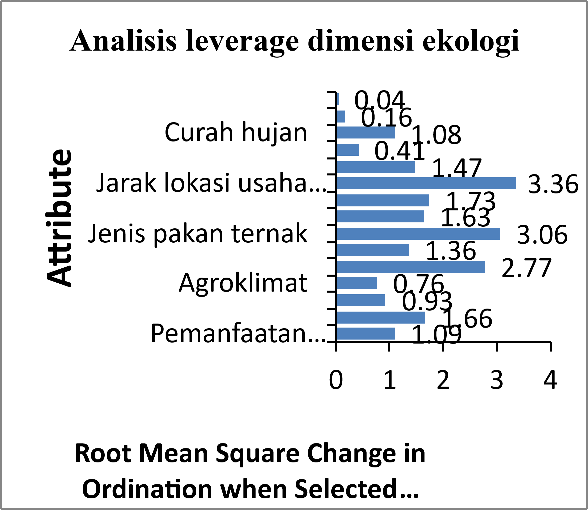

Figure 4. The Results of Ecological Dimension Leverage Analysis in Livestock Agribusiness Area

The following is the explanation of attributes that are sensitive to the value of the ecological dimension sustainability index.

(1) It is crucial to pay attention to the distance between the location of the livestock business and settlement areas because there are settlement areas that are very close to livestock pens; there are even pens located side by side with farmers' residences. Livestock pens that are very close to settlement areas will disrupt community activities around the pens and cause air pollution. The utilization of cattle waste remains limited among farmers, primarily due to the practice of open grazing. Nevertheless, such waste can be processed into organic fertilizer. As emphasized by (Huda and Wikanto, 2017), cattle manure carries substantial economic value, which may be comparable to the economic worth of beef. Livestock waste adjacent to settlements will result in the low health status of the owners due to the unpleasant odor emanating from the disposal of cow urine and feces every day. Such a condition needs to be anticipated by keeping the pens away from settlements and making collective pens for livestock groups so that pollution to the environment can be minimized. However, not all farmers/breeders are members of livestock groups, thus livestock management is still carried out individually. The establishment of collective pens makes it easier to manage livestock, for example, when carrying out Artificial Insemination (AI), feeding, anticipating diseases that may occur, urine and feces are easier to collect, livestock are safer, and marketing is also easier. If such management is carried out, the status of attributes that have a better impact on the sustainability index in the future will increase.

(2) The types of animal feed used by farmers are still not diverse. In general, the types of animal feed used in livestock agribusiness areas vary in the form of forage, supplementary food, and concentrates in the form of bran, tofu filter cake, cassava peels, and other agricultural waste. However, not all farmers use these types of feed. They feed forage only during the rainy season. In the dry season, forage feed cannot be given in full because it is difficult to obtain. Hence, efforts are made by adding fermented feed so that it can meet the feed needs of livestock.

(3) The carrying capacity of feed in livestock agribusiness areas is quite available. It must be guaranteed so that the livestock being developed has maximum potential. Agricultural waste that can be used as a supplement to feed includes rice straw, corn leaves, and cassava peels, as well as industrial waste such as tofu filter cake which is sufficiently available. Ensuring the availability of sufficient feed resources for livestock is crucial. According to (Umela, Syaiful ; dan Bulontio, 2016) corn stover can serve as an alternative feed for beef cattle in addition to forage grasses, particularly in corn producing regions.

**Sustainability Status of Economic Dimension**

Based on the results of the analysis, the sustainability index value for the economic dimension is 25.17, which is in the less sustainable category (Figure 5).

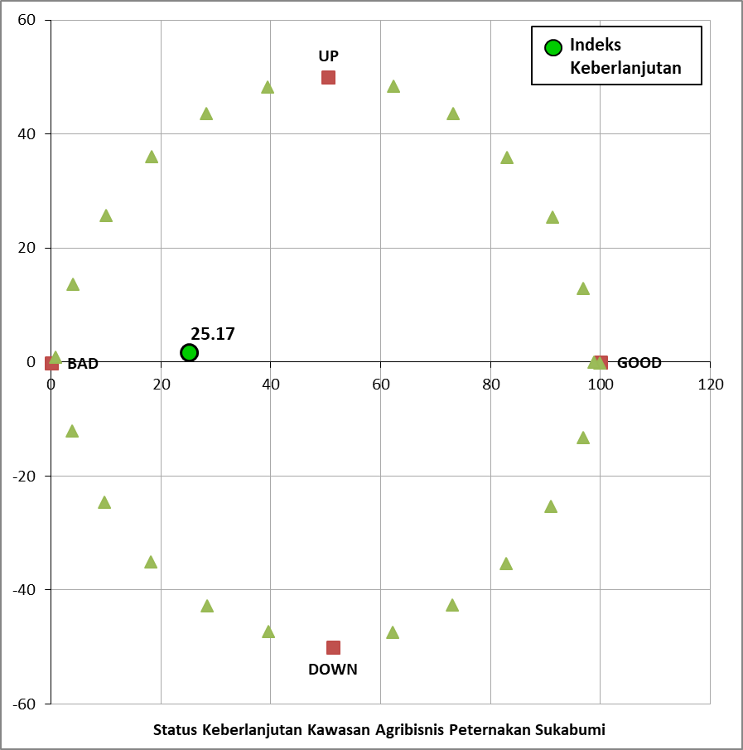

Figure 5. Sustainability Index of Economic Dimension of Livestock Agribusiness Area

Based on leverage analysis, two attributes that were sensitive to the sustainability index value of the economic dimension were found, namely the financial feasibility of beef cattle business and livestock commodity prices. The results of the leverage analysis are shown in Figure 6.

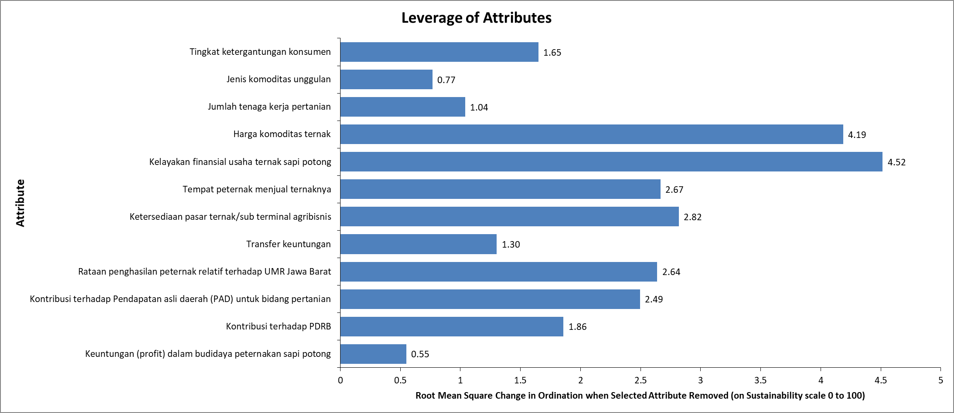

Figure 6. Leverage Analysis Results of the Economic Dimension of Agribusiness Livestock Area

The financial feasibility of beef cattle business is the most sensitive attribute in influencing the sustainability index on the economic dimension. Financially, beef cattle business can be said to be feasible. This can be seen from the R/C ratio analysis which shows that 89% of the analysis results are above 1, while the rest have an R/C ratio of less than 1. These results indicate that farmers continue to keep beef cattle because it is feasible to cultivate. Empirical evidence in the field shows that the majority of farmers maintain 2 to 5 head of cattle, primarily as a supplementary livelihood activity (Guntoro, 2002). Furthermore, cattle are perceived as a form of investment or financial reserve that can be liquidated at any time to fulfill farmers’ needs. As for those who get 'not feasible' analysis results, they need to be given more intensive understanding and extension on how to manage beef cattle rearing so that it can be an additional income for farmer households. This is supported by the findings of (Haloho, 2020) who reported that beef cattle fattening farming under the agribusiness concept achieved a profitability value of 31.34% per production period.

The price attribute of livestock commodities is still in the medium range, which does not satisfy farmers. This is because the sale of beef cattle is done with livestock collectors/middlemen who come directly to the pen so that the bargaining position of livestock prices is weak. Inadequate transportation facilities between places also become one of the causes of farmers' inability to determine the bargaining position of livestock prices. Farmers have to pay more for transportation costs, thus they are reluctant to sell their own livestock and end up accepting whatever price is determined by the livestock middlemen.

**Status of Socio-Cultural Dimension**

The results of the sustainability index analysis in the cultural social dimension are at 45.06 with a status of less sustainable (Figure 7).

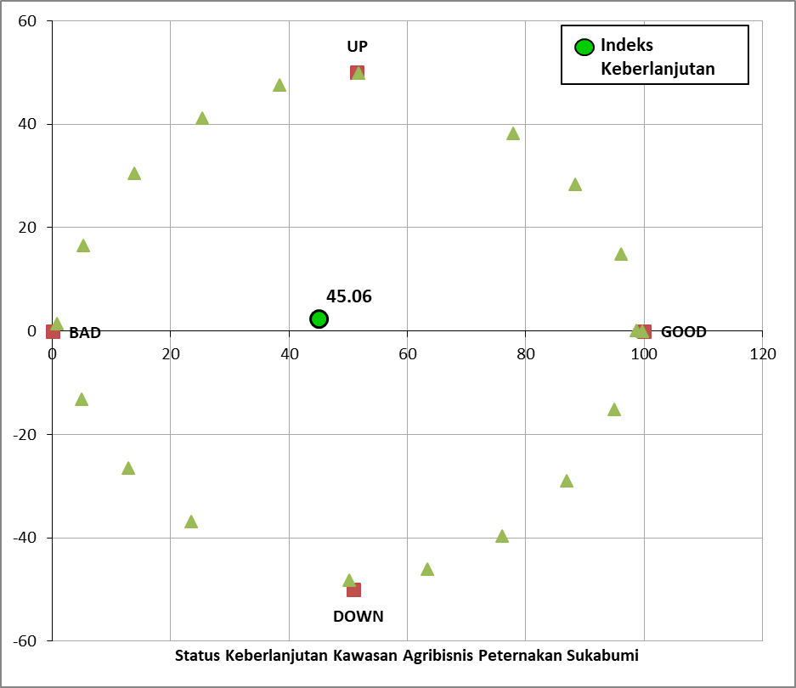

Figure 7. Sustainability Index of Socio-Cultural Dimension of Livestock Agribusiness Area

According to (Hidayanto, M. Supiandi S, 2009) the sosio-cultural sustainability dimensions of smallholder cocoa plantations attained an index value of 75.20, imply that sustainability dimensions may vary across regions and the sensitive attributes is empowering civilization. In the other hand there are two sensitive attributes in the socio-cultural dimension, namely business alternatives other than livestock agribusiness and frequency of counseling and training Alternative businesses other than livestock agribusiness are widely available; this is one of the reasons why farmers consider raising beef cattle in livestock agribusiness areas as a side business. Their main livelihood is paddy and upland rice farming in addition to growing secondary crops. This is because the entire area used as a livestock agribusiness has a temperate climate so that in the dry season it will be difficult to get water to support the farming. Some sub-districts included in the list of livestock agribusiness areas have natural tourism destinations, thus it is quite easy for farmers over there to get additional income from the tourism sector, either as a tourist guide, food and beverage seller, souvenirs seller. The involvement of farmers in sub-districts with tourism destinations provides considerable support for this attribute. Similarly, (Pratama, Aulia Rahman, 2020) reported that the development of production business units constitutes the most sensitive attribute, serving as a leverage factor for the sustainability of the Mandeh tourism area in West Sumatra Province.

Extension and training in the livestock sector are quite difficult because extension officers are not evenly available in each sub-district. This situation is one of the reasons why meetings between groups and livestock extension officers seem to have never taken place. The situation of extension officers who deal more with small ruminants such as sheep and goats will make beef cattle owners hardly feel that they get beef cattle farming technology from extension officers. Thus, it is very reasonable that if the frequency of extension and training attributes becomes a program priority, it will be a high leverage for the sustainability status of the livestock agribusiness area. The complete leverage analysis results on the socio-cultural dimension of the livestock agribusiness area are shown in Figure 8.

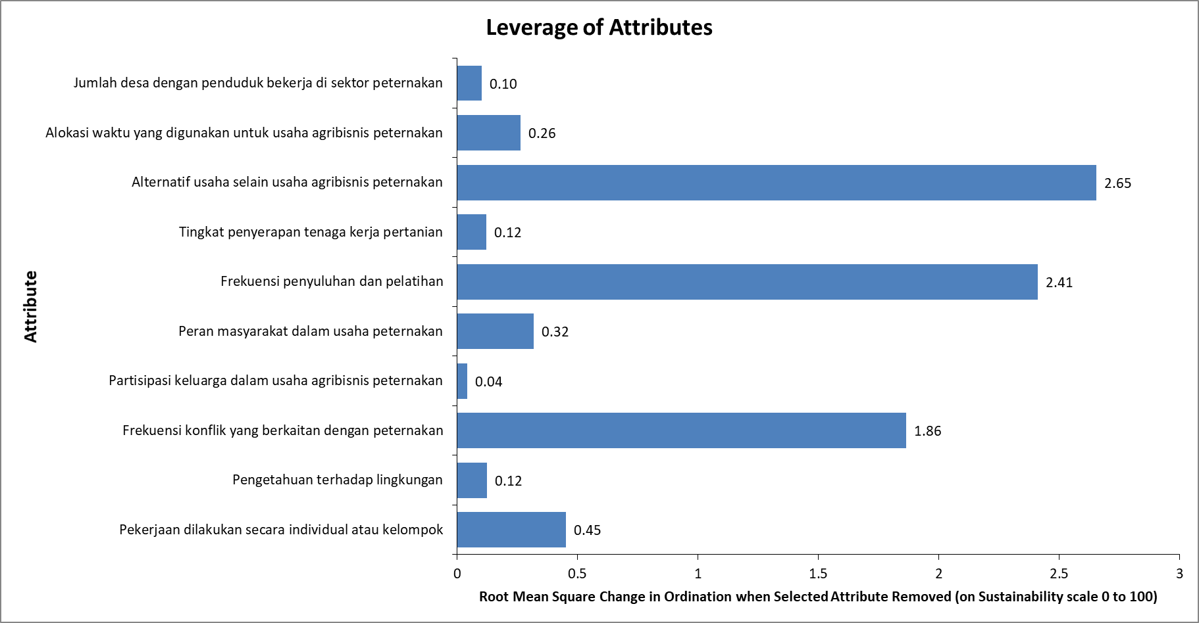

Figure 8. Leverage Analysis Results of Sociocultural Dimension of Livestock Agribusiness Area

**Sustainability Status of Technology and Infrastructure Dimension**

The results of the analysis of the sustainability index of the technology and infrastructure dimension show a figure of 34.71, which means it is categorized as a less sustainable status. Leverage analysis was conducted to determine the presence of sensitive attributes in the technology and infrastructure dimensions. The results of the analysis show attributes that are sensitive to the sustainability of the technology and infrastructure dimension are (1) livestock waste processing technology/livestock agro-industry, (2) livestock product processing technology, and (3) food technology. The overall results of the leverage analysis can be seen in Figure 9.

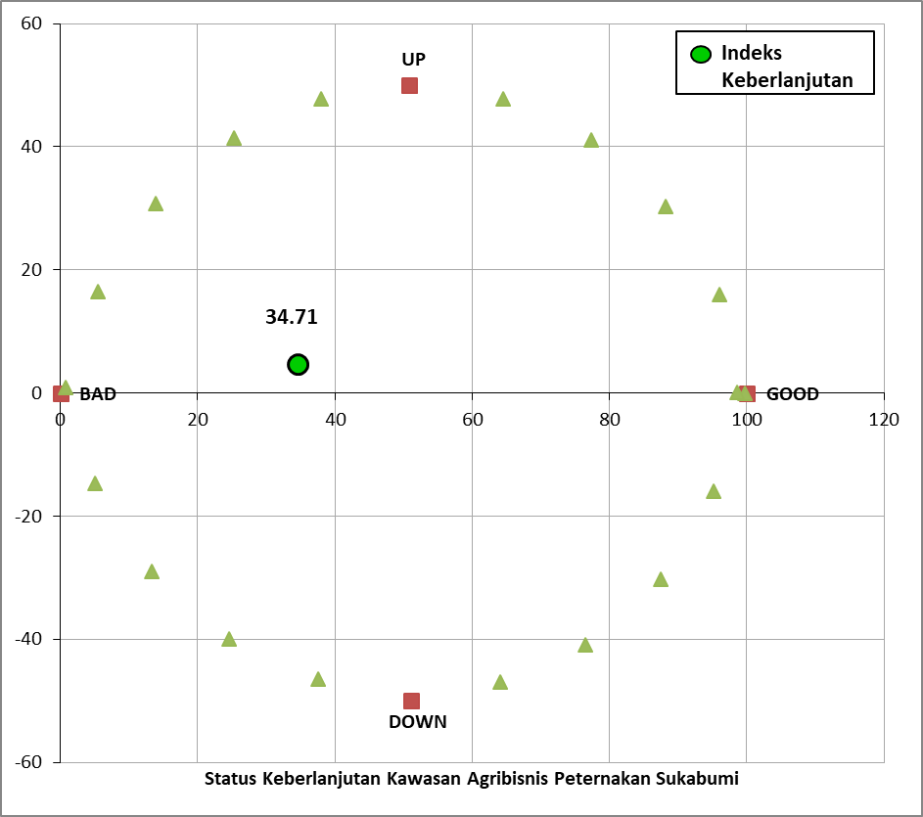

Figure 9. Sustainability Index of Technology and Infrastructure Dimension of Livestock Agribusiness Area

Attributes that are sensitive to influence the sustainability index value of the technology and infrastructure dimensions are (1) livestock/agro-industry waste processing technology that is still not well developed. According (Huda, 2017) that cattle manure can have a relatively high economic value when waste processing is carried out using technology."Livestock waste produced is used as organic fertilizer, but it is only done by some farmers who keep their cows in pens. Meanwhile, farmers who raise cows on pasture or free range during the day do not utilize their livestock waste. This will become one of the elements of environmental pollution where the manure waste produced is not collected in a special place which can decrease the health level of the surrounding population due to poor sanitation and unhealthy environment. Therefore, socialization and extension on livestock waste management and its utilization for organic fertilizer as well as cleaning/sanitation methods that can increase the knowledge of farmers and the community in general are needed. (2) Processing technology for livestock products that is not well developed. The processing technology used is still very simple and only to meet small-scale needs. This is very natural considering that livestock products are almost entirely sold alive and taken out of the livestock agribusiness area. Socialization and training are needed so that the technology of processing livestock products is more developed and able to meet the demands, at least for animal protein. (3) Feed technology on an industrial scale does not yet exist in the livestock agribusiness area; therefore, a helping hand is needed from the government and private sector to be able to utilize a lot of agricultural waste such as rice straw, corn straw, cassava peels, tofu filter cake, and soybean filter cake. The need for concentrate that is currently quite difficult to obtain is also one of the obstacles to the development of livestock so that their growth is not optimal. In addition to meeting the needs of animal feed, the feed industry can also absorb labor and have a positive economic impact on people's welfare.

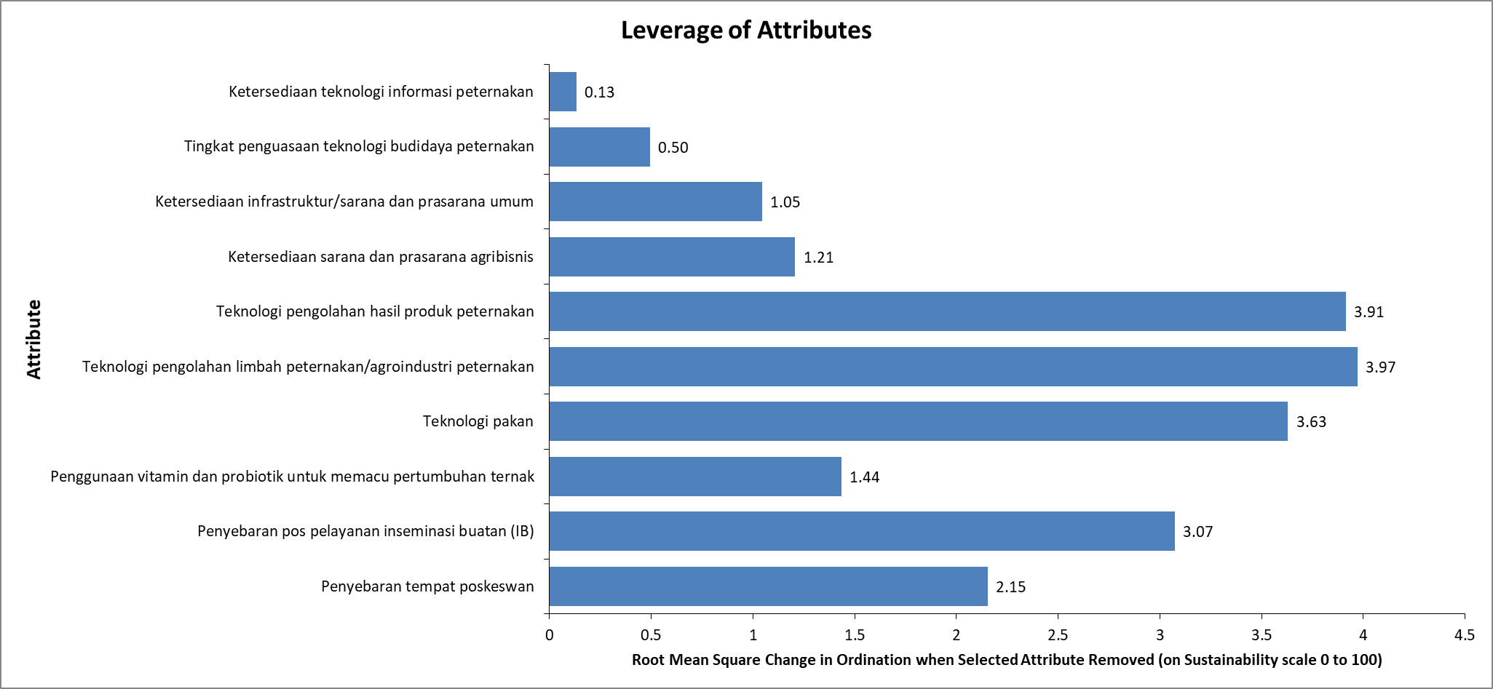

Figure 10. Leverage Analysis Results of Technology and Infrastructure Dimensions of Livestock Agribusiness areas

**Sustainability Status of Legal and Institutional Dimension**

The sustainability index value of the Rapfish analysis results in the legal and institutional dimension is 32.63, which indicates a less sustainable status (Figure 11). There needs to be a helping hand from the policy side, especially for the government of Sukabumi Regency to give attention and priority in the form of assistance, optimizing the role of extension workers for beef cattle farming, and training for processing livestock commodity products so that they are not taken out and disappear from the Sukabumi Regency area.

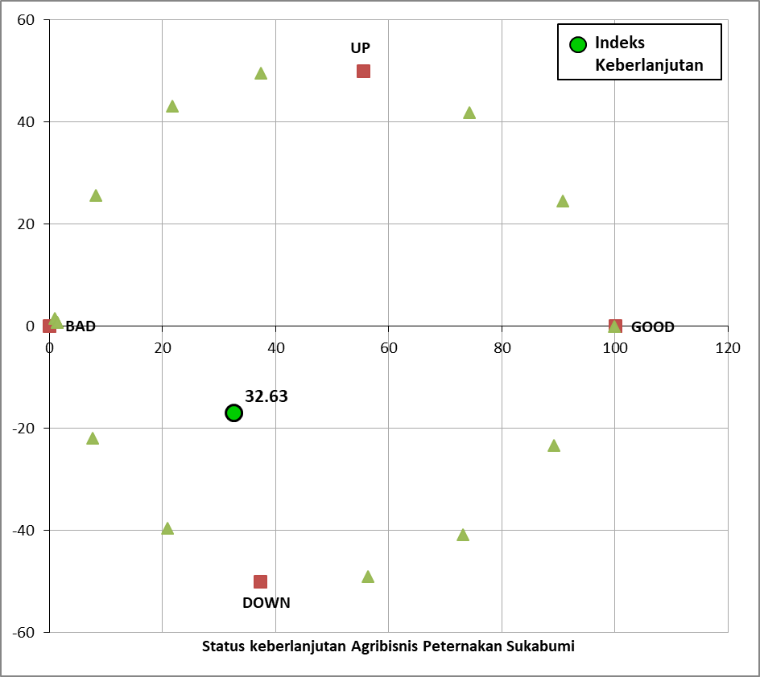

Figure 11. Sustainability Index of Legal and Institutional Dimensions of Livestock Agribusiness Area

Based on the results of the leverage analysis, three attributes that are sensitive to the value of the sustainability index were obtained, namely (1) Synchronization of central and regional policies, (2) availability of social institutions, and (3) livestock farmer groups.

An attribute sensitive to the legal and institutional dimensions and influences the sustainability index value is the synchronization of central and regional policies, where the central policy is outlined in Minister of Agriculture Regulation No. 50 of 2012 concerning guidelines for the development of agricultural areas. Development of the area can be done by four approaches, including the agribusiness system approach.

The agribusiness system approach is carried out through a comprehensive and integrated approach. Comprehensive means through an agribusiness system, all subsystems can be used as part of the system, thus it needs to be planned in an integrated manner as well. Planning needs to be done starting from the provision of production inputs to the marketing of products produced by farmers so that the effectiveness and efficiency of livestock product development can be achieved properly. The development of superior commodity areas include upstream agribusiness subsystems and consist of aspects of production input procurement, labor supply, and land/pens availability. The cultivation agribusiness subsystem consists of commodity production processes. The downstream agribusiness subsystem consists of aspects of marketing, price information, and commodity processing. The supporting agribusiness subsystem includes aspects of counseling and access to capital. In addition, the agribusiness approach is also oriented towards farm profits so that efficiency in the use of production inputs and production optimization is required. Not only that, the agribusiness system approach also requires the integration of agricultural stakeholders consisting of businesses, communities, and governments.

An attribute that is also sensitive to the value of the sustainability index in the legal and institutional dimensions is the availability of social institutions. Social institutions play an important role in providing knowledge and improving the skills of farmers. Unfortunately, there are currently no social institutions in the livestock agribusiness area related to beef cattle farming, even though the existence of these social institutions is very much needed. Social institutions that are formed can become partners of livestock extension workers whose numbers are still inadequate compared to the number of beef cattle farmers in the area. However, it is understandable if the community of livestock farmers do not feel the importance of social institutions since beef cattle management is only a side business.

Livestock groups are another attribute that is also quite sensitive to the sustainability index of the legal and institutional dimensions. The existence of livestock groups cannot be separated from the role of agricultural extension institutions (BPP). BPP as an extension institution is available in every sub-district, but the number of livestock extension officers, especially on beef cattle, is not proportional to the number of beef cattle farmers throughout Sukabumi Regency. This condition has an impact on the uneven number of livestock groups, especially beef cattle in livestock agribusiness areas. However, the findings of (Marhesa, Robi Hari, Luchman Hakim, 2022) in analyzing the sustainability of Ngargoretno tourism village in Magelang indicate that the presence of groups or communities capable of management serves as a leverage factor in enhancing the sustainability index of regional development. However, if the activities of livestock extension officers can be increased, especially in the frequency of extension, for example, for sensitive attributes in the socio-cultural dimension that can be synergized, it will be a lever to increase the sustainability index value of the legal and institutional dimensions. The results of the leverage analysis showing sensitive attributes can be seen in Figure 12.

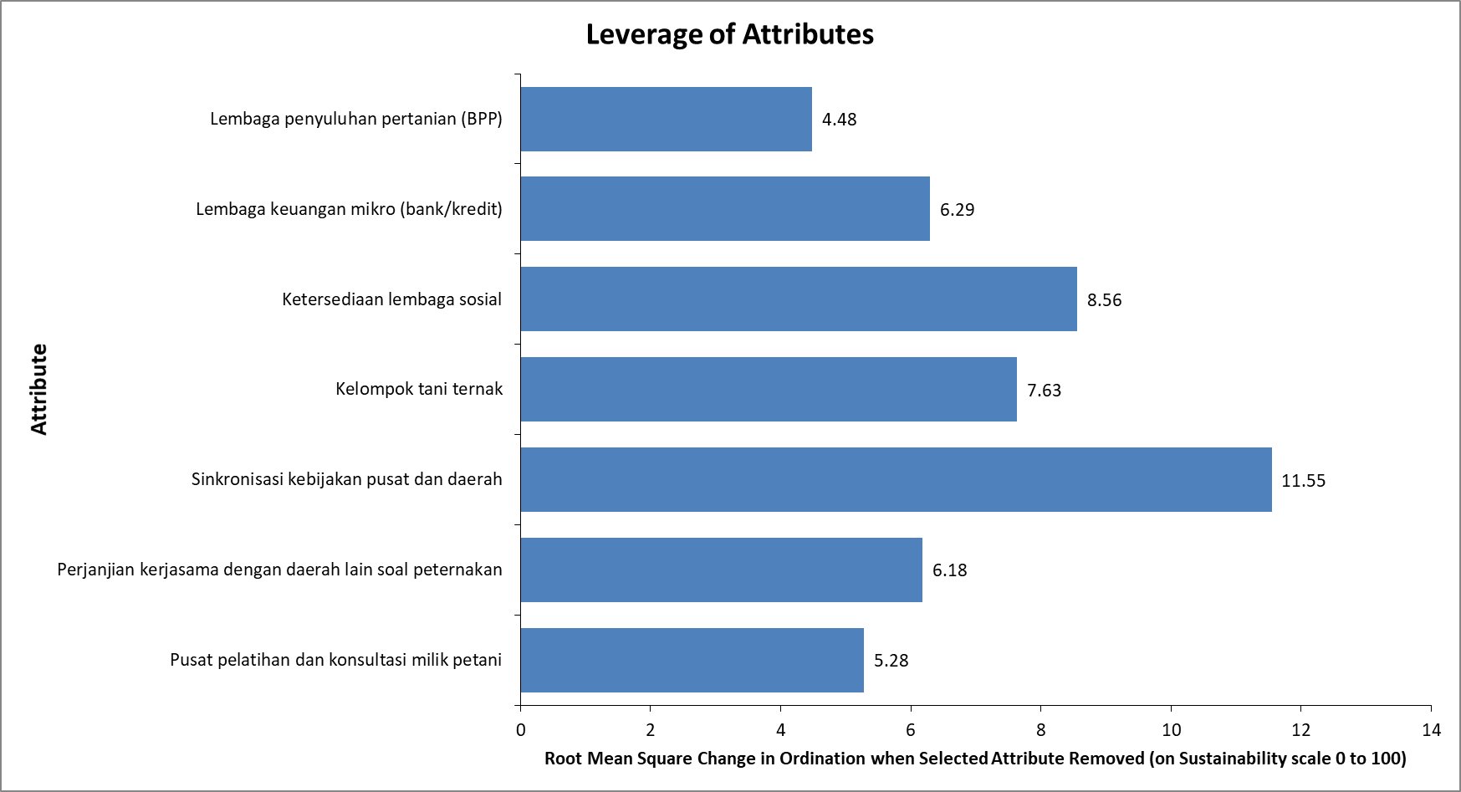

Figure 12. Results of Leverage Analysis of Legal and Institutional Dimensions in Livestock Agribusiness Areas

**Multidimensional Sustainability Status**

The results of the multidimensional analysis of the sustainability of the livestock agribusiness area of Sukabumi Regency obtained a sustainability index value of 34.92 with deficient/less sustainable criteria (Figure 13). The sustainability of areas with lower values indicates that certain processes have not yet been optimized. Meanwhile, the findings of (Khusna, Asmaul, Heny Kuswati Daryanto, 2016) suggest that in Bondowoso Regency, the development of beef cattle agribusiness requires integration among agribusiness subsystems as a primary priority for improvement. This value was obtained based on the assessment of 54 attributes from five dimensions of sustainability, namely the ecological dimension, economic dimension, socio-cultural dimension, technology and infrastructure dimension, and legal and institutional dimension. Meanwhile, as a comparison, the study by (Suyitman et al., 2009) reported that the calculation of livestock-based agropolitan areas in Situbondo Regency indicated a low level of sustainability

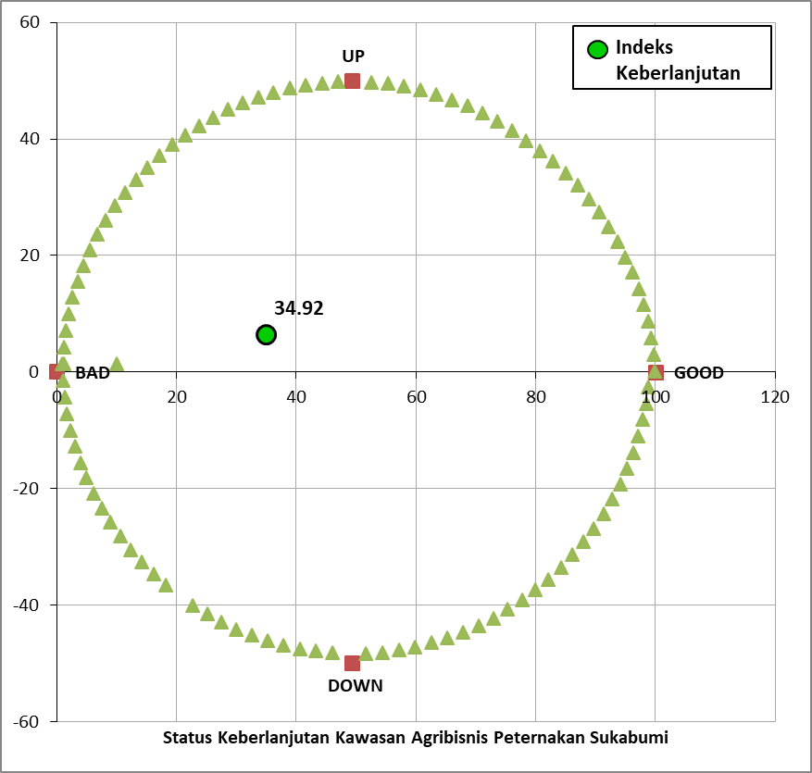

Figure 13. Multidimensional Sustainability Index Values in Livestock Agribusiness Areas

The results of the Monte Carlo analysis show that the sustainability index value of the agricultural agribusiness area at the 95% confidence level shows results that are not different from the results of the Rap-farm (MDS) analysis. This means that errors in the analysis can be minimized in terms of scoring each attribute, scoring variations, and data analysis processes carried out repeatedly stable. The difference in the sustainability index values of MDS and Monte Carlo analysis can be seen in Table 2.

Table 2. The Difference in Sustainability Index Values between Monte Carlo Analysis and Rap-farm Analysis

Sustainability Dimensions MDS Monte The Difference

Carlo

Ecology 52,77 51,85 0,92

Economy 25,17 27,20 2,03

Socio-cultural 45,06 45,25 0,19

Technology and infrastructure 34,71 35,03 0,32

Legal and Institutional 32,63 33,32 0,69

Multidimensional 34,92 35,61 0,69

The results of the Rapfish analysis show that all attributes studied on the sustainability status of the livestock agribusiness areas are accurate enough to provide good and accountable analysis results. This can be seen from the stress value which ranges from 13% to 15% and the coefficient of determination (R2) obtained ranges between 0.94 and 0.96. This is consistent with the findings of (Saragih, Ida Kurnia, Dwi Rachmina, 2020), which indicate that an S-stress value of less than 0.25 in each dimension or in the multidimensional analysis demonstrates that all attributes meet the criteria. Statistically, this can be used to explain the sustainability of livestock agribusiness areas. The stress value and coefficient of determination can be seen in Table 3.

Table 3. Rap-farm Analysis Results for Stress Value and Coefficient of Determination

Parameter Sustainability Dimension

Ecology Economy Socio- Technology Law & Multi dimensi

Culture & infrastruktur institutional

Stress 0,13 0,13 0,15 0,14 0,14 0,13

R2 0,95 0,95 0,95 0,95 0,94 0,96

Iteration 2 2 3 2 3 2

4. Conclusion AND SUGGESTION

Conclusion

Based on the results of the analysis of sustainability index values, the ecological dimension has a moderate sustainability status and the economic dimension has a bad/poor sustainability status. Meanwhile, the socio-cultural dimension, the technology and infrastructure dimension, and the legal and institutional dimension have a less sustainable status. Multidimensionally, the livestock agribusiness area is in a less sustainable status with 13 attributes that are sensitive to influence the improvement of sustainability index. These attributes are 3 attributes of the ecological dimension, 2 attributes of the economic dimension, 2 attributes of the socio-cultural dimension, 3 attributes of the technology and infrastructure dimension, and 3 attributes of the legal and institutional dimensions. These sensitive attributes are the key factors to make the livestock agribusiness area sustainable so that improvements and priorities need to be made to increase the sustainability index value.

**Suggestions**

The priority of increasing the sustainability index in the livestock agribusiness area is carried out through programs that are planned and implemented on attributes that are sensitive to increasing the sustainability index.

COMPETING INTERESTS DISCLAIMER:

Authors have declared that they have no known competing financial interests OR non-financial interests OR personal relationships that could have appeared to influence the work reported in this paper.

Disclaimer (Artificial intelligence)

Option 1:

Author(s) hereby declare that NO generative AI technologies such as Large Language Models (ChatGPT, COPILOT, etc.) and text-to-image generators have been used during the writing or editing of this manuscript.

Option 2:

Author(s) hereby declare that generative AI technologies such as Large Language Models, etc. have been used during the writing or editing of manuscripts. This explanation will include the name, version, model, and source of the generative AI technology and as well as all input prompts provided to the generative AI technology

Details of the AI usage are given below:

1.

2.

3.

References

Alder, J., Zeller, D., & Pitcher, T. (2000). Method for Evaluating Marine Protected Area Management. Fisheries Centre, University of British Columbia, Vancouver, Canada. *Coastal Management*, *30*, 121–131.

Amam, H. P. (2020). Permasalahan Utama Usaha Ternak Sapi Potong di Tingkat Peternak dengan Pendekatan Vilfredo Pareto Analysis. *Prosiding Seminar Nasional TPV*. https://doi.org/http://dx.doi.org/10.14334/Pros.Semnas.TPV-2019-p.241-250

Ardhani, F. (2009). Prospek analisa usaha penggemukan sapi potong di Kalimantan Timur ditinjau dari sosial ekonomi. *JEPP*, *3*, 21–30.

BPS. (2017). *Kabupaten Sukabumi dalam Angka*. BPS Kabupaten Sukabumi. sukabumikab.bps.go.id/id/publication/2017/08/11/1a2410e17b16e8209db31c1b/kabupaten-sukabumi-dalam-angka-2017.html

BPS. (2020). *Kabupaten Sukabumi dalam angka Tahun 2020*. https://sukabumikab.bps.go.id/publication/2020 /04/27/41135c1ab6fed195f7af76bf/kabupaten-sukabumi-dalam-angka-2020.html,

Devendra, C., & Burns, M. (1994). *Produksi Kambing di daerah Tropis*. Institut Pertanian Bogor Press.

Devendra, C., & Sevilla, C. (2002). Availability and use of feed resources in crop-animal systems in Asia. *Agric Syst*, *71*, 59–73.

Fauzi, A. (2019). *Teknik analisis Berkelanjutan*. PT. Gramedia.

Fauzi, A., & Anna, S. (2002). Evaluasi status berkelanjutan pembangunan perikanan, aplikasi RAPFISH, Studi Kasus Perairan Pesisir DKI Jakarta. *Jurnal Pesisir Dan Lautan*, *4*, 43–55.

Guntoro, S. (2002). *Membudidayakan Sapi Bali*. Kanisius.

Haloho, R. D. (2020). Analisis usaha penggemukan sapi potong dengan menggunakan paradigma agribisnis di Kecamatan Binjai Barat Kota Binjai Provinsi Sumatera Utara. *Agrimor Jurnal Agribisnis Lahan Kering*, *5*, 17–19.

Hidayanto, M. Supiandi S, S. Y. dan L. I. A. (2009). Analisis Keberlanjutan Perkebunan Kakao Rakyat di Kawasan Perbatasan Pulau Sebatik Kabupaten Nunukan Provinsi Kalimantan Timur. *Jurnal Agro Ekonomi*, *27*, 213–229.

Huda, S. wikanta. (2017). Pemanfaatan Limbah kotoran sapi menjadi pupuk organik sebagai upaya mendukung usaha peternakan sapi potong di kelompoktani Ternak Mandiri Jaya Desa Moropelang Kecamatan Babat Kabupaten Lamongan. *Aksiologiya*, *1*, 26–35.

Indrayani, I., Nurmalina, R., & Fariyanti, A. (2012). Analisis efisiensi teknis usaha penggemukan sapi potong di Kabupaten Agam Provinsi Sumatera Barat. *Jurnal Peternakan Indonesia*, *14*, 286–296.

Juanda, B. (2009). *Metodologi Penelitian Ekonomi dan Bisnis*. IPB Press.

Kavanagh, P. (2004). Implementing Microsoft Excel software for Rapfish : a technique for the rapid appraisal of fisheries status. Fisheries Centre, University of British Columbia. Vancouver, BC, Canada. 12(2) https://open.library.ubc.ca/soa/cIRcle/collections/facultyresearchandpublications/52383/items/1.0074801

Khusna, Asmaul, Heny Kuswati Daryanto, M. P. D. U. (2016). Pengembangan Strategi Agribisnis Sapi Potong di Kabupaten Bondowoso. *Jurnal Ilmu Pertanian Indonesia*, *21*, 69–75.

Mansyur, T., Dhalika, & Islami, R. (2012). Implementasi strategi dan teknologi kecukupan pakan sepanjang tahun untuk penyembangan peternakan sapi perah di Desa Sukawargi dan Cidatar Kecamatan Cisurupan Kabupaten Garut. *Dharmakarya: Jurnal Aplikasi Ipteks Untuk Masyarakat*, *1*, 64–73.

Marhesa, Robi Hari, Luchman Hakim, E. P. (2022). Analisis Keberlanjutan desa wisata ngargoretno kecamatan Salaman Kabupaten Magelang. *Jurnal Tata Kota Dan Daerah*, *14*, 25–33.

Mukhlisi, I.B, Hendrarto,&Purweni, H. (2014). Keberlanjutan Pengelolaan Hutan MAngrove di Desa Sidodadi Kecamatan PAdang Cermin Kabupaten Pesawaran Provinsi Lampung. *Jurnal Geografi*, *01*, 58–70.

Nuhung, I. A. (2015). Kinerja, Kendala, dan Strategi Pencapaian Swasembada daging Sapi,. *Forum Penelitian Agro Ekonomi*, *33* no *1*, 63–80.

Perda No 22 Tahun 2012 Tentang RTRW Kabupaten Sukabumi 2012-2032 (2012). https://peraturan.bpk.go.id/Details/170736/perda-kab-sukabumi-no-22-tahun-2012

Pitcher, TJ. and Preikshot, D. (2001). RAP-FISH: a rapid appraisal technique to evaluate the sustainability status of fisheries. *Fisheries Research*, *49*, 255–270.

Pratama, Aulia Rahman, I. U. (2020). Analisis Keberlanjutan Kawasan Wisata Mandeh Provinsi Sumatera Barat. *Jurnal Buana*, *4*, 484–502.

Putri, BRT, Suparta IN, Sudano IB, O. I. (2014). Strategy of Business Management ang Agribusiness System of Bali Cattle Breeding to improve Farmers Income. *Journal of Animal Science*, *3*, 1–7.

Ramadhan, D. R., Nindyantoro, N., & Suyitman, S. (2014). Status Keberlanjutan Wilayah Peternakan Sapi Potong untuk Pengembangan Kawasan Agropolitan di Kabupaten Bondowoso. *Jurnal Peternakan Indonesia (Indonesian Journal of Animal Science)*, *16*(2), 78. https://doi.org/10.25077/jpi.16.2.78-88.2014

Saragih, Ida Kurnia, Dwi Rachmina, B. K. (2020). Analisis Status Keberlanjutan Perkebunan kelapa Sawit Rakyat Provinsi Jambi. *Jurnal Agribisnis Indonesia*, *8*, 17–32.

Saragih, B. (2001). Kumpulan Pemikiran Agribisnis Paradigma baru Pembangunan ekonomi berbasis pertanian. In *Kumpulan Pemikiran Agribisnis Paradigma baru Pembangunan ekonomi berbasis pertanian*. Pustaka Wirausaha muda. PT. Loji Grafika Griya Sarana.

Sarma, P. (2014). An Agribusiness Development Approach of Beef Cattle In Selected Areas of Bangladesh. *Journal of the Bangladesh Agricultural University*, *12*, 351–358.

Sarmila, I., & Mulatsih, S. (2013). *Peran Investasi di Sektor Peternakan terhadap Pendapatan dan Penyerapan Tenaga Kerja*. Institut Pertanian Bogor.

Susilo, S. (2003). *Keberlanjutan Pembangunan Pulau Pulau kecil; Studi kasus Kelurahan Pulau Panggang dan Pulau Pari Kepulauan Seribu DKI Jakarta*. IPB University.

Suyitman, S. H. S., Herison, C., & Muladno. (2009). Status keberlanjutan wilayah berbasis peternakan di Kabupaten Situbondo untuk pengembangan kawasan agropolitan. *Jurnal Agro Ekonomi*, *27*.

Umela, Syaiful ; dan Bulontio, N. (2016). Daya Dukung Jerami Jagung Sebagai PAkan Ternak Sapi Potong. *Jurnal Technopreneur*, *4*, 64–72.