Original Research Article

Application of moving target detection in landslide warning based on OpenCV

Abstract
In recent years, with advances in computer vision, vision-based approaches for real-time landslide monitoring and early warning have become a research focus. Building on OpenCV-Python, this study evaluates three representative moving-object detection algorithms—frame differencing, background subtraction, and optical flow. Centering on key characteristics such as tracking the number of rock fragments before and after a landslide and performance in complex environments, we construct an experimental comparison framework using landslide video sequences to systematically assess each algorithm’s adaptability, accuracy, and practical deployment potential in early-warning scenarios. The results show that frame differencing achieves the fastest response and relatively high detection accuracy, making it suitable for rapid warnings in high-risk areas, though it risks missed detections in cluttered backgrounds; background subtraction is more sensitive to small deformations and is appropriate for applications that require monitoring the detailed evolution of landslides; and although optical flow can characterize motion trajectories and is useful for trend analysis, its detection accuracy is limited under complex backgrounds. Finally, this paper proposes a scheme that works together based on the respective advantages of the frame difference method, background subtraction method, and optical flow method. This work examines the applicability of multiple moving-object detection methods to landslide early warning and aims to inform technology selection and optimization for real-time geological-hazard monitoring systems.

Keywords: OpenCV-Python; Landslide warning; Frame differencing method; Background subtraction method; Optical flow method;

- INTRODUCTION

China is among the countries most frequently affected by geological hazards. According to statistics from the Ministry of Ecology and Environment^{[1]}, between 2015 and 2024 (Fig. 1) an average of 6,226 geological disasters occurred annually, with the number reaching as high as 9,710 in 2016, posing serious threats to lives, property, and regional development. In recent years, as public safety awareness has increased, many high-risk areas have gradually adopted engineering measures—such as retaining walls, pile–anchor supports, and spillway tunnels—to reduce the risks of landslides and rockfalls. Although such measures have lowered incident frequency to some extent, the combined influences of extreme climate, topography and geomorphology, and human activities mean that China still exhibits a high incidence of geological disasters. Landslides and rockfalls are the two most frequent types; in particular, landslides—owing to their sudden onset and destructive power—remain a central focus of research and prevention efforts in China.
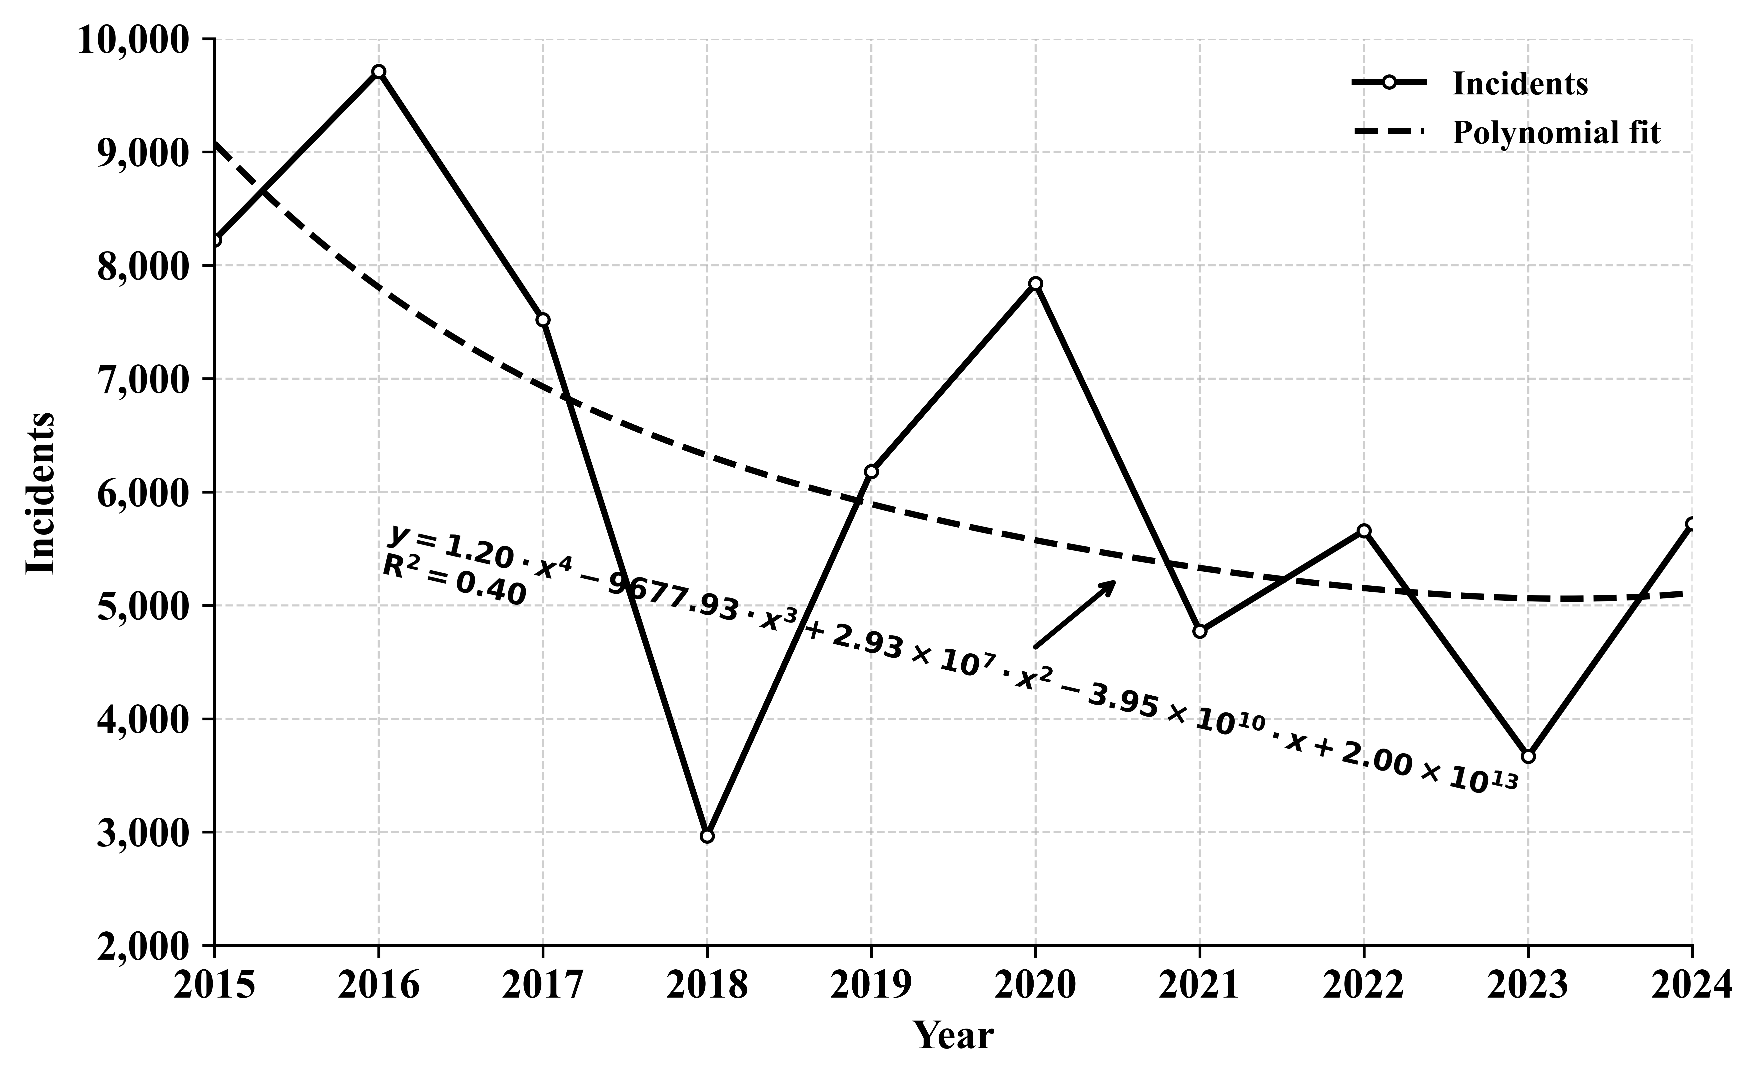
Fig. 1. The number of geological disasters in recent ten years (China from 2015 to 2024)

At present, research on landslides mainly focuses on identifying landslides using map information or simulating them with numerical simulation software, For example, Coline Hopquin et al. ^{[2]} by using satellite remote sensing technology, it was revealed that the movement speed of a slowly moving landslide on Reunion Island is directly related to rainfall and extreme climate events such as cyclones, and the effectiveness and practicality of remote sensing technology in such monitoring were proved. Mohamed Kouah et al. ^{[3]} Through multidisciplinary data and numerical simulation, the evolution process of a large deep paleolandslide in the Normandy region of France was reconstructed, and its possible triggering conditions and mechanisms were determined to better assess the risk of similar large landslides occurring in this area in the future. Therefore, based on the risk of landslides and the extensive integration of computer technology and landslides by many scholars, this paper applies OpenCV to landslides, which has certain research value.
As a critical component of landslide-disaster management, early warning has traditionally relied on surface-deformation monitoring, rainfall-threshold criteria, and analyses of remote-sensing imagery. While these approaches offer advantages for large-scale trend identification, they are comparatively weak in real-time performance and dynamic responsiveness. With the rapid development of computer vision, deep-learning models based on intelligent recognition and dynamic detection have opened new avenues for precisely capturing landslide precursors. In recent monitoring practice, deep-learning object-detection methods (e.g., the YOLO family) have become prominent due to their high accuracy and adaptability. For example, M. Upendra et al. ^{[4]} develops an automated bird repellent system that utilizes the YOLOv8 computer vision algorithm on a Raspberry Pi to detect birds in agricultural fields and repel them by playing distress calls, thereby reducing crop damage without human intervention; Naveen Chandra et al. ^{[5]}proposed a YOLOv5-based approach enhanced with CBAM and ECA modules for satellite-image landslide detection, achieving an accuracy of up to 77%. However, YOLO-based methods typically require large annotated datasets and pretrained models, place high demands on computing resources and deployment environments, and are constrained in real-time responsiveness—limitations that make it difficult to meet high-frequency monitoring and low-latency engineering requirements.
OpenCV is an open-source computer vision and machine learning library that provides a rich set of tools for image processing and object recognition, and is widely used in intelligent surveillance, medical image analysis, and traffic-scene understanding^{[6]}. Compared with YOLO-series models, traditional vision algorithms available in OpenCV—such as frame differencing, background subtraction, and optical flow—offer advantages of simpler structure, lower computational cost, and weaker dependence on hardware resources. They can run efficiently on lightweight devices or in edge-computing environments, making them suitable for rapid response in high-risk landslide zones. Although these methods may incur detection errors under complex backgrounds and target occlusions, they still deliver strong responsiveness and practical applicability in scenarios such as sudden rockfall and slope-body deformation.
Accordingly, this paper selects three representative methods—frame differencing, background subtraction, and optical flow—and uses key features such as falling rock blocks and changes to landslide boundaries as analysis variables to systematically evaluate their detection accuracy, processing efficiency, and practical suitability in landslide early-warning scenarios. In addition, by leveraging OpenCV’s timing functions (cv2.getTickCount/cv2.getTickFrequency) and frame-handling mechanism (cv2.CAP_PROP_POS_FRAMES), we objectively compare the performance of each algorithm under identical input conditions. This study aims to explore the application potential of multiple motion-detection approaches in landslide early warning, providing theoretical grounding and engineering reference for real-time geological-disaster monitoring based on video imagery. In our experiments, we extract the same number of frames across sequences to enable a fair comparison of the three methods’ early-warning effectiveness and computational performance, thereby facilitating subsequent in-depth research.

2 BASIC METHODS
2.1 Grayscale
A standard 24-bit image adopts the RGB color model composed of red (R), green (G), and blue (B) channels, with pixel values in each channel ranging from 0 to 255. In landslide image processing, reducing a three-channel (color) image to a single-channel (grayscale) image has no material impact on target identification and can improve subsequent computational efficiency. Accordingly, to lower image complexity, the RGB values are converted to a single-channel gray level by computing a weighted sum of the R, G, and B components. A commonly used weighting is:
$$\begin{aligned}Gray=0.299∙R+0.587∙G+0.114∙B\#\#\left(1\right)\end{aligned}$$
where $R$, $G$, and $B$ denote the pixel values of the red, green, and blue channels, respectively.
This method preserves the image’s principal luminance characteristics while effectively reducing redundant information, and is one of the standard techniques used during preprocessing. In practice, OpenCV provides the cv2.cvtColor() function to perform conversions among RGB, grayscale, HSV, and other color spaces, thereby streamlining the grayscale conversion process.

2.2 Binarization
Image binarization is a fundamental preprocessing technique that assigns each pixel in a grayscale image to one of two classes—white (pixel value 255) or black (pixel value 0)—based on a fixed threshold, thereby enhancing contrast between target regions and background. In landslide image processing, binarization helps highlight change regions, improves target recognition accuracy, and provides a sound basis for subsequent contour extraction, area measurement, and dynamic-change analysis. OpenCV implements fixed-threshold binarization via the cv2.threshold() function, whose principle can be expressed as:
$$\begin{aligned}S_{n}\left(x,y\right)=\left\{\begin{aligned}255,P_{n}\left(x,y\right)≥T \\ 0,P_{n}\left(x,y\right)<T\end{aligned}\right.\#\#\left(2\right)\end{aligned}$$
where $S_{n}\left(x,y\right)$ is the binarized pixel value, $P_{n}\left(x,y\right)$ is the original grayscale pixel value at coordinate $\left(x,y\right)$, and $T$ is the threshold, often set to 127 or adaptively determined from the image distribution.
As shown in Fig. 2, the grayscale image produced by the frame-differencing method (Fig. 2(a)) becomes more distinct after binarization (Fig. 2(b)): target-edge contours are clearer and image layering is more pronounced, which facilitates segmentation of the landslide region and subsequent computations.
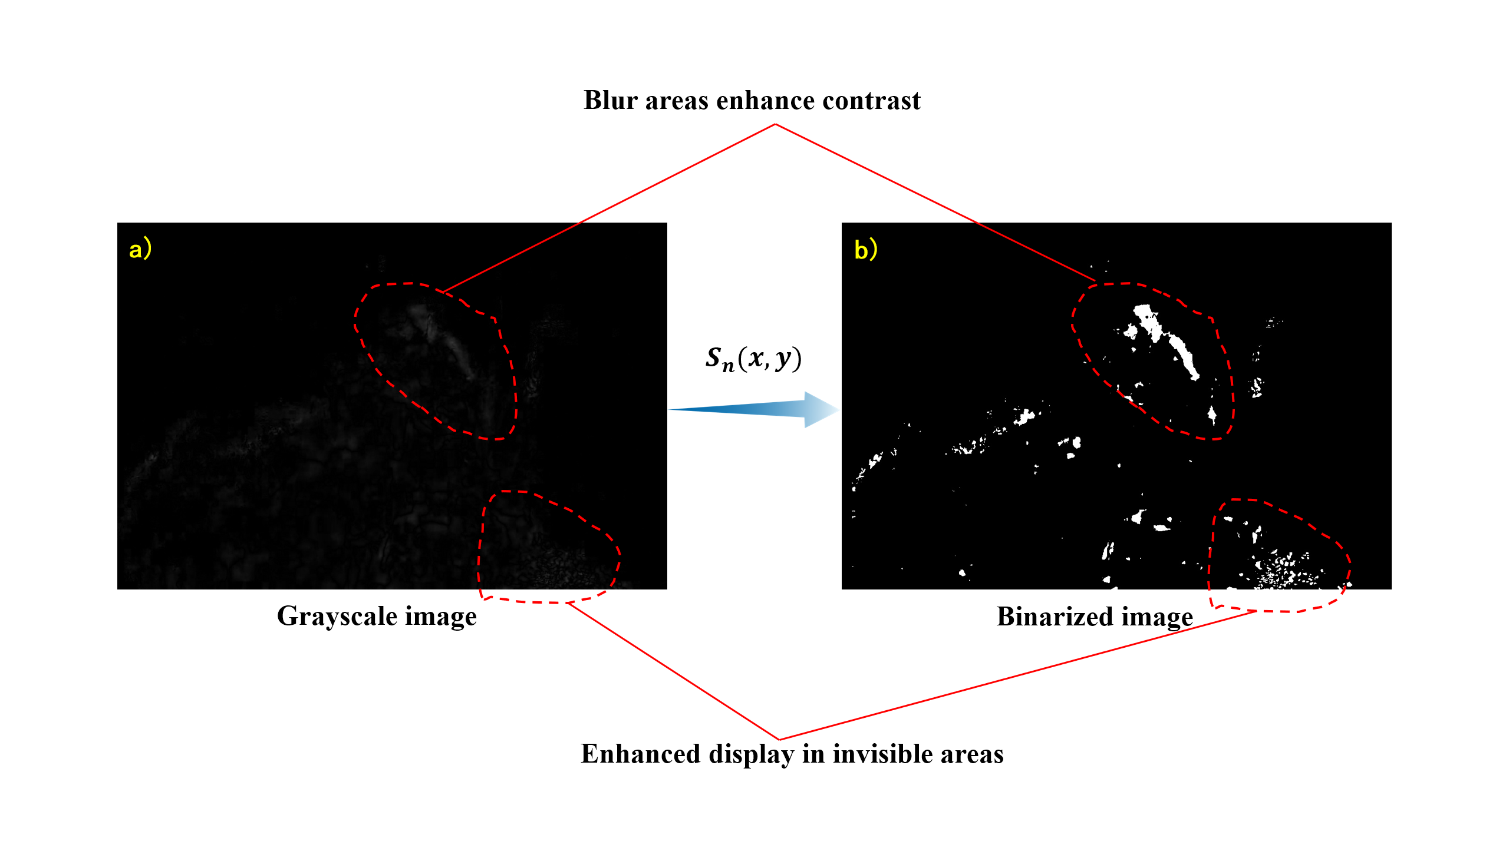
Fig. 2. Comparison between binary and grayscale images: a) Grayscale image obtained using the frame differencing method; b) Resulting binary image converted from the grayscale image.

2.3 Gaussian
During landslide video monitoring, image data may be contaminated by noise arising from factors such as camera aging, sensor heating, and insufficient ambient illumination. Such noise can hinder the recognition of falling rocks and thereby reduce detection accuracy. Gaussian filtering is a linear smoothing algorithm based on the normal distribution and is widely used for denoising and preprocessing. The core idea is to construct a two-dimensional Gaussian convolution kernel and apply a weighted average to each pixel and its neighborhood to suppress high-frequency noise. The Gaussian kernel is defined by the two-dimensional normal distribution:
$$\begin{aligned}G(x,y)=\frac{1}{2πσ^{2}}e^{-\frac{x^{2}+y^{2}}{2σ^{2}}}\#\#\left(3\right)\end{aligned}$$
Where $G(x,y)$ is the Gaussian value at location $(x,y)$, $σ$ is the standard deviation, and $x$ and $y$ are the horizontal and vertical pixel coordinates, respectively.
For example, with a 5×5 Gaussian kernel and $σ=1.5$ the weight of each kernel element is computed from Eq. (3), then normalized and used for image convolution. The filtering process at a specific pixel is illustrated in Fig. 3.

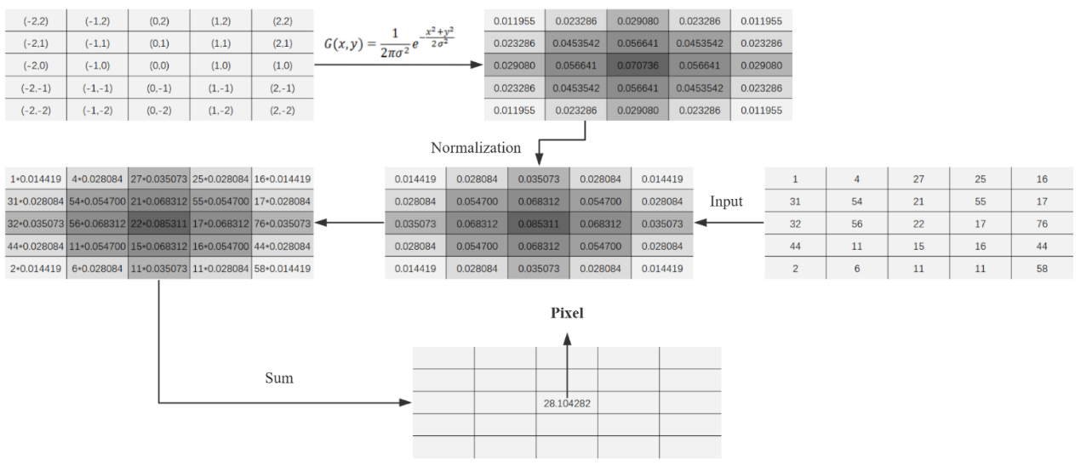
Fig.3. Schematic diagram of Gaussian filter (5*5)

OpenCV provides the cv2.GaussianBlur() function to perform Gaussian filtering and return the smoothed image. Users can specify the kernel size (commonly 3×3 or 5×5) and the value of 𝜎 σ to control the degree of smoothing. In general, larger kernels increase blurring and can more effectively suppress high-frequency noise. As shown in Fig. 4, applying Gaussian filtering prior to binarization (Fig. 4d) yields better smoothness and noise suppression than direct binarization without filtering (Fig. 4c): small spurious speckles are reduced or eliminated, facilitating subsequent region selection and comparison among the three methods. It should be noted, however, that an excessively large kernel may over-smooth the edges of small rock fragments in the landslide area, leading to loss of target information and reduced detection accuracy.
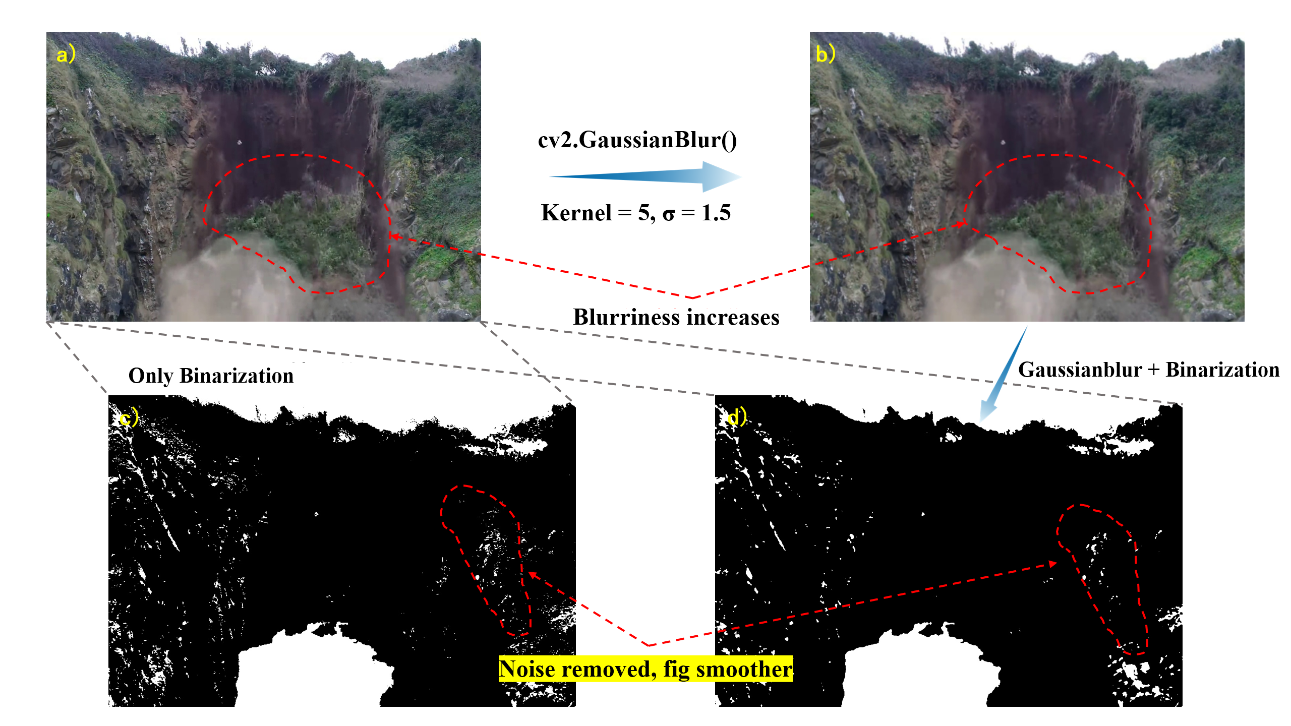
Fig. 4. Comparison of results with and without Gaussian filtering (a) Original image without Gaussian filter; (b) Gaussian filtered result (5×5 kernel); (c) Direct binarization without filtering; (d) Binarization after Gaussian filtering

2.4 Erode and dilate
Erosion operates by sliding a structuring element over the image and applying a pixelwise logical “AND” within the region covered by the structuring element. When the structuring element fully matches the underlying image region, the output pixel is set to 255 (white); Otherwise it is set to 0 (black). In this way, erosion shrinks object boundaries and removes small spurious speckles^{[7]}. It is commonly used to eliminate tiny isolated points and to thin target edges. In contrast, dilation follows a logical “OR” rule, expanding target regions and extending boundaries; this enhances contour prominence and improves detectability. As illustrated in Fig. 5, taking erosion as an example with a rectangular structuring element of size 3×3, the operation proceeds as schematized.
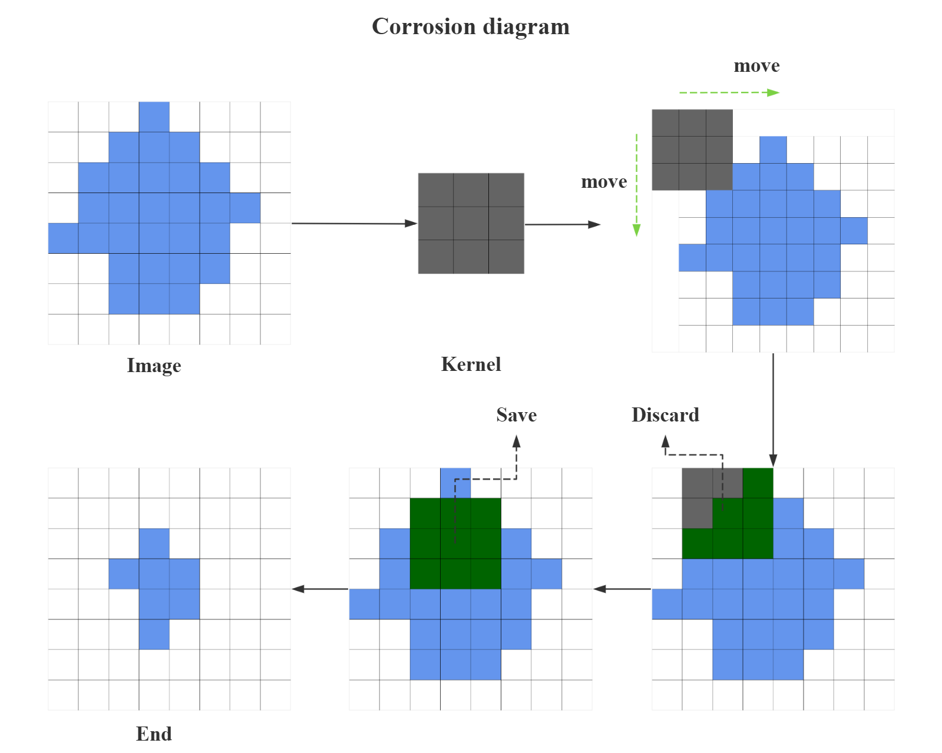
Fig. 5. Corrosion diagram

In OpenCV, the functions cv2.erode() and cv2.dilate() implement erosion and dilation, respectively, and are widely used for noise suppression and boundary refinement. As shown in Fig. 6, erosion can markedly attenuate bright regions in a binary image (Fig. 6b), effectively removing small regions and edge artifacts—useful in practice for reducing false responses caused by dust or slight disturbances. Dilation, by contrast, enlarges target regions (Fig. 6c) and improves boundary continuity, but in noise-dense settings may cause adjacent regions to merge, degrading spatial separability. To balance denoising with boundary preservation, an “opening” operation—erosion followed by dilation (Fig. 6d)—is often employed in landslide video analysis to suppress background noise and isolated pixels, thereby improving recognition accuracy for moving rock blocks.
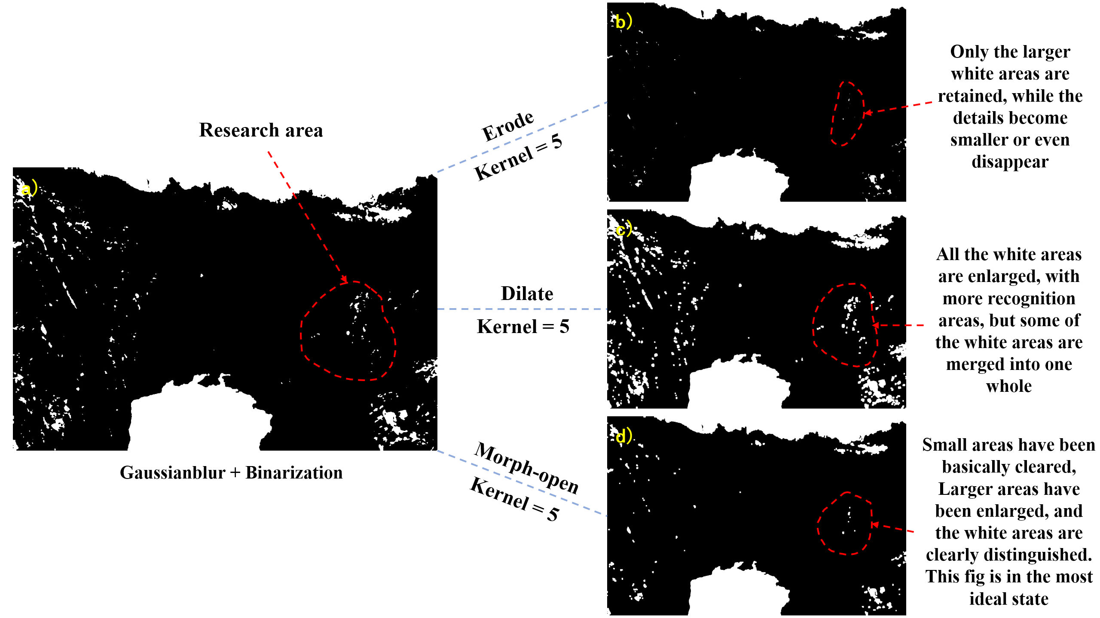
Fig. 6. Results of morphological operations applied to binarized image: (a) Binarized image after Gaussian filtering; (b) Erosion result of (a); (c) Dilation result of (a); (d) Opening result of (a)

2.5 Summary
The aforementioned four types of methods serve as the foundation before performing frame differencing, background subtraction, and optical flow methods. Continuously adjusting parameters to achieve optimal performance helps facilitate direct effectiveness and performance comparisons among various methods.

3. MAIN METHODS AND RESULTS
3.1 Frame Differencing Method
Frame differencing is a common method for identifying motion regions by computing grayscale changes between adjacent video frames. It offers simple implementation, low computational cost, and rapid response, and has been widely applied in real-time monitoring scenarios such as home security and intelligent transportation. In recent years, many scholars have improved and extended frame differencing. For example, Fanguo Zeng et al. ^{[8]} developed an automated method for detecting abnormal respiratory behavior (ARB) in calves using an improved YOLOv5 model with a squeeze-and-excitation (SE) module and frame differencing (FD) analysis, achieving high accuracy (96.80%) in identifying bovine respiratory disease symptoms via support vector machine (SVM) classification; Wenhan Du et al.^{[9]} proposed a motion-object edge-information extraction method based on an improved Canny algorithm that enables accurate extraction of moving-object boundaries. Given frame differencing’s strong motion sensitivity and efficiency, it can be used in landslide video-sequence analysis to detect dynamic targets such as rockfall and sliding changes triggered by landslides.
The basic principle can be summarized as follows: let the $n$ and $n-1$ frames be$f_{n}\left(x,y\right)$ and $f_{n-1}(x,y)$, respectively; the difference image $P_{n}(x,y)$ is obtained according to Eq. (4).
$$\begin{aligned}P_{n}(x,y)=f_{n}\left(x,y\right)-f_{n-1}(x,y)\#\#\left(4\right)\end{aligned}$$
Here, $f_{n}\left(x,y\right)$ denotes the current frame, $f_{n-1}(x,y)$ the previous frame, and $P_{n}(x,y)$ the resulting difference image.
The difference image is then binarized to highlight significant motion regions. Threshold selection (T) is critical in this process. If T is set too low, background disturbances (e.g., swaying leaves) are liable to be misclassified as sliding targets, producing excessive false positives; if T is set too high, small rock-motion signals during the landslide may be missed. In this experience, T=15 is used, which empirically balances the risks of false alarms and missed detections. The complete workflow for applying frame differencing to landslide video sequences is shown in Fig. 7.
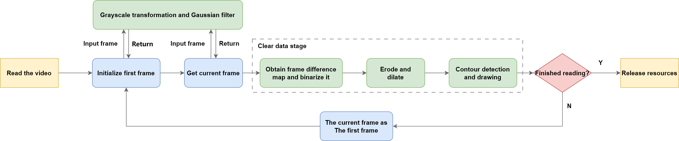
Fig.7. Frame differencing process diagram

As Fig. 7 indicates, the key lies in constructing the inter-frame differencing image to dynamically extract rock-motion features during a landslide. OpenCV’s cv2.absdiff() function computes the pixelwise absolute grayscale difference between two frames to generate the frame-difference map. Using this method, representative frames before and after the landslide were processed to verify the effectiveness of frame differencing in detecting landslide onset and rockfall events; results are shown in Figs. 8 and 9. As shown by the 19–20 frame pairs in Fig. 8, during the initial rockfall stage, frame differencing accurately captures and marks the trajectories of scattered rock fragments; even when rocks shatter into several pieces, the method can localize them individually without losing targets. However, when the landslide enters a phase of intense displacement accompanied by heavy dust occlusion (the 89–90 frame pairs in Fig. 9), detection sensitivity drops markedly: small rock fragments and dust regions are difficult to recognize, leading to missed and false detections and less stable overall performance.
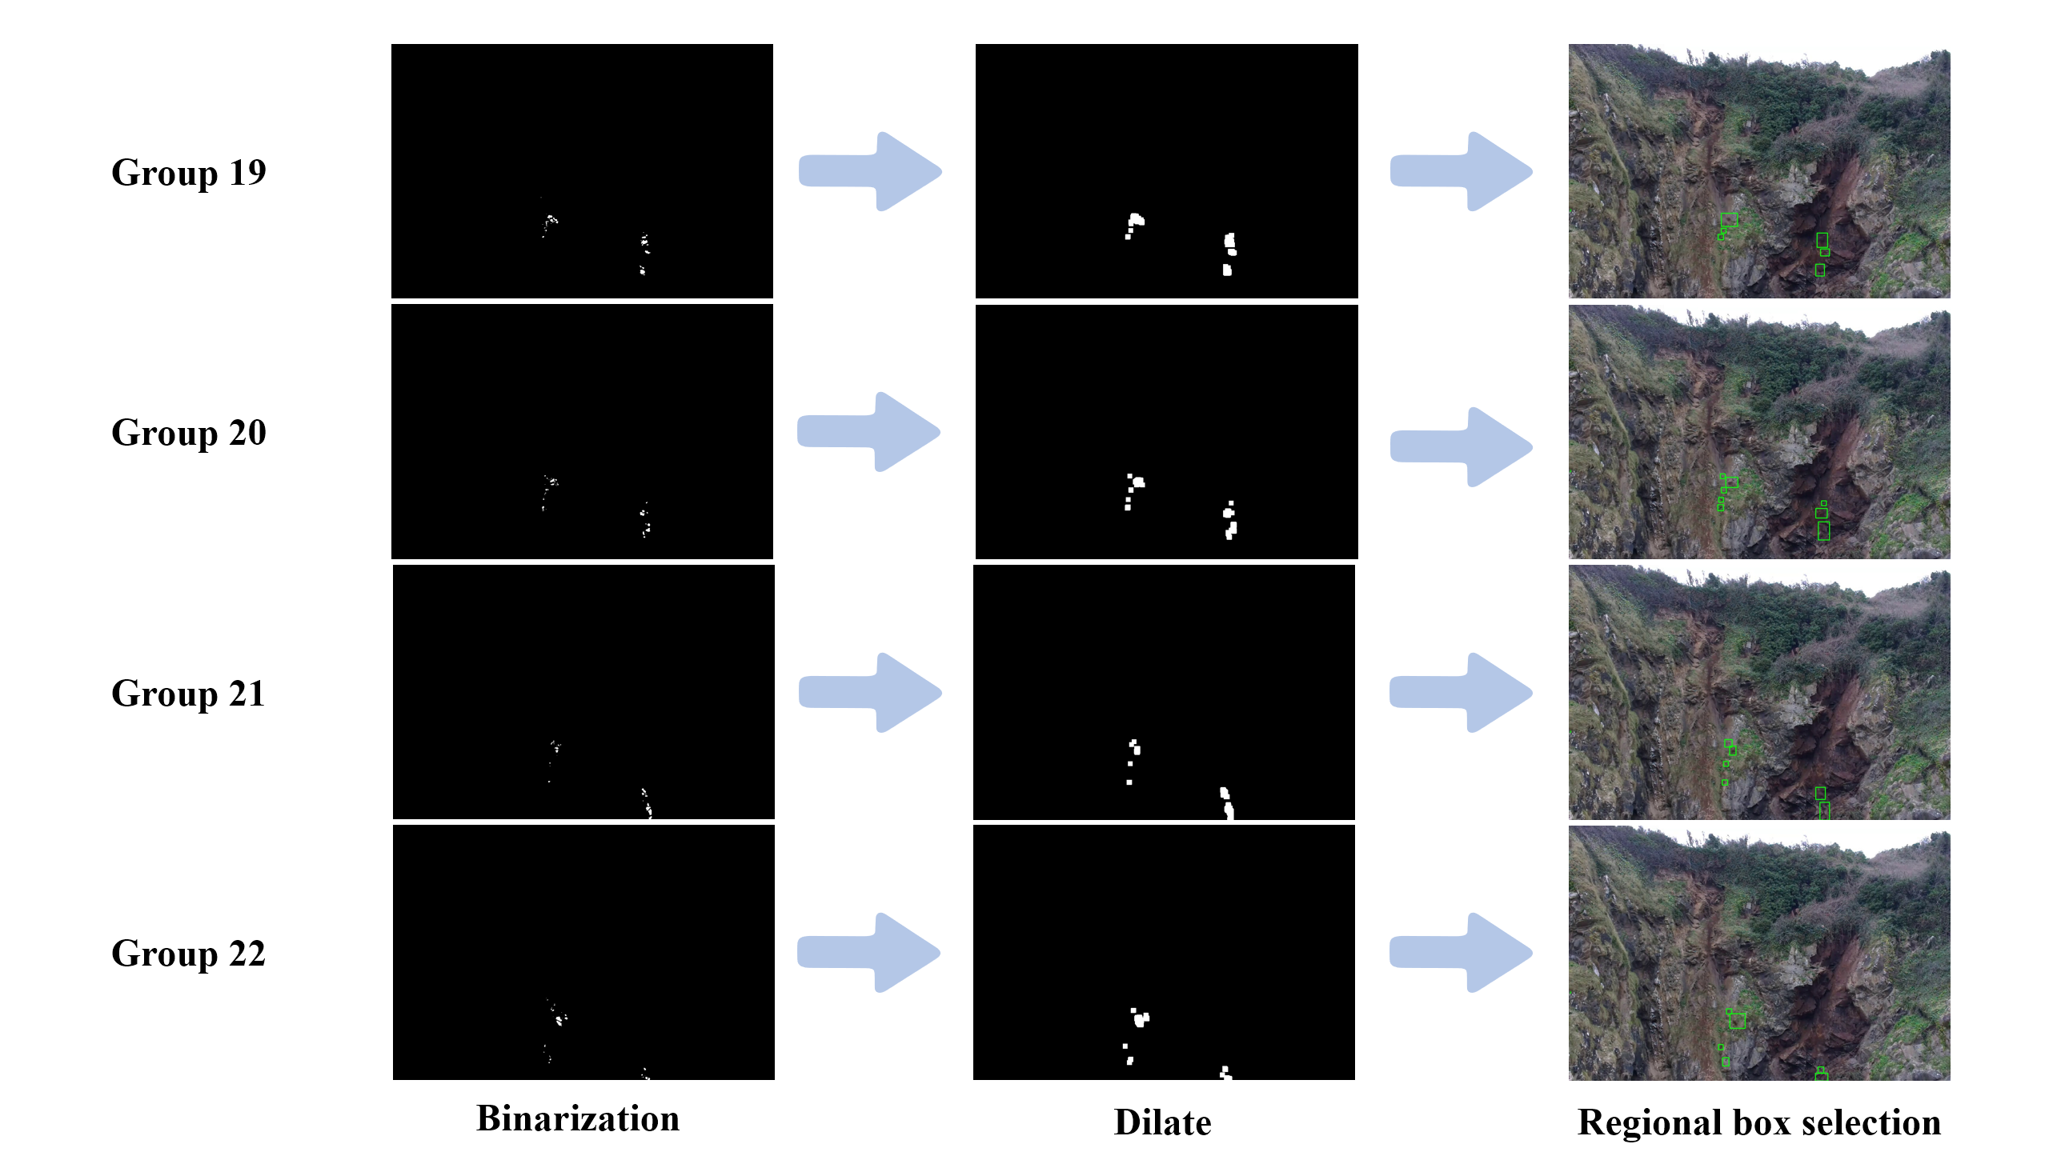
Fig.8. The frame differencing method is used to detect the image on the video sequence（Photos 19 to 22）

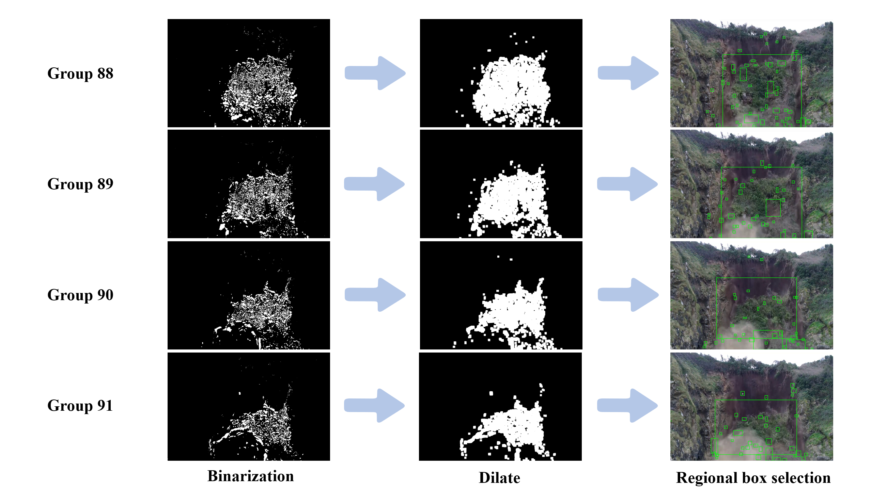
Fig.9. The frame differencing method is used to detect the image on the video sequence（Photos 88 to 91）

Based on these findings, frame differencing performs well for early-stage rock detection and holds promise for early landslide monitoring. Fixed cameras can be deployed to conduct continuous frame-difference analysis over potential sliding areas to enable rapid warnings of incipient micro-movements. Future research may focus on behavior under varying weather and illumination, and on algorithmic improvements or multi-camera collaborative detection to enhance practicality and engineering value in complex landslide scenarios.

3.2 Background Subtraction
Background subtraction identifies moving foreground objects by constructing and continuously updating a background model and comparing each incoming frame against it. Owing to its robustness and environmental adaptability, it has been widely used in domains such as industrial inspection and medical imaging. In recent years, some researchers have moved beyond algorithmic refinements to direct engineering deployments. For example, Campbell et al.^{[10]} used background subtraction to detect bee flight activity, and Yangyang Li^{[11]} developed an early-warning system for small-animal intrusion based on a Gaussian Mixture Model (GMM) background subtractor, further demonstrating the method’s practicality in complex environments.
To improve detection of falling rocks in landslide videos, this study employs a GMM-based background subtraction algorithm. Its core idea is to model each pixel in the video sequence with a mixture of $K$ Gaussian distributions. The value of pixel $j$ at time $t$ follows a mixture distribution, i.e., the probability that the pixel takes value $x_{j,t}$ is
$$\begin{aligned}p\left(x_{j}\right)=\sum_{i=1}^{K}{ω_{i,t}∙η(x_{j,t};μ_{i,t},∑_{i,t})}\#\#\left(5\right)\end{aligned}$$
where $K$ is the number of Gaussian components (a default of $K=5$ is recommended for complex landslide backgrounds), $ω_{i,t}$ is the weight of the $i$ Gaussian at time $t$ and $η$ is the Gaussian probability density function:
$$\begin{aligned}η(x_{j,t};μ_{i,t},∑_{i,t})=\frac{1}{(2π)^{\frac{d}{2}}|∑_{i,t}|^{\frac{1}{2}}}exp⁡[-\frac{1}{2}(x_{j,t})^{T}(∑_{i,t})^{-1}x_{j,t}-μ_{i,t}]\#\#\left(6\right)\end{aligned}$$
with $μ_{i,t}$ and $∑_{i,t}$​ denoting the mean and covariance of the $i$ Gaussian at time $t$, and $d$ the dimensionality of $x$.
When the background changes, each pixel’s GMM must be updated. At time $t$, the current pixel $x_{j,t}$​ is matched against the mixture components via:
$$\begin{aligned}\left|x_{j,t}-μ_{i,t-1}\right|≤2.5σ_{i,t-1}\#\#\left(7\right)\end{aligned}$$
i.e., if the distance to the $i$ component’s mean lies within 2.5 standard deviations, the pixel matches that component. Upon a match, the mean, variance, and weight are updated as
$$\begin{aligned}\left\{\begin{aligned}μ_{i,t}=\left(1-ρ\right)μ_{i,t-1}+ρx_{j,t} \\ σ_{i,t}^{2}=\left(1-ρ\right)σ_{i,t-1}^{2}+ρ(x_{j,t-1}-μ_{i,t-1})^{T}(x_{j,t-1}-μ_{i,t-1}) \\ ω_{i,t}=\left(1-α\right)ω_{i,t-1}+α\end{aligned}\right.\#\#\left(8\right)\end{aligned}$$
Where $α$ is the model learning rate (default 0.002) and $ρ$ is the parameter learning rate, typically，$ρ≈\frac{α}{ω_{i,t}}$. If no component matches, the mean and variance remain unchanged and the weight is updated by
$$\begin{aligned}ω_{i,t}=\left(1-α\right)ω_{i,t-1}\#\#\left(9\right)\end{aligned}$$
If still no component matches $x_{j,t}$ the Gaussian with the smallest weight is discarded and a new component is created, usually initialized with a large variance, small weight, and mean set to $x_{j,t}$.
To classify pixels as foreground or background after parameter updates, the $K$ components are sorted in descending order by $\frac{ω}{σ}$, Let the sorted indices be$i_{1},i_{2}…i_{k}$​. The smallest number $X$ of leading components whose cumulative weight exceeds a threshold $T$ (default 0.7) is chosen as
$$\begin{aligned}X=\arg{\min_{b}(\sum_{i=i_{1}}^{b}{ω_{i,t}>T}})\#\#\left(10\right)\end{aligned}$$
A pixel that matches any of these 𝑋 components is classified as background; otherwise, it is labeled as foreground^{[12]}. OpenCV encapsulates the above model in cv2.createBackgroundSubtractorMOG2(), which constructs a GMM-based background subtractor and exposes an apply method to extract foreground objects from video, greatly simplifying implementation.
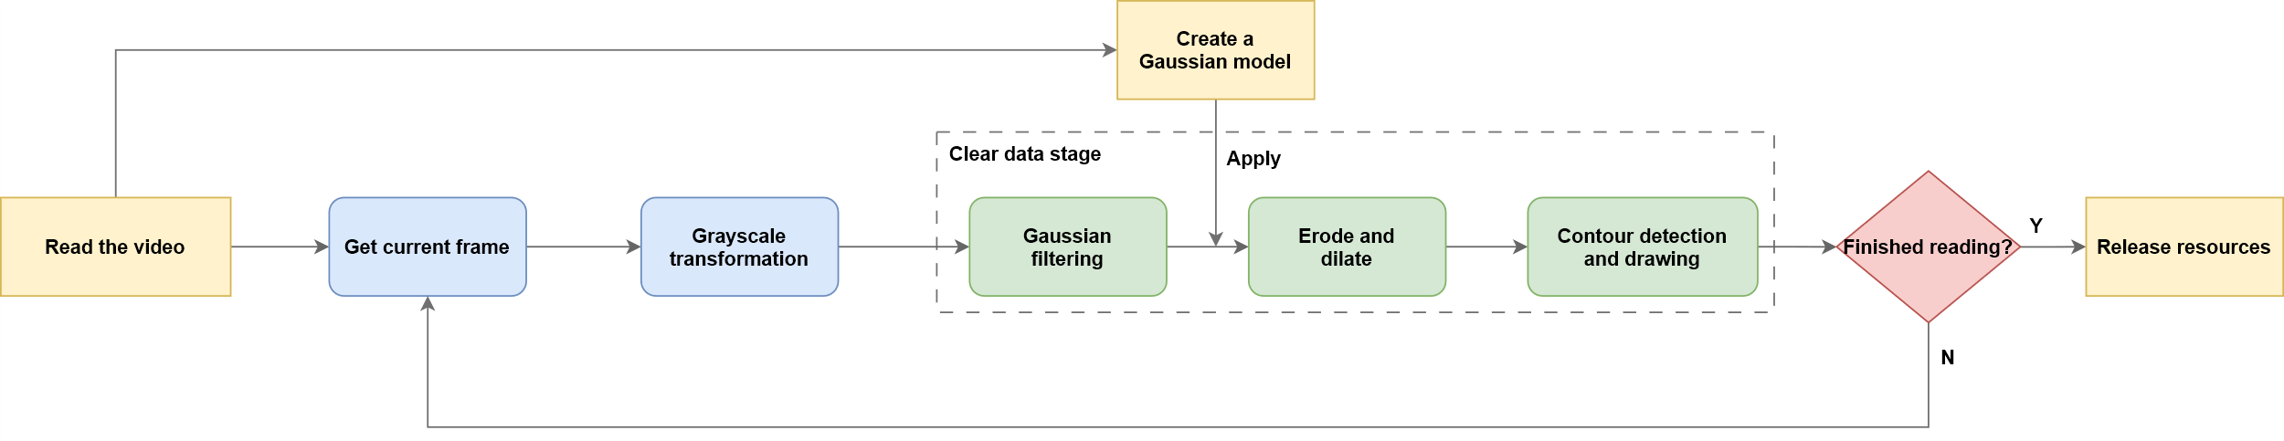
Fig.10. Flowchart of background subtraction method

Applied to landslide video sequences, the full workflow is shown in Fig. 10. For comparison with frame differencing, we use the same erosion and dilation kernels and select the same frame indices; representative results are given in Figs. 11–12.

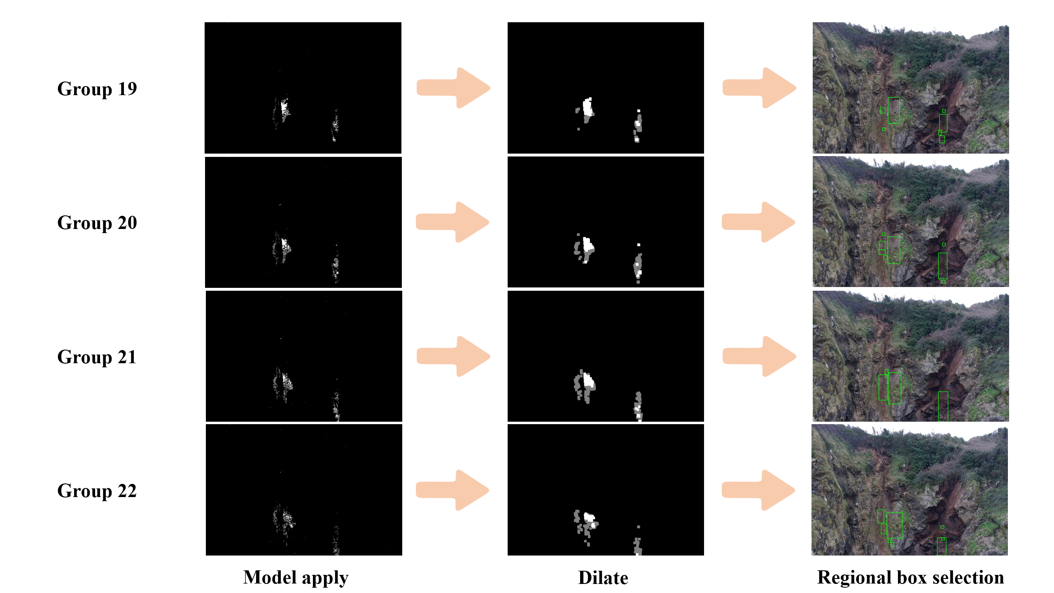
Fig.11. Background subtraction is used to detect images on video sequences（Photos 19 to 22）

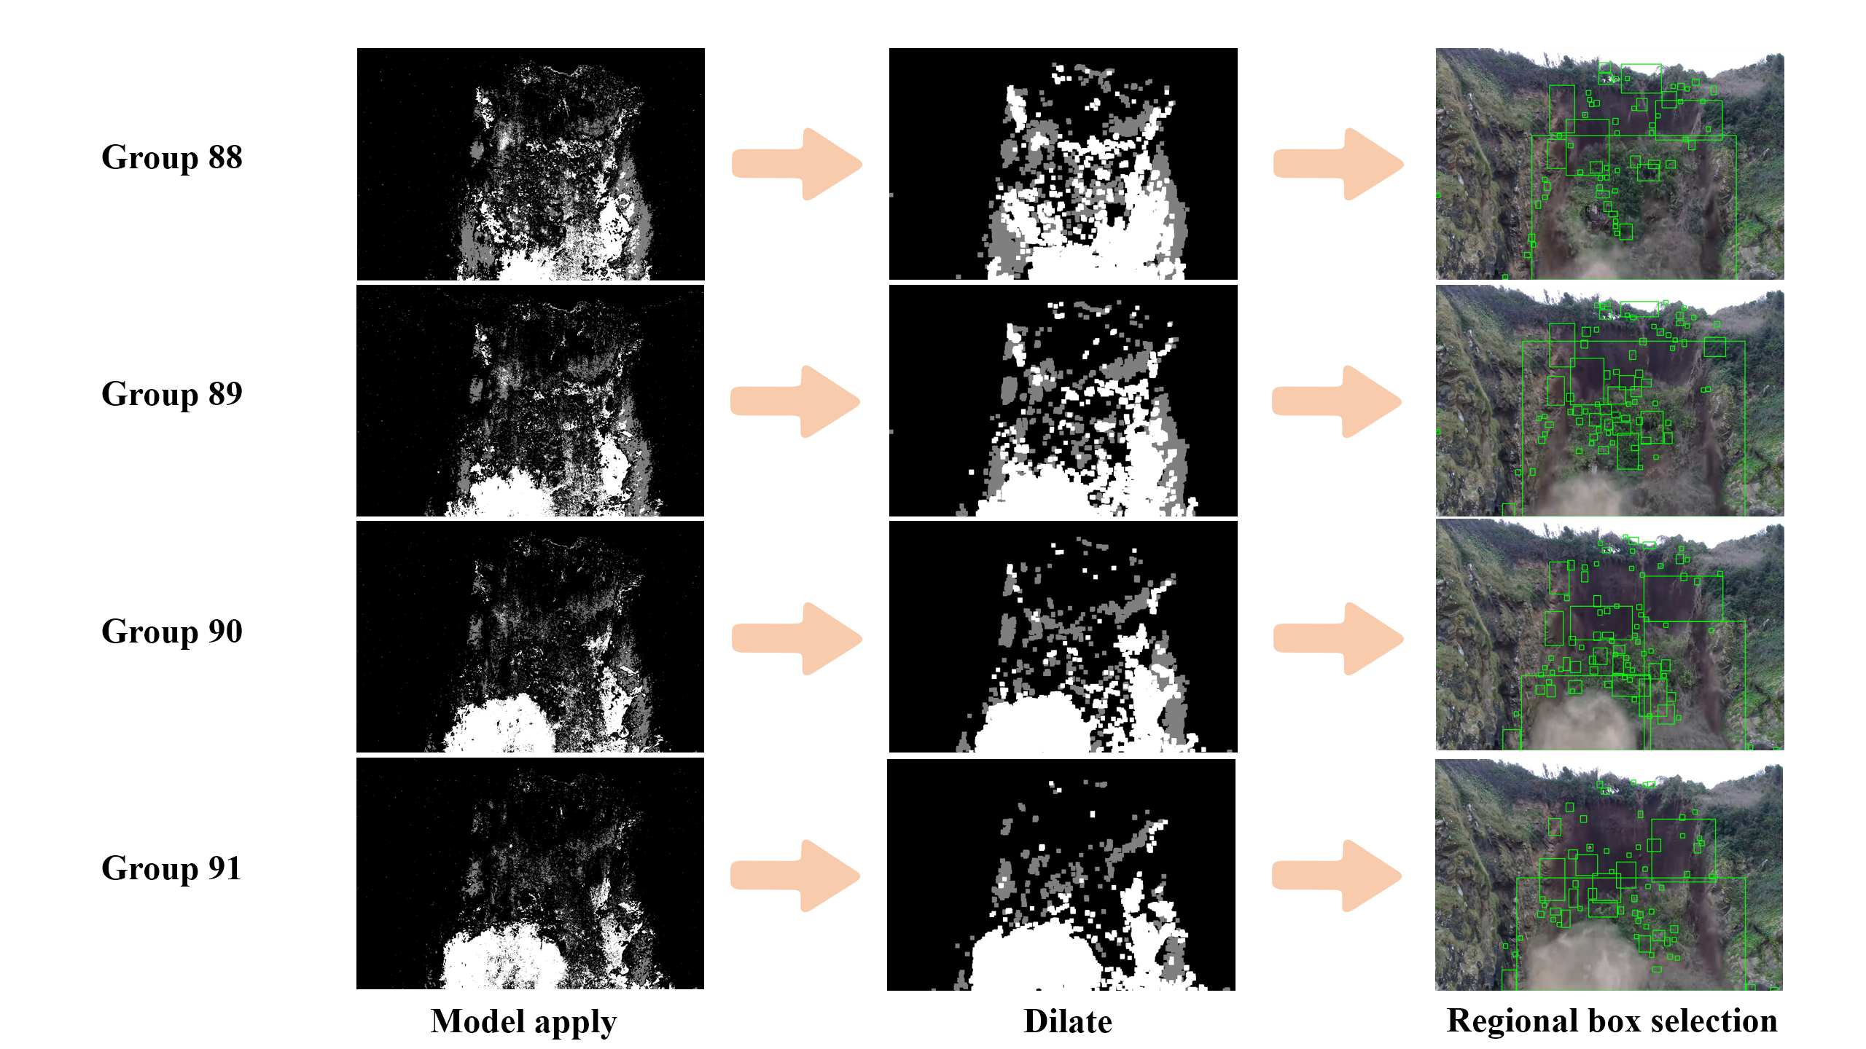
Fig.12. Background subtraction is used to detect images on video sequences（Photos 88 to 91）

As seen in the 20th frame pair of Fig. 11, in early-stage landslides when rock fragments are few, background subtraction may under-segment and merge adjacent rocks into a single target. However, by the 89th frame pair in Fig. 12—during active sliding—this method recognizes rock counts more accurately than frame differencing and remains more stable under complex dynamic backgrounds with dust interference. These observations indicate that background subtraction offers higher robustness and adaptability to drastic scene changes, effectively mitigating environmental disturbances in target detection.
Given these properties, background subtraction is particularly suitable for fine-grained monitoring of rock displacements under complex conditions in landslide early-warning systems. Especially during active sliding, it helps assess hazard severity and provides key evidence for determining the risk of secondary failures, underscoring its strong engineering value.

3.3 Optical Flow
Optical flow is a computer-vision technique that estimates an object’s motion speed and direction in image space from intensity changes across a sequence of video frames. Because of its adaptability and accuracy in motion detection and trajectory tracking, it has attracted considerable attention in recent years and has developed into a relatively mature methodology. For example, Yang Yan et al.^{[13]} proposed a flow-estimation method based on optical flow that demonstrates strong robustness under large displacements and illumination changes. Kim et al.^{[14]} presented an approach that integrates optical-flow techniques with photogrammetry to monitor and analyze rockfall behavior, verifying the method’s potential for geological-hazard assessment and slope-stability monitoring. The optical-flow formulation rests on two basic assumptions: (i) the brightness constancy assumption, which posits that the grayscale value of a given physical point remains unchanged across consecutive frames; and (ii) the motion continuity assumption, which assumes that inter-frame motion is continuous and smooth, with small displacements over unit time. Based on these assumptions, the optical-flow equation is written as
$$\begin{aligned}I(x,y,t)=I(x+dx,y+dy,t+dt)\#\#\left(11\right)\end{aligned}$$
Where $I\left(x,y,t\right)$ is the pixel intensity at $\left(x,y\right)$ and time $t$, $dx$ and $dy$ are the pixel displacements, and $dt$ is the elapsed time. Applying a first-order Taylor expansion to Eq. (11) yields
$$\begin{aligned}I\left(x,y,t\right)=I\left(x,y,t\right)+\frac{∂I}{∂x}dx+\frac{∂I}{∂y}dy+\frac{∂I}{∂t}dt+ε\#\#\left(12\right)\end{aligned}$$
Where the second-order term $ε$ is negligible. Combining Eqs. (11) and (12) and dividing by $dt$ gives
$$\begin{aligned}\frac{∂I}{∂x}\frac{dx}{dt}+\frac{∂I}{∂y}\frac{dy}{dt}+\frac{∂I}{∂t}\frac{dt}{dt}=0\#\#\left(13\right)\end{aligned}$$
Let $\frac{∂I}{∂x}=I_{x}$，$\frac{∂I}{∂y}=I_{y}$，$\frac{∂I}{∂t}=I_{t}$，$\frac{dx}{dt}=u$，$\frac{dy}{dt}=v$. Then
$$\begin{aligned}I_{x}u+I_{y}v+I_{t}=0\#\#\left(14\right)\end{aligned}$$
Where $I_{x}$、$I_{y}$、$I_{t} are obtained from image data and u$, $v$ are the velocity components along $x$ and $y$.
Because Eq. (14) contains two unknowns $(u,v)$ but only one constraint, an additional condition is needed for a unique solution. The Lucas–Kanade (LK) method imposes spatial consistency by assuming that the optical flow is constant within a small neighborhood around the target pixel. Suppose an $m × m$ window contains $n$ pixels and the flow is constant over this window; then
$$\begin{aligned}\left[\begin{aligned}I_{x1} \\ I_{x2} \\ ⋮ \\ I_{xn}\end{aligned} \begin{aligned}I_{y1} \\ I_{y2} \\ ⋮ \\ I_{yn}\end{aligned}\right]\left[\begin{aligned}u \\ v \end{aligned}\right]=\left[\begin{aligned}-I_{t1} \\ -I_{t2} \\ ⋮ \\ -I_{tn}\end{aligned}\right]\#\#\left(15\right)\end{aligned}$$
which we write compactly as
$$\begin{aligned}A\vec{V}=-b\#\#\left(16\right)\end{aligned}$$

by the least-squares criterion,
$$\begin{aligned}A^{T}A\vec{V}=A^{T}(-b)\#\#\left(17\right)\end{aligned}$$
so that
$$\begin{aligned}\vec{V}=(V^{T}A)^{-1}A^{T}(-b)\#\#\left(18\right)\end{aligned}$$
in expanded matrix form,
$$\begin{aligned}\left[\begin{aligned}u \\ v \end{aligned}\right]={\left[\begin{aligned}\sum_{i=1}^{n}{I_{xi}^{2}} \sum_{i=1}^{n}{I_{xi}^{2}} \\ \sum_{i=1}^{n}{I_{xi}I_{yi}} \sum_{i=1}^{n}{I_{yi}^{2}}\end{aligned}\right]}^{-1}\left[\begin{aligned}-\sum_{i=1}^{n}{I_{xi}I_{ti}} \\ -\sum_{i=1}^{n}{I_{yi}I_{ti}}\end{aligned}\right]\#\#\left(19\right)\end{aligned}$$
The resulting $\vec{V}=[u v]^{T}$ is the LK optical flow^{[15]}. OpenCV provides cv2.calcOpticalFlowPyrLK() to compute optical flow under the LK model, returning the coordinates of the tracked points in the current frame, a status flag array, and a per-point tracking error.
Compared with frame differencing and background subtraction, optical flow requires a more elaborate pipeline—feature detection, mask initialization and updating, and parameter tuning—and is sensitive to image quality and initial point selection, making it more cumbersome to deploy. As a result, it can be at a performance disadvantage, particularly in real-time responsiveness and interference robustness. The experimental workflow adopted here is shown in Fig. 13.
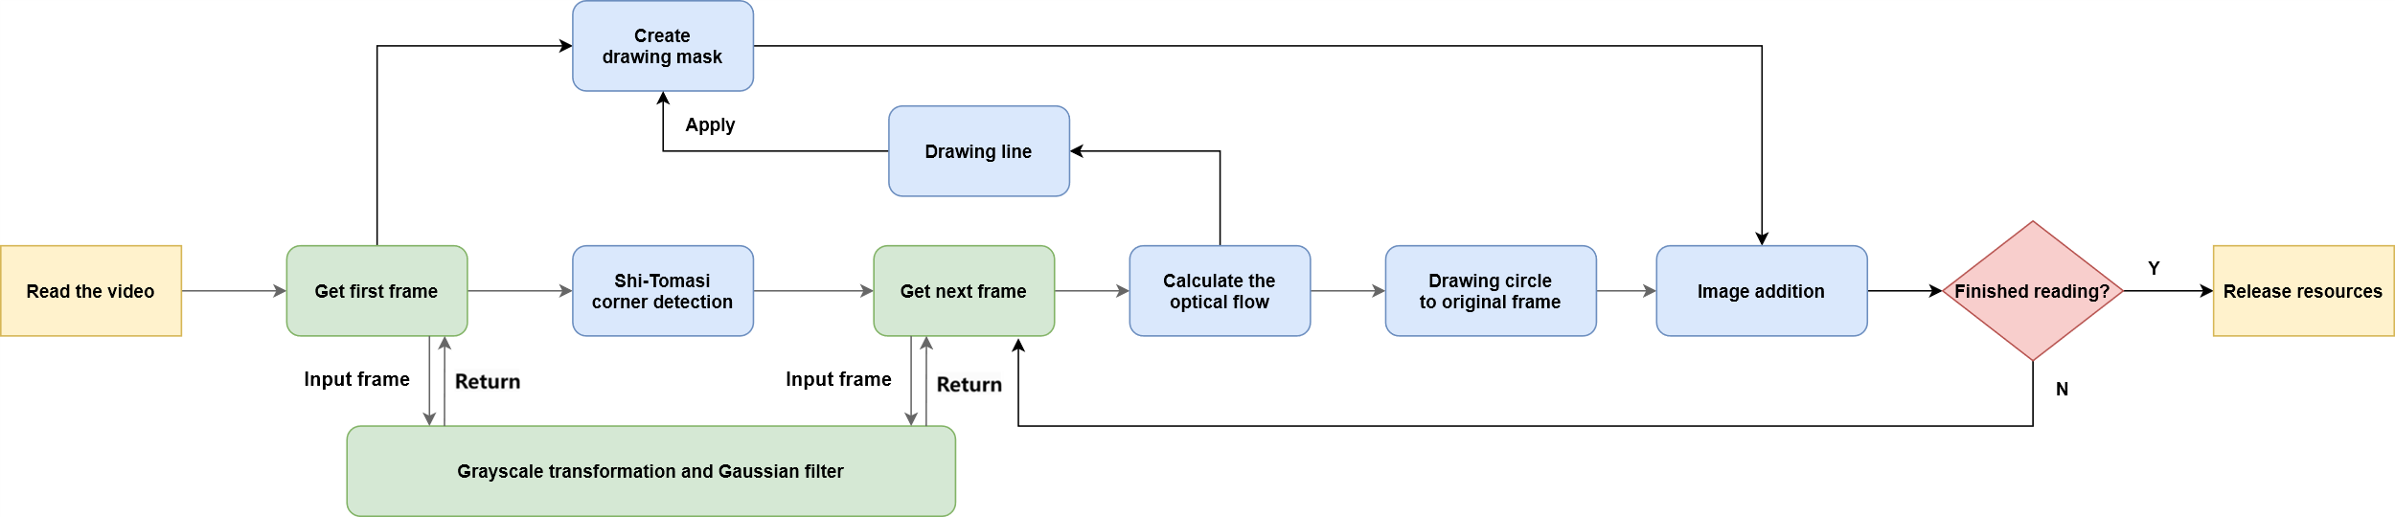
Fig.13. Optical flow process

Applying the method to the same frame indices used for frame differencing yields the results in Figs. 14 and 15.
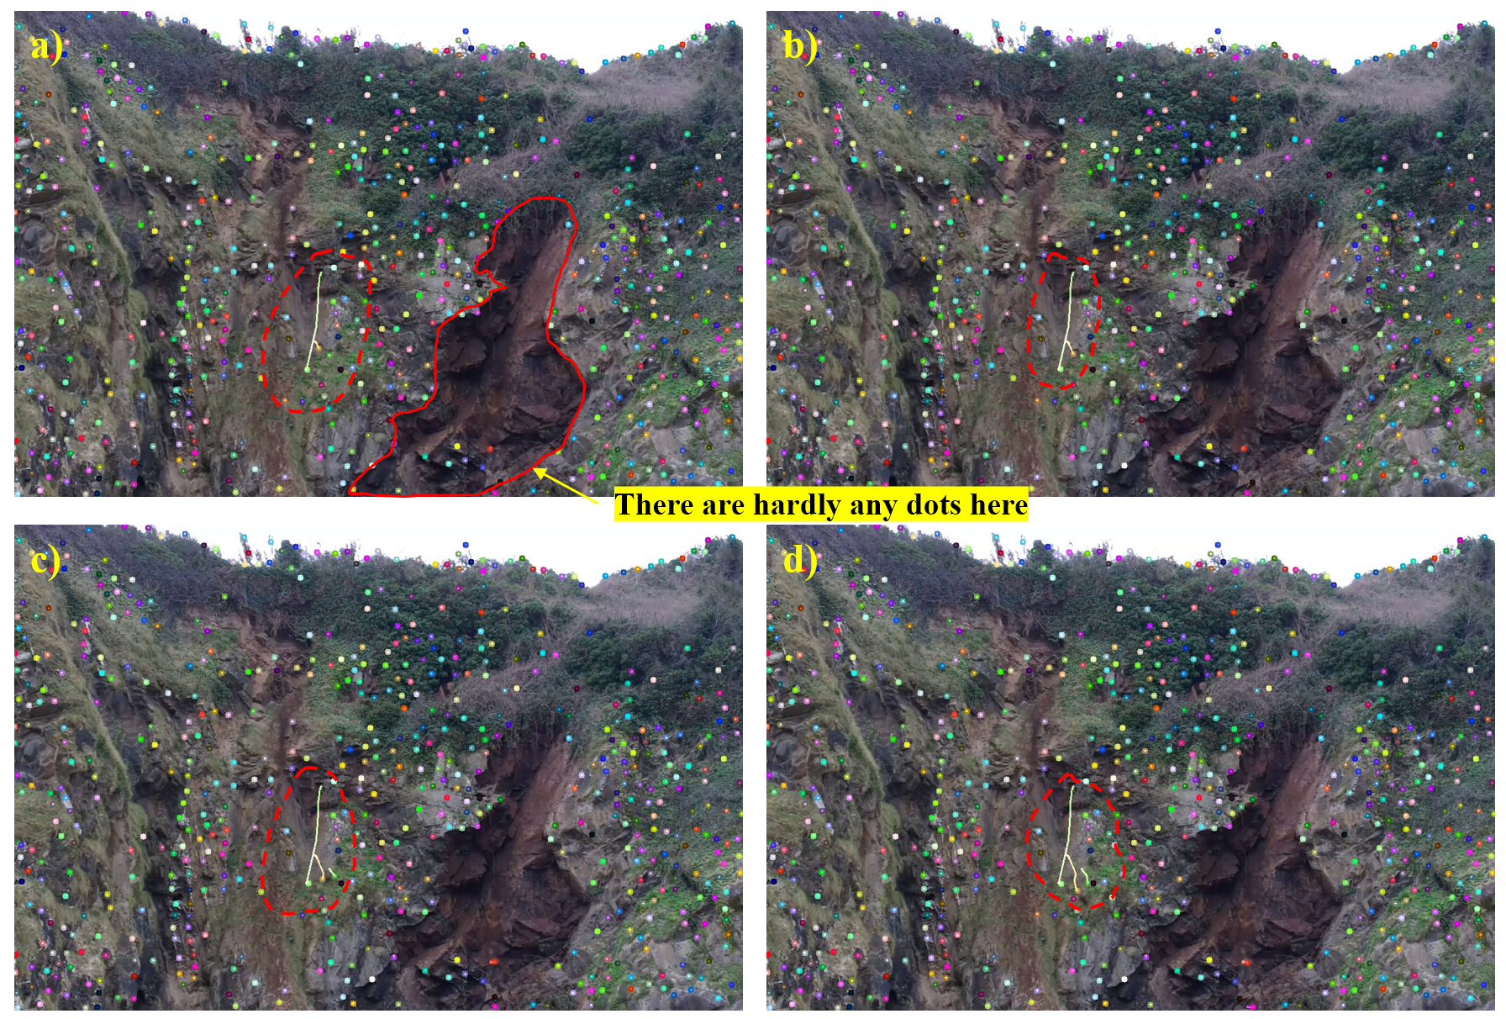
Fig.14. Diagram of optical flow method on video sequence a-d）Photos 19 to 22

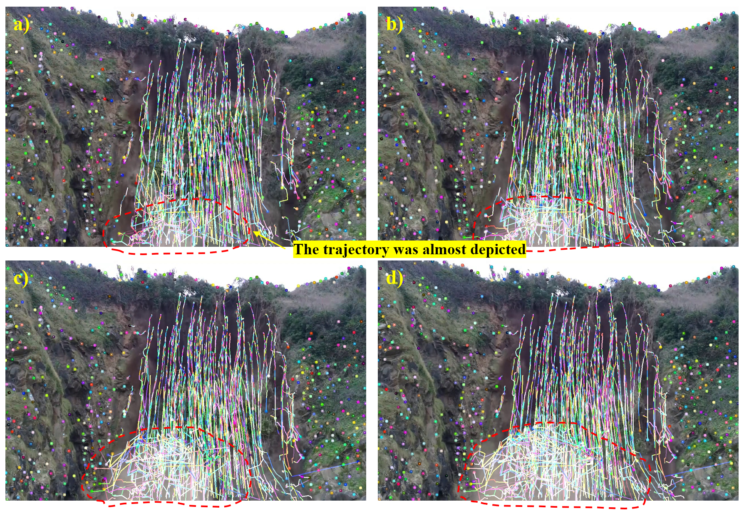
Fig.15. Diagram of optical flow method on video sequence a-d）Photos 88 to 91

As Fig. 14 indicates, optical flow not only tracks the trajectories of falling rocks effectively but also depicts the global motion path of the sliding mass with reasonable fidelity, providing strong support for analyzing landslide evolution trends. Nonetheless, certain limitations arise in practice. In Fig. 14a, the lower-right image region exhibits low texture and nearly uniform grayscale, yielding few detectable features; consequently, the optical-flow field there becomes discontinuous and local motion estimation may fail. In Fig. 15c, heavy dust generated by the landslide moves upward; motion blur induces partial disorder in the vector field, and the trajectories are not fully consistent. Even so, the method still responds well over dust-disturbed areas, indicating strong target sensitivity in complex scenes and suitability for overall dynamic analysis and trend identification during landsliding.
To address the scarcity of feature points in texture-poor regions, engineering practice can first use frame differencing or background subtraction to identify regions of change around the slope and then restrict optical-flow tracking to these regions of interest. This strategy both reduces the number of corner points—improving runtime while maintaining accuracy—and enhances the system’s sensitivity to subtle displacements and precursory signals, thereby improving the reliability and real-time performance of landslide monitoring and early warning.

3.4 Performance evaluation
For the three methods, there is no single, reliable metric of “detection rate”; in most cases the choice of method is informed by visual inspection in conjunction with the actual scene conditions. Compared with deep learning, traditional computer-vision approaches offer a speed advantage, so it is necessary to evaluate the performance of all three. The experimental hardware platform comprised an Intel® Core™ i7-12700H processor (base 2.30 GHz, turbo 4.70 GHz), 16 GB RAM, and an NVIDIA RTX 4070 discrete GPU. To ensure objective performance testing, all on-screen display and image-saving operations were disabled. We measured runtime by recording system timer ticks immediately before and after each algorithm and computed the elapsed time for processing the same landslide video sequences. The results are summarized in Table 1.
Table 1. Running time of each method (second)
 | Frame Differencing | Background subtraction | Optical Flow
Time-1 | 16.22 | 17.81 | 29.82
Time-2 | 16.18 | 17.54 | 29.43
Time-3 | 16.25 | 17.28 | 29.40
Average | 16.22 | 17.54 | 29.55

The experiments show that among the three representative motion-detection methods, frame differencing achieves the highest processing efficiency and the shortest overall runtime, making it suitable for rapid identification and real-time warning in the initial trigger zones of landslides. Background subtraction (GMM-based) requires slightly more time than frame differencing but remains sufficiently real-time, and is suitable for more precise recognition during later stages of landsliding. Optical flow, which estimates a motion vector field for selected points (or densely for pixels), incurs substantially higher computational cost and thus the lowest runtime efficiency, yet it offers clear advantages for trend analysis and displacement-trajectory estimation.
Given the differing strengths of the three methods in target tracking and performance, we propose a multi-stage, cooperative fusion strategy for landslide early-warning systems: in the initial stage, employ frame differencing for rapid screening to identify early abnormal activity in near real time and trigger a preliminary alert; in the intermediate stage, introduce optical flow to finely track rock-block displacements and analyze trends within priority regions, supporting dynamic assessment of risk levels; when the landslide enters an active evolution stage, incorporate background subtraction to model small-scale rock fragments and boundary details with high precision, thereby assisting in updating the warning extent and optimizing response strategies.

4. CONCLUSION
We experimentally compared three OpenCV-based motion-detection algorithms for landslide video and assessed their performance. Frame differencing responds the fastest for early anomaly detection; background subtraction exhibits superior boundary extraction in complex, dust-laden environments; and although optical flow is computationally slower, the resulting trajectory fields are highly valuable for analyzing displacement trends. Building on these findings, we propose a multi-stage fusion strategy: in the initial phase, frame differencing is used for rapid preliminary scanning, enabling near-real-time detection of early anomalies and triggering an initial alarm. During the intermediate phase, optical flow is applied to precisely track the motion of rock blocks and assess deformation trends in key areas, facilitating dynamic risk evaluation. Once the landslide enters an active stage, background subtraction is integrated to finely characterize rock debris and delineate boundaries, thereby supporting the refinement of warning zones and the improvement of response measures. This strategy preserves real-time performance while significantly enhancing detection accuracy and robustness, making it especially suitable for high-risk and landslide-prone regions. Compared with deep-learning approaches, these classical methods offer advantages in response speed; for practical deployment, cameras should be installed downslope in stable areas to maximize coverage of the monitored region and reduce occlusion. Algorithm choice and parameters should be adapted to site conditions and fused with contextual cues such as rainfall and vibration to strengthen situational awareness. Future work may explore combinations of the three methods with additional hybrid models to further improve system reliability under low-latency constraints.

Disclaimer (Artificial intelligence)
Author(s) hereby declare that generative AI technologies such as Large Language Models, etc. have been used during the writing or editing of manuscripts. This explanation will include the name, version, model, and source of the generative AI technology and as well as all input prompts provided to the generative AI technology
Details of the AI usage are given below:
1.Name: ChatGPT-5.0 Thinking, Purpose: For translation, prompts: “I'm writing an English thesis. Please translate this paragraph into English {message}”

COMPETING INTERESTS DISCLAIMER:
Authors have declared that they have no known competing financial interests OR non-financial interests OR personal relationships that could have appeared to influence the work reported in this paper.

References
- Ministry of Ecology and Environment. 2022 Bulletin of China's Ecological and Environmental Conditions [R/OL]. Beijing: Ministry of Ecology and Environment, 2023-05-29 [2025-08-28]. "Bulletin of China's Ecological and Environmental Conditions" column.
- Coline Hopquin, Eric Gayer, Laurent Michon, Antoine Lucas, Delphine Smittarello, Nicolas d’Oreye, Nicolas Villeneuve, Unveiling tropical slow-moving landslide response to seasonality and extreme meteorological events using a combination of InSAR and optical imagery: The case study of Grand Eboulis (Réunion island), Geomorphology, Volume 489, 2025, 109965, ISSN 0169-555X, https://doi.org/10.1016/j.geomorph.2025.109965.
- Mohamed Kouah, Yannick Thiery, Olivier Maquaire, François Nicot, Antoine Wautier, Thomas Roulland, Guillaume Thirard, Mathieu Fressard, Stéphane Costa, Robert Davidson, Reconstruction and verification of mechanism and triggering conditions of the Hermitage landslide at the Vaches Noires cliffs (Normandy), Geomorphology, Volume 465, 2024, 109399, ISSN 0169-555X, https://doi.org/10.1016/j.geomorph.2024.109399.
- M. Upendra, T. Anuradha, L. Prakash, Bird Repeller Using Opencv, Procedia Computer Science, Volume 252, 2025, Pages 975-984, ISSN 1877-0509, https://doi.org/10.1016/j.procs.2025.01.058.
- Naveen Chandra, Himadri Vaidya, Suraj Sawant, et al. Attention Driven YOLOv5 Network for Enhanced Landslide Detection Using Satellite Imagery of Complex Terrain,CMES - Computer Modeling in Engineering and Sciences,Volume 143, Issue 3,2025,Pages 3351-3375,ISSN 1526-1492,https://doi.org/10.32604/cmes.2025.064395..
- Zhiguo Zhu, Yao Cheng, Application of attitude tracking algorithm for face recognition based on OpenCV in the intelligent door lock, Computer Communications, Volume 154, 2020, Pages 390-397, ISSN 0140-3664, https://doi.org/10.1016/j.comcom.2020.02.003.
- Katika Harikrishna, Abeyram Nithin, M.J. Davidson, Automated microstructural segmentation and grain size measurement of Al + SiC nanocomposites using advanced image processing techniques on backscattered electron images, Materials Characterization, Volume 222, 2025, 114845, ISSN 1044-5803, https://doi.org/10.1016/j.matchar.2025.114845.
- Fanguo Zeng, Bin Li, Haifeng Wang, Jun Zhu, Nan Jia, Yuliang Zhao, Wenwen Zhao, Detection of calf abnormal respiratory behavior based on frame differencing and improved YOLOv5 method, Computers and Electronics in Agriculture, Volume 211, 2023, 107987, ISSN 0168-1699, https://doi.org/10.1016/j.compag.2023.107987.
- Wenhan Wu, Dongxing Li, Qiannan Wang, et al. Moving object detection based on improved frame differencing and edge extraction algorithm[J]. Science Technology and Engineering, 2022, 22(05):1944-1949.
- Campbell J,Mummert L,Sukthankar R.Video monitoring of honey bee colonies at the hive entrance[C].In:Proceedings of the 19th ICPR Workshop on Visual Observation&Analysis of Animal&Insect Behavior.Folorida:IEEE,2008:1-4
- Yangyang Li. Application of Gaussian mixture model based on background subtraction in cable trench animal prevention[J]. Information Technology and Informatization, 2020, (01):55-57.
- Yuhan Yang, Hui Bin, Chang Zheng, et al. Maritime moving target detection algorithm based on Gaussian Mixture Model[J]. Application Research of Computers, 2020, 37(S1):310-313.
- Yang Yan. Fluid motion estimation method based on optical flow method research [D]. North China electric power university, 2021. DOI: 10.27139/d.cnki.ghbdu.2021.000705.
- Dong-Hyun Kim, Ivan Gratchev. (2021). Application of optical flow techniques and photogrammetry to rockfall dynamics: a field test case study. Remote Sensing, 13 (20), 4124. https://doi.org/10.3390/rs13204124.
- Junsong Chen, Gong Jun, Geyou Zhang, et al. Measurement of cable elongation at break based on improved Lucas–Kanade optical flow[J]. Chinese Journal of Scientific Instrument, 2021, 42(04):256-264. DOI:10.19650/j.cnki.cjsi.J2107412.

