Original Research Article
Study on the performance of asphalt mixture
modified by coal gangue surface

Abstract
This paper studies the feasibility of using waste coal gangue as coarse aggregate of asphalt mixture. The surface modification of coal gangue aggregate was strengthened by methyl sodium silicate solution, and the best modification scheme was determined. The influence of different content and surface modification on the road performance of coal gangue asphalt mixture was studied by laboratory test. With the help of scanning electron microscope test, the change characteristics of the microstructure of coal gangue asphalt mixture before and after surface modification were explored. The results show that although the indexes of coal gangue are inferior to those of natural aggregate, it can be used to prepare asphalt mixture within the scope of specification requirements. The modification effect of sodium methyl silicate solution with modification time of 6h is the best, which can significantly improve the water absorption, density and crushing value of coal gangue. When the content of coal gangue is controlled within 30 %, the performance of asphalt mixture meets the requirements of the specification, and the amount of coal gangue in asphalt mixture can be increased after surface modification. After surface modification, the surface pores and cracks of coal gangue asphalt mixture are reduced, and the surface micro-damage under high temperature immersion and freeze-thaw cycle conditions is improved.
Keywords: Pavement materials；Coal gangue；Surface modification；Microscopic analysis；Road performance

1 Introduction
At present, a large number of highway construction in accelerating China 's national economy at the same time, also accelerated the consumption of a large number of natural stone, is bound to cause the lack of natural resources and the destruction of the natural environment , therefore, under the situation of promoting green development in an all-round way, it is particularly urgent to explore building materials that can replace natural aggregates, which is of great significance to promote the sustainable development of transportation engineering construction. In view of the non-renewable natural aggregate resources and the increasing number of industrial solid waste materials, more and more countries and regions around the world have begun to replace the aggregate in the asphalt mixture with industrial solid waste . The research shows that Martinho et al. [ 1 ] found in the indoor test that when the steel slag partially replaces the natural aggregate, the Marshall stability of the warm mix asphalt mixture is improved, but the stiffness modulus and water stability are slightly reduced, and the fatigue resistance is not significantly changed. Velasquez, Widojoko et al. [ 2,3 ] proposed the feasibility of using iron tailings as pavement aggregate through semi-circular bending test, indirect tensile test and immersion Marshall test. In order to broaden the application of waste glass in asphalt mixture, Zhou et al. [ 4 ] incorporated different proportions of glass aggregate to replace part of natural aggregate, and systematically studied the effect of glass aggregate incorporation on the optimum asphalt aggregate ratio and road performance of asphalt mixture. The test results show that with the increase of the content, the optimum oil-stone ratio, high temperature and low temperature performance and water stability all show a gradual downward trend, but the anti-skid performance is improved. Industrial wastes, such as steel slag, slag and glass, have the potential to be used as aggregates in road materials. These materials not only exhibit excellent physical properties, which can significantly improve the bearing capacity and durability of the road, but also effectively reduce the dependence on natural resources. In addition, coal gangue also has important application value in road engineering. The study of the former provides a solid theoretical basis and experimental method for the application of the latter.
Coal gangue is mainly used as coarse aggregate of asphalt mixture in road engineering. However, due to its high water absorption and large crushing value, its performance is partly inferior to that of natural stone, which affects its road performance and applicability. Therefore, surface modification of coal gangue has become a necessary measure. Through surface modification, the applicability and performance of coal gangue in road construction can be significantly improved. Most studies use physical and chemical methods to treat the surface of aggregates, aiming to improve the structure and performance of coal gangue and better meet the needs of road engineering.
In the modification study of coal gangue road application,Through three-point bending test and microwave heating test, Lu and Li et al. [ 5,6 ] found that the combination of coal gangue and functional aggregate promoted the self-healing of micro-cracks at the interface between aggregate and asphalt, and the crack resistance and healing effect were significantly improved.Zhang et al. [ 7 ] combined coal gangue into powder and basalt aggregate to evaluate the adhesion, mechanical properties, low temperature crack resistance, water stability, microwave heating capacity and self-healing efficiency of coal gangue asphalt mixture. It was found that the addition of coal gangue could improve the microwave heating speed, and also showed significant advantages in water stability and self-healing, further improving the utilization rate of coal gangue.Yao et al. [ 8 ] studied the mechanical properties of asphalt mixture with recycled aggregate ( RAP ) and coal gangue ( CG ) by Marshall stability test, rutting test, water stability test and low temperature semi-circular bending test. The research shows that compared with natural asphalt mixture, the performance indexes of asphalt mixture containing RAP and CG aggregate can meet the requirements of the specification, but slightly lower than that of natural asphalt mixture. Adding CG to asphalt mixture can improve the performance of asphalt mixture containing RAP.In addition, researchers also combine coal gangue with fly ash and cement materials to prepare geopolymer materials or new cement soil materials, and test their mechanical properties. It is found that they have good effects on compressive strength, corrosion resistance and environmental protection requirements, and can be widely used in road engineering [ 9 ].However, the process of the above modification method in practical application is more complex and the modification effect does not reach the optimal level. Therefore, this paper intends to use sodium methyl silicate solution to modify coal gangue in order to achieve a more ideal modification effect.

2 Raw material

2.1 Coal gangue and natural aggregate
In this paper, coal gangue produced from coal mining process is selected. Because the surface coal gangue is easy to be weathered, in order to ensure the strength, the unweathered and unspontaneous combustion coal gangue is preferred, and its color is mostly gray or gray black. According to the relevant technical specifications of ' Highway Engineering Aggregate Test Procedure ' ( JTG E42-2005 ) [ 10 ], the indexes were tested, and the test results are shown in Table 1.
Tab. 1 Coal gangue and natural aggregate performance test results
pilotproject |  | unit | coalgangue | technicalindex
apparent specific gravity | 5~10mm | - | 2.644 | ≥2.50
apparent specific gravity | 10~20mm | - | 2.656 | ≥2.50
water absorption | 5~10mm | % | 3.27 | ≤3.0
water absorption | 10~20mm | % | 2.86 | ≤3.0
crush value |  | % | 26.6 | ≤28
los Angeles wear value |  | % | 27.5 | ≤30
soil content |  | % | 0.8 | ≤1
asphalt adhesion grade |  | grade | 4 | ≥4

2.2 Modified materials
The sodium methyl silicate solution used in this experiment is a colorless transparent liquid with a density of about 1.18 g · cm − 3, a solid content of 40 %, and a pH value of ≥ 13. It is a non-combustible liquid and has good water repellency.

2.3 SBS asphalt
The SBS I-D modified asphalt is used in the test, and the basic performance test is carried out according to the ' Highway Engineering Asphalt and Asphalt Mixture Test Procedures ' ( JTG E20-2011 ) [ 11 ]. The test results are shown in Table 2. It can be concluded that the basic physical indexes of SBS modified asphalt meet the technical requirements of ' Highway Asphalt Pavement Construction Technical Specification ' ( JTG F40-2004 ) [ 12 ]..

Tab. 2 Main technical indexes of SBS modified asphalt
pilotproject | unit | coalgangue | technicalrequirement
needle penetration（25℃，100g，5s） | 0.1mm | 53 | 40~60
penetration index PI | - | 0.7 | ≥0
ductility（5cm/min，5℃） | cm | 36.2 | ≥20
Softening point ( global method ) | ℃ | 73.3 | ≥60
flash point | ℃ | 296 | ≥230

2.4 Fine aggregate and mineral powder
The natural gravel selected in this experiment is the most widely used limestone. AC-20 gradation with 4.75 mm as the boundary particle size of coarse and fine aggregate ; the basic properties of fine aggregate are listed in Table 3, and the main properties of mineral powder are tested. The results show that meet the technical requirements, [ 12 ].The test results are shown in Table 4.
Tab. 3 Main technical indexes of fine aggregate
pilotproject | unit | 3~5mm | 0~3mm
apparent specific gravity | - | 2.727 | 2.719
soil content | % | 1.3 | 1.8
sand equivalent | % | 72.4 | 71.7
ruggedness | % | 14 | 13
Tab. 4 Main technical indexes of mineral powder
targetsoftest |  | test result | technical  standard
apparent density （t/m³） |  | 2.641 | ≥2.50
water content（%） |  | 0.3 | ≤1
appearance |  | no agglomerates | no agglomerates
hydrophilic coefficient |  | 0.53 | ≤1
plasticity index（%） |  | 1.7 | ≤4
particle size range（%） | <0.6mm | 100 | 100
particle size range（%） | <0.15mm | 95.6 | 90~100
particle size range（%） | <0.075mm | 84.1 | 75~100

3 Test method

3.1 Coal gangue surface modification treatment
This study employs sodium methyl silicate solution to modify the surface of coal gangue.

3.2 Mix Design
This study selected AC-20 for asphalt mixture mix design. Aggregates No. 1 (10–20 mm), No. 2 (5-10 mm), No. 3 (3-5 mm), No. 4 (0-3 mm), and mineral powder were used. Coal gangue aggregate replaced 15%, 30%, 45%, and 60% of the 5–10 mm, and 10–20 mm natural aggregates to prepare AC-20 asphalt mixtures. Since the particle size distribution of coal gangue remained largely unchanged before and after surface modification, the same gradation design was applied to both modified and unmodified coal gangue asphalt mixtures in the experiments. The gradation curves are shown in the figure.
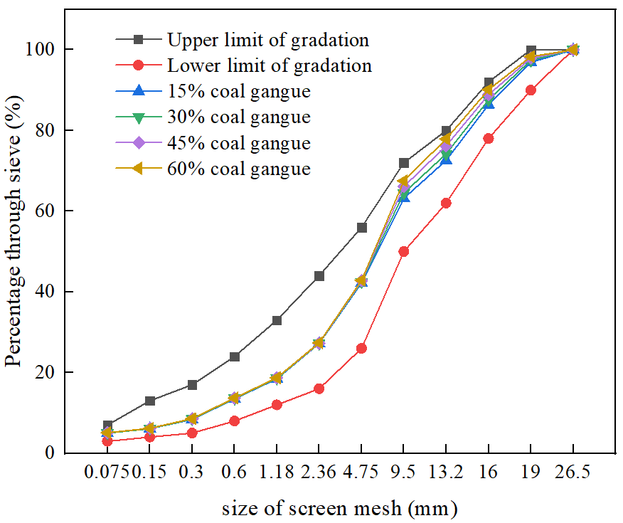
Fig. 1. Gradation curve under different coal gangue content

3.3 High-Temperature Rutting Test
This section employs a rutting test to quantify the impact of wheel load compaction on road materials, evaluating the stability of asphalt mixtures under high-temperature conditions. For each mixture design, three specimens were prepared at different asphalt content levels. After conditioning at 60°C for 5 hours, the specimens underwent rutting testing.

3.4 Low-Temperature Flexural Test
This section employs a beam flexural test to evaluate the crack resistance of coal gangue asphalt mixtures under low-temperature conditions. By loading beam specimens to failure, the material's resistance to low-temperature deformation is assessed through comprehensive analysis of failure characteristics including flexural tensile strength, maximum flexural strain, and flexural modulus.

3.5 Water Stability Test
(1) Water Immersion Marshall Test
Under different dosage conditions, prepare two sets of Marshall specimens each for the surface-modified and unmodified coal gangue asphalt mixtures, with four specimens per set. Group 1: After 40 minutes of immersion in a 60°C constant-temperature water bath, determine the stability index MS.
Group 2: After 48 hours of maintenance in a 60°C constant-temperature water bath, determine the stability index MS₁ and calculate the residual stability after immersion based on this value.
Take the average of the residual stability values from both groups as the final test result.
(2) Freeze-Thaw Splitting Test
For coal gangue asphalt mixtures with different admixture dosages, form two sets of specimens before and after surface modification, each set comprising four Marshall specimens. For Set 1, first use a maximum theoretical density apparatus to vacuum-saturate the specimens with water. Then place them in a 25°C water bath for 30 minutes. Immediately transfer them into plastic bags, add 10 mL of water, seal the bags, and freeze them in a -18°C low-temperature test chamber for 17 hours. Then, they were placed in a 60°C constant-temperature water bath for 24 hours. Subsequently, both Group 1 and Group 2 specimens were placed in a 25°C constant-temperature water bath for 3 hours before conducting the splitting test. The average value was taken as the test result.

4 Test Results and Analysis

4.1 Analysis of Modified Coal Gangue Properties
After surface modification with a 6% sodium methyllithium solution, the crushing value of coal gangue decreased while the aggregate's crush resistance and strength increased. This improvement stems from the following mechanisms: Surface modification increases the apparent density of coal gangue while reducing its water absorption rate. Pores and cracks are filled, resulting in a denser texture that enhances resistance to crushing. Notably, the sodium methyl silicate solution most significantly strengthened the aggregate's water absorption rate, substantially lowering it to meet relevant specifications for aggregates. This enables better application in asphalt mixtures.

4.2 High-Temperature Performance Analysis
The rutting depth of asphalt mixtures increased with rising gangue content, while dynamic stability showed a decreasing trend. Gangue-based asphalt mixtures modified with sodium metabisulfite solution exhibited significantly improved dynamic stability compared to unmodified samples, indicating that modification enhances high-temperature performance. However, at a 60% content, the dynamic stability still slightly fell short of specification requirements. Regarding high-temperature stability, the dynamic stability of coal gangue mixtures met specification requirements when the gangue content ranged from 15% to 45%.

4.3 Low-Temperature Performance Analysis
Asphalt mixture specimens incorporating surface-modified coal gangue aggregate exhibited significantly higher resistance to water damage compared to those containing unmodified coal gangue. This is attributed to the formation of a protective coating on the surface of coal gangue treated with sodium metasilicate solution, which hinders water penetration. Concurrently, the strength of modified coal gangue is enhanced to some extent. Consequently, the residual stability of modified coal gangue asphalt mixtures is significantly improved, meeting specification requirements even under prolonged water immersion conditions.
Compared to unmodified coal gangue asphalt mixtures, those treated with sodium methyl silicate solution exhibit markedly enhanced resistance to water damage. This improvement stems from: a significant reduction in water absorption after modification; the formation of an insoluble organosilicon resin protective layer on the coal gangue surface, effectively blocking water penetration; and the alkaline nature of this protective layer, which enhances adhesion between coal gangue and asphalt, thereby reducing freeze-thaw damage to the mixture.

5 Conclusions
(1) All performance indicators improved after modification with sodium methyllithium solution. Water absorption decreased by 45.53% and 51.01% for 5–10 mm and 10–20 mm fractions, respectively. Apparent relative density increased by 2.83% and 2.70%, while crushing value decreased by 11.11%.
(2) The incorporation of coal gangue reduced the high- and low-temperature performance, water stability, and fatigue resistance of the asphalt mixture to varying degrees. Considering the overall performance of coal gangue asphalt mixtures, it is recommended that the content of unmodified coal gangue in asphalt mixtures should not exceed 30%, while the content of surface-modified coal gangue can be increased to 45%.
(3) After high-temperature water immersion, massive water ingress in coal gangue asphalt mixtures causes asphalt detachment and extensive aggregate exposure. Freeze-thaw cycles induce numerous internal cracks. However, surface-modified coal gangue asphalt mixtures exhibit improved surface damage resistance under both water immersion and freeze-thaw conditions.

Disclaimer (Artificial intelligence)

Option 1:

Author(s) hereby declare that NO generative AI technologies such as Large Language Models (ChatGPT, COPILOT, etc.) and text-to-image generators have been used during the writing or editing of this manuscript.

Option 2:

Author(s) hereby declare that generative AI technologies such as Large Language Models, etc. have been used during the writing or editing of manuscripts. This explanation will include the name, version, model, and source of the generative AI technology and as well as all input prompts provided to the generative AI technology

Details of the AI usage are given below:
1.
2.
3.

6 References
- Martinho F, Picado-Santos L, Capitão S. Influence of recycled concrete and steel slag aggregates on warm-mix asphalt properties[J]. Construction and Building Materials, 2018, 185: 684-696.
- Velasquez R, Turos M, Moon H K, et al. Using recycled taconite as alternative aggregate in asphalt pavements[J]. Construction and Building Materials, 2009, 23(9): 3070-3078.
- Widojoko L. Evaluation the use of tailings as a filler in asphalt concrete-wearing course based on results of laboratory tests to the indonesian specification for hot-mix asphalt year 2010[J]. Advanced Materials Research, 2013, 723: 328-336.
- Zhou B, Pei J, Lv L, et al. Design and evaluation of glassphalt mixtures by using recycled waste cullet[J]. J. Southeast Univ.(English Edition), 2019, 35(2): 198-205.
- Lu D, Jiang X, Leng Z, et al. Dual responsive microwave heating-healing system in asphalt concrete incorporating coal gangue and functional aggregate[J]. Journal of Cleaner Production, 2023, 422: 138648.
- Li J R, Cao Y S, Sha A M, et al. Prospective application of coal gangue as filler in fracture-healing behavior of asphalt mixture[J]. Journal of Cleaner Production, 2022, 373: 133738.
- Zhang B, Gao X, Xu S, et al. Microwave heating healing of asphalt mixture with coal gangue powder and basalt aggregate[J]. Sustainability, 2023, 15(17): 12986.
- Yao Y Q, Gao J, 23, et al. Sustainable asphalt concrete containing RAP and coal gangue aggregate: performance, costs, and environmental impact[J]. Journal of Renewable Materials, 2022, 10(8): 2263-2285.
- Koshy N, Dondrob K, Hu L M, et al. Synthesis and characterization of geopolymers derived from coal gangue, fly ash and red mud[J]. Construction and Building Materials, 2019, 206: 287-296.
- JTG E42-2005, Highway engineering aggregate test procedures[S]. Beijing: People 's Transportation Publishing House, 2005.
- JTG E20-2011, Test Procedure for Asphalt and Asphalt Mixture of Highway Engineering[S]. Beijing: People 's Transportation Publishing House, 2011.
- JTG F40-2004, Standard specification for construction and acceptance of highway asphalt pavement[S]. Beijing: People 's Transportation Publishing House, 2004.

