Original Research Article
Performance Characteristics of Asphalt Binders Modified with Microwave-Activated Crumb Rubber

Abstract: This study investigates the use of microwave activation as a pretreatment method to enhance the compatibility between crumb rubber and asphalt, and systematically evaluates the road performance of microwave-activated crumb rubber modified asphalt (M-CRMA). Scanning electron microscopy (SEM) observations revealed that, after microwave activation, the crumb rubber surface became rougher with an increased specific surface area and higher reactivity, thereby facilitating stronger interactions with asphalt. Rheological properties were comprehensively analyzed through dynamic shear rheometer (DSR) tests, multiple stress creep recovery (MSCR) tests, and bending beam rheometer (BBR) tests, under varying crumb rubber contents (20%–60%). Results showed that M-CRMA exhibited optimal performance at a 50% crumb rubber content, significantly improving high-temperature stability, durability, and moisture resistance, although the enhancement in low-temperature cracking resistance was limited. This research provides an effective approach for preparing high-content CRMA and demonstrates considerable potential for engineering applications.
Keywords: Microwave activation; Microstructural properties; Crumb rubber modified asphalt; Pavement performance
1. Introduction
The rapid growth of the global vehicle fleet has led to a steady increase in waste tire generation, resulting in severe “black pollution” that poses significant environmental challenges. Recycling waste tires into crumb rubber and incorporating it into asphalt to produce crumb rubber modified asphalt (CRMA) is recognized as an effective strategy to simultaneously improve pavement performance and achieve high-value utilization of solid waste ^{[1-3]}. Previous studies have demonstrated that CRMA pavements exhibit superior performance compared with conventional asphalt mixtures, particularly in terms of rutting resistance at high temperatures, cracking resistance at low temperatures, durability, fatigue resistance, and driving comfort (e.g., noise reduction and skid resistance) ^{[4]}.
Despite these advantages, the large-scale application of CRMA is still hindered by poor compatibility between crumb rubber and base asphalt ^{[5-6]}. This is mainly attributed to the vulcanization of waste rubber, which results in strong chemical inertness and the presence of non-rubber components such as carbon black and fibers. These factors cause issues such as poor storage stability, processing difficulties, and rubber particle agglomeration, thereby limiting the achievable rubber content and restricting the full potential of CRMA ^{[7-8]}.
To address these challenges, pretreatment activation of crumb rubber has emerged as a promising approach to improve surface activity and reactivity ^{[9-10]}. Various methods have been proposed, including mechanical grinding, graft modification, biological desulfurization, and microwave/ultrasonic treatment. Among them, microwave activation has attracted growing attention due to its efficiency, energy concentration, environmental friendliness, and operational simplicity^{[11-12]}. Microwave irradiation can selectively heat polar substances, disrupt sulfur cross-linked networks and inert structures on the rubber surface, and generate micropores and cracks. These microstructural modifications increase the specific surface area of rubber particles, thereby enhancing their wetting, swelling, and interfacial interaction with asphalt ^{[13-14]}.
Nevertheless, the underlying mechanisms of microwave activation on the microstructure of crumb rubber remain insufficiently understood, and systematic evaluations of the pavement performance of high-rubber-content microwave-activated CRMA (M-CRMA) are still lacking. In particular, the effects on high- and low-temperature properties as well as fatigue resistance require further investigation ^{[15-16]}.
In this context, it is also relevant to note that styrene - butadiene - styrene (SBS) modified asphalt, a widely used commercial modifier, offers excellent high-temperature stability and elastic recovery. However, its low-temperature performance is limited, while its high cost and poor aging resistance further constrain its application. Compared with SBS, CRMA—especially when prepared with activated crumb rubber—has the potential to balance performance at different temperatures, reduce costs, and promote sustainable recycling of waste tires.
Therefore, this study focuses on the microwave activation of crumb rubber and its application in asphalt modification. CRMA with different rubber contents was prepared, and microstructural changes before and after activation were characterized using scanning electron microscopy (SEM). Rheological properties were systematically evaluated through dynamic shear rheometer (DSR), multiple stress creep recovery (MSCR), and bending beam rheometer (BBR) tests. The high-temperature performance, low-temperature cracking resistance, and fatigue resistance of M-CRMA were analyzed to determine the optimal rubber content. The results are expected to provide theoretical insights and practical guidance for the efficient utilization of microwave-activated crumb rubber in asphalt modification, thereby advancing waste tire recycling technologies.
2. Materials and Methods
2.1 Materials
2.1.1 Base asphalt
The base asphalt used in this study is 70# asphalt produced in Hebei Province. The corresponding technical indices were tested in accordance with the Specifications and Test Methods of Bitumen and Bituminous Mixtures for Highway Engineering. The main technical properties of the base asphalt are presented in Table 1.
Table 1 Technical indicators of A-70# road asphalt
Parameter | Result | Technical Requirement
Penetration (100g, 5s, 25°C)/(0.1mm) | 71.3 | 60~80
Softening Point/°C | 48.4 | ≥46
Ductility (10°C, 5cm/min)/cm | 35 | ≥20
After RTFOT（163℃，5h）
Mass Change/% | -0.54 | ≤±0.8
Residual Penetration Ratio (25°C)/% | 65.6 | ≥61
Residual Ductility (10°C)/cm | 6.9 | ≥6
2.1.2 Crumb Rubber
The crumb rubber used in this study was 30-mesh radial tire waste rubber powder produced in Shanxi Province, as shown in Figure 1. Its technical properties are presented in Table 2.
Table 2 Technical indicators of crumb rubber.
Parameter | Result | Technical Requirement
Relative density | 1.212 | 1.10~1.30
Moisture content/% | 0.55 | <1
Iron content/% | 0.12 | <0.03
Fiber content/% | 0.06 | <1
Ash content/% | 7.2 | ≤8
Rubber hydrocarbon content/% | 56 | ≥48
Solubility/% | 17.1 | ≥16
2.2 Preparation of Microwave-Activated Crumb Rubber
A total of 1.5 kg of dried raw crumb rubber was mixed sequentially with 100 g of activator and 50 g of plasticizer. Manual stirring was applied to ensure uniform blending of additives with the rubber particles. The mixture was then placed in a microwave oven operating at 2450 ± 50 Hz and heated for 10 minutes. After heating, the product was cooled to room temperature and stored in nitrogen for subsequent use.As shown in Figure 2.
2.3 Preparation of Microwave-Activated Crumb Rubber Modified Asphalt
Base asphalt (500 g) was used for the preparation, with crumb rubber contents set at 20%, 30%, 40%, 50%, and 60% (by weight of asphalt). When the base asphalt reached 120 °C, crumb rubber was gradually and repeatedly added in small portions with continuous stirring. Manual stirring was carried out for 10 minutes, followed by mechanical mixing. Once the temperature stabilized at 180 °C, the mixture was subjected to high-shear mixing for 60 minutes under constant temperature conditions, and then sheared for 60 seconds to complete preparation. The modified asphalt was stored for subsequent testing.As shown in Figure 3.
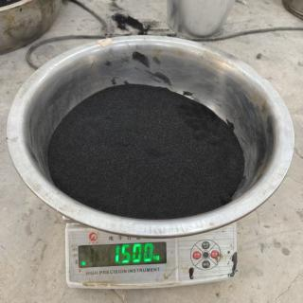 | 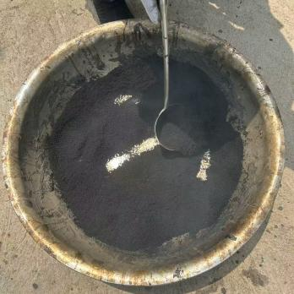 | 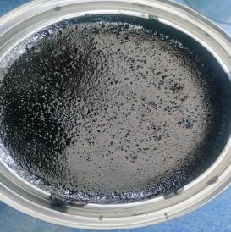
Fig. 1. Raw rubber powder. | Fig. 2. Activated rubber crumb. | Fig. 3. Microwave activated rubber powder modified asphalt.
2.4 Test Methods
2.4.1 Dynamic Shear Rheometer (DSR) Test
Dynamic shear rheometer (DSR) testing was conducted to evaluate the rheological behavior of the asphalt binder under high-temperature conditions. The viscoelastic properties of the binder were characterized by complex shear modulus (G*) and phase angle (δ), consisting of both storage and loss moduli. The rutting factor (G*/sinδ) was introduced as a performance indicator, reflecting the high-temperature deformation resistance of asphalt pavements.
2.4.2 Multiple Stress Creep Recovery (MSCR) Test
To more reasonably evaluate the high-temperature performance of microwave-activated crumb rubber modified asphalt, MSCR testing was performed at 64 °C and 70 °C. The total test duration was 200 seconds, consisting of 10 continuous creep–recovery cycles at stress levels of 0.1 kPa and 3.2 kPa, respectively. Each cycle included a 1-second creep phase and a 9-second recovery phase. Performance was evaluated based on non-recoverable creep compliance (Jnr) and load sensitivity (Jnr-diff).
2.4.3 Bending Beam Rheometer (BBR) Test
To assess the low-temperature performance of modified asphalt, BBR testing was conducted at –12 °C on binders with varying crumb rubber contents.
3 Results and Analysis
3.1 Microstructure of Crumb Rubber
The microstructure of the rubber powder is shown in the following figure.
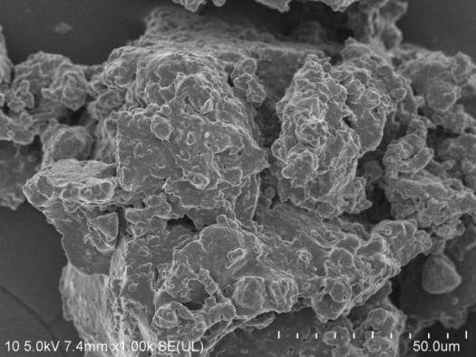 | 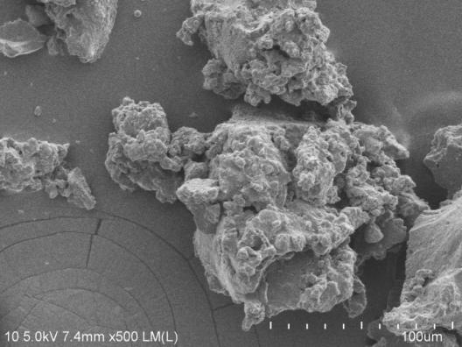
(a)Raw rubber powder. 50um | (b)Raw rubber powder. 100um
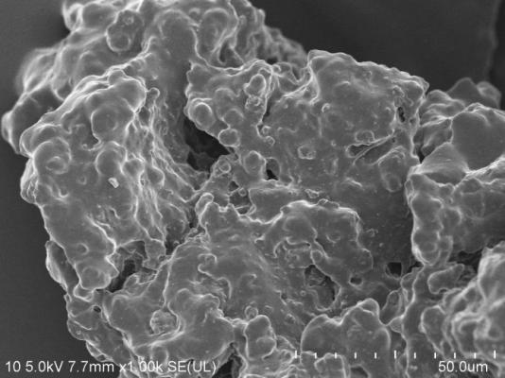 | 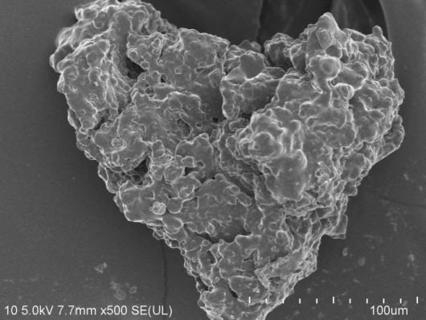
(c)Activated rubber crumb. 50um | (d)Activated rubber crumb. 100um
Fig. 4. Micromorphology of rubber powder
Compared with raw crumb rubber, microwave-activated rubber exhibited increased surface porosity and larger specific surface area. With enhanced surface reactivity, the particles tended to form loosely agglomerated clusters due to mutual adsorption. The degree of porosity and uniformity also varied with different activation processes. During asphalt processing, the increased contact area between activated crumb rubber and asphalt facilitated swelling and re-crosslinking reactions, thereby reducing processing difficulty and improving the performance and stability of the modified asphalt system.
3.2 Performance of Modified Asphalt
3.2.1 High-Temperature Performance
Figure 5 presents the MSCR test results of modified asphalt with different crumb rubber contents. With the increase in rubber powder content, the stress sensitivity index (Jnr-diff) shows an upward trend, while the non-recoverable creep compliance (Jnr) at both stress levels decreases significantly, indicating continuous improvement in the high-temperature performance of rubberized asphalt. This phenomenon can be attributed to the fact that rubber particles can still retain partial elasticity under high-temperature conditions, thereby effectively enhancing the elastic response capacity of the asphalt binder and improving its overall resistance to deformation. However, when the rubber content reaches 60%, the improvement in high-temperature performance becomes less pronounced. This is likely because excessive rubber addition exceeds its dispersion limit in asphalt, resulting in reduced compatibility and poor mixing uniformity, with some particles even agglomerating, which hinders the formation of a continuous elastic phase. This phenomenon also restricts the feasibility of applying higher rubber contents.
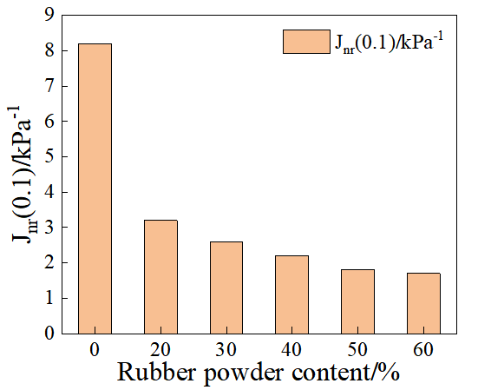 | 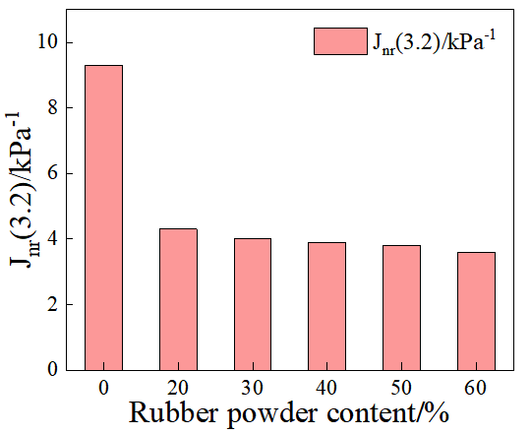 | 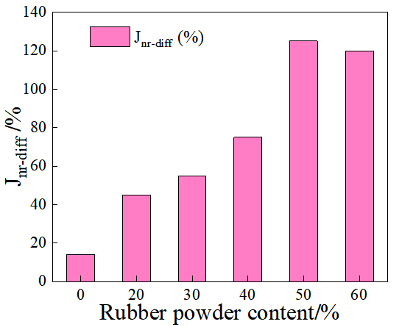
- J_{nr}(0.1)/kPa⁻¹ | - J_{nr}(3.2)/kPa⁻¹ | - J_{nr-diff}/%
Fig. 5. MSCR test results
3.2.2 Low-Temperature Performance
Figure 6 shows the BBR test results of modified asphalt with different crumb rubber contents. Under the same temperature condition, the stiffness modulus of asphalt generally decreases with increasing rubber content, while the creep rate (m-value) increases correspondingly, indicating that the addition of rubber significantly improves the low-temperature crack resistance of asphalt. According to the Superpave specifications for low-temperature asphalt performance (stiffness modulus S < 300 MPa, creep rate m > 0.3), all rubber-modified asphalt mixtures meet the requirements. Notably, when the rubber content increases to 60%, the m-value declines, suggesting that further addition at this level reduces or even negatively affects the improvement in low-temperature performance. This phenomenon may be related to poor matrix compatibility, particle agglomeration, and intensified stress concentration caused by excessive rubber addition. Therefore, considering both performance and economic factors, it is recommended to control the rubber content at around 50% to achieve an optimal balance of low-temperature performance and practical feasibility in engineering applications. Future work may further employ microstructural observation (e.g., SEM) or component analysis to elucidate the underlying mechanisms of performance deterioration at high rubber contents.
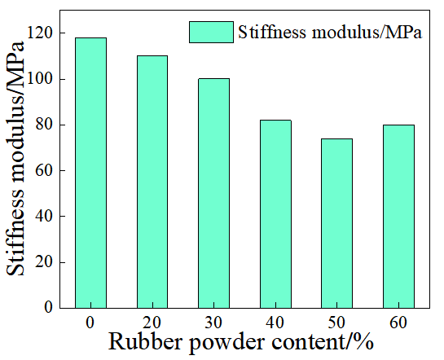 | 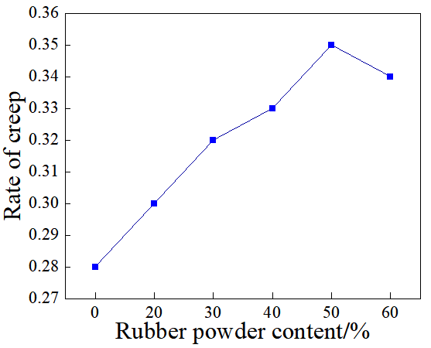
- Stiffness modulus | - Rate of creep
Fig. 6. BBR test result
2.2.3 Fatigue Properties
At the same test temperature, a smaller fatigue factor corresponds to better fatigue resistance of asphalt binders. As shown in Table 3, at 28 °C, the fatigue factor of modified asphalt decreases with the increase in rubber content. This is mainly attributed to the fact that rubber particles still exhibit good elasticity and flexibility at lower temperatures, which helps improve the fatigue resistance of asphalt materials. When the temperature rises to 40 °C and 52 °C, although the fatigue factor still shows a downward trend with increasing rubber content, the rate of decrease becomes significantly smaller. This indicates that the fatigue performance of rubber-modified asphalt is temperature-sensitive, and the beneficial effect of rubber on fatigue performance diminishes under high-temperature conditions. A possible explanation is that with increasing temperature, the asphalt binder softens, the modulus difference between rubber particles and the matrix decreases, and the elastic contribution of rubber becomes less significant. Therefore, increasing rubber content at lower temperatures can significantly enhance fatigue performance, while under higher temperature conditions, the benefits of higher dosage are limited, and additional modification strategies are required to further improve high-temperature fatigue durability.
Table 3. Fatigue factor test results
Asphalt sample |  | 20% | 30% | 40% | 50% | 60%
Complex shear modulus  (G*/kPa) | 28 | 569.2 | 386.54 | 426.13 | 316.89 | 305.6
Complex shear modulus  (G*/kPa) | 40 | 103.26 | 76.25 | 82.47 | 68.32 | 61.25
Complex shear modulus  (G*/kPa) | 52 | 17.23 | 12.5 | 15.3 | 16.89 | 17.65
Phase angle  (δ/°) | 28 | 61.59 | 60.59 | 61.23 | 59.89 | 60.48
Phase angle  (δ/°) | 40 | 67.71 | 65.81 | 64.55 | 63.94 | 62.13
Phase angle  (δ/°) | 52 | 70.25 | 68.93 | 68.12 | 64.58 | 63.77
fatigue factor  (G*sinδ)/kPa | 28 | 488.69 | 359.23 | 381.76 | 269.59 | 248.99
fatigue factor  (G*sinδ)/kPa | 40 | 90.63 | 65.9 | 72.54 | 57.65 | 56.19
fatigue factor  (G*sinδ)/kPa | 52 | 19.64 | 17.82 | 17.33 | 15.79 | 14.57
- Conclusions
- Microwave activation effectively disrupts the inert structures on the surface of crumb rubber, increases its porosity and specific surface area, and significantly improves its compatibility with asphalt. Microwave-activated crumb rubber modified asphalt (M-CRMA) exhibits excellent rheological properties, with remarkable improvements in both high- and low-temperature performance as well as durability. The optimal comprehensive performance is achieved at a 50% rubber content.
- Compared with SBS-modified asphalt, M-CRMA demonstrates comparable or even superior performance in terms of high-temperature stability, moisture resistance, and fatigue resistance, while also offering environmentally friendly raw material sources and lower costs. However, its improvement in low-temperature cracking resistance remains limited.
- The high-temperature deformation resistance of M-CRMA continuously increases with rubber content, and good processability and storage stability are maintained at a 50% content. Excessive addition (e.g., 60%) leads to decreased compatibility and rubber particle agglomeration.
- M-CRMA exhibits favorable fatigue resistance. At medium and low temperatures (28 ℃ and 40 ℃), the fatigue factor decreases significantly with increasing rubber content. At higher temperatures (52 ℃), however, the adverse effect of temperature outweighs the improvements brought by higher rubber content.
- From a life-cycle perspective, M-CRMA technology not only contributes to waste tire utilization and mitigation of “black pollution” but also provides economic and environmental benefits. It is suitable for practical engineering applications such as high-grade highways, bridge deck pavements, and recycled asphalt mixtures, demonstrating broad potential for promotion.
- This study still has certain limitations, such as the lack of systematic evaluation of performance evolution after long-term aging and the road performance of actual mixtures. Future work may combine laboratory accelerated aging tests with trial pavement sections to further verify its durability and engineering applicability.

Disclaimer (Artificial intelligence)

Author(s) hereby declare that NO generative AI technologies such as Large Language Models (ChatGPT, COPILOT, etc.) and text-to-image generators have been used during the writing or editing of this manuscript.

Reference
- Chen X ,Zhang L ,Liu J , et al.Preparation and properties of synergistic activated rubber powder/SBS composite modified asphalt for waterproof coatings[J]. Case Studies in Construction Materials,2025,22e04786-e04786.
- Li G ,Tian X ,Gao K , et al.Study on the performance and microscopic mechanism of activated crumb rubber synergistic polyurethane composite modified asphalt[J]. Construction and Building Materials,2024,450138739-138739.
- Xie J ,Li S ,Lin J , et al.Influence of graft-activated crumb rubber on the aging performance of modified bitumen: Experimental analysis and molecular dynamics simulation[J]. Materials Today Communications,2024,3910-9249.
- Juan X ,Xucheng Z ,Wen H , et al.Improving anti-aging performance of terminal blend rubberized bitumen by using graft activated crumb rubber[J]. Journal of Polymer Engineering,2023,43(10):855-864.
- Peng Z ,Dongna L ,Bo L , et al.The Properties of Sodium-Hypochlorite-Activated Crumb Rubber and the Influence of Aging on the Rheological Properties of Activated Asphalt Rubber[J]. Buildings,2023,13(3):712-712.
- Yin, L., Yang, X., Shen, A., Wu, H., Lyu, Z., & Li, B. Mechanical properties and reaction mechanism of microwave-activated crumb rubber-modified asphalt before and after thermal aging[J]. Construction and Building Materials, 2021, 267, 120773.
- Li, M., Xu, O., Min, Z., & Wang, Q. Engineering performance and activation mechanism of asphalt binder modified by microwave and diesel pre-processed waste crumb rubber[J]. Materials and Structures, 2023,56(7), 117.
- Lei Y ,Xiaolong Y ,Aiqin S , et al.Mechanical properties and reaction mechanism of microwave-activated crumb rubber-modified asphalt before and after thermal aging[J]. Construction and Building Materials,2021,2671-20773.
- Liu B ,Li J ,Han M , et al.Properties of polystyrene grafted activated waste rubber powder (PS-ARP) composite SBS modified asphalt[J]. Construction and Building Materials,2020,238117737-117737.
- Ju Z ,Ge D ,Zhang H , et al.Rheological behavior and microscopic characteristic of electromagnetic thermal activated crumb rubber and SBS modified asphalt[J]. Construction and Building Materials,2024,444137892-137892.
- Hu C ,Sun Z ,Xi L , et al.Rheology and Phase Morphology Properties of Recycled Asphalt Modified with Waste Cooking Oil and Activated Crumb Rubber[J]. International Journal of Pavement Research and Technology,2024,(prepublish):1-16.
- Ming L ,Xuehao L ,Zhengmei Q , et al.Microscopic Analysis of Activated Crumb Rubber and Its Effect on Mechanical Performance of Asphalt Mixtures Using Dry Process[J]. Journal of Materials in Civil Engineering,2023,35(12).
- Juan X ,Xucheng Z ,Songtao L , et al.Research on performance and mechanism of terminal blend/grafting activated crumb rubber composite modified asphalt[J]. Construction and Building Materials,2023,394.
- Yang X ,Shen A ,Li B , et al.Effect of microwave-activated crumb rubber on reaction mechanism, rheological properties, thermal stability, and released volatiles of asphalt binder[J]. Journal of Cleaner Production,2020,248119230-119230.
- Xiuli .Surface area and microstructure of microwave activated crumb rubber modifier and its influence on high temperature properties of crumb rubber modifier binders[J]. Materials Express,2020,10(2):272-277.
- Li Bo Zhu Xuwei Zhang Xingjun Yang Xiaolong Su Xiuli. Surface area and microstructure of microwave activated crumb rubber modifier and its influence on high temperature properties of crumb rubber modifier binders. Materials Express 10.2(2020):272-277.

