Commentary / Opinion Article
A Systematic Review of Explainable AI Methods and Their Applications in Geotechnical Engineering

ABSTRACT: In recent years, artificial intelligence (AI) has achieved remarkable results in various fields; however, the opacity of its decision-making process limits its deployment in safety-critical domains and undermines user trust. This paper presents a conceptual review of the latest research progress in Explainable Artificial Intelligence (XAI). This review constructs a conceptual classification framework to categorize mainstream explanation methods into two types: pre-hocinterpretability (characterized by inherent transparency) and post-hoc interpretability (relying on ex-post analysis). The latter is further divided into “perturbation-based” and “backpropagation-based” paradigms. Secondly, the paper delves into the core contradictions of different methods in terms of theoretical completeness, computational efficiency, and explanation validity. Then, it focuses on innovative application cases of XAI in the field of geotechnical engineering to verify its technical adaptability in complex real-world scenarios. Finally, from an interdisciplinary perspective, we propose key directions for future research, providing theoretical support and practical approaches for building trustworthy AI systems.
Keywords:Explainable Artificial Intelligence ;Interpretability Methods;Pre-hoc Interpretability; Post-hoc Interpretability;Geotechnical Engineering.
- Introduction
Artificial intelligence (AI) originated in the 1950s. In the 21st century, breakthroughs in big data technology and innovations in deep learning algorithms have driven the rapid development of AI [1].However, the opacity of its decision-making process has triggered an urgent demand from stakeholders for transparency and interpretability of models[2][3][4][5].Currently, AI research is shifting from a sole focus on performance to a focus on interpretability.
Many AI models are regarded as black-box models due to their huge parameter space and complexity[6]. Taking deep neural networks as an example, their complex internal structures and massive parameters make the decision-making process difficult to understand intuitively, while multi-source and complex training data further exacerbate the untraceability of information extraction [7]. Explainable artificial intelligence (XAI) helps users understand model decision-making by providing explanations for the process [8][9],and its methodological framework is illustrated in Fig. 1. By generating additional information or in-depth explanations, XAI aims to achieve specific goals [10][11], and the correlations between these goals are presented in the knowledge graph shown in Fig. 2.
Fig. 1. Principle of interpretability method.

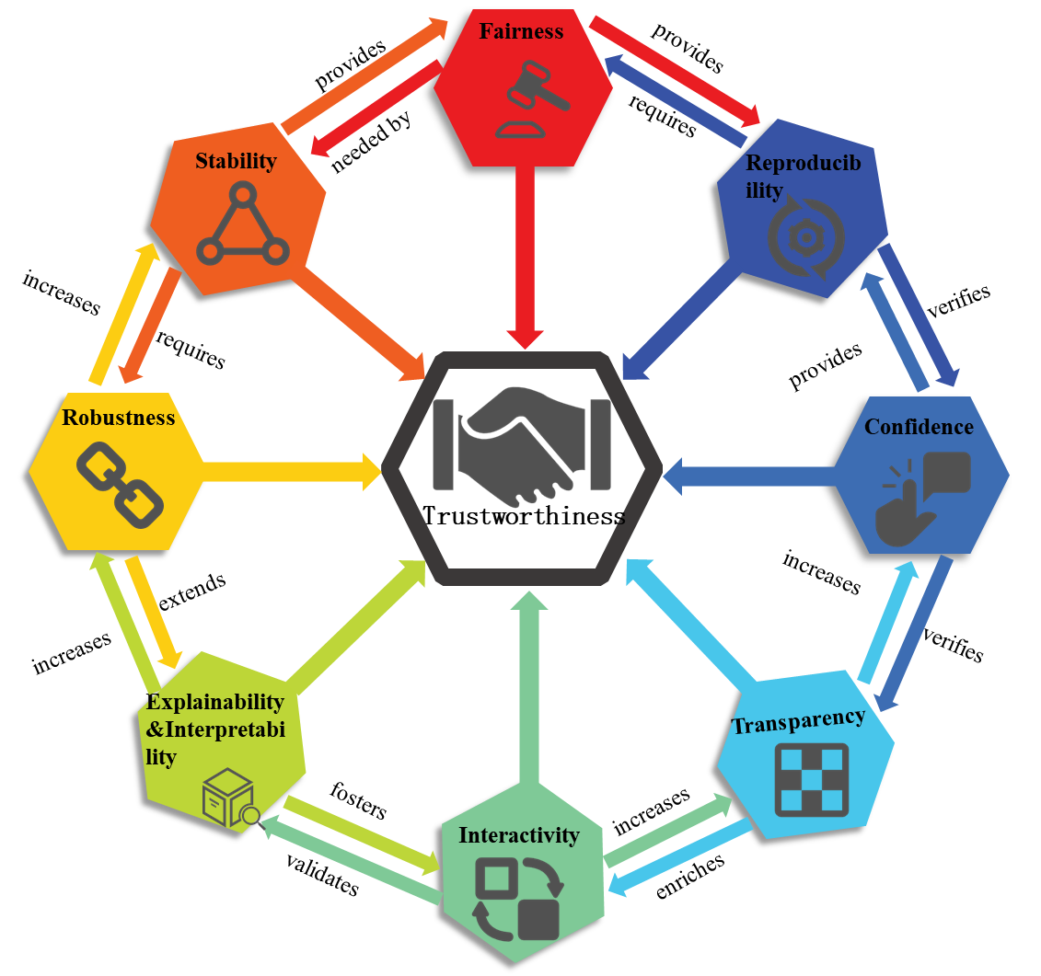
Fig. 2. Interconnectedness of individual goal concepts through interpretability to achieve multiple goals. Inspired by[11].
- Different scopes of AI interpretability: a categorization of approaches
Interpretability lacks a unified definition [5],with different researchers emphasizing different aspects. In this paper, interpretability is defined as 'the ability of users to understand and trace the process by which a model generates outputs from input data." Based on processing methods and temporal nodes, this paper classifies interpretability methods into a pre-hoc interpretability and post-hoc interpretability. Among these, post-hoc interpretability is further divided into perturbation-based methods and backpropagation-based methods according to the attribution of decision characteristics. The attributes of these methods are presented in Table 1.
Table 1. Properties of various interpretation methods.
Interpretation Methods | Pre-hoc | Post-hoc | Perturbation | Backpropagation | Global | Local
Bayesian Rule Lists[12]
Generalized Additive Model[13][14]
neural additive models[15]
SHapley Additive exPlanations[16][17]
Prediction Difference Analysis[18]
Randomized Input Sampling for Explanation[19]
Influence Function[20][21]
Activation Maximization[22]
Class Activation Mapping[23][24]
Gradient-weighted Class Activation Mapping[25]
2.1 Pre-hoc interpretability
Pre-hoc interpretability refers to the integration of comprehensible designs into the model construction and training phases, which endows the model itself with interpretability.
The decision tree model partitions data based on a tree-like structure and generates predictions from the root node to leaf nodes through hierarchical decision-making. It features fast computation speed, easy-to-understand results, and robustness. The Bayesian rule lists(BRL) proposed by Letham et al. [12] generates "If…Then…" decision lists by sampling pre-mined rules. Although they exhibit excellent interpretability, their parameter selection requires manual adjustment.
The generalized additive model (GAM) is a nonparametric regression model that typically uses spline functions to fit the relationships between independent variables and the dependent variable [13], while accounting for the interactive effects among multiple independent variables. Its form is expressed as follows:
(1)
Herein, ${\text{f}}_{\text{i} }$denotes a univariate function satisfiying $\text{E}{\text{(}\text{f}}_{\text{i}}\text{)=0}$.GAM employs non-parametric functions to fit the relationship between independent and dependent variables.In contrast, GA²M(Generalized Additive Model with Pairwise Interactions) incorporates pairwise interaction effects between variables, thereby enhancing the model's capability to characterize complex relationships. To improve accuracy, integrating pairwise interactions into GAM yields GA²M , whose mathematical form is given by:
(2)
Caruana et al. [14] applied GA²M to pneumonia risk prediction, achieving state-of-the-art performance while preserving interpretability. Traditional GAM models typically use smooth low-order splines to fit shape functions; to address this limitation, Agarwal et al. [15] proposed Neural Additive Models (NAM). NAMs retain the inherent interpretability of GAMs while leveraging the expressive power of deep neural networks to learn shape functions. Table 2 summarizes the relevant studies on pre-hoc interpretability methods.
Table 2. Overview of pre-hoc interpretability methods.
Method | Methods of interpretation | Advantages and disadvantages | Evaluation criteria
BRL | Combine a priori knowledge and data to obtain a posteriori probabilities to estimate the unknown parameters | Can analyze a priori knowledge with new data, but requires data to conform to a distribution | Highly accurate Interpretable
GAM | Predictor variables are transformed by a nonparametric smooth function before summing the function values | Fit nonparametric relationships, but is computationally intensive | Robust and highly interpretable
NAM | Prediction by learning linear combinations of neural networks | Capable of handling nonlinear problems, but more parameters need to be adjusted | Accuracy  Flexibility
2.2 Post-hoc interpretability
Post-hoc interpretability refers to the use of external methods (which are not embedded within the model itself) to explain a model’s reasoning process and results after training. In this section, explanation methods are classified into perturbation-based methods and backpropagation-based methods according to the attribution of decision characteristics.
2.2.1 Interpretation methods based on perturbations
Perturbation-based interpretability methods explore a model’s sensitivity to and dependence on different features by perturbing inputs, thereby revealing its working principles and decision-making bases.
The SHapley Additive Explanations (SHAP) method is based on the Shapley value—a game theory concept proposed by economist Lloyd Shapley[16]. Lundberg et al. [17] utilized SHAP to calculate differences in model outputs by perturbing features, thereby evaluating the influence of features. SHAP assigns a specific importance value to each feature, which is expressed as:
(3)
Herein, represents the feature attribute of the i-th feature,
Prediction Difference Analysis (PDA) [18] assesses the impact of input features on the model by systematically altering these features:
(4)
This method calculates the weight of feature i by comparing class probabilities and ,significantly enhancing model interpretability. Building upon PDA, the Randomized Input Sampling for Explanation (RISE) method, proposed by Petsiuk et al. [19] expands the explanation scope. The formula for calculating the saliency score in the RISE algorithm is as follows:
(5)
The RISE method exhibits high computational complexity.This is due to the generation of numerous random masks and the calculation of model outputs. In contrast, the influence function improves computational efficiency by calculating the inverse of the Hessian matrix via efficient numerical methods [20], and it does not require model retraining. Koh et al. [21] utilized the influence function to measure the impact of training instances on model parameters and predictions:
(6)
Herein,denotes the optimal parameters; L(·) represents the loss function;and is a positive definite Hessian matrix.Table 3 summarizes the relevant studies on perturbation-based explanation methods.
Table 3. Overview of perturbation-based explanation methods.
Method | Global / Local | Methods of interpretation | Advantages and disadvantages | Evaluation criteria
SHAP | G/L | Interpretation by assigning an importance value to each feature value | Suitable for complex models but poorly handles interaction - term datasets. | Understandability
PDA | L | By quantifying the contribution of features to category prediction, presented in a visual way. | Considers multiple features simultaneously, but accuracy depends on the classifier. | Predictive Accuracy
RISE | L | The extent to which each pixel contributes to the model is estimated by randomly masking the pixels of the input image and recording the response of the model. | The concept hierarchy and semantic network can be updated at any time, but the matching accuracy is too demanding. | Generalizability, Interpretability
Influence function | L | Identify the most responsible training points by learning algorithms back to the training data. | High accuracy but high data quality requirements. | Systematic

2.2.2 Interpretation methods based on backpropagation
Backpropagation is a gradient - descent - based algorithm in deep learning that updates network parameters by propagating the loss function’s gradient via the chain rule.
Erhan et al. [22] proposed the Activation Maximization (AM) method, which searches the input space via gradient ascent to visualize the response features of high-level units in the network. Erhan formulated an optimization problem: given $\text{θ}$ as the model parameters and ${\text{z}}_{\text{ij}}\text{(}\text{θ}\text{,}\text{x}\text{)}$ as the activation of unit j in layer i ,the activation map is defined as follows(with $\text{θ}$ fixed):
(7)
Compared with the AM (Activation Maximization) method, which requires multiple forward propagations, the Class Activation Mapping (CAM) method [23] can generate a class activation map and localize discriminative regions with only a single forward propagation. The CAM method replaces fully connected layers (excluding the final softmax layer) in traditional CNNs with a global average pooling layer. By projecting the weights ${\text{w}}_{\text{k}}^{\text{c}}$ of the output layer onto the output feature maps ${\text{F}}^{\text{k}}$ of the last convolutional layer, it generates a class saliency map with the same size as the input image to localize the important regions in the input sample that distinguish classes. The finally calculated class saliency map is denoted as ${\text{L}}^{\text{c}}$[24]:
${\text{L}}_{\text{ij}}^{\text{c}}\text{=}\sum_{\text{k}}{{\text{ω}}_{\text{k}}^{\text{c}}{\text{F}}_{\text{ij}}^{\text{k}}}$ (8)
To apply the CAM algorithm to general networks, Gradient-Weighted Class Activation Mapping (Grad-CAM) was proposed [25]. This method integrates gradient information with feature maps: by calculating the gradients of the target class with respect to each feature map in the last convolutional layer, and performing global average pooling on these gradients, the importance weights of each feature map are obtained:
(9)
Here, Z denotes the number of pixels in the feature map, used to derive the importance weight of each feature map, and $y^{c}$ represents the score for class c. Table 4 summarizes the relevant studies on backpropagation-based explanation methods.
Table 4. Overview of backpropagation-based methods.
Method | Global / Local | Methods of interpretation | Advantages and disadvantages | Evaluation criteria
AM | L | Maximizes a cell’s activation via input pattern optimization to obtain its "visual" representation. | It is widely applicable, but requires iterative optimization, making it more computationally expensive. | Explainability  Stability
CAM | L | Map the categorization layer weights back to the feature map to generate the category activation map. | Better able to determine the overall scope of the target object, but has some limitations on the network structure. | Explainability
Grad-CAM | L | Using the gradient output from the model in the last convolutional layer, the class activation map is obtained by weighted summation | Computationally efficient but fails to reflect the model’s overall behavior. | Model fidelity
This paper provides a systematic review and comparison of model explanation methods, encompassing both pre - hoc and post - hoc interpretability. Currently, the research community is dedicated to designing models with superior performance, enhanced reliability, and higher efficiency [26].By integrating human knowledge to improve data annotation and decision - making processes [27][28][29],and incorporating external knowledge in human - computer interaction frameworks [30][31],these approaches significantly enhance model adaptability and robustness in complex scenarios—even though they may potentially slow down the learning process [32].Collectively, these studies are driving a fundamental shift in artificial intelligence from pure performance optimization to an interpretability - driven research paradigm.

- Applications of XAI
In the field of geotechnical engineering, the application of XAI not only integrates abstract theories with engineering practice, but also gains in-depth insights into the unique demands of geotechnical engineering for AI, enhances users' trust in AI systems, and verifies the effectiveness and practicality of AI technologies. The specific applications of XAI in geotechnical engineering are elaborated as follows.
  - Rock mass identification
Lithology identification is crucial for geological exploration and resource development. Traditional manual observation and laboratory analysis incur high costs. To address this, Lin et al. [33] constructed a VGG-based classifier for the task.They used feature maps generated by the convolutional neural network to explain the features extracted by the model from original images, further improving the identification accuracy and interpretability.Antonini et al. [34] developed a Random Forest-based prediction model, which classifies mafic and ultramafic rocks intercepted by drill cores using geochemical parameters. The results show that the model's accuracy ranges from 86% to 94%. The model's interpretability was enhanced by quantifying input attribute importance via SHAP.
  - Rock mass blasting
To better study rock blasting, Gebretsadik et al. [35] focus on rock fragmentation. A method for optimizing fragmentation prediction was developed using four models: Random Forest Regression, Support Vector Regression, XGBoost, and Neural Network Regression. The results show that Random Forest Regression exhibits the best performance, with a coefficient of determination (R²) reaching 0.94. Furthermore, the model's interpretability was enhanced through explanations using permutation importance, partial dependence plots, and SHAP values.To address low prediction accuracy and poor applicability in traditional rock blasting mean fragmentation size prediction, Huan et al. [36] proposed a hybrid prediction model (NRBO-CNN-LSSVM). This model integrates Convolutional Neural Networks (CNN), Least Squares Support Vector Machines (LSSVM), and the Newton-Raphson Optimizer (NRBO). They enhanced the model's reliability through data preprocessing steps such as Random Forest (RF) feature selection and Isolation Forest (IForest) outlier removal. Meanwhile, an interactive Graphical User Interface (GUI) was developed to provide mining engineers with a convenient tool for optimizing blasting parameters. Additionally, by leveraging SHAP to quantify the global and local contributions of features, and Partial Dependence Plots to visualize the trend of relationships between features and fragmentation size, the contribution of each input feature to the model's prediction results was clarified.
  - Geotechnical mechanical parameter prediction
The complexity, heterogeneity, and nonlinear characteristics of rock structures make rock parameter evaluation a major challenge in the engineering field. Ding et al. [37] employed an approach integrating advanced deep learning models (including Convolutional Neural Networks, Gated Recurrent Units, Long Short-Term Memory, and Recurrent Neural Networks) to predict rocks’ Uniaxial Compressive Strength and Tensile Strength. These models can effectively capture complex non-linear relationships in input data; among them, the Long Short-Term Memory model performs best. Meanwhile, the SHAP method was used to analyze the influence mechanism of key parameters, thereby providing interpretability for the model.Hu et al. [38] used machine learning to predict rocks’ compressive strength after high - temperature exposure, and employed the AdaBoost - CART model to explain input parameter importance for prediction results, further enhancing interpretability.

4.Discussion and outlook
To analyze the research status of XAI, this study explores its interpretability through a literature review. The review indicates that XAI, as a rapidly evolving research field, is dedicated to enhancing the comprehensibility and transparency of AI systems to address the transparency and trust issues arising from their growing prevalence. In this review, we discuss the conceptual definition of interpretability and reclassify existing interpretability methods. It is pointed out that numerous methods exist, but they vary in interpretive perspectives and effects. Most focus on data-level or visualization approaches, lacking multi-dimensional interpretive capabilities. Additionally, the application scope of interpretive methods needs to be expanded to support both local and global explanations, as demonstrated by the SHAP method.

The review also reveals that XAI shows potential in interdisciplinary collaboration, and its application in geotechnical engineering has proven its value. However, XAI is still in its infancy in constructing fully transparent AI systems, and there is a gap from achieving comprehensive and effective applications. Based on this, we propose key directions for future research:
I. Enhancing User Experience
1.Improving interpretation accuracy to ensure consistency between explanations and the actual decision-making process of AI, and enabling traceability of sources;
2.Achieving real-time interpretation capabilities, especially in fast-decision-making fields such as autonomous driving and medical diagnosis;
Developing multimodal interpretation technologies to meet the needs of different users.
II. Cross-disciplinary Integration
1.Exploring the potential of XAI to enhance decision-making processes in various fields;
2.Developing and conducting detailed evaluations of explainable methods for practical problems in industries such as healthcare, finance, and law.

5.Conclusion
As artificial intelligence technologies increasingly shape user decision-making, the demand for trust in these systems has reached critical importance. This paper presents an overview of XAI, encompassing its fundamental concepts and methodological classifications (including evaluation frameworks), while identifying future development trends in XAI. By analyzing research directions in XAI, this work aims to provide theoretical support for the sustainable advancement of AI technologies. Notably, reliability, interpretability, and trustworthiness have emerged as pivotal metrics for evaluating AI's value. Constructing trustworthy AI systems necessitates collaborative efforts across diverse sectors to drive their research, development, and widespread adoption.

Declaration of Competing Interest
The authors declare that they have no known competing financial interests or personal relationships that could have appeared to influence the work reported in this paper.

Disclaimer (Artificial intelligence)

Option 1:

Author(s) hereby declare that NO generative AI technologies such as Large Language Models (ChatGPT, COPILOT, etc.) and text-to-image generators have been used during the writing or editing of this manuscript.

Option 2:

Author(s) hereby declare that generative AI technologies such as Large Language Models, etc. have been used during the writing or editing of manuscripts. This explanation will include the name, version, model, and source of the generative AI technology and as well as all input prompts provided to the generative AI technology

Details of the AI usage are given below:
1.Using Doubao (developed by ByteDance), a large-language model, to conduct linguistic refinement, including grammatical correction, translational accuracy verification, and academic writing polishing, for the manuscript’s English.
2.
3.

Reference
- Lei T, Barzilay R, Jaakkola T. Rationalizing neural predictions[J]. arxiv preprint arxiv:1606.04155, 2016.
- Preece A, Harborne D, Braines D, et al. Stakeholders in explainable AI[J]. arxiv preprint arxiv:1810.00184, 2018.
- Véliz C, Prunkl C, Phillips-Brown M, et al. We might be afraid of black-box algorithms[J]. Journal of Medical Ethics, 2021, 47(5): 339-340.
- Dzindolet M T, Peterson S A, Pomranky R A, et al. The role of trust in automation reliance[J]. International journal of human-computer studies, 2003, 58(6): 697-718.
- Lipton Z C. The mythos of model interpretability: In machine learning, the concept of interpretability is both important and slippery[J]. Queue, 2018, 16(3): 31-57.
- Castelvecchi D. Can we open the black box of AI?[J]. Nature News, 2016, 538(7623): 20.
- Dombrowski A K, Alber M, Anders C, et al. Explanations can be manipulated and geometry is to blame[J]. Advances in neural information processing systems, 2019, 32.
- Guidotti R, Monreale A, Ruggieri S, et al. A survey of methods for explaining black box models[J]. ACM computing surveys (CSUR), 2018, 51(5): 1-42.
- Ribeiro M T, Singh S, Guestrin C. " Why should i trust you?" Explaining the predictions of any classifier[C]//Proceedings of the 22nd ACM SIGKDD international conference on knowledge discovery and data mining. 2016: 1135-1144.
- Gunning D, Stefik M, Choi J, et al. XAI—Explainable artificial intelligence[J]. Science robotics, 2019, 4(37): eaay7120.
- Rojat T, Puget R, Filliat D, et al. Explainable artificial intelligence (xai) on timeseries data: A survey[J]. arxiv preprint arxiv:2104.00950, 2021.
- Letham B, Rudin C, McCormick T H, et al. Interpretable classifiers using rules and bayesian analysis: Building a better stroke prediction model[J]. 2015.
- Hastie T J. Generalized additive models[J]. Statistical models in S, 2017: 249-307.
- Caruana R, Lou Y, Gehrke J, et al. Intelligible models for healthcare: Predicting pneumonia risk and hospital 30-day readmission[C]//Proceedings of the 21th ACM SIGKDD international conference on knowledge discovery and data mining. 2015: 1721-1730.
- Agarwal R, Melnick L, Frosst N, et al. Neural additive models: Interpretable machine learning with neural nets[J]. Advances in neural information processing systems, 2021, 34: 4699-4711.
- Clement T, Nguyen H T T, Kemmerzell N, et al. Co** with data distribution shifts: Xai-based adaptive learning with shap clustering for energy consumption prediction[C]//Australasian Joint Conference on Artificial Intelligence. Singapore: Springer Nature Singapore, 2023: 147-159.
- Lundberg S M, Lee S I. A unified approach to interpreting model predictions[J]. Advances in neural information processing systems, 2017, 30.
- Zintgraf L M, Cohen T S, Adel T, et al. Visualizing deep neural network decisions: Prediction difference analysis[J]. arxiv preprint arxiv:1702.04595, 2017.
- Petsiuk V, Das A, Saenko K. Rise: Randomized input sampling for explanation of black-box models[J]. arxiv preprint arxiv:1806.07421, 2018.
- Cook R D, Weisberg S. Characterizations of an empirical influence function for detecting influential cases in regression[J]. Technometrics, 1980, 22(4): 495-508.
- Koh P W, Liang P. Understanding black-box predictions via influence functions[C]//International conference on machine learning. PMLR, 2017: 1885-1894.
- Erhan D, Courville A, Bengio Y. Understanding representations learned in deep architectures[J]. Department dInformatique et Recherche Operationnelle, University of Montreal, QC, Canada, Tech. Rep, 2010, 1355(1): 69.
- Zhao G, Zhou B, Wang K, et al. Respond-cam: Analyzing deep models for 3d imaging data by visualizations[C]//International Conference on Medical Image Computing and Computer-Assisted Intervention. Cham: Springer International Publishing, 2018: 485-492.
- Zhou B, Khosla A, Lapedriza A, et al. Learning deep features for discriminative localization[C]//Proceedings of the IEEE conference on computer vision and pattern recognition. 2016: 2921-2929.
- Selvaraju R R, Das A, Vedantam R, et al. Grad-CAM: Why did you say that?[J]. arxiv preprint arxiv:1611.07450, 2016.
- Weber L, Lapuschkin S, Binder A, et al. Beyond explaining: Opportunities and challenges of XAI-based model improvement[J]. Information Fusion, 2023, 92: 154-176.
- Zaidan O, Eisner J, Piatko C. Using “annotator rationales” to improve machine learning for text categorization[C]//Human language technologies 2007: The conference of the North American chapter of the association for computational linguistics; proceedings of the main conference. 2007: 260-267.
- Hendricks L A, Burns K, Saenko K, et al. Women also snowboard: Overcoming bias in captioning models[C]//Proceedings of the European conference on computer vision (ECCV). 2018: 771-787.
- Zhang Y, Marshall I, Wallace B C. Rationale-augmented convolutional neural networks for text classification[C]//Proceedings of the Conference on Empirical Methods in Natural Language Processing. Conference on Empirical Methods in Natural Language Processing. 2016, 2016: 795.
- Judah K, Fern A, Dietterich T G. Active Imitation Learning via Reduction to IID Active Learning[C]//AAAI Fall Symposium: Robots Learning Interactively from Human Teachers. 2012.
- Shivaswamy P, Joachims T. Coactive learning[J]. Journal of Artificial Intelligence Research, 2015, 53: 1-40.
- Finlay C, Oberman A M. Scaleable input gradient regularization for adversarial robustness[J]. Machine Learning with Applications, 2021, 3: 100017.
- Bai, L., Wei, X., Liu, Y., et al. (2019). Rock thin section image recognition based on the VGG model[J]. Geological Bulletin of China, 38(12), 2053-2058.( Chinese)
- Antonini A S, Tanzola J, Asiain L, et al. Machine Learning model interpretability using SHAP values: Application to Igneous Rock Classification task[J]. Applied Computing and Geosciences, 2024, 23: 100178.
- Gebretsadik A, Kumar R, Fissha Y, et al. Enhancing rock fragmentation assessment in mine blasting through machine learning algorithms: a practical approach[J]. Discover Applied Sciences, 2024, 6(5): 223.
- Huan B, Li X, Wang J, et al. An interpretable deep learning model for the accurate prediction of mean fragmentation size in blasting operations[J]. Scientific Reports, 2025, 15(1): 11515.
- Ding X, Hasanipanah M, Rezaei M. Assessment of mechanical properties of rock using deep learning approaches[J]. Measurement, 2025, 250: 117180.
- Hu X, Shentu J, Xie N, et al. Predicting triaxial compressive strength of high-temperature treated rock using machine learning techniques[J]. Journal of Rock Mechanics and Geotechnical Engineering, 2023, 15(8): 2072-2082.

