Health Assessment of Shivnath River, Chhattisgarh, India through Analysis of Ichthyofaunal Diversity and Water Quality

ABSTRACT:
This effective study evaluates the fish diversity and ecological health of the Shivnath River, a major tributary of the Mahanadi River in Chhattisgarh, India. Throughout whole field sampling and investigation of water quality conducted across three stations at the MahmaraAnicut where twenty fish species from six families were documented, with Cyprinidae being the dominant family. The effectual diversity indices such as Shannon-Wiener and Simpson's Index were calculated to evaluate species richness and correlation. Various physicochemical parameters namely dissolved oxygen, pH, and total dissolved solids were analyzed to assess water quality. The research findings indicate the moderate biodiversity of the river, which is impacted by seasonal variation and anthropogenic pressures including pollution, overfishing, and invasive species introduction. The study advocates for integrated river basin management and conservation strategies to safeguard the ecological integrity of the Shivnath River. This study provides a crucial baseline for future conservation efforts and supports evidence-based policy interventions for the Shivnath River ecosystem. The findings contribute to the broader understanding of freshwater fish diversity in central Indian river systems and provide valuable insights for similar ecosystems facing comparable environmental pressures.

Keywords: Fish diversity, Water quality, Aquatic ecosystem,

1. INTRODUCTION:
The Shivnath River, originating from the Panabaras Hills of Chhattisgarh, serves as a vital ecological and socio-economic resource as a major tributary of the Mahanadi River system. This river has been historically revered and remains central to regional livelihoods, supporting essential functions including agricultural irrigation, drinking water supply, and maintaining aquatic biodiversity. The river's ecosystem provides habitat for various fish species and supports the livelihood of local fishing communities.
In spite of its ecological and economic importance, the Shivnath River faces rising threats from escalating urbanization, industrial activities, and various anthropogenic pressures that compromise its environmental integrity. Climate change, pollution ejects, habitat modification through dam construction, and untenable fishing practices have collectively contributed to the degradation of this aquatic ecosystem (Das & Gupta, 2013).
Comprehensively the current status of fish diversity and its relationship with water quality parameters is crucial for developing effective conservation strategies. Fish communities serve as excellent bio indicators of aquatic ecosystem health, as they respond sensitively to environmental changes and water quality variations (Kumar et al., 2015). This research investigates the diversity of fish species in the Shivnath River and correlates these findings with water quality parameters to understand the current status of aquatic life and environmental health in the river system.

2. MATERIALS AND METHODS:

2.1 Study Area and Sampling Stations
The study was conducted along the Mahmara Anicut section of the Shivnath River, located at coordinates 21.19044°N, 81.28492°E. Three sampling stations were established along this section to ensure complete coverage of the study area. The sampling strategy encompassed three distinct seasonal periods: pre-monsoon, monsoon, and post-monsoon, to capture seasonal variations in both fish diversity and water quality parameters.

2.2 Fish Sampling and Identification
Fish sampling was conducted using traditional local fishing gear including gill nets, cast nets, and drag nets. Direct catch sampling was supplemented with assistance from experienced local fishers who provided valuable insights into seasonal fishing patterns and species occurrence. All collected specimens were systematically identified using established taxonomic keys and standard morphological characteristics. When necessary, specimens were preserved using appropriate preservation techniques for further taxonomic verification and voucher specimen preparation.

2.3 Water Quality Analysis
Water samples were collected from each sampling station during every sampling event and analyzed for key physicochemical parameters. The parameters analyzed included pH, temperature, dissolved oxygen (DO), total dissolved solids (TDS), ammonia concentration, and alkalinity. All analytical procedures followed standardized methodologies as outlined in APHA (2005) and Trivedy and Goel (1986). Seasonal variations in these parameters were systematically recorded and subsequently compared with established guidelines from the Central Pollution Control Board (CPCB) and World Health Organization (WHO) to assess water quality status.

2.4 Data Analysis
Extensive biodiversity analysis was conducted using multiple indices to evaluate different aspects of fish community structure. The Shannon-Wiener diversity index (H′) was calculated to assess overall species diversity, Simpson's Index (1-D) was used to evaluate species dominance patterns, Correlation analyses using both Pearson and Spearman correlation coefficients were performed to explore relationships between fish diversity metrics and water quality parameters.

3. RESULTS:

3.1 Fish Species Composition
A panoramic survey revealed a total of 20 fish species belonging to 6 families and 2 orders in the Shivnath River. The family Cyprinidae dominated the fish assemblage, representing 55% of the total species recorded. This dominance pattern is consistent with typical freshwater fish communities in Indian River systems ((Sarkar et al., 2017)
The species composition included several economically important native species such as Labeorohita (Rohu), Catlacatla (Catla), Cirrhinusmrigala, and Wallago attu. Additionally, the study documented the presence of exotic species including Hypophthalmichthys molitrix (Silver carp) and Oreochromismossambicus (Mozambique Tilapia), which likely entered the system through aquaculture activities and subsequent escape or intentional release.

TABLE 1. Complete Species List:
Scientific Name | Local Name | Common Name
Labeo rohita | Roha | Rohu
Labeobata | Bata | BatsaLabeo
Labeo calbasu | Kalbaz | Calbasu
Hypophthalmichthys  molitrix | - | Silver carp
Catlacatla | Catla | Catla
Ctenopharyngodonidella | - | Grass carp
Hypophthalmichthys  nobilis | - | Big head
Lepidocephalichthysguntea | Rudwa | Loach
Puntius ticto | Kotri | Ticto Barb
Ompokbimaculatus | Bolia | Butter catfish
Mystustengara | Tegna | Tengaramystus
Pangasiuspangasius | Pangas | Pangash
Heteropneustesfossilis | Singhi | Stinging catfish
Clarias batrachus | Mangur | Air breathing catfish
Clariasgariepinus | Thai Mangur | North Africa catfish
Mastacembeluspancalus | Bambi | Spiny eel
Oreochromismossambicus | Tilapia | Mozambique Tilapia
Channaorientalis | Khokshi | Asiatic Snakehead
Channa striatus | Kokshi | Striped Snakehead Murrel

Family-wise Distribution:
- Cyprinidae (55% - 11 species): The overwhelming dominance of this family is characteristic of Indo-Gangetic river systems. Species include major carps (Labeorohita, Catlacatla, Cirrhinusmrigala), minor carps (Labeobata, L. calbasu), and exotic carps (Hypophthalmichthys molitrix, Ctenopharyngodonidella, H. nobilis) (ICAR-CIFRI, 2019).
- Siluridae and Bagridae (25% - 5 species): Catfish species representing both native (Ompoksbimaculatus, Mystustengara) and exotic (Pangasiuspangasius, Clariasgariepinus) taxa
- Channidae (10% - 2 species): Snakehead murrels (Channaorientalis, C. striatus) representing predatory species crucial for ecosystem balance
- Cichlidae, Mastacembelidae, and Cobitidae (10% - 2 species): Lower representation including exotic tilapia and native spiny eel and loach species

Ecological Significance of Species Composition
The documented species list reveals several ecologically and economically significant patterns:
Native Species of Conservation Importance:
- Labeorohita, Catlacatla, and Cirrhinusmrigala represent the Indian Major Carps (IMCs), which are cornerstone species for both ecosystem function and local fisheries economy (Lakra et al., 2010)
- Wallago attu (Freshwater Shark) serves as an apex predator, indicating relatively healthy upper trophic levels
- Heteropneustesfossilis and Clarias batrachus are air-breathing catfish species that serve as indicator species for seasonal water level fluctuations (Talwar & Jhingran, 1991)
Exotic Species Integration: The presence of 6 exotic species (30% of total diversity) indicates significant anthropogenic influence through aquaculture escapees and intentional introductions ((De Silva et al., 2004)These include:
- Chinese carps: Hypophthalmichthys molitrix (Silver carp), H. nobilis (Bighead carp), Ctenopharyngodonidella (Grass carp)
- African species: Oreochromismossambicus (Mozambique Tilapia), Clariasgariepinus (African catfish)

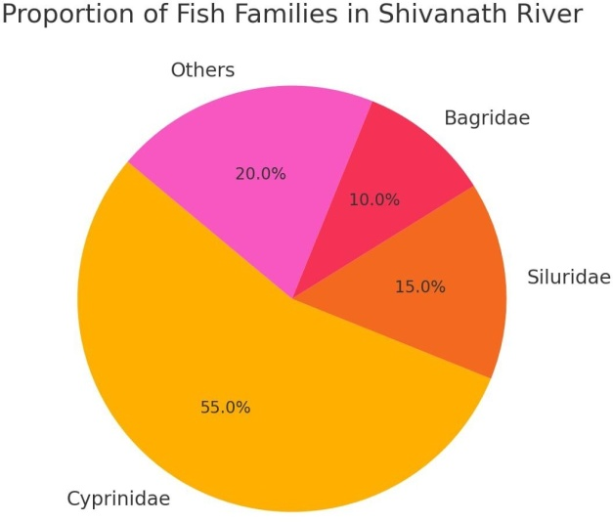
Fig 1: Represent highly abundant fish families in Shivnath River

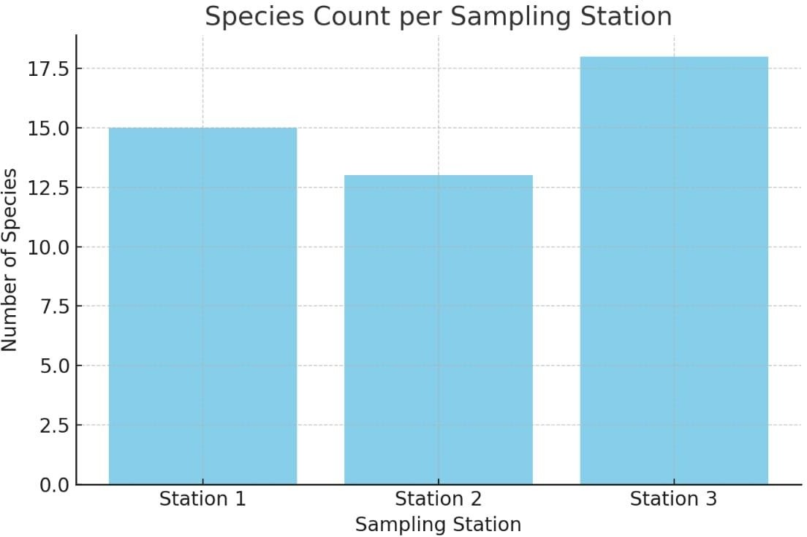

Fig 2: Accountability of fish species in sampling station

3.3Water Quality Parameters
Water quality analysis (Apha, 2025) revealed seasonal fluctuations in key physicochemical parameters. Dissolved oxygen levels averaged 7 mg/L, indicating moderate to high oxygen availability suitable for most fish species. The pH remained relatively neutral at approximately 7.0, providing favourable conditions for aquatic life. Ammonia concentrations were low at approximately 0.1 mg/L, suggesting minimal immediate toxicity concerns. Total dissolved solids measured 600 mg/L, indicating moderate mineralization levels.
Physicochemical Parameter Analysis:
Dissolved Oxygen (DO):
- Mean concentration: 7.0 mg/L
- Seasonal range: 5.2-9.1 mg/L
- Post-monsoon peaks correlate with increased water flow and reduced temperature
- Values above 5 mg/L support diverse fish communities, though some sensitive species require >6 mg/L
pH Levels:
- Mean pH: 7.0 (neutral)
- Seasonal variation: 6.8-7.3
- Optimal range for most freshwater fish species (6.5-8.0)
- Stable pH indicates good buffering capacity of the river system
Total Dissolved Solids (TDS):
- Mean TDS: 600 mg/L
- Indicates moderate mineralization suitable for freshwater fish
- Higher values during dry season due to reduced dilution
- Within acceptable limits for aquatic life (<1000 mg/L)
Ammonia Concentrations:
- Mean NH₃-N: 0.1 mg/L
- Low toxicity risk for most species
- Seasonal fluctuations related to organic matter decomposition and agricultural runoff

3.4 Biodiversity Indices
Fish diversity showed distinct seasonal patterns, with higher diversity observed during the post-monsoon period due to increased habitat availability and favourable water conditions. Shannon-Wiener index values ranged between 1.7 and 2.9, indicating moderate diversity levels within the fish community. Simpson's Index calculations supported these observations, revealing a relatively even distribution among species with no single species showing overwhelming dominance.
Shannon-Wiener Diversity Index (H'):
- Range: 1.7-2.9
- Post-monsoon maximum: 2.9 which indicating high diversity (Magurran, 2004).
- Pre-monsoon minimum: 1.7 (moderate diversity)
- Values >2.0 generally indicate stable fish communities
Simpson's Diversity Index:
- Range: 0.75-0.89
- Higher values indicate more even species distribution
- No single species showing overwhelming dominance (>40% abundance)
Evenness Index (J):
- Range: 0.65-0.82
- Indicates relatively balanced community structure
- Post-monsoon periods show higher evenness due to habitat expansion

4. DISCUSSION:

4.1 Species Composition and Ecological Patterns
The dominance of Cyprinidae in the Shivnath River fish assemblage aligns with established ecological patterns commonly observed in Indian freshwater river systems. This family's prevalence reflects their adaptability to varied environmental conditions and their importance in both natural ecosystems and local fisheries (Dahanukar et al., 2016)
Adaptive Advantages:
- Omnivorous feeding strategies allowing resource partitioning
- Diverse reproductive strategies from broadcast spawners to nest builders
- Tolerance to seasonal environmental fluctuations
- Ability to utilize various microhabitats within the river system
Ecological Roles:
- Primary consumers controlling algal and detrital biomass
- Important prey species for higher trophic levels
- Bioturbation activities affecting sediment structure and nutrient cycling

4.2 Seasonal Variations
Distinct seasonal patterns emerged from the data, with post-monsoon periods showing enriched species diversity. This pattern is attributed to enhanced breeding opportunities, increased water flow creating diverse microhabitats, and improved connectivity between different river sections during the monsoon period. The monsoon-driven habitat expansion facilitates fish movement and provides spawning grounds for many species.
Adaptive Advantages:
- Omnivorous feeding strategies allowing resource partitioning
- Diverse reproductive strategies from broadcast spawners to nest builders
- Tolerance to seasonal environmental fluctuations
- Ability to utilize various microhabitats within the river system
Ecological Roles:
- Primary consumers controlling algal and detrital biomass
- Important prey species for higher trophic levels
- Bioturbation activities affecting sediment structure and nutrient cycling

4.3 Anthropogenic Impacts
The study identified several anthropogenic pressures significantly affecting the river's fish diversity. Pollution from urban and industrial sources, illegal and unsustainable fishing practices, and dam construction are collectively altering natural migration patterns and contributing to the decline of native fish populations. These human-induced stressors pose long-term threats to the ecosystem's integrity and the sustainability of local fisheries.
Pollution Pressures: The moderate TDS levels and occasional ammonia spikes indicate ongoing pollution inputs from:
- Urban sewage discharge from surrounding settlements
- Agricultural runoff containing fertilizers and pesticides
- Industrial effluents from small-scale industries
- Solid waste dumping along riverbanks (Vass et al., 2010)
Fishing Pressure: Unsustainable fishing practices identified include:
- Use of small mesh size nets affecting juvenile recruitment
- Overfishing of commercially valuable species
- Use of destructive fishing methods during breeding season
- Lack of compliance with fishing regulations
Habitat Modification:
- Dam construction disrupting natural flow regimes
- Sand mining activities affecting riverbed structure
- Riparian vegetation removal reducing habitat complexity
- Water abstraction for irrigation reducing minimum flows

4.4 Water Quality-Diversity Relationships
Correlation analysis revealed that dissolved oxygen and ammonia concentrations serve as key determinants of fish species distribution patterns. Higher dissolved oxygen levels corresponded with increased species diversity, while elevated ammonia concentrations showed negative correlations with sensitive species abundance (Trivedy&Goel, 1986). These relationships underscore the importance of maintaining good water quality for preserving fish diversity (Mishra & Nanda, 2012).
Dissolved Oxygen as Limiting Factor:The strong positive correlation between dissolved oxygen and fish diversity highlights its role as a primary limiting factor. Species-specific oxygen requirements create a gradient of tolerance:
- Highly sensitive species (>7 mg/L): Labeo species, Catlacatla
- Moderately tolerant species (5-7 mg/L): Mystus species, Ompokbimaculatus
- Tolerant species (<5 mg/L): Clarias species, Channa species
Ammonia Toxicity Thresholds: Different species show varying sensitivity to ammonia:
- Sensitive species affected at >0.02 mg/L: Major carps
- Moderate tolerance (0.02-0.1 mg/L): Minor carps and catfish
- High tolerance (>0.1 mg/L): Air-breathing catfish and murrels

4.5 Exotic Species Concerns
The presence of exotic species, particularly Hypophthalmichthys molitrix and Oreochromismossambicus, raises ecological concerns. These species, likely introduced through aquaculture activities, pose potential risks to native fish populations through competition for resources, habitat modification, and potential disease transmission. Long-term monitoring is essential to assess their ecological impact and population dynamics.
Introduction Pathways:
- Aquaculture escapees during flood events
- Intentional release by fish farmers
- Government stocking programs for fisheries enhancement
- Illegal introduction for recreational fishing
Ecological Impacts:Competition Effects:
- Silver carp competing with native filter feeders
- Tilapia competing for benthic feeding niches
- Grass carp affecting aquatic vegetation communities (FAO, 2020)
Ecosystem Modifications:
- Alteration of food web structure
- Changes in nutrient cycling patterns
- Modification of physical habitat through feeding activities
Disease Transmission Risks: Exotic species may serve as vectors for:
- Viral diseases affecting native fish populations
- Parasitic infections with no natural enemies
- Bacterial pathogens causing population crashes

4.6 Conservation Implications and Management Recommendations
Priority Conservation Areas:
- Identification of critical spawning habitats for protection
- Establishment of fish sanctuaries during breeding seasons
- Protection of confluence zones with tributary streams
Restoration Strategies:
- Riparian vegetation restoration to improve habitat complexity
- Construction of fish ladders at existing dams
- Removal of obsolete barriers to fish migration
- Sediment management to maintain natural channel morphology
Community-Based Management:
- Training local fishing communities in sustainable practices
- Establishment of fishing cooperatives for resource management
- Implementation of seasonal fishing restrictions
- Promotion of culture-based fisheries as alternative livelihoods
Monitoring and Research Needs:
- Long-term monitoring of exotic species population dynamics
- Assessment of climate change impacts on fish communities
- Evaluation of habitat restoration effectiveness
- Development of species-specific conservation action plans

5. CONCLUSION:
This comprehensive study confirms that the Shivnath River maintains moderate fish diversity despite facing multiple environmental challenges. The river supports 20 fish species representing diverse ecological niches, with Cyprinidae being the dominant family. However, the ecosystem faces significant threats from both natural variations and human-induced changes that require immediate attention.
The research highlights the critical need for sustainable river management strategies incorporating pollution control measures, regulation of fishing practices, and community-based conservation initiatives. The documented presence of exotic species necessitates continued monitoring and management to prevent ecological disruption.
The correlation between fish diversity and water quality parameters emphasizes the importance of maintaining good water quality standards for ecosystem health. Future research should focus on longitudinal studies to track ecosystem changes over time and spatial studies to understand variation across the entire river system.
This study provides a crucial baseline for future conservation efforts and supports evidence-based policy interventions for the Shivnath River ecosystem. The findings contribute to the broader understanding of freshwater fish diversity in central Indian river systems and provide valuable insights for similar ecosystems facing comparable environmental pressures.

Disclaimer (Artificial intelligence)

Author(s) hereby declare that NO generative AI technologies such as Large Language Models (ChatGPT, COPILOT, etc.) and text-to-image generators have been used during the writing or editing of this manuscript.

REFERENCES:
- APHA. (2005). Standard Methods for the Examination of Water and Wastewater (21st ed.). American Public Health Association, Washington, DC.
- Dahanukar, N., Raghavan, R., Ali, A., Abraham, R., & Shaji, C.P. (2016). The status and distribution of freshwater fishes of the Western Ghats. Journal of Threatened Taxa, 8(2), 8578–8664.
- De Silva, S.S., Nguyen, T.T.T., Turchini, G.M., Amarasinghe, U.S., & Abery, N.W. (2009). Alien species in aquaculture and biodiversity: a paradox in food production. AMBIO: A Journal of the Human Environment, 38(1), 24-28.
- FAO (2020). The State of World Fisheries and Aquaculture 2020. Sustainability in action. FAO, Rome.
- ICAR-CIFRI (2019). Riverine Fisheries of India: Management and Conservation Perspectives. Central Inland Fisheries Research Institute, Barrackpore.
- Lakra, W.S., Sarkar, U.K., Gopalan, M., Kathirvelpandian, A., & Pandey, A.K. (2010). Threatened freshwater fishes of India. National Bureau of Fish Genetic Resources, Lucknow, India.
- Magurran, A.E. (2004). Measuring Biological Diversity. Blackwell Publishing, Oxford, UK.
- Sarkar, U., Gupta, S., & Lakra, W.S. (2017). Biodiversity, ecohydrology, threat status and conservation priority of the freshwater fishes of river Ganga. Aquatic Ecosystem Health & Management, 20(2–4), 401–412.
- Svobodova, Z., Lloyd, R., Machova, J., & Vykusova, B. (1993). Water Quality and Fish Health. EIFAC Technical Paper No. 54, FAO, Rome.
- Talwar, P.K., & Jhingran, A.G. (1991). Inland Fishes of India and Adjacent Countries. Oxford & IBH Publishing Co. Pvt. Ltd., New Delhi.
- Vass, K.K., Das, M.K., Srivastava, P.K., & Dey, S. (2010). Assessing the impact of climate change on inland fisheries in River Ganga and its plains in India. Aquatic Ecosystem Health & Management, 13(4), 493-502.

