Opinion Article

Review of Comprehensive Assessment on Mechanical Properties of Water Conveyance Tunnel Linings

Abstract: To investigate the mechanical behavior of lining structures in water conveyance tunnels under complex working conditions, this study systematically examines the influence of key factors including buffer layer properties, drainage board layout, rheological characteristics of surrounding rock, segment assembly methods, and high internal water pressure on structural performance. Using typical project cases from various regions and combining theoretical analysis, numerical simulations, and field tests, the research demonstrates that under normal load conditions, the outer segments act as the main load-bearing component in double-layer linings, whereas the inner lining's load-bearing proportion increases to 30%-45% under sudden loads. Local installation of drainage boards causes cracks in self-compacting concrete to concentrate within the installation area. Rheological effects in the surrounding rock lead to a gradual increase in axial force in the segments during operation. The longitudinal stiffness of segments with staggered-joint assembly exceeds that of continuous-joint assembly, resulting in reduced stress on circumferential bolts. Under high internal water pressure, the load-sharing ratio of the surrounding rock increases with its elastic modulus. The findings of this review provide theoretical support for the optimized design and long-term safety assessment of lining structures in water conveyance tunnels.
Keywords: water conveyance tunnel; lining structure; mechanical characteristics; high internal water pressure
- Introduction
With the advancement of China's "Water Network" strategy, water conveyance tunnels, as critical structures for trans-regional water resource allocation, are developing toward greater burial depth, larger diameter, and higher internal water pressure. As the core load-bearing unit of tunnels, the lining structure must simultaneously withstand external water and soil pressure, internal water pressure, surrounding rock rheological loads, and construction disturbances. Its mechanical state directly determines engineering safety and service life^{[1-2]}.
Currently, numerous studies have been conducted by domestic and international scholars on the mechanical behavior of water conveyance tunnel linings: He Yitao et al.^{[3]} established a beam-spring model considering a flexible buffer layer, revealing the regulatory effect of buffer layer thickness on the internal force distribution of double-layer linings; Yang Zhao et al.^{[4]} proposed a solid composite model, addressing the limitation of traditional frame models that ignore the influence of pre-deformation of segments; Yang Guanghua et al.^{[5]} developed a load-structure interaction model to quantify the internal water pressure sharing ratio between surrounding rock and lining; Liu Yijie et al.^{[6]} analyzed the joint bearing mechanism of steel liner-concrete-surrounding rock after concrete cracking based on the complex variable function method; Wang Hanhui et al.^{[7]} employed a plastic damage multi-crack model to investigate the effect of drainage boards on lining crack development. However, most existing studies focus on single factors, and systematic analysis of lining mechanics under the coupling effects of multiple factors remains insufficient, particularly regarding the coupled influence of soft rock rheology and construction assembly methods^{[8]}.
Regarding lining defects and mechanical mechanisms: Ye Yichao et al.^{[9]} used the load-structure method to analyze the impact of different void conditions on tunnel safety; Zhang Qinghai et al.^{[10]} studied the effects of surrounding rock thickness on lining mechanics, crack propagation, and damage through finite element simulation; Li Xiangyu et al.^{[11]} statistically analyzed defect types and crack distributions based on measured data, combined with simulations to identify main controlling factors of cracks; She Lei et al.^{[12]} theoretically derived the sensitivity of materials, surrounding rock, and reinforcement to cracking characteristics. In terms of detection technology: Wu Bin et al.^{[13]} utilized intelligent robots to achieve comprehensive detection of surface defects in tunnels, highlighting the high risk, large errors, and long cycles associated with traditional methods; Su Kai et al.^{[14]} studied the bearing mechanism of steel-lined reinforced concrete pipelines from the perspectives of frictional contact and seepage-stress coupling. Regarding surrounding rock rheology and long-term mechanical behavior: Zhang Jiabing et al.^{[15]} studied layered phyllite's creep impact on tunnel deformation via tests and FLAC3D, revealing laws under different bedding dips. Song Yi et al.^{[16]} analyzed the time-dependent laws of lining internal forces and surrounding rock pressure through mudstone creep tests; Xue Xiaojie et al.^{[17]} built an ABAQUS model for Haizhu Bay super-large shield tunnel, analyzing grouting/jack effects on segments and identifying key deformation factors; Qian Wenxi et al.^{[18]} and Xu Guowen et al.^{[19]} studied the long-term safety and reinforcement timing of soft rock sections and cracked linings under rheological conditions, respectively.
This paper integrates research findings on the mechanical behavior of linings in typical domestic water conveyance tunnels, analyzing from three aspects: theoretical models, key influencing factors, and engineering validation. It reveals the mechanical laws of lining structures under different working conditions, providing references for engineering practice.
2. Lining Structure Types and Mechanical Theoretical Models for Water Conveyance Tunnels
2.1 Common Lining Structure Types:
Based on functional requirements and mechanical characteristics, water conveyance tunnel linings can be categorized into three main types. The double-layer lining consists of an outer shield segment layer and an inner layer of cast-in-place concrete or steel pipe, with a buffer layer in between. It accommodates stiffness differences between the inner and outer linings through nonlinear deformation and is suitable for conditions with high internal water pressure and stringent anti-seepage requirements. The composite lining adopts a "segment–self-compacting concrete–steel pipe" laminated system (as exemplified by the drainage board structure in the Pearl River Delta Water Resources Allocation Project), which utilizes multi-material collaboration to balance internal water pressure transmission and seepage resistance. In this system, the steel pipe bears 30%–40% of the internal water pressure, while the self-compacting concrete acts as a transition and anti-seepage layer. The permeable lining operates on the principle of "controlled leakage and mobilization of the self-supporting capacity of the surrounding rock" . After cracking, the reinforcement and surrounding rock share the load collectively, with leakage controlled by a grouting circle, allowing a reduction in lining thickness by 20%–30%.
2.2 Core Mechanical Theoretical Models:
(1) Thick-Walled Cylinder Model:
Based on the Lamé solution in elasticity theory, this model is suitable for axisymmetrically loaded homogeneous linings (e.g., steel pipes or monolithic concrete). It can derive the radial and hoop stresses of each layer. For a multi-layer structure such as "steel pipe–self-compacting concrete–segment," the relationship between interfacial contact pressure and internal forces is established through displacement compatibility conditions.
(2) Solid Composite Model:
To address the complexity of segment joints, a "solid element for segment simulation + simplified joint model " is adopted. Segment joints are connected via rigid bodies, with reference points located at the centroid of the segment cross-section. Shear springs and bending springs are set between two points to simulate the mechanical characteristics of the joints. The interaction between segments and surrounding rock is simulated using "hard contact + Coulomb friction" (friction coefficient 0.6). This model can consider stress release during the construction stage. In the case of the Qingcaosha Tunnel, the calculated maximum bending moment of the segments (1.10 × 10⁵ N·m) deviated by less than 5% from the measured value.
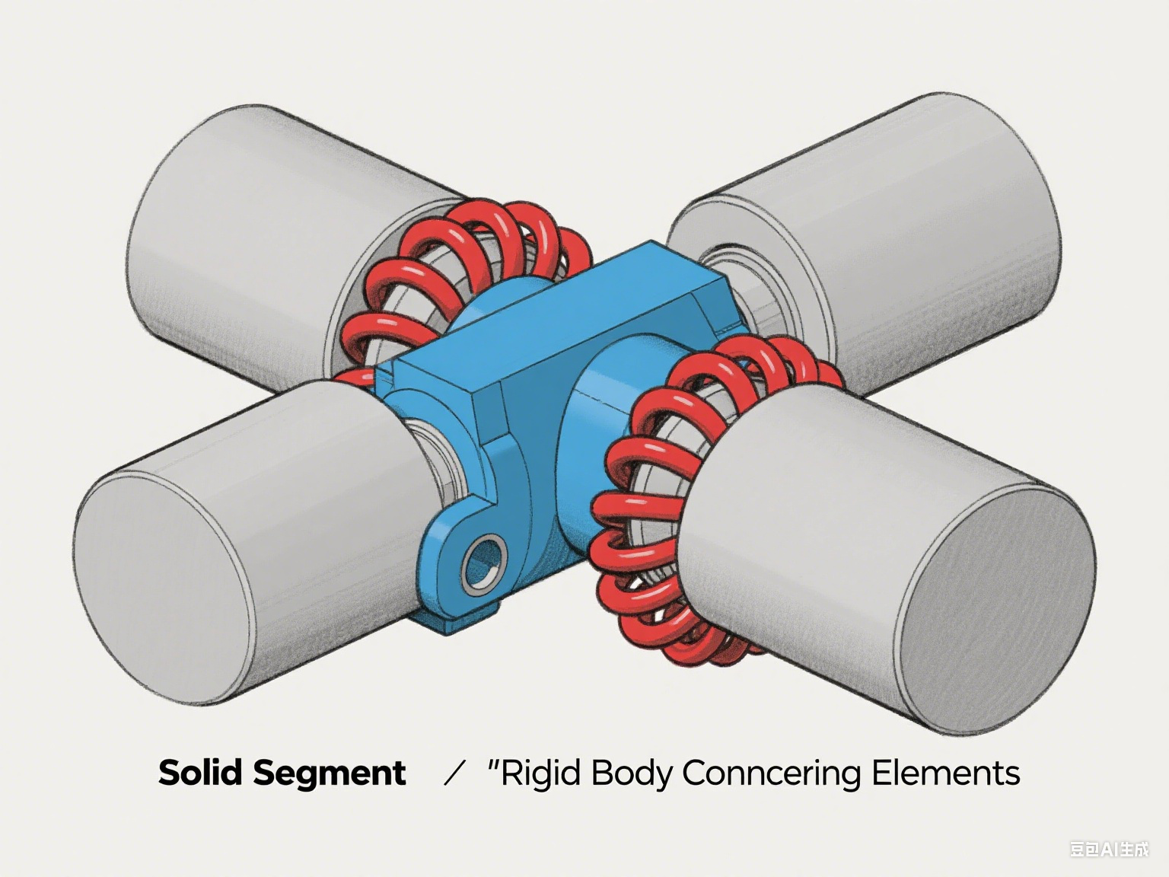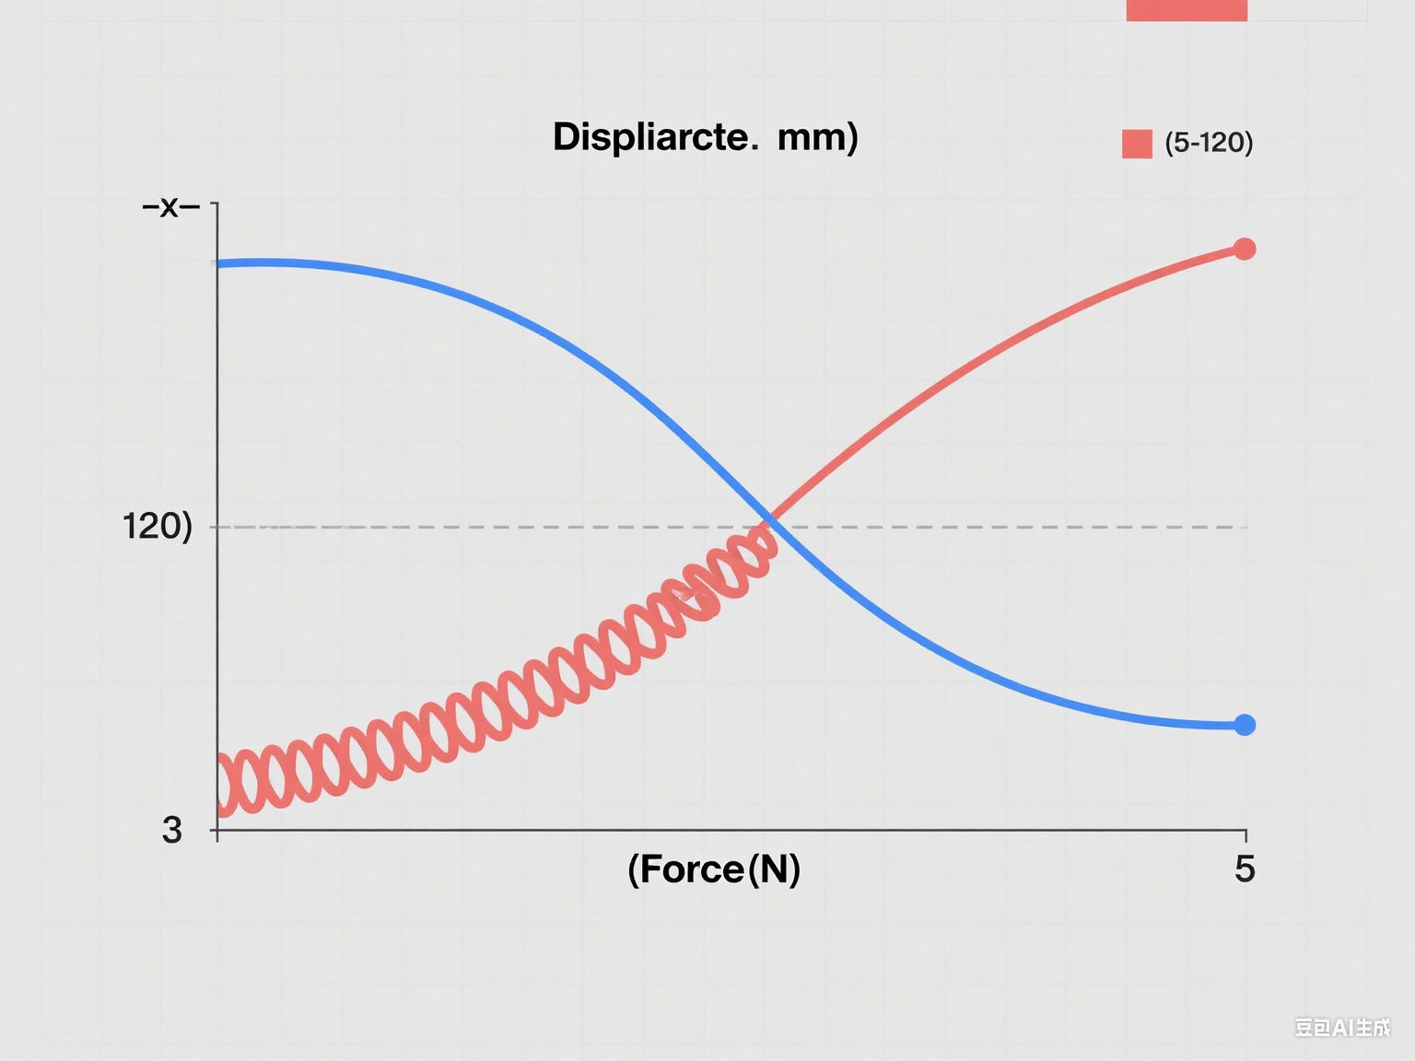
Fig. 1 Solid element for segment simulation Fig. 2 Simplified joint model
(3) Load-Structure Interaction Model:
Based on the principle of deformation coordination, the load-sharing ratio of each component is determined by establishing the "internal water pressure–radial displacement" relationship for the steel liner, segments, and surrounding rock. The computational efficiency of this model is 30%–50% higher than that of finite element methods. In the Pearl River Delta Project, the calculated internal water pressure sharing ratio of the steel pipe (30.2%) closely matched the field monitoring result (28.7%).
3. Analysis of Key Influencing Factors on Mechanical Behavior of Water Conveyance Tunnel Linings
3.1 Influence of Buffer Layer and Contact Interface Properties:
As the core coordination unit in double-layer linings, the material properties, thickness, and contact behavior of the buffer layer critically influence the efficiency of internal force distribution. Polyethylene foam is the most common buffer material, and its mechanical performance varies considerably with density. For instance, higher-density foam exhibits much lower strain under the same stress level compared to low-density foam, with the latter showing over two-and-a-half times greater elastic buffering capacity. During the yield stage, the stress increase rate in high-density foam is approximately twice that of low-density foam. Upon entering the densification stage, the stress sustained by higher-density foam can be twice as high. Considering both cushioning performance and structural stability, polyethylene foam with higher density is generally preferred in engineering practice.
3.2 Drainage Board Installation and Concrete Cracking Behavior
While localized installation of drainage boards can improve the seepage field, it alters the stress distribution and cracking behavior of self-compacting concrete, requiring coordinated control with the grouting circle. Taking the Pearl River Delta Water Resources Allocation Project as an example , the stress distribution differs significantly with and without drainage boards.
3.3 Rheological Effects of Surrounding Rock and Long-Term Mechanical Behavior
In soft rock strata, the rheological behavior of surrounding rock (creep and stress relaxation) leads to long-term growth in lining internal forces, necessitating quantification through nonlinear rheological models. The stress release rate during construction significantly affects rheological effects.
3.4 Influence of Segment Assembly Methods and Construction Loads
Segment assembly methods and construction excavation loads directly affect the overall stiffness of the lining and construction safety, requiring optimization through comparative analysis and field monitoring. Taking a water conveyance tunnel in Shenzhen as an example (Class III surrounding rock, burial depth 544 m, C50 segments, thickness 30 cm), the mechanical performance of continuous-joint and staggered-joint assembly differs significantly.
3.5 Joint Load-Bearing Mechanism Under High Internal Water Pressure
Under high internal water pressure (>1.0 MPa), the joint load-bearing characteristics of the steel liner, concrete, and surrounding rock are central to design, requiring stage-wise analysis of load transfer mechanisms. Taking a deeply buried tunnel with an internal water pressure of 1.3 MPa as an example, the load-bearing process can be divided into two distinct stages.
4. Pearl River Delta Water Resources Allocation Project
As a major trans-regional water diversion project in South China, the Pearl River Delta Water Resources Allocation Project features a total tunnel length of 30.5 km, an inner diameter of 6.4 m, and a design internal water pressure of 1.3 MPa. It adopts a composite lining structure consisting of C50 segments with a thickness of 30 cm, C30 self-compacting concrete with a thickness of 30 cm, and a steel pipe with a thickness of 20 mm. Drainage boards measuring 2 cm in thickness are installed over a 240-degree arc at the pipe crown. The project aims to address the uneven distribution of water resources between the eastern and western regions of the Pearl River Delta. The geological conditions primarily consist of Class III surrounding rock, which imposes stringent requirements on the load-bearing efficiency and anti-seepage performance of the lining structure.
(1) Lining Stress Analysis and Key Findings
Based on a load-structure interaction model and joint load-bearing theory, stress analysis reveals the following: Under normal operation, the steel pipe carries nearly one-third of the internal water pressure, resulting in considerable hoop stress. The self-compacting concrete bears more than half of the pressure, with hoop stress exceeding its tensile capacity and leading to cracking. The segments carry a minor portion of the load, with axial force reaching a relatively high magnitude. Under exceptional loads such as seismic events, simulated via concentrated displacement, the buffer layer—composed of medium-density polyethylene foam—enters densification. This raises the load share taken by the steel pipe to a significantly higher level, while reducing segment stress noticeably, thereby preventing structural failure. In the long term, accounting for surrounding rock creep with a moderate elastic modulus, segment deformation after a century of service remains within allowable limits. Crack and leakage control are central concerns for the project. Without a grouting circle, crack width and leakage rate reach elevated levels. The introduction of a thick grouting zone with very low permeability at the drainage board ends reduces both crack width and leakage substantially, demonstrating effective seepage control.
(2) Engineering Optimization Measures and Implementation Results
In response to the analysis, several optimizations were introduced:Staggered-joint assembly was used for the segments along with a moderate increase in pre-tightening force of longitudinal bolts, which helped keep bolt stresses below yield levels.The drainage board layout was enhanced by incorporating a grouting zone at its extremity. Grouting pressure was carefully regulated to ensure tight interfaces among the grouting ring, concrete, and surrounding rock, thus minimizing voids.A long-term monitoring system was implemented to track segment deformation, bolt stresses, and leakage rates over time.
5. Conclusion
This study, through theoretical analysis, numerical simulation, and engineering validation, has identified the core mechanical behavior of lining structures in water conveyance tunnels and key technical points for the entire process. The conclusions are as follows:
(1) Lining system optimization requires scenario-specific parameter calibration. Double-layer linings with polyethylene foam buffers redistribute loads from outer segments, which bear the vast majority under normal conditions, to inner linings, which take on a substantially increased share under sudden loads. High-pressure applications necessitate the use of staged models accounting for interactions among steel, concrete, and surrounding rock.
(2) Construction quality plays a decisive role in crack and leakage control. The combination of thick grouting circles with low permeability and strategically placed drainage boards leads to a major reduction in leakage and restricts crack width to a low level. Staggered-joint assembly together with a properly controlled excavation release rate helps prevent oval deformation and overstress in bolts.
(3) Long-term safety depends critically on rheological management. Creep in soft rock may lead to a considerable increase in axial forces over extended service periods, calling for regular modulus verification and periodic force reassessments. Implementing a closed-loop process integrating design, construction, and operation ensures coordinated load-bearing, precision in construction, and targeted maintenance.
Disclaimer (Artificial intelligence)

Option 1:

Author(s) hereby declare that NO generative AI technologies such as Large Language Models (ChatGPT, COPILOT, etc.) and text-to-image generators have been used during the writing or editing of this manuscript.

Option 2:

Author(s) hereby declare that generative AI technologies such as Large Language Models, etc. have been used during the writing or editing of manuscripts. This explanation will include the name, version, model, and source of the generative AI technology and as well as all input prompts provided to the generative AI technology

Details of the AI usage are given below:
1.
2.
3.

References
[1] XIANG Chengbing. Study on stress and deformation of initial support in hydraulic tunnels [J]. Hydro Science and Cold Zone Engineering, 2025, 8(7): 129–132.
[2] YANG Liyi, WANG Haoran, XIE Hui, et al. Defect distribution characteristics and mechanical mechanism of different structural sections in diversion tunnels [J]. Science Technology and Engineering, 2024, 24(34): 14806–14812.
[3] HE Yitao, LUO Zejun, ZHANG Qingzhao, et al. Analysis of mechanical properties of double-layer lining in large-diameter shield tunnels [J]. Modern Tunnelling Technology, 2018, 55(S2): 1139–1143.
[4] YANG Zhao, PAN Xiaoming, YU Jun. A computational model for composite lining of shield water conveyance tunnel [J]. Journal of Central South University (Science and Technology), 2010, 41(5): 1945–1952.
[5] YANG Guanghua, LI Zhiyun, XU Chuanbao, et al. A load-structure interaction model for composite lining of shield tunnel [J]. Journal of Hydroelectric Engineering, 2018, 37(10): 20–30.
[6] LIU Yijie, ZHANG Xuhui, HUANG Bensheng, et al. Study on the joint bearing mechanism of deep-buried pressure pipeline under high internal water pressure [J/OL]. Advanced Engineering Sciences, 1–17[2025-08-26].
[7] WANG Hanhui, WANG Boshi, ZHANG Cunhui, et al. Study on cracking characteristics of composite lining structure in hydraulic tunnels [J]. People's Yangtze River, 2024, 55(10): 173–181.
[8] YOU Zexi, ZHAO Dazhou. Influence of surrounding rock rheology on long-term mechanical behavior of segmental lining in pressurized water conveyance tunnels [J]. Chinese Journal of Underground Space and Engineering, 2025, 21(3): 929–939.
[9] YE Yichao, PENG Limin, LEI Mingfeng, et al. Analysis of structural safety of tunnel under different void modes [J]. Journal of Railway Science and Engineering, 2018, 15(11): 2875–2883.
[10] ZHANG Qinghai, JIN Nenglong, ZHANG Sheng, et al. Analysis of cracking mechanism and damage failure of lining structure in shallow buried bias tunnel [J]. Highway, 2019, 64(10): 315–320.
[11] LI Xiangyu, LI Jun, WANG Haijun, et al. Distribution law and simulation analysis of lining cracks in long-service tunnel [J]. Water Resources and Hydropower Engineering, 2023, 54(1): 108–118.
[12] SHE Lei, WANG Yujie, CAO Ruilang, et al. Evaluation and analysis of calculation methods for crack width in reinforced concrete lining of high-pressure hydraulic tunnels [J]. Water Resources and Hydropower Engineering, 2018, 49(8): 142–149.
[13] WU Bin, MA Fangping, CHEN Yongxu, et al. Structural defect characteristics analysis of diversion tunnel based on robotic inspection [J]. Science Technology and Engineering, 2022, 22(26): 11616–11622.
[14] SU Kai, ZHANG Wei, WU Hegao, et al. Bearing mechanism of steel-lined reinforced concrete pipeline considering frictional contact characteristics [J]. Journal of Hydraulic Engineering, 2016, 47(8): 1070–1078.
[15] XUE Xiaojie, DONG Xin, WU Luxiang, et al. Mechanical response and influencing factors of segments during construction of super-large diameter shield tunnels[J]. Gonglu (Highway), 2025, 70(07): 347-355.
[16] SONG Yi, QIAO Chunsheng, ZHU Ju. Study on long-term mechanical state of deep-buried tunnel structure in creeping stratum [J]. Modern Tunnelling Technology, 2020, 57(S1): 343–350.
[17] ZHANG Jiabing, YANG Zongquan, DU Ronghuan, et al. Study on deformation characteristics of tunnel structures based on anisotropic creep characteristics[J]. Chinese Journal of Underground Space and Engineering, 2025, 21(03): 917-928.
[18] QIAN Wenxi, LIANG Guoqing, GENG Daxin. Influence of surrounding rock creep on safety of operational tunnel lining [J]. Journal of Highway and Transportation Research and Development, 2020, 37(9): 90–96.
[19] XU Guowen, HE Chuan, WANG Yao. Safety performance of cracked secondary lining under rheological load in tunnels [J]. China Civil Engineering Journal, 2016, 49(12): 114–123.

