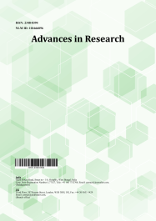
Advances in Research

Volume XXX, Issue XX, Page XX-XX, 20YY; Article no.AIR.143470
ISSN: 2348-0394, NLM ID: 101666096

Study on Sensory Properties and

Cost of Production of Bhapa dahi

Prepared by Utilization of Jackfruit

(Artocarpus heterophyllus L.) Pulp

Authors’ Name……………………………………………………

Affiliations……………………………………………………….………………

Authors’ contributions

This work was carried out in collaboration among all authors. ‘Author A’ designed the study, performed the statistical analysis, wrote the protocol, and wrote the first draft of the manuscript. ‘Author B’ and ‘Author C’ managed the analyses of the study. ‘Author C’ managed the literature searches. All authors read and approved the final manuscript.

Article Information

DOI: 10.9734/AIR/2025/XXXXX

Open Peer Review History:
This journal follows the Advanced Open Peer Review policy. Identity of the Reviewers, Editor(s) and additional Reviewers, peer review comments, different versions of the manuscript, comments of the editors, etc are available here:

Received: DD/MM/20YY
Original Research Article
Published: DD/MM/20YY

ABSTRACT

The research study was conducted at the Dairy Science Laboratory of Department of Animal Husbandry and Dairy Science, College of Agriculture, Dapoli, Dist. Ratnagiri (M.S.) to study the utilization of jackfruit (Artocarpus heterophyllus L.) pulp for preparation of Bhapa dahi. Jackfruit is a nutrient-dense tropical fruit commonly found in India. It offers multiple health benefits, including antimicrobial and anti-inflammatory effects. In present investigation, Bhapa dahi was prepared using chakka and condensed milk (prepared from cow milk) in 50:50 (by w/w basis) with jackfruit pulp. Jackfruit pulp was used at five levels i.e., 0 % (T₀), 10 % (T₁), 20 % (T₂), 30% (T₃) and 40% (T₄). The 15% sugar (on the basis of weight of base mix) was used for preparation of Bhapa dahi. Studied for its sensory attributes such as colour and appearance, body and texture, flavour and overall acceptability was carried out by ten panelists using 9-point hedonic scale. It was found that utilization of jackfruit pulp at 20% was best with overall acceptability score of 8.34. The cost of production of most acceptable treatment i.e. Bhapa dahi using 20% jackfruit pulp is Rs.175.85/ kg. Also it may conclude that utilization of jackfruit pulp for preparation of Bhapa dahi can be successfully improved sensory properties of Bhapa dahi.

Keywords: Bhapa dahi; Jackfruit pulp; fermented milk product; sensory evaluation; condensed milk; chakka.

Please check all Figures and Tables

1. INTRODUCTION

Milk is considered as one of the most complex food that supplies vital nutrients required for growth and development of young mammals. Nutritionally, it is considered nature’s nearly perfect diet. While some other food might contain higher amount of certain vitamins, milk is widely regarded as one of the most well-balanced food available. India is the world’s largest milk producer, with an estimated 239.30 million tonnes in 2023-2024 and the per capita milk availability has risen to 471 g/day (Basic Animal Husbandry Statistics, 2024). Milk is a highly perishable in nature which can spoil quickly if not handled properly. Apart from being consumed directly as liquid milk, surplus milk is frequently processed into variety of dairy products. These include a wide range of delicious recipes that utilize desiccated, coagulated, fermented and frozen forms of milk (De, 2019).

Fermented milk constitutes a vital component of human diet in many regions of the world. The production of fermented foods is one of the oldest food processing technologies known to man. The primary purpose of fermenting food substrates was to achieve a preservation effect. The demand for fermented milk products is increasing and it has been estimated that about 10 %of total milk produced in India is used for preparation of traditional fermented milk products. Dahi is a traditional Indian fermented milk product that has remained popular in the Indian diet, even with changing lifestyles and food habits. Around 6.9 %of the total milk produced in India is used to make dahi, which is meant for direct consumption (Khurana and Kanawjia, 2007). The Indian yogurt market is in growth and surprisingly comes second after China in terms of revenue with a growth rate of 10.20 per cent. The CAGR of Revenue per capita, price, and volume have values of 9.1, 6.6 and 3.4 per cent, respectively (Singh and Sharma, 2022).

‘Bhapa Doi’ is a popular Bengali delicacy prepared at household level in West Bengal. ‘Bhapa’ means steamed and ‘doi’ means dahi. It is basically steamed sweet dahi and is often called the ‘Indian cheese cake’. Bhapa dahi is served in Indian festivals like Durga puja, Diwali in the states such as West Bengal, Odisha and Bangladesh. The traditional recipe of preparing Bhapa dahi is time consuming as it involves thickening of the milk by slowly condensing it, setting of curd (dahi) and then steaming it to obtain a gelled product (Chaudhari, 2016). ‘Bhapa dahi’ is a fermented dairy product, which is prepared by steaming a mixture of concentrated milk, chakka and sugar. Till date not a single dairy started commercialization of Bhapa doi (Yadav, 2017).

Jackfruit is a tropical fruit species found in tropical, high rainfall, coastal and humid areas of the world. It belongs to family Moraceae. Jackfruit is the favourite fruit of many individuals, owing to its sweetness. Jackfruit is rich in several nutrients and can also act as source of complete nutrition to the consumers (singh et al., 2014). Jackfruit is rich in dietary fibre, carbohydrates and proteins. It contains high quantity of vitamins and minerals such as vitamin A, vitamin B-complex, vitamin C, calcium, iron, magnesium, potassium and sodium (Srivastava and Singh, 2020). Its seeds are rich in proteins and can be relished as a nutritious nut. The presence of resistant starch in seeds contributes the blood sugar regulation levels and the promotion of gut health (Akmeemana et al., 2022). The fruit is also the source of chemical ‘Jacalin’ useful in preventing colon cancer, AIDS etc. (singh et al., 2014). Health benefits of jackfruit including anticarcinogenic, antimicrobial, antifungal, anti-inflammatory, wound healing and hypoglycemic properties are well established (Todkar, 2023).

As per first advanced estimates 2024-25, India produces at about 3284 metric tonnes of Jackfruit in 186000 ha area annually (Anonymous, 2025). However, Jackfruit is highly perishable in nature and available in abundance during its peak season, a large amount often goes to waste. During peak season of Jackfruit, post-harvest losses are reported to be around 30-35 % (Srivastava et al., 2017). So, by turning it into new product, we can reduce wastage of Jackfruit. This can also help farmers earn more money from their jackfruit crop, especially in areas like Konkan.

Considering the importance of milk and dahi in our diet, nutritional importance and availability of Jackfruit in Konkan region, the present study is undertaken to prepare Bhapa dahi using chakka and condensed milk prepared from cow milk and varying concentration of jackfruit pulp. This study aims to enhance the sensory properties of the Bhapa dahi by combining the distinct characteristics of used ingredients, resulting in a tasty and value added product. Also study aim to estimate cost of production of jackfruit Bhapa dahi.

2. MATERIALS AND METHODS

The research study carried out at Department of Animal Husbandry and Dairy Science, College of Agriculture, Dapoli, Dist. Ratnagiri (M.S.), entitled as “Studies on utilization of Jackfruit (Artocarpus heterophyllus L.) pulp for preparation of Bhapa dahi” during the academic year 2024-2025.

2.1 Raw Material

2.1.1 Milk

Fresh cow milk was obtained from the Instructional Dairy Farm of College of Agriculture, Dapoli, Dist. Ratnagiri (M.S.), India.

2.1.2 Sugar

The sugar was purchased from the local market at Dapoli, Dist. Ratnagiri (M.S.), India.

2.1.3 Jackfruit pulp

Processed jackfruit pulp was procured from the local market at Dapoli, Dist. Ratnagiri (M.S.), India.

2.1.4 Condensed milk

For preparation of condensed milk, cow milk was obtained from the Instructional Dairy Farm of College of Agriculture, Dapoli. This milk was filtered through 2 folds muslin cloth to remove any visible dirt particles, after that milk was continuously boiled in ratio of 2:1. In this sugar is added at 15% of the final base mixture’s weight was added and contents was mixed thoroughly so that sugar got dissolved completely. This condensed milk was stored in refrigerator and used for preparation of Bhapa dahi.

2.1.5 Chakka

Chakka was prepared using cow milk which is obtained from the Instructional Dairy Farm of College of Agriculture, Dapoli.

2.2 Methodology

2.2.1 PHASE-I: Determination of optimum combination of chakka and condensed milk to prepare Bhapa dahi

In phase I, the most optimum combination of chakka and condensed milk was selected on the basis of sensory evaluation and was selected for phase-II for further studies. The sensory parameters were studied during research experiments for colour and appearance, body and texture, flavor and overall acceptability.

‘Bhapa dahi’ was prepared as per flow diagram given by Bhattacharya et al. (1979) with slight modification.

2.2.1.1 Treatments

In first phase, different combinations of chakka and condensed milk were used to prepare Bhapa dahi.

List 1: The treatment details were as given below:

Treatment | Details (chakka: condensed milk ratio)
T₁ | 60:40
T₂ | 50:50
T₃ | 40:60

2.2.2 PHASE-II: Preparation of Bhapa dahi incorporated with Jackfruit (Artocarpus heterophyllus L.) pulp

In the second phase, Bhapa dahi was prepared from the most optimum combination obtained in phase I. However, in this phase different levels of Jackfruit (Artocarpus heterophyllus L.) pulp were used for preparation of most acceptable quality of Bhapa dahi incorporated with Jackfruit (Artocarpus heterophyllus L.) pulp.

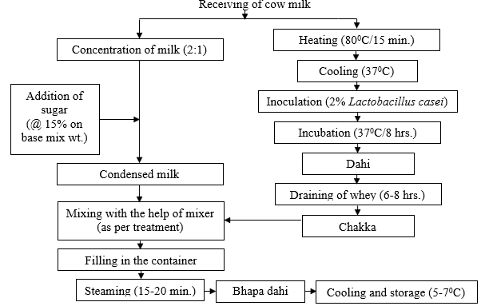

Fig. 1. Preparation of Bhapa dahi

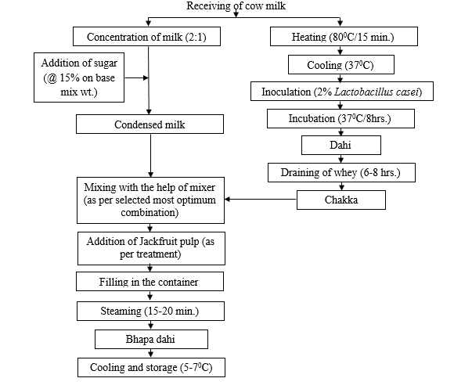

Fig. 2. Preparation of Bhapa dahi incorporated with Jackfruit pulp

2.2.2.1 Treatments

In the present study, different levels of jackfruit pulp were used for preparation of most acceptable quality of Bhapa dahi incorporated with jackfruit pulp. The treatment details were as given below:

List 2 : treatment details

Treatment | Details
T₀ | Selected base mixture + without Jackfruit pulp
T₁ | Selected base mixture + 10 % Jackfruit pulp
T₂ | Selected base mixture + 20 % Jackfruit pulp
T₃ | Selected base mixture + 30 % Jackfruit pulp
T₄ | Selected base mixture + 40 % Jackfruit pulp

‘Bhapa dahi’ was prepared as per flow diagram given by Bhattacharya et al. (1979) with slight modification and by incorporation of jackfruit pulp.

Replications: The trial was conducted with five replications.

2.3 Sensory Evaluation of Jackfruit Bhapa Dahi

Sensory analysis was performed in the laboratory under environmental conditions. The product was analysed for sensory properties such as colour and appearance, body and texture, flavour and overall acceptability using 9- points hedonic scale as per IS: 6273, Part-I (1971). A total of ten panelists were chosen with no medical conditions.

2.4 Statistical Analysis

For present investigation, CRD (Complete Randomized Design) design was employed using five replications.

2.5 Cost of Production

The material/ingredients needed for preparation of Bhapa dahi with jackfruit pulp were rated as per the current market rates (2024-2025) and cost of production of Bhapa dahi with jackfruit pulp was worked out.

3. RESULTS AND DISCUSSION

3.1 Sensory Evaluation of JACKFRUIT BHAPA DAHI

3.1.1 Colour and appearance

For any food product, visual appeal is an exceedingly important characteristic that enhances consumer attention. In particular, when it comes to any dairy item, the colour and appearance profoundly influence customer responses. Jackfruit Bhapa dahi should have light yellow and uniform colour.

Table 1. Effect of different levels of jackfruit pulp on colour and appearance of jackfruit Bhapa dahi (out of nine)

Treatments | Replications
Treatments | R1 | R2 | R3 | R4 | R5 | MEAN
T₀ | 7.25 | 7.50 | 7.56 | 7.50 | 7.56 | 7.47^{bc}
T₁ | 7.38 | 7.63 | 7.67 | 7.63 | 7.69 | 7.60^{b}
T₂ | 7.75 | 8.50 | 8.17 | 8.25 | 8.19 | 8.17ª
T₃ | 8.00 | 8.38 | 8.33 | 7.94 | 7.81 | 8.09^{ab}
T₄ | 7.00 | 7.13 | 7.22 | 7.00 | 7.25 | 7.12^{bc}

ANOVA Table

SV | DF | SS | MSS | F Cal | F Tab (5%) | Result | F Tab (1%) | Result
Treatment | 4 | 3.87 | 0.97 | 26.61 | 2.87 | SIG | 4.43 | SIG
Error | 20 | 0.73 | 0.04 | - | - | - | - | -
Total | 24 | 4.60 | - | - | - | - | - | -

 | SEd | SEm | CD | CV
5% | 0.12 | 0.09 | 0.35 | 2.48
1% | - | - | 0.53 | -

A close examination of Table 1 indicated that the treatment T₂, having 20 %jackfruit pulp registered highest score (8.17), whereas the treatment T₄ with 40 %jackfruit pulp, recorded the lowest score (7.12).

Statistical analysis revealed that the result obtained for colour and appearance are statistically significant for jackfruit pulp at both (p<0.01) and (p<0.05) levels of significance. However it has been observed that treatment T₂ and T₃ were statistically comparable, both shows significant superiority over T₀, T₁ and T₄. Significantly, Treatment T₄, containing the highest pulp concentration, scored markedly lower than all other treatments.

Patel et al. (2017) noted that Bhapa dahi with 18 %mango pulp showed higher score (8.81) than Bhapa dahi having 21 %mango pulp (8.55). Bhapa dahi made using carrot shred at 8 %registered highest score (8.74) than remaining i.e., 6 and 10 %levels.

3.1.2 Body and texture

Each dairy product has distinctive mouth feel qualities that are typically described in terms of body and texture. Bhapa dahi has a firm body, smooth texture and gel like structure.

The sensory evaluation data for the body and texture of Bhapa dahi showed that treatment T₂ with 20 %jackfruit pulp received the highest score (8.19), followed by treatment T₁ with 10 %jackfruit pulp (8.06). The product’s score dropped concurrently as amount of jackfruit pulp increased, which may have caused by the product’s loose body cause small air hole which ultimately damage the products appearance. The Bhapa dahi with 40 %had lowest score (7.01). The Bhapa dahi without jackfruit pulp and with 30 %jackfruit pulp score 7.92 and 7.32, respectively.

It is observed that the treatments are statistically significant for jackfruit pulp at both (p<0.01) and (p<0.05) levels of significance. It is observed that the treatments are statistically significant for jackfruit pulp at both 5 and 1 %levels of significance.

According to Patel et al. (2017), body and texture of Bhapa dahi having 18 %mango pulp had higher score (27.67 out of 30) than Bhap dahi with 21 %mango pulp (26.71 out of 30). Bhapa dahi made using 18.0 %mango pulp had a uniform, firm body, smooth texture with good slicing properties. On the other hand, Bhapa dahi made using 21.0 %mango pulp was associated with slight pasty and loose body and a granular texture. This led to lower body and texture score associated with Bhapa dahi containing higher level of mango pulp.

3.1.3 Flavour

The quality of any dairy product is greatly determined by its flavour, which in turn determines products acceptability. Flavour is the most important factor in acceptability of dairy products. Bhapa dahi has pleasant, mild acidic and sweet flavour.

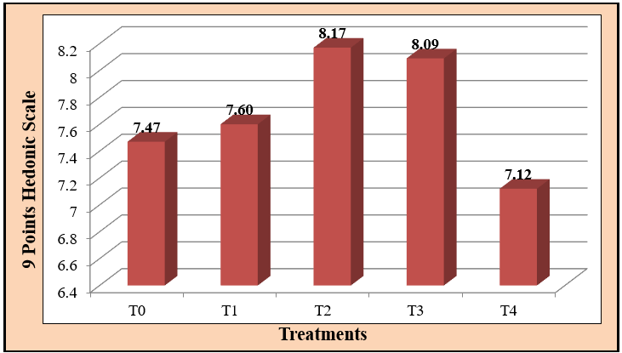

Fig. 3. Effect of different levels of jackfruit pulp on colour and appearance of jackfruit Bhapa dahi (Out of nine)
Table 2. Effect of different levels of jackfruit pulp on body and texture of jackfruit Bhapa dahi (out of nine)

Treatments | Replications
Treatments | R1 | R2 | R3 | R4 | R5 | MEAN
T₀ | 7.75 | 7.88 | 7.89 | 8.06 | 8.00 | 7.92^{ab}
T₁ | 7.81 | 8.00 | 8.11 | 8.25 | 8.13 | 8.06^{ab}
T₂ | 8.00 | 8.13 | 8.33 | 8.38 | 8.13 | 8.19ª
T₃ | 7.13 | 7.13 | 7.78 | 7.50 | 7.06 | 7.32^{b}
T₄ | 6.88 | 7.19 | 7.11 | 6.75 | 7.13 | 7.01^{bc}

ANOVA Table

SV | DF | SS | MSS | F Cal | F Tab (5%) | Result | F Tab (1%) | Result
Treatment | 4 | 5.20 | 1.30 | 32.88 | 2.87 | SIG | 4.43 | SIG
Error | 20 | 0.79 | 0.04 | - | - | - | - | -
Total | 24 | 5.99 | - | - | - | - | - | -

 | SEd | SEm | CD | CV
5% | 0.13 | 0.09 | 0.36 | 2.58
1% | - | - | 0.56 | -

Table 3. Effect of different levels of jackfruit pulp on flavour of jackfruit Bhapa dahi (out of nine)

Treatments | Replications
Treatments | R1 | R2 | R3 | R4 | R5 | MEAN
T₀ | 7.13 | 7.38 | 7.11 | 7.25 | 7.25 | 7.22^{bc}
T₁ | 7.63 | 7.94 | 7.67 | 8.38 | 8.44 | 8.01^{ab}
T₂ | 8.50 | 8.50 | 8.17 | 8.63 | 8.19 | 8.40ª
T₃ | 7.31 | 7.44 | 7.56 | 7.88 | 7.50 | 7.54^{b}
T₄ | 7.19 | 7.06 | 7.06 | 7.19 | 7.25 | 7.15^{bc}

ANOVA Table

SV | DF | SS | MSS | F Cal | F Tab (5%) | Result | F Tab (1%) | Result
Treatment | 4 | 5.66 | 1.41 | 28.01 | 2.87 | SIG | 4.43 | SIG
Error | 20 | 1.01 | 0.05 | - | - | - | - | -
Total | 24 | 6.67 | - | - | - | - | - | -

 | SEd | SEm | CD | CV
5% | 0.13 | 0.09 | 0.36 | 2.58
1% | - | - | 0.56 | -

Table.3 showed that the flavour of Bhapa dahi with 20 %jackfruit pulp received the highest score (8.40), followed by 10 %jackfruit pulp (8.01). Increase or decline in any other level besides these was deemed less acceptable by the judges. The judges may not have enjoyed the light, irrelevant smell of the pulp at the lower levels, which has a poor score, while they didn't enjoy the deep cooked aroma and intense flavour of the pulp at the upper levels. Treatment T₄, Bhapa dahi with 40 %jackfruit pulp, received the lowest score out of all the treatments.
The statistical analysis confirmed that that the flavour variations for jackfruit pulp among the jackfruit Bhapa dahi samples are significant at both (p<0.01) and (p<0.05) levels of significance.

Patel et al. (2017) observed that Bhapa dahi with 18 %mango pulp showed higher score (42.33 out of 45) than Bhapa dahi having 21 %mango pulp (41.43 out of 45). This indicated that use of excess mango pulp had some adverse effect on the sensory acceptability of the product. This may be due to the intense mango taste as well
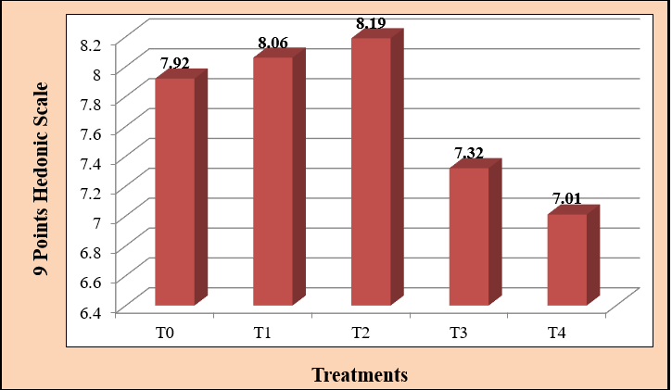

Fig. 4. Effect of different levels of jackfruit pulp on body and texture of jackfruit Bhapa dahi (Out of nine)

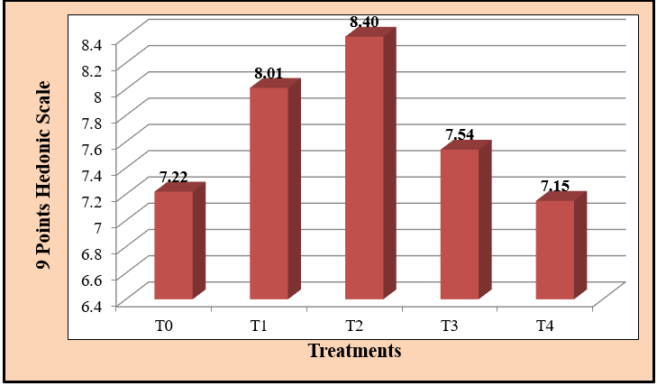

Fig. 5. Effect of different levels of jackfruit pulp on flavour of jackfruit Bhapa dahi (Out of nine)

as the higher tartness. Bhapa dahi made using carrot shred at 8 %registered highest score (42.00) than remaining i.e., 6 and 10 %level. The reason for the least flavour score associated with Bhapa dahi prepared using 6.0 %carrot shreds was low flavour (carrot) impact when such product was consumed. The reason for the decline in the flavour score of Bhapa dahi at carrot shred level exceeding 8.0 %was due to perception of intense carrot flavour. Mild carrot flavour was preferred by the judges compared to intense one.

3.1.4 Overall acceptability

The results showed that the treatment T₂ with 20 %jackfruit pulp registered the highest score for overall acceptability, with a score of 8.34, while the treatment T₄ with 40 %jackfruit pulp, received the lowest score of 7.06.

From Table 4, it was observed that the results obtained for overall acceptability are statistically significant at both (p<0.01) and (p<0.05) levels of significance, which indicated that there is significant difference in overall acceptability of jackfruit Bhapa dahi due to the addition of jackfruit pulp.

Patel et al. (2017) observed that Bhapa dahi with 18 %mango pulp showed higher score (92.07 out of 100) than Bhapa dahi having 21 %mango pulp (89.71 out of 100). Bhapa dahi made using carrot shred at 8 %registered highest score (90.98 out of 100) than remaining i.e., 6 and 10 %level.

Table 4. Effect of different levels of jackfruit pulp on overall acceptability of jackfruit Bhapa dahi (out of nine)

Treatments | Replications
Treatments | R1 | R2 | R3 | R4 | R5 | MEAN
T₀ | 7.63 | 7.63 | 7.39 | 7.31 | 7.44 | 7.48^{c}
T₁ | 7.88 | 8.25 | 7.72 | 8.44 | 8.38 | 8.13^{ab}
T₂ | 8.50 | 8.50 | 8.22 | 8.31 | 8.19 | 8.34ª
T₃ | 7.56 | 7.69 | 7.39 | 7.75 | 7.63 | 7.60^{b}
T₄ | 7.13 | 7.06 | 7.28 | 6.94 | 6.88 | 7.06^{bc}

ANOVA Table

SV | DF | SS | MSS | F Cal | F Tab (5%) | Result | F Tab (1%) | Result
Treatment | 4 | 5.37 | 1.34 | 35.93 | 2.87 | SIG | 4.43 | SIG
Error | 20 | 0.75 | 0.04 | - | - | - | - | -
Total | 24 | 6.11 | - | - | - | - | - | -

 | SEd | SEm | CD | CV
5% | 0.12 | 0.09 | 0.35 | 2.50
1% | - | - | 0.54 | -

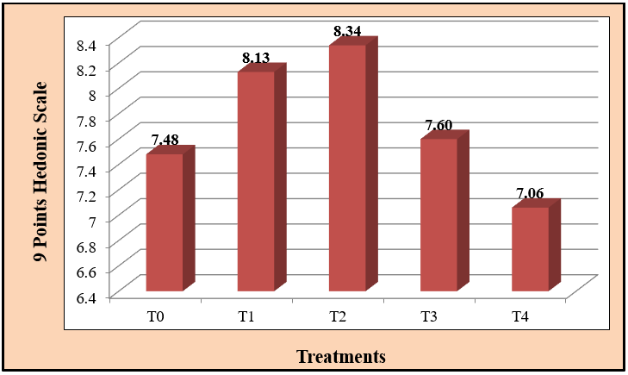

Fig. 6. Effect of different levels of jackfruit pulp on overall acceptability of jackfruit Bhapa dahi (Out of nine)

Table 5. Cost of production of jackfruit Bhapa Dahi (Based on cost of ingredients only)

Treatments |  | T₀ | T₁ | T₂ | T₃ | T₄
Condensed milk | Qty (g) | 50 | 50 | 50 | 50 | 50
Condensed milk | Cost (Rs.) | 6.3 | 6.3 | 6.3 | 6.3 | 6.3
chakka | Qty (g) | 50 | 50 | 50 | 50 | 50
chakka | Cost (Rs.) | 9.5 | 9.5 | 9.5 | 9.5 | 9.5
Sugar | Qty (g) | 15 | 15 | 15 | 15 | 15
Sugar | Cost (Rs.) | 0.66 | 0.66 | 0.66 | 0.66 | 0.66
Jackfruit pulp | Qty (g) | - | 10 | 20 | 30 | 40
Jackfruit pulp | Cost (Rs.) | - | 3.64 | 7.28 | 10.92 | 14.56
Total quantity of Bhapa dahi prepared (g) |  | 115 | 125 | 135 | 145 | 155
Total cost of Bhapa dahi(Rs.) |  | 16.46 | 20.1 | 23.74 | 27.38 | 31.02
Production of Bhapa dahi per 1000 g (Rs.) |  | 143.13 | 160.8 | 175.85 | 188.83 | 200.13

Cost of ingredient used-1. Cow milk – Rs. 60/1000ml; 2. Condensed milk – Rs. 63/500g,3. Chakka – Rs. 190/1000g, 4. Sugar – Rs. 44/1000g, 5. Jackfruit pulp – Rs. 100/275g

3.2 Cost of Production of Jackfruit Bhapa dahi

The Table 5 effectively explained how varying level of jackfruit pulp in jackfruit Bhapa dahi affects the overall production cost and the total quantity of the final product. The addition of jackfruit pulp increases both the total cost and quantity of the Bhapa dahi. The highest cost (Rs. 220.13 / kg) was recorded in case of Bhapa dahi prepared with 40 % jackfruit pulp (T₄), while lower cost (Rs. 143.13 / kg) recorded in case of Bhapa dahi without jackfruit pulp (T₀). The production cost of most acceptable level (T₂) was Rs. 175.85 / kg.

Cost of production of Jackfruit Bhapa dahi was more comparable with Patel (2014) reported the cost of production for Bhapa dahi was Rs. 168.30, 169.70 and Rs. 158.80 per kg for plain, mango and carrot forms, respectively.

Yadav (2017) estimated cost of production of chocolate steamed dahi at Rs. 148.0 per 1000 g when packed in earthen pots and Rs. 152.0 per 1000 g for the product packaged in polypropylene (PP) containers.

4. CONCLUSION

According to the findings, Bhapa dahi made from utilization of jackfruit pulp at 20% was best organoleptic characteristics, including colour and appearance, body and texture, flavour and overall acceptability. Thus, T₂ treatment was found as most acceptable with overall acceptability score of 8.34. The cost of production of most acceptable treatment i.e. Bhapa dahi using 20% jackfruit pulp is Rs.175.85/ kg. We can say that successful development and optimization of jackfruit Bhapa dahi using chakka and condensed milk in 50:50 and varying level of jackfruit pulp is feasible.

DISCLAIMER (ARTIFICIAL INTELLIGENCE)
Please write this section
Option 1:

Author(s) hereby declare that NO generative AI technologies such as Large Language Models (ChatGPT, COPILOT, etc) and text-to-image generators have been used during writing or editing of this manuscript.

Option 2:

Author(s) hereby declare that generative AI technologies such as Large Language Models, etc have been used during writing or editing of this manuscript. This explanation will include the name, version, model, and source of the generative AI technology and as well as all input prompts provided to the generative AI technology.

Details of the AI usage are given below:

1.
2.
3.

Competing interests

Authors have declared that no competing interests exist.

REFERENCES

Akmeemana, C., Wickramasinghe, I., Wanniarachchi, P. C., & Vithanage, T. (2022). Effect of drying and frying pre-treatments on nutrient profile, antioxidant capacity, cooking time, and sensory acceptability of easy to cook jackfruit seeds. Applied Food Research, 2(2), 100234.
Anonymous. (2025). Statistical Horticultural Estimates. Retrieved from Ministry of Agriculture & Farmers Welfare, Government of India.
Basic Animal Husbandry Statistics. (2024). Ministry of Fisheries, Animal Husbandry and Dairying, Government of India.
Bhattacharya, D. C., Tewari, B. D., Raj, D., & Srinivasan, M. R. (1979). A technique for the production of bhapa dahi. Indian Journal of Dairy Science, 32(2), 168–172.
Chaudhari, A. (2016). Study on the use of natural food additives and packaging on the shelf life of ‘bhapa dahi’ (M. Tech. thesis). Anand Agricultural University, Anand, Gujarat, India.
De, S. (2019). Outlines of dairy technology (46th ed.). New Delhi, India: Oxford University Press.
Indian Standards Institution (ISI). (1971). IS: 6273 Part I: Guide for sensory evaluation of food – Methods and evaluation cards. New Delhi, India: Manak Bhavan.
Khurana, H. K., & Kanawjia, S. K. (2007). Recent trends in development of fermented milks. Current Nutrition & Food Science, 3(1), 91–108.
Patel, R. A. (2014). Development of value-added ‘bhapa’ (steamed) dahi (M. Tech. thesis). Anand Agricultural University, Anand, Gujarat, India.
Patel, R., Jana, A., Modha, H., & Balakrishnan, S. (2017). Selecting the flavouring among the mango pulp and sugar-treated carrot shreds for developing value-added bhapa dahi. An International Journal of Life Sciences, 12(2), 873–880.
Priya Devi, S., Talaulikar, S., Gupta, M. J., Thamgam, M., & Singh, N. P. (2014). A guide on jackfruit cultivation and value addition (Technical Bulletin No. 41). ICAR Research Complex, Goa.
Srivastava, A., Bishnoi, S. K., & Sarkar, P. K. (2017). Value addition in minor fruits of Eastern India: An opportunity to generate rural employment. In Fruits for Livelihood: Production Technology and Management Practices (pp. 395–417). Jodhpur, India: Agrobios (India).
Srivastava, R., & Singh, A. (2020). Jackfruit (Artocarpus heterophyllus Lam.): Biggest fruit with high nutritional and pharmacological values – A review. International Journal of Current Microbiology and Applied Sciences, 9, 764–774.
Todkar, V. U. (2023). Development and quality evaluation of probiotic herbal jackfruit (Artocarpus heterophyllus L.) lassi (M.Sc. thesis). Dr. Balasaheb Sawant Konkan Krishi Vidyapeeth, Dapoli, Maharashtra, India.
Yadav, N. (2017). Technology of chocolate steamed dahi (M. Tech. thesis). ICAR–National Dairy Research Institute (Deemed University), Karnal, Haryana, India.

Disclaimer/Publisher’s Note: The statements, opinions and data contained in all publications are solely those of the individual author(s) and contributor(s) and not of the publisher and/or the editor(s). This publisher and/or the editor(s) disclaim responsibility for any injury to people or property resulting from any ideas, methods, instructions or products referred to in the content.
_________________________________________________________________________________
© Copyright (2025): Author(s). The licensee is the journal publisher. This is an Open Access article distributed under the terms of the Creative Commons Attribution License (http://creativecommons.org/licenses/by/4.0), which permits unrestricted use, distribution, and reproduction in any medium, provided the original work is properly cited.

