Original Research Article

Deciphering Morphological, Biochemical, and Genotypical Contrasts between Salt-Tolerant and Salt-Sensitive Rice Genotypes under Salinity Stress

.
ABSTRACT

Aim: Salinity stress is a major constraint to rice production, causing osmotic imbalance, ion toxicity, and reduced yield. Developing salt-tolerant varieties is critical for sustaining food security in salt-affected regions. This study aimed to elucidate the morphological, biochemical, and gene expression responses of two contrasting rice genotypes: Improved Samba Mahsuri and FL-478.
Place and Duration of Study: School of Biotechnology and Bioinformatics, DY Patil Deemed to be University, Navi Mumbai, India, June 2024 – January 2025.
Methodology: Seedlings of ISM and FL-478 were subjected to saline stress under controlled hydroponic conditions. Morphological traits, osmolyte accumulation, and Na⁺/K⁺ ratios were assessed, while the expression of stress-responsive genes (HAK1, HAK5, and MYB6) was analyzed using qRT-PCR.
Results: FL-478 maintained superior growth and leaf integrity under saline stress, while ISM exhibited reduced growth and significant leaf damage. Biochemical assays revealed that FL-478 accumulated higher levels of proline, glycine betaine, and soluble sugars, along with a more favorable Na⁺/K⁺ balance, compared to ISM. Gene expression analysis showed strong upregulation of HAK1, HAK5, and MYB6 in FL-478 under stress, whereas ISM displayed minimal transcriptional changes. These combined morphological, biochemical, and molecular traits underscore the robust tolerance of FL-478 to salinity.
Conclusion: The integration of phenotypic and genotypic analyses highlights FL-478’s superior adaptive mechanisms under salt stress. These insights strengthen the basis for breeding salt-resilient rice cultivars and support sustainable crop production in saline-prone environments.

Keywords: ISM, FL478, Salt stress, Osmolytes, Osmotic stress.

1. INTRODUCTION

To sustain global food supply, staple crops are grown in specific agro-ecological regions, providing food for billions of people. As the major staple food grain, rice (Oryza sativa) is consumed by more than 3.5 billion people in Asia, Africa, and Latin America. India is endowed with vast population and rich agricultural heritage that grows diversified staple (Naomi and Lewis 2019) cereals including rice, wheat, maize, and pulses. States like Andhra Pradesh, Assam, and Odisha, being major rice consumers grow substantial quantities of rice. (Kousik et al. 2023) Despite its significance, rice production is beset with various pests and diseases, causing enormous losses in terms of quantity, quality, and sustainability. Abiotic constraints such as drought, salinity, and flooding further, make rice highly vulnerable to pests and diseases, eventually resulting in yield loss and poor quality. Particularly, the impact of abiotic stresses like salinity, impacts greatly on reduction of crop yield. (Neji et al. 2022) Major challenge in achieving best rice yields in many countries of the world is salinity in irrigated soils, however, the mechanisms of rice's tolerance to salinity are largely unknown.
In plants, salinity stress results in osmotic, ionic, and oxidative stress, which alter plant physiology and growth in different ways. Characterizing rice phenotype under salt stress involves assessing osmotic adjustment, root growth, leaf health, and shoot morphology. Salt stress not only affects chlorophyll synthesis but also causes degradation of the available chlorophyll resulting in reduction of photosynthesis efficiency and overall plant health. (Ashraf and Foolad 2007) Rice varieties that are more tolerant to high salinity have less chlorophyll damage, underlining the importance of this feature in salt tolerance. In addition to this, anthocyanins, pigments giving blue, purple, and red hues, are also involved in plant response to salt stress.(Thi et al. 2016)
In response to salt stress, rice plants have naturally developed biochemical and physiological mechanisms to help them cope, including ion transporter modifications, osmolyte accumulation and stress responsive gene activation. (Citao et al. 2022) These mechanisms crucially depend on the regulation of ion transport, specifically the maintenance of an appropriate ratio of sodium (Na+) to potassium (K+) ions. Soils with high salinity disturb this balance leading to the harmful over accumulation of sodium that is in turn perilous to the plant. Maintaining a good ratio is indispensable for normal cellular functions. (Zhoufei et al. 2012) To meet this goal, rice plants employ diverse mechanisms of ion transport regulation and ion balance maintenance specifically, ions are compartmentalized in vacuoles using certain ion transporters.
Ion transport pumps and channels are key to governing the flow of chloride and sodium ions across cell membranes to preserve ion balance and reduce salt stress. An imbalance in the Na+/K+ ratio leads to decreased enzyme activity and poor plasma membrane protein synthesis, impairing the plant's ability to cope with salt stress. (Diego, Oliveira, and Nelson 2017) To Adjust to this very saline environment, genetic regulation in the developing rice plant is crucial. For instance, the overexpression of the SOS1 gene helps remove sodium ions from the cytoplasm, while the HKT1 transporter gene regulates potassium and sodium ion absorption and transport in plant roots, mitigating the adverse effects of salt stress. (John Damien, James, and Abdelbagi 2013; Diego, Oliveira, and Nelson 2017)
OsMYB6, OsHAK5, and OsHAK1 are all examples of crucial rice salt stress responsive genes. (Muhammad et al. 2021) OsMYB6 is a transcription factor that regulates osmotic adjustment, antioxidation stress, and ion homeostasis in rice under salt stress conditions OsHAK5, which up-regulates significantly in salt-tolerant rice, enhances high-affinity potassium uptake from the soil and improves salt stress, particularly ion balance, by reduced Na+ accumulation. OsHAK1, a stress salt tolerance gene associated with potassium uptake, regulates more solid osmotic regulation by controlling rice enzyme activity, turgor, and stomatal function, improving overall salt tolerance. (Muhammad et al. 2021)
This study focuses on two distinct rice varieties: Improved Samba Mahsuri (ISM), a salt-sensitive variety, and FL-478, a salt-resistant inbred variety developed from the resilient Pokkali rice crossed with IR-29. (Shahabuddin et al. 2019; Rima et al. 2019) While the Pokkali variety has been extensively studied, both FL-478 and ISM are relatively new and less characterized. Examining these two phenotypically opposite varieties in terms of their salt tolerance abilities offers a clearer understanding of the mechanisms involved in salt tolerance, providing valuable insights into breeding and agricultural practices. In this research, we aim to understand the morphological and genetic differences between these varieties under salt stress. The phenotypic evaluations were conducted to assess morphological, physiological, and agronomic traits. Moreover, the expression analysis of key genes involved in homeostasis was performed to unravel the molecular mechanisms that underlie salt tolerance. Besides, the specific markers within the SALTOL QTL region were used to profile the selected rice varieties which will provide the insights about the genetic variation of these varieties and their response to salt stress. (Rekha et al. 2018)
While progress has been made, there are still significant gaps in our knowledge of the regulatory networks of salt tolerance that require investigation. This work seeks to address these open questions by conducting detailed morphological assessments, investigating the roles of osmolytes, and bridging them with changes in gene expression. The purpose of this study is to deepen our understanding of the morphological and genetic differences between salt-sensitive and salt-resistant rice varieties under salt stress. By conducting comprehensive phenotypic evaluations, analyzing gene expressions, and profiling genetic markers within the SALTOL QTL region, this research seeks to unravel the molecular mechanisms that underlie salt tolerance. The insights gained from this study will inform breeding programs and agricultural practices, fostering the development of resilient rice varieties capable of thriving in saline environments and contributing to global food security and sustainable agriculture.

2. material and methods

2.1. Germination, Salt stress, and Sampling
Seeds of two rice genotypes, Improved Samba Mahsuri (ISM, salt-sensitive) and FL-478 (salt-tolerant), were obtained from ICAR–Directorate of Rice Research, Hyderabad due to their contrasting salt tolerance scores as reported in prior studies. (Rekha et al. 2022) Seeds were surface-sterilized with 70% ethanol for 2 min, rinsed with sterile distilled water, and germinated on moist filter paper in Petri dishes supplemented with a mild fungicide. On the 9th day, seedlings showing uniform shoot and root emergence were transferred to a hydroponic setup containing Yoshida nutrient solution. The experiment was conducted using a completely randomized design (CRD) with two treatments:
Control: seedlings maintained in normal Yoshida solution.
Salt stress: seedlings exposed to 125 mM NaCl starting on the 15th day of growth.
Each treatment was replicated three times (biological replicates), with 10 seedlings per replicate.
2.2. Phenotypic evaluation
Morphological traits including shoot length, root length, seedling height, fresh weight, and visual salt injury were assessed following the Standard Evaluation System (SES) scale for rice. (Fatien Najwa Che et al. 2023) Measurements were recorded at 19 days post-germination, prior to biochemical analysis.

2.3. Biochemical evaluation
2.3.1. Quantitative analysis of Total Chlorophyll and Total Anthocyanin content
Biochemical traits including chlorophyll content, anthocyanins, soluble sugars (sucrose and glucose), proline, and glycine betaine were quantified using established spectrophotometric methods. (Vanisri et al. 2017) (Sumitahnun et al. 2016) For each replicate, three seedlings were pooled and assayed, and each assay was performed in triplicate (technical replicates) to ensure reproducibility. The chlorophyll a (Ca) and chlorophyll b (Cb) content in milligram per litre was determined according to the formulae given below (Ashraf and Foolad 2007) (written using MathType) and further expressed in milligram per gram of fresh weight of plant material.
Chlorophyll a,
Chlorophyll b,
Total chlorophyll,
2.3.2. Analysis of Sucrose and Glucose
Sucrose and Glucose analysis is integral to understanding plant tissue response to salt stress. Glucose is a simple sugar and serves as a primary source of energy for plants. Sucrose, a disaccharide composed of glucose and fructose, plays a crucial role in carbohydrate transport and storage in plants. After harvesting, 0.1 g of each sample was weighed and mixed with 4 mL of Anthrone solution. Vortex mixing ensured thorough interaction between the solution and plant material. Spectrophotometric analysis was then conducted to quantify Sucrose and Glucose concentration at 565 nm. (Philippe et al. 2022)
2.3.3. Analysis of Proline
The most common endogenous osmolyte that responds to salinity by increasing its accumulation in plants is proline, and there is evidence that its overexpression in rice plants leads to improved salinity tolerance. (Akihiro, Yuko, and Tetsuko 2007) Proline content was analyzed using a modified procedure provided by (Chunthaburee et al. 2016). Accordingly, 0.1 gram of the fresh leaf tissue was homogenized in 5 mL of 3% aqueous sulfosalicylic acid. Subsequently, 2 mL of the resultant extract was mixed with 2 mL of acid ninhydrin along with 2 mL glacial acetic acid, followed by boiling at 96℃ for an hour. The reaction was then quenched by keeping the tube on ice at once. The solutions were further extracted using toluene and the absorbance of the toluene fraction was then measured at 520 nm spectrophotometrically. A calibration curve was plotted using known proline standards.
2.3.4. Analysis of Glycine betaine
Glycine betaine (GB), an osmolyte, which accumulates in cells, protects organisms from abiotic stresses. We analyzed the endogenous levels of GB in the two phenotypically distinct rice varieties to gain insights into the inherent salt tolerance mechanisms in FL478. Lyophilized plant material was ground and mixed with 2 N H2SO4 for 10 minutes at 60°C to extract quaternary ammonium compounds, including glycine betaine. After centrifugation, the supernatant was mixed with cold KI-I2, incubated, and centrifuged again. The resulting precipitate was dissolved in 1,2-dichloromethane, and its absorbance at 265 nm was measured using a spectrophotometer after 48 hours. Glycine betaine levels were quantified using a standard curve prepared from stock solutions with concentrations of 5, 10, 15, 20, 25, 30 µL. (Ma Guadalupe et al. 2016)
2.4. Measurement of Ion content
Leaf Samples were evaluated for the concentrations of Na+ and K+ ions using atomic absorption spectroscopy. Approximately 0.5 grams of the sample were digested with 7 ml of nitric acid and 3 ml of hydrochloric acid in a microwave digester system under pressure at 250℃ for an hour. After cooling, the samples were then filtered and further diluted to 50 ml with water. Consequently, the digested samples were aspirated against known standards in Inductively Coupled Plasma Optical Emission Spectroscopy (ICP-OES) instrument. For each treatment, pooled samples from three replicates were digested and analyzed against standard calibration curves. The final concentrations of the analytes in the samples were calculated using a dedicated software for the same. (Toi et al. 2019)
2.5. Quantitative Real-Time PCR Analysis
RNA was extracted from the leaf samples after 0, 8, 24, and 48 hours using the CTAB method. Subsequently, cDNA conversion was conducted using Aura cDNA synthesis kit as per the manufacturer's instructions. It was followed by Real-Time PCR (using the SYBR green method) based gene expression analysis for stress-resistant/tolerant genes against their controls. It was performed using three genes MYB6, HAK1, and HAK5. GAPDH was used as a housekeeping gene. The primers for these genes were designed using Batch3 primer software. The primer sequences used are given in Table 2. The data obtained was assessed using the ddCt method for calculations.(Shahabuddin et al. 2019) (Table 1 summarizes the thermal profile for the amplification.
Segment | Plateau | Temperature | Duration | Cycle
Hot Start | 1 | 95 | 00:02:00 | 1
Amplification | 1 | 95 | 00:00:10 | 40
Amplification | 2 | 60 | 00:00:20 | 40
Amplification | 3 | 72 | 00:00:15 | 40
RT | 1 | 25 | 00:05:00 | 1

Table 1: Thermal Profile parameters used for qRT-PCR
2.6. DNA Extraction and SSR Genotyping
With a few adjustments, the CTAB technique was used to isolate genomic DNA from leaf samples. (Kiss et al. 2024) Its quantity was calculated using spectrophotometry, and its quality was assessed using 0.8% agarose gel electrophoresis in 1X TBE buffer stained with ethidium bromide. In this study, PCR analysis was conducted using the following markers: RM10720, RM8094, and RM1287. Details on the markers were obtained from the GRAMENE database, and their sequences are provided in Table 2. The selection of this STMS marker is based on its proximity to the Saltol QTL on Chromosome 1, which is commonly used for the recombinant selection of lines that exhibit a salt tolerance response. (Islam et al. 2012) The isolated DNA was used for PCR amplification using the primers mentioned in table 2. The thermal parameters of the PCR reaction are summarized in table 3. The DNA ladder (excel BioSolutions) and the amplification products were combined with loading buffer, resolved on a 3% agarose gel in 1x TBE buffer, and monitored by the gel documentation system for 90 minutes at a constant voltage of 80 V. The 100 bp DNA ladder was used as a molecular size benchmark to compare the PCR products' sizes.
Name of gene | Primer type | Primer Sequence (5’-3’)
OsMYB6 | Forward Primer | CAAAGGCGACTGGAGGAGTA
OsMYB6 | Reverse Primer | CTGGCTGTCCAATTGTCGTA
OsHAK1 | Forward Primer | CGCTCTACTCGCTGATCTCC
OsHAK1 | Reverse Primer | TGCGTCTGAGTCAAGTTTGG
OsHAK5 | Forward Primer | AGGCTGCCAGGAATAGGTTT
OsHAK5 | Reverse Primer | ATTCCTCGTGGATGAATTGC
Name of STMS marker
RM10720 | Forward Primer | GCAAACGTCTACGTGAGAAACAAGC
RM10720 | Reverse Primer | GCATGTGGTGCCTTAACATTTGG
RM8094 | Forward Primer | AAGTTTGTACACATCGTATACA
RM8094 | Reverse Primer | CGCGACCAGTACTACTACTA
RM1287 | Forward Primer | GTGAAGAAAGCATGGTAAATG
RM1287 | Reverse Primer | CTCAGCTTGCTTGTGGTTAG
Table 2. List of designed gene specific primer and selected STMS marker flanking to Saltol QTLs and their sequences
Temperature | Time
94℃ | 5 Mins
94℃ | 40 Secs
65℃ | 30 Secs
72℃ | 1 Min
72℃ | 5 Mins
CYCLES | 30
HOLD | Infinite At 4℃
Table 3: Thermal Profile parameters used for PCR
2.7. Statistical analysis
Data were analyzed using two-way ANOVA in GraphPad Prism v8.0. Factors considered were genotype (ISM vs. FL-478) and treatment (control vs. salt stress). Replication ensured that residual error could be estimated, and means were compared using Tukey–Kramer’s post-hoc test at p ≤ 0.05.
2.8. Use of large language model
Quill Bot- Inbuilt in MS word was used as a paraphrasing tool in some parts of the introduction section of the manuscript.

3. results and discussion
3.1 Phenotypic evaluation
FL478 plants exhibited superior health compared to the ISM variety following salt treatment. The percentage of viable leaves was significantly lower in the ISM variety after exposure to saline stress, whereas the FL478 variety-maintained leaf integrity. Moreover, distinct morphological differences were observed between the two varieties: ISM plants developed long, lateral roots, while FL478 plants predominantly featured crown roots. Visual salt injury was rated based on specific criteria, ranging from 1 (highly tolerant) to 9 (highly susceptible). The results reveal that ISM and FL478 control and test seedlings exhibit similar trends in response to salt stress, albeit with some distinctions. FL478 control seedlings demonstrated superior initial growth parameters like number of leaves and rate of shoot growth. Following salt stress, ISM and FL478 test seedlings diverge in their responses. FL478 test seedlings exhibit lower growth percentage but maintain better growth performance and leaf health compared to ISM. Notably, FL478 test seedlings maintain 100% leaf survival, indicating minimal salt-induced leaf damage, whereas ISM test seedlings show moderate leaf damage with 50% leaf survival. ISM test plants display a score of 7, indicating complete growth cessation with dried lower leaves and wilting of the two youngest leaves, while FL478 test plants receive a score of 3, suggesting nearly normal growth with slight leaf symptoms. FL478 also demonstrated higher shoot length compared to ISM, the difference however was not statistically significant. There was a significant decrease in total plant weight in ISM treated plants compared to ISM control plants, contrastingly the plant weight remained comparable in FL478 pre and post salt treatment. ANOVA results for hydroponic-based studies are represented in graphical form in Fig. 2. A visual representation of all plant leaves is given below in Fig. 1, offering the evidence of salt injury and leaf symptoms observed in ISM and FL478 under salt stress conditions.
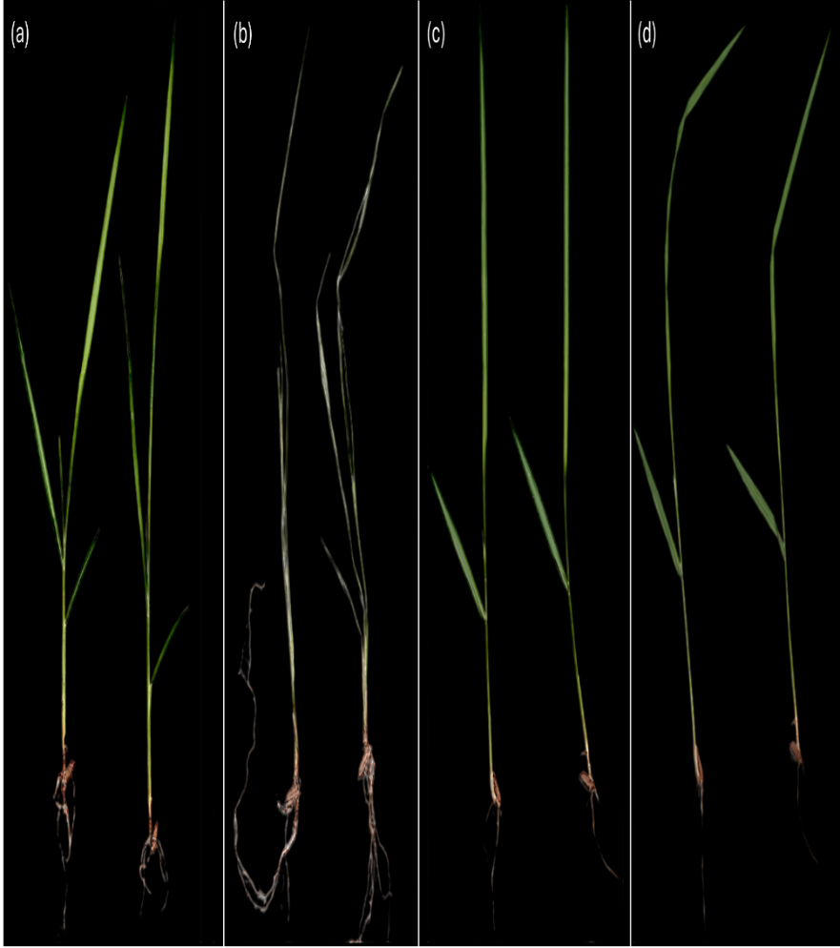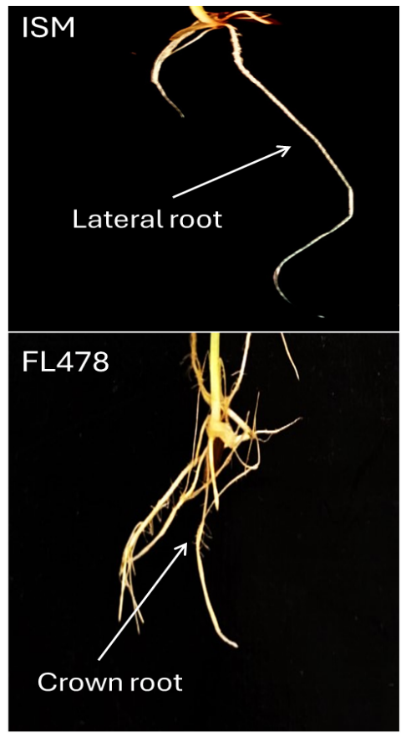
Fig.1 Leave samples of ISM and FL478 before and after stress(left) a, b: ISM, c, d: FL478; difference in the root structure of ISM and FL478(right).
3.2 Biochemical evaluation
3.2.1. Quantitative analysis of TC and TA content
The chlorophyll analysis showed significant differences between ISM and FL478 control and test seedlings. ISM control seedlings exhibited Ca levels of 7.78 mg/g, Cb at 6.64 mg/g, and TC at 14.43 mg/g. In contrast, ISM test seedlings displayed significantly reduced levels: Ca at 2.86 mg/g, Cb at 1.11 mg/g, and TC at 3.97 mg/g post saline treatment. FL478 control seedlings had higher chlorophyll levels: Ca at 17.35 mg/g, Cb at 5.16 mg/g, and TC at 22.51 mg/g. Remarkably, FL478 test seedlings showed even higher chlorophyll content: Ca at 22.52 mg/g, Cb at 9.27 mg/g, and TC at 31.79 mg/g, ANOVA revealed that this increase was statistically significant.
The analysis of total anthocyanin content revealed variations among the rice varieties. ISM control had TA levels of 0.258 mg/g, slightly increasing to 0.304 mg/g in the test group. Similarly, FL478 control had TA content of 0.293 mg/g, while the test group showed a notable increase to 0.590 mg/g. Graphical representation for both TC and TA contents is as given in Fig. 3.
3.2.2. Analysis of Sucrose and Glucose
The baseline glucose and sucrose content data highlights significant metabolic differences between the ISM and FL478 rice varieties even prior to saline stress. FL478 consistently demonstrates higher levels of both glucose and sucrose compared to ISM. (Fig. 3) FL478 exhibits a glucose concentration of 118.04 mg/ml, notably surpassing ISM's concentration of 90.04 mg/ml. Similarly, FL478 showcases elevated sucrose levels, with a concentration of 144.74 mg/ml, compared to ISM's concentration of 97.37 mg/ml.
3.2.3. Analysis of proline
The proline analysis data reveals significant differences in proline levels between the ISM and FL478 rice varieties under control and test conditions. In the control group, FL478 exhibits notably higher proline levels compared to ISM, with a concentration of 82.15 µg/g compared to ISM's concentration of 14.78 µg/g. In the test group, there is a notable decrease in proline levels for ISM, with a concentration of 1.15 µg/g compared to the control group's concentration of 14.78 µg/g. In contrast, FL478 continues to exhibit high proline levels even in the test group, with a concentration of 97.20 µg/g compared to the control group's concentration of 82.15 µg/g. (Fig. 3)
3.2.4. Quantification of Glycine Betaine
The quantification of glycine betaine levels in ISM and FL478 rice varieties showed distinct concentrations under both control and test conditions. In the control group, ISM exhibited a concentration of 4.05 micrograms per milligram, whereas FL478 displayed a higher concentration of 12.01 micrograms per milligram. Under salt stress conditions, ISM showed a significant increase in glycine betaine levels, reaching 23.71 micrograms per milligram, while FL478 exhibited increasing concentration of 18.09 micrograms per milligram, however the increase was not statistically significant. (Fig. 3)
3.2.5. Measurement of ion concentration
The ion content measurements revealed significant distinctions between the ISM and FL478 samples. FL478 control samples exhibited sodium and potassium levels of 42.7, 2.41 ppm respectively which were found to be comparable to ISM control samples that is 46.685 ppm Na⁺ and 2.135 K⁺, with no statistical significance, indicating similar baseline sodium content in both the varieties. However, post salt stress ISM treated samples displayed statistically significant higher levels of sodium, 305.905 ppm compared to FL 478 test samples, which amounted to 148.505 ppm. Potassium levels post saline stress were comparable in both ISM and FL478 with 2.94, 3.075 ppm respectively. The significant higher Na⁺/K⁺ ratio in ISM compared to FL478 (Fig. 3) indicates better homeostatic mechanism employed by FL478 under saline stress.
3.2.6. Quantitative Real-Time PCR Analysis
For the MYB6 gene, there was a marginal increase observed in ISM control vs saline treated samples, whereas FL478 had a significant 1.15-fold increase in expression of MYB6 gene expression post salt treatment compared to control as seen in Fig. 4. Further, the expression of the HAK1 and HAK 5 also had a significant increase in FL478 saline treated samples compared to control samples, (2.5, 1.5) fold increase respectively in case of ISM, HAK 1 expression levels remained unaltered in saline treated samples. HAK 5 expression was slightly increased in ISM treated samples compared to control, however, the increase was not found to be statistically significant.

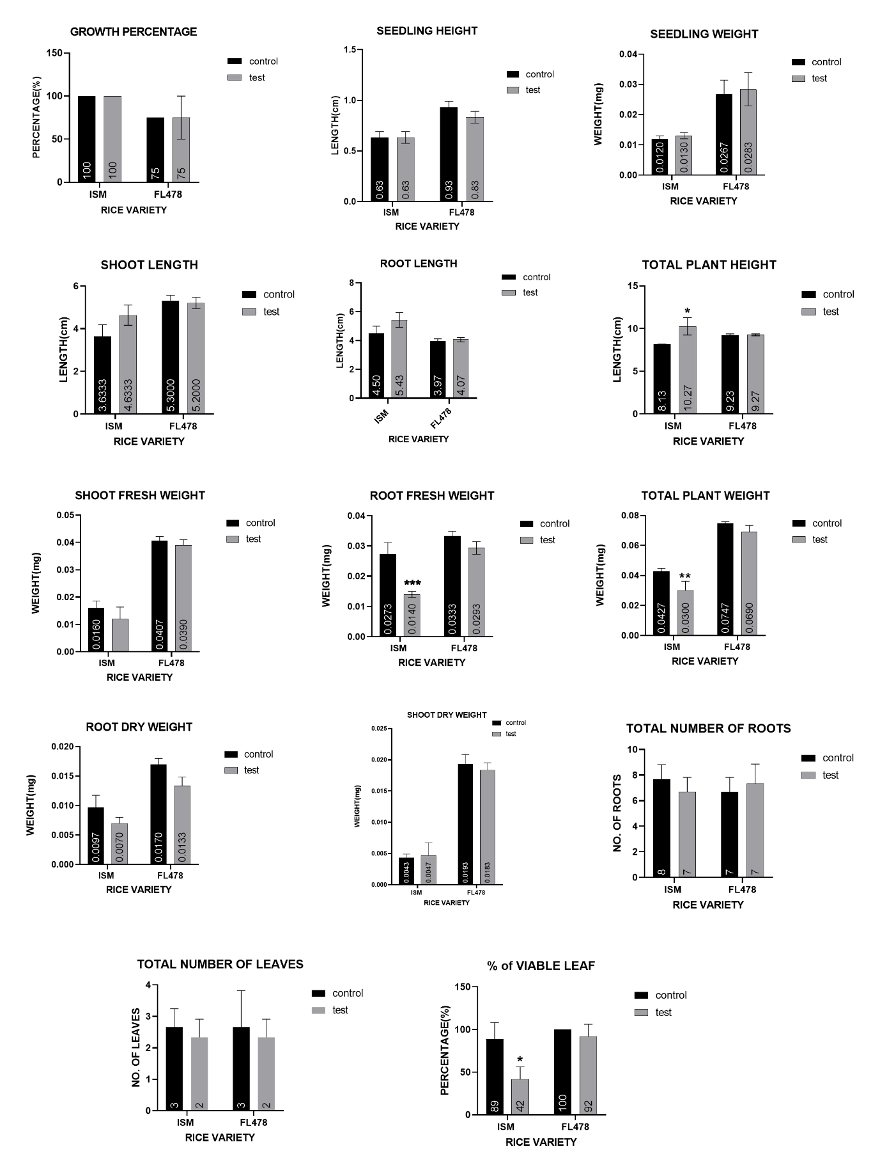
Fig.2 Morphological characteristics differences between FL478 and ISM rice varieties pre and post salt treatment. Data represented as mean ±SEM, (N=3) p≤0.05 is considered significant. *, **, ***, **** denotes p values of 0.05,0.01,0.001,0.0001 respectively

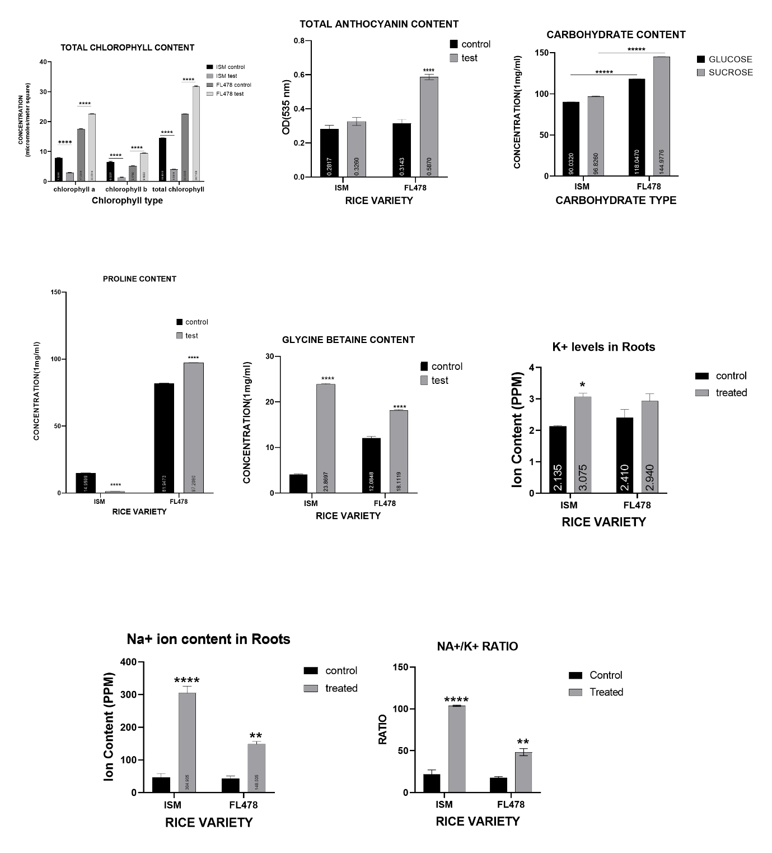
Fig. 3 Biochemical characterization differences between FL478 and ISM rice varieties pre and post salt treatment. Data represented as mean ±SEM, (N=3) p≤0.05 is considered significant. *, **, ***, **** denotes p values of 0.05,0.01,0.001,0.0001 respectively

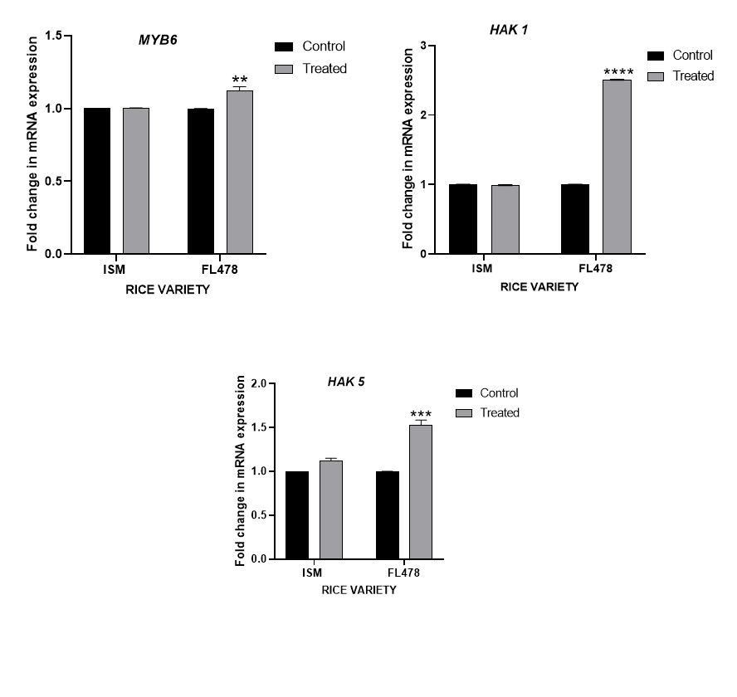
Fig.4 Gene expression analysis Data represented as mean ±SEM, (N=2) p≤0.05 is considered significant. *, **, ***, **** denotes p values of 0.05,0.01,0.001,0.0001 respectively.

3.2.7. DNA Extraction and SSR Genotyping
DNA extraction was successfully conducted using the CTAB method, followed by PCR amplification for SSR analysis. The extracted DNA was run for quality and quantity estimation and the representative image for the same is as seen in supplementary file 1. The precision of PCR product size was rigorously validated by aligning band positions with a standard ladder of 100 base pairs (bp). RM10720 exhibited a PCR product size of about 70 bp for both the markers. Subsequently, marker RM8094 revealed two bands with product sizes of approximately 190 and 110 bp for ISM and 200 bp for FL478.(Hoque et al. 2015) Finally, marker RM1287 showed product sizes around 180 bp for both ISM and FL478. This band size alignment for all three markers with the expected size indicates the successful amplification of the target SSR region. The precision of the PCR product size was confirmed by the consistency of the band position relative to the standard ladder. Since the markers were specifically selected only for rice varieties, the presence of both bands confirms that both plant samples used were of Rice. A visual representation of the markers is as given in Fig. 5.
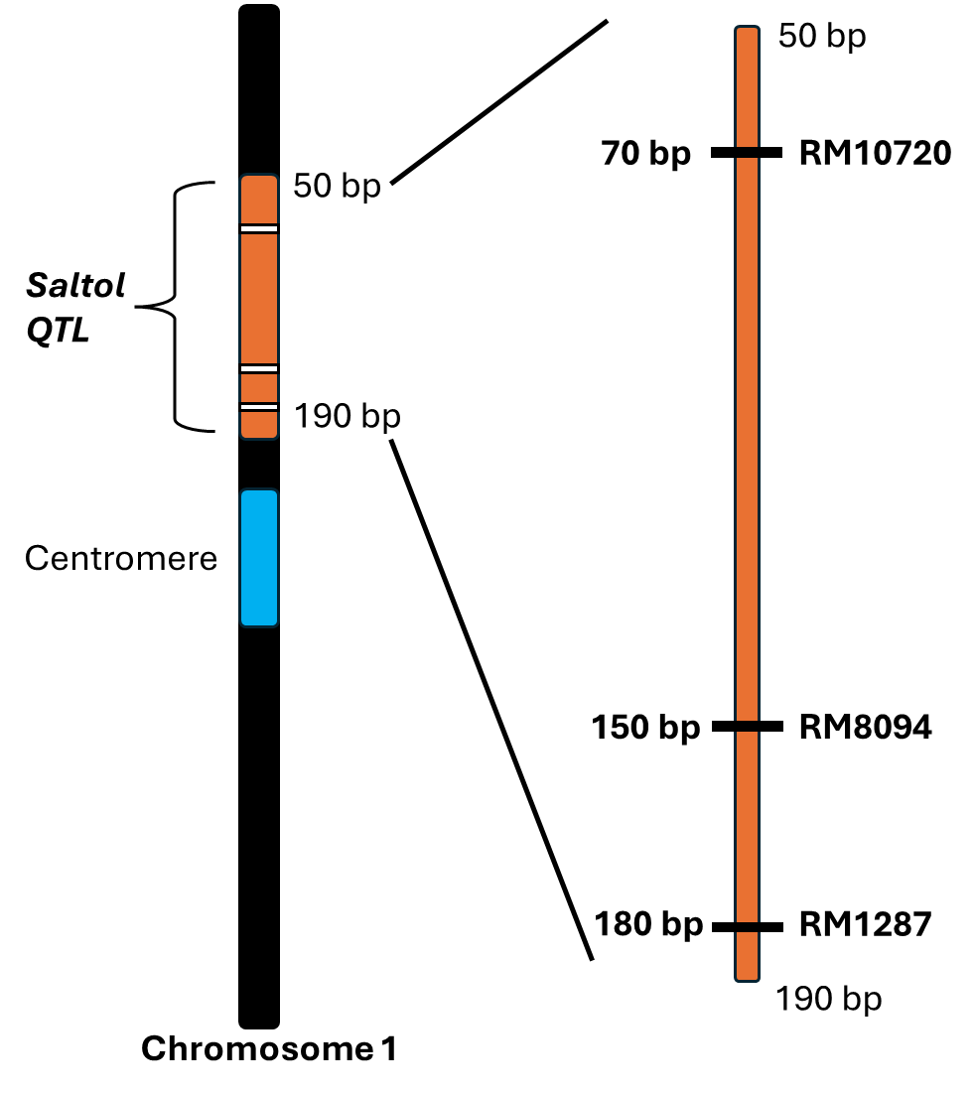
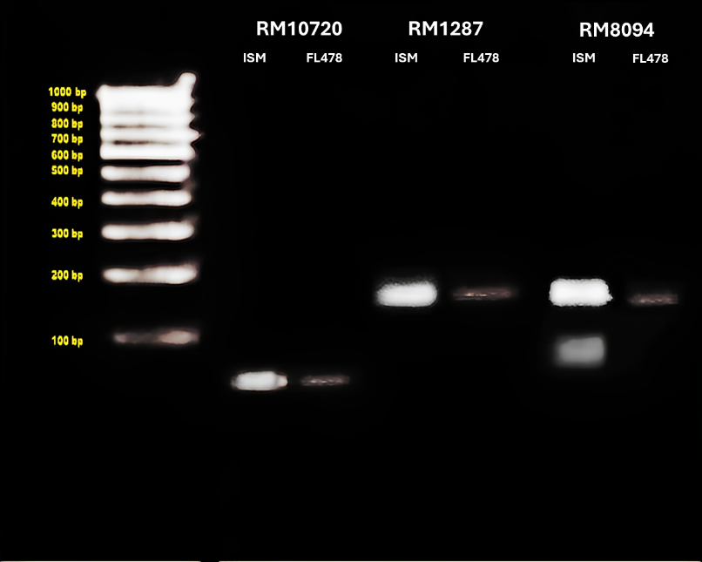
Fig.5 SSR Profile of the markers with 100 bp ladder (left), and a representation of the markers at chromosome 1. (right)

Phenotypic evaluation of salt tolerance in ISM and FL478 rice varieties revealed significant differences in their response to salt stress. Our S.E.S. evaluations showed clear distinctions between the two varieties, with FL478 faring much better in terms of leaf damage and overall growth. Our finding mirrors previous research that has credibly argued FL478's enhanced tolerance, attributed to its genetic background derived from the Pokkali strain, known for its salinity resilience. In our study, FL478 maintained better growth and leaf health under salt stress conditions compared to ISM, further highlighting its advantage in salt tolerance. The contrasting root structures of ISM and FL478, with ISM exhibiting lateral roots and FL478 displaying crown roots, that significantly influence their response to salt stress. Lateral roots, as observed in ISM, primarily grow horizontally from the main root, and spread widely. While lateral roots can aid in nutrient absorption and provide stability to the plant, they may also increase the surface area exposed to salt stress, potentially leading to higher salt uptake and subsequent damage to the plant. In contrast, FL478's crown roots, which grow vertically from the base of the stem, may offer advantages under salt stress conditions. It was found in a study that crown roots tend to grow deeper into the soil, allowing the plant to access water and nutrients from deeper soil layers where salt concentrations are lower.(Karlova et al. 2021) Additionally, the vertical orientation of crown roots may help minimize salt exposure compared to lateral roots, reducing the risk of salt accumulation in the root system.
Quantitative analysis of TC and TA contents in ISM and FL478 rice varieties revealed significant differences in their responses to salt stress. FL478 consistently exhibited higher TC levels compared to ISM, suggesting a genetic advantage in chlorophyll production. This higher TC content in FL478 implies a greater capacity for photosynthesis, enabling sustained growth and stress tolerance, particularly under salt stress conditions. On the other hand, FL478 also showed higher TA levels compared to ISM, indicating a potential genetic predisposition towards greater anthocyanin accumulation. Anthocyanins are known to minimize oxidative damage and act as antioxidants, potentially contributing to FL478's superior performance and stress tolerance, our findings were found to be consistent to previous studies. (Vanisri et al. 2017) The observed differences in TC and TA contents between ISM and FL478 underscore FL478's genetic advantage in coping with environmental stressors like salinity, highlighting its potential for cultivation in saline-prone areas.
Further evaluation of osmolytes revealed higher glucose content in FL478 suggesting it may have a more efficient carbohydrate metabolism or greater capacity for glucose synthesis compared to ISM potentially enabling better coping with stress conditions like salinity. Elevated sucrose levels in FL478 indicate a higher capacity for carbohydrate accumulation and transport, suggesting enhanced mechanisms for sucrose synthesis or transport compared to ISM. (Abhimanyu 2019) These metabolic differences may contribute to FL478's superior performance and stress tolerance.
The proline analysis data reveals significant differences in proline levels between the ISM and FL478 rice varieties under control and test conditions. FL478 exhibits notably higher proline levels compared to ISM in the control group, which in turn has been studied to impart stress tolerance by maintaining cell turgor or osmotic balance; stabilizing membranes thereby preventing electrolyte leakage. (Ashraf and Foolad 2007) However, in the test group, while FL478 maintains high proline levels even under stress conditions, ISM shows a notable decrease in proline levels. This decrease indicates potential modulation of proline metabolism in ISM under stress conditions, reflecting a different stress response mechanism compared to FL478. These differences in proline accumulation patterns between ISM and FL478 may reflect variations in stress tolerance mechanisms, highlighting the potential for targeted genetic modulation strategies in rice varieties. (Akihiro, Yuko, and Tetsuko 2007)
The quantification of glycine betaine levels in ISM and FL478 rice varieties sheds light on their osmotic stress response mechanisms. Both varieties showed increased glycine betaine levels under salt stress compared to controls, indicating active accumulation as a protective response. FL478 displayed higher basal glycine betaine levels than ISM under control conditions, suggesting a pre-existing adaptive mechanism contributing to its salt tolerance. (Chuamnakthong, Nampei, and Ueda 2019) The slower increase in glycine betaine levels in FL478 compared to ISM under salt stress may be due to pre-existing stress coping mechanisms or genetic factors favoring a gradual response. Despite this, both varieties demonstrated significant increases in glycine betaine levels under salt stress, indicating a common stress response mechanism.
Ion content measurements revealed distinct differences in sodium (Na+) and potassium (K+) levels between the varieties. FL478 exhibited lower Na+ and K+ levels than ISM post salt stress, suggesting mechanisms for maintaining ion balance under salt stress, thereby contributing to improved tolerance. (Chuamnakthong, Nampei, and Ueda 2019) The lower Na+/K+ ratio in FL478 indicates a better ability to maintain ion homeostasis, further enhancing its salt stress tolerance.

The gene expression analysis revealed intriguing patterns in the response of FL-478 and ISM rice varieties under the tested conditions. All the genes considered for the study viz. MYB6, HAK1and HAK5, showed a marginal increase in ISM test samples, suggesting little to no modulation in response to salt stress. In contrast, the expression of the MYB 6, HAK1and HAK5 gene showed a significant increase in FL-478 test samples. These findings indicate a more pronounced response in upregulating gene expression in FL-478 compared to ISM under the saline stress conditions. (Mirdar Mansuri et al. 2019) Earlier investigations have hinted the role of upregulation of MYB 6 in response to salt and drought stress suggesting that the transcription factor has role in modulating osmolyte accumulations. (Bhat et al. 2024) The osmolyte concentrations we obtained in our rice varieties confirms and bridges the function of gene upregulation with respect to salinity stress. The upregulation of HAK1 and HAK5 gene expression, particularly under salt stress, is pivotal for potassium transport and balance in plants encountering saline conditions. (Okada et al. 2018) HAK1 plays a critical role in potassium uptake from the soil when external potassium is scarce, while HAK5 assists in potassium absorption in roots. Through enhancing the expression of these genes, FL-478 exhibits a superior capacity to regulate potassium uptake and sustain balance compared to ISM, potentially augmenting its salt tolerance. Studies have indicated that under salt stress, plants activate high-affinity potassium transporters to facilitate potassium uptake and restore cellular sodium and potassium equilibrium, underscoring the significance of genes like HAK1 and HAK5 in maintaining ion homeostasis. (Fabiane Igansi de Castro dos et al. 2018) Overall, these results highlight the differential gene expression responses between FL-478 and ISM rice varieties, with FL-478 showing a more significant increase in the expression of stress-responsive genes HAK1 and HAK5.
The successful amplification of the target SSR region, as indicated by the observed band on the agarose gel, confirms the reliability of the CTAB-based DNA extraction method and the specificity of the PCR amplification using the three markers for SSR analysis in the rice samples. For RM8094, the resulting PCR products differed in size between the two varieties, with ISM sensitive yielding approximately 190base pairs (bp) and 110 bp bands and FL478 producing 170 bp fragments. These distinct product sizes hint at potential locus heterozygosity in the variety used for this study. Another possible reason could be that the primer used for RM 8094 might not be strictly specific. However, markers RM1287 and RM1072 exhibited monomorphic banding patterns, indicating uniformity in genetic composition, and validating the genotypes used belonged to Oryza sativa. (Dahanayaka et al. 2015)
4. Conclusion

In conclusion, our comprehensive study on two phenotypically distinct rice varieties, ISM and FL478 under salt stress conditions has provided valuable insights into their adaptive mechanisms and potential applications in agriculture. Attributing to its distinct root structure, higher chlorophyll, and anthocyanin contents, efficient osmolyte accumulation, better ion homeostasis, and specific gene expression patterns. These findings align with previous research and underscore the potential for genetic manipulation to enhance salt stress tolerance in rice.
Overall, our findings position FL478 as a promising candidate for cultivation in saline-affected regions, offering sustainable solutions to global food security challenges. Further research into the underlying genetic and biochemical mechanisms driving FL478's superior traits could unlock new avenues for crop improvement and the development of salt-tolerant rice varieties, ensuring resilient agricultural systems capable of withstanding environmental stressors and ensuring food security for future generations

COMPETING INTERESTS DISCLAIMER:
Authors have declared that they have no known competing financial interests OR non-financial interests OR personal relationships that could have appeared to influence the work reported in this paper.
Disclaimer (Artificial intelligence)
Author(s) hereby declare that NO generative AI technologies such as Large Language Models (ChatGPT, COPILOT, etc.) and text-to-image generators have been used during the writing or editing of this manuscript.

References

Abhimanyu, Jogawat. 2019. 'Osmolytes and their Role in Abiotic Stress Tolerance in Plants.' in (wiley).
Akihiro, Ueda, Yamamoto-Yamane Yuko, and Takabe Tetsuko. 2007. 'Salt stress enhances proline utilization in the apical region of barley roots', Biochemical and Biophysical Research Communications, 355: 61-66.
Ashraf, M., and M. R. Foolad. 2007. 'Roles of glycine betaine and proline in improving plant abiotic stress resistance', Environmental and Experimental Botany, 59: 206-16.
Bhat, Basharat Ahmad, Rakeeb Ahmad Mir, Wajahat Rashid Mir, Syed Suhail Hamdani, and Manzoor Ahmad Mir. 2024. 'Transcription factors-golden keys to modulate the plant metabolism to develop salinity tolerance', Plant Stress, 11: 100409.
Chuamnakthong, Sumana, Mami Nampei, and Akihiro Ueda. 2019. 'Characterization of Na+ exclusion mechanism in rice under saline-alkaline stress conditions', Plant Science, 287: 110171.
Chunthaburee, Sumitahnun, Anoma Dongsansuk, Jirawat Sanitchon, Wattana Pattanagul, and Piyada Theerakulpisut. 2016. 'Physiological and biochemical parameters for evaluation and clustering of rice cultivars differing in salt tolerance at seedling stage', Saudi Journal of Biological Sciences, 23: 467-77.
Citao, Liu, Mao Bigang, Yuan Dingyang, Chu Chengcai, and Duan Meijuan. 2022. "Salt tolerance in rice: Physiological responses and molecular mechanisms." In, 13-25. Institute of Crop Sciences.
Dahanayaka, B. A., D. R. Gimhani, N. S. Kottearachchi, and W. L. G. Samarasighe. 2015. 'Assessment of Salinity Tolerance and Analysis of SSR Markers Linked with Saltol QTL in Sri Lankan Rice (Oryza sativa) Genotypes', Journal of Experimental Agriculture International, 9: 1–10.
Diego, M. Almeida, M. Margarida Oliveira, and J. M. Saibo Nelson. 2017. "Regulation of Na+ and K+ homeostasis in plants: Towards improved salt stress tolerance in crop plants." In, 326-45. Brazilian Journal of Genetics.
Fabiane Igansi de Castro dos, Santos, Marini Naciele, Santos Railson Schreinert dos, Hoffman Bianca Silva Fernandes, Alves-Ferreira Marcio, and Oliveira Antonio Costa de. 2018. 'Selection and testing of reference genes for accurate RT-qPCR in rice seedlings under iron toxicity', PLOS ONE, 13: e0193418.
Fatien Najwa Che, Yah, Shamsudin Noraziyah Abd Aziz, Razak Mohd Shahril Firdaus Ab, Y. Rafii Mohd, Bhuiyan Md Atiqur Rahman, Nordin Mohd Shukor, and Salleh Mohd Syahmi. 2023. 'Morphological, biochemical and genetic variation of rice (Oryza sativa L.) genotypes to vegetative stage salinity stress', Plant Science Today, 10: 11-21.
Hoque, ABMZ, Md Ashraful Haque, Md Ruhul Amin Sarker, and Mohammad Akhlasur %J Int. J. Biosci Rahman. 2015. 'Marker-assisted introgression of saltol locus into genetic background of BRRI Dhan-49', 6: 71-80.
Islam, Mohammad Rafiqul, Glenn Borja Gregorio, Md Abdus Salam, Bertrand CY Collard, Rakesh Kumar Singh, and Lutful %J Molecular Plant Breeding Hassan. 2012. 'Validation of SalTol linked markers and haplotype diversity on chromosome 1 of rice', 3.
John Damien, Platten, A. Egdane James, and M. Ismail Abdelbagi. 2013. 'Salinity tolerance, Na+ exclusion and allele mining of HKT1;5 in Oryza sativa and O. glaberrima: Many sources, many genes, one mechanism?', BMC Plant Biology, 13.
Karlova, Rumyana, Damian Boer, Scott Hayes, and Christa Testerink. 2021. 'Root plasticity under abiotic stress', Plant Physiology, 187: 1057-70.
Kiss, Tibor, Zoltán Karácsony, Adrienn Gomba-Tóth, Kriszta Lilla Szabadi, Zsolt Spitzmüller, Júlia Hegyi-Kaló, Thomas Cels, Margot Otto, Richárd Golen, Ádám István Hegyi, József Geml, and Kálmán Zoltán Váczy. 2024. 'A modified CTAB method for the extraction of high-quality RNA from mono-and dicotyledonous plants rich in secondary metabolites', Plant Methods, 20: 62.
Kousik, Atta, Mondal Saptarshi, Gorai Shouvik, Singh Aditya Pratap, Kumari Amrita, Ghosh Tuhina, Roy Arkaprava, Hembram Suryakant, Gaikwad Dinkar Jagannath, Mondal Subhasis, Bhattacharya Sudip, Jha Uday Chand, and Jespersen David. 2023. 'Impacts of salinity stress on crop plants: improving salt tolerance through genetic and molecular dissection', Frontiers in Plant Science, 14.
Ma Guadalupe, Valadez-Bustos, Aguado-Santacruz Gerardo Armando, Tiessen-Favier Axel, Robledo-Paz Alejandrina, Muñoz-Orozco Abel, Rascón-Cruz Quintin, and Santacruz-Varela Amalio. 2016. 'A reliable method for spectrophotometric determination of glycine betaine in cell suspension and other systems', Analytical Biochemistry, 498: 47-52.
Mirdar Mansuri, R., Z. S. Shobbar, N. Babaeian Jelodar, M. R. Ghaffari, G. A. Nematzadeh, and S. Asari. 2019. 'Dissecting molecular mechanisms underlying salt tolerance in rice: a comparative transcriptional profiling of the contrasting genotypes', Rice (N Y), 12: 13.
Muhammad, Farooq, Park Jae Ryoung, Jang Yoon Hee, Kim Eun Gyeong, and Kim Kyung Min. 2021. 'Rice Cultivars Under Salt Stress Show Differential Expression of Genes Related to the Regulation of Na+/K+ Balance', Frontiers in Plant Science, 12.
Naomi, K. Fukagawa, and H. Ziska Lewis. 2019. "Rice: Importance for Global Nutrition." In, 2-3.
Neji, Tarchoun, Saadaoui Wassim, Mezghani Najla, I. Pavli Ourania, Falleh Hanen, and A. Petropoulos Spyridon. 2022. 'The Effects of Salt Stress on Germination, Seedling Growth and Biochemical Responses of Tunisian Squash (Cucurbita maxima Duchesne) Germplasm', Plants, 11.
Okada, T., S. Yamane, M. Yamaguchi, K. Kato, A. Shinmyo, Y. Tsunemitsu, K. Iwasaki, D. Ueno, and T. Demura. 2018. 'Characterization of rice KT/HAK/KUP potassium transporters and K(+) uptake by HAK1 from Oryza sativa', Plant Biotechnol (Tokyo), 35: 101-11.
Philippe, Jeandet, Formela-Luboińska Magda, Labudda Mateusz, and Morkunas Iwona. 2022. "The Role of Sugars in Plant Responses to Stress and Their Regulatory Function during Development." In.: MDPI.
Rekha, G., V. Abhilash Kumar, C. G. Gokulan, M. B. V. N. Koushik, B. Laxmi Prasanna, Kulkarni Swapnil, D. Aleena, G. Harika, S. K. Hajira, K. Pranathi, E. Punniakoti, R. R. Kale, T. Dilip Kumar, D. Ayyappa, M. Anila, Sinha Pragya, K. K. Manohara, G. Padmavathi, L. V. Subba Rao, G. S. Laha, M. S. Srinivas Prasad, R. A. Fiyaz, K. Suneetha, S. M. Balachandran, Patel Hitendra Kumar, V. Sonti Ramesh, P. Senguttuvel, and R. M. Sundaram. 2022. 'DRR Dhan 58, a Seedling Stage Salinity Tolerant NIL of Improved Samba Mahsuri Shows Superior Performance in Multi-location Trials', Rice, 15.
Rekha, G., G. Padmavathi, V. Abhilash, M. B. V. N. Kousik, S. M. Balachandran, R. M. Sundaram, and P. Senguttuvel. 2018. 'A protocol for rapid screening of rice lines for seedling stage salinity tolerance', Electronic Journal of Plant Breeding, 9: 993-1001.
Rima, Kumari, Kumar Pankaj, V. K. Sharma, and Kumar Harsh. 2019. 'Seedling stage salt stress response specific characterization of genetic polymorphism and validation of SSR markers in rice', Physiology and Molecular Biology of Plants, 25: 407-19.
Shahabuddin, Ahmed, Anik Touhidur Rahman, Islam Ashraful, Uddin Imtiaz, and S. Haque Mohammad. 2019. 'Screening of Some Rice (Oryza sativa L.) Genotypes for Salinity Tolerance using Morphological and Molecular Markers', Biosciences, Biotechnology Research Asia, 16: 377-90.
Sumitahnun, Chunthaburee, Dongsansuk Anoma, Sanitchon Jirawat, Pattanagul Wattana, and Theerakulpisut Piyada. 2016. 'Physiological and biochemical parameters for evaluation and clustering of rice cultivars differing in salt tolerance at seedling stage', Saudi Journal of Biological Sciences, 23: 467-77.
Thi, Hoang, Tran Thach, Nguyen Thuy, Williams Brett, Wurm Penelope, Bellairs Sean, and Mundree Sagadevan. 2016. 'Improvement of Salinity Stress Tolerance in Rice: Challenges and Opportunities', Agronomy, 6: 54.
Toi, Ketehouli, Carther Kue Foka Idrice, Noman Muhammad, Wang Fa-Wei, Li Xiao-Wei, and Li Hai-Yan. 2019. 'Adaptation of Plants to Salt Stress: Characterization of Na+ and K+ Transporters and Role of CBL Gene Family in Regulating Salt Stress Response', Agronomy, 9: 687.
Vanisri, S., M. Sreedhar, L. Jeevan, A. Pavani, Chaturvedi Anurag, M. Aparna, D. Pavan Kumar, T. Sunitha, K. Aruna, V. G. N. Tripura Venkata, Raju Ch. Surender, and R. Jagadeeswar. 2017. 'Evaluation of Rice Genotypes for Chlorophyll Content and Scavenging Enzyme Activity under the Influence of Mannitol Stress towards Drought Tolerance', International Journal of Current Microbiology and Applied Sciences, 6: 2907-17.
Zhoufei, Wang, Chen Zhiwei, Cheng Jinping, Lai Yanyan, Wang Jianfei, Bao Yongmei, Huang Ji, and Zhang Hongsheng. 2012. 'QTL Analysis of Na+ and K+ Concentrations in Roots and Shoots under Different Levels of NaCl Stress in Rice (Oryza sativa L.)', PLOS ONE, 7.

