Review Article
Smart sericulture systems based on Internet of things (IoT) and Image processing

ABSTRACT
Sericulture alludes to the raising of silkworms to produce silk. India is the second biggest producer of silk. Temperature, Relative humidity, light and air plays a major role in sound silkworm production and quality cocoon production mainly depends upon the quality of mulberry leaves. Internet of Things is an ecosystem of connected physical objects that are accessible through internet. IoT empowered Arduino based system used to monitor the rearing room conditions and to monitoring the field conditions. In addition to that, Image processing is an analysis and manipulation of a digitized image, tailored to improve image quality and for separate data from images. Silkworm eggs counting system using image processing is a state of art technology to count eggs accurately and reduces the time of manual counting using conventional methods. Cocoon quality assessment using image processing is more reliable, precise, faster and economically feasible. Sex separation using image processing showed high degree of accuracy. This review highlights the potential of smart sericulture systems employing digital technologies. This will further helps the farming and scientific community in precision sericulture.
Key words: Sericulture, Smart systems, Internet of things (IoT) and Image processing.
INTRODUCTION:
Sericulture is an art of science mainly involves in the cultivation of mulberry and rearing of silkworms for the production of silk. India is the second biggest producer of silk in the world and produces all four types of silk namely Mulberry, Tasar, Eri and Muga. The larvae of Silkworm are nourished by means of mulberry plants and it spins their silken cocoons after the fourth shed. The moisture and temperature assumes a key part in each phase of sericulture process, and a great deal of care is additionally should have been taken to maintain a strategic distance from sicknesses.
A successful cocoon crop is dependent on both abiotic and biotic factors namely temperature, humidity, light, leaf quality, silkworm race and hygiene. All these factors altogether mainly temperature and humidity decide the quality and success rate of the cocoon crop. The seasonal variations in the environmental factors like temperature and humidity affect the genotypic constitution which is expressed in commercial characters in terms of cocoon weight, shell weight, shell ratio percentage (Rahmathulla, 2012). In addition to that, climatic factors have significant influence on disease incidence in silkworm which leads to crop loss (Kant et al. 2022)
The Internet of Tings (IoT) is an emerging paradigm that enables the communication between electronic devices and sensors through the internet in order to facilitate our lives. IoT use smart devices and internet to provide innovative solutions to various challenges and issues related to various businesses, governmental and public/private industries across the world (Sfar et al.2017). Internet of things (IoT) is an ecosystem of connected physical objects that are accessible through internet. Temperature, Relative Humidity, light and atmospheric air in the silkworm rearing room plays a major role in sound silkworm production. IoT empowered with Arduino based system used to monitor the silkworm rearing room conditions (Nivaashini et al.2018). The main aim of using Internet of Things is to minimize the manual intervention of the farmer, by automating the process of irrigation of mulberry plantation and monitoring the field conditions (Madihalli and Ittannavar, 2017).
Image processing is an analysis and manipulation of a digitized image, tailored to improve image quality and for separate data from images. Silkworm egg counting is necessary to avoid loss for silkworm egg producers and farmers. Silkworm egg counting system using image processing is a state of art technology to count eggs accurately and reduces the time of manual counting using conventional methods (Pathan and Harale, 2016b). Sex separation is one of the important activities in the grainage to avoid Selfing through that it helps to obtain high quality of raw silk production and helps in breeding by maintaining purity in races. Separation by visual inspection is a time consuming and labour intensive process. Sex separation using image processing showed high degree of accuracy and reduces the labour involvement and helps in time saving (Sarun et al.2013). Quality assessment of cocoons is an important process in the cocoon market activities which ensures reelers to get quality cocoons leads to high grade silk production. Cocoon quality assessment using image processing is more reliable, faster and economically feasible (Prosobhkumar et al. 2018).
INTERNET OF THINGS (IoT):
The Internet of Things (IoT) is the network of physical objects or "things" embedded with electronics, software, sensors, and network connectivity, which enables these objects to collect and exchange data (Sunita et al. 2012).IoT allows objects to be sensed and controlled remotely across existing network infrastructure, creating opportunities for more direct integration between the physical world and computer-based systems, and resulting in improved efficiency, accuracy and economic benefit (Vijayanand et al.2016).Internet of Things helps in the field of heart monitoring implants, biochip transponders on farm animals, automobiles with built in sensors, DNA analysis devices, Food/ Environmental/ Pathogen monitoring devices, field operation devices and for rescue operations. The methodology of IoT divided into phases of Requirement analysis, System design, Hardware Implementation, Software Development and Integration Testing (Yamuna et al. 2025).
HOW IOT WORKS?
Internet of Things is not the result of a single novel technology; instead, several complementary technical developments provide capabilities that taken together help to bridge the gap between the virtual and physical world. These capabilities include communication and cooperation, addressability, identification, sensing, actuation, embedded information processing, localization and user interfaces.
The major components of IoT comprise thing or device, gateway, cloud, analytics and user interface. The components of IoT implementation are sensors, standards, intelligent analysis, intelligent actions and networks.
Applications of IoT:
- Building and Home automation
- Manufacturing
- Medical and Healthcare systems
- Media
- Environmental monitoring
- Field monitoring
- Infrastructure management
- Energy management
- Transportation
IOT IN SERICULTURE:
IoT in sericulture will help in maintaining temperature and other factors automatically with the help of sensors and microcontroller. The mapping of the plantation, infestation of diseases and pests, surveying, etc. can be monitored regularly. Sericulture is a labour-intensive venture thereby requires sufficient skilled workers in grainage operations, rearing of silkworms, bed cleaning, harvesting of leaves, mounting and many more. The adoption of artificial intelligence (AI) with internet of things (IoT) simultaneously and utilization will save both time and money of the rearers leading to sustainable sericulture (Shilpa and Monimala, 2023)
The main goal is to automate the process of streamlining the operation by using sensors to identify dangerous gases, temperature, moisture, and vibration. It also intends to install a fire alarm preventive system and develop timer-based disinfection and lime water sprayers for illness prevention (Krishnapriya et al. 2024).
The art of culturing silkworm for the production of silk is termed as sericulture. Moistness and temperature take part a critical position in the progression of solid silkworms in each stage. Internet of Things (IoT) empowered Wireless Personal Area Network (WPAN) system in order to deal with a continuous observation of silkworm development (Nivaashini et al. 2018). The complete system is designed and implemented to control the atmospheric condition inside the sericulture system as per the requirements in each stage of sericulture life cycle (Divyadharshini et al. 2016).
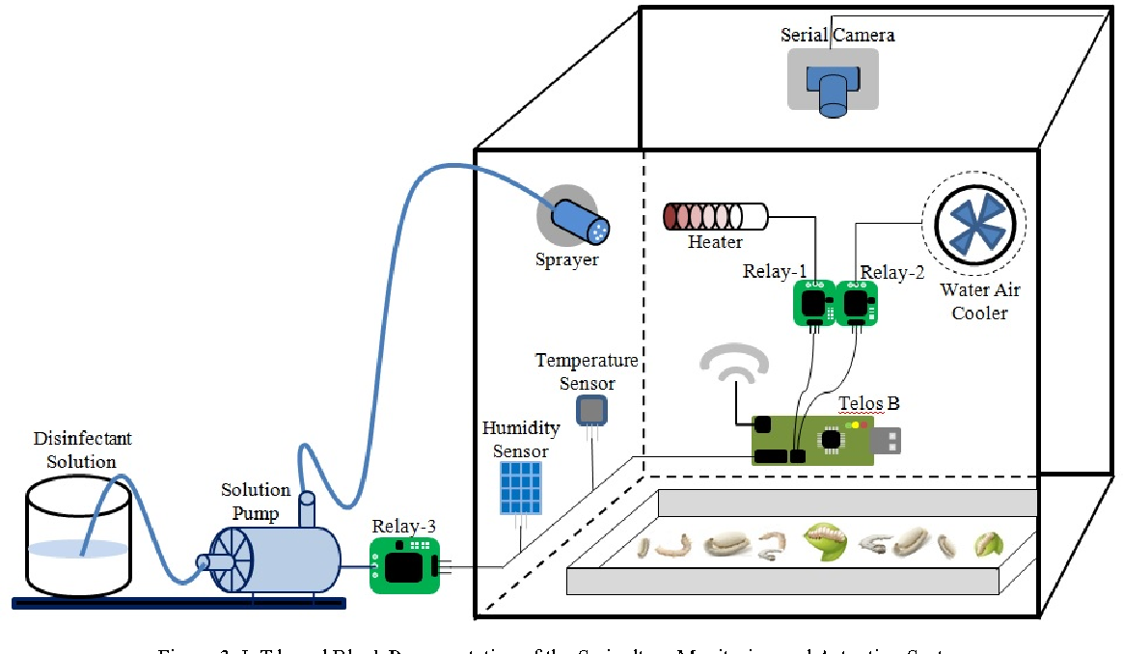
Sensor Hub
Figure 1. Arduino based silkworm growth monitoring system
SILKWORM GROWTH MONITORING SYSTEM:
The system is built in two parts one is hardware which is brain of the system it monitors the system based on the data received from the sensors and another one is software which is used to develop code required for the arduino which monitors and controls the external devices and sensors (Shwetha et al. 2021). The model employed utilizing Arduino Software and sensors to gauge the environmental circumstances within the arrangement of silkworms according to the prerequisites for each and every stages of silkworm life cycle (Nivaashini et al. 2018).
ARDUINO BASED AUTOMATED SMART SILKWORM GROWTH MONITORING SYSTEM:
Arduino is an open-source platform utilized for the construction of electronic gadgets. Arduino comprises of both a physical programmable circuit board (microcontroller) and a portion of Integrated Development Environment (IDE) that keeps running on the Personal Computer (PC), used to compose and transfer PC code to the physical board.
Temperature, Relative Humidity, Light force and Atmospheric air assumes an imperative part in the advancement of sound silkworms. This model faculties and controls the natural variables like temperature, relative humidity, CO2 and light power. Food feeder and solution sprayers are additionally mounted over the homestead. This is about to give automated control to the farmers utilizing wireless sensors, microcontroller and GSM (Manjunatha and Magesh, 2018)
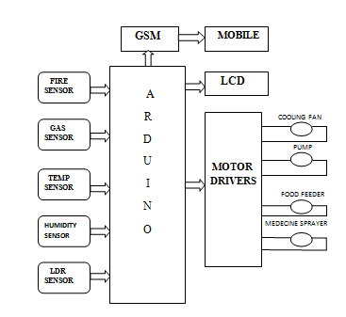
Figure 2. Components of Arduino system
COMPONENTS OF THIS SYSTEM:
The system consists of both the software and hardware components which are classified as follows:
SOFTWARE COMPONENTS: Arduino programming: The purpose of the arduino programming is to control the operation of the arduino microcontroller. It is simple and it controls the overall process on the basis of the conditions given in the program.
HARDWARE COMPONENTS: The microcontroller receives the commands from temperature, moisture, fire, gas and LDR sensor. Based on the values fed into it, the controller will analyze the sustaining condition of these sensors is suitable for the silkworm and then it does the controlling operation. Other components are temperature sensor, humidity sensor, gas sensor, light sensor, fire sensor, GSM module, buzzer and LCD display (Sapna and Kaur, 2022).
Functions of components:
- Micro controller: It is known as brain of the system. Temperature, humidity, and light dependent resistor (LDR) sensors all provide commands to it. After receiving the data, the controller compares it to the threshold values recorded in the cloud over the internet and maintains the needed silkworm environmental conditions.
- Temperature sensor: The temperature sensors are precision integrated circuits with a proportional output in Celsius. It is powered by a single source of electricity. It is capable of measuring temperature more accurately than a thermistor.
- Light Dependent Sensor (LDR): Resistance decreases with increase in the falling light strengths. Also known as photodetector & built up of a high resistive semiconductor.
- Moisture sensor: Moisture sensors also known as humidity sensor are day by day gaining significances in the miscellaneous field for the measurements & the control technologies.
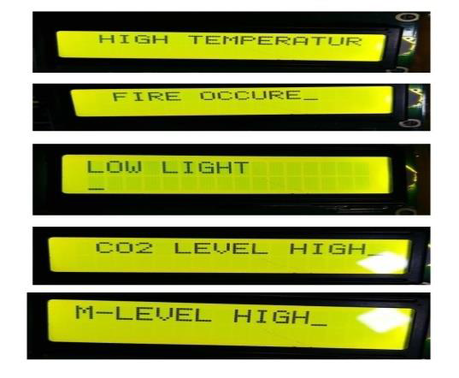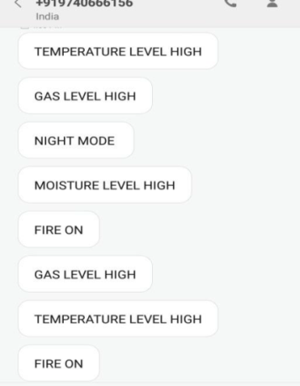
Message sent to the farmer
LCD display

Figure 3. Display of messages
ARDUINO BASED SYSTEMS AT FIELD LEVEL:
The mulberry plantation is the only source of food for the silkworms, require regular irrigation which is both time consuming and also requires the presence of farmers on land.
The main objective is to minimize manual intervention of the farmer, by automating the process of irrigation by using a Low cost micro-controller board (Arduino UNO) (Madihalli and Ittannavar, 2017)
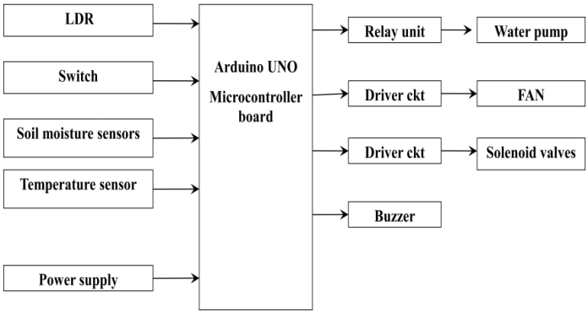
Figure 4. Field level monitoring system
Moisture sensor:
- The Soil Moisture Sensor is used to measure the volumetric water content of soil.
- Measure the loss of moisture over time due to evaporation and plant uptake.
- Monitor soil moisture content to control and regulate irrigation.
Temperature sensor:
Temperature sensor is mainly used to measure the soil temperature. It helps in maintaining the soil moisture and regulates the flow of irrigation.
Photo-resistor:
A Photo-resistor (or light-dependent resistor, LDR, or Photo-conductive cell) is a light controlled variable resistor. The resistance of a photo-resistor decreases with increasing incident light intensity; in other words, it exhibits photoconductivity.
Relay module:
A relay is an electromagnetic switch operated by a relatively small electric current that can turn on or off a much larger electric current. Relays can work either as switches (turning things on and off) or as amplifiers (converting small currents into larger ones).

IMAGE PROCESSING IN SERICULTURE:
Image processing is a system which principally changes an image into computerized shape and to play out few activities on it, to decipher the physical nature, to enhance the nature of the picture or to separate some helpful data from it. It uses in sericulture in the ways of Silkworm sex separation, Silkworm egg counting, Quality assessment of cocoons and Disease identification monitoring (Pathan and Harale, 2016a and Jayaraghavan et al. 2018)
Silkworm egg counting system:
- Counting of silkworm eggs is necessary to avoid loss for silkworm egg producers and farmers. It is compulsory to count the silkworm eggs for selling the silkworm eggs to farmers.
- Present methods of counting of Silkworm eggs such as manual counting is waste of time and it requires a lot of man power, other method such as calculator causes harm to the eggs. So avoid loss to sericulturists and farmers, automatic methods such as silkworm egg counting system using image processing algorithm is perfect method for counting silkworm eggs.
EGG COUNTING USING IMAGE PROCESSING:
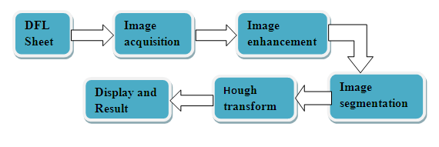
Figure 5. Processes involved in silkworm egg counting system
Image acquisition:
Image acquisition consists of capture image through camera. The quality of image depends on camera parameters, camera resolution, lighting conditions, environmental condition and size of objects. For getting high quality images, cameras with higher resolution are preferred (Pathan and Harale, 2016a).
Image enhancement:
Image enhancement is to enhance the image clarity and the resulting image is more suitable than original image and noise (Pathan and Harale, 2016a).
Image segmentation:
The goal of segmentation is to simplify and/or change the representation of an image into something that is more meaningful and easier to analyse (Pathan and Harale, 2016a).
Hough transforms:
The purpose of the technique is to find out the imperfect instances of objects within a certain classes of shapes (Pathan and Harale, 2016a).
Object counting:
Object counting is to get a number of segmented areas.

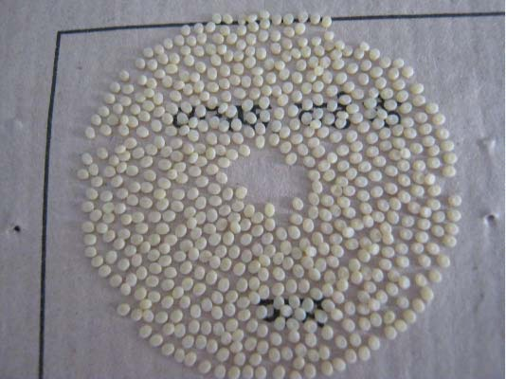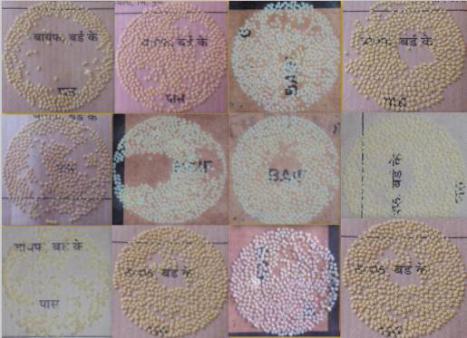
Sample dfl
Image acquisition

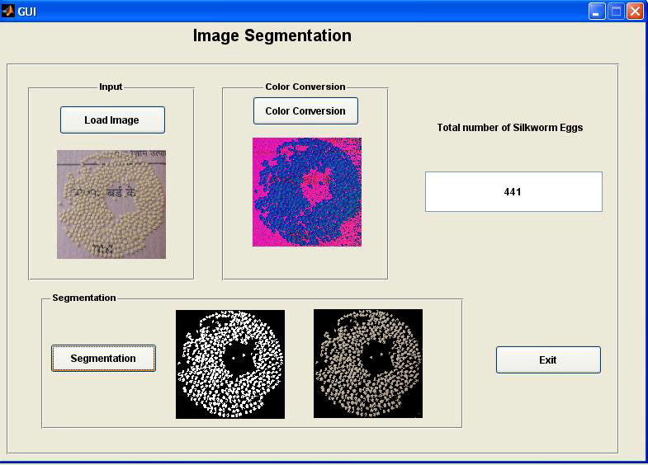
Figure 6. Egg counting using Image processing
SEX SEPARATION USING IMAGE PROCESSING:
Importance of sex separation:
- To achieve high quality of raw silk.
- Visual inspection- which requires well trained and highly-skilled persons.
- In visual inspection sometimes error occurs due to silkworms having similar shape and size.
- So, the systems using image processing shows high accuracy in sex identification of silkworms.
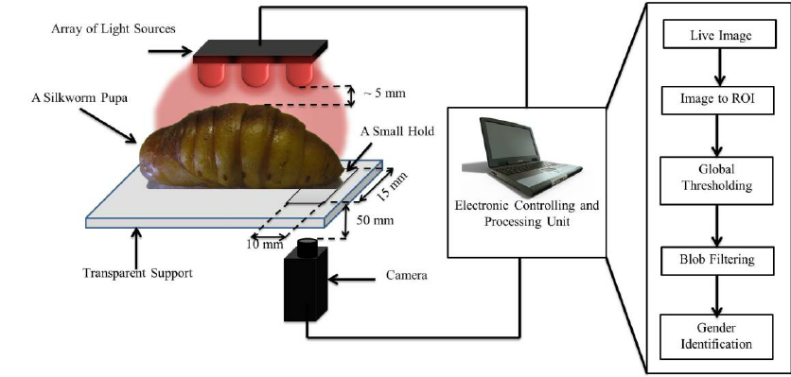
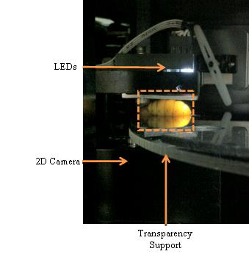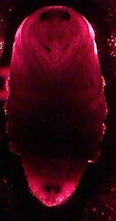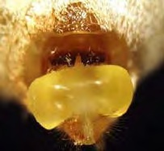
Chitin gland of female silkworm
Female silkworm

Figure 7. Sex Separation using Image processing

Disease detection:
Silkworms are highly sensitive to environmental conditions and it needs timely monitoring to avoid crop losses occurring due to disease incidence. In case of disease occurrence rapid identification and management is indispensable to secure the crop from crop loss.
Disease detection stands as a crucial aspect in the complicated tapestry of sericulture, safeguarding the delicate balance of silk production by arming sericulturists with an unparalleled vantage point into the health of their silkworm colonies. As image processing algorithms unravel the visual secrets of silkworm colonies, early signs of diseases and infections, hitherto concealed in the shadows of the microscopic world. Early detection through image processing unshackles sericulturists from the realms of reactive responses, empowering them to tackle diseases at their inception, before they morph into formidable adversaries capable of wreaking havoc on sericulture farms (Puneeth and Veena, 2024).
An automated system for the identification of silkworm diseases and the provision of treatment recommendations using Convolutional Neural Networks (CNN) is a suitable and defined method in disease detection. CNNs, a class of deep learning algorithms, have demonstrated remarkable success in image classification tasks owing toward their capacity to automatically learn and extract structures from images. (Shilpa and Anita, 2025)
Figure 8. Grasserie affected silkworm captured through image processing

QUALITY ASSESSMENT OF COCOONS:
Cocoon quality assessment is important for the transaction between farmers and reelers in the market. Quality assessment is important to calculate the economic parameters like cocoon weight, shell ratio, shell weight and also helpful to fix the cocoon price. In order to attain a good quality raw silk, the elimination of defective cocoons is incredibly essential
Cocoon quality assessment using image processing has more advantages such as counting, grading, sorting, quality assessment, disease detection and yield predictioncompared to normal methods with increased assessment rate and accurateness (Prasobhkumaret al. 2018)
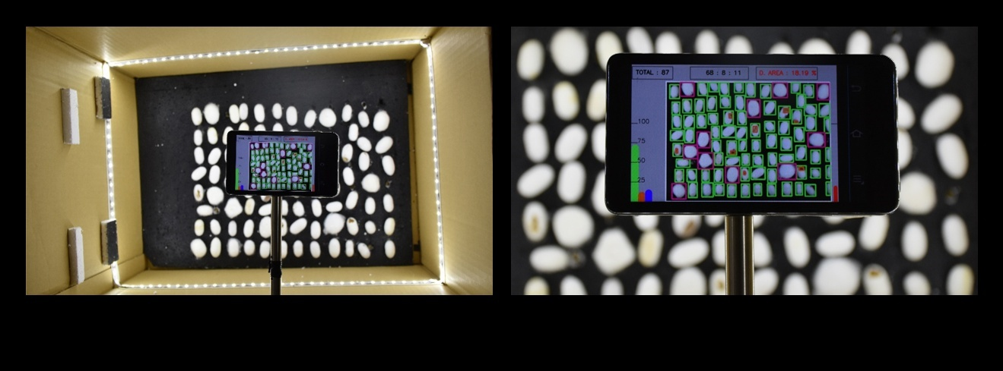
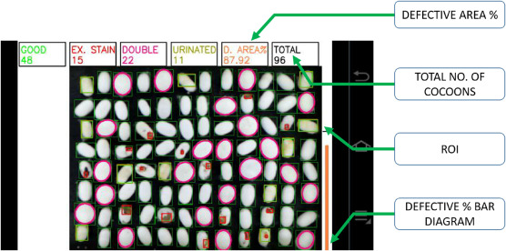
Figure 9. Cocoon quality assessment through Image processing
Advantages:
Silkworm growth monitoring: Maintains the atmospheric conditions in the rearing room, immediate indication to farmers and facilitates easy maintenance from far distances.
Field monitoring: Helps to regulate the field moisture, temperature and irrigation by automation process and reduce the labour involvement.
Egg counting system: Accuracy, to count overlapped eggs, reduces the time of manual counting, increase benefits in sericulture production and increases the silk production
Sex separation: Facilitates easy grainage operation, reduces the occurrence of errors through manual separation and saves time and labour.
Cocoon quality assessment: To avoid economic loss, helps in the identification of double, externally stained, uzipierced and urinated also detected using the image processing technique.
More reliable, faster, easily upgradeable and economic compared to the current manual method.
Disease monitoring:Easy prediction, accurate identification and helps to avoid batch failure through early forecasting.
CONCLUSION:
Overall, using IoT in sericulture offers many advantages. It reduces the need for manual monitoring, helps in maintaining a stable environment, and increases the chances of a successful silk harvest. However, it also has some challenges, such as the cost of the equipment and the need for internet connectivity, which may not always be available in rural areas. Despite these challenges, IoT-based systems have great potential to modernize sericulture and support farmers by making the process more efficient and less labour-intensive.
By automating the various parameters accordingly, it favours the environment for silkworm to grow healthily and the farmer can get the maximum yield. The system can be programmed to include additional elements in the process of raising silkworms as desired by the farmer, such as the environmental parameters (threshold can be altered) can be appropriately adjusted based on different geographical areas. As the system is based on open- source materials, it offers a fundamental basis for any upcoming sericulture-related embedded and internet of things advancements.
Details of the AI usage are given below:
1. I, Bhuvaneshwari. T (Corresponding author) hereby declare that NO generative AI technologies such as Large Language Models (Chat GPT, COPILOT, etc.) and text-to-image generators have been used during the writing or editing of this manuscript.
REFERENCES:
Divyadarshini, B., Adarsh, B.U., shivayogappa, H.J. and Navya, K.N. (2016) Automated smart sericulture system based on 6LoWPAN and Image processing Technique. ICCCI.
Jayaraghavan, V., Manjunath, C.R. and Soumya, K.N. (2018). A survey: Silkworm egg counting and Monitoring based on Image processing and Internet of Things (IoT). IJTSRD, 2 (4).
Kant, R., Bali, K., Gupta, R. K., Sharma, R., Sharma, S. and Singh, P. (2022). Role of biotic and abiotic factors influencing cocoon productivity in Jammu region. Biological Forum- An International Journal, 14(2), 1140-1145.
Krishnapriya, N., Vibin Auto, S. and Vasuda, M. (2024). Deployment of IoT and AI in a smart sericulture framework: streamlining silk production processes. International journal of new innovations in engineering and technology, 24 (1).
Madihalli, D.B., and Ittannavar, S.S. (2017). Arduino based automated sericulture system. Journal of Advances in science and Technology, 14 (1): 2230-2659.
Manjunatha and Magesh, B. (2018) Arduino based automated smart sericulture system. IJCSMC, 7(7): 88-95.
Nivaashini, M., Soundariya, R.S., and Dinesh kumar, A. (2018). Silkworm growth monitoring smart sericulture system based on Internet of Things (IoT) and image processing. International journal of Computer applications, 180 (18).
Pathan, S. and Harale, D. (2016a) Silkworm egg counting using image processing algorithm- A review.IRJET, 3 (6): 2395-0056.
Pathan, S. And Harale, D. (2016b) A method of Automatic Silkworm eggs counting system. IJIRCCE, 4 (12).
Prasobhkumar, P.P, Francis, C.R. and Sai Siva Gorthi. (2018). Automated quality assessment of cocoons using a smart camera based system. Engineering in agriculture, Environment and food, 187.
Rahmathulla, V.K. (2012). Management of climatic factors for successful silkworm (Bombyx mori L.) crop and higher silk production: a review. Psyche: A Journal of Entomology, 1-12. https://doi.org/10.1155/2012/121234
Puneeth, M. and Veena, S. (2024). IoT and Image Processing in Sericulture. International journal of Research Publication and Reviews, 5 (5): 4439-4445.
Sarun, S., Chakkrit K. and Chiranaut S.N. (2013). Spectral Imaging analysis for silkworm gender classification. International society for optical engineering.
Shilpa, S. and Manimala, S. (2023). Smart sericulture and IoT: A Review. Biological Forum-An International journal. 15(1): 545-549.
Sunita, Jyoti Malik and Suman Mor. (2012).Comprehensive Study of Applications Sensor Network.International Journal of Advanced Computer Science Research and Software Engineering, 2(11).
Sapna, C. and Kaur, P. (2022). A new technique of automated sericulture based on IoT. International journal of innovative research in computer science and technology, 10 (2): 102-105.
Sfar, A.R., Zied, C. andChallal, Y. (2017) .A systematic and cognitive vision for IoT security: a case study of military live simulation and security challenges. International conference on smart, monitored and controlled cities (SM2C), Sfax, Tunisia, 17–19 Feb. 2017.
Shilpa, B. K. and Anita. (2025). A Novel approach for silkworm disease detection and classification by using CNN and Image Processssssssing techniques. Journal of Scientific Research and Technology, 3(3): 21-29.
Shwetha, R., Guruprasad, M. K.,Mallesh, M. S., Banu, S., Jyoti, S. N. andThippesha, D. (2021).Smart sericulture system based on IoT and Image processing technique. International conference on computer communication and informatics (ICCCI).
Vijayanand, S., Immanuvel Bright, E. and Vijay Anand, L. (2016) Automation in sericulture farm.International Research Journal of Advamced Engineering and Science, 1(2): 17-19.
Yamuna, C. S., Nandanm G. N. andDivakara, S.S. (2025). IoT based smart monitoring and controlling automated sericulture system. International journal of Research Publication and Reviews, 6 (5):4259-4262.

