CITIZEN PARTICIPATION IN LOCAL DEVELOPMENT. WHAT IS THE ANSWER TO PARTICIPATORY BUDGETING IN CÔTE D’IVOIRE ?

Abstract
After 45 years, decentralization, which aroused much enthusiasm in Côte d'Ivoire in the 1980s, is still struggling to achieve the desired inclusive local development. The expectations and needs expressed by the local population are still not taken into account by elected officials in development actions. What reveals the challenges of local governance: crisis of legitimacy, decline in financial resources and especially the challenge of action efficiency that requires the participation of actors. How can local populations, marginalized by the discourse of local elected officials, contribute to decision-making that affects them in development projects? The objective of this study is to show that the Participatory Budget is an appropriate tool for citizen participation in the face of the communication deficit between the different actors of local development. The methodology is based on secondary data, including case studies and an analysis of work related to participatory budgeting in Porto Alegre, Brazil, and Yakassé-Attobrou, Côte d’Ivoire. To this is added information collected from 229 heads of household in Taabo and 327 in Alépé. Then interviews with municipal authorities in 2008 and 2014. The results show that the participatory budget, contextualized and applied as a tool for democratic debate in local affairs management, is an appropriate instrument to identify development actions to be carried out, as was the case in Porto Alegre in Brazil and in Yakassé-Attobrou in Côte d'Ivoire. This has facilitated the realization of equipment that corresponds to the needs expressed by the population in Yakassé-Attobrou.The popularization of this citizen participation mechanism will avoid the gap between municipal investment and the needs expressed by the populations of Alépé and Taabo. However, its effectiveness depends on the willingness of elected officials to engage in transparent and inclusive decision-making processes.

Keywords: Alépé, Participatory Budget, Côte d'Ivoire, citizen participation, local development, Taabo, Yakassé-Attobrou.

1. INTRODUCTION

The year 1980 marks the beginning of the effective implementation of decentralization in Côte d’Ivoire. Since then, local elected officials have carried out various projects to provide decentralized territories with infrastructure, socio-collective equipment and new social services. However, these investments are far from meeting the needs expressed by local populations (Adomon, 2015). Among the reasons mentioned, the recurring issue is that of citizen involvement in the management of local affairs.
Indeed, authors like Baiocchi (2001 and 2005); Gret and al., (2002); Herzberg and al., (2008); Bara (2008); Ferdinand and al, (2018); Brandeleer and al. (2014) believe that the decentralization which has generated enthusiasm in developing countries is a victim of the low level of involvement of the local population in the business management process. Bara (2008, p7) reports that actions aimed at strengthening the power of local governments and citizen participation were carried out in the early 1980s, but notes that today the role of these populations within decision-making mechanisms at the local level is less perceptible. In Côte d'Ivoire, for example, despite the reduction of the power of the central administration to the benefit of local elected officials since communalization initiated in 1980 (organic and regulatory texts of decentralization)¹; the mechanism for monitoring and controlling the actions of elected officials still escapes the average citizen. Moreover, women’s and youth groups are often absent from local decision-making mechanisms. According to Koffi Yéboué S. and al (2014), citizen participation is fundamentally limited to the choices of local elected officials better, they are less and less associated with the implementation of local development projects.
Local development is a global approach of synergy and movement of local actors for the enhancement of local resources in a given territory Paul Houée (1996). It is therefore of a negotiated approach with the decision-making centers of economic, social and political groupings in which all are integrated. For Bernard Pecqueur (2002), this approach of capitalization of collective learning and the valorization of collective know-how should allow the local community to participate in shaping its own environment.
45 years after decentralization in Côte d'Ivoire, the expectations and needs expressed by the populations are not sufficiently taken into account by local elected officials in development projects (Adomon, 2015); (Adomon and al, 2017) and Atta and al (2015). Today (September 2023) still operations of urban development, restructuring and eviction of spaces for public utility are unfortunately underway in the District of Greater Abidjan despite the recriminations of the affected populations.
Such findings raise the problem of the communication deficit between local development actors. How can local populations, marginalized by local elected officials, contribute to decision-making that affects them in development projects?
The objective of this article is to show that participatory budgeting can be an appropriate tool in the face of the communication deficit between the different actors of local development.
The article presents a Participatory Budget system contextualized as a response to the communication crisis between elected officials and local populations in the municipalities of Taabo and Alépé based on the one implemented in Yakassé-Attobrou in Côte d’Ivoire.

(1) - Laws 80-1180, 80-1181 and 80-1182 of 17 October 1980, respectively relating to the municipal organization, the municipal electoral regime and the special status of the city of Abidjan;
- Law No. 95-892 of 27 October 1995 on the general organization of Territorial Administration;
- Law No. 98-485 of 7 September 1998 on the organization of administrative regions into territorial communities and Law No. 2001-476 of 9 August 2001 on the general organization of the territorial administration;
- Law 2003-208 of 7 July 2003 on the transfer and distribution of powers from the State to the Territorial Communities, etc...
2. METHOD
2.1. Presentation of the study framework
The municipalities of Alépé, Taabo and Yakassé-Attobrou served as a reference
framework (figure n°1).

figure 1: Geographical location of the study's reference framework
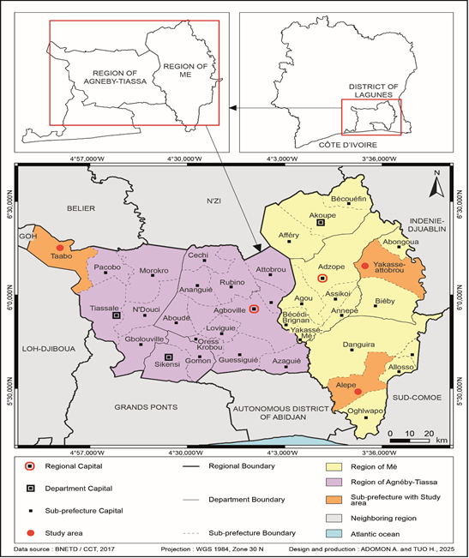

Alépé located about 45km from Abidjan in the south-east of Côte d’Ivoire was established as a full-fledged municipality on august 16, 1985 by law n°85-1085 of august 16, 1985 and covers an area of 2,343 km2.
This territory is structured by rural and semi-urban areas where various ethnic groups of 60,468 inhabitants (RGPH-21) coexist in a dynamic ethnocultural mix in the region of Mé.
Taabo, established as a full-fledged commune on 13 December 1995 by decree no. 95-942, is located 175 km from Abidjan. this space presents favorable socio-economic and tourist assets related to the related activities of the dam created in 1979. includes in the region of Agneby-Tiassa. this territory has a population of 57187 souls according to RGPH-21
The municipality of Yakassé-Attobrou, located in the la Mé region near Adzopé (south-east of Côte d'Ivoire), was established as a fully-fledged municipality in 1985 by law no. 85-1085 of 17 October 1985. it is a small town with a population of 106,000 (RGPH-21) in a forested area 103 km from Abidjan, where agriculture is thriving.
2.2. Data collection technique
The methodological approach is essentially based on documentary research, the analysis of data from our work on Alépé and Taabo (thesis and scientific article publications...); the analysis of the participatory budget in Porto Alegre, Brazil, and the participatory budget implemented in Yakassé-Attobrou between 2001 and 2009. in addition, an interview with the former mayor of Yakassé-Attobrou that we met at the international conference of the association of geographers of Côte d'Ivoire from march 18 to 21, 2024, allowed us to identify the ins and outs of the participatory budget implemented in Yakassé-Attobrou and to have an idea of the involvement of women and young people in local governance. the processing of this data resulted in the following result.

3. results AND DISCUSSION

3.1. The communication deficit, a reality of the failure of local development actions within local authorities in Côte d'Ivoire

The data collected on the ground from the populations in Alépé and Taabo reveal that they are little associated with the choices of investments made by the municipal authorities for their benefit. Tables n°1 and n°2, which are an overview of the municipal investment areas and the needs expressed by the population in order of priority, allow to understand the reality on the ground.

Table 1: Synthesis of classification by order according to the areas of intervention of the town halls in Alépé and Taabo from 1980 to 2006.
Field of intervention | Alépé | Taabo
Education | 3rd | 2nd
Various Roads and Networks (VRD) | 2nd | 3rd
Sanitation and public health | 4th | 5th
Socio-cultural and leisure | 5th | 7th
Socio-economic | 1st | 6th
Urbanism and Housing | 6th | 1st
Public-health | 7th | 4th
Security | - | 8th
Human promotion and employment | - | -
Source: Adomon,2015 (Doctoral thesis). Administrative accounts of Alépé and Taabo 1980 to 2006.
Realization: Adomon,2025

Table 2: Synthesis of the needs expressed by the populations of Alépé and Taabo
between 2007 and 2008
Needs expressed by the population | Alépé | Taabo
Sanitation and public health | 1st | 2nd
human promotion | - | -
Various Roads and Networks (VRD) | 3rd | 4th
Urbanism and Housing | 7th | 1st
Security | - | 8th
Education | 6th | 5th
Public-health | 5th | 3eme
Socio-economic | 4th | 6th
Socio-cultural and leisure | 2nd | 7th
Source: Adomon, 2015 (Doctoral thesis). Surveys at Alépé and Taabo 2007 and 2008
Realization: Adomon,2025

Table 1 shows that the municipal authorities have prioritized in order of priority the field of education, placing it for some at the third place in Alépé and at the second in Taabo, for example. On the other hand, table 2 reveals that the populations have mostly opted in order of priority for sanitation and public health in first position in Alépé and second in Taabo. Thus, relaying the field of education to the 5th place in Taabo and the 6th place in Alépé.

It appears from our investigations that in reality, once the practices of local governments do not promote citizen participation in the management of local affairs in accordance with the framework objectives provided for in the texts (Law No. 2001-476 of 9 August 2001 on the general organization of territorial administration; Law 2003-208 of 7 July 2003 transferring and allocating powers from the State to the Territorial Communities). Moreover, the approval of three-year programmes is done exclusively at institutional level. Consequence, there is a discrepancy between the communal investments made and the needs expressed by the populations in Alépé and Taabo as illustrated by table 3 below.

Table 3: Synthesis of communal investments (1980 to 2006) and needs expressed by the population in Alépé and Taabo between Taabo and Alépé
Municipal investments in Alépé | Rang | Needs expressed by the population in Alépé | Rang
Socio-economic | 1st | Sanitation and public health | 1st
Miscellaneous network roads (VRD) | 2nd | Socio-cultural and leisure | 2nd
Education | 3rd | Miscellaneous network roads (VRD) | 3rd
Sanitation and public health | 4th | Socio-economic | 4th
Socio-cultural and leisure | 5th | Public-health | 5th
Urbanism and Housing | 6th | Education | 6th
Public-health | 7th | Urbanism and Housing | 7th
Municipal investments in Taabo | Rang | Needs expressed by the population in Taabo | Rang
Urbanism and Housing | 1st | Urbanism and Housing | 1st
Education | 2nd | Sanitation and public health | 2nd
Miscellaneous network roads (VRD) | 3rd | Public-health | 3rd
Public-health | 4th | Miscellaneous network roads (VRD) | 4th
Sanitation and public health | 5th | Education | 5th
Socio-economic | 6th | Socio-economic | 6th
Socio-cultural and leisure | 7th | Socio-cultural and leisure | 7th
Source: Adomon, 2015 (Doctoral thesis). Surveys at Alépé and Taabo 2007 and 2008
Realization: Adomon,2025

A cross-analysis of table n°3 suggests a disconnect between municipal investments and the needs of local populations in the two municipalities. Our analyses attest that the communication deficit between the population and elected officials would be the main cause of this discrepancy.

A current reality that is becoming more accentuated today by illustrating demonstrations of disapproval from the populations in Yopougon Gesco and Adjamé village of the working-class neighborhoods of the Abidjan District where urban development operations, of restructuring and eviction of urban spaces for public utility are underway since September 2023. The testimony of a victim of the eviction who requested anonymity illustrates this lack of communication: "I, I am intoxicated with father and mother, I participate in generational celebrations in my village (Adjamé), we will never accept that our village be broken, ever...".

Implementing a municipal communication mechanism involving citizens in the decision-making process and in the choice of actions to be taken by local elected representatives would improve the quality of local democracy, as was the case in Porto Alegre in Brazil.

3.2. Citizen participation, a answer to the communication gap between local development actors

3.2.1. The Participatory Budget of Porto Alegre in Brazil, a model of participatory and deliberative democracy of local management

The Participatory Budget or 'citizen’s budget' is a democratic innovation in Porto Alegre, Brazil, in 1989, a city located in the state of Rio Grande Do SuL. The objective was to involve citizens in the budgetary process, to strengthen the transparency and accountability of local authorities but above all to respond to the priority needs of the population through the allocation of public resources. Concretely, a part of the municipal budget is reserved for projects proposed by residents, who then vote to decide which ones will be funded.

In terms of feasibility, this translated into the creation of neighbourhood-level assemblies composed of citizens, civil society representatives, elected officials and civil servants. Within these assemblies, citizens participate in the development of projects that are subsequently incorporated into the municipal or regional budget. Decentralized technical services, local associations, village chiefs and the private sector (...) are all stakeholders in local development decisions (Loquai and al., 2007). This participatory budget consists of five stages, according to the work of Loquai and al. (2007) and Brandeleer and al. (2014).

Step 1: Public meetings are organized by sector, where residents submit projects based on their needs and establish priorities.

Step 2: Social actors work in five (5) thematic committees, taking into account a more comprehensive vision of the city (transport, education, economic development, social and cultural development, and health and the environment).

Step 3: Each sector and each committee presents its priorities to the Planning Cabinet, which draws up the draft budget based on the choices made previously.

Step 4: After various additional rounds in the committees, the budget is finally presented and voted on by the municipal council.

Step 5: After implementation, the population evaluates the completion of the works and services planned in the previous year's participatory budget during various meetings.

It should be noted from the above that the Brazilian participatory budget is a practice of representative democracy that facilitates the participation of volunteers in discussions and decision-making regarding the allocation of the municipal budget for investment decisions on a theme particular. (For example, neighborhood development). In this respect, it breaks with the marginalization of social groups such as young people and women.

3.2.2. The MO.P.A.D., the contextualized participatory budget of Yakassé-Attobrou in Côte d'Ivoire from 2001 to 2009

Between 2001 and 2009, the communal development in Yakassé-Attobrou was focused on promoting a citizenship structured around (MO.P.A.D.) which means: Model, Prioritize, Animate and Develop.
- Modelling consists of establishing guidelines to follow, a master plan for development, and a management philosophy for action.

- Prioritising consists of defining priorities based on promoting the general interest by prioritising choices from the general to the specific.

- Mobilising involves organizing citizens, particularly young people and women, by putting them to work and, above all, engaging in lobbying to seek funding for sustainable development.

- Developing involves promoting quality of life in strategic sectors such as education, health, development infrastructure and capacity building for men and women through gender equality.

The objective of this participatory budget was to allow people to express their needs and concerns and make proposals through the holding of delocalized municipal councils. In the feasibility, the work of Yapi (2017) sets out four steps :

Step 1 : Organize a solemn return to mobilize and raise awareness among the population about the importance of their involvement in managing local affairs

Step 2 : Hold delocalized municipal councils in the villages of the communalized spaces to allow residents to express their needs and make proposals for improving their living environment

Step 3 : organize the cultural week of the town hall and birthday ceremonies

Step 4 : Institute a mid-term review meeting and the preparation of annual management reports.

It should be noted that the consultations and delocalized deliberations of municipal councils in the villages of communalized spaces have facilitated:
- Involvement of everyone (young people, women, local economic operators, civil servants and executives...) in decision-making in harmony with the needs expressed by the population.
- The organization and support for women and young people
- Making significant investments in the sectors: Education, Health, Quality of life, Wealth creation through the enhancement of group work and mental and citizen construction in harmony with the expressed needs (Table n°4 below)

Table 4 : Municipal achievements in Yakassé-Attobrou by order of priority of needs expressed by the populations from 2001 to 2008
Fields of intervention | Development actions carried out
Education | •Erection of the municipal college into a municipal high school  • Building of a primary inspection  • Building of 12 classes : 6 at the Epp of Amon Kokochié and 6 at the Epp of Ahuikoi  •Support and educational support for vulnerable families
Wellness | •Building of an operating room  •Building of a 14-bed hospital ward  • Building of a dispensary in Diangobo-Fiassé  •Acquisition of an ambulance  •Donations of medicines and medical equipment  •Pharmaceutical support for needy patients.
Life quality | • Building of the pipeline in the villages of Diangobo and Fiassé  •Intervention for the installation of cellular telephony in the municipality  •Intervention for the construction of a gas station
Creation of wealth by putting the municipality to work | • Organization and support for women and young people  •Implementation of an economic promotion tool et financière.
Mental and citizen construction | • Promotion of the municipality through municipal communication  • Organization of the formal return to school  • Organization of anniversary ceremony  • Initiation, in Côte d'Ivoire, of the holding of local municipal council meetings  •Establishment of the mid-term review and preparation of annual management reports  •Strengthening of municipal activities through the reactivation of the •organization of the cultural week of the town hall of Yakassé-Attobrou (SECUMAYA)  •Organization of the show 'COULEURS VACANCES'.
Source : A model of municipal animation in Côte d’Ivoirre. Yapi Yapo (2017).
Design and realization : Adomon, 2025

3.3. Advocacy for a contextualized participatory budgeting model as an answer to citizen participation in the local development process in Côte d'Ivoire

Law No. 2012-1128 of 13 December 2012 on decentralization defines the institutional and legal framework for citizen participation in Côte d'Ivoire. It requires local authorities to set up local management structures as illustrated (Figure 2).

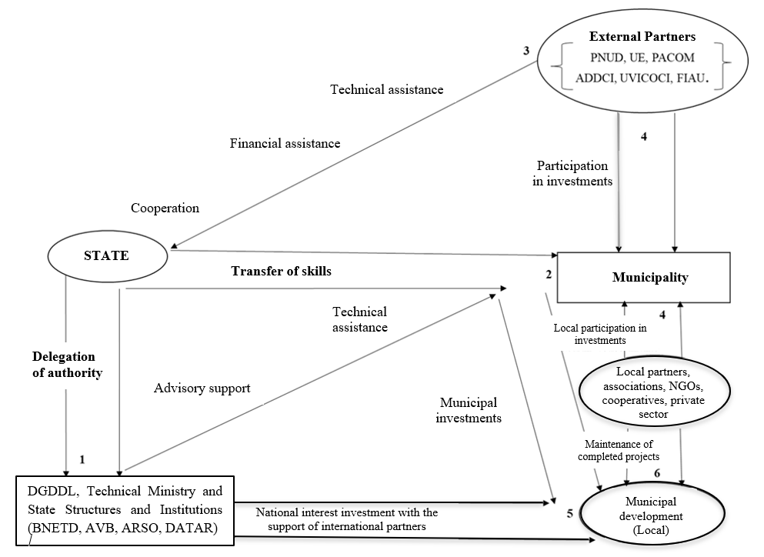
Figure 2 : Mechanism of stakeholders' intervention in the local development process
Source: Adomon A. Athanase, PhD Thesis, 2015
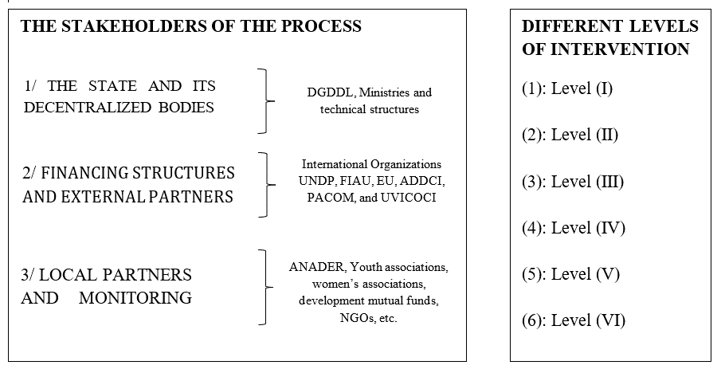
Since 2016, the law (n°2012-1128 of 13 December 2012) requires local authorities to set up proximity structures such as neighbourhood development committees as can be seen in figure n°2. This law on decentralization defines the institutional and legal framework for citizen participation in the local development process in Côte d’Ivoire. Indeed, in Figure 2, the State delegates part of its prerogatives to deconcentrated structures (level 1) and transfers of powers to decentralized communities (level 2) for the State to pursue local development (level 5); this in collaboration with external partners (level 3) and local partners (level 4). These local partners intervene and exercise control, monitoring and maintenance of the investments made (level 6). The latter thus effectively participate in local development. It is citizen participation

Such a mechanism is similar to the 'System-Productive-Localized (SPL)' that Bernard Pecqueur (2000) calls the framework of concerted planning on a local territory which offers citizens a lever for supervision in the execution of projects selected by the actors. (Institutional, entrepreneurs, politicians, associations and populations). In such a "System-Productive-Localized (SPL)", the indispensable and mandatory communication between the actors is so that the initiatives of some are enriched by contact with others. It is in this context that Gourbier and Moysan (2022) affirm that participatory budgeting is an opportunity for local elected officials to actively strengthen citizen participation in the decision-making process and to legitimize through mutual exchanges, the questioning of public actions due to lack of funding.

In Uganda and Zambia, this participatory approach has yielded convincing results with the signing of collaboration protocols between the municipality and civil society associations [CitizenLab (a) and (b)]. These associations have been entrusted with the conduct and monitoring-evaluation of the implementation of basic projects in the health and education sectors. Hence the meaning of our advocacy for the implementation of a contextualized participatory budget in Côte d'Ivoire, especially since the laws n°2001-476 of 09 August 2001 and n°2012/1128 of 18 December 2012 offer new insights into the participatory

This approach, by regulating communication between local development actors takes into account marginalized layers such as women and young people in local development actions (Guiriobe, 2016 and 2018). Also, we propose a contextualized approach to participatory budgeting in Côte d'Ivoire as follows:

Step 1: Conduct a participatory diagnosis (inventory) to identify the priority needs of the population through observation, surveys, interviews, documents....

Step 2: Set up a real communication plan to mobilize and raise awareness among citizens about the need for their participation in local development within neighborhood/village committees where they can propose projects aimed at meeting their needs.

Step 3: Have these proposals evaluated by an expert firm based on their relevance and feasibility in the field.

Step 4: Organize delocalized municipal councils to debate, vote and legitimize the identified projects that will be funded.

Step 5: Set up a steering and monitoring committee in the execution of the project composed of representatives of local partners.

4. Conclusion

45 years later, the decentralization policy in Côte d'Ivoire requires a reorientation and a redefinition of operational objectives at the level of execution scales to address the low level of participation of populations in local management. Participatory Budgeting appears to be the decision-making tool best suited for finding solutions, as was the case with the Brazilian Participatory Budget of MO.P.A.D. in Yakassé-Attobrou which gave satisfaction in involving marginalized groups (women and young people). through the understanding of the needs expressed by the local community. As such, it is an effective communal communication instrument. Hence the interest of advocacy in order to contextualize it according to the realities of the local environment by taking into account our recommendations.

Disclaimer (Artificial intelligence)
Option 1:
Author(s) hereby declare that NO generative AI technologies such as Large Language Models (ChatGPT, COPILOT, etc.) and text-to-image generators have been used during the writing or editing of this manuscript.
Option 2:
Author(s) hereby declare that generative AI technologies such as Large Language Models, etc. have been used during the writing or editing of manuscripts. This explanation will include the name, version, model, and source of the generative AI technology and as well as all input prompts provided to the generative AI technology
Details of the AI usage are given below:
1.
2.
3.

References

Adomon Abodou Athanase (2015). Assessment of the decentralization policy in Côte d’Ivoire: Case of the municipalities of Alépé, Taabo and Yopougon. Single doctoral thesis, Felix Houphouët Boigny University, 443p
Baiocchi, Gianpaolo (2001). Participation, Activism, and Politics: The Porto Alegre Experiment and Deliberative Democratic Theory », Politics & Society,vol. 29, nº.1; pp43-72. https://doi.org/10.1177/0032329201029001003

Baiocchi, Gianpaolo (2005), Militants and Citizens: The Politics of Participatory Democracy in Porto Alegre, Stanford University Press, (ed) Princeton. 224p

Gret Marion et Sintomer Yves, (2002), Porto Alegre, the hope of another democracy, (ed) La Découverte, Paris.140p

Bara Gueye, 2008. Participatory Budgeting in practice. A practical guide for local actors. Program Succeeding in Decentralization. Innovations Environment Development (IED) Africa. 60p

Ferdinand K. Oka; Jean A. Y. Assue ; Koissy S. Y. Koffi. (2018). The contribution of the participatory budget in the relaunch of the development of the former besieged commune of Bouake in Ivory Coast. Journal of Geography of Lardymes. University of Lomé. N°21-12th year December 2018. pp139-149 ISSN 1993-3134

Brandeleer Céline. (2014). The participatory budget: a tool for active citizenship at the service of municipalities. Collections for Solidarity - PLS. Notebooks | Oct. 14 | N°33 Citizen participation. 85p

Koffi Yéboué Stéphane Koissy, Koffi Brou Emile et Kra Kouadio Joseph (2014). Strengthening citizen participation in the decentralization process in Côte d’Ivoire: case of the municipalities of Bingerville and Koun-Fao. Review of Tropical Geography and Environment, n° 1, pp 40-48

Paul Houée (1996), Rural development policies, 2nd edition, INRA/ Economica, 1996, 213 p.

Bernard Pecqueur (2002), Territorial development as a preamble to the social economy, in Économie sociale et développement local (Franco-Québécois colloquium, December 2002), The notebooks of social economy Nº 3, Harmattan, 2002, pp.23-25

Adomon Abodou Athanase, Gogbe Teré, Atta Koffi Lazare (2017). Decentralization and local development: impact of municipal investments in the dynamics of development in Alépé from 1980 to 2011. Ivorian Journal of Literature, Arts and Humanities (RIIASH), No. 33 March 2017. Ecole Normale Supérieure d'Abidjan (ENS) ISSN 2017-8705. pp140-154

Atta Koffi Lazare, Adomon Abodou Athanase (2015). The answer of decentralization to social demand: the case of municipal investments in Taabo from 1995 to 2011 (Côte d'ivoire). African Journal of Scientific and Technological Communication. Social Sciences and Humanities Series. National Pedagogical Institute for Technical and Vocational Education (IPNETP) Nº. 30 /May 2015 ISBN 2-909426-32-7 / EAN 9782909426327. Pp 3959-3971.

Loquai. C. and Le Bay S (2007). Strengthening the monitoring and evaluation capacities of decentralization and local governance: Experiences, challenges and perspectives. In brief n°19 December 2007. WWW.ecdpm.org/inbreief19fr

Yapi Yapo (2017). A model of municipal animation in Côte d'Ivoire. Edition The Involved Publisher, 2017 21 bis, rue des écoles, 75005 Paris. 268p

Bernard Pecqueur (2000), Local development, 2nd edition revised and expanded, (ed) Syros, 2000, 121p

Gourbier Léonrd et Moysan Emiie (2022). Citizen participation and local budgets. In Public management and finance (2022 / 6 n°6) 25-29

CitizenLab (a): The Participatory Budget Guide: An introduction to implementing a participatory budget for local authorities. www.citizenlab.co/fr xxxxx@citizenlab.co 12p Wietse Van Ransbeeck,

CitizenLab (b): The practical guide Getting support from leaders: Building a culture of citizen participation. www.citizenlab.co/fr xxxxxx@citizenlab.co 22 p

Guiriobe Paumahoulou Jean-Arsène, 2016, Citizen participation in the management of the municipality of Guiglo in Côte d'Ivoire, European Scientific Journal, Vol 12, N°11, pp398-411.

Guiriobe Paumahoulou Jean-Arsène, 2018, The determinants of the low rate of citizen participation in the management of local authorities in Côte d’Ivoire: case of the municipality of Bouaké, KASA BYA KASA, n° 38, pp7-22.

Céline DU BOYS, SEdina oldo (2025), The Participatory Budget: Analysis of organizational factors fashionable device. HAL Id: hal-04904147 https://hal.science/hal-04904147v1 Submitted on 22 Jan 2025. 25p

City of Paris. General Inspection (2020) Report on the participatory budget and its appropriation by parisians November 2020 N°18-27.01. 180p

Klausen, J. E., Vabo, S. I., & Winsvold, M. (2022). Competing perspectives on participatory arrangements: explaining the attitudes of elected representatives. International Political Science Review, 44(5), 694-709. https://doi.org/10.1177/01925121221092600

Talukder, D., Bedock, C., & Rangoni, S. (2022). How MPs perceive participatory democracy and mini-audiences: a survey in French-speaking Belgium. Politics and Societies, 41(2), 93. https://doi.org/10.7202/1086926ar

Petit, Guillaume. (2021) Do the elect love and they love democracy ?. Participations, N° 26-27(1), 7-40. https://doi.org/10.3917/parti.026.0007

