**Original Research Article**

**Optimization of Spray Drying Parameters for Passion Fruit Juice Powder: Physicochemical and Quality Evaluation**

**Abstract**

Passion fruit is rich in juice and valued for its pleasant flavour, aroma, and nutritional profile, but its high perishability limits direct utilization. In this study, spray drying was employed to convert yellow passion fruit juice into a stable powder using a maltodextrin–corn starch (3:2) carrier system. Seventeen experimental trials were conducted to evaluate the effects of wall material concentration (15%, 17.5%, and 20% w/v), inlet air temperature (150°C, 160°C, and 170°C) and feed pump speed (8, 10, and 12 rpm) on quality parameters of spray dried powder. The effects of wall material concentration, inlet air temperature, and feed pump speed were evaluated using a Box–Behnken response surface methodology design. The process was optimized at 12% maltodextrin, 8% corn starch, 165 °C inlet temperature, and 12 rpm feed pump speed, resulting in a powder yield of 61.23% with low moisture content (1.62%), excellent dispersibility (89.32%), and rapid wettability (12.42 s). The optimized powder also retained desirable colour characteristics (ΔE = 20.37), ensuring good reconstitution properties. These findings demonstrate that optimized spray drying can significantly improve the shelf stability and functional quality of passion fruit juice powder, supporting its application in the food and nutraceutical industry.

**Keywords:** Yellow passion fruit, Spray drying, Juice powder, Response surface methodology, Maltodextrin, Corn starch

1. **Introduction**

Yellow passion fruit (*Passiflora edulis* f. *flavicarpa*) is widely consumed for its distinct aroma, tangy flavour, and high nutritional value (Fonseca et al., 2022). It is a rich source of bioactive compounds, including vitamin C, carotenoids, and polyphenols, which contribute to its antioxidant properties and potential health benefits (Ruxton & Myers, 2021; Arshad et al., 2025). However, due to its high moisture content and water activity, fresh passion fruit juice is highly perishable, restricting its shelf life and commercial utilization (da Silva et al., 2024).

The production and commercialization of passion fruit juice face several challenges, such as short shelf life, low consumer awareness, inadequate infrastructure, insufficient post-harvest management, and complex transportation logistics (Wang et al., 2025). Therefore, converting the juice into a powdered form offers an effective solution to enhance stability, ease of transportation, and versatility in food formulations (Pujapanda et al., 2025).

Tropical fruits and plants are also recognized for their nutritional richness and therapeutic potential. For example, *Mangifera indica* leaves exhibit strong antioxidant, cytotoxic, and thrombolytic activities, demonstrating the health-promoting potential of plant-based bioactive compounds (Usman et al., 2025). Similarly, passion fruit is an underutilized fruit crop rich in vitamins, minerals, and phytochemicals, but its perishability necessitates effective preservation strategies (Weyya et al., 2024).

Spray drying is a widely applied technique for producing fruit juice powders while maintaining their sensory and nutritional qualities (Tonon et al., 2008; Caliskan & Dirim, 2013). The process involves atomizing liquid juice into fine droplets and rapidly drying them with hot air, resulting in a free-flowing powder. However, direct spray drying of passion fruit juice is difficult due to its high sugar and acid content, which can cause stickiness, low yield, and poor flowability (Cano-Chauca et al., 2005). To overcome these limitations, carrier agents such as maltodextrin and corn starch are commonly added to improve drying efficiency, reduce stickiness, and enhance powder quality (Azhar et al., 2021).

Despite the proven advantages of spray drying, optimizing process parameters such as wall material concentration, inlet air temperature, and feed pump speed is critical to obtaining a high-quality powder with good reconstitution properties (Kha et al., 2014; Mishra et al., 2014). Although studies have investigated spray drying in other tropical fruit juices, limited research has focused specifically on optimizing spray drying conditions for yellow passion fruit juice. Addressing this gap, the present study aims to optimize spray drying parameters for passion fruit juice using response surface methodology, with an emphasis on improving powder yield, stability, and functional properties for potential commercial applications.

1. **Materials and methods**
   1. **Raw materials**

Fresh yellow passion fruits (*Passiflora edulis f. flavicarpa*) were procured from M/s. Riya Farms, Wayanad, Kerala, India. The carrier materials used for spray drying, including maltodextrin (DE 20) and corn starch, were obtained from M/s. Chemind, Thrissur, Kerala, India. All other chemicals and reagents utilized in this study were of analytical grade.

* 1. **Sample preparation and spray drying**

Fresh yellow passion fruits were washed thoroughly using potable tap water followed by rinsing with distilled water, and then well drained. The fruits were halved, and the pulp was extracted manually using a stainless-steel spoon. The extracted pulp was filtered through a muslin cloth (pore size approximately 60–80 µm) to remove seeds. The seed-free pulp was stored in an air blast freezer at –20 °C until further processing. Spray drying experiments were conducted using a lab-scale vertical co-current tall-type spray dryer (M/s. S. M. Scientech, Kolkata, India). Fluid flow pattern followed in this spray dryer is co-current type having an evaporation rate of 1000 ml/h. The feed solution was prepared and the spray dryer was set to the desired inlet temperature and feed rate. The atomizer pressure was maintained at 2.5 kg/cm² with a blower speed of 1700 rpm. Distilled water was initially pumped to stabilize the outlet air temperature at 75 °C, after which it was replaced with the feed solution. The feed was sprayed into the drying chamber, where moisture was removed, and the powder was collected at the outlet. After cooling, the powder was packed in 150 µm aluminium-laminated pouches for further analysis. The process flow chart for the production of spray dried passion fruit powder is shown in Figure1.

**Figure 1. Process flow chart for the spray drying of passion fruit juice**

* 1. **Design of experiment**

In this study, Response Surface Methodology (RSM) was employed for the experimental design. RSM is a collection of statistical and mathematical techniques used for developing, improving and optimizing processes. It explores the relationships between multiple explanatory variables and one or more response variables, particularly in cases where limited prior knowledge about the process is available. By carefully designing experiments, RSM facilitates the optimization of responses influenced by various independent variables, ultimately maximizing the production of the desired product. A three-factor, three-level Box-Behnken design (BBD) was used to evaluate the effects of independent variables on the spray drying process. Maltodextrin (DE 20) and corn starch were used as carrier materials in a 3:2 ratio at three different concentrations: C1 (15%), C2 (17.5%), and C3 (20%). The spray drying process was performed under varying operating conditions, including inlet air temperatures of T1 (150°C), T2 (160°C), and T3 (170°C) and feed rates of F1 (8 rpm), F2 (10 rpm), and F3 (12 rpm). The process parameters were optimized based on the quality attributes of the resulting passion fruit juice powder. The experimental design corresponds to seventeen experimental trials are presented in Table 1. Carrier concentration, inlet temperature, and feed rate are the independent variables used to optimize and analyse the flow properties of spray-dried powder, based on responses like bulk density, tapped density, Carr’s index, and Hausner ratio. `

**Table 1. Factors and levels tested for experimental design**

|  |  |  |  |  |
| --- | --- | --- | --- | --- |
| **Independent variables** | **Factor** | **Levels in coded form** | | |
| **1** | **0** | **+1** |
| Carrier concentration (%) | A | 15 | 17.5 | 20 |
| Inlet temperature (°C) | B | 150 | 160 | 170 |
| Feed rate (rpm) | C | 8 | 10 | 12 |

* 1. **Properties of spray dried powder**
     1. **Product Yield**

Product yield is a key indicator of process efficiency, defined as the percentage ratio of the mass of powder collected after drying to the total mass of solids in the feed solution, including both fruit juice solids and carrier material. High product yield is essential for economic feasibility in industrial production. As noted by Can Karaca et al. (2016), low yield is often attributed to stickiness of certain food components, while Santos et al. (2018) suggested that a successful spray drying process should achieve yields above 50%. The product yield (%) was calculated using the following equation 1.

…………. (1)

* + 1. **Moisture Content**

The amount of moisture present in spray dried passion fruit juice powder was estimated using the method by Horwitz and Latimer (2005) methodology. Percentage wet basis moisture was found by using the following equation 2.

$Moisture content\left(\% wb\right)=\frac{Wi-Wf}{Wi}×100$…………………. (2)

where,

Wi – initial weight of raw tomato, g

Wf – dry weight of raw tomato, g

* + 1. **Wettability**

Wettability was determined by measuring the time required for complete wetting of the powder. A 1.5 g sample was gently placed on the surface of 100 ml of water maintained at 30 °C in a beaker. The time taken for all powder particles to fully immerse from the surface to the bottom was recorded using a stopwatch, following the method described by Abadio et al. (2004).

* + 1. **Dispersibility**

Dispersibility was evaluated following the method described by Jinapong et al. (2008). A 1 g powder sample was added to 10 ml of distilled water at 25 °C in a 50 ml beaker. Using a spoon, 25 circular movements were made both clockwise and counterclockwise for 20 seconds to aid dispersion. The mixture was then filtered through a 150 µm sieve. To determine the solid content of the filtrate, 1 ml was transferred to a drying vessel and dried in a vacuum oven at 65 °C until a constant weight was achieved, or at 105 °C for 4 hours. Dispersibility (%) was calculated using the equation 3.

$Dispersibility \left(\%\right)=\frac{(100+a)×b}{a×(100-c)}×100$…………………… (3)

Where:

a = Amount of powder used (g)

b = % Dry matter in the filtrate

c = % Moisture content of the powder

* + 1. **Total colour difference**

The colour properties of food powders are typically evaluated using Hunter L*, a*, and b* values. However, interpreting these values in isolation can be challenging. Therefore, the analysis was extended to include the total colour difference (ΔE), which provides a more comprehensive assessment of colour changes. The ΔE was calculated relative to the raw feed solution, as a reference, using the appropriate equation 4. A lower ΔE value indicates minimal colour deviation, which is desirable for producing a high-quality spray-dried product.

Total color difference = $\sqrt{{(L-L_{0})}^{2} + {(a-a_{0})}^{2}+{(b-b_{0})}^{2}}$............ (4)

Where;

L0, a0, and b0 = Colour parameters for the feed

L, a, and b= Colour parameters of the product

* + 1. **Statistical analysis**

A statistical software package Design expert 12 from a private company Stat-Ease Inc. specifically designed to perform the design of experiments was used in the optimisation of various process parameters. The procedure of optimisation was conducted using Box-Behnken design which is a most efficient and economical way to estimate the first and second order coefficients of mathematical model ( Bezerra et al., 2008). Besides providing optimised treatments response surface plots are also obtained using Design Expert software

**3. Results and Discussions**

**3.1.** **Optimization of process parameters on spray drying**

The influence of three independent process variables on the spray drying process was individually analysed using Design-Expert software to identify the optimal treatment conditions. The effects of the spray drying process parameters on the respective response variables are summarized in Table 2. To assess the statistical significance of these effects, an Analysis of Variance (ANOVA) was performed for each response parameter.

**3.1.1. Effect of Process Parameters on product yield**

The influence of spray drying parameters on the product yield of passion fruit powder is presented in Table 2, while the 3D response surface plots are shown in Figure 1. The ANOVA results indicated that the quadratic model was highly significant (p = 0.0007, p ≤ 0.01), with a high coefficient of determination (R² = 0.95), confirming a good fit between experimental and predicted values. Carrier concentration, inlet temperature, and feed rate significantly influenced product yield (p ≤ 0.01), with a notable interaction observed between feed rate and yield. The fitted second-order regression model describing the effect of independent variables on product yield is as follows:

Product Yield (%) = 8.13 + 0.48A - 0.37B - 0.54C - 0.011AB - 0.085AC + 0.027BC + 0.054A2 + 0.25B2 - 0.56C2……………………………. (5)

Where

A = carrier concentration (%)

B = inlet temperature (°C)

C = feed rate (rpm)

Product yield ranged from 45.32% to 84.49% (Figure 2), with the highest yield (84.49%) achieved at a carrier concentration of 20%, inlet temperature of 150 °C, and feed rate of 10 rpm. Carrier concentration significantly influenced yield, showing a positive correlation; values increased from 45.99% to 84.49% as the concentration rose from 15% to 20%. Similar findings were reported for acerola and pitanga juice powders, where higher maltodextrin concentrations improved drying efficiency and reduced stickiness (Borges et al., 2016; Dang et al., 2024). In contrast, an increase in inlet temperature led to a significant decrease in yield. This reduction has also been observed in other sugar-rich fruit juices, where elevated drying temperatures caused caramelization and stickiness, resulting in powder losses (Samborska et al., 2023; Bednarska et al., 2020). Feed rate exhibited a negative correlation with product yield; increasing feed rate from 8 to 12 rpm reduced the yield. Similar results were reported by Iwuozor et al. (2020), who found that higher feed flow rates produced larger droplets, reducing heat and mass transfer efficiency and leading to incomplete drying.

|  |  |  |  |  |  |  |  |  |  |
| --- | --- | --- | --- | --- | --- | --- | --- | --- | --- |
| **Experiment No.** | **Concentration**  **(%)** | **Temperature**  **(°C)** | **Feed rate**  **(rpm)** | **Product yield**  **(%)** | **Moisture content**  **(%)** | **Ascorbic Acid**  **(mg/100g)** | **Dispersibility**  **(%)** | **Wettability**  **(Sec)** | **Overall colour difference value (ΔE)** |
| 1 | 20.0 | 150 | 10 | 84.49±0.67 | 2.50±0.02 | 15.91±0.43 | 60.93±0.48 | 24.93±0.02 | 18.17±0.85 |
| 2 | 15.0 | 150 | 10 | 70.07±0.47 | 4.73±0.03 | 27.27±0.59 | 63.37±0.62 | 47.19±0.13 | 07.58±0.76 |
| 3 | 17.5 | 160 | 10 | 65.75±1.01 | 3.73±0.01 | 20.45±0.72 | 79.71±0.71 | 13.34±0.34 | 13.01±0.66 |
| 4 | 17.5 | 170 | 12 | 45.32±0.62 | 3.48±0.02 | 18.18±0.63 | 94.90±0.65 | 12.72±0.36 | 22.24±0.45 |
| 5 | 20.0 | 160 | 12 | 60.02±0.48 | 1.55±0.06 | 22.73±0.58 | 84.16±0.46 | 10.09±0.63 | 21.42±0.58 |
| 6 | 17.5 | 150 | 08 | 80.19±0.83 | 3.44±0.02 | 18.18±0.78 | 70.91±0.37 | 24.93±0.74 | 21.19±0.82 |
| 7 | 20.0 | 160 | 08 | 74.55±0.58 | 1.47±0.04 | 20.45±0.62 | 84.47±0.4 | 10.27±0.08 | 29.00±0.87 |
| 8 | 15.0 | 160 | 08 | 53.69±0.54 | 3.97±0.02 | 25.00±0.82 | 94.83±0.83 | 22.65±0.43 | 09.83±0.48 |
| 9 | 17.5 | 160 | 10 | 65.75±0.87 | 3.33±0.06 | 18.18±0.44 | 75.90±0.67 | 14.23±0.68 | 16.72±0.86 |
| 10 | 17.5 | 160 | 10 | 66.66±0.68 | 3.33±0.02 | 18.18±0.48 | 75.12±0.37 | 20.34±0.46 | 13.82±0.48 |
| 11 | 17.5 | 160 | 10 | 65.75±0.43 | 3.33±0.02 | 20.45±0.63 | 76.21±0.84 | 21.67±0.84 | 20.12±0.68 |
| 12 | 20.0 | 170 | 10 | 71.84±1.32 | 1.50±0.04 | 20.45±0.37 | 88.01±0.66 | 15.96±0.48 | 29.24±0.79 |
| 13 | 17.5 | 170 | 08 | 66.01±0.89 | 2.80±0.02 | 15.90±0.42 | 95.01±0.48 | 10.06±0.64 | 22.00±0.72 |
| 14 | 17.5 | 160 | 10 | 66.67±0.73 | 2.33±0.04 | 18.18±0.64 | 78.31±0.63 | 08.45±0.86 | 10.05±0.89 |
| 15 | 17.5 | 150 | 12 | 55.58±0.62 | 3.88±0.05 | 20.45±0.48 | 68.66±0.64 | 24.93±0.42 | 13.48±0.54 |
| 16 | 15.0 | 160 | 12 | 45.99±0.72 | 4.60±0.02 | 25.00±0.74 | 84.61±0.48 | 15.51±0.67 | 13.15±0.84 |
| 17 | 15.0 | 170 | 10 | 59.27±0.82 | 3.88±0.02 | 24.99±0.53 | 96.27±0.52 | 12.20±0.82 | 21.25±0.78 |

**Table 2. The experimental data for response surface analysis of the effect of processing conditions on the quality of passion fruit juice powder**

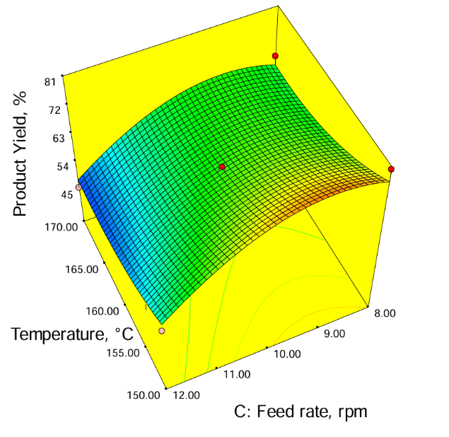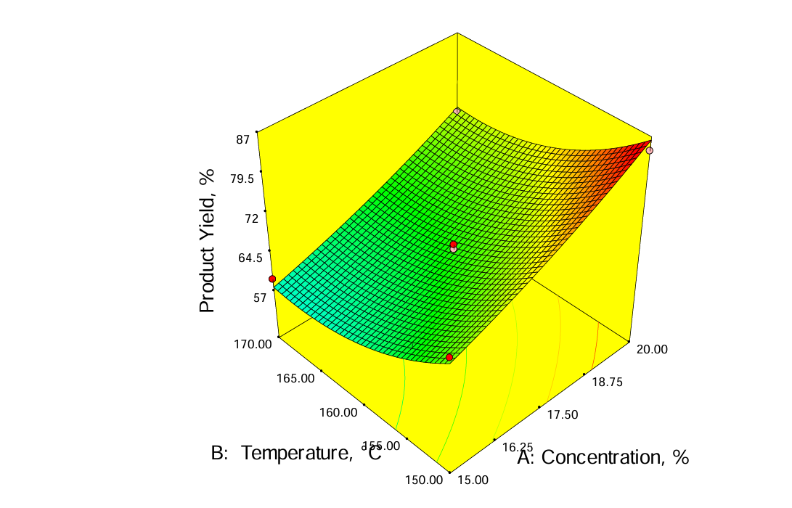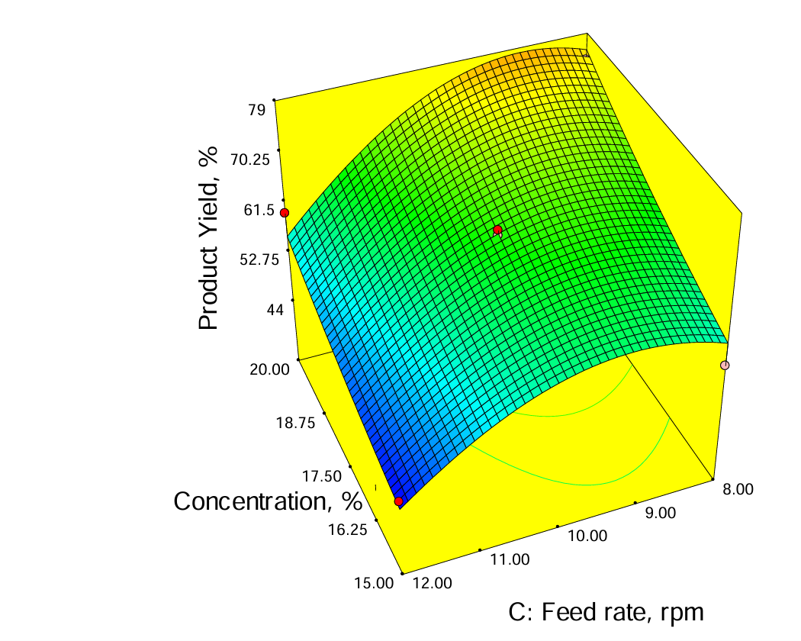

**Figure 2. Response surface plot for product yield**

**3.1.2. Effect of Process Parameters on moisture content**

The moisture content of the spray-dried passion fruit powder across seventeen trials is presented in Table 2. Statistical analysis revealed that the process variables significantly influenced moisture content, with carrier concentration (A) showing the highest significance (p < 0.0001). The fitted model demonstrated good predictive ability (R² = 0.9191), and the regression equation is as follows:

Moisture Content (%) = 1.79 − 0.38A − 0.11B + 0.062C − 0.038AB − 0.030AC + 0.019BC − 0.12A2 + 0.072B2 − 0.017C2 ……………………. (6)

Where,

A = carrier concentration (%)

B = inlet temperature (°C)

C = feed rate (rpm).

Moisture content ranged from 1.47% to 4.60% (wb), with the lowest value observed at 20% carrier concentration, 160 °C, and 8 rpm feed rate. The highest value occurred at 15% concentration, 160 °C, and 12 rpm. Response surface plots (Figure 3) demonstrated that moisture content decreased with increasing carrier concentration and temperature, while feed rate showed a positive linear effect. These observations are consistent with recent studies on spray-dried tropical fruit juices, including acerola, pitanga, and pineapple powders, where higher carrier concentrations reduced surface stickiness and enhanced drying efficiency (Borges et al., 2016; Pujapanda et al., 2025). Elevated inlet temperatures also accelerated water evaporation, lowering residual moisture, although excessive heating may cause crust formation on particle surfaces, reducing rehydration ability (Saikia et al., 2015). Conversely, increased feed rates resulted in larger droplets with reduced heat and mass transfer efficiency, leading to higher moisture retention, a trend similarly reported in spray-dried guava and mango powders (Tontul & Topuz, 2017; George et al., 2023).

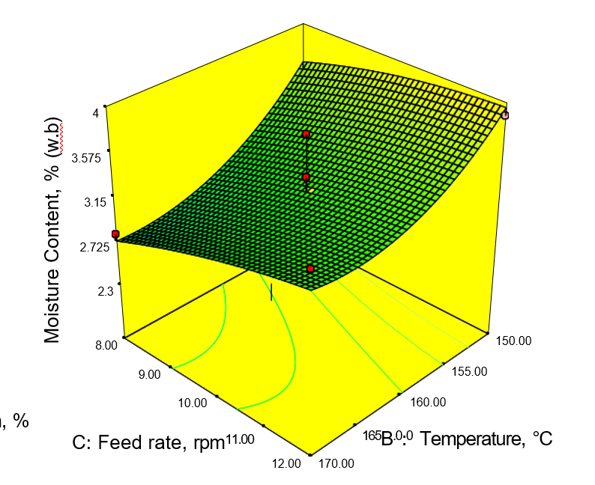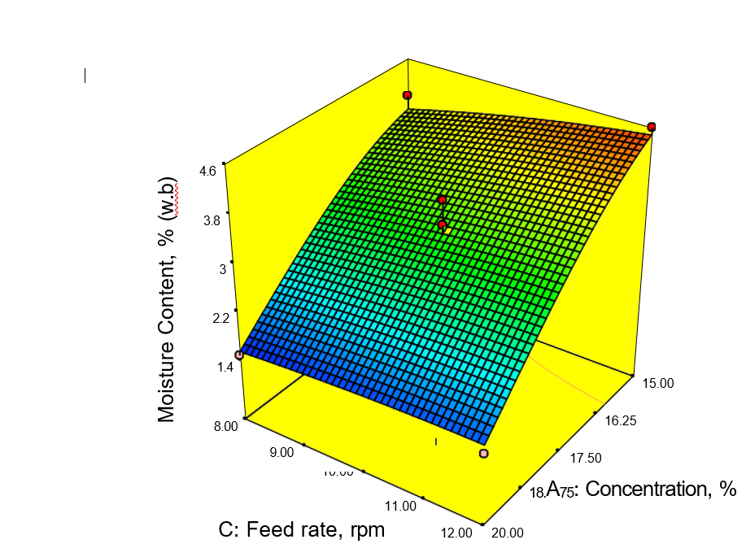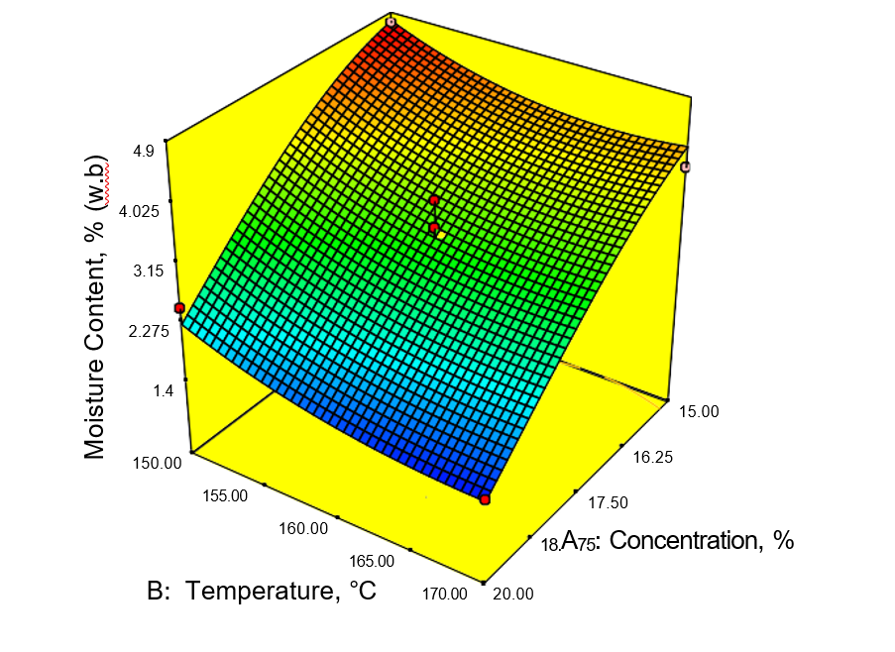

**Figure 3. Response surface plot for moisture content**

**3.1.3. Effect of Process Parameters on ascorbic acid**

Table 2 presents the variation in ascorbic acid content across different spray drying conditions, while Fig. 4 illustrates the response surface plots. ANOVA results confirmed that carrier concentration significantly affected vitamin C retention (p ≤ 0.01), along with a significant third-level interaction. The model showed good fit with an R² value of 0.8571. The regression model (Equation 7) predicting ascorbic acid content is:

Vitamin C = 4.37 - 0.30A - 0.028B + 0.097C + 0.19AB + 0.061AC + 4.185BC + 0.44A2 - 0.12B2 + 0.016C2 ………………………… (7)

Where,

A = carrier concentration (%)

B = inlet temperature (°C)

C = feed rate (rpm)

Ascorbic acid content ranged from 15.90 to 27.27 mg/100 g. The maximum retention (27.27 mg/100 g) was observed at 150 °C, 15% carrier concentration, and 10 rpm feed rate. The lowest (15.90 mg/100 g) occurred at 170 °C, 17.5% concentration, and 8 rpm. Response surface graph clearly showed that there was a better retention of ascorbic acid at lowest temperature and lowest carrier concentration. Temperature and carrier concentration negatively impacted vitamin C content due to thermal and oxidative degradation, aligning with findings in spray-dried guava, gac aril, seabuckthorn, and other juices (Nguyen et al., 2022; Tandale, 2007; Selvamuthukumaran & Khanum, 2014). Conversely, feed rate had a positive effect. Higher feed rates led to faster drying and reduced thermal exposure, minimizing nutrient loss, consistent with studies on passion fruit, orange, and blackberry juices (Angel et al., 2009; Chegni et al., 2005; Ferrari et al., 2012).

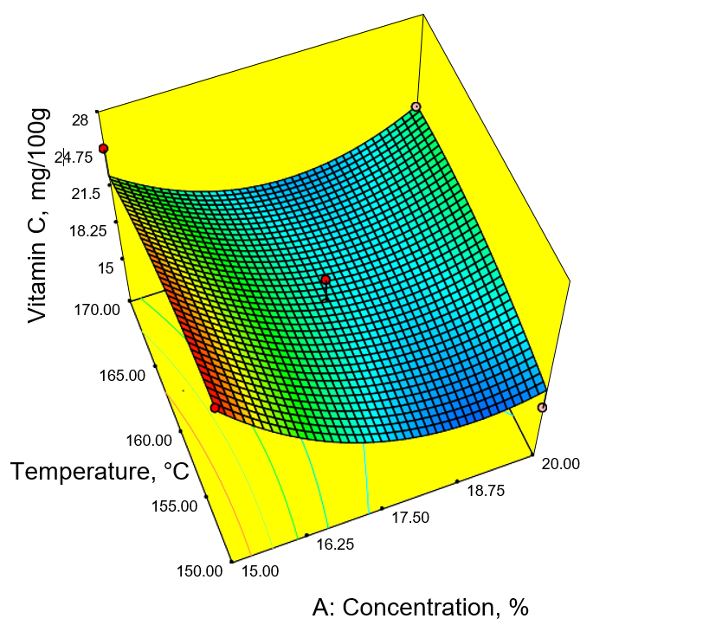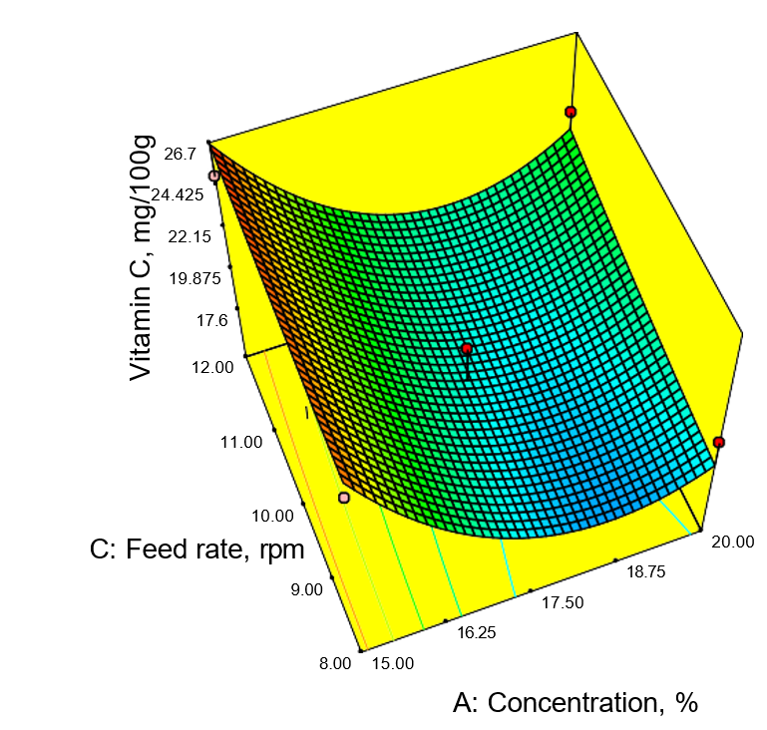

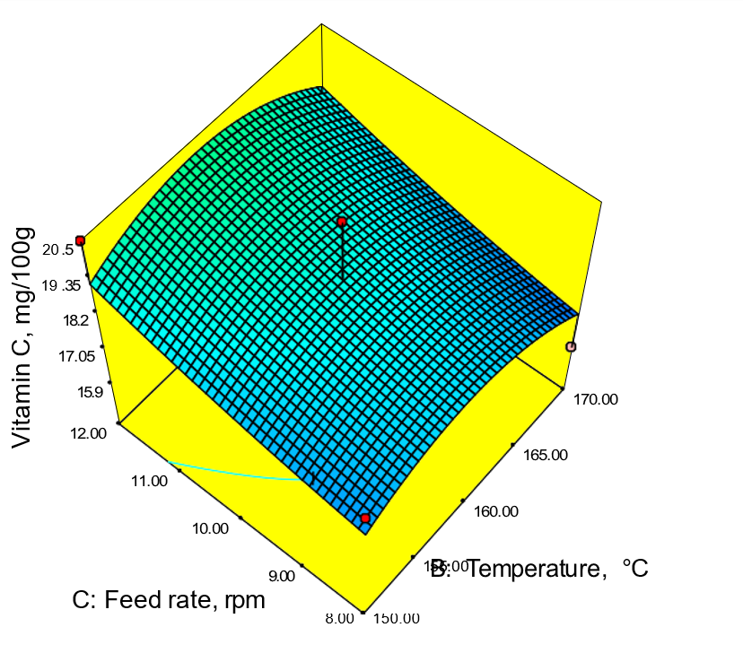

**Figure 4. Response surface plot for ascorbic acid**

**3.1.4. Effect of Process Parameters on Dispersibility**

Dispersibility, a key indicator of reconstitution quality, was significantly influenced by processing parameters (Table 2). ANOVA results revealed that inlet air temperature (p < 0.0001) and carrier concentration (p ≤ 0.05) had significant effects, with temperature-feed rate interactions also showing significance. The model had excellent fit (R² = 0.9806). The regression model (Equation 8) was

Dispersibility = 8.78 - 0.14A + 0.78B - 0.087C - 0.069AB + 0.13AC + 0.032BC + 0.12A2 - 0.16B2 + 0.43C2……………………. (8)

Where,

A = carrier concentration (%)

B = temperature (°C)

C = feed rate (rpm)

Dispersibility ranged from 60.93% to 96.27%. The highest value was observed at 15% carrier, 170 °C, and 10 rpm, while the lowest occurred at 20% carrier, 150 °C, and 10 rpm. Dispersibility of spray dried passion fruit juice powder increased linearly with increasing temperature (Figure 5). Temperature positively influenced dispersibility, as higher inlet temperatures promoted better particle formation, consistent with findings in jamun, goat milk, and sugarcane juice powders (Santhalakshmy et al., 2015; Reddy et al., 2014; Khuenpet et al., 2016). Carrier concentration had minimal impact, aligning with Bhusari et al. (2014) for tamarind powder. Feed rate negatively influenced dispersibility, with lower feed rates producing finer particles and higher dispersibility, corroborating results from studies on tomato paste and date powder (Banat et al., 2002; Manickavasagan et al., 2015).

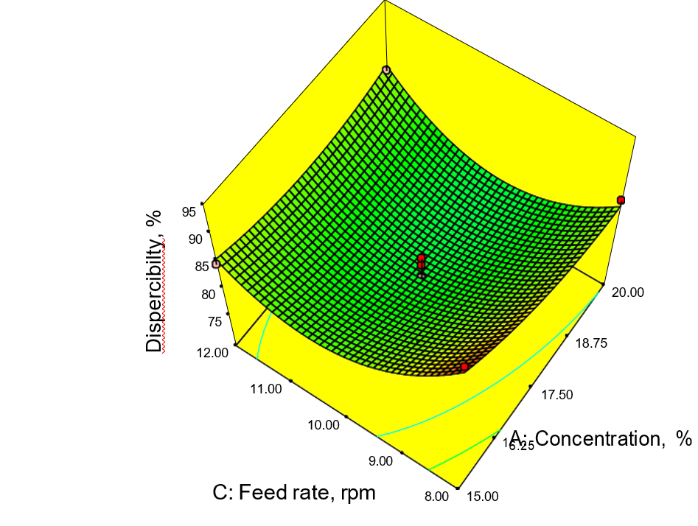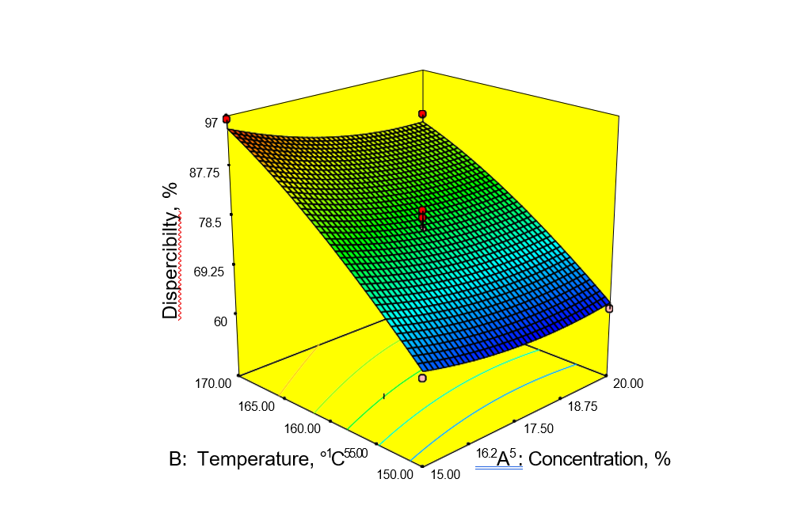

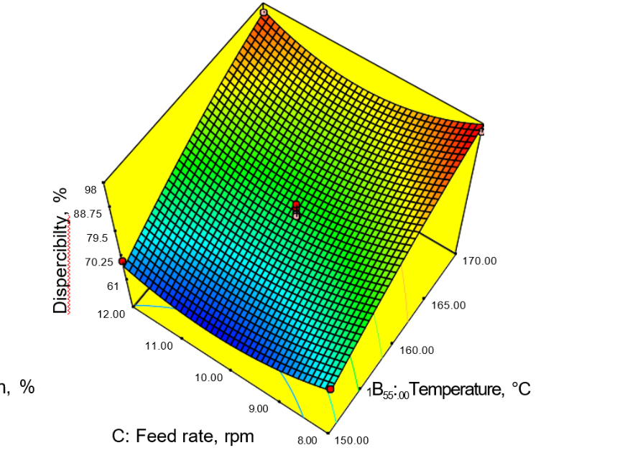

**Figure 5. Response surface plot for dispersibility**

**3.1.5. Effect of Process Parameters on wettability**

Wettability, an indicator of powder's reconstitution behaviour, was significantly influenced by inlet air temperature. The highest wettability (47.19 s) was observed at 15% carrier, 150 °C, and 10 rpm, while the lowest (8.45 s) occurred at 17.5% carrier, 160 °C, and 10 rpm (Table 2). The regression model had good fit (R² = 0.844), and the predicted equation was

Wettability (sec) = 3.90 - 0.46A - 0.95B - 0.057C + 0.59AB + 0.20AC + 0.099BC + 0.26A2 + 0.67B2 - 0.39C2………………………… (9)

Where,

A = carrier concentration (%)

B = temperature (°C)

C = feed rate (rpm)

From response surface plots (Figure 6) it is observed that the increased inlet air temperature negatively influenced on wettability of spray dried powder, while concentration and feed rate had no considerable effect. Inlet temperature had a highly significant negative effect (p ≤ 0.01), while concentration and feed rate showed no significant influence. The inverse relation between temperature and wettability may be due to the formation of coarser particles at higher temperatures, which resist water penetration. This aligns with findings from Santhalakshmy et al. (2015) and Cynthia et al. (2015), where lower wettability was associated with larger particle sizes. Fine powders exhibited better wettability due to faster water absorption.

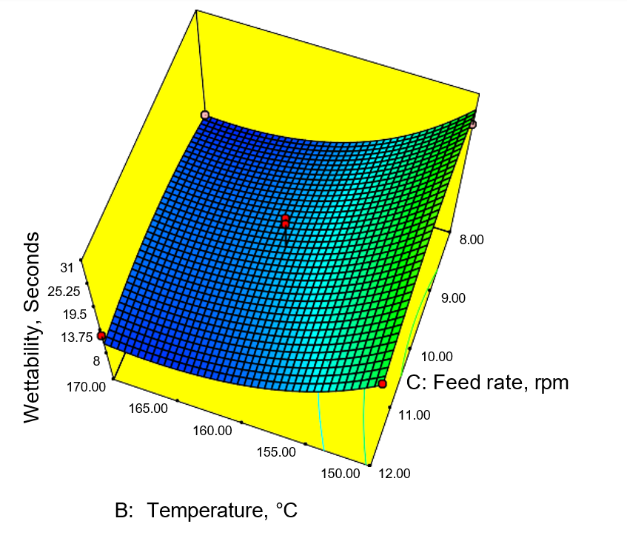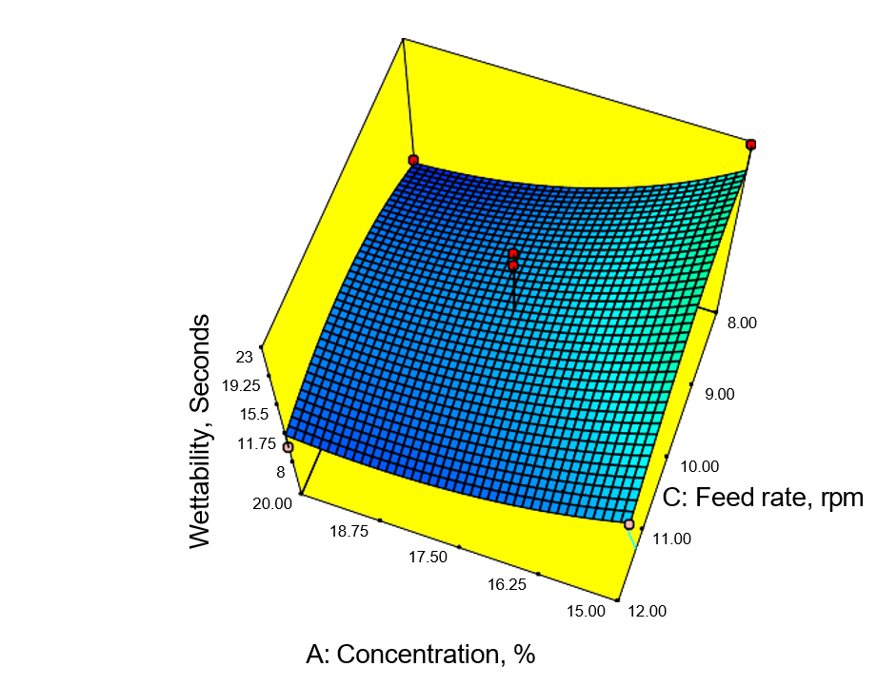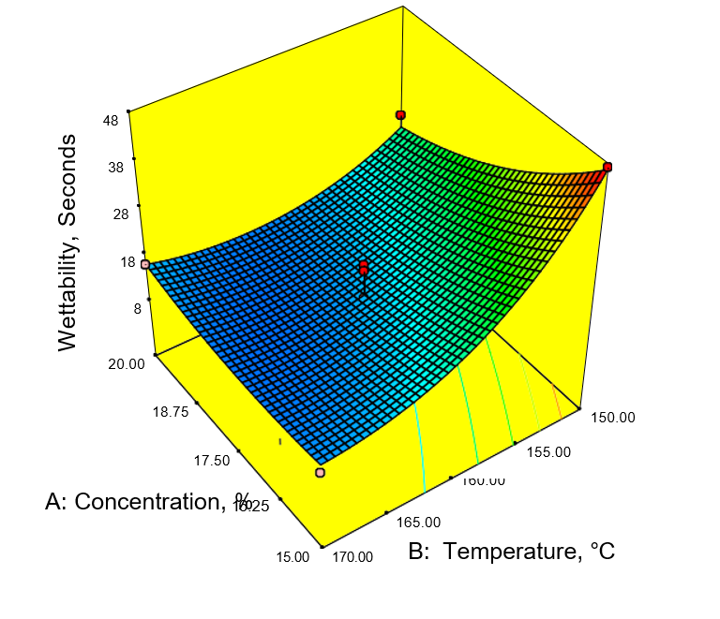

**Figure 6. Response surface plot for wettability**

**3.1.6. Effect of Process Parameters on total colour difference**

The total colour difference (∆E) of spray-dried passion fruit juice powder was significantly influenced by carrier concentration (p ≤ 0.01) and inlet air temperature (p ≤ 0.05), while feed rate showed no significant effect. The model showed good fit (R² = 0.8309), and the second-order regression equation is given as:

Total Colour Difference = 3.81 + 0.69A + 0.52B - 0.15C - 0.18AB - 0.31AC + 0.24BC + 0.11A2 + 0.34B2 + 0.27C2………………………… (10)

Where,

A = carrier concentration (%)

B = temperature (°C)

C = feed rate (rpm)

From the response surface plots (Figure 7) identified the variation in colour with respect to processing parameters. The temperature and carrier agent concentration exhibited positive effect on total colour difference. As temperature and concentration of carrier material increased the colour difference also increased linearly. The ∆E ranged from 7.58 to 29.24. Minimum colour deviation (7.58) was observed at 15% carrier, 150 °C, and 10 rpm, while maximum deviation (29.24) occurred at 20% carrier, 170 °C, and 10 rpm. Higher inlet temperatures and carrier concentrations increased ∆E due to intensified browning reactions such as Maillard and caramelization (Chen et al., 2014; Lee et al., 2017). Similar findings were reported for seabuckthorn and tamarind juice powders (Selvamuthukumaran & Khanum, 2014; Kha et al., 2010). Interactions between feed rate and other parameters were statistically insignificant, though variation in ∆E was observed across combinations. Maltodextrin in combination with corn starch significantly impacted colour change more than maltodextrin alone (Tontul & Topuz, 2017).

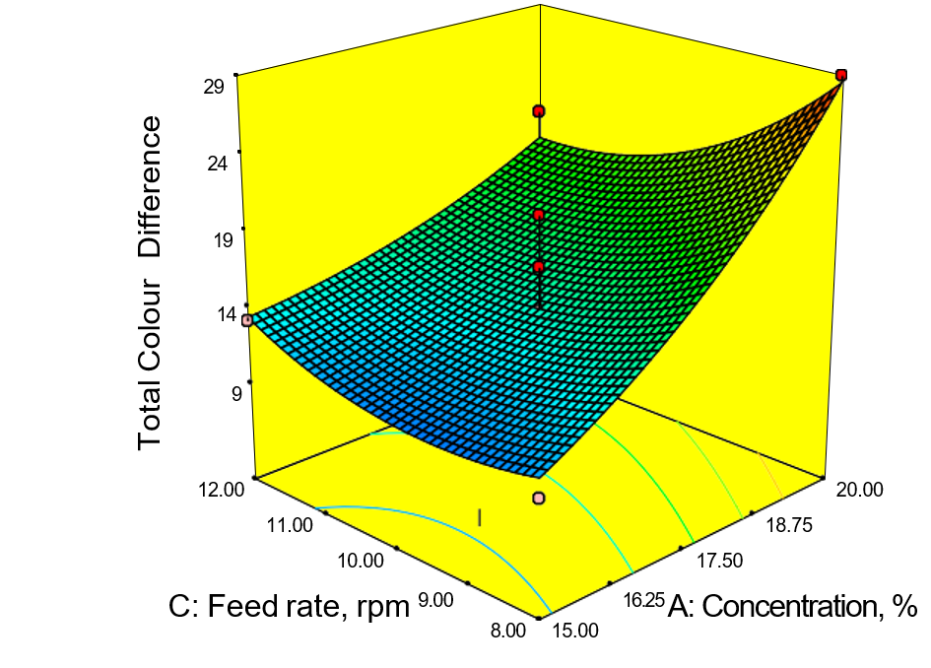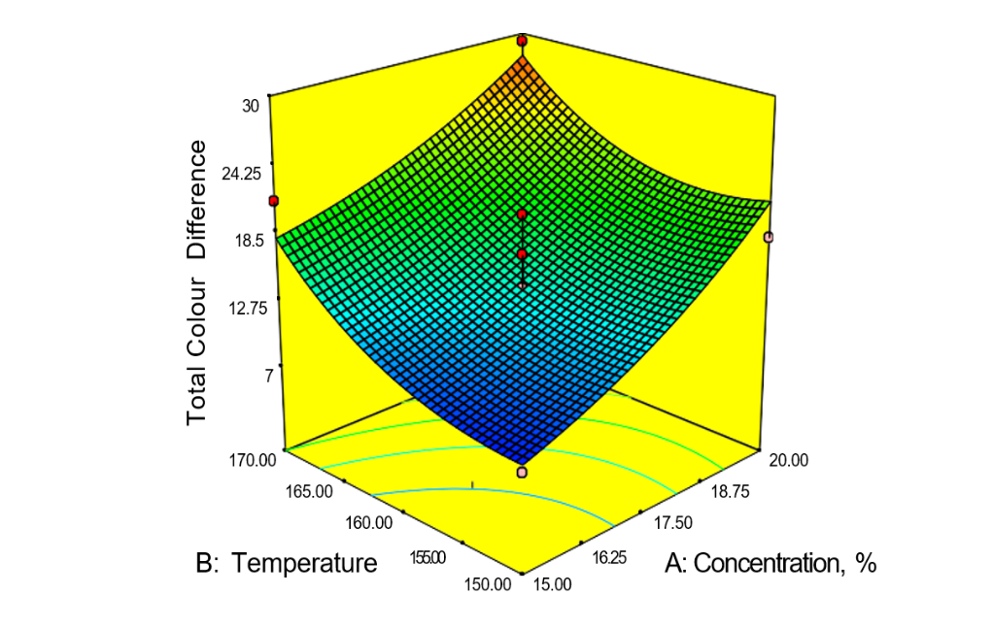

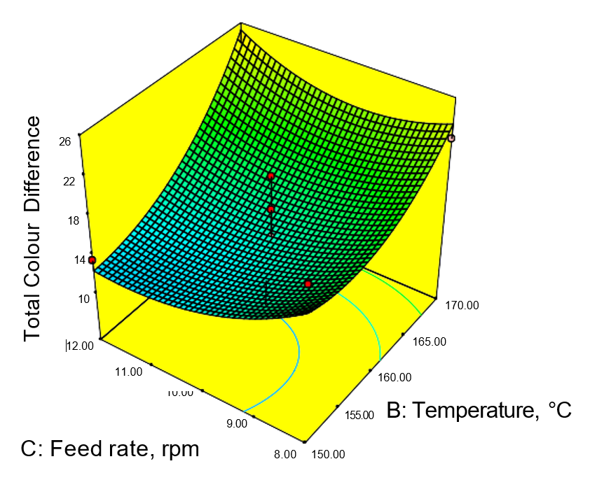

**Figure 7. Response surface plot for total colour difference**

The spray drying of passion fruit juice was optimized using a carrier combination of maltodextrin and corn starch in the ratio 3:2, with a total carrier concentration of 20%. The optimized process parameters included an inlet air temperature of 165 °C, outlet air temperature of 72–75 °C, feed pump speed of 12 rpm (0.83 L/h), blower speed of 1700 rpm, and atomizer pressure of 2.5 kg/cm². Under these conditions, the resulting powder exhibited desirable physicochemical characteristics. A product yield of 61.23 ± 0.034% was achieved, indicating efficient juice-to-powder conversion. The low moisture content (1.62 ± 0.002%) suggests good shelf stability, while the high dispersibility (89.32 ± 0.821%) reflects excellent reconstitution ability. The powder also demonstrated fast wetting behaviour, with a wettability value of 12.42±0.34 seconds, making it an advantageous trait for instant beverage applications.

1. **Conclusion**

This study successfully optimized the spray drying process for passion fruit juice powder, achieving a product with high yield, low moisture content, excellent dispersibility, and rapid wettability. Using maltodextrin and corn starch (3:2 ratio) as carrier agents at a 20% concentration, an inlet air temperature of 165 °C, and a feed rate of 12 rpm, the researchers achieved a powder with desirable functional and physicochemical properties. Inlet air temperature and carrier concentration were identified as the most critical factors influencing powder quality. The optimized conditions ensured strong predictive accuracy of the developed models and produced a powder with desirable reconstitution properties. These findings demonstrate that spray drying is an efficient strategy for extending the shelf life and enhancing the functional quality of passion fruit juice, supporting its potential use in commercial food and nutraceutical applications.

**Data Availability Statement:**

The data that support the findings of this study are available from the corresponding author upon reasonable request.

Disclaimer (Artificial intelligence)

Option 1:

Author(s) hereby declare that NO generative AI technologies such as Large Language Models (ChatGPT, manuscript.

Option 2:

Author(s) hereby declare that generative AI technologies such as Large Language Models, etc. have been used during the writing or editing of manuscripts. This explanation will include the name, version, model, and source of the generative AI technology and as well as all input prompts provided to the generative AI technology

Details of the AI usage are given below:

1.

2.

3.

**References**

Abadio, F. D. B., Domingues, A. M., Borges, S. V., & Oliveira, V. M. (2004). Physical properties of powdered pineapple (Ananas comosus) juice––effect of malt dextrin concentration and atomization speed. *Journal of Food Engineering*, *64*(3), 285-287..

Angel, R. C. M., Espinosa-Muñoz, L. C., Aviles-Aviles, C., González-García, R., Moscosa-Santillán, M., Grajales-Lagunes, A., & Abud-Archila, M. (2009). Spray-drying of passion fruit juice using lactose-maltodextrin blends as the support material. *Brazilian archives of biology and technology*, *52*, 1011-1018.

Arshad, M. T., Basher, N. S., Ibrahim, N. A., Ikram, A., Maqsood, S., Rasheed, A., ... & AL‐Farga, A. (2025). Nutritional, Pharmacological and Industrial Applications of Mangosteen and Passion Fruit: A Review. *Food Science & Nutrition*, *13*(7), e70574.

Azhar, M. D., Abd Hashib, S., Ibrahim, U. K., & Abd Rahman, N. (2021). Development of carrier material for food applications in spray drying technology: An overview. *Materials today: proceedings*, *47*, 1371-1375.

Banat, F., Jumah, R., Al‐Asheh, S., & Hammad, S. (2002). Effect of operating parameters on the spray drying of tomato paste. *Engineering in life sciences*, *2*(12), 403-407.

Bednarska, M. A., & Janiszewska-Turak, E. (2020). The influence of spray drying parameters and carrier material on the physico-chemical properties and quality of chokeberry juice powder. *Journal of Food Science and Technology*, *57*(2), 564-577.

Bezerra, M. A., Santelli, R. E., Oliveira, E. P., Villar, L. S., & Escaleira, L. A. (2008). Response surface methodology (RSM) as a tool for optimization in analytical chemistry. *Talanta*, *76*(5), 965-977.

Bhandari, B. R., Dumoulin, E. D., Richard, H. M. J., Noleau, I., & Lebert, A. M. (1992). Flavor encapsulation by spray drying: application to citral and linalyl acetate. *Journal of Food Science*, *57*(1), 217-221.

Bhusari, S. N., Muzaffar, K., & Kumar, P. (2014). Effect of carrier agents on physical and microstructural properties of spray dried tamarind pulp powder. *Powder technology*, *266*, 354-364.

Bicudo, M. O. P., Jó, J., Oliveira, G. A. D., Chaimsohn, F. P., Sierakowski, M. R., Freitas, R. A. D., & Ribani, R. H. (2015). Microencapsulation of juçara (Euterpe edulis M.) pulp by spray drying using different carriers and drying temperatures. *Drying Technology*, *33*(2), 153-161.

Borges, K. C., Bezerra, M. D. F., Rocha, M. P., Silva, E. S. D., Fujita, A., Genovese, M. I., & Correia, R. T. P. (2016). Fresh and spray dried pitanga (Eugenia uniflora) and jambolan (Syzygium cumini) pulps are natural sources of bioactive compounds with functional attributes.

Caliskan, G., & Dirim, S. N. (2013). The effects of the different drying conditions and the amounts of maltodextrin addition during spray drying of sumac extract. *Food and bioproducts Processing*, *91*(4), 539-548.

Cano-Chauca, M., Stringheta, P. C., Ramos, A. M., & Cal-Vidal, J. (2005). Effect of the carriers on the microstructure of mango powder obtained by spray drying and its functional characterization. *Innovative Food Science & Emerging Technologies*, *6*(4), 420-428.

Can Karaca, A., Guzel, O., & Ak, M. M. (2016). Effects of processing conditions and formulation on spray drying of sour cherry juice concentrate. *Journal of the Science of Food and Agriculture*, *96*(2), 449-455.2016.

Chegini, G. R., Khazaei, J., Ghobadian, B., & Goudarzi, A. M. (2008). Prediction of process and product parameters in an orange juice spray dryer using artificial neural networks. *Journal of food engineering*, *84*(4), 534-543.

Chen, Q., Bi, J., Zhou, Y., Liu, X., Wu, X., & Chen, R. (2014). Multi-objective optimization of spray drying of jujube (Zizyphus jujuba Miller) powder using response surface methodology. *Food and bioprocess technology*, *7*(6), 1807-1818.

Cynthia, S. J., Bosco, J. D., & Bhol, S. (2015). Physical and structural properties of spray dried tamarind (Tamarindus indica L.) pulp extract powder with encapsulating hydrocolloids. *International Journal of Food Properties*, *18*(8), 1793-1800.

Dang, Y. T., Tran, H., & Kha, T. C. (2024). Encapsulation of W/O/W acerola emulsion by spray drying: Optimization, release kinetics, and storage stability. *Foods*, *13*(10), 1463.

Deliza, R., MacFie, H. A. L., & Hedderley, D. (2005). The consumer sensory perception of passion‐fruit juice using free‐choice profiling. *Journal of Sensory Studies*, *20*(1), 17-27.

Fazaeli, M., Emam-Djomeh, Z., & Yarmand, M. S. (2016). Influence of black mulberry juice addition and spray drying conditions on some physical properties of ice cream powder. *International Journal of Food Engineering*, *12*(3), 277-285.

Ferrari, C. C., Germer, S. P. M., & de Aguirre, J. M. (2012). Effects of spray-drying conditions on the physicochemical properties of blackberry powder. *Drying Technology*, *30*(2), 154-163.

George, S., Thomas, A., Kumar, M. V. P., Kamdod, A. S., Rajput, A., T, J. J., & Abdullah, S. (2023). Impact of processing parameters on the quality attributes of spray-dried powders: A review. *European Food Research and Technology*, *249*(2), 241-257.

Goula, A. M., & Adamopoulos, K. G. (2010). A new technique for spray drying orange juice concentrate. *Innovative Food Science & Emerging Technologies*, *11*(2), 342-351.

Iwuozor, K. O., Adeniyi, A. G., Emenike, E. C., Adepoju, M. I., & Ahmed, M. O. (2023). Sugarcane juice powder produced from spray drying technology: a review of properties and operating parameters. *Sugar Tech*, *25*(3), 497-507.

Jinapong, N., Suphantharika, M., & Jamnong, P. (2008). Production of instant soymilk powders by ultrafiltration, spray drying and fluidized bed agglomeration. *Journal of food engineering*, *84*(2), 194-205.

Kha, T. C., Nguyen, M. H., Roach, P. D., & Stathopoulos, C. E. (2014). Microencapsulation of gac oil by spray drying: Optimization of wall material concentration and oil load using response surface methodology. *Drying Technology*, *32*(4), 385-397.

Khuenpet, K., Charoenjarasrerk, N., Jaijit, S., Arayapoonpong, S., & Jittanit, W. (2016). Investigation of suitable spray drying conditions for sugarcane juice powder production with an energy consumption study. *Agriculture and Natural Resources*, *50*(2), 139-145.

Khuwijitjaru, P., & Klinchongkon, K. (2020). Passion fruit. In *Valorization of Fruit Processing By-products* (pp. 183-201). Academic Press.

Lee, C. G., Ahmed, M., Jiang, G. H., & Eun, J. B. (2017). Color, bioactive compounds and morphological characteristics of encapsulated Asian pear juice powder during spray drying. *Journal of food science and technology*, *54*(9), 2717-2727.

Manickavasagan, A., Thangavel, K., Dev, S. R., Delfiya, D. A., Nambi, E., Orsat, V., & Raghavan, G. S. V. (2015). Physicochemical characteristics of date powder produced in a pilot-scale spray dryer. *Drying Technology*, *33*(9), 1114-1123.

Mishra, P., Mishra, S., & Mahanta, C. L. (2014). Effect of maltodextrin concentration and inlet temperature during spray drying on physicochemical and antioxidant properties of amla (Emblica officinalis) juice powder. *Food and bioproducts processing*, *92*(3), 252-258.

Pujapanda, R., Hamid, Bashir, O., Shams, R., Dash, K. K., Goksen, G., ... & Béla, K. (2025). Influence of carrier agents on nutritional, chemical, and antioxidant profiles of fruit juices during drying processes: a comprehensive review. *Discover Food*, *5*(1), 228.

Reddy, R. S., Ramachandra, C. T., Hiregoudar, S., Nidoni, U., Ram, J., & Kammar, M. (2014). Influence of processing conditions on functional and reconstitution properties of milk powder made from Osmanabadi goat milk by spray drying. *Small Ruminant Research*, *119*(1-3), 130-137.

Sagar, V. R., & Suresh Kumar, P. (2010). Recent advances in drying and dehydration of fruits and vegetables: a review. *Journal of food science and technology*, *47*(1), 15-26.

Saikia, S., Mahnot, N. K., & Mahanta, C. L. (2015). Effect of spray drying of four fruit juices on physicochemical, phytochemical and antioxidant properties. *Journal of food processing and preservation*, *39*(6), 1656-1664.

Samborska, K., Sarabandi, K., Tonon, R., Topuz, A., Eroğlu, E., Kaymak-Ertekin, F., ... & Jafari, S. M. (2023). Recent progress in the stickiness reduction of sugar-rich foods during spray drying. *Drying Technology*, *41*(16), 2566-2585.

Santhalakshmy, S., Bosco, S. J. D., Francis, S., & Sabeena, M. (2015). Effect of inlet temperature on physicochemical properties of spray-dried jamun fruit juice powder. *Powder Technology*, *274*, 37-43.

Santos, D., Maurício, A. C., Sencadas, V., Santos, J. D., Fernandes, M. H., & Gomes, P. S. (2018). Spray drying: an overview. *Biomaterials-Physics and Chemistry-New Edition*, *2*, 9-35.

Selvamuthukumaran, M., & Khanum, F. (2014). Optimization of spray drying process for developing seabuckthorn fruit juice powder using response surface methodology. *Journal of food science and technology*, *51*(12), 3731-3739.

Shishir, M. R. I., & Chen, W. (2017). Trends of spray drying: A critical review on drying of fruit and vegetable juices. *Trends in food science & technology*, *65*, 49-67.

Shishir, M. R. I., Taip, F. S., Aziz, N. A., & Talib, R. A. (2014). Physical properties of spray-dried pink guava (Psidium guajava) powder. *Agriculture and Agricultural Science Procedia*, *2*, 74-81.

Tandale, S. R. (2007). Microencapsulation of vitamin C and gallic acid in whey protein concentrate by spray and freeze drying: characterization and degradation kinetics.

Tonon, R. V., Brabet, C., & Hubinger, M. D. (2008). Influence of process conditions on the physicochemical properties of açai (Euterpe oleraceae Mart.) powder produced by spray drying. *Journal of food engineering*, *88*(3), 411-418.

Tontul, I., & Topuz, A. (2017). Spray-drying of fruit and vegetable juices: Effect of drying conditions on the product yield and physical properties. *Trends in food science & technology*, *63*, 91-102.

Usman, A., Kashif, A. R., Asadullah, M., Bibi, H., & Younas, M. U. (2025). Therapeutic potential of Mangifera indica leaves: Antioxidant, cytotoxic, and thrombolytic properties of solvent extracts. *Journal of Pharmacognosy and Phytochemistry*, *14*(1), 373-379.

Wang, L., Yang, H., Li, X., Liao, Y., Lang, J., Hong, Z., ... & Peng, Y. (2025). Health Benefits, Supply Chain Challenges and Opportunities of Minor Tropical Fruits: A Review. *Food Reviews International*, 1-18.

Weyya, G., Belay, A., & Tadesse, E. (2024). Passion fruit (Passiflora edulis Sims) by-products as a source of bioactive compounds for non-communicable disease prevention: extraction methods and mechanisms of action: a systematic review. *Frontiers in Nutrition*, *11*, 1340511.