Original Research Article
Spatio-Temporal Modelling of Crime and Violence Trends in Mombasa County, Kenya

ABSTRACT
Criminal activities are a pervasive national security threat with far reaching effects on Kenya’s social and economic well-being. At such, criminal activities in Kenya have increased in both variety, frequency and numbers every year. Such activities span a wide range including petty theft, assault, vandalism, murder, rape, fraud, organized crime, youth gangs, kidnaps, terrorism, radicalization, and other cases. Further, the move to a devolved system of governance brings new threats of crime and violence relating to investment and urbanization of rural centers, as well as new borders and resource conflicts which may manifest in crime. Analyzing geo-coded crime data provides new insights for designing, allocating, and implementation of data driven crime prevention policies and programs. The main objective of this study is to model crime incident patterns using spatial-temporal techniques across the county with a view of informing crime prevention policy and reducing violence activities by understanding crime trends. Datasets from secondary sources were used (Kenya Police Sub County Stations).
This study will apply statistical models and data science approaches to identify crime-general and crime-specific hotspots in Mombasa County in Kenya between 2019–2021. We employed Kernel Density Estimation (KDE) to determine spatial crime hotspots. We also used Moran’s I statistics to assess spatial autocorrelation in the study. To model temporal variations and predict crime occurrences in the area of study we employed Poisson regression. The findings of the study revealed that drug related offences and interpersonal violence were the most rampant crimes types. The intensity of these activities varied across the sub-counties where Mvita, Kisauni and Likoni came on top as persistent crime hotspots. With these insights the study demonstrated that there is need to incorporate Geographic Information System (GIS) with statistical modelling in understanding localized crime distribution. The study therefore recommends that the root cause of the crimes should be identified more so deployment of police officers, patrols, and surveillance infrastructure in persistent hotspots (e.g., Mvita, Kisauni, Likoni) should be enhanced.

Keywords: Crime Trends, Crime Hotspots, Mombasa County, GIS, Spatio-Temporal Modelling
1. INTRODUCTION
Crime remains a pressing global concern due to its disruptive effects on peace, social cohesion, and economic development (Nilsson, 2021). It poses an evolving challenge to governments, law enforcement agencies, and communities. In urban settings where rapid urbanization, demographic transitions, socio-economic inequalities, and weak institutional capacity converge the risk of crime is amplified (Yar & Nasir, 2016). These conditions often foster an environment conducive to criminal behavior, particularly in marginalized neighborhoods marked by racial segregation, environmental stressors, and concentrated disadvantage (Mansourihanis et al., 2025). Criminal activity encompasses a wide range of unlawful behaviors, including theft, assault, drug trafficking, fraud, vandalism, and terrorism. Such offenses erode public trust in institutions, deter investment, and instill fear especially among vulnerable groups in society (Lamond, 2007). As such, understanding the spatial and temporal dimensions of crime is crucial to designing effective urban policies and ensuring public safety. Globally, crime trends are influenced by both structural and episodic factors (Wang et al, 2013). For instance, the United States recorded a 30% surge in murder rates in 2020, attributed largely to gun violence and socio-economic stressors linked to the COVID-19 pandemic (Grawert et al,.2021). While global crime rates had shown a general decline between 2017 and 2019, they spiked again in 2020 due to the pandemic's social and economic disruptions (Perez, 2022). In African cities such as Nairobi, Johannesburg, and Lagos, the rise of gender-based violence, cybercrime, and organized crime has been fueled by governance deficits, rapid urban expansion, and widespread youth unemployment (Akanmu et al,.2021; Danjuma, 2023). In Kenya, crime has exhibited both an upward trajectory and increasing diversity in form particularly in urban counties (Baraka, 2023). Data from the Kenya National Bureau of Statistics (KNBS) and the National Police Service (NPS) show frequent incidences of homicide, drug possession, robbery with violence, and theft, especially in informal settlements. Mombasa County, the country’s second-largest urban hub and a strategic node for transportation, trade, and tourism, has emerged as a notable crime hotspot. High levels of income inequality, unemployment, drug abuse, and inadequate infrastructure particularly in areas such as Likoni, Majengo, and Bangladesh are major contributors to this trend (Aronson, 2010; Badurdeen, 2023). Despite ongoing interventions such as community policing, youth empowerment programs, and civil society engagement, many of these efforts remain reactive and fragmented. One major constraint is the lack of disaggregated, location-specific crime data, which limits policymakers’ ability to implement targeted interventions. Existing crime reports often lack spatial and temporal specificity, hampering strategic planning and resource deployment. Advancements in GIS and spatial-temporal modeling have revolutionized crime analysis globally (Kannan & Singh 2023). These tools have proven effective in detecting crime hotspots, uncovering socio-environmental correlates, and supporting predictive policing strategies (Gakuru, 2019; Sigel, 2016). Techniques such as KDE, Moran’s I (a spatial autocorrelation metric), and Poisson regression modeling have been widely applied in countries like Brazil, the United States, and South Africa, where they inform decisions on resource allocation and crime prevention (Braga et al.,2012; Gahlin, 2014). KDE is instrumental in identifying spatial concentrations of crime, as evidenced by its application in visualizing burglary hotspots in residential areas (Gahlin, 2014). Moran’s I help determine whether crime is randomly distributed or spatially clustered, which is essential for understanding localized crime dynamics (Eck et al., 2011). Poisson regression, on the other hand, allows researchers to predict count-based crime incidents while incorporating socio-spatial covariates such as population density and proximity to urban centers (Zhanjum et al.,2022). However, in Kenya, the application of these advanced analytical tools remains limited. Most studies still rely heavily on descriptive statistics and basic mapping techniques, with minimal integration of spatial autocorrelation or predictive modeling. For instance, although Gakuru (2019) mapped crime distribution in Nairobi using GIS, the analysis lacked temporal regression and advanced spatial statistics. This methodological gap underscores the need for more robust, integrated approaches that can generate actionable, place-based insights.
1.1 Objectives of the Study
This study addresses these gaps by applying an integrated spatial-temporal framework to analyze crime in Mombasa County from 2019 to 2021. The study is guided by the following specific objectives: (i) to determine the typology of crime by spatial location across sub-counties in Mombasa County; (ii) to assess the spatio-temporal trends of crime between 2019 and 2021; (iii) to map crime hotspots by typology using KDE, and evaluate spatial clustering using Moran’s I; and (iv) to analyze the relationship between crime incidents and socio-spatial predictors using Poisson regression modeling. Geo-referenced police crime data were analyzed using spatial and statistical techniques to produce visual and quantitative insights. By employing these methods, the study enhances the evidence base for crime prevention and planning in Mombasa and potentially other Kenyan urban counties. Ultimately, the findings will inform localized and integrated strategies that move beyond reactive enforcement to embrace proactive, data-driven interventions. In doing so, the study contributes to the growing discourse on spatial justice and urban safety, especially within the context of rapidly urbanizing cities in the Global South.
2. MATERIALS AND METHODS
This study employed a spatio-temporal modelling approach integrating crime mapping, spatial statistics and regression analysis in examining patterns of crime and violence in Mombasa County, Kenya. The research design involved descriptive, analytical and geospatial techniques in exploring crime typology, intensity, clustering and temporal trends in 2019 to 2021. The methodology used borrowed from established practices in spatial criminology and adapted them to the Kenyan context using available secondary data and GIS tools.
2.1 Site Description
Mombasa County is located along the Kenyan coast and serves as an entry point for imported goods. It also a tourist destination as well as an economic center in Kenya. It covers approximately 294.7 km² and comprises six sub-counties namely Changamwe, Jomvu, Likoni, Mvita, Nyali, and Kisauni (Fig. 1). According to 2019 Kenya Population and Housing Census the county had a population of 1,208,333 with a projected growth to over 1.4 million by 2027 (KNBS, 2019). Its demographic characterized by high youth unemployment, high population density and prevalence of informal settlements that is linked to crime vulnerability (Gakuru, 2019; Barasa, 2013). Due to its urban nature, strategic location and socioeconomic status, Mombasa is both a site of economic opportunity and a hotspot for criminal activity. The concentration of trade, transport infrastructure and tourism make it more exposed to a wide range of criminal activities which includes theft, assault, drug abuse, and terrorism-related violence (Bardudeen, 2023). With these dynamics, Mombasa County is an ideal site for spatio-temporal analysis of crime patterns using GIS and statistical modeling.

Fig 1. Mombasa sub-counties study area
2.2 Data Sources
This study used secondary data collected from the National Police Service (NPS) through the respective Sub-County Police Headquarters within Mombasa County. The data comprised all officially reported crime incidents from 2019 to 2021. They were categorized by type, time and sub-county location. In total, 8,487 individual crime incidents were compiled into an Excel file. Each record had attributes which included crime category, reporting date and administrative unit in the County.
The dataset had 73 variables that represented different crime types ranging from petty offences such as drunkenness to serious crimes such as robbery with violence, defilement and murder. To enable systematic analysis of the data, the crimes were grouped into broader categories which included stealing, offences against persons, drug-related crimes, economic crimes, sexual offences, robbery, homicide, and others (Muindi et.,2022). In addition, administrative boundary shapefiles for the six sub-counties were obtained from the Kenya Open Data portal and supplemented with layers from the Independent Electoral and Boundaries Commission (KNBS, 2019).
2.3 Data Cleaning and Standardization
The data was cleaned before analysis and standardized in Microsoft Excel and QGIS. The cleaning procedure entailed checking for duplicates, missing values and inconsistencies in crime classification. Further still the crime categories were unified by merging similar offences under standard headers based on the crime type (NPS, 2019). Textual errors in sub-county naming and misclassifications were also corrected as part of data cleaning. Geospatial referencing was conducted by associating each crime record with its corresponding sub-county polygon, given the lack of individual incident GPS coordinates (Barasa, 2013).
The data was then exported into shapefiles and joined with sub-county boundary maps in ArcGIS 10.8. These processes allowed simplified visual representation and subsequent spatial analyses. Each crime type was coded numerically for statistical modeling and additional attributes such as population data and land use were added as covariates for regression analysis.
2.4 Typology and General Spatial Trends of Crime
To understand the distribution of different crime types, the data was grouped by category and summarized by sub-county and year. Charts and graphs were created to visualize dominant crime types and their changes over the three-year period. These descriptive analyses provided a clear understanding of the spatial extent and frequency of different types of crime serving as input into the subsequent spatial modeling steps.
The analysis, however helped to align the study with national trends that are reported by the National Crime Research Centre hence providing an important insight for mapping hotspots and determining variables for spatial autocorrelation analysis.
2.5 GIS-Based Hotspot Analysis Using Kernel Density Estimation (KDE)
KDE is a widely used spatial analysis technique for identifying crime hotspots (Braga et al.,2012; Gahlin, 2014). In this study, KDE with Epanechnikov kernel function was applied using ArcGIS to create surface density maps that represented the concentration of crime incidents across the six sub-counties. KDE calculates the density of crime events in a defined area around each grid cell, using a kernel function that assigns greater weight to events closer to the center point. The KDE function is defined in equation (1):
$$\hat{f} \left(x\right)= \frac{1}{nh^{2}} \sum_{i=1}^{n}{K} \left(\frac{x - x_{i}}{h}\right)$$
Where;
$$\hat{f}\left(x\right)=estimated density function at location x,$$
$n$ = number of crime events,
$h$ = bandwidth or smoothing parameters that determines the extent of smoothing,
$x_{i}$ = coordinates of each crime event,
K = kernel function (commonly Gaussian or Epanechnikov)
u = standardized distance between a point $x$ and a data point $x_{i}$, scaled by the bandwidth $h$.
$${K\left(u\right)= \frac{1}{\sqrt{2}π} e^{-\frac{1}{2 } u}}^{2}$$
In this study, a fixed bandwidth of 1000 meters was applied to generate continuous raster surfaces. Separate KDE maps were produced for each year and crime category. These visualizations identified persistent hotspots in areas such as Mvita, Likoni, and Kisauni, particularly for stealing, drug abuse, and interpersonal violence.
2.6 Spatial Autocorrelation Analysis Using Moran’s I
To test whether crime patterns were spatially clustered or randomly distributed, Moran’s I statistic was computed using ArcGIS’s spatial statistics toolbox (Moran, 1950). Moran’s I is a global measure of spatial autocorrelation that can be used to quantify the degree to which similar crime values cluster together spatially Eck et al., (2011) by using the equation (2):
$$I=\frac{n}{\sum_{i=1}^{n}{\sum_{j=1}^{n}{ω_{ij}}}} \frac{\sum_{i=1}^{n}{ \sum_{j=1}^{n}{ω_{ij \left(x_{i }- \overline{x}\right)\left(x_{j}- \overline{x}\right) }}}}{\sum_{i=1}^{n}{ {(x_{i}-\overline{x})}^{2} }}$$
Where;
$I$ = Moran’s I statistics,
$n$ = number of spatial units (crime events),
$ω_{ij}$ = spatial weight between observation $i$ and $j$ (typically based on distance)
$x_{i }$ and $x_{j}$ = crime data values at locations $i$ and $j$,
$\overline{x}$ = mean of the crime data values.
Moran’s I values range from −1 to +1, with a positive Moran’s I value indicating similar value clustering, a negative Moran’s I value indicating dissimilar value clustering, and a value of 0 indicating random distribution. The significance of spatial clustering was tested using z-scores and p-values.
2.7 Temporal Crime Modelling Using Poisson Regression
To model crime trends over time and evaluate the influence of spatial and socioeconomic factors, a Poisson regression model was utilized. This statistical model is appropriate for counting data and assumes that the variance equals the mean which is a reasonable assumption for aggregated crime data (Zhanjun et al.,2022). The general form of the model can be seen from the equation (3):
$$\operatorname{Log}\left(λ_{i}\right)=β_{ο }+ β_{1}χ_{1i}+β_{2}χ_{2i} {+ …+β_{k}χ_{ki}}_{}$$
Where;
$λ_{i}$ = expected count of crime incidents in area $i$
$β_{ο }$ = intercept
$χ_{1i},$ $χ_{2i}$…$χ_{ki}$ = covariates
$β_{1},β_{2}…β_{k}$ = regression coefficients
Independent variables included year, sub-county population, distance to the city center and presence of informal settlements. The model was estimated using the R software environment (version 4.2.2) (R Core Team, 2022) and overdispersion was checked using deviance statistics. For variables showing overdispersion, a negative binomial model was considered as an alternative specification. Results from this model were used to predict crime trends and assess the effect of contextual factors on crime incidence.
3. RESULTS
3.1 Typology and General Spatial Trends of Crime
A total of 8,487 crime incidents were reported across the six sub-counties of Mombasa County during the study period. Analysis of crime typologies showed that stealing was the most prevalent crime with approximately 37.1% of the total incidents across within the three years period. This was closely followed by offences against persons at 22.4%, drug-related crimes 18.3% and sexual offences accounting for 8.9% of the reported cased. Other less frequent crimes included economic crimes, homicides, robbery and traffic offences Table 1.
Table 1. Top crime types by year
Crime type | 2019 | 2020 | 2021 | Total
Theft | 1250 | 980 | 900 | 3130
Assault | 700 | 630 | 570 | 1900
Drug Offences | 550 | 510 | 490 | 1550
Sexual Offences | 290 | 280 | 190 | 760
Homicide | 120 | 110 | 100 | 330
Robbery | 140 | 130 | 120 | 390
Others | 152 | 141 | 134 | 427

Yearly trends indicated a notable fluctuation in crime activities reported. 2019 reported 3,202 cases which then in 2020 with 2,781 cases reported which can be attributed to COVID-19 pandemic measures. These measures travel restrictions, curfews and lockdowns that reduced both social and criminal activities. In 2021, crime cases reported began to rise again at 2,504 cases more particularly in urban hotspots coinciding with the relaxation of restrictions (Perez, 2022). Notably, drug-related crimes remained consistent across all three years. This was evident in Kisauni and Likoni sub-counties emphasizing the challenge of substance abuse and trafficking in coastal Kenya (Badurdeen, 2023).
Crime typology for each sub-County was visualized using pie charts, which displayed the proportion of each crime type in all six sub-counties for the years 2019, 2020, and 2021 individually, as well as for the three years combined. As shown in Fig. 2, in 2019, the most dominant crime types in Changamwe were stealing, dangerous drugs, other offences against persons, other penal code offences, and offences against morality. In Jomvu, stealing, other offences, dangerous drugs, offences against morality, and other penal code offences were the most prevalent. Kisauni recorded high incidences of stealing, other offences against persons, other penal code offences, dangerous drugs, and criminal damages. Similarly, in Likoni, the most dominant crimes were stealing, other offences against persons, dangerous drugs, offences against morality, and other penal code offences. In Mvita, dangerous drugs, stealing, economic crimes, other penal code offences, and other offences against persons were the leading crime categories. Lastly, in Nyali, stealing, other offences against persons, other penal code offences, offences against morality, and breaking were the most frequent crimes. Overall, stealing emerged as the most dominant crime across all six sub-counties, as highlighted in the 2019 map, where it appears with the highest proportion, represented by the orange color.
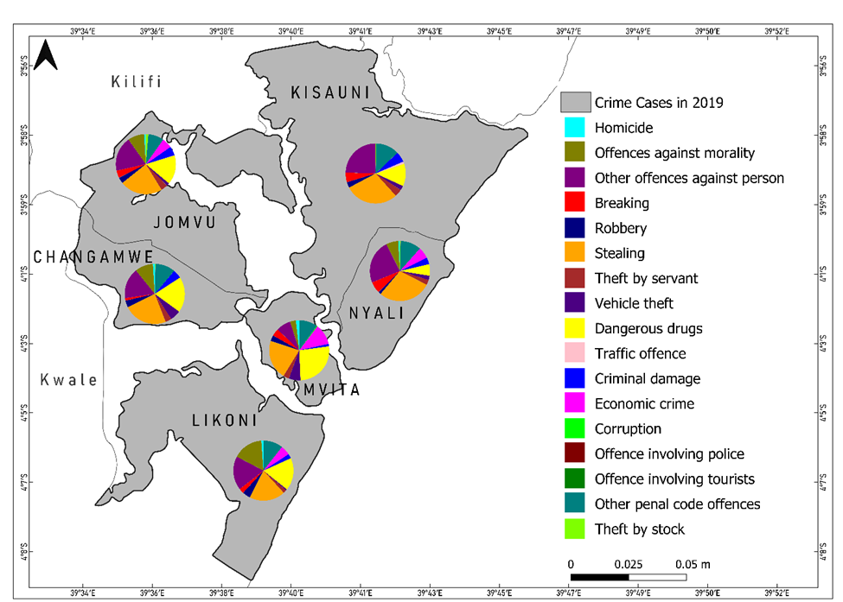
Fig.2. Map showing the proportion of different types of crimes reported in Mombasa sub-counties in 2019
In 2020, as shown in Fig. 3, the dominant crime types in Changamwe remained consistent with those in 2019, with stealing, dangerous drugs, other offences against persons, other penal code offences, and offences against morality being the most prevalent. In Jomvu, the leading crimes were stealing, other offences against persons, offences against morality, dangerous drugs, and other penal code offences. Kisauni recorded high incidences of stealing, other offences against persons, offences against morality, other penal code offences, and dangerous drugs. In Likoni, the most dominant crimes were other offences against persons, offences against morality, stealing, robbery, and other penal code offences. Mvita had high occurrences of stealing, dangerous drugs, economic crimes, other penal code offences, and other offences against persons, while in Nyali, the most reported crimes were stealing, other offences against persons, other penal code offences, offences against morality, and breaking.
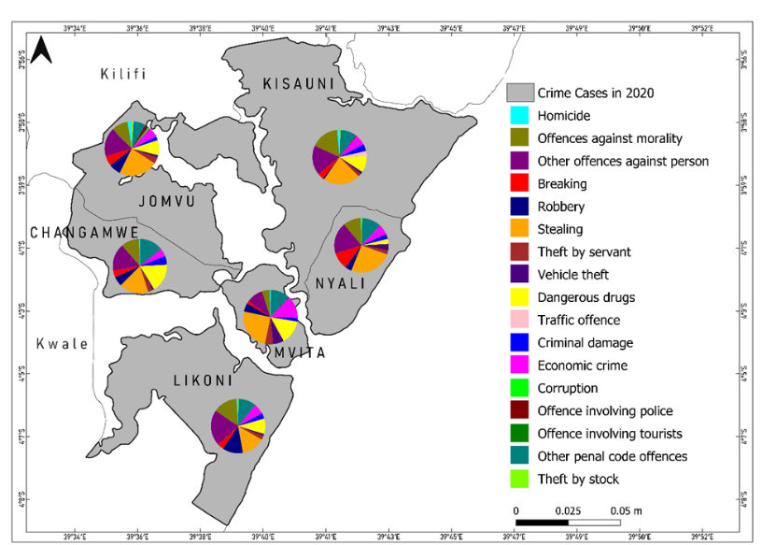
Fig. 3. Map showing the proportion of different types of crimes reported in Mombasa sub-counties in 2020
In 2021, stealing continued to be the most dominant crime in all sub-counties except for Likoni, where other offences against persons were the most frequently reported. As shown in Fig.4, in Changamwe, the most reported crimes were other offences against persons, stealing, offences against morality, other penal code offences, and dangerous drugs. In Jomvu, stealing, other offences against persons, offences against morality, other penal code offences, and dangerous drugs were the most prevalent. Kisauni recorded high occurrences of offences against morality, other offences against persons, other penal code offences, stealing, and traffic offences. In Likoni, stealing, other offences against persons, other penal code offences, offences against morality, and robbery were dominant. Mvita had stealing, other penal code offences, dangerous drugs, and economic crimes as the most frequent crime categories. Lastly, in Nyali, stealing, other offences against persons, offences against morality, economic crimes, and other penal code offences were the most reported crimes.
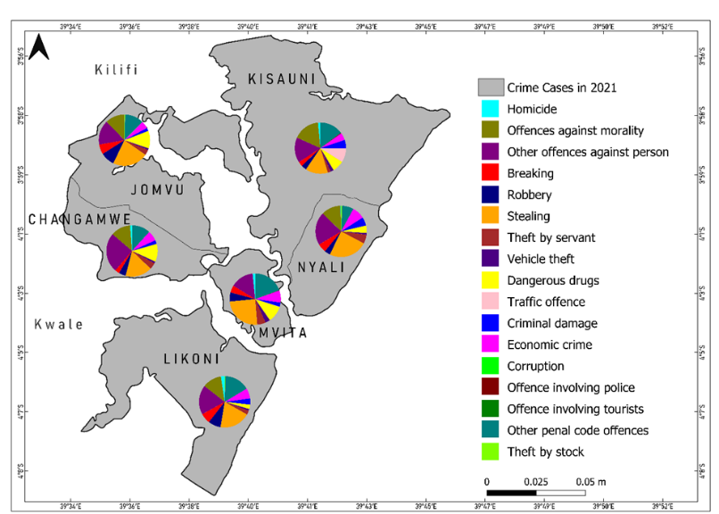
Fig. 4. Map showing the proportion of different types of crimes reported in Mombasa sub-counties in 2021
When all crime cases from 2019 to 2021 are combined as shown in Fig. 5, the most dominant crime types across the six sub-counties include stealing, other offences against persons, dangerous drugs, other penal code offences, and offences against morality. In Changamwe, these five crime categories each accounted for more than 10% of all reported crimes. In Jomvu, the dominant crimes were stealing, other offences against persons, dangerous drugs, offences against morality, and other penal code offences each making up over 18% of all crimes in the subcounty. In Kisauni, these five categories were even more prevalent, with each contributing to more than 22% of total crime cases. In Likoni, the most reported crime type was other offences against persons, followed by stealing, offences against morality, other penal code offences, and dangerous drugs, each exceeding 20% of the total cases in the subcounty. In Mvita, the dominant crimes were stealing, offences against morality, other penal code offences, and dangerous drugs each accounted for over 20% of the total crimes. In Nyali, the most reported crimes were stealing, other offences against persons, other penal code offences, offences against morality, and breaking.
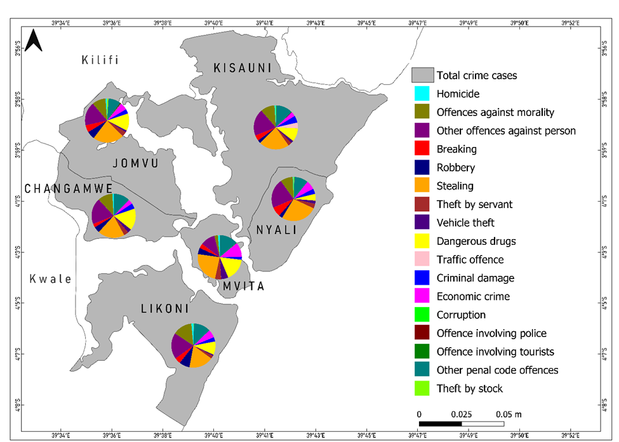
Fig. 5. Map showing the proportion of all different types of crimes reported in Mombasa sub-counties from 2019 to 2021
Across the three years, stealing has remained the most frequently reported crime type across all sub-counties: Nyali recorded the highest proportion of stealing cases at 63.1%, followed by Kisauni at 51.1%, Jomvu and Mvita at 45.8%, while Changamwe recorded the lowest stealing cases at 19.7%. However, Likoni stood out as the only subcounty where other offences against persons (31%) surpassed stealing as the most reported crime category.
While certain crimes were highly prevalent across the sub-counties, some offences were reported at significantly lower frequencies. Traffic offences were minimal, with 0.1% of cases in Likoni, 0.3% in Jomvu and Mvita, 9.7% in Kisauni, and no reported cases in Changamwe and Nyali. Offences involving police officers were also rare, with 0.3% of cases in Mvita, 0.5% in Kisauni, 1.1% in Jomvu, and no reported cases in Changamwe, Likoni, and Nyali. Corruption cases were only recorded in Mvita (0.3%) and Jomvu (0.5%). Offences involving tourists were entirely absent across all sub-counties. Spatial-temporal trends of various crimes across Mombasa sub-counties from 2019 to 202 are depicted from bar graphs in Figs. 6, 7 and 8. Table 2 gives a summary of the spatial-temporal crime trends across sub-counties.

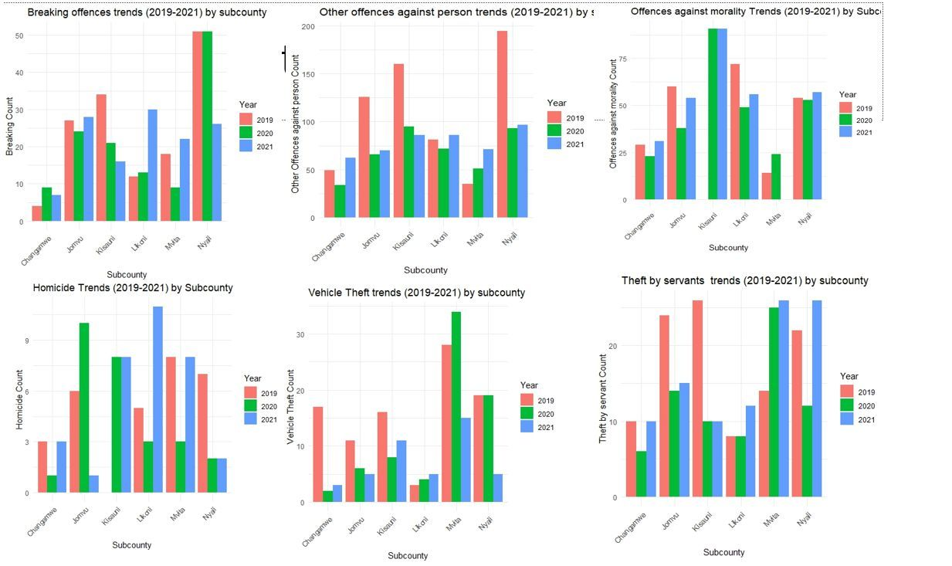
Fig. 6. Bar graphs showing the spatial-temporal trends of various crimes across Mombasa sub counties from 2019 to 2021. (a) Breakings, (b) Other Offences Against Persons (c)Offences Against Morality, (d) Homicides (e) Vehicle Thefts (d) Theft by Servants
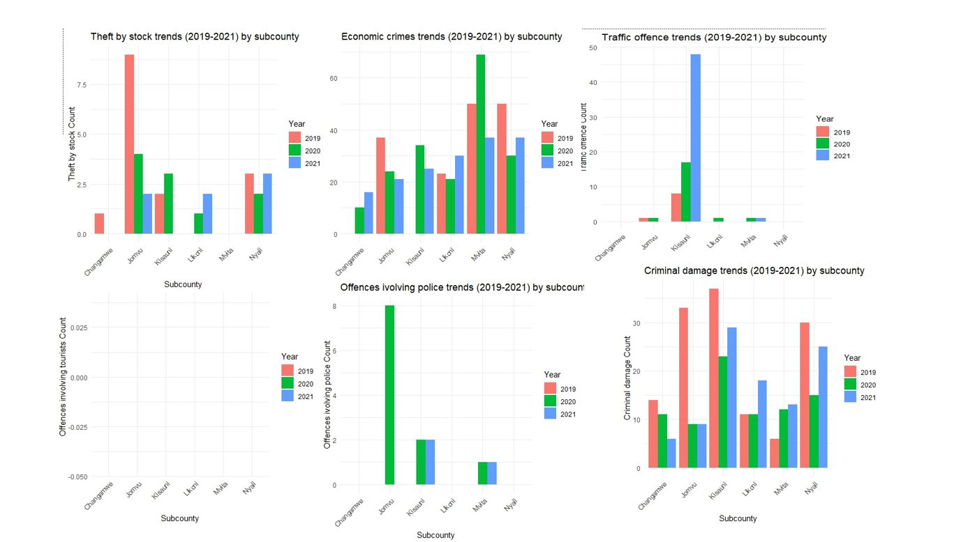
Fig. 7. Bar graphs showing the spatial-temporal trends of various crimes across Mombasa sub counties from 2019 to 2021. (a) Theft by stock (b) Economic crimes (c)Traffic offence (d) Offences involving tourists (e) Offence involving police (d) Crime damage trend
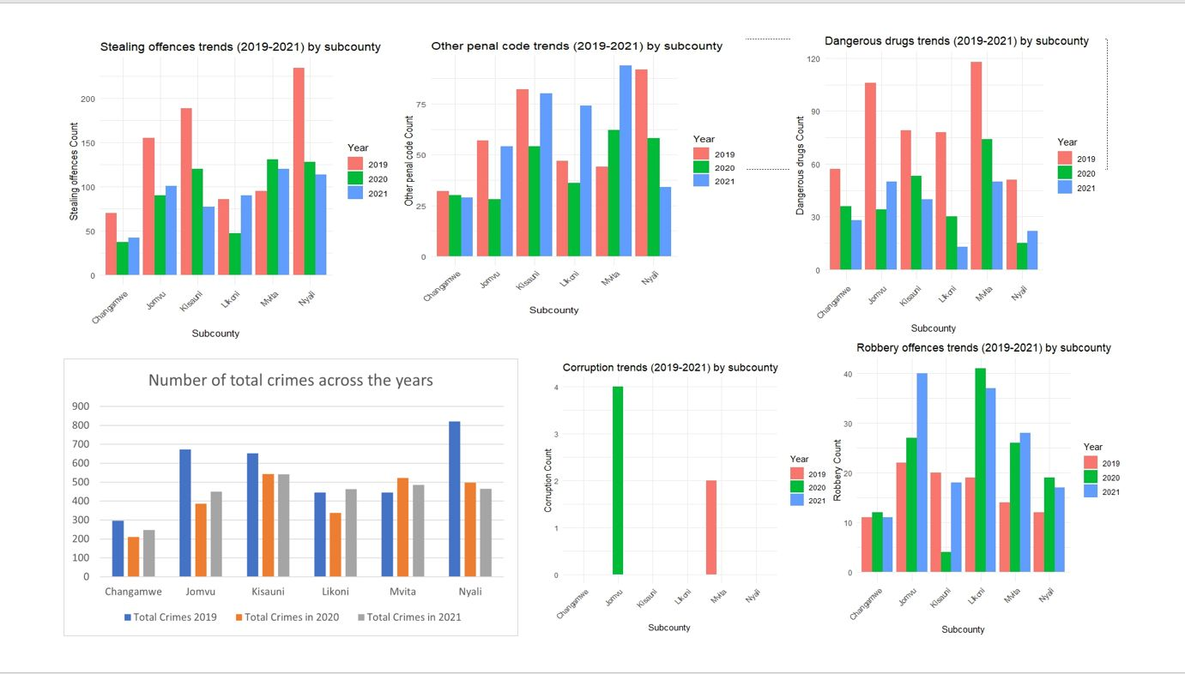
Fig. 8. Bar graphs showing the spatial-temporal trends of various crimes across Mombasa sub counties from 2019 to 2021. (a) Stealing (b) Other penal code (c)Dangerous drugs (d) Number of total crimes per year (e) Corruption trends (d) Robbery offences

Table 2. Summary of the spatio-temporal crime trends across sub-counties
Crime Type | Sub-County with Highest Increase | Sub-County with Highest Decrease | Notes
Homicide | Likoni (2021, +266%) | Mvita (2020, -62.5%) | Sharp fluctuations across sub-counties
Offences Against Morality | Kisauni (2020, from 0 to 91) | Mvita (2021, -100%) | Kisauni experienced high absolute increase from 0
Other Offences Against Person | Mvita (2020-21, +39.2%) | Nyali (2020, -52.3%) | Mixed trends, especially in Mvita
Breaking | Likoni (2021, +130.8%) | Kisauni (2021, -23.8%) | Highest volatility in Likoni and Mvita
Robbery | Kisauni (2021, +350%) | Kisauni (2020, -80%) | Very high spike in Kisauni post major drop
Stealing | Mvita (2020, +27.5%) | Changamwe (2020, -89%) | Significant drop in Kisauni
Theft by Servants | Nyali (2021, +116.6%) | Jomvu (2020, -41.7%) | Varied patterns; high volatility in Nyali
Vehicle Theft | Nyali (2021, +73.7%) | Changamwe (2020, -88.2%) | Mostly upward trends, especially in coastal areas
Dangerous Drugs | Likoni (2020-21, +56.7%) | Kisauni (2021, -24%) | Strong increases in Likoni and Nyali
Traffic Offences | Kisauni (2020-21, +182.4%) | Jomvu (2021, -100%) | Kisauni shows steep rise over two years
Criminal Offences | Mvita (2020-21, +108.3%) | Changamwe (2021, -45.5%) | Mvita showed consistent increases
Economic Crimes | Kisauni (2020, from 0 to 34) | Nyali (2020, -40%) | Kisauni had highest jump from zero
Corruption | Jomvu (2020, from 0 to 2) | Mvita (2020, -100%) | Minimal cases reported overall
Police Offences | Jomvu (2020, from 0 to 8) | Jomvu (2021, -100%) | Localized and short-lived spikes
Tourist Offences | None | All (no cases reported) | No cases reported throughout 2019–2021
Penal Code Offences | Mvita (2020-21, +51.6%) | Nyali (2021, -41.4%) | Mvita showed strong consistent growth
Theft by Stock | Nyali (2021, +50%) | Jomvu (2021, -50%) | Nyali showed sharp year-on-year growth

3.2 Spatio Distribution and Hotspots of Crime
Geospatial analysis using KDE with Epanechnikov kernel function revealed significant spatial disparities in the distribution of crime across Mombasa’s sub-counties. The KDE outputs consistently identified Mvita, Kisauni, and Likoni as persistent crime hotspots over the three-year period (2019–2021), collectively accounting for over 70% of all reported criminal incidents. High-density clusters were particularly prominent in neighborhoods such as Majengo, Bangladesh, and Old Town, suggesting the presence of localized structural crime drivers (see Figs. 9, 10 and 11). Table 3 presents the total number of reported crimes by sub-county during the study period.
Table 3. Total crime incidents by sub-county
Sub-county | Total Reported Crimes
Mvita | 2200
Kisauni | 1800
Likoni | 1700
Changamwe | 1000
Jomvu | 950
Nyali | 837

Mvita sub-county consistently recorded the highest number of incidents, with a predominance of stealing, interpersonal violence, and economic crimes. This trend can be attributed to Mvita’s proximity to Mombasa’s Central Business District (CBD), an area marked by intense economic activity and high pedestrian traffic—factors often linked to increased crime opportunities (Braga et al.,2012, Gakuru, 2019). In contrast, Kisauni and Likoni emerged as primary hotspots for drug-related offences and sexual violence. These patterns are indicative of distinct socio-economic conditions, including high youth unemployment, the prevalence of informal settlements, and limited access to essential social services (Barasa, 2013). Notably, some crime hotspots remained geographically stable across the three years, suggesting the presence of entrenched structural and environmental risk factors. These findings align with theories in environmental criminology, which emphasize the role of urban form, land use, and economic opportunity in shaping the spatial behavior of offenders (Eck et al.,2011). A breakdown of crime types revealed further spatial differentiation. Homicide cases were most prevalent in Likoni and Mvita, while offences against morality were heavily concentrated in Likoni, followed by Mvita. Offences against persons were most common in Nyali and Kisauni, whereas breaking cases were primarily reported in Nyali and Jomvu. Robbery was heavily concentrated in Likoni and Jomvu, while stealing, the most dominant crime overall, was particularly pronounced in Nyali and Kisauni. Mvita recorded the highest numbers of both theft by servants and vehicle theft, followed closely by Nyali. Dangerous drug offences were most frequent in Mvita and Jomvu, and traffic offences were overwhelmingly concentrated in Kisauni.
Crime hotspots were visualized using choropleth maps, where crime intensity was represented in shades of red. lighter shades showed lower crime numbers and darker shades showed hotspots with higher crime rates. In 2019 (Fig 9), Nyali recorded the highest total crime cases, with 821 incidents, while Changamwe had the lowest at 297 cases.
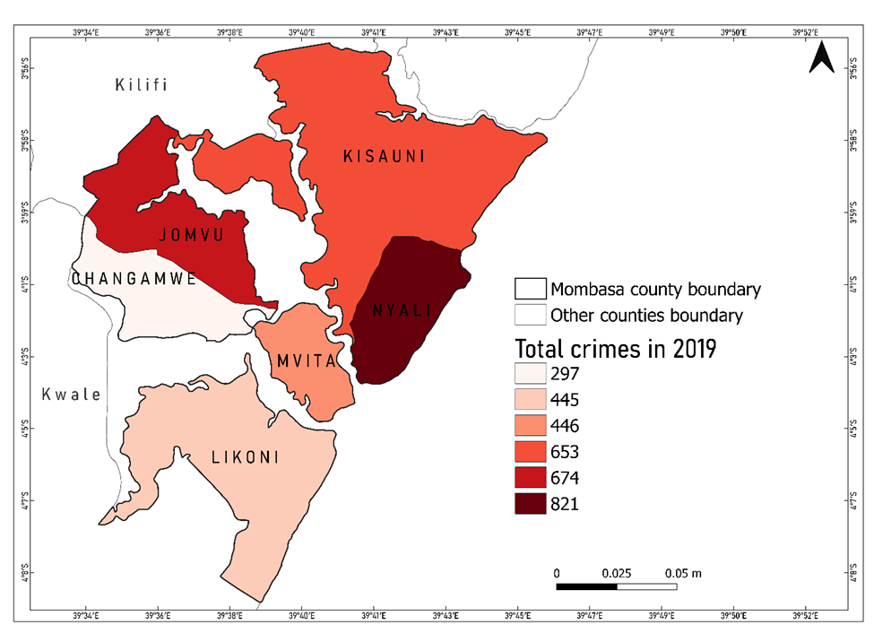
Fig. 9. Map showing the total number of crimes reported in Mombasa sub-counties in 2019

In 2020 (Fig 10), Kisauni emerged as the most crime-prone area, reporting 543 cases, whereas Changamwe again had the fewest at 211 cases.
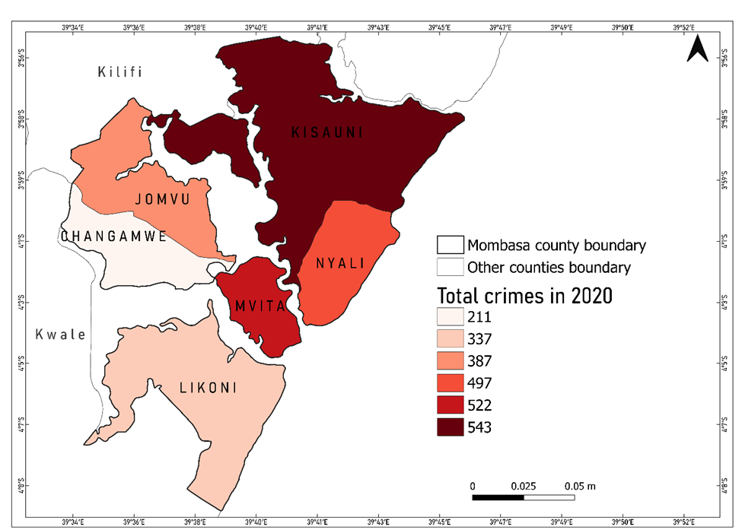
Fig. 10. Map showing the total number of crimes reported in Mombasa sub-counties in 2020
The trend continued in 2021 as shown in Fig. 11, with Kisauni leading at 541 cases, while Changamwe recorded 248 cases. Overall, Changamwe consistently reported the lowest crime numbers across the three years, while Kisauni emerged as a major crime hotspot in 2020 and 2021.

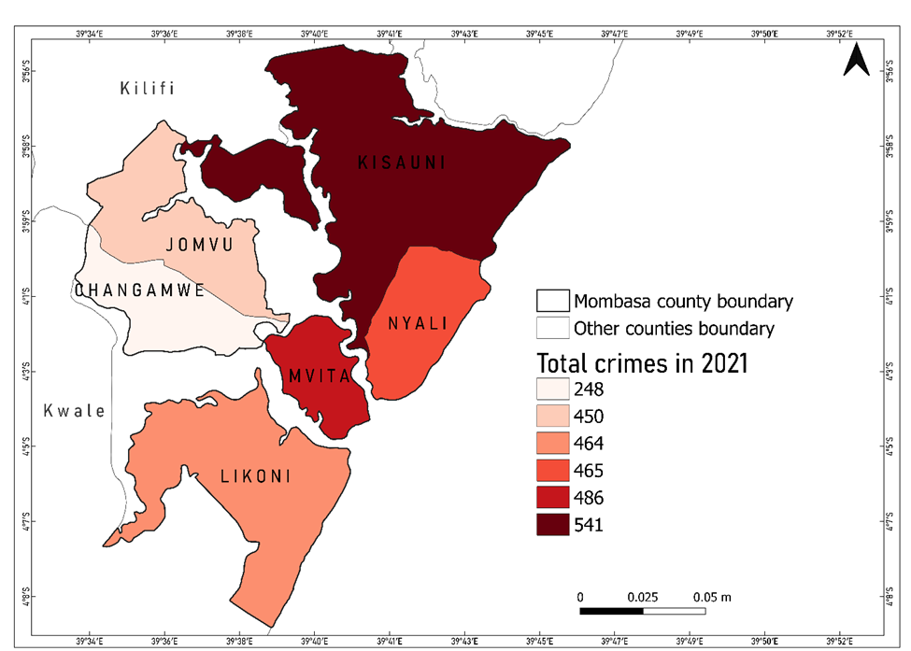
Fig. 11. Map showing the total number of crimes reported in Mombasa sub-counties in 2021
3.3 Spatial Autocorrelation Analysis (Moran’s I)
To statistically validate the presence of spatial clustering, Moran’s I was applied for aggregated crime data. The overall Moran’s I for total crimes across sub-counties was 0.482 (p < 0.01), indicating moderate positive spatial autocorrelation. This suggested that high-crime sub-counties are spatially proximate to other high-crime areas, while low-crime areas are adjacent to similarly low-crime neighborhoods.
Table 4. Moran’s I statistics by crime type
Crime Type | Moran’s I | Z -score | P – value | Spatial Pattern
Theft | 0.518 | 2.74 | <0.01 | Significant clustering
Drug Offences | 0.467 | 2.31 | <0.05 | Significant clustering
Assault | 0.442 | 2.10 | <0.05 | Moderate clustering
Homicide | 0.298 | 1.50 | 0.08 | Weak clustering

Disaggregated analysis revealed that stealing had the highest spatial clustering at 0.518, followed by drug-related crimes at 0.467 and offences against persons at 0.442. These values highlighted a non-random, patterned spatial arrangement of crime incidents in Mombasa. In regards to Likoni and Kisauni, they had the strongest clustering for drug-related crimes which was likely fueled by established trafficking networks and socio-economic marginalization (Badurdeen, 2023). Similarly, economic crimes and homicides demonstrated relatively lower spatial autocorrelation suggesting more random distributions or underreporting in less urbanized areas.
These findings retaliated earlier studies by Fonji et al., (2014), who emphasized the utility of Moran’s I in identifying spatial dependency in urban crime systems. They also support Eck et al., (2011), who noted that repeat victimization and offender familiarity contribute to geographic concentration of crimes.
3.4 Poisson Regression for Temporal Crime Modeling
To assess temporal variations and predictors of crime, a Poisson regression model was used to count crimes per sub-county per year. The independent variables used included year, population size and proximity from the CBD. The model was statistically significant at the 0.01 level which indicated a good fit for explaining temporal crime variation.
Table 5. Poisson regression results
Variable | Coefficient (β) | Std.Error | Z – Value | P - Value | Interpretation
Intercept | 1.250 | 0.234 | 5.34 | <0.001 | Baseline crime level
Year 2020 | -0.219 | 0.092 | -2.38 | <0.05 | Covid-19 effect
Population (log) | 0.392 | 0.067 | 5.85 | <0.001 | High population
Distance from CBD (km) | -0.153 | 0.059 | -2.59 | <0.05 | Further from center

The regression revealed that the year 2020 had a significant negative coefficient (β = -0.219, p < 0.05) which was consistent with the observed drop in crime during the peak of the COVID-19 pandemic. It also revealed that population size was a significant positive predictor (β = 0.392, p < 0.01) indicating that crime levels were higher in more densely populated sub-counties. Similarly, the distance from CBD had a negative coefficient (β = -0.153, p < 0.05) which suggested that areas further from central Mombasa had fewer reported crimes.
These results underlined the utility of temporal regression models in capturing the influence of demographic and geographic factors on crime rates. Similar conclusions were drawn by Zhanjun et al (2022) who applied Poisson models to urban crime data and found significant associations with spatial proximity, mobility and population concentration. Osgood (2017) used poisson-based regression models of offense counts to analyze per capita offense rates in nonmetropolitan counties in four states in the USA and found out that the Poisson-based negative binomial model provides a very good fit to the data, while OLS analyses produce outliers and require arbitrary choices that have a striking impact on results, on contrary Dian ,(2021) investigated Count Regression Models for Analyzing Crime Rates in The East Java Province,Indonesia and found out that fitting Poisson regression model for analyzing the relationship between crimerates and some explanatory variables in the East Java Province is not suitable because there is an indication of overdispersion.
4. DISCUSSION
4.1 Spatio-Temporal patterns and trends of Crime in Mombasa County
This study aimed to examine the spatio and temporal patterns of crime in Mombasa County using a combination of GIS, spatial autocorrelation and statistical modeling. Guided by three specific objectives analyzing crime typology by sub-county, evaluating spatio-temporal trends and identifying crime hotspots the research provided comprehensive insights into the dynamics of crime across the county between 2019 and 2021. Other more recent Kenyan or East African studies applying geospatial analysis include Korir et al. (2024) and Adionyi et al. (2024).
The findings support the integration of geospatial science into both policy-making and practical crime prevention strategies. Regarding the first objective, the analysis confirmed that stealing was the predominant crime across nearly all sub-counties. It accounted for more than half of the reported incidents in Nyali (63.1%) and Kisauni (51.1%), and remained the most prevalent category in Mvita and Jomvu. In contrast, Likoni reported a higher proportion of offences against persons (31%), highlighting sub-county-level variation in crime typology. The dominance of stealing corresponds with structural socio-economic factors such as unemployment, poverty and rapid urbanization which tend to heighten vulnerability to petty and opportunistic crimes. These patterns echo national trends reported by the Kenya National Bureau of Statistics (KNBS, 2022) and align with findings by Gitonga & Soi (2022), who link theft to economic hardship and urban density. Spatial mapping of crime types provided visual clarity on how different categories are distributed across sub-counties. This visualization approach helped contextualize the demographic and economic disparities that may influence crime patterns, underscoring the importance of place-based analysis in understanding urban security challenges.
In relation to the second objective, temporal analysis revealed that crime levels fluctuated significantly year by year, shaped by broader societal disruptions. For instance, homicide cases in Changamwe fell by 66.7% in 2020 but increased by 200% in 2021, while Likoni experienced a 40% drop followed by a 266% increase. A similar trend was seen in offences against morality in Kisauni and Changamwe. These shifts point to a crime environment that is reactive to external pressures particularly the effects of the COVID-19 pandemic. Movement restrictions and curfews likely suppressed crime in 2020, while their removal in 2021 coincided with a resurgence, possibly exacerbated by economic strain and weakened social controls (Akanmu et al., 2021).
For the third objective, the identification of spatio crime hotspots using KDE revealed consistent concentrations of criminal activity in Kisauni, Likoni, and Mvita sub-counties. These areas share structural vulnerabilities including high population density, inadequate public services, informal housing, and high youth unemployment conditions that collectively foster environments conducive to crime (Kiplagat, 2021). This spatio pattern was statistically confirmed through Moran’s I analysis, which demonstrated significant spatial autocorrelation, indicating that crime clusters are not random but geographically systematic. The application of Poisson regression further reinforced the spatio findings with proximity to the CBD and high population density emerging as significant predictors of crime frequency. These results support rational choice theory, which posits that offenders weigh opportunity, risk and escape routes before committing crimes. High-density, economically active areas tend to offer anonymity and abundant targets, making them attractive to offenders.
Additionally, the findings align with social learning theory, which suggests that repeated exposure to criminal behavior particularly in communities with weak institutional controls can normalize crime and encourage imitation (Barasa, 2013). Taken together, the results highlight the spatially clustered and socio-economically embedded nature of crime in Mombasa County. Crime is not only a law enforcement issue but a manifestation of underlying systemic challenges. Addressing it effectively thus requires a holistic, multi-dimensional approach one that goes beyond traditional policing to incorporate urban planning, economic development, youth empowerment, and community-based interventions. This holistic way involves coordinating multiple actors including local governments, civil society, education institutions, and public health agencies to tackle the root causes of crime while improving institutional trust and community resilience.
Ultimately, the integration of spatial analytics and predictive modeling offers a powerful toolkit for diagnosing, anticipating, and responding to urban crime. These tools help shift crime prevention from a reactive to a proactive stance by identifying vulnerable areas, optimizing resource allocation, and guiding targeted interventions. The evidence generated from this study supports the adoption of data-driven, context-specific crime prevention strategies that are adaptable to the socio-economic realities of Mombasa and other rapidly urbanizing regions.
While this study has provided critical insights into the spatial and temporal dynamics of crime in Mombasa County, it also opens up several avenues for future research. First, subsequent studies could benefit from higher-resolution spatial data, such as georeferenced coordinates at the neighborhood or street level, to allow for more granular hotspot detection and analysis. This would improve the precision of interventions and resource allocation. Second, incorporating qualitative data including community perceptions, victim experiences, and local policing strategies would provide a richer understanding of the social context surrounding crime. Such mixed-methods approaches can bridge the gap between statistical findings and lived realities, enabling more grounded policy responses. Third, future work could integrate longitudinal datasets that span a longer time frame to identify sustained trends, cyclical patterns, or the long-term effects of major social disruptions (e.g., pandemics, elections). This would help distinguish between short-term anomalies and persistent structural problems.
Additionally, expanding the scope of research to include socioeconomic and infrastructural variables such as income levels, education, land use, and access to services would deepen the explanatory power of predictive models. These variables can help uncover root causes of crime and refine strategies for long-term prevention. Finally, applying and testing the study’s methodological framework in other urban and peri-urban counties across Kenya or East Africa would assess its generalizability and relevance across diverse spatial and governance contexts. Comparative analysis could also identify regional best practices in crime prevention and spatial planning. By building on the current study, future research can play a pivotal role in advancing a more evidence-based, context-aware, and integrated approach to urban security and development.
4.2 Limitations of the study
Despite its contributions, this study is subject to several limitations that should be acknowledged. First, the analysis was based solely on officially reported crime data, which may underrepresent the actual magnitude of criminal activity due to underreporting a common issue influenced by public trust in law enforcement, social stigma, or accessibility to reporting mechanisms. Second, the spatial resolution of the data was confined to the sub-county level, limiting the ability to detect finer-grained crime patterns at the neighborhood or street level. This may have masked critical micro-hotspots of criminal activity. Third, the absence of precise georeferenced coordinates for individual crime incidents reduced the spatial accuracy of the analysis. As a result, spatial clustering and density estimations relied on aggregated data, which may obscure localized variations in crime distribution. Fourth, the study did not incorporate potentially influential socio-economic and demographic variables such as household income, educational attainment, and population density due to the unavailability of reliable and spatially disaggregated datasets. The exclusion of these factors may limit the comprehensiveness of the explanatory models used. Nevertheless, the integration of KDE, Moran’s I, and Poisson regression modeling provided a robust analytical framework for exploring spatial and temporal crime dynamics in Mombasa County. Despite the outlined constraints, the findings offer a valuable foundation for evidence-based policy-making and targeted crime prevention interventions.
4.3 Interpretation and Policy Implications
The convergence of results from KDE, Moran’s I, and Poisson regression analysis reveals that crime in Mombasa County is spatially clustered and strongly influenced by socio-economic and environmental factors. Crime is concentrated in specific sub-counties particularly Mvita, Kisauni, and Likoni rather than being uniformly distributed. These hotspots persist across time, pointing to structural drivers such as economic inequality, urban density, limited social services, and inadequate infrastructure. These findings challenge the effectiveness of reactive or enforcement-focused policing strategies. Instead, they support the need for integrated, place-based interventions that combine law enforcement with community engagement, youth empowerment, drug rehabilitation, and urban renewal. In particular, the prominence of drug-related offences and interpersonal violence in certain areas underscores the importance of addressing substance abuse and social exclusion, especially in informal settlements. From a policy and planning perspective, incorporating spatial analysis tools into crime monitoring systems can greatly enhance the targeting and deployment of policing resources, including surveillance infrastructure and patrol routes. Routine use of geospatial data enables authorities to prioritize high-risk areas, make informed decisions, and adopt proactive crime prevention strategies. Collaboration is essential. County governments, national security agencies, urban planners, and civil society must work together to implement evidence-based, data-driven interventions tailored to the unique socio-economic context of each hotspot. Moreover, the methodological framework employed in this study can be replicated in other urban settings, offering a scalable tool for security planning, resource allocation, and legislative guidance across Kenya and beyond.
5. CONCLUSION
This study investigated the spatial and temporal dynamics of crime in Mombasa County between 2019 and 2021, using a combination of crime mapping, spatial autocorrelation, and Poisson regression. The analysis uncovered clear patterns in the distribution, typology, and intensity of crime, offering new insights into the geography of urban insecurity. Crime was found to be concentrated in a few sub-counties, especially Mvita, Kisauni, and Likoni, with recurring patterns of stealing, drug offences, and interpersonal violence. Spatial autocorrelation confirmed that crime is not randomly distributed but is significantly clustered, reflecting deeper socio-economic and environmental disparities across neighborhoods. Temporal trends showed a noticeable decline in crime during 2020, likely due to COVID-19 containment measures, followed by a sharp resurgence in 2021, signaling a return to pre-pandemic patterns. The Poisson regression analysis further emphasized the role of population density and urban proximity in explaining crime prevalence, reinforcing established criminological theories that link urbanization with increased crime risk. Overall, the study demonstrates the value of GIS and spatial-statistical methods in diagnosing urban crime patterns. These tools are not only effective for visualizing and analyzing crime but are also crucial for guiding evidence-based decision-making. The findings underscore the urgent need for localized, data-informed, and multi-sectoral crime prevention strategies that are responsive to the spatial realities and socio-economic context of affected communities

Disclaimer (Artificial intelligence)
Option 1:
Author(s) hereby declare that NO generative AI technologies such as Large Language Models (ChatGPT, manuscript.
Option 2:
Author(s) hereby declare that generative AI technologies such as Large Language Models, etc. have been used during the writing or editing of manuscripts. This explanation will include the name, version, model, and source of the generative AI technology and as well as all input prompts provided to the generative AI technology
Details of the AI usage are given below:
1.
2.
3.

REFERENCES

Adionyi, L., Adero, N., Mutua, S., Korir, D., & Siljander, M. (2024). Habitat Suitability Modeling for the Invasive Opuntia stricta Using Remote Sensing and Maxent in Tsavo East National Park, Kenya. Journal of Geography, Environment and Earth Science International, 28(12), 1-18.
Akanmu, A. A., Salisu, U. O., Daramola, O. P., Ogunsesan, A. S., Fasina, S. O., Adejare, J. A., .Olatunji, O. M. (2021). The COVID-19 pandemic and insecurity: the furiousness in Nigerian Communities. Urban Planning and Transport Research, pp. 9(1), 368-406. doi:https://doi.org/10/1080/21650020.2021.1946420
Aronson, S. L. (2010). Crime and development in Kenya: Emerging trends and the transnational implications of political, economic and social instability. Inquires Journal, 2, 1-6.
Badurdeen, F. A. (2023). International and local NGOs addressing violent and hateful extremism in Kenya. Conflict, Security and Development. doi:https://doi.org/10.1080/14678802.2023.2211034
Baraka, E. G. (2023). An Evidence based Theoretical Underpinning of Technological Transformation in Policing: From Manual Crime Mapping to Geographical Information Systems in Kenya. International Journal of Police Science and Management. doi:DOI:10.13140/RG.2.2.22835.91682
Barasa, B.M. (2013). Factors influencing drug abuse among students in public secondary schools in Mombasa district, mombasa county, Kenya. Mombasa, Kenya.
Braga, A., Papachristos, A., & Hureau, D. (2012). Hot spots policing effects on crime. Campbell Systematic Reviews. doi:https://doi.org/10.4073/csr.2012.8
Danjuma, I. A. (2023). The influx of irregular migrants as a challenge to security in Nigeria. International Journal of Management Studies and Social Science Research, 05(06), 89–96. doi:https://doi.org/10.56293/ijmsssr.2023.4710
Eck, J. E., Chainey, S., & Cameron, J. G. (2011). Mapping Crime: Understanding Hotspots. National Institute of Justice.
Fonji, S. F., & Larrivee, M. (2014). Public Participation GIS (PPGIS) for Regional Mapping and Environmental Awareness. Journal of Geographic Information System, 135 - 149. doi:10.4236/jgis.2014.62015.
Gahlin, C. (2014). Crime Hotspots: An Evaluation of the KDE Spatial Mapping Technique. Karlskrona: Blekinge Institute of Technology.
Gakuru, J. K. (2019). GIS Approach to crime mapping and spatial analysis: Nairobi City County. Nairobi: University of Nairobi.
Grawert, A. C., Kimble, C., & Fielding, J. (2021). Poverty and Mass Incarceration in New York. An Agenda for Change.
Handayani, D., Artari, A. F., Safitri, W., Rahayu, W., & Santi, V. M. (2021, November). Count Regression Models for Analyzing Crime Rates in The East Java Province. In Journal of Physics: Conference Series (Vol. 2123, No. 1, p. 012028). IOP Publishing.
Kannan, M. & Singh, M. (2023). Geographical Information System and Crime Mapping. 1st ed. Routledge, London
Korir, D. K., Namu, F., Adionyi, L., & Siljander, M. (2024). Geospatial Patterns and Behavioural Responses of Elephants to Cattle and Mortality Risk in a Pastoralist Maasai Mara Landscape, Kenya. Journal of Geography, Environment and Earth Science International, 28(12), 112-130.
KNBS. (2019). Economic Survey. Nairobi: Kenya National Bureau of Statistics.
Lamond, G. (2007). What is a crime? Oxford Journal of Legal Studies,, 27(4), 609–632. doi:https://doi.org/10.1093/ojls/gqm018
Mansourihanis, O., Tilaki, M. J. M., Armitage, R., & Zaroujtaghi, A. (2025). Evolution and prospects of Geographic Information Systems (GIS) applications in urban crime analysis: A review of literature. Remote Sensing Applications: Society and Environment, 38, 101583. https://doi.org/10.1016/j.rsase.2025.101583
Moran, P.A., 1950. Notes on continuous stochastic phenomena. Biometrika 37, 17–23.
https://doi.org/10.1093/biomet/37.1-2.17.
Muindi, K., Mberu, B., Aboderin, I., & Amugsi, D. (2022). Conflict and crime in municipal solid waste management: evidence from Mombasa and Nairobi, Kenya. Cities and Health. 6(1), 159–167. doi: https://doi.org/10.1080/23748834.2020.1810600
Nilsson, L. (2021). The Portrayal Of Crime Printed News Media’s Representation Of Crime in MALMO. August.
NPS. (2019). National Police Service annual report 2022 Service with dignity.

Osgood, D. W. (2017). Poisson-based regression analysis of aggregate crime rates. In Quantitative methods in criminology (pp. 577-599). Routledge.

Perez, R. (2022). An analysis of the suspect: The impact of economic conditions on crime.
R Core Team, 2022., R: A language and environment for statistical computing. R Foundation for Statistical Computing, Vienna, Austria. https://www.R-project.org/.
Sigel, L. (2016). Criminology, Theories, Patterns and Typology. New York: West Publishing.
Wang, D., Ding, W., Lo, H., & Stepinski, T. (2013). Crime hotspot mapping using the crime related factors - A spatial data mining approach. Applied Intelligence, 39, 772. doi:DOI:10.1007/s10489-012-0400-x
Yar, P., & Nasir, J. (2016). GIS Based Spatial and Temporal Analysis of Crimes, a Case Study of Mardan City, Pakistan. International Journal of Geosciences, 7, 325 - 334. doi:doi: 10.4236/ijg.2016.73025.
Zhanjun, H., Zhipeng, W., Zhong, X., & Liang, W. (2022). Multiscale analysis of the influence of street built environment on crime occurrence using street-view images. Computer, Environment and Urban Systems, 97(3).

