Water Quality Index-Based Groundwater Assessment for Irrigation and Drinking Purposes in Erode District, Tamil Nadu, India

Abstract
Groundwater is an essential water resource for drinking and irrigation, especially in semi-arid areas such as Erode District, Tamil Nadu, India. This research assesses groundwater quality both for drinking and agriculture using standard water quality indices. 48 groundwater samples were gathered from 44 villages in the premonsoon season of 2021 and analysed for physicochemical parameters such as pH, electrical conductivity (EC), total dissolved solids (TDS), major cations (Ca²⁺, Mg²⁺, Na⁺, K⁺), and major anions (Cl⁻, SO₄²⁻, CO₃²⁻, HCO₃⁻, NO₂⁻+NO₃⁻) as well as fluoride. Drinking water quality was determined via Water Quality Index (WQI), while irrigation suitability was determined via Sodium Adsorption Ratio (SAR), Residual Sodium Carbonate (RSC), and Sodium Percentage (Na%). Results indicated that 23% of the samples were excellent, 43% good, 25% poor, and 9% unsuitable for consumption. 82% of the samples had low sodium hazard as per SAR, 77% were good as per RSC, and 37% doubtful as per Na%. Spatial analysis showed that the deterioration in groundwater quality was stronger in the east and center of the district, which pointed out the area of concern. The research presents new, location-specific information that can be used to develop sustainable groundwater management measures such as monitoring, remediation, and policy planning. These results emphasize the necessity of continuous monitoring of groundwater quality for guaranteeing safe drinking water supply and sustainable agricultural production in areas with intense farming and industrial pursuits.
Keywords: Irrigation suitability; Sodium Adsorption Ratio; Residual Sodium Carbonate; Sustainable groundwater management
Introduction
Groundwater is an essential natural resource used as the major source of water for drinking and irrigation purposes in most parts of the globe, particularly in water-limited areas (Adimalla and Qian, 2019; Bojago et al., 2023). In India, about 85% of rural drinking water and 60% of irrigation water needs are satisfied by groundwater resources (Central Ground Water Board, 2019). Nevertheless, quick urbanization, industrialization, intensification of agriculture, and climatic change have profoundly influenced the quality of groundwater (Ravi Kumar et al., 2017; Rajesh et al., 2024; Ahamad et al., 2025). Erode District in the western region of Tamil Nadu, India, is a significant agricultural and industrial region with significant groundwater resource dependency. The industries, cultivation of turmeric, and intensive farming are predominant activities in the district. These activities, combined with natural elements like geology and climate, have the potential to affect groundwater quality (Lang and Kannan, 2007; Bhutiani et al., 2019; Ahamad et al., 2023; Rajesh and Prasad, 2024; Sangeetha et al., 2024).
Groundwater quality assessment is needed to determine its appropriateness for use in different purposes, especially drinking and irrigation. Ingestion of polluted water can contribute to many health problems, ranging from gastrointestinal disorders to fluorosis and methemoglobinemia (WHO, 2017). Irrigation water with poor quality also has undesirable impacts on soil characteristics, crop productivity, and sustainable agriculture in the long run (Ayers and Westcot, 1985; Siddharam et al., 2024). Water Quality Indices (WQI) have proved to be useful measures to represent complicated water quality information as simple and intelligible data (Horton, 1965; Brown et al., 1970). The WQI combines multiple water quality parameters into one number and presents a single and holistic picture of the overall quality of water (Ramakrishnaiah et al., 2009). In the same manner, irrigation indices like Sodium Adsorption Ratio (SAR), Residual Sodium Carbonate (RSC), and Sodium Percentage (Na%) are commonly used to assess the suitability of water for irrigation purposes (Richards, 1954). Even though groundwater plays an important role in Erode District, detailed studies on assessment of groundwater quality by employing various indices are scarce. Hence, this investigation seeks to to evaluate the physicochemical characteristics of groundwater in Erode District, Tamil Nadu, and assess its suitability for drinking and irrigation using WQI, SAR, RSC, and Na%.
Materials and Methods
Study Area
Erode District is located in the western region of Tamil Nadu, India, between 10.36° to 11.75° North latitude and 76.49° to 77.97° East longitude, with an area of around 5,722 km². The district is under a semi-arid climate with an average of around 700 mm of rainfall annually (Central Ground Water Board, 2019). The important river system of the district is the Cauvery and its tributaries Bhavani and Noyyal. Geologically, the district consists mainly of hard rock units such as granites, gneisses, and charnockites of Archaean age. Groundwater in the district is found in weathered and fractured parts of such crystalline rocks. The thickness of the weathered zone ranges from 5 to 20 meters, creating the major aquifer system within the area. Agriculture is the main vocation of the district, where major crops are turmeric, sugarcane, paddy, and vegetables(Elango & Kannan, 2007). The textile industries are also popular in the district, especially in Perundurai, Gobichettipalayam, and Erode town.
Sampling and Analytical Methods
A total of 48 groundwater samples were collected from various villages across Erode District, Tamil Nadu, in January 2018. The samples were taken from both bore wells and open wells commonly used for drinking and irrigation purposes. In addition to field sampling, secondary data on groundwater levels and historical water quality were obtained from the Public works Department (PWD), Government of Tamil Nadu, and national databases maintained by agencies such as the Central Ground Water Board (CGWB), Ministry of Jal Shakti, Government of India. All collected samples were stored in clean polyethylene bottles, labelled appropriately, and transported to the laboratory for analysis. The physico-chemical analysis of the water samples was carried out at the Soil and Water Testing Laboratory, Tamil Nadu Agricultural University (TNAU), Coimbatore, using standard procedures recommended by the American Public Health Association (APHA, 2012). The parameters analysed in the laboratory included pH, electrical conductivity (EC), total dissolved solids (TDS), total hardness (TH), calcium (Ca²⁺), magnesium (Mg²⁺), sodium (Na⁺), potassium (K⁺), chloride (Cl⁻), sulfate (SO₄²⁻), nitrate (NO₃⁻), bicarbonate (HCO₃⁻), and fluoride (F⁻). These measured values were then used to calculate the Water Quality Index (WQI) and assess the suitability of groundwater for drinking and irrigation purposes.
Water Quality Assessment Techniques
Water Quality Index (WQI) for Drinking Intent
Water Quality Index (WQI) was computed in order to assess the acceptability of groundwater for drinking intent based on the weighted arithmetic index method (Brown et al., 1970). Calculations consist of the following:
- Assignment of weight (WI) to each parameter depending upon its relative significance in the total water quality.
- Computation of quality rating scale (qi) for every parameter using the formula
qi = [(Ci - Cio) / (Si - Cio)] × 100
Where, Ci is the concentration of the parameter in the water sample, Si is the standard value of the parameter as per WHO or national standards, and Cio is the optimal value of the parameter (commonly zero for all parameters except pH, for which Cio = 7).
3. Calculation of the sub-index (SIi) for every parameter
SIi = wi × qi
4. Calculation of the final WQI through the summation of all sub-indices:
WQI = ∑SIi
The values of WQI were categorized as below <50 (excellent water quality), 50-100 (good water quality), 100-200 (poor water quality), 200-300 (very poor water quality), and >300 (not fit for consumption).
Irrigation Water Quality Indices
Three principal indices were employed to evaluate the suitability of groundwater for irrigation include Sodium Adsorption Ratio (SAR). SAR is a measure of relative ratio of sodium to calcium and magnesium in water and is expressed by the equation: SAR = Na⁺ / √[(Ca²⁺ + Mg²⁺) / 2] Where all concentrations of ions are in mill equivalents per litre (meq/L).Residual Sodium Carbonate (RSC): RSC reflects the alkalinity risk and is obtained from the following equation: RSC = (CO₃²⁻ + HCO₃⁻) - (Ca²⁺ + Mg²⁺) Where all the concentrations are in meq/Sodium Percentage (Na%): Na% is obtained from the following equation: Na% = [Na⁺ / (Ca²⁺ + Mg²⁺ + Na⁺ + K⁺)] × 100, where all concentrations are in meq/L. The classification of water for irrigation based on these indices is presented in (Table 1).
Table 1: Classification of irrigation water based on SAR, RSC, and Na%
Index | Range | Water Class
SAR (Sodium Adsorption Ratio) | < 10 | Low sodium hazard
 | 10 – 18 | Medium sodium hazard
 | 18 – 26 | High sodium hazard
 | > 26 | Very high sodium hazard
RSC (Residual Sodium Carbonate) | < 1.25 | Safe
 | 1.25 – 2.5 | Marginally suitable
 | > 2.5 | Unsuitable
Na% (Sodium Percentage) | < 20 | Excellent
 | 20 – 40 | Good
 | 40 – 60 | Permissible
 | 60 – 80 | Doubtful
 | > 80 | Unsuitable

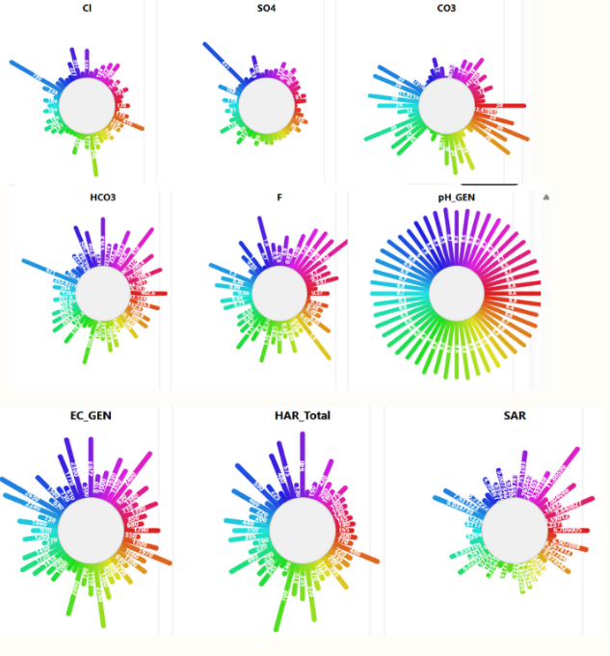
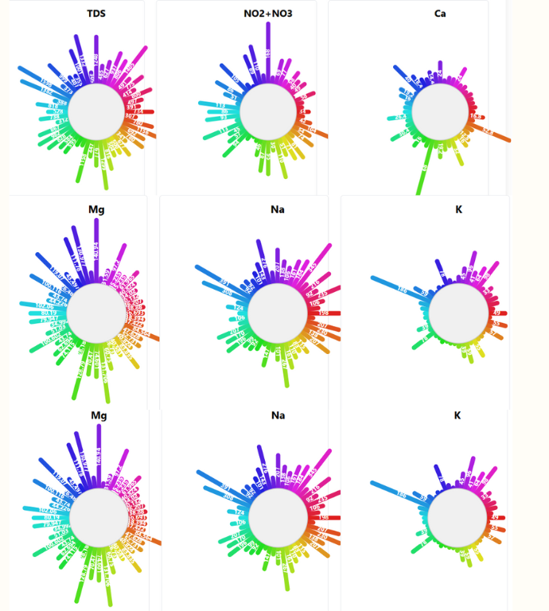
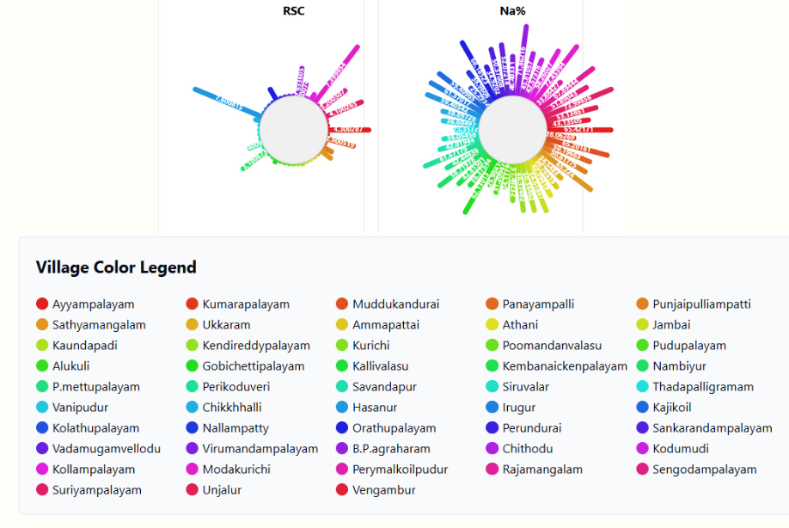
Fig.1: variation Physiochemical parameters in the study area
Statistical Analysis
Descriptive statistics, including minimum, maximum, mean, and standard deviation, were calculated for all measured parameters using R software. Pearson correlation analysis was performed in R to examine the interrelationships among various water quality parameters.
Results and Discussion
General Hydrochemistry
Descriptive statistics of groundwater parameters, including minimum, maximum, mean, and standard deviation, are presented (Table 2). Irrigation water classification based on SAR, RSC, and Na% is shown to indicate suitability from low hazard/excellent to very high hazard/unsuitable (Table 1). variation of Physiochemical parameters are represented in Fig 1. pH ranged from 7.8 to 8.9 with a mean of 8.5, suggesting that the groundwater in the study area is mostly alkaline. EC values ranged widely from 380 to 2630 μS/cm with a mean of 1146 μS/cm. Also, TDS concentrations varied from 214 to 1598 mg/L with a mean of 700 mg/L.Among the cations, sodium (Na⁺) was the prevailing ion with a range of 23 to 391 mg/L (mean: 142 mg/L), followed by magnesium (Mg²⁺) between 12.15 and 140.94 mg/L (mean: 60.7 mg/L), potassium (K⁺) between 1 and 186 mg/L (mean: 30 mg/L), and calcium (Ca²⁺) between 2.4 and 68 mg/L (mean: 14.6 mg/L).
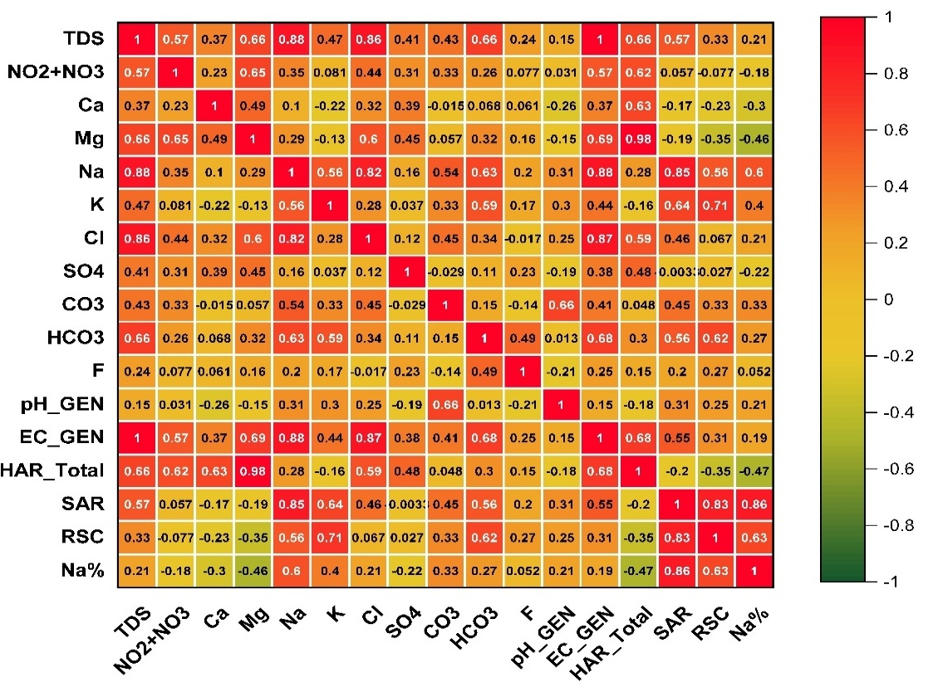
In anions, bicarbonate (HCO₃⁻) was the prevailing ion with levels of 84.7 to 671 mg/L (mean: 275 mg/L), followed by chloride (Cl⁻) of 35 to 780 mg/L (mean: 173 mg/L), sulfate (SO₄²⁻) of 4 to 451 mg/L (mean: 80 mg/L), and carbonate (CO₃²⁻) of 0 to 36 mg/L (mean: 14 mg/L). Nitrite and nitrate (NO₂⁻+NO₃⁻) levels ranged from 1 to 168 mg/L with a mean of 56 mg/L, whereas fluoride (F⁻) levels ranged from 0.05 to 1.62 mg/L with a mean of 0.73 mg/L.The elevated levels of Na⁺, HCO₃⁻, and Cl⁻ in groundwater reflect water-rock interactions, especially silicate mineral weathering and ion exchange reactions.
Figure 2: Corelation between various physiochemical parameters over the study area
Corelation analysis
The correlation analysis provides valuable insights into the interrelationships among various groundwater quality parameters in the study area (Fig. 2). Total Dissolved Solids (TDS) showed strong positive correlations with sodium (Na⁺; r = 0.88), chloride (Cl⁻; r = 0.86), and electrical conductivity (EC_GEN; r = 0.87), indicating that these ions are the major contributors to salinity and electrical conductivity. Similar trends have been reported by Priya &Arulraj, (2011), where Na⁺ and Cl⁻ were the dominant contributors to TDS and EC in groundwater across agricultural regions.
Sodium also correlated strongly with Sodium Adsorption Ratio (SAR; r = 0.85) and sodium percentage (Na%; r = 0.86), emphasizing its central role in sodicity-related indices that determine irrigation water quality. These findings are in agreement with Changsheng et al., (2022), who observed comparable relationships in groundwater from semi-arid areas, underscoring sodium’s influence on irrigation suitability.
Total hardness (HAR) exhibited a high correlation with magnesium (Mg²⁺; r = 0.98) and calcium (Ca²⁺; r = 0.63), confirming their contributions to water hardness. Electrical conductivity was also positively correlated with Cl⁻ (r = 0.87) and HAR (r = 0.68), reflecting the impact of ionic strength on conductivity, as noted by Duraisamy et al., (2019) in groundwater studies from Tamil Nadu. The Weaker correlations were observed for parameters like pH, sulfate (SO₄²⁻), fluoride (F⁻), and carbonate (CO₃²⁻), suggesting they have less influence on salinity and sodicity. Negative correlations between Mg²⁺ and SAR (r = –0.35) and Na% (r = –0.46) may result from competitive ionic interactions affecting sodium uptake and soil permeability.
Table 2: Statistics of Groundwater Quality Parameters Compared with WHO Guidelines
Parameter | Unit | Minimum | Maximum | Mean | Standard Deviation | WHO Guideline
pH | – | 7.8 | 8.9 | 8.5 | 0.3 | 6.5 – 8.5
EC | μS/cm | 380 | 2630 | 1146 | 586 | 1500
TDS | mg/L | 214 | 1598 | 700 | 367 | 1000
Ca²⁺ | mg/L | 2.4 | 68 | 14.6 | 13.8 | 75
Mg²⁺ | mg/L | 12.15 | 140.94 | 60.7 | 34.4 | 50
Na⁺ | mg/L | 23 | 391 | 142 | 84 | 200
K⁺ | mg/L | 1 | 186 | 30 | 36 | 12
Cl⁻ | mg/L | 35 | 780 | 173 | 135 | 250
SO₄²⁻ | mg/L | 4 | 451 | 80 | 73 | 250
CO₃²⁻ | mg/L | 0 | 36 | 14 | 11 | –
HCO₃⁻ | mg/L | 84.7 | 671 | 275 | 138 | –
NO₂⁻ + NO₃⁻ | mg/L | 1 | 168 | 56 | 38 | 50
F⁻ | mg/L | 0.05 | 1.62 | 0.73 | 0.37 | 1.5

Water Quality for Drinking Purposes
Comparison with Drinking Water Standards
The groundwater quality parameters were also compared against the World Health Organization (WHO) guideline values for drinking water quality (Table 3). The pH level of 45% of the samples was above the guideline maximum value of 8.5, showing alkalinity. The EC reading in 30% of the samples was higher than the WHO guideline value of 1000 μS/cm, which was an indication of elevated mineralization. For TDS, 20% of the samples contained concentrations above the WHO guideline value of 1000 mg/L. Elevated levels of TDS have a bad taste and can irritate the stomach in some people. For the major ions, 25% of the samples contained Na⁺ above the WHO guideline value of 200 mg/L, and 27% of the samples contained Cl⁻ above the guideline value of 250 mg/L. Excessive sodium consumption via drinking water has been linked to hypertension, whereas excessive chlorine levels can give water a salty flavour. Most significantly, 55% of the samples contained NO₂⁻+NO₃⁻ levels in excess of the WHO guideline level of 50 mg/L. High nitrate levels in drinking water present a serious health threat, especially to infants (blue baby syndrome) and expectant mothers (Fewtrell, 2004).Fluoride levels in the majority of samples (95%) were below the WHO guideline level of 1.5 mg/L. Five percent of the samples, however, contained F⁻ levels higher than this threshold, which can potentially cause dental fluorosis (Ahamad et al., 2024).
Water Quality Index (WQI)
The calculated WQI values for the groundwater samples ranged from 31.5 to 342.8, with a mean of 98.6. Based on the Water Quality Index (WQI) classification, groundwater quality is categorized into five types. Water with a WQI less than 50 is considered excellent, while a WQI between 50 and 100 is classified as good. Values between 100 and 200 indicate poor water quality, and 200 to 300 are considered very poor. Any water with a WQI greater than 300 is deemed unsuitable or not fit for drinking, 23% of the samples were categorized as excellent water quality (WQI < 50), 43% as good water quality (WQI 50-100), 25% as poor water quality (WQI 100-200), 7% as very poor water quality (WQI 200-300), and 2% as unsuitable for drinking (WQI > 300). These results are consistent with the findings of Changsheng et al. (2022), who reported similar groundwater quality distributions using WQI-based assessments.
Water Quality for Irrigation Purposes
Sodium Adsorption Ratio (SAR)
The SAR levels in the groundwater samples varied from 0.85 to 11.87 with a mean of 3.90. According to the SAR classification, 82% of the samples were of low sodium hazard, 16% medium sodium hazard, and 2% of high sodium hazard with SAR < 10, SAR 10-18, and SAR 18-26, respectively. No samples were classified in the very high sodium hazard class (SAR > 26). High SAR levels in irrigation water may cause decreased soil permeability and infiltration rates because of the dispersion of soil aggregates this may negatively impact plant growth by minimizing water availability and hindering root development.
Residual Sodium Carbonate (RSC)
The RSC values of the groundwater samples analyzed varied from -9.54 to 7.6 meq/L with a mean of 0.85 meq/L. Based on the RSC classification, 77% of the samples were safe for irrigation (RSC < 1.25 meq/L), 14% were marginally suitable (RSC 1.25-2.5 meq/L), and 9% were unsuitable (RSC > 2.5 meq/L). High RSC values point toward an excess of bicarbonate and carbonate ions over calcium and magnesium ions. When such water is applied to irrigation, the calcium and magnesium precipitate as carbonates, and only sodium remains as the major cation in solution. This can raise the SAR of the soil solution, resulting in sodicity of the soil (Eaton, 1950).
Sodium Percentage (Na%)
The Na% contents in groundwater samples varied from 23.36% to 73.99%, and the average was 48.56%. According to the Na% classification, 2% of the samples fell under excellent (<20%), 27% under good (20-40%), 34% under permissible (40-60%), 37% under doubtful (60-80%), and none under unsuitable (>80%). These regions comprise villages like Modakurichi, Suriyampalayam, B.P.agraharam, and Hasanur. Excessive Na% in water used for irrigation can contribute to the formation of sodic soils with poor physical qualities, such as decreased permeability, low aeration, and increased soil crusting (Wilcox, 1955). Such soil conditions can limit plant growth and decrease yields.

Relationships among Water Quality Parameters

Pearson correlation analysis was conducted to determine the interrelations between different water quality parameters (Table 4). Highly positive correlations existed between EC and TDS (r = 0.99), which suggest that TDS is dominated mainly by the ionic composition of groundwater. Likewise, high positive correlations were established between EC and Na⁺ (r = 0.85), EC and Cl⁻ (r = 0.87), and Na⁺ and Cl⁻ (r = 0.78), implying that these ions are dominant in groundwater mineralization in the area under study. The high positive correlation between NO₂⁻+NO₃⁻ and Cl⁻ (r = 0.56) implies a shared source of the contaminants, most probably from anthropogenic processes like farming activities and casual dumping of domestic waste. The positive relationship between Na⁺ and HCO₃⁻ (r = 0.62) reflects the control of silicate weathering as well as ion exchange reactions on groundwater chemistry. Irrigation indices, SAR and Na%, were highly positively related to Na⁺ (r = 0.92 and r = 0.89, respectively) and inversely related to Ca²⁺ (r = -0.38 and r = -0.45, respectively) and Mg²⁺ (r = -0.42 and r = -0.61, respectively). These correlations are anticipated considering the mathematical expressions of these indices and underscore the significance of the relative fractions of these ions in assessing the irrigation suitability of groundwater.

Conclusion

This study evaluated the groundwater quality in Erode District, Tamil Nadu, for drinking and irrigation purposes. The groundwater is mostly alkaline, with pH ranging from 7.8 to 8.9. Based on the Water Quality Index (WQI), 66% of the samples were categorized as excellent to good, whereas 34% were poor to unsuitable for drinking. Major contributors to poor potability were nitrate (NO₂⁻+NO₃⁻), sodium (Na⁺), and chloride (Cl⁻). For irrigation, 82% of samples were of low sodium hazard (SAR), 77% were safe based on RSC, but 37% were doubtful according to sodium percentage (Na%). Specific wells in villages such as Modakurichi, Suriyampalayam, B.P. Agraharam, and Hasanur were identified as unsuitable for irrigation due to high Na%. Wells exceeding WQI > 300 were flagged as unfit for drinking. These results emphasize the need for targeted groundwater management, including monitoring, remediation, and informed water use planning to ensure safe drinking water and sustainable agriculture. Wells are classified based on WQI for drinking and SAR, RSC, and Na% for irrigation. WQI <50 is excellent, 50–100 good, 100–200 poor, 200–300 very poor, and >300 not fit for drinking. For irrigation, low SAR (<10), RSC <1.25, and Na% 20–40 indicate good water, while higher values signal permissible, doubtful, or unsuitable water. Wells flagged as “Not Fit” or “Doubtful” require treatment, alternative sources, or restricted use (Table 2).

Table 3: Groundwater Suitability for Drinking and Irrigation in Erode District
Village / Well | WQI (Drinking) | Drinking Suitability | SAR | RSC | Na% | Irrigation Suitability
Modakurichi | 210 | Not Fit | 5.2 | 0.9 | 65 | Doubtful
Suriyampalayam | 125 | Poor | 4.8 | 1.1 | 62 | Doubtful
B.P. Agraharam | 98 | Good | 3.5 | 1.0 | 59 | Permissible
Hasanur | 142 | Poor | 6.0 | 0.8 | 70 | Doubtful
Sample Well 5 | 45 | Excellent | 2.3 | 0.5 | 35 | Good
Sample Well 6 | 320 | Not Fit | 11.5 | 3.0 | 78 | Doubtful

Recommendations

To sustainably manage groundwater in Erode District, it is suggested to promote balanced fertilizer use and organic farming, enforce strict treatment of industrial effluents, improve household waste management, and regularly monitor water quality. Public awareness programs, rainwater harvesting, artificial recharge, cultivation of salt-tolerant crops, gypsum application on sodic soils, and integrated watershed management are also recommended to maintain water quality and availability.

Conflict of interest
The authors declare no conflicts of interest, financial or personal, that could have influenced this work.

Disclaimer (Artificial intelligence)
Option 1:
Author(s) hereby declare that NO generative AI technologies such as Large Language Models (ChatGPT, COPILOT, etc.) and text-to-image generators have been used during the writing or editing of this manuscript.
Option 2:
Author(s) hereby declare that generative AI technologies such as Large Language Models, etc. have been used during the writing or editing of manuscripts. This explanation will include the name, version, model, and source of the generative AI technology and as well as all input prompts provided to the generative AI technology
Details of the AI usage are given below:
1.
2.
3.

6. References
- Adimalla, N., & Qian, H. (2019). Groundwater quality evaluation using water quality index (WQI) for drinking purposes and human health risk (HHR) assessment in an agricultural region of Nanganur, south India. Ecotoxicology and environmental safety, 176, 153-161.
- Ahamad, F., Chauhan, A., Chauhan, P. K., Upadhyay, S. K., Tomar, A., Singh, N., & Andrade, T. (2025). Addressing complex challenges in water quality management: emerging technologies and sustainable strategies. Computational Automation for Water Security, 251-276.
- Ahamad, F., Tyagi, S. K., Singh, M., & Sharma, A. K. (2023). Groundwater in arid and semi-arid regions of India: A review on the quality, management and challenges. Groundwater in Arid and Semi-Arid Areas: Monitoring, Assessment, Modelling, and Management, 11-52.
- Ahamad, F., Tyagi, I., Bhutiani, R., Kumar, V., Tyagi, K., Chandniha, S. K., & Sen, N. (2024). Evaluation of the health risk of fluoride and nitrate-rich groundwater in arid and semi-arid parts of India: An overview. Environmental Metagenomics, Water Quality and Suggested Remediation Measures of Polluted Waters: A Combined Approach. Elsevier. pp. 89-105.
- Ameta, S. K., Kamaal, M., & Ahamad, F. (2023). Impact of Domestic and Industrial Effluent Disposal on Physicochemical Characteristics of River Malin at Najibabad City, India. AgroEnvironmental Sustainability, 1(3), 246-256.
- APHA (2012). Standard Methods for the Examination of Water and Wastewater. 22nd Edition, American Public Health Association, American Water Works Association, Water Environment Federation, Washington, D.C.
- Ayers, R. S., & Westcot, D. W. (1985). Water quality for agriculture. FAO Irrigation and Drainage Paper No. 29, Food and Agriculture Organization, Rome, Italy.
- Bhutiani, R., Ram, K., & Ahamad, F. (2019). Assessment of suitability of ground water quality in and around Laksar, Haridwar, Uttarakhand on the basis Water Quality Index (WQI).
- Bhutiani, R., Khanna, D. R., Kumar, R., Ram, K., & Ahamad, F. (2019). Impact assessment of sewage treatment plants’ effluent discharge on the quality of Ganga river at Haridwar, Uttarakhand. Journal of Mountain Research,(2), 77-83.
- Brown, R. M., McClelland, N. I., Deininger, R. A., & Tozer, R. G. (1970). A water quality index: Do we dare? Water & Sewage Works, 117(10), 339-343.
- Bojago, E., Tyagi, I., Ahamad, F., & Chandniha, S. K. (2023). GIS based spatial-temporal distribution of water quality parameters and heavy metals in drinking water: Ecological and health modelling. Physics and Chemistry of the Earth, Parts a/b/c, 130, 103399.
- Central Ground Water Board (2019). Ground Water Year Book – Tamil Nadu and Puducherry (2018-19). Ministry of Water Resources, River Development & Ganga Rejuvenation, Government of India.
- Changsheng, H., Akram, W., Rashid, A., Ullah, Z., Shah, M., Alrefaei, A. F., ... & Abdel-Daim, M. M. (2022). Quality assessment of groundwater based on geochemical modelling and water quality index (WQI). Water, 14(23), 3888.
- Duraisamy, S., Govindhaswamy, V., Duraisamy, K., Krishinaraj, S., Balasubramanian, A., & Thirumalaisamy, S. (2019). Hydrogeochemical characterization and evaluation of groundwater quality in Kangayam taluk, Tirupur district, Tamil Nadu, India, using GIS techniques. Environmental Geochemistry and Health, 41(2), 851-873.
- Eaton, F. M. (1950). Significance of carbonates in irrigation waters. Soil Science, 69(2), 123-134.
- Elango, L., & Kannan, R. (2007). Rock-water interaction and its control on chemical composition of groundwater. Developments in Environmental Science, 5, 229-243.
- Fewtrell, L. (2004). Drinking-water nitrate, methemoglobinemia, and global burden of disease: A discussion. Environmental Health Perspectives, 112(14), 1371-1374.
- Horton, R. K. (1965). An index number system for rating water quality. Journal of Water Pollution Control Federation, 37(3), 300-306.
- Memon, Y. I., Qureshi, S. S., Kandhar, I. A., Qureshi, N. A., Saeed, S., Mubarak, N. M., ... & Saleh, T. A. (2023). Statistical analysis and physicochemical characteristics of groundwater‎ quality parameters: a case study. International Journal of Environmental Analytical Chemistry, 103(10), 2270-2291.
- Rajesh, G. M., & Prasad, S. (2024). Extraction of MODIS land surface temperature and its validation over Samastipur district of Bihar. Journal of Agrometeorology, 26(1), 124-127.
- Rajesh, G. M., Prasad, S., & Bhagat, I. B. (2024). Spatio-temporal reconstruction of MODIS land surface temperature over Samastipur district, Bihar with GLDAS using geo-matics. Indian Journal of Ecology, 51(1), 1-13.
- Ramakrishnaiah, C. R., Sadashivaiah, C., & Ranganna, G. (2009). Assessment of water quality index for the groundwater in Tumkur Taluk, Karnataka State, India. E-Journal of Chemistry, 6(2), 523-530.
- Ravikumar, P., Somashekar, R. K., & Angami, M. (2017). Hydrochemistry and evaluation of groundwater suitability for irrigation and drinking purposes in the Markandeya River basin, Belgaum District, Karnataka State, India. Environmental Monitoring and Assessment, 189(6), 248.
- Sangeetha, C., Moond, V., Rajesh, G. M., Damor, J. S., Pandey, S. K., Kumar, P., & Singh, B. (2024). Remote sensing and geographic information systems for precision agriculture: A Review. International Journal of Environment and Climate Change, 14(2), 287-309.

- Siddharam, Aiswarya, L., Rajesh, G. M., Gaddikeri, V., Jatav, M. S., Dimple, & Rajput, J. (2024). Assessment and Development of Water Resources with Modern Technologies. In Recent Advancements in Sustainable Agricultural Practices: Harnessing Technology for Water Resources, Irrigation and Environmental Management (pp. 225-245). Singapore: Springer Nature Singapore.

