Original Research Article
FUNGAL FLORA OF AGROFORESTRY TREES AT HAMELMALO AGRICULTURAL COLLEGE CAMPUS, ERITREA: OCCURRENCE AND DIVERSITY

ABSTRACT
Agroforestry, which involves the mixed cultivation of trees and woody plants that persist for more than two years, provides significant benefits, including timber, medicine, shade, and soil improvement. However, the health of these perennial species can be compromised by pathogens and saprobes, highlighting the need for understanding the diseases affecting them. This study was conducted over six months at Hamelmalo Agricultural College to survey and identify pathogenic and non-pathogenic organisms impacting forest trees. The survey included 21 woody and shrubby tree species. Suspected diseased samples were collected and inoculated onto Potato Dextrose Agar media for incubation and microbiota identification. Out of nine identified diseases, common afflictions included leaf blights, leaf spots, powdery mildew, and anthracnose. A total of 20 fungal species were identified, with the most prevalent being Aspergillus niger, Alternaria alternata, Ascochyta graminicola, Cladosporium oxysporum, Curvularia clavata, Fusarium spp., and Septogloeum. The study also revealed that many other tree species are affected by diseases that are not yet documented, which could impact the utility of these trees. This research underscores the importance of monitoring and managing tree health in agroforestry systems to mitigate the effects of disease on valuable tree resources.
Keywords: Diseases; Forest Trees; Pathogenic and Non-Pathogenic Fungi.

INTRODUCTION
Background Information: Eritrea, situated in northeastern Africa, is endowed with diverse forest resources, vital to its ecosystem and economy. Covering 124,432 km², the country’s altitudes range from 60 meters below sea level to 3,180 meters above sea level, creating varied climates from lush highlands to hot, arid lowlands and saline coastal areas. This diversity supports a rich array of plant and animal species. This wide range of ecological conditions provides an environment for many species of plants and animals, and Eritrea boasts a diverse array of trees (Bein et al. 1996). However, many economically important tree and shrub species are now endangered, with some nearing extinction due to habitat loss, climate change, and unsustainable practices. Therefore, documenting and analyzing the impact of fungal flora on agro-forestry trees at Hamelmalo Agricultural College is essential for conserving Eritrea's forest resources.
The Importance of Agroforestry Trees: Agroforestry means mixed cultivation of trees and crops (fruit trees, timber trees, bamboo, vegetables, spices, medicinal plants, etc.) Woody plants (useful trees and shrubs) are perennial plant species that stand more than 2 years, with useful, ecological roles and different essential impacts on humans and animals. Trees and shrubs provide a wide range of benefits to man regarding products such as timber or medicine and services such as shade or soil improvement. There are many different woody tree species such as Adansonia digitata, Balanites aegyptiaca, Ziziphus spina Christi, Sclericing birrea, Grenia species, Azadirachta indica, and some other useful trees. Trees and shrubs provide a wide range of benefits to man regarding products such as timber or medicine and services such as shade or soil improvement.
Statement of the Problem: A century ago, forest coverage in Eritrea was approximately 30% of the total land area, but it has since dramatically decreased to 11% by 1952 (NEMP-E, 1995; Bein et al., 1996) and an estimated 5% by 1960 (MoA, 1995). Presently, bushland covers about 60% of the country, while open forest areas account for less than 1% (FAO, 1997). Major factors contributing to this decline include land conversion for agriculture, over-grazing, wood consumption for fuel, conventional housing construction, fluctuating rainfall, recurrent droughts, pest and disease outbreaks, and military land allocations (World Bank, 1994; NEMP-E, 1995; Haile et al., 1996; Bein, 1998). Ogbazghi and Bein (2006) observed that droughts often lead to tree mortality, exacerbated by the introduction of non-native species and pathogens. Notably, Dutch elm disease and Armillaria root rot have significantly impacted tree populations; and Eucalypt plantations face challenges from Anthracnose caused by Colletotrichum spp. and root rot from Phytophthora cinnamomi. Recent surveys indicate a diverse range of Phytophthora taxa posing a potential threat to natural ecosystems (Ignazio et al., 2020). Despite these challenges, there is limited information on disease identification and management in Eritrea. This study aims to assess the presence of diseases and isolate and identify pathogenic and non-pathogenic organisms affecting woody trees and shrubs at Hamelmalo Agricultural College (HAC), where plantations may serve as reservoirs for pathogenic microbes.
MATERIAL AND METHODS
Area of Survey: The survey on mycobiota was conducted in Hamelmalo Agricultural College campus, Anseba region which is located 13km away from Keren towards Nakfa road (Fig. 1). The altitude of this area is about 1330 m above mean sea level; and the average rainfall and annual temperature are 436 mm and 24°C respectively (MoA, 2008).
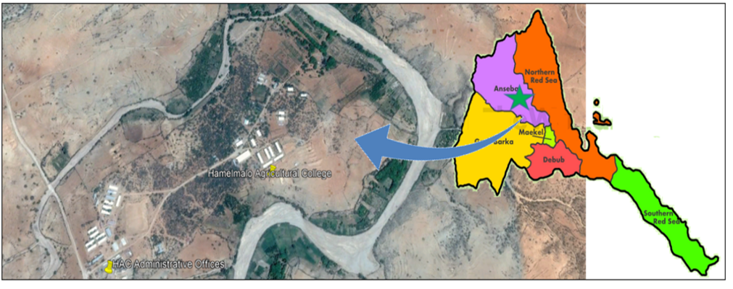
Fig. 1. Aerial view of HAC and the Zoba Anseba (starred) in Eritrea
Survey Duration: The survey was carried out from December 2021 to May 2022.
Environmental Conditions: During the survey, the recorded temperatures ranged from 15 to 29°C, the relative humidity percentage was between 62.6 and 74.2, and the soil of the surveyed site was sandy loam with a pH ranging from 6-7 (MoA, 2005). All these ecological factors might have exhibited some impact on the influence of diseases and the occurrence of nonpathogenic organisms on the trees.
Data Collection: Around 21 woody and shrubby trees have been found with some diseases during the six months. The infected samples and suspected diseased plant parts, such as leaves, leaflets, and bark, were collected in polythene covers and isolated in the Plant Pathology Laboratory for the identification of causative agents.
Isolation and Identification of fungi: In this study, fungi were isolated and identified using the moist blotter paper method (de Tempe, 1953) and Potato Dextrose Agar (PDA) media (ISTA, 1976). Diseased plant parts from forest trees were inoculated onto blotter paper and PDA, and incubated under 12-hour light and dark cycles for 7-10 days. Post-colony formation, fungal identification was performed based on colony characteristics and spore morphology, examined under a compound microscope at 10x and 40x magnification (Aneja, 2004; Barnet & Hunter, 1998; Ellis, 1971; Rifai, 1969). Pathogenic and non-pathogenic fungi were identified using standard keys (Gilman, 1957; Nagamani et al., 2006; CMI, 1971; Neergaard, 1977; Booth, 1977; Ainsworth et al., 1973; Quimio & Hanlin, 1999).

RESULTS AND DISCUSSION
During the survey, about 9 different types of diseases (leaf spots, Alternaria blights, black spots, powdery mildew, grey leaf spots, Ascochyta blights, anthracnose, pod necrosis, and dieback) have been documented on 21 different forest trees. The diseased symptoms were noticed on the various parts of the plants in general, and on leaves, twigs, and bark, in particular. These results in line with a report (Anonymous, 2010) revealed that, by fungal leaf spot, the infested trees turn brown, dry up, and then die of the tissues, later the plant becomes weak with low timber quality; Phomopsis artocarpi fungus causes leaf spot disease in damaging trees (Elevitch and Manner, 2006b).
Biology and Infections of Agroforestry Trees
The following tree species were described in Eritrea by Bein et al. (1996), and the associated diseases were subsequently recorded and identified on the Hamelmalo Agricultural College (HAC) campus (Figs. 2-22).
- Alia (Acacia tortilis): It can grow about 4-21m tall with a layered crown and fissured grey-brown-black bark. It features both small hooked and long straight thorns, 2-10 pairs of pinnate leaves, fragrant cream flowers, and yellow-brown pods with up to 10 seeds. Leaf spots were noticed on the leaflets.
- Bessenna (Albizia anthelmintica): It has smooth, pale grey bark that turns red-brown and rough with age. Compound leaves have 1-4 paired leaflets. White fluffy flowers bloom on leafless twigs, and the papery pods contain 3-5 flat, round seeds. Leaf blights were visible on the leaflets, which are caused by fungi.
- Duma (Adansonia digitata): This 25m tall deciduous tree thrives in tropical Africa. It has smooth grey bark, stiff root-like branches, and spongy water-storing wood. Mature leaves have up to 9 leaflets. Large white flowers attract fruit bats, and hairy yellow-brown capsules contain seeds in edible, tart pulp. Leaf blights appeared on leaves and bark.
- Gaba (Ziziphus spinachristi): This tree has a grey-brown trunk with zigzag yellow-white branchlets. Its narrowly ovate leaves have 3 clear veins and serrated margins. Yellow-green flowers and woolly fruit ripen from yellow to red, with edible flesh. Some of the leaves and fruits were infected with blight diseases.
- Ghonok (Dichrostachys cinerea): This small shrubby tree contains feathery, thick, grey compound leaves and short, slightly hooked thorns. Flowers have pink and yellow heads. Clustered fruits are twisted or flattened pods, each containing 4 seeds. A tiny black spots developed on the pods.
- Gulli (Ricinus communis): This drought- and termite-resistant shrub, common in Eritrea, has red, hollow stems with noticeable leaf nodes and scars. Young leaves are shiny and dark red-green, while mature leaves are large and palmate. Spiny, green-brown fruit capsules split to release shiny, spotted seeds with a small caruncle. Leaf blights manifested on both the leaves and stems.
- Humer (Tamanndus indica): The stem has rough, grey-brown, flaking bark. Compound leaves feature 10-18 oblong leaflets with raised veins. Flowers have red buds and gold petals. Fruits are pale brown, cracking to reveal sticky brown pulp and dark brown seeds. Manifestations of leaf blights were visible on leaflets.
- Kermed (Boscia angustifolia): This tree, with a massive trunk and ascending branches, grows across Eritrea, including Hamelmalo. It has silver-grey bark with horizontal scars, stiff grey-green leaves tipped with a spine, and fragrant small flowers in crowded heads. The rounded red-purple fruits contain edible pulp and up to 7 seeds. Blight infections usually form on leaflets.
- Keyih chea (Acacia seyal): The bark is powdery white to pale green or orange-red, peeling to reveal green under-bark. It has wide-angled white thorns, bright yellow fragrant flowers, and shiny, light brown curved pods. Diseases of leaf spots were recorded on leaflets.
- Kenteb (Acacia laeta or A. trentiniani): Kenteb is a shrub or small tree with a rounded crown. The grey-green bark appears black from a distance. Claw-shaped prickles grow below leaf nodes. Cream-white fragrant flowers bloom in spikes, and pale brown oblong pods split to release rounded seeds. Blight symptoms were observed on the leaflets.
- Meqie (Balanites aegyptiaca Del.) This 'desert date' grows 6-10m tall with thick, glossy leaves and spiny branches. Common across Eritrea, it has smooth green bark that darkens and cracks over time. It produces yellow-green fragrant flowers and oblong, yellow fruits with bitter-sweet flesh and a hard seed. Most of the leaves and twigs were infected with powdery mildew.
- Momona (Faidherbia albida): This large leafy tree has a wide, rounded crown. Barks are grey-brown and rough; zigzag twigs have long thorns. The fragrant, creamy flowers produce bright orange-red pods with 10-20 seeds. Unknown white spots emerged on the leaves.
- Moringa (Moringa olerifera): This deciduous tree with pale feathery foliage is an indigenous species of North Eastern tropical Africa (Philips, 1951) and was introduced to Eritrea, and these trees are found in Solomuna (green belt) and Hamelmalo. Barks are thick, grey, and corky, peeling in patches. Pale green, thrice-compound leaves have oval leaflets. Cream flowers with 5 petals attract insects. Long capsules split to release 9 dark brown 3-winged seeds. The leaves and twigs were affected by blights.
- Neem (Azadirachta indica L.): This fast-growing medium-sized tree, up to 20m tall, has a dense oval canopy and pale grey-brown grooved bark. Glossy green, saw-toothed leaves, and small fragrant, cream-white flowers produce oval yellow berries with oily pulp and a seed. Blight infections were common on leaves during the autumn season.
- Seraw (Acacia etbaica): The African species vary in pods, thorns, and hairs. Subspecies etbaica is a shrub or tree with a flattened crown, pale to dark bark, straight thorns, compound leaves, and shiny red-brown pods with 8 seeds. The pods were extensively covered with black spots.
- Shewit hagai (Parkinsonia aculeata): This spiny shrub or small tree usually 5-8 m, has a light, feathery foliage, and a low crown. This tree displays sharp thorns, fragrant yellow flowers, and narrow woody pods with pointed tips. The most common disease, anthracnose, affects the leaflets.
- Tsaeda kenteb (Acacia senegal): A shrub or tree that grows rounded, with many low branches. The bark is variable, smooth, or peeling yellow from a red-brown base. It has three prickles, one hooked; leaves are hairy with small grey-green leaflets. Creamy, fragrant flowers and thin, flat, oblong pods release seeds. Diseases of leaf blight and bark necrosis were reported on leaflets.
- Tsaeada-kelamitos (Eucalyptus globulus subsp. globulus): Eucalypts are widely planted in Eritrea. This tall tree has a rounded crown and straight main stems. Its blue-grey bark peels in strips. Young, camphor-scented leaves are long and thin. White flowers produce stalkless, woody half-sphere fruits with black seeds. Dieback, a common infectious disease transmitted by pests, was prevalent on these trees, with leaf blights also evident on the leaves.
- Tselim-kenteb (Acacia mellifera): These trees feature smooth, pale grey-brown bark and small, hooked thorns. They have 2-3 pairs of blue-green leaflets and creamy flowers that attract bees. Their short, flat, pale brown-yellow pods contain 2-4 seeds. Leaf blights appeared on the leaflets, and the pods were necrotic due to fungi.
- Ubel (Tamarix aphylla): a well-branched evergreen -conifer-like- shrub extending up to 9 m. Barks are light grey to red-brown, thick, and rough. Smooth purple-brown branches. Leaves are green-grey, sharp-tipped, and jointed. Capsules split into 3, releasing tiny brown seeds. Leaf spot, an infection affecting the leaflets, was reported.
- Zebe (Dalbergia melanoxylon): a spiny shrub or tree much much-branched from the base. The tree's bark ranges from smooth, pale grey to rough and flaky with age. It has compound leaves with rounded or notched leaflets, small, sweet-scented white flowers, and long, pointed, papery pods with 1-2 seeds. A fungal disease, anthracnose, was reported on the leaves.
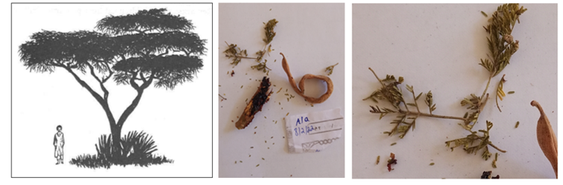
Fig. 2. Alia tree; leaflets and pod; black spots on leaflets.
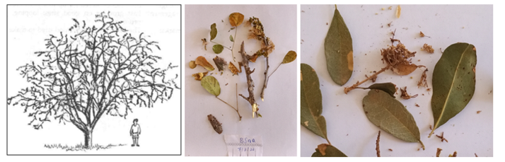
Fig. 3. Bessenna tree; leaves and twigs; and leaf blight.
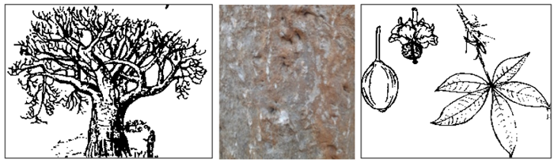
Fig. 4. Tree; Bark (with infection) of Duma; leaflets, flower, and fruit.
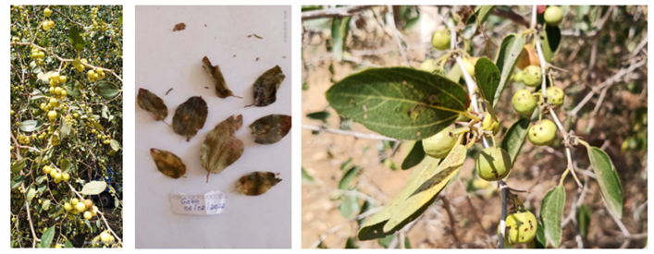
Fig. 5. Gaba Tree; Leaves; blights on leaves and fruit.

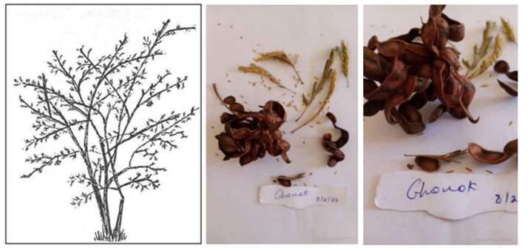
Fig. 6. Tree; Leaflets and Pods of Ghonok; black spots of the pods.
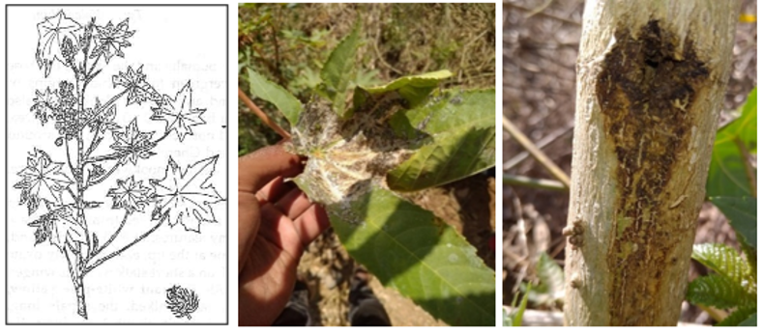
Fig. 7. Branch; palmate leaf; and hollow stem of Gulli.
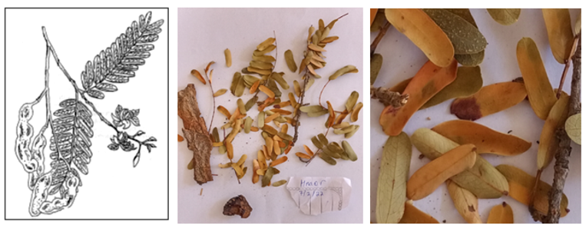
Fig. 8. Humor branch; bark and leaflets; leaf blights on leaflets.
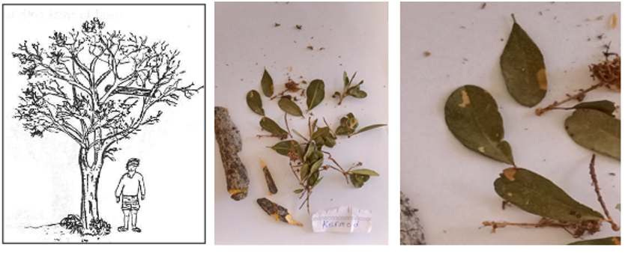
Fig. 9. Kermed Tree; bark, leaves; and leaf blight
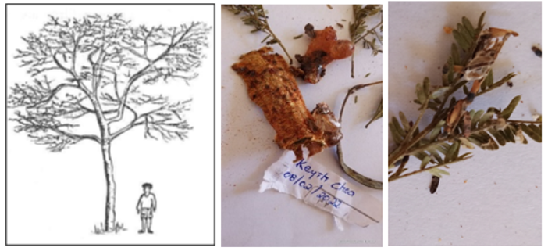
Fig. 10. Keyih chea Tree; leaflets and bark; and leaf spots on leaflets.
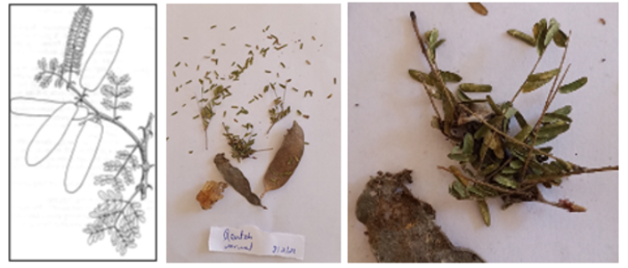
Fig. 11. Kenteb branch and compound leaf; leaflets and pods; infection on plant parts.
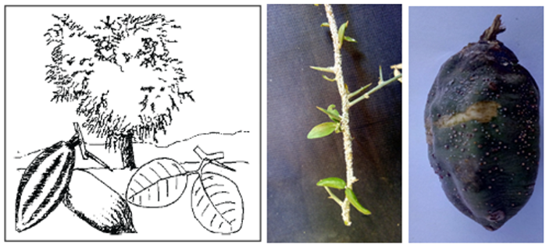
Fig. 12. Balanites tree; twig with leaves; and fruit
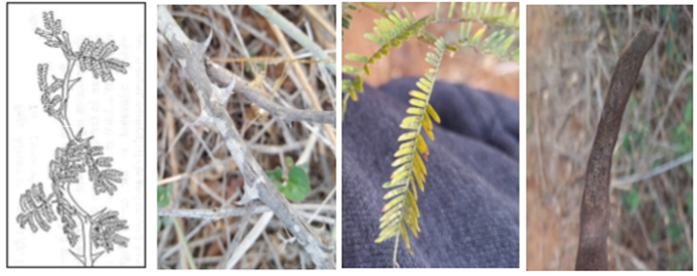
Fig. 13. Branch; thorns; leaflets and part of pod of Momona.
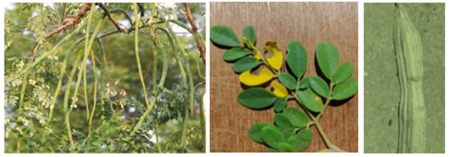
Fig. 14. Moringa Tree with fruits; thrice compound leaves; and long, triangular capsule.
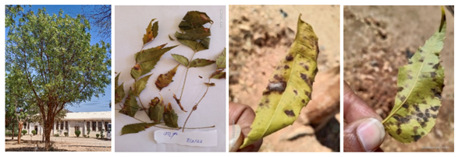
Fig. 15. Tree; leaves of Neem; Ascochyta blights on both sides of leaves.
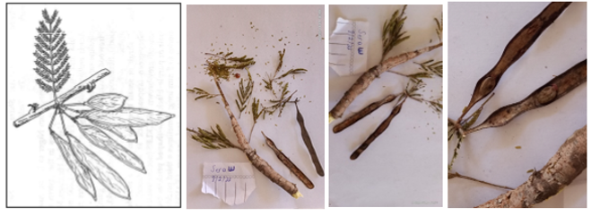
Fig. 16. Seraw Branch; leaflets and pods; infection on pods.
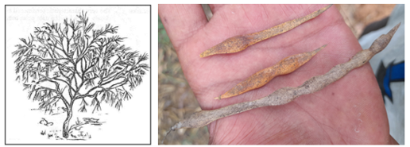
Fig. 17. Parkinsonia spiny shrub; flowers and fruit.
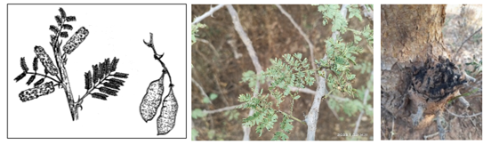
Fig. 18. Shrub; infections on the surface of the bark of Tsaeda kenteb
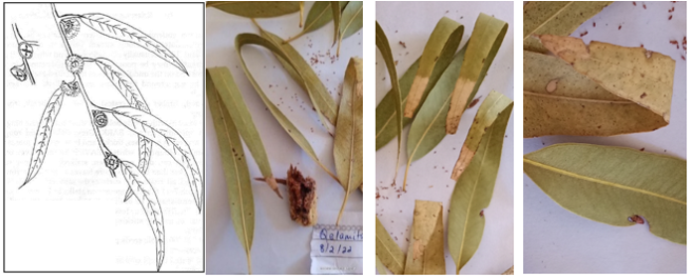
Fig. 19. Tsaeda-kelamitos leaves and bark; leaf blights
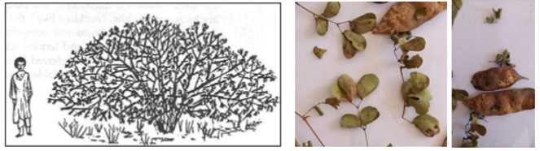
Fig. 20. Tselim-kenteb tree; leaflets and pods; leaf blights and pod necrosis.
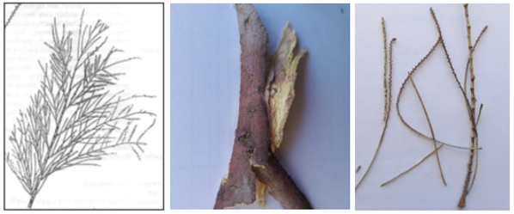
Fig. 21. Shrub; bark and branchlets of Ubel
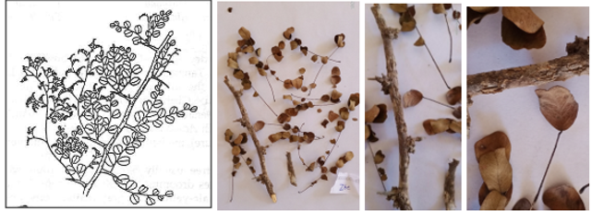
Fig. 22. Branch of the Dalbergia tree; leaves of anthracnose and blights.
Microbial (pathogenic and non-pathogenic) Cultures from the Infected Agroforestry Trees:
The infected plant parts were brought to the Plant Pathology Lab, HAC, and were inoculated on a PDA medium for culturing the pathogenic and non-pathogenic microbes (Fig. 23). Biotrophic microbes which were not cultivated in media, were observed directly under the microscope.
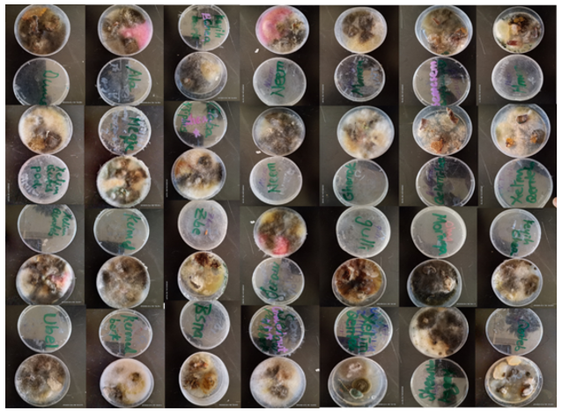
Figure 23. Cultures Grown On PDA Medium from the Infected and Plant Parts of Agroforestry Trees

4.3. Mycobiota (pathogenic and non-pathogenic fungi) isolated from the Agroforestry Trees
Diseases may be difficult to identify until the symptoms are visible or they have damaged the tree; however, if signs are observed, some diseases have very specific identifiable symptoms (Heather et al., 2007). The infected plant parts were isolated on PDA media.
Twenty fungal species of thirteen genera, both causative agents of diseases and the associated saprophytes, on the various parts of the trees/shrubs, were identified. They are: Ascochyta graminicola Saccado; Alternaria alternata (Fr.) Keissel; Aspergillus clavatus Desm.; Aspergillus fischeri Fennell & Raper; Aspergillus flavus Link; Aspergillus niger Tiegh.; Aspergillus terreus; Cladosporium oxysporium Bark & Cutt.; Cochliobolus australiensis (Tsuda & Ueyama) Alcorn; Curvularia clavata Boedijn.; Drechslera halodes (Drechsler) Subram & Jain; Fusarium equiseli (Corda) Saccardos; Fusarium javanicum Koorders; Fusarium scirpi (El & Er) Wollenweber; Hendersonia sp. Sacc.; Mucor recemosus Fresenius; Pithomyces sps. Berkeley & Broome; Rhizopus nigricans Ehrenberg; Septogloeum Sacc.; and Sterile mycelium. The powdery mildew causal organism Phyllactinia darbergiae, is a biotroph identified under the microscope (Table 1).
Table 1. Pathogens and Saprophytes Isolated from Agroforestry Trees at HAC
Sl. No. | Identified pathogen/saprophyte | Local name (Tigrigna) and  The scientific name of the tree/shrubs | Infected Part of the tree
 | Ascochyta graminicola Saccado | Gulli (Ricinus communis) | Leaf blights of leaves/stem
 | Ascochyta graminicola Saccado | Momona (Faidherbia albida) | White spots on leaves/ branches
 | Ascochyta graminicola Saccado | Moringa (Moringa oleifera) | Blightened leaves; branches
 | Ascochyta graminicola Saccado | Neem (Azadirachta indica) | Ascochyta blights on leaves/twigs
 | Ascochyta graminicola Saccado | Tsaeda-kelamitos (Eucalyptus globulus | Dieback and leaf blights Leaves
2. | Alternaria alternata (Fr.) Keissel. | Alia (Acacia tortilis) | Black leaf spots on leaflets
2. | Alternaria alternata (Fr.) Keissel. | Ghonok (Dichrostachys cinerea) | Infected tree trunk
2. | Alternaria alternata (Fr.) Keissel. | Gulli (Ricinus communis) | Leaf blights of leaves/stem
2. | Alternaria alternata (Fr.) Keissel. | Kermed (Boscia angustifolia) | Leaf blights
2. | Alternaria alternata (Fr.) Keissel. | Momona (Faidherbia albida) | White spots on leaves/ branches
2. | Alternaria alternata (Fr.) Keissel. | Moringa (Moringa oleifera) | Blights on leaves; branches
2. | Alternaria alternata (Fr.) Keissel. | Shewit hagay (Parkinsonia aculeate) | Anthracnose on leaflets
2. | Alternaria alternata (Fr.) Keissel. | Tsaeda-kelamitos (Eucalyptus globulus) | Dieback and leaf blights
2. | Alternaria alternata (Fr.) Keissel. | Ubel (Tamarix aphylla) | Leaf spots
 | Aspergillus clavatus Desm. | Gaba (Ziziphus spinachristi) | Blights of leaves/fruit and tree trunk
 | Aspergillus fischeri Fennell & Raper | Zebe (Dalbergia melanoxylon) | Anthracnose on leaves and Fruits
 | Aspergillus flavus Link. | Hmor (Tamarindus indica) | Leaf blights on leaflets
 | Aspergillus flavus Link. | Moringa (Moringa oleifera) | Blights on leaves; branches
 | Aspergillus flavus Link. | Tselim kenteb (Acacia senegal) | Leaf blights on leaves and pods and bark necrosis
 | Aspergillus flavus Link. | Zebe (Tamarindus indica) | Anthracnose on leaves
 | Aspergillus niger Tiegh. | Alia (Acacia tortilis) | Leaves
 | Aspergillus niger Tiegh. | Bessenna (Albizia anthelmintica) | Bark, Leaf blights
 | Aspergillus niger Tiegh. | Duma (Adansonia digitata) | Leaf blights of leaves/bark/Tree trunk
 | Aspergillus niger Tiegh. | Ghonok (Dichrostachys cinerea) | Black spots on the pods Tree trunk
 | Aspergillus niger Tiegh. | Gulli (Ricinus communis) | Leaf blights of leaves/stem
 | Aspergillus niger Tiegh. | Hmor (Tamarindus indica) | Leaf blights on leaflets
 | Aspergillus niger Tiegh. | Kenteb (Acacia laeta or A. trentiniani) | Blights on leaflets and Bark
 | Aspergillus niger Tiegh. | Momona (Faidherbia albida) | White spots Leaves/ branches
 | Aspergillus niger Tiegh. | Moringa (Moringa oleifera) | Blights Leaves; branches
 | Aspergillus niger Tiegh. | Tsaeda-kelamitos (Eucalyptus globulus) | Dieback and leaf blights
 | Aspergillus niger Tiegh. | Tselim kenteb (Acacia senegal) | Leaf blights and bark necrosis
 | Aspergillus niger Tiegh. | Ubel (Tamarix aphylla) | Leaf spots
 | Aspergillus niger Tiegh. | Zebe (Dalbergia melanoxylon) | Anthracnose on leaves
7. | Aspergillus terreus Thom | Hmor (Tamarindus indica) | Leaf blights on leaflets
8. | Cladosporium oxysporium Bark & Cutt | Alia (Acacia tortilis) | Leaves
8. | Cladosporium oxysporium Bark & Cutt | Gulli (Ricinus communis) | Leaf blights of leaves/stem
8. | Cladosporium oxysporium Bark & Cutt | Hmor (Tamarindus indica) | Leaf blights on leaflets and Bark
8. | Cladosporium oxysporium Bark & Cutt | Moringa (Moringa oleifera) | Blights Leaves; branches
8. | Cladosporium oxysporium Bark & Cutt | Seraw (Acacia etbaica) | Black spots on pods and leaves
8. | Cladosporium oxysporium Bark & Cutt | Shewit hagay (Parkinsonia aculeate) | Anthracnose on leaflets
8. | Cladosporium oxysporium Bark & Cutt | Tsaeda-kelamitos (Eucalyptus globulus) | Dieback and leaf blights
8. | Cladosporium oxysporium Bark & Cutt | Tselim-kentub (Acacia mellifera) | Leaf blights and pod necrosis
8. | Cladosporium oxysporium Bark & Cutt | Ubel (Tamarix aphylla) | Leaf spots
9. | Cochliobolus australiensis (Tsuda & Ueyama) Alcorn | Tselim-kentub (Acacia mellifera) | Leaf blights and pod necrosis
9. | Cochliobolus australiensis (Tsuda & Ueyama) Alcorn | Seraw (Acacia etbaica) | Black spots on pods
9. | Cochliobolus australiensis (Tsuda & Ueyama) Alcorn | Momona (Faidherbia albida) | White spots on leaves/ branches
10. | Curvularia clavata Boedijn. | Gulli (Ricinus communis) | Leaf blights of leaves/stem
10. | Curvularia clavata Boedijn. | Kermed (Boscia angustifolia) | Leaf blights Bark
10. | Curvularia clavata Boedijn. | Seraw (Acacia etbaica) | Black spots on pods and Bark
10. | Curvularia clavata Boedijn. | Shewit hagay (Parkinsonia aculeate) | Anthracnose on leaflets
10. | Curvularia clavata Boedijn. | Tselim-kentub (Acacia mellifera) | Leaf blights and pod necrosis
10. | Curvularia clavata Boedijn. | Zebe (Dalbergia melanoxylon) | Anthracnose on leaves and on Fruits
10. | Curvularia clavata Boedijn. | Seraw (Acacia etbaica) | Black spots on pods
10. | Curvularia clavata Boedijn. | Tselim kenteb (Acacia senegal) | Leaf blights and bark necrosis
11. | Drechslera halodes (Drechsler) Subram & Jain | Tselim-kentub (Acacia senegal) | Leaf blights and bark necrosis
11. | Drechslera halodes (Drechsler) Subram & Jain | Seraw (Acacia etbaica) | Black spots on pods and leaves
12. | Fusarium equiseli (Corda) Saccardos | Zebe (Dalbergia melanoxylon) | Anthracnose on leaves
13. | Fusarium javanicum Koorders | Keyih chea (Acacia seyal) | Leaf spots on leaflets /Tree Bark
13. | Fusarium javanicum Koorders | Shewit hagay (Parkinsonia aculeate) | Anthracnose on leaflets
14. | Fusarium scirpi (El & Er) Wollenweber | Ghonok (Dichrostachys cinerea) | Black spots on the pods / Tree trunk
14. | Fusarium scirpi (El & Er) Wollenweber | Momona (Faidherbia albida) | White spots Leaves/ branches
15. | Hendersonia sp. Sacc. | Keyih chea (Acacia seyal) | Leaf spots on leaflets
15. | Hendersonia sp. Sacc. | Momona (Faidherbia albida) | White spots Leaves/ branches
16. | Mucor recemosus Fresenius | Bessenna (Albizia anthelmintica) | Leaves
16. | Mucor recemosus Fresenius | Momona (Faidherbia albida) | White spots Leaves/ branches
17. | Pithomyces sps. Berkeley & Broome | Kermed (Boscia angustifolia) | Leaf blights Leaves
18. | Phyllactinia darbergiae (Powdery mildew) | Meqie (Balanites aegyptiaca) | Powdery mildew on leaves/twigs
19. | Rhizopus nigricans Ehrenberg | Duma (Adansonia digitata) | Leaves
19. | Rhizopus nigricans Ehrenberg | Bessenna (Albizia anthelmintica) | Bark
20. | Septogloeum Sacc. | Gaba (Ziziphus spina-christi) | Blights of leaves/fruit
20. | Septogloeum Sacc. | Ghonok (Dichrostachys cinerea) | Black spots on the pods/ Tree trunk
20. | Septogloeum Sacc. | Gulli (Ricinus communis) | Leaf blights of leaves/stem
20. | Septogloeum Sacc. | Momona (Faidherbia albida) | White spots Leaves/ branches
20. | Septogloeum Sacc. | Shewit hagay (Parkinsonia aculeate) | Anthracnose on leaflets
20. | Septogloeum Sacc. | Tselim kenteb (Acacia senegal) | Leaf blights and bark necrosis
21. | Sterile mycelium | Moringa (Moringa oleifera) | Blights Leaves; branches
21. | Sterile mycelium | Seraw (Acacia etbaica) | Black spots on pods Bark and Pod
21. | Sterile mycelium | Tselim-kentub (Acacia mellifera) | Leaf blights and pod necrosis
The following fungi were isolated from infected plant parts through cultural methods and identified using standard identification keys.
- Ascochyta spp. Saccado.
Species of Ascochyta mostly cause leaf spots on different trees. They were reported as parasitic and saprophytic on leaves of Ricinus communis and Eucalyptus globulus, and both leaves and branches of Faidherbia albida, Moringa oleifera, and Azadirachta indica. Ascochyta colonies on media appear dark brown with septate, branched mycelium. The fungus forms pycnidia, lacks conidiophores, and produces two-celled, smooth, ovoid to oblong conidia, globose and embedded in leaf tissue.
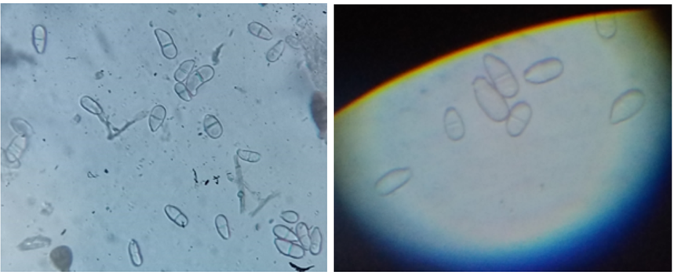
Figure 24. conidia of Ascochyta graminicola Saccado.
- Alternaria alternata (Fr.) Keissel.
Species of Alternaria chiefly causing blights appeared on the parts of leaves of Acacia tortilis, Ricinus communis, Boscia angustifolia, Faidherbia albida, Moringa oleifera, Parkinsonia aculeate, Eucalyptus globulus and Tamarix aphylla; on the branches of Faidherbia albida and Moringa oleifera; Dichrostachys cinerea was identified on the tree trunk. Alternaria alternata colonies are dark brown in colour, grown in concentric circles on PDA media. Conidiophores are dark, elongate, bearing simple or branched chains of conidia. Elliptical or ovoid-shaped conidia are dark, typically with both cross and longitudinal septa.
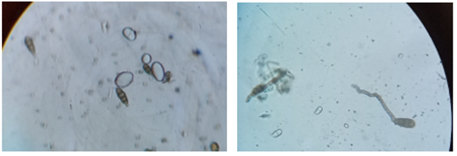
Figure 25. Conidia of Alternaria alternata (Fr.) Keissel.
- Aspergillus clavatus Desm.
This fungus was identified on the leaves of Ziziphus spinachristi, causing blights on leaves, fruit, and tender branches. Colonies were blue-green to olive, with plenty of conidial heads. Conidiophores enlarge at the apex and the phialides in a single series. Conidial heads are clavate, light green, smooth, and elliptical.
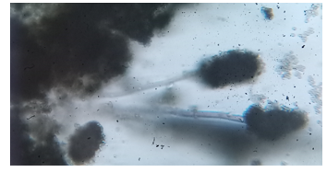
Figure 26. Conidial heads of Aspergillus clavatus Desm.

Aspergillus fischeri Fennell & Raper.
This saprophytic fungus was isolated from the fruits of Dalbergia melanoxylon. Colonies dissected appearance. Conidial heads are globose. Conidiophores are flask-shaped, grey-green in colour. Uniseriate philiades. Globose conidia.
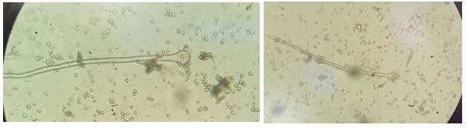
Figure 27. Conidial heads of Aspergillus fischeri Fennell & Raper

Aspergillus flavus Link.
This saprophytic fungus was isolated from the branches and leaves of Moringa oleifera, leaves and pods of Acacia senegal, and only from the leaves of Tamarindus indica and Tamarindus indica. According to Dayan (2003), this saprobe was also the habitat of Azadiracta, Acacia pera, Bauhinia acuminate, and Albizia lebbek trees. Dark yellow-greenish colonies grew on PDA medium. Conidial heads are big in size, radiate, and phialides are bi-seriate. Conidia are globose, echinulate, and yellowish green.
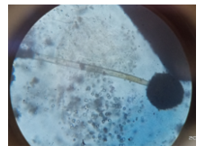
Figure 28. Conidiophore and conidia of Aspergillus flavus Link.
- Aspergillus niger Tiegh.
It is reported on tree trunks of Adansonia digitate and Dichrostachys cinerea; on the leaves and pods of Acacia Senegal; on leaves and branches of Faidherbia albida and Moringa oleifera; and only on the leaves of Dalbergia melanoxylon, Tamarix aphylla, Eucalyptus globulus, Tamarindus indica, Ricinus communis, and Acacia tortilis. This fungus causes black mold of forest tree species of Eucalyptus grandis, Acacia siamea, and Acacia julibrissin (Dayan, 1986 and 2003). Carbon black-coloured colonies. Sometimes appears in brownish black. Conidial heads were large and black, conidiophores arising directly from the substratum. Conidia are black and globose.
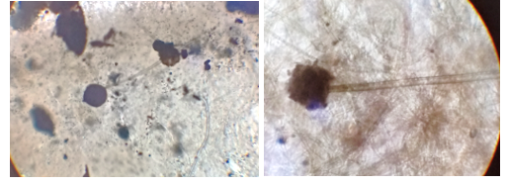

Figure 29. Conidiophores of Aspergillus niger Tiegh.
- Aspergillus terreus
It is isolated from the leaves of the Tamarindus indica tree. Colonies are plain or radial furrows, cinnamon to wood brown, and reverse side dull brown. Conidiophores were hemispherical, phialides biseriate, and closely packed. Conidia are globose.
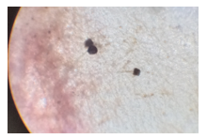
Figure 30. Conidiophores and conidia of Aspergillus terreus

Cladosporium oxysporium Bark & Cutt.
These fungi were identified from the leaf spots of leaves of Acacia tortilis, Acacia etbaica, Ricinus communis, Parkinsonia aculeata, Eucalyptus globulus, Acacia mellifera, and Tamarix aphylla, and bark of Tamarindus indica, and leaves and branches of Moringa oleifera. Velvety, olive-green colonies contain smooth conidiophores. They are sympodial, branching, and producing conidia in chains. Conidia aseptate, ellipsoidal, smooth, olivaceous brown.
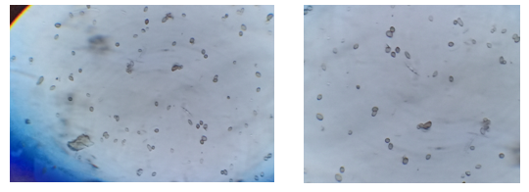
Figure 31. Conidia of Cladosporium oxysporium Bark & Cutt

Cochliobolus australiensis (Tsuda & Ueyama) Alcorn.
It is isolated from the surface of the leaves of Acacia mellifera and Acacia etbaica and the leaves and branches of Faidherbia albida. The genus Cochliobolus contains some of the best-studied and most highly damaging plant pathogens. Kumar et al. (2002) reviewed Cochliobolus sativus (B. sorokiniana) as the cause of a variety of root and leaf necrosis of cereals in warm, humid climates of South East Asia, Australia, North and South America. Grey to dark blackish-brown colonies. Solitary conidiophores of Cochliobolus contain ellipsoidal conidia and are 3-septate.
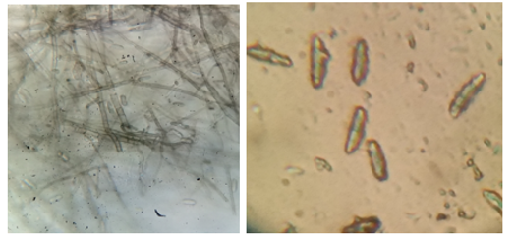
Figure 32. Straight conidia of Cochliobolus australiensis (Tsuda & Ueyama) Alcorn

Curvularia clavata Boedijn.
This parasitic fungus appeared on the surface of leaves of Ricinus communis and Parkinsonia aculeata, the bark and pod of Acacia etbaica; and Acacia mellifera, the bark of Boscia angustifolia, and the fruit of Dalbergia melanoxylon. Several fungi, including Curvularia eragrostidis, have been noticed in affected trees as secondary pathogens (Bosu, 2016). Colonies were dark grey, cottony, or velvety. Conidiophores are brown and smooth, macronematous. Conidia are simple, straight, often curved, symmetrical, clavate, with 3-transfer septa with paler end cells.
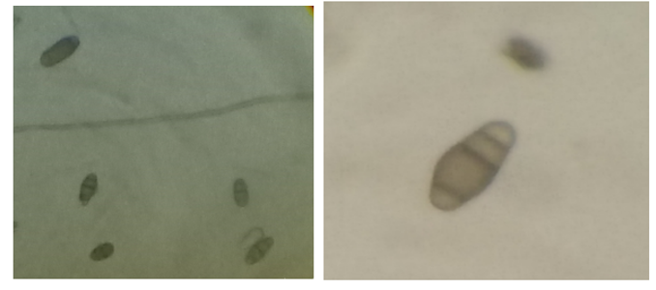
Figure 33. Curvularia clavata Boedijn.

Drechslera halodes (Drechsler) Subram & Jain.
This saprophyte appeared on the leaves and pods of Acacia senegal. Colonies were grey-brown and hairy. Conidiophores are smooth and unbranched. Conidia are dark, cylindrical, 1-15 septate, fusiform, and rounded at ends.
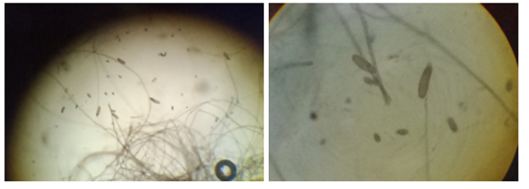
Figure 34. Drechslera halodes (Drechsler) Subram & Jain

Fusarium equiseli (Corda) Saccardos
Fusarium equiseli isolated on the leaves of Dalbergia melanoxylon. This is in line with James et. al., (1989) that F. oxysporum only had an average rating of around 5 on a pathogenicity scale of 1-10. A similar pathogenic fungus was also recorded on mahogany trees by Dayan, (2003). Mycelium is fluffy, dense, and peach to brown colour. Macroconidia are falcate, thick in the middle, parabolic curvature, tapering to a fine point, 3-4 septate. Chlamydospores are clusters or in chains.
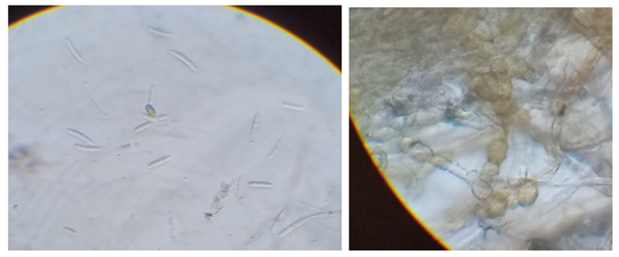
Figure 35. Fusarium

Fusarium javanicum Koorders.
This fungus was identified on the leaves and tree bark of Acacia seyal and the leaves of Parkinsonia aculeate. The fungus features cottony mycelium with pink, purple, or yellow tints, and dense, floccose aerial mycelium in peach with a carmine red reverse. Conidiophores form sporodochia, with macroconidia 0-7 septate and slightly curved, and microconidia single-celled. Chlamydospores are spherical, intercalary, and smooth-walled.
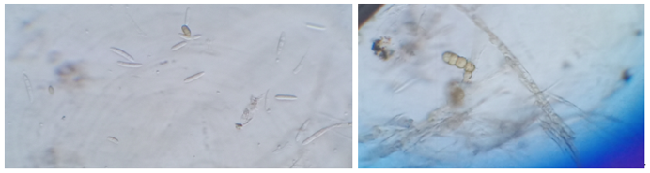
Figure 36. Fusarium javanicum Koorders macro-conidia and chlamydospores

Fusarium scirpi (El & Er) Wollenweber
This microbial fungus was identified on the tree trunk of Dichrostachys cinerea and the leaves and branches of Faidherbia albida. According to Suharti and Hadi, (1974). Fusarium solani (Anamorphic Gibberella), which causes wilt and dieback of more than 15-year-old trees, as reported from Indonesia, seems to be economically important. Colonies carmine red. Microconidia sickle-shaped, tapering at both ends. Basal cell is 5-septate, pedicellate. Chlamydospores are brownish, intercalary, and in chains.

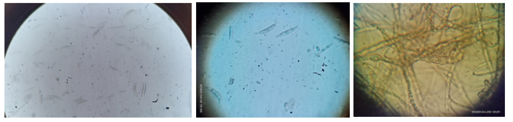
Figure 37. Fusarium scirpi (El & Er) Wollenweber; Intercalary Chlamydospores.

Hendersonia sps. Sacc.
Hendersonia was isolated on the surface of the leaves and branches of Faidherbia albida and the leaves of Acacia seyal. Colonies fawn to greyish, aerial, and branched mycelium are abundant. Dark pycnidic are profuse, globose, ostiolate, and immersed. Conidia are dark, several-celled, and elongate.
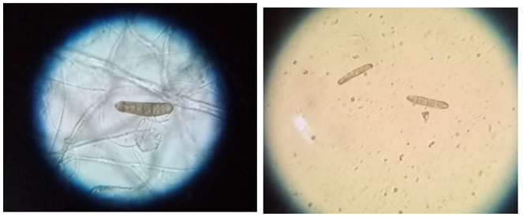

Figure 38. Hendersonia sp. Sacc.
- Mucor recemosus Fresenius
Isolated from the leaves of Albizia anthelmintica and also on the branches of Faidherbia albida. Colonies are tough and grey-brown with erect, irregularly branched sporangiophores. Sporangia and columella are pale brownish. Zygophores are reddish brown, with thin-walled columella rupturing at maturity.
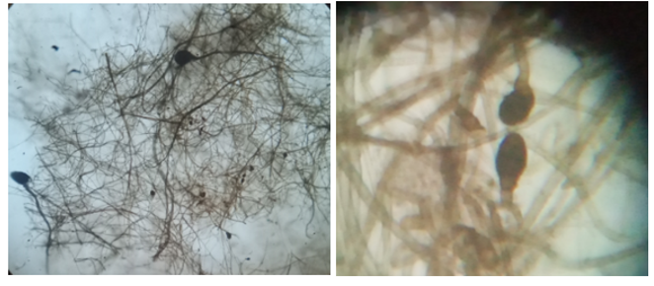
Figure 39. Mucor recemosus Fresenius
- Pithomyces sps. Berkeley & Broome
This fungus was isolated from the leaves of Boscia angustifolia. Colonies are olive green, brown to black, with superficial mycelium. Conidiophores branched, conidia solitary, ellipsoid, 2-3 transverse septa, mature conidia with longitudinal septa, constricted at the septum.
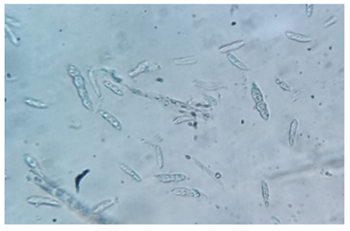
Figure 40. Pithomyces sps. Berkeley & Broome

Rhizopus nigricans Ehrenberg.
This mold was identified on the leaf surface of Adansonia digitata and the bark of Albizia anthelmintica. Colonies start white, turning brownish-black. Well-branched stolons with brown rhizoids at nodes. Sporangiophores cluster, with globose sporangia, olivaceous and hemispherical columella. Sporangiospores are round to oval; zygospores are brown-black, round to oval.
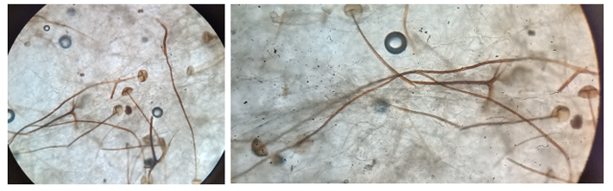
Figure 41. Rhizopus nigricans Ehrenberg

Septogloeum sp. Sacc.
These nonpathogenic fungi were identified on different parts of Ziziphus spina-christi, Dichrostachys cinerea, Ricinus communis, Faidherbia albida, Parkinsonia aculeate, and Acacia Senegal. The fruiting bodies acervuli are sub-epidermal, pale, conidiophores short, simple, conidia several celled, oblong to fucoid. They are parasites on leaves.
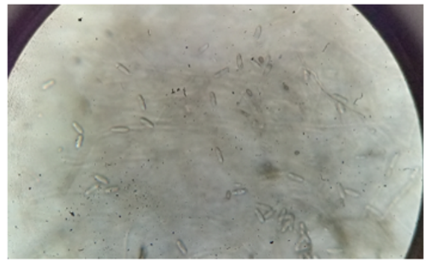
Figure 42. Septogloeum sp. Sacc.

Phyllactinia dalbergiae
The fungus, Phyllactinia darbergiae appeared on the twigs and leaves of Balanites aegyptiaca (Fig. 43). These ascomycetes cause powdery mildew of shade and forest trees, which are cosmopolitan biotrophic parasites on angiosperms. This obligate parasite cannot be cultured on artificial nutrient media. The symptoms are visible under a microscope as cottony and powdery white stratum on the surface of leaves. The mycelium is superficial; conidiophores are produced on superficial hyphae, and the base is usually straight or twisted. Conidia are pointed. It is in line with John and Roland (2007) that the superficial mycelium produces short lateral appressoria, which emit penetration hyphae through the stomata into the mesophyll (John and Roland, 2007). The findings are consistent with those reported by Awet et al. (2016), which revealed that the severity of powdery mildew, caused by Sphaerotheca species, was significantly heightened during the autumn season. This increase in severity can be attributed to the elevated RH and intensified temperature during this period. In a study by Syed et al. (2016), it was noticed that powdery mildew pathogens had a substantial impact on various vegetable crops, with infection rates reaching 50-60% in areas proximal to specific tree species. The proximity of these trees likely facilitated the dispersal of the pathogens via wind-borne transmission, significantly contributing to the spread of the disease across the entire host plant.
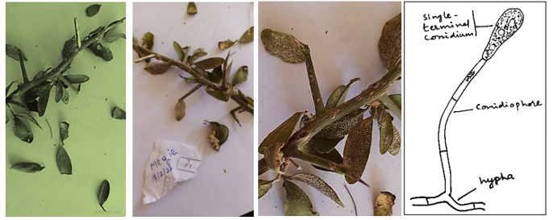
Figure 43. Twig; leaves of Balanites aegyptiaca; Powdery mildew on twigs and leaves; Conidiophore (hand drawn) and terminal conidium (Adapted from Webester, 1980).
CONCLUSION and RECOMMENDATIONS
This study investigated pathogenic and saprophytic fungi on 21 woody and shrubby trees at Hamelmalo Agricultural College. Among the 9 identified diseases, blights, leaf spots, powdery mildew, and anthracnose were prevalent. The most affected species included Ricinus communis, Faidherbia albida, Dalbergia melanoxylon, and Acacia senegal. Common fungi found were Aspergillus niger, Alternaria alternata, Ascochyta graminicola, Cladosporium oxysporum, Curvularia clavata, Fusarium spp., and Septogloeum. Disease impact was greater on older trees. Agroforestry trees, vital for food, medicine, and agriculture, are being compromised by these diseases, which could potentially spread to cultivated crops if not controlled.

REFERENCES
Ainsworth GC, FK Sparrow, and AS Sussman (Eds). (1973). Fungi: An Advanced Treatise IVA. Academic Res. Inc. London, Ltd.
Aneja K.R. (2004). Experiment in microbiology, plant pathology, and biotechnology. 4th Ed, New International (P) Limited Publisher, India, 121-128.
Anonymous. Annual report (2010). Horticulture Research Center, Bangladesh Agricultural Research Institute, Gazipur, Bangladesh 2010.
Awet Mulbrhan, Brikity, Aster, Yohana, Sethumadhava Rao and Syed Danish. (2016). Survey of Disease Incidence and Severity of Powdery Mildews on Roses (Rosa Sinensis L.) in Greenhouses in Maisirwa, Eritrea. Asian Journal of Science and Technology (07) 05, pp.2850-2856. Available Online at http://www.journalajst.com. ISSN: 0976-3376.
Barnett HL and BB Hunter. (1998). “Illustrated Genera of Imperfect Fungi.” 4th Ed. APS Press, St. Paul, MN.
Bein, E., (1998). The effect of deforestation on climate change in Eritrea. A paper presented in the initiation workshop on climate change issues organized by the Department of Environment, September 3-4, 1998, Asmara. 8 pp.
Bein, E., B. Habte, A. Jaber, Ann Birnie, and Bo Tengnas. (1996). Useful Trees and Shrubs in Eritrea- Identification, Propagation and Management for Agricultural and Pastoral Communities. Technical Handbook No 12. Regional Soil Conservation Unit, RSCU/Sida. Nairobi. ISBN 9966-896-24-4.
Booth C (1977). The Genus Fusarium, Commonwealth Mycological Institute. England.
Bosu, P., (2016). Status and Trends of Forest and Tree Pests and Diseases in West and Central Africa. Technical Report, African Forest Forum.
Commonwealth Mycological Institute. (1971). Description of Pathogenic Fungi and Bacteria. CMI Kew, Surrey, England, pp 91-95.
Dayan, M.dP. (1986). Fungi associated with different forest tree seeds of the Forest Research Institute seed bank. the Embryon, vol. 2, no. 1. ASEAN Forest Tree Seed Centre, Muak-Lek. Saraburi, Thailand.
Dayan, M.dP. (2003). biochemical and physiological changes in microbial-infected forest tree seed species. NRCP-ERDB Unpublished terminal report. ERDB. College. Laguna.
de Tempe (1953). The blotter method of seed health testing; Proc. Int. Seed test. Ass. 28: 133-151.
Elevitch CR, Manner HI. (2006b). Species profiles for Pacific Island agroforestry: Artocarpus heterophyllus (jackfruit) (Accessed December 2014).
Ellis MB (1971). Demotiaceous Hyphomycetes. C.M.I., Kew, Surrey, England, 608.
FAO (1997). Agro-ecological zones map of Eritrea. Legend. Department of Environment, Ministry of Land, Water and Environment. Project FAO/TCP/ERI/4554 (A) field document 2, 67 pp.
Gilman J C., (1957). A Manual of Soil Fungi, 2nd Indian Edition, Biotech Books, Delhi, 2001.
Haile, A., Gebretatios, I., Ogbazghi, W., Omer, M.K., Araia, W., Gebremariam, T. and Ogbay, T., (1996). Rehabilitation of degraded lands in Eritrea. 1st edition. University of Asmara. Asmara. 60 p.
Heather Morrison, Claralynn Nunamaker, John Leblanc, Gregory Giusti, and Gary Nakamura (2007). Forest pests and diseases. University of California. ISBN: 13:978-1-60107-466-9. http://anrcatalog.ucdavis.edu.
Ignazio Graziosi, Mathias Tembo, Jean Kuate, Alice Muchugi. (2020). Tree resistance to pests and pathogens, Vol. 2, Issue 1. https://doi.org/10.1002/ppp3.31.
ISTA (International Seed Testing Association), (1976); Soil Sci. Tech. 4: 3-49.
James RL, Dumroese RK, Gilligan CJ, Wenny DL. (1989). Pathogenicity of Fusarium isolates from Douglas-fir seed and container-grown seedlings. Moscow (ID): University of Idaho, College of Forestry, Wildlife and Range Sciences. Bulletin 52. 10p.
John Webster and Roland Weber. (2007). Cambridge University Press, 3rd Edn. The Edinburgh Building, Cambridge CB2 8RU, UK. Published in the United States of America by Cambridge University Press, New York. ISBN-13 978-0-511-27783-2.
Kumar, J., Scha¨fer, P., Hu¨ckelhoven, R., et al. (2002). Bipolaris sorokiniana, a cereal pathogen of global concern: cytological and molecular approaches towards better control. Molecular Plant Pathology, 3, 185-195.
MoA. (1995). Statistical report, Asmara, Eritrea.
MoA. (2008). Ministry of Agriculture, Zoba Anseba.
MoA. (2005). Statistical report, Asmara, Eritrea.
Nagamani A, Kumar I K and Manoharachary C (2006). Handbook of Soil Fungi, IK International Publishing House Pvt Ltd, New Delhi, India.
Neergaard, P. (1977). Seed Pathology Halsted Press Book. New York, John Wiley and Sons.
Ogbazghi Woldeselassie and Bein Estifanos. (2006). Assessment of Non-Wood Forest Producing Products and their Role in the Livelihoods of Rural Communities in the Gash-Barka Region, Eritrea. Ziziphus spina Christi (Gaba). Drylands Coordination Group Report No. 40 (01, 2006). Drylands Coordination Group c/o Miljøhuset G9, Grensen 9b, N-0159, Oslo, Norway. ISSN: 1503-0601.
Quimio H T and R T Hanlin (1999). Illustrated Genera and Species of Plant Pathogenic Fungi in the Tropics. College of Agriculture. UP Los Banos. College Laguna.
Philips, E.P. (1951). The Genera of South African Flowering Plants. 2nd ed. Gov. Printer, Pretoria, p. 358.
Rifai, M.A. (1969). A revision of the genus Trichoderma, Mycological papers.
Suharti M, and S. Hadi. (1974). Wilt disease of Dalbergia latifolia in Malang forest district, E. Java. Laporan, Lembaga Penelitian Hutan, CAB Digital library, No. 194, [ii] + 9 pp. ref. 3. https://www.cabidigitallibrary.org/doi/full/10.5555/19760632934.
Syed Danish Yaseen Naqvi, Adugna Haile, Sethumadhava Rao, Belay Teweldemedhin, and Virendra Kumar Sharma. (2016). Occurrence and prevalence of diseases and insect pests on vegetable crops in Zoba Anseba, Eritrea. Journal of Eco-friendly Agriculture 12 (1): 29-40.
World Bank (1994). Eritrea's options and strategies for growth Vol. I-II. Report No 12930-ER. Washington D.C. pp. 59-87.

