Improving Infrastructure Resilience in Developing Regions: Addressing Climate Risks and Natural Hazards in Africa.

Abstract
Climate change and natural disasters are making Africa's infrastructure systems more vulnerable, making it harder to develop electricity, water, transportation, health, and sanitation. The continent's infrastructure is still very vulnerable to floods, droughts, heat extremes, and geophysical disasters because cities are growing quickly, people can't adapt quickly, and there hasn't been enough investment. This assessment brings together information from climate science, engineering, socioeconomics, and government to give a full picture of the climate threats, infrastructure weaknesses, and resilience options in Africa. It looks at both the systemic deficiencies that make people more vulnerable and the new strategies to develop resilience, using peer-reviewed studies, policy reports, and case examples. Governance changes, technology advances, community-based adaptation, and funding mechanisms are all given special emphasis, as are lessons learnt from African case studies and experiences from throughout the world. The uniqueness of this assessment resides in its interdisciplinary approach, integrating climate research with infrastructure design and policy analysis to provide a context-specific framework for Africa. This article asks for urgent, coordinated effort to make resilience a key part of sustainable infrastructure development in Africa. It does this by pointing out research gaps and future directions, such as digital resilience tools, multi-hazard approaches, and cross-border frameworks.
Keywords: Climate change, Natural disasters, Infrastructure vulnerability, Resilience strategies, Africa.

- Introduction
Infrastructure systems are the foundation of economic progress, social well-being, and long-term development [1], but these systems are becoming more vulnerable in emerging areas because of the worsening effects of climate change [2]. Rising temperatures, unpredictable rainfall, long-lasting droughts, heavy floods, and cyclones are not only making it harder for people to make a living, but they are also making important infrastructure less stable and useful [3, 4]. Climate change, therefore, exacerbates risks by intensifying existing vulnerabilities and increasing the costs of infrastructure failure in areas already facing resource limitations [5]. These problems are especially bad for Africa [6]. Some of the fastest rates of urbanisation in the world are happening on the continent, frequently in places where planning is poor, infrastructure is lacking, and informal settlements are developing [7, 8]. These factors, along with a lack of institutional capacity, chronic underinvestment, and a large reliance on climate-sensitive sectors like agriculture and water resources, make African infrastructure systems very vulnerable to climate-related shocks and natural disasters [9, 10]. The effects are also very different [11]. For example, floods can impair transportation networks, heat and drought can impact electricity systems, and extreme weather can cause problems with water and sanitation services. Even while more people are becoming aware of these concerns, there is still a lack of research on how to make African infrastructure more resilient. A lot of the research looks at only one danger or sector, and there aren't many complete syntheses that bring together climate science, engineering, and governance. Additionally, global frameworks for resilience, including the Sendai Framework for Disaster Risk Reduction and the Sustainable Development Goals, are frequently addressed in broad terms, lacking adequate contextualisation for Africa's distinct socio-political and economic circumstances [12]. This gap emphasizes the necessity for a continent-specific review that integrates several disciplines and elucidates practical measures for resilience.
The goal of this analysis is to critically combine what is already known about climate threats, infrastructure weaknesses, and ways to be more resilient in Africa. The article uses peer-reviewed studies, policy reports, and case studies to show current problems, find research gaps, and suggest methods to make infrastructure systems stronger in the face of climate change and natural disasters. This analysis seeks to offer a thorough synthesis of the existing knowledge about climate risks, infrastructure vulnerabilities, and resilience options throughout Africa. It uses peer-reviewed articles, policy papers, and case studies to show what problems are now being faced, what information is missing, and what approaches to improve infrastructure systems in a specific environment. This study begins with the conceptual foundations of resilience, followed by an overview of the major climate threats and natural hazards affecting Africa. Subsequent sections examine the specific weaknesses of infrastructure, assess potential resilience-building measures, and present illustrative examples from different regions. The study concludes by outlining key challenges, future research priorities, and actionable implications for policymakers, practitioners, and researchers working to enhance the resilience of Africa’s infrastructure systems.

2.0. Methodology of the Review
This review employed a systematic methodology for the identification, selection, and synthesis of pertinent literature to guarantee transparency and rigour. (i) A thorough search was performed across prominent scientific databases, including Web of Science, Scopus, PubMed, and Google Scholar. As Falagas et al. [13] emphasize, no single database offers complete coverage, and each has distinct strengths and limitations; therefore, multiple databases were used to ensure breadth and minimize selection bias. Key policy repositories such as UNDRR, IPCC, the World Bank, and the African Development Bank were also included.”. (ii) We employed other combinations of keywords and Boolean operators, such as "infrastructure resilience," "climate risks," "natural hazards," "Africa," "developing regions," "climate adaptation," and "disaster risk reduction." The search was limited to papers from 2000 to 2025, which is when climate change and resilience discussions really took off in both policy and academic circles. (iii) The main focus was on Africa, but lessons from other developing regions, like South Asia and Latin America, were also incorporated when they were useful for understanding Africa. A total of about 180 sources were looked at, including peer-reviewed scientific papers, empirical case studies, policy reports, technical frameworks, and international evaluation documents [14, 15]. Studies were included if they directly addressed: (i) climatic or natural hazard impacts on infrastructure systems; (ii) resilience solutions in African or equivalent developing contexts; or (iii) governance, financing, or policy frameworks pertinent to infrastructure resilience. Studies were omitted if they were excessively technical without a comprehensive resilience framework, or if they were not pertinent to the African setting [5, 16]. This review has several limitations, as highlighted in the review methodology literature by Grant and Booth [17]. First, although attempts were made to include grey literature, certain unpublished papers and local case studies may have been neglected. Second, the variety of methods used in different research made it hard to compare them directly. Therefore, a qualitative synthesis was used instead of a quantitative meta-analysis, a strategy also employed by Mallett et al..[18]. Lastly, the focus on English-language publications may have left out important French, Portuguese, and Arabic sources, especially those from North and West Africa. Even with these limitations, the review gives a clear summary of what we know now and sets the stage for more research and practice on infrastructure resilience in Africa.
3.0. Conceptual and Theoretical Foundations
The idea of infrastructure resilience has changed over time because of ideas from engineering, ecology, and the social sciences. (DRR) From an engineering point of view, resilience is the ability of infrastructure systems to handle external shocks, take damage, and get back to normal operation within acceptable limits [19]. (CRDP) The ecological viewpoint focusses on flexibility and change, seeing infrastructure as part of a larger socio-ecological system that needs to change as the environment does [20, 21]. The socio-economic viewpoint positions resilience within the human sphere, emphasising the significance of governance, equity, and community engagement in sustaining infrastructure services during and after crises [22, 23]. These viewpoints show that resilience is not just about being strong technically; it is also about being able to adjust and having strong institutions. There are several global frameworks that give guidelines for making infrastructure more resilient. The Disaster Risk Reduction (DRR) method focuses on lowering exposure and vulnerability while raising readiness and recovery [24]. The Climate Resilient Development Pathways (CRDP) concept, as described in the IPCC reports, includes climate adaptation in development planning [25]. It shows how resilience and sustainability may operate together. (Adger, 2000) The Sendai Framework for Disaster Risk Reduction [26] builds on these ideas and puts a lot of stress on governance, risk-informed investing, and making decisions that include everyone. These frameworks are very important for Africa since creating resilience there needs more than just new technology. These frameworks are particularly important for Africa, where building resilience requires not only technological innovation but also institutional reform and greater social inclusion. In this context, resilience is frequently described through the five Rs of resilience: robustness, the ability of systems to remain strong under duress [24]; redundancy, the presence of alternative systems or channels that can take over when one component fails [26]; resourcefulness, the capacity to mobilize and effectively utilize resources in times of crisis [4]; rapidity, the speed at which systems can be restored following disruption; and recovery and adaptation, which extend beyond restoring normal function to emphasize the ability to “bounce forward” by integrating lessons learned to enhance long-term resilience [21].

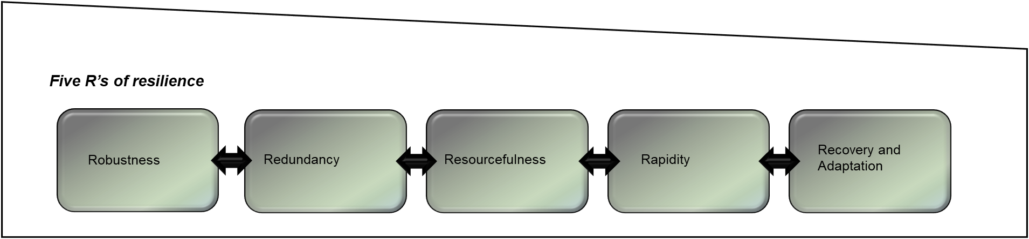
Figure 1: The Five Rs of Resilience
This review presents a conceptual framework (Figure 2) that synthesizes hazards, vulnerabilities, and resilience methods within a systems viewpoint. The framework sees climate threats as outside forces that affect infrastructure weaknesses, with resilience dimensions (robustness, redundancy, resourcefulness, speed, recovery) as shown in Figure 1 functioning as a buffer. It also shows how government, financing, technology, and community involvement can help shape outcomes. This integrative model serves as a foundation for examining the shift of Africa's infrastructure systems from vulnerability to resilience in response to climate change and natural hazards.

4.0. Climate Risks and Natural Hazards in Africa
Africa is highly exposed to a wide range of natural disasters, and many of these are because of climate change [27, 28]. The continent's geography is very different from one location to the next [29]. Some areas are deserts, while others are wet tropics with long coastlines [6]. This means that different places are exposed to different things [30]. These dangers threaten the entire infrastructure, often breaking down systems that are already weak and making social and economic problems worse. [5, 31]. Hydro-meteorological dangers are the most serious threats. Floods are happening more often and are getting worse, ruining transportation networks, disrupting electrical systems, and destroying homes and farms [32]. Heavy rains have caused cities in West and Central Africa, such as Lagos, Accra, and Dakar, to flood every year [33]. Droughts are still a constant threat in the Sahel and Horn of Africa [34]. They damage water delivery systems, hydroelectric power plants, and irrigation systems for farming [35]. Tropical cyclones don't happen as often in Africa as they do in Asia, but when they do, they may be very damaging [36]. Cyclone Idai in Mozambique in 2019, for example, destroyed roads, power lines, and communication networks [37]. Also, heat stress and high temperatures are putting more and more stress on energy systems, especially in Southern Africa, where the need for cooling is growing at the same time that there is less water available for hydropower. Geophysical hazards are not as common, but they can pose serious threats in certain areas [5]. Earthquakes and volcanoes in the East African Rift Valley put cities and important infrastructure corridors at risk. Heavy rain can cause landslides that block roads, destroy homes, and kill people in hilly areas like Ethiopia, Uganda, and Rwanda. Even while these risks don't happen as often as hydro-meteorological catastrophes, they can nonetheless have a big effect on fragile infrastructure systems. Emerging and compound dangers are adding new levels of vulnerability on top of existing ones. Rising sea levels and coastal erosion put major port cities like Alexandria, Lagos, and Dar es Salaam at risk, which might hurt trade and people's jobs. Floods and epidemics, like the cholera outbreaks in Mozambique and Malawi, show how problems with water and sanitation may lead to public health catastrophes. Urban heat islands in cities that are rising quickly make things much more complicated, raising the hazards to energy grids, transportation networks, and health systems. The effects of these dangers are different in different parts of Africa. Drought, desertification, and very different amounts of rain are most common in the Sahel. The Horn of Africa must deal with droughts, flash floods, and locust outbreaks that happen again and again, which makes its infrastructure even more fragile. South Africa and Mozambique are especially at risk from heat waves, droughts, and cyclones that hit southern Africa [38]. West Africa has a lot of problems with coastal erosion, heavy flooding, and fast-growing cities that make disasters more likely. The risk profile for each region shows how important it is to have resilience tactics that are particular to that region instead of ones that work for everyone.
Africa's exposure to many different threats that interact with each other shows how badly the continent needs strong infrastructural systems. Climate change is not only making these risks happen more often and more severely, but it is also making them happen in a chain reaction that makes traditional planning methods harder to use. To deal with these problems, we need to combine lessons learnt from different regions with information about individual hazards to create flexible, multi-hazard resilience frameworks. Table 1 shows a list of the main climate risks and natural disasters that affect Africa. It also shows how these hazards affect infrastructure systems and gives some instances from different regions. The table shows how different hazards are on the continent and how important it is to have strategies for resilience to more than one type of hazard.

Table 1. Major Climate Risks and Natural Hazards in Africa: Impacts on Infrastructure and Regional Examples
Table 1. Major Climate Risks and Natural Hazards in Africa: Impacts on Infrastructure and Regional Examples
Hazard Type | Primary Impacts on Infrastructure | Regional Examples in Africa
Floods (riverine/urban) | Damage to roads, bridges, housing, power lines, water/sanitation systems, transport disruptions | Nigeria (2022 floods), Accra (Ghana), Dakar (Senegal)
Droughts | Reduced hydropower generation, water supply failures, agricultural irrigation collapse | Sahel (Niger, Mali), Horn of Africa (Ethiopia, Somalia, Kenya)
Cyclones/Storm Surges | Coastal infrastructure damage, electricity grid failures, communication network collapse | Cyclone Idai (Mozambique, Zimbabwe, Malawi, 2019), Cyclone Freddy (2023)
Extreme Heat/Heat Stress | Overloading of energy systems (cooling demand), road surface damage, reduced water storage capacity | South Africa (heatwaves), Botswana, Namibia
Sea-Level Rise & Coastal Erosion | Threats to ports, coastal highways, and housing; salinization of water infrastructure | Lagos (Nigeria), Dar es Salaam (Tanzania), Alexandria (Egypt)
Earthquakes & Volcanic Activity | Building and road collapse, disruption of pipelines and energy corridors | East African Rift Valley (Ethiopia, Kenya, Uganda, DR Congo)
Landslides | Road blockages, housing destruction, fatalities | Rwanda, Uganda, Ethiopia highlands
Compound Risks (e.g., Floods + Epidemics) | Public health crises from damaged water/sanitation infrastructure; cascading system failures | Mozambique & Malawi (cholera outbreaks after floods)

Figure 2 illustrates the interconnected pathways through which climate hazards interact with existing vulnerabilities to produce cascading infrastructure impacts across Africa. This systems diagram (Figure 2) illustrates how climate hazards (floods, droughts, cyclones, extreme heat, and sea-level rise) interact with existing vulnerabilities (aging infrastructure, weak governance, limited financing, and rapid urbanization) to produce cascading impacts across infrastructure sectors, including energy, water and sanitation, transport, and health systems. (Floods, droughts, cyclones, extreme heat, and sea-level rise).

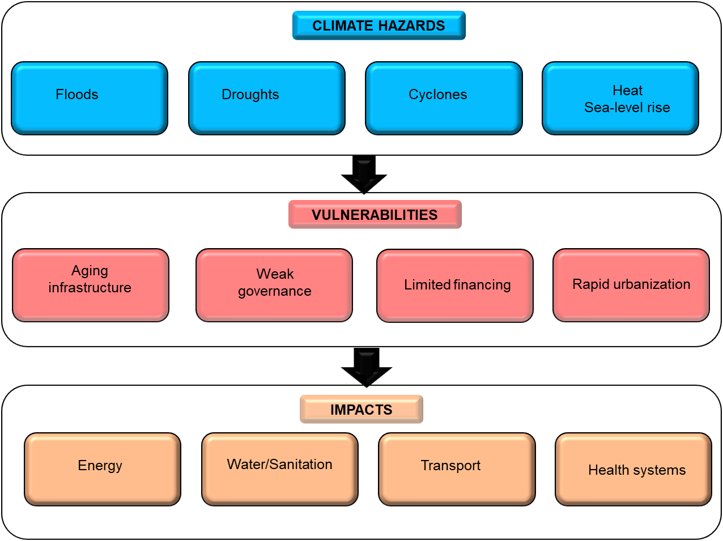
Figure 2. Integrated Climate–Infrastructure Risk Pathways in Africa
It emphasizes the interconnectedness of risks and the pathways through which climate change exacerbates infrastructure fragility. (aging infrastructure, weak governance, limited financing, and rapid urbanization)
5.0. Infrastructure Vulnerabilities in Developing Regions
Infrastructure systems in developing areas are more vulnerable to climate risks and natural disasters because they have several levels of weakness [5]. In Africa, these weaknesses come from more than just the physical weakness of infrastructure. [39, 40]. They also come from bigger social, economic, and institutional problems according to WHO and UNICEF (2017) [41]. Energy systems are quite unstable since many countries rely on hydropower, which is very sensitive to droughts and changes in rainfall [42]. Power grids are frequently old and don't have backups, thus they can fail during bad weather [43]. In many areas, water and sanitation systems are still not very good [44]. For example, in rural areas, people still depend on surface water or shallow wells that are very easy to pollute when it rains [4]. During disasters, weak wastewater treatment systems make public health hazards much worse. Roads, bridges, and trains are often built without enough protection from the weather, making them very easy to damage by floods, landslides, and heat. [5]. Transportation problems not only make it harder for emergency responders to get to the scene, but they also make it harder for businesses to trade and for food to be distributed, which has a ripple effect on the economy [45]. Health infrastructure is also under a lot of stress. Many hospitals and clinics around the world don't have sturdy buildings, backup power, or enough medical supplies to handle the rise in demand caused by climate change [46]. The gap between cities and rural areas makes these weaknesses even worse. Cities like Lagos, Nairobi, and Kinshasa that are growing quickly are at greater risk because of unrestrained growth, old infrastructure, and services that are too stretched. Informal settlements are more vulnerable since they are generally built on floodplains, on unstable hillsides, or along the ocean where there aren't enough drainage or protection systems. On the other hand, rural areas are chronically underinvested, have limited access to essential amenities, and rely heavily on vulnerable water and transportation systems. Resilience is also limited by problems with institutions and governance. Systemic weaknesses are caused by weak enforcement of construction codes, fragmented planning across sectors, and poor cooperation between national and local governments. Many African countries depend on outside funding and foreign aid to build their infrastructure, which makes the problem worse [47]. This dependence often leads to programs that are driven by donors but don't always meet local needs or long-term aims for resilience. Table 2 shows the sector-specific flaws that make Africa's infrastructure less resilient. It shows how physical weaknesses are made worse by problems with governance and finances, and it also summarizes the key infrastructure vulnerabilities across critical sectors, with examples from African contexts. These examples show how resilience problems are linked across the continent.

Table 2. Key Infrastructure Vulnerabilities in Africa and Illustrative Examples
Sector | Vulnerabilities | Illustrative African Examples
Energy | Dependence on hydropower; aging grids; lack of redundancy; climate-sensitive systems | Zambia & Ethiopia (hydropower shortages during droughts); South Africa (load shedding)
Water & Sanitation | Inadequate water supply and wastewater treatment; contamination risks during floods | Nigeria (urban flooding contaminating water systems); Malawi (cholera outbreaks post-floods)
Transport | Poor road design, limited maintenance, susceptibility to floods and landslides | Mozambique (roads destroyed by Cyclone Idai, 2019); Uganda & Rwanda (landslides disrupting highways)
Health | Weak hospital infrastructure; limited emergency capacity; lack of backup energy | Sierra Leone (hospital outages during floods); Kenya (health services disrupted by flooding)
Urban Systems | Informal settlements in hazard-prone zones; overstretched services | Lagos (informal settlements prone to flooding); Nairobi (slum areas affected by poor drainage)
Rural Systems | Chronic underinvestment, limited transport, and energy access | Sahel (limited rural roads restricting drought relief efforts); Ethiopia (remote communities cut off during floods)
Governance & Finance | Weak regulation enforcement, dependence on donor-driven projects, and limited local capacity | Multiple African countries are relying on World Bank/AfDB projects without local adaptation

The spider chart (Figure 3) compares the relative vulnerabilities of key infrastructure sectors. energy, water and sanitation, transport, health, urban systems, rural systems, and governance/finance across four dimensions: climate sensitivity, redundancy, financial fragility, and institutional weakness. The radial axes represent the severity of each vulnerability, while the polygonal shapes highlight how different sectors are exposed to climate and governance-related risks.

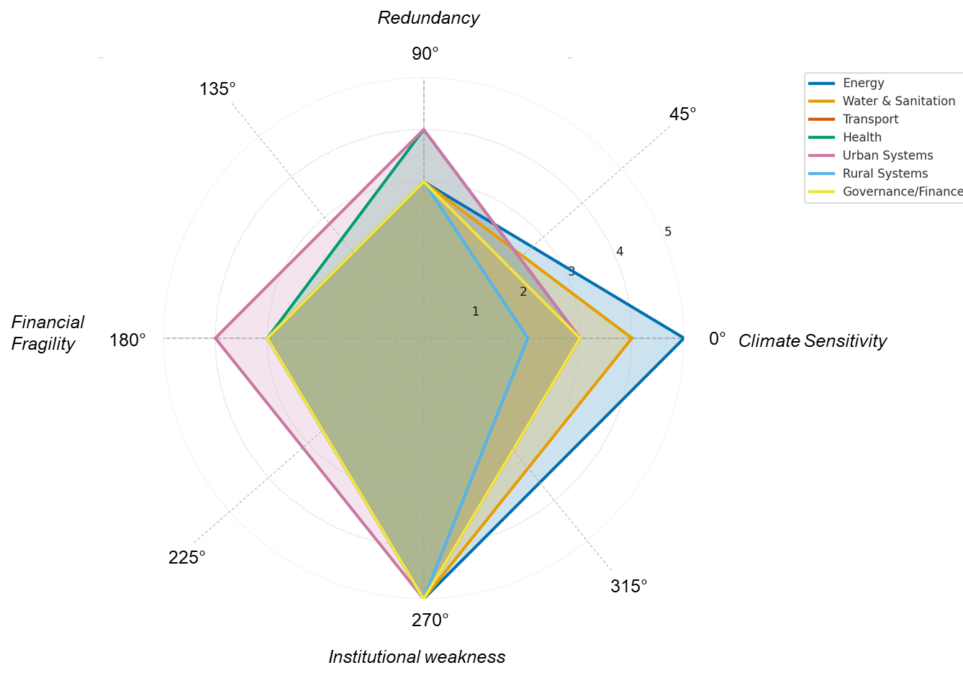

Figure 3. Infrastructure Vulnerabilities by Sector in Africa.

6.0. Strategies for Enhancing Infrastructure Resilience
Building resilient infrastructure in Africa requires a multi-dimensional approach that integrates governance reforms, technological innovations, community engagement, and sustainable financing [48]. Existing literature demonstrates that resilience cannot be achieved through isolated interventions; instead, it demands cross-sectoral and multi-scalar strategies that address both structural and systemic vulnerabilities. This section synthesizes key strategies emerging from research and practice.
6.1 Governance and Policy Interventions
The basis of infrastructure resilience is good governance. (AU) Incorporating climate risk into national development plans, building standards, and land-use rules guarantees that resilience is included in from the beginning of infrastructure design and investment [49]. Countries like South Africa and Rwanda have started using resilience criteria in their city planning, although the process is still not very consistent [50]. The African Union (AU), African Development Bank (AfDB), Economic Community of West African States (ECOWAS), and Southern African Development Community (SADC) are some of the most important regional organisations that help people work together across borders, set standards, and share information. (SADC) There are still loopholes in translating regional promises into national laws that can be enforced [45]. Weak rules, bad enforcement of standards, and not enough resources in institutions are still big problems [51]. Making accountability stronger and making resilience a part of governance systems are, therefore very important goals.
6.2 Engineering and Technological Innovations
Engineering and technology provide concrete methods for diminishing infrastructure susceptibility. (GIS) Using climate-resilient design and building elements, such as raised roadbeds, permeable pavements, and heat-resistant materials, can make things stronger [52]. Smart technologies, including remote sensing, geographic information systems (GIS), and real-time monitoring, improve early warning systems and help with adaptive management [53]. Green and nature-based solutions are just as significant because they offer long-lasting and cost-effective options. Restoring mangroves to safeguard the shoreline, creating green spaces in cities to lower the risk of flooding, and planting trees to stabilise slopes are all examples [54]. The use of these kinds of technology in Africa is often blocked by money and technical problems, which shows how important it is to build capacity and share information.
6.3 Socioeconomic and Community Approaches
Resilience methods should encompass not only technological solutions but also social and community aspects [22]. Local knowledge, like how people in the Sahel traditionally manage water, can work well with modern technical methods [55]. Participatory planning techniques enhance ownership and guarantee that actions are contextually suitable [56]. It's also important to pay attention to fairness[57]. Children and marginalized groups frequently experience the most severe effects of infrastructure collapse and should be a primary focus of resilience-building efforts. Also, socioeconomic tools like insurance, microfinance, and community-based risk-sharing systems act as safety nets that assist families get back on their feet faster after problems [58]. Successful models, like index-based agricultural insurance programs in East Africa, show how financial inclusion may help people become more resilient.
6.4 Financing and International Support
One of the biggest problems for infrastructure resilience in Africa is still getting money that lasts. (GCF) The AfDB and other regional organisations have started projects to make climate resilience a normal part of infrastructure investment [16]. (GEF) The Green Climate Fund (GCF) and the Global Environment Facility (GEF) are two international structures that also provide important sources of money [59]. However, getting to them can be hard because of red tape, and they generally favour nations with higher institutional ability [60]. People are looking at new ways to use money more and more. (CBN, 2017; National Treasury South Africa, 2019) Green bonds, resilience bonds, and blended finance models are ways to get private sector money to invest in projects that make communities more resilient. Nigeria and South Africa, for instance, have issued green bonds to pay for long-lasting infrastructure. This has set a good example for other countries on the continent to follow [61]. To avoid making current problems worse, it's important to make sure that financial systems are fair, accessible, and in line with local needs. Figure 4 shows a multi-layered resilience paradigm that shows how government, technology, community engagement, and financing must all work together to make Africa's infrastructure systems stronger.

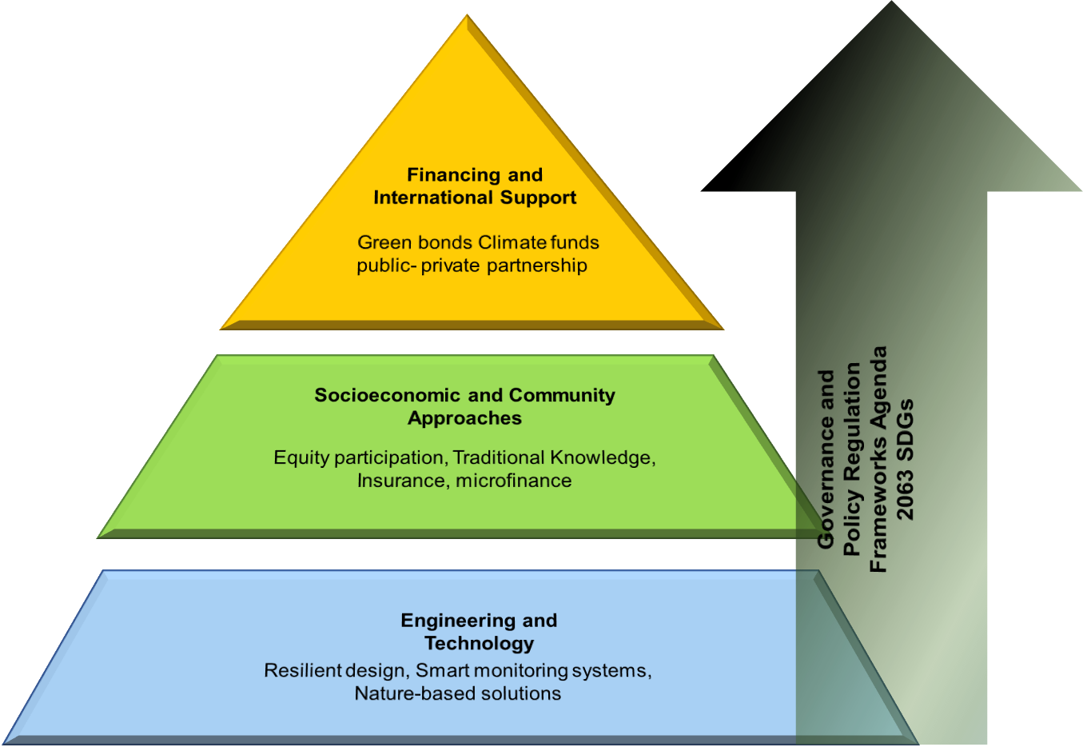

Figure 4. Multi-Layered Resilience Strategies Framework for Africa.
This pyramid framework illustrates the layered strategies required to build infrastructure resilience in Africa. At the base, engineering and technology provide the technical foundation through resilient design, smart monitoring systems, and nature-based solutions. The middle layer highlights socioeconomic and community approaches, including equity participation, traditional knowledge, insurance, and microfinance. At the top, financing and international support, such as green bonds, climate funds, and public-private partnerships, supply the enabling resources needed for implementation. Governance and policy regulation frameworks, aligned with Agenda 2063 and the SDGs, act as a guiding structure that shapes and supports all these layers. Together, these dimensions demonstrate how multi-level interventions interact to strengthen infrastructure systems against climate and disaster risks.

7.0. Case Studies and Best Practices
Looking at real-life situations gives us useful information about how to use resilience tactics in different situations [62]. Case studies from African nations illustrate both the achievements and persistent obstacles of infrastructure resilience, whereas comparative insights from Asia and Latin America present prospects for mutual learning. [63]. Mozambique Recovery after Cyclone Idai: Cyclone Idai in 2019 was one of the worst climate disasters in Africa in a long time. It destroyed homes, roads, electricity lines, and health care facilities [64]. Mozambique's recovery showed how important it is to get help from other countries and regions quickly, such as humanitarian aid and money for rebuilding [65]. During the rebuilding phase, the idea of "build back better" has become more important [66]. This includes making homes that can withstand floods and roads that are stronger. But ongoing financial deficits and sluggish institutional changes show how hard it is to keep resilience gains going after the emergency phase [67].
Kenya Strong Transport Systems: Kenya has been a leader in trying to make its transport infrastructure more climate resilient. To protect against climate change, the Kenya Rural Roads Authority has raised roadbeds, made drainage systems better, and reinforced bridges in regions that are likely to flood. These changes have not only made things more resilient, but they have also lowered the expense of long-term upkeep. The Kenya Urban Resilience Project, which is funded by the World Bank, is an example of how to include resilience in basic infrastructure development. It provides extra resources and technical experience [63].
South Africa Urban Resilience Frameworks: South Africa has come a long way in making cities more resilient, especially in Cape Town and Durban. Cape Town learnt from the 2018 "Day Zero" water crisis and came up with new ways to control demand, raise public awareness, and invest in a wider range of water sources [68]. Durban has come up with a full Municipal Climate Change Strategy that combines ecosystem-based initiatives, including restoring wetlands, with improvements to infrastructure. These examples show how local governments can make resilience a part of their institutions by changing the way they govern, getting more people involved, and making climate risk a part of their policies [64].
Flood Management in Rwanda: Rwanda has started community-led flood management programs in highland areas that are likely to have landslides and flash floods. Terracing, reforestation, and community-based early warning systems are some of the most important ways to lower the risk of disasters. Rwanda's model is important because it stresses community involvement and ownership, which makes sure that programs meet local needs and use local expertise. This bottom-up approach makes things more sustainable and socially acceptable, and it also fits well with national resilience plans.
Comparative Insights from Asia and Latin America: Insights from Asia and Latin America that are similar. Lessons can also be learnt from things that happen outside of Africa. The combination of community-based cyclone shelters and early warning systems in Bangladesh has greatly lowered the number of deaths, which could be useful for African coastal countries [66]. Seismic building standards and enforcement mechanisms in Chile and Mexico show how important it is to have strong regulatory frameworks for dealing with geophysical hazards [69]. Latin America's use of resilience bonds also shows new ways to finance projects that could work in Africa. These comparative findings emphasise that although resilience methods must be customised to Africa's distinct settings, cross-regional learning helps expedite the implementation of validated solutions.
In general, these case studies show that it is possible to make infrastructure more resilient when governance, technical innovation, community involvement, and financing come together. They also point out that long-term investment and strong political commitment are important for spreading optimal practices beyond just a few successful cases.
8.0 Challenges and Research Gaps
Despite increasing recognition of the urgency to strengthen infrastructure resilience in Africa, significant challenges continue to hinder progress. These challenges span technical, institutional, and financial domains, while key research gaps limit evidence-based policymaking and innovation.
Data and Modeling Limitations: A critical barrier remains the scarcity of reliable, high-resolution climate and hazard data across much of Africa. Limited meteorological and hydrological monitoring networks constrain the accuracy of risk models, leaving decision-makers to rely on fragmented or externally generated datasets. This restricts local capacity to develop context-specific resilience solutions and undermines early warning systems.
Weak Integration of Multi-Hazard Approaches: Current planning frameworks often address hazards in isolation, for example, focusing on floods or droughts separately while failing to capture the compound and cascading nature of risks. This siloed approach leads to resilience measures that are effective against single hazards but inadequate for multi-hazard or systemic risks, such as the interaction of floods with disease outbreaks or sea-level rise with coastal erosion.
Institutional Fragmentation and Governance Deficits: Governance challenges remain a major obstacle. Fragmented institutional responsibilities across ministries, weak enforcement of building codes, and limited coordination between local and national authorities dilute the effectiveness of resilience interventions. Furthermore, short political cycles often prioritize immediate infrastructure needs over long-term climate risk management, perpetuating vulnerability.
Financing Gaps and Donor Dependency: The high costs of resilient infrastructure exceed the fiscal capacity of many African governments. Although international climate funds and donor programs provide critical resources, these projects often suffer from limited sustainability once external funding ends. Innovative financing mechanisms such as green bonds, resilience bonds, and blended finance remain underdeveloped and underutilized across the continent.
Under-Researched Themes: The literature and practice of infrastructure resilience in Africa exhibit considerable deficiencies. (including regional power pools, transboundary water infrastructure, and transport corridors) First, the use of digital tools and smart technologies for monitoring, early warning, and adaptive management is still not well understood in Africa. Second, there isn't enough documentation and use of the integration of indigenous knowledge systems, which have historically helped people adapt to their local environments. Third, the dangers of cross-border infrastructure systems (including regional power pools, transboundary water infrastructure, and transport corridors) are not looked into very often, even though they are becoming more important for regional growth. These problems show how important it is to put more money into data infrastructure, multi-hazard risk modelling, institutional reforms, and long-term funding plans. They also point out research priorities that, if they were addressed, might greatly improve Africa's ability to plan and build infrastructure that can withstand climate change and natural disasters.
9.0. Future Directions
Addressing Africa’s infrastructure vulnerabilities in the face of escalating climate risks requires a forward-looking agenda that transcends fragmented interventions. The future of resilient infrastructure in Africa lies in approaches that are multi-sectoral, cross-border, and technologically enabled, while rooted in inclusive and collaborative governance.
Multi-Sectoral and Cross-Border Frameworks: Infrastructure systems are all connected, thus planning for resilience needs to happen across industries and countries. Power grids, water basins, and transportation routes in Africa sometimes extend across several nations, requiring regional frameworks that align regulations and technological standards. The African Union (AU) and regional economic communities (RECs) could play a big role in encouraging cooperation across borders. (SDGs) They should make sure that resilience strategies take into account both local situations and regional connections. In line with Agenda 2063 and the SDGs, Infrastructure resilience must be strategically integrated into Africa's long-term development frameworks, notably the AU's Agenda 2063 and the United Nations Sustainable Development Goals (SDGs). This would make resilience a part of larger development goals like health systems strengthening, energy access, and sustainable cities would make climate-proofing a key part of growth and change, not just something extra.
Harnessing Emerging Technologies: Artificial intelligence (AI), big data analytics, and digital twins are all making huge strides that make risk assessment, infrastructure monitoring, and scenario planning much easier. Digital twins let you test infrastructure systems in a virtual environment, and AI-powered models can make predictions about climate hazards more accurate. To make the most of these technologies for proactive resilience development, it will be important to increase digital capability in Africa and encourage cooperation between the public and commercial sectors.
Transdisciplinary and Inclusive Collaboration: Transdisciplinary collaboration is needed to support future attempts to make people more resilient. Engineers, climate scientists, urban planners, economists, policymakers, and communities must collaborate in the co-design of solutions. Inclusivity must remain a core tenet; the perspectives of marginalised populations, particularly women, youth, and indigenous people, should be incorporated into planning processes to guarantee fair resilience outcomes. In short, the future of resilient infrastructure in Africa depends on brave, systemic strategies that connect fields, sectors, and countries while making use of new technologies. If political will and funding are kept up, this forward-looking program has the potential to turn Africa's infrastructure into a base for sustainable development in the Anthropocene period.
Conclusion
This analysis makes it clear that making Africa's infrastructure more resilient is both an urgent need and a difficult task. The research shows that climate risks and natural disasters are getting worse all over the continent, which puts important systems like energy, transportation, water, health, and sanitation at danger of being disrupted over and over again. However, resilience cannot be simplified to just technological solutions; it necessitates a socio-technical framework that amalgamates engineering innovation, strong governance, community involvement, and sustainable funding.
The assessment shows that even if there has been some progress—through policy frameworks, innovative design, and localised adaption practices—there are still big gaps in data infrastructure, multi-hazard integration, institutional coordination, and financial mechanisms. These gaps keep people vulnerable and show how important it is for people from different fields and regions to work together. For African governments and regional organisations, the policy imperative is unequivocal: resilience must be integrated into development planning, investment frameworks, and governance mechanisms. Donors, multilateral agencies, and private sector investors from other countries must make sure that their support is in line with Africa's needs and that it will last beyond the end of short-term projects.
In the end, we need brave, organised, and forward-thinking action to go forward. Resilience should be regarded as a fundamental component of Africa's sustainable development, rather than a secondary consideration. Climate hazards will keep taking away hard-won development advantages unless we invest and work together quickly. On the other hand, Africa can construct infrastructure that not only can handle shocks but also encourages inclusive, sustainable growth in the face of 21st-century problems by making resilience a part of the design, governance, and financing of the infrastructure.

COMPETING INTERESTS DISCLAIMER:
Authors have declared that they have no known competing financial interests OR non-financial interests OR personal relationships that could have appeared to influence the work reported in this paper.

References
1. Calderón, C. and L. Servén, Infrastructure, growth, and inequality: An overview. World Bank Policy Research Working Paper, 2014(7034).
2. Stuart, L., J. Lüterbacher, L. Paterson, R. Deviller, and S. Castonguay, United In Science 2022: a multi-organization high-level compilation of the most recent science related to climate change, impacts and responses. 2022.
3. Citaristi, I., United nations human settlements programme—UN-habitat, in The Europa directory of international organizations 2022. 2022, Routledge. p. 240-243.
4. Satterthwaite, D., D. Archer, S. Colenbrander, D. Dodman, J. Hardoy, D. Mitlin, and S. Patel, Building resilience to climate change in informal settlements. One earth, 2020. 2(2): p. 143-156.
5. Hallegatte, S., J. Rentschler, and J. Rozenberg, Lifelines: The resilient infrastructure opportunity. 2019: World Bank Publications.
6. Adelekan, I., C. Johnson, M. Manda, D. Matyas, B. Mberu, S. Parnell, M. Pelling, D. Satterthwaite, and J. Vivekananda, Disaster risk and its reduction: An agenda for urban Africa. International development planning review, 2015. 37(1): p. 33-43.
7. Bryan, E., Q. Bernier, M. Espinal, and C. Ringler, Making climate change adaptation programmes in sub-Saharan Africa more gender responsive: insights from implementing organizations on the barriers and opportunities. Climate and Development, 2018. 10(5): p. 417-431.
8. Apollo, A. and M.F. Mbah, Challenges and opportunities for climate change education (CCE) in East Africa: A critical review. Climate, 2021. 9(6): p. 93.
9. UN, G.A., Transforming our world: The 2030 agenda for sustainable development. Division for Sustainable Development Goals. New York: World Health Organization, 2015.
10. Aronsson-Storrier, M., UN office for disaster risk reduction (2019). YB Int'l Disaster L. Online, 2021. 2: p. 377.
11. Aitsi-Selmi, A., V. Murray, C. Wannous, C. Dickinson, D. Johnston, A. Kawasaki, A.-S. Stevance, and T. Yeung, Reflections on a science and technology agenda for 21st century disaster risk reduction: Based on the scientific content of the 2016 UNISDR science and technology conference on the implementation of the Sendai framework for disaster risk reduction 2015–2030. International journal of disaster risk science, 2016. 7(1): p. 1-29.
12. Reduction, U.N.I.S.f.D., Global assessment report on disaster risk reduction 2019. 2019: UN.
13. Falagas, M.E., E.I. Pitsouni, G.A. Malietzis, and G. Pappas, Comparison of PubMed, Scopus, web of science, and Google scholar: strengths and weaknesses. The FASEB journal, 2008. 22(2): p. 338-342.
14. Petticrew, M. and H. Roberts, Systematic reviews in the social sciences: A practical guide. 2008: John Wiley & Sons.
15. Snyder, H., Literature review as a research methodology: An overview and guidelines. Journal of business research, 2019. 104: p. 333-339.
16. Outlook, A.E., Supporting climate resilience and a just energy transition in Africa. African Development Bank (AfDB), Abidjan, Cote d'Ivoire, 2022.
17. Grant, M.J. and A. Booth, A typology of reviews: an analysis of 14 review types and associated methodologies. Health information & libraries journal, 2009. 26(2): p. 91-108.
18. Mallett, R., J. Hagen-Zanker, R. Slater, and M. Duvendack, The benefits and challenges of using systematic reviews in international development research. Journal of development effectiveness, 2012. 4(3): p. 445-455.
19. Rose, A., Economic resilience to natural and man-made disasters: Multidisciplinary origins and contextual dimensions. Environmental hazards, 2007. 7(4): p. 383-398.
20. Holling, C.S., Resilience and stability of ecological systems. 1973, International Institute for Applied Systems Analysis Laxenburg.
21. Folke, C., Resilience: The emergence of a perspective for social–ecological systems analyses. Global environmental change, 2006. 16(3): p. 253-267.
22. Adger, W.N., Social and ecological resilience: are they related? Progress in human geography, 2000. 24(3): p. 347-364.
23. Wisner, B. and B. Wisner, At risk: natural hazards, people's vulnerability and disasters. 2004: Psychology Press.
24. Bruneau, M., S.E. Chang, R.T. Eguchi, G.C. Lee, T.D. O'Rourke, A.M. Reinhorn, M. Shinozuka, K. Tierney, W.A. Wallace, and D. Von Winterfeldt, A framework to quantitatively assess and enhance the seismic resilience of communities. Earthquake spectra, 2003. 19(4): p. 733-752.
25. Marbaix, P., A.K. Magnan, V. Muccione, P.W. Thorne, and Z. Zommers, Climate change risks illustrated by the Intergovernmental Panel on Climate Change (IPCC)“burning embers”. Earth System Science Data, 2025. 17(1): p. 317-349.
26. Girardet, L.H., United nations office for disaster risk reduction (undrr). 2020.
27. Chapman, C.A., K. Abernathy, L.J. Chapman, C. Downs, E.O. Effiom, J.F. Gogarten, M. Golooba, U. Kalbitzer, M.J. Lawes, and A. Mekonnen, The future of sub-Saharan Africa’s biodiversity in the face of climate and societal change. Frontiers in Ecology and Evolution, 2022. 10: p. 790552.
28. Ziervogel, G., C. Lennard, G. Midgley, M. New, N.P. Simpson, C.H. Trisos, and L. Zvobgo, Climate change in South Africa: Risks and opportunities for climate-resilient development in the IPCC Sixth Assessment WGII Report. South African Journal of Science, 2022. 118(9-10): p. 11-15.
29. Douglas, I., Climate change and the increasing vulnerability of the poor in the Commonwealth. The Round Table, 2021. 110(5): p. 564-574.
30. Masih, I., S. Maskey, F. Mussá, and P. Trambauer, A review of droughts on the African continent: a geospatial and long-term perspective. Hydrology and earth system sciences, 2014. 18(9): p. 3635-3649.
31. Africa, N., Other United Nations Bodies. Organization, 2020.
32. Biggs, E.M., B. Boruff, E. Bruce, J. Duncan, B.J. Haworth, S. Duce, J. Horsley, J. Curnow, A. Neef, and K. McNeill, Environmental livelihood security in Southeast Asia and Oceania: a water-energy-food-livelihoods nexus approach for spatially assessing change. White paper. 2014: IWMI.
33. Claessens, L., A. Knapen, M. Kitutu, J. Poesen, and J.A. Deckers, Modelling landslide hazard, soil redistribution and sediment yield of landslides on the Ugandan footslopes of Mount Elgon. Geomorphology, 2007. 90(1-2): p. 23-35.
34. Neumann, J.E., K.A. Emanuel, S. Ravela, L.C. Ludwig, and C. Verly, Risks of coastal storm surge and the effect of sea level rise in the Red River Delta, Vietnam. Sustainability, 2015. 7(6): p. 6553-6572.
35. Rebaudet, S., B. Sudre, B. Faucher, and R. Piarroux, Environmental determinants of cholera outbreaks in inland Africa: a systematic review of main transmission foci and propagation routes. The Journal of infectious diseases, 2013. 208(suppl_1): p. S46-S54.
36. van Niekerk, D. and L.D. Nemakonde, Natural hazards and their governance in Sub-Saharan Africa, in Oxford Research Encyclopedia of Natural Hazard Science. 2017.
37. Serdeczny, O., S. Adams, F. Baarsch, D. Coumou, A. Robinson, W. Hare, M. Schaeffer, M. Perrette, and J. Reinhardt, Climate change impacts in Sub-Saharan Africa: from physical changes to their social repercussions. Regional Environmental Change, 2017. 17(6): p. 1585-1600.
38. Taruvinga, A., M. Visser, and L. Zhou, Barriers and opportunities to climate change adaptation in rural Africa: Evidence from the Eastern Cape Province of South Africa. International Journal of Development and Sustainability, 2016. 5(11): p. 518-535.
39. Pepermans, Y. and I. Loots, Wind farm struggles in Flanders fields: A sociological perspective. Energy Policy, 2013. 59: p. 321-328.
40. Conway, D., E.A. Van Garderen, D. Deryng, S. Dorling, T. Krueger, W. Landman, B. Lankford, K. Lebek, T. Osborn, and C. Ringler, Climate and southern Africa's water–energy–food nexus. Nature Climate Change, 2015. 5(9): p. 837-846.
41. Unicef, Progress on drinking water, sanitation and hygiene: 2017 update and SDG baselines. 2017.
42. Engeland, K., M. Borga, J.-D. Creutin, B. François, M.-H. Ramos, and J.-P. Vidal, Space-time variability of climate variables and intermittent renewable electricity production–A review. Renewable and Sustainable Energy Reviews, 2017. 79: p. 600-617.
43. Mulyanyuma, A.A., J. Niringiyimana, and P. Nareeba, Vulnerability of Energy Infrastructure to Climate Change in East Africa. Covenant University Journal of Politics and International Affairs, 2024: p. 11-11.
44. Un-Habitat, World cities report 2020: The value of sustainable urbanization. 2020: UN.
45. Pelling, M. and K. Dill, Disaster politics: tipping points for change in the adaptation of sociopolitical regimes. Progress in human geography, 2010. 34(1): p. 21-37.
46. Wade, R., Climate change and healthcare: creating a sustainable and climate-resilient health delivery system. Journal of Healthcare Management, 2023. 68(4): p. 227-238.
47. Bräutigam, D.A. and S. Knack, Foreign aid, institutions, and governance in sub-Saharan Africa. Economic development and cultural change, 2004. 52(2): p. 255-285.
48. Bahadur, A.V., M. Ibrahim, and T. Tanner, The resilience renaissance? Unpacking of resilience for tackling climate change and disasters. 2010.
49. Outlook, A.E., Developing Africa’s workforce for the future. African Development Bank Group: Abidjan, Côte d’Ivoire, 2020.
50. Canton, H., Economic Community of West African States—ECOWAS, in The Europa Directory of International Organizations 2021. 2021, Routledge. p. 534-542.
51. Cartwright, A., What Evidence Informs Urban Policy in East Africa, and How Does It Get There? 2025.
52. Canton, H., United nations environment programme—unep, in The Europa directory of international organizations 2021. 2021, Routledge. p. 188-214.
53. Goodchild, M.F., Citizens as sensors: the world of volunteered geography. GeoJournal, 2007. 69(4): p. 211-221.
54. Kabisch, N., N. Frantzeskaki, S. Pauleit, S. Naumann, M. Davis, M. Artmann, D. Haase, S. Knapp, H. Korn, and J. Stadler, Nature-based solutions to climate change mitigation and adaptation in urban areas: perspectives on indicators, knowledge gaps, barriers, and opportunities for action. Ecology and society, 2016. 21(2).
55. Reed, M.S., Stakeholder participation for environmental management: a literature review. Biological conservation, 2008. 141(10): p. 2417-2431.
56. Arora-Jonsson, S., Virtue and vulnerability: Discourses on women, gender and climate change. Global environmental change, 2011. 21(2): p. 744-751.
57. Linnerooth-Bayer, J. and S. Hochrainer-Stigler, Financial instruments for disaster risk management and climate change adaptation. Climatic Change, 2015. 133(1): p. 85-100.
58. Greatrex, H., J. Hansen, S. Garvin, R. Diro, M. Le Guen, S. Blakeley, K. Rao, and D. Osgood, Scaling up index insurance for smallholder farmers: Recent evidence and insights. 2015.
59. Michaelowa, K. and C. Namhata, Climate finance as development aid, in Handbook of international climate finance. 2022, Edward Elgar Publishing. p. 62-82.
60. Fatin, L. and A. Whiley, Climate bonds initiative, in World Scientific Encyclopedia of Climate Change: Case Studies of Climate Risk, Action, and Opportunity Volume 1. 2021, World Scientific. p. 57-61.
61. Olawoye-Mann, S., A green mandate: The Central Bank of Nigeria and sustainable development, in Central Banking, Monetary Policy and the Environment. 2022, Edward Elgar Publishing. p. 219-233.
62. Clinton, W.J., Key propositions for building back better: lessons learned from tsunami recovery. online], Office of the Secretary-General's Special Envoy for Tsunami Recovery (SETR), December, http://www. preventionweb. net/files/2054_VL108301. pdf [date of reference: 17 July 2013], 2006.
63. Kull, D., H. Gitay, S. Bettencourt, R. Reid, A. Simpson, and K. McCall, Building resilience: World bank group experience in climate and disaster resilient development, in Climate Change Adaptation Strategies–An Upstream-downstream Perspective. 2016, Springer. p. 255-270.
64. Roberts, D. and S. O’Donoghue, Urban environmental challenges and climate change action in Durban, South Africa. Environment and Urbanization, 2013. 25(2): p. 299-319.
65. Paleari, S., Disaster risk insurance: A comparison of national schemes in the EU-28. International Journal of Disaster Risk Reduction, 2019. 35: p. 101059.
66. Paul, B.K., Why relatively fewer people died? The case of Bangladesh’s Cyclone Sidr. Natural Hazards, 2009. 50(2): p. 289-304.
67. Linnenluecke, M.K. and A. Griffiths, The climate resilient organization: Adaptation and resilience to climate change and weather extremes, in The Climate Resilient Organization. 2015, Edward Elgar Publishing.
68. Enqvist, J.P. and G. Ziervogel, Water governance and justice in Cape Town: An overview. Wiley Interdisciplinary Reviews: Water, 2019. 6(4): p. e1354.
69. Torres Pinedo, M., The Role of Networks in Vulnerability and Disaster Risk Governance of Mexico City. A Mixed Methods Study with an Intersectional Approach. 2023, UCL (University College London).

