Efficacy of plant extracts and Trichoderma harzianum against purple blotch of garlic (Allium sativum L.)

Abstract
Garlic (Allium sativum L.) Nnamed as "Lahsun," garlic (Allium sativum L.), the second most grown Allium species after onions, is an essential crop in the Amaryllidaceae family. Alternaria porri purple blotch disease, which drastically lowers productivity and continues to be a serious worry for growers, is one of the biggest dangers to garlic supply. This study, conducted during the rabi Rabi season of 2023–24 at Sam Higginbottom University of Agriculture, Technology and Sciences, Prayagraj, aimed to evaluate the efficacy of various plant extracts and the biocontrol agent Trichoderma harzianum in managing the disease and improving garlic growth. Eight treatments were tested, including Trichoderma harzianum (10%), leaf extracts of Eucalyptus, Neem, Tulsi, Lantana camara, and Datura (each at 10%), a chemical control (Mancozeb + Tebuconazole at 0.2%), and an untreated control, with three replications each. According to field data, eucalyptus leaf extract outperformed neem extract in terms of lowering disease severity and increasing yield. In vitro studies using dual culture and poisoned food techniques revealed that Trichoderma harzianum exhibited the highest fungal growth inhibition among bio-agents, while Neem leaf extract was most effective among plant extracts. Overall, all treatments reduced disease incidence compared to the control.
Keyword – Alternaria porri, D disease intensity, Garlic, Pplant extracts, Purple blotch of garlic,
Trichoderma harzianum

Introduction
As the second most widely grown Allium species after onions, garlic (Allium sativum L.), often known as "Lasun," is one of the most significant spices in the Amaryllidaceae family. In comparison to other Allium crops, it has a higher nutritional value. Carbohydrates (29%) proteins

(6.3%) minerals (0.3%) and essential oils (0.1–0.4%) are all abundant in garlic. It also has trace levels of vitamin C, sulfur compounds, and lipids. Ascorbic acid is abundant in green garlic in particular. Due to its natural properties, garlic oil and extracts are being utilized as potential bio- pesticides, serving as effective insecticides and fungicides in organic farming practices (Memane et al. 2008). According to Etoh and Simon (2002), garlic is thought to be indigenous to Southern Europe and Western Asia. It has been used for more than 5,000 years in China and India, and for more than 4,000 years in Egypt (Kamenetsky and Rabinowitch 2001). Numerous diseases and insect pests, such as purple blotch, Botrytis leaf blight, downy mildew, Fusarium basal rot, white rot, and stem and bulb nematodes, can affect garlic (Allium sativum L.). These diseases and pests affect the crop both during its growth in the field and post-harvest storage, resulting in significant losses in yield and a decline in marketable quality (Prahlad et al. 2021).
Alternaria porri is the cause of purple blotch, a serious foliar disease that affects garlic. It grows best in warm, humid environments with relative humidity levels between 80 and 90% and temperatures between 25 and 30 °C (Dar et al. 2020). The disease begins with the appearance of small, whitish flecks on the leaves and flower stalks. These spots gradually expand into sunken, purple-colored lesions bordered by yellow to pale brown margins (Nolla et al. 1927).
The pathogen remains viable in infected garlic cloves but does not persist in the soil (Dicklow et al. 2013). Crop losses as high as 60% have been documented, primarily due to the drying of leaves (Bisht and Agarwal 1993). Alternaria porri produces obclavate conidia with several septa, formed on purple to brown conidiophores that display clear conidial scars (Dar et al. 2020). This disease poses a major challenge in garlic-producing areas across the globe (Hausbeck et al. 1999; Bisht and Thomas 1992).

Materials and methods Geographical lLocation
The current study was conducted at Sam Higginbottom University of Agriculture, Technology and Sciences (SHUATS), Prayagraj, at the Central Research Farm, Department of Plant Pathology.

Isolation and identification of fungi
Garlic leaves displaying distinctive indications of purple blotch were gathered and properly cleaned under running water. The existence of Alternaria species was then confirmed by microscopically examining the symptomatic tissues. Small pieces with both healthy and diseased parts were removed under sterile conditions, surface sterilized for one minute with 1% sodium hypochlorite (NaOCl), and then rinsed three times with sterile distilled water. As explained by (Tuite 1969), these tissue fragments were air-dried on sterile filter paper before being put (4–5 pieces per plate) onto sterilized Petri plates filled with potato dextrose agar (PDA) treated with streptomycin at 100 ppm to prevent bacterial development. In a BOD incubator, the plates were incubated at 27 ± 2 °C. After three days, fungus development became apparent, and single hyphal tip cultures were extracted using a cork borer to produce pure cultures. The fungal pathogen was identified based on its colony morphology, spore characteristics, and comparison with established taxonomic keys.

Dual culture technique
Twenty milliliters of autoclaved, cooled potato dextrose agar (PDA) media were added to sterilized Petri plate. The pathogen was infected on one side of the Petri plate and the antagonist was positioned on the opposite side, leaving about 4 cm between them, in order to evaluate the efficacy of fungal antagonists. Following incubation, the radial development of the pathogen in the treatment plates was assessed once the fungal growth in the control plate had grown to a diameter of 90 mm (Vincent 1947).
The percentage inhibition of mycelial growth of the test pathogen was calculated using the following formula:

𝐼 =
𝐶 − 𝑇

𝐶
𝑥100

Where,

I = % reduction in growth of test pathogen C = Radial growth (mm) in control
T = Radial growth (mm) in treatment

Evaluation of botanical extracts on the colony growth of test fungus
The experimental procedure followed the method described by Nene and Thapliyal (1993). Forty milliliters of sterilized and cooled potato dextrose agar (PDA) medium were carefully combined with a specified volume of plant extract. Sterilized glass Petri plate was filled with 15–20 milliliters of this modified medium, which was then left to harden at room temperature. Three separate tests were conducted for each botanical extract and its corresponding concentration. The control was PDA-containing plates devoid of any botanical extract. A 5 mm mycelial disk was positioned in the center of each treatment and control plate to aseptically inoculate them once the media had solidified. This disc was extracted from a pure culture of Alternaria porri that was one week old and vigorously developing. For a maximum of seven days, or until the mycelial growth in the control plates fully covered the surface, the inoculated plates were incubated at 25 ± 1 °C. Up to the seventh day, the amount of Alternaria porri growth inhibition (measured in millimeters) was noted every day. Two diameters collected at right angles across the colony were averaged to determine the radial mycelial growth in each plate.

Poisoned food technique
Each Petri plate holding the botanicals at the necessary concentration dissolved in PDA has a five mm diameter Alternaria porri culture disc in the middle. There were three replications kept up to date. Colony diameter was measured after the plates were incubated for seven days at 27±2˚C (Vincent 1947).
The following formula was used to determine the percentage inhibition of mycelial growth:
𝐼 = 𝐶−𝑇 𝑥100
𝐶

where,

I = Per cent inhibition,

C=Growth (mm) of test fungus in untreated control plates, T=Growth (mm) of test fungus in treated plate

Field experiment
The experimental field was well-prepared and organized according to the designated layout and design. Healthy seedlings, aged 25–30 days, were transplanted into pre-marked hills. Gap filling was done 15 days following transplanting in order to preserve a consistent plant population. Weeds were controlled through regular manual weeding, which also helped in conserving soil moisture. Foliar spray treatments were initiated at the first appearance of disease symptoms, with a total of three applications made at 15-day intervals. Spraying was conducted in the evening using a hand sprayer to enhance treatment effectiveness.
Management of disease through botanicals and Trichoderma harzianum
The Department of Plant Pathology at SHUATS conducted a field evaluation of the effectiveness of a few chosen botanicals and their commercial formulations during the Rabi season of 2023– 2024. Three replications of the experiment were carried out using a Randomized Block Design (RBD).
Three foliar treatments were administered at 15-day intervals following the onset of purple blotch symptoms. At weekly intervals from the onset of disease for each treatment, the incidence of disease was visually evaluated in each plot.

Observation recorded
Observations recorded on purple blotch of garlic were disease intensity (%), Plant height (cm), Number of leaves per plant and yield.

Disease Intensity
Every week, beginning with the onset of symptoms for each therapy, the disease incidence in each plot was visually observed and documented. The gathered information was statistically examined. The Wheeler (1969) formula was used to determine the disease incidence.
Sum of all disease ratings
Disease intensity (%) = X 100
Total no. of rating X Maximum disease grade

List 1 -Disease rating scale

Grade | Leaf area covered (%)
0 | No disease symptoms
1 | 1%
2 | 2-5%
3 | 6-10%
4 | 11-15%
5 | 16-25%
6 | 26-40%
7 | 41-60%
8 | 61-75%
9 | >75% in addition to dryness of most leaves
(Mayee and Datar, 1986)

Results and discussion
Evaluation of Trichoderma harzianum and plant extracts on Alternaria porri in vitro

Under laboratory conditions, the experiment was conducted using a completely randomized block design (CRD). Dual culture with the test pathogen was used to assess the effects of the bioagents. Using the poison food technique, all plant extracts were assessed at a 10% concentration.
The present finding revealed significant reduction in T1 – Neem leaf extract (22.70mm) followed by T4 - Lantana leaf extract (26.42mm), T3 – Eucalyptus leaf extract (30.77mm) T4 – Datura leaf extract (31.18 mm), T5 – Tulsi leaf extract (36.03mm) as compared to untreated check control T0 – (90mm).
The current investigation found that T₃ (neem leaf extract) had the highest mycelial growth inhibition, most likely as a result of the presence of bioactive substances such limonoids, nimbin, azadirachtin, and salin. These components have the ability to break down fungal cell membranes and block important enzymes that are necessary for fungal growth. Neem has been shown to have comparable antifungal properties against Alternaria porri (Kumar et al. 2008). (Chethana et al. 2012) and (Abdel Hafez et al. 2013) attributed the inhibitory activity to azadirachtin’s ability to penetrate spores and exert fungitoxic effects. (Jabeen et al. 2013) and (Priya et al. 2018) also confirmed the efficacy of Azadirachta indica extracts, reporting a minimum inhibitory concentration (MIC) of 0.19 mg, which was more effective than the MIC of 0.78 g for metalaxyl
+ mancozeb.

Table 1 Effects of selected plant extracts on radial growth (mm) of A.porri

Sr.  no. | Treatments | Concentration | Mean Colony diameter (mm) | Percent inhibition
T0 | Control (untreated check) | - | 90.00 | 0.00
T1 | Datura leaf extract | 10% | 31.18ª | 65.68ª
T2 | Tulsi leaf extract | 10% | 36.03 | 59.95
T3 | Neem leaf extract | 10% | 22.77 | 74.69
T4 | Lantana leaf extract | 10% | 26.42 | 70.64
T5 | Eucalyptus leaf extract | 10% | 30.77ª | 65.78ª
 |  | SE(m)± | 0.34 | 0.36
 |  | CD (5%) | 1.02 | 1.01

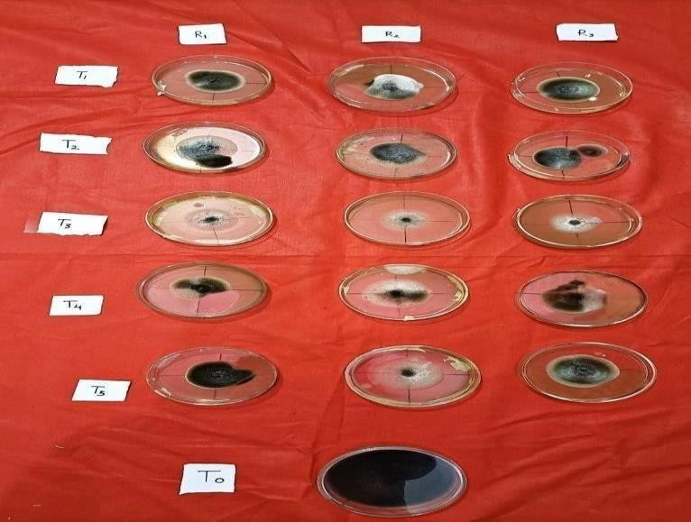

Fig.1 Efficacy of plant extract on percent mycelial inhibition of Alternaria porri by poisoned food technique

Effect of T. harzianum on mycelial growth of A. porri
In comparison to the untreated control (0%), the data showed that the bioagent tested demonstrated antifungal action against A. porri and greatly suppressed its growth. The test pathogen exhibited the greatest mycelial growth suppression (76.30 mm), indicating that T. harzianum was the most effective antibiosis controlling Trichoderma harzianum. (Vinale and others, 2008) Trichoderma spp. were tested for efficacy using the dual culture technique, and it was discovered that they produced secondary metabolites such as 6-pentyl- alpha-pyrone (6pp), iso-cyanide derivatives, acids (heptadic and koningic acid), peptaibols, and cell wall degrading enzymes (CDWE), all of which are involved in the growth inhibition of many phytopathogenic fungi.
Table-2 Effect of T. harzianum against mycelial inhibition of Alternaria porri

(%) percent inhibition
Treatment No. | Treatment details | R1 | R2 | R3 | Mean
T1 | Trichoderma harzianum | 76.30 | 75.10 | 75.50 | 75.63
T0 | Control | 0.00 | 0.00 | 0.00 | 0.00
 | SE(m) |  |  |  | 0.36
 | CD (5%) |  |  |  | 1.14

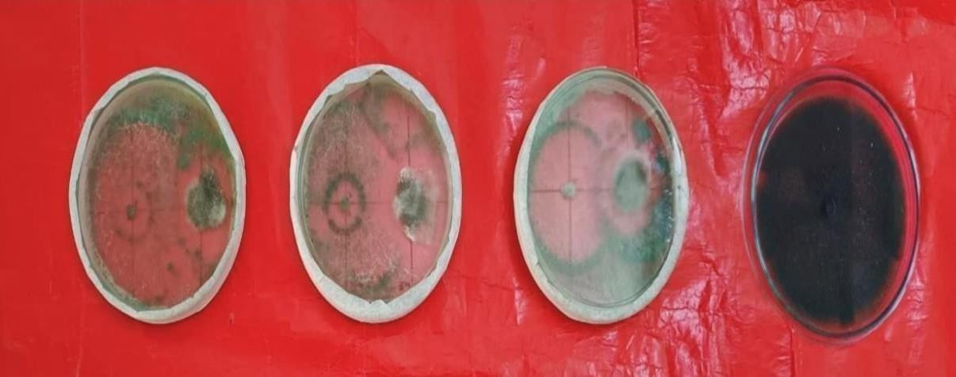

Fig.2 T. harzianum shows mycoparasitism over Alternaria porri

Effects of treatments on plant height at 90 DAS
In the present findings, the data on plant height at 90 DAS reveals that plant height(cm) significantly increased in- T3 (T. harzianum + Eucalyptus leaf extract – 46.35cm) followed by T6 (T. harzianum + Neem leaf extract –42.54cm), T1 (T. harzianum –41.91cm), T2 (T. harzianum + Lantana leaf extract – 40.11cm), T5 (T. harzianum + Datura leaf extract – 39.01cm) and T4 (T. harzianum + Tulsi leaf extract – 38.05cm) as compared to T7 (Treated Check) (Mancozeb + Tebuconazole – 51.30cm) as well as non- treated check -T0 (control- 32.14cm).

Effects of treatments on number of leaves at 90 DAS
In the present findings, the data on plant height at 90 DAS reveals that the number of leaves significantly increased in- T3 (T. harzianum + Eucalyptus leaf extract – 9.73) followed by T6 (T. harzianum + Neem leaf extract –9.40), T1 (T. harzianum –9.06), T2 (T. harzianum + Lantana leaf extract –8.80), T5 (T. harzianum + Datura leaf extract –8.40) and T4 (T. harzianum + Tulsi leaf extract – 8.26) as compared to T7 (Treated Check) (Mancozeb + Tebuconazole – 10.13) as well as non-treated check -T0 (control-7.73).

Effects of treatments on disease intensity at 75 DAS
In the present findings, the data on disease intensity at 75 DAS reveals that the disease intensity (%) significantly decreased in -T3 ( T. harzianum + Eucalyptus leaf extract – 28.34%) followed by T6 (T. harzianum + Neem leaf extract – 30.08%), T1 (T. harzianum – 31.11%), T2 (T. harzianum + Lantana leaf extract – 32.37%), T5 (T. harzianum + Datura leaf extract – 33.52%) and T4 (T. harzianum + Tulsi leaf extract – 34.90%) as compared to T7 (Treated Check) (Mancozeb + Tebuconazole – 25.88%) as well as non-treated check -T0 (control-39.20%).

Effects of treatments on yields (t ha-1)
In the present findings, the data on yield reveals that after harvest, maximum yield was observed in -T3 (T. harzianum + Eucalyptus leaf extract –5.41t/ha ) followed by T6 (T. harzianum + Neem leaf extract – 11.50t/ha), T1 (T. harzianum –10.10t/ha), T2 (T. harzianum + Lantana leaf extract – 9.00t/ha), T5 (T. harzianum + Datura leaf extract –8.00 t/ha) and T4 (T. harzianum + Tulsi leaf extract –7.30t/ha) as compared to T7 (Treated Check) (Mancozeb + Tebuconazole – 14.17t/ha) as well as non-treated check - T0 (control-5.41t/ha)

Table 3 Effects of treatments on growth parameters

 |  | Per cent disease intensity |  |  | Plant height (cm) | No. of leaves | Yield  (t/ha)
Treatments | Treatment details | 45 DAS | 60 DAS | 75 DAS | 90 DAS | 90 DAS
T0 | Control | 12.33 | 30.45 | 39.20 | 32.14 | 7.73 | 5.41
T1 | Trichoderma harzianum + Trichoderma harzianum 10g/kg (S.T.) +10% (F.S.) | 7.40^{b} | 23.11^{cd} | 31.11^{cd} | 41.91ª | 9.06ª | 10.10ª
T2 | Trichoderma harzianum + Lantana leaf extract 10g/kg (S.T.) +10% (F.S.) | 8.17 | 24.06^{bc} | 32.37^{bc} | 40.11 | 8.80ª | 9.00
T3 | Trichoderma harzianum + Eucalyptus leaf extract 10g/kg (S.T.) +10% (F.S.) | 5.34 | 19.77 | 28.34 | 46.35 | 9.73 | 12.27
T4 | Trichoderma harzianum  +Tulsi leaf extract 10g/kg (S.T.) +10% (F.S.) | 9.26ª | 26.09ª | 34.90ª | 38.05^{b} | 8.26^{b} | 7.30^{b}
T5 | Trichoderma harzianum  +Datura leaf extract 10g/kg (S.T.) +10% (F.S.) | 8.98ª | 25.12^{ab} | 33.52^{ab} | 39.01^{b} | 8.40^{b} | 8.00^{b}
T6 | Trichoderma harzianum  +Neem leaf extract 10g/kg (S.T.) +10% (F.S.) | 6.66^{b} | 22.10^{d} | 30.08^{d} | 42.54ª | 9.40 | 11.00ª
T7 | Mancozeb +Tebuconazole (Treated check) | 3.73 | 16.51 | 25.88 | 51.30 | 10.13 | 14.17

The present results align with the studies carried out by Saxena et al. (2015) and Kanta et al. (2018). Eucalyptus globes have a good allelopathy impact, and their extracts are mostly composed of bioactive chemicals such phenolic acid and phytochemical makeup, according to Hedfi et al.'s

2014 study testing the efficacy of phytoextracts against Alternaria spp. A natural defense mechanism that strengthens the cell wall and promotes the synthesis of antifungal chemicals may be triggered by phenolic acid. The study conducted by Kishore et al. (2007) has verified that the inhibition of fungal growth, which prevents hyphal development and sporulation, interferes with food intake and metabolism, and induces lysis, is the cause of eucalyptus leaf extract control.
Through causing modifications to the composition of the cell wall, disruption of the plasma membrane, disarray of the mitochondrial structure, and interference with the respiratory enzymatic processes of the mitochondrial membrane, they are also accountable for the variation in fungal physiology. Numerous phytochemicals present in eucalyptus leaf extract, including phenolic diterpenes, flavonoids, organic compounds, and phenolic acid, disrupt the pathogen's cell and reduce the activity of specific enzymes required for fungi to multiply in the wild, ultimately leading to their death (Hedfi et al. 2014). Eucalyptus may therefore have an indirect effect on plant development and other growth-related factors.

Conclusions
According to the findings of the current study, "Efficacy of plant extracts and Trichoderma harzianum against purple blotch of garlic (Allium sativum L)," the bio-agent Trichoderma harzianum and Neem leaf extract outperformed the other plant extracts in vitro against Alternaria porri. The information shows that Trichoderma harzianum (S.T.) + Eucalyptus leaf extract (F.S.) had the highest plant height (cm), the most leaves, the yield (t/ha), and the lowest disease intensity (%).

Declaration

Conflict of interest on behalf of all authors, the corresponding author states that there is no conflict of interest.

References

Abdel-Hafez SII, Abo-Elyousr KAM, Abdel-Rahim IR (2014). Effectiveness of plant extracts to control purple blotch and Stemphylium blight diseases of onion (Allium cepa L.) in Assiut, Egypt. Archives of Phytopathology and Plant Protection, 47(3):377- 387.
Bisht IS, Agarwal RC (1993). Susceptibility to purple blotch (Alternaria porri) in garlic. Annals of Applied Biology, 122: 31-38.

Bisht IS, Thomas TA (1992). Field screening of garlic germplasm against purple blotch and Stemphylium blight. Indian Phytopathology, 45: 244-245.
Chethana BS, Ganeshan G, Rao AS, Bellishree K (2012). In vitro evaluation of plant extracts, bioagents and fungicides against Alternaria porri (Ellis) Cif. causing disease of onion. Pest Management in Horticultural Ecosystems, 18(2):194-198.
Dar AA, Sharma S, Mahajan R, Mushtaq M, Ahmad S, Sharma JP (2020). Overview of purple blotch disease and understanding its management through chemical, biological and genetic approaches. Journal of Integrated Agriculture, 19(12): 3013-3024.
Dicklow MB (2013). Storage diseases of onion and garlic. UMass Extension-Vegetable Program.
Etoh T, Simon PW (2002). Diversity, fertility and seed production of garlic. Allium crop science: Recent Advances. CAB International, Wallingford, UK, pp: 101-117.

Hajji-Hedfi L, Rhouma A, Hlaoua W, Dmitry KE, Jaouadi R, Zaouali Y, ebouh NY (2024). Phytochemical characterization of forest leaves extracts and application to control apple postharvest diseases. Scientific Reports, 14(1) :2014.

Hausbeck MK, Hartwell J, Byrne JM (1999). Epidemiology of Stemphylium leaf spot and purple spot in no till asparagus. Acta Horticulture, 479: 205-210.

Jabeen R, Manzoor M, Irfan S, Iftikhar T (2013). Potential of azadirachtin-d fraction against bacterial leaf blight disease in rice caused by Xanthomonas oryzae pv. oryzae. Pakistan Journal of Botany, 45(5): 1789-1794.
Kamenetsky R, Rabinowitch HD (2001). Floral development in bolting garlic.

Kanta SA (2020). Management of purple blotch and white blotch of onion using chemicals, micronutrients, and botanicals (doctoral dissertation, department of plant pathology).
Kishore GK, Pande S, Harish S (2007). Evaluation of essential oils and their components for broad- spectrum antifungal activity and control of late leaf spot and crown rot diseases in peanut. Plant disease, 91(4): 375-379.

Kumar TP, Palakshappa MG (2008). Management of purple blotch of onion through bioagents. Karnataka Journal of Agricultural Sciences, 21(2): 306- 308.

Mayee CD, VV Datar (1986). Phytopathometry. Tech Bulletin.1(Special Bulletin3), Marathwada Agricultural University Parbhani, Maharashtra, India. Minnesota, pp: 95-239.
Memane PG, Tomar RS, Kakade DK, Kulkarni GU, Chovatia RS (2008). Effect of clove weight and plant growth regulators on growth and yield of garlic (Allium sativum L.) cv GG 3. The Asian Journal of Horticulture, 3(1): 82-86.

Nene YL, Thapliyal PN (1993). Evaluation of fungicides. In: Fungicides in Plant Disease Control (3rd ed.), Oxford IBH Pub. Co., New Delhi, pp : 31.
Nolla JAB (1927). A new Alternaria disease of onions (Allium cepa L.) Phytopathology 17:115- 137.
Prahlad A, Godara SL, Kumhar DR, Chawla N (2021). Prevalence and management of major diseases of garlic is it global level: A review. Agricultural Reviews, 42(1): 1-8.
Priya RU, Sataraddi AR, Kavitha TR (2018). Studies on cultural and physiological variability of Alternaria porri (Ellis) Cif. - a causative of purple blotch of onion (Allium cepa L.).
International Journal Current Microbiology Applied Science, 7(8): 3284-3291.

Saxena S (2015). Studies on antifungal activity of phytoextracts against purple blotch disease of onion (Allium Cepa L.) PhD (Ag.) Thesis, Agra Department of Botany, Dr B R Ambedkar University Agra. Sexual Reproduction, (4): 235-241.
Tuite J (1969). Plant Pathological Methods. Fungi and Bacteria. Burgess: Minneapolis.

Vinale F, Sivasithamparam K, Ghisalberti EL, Marra R, Barbetti MJ, Li H, Lorito M (2008). A novel role for Trichoderma secondary metabolites in the interactions with plants.
Physiological and Molecular Plant Pathology, 72(1-3): 80-86.

Vincent JM (1947). Distortion of fungal hyphae in the presence of certain inhibitors, Nature.

Wheeler BEJ (1969). An Introduction to plant disease. John Wiley and Sons Limited London. 301.

