Original Research Article
Synergistic Effect of Organic, Inorganic, and Biofertilizers on Growth and Productivity of Chilli

.ABSTRACT

Aims:
To evaluate the effect of integrated nutrient management on growth and yield attributes of chilli (Capsicum annuum L.) under subtropical conditions of Uttar Pradesh, India.
Study design:
Field experiment in a randomized block design with three replications conducted over two consecutive Rabi seasons.
Place and Duration of Study:
Vegetable Research Farm, Department of Horticulture, Institute of Agricultural Sciences, Banaras Hindu University (BHU), Varanasi, India, during 2022–2023 and 2023–2024.
Methodology:
Thirteen treatments combining inorganic fertilizers, organic manures (vermicompost, farmyard manure, poultry manure) and biofertilizers (Azospirillum + phosphate solubilizing bacteria) were evaluated. Growth parameters (plant height, primary branches, leaf area index, internodal length) at 30DAT, reproductive traits (number of fruits per plant), and fruit yield per plot were recorded. Data were analyzed using pooled ANOVA, with SEm and LSD, calculated. Line graphs and heatmaps visualized treatment responses.
Results:
INM significantly enhanced vegetative and reproductive traits compared to sole organic, inorganic, or no fertilizer. Treatments T₅ (RDF 50% + vermicompost 50% + biofertilizers) and T₇ (RDF 50% + poultry manure 50% + biofertilizers) produced the tallest plants (24.02 cm), highest branching (4.87), greater leaf area index (0.70), more fruits per plant (210), and highest fruit yield per plot (21.54 kg), whereas the control (T₁₃) recorded the lowest values. Year-wise trends and heatmaps confirmed the consistency of INM effects.
Conclusion:
Combining organic manures, chemical fertilizer and biofertilizers effectively improves chilli growth, fruit set, and yield. INM is a sustainable strategy for enhancing productivity and maintaining soil fertility under subtropical conditions.

Keywords: Integrated nutrient management, chilli, organic manures, biofertilizers, soil fertility, yield attributes, sustainable agriculture, vegetative growth

1. INTRODUCTION
Soil fertility depletion is one of the major factors limiting chilli (Capsicum annuum L.) productivity in India and many other tropical and subtropical regions (Votava and Bosland, 2002). Soils is often deficient in essential macro- and micronutrients and have low organic matter content, which adversely affects chilli growth and yield. Studies have shown that imbalanced nutrient removal through harvest and continuous cultivation has led to depletion of nitrogen (N), phosphorus (P), potassium (K) and micronutrients such as zinc (Zn) and boron (B), reducing soil fertility and productivity.
The application of chemical fertilizers such as urea (46% N), di-ammonium phosphate (DAP: 18% N, 46% P₂O₅) and muriate of potash (MOP: 60% K₂O) is the common practice to maintain soil fertility for chilli production (Shashidhara et al., 2007). However, many smallholder farmers apply fertilizers at sub-optimal rates due to high cost, limited access and lack of soil- and crop-specific recommendations (Sujana et al., 2019). Nationally, average fertilizer application in chilli is far below the recommended dose, which limits yield potential and leads to further depletion of secondary and micronutrients when N and P are applied alone (Khurshid et al., 2021). Although blended fertilizers containing S, Zn and B have been introduced, continuous reliance on chemical fertilizers alone is unsustainable and may result in soil acidification, loss of organic matter and deterioration of soil health (Liu et al., 2010).
Evidence suggests that organic amendments such as farmyard manure, poultry manure, compost and vermicompost improve soil physical, chemical and biological properties, increase water-holding capacity, nutrient availability and enhance crop growth and yield (Arancon et al., 2005; Densilin et al., 2011). Nevertheless, small-scale farmers face limitations in using adequate quantities of organic inputs due to scarcity of materials, competing uses as animal feed or fuel, labour constraints and bulkiness of organic fertilizers (Abunyewa et al., 2007; Rao and Tilak, 1977). Therefore, the use of organic amendments alone cannot meet the nutrient demand of a high-value crop like chilli. In this context, the integration of biofertilizers such as phosphate solubilizing bacteria (PSB) and other beneficial microbial inoculants offers a sustainable option, as they not only improve nutrient solubilization and availability (particularly phosphorus), but also stimulate root growth, enhance microbial activity, and complement the nutrient supply from organic and inorganic sources, thereby improving crop productivity in a cost-effective and eco-friendly manner (Vanlauwe et al., 2010; Sujana et al., 2019). However, adoption of INM practices for chilli is still low in many regions, and location-specific recommendations for optimal combinations of organic manures, inorganic fertilizers and biological nutrient sources are lacking. Therefore, this study was designed to evaluate the effect of integrated nutrient management on growth and yield attributes of chilli in Uttar Pradesh.
2. experimental details

2.1 Study Area
The study was conducted at the Vegetable Research Farm, Department of Horticulture, Institute of Agricultural Sciences, Banaras Hindu University (BHU), Varanasi, Uttar Pradesh, India, during the Rabi seasons of 2022–2023 and 2023–2024. Varanasi is located at 25°10′ N latitude and 83°03′ E longitude at an elevation of 86 m above mean sea level. The experimental site lies in the North Gangetic Alluvial Plain and features well-drained alluvial soils with uniform topography, making it ideal for horticultural experimentation. The region experiences a humid subtropical climate, with hot summers (April–June), a monsoon period (July–mid October), and cool winters (late October–February). During the study period, maximum and minimum temperatures ranged from 32–45°C and 6–9°C, respectively, with an annual rainfall of approximately 1,110 mm (Fig. 1). Weekly meteorological data, including temperature and rainfall, were recorded at the BHU meteorological observatory.

2.2 Soil Characteristics
Before planting, composite soil samples were collected from 0–15 cm depth and analysed for physical and chemical properties. The soil was sandy clay loam, slightly alkaline (pH 7.78–7.85), with 0.44–0.45% organic carbon and low to medium levels of available nitrogen (200–205 kg ha⁻¹), phosphorus (26.5–27.8 kg ha⁻¹), and potassium (190–192 kg ha⁻¹). Post-harvest soil samples were also collected from each plot to assess changes in nutrient status due to integrated nutrient management (INM). All analyses were performed following standard laboratory methods (Bremner and Mulvaney, 1982; Olsen et al., 1954; Mehlich, 1984; Van

Reeuwijk, 2002).

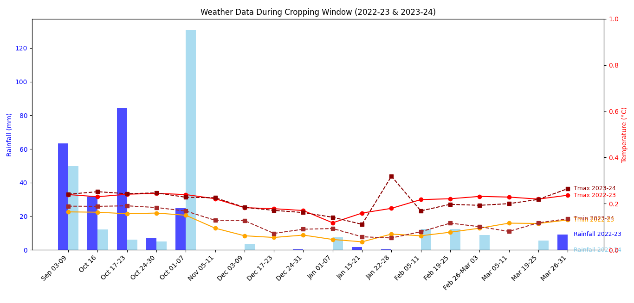

Fig. 1. Weekly distribution of rainfall (mm), maximum temperature (°C), and minimum temperature (°C) during the cropping seasons of chilli in 2022–23 and 2023–24.

2.3 Experimental Material, Treatments and Experimental Design

The experiment was conducted on chilli (Capsicum annuum L.) variety Kashi Anmol, known for its high yield potential and adaptability to subtropical conditions. The experiment consisted of 13 treatments (Table 1), combining inorganic fertilizers, organic manures, and biofertilizers (Azospirillum + Phosphate Solubilizing Bacteria). Treatments were arranged in a Randomized Block Design (RBD) with three replications. Each treatment was applied to a 3 × 3 m plot containing 25 plants, planted at 60 × 45 cm spacing to ensure uniform growth, aeration, and nutrient uptake.
Table 1: List of Treatment Details
Symbol | Treatment Description
T₁ | Vermicompost (100% @ 6 t/ha)
T₂ | Farmyard Manure (100% @ 25 t/ha)
T₃ | Poultry Manure (100% @ 5 t/ha)
T₄ | RDF (100% @ 150 kg N, 60 kg P₂O₅, 60 kg K₂O/ha)
T₅ | RDF (50%) + VC (50%) + Azospirillum and PSB (100%) @ 2.5 kg/ha each
T₆ | RDF (50%) + FYM (50%) + Azospirillum and PSB (100%) @ 2.5 kg/ha each
T₇ | RDF (50%) + PM (50%) + Azospirillum and PSB (100%) @ 2.5 kg/ha each
T₈ | RDF (50%) + 16.6% VC + 16.6% FYM + 16.6% PM + Azospirillum and PSB (100%) @ 2.5 kg/ha each
T₉ | RDF (25%) + VC (75%) + Azospirillum and PSB (100%) @ 2.5 kg/ha each
T₁₀ | RDF (25%) + FYM (75%) + Azospirillum and PSB (100%) @ 2.5 kg/ha each
T₁₁ | RDF (25%) + PM (75%) + Azospirillum and PSB (100%) @ 2.5 kg/ha each
T₁₂ | RDF (25%) + 25% VC + 25% FYM + 25% PM + Azospirillum and PSB (100%) @ 2.5 kg/ha each
T₁₃ | Control (no fertilizer or manure)

2.5 Agronomic Practices and Observations
Uniform agronomic practices, including irrigation, weeding, staking, and pest management, were followed across all treatments. Bio-fertilizers were applied at 2.5 kg ha⁻¹ according to the treatment schedule. Fruits were harvested at full maturity for yield and quality assessment. Growth, yield, and yield-contributing traits were recorded, including plant height at 30 days after transplanting (PH30DAT, cm), number of primary branches per plant (NPB30DAT), leaf area index (LAI30DAT, m²), inter-nodal length (IL30DAT, cm), number of fruits per plant (NFPP), and fruit yield per plot (FYPP, kg). These parameters provided comprehensive insights into the performance and productivity of chilli under different nutrient management strategies.
2.6 Statistical Analysis
The experimental data recorded on growth and yield attributes of chilli under different integrated nutrient management (INM) treatments were subjected to analysis of variance (ANOVA) following the standard procedure for randomized block design (RBD) as described by Panse and Sukhatme (1985). Pooled analysis of variance was performed over two years to evaluate the consistency of treatment effects across environments. The significance of treatment differences was tested using the F-test at 5% probability level. The standard error of mean (SEm ±) and least significant difference (LSD) at 5% probability level were calculated to facilitate comparison of treatment means wherever the F-test was significant. The critical difference (CD) values were also computed to identify the magnitude of difference required for statistical significance. Statistical computations were carried out using OPSTAT and R-studio.
3. results and discussion
The effect of different combinations of integrated nutrient management had significantly affected the growth and yield attributes. The observations are presented in Table 2

3.1 Plant Height (PH) at 30 DAT
During 2022–23, PH ranged from 18.39 cm (T₁₃) to 24.20 cm (T₄). Treatments T₈ (23.00 cm), T₃ (22.03 cm), T₁₀ (22.64 cm), T₁ (22.01 cm), and T₅ (22.41 cm) were statistically comparable to the maximum. In 2023–24, PH varied from 18.47 cm (T₁₂) to 24.20 cm (T₄). The tallest plants were recorded in T₄ (24.20 cm), followed by T₈ (23.00 cm), T₁₀ (22.64 cm), T₅ (22.41 cm), and T₉ (22.30 cm), all statistically similar. The F-test (p = 0.10) confirmed homogeneity of error variance, supporting pooled analysis. Pooled data showed the maximum PH in T₄ (24.02 cm), followed by T₈ (22.45 cm), both statistically at par. The lowest PH was observed in T₁₃ (18.51 cm), with an overall pooled mean of 21.18 cm. These results indicate enhanced early growth under nutrient-managed conditions.
These findings are in agreement with earlier reports where combined application of chemical fertilizers and organic amendments significantly improved plant height and vegetative traits in tomato and chilli. The improvement in PH under INM is attributed to enhanced nutrient availability, particularly nitrogen, which promotes cell division and elongation, and phosphorus, which supports root development and overall vigor (Singh et al., 2020). Biofertilizers such as Azospirillum and phosphate solubilizing bacteria (PSB) may also have contributed by improving nitrogen fixation and phosphorus solubilization, thus enhancing nutrient uptake efficiency (Kumar et al., 2019).

3.2 Number of Primary Branches (NPB) at 30 DAT
The number of primary branches per plant is a critical vegetative trait that influences canopy architecture, light interception and potential fruit-bearing sites in chilli (Table 2). During 2022–23, NPB ranged from 2.59 (T₁₃) to 4.07 (T₅). Treatments T₉ (3.93), T₁₁ (3.89), T₆ (3.88), T₄ (3.81), T₁ (3.73), T₈ (3.65), T₇ (3.56), T₃ (3.55), T₂ (3.45), and T₁₀ (3.44) were statistically comparable to the maximum. In 2023–24, NPB ranged from 3.26 (T₁₃) to 5.67 (T₅), followed by T₇ (4.70) and T₈ (4.17). None of the treatments were statistically at par with T₅. The F-test (P = 0.23) confirmed homogeneity of error variance, supporting pooled analysis. Pooled data showed the maximum NPB in T₄ (4.87), followed by T₇ (4.13) and T₉ (4.02). The lowest was consistently observed in T₁₃ (2.93). The overall pooled mean was 3.80 branches, indicating moderate branching under nutrient-managed conditions.
The observed increase in primary branches under INM can be explained by the balanced supply of nutrients, particularly nitrogen, which stimulates axillary bud differentiation and elongation in chilli plants (Kumar et al., 2020). Organic amendments such as vermicompost and poultry manure improve soil structure, moisture retention, and microbial activity, which indirectly promotes vegetative growth and branch proliferation (Singh et al., 2018). Biofertilizers like Azospirillum and PSB enhance root development and nutrient uptake efficiency, further supporting the formation of additional branches (Ramesh et al., 2021). The pooled analysis across two growing seasons confirmed the consistency of INM effects under varying environmental conditions. Treatments that ensured adequate and balanced nutrient supply resulted in improved canopy development, while nutrient omission (control) restricted branching, potentially limiting light interception and subsequent photosynthesis. These findings align with previous reports in chilli, where INM combining organic and inorganic sources of nutrients improved vegetative growth, including the number of primary branches, ultimately supporting higher flowering and fruit set (Jain et al., 2019; Sharma et al., 2022). Enhanced branching is directly correlated with higher flowering sites and fruit-bearing potential, thereby contributing to improved yield in chilli.

3.3 Leaf Area Index (LAI, m²) at 30 DAT
Leaf area index (LAI) reflects the canopy development and photosynthetic potential of chilli plants. In this study, INM treatments significantly increased LAI compared to control, indicating improved leaf expansion and light interception (Table 2). During 2022–23, LAI ranged from 0.66 (T₁₃) to 0.72 (T₅). Treatments T₇ (0.72), T₆ (0.71), and T₄ (0.70) were statistically comparable to the maximum. Treatments T₉, T₁₀, T₁₁ (0.69) and T₁, T₃, T₈, T₁₂ (0.67) formed a second statistical group. In 2023–24, LAI ranged from 0.56 (T₁₃) to 0.69 (T₅, T₇), followed by T₆ (0.68). Treatments T₄, T₉ (0.68) and T₁₀, T₁, T₃, T₈, T₁₁, T₁₂ (0.67) were statistically comparable. The F-test (P = 0.26) confirmed homogeneity of error variance, supporting pooled analysis. Pooled data showed the highest LAI in T₅, T₆, and T₇ (0.70), followed by T₄ (0.69), all statistically similar. Treatments T₉, T₁₀, T₁₁ (0.68) and T₁, T₃, T₈, T₁₂ (0.67) formed the next group, significantly higher than T₁₃ (0.61). The overall pooled mean LAI was 0.68, indicating moderate leaf development under nutrient-managed conditions. Enhanced LAI under INM can be attributed to improved nutrient availability, particularly nitrogen and potassium, which promote leaf expansion and chlorophyll synthesis (Kumar et al., 2020). Organic amendments improve soil structure and water retention, supporting sustained leaf growth, while biofertilizers enhance nutrient uptake efficiency (Ramesh et al., 2021). Higher LAI contributes to better light interception, increased photosynthesis, and ultimately higher reproductive success in chilli (Singh et al., 2018).
3.4 Inter-nodal Length (IL, cm)
Inter-nodal length is a key indicator of stem elongation and canopy architecture. The effect of integrated nutrient management on inter-nodal length was evaluated at 30 DAT over two years (2022–23 and 2023–24) (Table 2). During 2022–23, internodal length ranged from 3.36 cm (T₁₀) to 3.82 cm (T₁₃). Treatments T₄ (3.78), T₆ (3.77), T₅ (3.74), T₁₂ (3.72), T₁₁ (3.71), T₁ (3.70), T₃ (3.69), T₉ (3.68), T₈ (3.66), and T₇ (3.64) were statistically comparable to the control (T₁₃). In 2023–24, internodal length ranged from 3.49 cm (T₁, T₄) to 3.82 cm (T₁₃). Treatments T₁₂ (3.68), T₃ (3.51), T₈ (3.51), T₄ (3.49), and T₁ (3.49) were statistically at par with the control. The F-test (P = 0.17) indicated homogeneous error variance, supporting pooled analysis. Pooled data showed the highest internodal length in T₁₃ (3.82), followed by T₁₂ (3.70) and T₄ (3.63), all statistically similar. The lowest was observed in T₂ (3.02), with a pooled mean of 3.54 cm.
In the present study, the control (T₁₃) exhibited the longest internodes, while treatments with balanced nutrient management showed moderate internodal length. Excessive internode elongation in control may reflect etiolation due to nutrient deficiency (particularly nitrogen and potassium) that limits balanced vegetative development (Sharma et al., 2022). Moderate internodal length in INM treatments ensures compact canopy architecture, improving mechanical support and reducing lodging risk. The combined use of organic manures and biofertilizers likely contributed to better nutrient uptake and uniform vegetative growth, as also reported by Kumar et al. (2020) and Ramesh et al. (2021). Properly spaced internodes optimize leaf display and light penetration, enhancing photosynthetic efficiency and reproductive success.

3.5 Number of Fruits per Plant (NFP)
The effect of integrated nutrient management on the number of fruits per plant (NFP) was devaluated over two consecutive years (2022–23 and 2023–24). Table 2 presents that during 2022–23, NFP ranged from 195.33 (T₁₃) to 211 (T₅). The highest NFP was observed in T₅ (211), followed by T₆ (210.33), T₇ (210.33), T₄ (210), T₉ (210), and T₁₁ (210), which were statistically at par. The lowest NFP was recorded in T₁₃ (195.33). The year mean was 207.44. In 2023–24, NFP ranged from 192.67 (T₁₃) to 209 (T₅). The highest NFP was recorded in T₅ (209), followed by T₇ (207), T₆ (205.33), T₄ (204.67), T₉ (202.67), T₁₀ (202), and T₁₁ (202), which were statistically comparable. The lowest NFP was observed in T₁₃ (192.67). The year mean was 202.1. A non-significant F-test (P = 0.21) confirmed homogeneous error variance across years, supporting pooled analysis. Pooled data revealed the highest NFP in T₅ (210), followed by T₇ (208.67), T₆ (207.83), T₄ (207.33), T₉ (206.3), T₁₁ (202), and T₁₀ (202), all statistically at par. The lowest pooled NFP was observed in T₁₃ (194). The overall pooled mean NFP was 204.77 fruits per plant, with LSD (5%) = 4.72, CV = 1.83%, and SEm = 1.65, indicating high precision and consistency across years. Enhanced NFP can be attributed to improved vegetative vigor, higher LAI, and better branching, which together create more potential sites for flowering and fruit set (Jain et al., 2019; Sharma et al., 2022). Biofertilizers improve root development and nutrient uptake, ensuring adequate supply of nitrogen, phosphorus, and potassium during flowering, which is critical for ovule development and fruit set (Ramesh et al., 2021). The pooled data across seasons confirm that INM enhances reproductive efficiency in chilli even under variable environmental conditions.

3.6 Fruit Yield per Plot (FYPP, kg)
The effect of integrated nutrient management on fruit yield per plot was evaluated during two growing years are presented in Table 2. During 2022–23, FYPP ranged from 16.19 kg (T₁₃) to 21.40 kg (T₇). The highest FYPP was observed in T₇ (21.40 kg), followed by T₅ (20.67 kg) and T₉ (20.41 kg), which were statistically similar. The lowest FYPP occurred in T₁₃ (16.19 kg). The year mean was 18.8 kg, with LSD (5%) = 2.8 kg, CV = 8.85%, and SEm = 0.96 kg. In 2023–24, FYPP ranged from 14.92 kg (T₁₃) to 21.89 kg (T₅). The highest FYPP was recorded in T₅ (21.89 kg), closely followed by T₇ (21.68 kg) and T₆ (21.55 kg), which were statistically at par. The lowest FYPP was observed in T₁₃ (14.92 kg). The year mean was 19.2 kg, with LSD (5%) = 2.43 kg, CV = 7.5%, and SEm = 0.83 kg, indicating moderate variation and acceptable precision.A non-significant F-test (P = 0.24) confirmed homogeneous error variance across years, validating pooled analysis. Pooled data revealed the highest FYPP in T₇ (21.54 kg), followed by T₅ (21.28 kg), T₆ (20.42 kg), and T₉ (20.31 kg), which were statistically comparable. The lowest pooled FYPP was recorded in T₁₃ (15.56 kg). The overall pooled mean FYPP was 19.0 kg, with LSD = 1.87 kg, CV = 7.82%, and SEm = 0.64 kg, confirming consistency and precision across years.
Fruit yield per plot, the ultimate economic trait, was significantly influenced by integrated nutrient management. Treatments combining inorganic fertilizers with organic manures and biofertilizers (T₅ and T₇) consistently outperformed control (T₁₃) across two years and pooled data. Increased FYPP under INM is a direct outcome of improved vegetative growth (plant height, branching, LAI) and higher fruit numbers, creating more sites for fruit development and better assimilate partitioning to fruits (Kumar et al., 2020; Jain et al., 2019). The synergistic effect of organics, inorganics, and biofertilizers ensures slow and sustained nutrient release, improving flowering, fruit set, and fruit development in chilli (Ramesh et al., 2021). The consistency across years confirms the robustness of INM in enhancing chilli productivity under variable climatic conditions. These results align with prior studies demonstrating that combined nutrient management significantly improves chilli yield compared to sole chemical or organic fertilization (Singh et al., 2018; Sharma et al., 2022).

Table 2. Effect of Integrated Nutrient Management on key growth and quality attributes of chilli (year wise and pooled data of 2022–23 and 2023–24).
Treatment | Plant Height at 30 DAT (PH; cm) |  |  | Number of primary branches per plant at 30 DAT (NPB) |  |  | Leaf Area Index at 30 DAT (LAI; m²) |  |  | Inter-nodal length at 30 DAT (IL; cm) |  |  | Number of fruit per plant |  |  | Fruit yield per plot (FYPP; kg)
Treatment | 2022-2023 | 2023-2024 | Pooled | 2022-2023 | 2023-2024 | Pooled | 2022-2023 | 2023-2024 | Pooled | 2022-2023 | 2023-2024 | Pooled | 2022-2023 | 2023-2024 | Pooled | 2022-2023 | 2023-2024 | Pooled
T₁ | 21.46 | 22.01 | 21.73 | 3.73 | 3.49 | 3.61 | 0.67 | 0.67 | 0.67 | 3.7 | 3.49 | 3.6 | 200.3 | 206.7 | 203.5 | 18.04 | 18.26 | 18.15
T₂ | 19.73 | 20.97 | 20.35 | 3.45 | 3.67 | 3.56 | 0.67 | 0.62 | 0.65 | 3.53 | 2.51 | 3.02 | 199 | 203.3 | 201.2 | 17.25 | 16.65 | 16.95
T₃ | 21.67 | 22.03 | 21.85 | 3.55 | 3.55 | 3.55 | 0.67 | 0.67 | 0.67 | 3.69 | 3.51 | 3.6 | 200 | 206.3 | 203.2 | 17.86 | 17.28 | 17.57
T₄ | 23.83 | 24.2 | 24.02 | 3.81 | 3.83 | 3.82 | 0.7 | 0.68 | 0.69 | 3.78 | 3.49 | 3.63 | 204.7 | 210 | 207.3 | 18.83 | 20.45 | 19.64
T₅ | 21.13 | 22.41 | 21.77 | 4.07 | 5.67 | 4.87 | 0.72 | 0.69 | 0.7 | 3.74 | 3.28 | 3.51 | 209 | 211 | 210 | 20.76 | 22.31 | 21.54
T₆ | 20.83 | 21.41 | 21.12 | 3.88 | 4.1 | 3.99 | 0.71 | 0.68 | 0.7 | 3.77 | 3.34 | 3.55 | 205.3 | 210.3 | 207.8 | 19.29 | 21.55 | 20.42
T₇ | 19.4 | 21.52 | 20.46 | 3.56 | 4.7 | 4.13 | 0.72 | 0.69 | 0.7 | 3.64 | 3.45 | 3.55 | 207 | 210.3 | 208.7 | 20.88 | 21.68 | 21.28
T₈ | 21.9 | 23 | 22.45 | 3.65 | 4.17 | 3.91 | 0.68 | 0.67 | 0.68 | 3.66 | 3.51 | 3.59 | 201.3 | 207.7 | 204.5 | 18.32 | 18.83 | 18.57
T₉ | 19.67 | 22.3 | 20.98 | 3.93 | 4.1 | 4.02 | 0.69 | 0.68 | 0.68 | 3.68 | 3.44 | 3.56 | 202.7 | 210 | 206.3 | 20.41 | 20.2 | 20.31
T₁₀ | 21.63 | 22.64 | 22.14 | 3.44 | 3.8 | 3.62 | 0.68 | 0.67 | 0.68 | 3.36 | 3.3 | 3.33 | 202 | 208.7 | 205.3 | 18.55 | 19.3 | 18.93
T₁₁ | 20.14 | 21.66 | 20.9 | 3.89 | 3.66 | 3.78 | 0.69 | 0.67 | 0.68 | 3.71 | 3.45 | 3.58 | 202 | 210 | 206 | 19.53 | 20.12 | 19.82
T₁₂ | 18.47 | 19.72 | 19.1 | 3.35 | 4 | 3.68 | 0.68 | 0.67 | 0.67 | 3.72 | 3.68 | 3.7 | 201.3 | 207 | 204.2 | 18.12 | 18.49 | 18.31
T₁₃ (Control) | 18.63 | 18.39 | 18.51 | 2.59 | 3.26 | 2.93 | 0.66 | 0.56 | 0.61 | 3.82 | 3.82 | 3.82 | 192.7 | 195.3 | 194 | 16.19 | 14.92 | 15.56
Mean | 20.65 | 21.71 | 21.18 | 3.61 | 4 | 3.8 | 0.69 | 0.66 | 0.68 | 3.68 | 3.41 | 3.54 | 202.1 | 207.44 | 204.77 | 18.8 | 19.2 | 19
CD at 5% | 2.75 | 2.11 | 1.7 | 0.65 | 0.56 | 0.82 | 0.04 | 0.07 | 0.05 | 0.28 | 0.34 | 0.41 | 7.38 | 6.22 | 4.72 | 2.8 | 2.43 | 1.87
C.V. | 7.9 | 5.77 | 6.39 | 10.69 | 8.3 | 9.35 | 3.83 | 7.87 | 6.07 | 4.53 | 5.99 | 5.19 | 2.17 | 1.78 | 1.83 | 8.85 | 7.5 | 7.82
SEm | 0.94 | 0.72 | 0.59 | 0.22 | 0.19 | 0.15 | 0.015 | 0.043 | 0.017 | 0.1 | 0.12 | 0.08 | 2.53 | 2.13 | 1.65 | 0.96 | 0.83 | 0.64

3.7 Graphical and Heatmap Analysis
Year-wise line graphs (Figs. 2) indicated slightly higher plant height and number of fruits per plant in 2023–24 compared to 2022–23, reflecting favourable seasonal conditions. The relative performance of treatments remained consistent, with T₅ and T₇ outperforming others in both years.
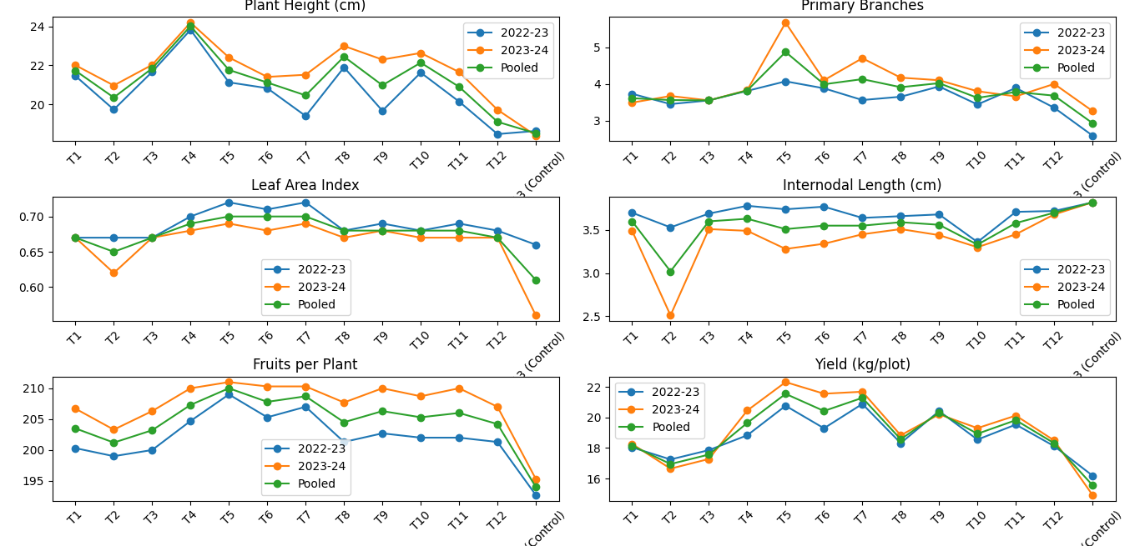
Fig. 2. Year-wise (2022–23, 2023–24) and pooled performance of chilli under different INM treatments for key growth and yield attributes.
The pooled heatmap (Fig. 3) illustrated treatment responses across all traits. T₅ and T₇ exhibited darker intensities for NPB, NFP, and FYPP, indicating superior performance, while T₁₃ consistently showed lighter shades, highlighting poor growth and yield without nutrient supplementation. The heatmap, together with the line graphs, provides a holistic overview, confirming the effectiveness of integrated nutrient management in enhancing early growth and productivity of the crop. Conversely, the control (T₁₃) consistently exhibited the lowest intensities across most traits, reflecting poor growth and yield without nutrient supplementation. These findings are in line with Kumar et al. (2020) and Jain et al. (2019).
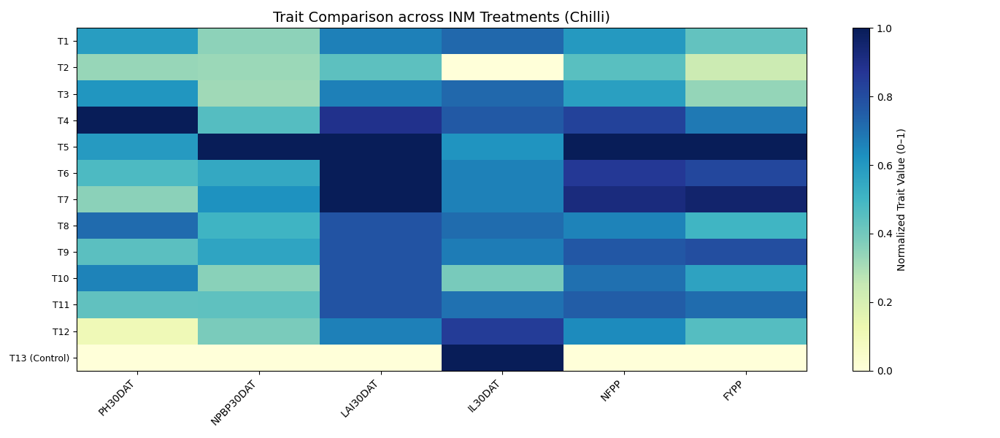
Fig. 3. Effect of Integrated nutrient management on chilli growth and yield attributes

4. Conclusion

Integrated nutrient management (INM) significantly improved the growth and yield attributes of chilli. Treatments T₅ (RDF 50% + Vermicompost 50% + Biofertilizers) and T₇ (RDF 50% + Poultry Manure 50% + Biofertilizers) consistently outperformed others, while the control (T₁₃) recorded the lowest values. The results confirm that combining organic manures, chemical fertilizers, and biofertilizers enhances chilli productivity and ensures sustainable nutrient management.

References
- Shashidhara, G. B., Babu, R., & Reddy, S. N. (2007). Effect of different levels of nitrogen and phosphorus on growth, yield and quality of chilli (Capsicum annuum L.). Karnataka Journal of Agricultural Sciences, 20(2), 385–387.
- Sujana, P., Kumar, M. R., & Reddy, S. S. (2019). Effect of integrated nutrient management on growth and yield of chilli (Capsicum annuum L.). International Journal of Chemical Studies, 7(1), 1182–1186.
- Khurshid, A., Singh, R. P., & Kumar, P. (2021). Nutrient management practices in chilli (Capsicum annuum L.) for sustainable production. Journal of Pharmacognosy and Phytochemistry, 10(1), 1412–1416.
- Liu, E., Yan, C., Mei, X., Zhang, Y., Fan, T., & Ruan, H. (2010). Long-term effect of chemical fertilizer, straw, and manure on soil chemical and biological properties in northwest China. Geoderma, 158(3–4), 173–180. https://doi.org/10.1016/j.geoderma.2010.04.029
- Arancon, N. Q., Edwards, C. A., Bierman, P., Welch, C., & Metzger, J. D. (2005). Influences of vermicomposts on field strawberries: 1. Effects on growth and yields. Bioresource Technology, 93(2), 145–153. https://doi.org/10.1016/j.biortech.2003.10.014
- Densilin, D. M., Muthumanickam, D., & Thamburaj, S. (2011). Effect of integrated nutrient management on growth, yield and quality of chilli (Capsicum annuum L.). Madras Agricultural Journal, 98(4–6), 155–158.
- Abunyewa, A. A., & Mercer-Quarshie, H. (2007). Response of maize to magnesium and zinc application in the semi-arid zone of West Africa. Asian Journal of Plant Sciences, 6(5), 787–791.
- Rao, A. V., & Tilak, K. V. B. R. (1977). Bacteria in the rhizosphere and their role in plant growth and yield. Plant and Soil, 47, 283–292.
- Vanlauwe, B., Descheemaeker, K., Giller, K. E., Huising, J., Merckx, R., Nziguheba, G., … Zingore, S. (2010). Integrated soil fertility management: Operational definition and consequences for implementation and dissemination. Outlook on Agriculture, 39(1), 17–24. https://doi.org/10.5367/000000010791169998
- Votava, E. J., & Bosland, P. W. (2002). Peppers: Vegetable and spice capsicums. Wallingford: CABI Publishing.
- Bremner, J. M., & Mulvaney, C. S. (1982). Nitrogen—Total. In A. L. Page (Ed.), Methods of soil analysis, Part 2: Chemical and microbiological properties (2nd ed., pp. 595–624). Madison: American Society of Agronomy.
- Olsen, S. R., Cole, C. V., Watanabe, F. S., & Dean, L. A. (1954). Estimation of available phosphorus in soils by extraction with sodium bicarbonate (USDA Circular 939). Washington, DC: U.S. Government Printing Office.
- Mehlich, A. (1984). Mehlich 3 soil test extractant: A modification of Mehlich 2 extractant. Communications in Soil Science and Plant Analysis, 15(12), 1409–1416. https://doi.org/10.1080/00103628409367568
- Van Reeuwijk, L. P. (2002). Procedures for soil analysis (6th ed.). Wageningen: International Soil Reference and Information Centre (ISRIC).
- Panse, V. G., & Sukhatme, P. V. (1985). Statistical methods for agricultural workers (4th ed.). New Delhi: Indian Council of Agricultural Research.
- Jain, S., Kumar, R., & Sharma, A. (2019). Effect of integrated nutrient management on growth and yield of chilli (Capsicum annuum L.). International Journal of Chemical Studies, 7(3), 2290–2294.
- Sharma, D., Singh, V., & Patel, R. (2022). Influence of integrated nutrient management on growth, yield and quality of chilli. Journal of Pharmacognosy and Phytochemistry, 11(2), 138–143.
- Singh, P., Meena, R. S., & Choudhary, S. (2018). Integrated nutrient management for sustainable chilli production. International Journal of Current Microbiology and Applied Sciences, 7(5), 1452–1460.
- Ramesh, K., Kumar, M., & Ali, S. (2021). Role of biofertilizers in vegetable production: A review. Journal of Applied and Natural Science, 13(3), 1052–1060.
- Kumar, R., Singh, A., & Yadav, S. (2020). Effect of organic and inorganic nutrient sources on growth and yield of chilli (Capsicum annuum L.). Indian Journal of Agricultural Research, 54(1), 77–82.
- Kumar, V., Sharma, A., & Singh, B. (2019). Effect of biofertilizers on growth, yield and quality of chilli (Capsicum annuum L.). Plant Archives, 19(2), 3071–3074.

