Original Research Article

Characterization of Fall Army Worm Damage Response in Maize Using Proximal Remote Sensing

ABSTRACT
In maize crops, the fall armyworm (FAW) (Spodoptera frugiperda) is a major invasive pest that causes significant economic losses. Traditional visual detection of pest infestations is labor-intensive, but spectral data related to plant damage can aid in automated detection. The main purpose of the study is to identify FAW infestation levels in maize using hyperspectral proximal remote sensing and machine learning. Nylon net cages were placed over maize plants in a field, and artificial FAW infestations were created. A handheld Apogee multispectral spectroradiometer (350–1150 nm) measured reflectance changes at varying FAW densities with a 1 nm spectral resolution. Reflectance result revealed that the visible zone (400–700 nm) was found to be directly related to FAW damage, increasing with the extent of damage. In contrast, reflectance in the near-infrared zone (700–1050 nm) exhibited an inverse trend due to different gradients of FAW damage in the maize canopy. The present findings revealed that significant wavebands 391–401, 411–440, 524–527, 568–577, 586–587, 597, 602–694, and 703–1050 nm were identified as highly sensitive to FAW damage. Sensitivity analysis via reflectance sensitivity yielded minima at 413 and 689 nm and maxima at 390, 404, and 694 nm, which were attributed as the most responsive wavelengths for FAW damage characterization. These findings concluded that hyperspectral sensing can effectively detect FAW damage in maize fields. Proximal remote sensing offers a promising tool for FAW monitoring, providing a more efficient alternative to manual inspection.
Keywords: Maize, Spodoptera frugiparda, Spectral Reflectance, Wavebands, reflectance sensitivity.
- INTRODUCTION
Maize, globally known as the "queen of cereals" due to its high genetic yield potential, is the third most important food grain for the Indian population, following wheat and rice (Murdia et al., 2016). The area, production, and productivity of maize in India during 2020 were 9.2 million hectares, 27.8 million metric tons (MMT), and 2965 kg/ha, respectively (Anonymous, 2020). Furthermore, Tali (2018) highlighted the significance of the maize crop, stating that it contributes approximately 9% to the national food basket. More than half of the total maize production is contributed by four states: Andhra Pradesh, Karnataka, Rajasthan, and Madhya Pradesh (Murdia et al., 2016).
In 2018, the Indian agrarian community faced a severe invasion by a polyphagous pest identified by the National Bureau of Agricultural Insect Resources as the fall armyworm (FAW) [Spodoptera frugiperda (J.E. Smith); Lepidoptera: Noctuidae] (www.nbair.res.in). It was first reported in the maize fields of Shivamogga district, Karnataka (Sharanabasappa et al., 2018). The pest rapidly spread, causing significant damage to Indian agriculture by attacking crops such as maize, sugarcane, rice, and wheat. FAW caused severe destruction to maize, particularly during its early vegetative and reproductive stages, leading to extensive defoliation and cob infestation.
The invasion of FAW resulted in heavy defoliation, causing yield losses ranging from 21% to 53% in maize (Day et al., 2017). Notably, FAW infests maize at both the vegetative stage (windowing in leaves by young larvae and complete defoliation by older larvae) and the reproductive stage (boring and feeding in the cob), making it one of the most severe pests affecting maize (Acharya et al., 2020). Given its potential to cause catastrophic losses for maize growers and agro-industries, it is essential to develop an integrated pest management (IPM) strategy that is holistic, cost-effective, and environmentally friendly. The foundation of IPM lies in pest monitoring and decision-making based on economic thresholds (Karuppuchamy and Venugopal, 2016). Therefore, the first and foremost priority should be large-scale monitoring and mapping of FAW damage.
This situation underscores the need to adopt remote or proximal sensing technologies in agriculture. These technologies offer significant advantages, particularly in reducing time and effort through automated crop monitoring (Dara, 2019; Carrière et al., 2006; Backoulou et al., 2011). Remote sensing technologies have been widely adopted in agriculture, especially for pest monitoring, yield forecasting, and early warning systems. These innovations assist farmers in timely and efficient pest management while reducing the need for extensive ground sampling (Hoseny et al., 2023). Remote sensing has been successfully used to detect and identify plant stress caused by arthropod herbivory across various crops, including maize (Nansen et al., 2010), soybean (Huang et al., 2013), rice (Liu & Sun, 2016; Prasannakumar et al., 2014), wheat (Mirik et al., 2014), peach trees (Severtson et al., 2016; Luedeling et al., 2009), potatoes (Hunt and Rondon, 2017), and for specific pests such as aphids (Chen et al., 2018), leafhoppers (Prabhakar et al., 2011), and Solenopsis mealybugs (Prabhakar et al., 2013) using hyperspectroscopy. Recent studies have further extended the use of these technologies for detecting leafworms in controlled greenhouse environments (Tageldin et al., 2020). The diversity of approaches and remote sensing methods highlights the potential of these technologies in supporting various agricultural applications.
Remote sensing in agriculture is based on the principle that insect damage alters a crop's morphological and physiological properties, such as chlorophyll content, cellular structure, nutrient and water uptake, and gas exchange. These changes affect the crop's light absorption and reflection, leading to distinct spectral reflectance characteristics. Remote sensors can effectively detect and quantify these spectral variations, offering valuable insights into the extent of crop stress (Franklin, 2001; Mirik et al., 2006). By analyzing spectral reflectance, it becomes possible to monitor pest activity continuously, conduct rapid surveys, and implement less labor-intensive and cost-effective methodologies for detecting pest damage (Prasannakumar et al., 2014). Spectral reflectance data can also be used to estimate infestation levels of various insect pests (Reisig & Godfrey, 2010; Huang et al., 2012; Mirik et al., 2012).
Ground-based sensors, such as spectroradiometers providing multispectral/hyperspectral readings, are essential for understanding the spectral response of FAW-stressed maize canopies and identifying suitable spectral signatures. These spectral signatures serve as fundamental ground truth data for satellite and aerial imaging (Mirik et al., 2006). Hyperspectral proximal sensing (PS) is a valuable tool that enables the identification of arthropod-infested areas without direct contact with the plants (Barros et al., 2021).
Remote sensing devices analyze the wavelengths of light reflected from leaves, offering insights into plant health and responses to environmental factors (Warren et al., 2005; Reisig & Godfrey, 2006). Plant stress triggers physiological changes that vary depending on the stressor, which in turn alters leaf reflectance patterns compared to healthy plants (Prabhakar et al., 2012; Jensen, 2000; Carter & Knapp, 2001). These changes in spectral response result from internal physiological modifications, including alterations in leaf pigment content and tissue structure (Knipling, 1970; Pinter et al., 2003). These physiological responses correspond to variations in reflectance within the visible (VIS) and near-infrared (NIR) regions of the electromagnetic spectrum. By analyzing spectral changes at specific diagnostic wavelengths, it is possible to assess the plant's physiological and biochemical state (Jensen, 2000; Carter & Knapp, 2001).
This relationship between physiological changes and spectral responses provides a basis for diagnosing crop stress through non-destructive and repeatable measurements using advanced sensor technologies (Prabhakar et al., 2012). Additionally, analyzing spectral reflectance in the VIS and NIR regions can effectively distinguish different growth characteristics of crop plants at various developmental stages.
The main purpose of this research is to apply a new method for detecting FAW infestation without causing crop losses. This study also aims to characterize the reflectance spectra of maize plants with known FAW infestations to differentiate between healthy and infested maize. Additionally, the research seeks to identify narrow wavelengths that are sensitive to FAW damage. This study represents a new approach for diagnosing and detecting FAW infestation in maize canopies under field conditions.
- MATERIAL AND METHODS
2.1 Field experiment
Research was conducted in an experimental maize field during the rainy season of 2022 at the Department of Entomology, College of Agriculture, Jawaharlal Nehru Krishi Vishwa Vidyalaya (JNKVV), Jabalpur in Madhya Pradesh (latitude and longitude of 22⁰ 49" and 28⁰ 8" North and 78⁰ 21" and 80⁰ 58" East, respectively). The maize variety 'JM 216' was sown on May 27, 2022, in 20 plots with a spacing of 60 cm × 20 cm, each plot measuring 2.5 m × 1.2 m. The experiment was laid out in a randomized block design with four treatments (low, moderate, high, and control) in five replications. The plants were maintained with all recommended practices. Each plot was covered with 40-mesh nylon netting to prevent the invasion of other insects and to maintain the specific required population level of the FAW. A variable number of FAW neonate larvae were released in different plots to create differential FAW infestation levels (Table 1).
2.2 Insect rearing

Mass rearing of FAW larvae under laboratory conditions was carried out as described by Sisay et al (2019). The FAW larvae were collected from maize fields at the JNKVV farm, Jabalpur, and were fed and reared on maize leaves (cv. JM-216). Due to the insect’s cannibalistic nature, larvae were kept individually in small plastic bottles with minute holes in the lid for air circulation. The prepupal stage was transferred into plastic jars, one-third of which was filled with sterilized soil, serving as a pupation site. The pupae were collected, sexed following the method described by Sharanabasappa et al (2018), and placed in moistened Petri plates inside oviposition cages. These cages were supplied with a 5% sugar solution as a food source for emerging adults, while maize plants served as oviposition substrates. The first-instar larvae were collected and reared at 26–27°C, 50% relative humidity (RH), and a 12:12-hour light-dark photoperiod inside a BOD chamber for the next generation.

2.3 Insect release

In each plot, different FAW damage levels were generated by releasing a known population of FAW larvae (neonates) at the V1 stage (1–3 days after emergence, DAE). After release, the insect population was continuously monitored for natural mortality. To maintain the required population, larvae of the same age were reintroduced in numbers equivalent to the observed mortality (Table 1).
The crop stage for larval release was determined based on previous studies, which indicate that FAW infestation in maize typically begins at the V1 stage and continues up to the reproductive stage (60–100 DAE), with foliage damage decreasing as the crop matures (Murúa et al., 2006).
However, the most significant and prominent damage symptoms occur between the V3 (1–3 DAE) and V6 (18–21 DAE) stages (Assefa and Ayalew, 2019). Early identification of FAW damage during these stages is crucial for protecting the crop from severe infestation at later growth stages, thereby preventing economic losses.
Table 1. Treatment details for spectral characterization of FAW damage in the maize crop
Treatment Number | Infestation level | No. of larvae released (larvae /plant)
T₁ | No damage (Control -no larvae) | 0
T₂ | Low | 1
T₃ | Moderate | 2
T₄ | High | 3

2.4 Data collection
FAW foliar damage and spectral reflectance data were collected from five different spots within each plot. The spectral data were then averaged to obtain a representative spectral reading for the plot. Observations on foliar damage and spectral readings were conducted at the V6 stage of the maize crop, as this stage corresponds to peak infestation and the development of distinguishable symptoms.
Foliar damage caused by varying infestation levels was recorded using a 0 to 9 scale, as outlined by Davis and Williams (1992).
Spectral readings were collected from each spot using the Apogee handheld multispectral spectroradiometer (Model PS 100), which measured radiance at wavelengths ranging from 350 to 1150 nm, with a spectral resolution of 1 nm. For spectral data recording, the fiber optic cable was positioned 0.1 m above the canopy on a clear, sunny day at 12 noon, as recommended in the device's instruction manual (www.apogeeinstruments.com). Before each reflectance measurement, the instrument was calibrated against solar radiation using black and white reference standards to account for changing atmospheric conditions. A barium plate was used as the white standard due to its ability to reflect 100% of incident light. Spectral data detected by the sensor were saved using SpectraWiz software and later imported into an Excel file for further analysis.
The radiance recorded after 1050 nm had too much spectral noise; hence, it was eliminated from the study to obtain clear curves.
2.5 Data analysis
Reflectance spectra (in percentage), relative to the white reflectance standard (barium plate), were calculated by dividing the canopy radiance by the radiance obtained from the barium plate and multiplying by 100 (Barros et al., 2021). The spectral reflectance data were subjected to the Savitzky-Golay smoothing process available in the signal package of R software (version 4.2.0) with a moving window of 11 nm to reduce minor noise, as suggested by Liu et al (2020).
The smoothed spectral reflectance data of maize under varying FAW infestation levels, across different wavebands (Blue, Green, Red, and NIR zones), were analyzed using one-way ANOVA and the Tukey test in R software to identify significant wavelengths or wavebands that differentiate FAW damage gradients in maize. Further, to determine the most sensitive bands among the identified significant bands, sensitivity analysis was performed by computing and plotting two parameters—reflectance difference and sensitivity reflectance—as described by Cibula and Carter (1992) and Riedell and Blackmer (1999). The formulas for these parameters are as follows:
$$Reflectance difference=R_{h} - R_{i}$$
$$Sensitivity Reflectance=(R_{h} - R_{i})/R_{h}$$
Where, $R_{h}$ = Reflectance obtained from healthy canopy
$R_{i}$ = Reflectance obtained from infested canopies (low, moderately and highly infested)
- RESULTS AND DISCUSSION
3.1 Spectral reflectance
Spectral reflectance of the maize crop, influenced by different gradients of FAW infestation under field conditions, varied across the wavelength range of 350–1150 nm. The spectral reflectance of healthy plants was lower than that of infected plants in the visible zone (400–700 nm). In this range, reflectance of infested plants was directly related to FAW damage, increasing with the severity of infestation. Conversely, in the NIR zone (700–1050 nm), reflectance decreased as FAW damage intensified. Thus, maize crop reflectance exhibited a positive relationship with FAW damage in the visible zone and a negative relationship in the NIR zone.
3.2 Spectral curve
A spectral curve is a graph that represents the light absorbance and reflectance of a given surface across different wavelengths of the electromagnetic spectrum, making its shape a characteristic property of the sample surface. The spectral curve obtained from the maize canopy infested with varying gradients of FAW larvae displayed different levels of damage symptoms. It is evident from the spectral curve that in the visible zone (400–700 nm), reflectance increased with increasing FAW damage. In contrast, the opposite trend was observed in the NIR zone (700–1050 nm), where reflectance decreased as FAW damage intensified (Fig. 1).
Huete (2004) stated that the shape of the curve in the visible zone represents chlorophyll absorption, while the curve in the near-infrared (NIR) zone is formed due to reflectance from cell structures. The present findings confirm those of Ahmad et al (2018) and Liu et al (2020), who also observed increased reflectance in the visible zone (due to low chlorophyll content, low absorption, and more reflectance) and decreased reflectance in the NIR zone (due to changes in internal cell structure) for the bagworm-damaged oil palm canopy and leaf-folder-damaged rice canopy, respectively. Moreover, the present findings also align with those of Rahman et al (2010) and Barros et al (2021), who observed increased reflectance in the visible zone of whitefly-infested soybean canopies and thrips-infested sugarcane canopies, respectively. However, Stone et al (2001) compiled and indicated variations in the patterns of reflectance curves due to insect damage.
The spectral reflectance curve for a healthy maize plant, starting from 350 nm, initially showed a gradual decrease in reflectance values until reaching 413 nm. After this point, reflectance values gradually increased, peaking at 559 nm (8.01%). This was followed by a decline, reaching a minimum of 3.09% at 689 nm. Subsequently, reflectance values sharply increased within the short waveband of 690–730 nm, reaching a peak of 48.15%. Beyond this, the curve stabilized, with reflectance values ranging between 48% and 52.5% up to 826 nm. A gradual decline followed, with reflectance reaching a minimum of 42.4% at 900 nm. Afterward, there was a slight rise, peaking at 971 nm (47.5%), followed by fluctuations that ultimately stabilized between 43% and 45% up to 1050 nm (Fig. 1).
Moreover, the present study focuses on multispectral data, which is considered a narrow range, and includes the examination of variations in the visible (Blue, Green, and Red zones) and NIR zones of the electromagnetic (EM) spectrum, generated by different gradients of FAW damage in the maize canopy (Table 2).
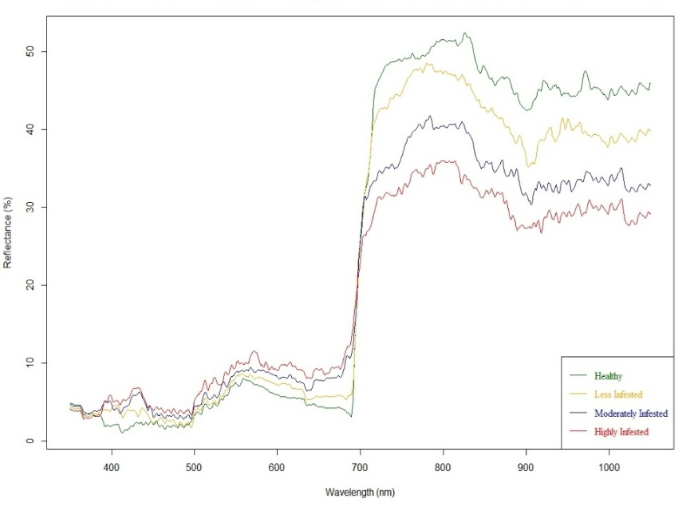
Fig.1 Spectral reflectance curve of healthy and S. frugiperda infested kharif maize crop at different levels of larval infestation under field caged conditions.
3.3 Mean reflectance
The mean reflectance in the blue zone (400–500 nm) of the visible region was found to range from 1.98 ± 0.37% for healthy plants to 4.66 ± 1.01% for highly infested plants, showing an increasing trend with higher infestation levels. Similarly, the reflectance values in the green and red zones of the visible region followed the same trend as the blue zone, with values ranging from 5.66 ± 1.24% to 8.91 ± 1.31% in the green zone, and from 7.25 ± 6.80% to 12.41 ± 4.23% in the red zone for healthy to highly infested maize crops, respectively. Conversely, an opposite trend was observed in the NIR zone, where reflectance values decreased with increasing infestation levels. The reflectance for healthy plants was recorded at 46.35 ± 3.76%, while for highly infested plants, it was 30.79 ± 2.64% (Table 2).
Table 2. Mean reflectance in the visible and near infrared zone of spectra observed for different levels of FAW infestation in maize.
Different levels of S. frugiperda infestation in the maize crop | Larval density/plant | Mean reflectance observed in different spectral regions (%)
 | Larval density/plant | Waveband (nm)
 | Larval density/plant | Blue  (400 - 500) | Green  (500 – 660) | Red  (660-700) | Near infra-red (700 – 1050)
Healthy | 0 | 1.98 ± 0.37 | 5.66 ± 1.24 | 7.25 ± 6.80 | 46.35 ± 3.76
Less infested | 1 | 3.07 ± 0.82 | 6.59 ± 1.35 | 8.60 ± 6.12 | 41.54 ± 3.96
Moderately infested | 2 | 3.95 ± 1.00 | 7.59 ± 1.33 | 11.34 ± 4.81 | 35.14 ± 3.14
Highly infested | 3 | 4.66 ± 1.01 | 8.91 ± 1.31 | 12.41 ± 4.23 | 30.79 ± 2.64
3.4 Identification and significance testing of suitable spectral zones
To identify suitable spectral zones/wavelengths for detecting stress in the canopy, it is essential to pinpoint the zones of the spectral curve that show significant variation. Therefore, a one-way ANOVA was performed on the spectral data obtained from maize crops infested with different gradients of FAW. Only the zones exhibiting significant variation among the treatments were considered suitable for characterizing FAW damage in the maize crop. The p-values for the corresponding wavelengths were calculated and plotted to mark the significant zones (p < 0.05) of the spectral curve. The highlighted portions of the probability plot (Fig. 2) show the identified significant zones of variation observed in the spectral curves resulting from different FAW damage gradients in the maize crop. The significant zones (p < 0.05) included the wavebands from 390–441 nm, 506–510 nm, 512–516 nm, 519–529 nm, 534–535 nm, 537–540 nm, 545–546 nm, 551–556 nm, 566–694 nm, and 697–1050 nm. The wavebands from 391–401 nm, 411–440 nm, 524–527 nm, 568–577 nm, 586–587 nm, 597 nm, 602–694 nm, and 703–1050 nm were found to be highly significant (p < 0.01) for characterizing FAW damage in the maize crop (Fig. 2).
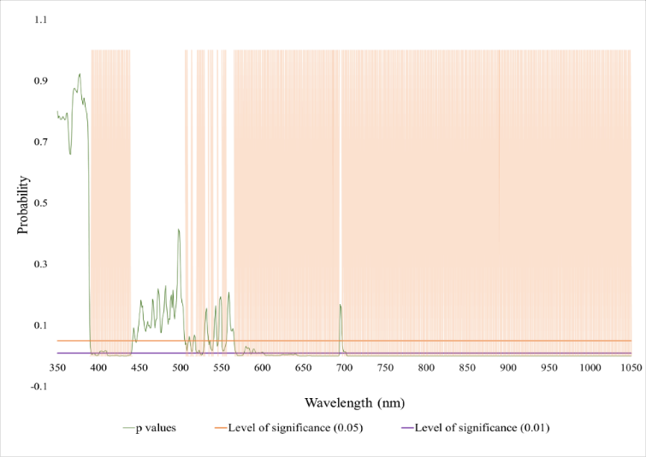
Fig. 2 One-way ANOVA showing the level of significance of reflectance values obtained for different levels of FAW infestation in kharif maize crop.
Similar findings have been reported by Stone et al (2001), who also identified the red-edge zone as the most sensitive band for determining the percentage of herbivory in eucalyptus. Kumar et al (2013) identified spectral bands, namely the visible zone (550-560 nm) and NIR zones (700-1250 nm), as most effective in detecting aphid infestation in mustard crops. Moreover, the findings of Zhang et al (2016) and Ramos et al (2022) align with the present results, as they also observed significant and stronger sensitivity in the red and NIR bands (650-1350 nm) for FAW damage in maize and cotton crops, respectively. Furthermore, Barros et al (2021) stated that in the spectral region corresponding to blue light, absorption occurs near the wavelength of 460 nm and is related to the presence of xanthophyll, carotenes, and chlorophyll pigments a and b. In the red-light region, chlorophyll absorbs energy near 645 nm, which provides an explanatory basis for the identified sensitive bands recorded in the present investigation.
3.5 Sensitivity analysis
After identifying the significant zones of the spectral graph for distinguishing FAW larval damage, the next step was to find the most responsive and sensitive bands/wavelengths with the highest capability to characterize the stress. Sensitivity analysis was then performed by calculating and plotting two parameters: reflectance difference, which showed the deviation in reflectance values relative to those obtained from a healthy maize plant, and sensitivity, which defined the change in reflectance values based on damage levels compared to the reflectance from a healthy plant.
3.5.1 Reflectance difference vs. wavelength
The minima reflectance differences were located at wavelengths of 426, 690, 767, 858, and 962 nm, while the maxima reflectance differences were noted at wavelengths of 694, 823, 919, and 971 nm. These identified wavelengths can be attributed to being strongly affected by FAW damage in maize (Fig. 3).
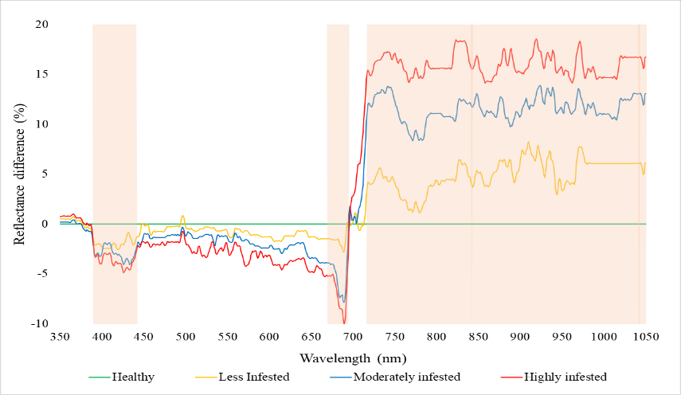
Fig. 3 Sensitivity analysis: Reflectance difference vs. Wavelength
3.5.2 Sensitivity vs. wavelength
The maxima for the reflectance sensitivity were found to be located at 390, 404, and 694 nm, while the minima were noted at 413 and 689 nm. The wavelengths depicting the reflectance sensitivity maxima and minima were found to be most responsive to FAW damage in maize (Fig. 4
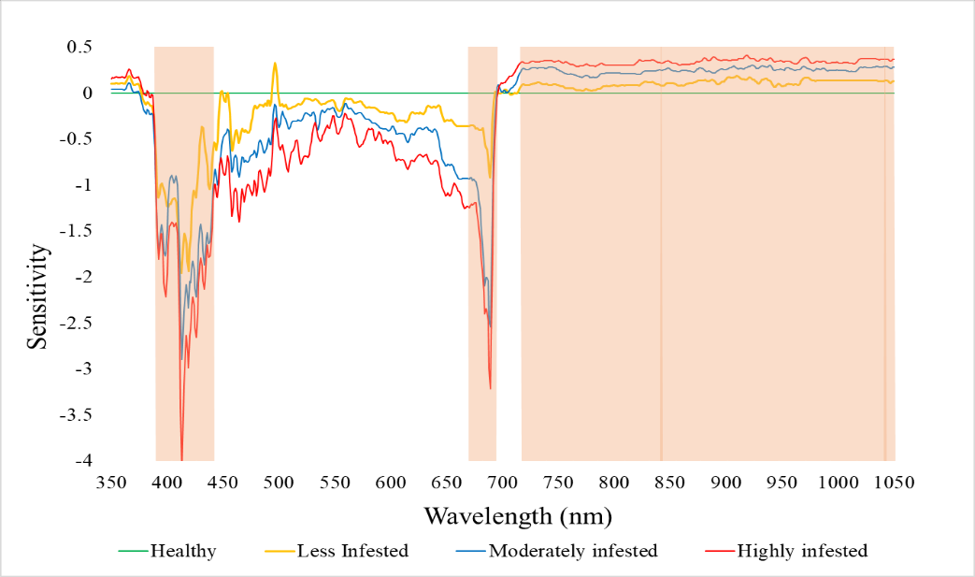
Fig. 4 Sensitivity analysis: Sensitivity vs. Wavelength
Similar trends have also been observed by Rahman et al (2010), who found that the maxima and minima of reflectance difference were located at 407 and 700 nm, respectively, while those of reflectance sensitivity were located at 400, 635, 680, and 697 nm. These wavelengths were identified as the most strongly affected regions by thrips damage in sugarcane. Similar findings were documented by Liu et al (2020), who also identified spectral bands near 410, 470, 490, 570, 625, and 720 nm as sensitive regions for detecting leaf folder damage in rice. However, Prabhakar et al (2012) stated that the sensitivity of spectra to biotic stress is crop- and pest-specific, depending on the nature of damage induced by the pest. This explains the variation in the most responsive wavelengths identified by previous researchers, as well as those recorded in the present study.

The candidate manuscript does not have a robust scientific discussion. I suggest the authors incorporate the suggested paragraphs; in this way, it would improve the scientific quality of the manuscript.
Climatic variables such as precipitation (Rodriguez et al. 2013), temperature (Hernandez et al. 2018a), and humidity (Hernandez et al. 2018b) play a decisive role in the interaction between maize physiology and pest dynamics, particularly with fall armyworm infestations (Bertorelli and Olivares, 2020). The present study demonstrates how spectral reflectance can capture stress signatures induced by FAW damage; however, these stress responses are often amplified or mitigated depending on prevailing environmental conditions (Araya Alman et al. 2020; Campos, 2023). For instance, higher humidity levels and moderate temperatures can prolong larval survival and intensify foliar damage, whereas drought stress exacerbates the visible reflectance response by reducing chlorophyll content (Cortez et al. 2018; Campos et al. 2023). Similar findings have been reported in tropical cropping systems in Venezuela, where irregular rainfall patterns linked to climate variability aggravated pest outbreaks in maize and banana, showing that pest-induced stress cannot be disentangled from agro-environmental influences (Olivares et al. 2022a; 2022b).
Soil quality and agronomic management further modulate plant resilience to FAW damage. Healthy soils with balanced nutrient and microbial dynamics improve maize tolerance to both biotic and abiotic stressors, which directly affects reflectance signals in the visible and NIR regions (Hernández and Olivares, 2020, Olivares et al. 2022c). In Colombian studies, degraded soils under continuous monocropping of maize and banana were found to weaken plant vigor, increasing susceptibility to both pests and drought stress, thereby magnifying remote sensing signatures of damage (Lopez and Olivares, 2019; Lopez et al. 2019; Rodriguez et al. 2023a). Conversely, integrated soil fertility management and conservation practices enhanced crop recovery, highlighting the need to consider soil-plant-pest interactions when interpreting hyperspectral data (Lobo et al. 2023; Rodriguez et al. 2023b).
The role of climate change is particularly relevant in tropical regions, where shifts in temperature and rainfall regimes are altering pest population dynamics and crop responses (Olivares et al. 2017a; 2017b). In Panama, studies on banana and maize have shown that warming trends and unpredictable rainfall increase the risk of overlapping pest generations, leading to higher cumulative stress levels on crops (Montenegro et al. 2021; Olivares et al. 2016). These environmental shifts also complicate remote sensing analyses, since spectral changes can simultaneously reflect both climate-induced stress and pest damage (Montenegro et al, 2020; Hernandez et al. 2020). The present findings on sensitive wavebands for FAW detection should therefore be interpreted as part of a broader spectrum of environmental stressors, many of which are intensifying under climate change (Olivares et al. 2011; Hernández and Olivares, 2019).
Finally, the integration of remote sensing with agro-environmental data opens new pathways for precision agriculture in tropical systems (Olivares, 2016). By combining spectral reflectance monitoring with localized weather, soil, and management datasets, it becomes possible to build predictive models that differentiate pest damage from other environmental stresses (Olivares et al. 2015). Evidence from Venezuela and Colombia suggests that such integrative approaches improve early-warning systems, reduce pesticide dependence, and support climate-smart pest management strategies (Rodríguez et al. 2016a; 2016b; Olivares and Zingaretti, 2019). This reinforces the broader applicability of the current study, demonstrating that hyperspectral sensing is not only a diagnostic tool for FAW damage in maize but also a cornerstone technology for sustainable pest management in the face of agro-environmental variability (Olivares et al. 2020; Olivares and Franco, 2015).
- CONCLUSION
Spectral analysis revealed that as FAW infestation in maize increased, reflectance rose in the visible zone (400–700 nm) but declined in the near-infrared zone (700–1050 nm). Notably, the wavebands 391–401, 411–440, 524–527, 568–577, 586–587, 597, 602–694, and 703–1050 nm were especially important for detecting FAW impact. Additionally, prominent minima at 426, 690, 767, 858, and 962 nm and maxima at 694, 823, 919, and 971 nm, based on the difference in reflectance, marked wavelengths most affected by infestation. Sensitivity analysis further pinpointed minima at 413 and 689 nm, alongside maxima at 390, 404, and 694 nm, as the most sensitive to FAW-induced changes, making these wavelengths particularly valuable for characterizing pest damage in maize

REFERENCES
Abdel-Rahman, E. M., Ahmed, F. B., van den Berg, M., & Way, M. J. (2010). Potential of spectroscopic data sets for sugarcane thrips (Fulmekiola serrata Kobus) damage detection. International Journal of Remote Sensing, 31(15), 4199-4216. https://doi.org/10.1080/01431160903241981
Acharya, S., Kaphle, S., Upadhayay, J., Pokhrel, A., & Paudel, S. (2020). Damaging nature of fall armyworm and its management practices in maize: A review. Tropical Agrobiodiversity, 1(2), 82-85. http://doi.org/10.26480/trab.02.2020.82.85
Ahmad, M. N., Shariff, A. R. M., & Moslim, R. (2018). Monitoring insect pest infestation via different spectroscopic techniques. Applied Spectroscopy Reviews, 53(10), 836-853. https://doi.org/10.1080/05704928.2018.1445094
Anonymous. (2020). Maize- All India. Agricultural Statistics at a Glance. DACNET, p. 58.
Assefa, F., & Ayalew, D. (2019). Status and control measures of fall armyworm (Spodoptera frugiperda) infestations in maize fields in Ethiopia: A review. Cogent Food & Agriculture, 5(1), 1641902. https://doi.org/10.1080/23311932.2019.1641902

Araya-Alman, M., Olivares, B., Acevedo-Opazo, C. et al. (2020). Relationship Between Soil Properties and Banana Productivity in the Two Main Cultivation Areas in Venezuela. J Soil Sci Plant Nutr.; 20 (3): 2512-2524. https://doi.org/10.1007/s42729-020-00317-8
Backoulou, G. F., Elliott, N. C., Giles, K., Phoofolo, M., & Catana, V. (2011). Development of a method using multispectral imagery and spatial pattern metrics to quantify stress to wheat fields caused by Diuraphis noxia. Computers and Electronics in Agriculture, 75(1), 64-70. https://doi.org/10.1016/j.compag.2010.09.011
Barros, P. P., Schutze, I. X., Iost Filho, F. H., Yamamoto, P. T., Fiorio, P. R., & Demattê, J. A. (2021). Monitoring Bemisia tabaci (Gennadius) (Hemiptera: Aleyrodidae) infestation in soybean by proximal sensing. Insects, 12(1), 47. https://doi.org/10.3390/insects12010047

Bertorelli, M., B.O. Olivares. 2020. Population fluctuation of Spodoptera frugiperda (J.E. Smith) (Lepidoptera: Noctuidae) in sorghum cultivation in Southern Anzoategui, Venezuela. Journal of Agriculture University of Puerto Rico., 104(1):1-16. https://doi.org/10.46429/jaupr.v104i1.18283
Carrière, Y., Ellsworth, P. C., Dutilleul, P., Ellers-Kirk, C., Barkley, V., & Antilla, L. (2006). A GIS-based approach for areawide pest management: the scales of Lygus hesperus movements to cotton from alfalfa, weeds, and cotton. Entomologia Experimentalis et Applicata, 118(3), 203-210. https://doi.org/10.1111/j.1570-7458.2006.00384.x
Carter, G. A., & Knapp, A. K. (2001). Leaf optical properties in higher plants: linking spectral characteristics to stress and chlorophyll concentration. American Journal of Botany, 88(4), 677-684. https://doi.org/10.2307/2657068
Chen, T., Zeng, R., Guo, W., Hou, X., Lan, Y., & Zhang, L. (2018). Detection of stress in cotton (Gossypium hirsutum L.) caused by aphids using leaf level hyperspectral measurements. Sensors, 18(9), 2798. https://doi.org/10.3390/s18092798
Cibula, W. G., & Carter, G. A. (1992). Identification of a far-red reflectance response to ectomycorrhizae in slash pine. International Journal of Remote Sensing, 13(5), 925-932. https://doi.org/10.1080/01431169208904165
Campos, B. O. (2023). Banana Production in Venezuela: Novel Solutions to Productivity and Plant Health. Springer Nature. https://doi.org/10.1007/978-3-031-34475-6
Campos, B. O. O., Araya-Alman, M., & Marys, E. E. (2023). Sustainable Crop Plants Protection: Implications for Pest and Disease Control (p. 200). MDPI-Multidisciplinary Digital Publishing Institute. https://doi.org/10.3390/books978-3-0365-9150-6
Cortez, A., Olivares, B., Parra, R., Lobo, D., Rodríguez, M. F., & Rey, J. C. (2018). Descripción de los eventos de sequía meteorológica en localidades de la cordillera central, Venezuela. Cs Ing Apls I (1): 22–44.
Dara, S. K. (2019). The new integrated pest management paradigm for the modern age. Journal of Integrated Pest Management, 10(1), 12. https://doi.org/10.1093/jipm/pmz010
Davis, F. M., Ng, S. S., & Williams, W. P. (1992). Visual rating scales for screening whorl-stage corn for resistance to fall armyworm. Technical Bulletin - Mississippi Agricultural and Forestry Experiment Station,186, Mississippi State University, MS39762, USA.
Day, R., Abrahams, P., Bateman, M., Beale, T., Clottey, V., Cock, M., Colmenarez, Y., Corniani, N., Early, R., Godwin, J., Gomez, J., Moreno, P.G., Murphy, S.T., Oppong-Mensah, B., Phiri, N., Pratt, C., Silvestri, S., & Witt, A. (2017). Fall armyworm: impacts and implications for Africa. Outlooks on Pest Management, 28(5), 196-201. https://doi.org/10.1564/v28_oct_02
Franklin, S. E. (2001). Remote sensing for sustainable forest management. CRC press. Lewis Publishers, Boca Raton, FL. p 407. https://doi.org/10.1201/9781420032857
Hernández, R., Olivares, B., (2020). Application of multivariate techniques in the agricultural land’s aptitude in Carabobo, Venezuela. Tropical and Subtropical Agroecosystems, 23(2):1-12. https://n9.cl/zeedh
Hernández, R; Olivares, B. Arias, A; Molina, Jc., Pereira, Y. (2018ª). Agroclimatic zoning of corn crop for sustainable agricultural production in Carabobo, Venezuela. Revista Universitaria de Geografía. . 27 (2): 139-159. https://n9.cl/l2m83
Hernandez, R., Olivares, B., Arias, A, Molina, Jc., Pereira, Y. (2020). Eco-territorial adaptability of tomato crops for sustainable agricultural production in Carabobo, Venezuela. Idesia. 38(2):95-102. http://dx.doi.org/10.4067/S071834292020000200095
Hernández, R; Olivares, B., Arias, A; Molina, Jc., Pereira, Y. (2018b). Identification of potential agroclimatic zones for the production of onion (Allium cepa L.) in Carabobo, Venezuela. Journal of the Selva Andina Biosphere., 6 (2): 70-82. http://www.scielo.org.bo/pdf/jsab/v6n2/v6n2_a03.pdf
Hernández, R. Olivares, B. (2019). Ecoterritorial sectorization for the sustainable agricultural production of potato (Solanum tuberosum L.) in Carabobo, Venezuela. Agricultural Science and Technology. 20(2): 339-354. https://doi.org/10.21930/rcta.vol20_num2_art:1462
Hoseny, M. M. E., Dahi, H. F., Shafei, A. M. E., & Yones, M. S. (2023). Spectroradiometer and thermal imaging as tools from remote sensing used for early detection of spiny bollworm, Earias insulana (Boisd.) infestation. International Journal of Tropical Insect Science, 43(1), 245-256. https://doi.org/10.1007/s42690-022-00917-0
Huang, J., Liao, H., Zhu, Y., Sun, J., Sun, Q., & Liu, X. (2012). Hyperspectral detection of rice damaged by rice leaf folder (Cnaphalocrocis medinalis). Computers and electronics in agriculture, 82, 100-107. https://doi.org/10.1016/j.compag.2012.01.002
Huang, M., Wan, X., Zhang, M., & Zhu, Q. (2013). Detection of insect-damaged vegetable soybeans using hyperspectral transmittance image. Journal of Food Engineering, 116(1), 45-49. https://doi.org/10.1016/j.jfoodeng.2012.11.014
Huete, A. R. (2004). Remote sensing for environmental monitoring. Environmental monitoring and characterization, Academic Press, 183-206. https://doi.org/10.1016/B978-012064477-3/50013-8
Hunt Jr, E. R., & Rondon, S. I. (2017). Detection of potato beetle damage using remote sensing from small unmanned aircraft systems. Journal of Applied Remote Sensing, 11(2), 026013-026013. https://doi.org/10.1117/1.JRS.11.026013
Jensen, J. R. (2009). Remote sensing of the environment: An earth resource perspective 2/e. Pearson Education India.
Karuppuchamy, P., & Venugopal, S. (2016). Integrated pest management. In Ecofriendly pest management for food security (pp. 651-684). Academic Press. https://doi.org/10.1016/B978-0-12-803265-7.00021-X
Knipling, E. B. (1970). Physical and physiological basis for the reflectance of visible and near-infrared radiation from vegetation. Remote sensing of environment, 1(3), 155-159. https://doi.org/10.1016/S0034-4257(70)80021-9
Kumar, J., Vashisth, A., Sehgal, V. K., & Gupta, V. K. (2013). Assessment of aphid infestation in mustard by hyperspectral remote sensing. Journal of the Indian Society of Remote Sensing, 41(1), 83-90. https://doi.org/10.1007/s12524-012-0207-6
Liu, T., Shi, T., Zhang, H., & Wu, C. (2020). Detection of rise damage by leaf folder (Cnaphalocrocis medinalis) using unmanned aerial vehicle based hyperspectral data. Sustainability, 12(22), 9343. https://doi.org/10.3390/su12229343
Liu, X. D., & Sun, Q. H. (2016). Early assessment of the yield loss in rice due to the brown planthopper using a hyperspectral remote sensing method. International Journal of Pest Management, 62(3), 205-213. https://doi.org/10.1080/09670874.2016.1174791
Lobo, D; Olivares, B; Rey, J.C; Vega, A; Rueda-Calderón, A. (2023). Relationships between the Visual Evaluation of Soil Structure (VESS) and soil properties in agriculture: A meta-analysis. Scientia agropecuaria, ; 14 - 1, 67 - 78. https://doi.org/10.17268/sci.agropecu.2023.007
López, M. Olivares, B. (2019). Normalized Difference Vegetation Index (NDVI) applied to the agricultural indigenous territory of Kashaama, Venezuela. UNED Research Journal. 11(2): 112-121. https://doi.org/10.22458/urj.v11i2.2299
López-Beltrán, M., Olivares, B., Lobo-Luján, D. (2019). Changes in land use and vegetation in the agrarian community Kashaama, Anzoátegui, Venezuela: 2001-2013. Revista Geográfica De América Central. 2(63):269-291. https://doi.org/10.15359/rgac.63-2.10
Luedeling, E., Hale, A., Zhang, M., Bentley, W. J., & Dharmasri, L. C. (2009). Remote sensing of spider mite damage in California peach orchards. International Journal of Applied Earth Observation and Geoinformation, 11(4), 244-255. https://doi.org/10.1016/j.jag.2009.03.002
Mirik, M., Ansley, R. J., Michels, G. J., & Elliott, N. C. (2012). Spectral vegetation indices selected for quantifying Russian wheat aphid (Diuraphis noxia) feeding damage in wheat (Triticum aestivum L.). Precision Agriculture, 13, 501-516. https://doi.org/10.1007/s11119-012-9264-7
Mirik, M., Ansley, R.J., Steddom, K., Rush, C.M., Michels, G.J., Workneh, F., Cui, S., & Elliott, N. C. (2014). High spectral and spatial resolution hyperspectral imagery for quantifying Russian wheat aphid infestation in wheat using the constrained energy minimization classifier. Journal of applied remote sensing, 8(1), 083661-083661. https://doi.org/10.1117/1.JRS.8.083661
Mirik, M., Michels Jr, G. J., Kassymzhanova-Mirik, S., Elliott, N. C., & Bowling, R. (2006). Hyperspectral spectrometry as a means to differentiate uninfested and infested winter wheat by greenbug (Hemiptera: Aphididae). Journal of economic entomology, 99(5), 1682-1690. https://doi.org/10.1093/jee/99.5.1682
Montenegro, E., Pitti-Rodríguez, J, Olivares-Campos, B. (2021). Identification of the main subsistence crops of Teribe: a case study based on multivariate techniques. Idesia (Arica), 39(3), 83-94. https://dx.doi.org/10.4067/S0718-34292021000300083
Montenegro Gracia, E. J. M., Rodríguez, J. E. P., & Campos, B. O. O. (2020). Adaptation to climate change in indigenous food systems of the Teribe in Panama: a training based on CRISTAL 2.0. Revista Luna Azul, (51), 182-197. https://www.redalyc.org/journal/3217/321770011010/321770011010.pdf
Murdia, L. K., Wadhwani, R., Wadhawan, N., Bajpai, P., & Shekhawat, S. (2016). Maize utilization in India: an overview. American Journal of Food and Nutrition, 4(6), 169-176. https://doi.org/10.12691/ajfn-4-6-5
Murúa, G., Molina-Ochoa, J., & Coviella, C. (2006). Population dynamics of the fall armyworm, Spodoptera frugiperda (Lepidoptera: Noctuidae) and its parasitoids in northwestern Argentina. Florida Entomologist, 89(2), 175-182. https://doi.org/10.1653/0015-4040(2006)89[175:PDOTFA]2.0.CO;2
Nansen, C., Sidumo, A. J., & Capareda, S. (2010). Variogram analysis of hyperspectral data to characterize the impact of biotic and abiotic stress of maize plants and to estimate biofuel potential. Applied spectroscopy, 64(6), 627-636. https://opg.optica.org/as/abstract.cfm?URI=as-64-6-627
Olivares, B.O.; Rey, J.C.; Perichi, G.; Lobo, D. (2022a). Relationship of Microbial Activity with Soil Properties in Banana Plantations in Venezuela. Sustainability 14, 13531. https://doi.org/10.3390/su142013531
Olivares B, Rey Jc, Lobo D, Navas-Cortés Ja, Gómez Ja, Landa B. (2022b). Machine Learning and the New Sustainable Agriculture: Applications in Banana Production Systems of Venezuela. Agricultural Research Updates. 42, 133 - 157. Nova Science Publishers, Inc
Olivares, B. 2016. Description of soil management in agricultural production systems in the Hamaca de Anzoátegui sector, Venezuela. La Granja: Revista de Ciencias de la Vida. 23(1): 14–24. https://n9.cl/ycp08
Olivares, B., Verbist, K., Lobo, D., Vargas, R.; Silva, O. (2011). Evaluation of the USLE model to estimate water erosion in an Alfisol. Journal of Soil Science and Plant Nutrition of Chile. 11 (2):71-84. http://dx.doi.org/10.4067/S0718-95162011000200007
Olivares, B.O., Calero, J., Rey, J.C., Lobo, D., Landa, B.B., Gómez, J. A. (2022c). Correlation of banana productivity levels and soil morphological properties using regularized optimal scaling regression. Catena; 208: 105718. https://doi.org/10.1016/j.catena.2021.105718
Olivares, B., Lobo, D., Verbist, K. (2015). Application USLE model on erosion plots under soil conservation practices and water in San Pedro de Melipilla, Chile. Revista Ciencia e Ingeniería. 36 (1):3-10. https://www.redalyc.org/pdf/5075/507550627001.pdf
Olivares, B., Zingaretti, M.L. (2019). Aplicación de métodos multivariados para la caracterización de periodos de sequía meteorológica en Venezuela. Revista Luna Azul. 48, 172:192. http://dx.doi.org/10.17151/luaz.2019.48.10
Olivares, B., Lobo, D., Cortez, A., Rodríguez, M.F., Rey, J.C. (2017ª). Socio-economic characteristics and methods of agricultural production of indigenous community Kashaama, Anzoategui, Venezuela. Rev. Fac. Agron. (LUZ) 34 (2): 187-215. https://n9.cl/p2gc5
Olivares, B., Cortez, A., Parra, R., Lobo, D., Rodríguez, M.F, Rey, J.C. (2017b). Evaluation of agricultural vulnerability to drought weather in different locations of Venezuela. Rev. Fac. Agron. (LUZ) 34 (1): 103-129. https://n9.cl/d827w
Olivares, B., Pitti, J., Montenegro, E. (2020). Socioeconomic characterization of Bocas del Toro in Panama: an application of multivariate techniques. Revista Brasileira de Gestao e Desenvolvimento Regional, 16(3):59-71. HTTPS://DOI.ORG/10.54399/RBGDR.V16I3.5871
Olivares, B. & Franco, E. (2015). Agrosocial diagnosis of the Kashaama indigenous community: An empirical study in Anzoátegui state, Venezuela. Revista Científica Guillermo de Ockham. 13 (1): 87-95. https://doi.org/10.21500/22563202.1691
Olivares, B., Cortez, A., Muñetones, A. y Casana, S. (2016). Strategic Elements of Organizational Knowledge Management for Innovation. Case: Agrometeorology Network. Revista Digital de Investigación en Docencia Universitaria. 10 (1): 68-81. http://dx.doi.org/10.19083/ridu.10.446
Pinter Jr, P. J., Hatfield, J. L., Schepers, J. S., Barnes, E. M., Moran, M. S., Daughtry, C. S., & Upchurch, D. R. (2003). Remote sensing for crop management. Photogrammetric Engineering & Remote Sensing, 69(6), 647-664. https://doi.org/10.14358/PERS.69.6.647
Prabhakar, M., Prasad, Y. G., Thirupathi, M., Sreedevi, G., Dharajothi, B., & Venkateswarlu, B. (2011). Use of ground based hyperspectral remote sensing for detection of stress in cotton caused by leafhopper (Hemiptera: Cicadellidae). Computers and Electronics in Agriculture, 79(2), 189-198. https://doi.org/10.1016/j.compag.2011.09.012
Prabhakar, M., Prasad, Y. G., Vennila, S., Thirupathi, M., Sreedevi, G., Rao, G. R., & Venkateswarlu, B. (2013). Hyperspectral indices for assessing damage by the solenopsis mealybug (Hemiptera: Pseudococcidae) in cotton. Computers and Electronics in Agriculture, 97, 61-70. https://doi.org/10.1016/j.compag.2013.07.004
Prabhakar, M., Prasad, Y.G., & Rao, M.N. (2012). Remote sensing of biotic stress in crop plants and its applications for pest management. In: Venkateswarlu, B., Shanker, A., Shanker, C., Maheswari, M. (eds) Crop Stress and its Management: Perspectives and Strategies. Springer, Dordrecht.
Prasannakumar, N. R., Chander, S., & Sahoo, R. N. (2014). Characterization of brown planthopper damage on rice crops through hyperspectral remote sensing under field conditions. Phytoparasitica, 42, 387-395. https://doi.org/10.1007/s12600-013-0375-0
Ramos, A.P.M., Gomes, F.D.G., Pinheiro, M.M.F., Furuya, D.E.G., Gonçalvez, W.N., Junior, J.M., Micheref, M.F.F., Blassioli Moraes, M.C., Borges, M., Alaumann, A.R., Liesenberg, V., Jorge, L.A.C., & Osco, L. P. (2022). Detecting the attack of the fall armyworm (Spodoptera frugiperda) in cotton plants with machine learning and spectral measurements. Precision Agriculture, 23(2), 470-491. https://doi.org/10.1007/s11119-021-09845-4.
Reisig, D., & Godfrey, L. (2006). Remote sensing for detection of cotton aphid–(homoptera: aphididae) and spider mite–(acari: tetranychidae) infested cotton in the San Joaquin Valley. Environmental entomology, 35(6), 1635-1646. https://doi.org/10.1093/ee/35.6.1635
Riedell, W. E., & Blackmer, T. M. (1999). Leaf reflectance spectra of cereal aphid‐damaged wheat. Crop Science, 39(6), 1835-1840. https://doi.org/10.2135/cropsci1999.3961835x
Rodríguez-Yzquierdo, G.; Olivares, B.O.; González-Ulloa, A.; León-Pacheco, R.; Gómez-Correa, J.C.; Yacomelo-Hernández, M.; Carrascal-Pérez, F.; Florez-Cordero, E.; Soto-Suárez, M.; Dita, M.; et al. (2023a). Soil Predisposing Factors to Fusarium oxysporum f.sp Cubense Tropical Race 4 on Banana Crops of La Guajira, Colombia. Agronomy, 13, 2588. https://doi.org/10.3390/agronomy13102588
Rodríguez-Yzquierdo, G.; Olivares, B.O.; Silva-Escobar, O.; González-Ulloa, A.; Soto-Suarez, M.; Betancourt-Vásquez, M. (2023b). Mapping of the Susceptibility of Colombian Musaceae Lands to a Deadly Disease: Fusarium oxysporum f. sp. cubense Tropical Race 4. Horticulturae 9, 757. https://doi.org/10.3390/horticulturae9070757
Rodríguez, M., Olivares, B., Cortez, A., Parra, R., Lobo, D. y Rey, J.C. (2016b). Análisis temporal de la sequía meteorológica en localidades semiáridas de Venezuela. UGCiencia 22 (1):11-24. Disponible en DOI: https://doi.org/10.18634/ugcj.22v.1i.481
Rodríguez, M.F, Olivares, B., Cortez, A., Rey, J.C. y Lobo, D. (2016ª). Desarrollo del sistema de información de la red de pluviómetros alternativos en medios rurales. Caso: Anzoátegui, Venezuela. Acta Universitaria 26 (4):65-76. DOI: 10.15174/au.2016.961
Rodríguez, M.F., Cortez, A., Olivares, B., Rey, J.C, Parra, R., Lobo, D (2013). Análisis espacio temporal de la precipitación del estado Anzoátegui y sus alrededores. Agronomía Tropical 63 (1-2): 57-65. https://n9.cl/14iow
Severtson, D., Callow, N., Flower, K., Neuhaus, A., Olejnik, M., & Nansen, C. (2016). Unmanned aerial vehicle canopy reflectance data detects potassium deficiency and green peach aphid susceptibility in canola. Precision Agriculture, 17, 659-677. https://doi.org/10.1007/s11119-016-9442-0
Sharanabasappa, S. D., Kalleshwaraswamy, C. M., Maruthi, M. S., & Pavithra, H. B. (2018). Biology of invasive fall army worm Spodoptera frugiperda (JE Smith) (Lepidoptera: Noctuidae) on maize. Indian Journal of Entomology, 80(3), 540-543. http://dx.doi.org/10.5958/0974-8172.2018.00238.9
Sisay, B., Tefera, T., Wakgari, M., Ayalew, G., & Mendesil, E. (2019). The efficacy of selected synthetic insecticides and botanicals against fall armyworm, Spodoptera frugiperda, in maize. Insects, 10(2), 45. https://doi.org/10.3390/insects10020045
Stone, C., Chisholm, L., & Coops, N. (2001). Spectral reflectance characteristics of eucalypt foliage damaged by insects. Australian Journal of Botany, 49(6), 687-698. https://doi.org/10.1071/BT00091
Tageldin, A., Adly, D., Mostafa, H., & Mohammed, H.S. (2020). Applying machine learning technology in the prediction of crop infestation with cotton leafworm in greenhouse. Biorxiv 2020-09. https://doi.org/10.1101/2020.09.17.301168
Warren, G., & Metternicht, G. (2005). Agricultural applications of high-resolution digital multispectral imagery. Photogrammetric Engineering & Remote Sensing, 71(5), 595-602. https://doi.org/10.14358/PERS.71.5.595
Zhang, J., Huang, Y., Yuan, L., Yang, G., Chen, L., & Zhao, C. (2016). Using satellite multispectral imagery for damage mapping of armyworm (Spodoptera frugiperda) in maize at a regional scale. Pest Management Science, 72(2), 335-348. https://doi.org/10.1002/ps.4003

