Efficacy of fungicides against downy mildew in sponge gourd under in vivo conditions

ABSTRACT
Downy mildew, caused by Pseudoperonospora cubensis, is one of the most destructive diseases of sponge gourd (Luffa cylindrica), causing significant yield losses in cucurbits worldwide. The present field experiment was conducted during Kharif 2024 at Zonal Agriculture Research Station, Ganeshkhind, Pune to evaluate the efficacy of seven fungicidal treatments against downy mildew under in vivo conditions. A Randomized Block Design with three replications was used, comprising the following treatments: Carbendazim 12% + Mancozeb 63% (0.15%), Azoxystrobin 4.8% w/w + Chlorothalonil 40% w/w SC (0.6%), Azoxystrobin 11% w/w + Tebuconazole 18.3% (0.15%), Aureofungin 46.25% w/w SP (0.005%), Copper sulphate 47.15% + Mancozeb 30% WDG (0.5%), Kresoxim methyl 18% + Mancozeb 54% WP (0.2%), and Potassium salt of Phosphoric acid (0.4%), along with an untreated water-spray control. Data on Per cent Disease Index (PDI), Per cent Disease Control (PDC), Area Under Disease Progress Curve (AUDPC), yield, and economic returns were recorded.
Results showed that Azoxystrobin 11% w/w + Tebuconazole 18.3% exhibited the highest efficacy, with the lowest mean PDI (10.90), maximum PDC (78.16%), lowest AUDPC (237.50), and the highest yield (130 q/ha), resulting in the best benefit–cost ratio (2.05). Kresoxim methyl 18% + Mancozeb 54% WP was found at par as it showed (PDC 73.92%, yield 128 q/ha, B:C ratio 2.01). The untreated control had the highest disease severity (52.91%) and least yield (90.5 q/ha).
Overall, fungicide application significantly reduced downy mildew severity, improved yield, and enhanced profitability, with Azoxystrobin 11% w/w + Tebuconazole 18.3% emerging as the most effective and economically viable option for managing downy mildew in sponge gourd under field conditions.

Keywords: Luffa cylindrica, Pseudoperonospora cubensis,fungicides.
INTRODUCTION
The Cucurbitaceae family comprises a diverse array of warm-season crops. Among these, sponge gourd is an important dietary component, valued for its role in maintaining nutritional balance (McGrath, 2004). It is nutritionally rich, containing carotenes, phenolic antioxidants, and high levels of dietary fibre, which supports digestion. A 100 g serving provides approximately 410 IU of vitamin A, 12 mg of vitamin C, 7 µg of folate, and 139 mg of potassium. Cucurbits play a vital role in food security, particularly in developing regions, due to their affordability and adaptability to diverse growing conditions. Its cultural significance extends beyond food, as the dried fibrous skeleton is used as a natural sponge for household and personal care, highlighting its multifaceted utility. These products offer farmers opportunities to diversify income streams, reduce post-harvest losses, and tap into niche markets focused on sustainable and organic goods (Pandit et al., 2023). Smallholder farmers, in particular, benefit from the crop’s low input requirements and relatively short growth cycle, which allows for multiple harvests per season.

India is a global leader in sponge gourd production, with Punjab and Uttar Pradesh as major contributors, alongside significant cultivation in Maharashtra’s districts of Pune, Nashik, Aurangabad, and Jalgaon, where it is grown for both subsistence and commercial purposes. It is cultivated over an area of about 7.21 lakh hectares, producing approximately 12.87 lakh tonnes, with a productivity of 10.52 tonnes per hectare (Anon., 2022).
Cucurbit crops are highly susceptible to diseases caused by fungi, bacteria, viruses, and mycoplasma-like organisms, which severely impact yield and quality. Among the numerous diseases affecting cucurbits, downy mildew is the most significant. Downy mildew, caused by the oomycete Pseudoperonospora cubensis, is a major foliar disease affecting cucurbits, particularly in warm, humid, or tropical climates. It shows as pale green patches on the upper leaf surfaces, which develop into bright yellow, angular or rectangular spots confined by leaf veins. These lesions eventually merge, causing necrosis and a scorched appearance, leading to significant reductions in photosynthesis, stunted growth, and yield losses, especially in cucumbers (Colucci & Holmes, 2010).
Under high humidity, water-soaked lesions with light grey to dark purple, fuzzy sporulation appear on leaf undersides. Premature defoliation increases fruit exposure to sunlight, causing sunscald. The disease spreads rapidly via wind- or rain-dispersed sporangia, with optimal sporulation at 15–20°C and six hours of high humidity. Symptoms appear 3–12 days post-infection, depending on environmental conditions and inoculum levels. Symptom variation across cucurbit species includes angular lesions in cucumbers and squash versus irregular, rapidly browning lesions in watermelon and cantaloupe thereby complicating diagnosis, often leading to confusion with diseases like Anthracnose or Alternaria leaf spot.
As an obligate parasite, P. cubensis requires living host tissue and overwinters in plant debris in frost-free regions. High temperatures above 35°C hinder disease development, but cooler nights promote it. Climate change, with warmer temperatures and erratic rainfall, exacerbates diseases like downy mildew. Climate-smart practices, such as mulching and shade nets, help mitigate these challenges (Shaffique et al., 2022).
Management of downy mildew relies on resistant or tolerant varieties, chemical controls that includes broad-spectrum contact fungicides and systemic fungicides.
MATERIALS AND METHODS
To evaluate the efficacy of most effective fungicides, a field experiment was conducted during kharif, 2024. On 15 August, 2024, the seeds of sponge gourd Cv. Phule Prajakta was sown in the field plots with a spacing of 150cm × 100cm and the crop was grown by applying all packages of practices. At the first appearance of downy mildew disease symptoms, first foliar spraying of the test fungicides was commenced and further two sprayings were done at 10 days interval.
Experiment details:
Design | Randomized Block Design (RBD)
Replications | 3
Treatments | 8
Sprays | Three

Table 1. Treatment details
Treatments | Fungicides/chemicals | Conc.(%)
T1 | Carbendazim 12%+ Mancozeb 63% | 0.15
T2 | Azoxystrobin 4.8% w/w + Chlorothalonil 40% w/w SC | 0.6
T3 | Azoxystrobin 11% w/w + Tebuconazole 18.3 | 0.15
T4 | Aureofungin 46.25 w/w SP | 0.005
T5 | Copper sulphate 47.15 + Mancozeb 30% WDG | 0.5
T6 | Kresoxim methyl 18% +Mancozeb 54% WP | 0.2
T7 | Potassium salt of Phosphoeric acid | 0.4
T8 | Control (water spray) | -

Observations on downy mildew intensity were recorded at first appearance of the disease. Further, observations on downy mildew intensity were recorded one day before the first and second spray and 15 days after third spraying. For recording downy mildew intensity, three plants per replication were selected randomly and tagged. On these tagged plants, three leaves (one each from bottom, middle and top) per plant were selected and the disease intensity was recorded by applying 0 - 9 disease rating scale (Mayee and Datar,1986) as described below.

Table 2. Disease Reaction Scale
Grade | Description | Reaction
0 | No symptom on leaves | Immune (I)
1 | Small scattered specks covering 1% or less leaf area. | Highly Resistant (HR)
3 | Small lesions covering 1 to 10% leaf area | Resistant (R)
5 | Lesions enlarged covering 11 to 25 % leaf area | Moderately Resistant (MR)
7 | Lesions coalesce to form big patches covering 26 to 50 % leaf area. | Susceptible (S)
9 | Big patches covering 51% or more of leaf area and defoliation occur. | Highly Susceptible (HS)

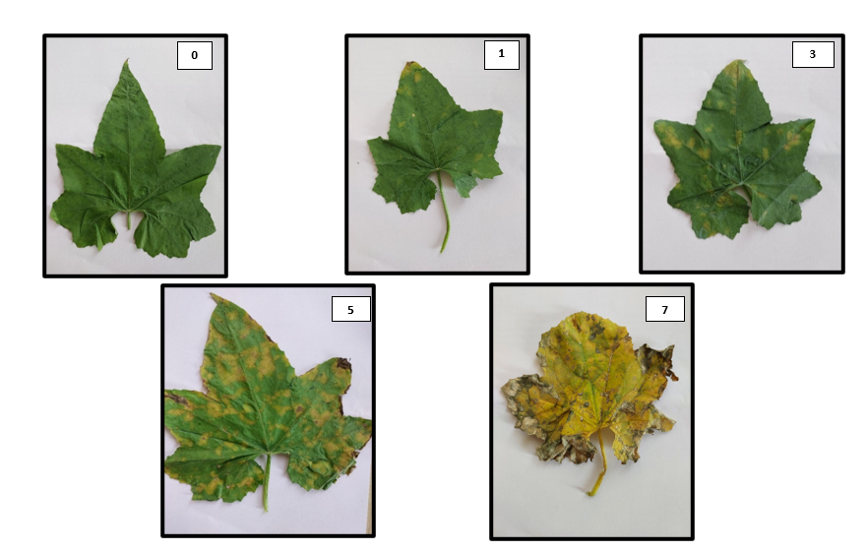

Further, per cent disease intensity (PDI) and its reduction over control (PDC) and area under disease progress curve were calculated by applying the following formulae Wheeler (1969).

Per cent Disease Index (PDI) by using 0-9 scale
PDI (Per cent Disease Index) = ∑ (Numerical Ratings​) ×100
(Number of Plants Assessed×Maximum Rating
Per cent disease reduction over control (PDC)
PDC (%) = (Disease severity in treatment – Disease severity in control) X 100
Disease severity in control
Area under Disease Progression Curve (AUDPC)
X_{i} + X_{i-1} × D
[Xi+Xi−1] AUDPC= ∑^{n-1}
^{i=1}
²
Where, Xi = Per cent disease index (PDI) at the end of the i^{th} week.
K = number of successive evaluations of downy mildew.
D = days interval between two observations.
Apparent rate of infection
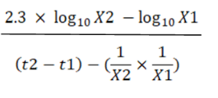
Rate of disease spread=

Where, r = apparent rate of infection/ spread
X1 = PDI (Per cent disease intensity/index) at time t1
X2 = PDI (Per cent disease intensity/index) at time t2
t2-t1 = time interval in days between the two consecutive observations
Sponge gourd fruits were harvested at harvestable stage of the fruits. Yield characteristics such as length, girth, average fruit weight, yield was calculated. Also, the most economical treatment was determined based on incremental cost: benefit ratio (ICBR).

RESULTS AND DISCUSSION
Effect of treatments on per cent disease intensity and per cent disease control on downy mildew (P. cubensis) in sponge gourd (Kharif 2024).
The results shown in table 3 revealed that the combination of Azoxystrobin 11% w/w + Tebuconazole 18.3% at 0.15% (T₃) emerged as the most effective, reducing disease severity to 10.9% and achieving a 78.16% control rate. Similarly, Kresoxim methyl 18% + Mancozeb 54% WP at 0.2% (T₆) demonstrated significant efficacy with a disease severity of 12.90% and a 73.92% control rate. In comparison, treatments such as Aureofungin 46.25 w/w SP at 0.05% (T₄) and Potassium salt of Phosphoric acid at 0.4% (T₇) showed higher disease severities of 35.16% and 32.72%, respectively, with control rates of 30.74% and 35.52%. The control treatment (T₈, water spray) recorded the highest severity at 52.91% with no control (0.00%). Treatment T₃ (Azoxystrobin 11% w/w + Tebuconazole 18.3%) is statistically superior, however T₃ is on par with T₆ (Kresoxim methyl 18% + Mancozeb 54% WP) and T₂ (Azoxystrobin 4.8% w/w + Chlorothalonil 40% w/w SC) with disease severities of 12.90(%) and 15.58(%) respectively. These findings underscore the superior performance of T₃ and T₆ in mitigating downy mildew, significantly outperforming other treatments and the control.
Table 3: Effect of treatments on per cent disease intensity and per cent disease control on downy mildew (Pseudoperonospora cubensis) in sponge gourd (Kharif 2024).
Tr.No. | Treatment Details | Conc. (%) | Mean Per cent disease intensity | Per cent Disease Control
T₁ | Carbendazim 12%+ Mancozeb 63% | 0.15 | 16.79  (24.15) | 66.07
T₂ | Azoxystrobin 4.8% w/w + Chlorothalonil 40% w/w SC | 0.6 | 15.58  (23.20) | 68.73
T₃ | Azoxystrobin 11% w/w + Tebuconazole 18.3 | 0.15 | 10.90  (19.15) | 78.16
T₄ | Aureofungin 46.25 w/w SP | 0.005 | 35.16  (36.27) | 30.74
T₅ | Copper sulphate 47.15 + Mancozeb 30% WDG | 0.5 | 29.12  (32.50) | 43.24
T₆ | Kresoxim methyl 18% +Mancozeb 54% WP | 0.2 | 12.90  (21.00) | 73.92
T₇ | Potassium salt of Phosphoric acid | 0.4 | 32.72  (34.78) | 35.52
T₈ | Control (water spray) |  | 52.91  (46.93) | 0.00
 | S.E. (m) ± |  | 1.39
 | CD (5%) |  | 4.21

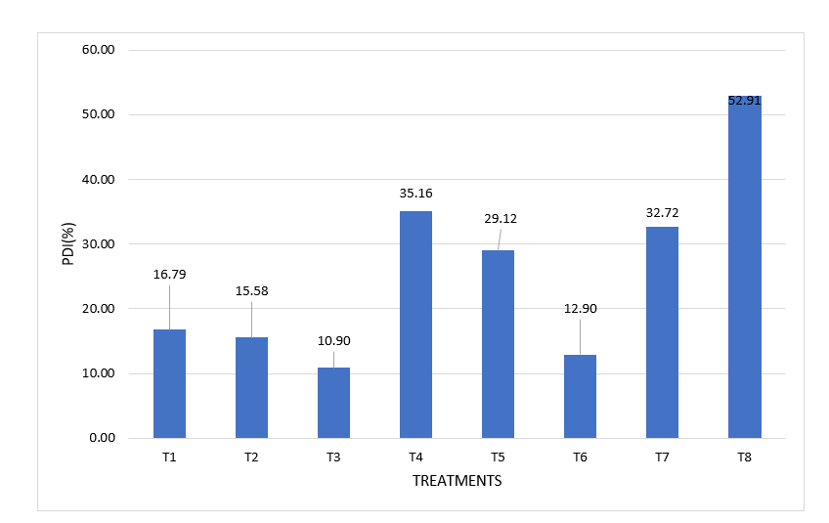
Fig.1 Effect of treatments on per cent disease intensity on downy mildew in sponge gourd
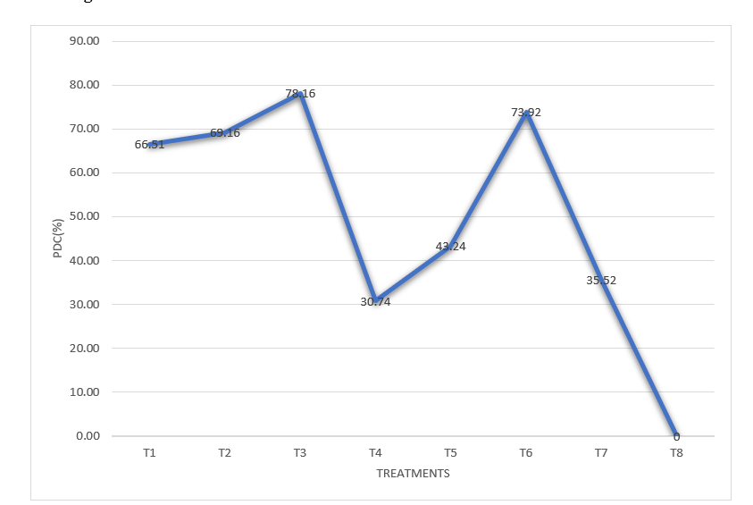
Fig.2 Effect of treatments on per cent disease control on downy mildew in sponge gourd

AUDPC analysis of Downy Mildew control in sponge gourd across treatments
As presented in Table 4, the AUDPC values varied significantly across the eight treatments, reflecting differential disease pressure and control. Treatment T₈ exhibited the highest AUDPC value of 1212.75, indicating the most severe disease progression and serving as the untreated control. In contrast, treatments T₃ and T₆ demonstrated the lowest AUDPC values of 273.50 and 328.85, respectively, corresponding to PDC values of 78.16% and 73.92%. These results suggest that T₃, with a concentration of 0.15%, and T₆, with 0.2%, were the most effective in reducing disease progression due to their optimal suppression of downy mildew development over the observation period.

Table 4: Effect of different fungicidal treatments on AUDPC of Downy mildew in sponge gourd
Tr.No. | Treatment | Conc. (%) | PDI before first spray | PDI after |  |  | Mean | AUDPC | PDC
 |  |  |  | 10 days after 1st spray | 10 days after 2nd spray | 10 days after 3rd spray | Mean | AUDPC | PDC
T₁ | Carbendazim 12%+ Mancozeb 63% | 0.15 | 1.75  (7.61) | 13.94  (21.92) | 17.77  (24.93) | 18.66  (25.59) | 16.79 | 419.15 | 66.07
T₂ | Azoxystrobin 4.8% w/w + Chlorothalonil 40% w/w SC | 0.6 | 1.74  (7.59) | 12.63  (20.82) | 16.27  (23.79) | 17.84  (24.98) | 15.58 | 386.90 | 68.73
T₃ | Azoxystrobin 11% w/w + Tebuconazole 18.3 | 0.15 | 1.80  (7.72) | 8.69  (17.13) | 11.51  (19.79) | 12.50  (20.52) | 10.90 | 237.50 | 78.16
T₄ | Aureofungin 46.25 w/w SP | 0.005 | 1.72  (7.53) | 26.59  (31.04) | 35.48  (36.55) | 43.42  (41.22) | 35.16 | 846.40 | 30.74
T₅ | Copper sulphate 47.15 + Mancozeb 30% WDG | 0.5 | 1.74  (7.59) | 21.17  (27.38) | 28.81  (32.43) | 37.38  (37.69) | 29.12 | 695.40 | 43.24
T₆ | Kresoxim methyl 18% +Mancozeb 54% WP | 0.2 | 1.78  (7.66) | 10.83  (19.21) | 13.46  (21.52) | 14.41  (22.26) | 12.90 | 323.85 | 73.92
T₇ | Potassium salt of Phosphoric acid | 0.4 | 1.73  (7.57) | 25.11  (30.05) | 32.48  (34.73) | 40.58  (39.57) | 32.72 | 787.45 | 35.52
T₈ | Control (water spray) |  | 1.81  (7.74) | 35.53  (36.58) | 46.48  (42.98) | 76.72  (61.24) | 52.91 | 1212.75 | 0.00
S.E. (m) ± |  |  | 0.06 | 1.02 | 1.54 | 1.61
CD at 5% |  |  | 0.17 | 3.08 | 4.67 | 4.90
*Figures in parentheses are arcsine transformed values
Analysis of Infection Rate and PDI Progression in Sponge Gourd Under Different Fungicidal Treatments
A shown in table 5, Treatment T₃, a combination of Azoxystrobin 11% and Tebuconazole 18.3% at a 0.15% concentration, emerged as the most effective, displaying the lowest infection rates of 0.689 (first 10 days), 0.282 (10-20 days), and 0.10 (20-30 days). This performance aligns closely with its PDI values, which increased modestly from 1.80 before the first spray to 12.5 after the third, suggesting a robust capacity to suppress fungal growth over time.
In comparison, T₆, formulated with Kresoxim methyl 18% and Mancozeb 54% WP at 0.2%, showed a more moderate infection rate profile (0.905, 0.263 and 0.10), with PDI rising from 1.78 to 14.41. Treatments T₄ and T₇, with higher infection rates—T₄ at 2.487, 0.889 and 0.794, and T₇ at 2.338, 0.737 and 0.810 which indicated less initial control or inconsistent suppression, as reflected in their PDI trends. The untreated control (T₈) recorded the highest infection rates (3.372, 1.095 and 3.024), with PDI escalating from 1.81 to 76.72, underscoring the rapid disease progression without intervention.
Table 5: Effect of different Fungicidal treatments on PDI and infection rate of Downy mildew in sponge gourd

Tr.No. | Treatment | Conc.  (%) | PDI before first spray | PDI after |  |  | ‘r’ (from disease appearance to 1st obs. after spray) | ‘r’  (10-20 days) | ‘r’ (20-30 days)
 |  |  |  | 10 days after 1st spray | 10 days after 2nd spray | 10 days after 3rd spray | ‘r’ (from disease appearance to 1st obs. after spray) | ‘r’  (10-20 days) | ‘r’ (20-30 days)
T₁ | Carbendazim 12%+ Mancozeb 63% | 0.15 | 1.75  (7.61) | 13.94  (21.92) | 17.77  (24.93) | 18.66  (25.59) | 1.219 | 0.383 | 0.089
T₂ | Azoxystrobin 4.8% w/w + Chlorothalonil 40% w/w SC | 0.6 | 1.74  (7.59) | 12.63  (20.82) | 16.27  (23.79) | 17.84  (24.98) | 1.089 | 0.364 | 0.157
T₃ | Azoxystrobin 11% w/w + Tebuconazole 18.3 | 0.15 | 1.80  (7.72) | 8.69  (17.13) | 11.51  (19.79) | 12.50  (20.52) | 0.689 | 0.282 | 0.099
T₄ | Aureofungin 46.25 w/w SP | 0.005 | 1.72  (7.53) | 26.59  (31.04) | 35.48  (36.55) | 43.42  (41.22) | 2.487 | 0.889 | 0.794
T₅ | Copper sulphate 47.15 + Mancozeb 30% WDG | 0.5 | 1.74  (7.59) | 21.17  (27.38) | 28.81  (32.43) | 37.38  (37.69) | 1.943 | 0.764 | 0.857
T₆ | Kresoxim methyl 18% +Mancozeb 54% WP | 0.2 | 1.78  (7.66) | 10.83  (19.21) | 13.46  (21.52) | 14.41  (22.26) | 0.905 | 0.263 | 0.095
T₇ | Potassium salt of Phosphoric acid | 0.4 | 1.73  (7.57) | 25.11  (30.05) | 32.48  (34.73) | 40.58  (39.57) | 2.338 | 0.737 | 0.810
T₈ | Control (water spray) |  | 1.81  (7.74) | 35.53  (36.58) | 46.48  (42.98) | 76.72  (61.24) | 3.372 | 1.095 | 3.024
S.E. (m) ± |  |  | 0.06 | 1.02 | 1.54 | 1.61
CD at 5% |  |  | 0.17 | 3.08 | 4.67 | 4.9

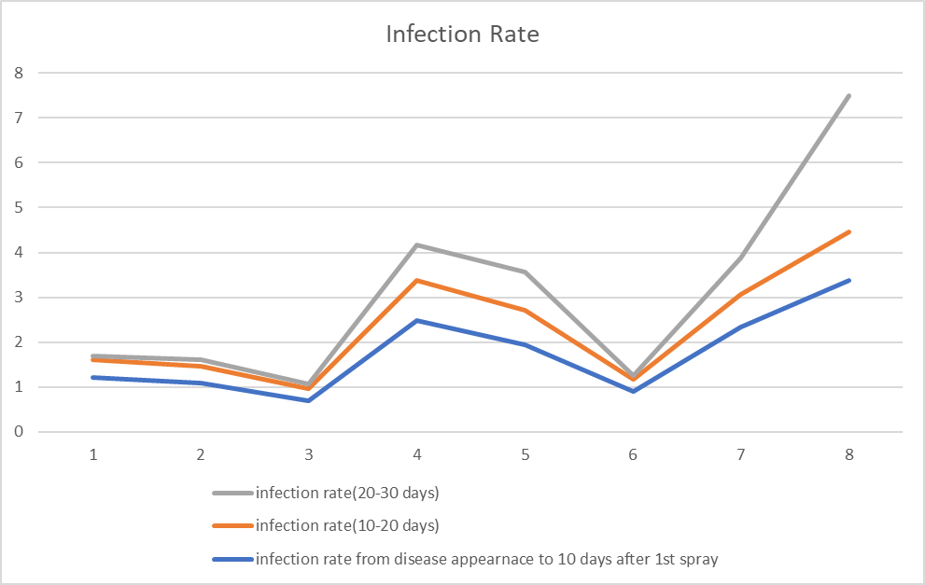
Fig.3 Infection rate of Downy mildew in sponge gourd under different treatments at various intervals

Effect on Yield characteristics:
The fruit length was maximum in the treatment T₃ (Azoxystrobin 11% w/w + Tebuconazole 18.3) (20.8 cm) which is on par with T₆ (Kresoxim methyl 18% +Mancozeb 54% WP) (20.46cm). The lowest fruit length was recorded in untreated control T₈ (15.63 cm). The maximum fruit width was observed in the treatment T₃ (Azoxystrobin 11% w/w + Tebuconazole 18.3) (3.4 cm) which is on par with T₂ (Azoxystrobin 4.8% w/w + Chlorothalonil 40% w/w SC) (3.3cm). The lowest fruit width was recorded in untreated control T₈ (2.2 cm). Number of fruits were maximum in the treatment T₃ (Azoxystrobin 11% w/w + Tebuconazole 18.3) (12) which is on par with T₆ (Kresoxim methyl 18% +Mancozeb 54% WP) (11). The number of fruits per plant were lowest in control (4). The average fruit weight was maximum in T₃ (Azoxystrobin 11% w/w + Tebuconazole 18.3) (170.1) which is on par with T₆ (Kresoxim methyl 18% +Mancozeb 54% WP) (164.8). The least average fruit weight was observed in T₈ (untreated control) (120.2). The fruit yield was superior in T₃ (Azoxystrobin 11% w/w + Tebuconazole 18.3) (130 q/ha) which is on par with T₆ (Kresoxim methyl 18% +Mancozeb 54% WP) (128 q/ha). Least yield was obtained in treatments T₄ and T₈, (98.2 q/ha and 90.5 q/ha) respectively.
The results demonstrate significant variations in yield parameters of sponge gourd across the applied treatments, reflecting their differential efficacy against Downy and Powdery mildew infections. Treatment T₃ (Azoxystrobin 11% w/w + Tebuconazole 18.3) emerged as the most effective, achieving the highest yield (130 q/ha) and number of fruits per vine (12), alongside the largest average fruit weight (170.1 g). This suggests that Azoxystrobin 11% w/w + Tebuconazole 18.3 effectively controlled the mildew pathogens, enhancing fruit development and overall productivity. The increased fruit dimensions (length 20.8 cm, width 3.4 cm) further support its role in improving plant health under disease pressure.
Treatment T₄ recorded the lowest yields (98.2 q/ha), which may be attributed to reduced fruit length (17.56 cm) and width (2.7 cm). This could indicate a phytotoxic effect or insufficient disease control at the applied concentrations (0.005%). In contrast, T₇ (Potassium salt of Phosphoric acid @ 0.4%) achieved a yield of 118 q/ha with improved fruit weight (141.4 g) and number (8 per vine), suggesting that phosphoric acid-based treatments enhance plant resistance and yield, likely through systemic acquired resistance mechanisms.
The untreated control (T₈) exhibited the poorest performance, with a yield of only 90.5 q/ha and minimal fruit production (4 per vine), highlighting the severe impact of untreated mildew infections on sponge gourd. The reduced fruit dimensions (length 15.63 cm, width 2.2 cm) and weight (120.2 g) in the control group underscore the necessity of fungicidal intervention.

Table 6: Effect of Treatments on Yield Parameters of Sponge Gourd Infected by Downy Mildew and Powdery Mildew

Tr.No. | Treatments | Conc. (%) | Length of fruit (cm) | Width of fruit (cm) | Avg. Min. fruit weight (g) | No: of fruits per vine | Yield (q/ha)
T₁ | Carbendazim 12%+ Mancozeb 63% | 0.15 | 20.2 | 3.1 | 153.4 | 9 | 124
T₂ | Azoxystrobin 4.8% w/w + Chlorothalonil 40% w/w SC | 0.6 | 20.13 | 3.3 | 155 | 9 | 125.5
T₃ | Azoxystrobin 11% w/w + Tebuconazole 18.3 | 0.15 | 20.8 | 3.4 | 170.1 | 12 | 130
T₄ | Aureofungin 46.25 w/w SP | 0.005 | 17.56 | 2.7 | 129.9 | 5 | 98.2
T₅ | Copper sulphate 47.15 + Mancozeb 30% WDG | 0.5 | 17.33 | 2.8 | 151.1 | 8 | 121.5
T₆ | Kresoxim methyl 18% +Mancozeb 54% WP | 0.2 | 20.46 | 3.2 | 164.8 | 11 | 128
T₇ | Potassium salt of Phosphoric acid | 0.4 | 16.96 | 2.6 | 141.4 | 8 | 118
T₈ | Control (water spray) | - | 15.63 | 2.2 | 120.2 | 4 | 90.5
S.E. (m) ± |  |  | 0.73 | 0.12 | 3.81 | 0.41 | 3.81
CD at 5% |  |  | 2.20 | 0.36 | 11.56 | 1.25 | 11.57

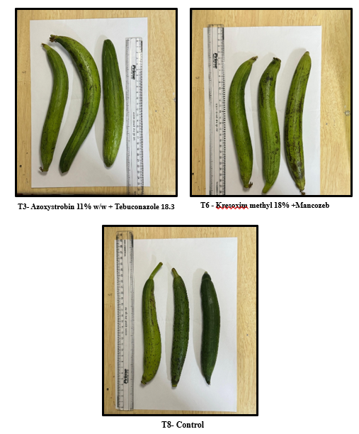

Plate 1: Efficacy of different fungicides against downy mildew and powdery mildew of sponge gourd

Economic Evaluation of Fungicidal Treatments for Managing Downy Mildew in Sponge Gourd (Luffa cylindrica)
Treatment T₃ (Azoxystrobin 11% + Tebuconazole 18.3% @ 0.15%) incurred a total cost of ₹1,26,800, yielded 130 q/ha, gross income of ₹2,60,000/ha, additional income of ₹79,000/ha, net profit of ₹1,33,200/ha, and the highest BCR of 2.05 followed by treatment T₆ (Kresoxim methyl 18% + Mancozeb 54% WP @ 0.2%) (2.01) and T₂ Azoxystrobin 4.8% w/w + Chlorothalonil 40% w/w SC (1.98).The control (T₈) served as a baseline, with a yield of 90.5 q/ha and no net profit, highlighting the economic loss from untreated disease. The BCR analysis aligns with yield results, highlighting T₃ and T₆ as cost-effective treatments due to their substantial returns.

Tr.No. | Treatments | Cost of cultivation (A) | Cost of spraying fungicides (B) | Labour wages (400/day) (C) | Total cost of production (D) | Yield (q/ha) | Gross income/ha | Additional income/ha | Net profit/ha | Benefit-cost ratio
T₁ | Carbendazim 12%+ Mancozeb 63% | 125200 | 155 | 1200 | 126555 | 124 | 248000 | 67000 | 121445 | 1.96
T₂ | Azoxystrobin 4.8% w/w + Chlorothalonil 40% w/w SC | 125200 | 469 | 1200 | 126869 | 125.5 | 251000 | 70000 | 124131 | 1.98
T₃ | Azoxystrobin 11% w/w + Tebuconazole 18.3 | 125200 | 400 | 1200 | 126800 | 130 | 260000 | 79000 | 133200 | 2.05
T₄ | Aureofungin 46.25 w/w SP | 125200 | 375 | 1200 | 126775 | 98.2 | 196400 | 15400 | 69625 | 1.55
T₅ | Copper sulphate 47.15 + Mancozeb 30% WDG | 125200 | 230 | 1200 | 126630 | 121.5 | 243000 | 62000 | 116370 | 1.92
T₆ | Kresoxim methyl 18% +Mancozeb 54% WP | 125200 | 1099 | 1200 | 127499 | 128 | 256000 | 75000 | 128501 | 2.01
T₇ | Potassium salt of Phosphoric acid | 125200 | 400 | 1200 | 126800 | 118 | 236000 | 55000 | 109200 | 1.86
T₈ | Control (water spray) | 0 | 0 | 0 | 0 | 90.5 | 181000 | 0 | 181000
Table 7: Economic Analysis of various Fungicidal Treatments in the Management of Downy Mildew in Sponge Gourd

These results are in conformity to the findings of several earlier workers. The fungicides viz., Carbendazim 12%+ Mancozeb 63%, Azoxystrobin 4.8% w/w + Chlorothalonil 40% w/w SC, Azoxystrobin 11% w/w + Tebuconazole 18.3, Aureofungin 46.25 w/w SP, Copper sulphate 47.15 + Mancozeb 30% WDG, Kresoxim methyl 18% +Mancozeb 54% WP and Potassium salt of Phosphoeric acid at their recommended field dosages were reported effective and economical for the management of downy mildews of various crop hosts such as Anand et al. (2008) in cucumber, Reddy et al.(2021) in grapes, Waychal et al.(2018) on okra, Kakade et al. (2001) on ridge gourd, Ghosh et al.(2020) on cucumber, Neelima, M. (2016) in ridge gourd and Bhat et al. (2013) on cucumber.
CONCLUSION
The study demonstrated that Azoxystrobin 11% w/w + Tebuconazole 18.3% at 0.15% concentration was the most effective fungicidal treatment against downy mildew in sponge gourd, significantly reducing disease severity and increasing yield. Kresoxim methyl 18% + Mancozeb 54% WP also showed comparable efficacy. These treatments not only controlled the disease efficiently but were also economically beneficial, highlighting their potential for sustainable downy mildew management in sponge gourd cultivation.

COMPETING INTERESTS DISCLAIMER:
Authors have declared that they have no known competing financial interests OR non-financial interests OR personal relationships that could have appeared to influence the work reported in this paper.

REFERENCES
Anand, T., Chandrasekaran, A., Kuttalam, S. P., Senthilraja, G., Raguchander, T., and Samiyappan, R., 2008. Effectiveness of azoxystrobin in the control of Erysiphe cichoracearum and Pseudoperonospora cubensis on cucumber. Journal of Plant Protection Research, 48(2), 183-191.
Anonymous. Area and production of horticulture crops. Ministry of Agriculture and Farmers Welfare, Government of India, Gurgaon, India; c2022. https://agricoop. nic.in.
Bhat, N. A., Masoodi, S. D., Mir, M. A., and Bhat, F. N., 2013. Bio-efficacy of fungicides against downy mildew of cucumber (Cucumis sativus L.) caused by Pseudoperonospora cubensis. International Journal of Plant Protection, 6(2), 347-351.
Colucci, S. J., and Holmes, G. J., 2010. Downy mildew management in cucurbits. Plant Disease Management Reports, 4, V112.
Ghosh, A. R., Chakraborty, K., and Das, S. K. 2020. Management of cucumber downy mildew with fungicides. Indian Journal of Plant Protection, 48(4), 846-851.
Kakade, D. S., Borkar, S. G., and Ujagare, H. D. 2001. Efficacy of fungicidal treatments in control of downy mildew of ridge gourd (Luffa acutangula). Journal of Maharashtra Agricultural Universities, 26(1), 12-15.
Mayee CD, Datar VV. Phytopathometry, Technical Bulletin-1 (Special Bulletin-3) Marathwada Agricultural University, Parbhani, Maharashtra, India; c1986, p. 95.
McGrath, M. T. 2004. Cucurbit crop diversity and utilization. HortTechnology, 14(2), 187–194.
Neelima, M. 2016. Management of downy mildew (Pseudoperonospora cubensis) in ridge gourd through fungicides and biorationals. The Bioscan, 11(1), 517-521.
Pandit, R., Pandit, M. K., Ghosh, S., Karak, C., & Bairagi, S. (2023). Importance of cucurbits for food cum nutritional security and climate resilience – a brief account. Indian Farmer, 10(7), 339-343.
Panse, V. G., & Sukhatme, P. V. (1967). Statistical methods for agricultural workers (2nd ed.). Indian Council of Agricultural Research.
Reddy, G. R., Kumari, D. A., & Vijaya, D. (2021). Field evaluation of fungicides for the management of downy mildew of grapes. The Pharma Innovation Journal, 10(11), 1165–1168.
Shaffique, S., Khan, M. A., Imran, M., Kang, S.-M., Park, Y.-S., Wani, S. H., & Lee, I.-J. (2022). Research Progress in the Field of Microbial Mitigation of Drought Stress in Plants. Frontiers in Plant Science, 13, 870626.
Waychal, G. U., Game, B. C., & Jagtap, S. D. (2018). Evaluation of fungicides for management of powdery mildew disease of okra (Abelmoschus esculentus Moench). International Journal of Chemical Studies, 6(2), 325–327.
Wheeler BEJ. An Introduction to Plant Disease. John Wiley and Sons Ltd., London; c1969, p. 301.

