Original Research Article
Attitude, Competency, Training Needs, and Constraints of Fertilizer Dealers in Kakinada District of Andhra Pradesh, India

ABSTRACT
A study was conducted in the Kakinada district of Andhra Pradesh, India, to assess attitude, competency, training needs, and constraints of retail fertilizer dealers. The survey research method was used for the collection of the required data. The attitude scores were obtained by using 5 positive statements each regarding soil health management and farmers’ welfare. A set of 10 multiple-choice questions was used to determine the competency scores of the respondents. The Weighted Mean Scores were used to rank the training areas. The constraints were analysed through Garrett’s ranking technique. The present study revealed that majority of the fertilizer dealers (67.86%) were adults (26-39 years) and degree holders. The majority (64.28%) of them owned agricultural land and were involved in the cultivation of crops for additional income. The overall attitude score of respondents was 0.95 ± 0.01, which indicates that most of the fertilizer dealers had a very high positive attitude towards sustainable agriculture and the welfare of the farming community. The mean competency score was 3.93 ± 1.86 out of 10. The balanced use of chemical fertilizers, bio-fertilizers and organic fertilizers was the most sought training area. Heavy competition, followed by non-availability of fertilizer stocks in the market at the appropriate time, and lack of credit facilities to procure the fertilizer stocks were the top three constraints in fertilizer dealership. A significant negative correlation (P < 0.05) between attitude score and competency score was found in the present study. It was concluded that, even though most of the fertilizer dealers in the Kakinada district of Andhra Pradesh had a very high positive attitude towards soil health management and farmers’ welfare, their competency levels were low. Most of the dealers want training on balanced use of chemical fertilizers, bio-fertilizers and organic fertilizers, and heavy competition was the major constraint perceived by them in fertilizer dealership.
Keywords: Fertilizer dealer, constraints, competency, attitude, training
1. INTRODUCTION
The fertilizer is the most critical input among all others that are needed for increasing agricultural productivity (Sharma and Thaker, 2010). India is ranked second and third in the world in terms of fertilizer consumption and production, respectively (Press Information Bureau, 2025; Shukla et al., 2022). The total fertilizer consumption in India was 64.84 million tonnes in 2023-24 (Fertiliser Association of India, 2024), most of which includes Urea (35.78 million tonnes), complex fertilizers containing Nitrogen (11.07 million tonnes), and DAP (10.81 million tonnes). The state of Andhra Pradesh ranked 7th in terms of fertilizer consumption in India (Anonymous, 2024). Ahmed et al. (2017), Sainju et al. (2020) and Martinez-Dalmau et al. (2021) reported that the excessive use of Nitrogen fertilizers can cause serious damage to environment. Creating awareness among farmers on balanced use of fertilizers, and the ill effects of their excessive use on the environment is the need of the hour.
The agri-input dealers are the closest points of contact for farmers for information on fertilizer doses, soil health management, and pest control, etc. (Latha et al., 2022; Meena and Badhla, 2024; and Rani et al., 2024). They act as a bridge between the government departments of agriculture and farmers. However, the majority of the dealers do not have formal agricultural education, and they need updated information on the above aspects so that they can pass it to the farmers effectively. For example, the fertilizer dealers need to be sensitised on new practices such as use of biofertilizers and nano-fertilizers, use of drones for fertilizer application, and growing of green manuring crops for improving soil health and reducing dependence on chemical fertilizers etc., Also, the availability of quality human resources at the grassroots level is essential for the sustainable development of agriculture (Reddy et al., 2025). In order to tap into the large number of input dealers present in India by improving their technical competency, the National Institute of Agricultural Extension Management (MANAGE), an autonomous body under Government of India is offering one year Diploma in Agricultural Extension Services for Input Dealers (DAESI) course for all kinds of agi-input dealers and 15 day Certificate Course on Integrated Nutrient Management (CCINM) exclusively for fertilizer dealers. The courses were made mandatory to obtain licences of agri-input dealerships for individuals not having the required degree, which is one of the driving forces for enrolment in the courses (Kumar et al., 2025). Latest information regarding the attitude, competency, training needs, and constraints of fertilizer dealers is a useful addition to the existing literature, and it may be helpful to design policies for promoting sustainable use of fertilizers. The present study was conducted to assess attitude, competency, training needs and constraints of retail fertilizer dealers in Kakinada district of Andhra Pradesh, India.
2. MATERIALS AND METHODS
The present study was conducted in the Kakinada district of Andhra Pradesh, India. The survey research method was used for the collection of data from about 42 respondents, i.e., 2 retail fertilizer dealers from each of 21 mandals in the district. The district of Kakinada had a total cultivation area of 91,562 ha., 94.86% of which is under Paddy cultivation. Black gram, Sugarcane, and Maize are the minor crops that were grown in 0.88, 0.46, and 0.41% respectively of the total cultivation area in the district during Kharif 2024-25 (Anonymous, 2025).
The basic details, such as age, educational qualification, year of establishment of fertilizer shop, agricultural land owned, additional sources of income, etc., were also collected from all the 42 respondents, apart from the data regarding attitude, competency, training needs, and constraints. The education score of a respondent was obtained by assigning 0, 1, 2, 3, 4 and 5 scores to choices of educational qualifications such as illiterate, primary school, lower secondary school, upper secondary school (intermediate), graduation and post-graduation, respectively.
The assessment of attitude of fertilizer dealers was done based 5 positive statements each regarding soil health management and farmers’ welfare. The respondent had to choose any one of 5 options, such as strongly agree, agree, undecided, disagree, and strongly disagree, with a scoring pattern of 5, 4, 3, 2, and 1, respectively, for each statement. The attitude score of each respondent was arrived at by dividing the sum of scores given by the respondent for all the statements by the maximum possible score. A set of 10 multiple-choice questions related to fertilizers, each carrying one mark without any negative marking, was used to determine the competency scores of the respondents.
A set of 5 training topics relevant to the fertilizer dealers were rated on a 5-point Likert scale i.e. Very much needed-5, Fairly needed-4, Needed-3, Least needed-2, and Not at all needed-1. The Weighted Mean Score of a topic was calculated by dividing the sum of scores given by the respondents for that particular topic by the total number of respondents. The topics were ranked based on the Weighted Mean Scores.
The fertilizer dealers were asked to rank the constraints perceived by them from a set of 10 constraints in fertilizer dealership. The Garett’s ranking technique was employed to analyse the constraints. It involved the calculation of percent positions from the order given by each dealer using the formula given below and the conversion of the percent positions into scores as per the table given by Garett and Woodworth (1969). The mean score of a constraint was obtained by dividing the sum of the scores of the respondents by the number of respondents who perceived the constraint. The constraints were ranked based on the mean scores through a simple rank order technique.
$$Percent position = \frac{(R_{ij}-0.50)}{N_{j}}×100$$
Where, R_{ij} is the rank given for i^{th} constraint by j^{th} individual, N_{j} is the number of constraints perceived or ranked by the j^{th} individual.
The Pearson correlation coefficients were used to assess the relationship among parameters such as age, year of establishment of fertilizer shop, education score, agricultural land owned, attitude score, and competency score.

3. RESULTS AND DISCUSSION
3.1 Basic information
The results regarding the distribution of fertilizer dealers in Kakinada district of Andhra Pradesh, as per basic parameters such as age, educational qualification, year of establishment of fertilizer shop, agricultural land owned, and additional sources of income, are given in Table 1. It was found through the present study that the majority of the fertilizer dealers (67.86%) were adults (26-39 years) and degree holders. The results were similar to the reports of Vishakha et al. (2023), Jhansi et al. (2022), and Singh et al. (2021). 42.86% of the respondents had established their fertilizer shops after 2020, which indicates that they had less experience in the fertilizer business when compared to others. The majority (64.28%) of them owned agricultural land and were involved in the cultivation of crops for additional income. A few (7.14%) respondents were doing business with other agricultural inputs, such as seeds, along with the fertilizers.

Table 1. Distribution of fertilizer dealers in Kakinada district of Andhra Pradesh as per basic parameters (N=42)
Age
Adult (26-39 years) |  |  | Middle aged adult (40-59 years)
67.86% |  |  | 32.14%
Educational qualification
Upper secondary school (Intermediate) |  |  | Degree | PG and above
3.57% |  |  | 67.86% | 28.57%
Year (A.D.) of establishment of fertilizer shop
Before 2001 |  |  | 2001-2010 | 2011-2020 |  | After 2020
14.29% |  |  | 10.71% | 32.14% |  | 42.86%
Agricultural land owned (Acres)
Nil |  |  | 0.1-2.5 |  |  | Above 2.5
35.71% |  |  | 53.57% |  |  | 10.71%
Additional sources of income (Apart from trading of fertilizers)
Nil | Crop production | Sale of seeds | Crop production and sale of seeds |  | Crop production and livestock production |  | Crop production and aquaculture
32.14% | 53.57% | 3.57% | 3.57% |  | 3.57% |  | 3.57%
N= Sample size

3.2 Attitude
The average attitude score of fertilizer dealers towards soil health management and farmers’ welfare was 0.93 ± 0.01 and 0.97 ± 0.01, respectively. The overall attitude score was 0.95 ± 0.01. The results of the present study indicated that most of the fertilizer dealers had a very positive attitude towards sustainable agriculture and the welfare of the farming community. Only a few respondents (17.86%) disagreed or strongly disagreed on the statement ‘I should promote use of bio-fertilizers without caring for the margins or expiry date issues’. Anitha (2005) reported similar results.

3.3 Competency
The present study revealed that the mean competency score of fertilizer dealers was 3.93 ± 1.86 out of 10. Only 50% of the respondents had a competency score of 5 and above out of 10. Similar values of knowledge score of agricultural input dealers were reported by Kumar et al. (2022) and Anitha (2005). The results are pointing towards the need to improve knowledge levels of fertilizer dealers through intensive training and awareness programmes so that the dealers can provide necessary information and advice to farmers effectively.

3.4 Training needs
It was found through the present study that the fertilizer dealers of Kakinada district need trainings on areas such as balanced use of chemical fertilizers, bio-fertilizers and organic fertilizers, testing of fertilizers for impurities or adulteration, important rules and amendments of Fertilizer (Control) Order, 1985, record maintenance and accounting, and fertigation, with weighted mean scores of 4.71, 4.57, 4.43, 4.29 and 3.71, respectively. The results were in agreement with those of Saikia et al. (2024), who found that training on Integrated Nutrient Management was the most sought-after area among dealers. Mohan et al. (2019) reported that the training on different types of manures and fertilizers was the most needed area of training among fertilizer dealers in Andhra Pradesh. The government regulations regarding fertilizers were reported to be priority areas for training among dealers Singh et al., 2021 & Meena et al., 2024).

3.5 Constraints in fertilizer dealership
The results of analysis of constraints perceived by fertilizer dealers in Kakinada district of Andhra Pradesh were presented in Table 2. Heavy competition, followed by non-availability of fertilizer stocks in the market at the appropriate time, and credit facilities to procure the fertilizer stocks were the top three constraints in fertilizer dealership in Kakinada district of Andhra Pradesh. The results coincided with those of Kale (2016). The present study showed that the major constraints in fertilizer dealership vary according to the age group of dealers. Heavy competition was the major constraint for adult dealers, while lack of proper knowledge on selling appropriate fertilizers to farmers was the top constraint for middle aged adult dealers.

Table 2. Analysis of constraints perceived by fertilizer dealers in Kakinada district of Andhra Pradesh (Garett’s ranking technique)
S.No. | Constraint | Age of dealers |  |  |  | Overall
S.No. | Constraint | Adult  (26-39 years) |  | Middle aged adult  (40-59 years)
S.No. | Constraint | Mean Score | Rank | Mean Score | Rank | Mean Score | Rank
1 | Failure of farmers to repay loan taken for fertilizers | 52.62 | IV | 62.40 | II | 55.33 | IV
2 | Lack of proper knowledge on selling appropriate fertilizers to farmers | 43.86 | VIII | 64.00 | I | 46.38 | VI
3 | Non-availability of fertilizer stocks in market at appropriate time | 59.56 | II | 53.63 | V | 57.58 | II
4 | Seasonal nature of fertilizer business | 43.27 | IX | 45.00 | IX | 43.64 | VIII
5 | No credit facilities to procure fertilizer stocks | 56.25 | III | 55.71 | III | 56.05 | III
6 | Heavy competition | 61.38 | I | 53.71 | IV | 59.04 | I
7 | High cost of transportation of fertilizer stocks | 52.25 | V | 50.00 | VI | 51.50 | V
8 | Non-availability of labourers | 46.67 | VII | 45.60 | VIII | 46.35 | VII
9 | High cost of labour | 34.20 | X | 48.50 | VII | 37.21 | X
10 | Difficulties in renewal of licence | 47.92 | VI | 29.20 | X | 42.41 | IX

3.6 Relationship among basic parameters, attitude, competency and constraints
The correlation coefficients among parameters of basic information, attitude score competency score and No. of constraints and the visualization of correlations were presented in Table 3 and Figure 1 respectively. The correlation plot between attitude score and competency score was depicted in Figure 2. The correlation coefficient (r) values between 0.10 and 0.29 indicate weak correlation; those between 0.30 and 0.49 indicate medium correlation, while those between 0.50 and 0.95 indicate strong correlation (Inoni and Okorie, 2022). A perusal of Table 3 shows that the year of establishment of the fertilizer shop had a low degree of negative association with the competency score, which may be due to the fact that knowledge levels improve with experience in any field. The age of the fertilizer dealer had a weak negative correlation with the education score and the number of constraints. The probable explanation for this is presence of a number of young and talented fertilizer dealers with higher educational qualifications. There was a moderate positive association between education score and attitude score, which indicates that the positive attitude increases with higher education. There was a significant negative correlation (P < 0.05) between attitude score and competency score (Figure 2). It indicates that the knowledge levels of dealers with high positive attitude are low. Kumar et al. (2022) reported a non-significant positive association between age and knowledge level, which is similar to the present study. Anitha (2005) stated that education and experience had positive associations with knowledge level.

Table 3. Correlation coefficients among parameters of basic information, attitude score competency score and No. of constraints
Parameter  (N = 42) | Age | Education score | Agricultural land owned | Attitude score | Competency score | No. of constraints perceived
Year of establishment of fertilizer shop | 0.177 | 0.012 | -0.125 | 0.159 | -0.240 | 0.068
Age |  | -0.261 | 0.004 | -0.125 | 0.065 | -0.275
Education score |  |  | 0.117 | 0.300 | 0.019 | -0.119
Agricultural land owned |  |  |  | -0.068 | 0.091 | -0.205
Attitude score |  |  |  |  | -0.447* | 0.107
Competency score |  |  |  |  |  | -0.026
*P < 0.05 N= Sample size

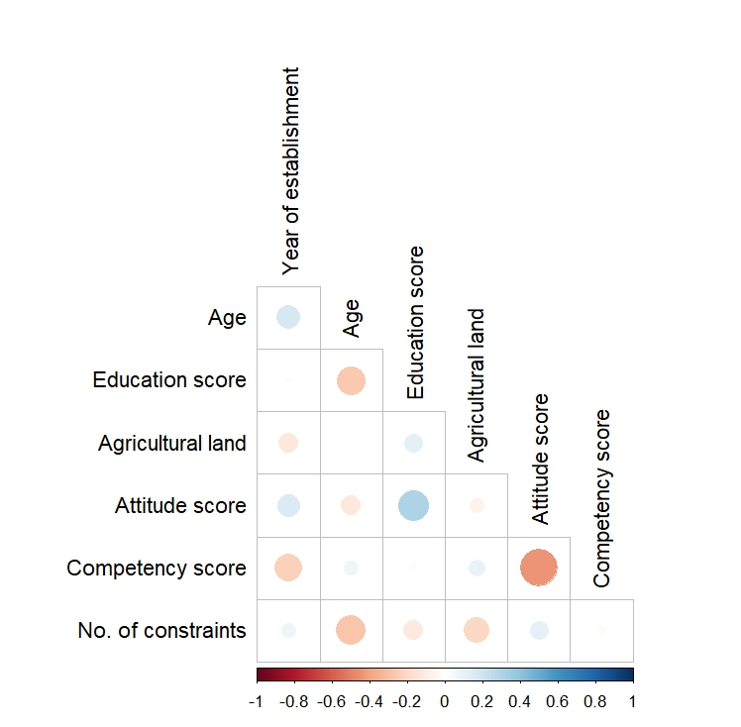
Fig. 1. Visualization of correlations among basic parameters, attitude, competency and constraints

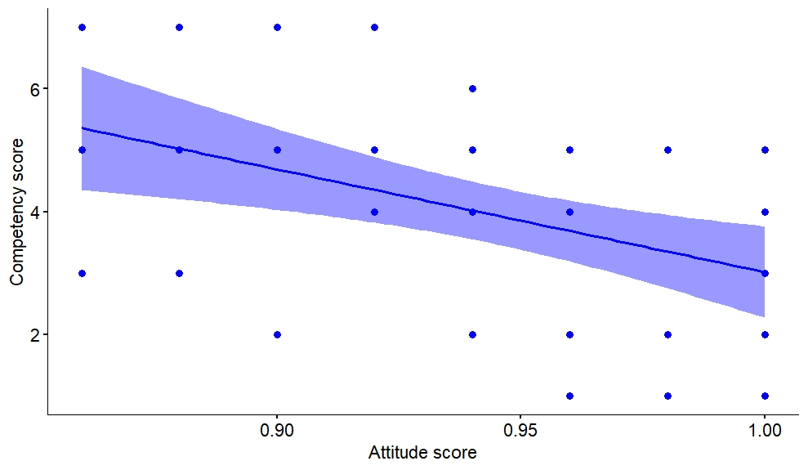
Fig. 2. Correlation plot between attitude score and competency score

4. CONCLUSIONS
Based on the results of present study, it can be concluded that most of the fertilizer dealers in Kakinada district of Andhra Pradesh had very high positive attitude towards soil health management and farmers’ welfare, the competency levels of fertilizer dealers are low, most of them want training on balanced use of chemical fertilizers, bio-fertilizers and organic fertilizers, and heavy competition was the major constraint perceived by them in fertilizer dealership.

REFERENCES
Ahmed, M., Rauf, M., Mukhtar, Z., & Saeed, N. A. (2017). Excessive use of nitrogenous fertilizers: an unawareness causing serious threats to environment and human health. Environmental science and pollution research international, 24(35), 26983–26987.
Anitha, B. N. (2005). A study on knowledge, attitude and training needs of agricultural input dealers in eastern dry zone of Karnataka. PhD thesis. University of Agricultural Sciences, Bangalore.
Anonymous. (2024). Agricultural Statistics at a Glance 2023. Economics, Statistics & Evaluation Division, Department of Agriculture & Farmers Welfare, Ministry of Agriculture & Farmers Welfare, Government of India.
Anonymous. (2025). Andhra Pradesh Agriculture Information & Management System. Agriculture Department, Government of Andhra Pradesh.
Fertiliser Association of India. (2024). Annual Review of Fertilizer Production and Consumption 2023-24. Indian Journal of Fertilisers, 20(9), 898-953.
Garett Henry, E., & Woodworth, R. S. (1969). Statistics in Psychology and Education. Vakils, Feffer and Simons Pvt. Ltd., Bombay.
Inoni, O. R., & Okorie, C. (2022). Brand quality, consumption emotions, and a decision to purchase washing machines. Ekonomski horizonti, 24(1), 95-113.
Jhansi, B., Ragini, M., Pawar, J. L. B., & Sankanagoudar, S. (2022). A Study on Socio-Personal Profile of Daesi Input Dealers. Asian Journal of Agricultural Extension, Economics and Sociology, 40(12), 344-351.
Kale, K. V. (2016). Training needs of farm input dealers about farm input. PG thesis. Dr. Panjabrao Deshmukh Krishi Vidyapeeth, Akola, Maharashtra.
Kumar, G.N., Gopichand, B., Bhagwat, K., & Shirur, M. (2025). Driving factors to become an agri-input dealer: Implications for institutionalising public-private partnership in extension service delivery. International Journal of Agriculture Extension and Social Development, 8(5), 35-40.
Kumar, R., Verma, R. K., Jhajharia, A. K., & Kumar, R. (2022). Knowledge level of respondents regarding important aspects covered under DAESI programme in Rajasthan. Indian Journal of Extension Education, 58(3), 170-174.
Latha, M.C., Kadian, K.S., Meena, B.S., Meena, H.R., & Meena, D.C. (2022). Role performance of trained input dealers as para extension workers in Andhra Pradesh. Indian Research Journal of Extension Education, 22(3), 140-143.
Martinez-Dalmau, J., Berbel, J., & Ordóñez-Fernández, R. (2021). Nitrogen Fertilization. A Review of the Risks Associated with the Inefficiency of Its Use and Policy Responses. Sustainability, 13(10), 5625.
Mohan, K., Kumar, P. G., & Rajasekhar, P. (2019). Training Needs Assessment of Agri-input dealers. The Journal of Research ANGRAU, 47(4), 60-68.
Press Information Bureau. (2025). Amrit Kaal: Empowering India’s Farmers Through Strategic Fertilizer Policy. https://www.pib.gov.in/PressNoteDetails.aspx?NoteId=154966&ModuleId=3
Rani, A.J., Kavitha, B., Murugan, P. P., Manimekalai, R., Abinaya, S., & Narmadha, N. (2024). Connecting agriculture, technology and farmers: an insight into the role of agricultural input dealers. GreenariA, 2(10), 120-124.
Reddy, B.N., Naidu, V.S.G.R., Madhav, M.S., & Hema, B. (2025). Career Preferences and Entrepreneurial Orientation among Undergraduate Female Agricultural Students. Agricultural Science Digest, 1-7. 10.18805/ag.D-6210.
Saikia, P., Das, P., & Deka, P. (2024). Training need assessment of agri-input dealers. Gujarat Journal of Extension Education, 37(2), 163-169.
Sainju, U. M., Ghimire, R., & Pradhan, G.P. (2020). Nitrogen Fertilization I: Impact on Crop, Soil, and Environment. Nitrogen Fixation, 10.5772/intechopen.86028
Sharma, V. P., & Thaker, H. (2010). Economic policy reforms and Indian fertilizer industry. Centre for Management in Agriculture (CMA)-Indian Institute of Management, Ahmedabad. Publication No. 233
Shukla, A. K., Behera, S. K., Chaudhari, S. K., & Singh, G. (2022). Fertilizer use in Indian agriculture and its impact on human health and environment. Indian Journal of Fertilisers, 18(3), 218-237.
Singh, N., Gupta, B. K., & Gautam, U. S. (2021). Training needs assessment of agro-input dealers in Banda district of Uttar Pradesh. Indian Journal of Extension Education, 57(2), 56-62.
Vishakha, K., Deepa, N., Rohini, A., Vidhyavathi, A., & Ravikumar, R. (2023). Awareness and Perception of Farmers and Dealers on Nano Urea in Gondia District of Maharashtra, India. International Journal of Environment and Climate Change, 13(10), 981-991.
Meena, S. K., & Badhala, B. S. (2024). Personal Profile of Cooperative and Private Agri Input Dealers in the Jaipur Region of Rajasthan, India. Asian Journal of Agricultural Extension, Economics & Sociology, 42(5), 431-437.
Meena, S. K. (2024). Knowledge of Cooperative and Private Agri Input Dealers Regarding Improved Barley Production Technology. Indian Journal of Extension Education, 60(3), 93-96.
Meena, S.K., Badhala, B. S., & Asiwal, B. L (2024). Knowledge of Agri Input Dealers Regarding Improved Tomato Production Technology. Gujarat Journal of Extension Education, 38 (1):106-110 https://doi.org/10.56572/gjoee.2024.38.1.0018
Yeragorla Venkata Harikrishna, J. B. Patel and Vinaya Kumar,H. M. (2023). A study on assessing the attitude ofATMA and KVK personnel towards e-extension.Gujarat Journal of Extension Education, 35 (2): 14-17. https://doi.org/10.56572/gjoee.2023.35.2.0004
Singh, Priti, Joshi, Madhuri, and Manhas, J. S. (2023). Problems faced by input dealers during the DAESI programme. Gujarat Journal of Extension Education, 36(2):31-37. https://doi.org/10.56572/gjoee.2023.36.2.0006.
Kumar, R., Verma, R. K., Jhajharia, A. K. and Kumar, R. (2022). Knowledge Level of Respondents Regarding Important Aspects Covered under the DAESI Programme in Rajasthan. Indian Journal of Extension Education, 58(3): 170-174.

