Morphological Responses of Common Bean under Competition with Hairy Beggarticks Using a Replacement Series

ABSTRACT
Common bean (Phaseolus vulgaris L.) turns out to be such a pivotal annual crop all of the world and has been commonly used for food security. Conversely, crop-weed competition induces stress in plants and can also bring about morphophysiological changes owing to a differential resource partition in cropping systems. The aim of the current research was to evaluate morphophysiological responses of common bean under competition with hairy beggarticks by means of a replacement series. For such, a replacement series was conducted in a completely randomized experimental design with four replications. Crop-weed treatment competition between common bean cv. BRS Esteio and hairy beggarticks (competitor) was imposed at the following mixture ratios: 100:0, 75:25, 50:50, 25:75 and 0:100. Morphophysiological parameters under scrutiny were plant height, foliar area, aerial shoot dry mass, photosynthetic rate, stomatal conductance, internal CO₂ concentration, transpiration, and instantaneous carboxylation efficiency at 50 days after emergency (DAE). Diagrams based on relative yield (RY) and relative yield total (RYT) were employed to identify crop-weed competition effects in light of the respective monoculture and additional control with one plant alone. Crop-weed competition reduced PR for both species, with such a greater loss to common bean plants due to intraspecific competition, whereas the interspecific competition strongly affected morphological parameters of hairy beggarticks. Common bean cv. BRS Esteio exhibited a more pronounced competitive ability plus aggressiveness compared to hairy beggarticks. Physiological parameters of common beans were negatively impacted by intraspecific competition at rations of 75:25 and 50:50. For hairy beggarticks, either intra or interspecific competition impinged upon ecophysiological responsiveness of common bean plants as opposed to monoculture cropping systems. Common bean cv. BRS Esteio evidenced a higher competitive ability along with competitiveness index compared to hairy beggarticks, indicating a faster establishment and a conspicuous advantage for the crop to capture available environmental resources in order to assure sustainable crop production at a commercial scale.

Keywords: Phaseolus vulgaris L.; Bidens pilosa L.; crop-weed competition; competitive ability; gaseous exchanges.

1. INTRODUCTION
Common bean (Phaseolus vulgaris L.) is an annual plant belonging to the Fabaceae Family widely known since civilizations of Egypt and Ancient Greece, with historical reports of cultivation from 1,000 years A.C. Such a specie possesses grains quite rich in protein as a source of energy, a low content in fat and is largely cultivated in Brazil for food security. Currently, there are fourteen types of beans grown in Brazil standing out pinto bean, cowpea bean, black bean, white bean, broad bean along with so many other colorful beans (Coêlho, 2018). In view of a world scenario, the countries that most produce beans are China, India, Myanmar, and Brazil. With regard to national production of black common beans, Southern Brazil leads the market, particularly throughout the second harvest as a succeeding crop to corn, with annual yields of 757.6 thousand tons from areas of approximately 467.3 thousand hectares. Moreover, Parana State is considered the largest producer when it comes to black common bean with annual yields corresponding to roughly 500 thousand tons (CONAB, 2024). Brazilian bean yield largely comes from family farming differencing from field to field as a function of technological levels owing to adoption of improper agricultural practices that might compromise commercial yields and also profitability (Barbosa and Gonzaga, 2012).

Prevailing local edaphoclimatic conditions are considerably favorable for cultivation of common bean in Brazil, taking into consideration up to three growing seasons annually along with a lack of common bean crop responsiveness to photoperiod duration. In addition, the use of common bean within cropping systems in Southern Brazil comes to being a viable option in economic terms because its rapid vegetative cycle potentializes soil use in such a way as to guarantee sustainable tropical agriculture. However, the short cycle of the crop in conjunction with unsuitable canopy closing might result in higher susceptibility of the main crop to competition for either biotic or abiotic factors, particularly among weed species that negatively interfere with crop yield as a function of weed infestation itself and interference duration (Procópio et al., 2004; Manabe et al., 2014; Galon et al., 2017).

Occurrence of dicot weeds in common bean production fields might be envisioned as a challenge due to botanical similarities and difficulties concerning adoption of chemical control practices featured by a restricted number of selective herbicides available in the market to control in post-emergence. Usually, Bidens pilosa L. (hairy beggarticks) turns out to be an annual weed specie highly competitive found in common bean fields that evidence an erect growth, broad phenotyping plasticity, good growth and development under high temperatures and adverse solar radiation regimes, which in turn play an important role in competition among plants (Santos and Cury, 2011; Cury et al., 2013). Thus, crop-weed competition will impinge upon available resources, such as light, nutrients and water, with negative impacts on plant development capable of triggering morphophysiological changes like substantial reductions in photosynthesis rate owing to interference on light interception by competitor canopy (Taiz and Zeiger, 2017).

Conspicuous alterations on absorbed radiation quality as a result of competition are detected by phytochrome photoreceptors bringing about deteriorating morphophysiological effects on canopies (Mazza and Ballaré, 2015; Mckenzie-Gopsill et al., 2016). Shading of cultivated plants promoted by weed species modifies radiation ratios within shortwave and longwave red bands in such a fashion as to cause stem elongation along with changes in resources partitioning. At a physiological point of view, net radiation at a given crop is taken up to control stomata opening, gaseous exchanges between leaf and environment, and mainly to govern photosynthetic activity and water use efficiency in commercial production fields (Manabe et al., 2014). Conversely, interference degree of a specific crop hinges on morphophysiological characteristics that might be directly linked to competitive ability, such as preferential allocation of dry matter of aerial part, spatial distribution, germination and emergence, stature, growth habit, leaf area index, soil covering, solar radiation interception, and foliar density on the canopy (Curry et al., 2013; Manabe et al., 2014).

Several studies proposed to assess the impact of competitive interrelations on crop yields have widely been reported by literature to determine competition degree in production fields (Neve et al. 2014). Within the aforementioned context, a replacement series turns out to be an efficient approach to evaluate competitive interactions between crop and weed species at a commercial scale. The experimental method at issue allows for quantification of crop-weed competitive interactions by means of population alterations of both species, as well as measuring impacts of one specie over other on relative yield in order to identify which one of the species is supposed to be far more competitive and dominant (Cousens, 1991). Such a model includes a constant plant density previously assessed by means of a uniform spatial arrangement under which plants are then allocated in monoculture cropping systems in light of a mixture with another specific-specie in order to determine interactions detected plant by plant (Swanton et al., 2015). Therefore, responses with regard to relative yield compared to both pure stands and mixed populations plotted in diagrams provide information related to negative, positive or neutral interactions among species under scrutiny, considering both interspecific and intraspecific competition effects.

Currently, substantial knowledge on competition between common bean and hairy beggarticks by means of a replacement series applied to assess either competitive ability or morphophysiological responses of common bean is limited and still unclear to provide a better understanding on intricate mechanisms related to crop-weed competition to assure food security. We hypothesize that both interspecific and intraspecific competition impinge upon crop physiology and commercial yield. Thus, the aim of the current research was to identify the impacts of hairy beggarticks infestation on morphophysiological responses of common bean cv. Esteio under the edaphoclimatic conditions prevailing at Ponta Grossa, State of Parana, Brazil.

2. MATERIAL AND METHODS
2.1 Site description and climate

An experiment was conducted at a greenhouse belonging to Crop Science and Crop Protection Department of the State University of Ponta Grossa (UEPG) from February to March of 2021 at the municipality of Ponta Grossa, Parana State, Brazil, located at latitude of 25º05’S, longitude of 50º06’W, and altitude of 904 meters above sea level. Minimum and maximum air temperatures along with relative humidity regimes on a daily basis inside the greenhouse throughout experiment conduction are shown in Figure 1.

2.2 Experimental design, treatments, and experiment conduction

The experimental design adopted was a randomized complete block design (RCBD) with four replications, and treatments comprised five different proportions of black common bean cultivar BRS Esteio and hairy beggarticks combination as follows: 100:0; 75:25; 50:50; 25:75; 0:100. Both species were allocated in plastic pots with a 12-L volumetric capacity and filled with 15 kg of soil in conjunction with 10 g of 02-20-20 NPK formulation. Previously, soil classified as a typical dystrophic Oxisol (USDA Soil Taxonomy) collected from an Agricultural Experiment Station belonging to the UEPG was fully seized in order to have the pots filled afterwards. Planting density assessed by an additive series to estimate carrying capacity K based on the final production law (Radosevich et al., 2007) was obtained from a previous trial which stablished the necessity of a combination of 10 black common bean cv. BRS Esteio plants with 24 hairy beggarticks weed plants at 50 days after emergence (DAE), culminating in a final population corresponding to 280 plants m⁻² from a total of 16 plants per pot. BRS Esteio common bean is considered to belong to the black bean group with a medium cycle duration, physiological maturation reached at roughly 90 DAE, resistant to plant lodging and highly productive (Empresa Brasileira de Pesquisa Agropecuaria, 2018). Hairy beggarticks seeds were harvested from experimental area and then identified as to specie by the visualization of three awns attached to the achenes.

A replacement series was comprised by a monoculture of species considering 16 plants per pot. At proportion 75:25 12 plants of common bean with 4 hairy beggarticks were sown in each pot, at proportion 50:50 8 plants of both species were sown, at proportion 25:75 4 plants of common bean along with 12 plants of hairy beggarticks were sown in each one of the pots and therefore distributed equidistantly in every single experimental unity by making use of a standard sketch mold. Sowing of common bean was directly performed, and pruning the excess of plants in the pots shortly after emergence (1 DAE). For the hairy beggarticks, sowing was performed separately on a tray to assure uniform germination of both species. The experiment was conducted under daily irrigation episodes so that crop-weed water requirements were met in compliance with the microclimate prevailing in the protected environment under soil water capacity conditions.

2.3 Biometric variables and morphological assessments

Biometric variables along with yield components in order to quantify morphological parameters, such as plant height (PH), leaf area (LA), and aerial part dry mass (APDM) were evaluated at 50 DAE. PH (cm plant⁻¹) were determined by means of a millimeter ruler in such a manner as to take the vertical length of the plants from soil surface up to the last expanded leaf. LA (cm² plant⁻¹) was obtained from Easy Leaf Area Free software provided by Play Store App, which takes into consideration RGB values of each pixel of the imagines captured by a mobile phone camera positioned at a specific-fixed distance in order to measure LA after a previous calibration procedure in light of adjustments on spectral balance for evaluations of such a response-variable with high accuracy (Easlon and Bloom, 2014). APDM (g plant⁻¹) was quantified by weighting of aerial parts of the plants shortly after a close cut from the soil in conjunction with drying in oven at 60ºC for 72 hours.

PH, LA, and APDM measurements were plotted in graphical diagrams proposed for substitutive experiments (Cousens, 1991; Radosevich et al., 2007) hinged on relative yield (RY) and total relative yield (TRY) for each population proportion and response-variable at issue. RY of each specie was calculated by means of division between association average and monoculture average, whist TRY was obtained by summation of RY values within their respective plant population proportions (Hoffman and Buhler, 2002). Competition effects were detected from theoretical straight lines drawn between maximum and minimum RY (100 to 0%) and maximum TRY (100%), by intersection of the points between extremities. when RY is equal to a theoretical straight-line absence of interference between species is shown. A concave line ascribed to RY indicates development damage of one particular or both species, whereas convex line of RY depicts development benefit of one particular or both species. Whenever TRY coincides with theoretical straight-line competition for water, mineral nutrients, solar radiation and atmospheric CO₂ available resources takes place in cropping system. Conversely, whenever TRY is greater than 1 or merely remains above or below theoretical straight-line a lack of competition is evidenced by convex line, whereas competition for available resources featured by concave line will prevail in cropping system.

Relative competitiveness (RC), relative crowding coefficient (K), and aggressivity (A) indexes were calculated for the 50% proportion of plants, according to equations proposed by Hoffman e Buhler (2002). Comparative growth between species is represented by the symbol CG; K expresses relative dominance of species over one another; and A reveals which specie is meant to be more competitive and dominant (Cousens, 1991) in the face that common bean will be considered as the most competitive when values of RC > 1, K_{crop} > K_{weed}, and A > 0. The difference between RY and TRY curves of theoretical straight-lines and RC, K, and A values was taken into consideration when, at least, two plant proportions were statistically different between themselves by the t-test (p ≤ 0.05) (Bianchi et al., 2006).

Morphological parameters were subjected to either Shapiro-Wilk test to verify data normality or analysis of variance with application of the F test (p ≤ 0.05). Averages of PH, LA, and APDM were compared by the Dunnett test (p ≤ 0.05), considering their respective monocultures taken as a standard control treatment. Statistical analysis applied to RY, RC, K, and A for each one of the variables-response contemplated the factor monoculture of each specie in conjunction with plant proportions corresponding to 75:25, 50:50 and 25:75, whose effects were detected by comparison between averages by the t-test (Roush et al., 1989; Hoffman and Buhler, 2002). The criterium to demonstrate whether RY and TRY curves were different from theoretical straight-line was adopted when, at least, two plant proportions presented significant statistical differences detected by the t-test (Bianchi et a., 2006).

2.4 Ecophysiological parameters

Ecophysiological parameters were measured in common bean cv. BRS Esteio and hairy beggarticks plants by means of an Infrared Gas Analyzer (IRGA-Li-COR®6400 XT, Lincoln, NE, EUA), with a photosynthetic photon flux density of 1500 μmol m⁻² s⁻¹ and 400 ppm of CO₂ concentration. Such measurements were made between 9:00 and 10:00 a.m., taking the last leaf of the palnts from each pot, totalizing four measurements per plant under each particular plant proportion treatment compared to control treatment comprising one single plant per plot. Net photosynthetic rate (A), stomatal conductance (gs), intercellular CO₂ concentration (Ci), transpiration rate (E), and RuBisCo instantaneous carboxylation efficiency (A/Ci) were assessed at 50 DAE. A/Ci values were obtained from a ratio between the amount of CO₂ fixed by photosynthesis and intercellular CO₂ concentration.

2.5 Statistical analysis

Experimental data assessed in both species were subjected to normality test of Shapiro Wilk along with analysis of variance with application of the F test (p ≤ 0.05). When F values were significant for each single ecophysiological parameter, data obtained at each proportion and species were compared with the additional control treatment, which depicts one single plant per pot considering application of the F test (p ≤ 0.05), whereas the average of treatments between proportions were compared by means of Tukey test (p ≤ 0.05).

3. RESULTS AND DISCUSSION
The statistical analysis showed significant effects on morphological parameters among plant proportions for RY and TRY of common bean cv. BRS Esteio as to PH, LA, and APDM under competition with hairy beggarticks. According to the graphical diagrams of RY and TRY regarding to PH, LA, and APDM, crop-weed competition negatively affected development of common bean cv. BRS Esteio and hairy beggarticks with such a greater impact on weed responsiveness (Figure 2, 3 and 4).

By analyzing the RY of PH in common bean cv. BRS Esteio and hairy beggarticks, the competition caused damage on both species and lower values in relation to hypothetical line in the face of formation of concave line regardless of plant proportion (Figure 2, Table 1). For common bean cv. BRS Esteio, the higher distance of RY plotted in relation to hypothetical line was found at 75:25 and 50:50 proportions, indicating greater effects on crop under intraspecific competition. On the other hand, a lower population of common bean cv. BRS Esteio at such proportions did not affect RY for PH (Figure 2). By evaluating TYR, crop-weed competition significantly diminished PH at the 50:50 proportion, with thresholds approximately 28% lower compared to hypothetical line (Figure 2; Table 1).

Competition between common bean cv. BRS Esteio and hairy beggarticks assessed by means of a replacement series reduced RY of LA for both species as opposed to hypothetical line, with values up to 48% lower for common bean at the 25:75 proportion and up to 27% lower for weed at the 75:25 proportion. Such outcomes showed that intraspecific competition was substantially more detrimental to crop, whereas interspecific competition was far more harmful to weed, dropping RY of LA. Similarity, the concave line for TRY compared to theoretical straight-line indicated negative effects of the inter and intraspecific competition, with a reduction of 45% among different plant proportions (Figure 3, Table 1).

In light of assessment of RY of APDM in common bean cv. BRS Esteio, crop-weed competition reduced RY up to 9% at both 75:25 and 50:50 proportions (Figure 4, Table 1). However, increases in hairy beggarticks plant population under competition pressure with common bean cv. BRS Esteio detected by a replacement series did not impinge upon APDM accumulation, leading to thresholds up to 15% higher compared to hypothetical line for RY at the 25:75 proportion (Figure 4). For hairy beggarticks, competition with common bean cv. BRS Esteio strongly dropped APDM, with thresholds ranging from 56 to 93% lower as opposed to monoculture in such a manner at to indicate a low competitive potential with common bean (Figure 4, Table 1). Conversely, interspecific competition diminished TRY of APDM, particularly at the 50:50 proportion, with reductions corresponding to 50% in relation to RYT hypothetical line (Figure 4, Table 1).

Morphological alterations in plants due to competition are widely known to reduce available natural resources and considerably interfere with crop physiological processes, although perception and individual plant responsiveness to their neighbors might take place before limitations of resources in the environment are noticed (Colbach et al., 2023; Horvath et al., 2023). For instance, PH and LA turn out to be morphological characteristics directly linked to ability of the plants in capturing incident solar radiation, mainly throughout initial development stage, galvanizing rises in carbon accumulation and also in competitive ability (Pontes et al., 2003; Vidal et al., 2012). At a physiological prospect, changes on R:FR ratio are detected by photoreceptors and lead to negative effects on photoassimilates partition and stem elongation, favoring plant lodging (Ballaré, 2014). Such initialism revealing shade avoidance syndrome is a consequence of changes in both light quality and also quantity of photons intercepted by the plant canopy culminating in stem elongation and modifications in leaf orientation, privileging shoot growth over the roots (Rajcan and Swanton, 2004).

It is conspicuous that competition tends to bring about stem elongation and promote great risks for plant lodging at detrimental rates. Reductions in PA, LA and APDM accumulation lead to pivotal physiological changes concerning crop efficiency of solar radiation capture as a function of competition for available natural resources in production fields (Li et al., 2013; Darmency et al., 2013). For Benincasa (2004), plants with a lower competitive ability are more prone to formation of vegetative and reproductive structures. Nevertheless, PH of black common bean cv. BRS Esteio was only significantly affected by the 50:50 proportion in comparison to monoculture (Table 2). Conversely, plants of hairy beggarticks under competition pressure with common bean were a target of a strong reduction in height insofar as drops in plant proportions were detected by a replacement series (Table 2), with values 25 and 58% lower as opposed to monoculture cropping system.

Furthermore, PH of common bean cv. BRS Esteio reduced significantly at the 50:50 proportion compared to monoculture, whereas hairy beggarticks plants exhibited a strong reduction in PH, with drops ranging from 25 to 58% depending on proportion used in a replacement series (Table 2). Additionally, LA of common bean cv. BRS Esteio showed thresholds approximately 33% lower at both 75:25 and 50:50 proportions as opposed to monoculture, and hairy beggarticks plants exhibited a strong interspecific competition with a reduction of 94% in LA for the 75:25 proportion (Table 2). Similarly, crop-weed competition affected DMAP accumulation in common bean cv. BRS Esteio, with reductions 17% lower than monoculture at both 75:25 and 50:50 proportions in such a manner as to indicate that intraspecific competition caused a higher damage compared to interspecific competition. In hairy beggarticks, APDM was the most morphological parameter affected by competition with common bean, reducing up to 93% as a function of plant proportion in comparison to monoculture (Table 2). Radosevich et al. (2007) demonstrated that crop-weed competition impinges upon plants development and reduces productivity owing to limitation of natural resources to the environment, such as solar radiation, nutrients, water, atmospheric carbon dioxide and physical space. Similarly, APDM was lower at the 75:50 proportion of common bean BRS Esteio, with reductions of 17% in comparison to monoculture (Table 2). However, at the lowest proportion of common bean plants, APDM was to be the highest compared to monoculture cropping system. Conversely, at the lowest proportion of common bean plants APDM was the highest as opposed to monoculture, indicating that intraspecific competition was more harmful than it was under the influence of interspecific competition (Table 2). For hairy beggarticks, APDM was substantially conditioned by competition with common bean, evidencing reductions varying from 53 to 93% as a function of plant populations (Table2).

By considering the competitiveness indexes RG, Ka and C, common bean cv. BRS Esteio presented a greater competitiveness compared to hairy beggarticks, with values of RC>1, K_{crop}>K_{weed} and A>0 for all measured variables (Table 3). LA and APDM of common bean cv. BRS Esteio exhibited the highest differences in such a fashion as to trigger the highest aggressivity. In contrast, the K index to PH was similar for both species, with relative competitiveness nearly to 1 along with growth under interspecific competition (Table 3). Our outcomes reveal that such a higher competitive ability ascribed to common bean cv. BRS Esteio depicts a conspicuous crop advantage when in competition with hairy beggarticks as a function of rises in PH, LA, and APDM accumulation, which turns out to be considered as important morphological attributes when it comes to suppression. Apart from a wide genetic variability, occurrence of competition in weed species might trigger substantial changes in physiological responsiveness and, consequently, interfere with growth, development, and populational dynamics (Christoffoleti, 2001; Vila-Aiub et al., 2009). Such biological changes will in turn compromise photosynthesis, crop water use, stomatal opening and transpiration rates in light of crop-weed competition impairing photoassimilates partition and final yield (Ballaré and Pierik, 2017).

By examining the ecophysiological impacts of crop-weed competition measured with an infrared gases analyzer, the net photosynthetic rate of common bean was of 8% lower at the 50:50 proportion compared to monoculture cropping system (Table 4). Additionally, inter and intraspecific competition reduced the net photosynthetic rate between 13 and 24% as a function of plant population proportions as opposed to control treatment (Table 4). For hairy beggarticks, interspecific competition substantially reduced photosynthetic rate, with drops of 67% lower at the 25:75 proportion in comparison to monoculture. Conversely, net photosynthetic rate of hairy beggarticks plants under intraspecific competition was not even significantly influenced by plant population proportions compared to control (Table 4).

Rises in stomatal conductance were found in common bean BRS Esteio at the 100:0 and 75:25 proportions with values 40% greater than those obtained under control, indicating that intraspecific competition caused more pronounced impact on such an ecophysiological parameter. A reduction in plant stand plummeted stomatal conductance of common bean cv. BRS Esteio, exhibiting drops statistically similar to those under control treatment (Table 4). For hairy beggarticks, intraspecific competition did not affect stomatal conductance compared to control, whereas interspecific competition promoted considerable rises at the 50:50 and 25:75 proportions, with values up to 75% higher than those under control treatment and monoculture cropping system (Table 4). Similarity, crop-weed competition brought about increment in intercellular CO₂ concentration (Ci) in common bean BRS Esteio plus hairy beggarticks, with values up to 6% higher than those under control for both species (Table 4). Conversely, intraspecific competition did not impinge upon Ci in common bean cv. BRS Esteio, exhibiting values statistically equal to those under monoculture cropping system, whilst interspecific competition led to rises in Ci parameter for hairy beggarticks in comparison to monoculture (Table 4).

At all proportions of common bean cv. BRS Esteio under competition with hairy beggarticks, the transpiration rate (E) increased, particularly at the 75:25 proportion with increments of 27 and 16% in relation to monoculture and control treatment, respectively (Table 5). On the other hand, intraspecific competition for hairy beggarticks increased transpiration rates up to 74% at the 25:75 proportion compared to control; however, with thresholds only 7% lower than those under monoculture (Table 5). This evidenced that inter and intraspecific competition might govern either transpiration rates or plant development. Reductions in rubisco carboxylation efficiency of roughly 15% took place in monoculture of common bean cv. Esteio in comparison to control, whereas interspecific competition did not significantly affect such a physiological variable, irrespective of the proportion measured at 50 DAE (Table 5). In contrast, interspecific competition drastically reduced the RuBisco carboxylation efficiency (A/Ci) in hairy beggarticks, particularly at both 75:25 and 50:50 proportions, with readings 3.7 and 1.3-fold lower in comparison to control treatment and monoculture, respectively (Table 5). These results show strong physiological effects of crop on weed even under the influence of the lowest plant population proportion of common bean cv. BRS Esteio and hairy beggarticks in light of such a great damage to weed by means of a replacement series proposed to assess crop-weed competition herein.

Ecophysiological parameters are frequently affected by environmental stress conditions as an indication of adaptive temporal responses of the plants as a defense mechanism in conjunction with maintenance of basal metabolism (Carvezan et al., 2019). Such differential responses remarkably comprise hormonal regulation, osmotic adjustment, activation of antioxidant machinery e stomachic control governing directly biological processes, such as photosynthesis and gas exchanges (Huang et al., 2014). In addition, competition among species might be envisioned as a strong stressing agent under which competition level is related to plant characteristics, population density and interference duration (Andrew and Storkey, 2017). At a physiological prospective, reductions in photosynthetic rate, rises in stomatal conductance along with CO₂ intercellular concentration under competition indicate negative effects on crop yield due to changes in photosynthesis final product as a function of each atmospheric CO₂ molecule incorporated into the plant tissues (Taiz and Zeiger, 2017). For instance, net photosynthetic rate refers to the amount of available carbon fixed by each leaf unity per second, which in turn expresses organic compounds accumulated in the tissues as a function of global solar radiation intercepted by the leaves of the plants throughout photosynthesis process. Conversely, stomatal conductance along with intercell CO₂ concentration depicts how much of water per unity of leaf area and time is transferred to agricultural environment as a function of atmospheric demand, which is meant to increase insofar as intensity and duration of environmental stresses remain in compliance with crop-weed competition. However, CO₂ intercellular concentration refers to amount of gas within the leaf that is assimilated by plant tissues at the same time water vapor is conducted to the environment, which implies in providing the number of stomata totally or partially opened to promote gas diffusion (Taiz and Zeiger, 2017).

Differential responses on photosynthetic apparatus and oxidative stress were reported in plants of Roundup Ready soybean and Italian ryegrass (Lolium multiflorum L.) under inter and intraspecific competition by means of a replacement series in the face of spatial arrangement of the plants, resulting in negative effects on competitive capacity (Benemann et al., 2020). Repression of chloroplast modulators promoted by global solar radiation interception turns out to be determined by stressing agents and causes changes in flux of electrons of photosystems and increase in fluorescence at the antenna complex, reducing therefore liquid photosynthesis (Feng et al., 2014). Similarly, photosynthetic rate and stomatal conductance reduced whereas intercellular CO₂ concentration increased in corn under competition with Amaranthus retroflexus (Redroot pigweed), resulting in spectral light-harvesting modifications (Ronay et al., 2021). Moreover, RuBisco carboxylation efficiency is a physiological parameter that measures rates of CO₂ assimilation as a function of CO₂ intercellular concentration, being driven by air temperature regime along with crop-weed competition (Taiz and Zeiger, 2017). Recently, Amaral et al. (2024) reported negative impacts on Rubisco activity owing to plant stress factors, such as heat, lack of solar radiation incidence, and competition itself, which promoted rises in sensitivity to degradation under high oxidative stress levels associated with catalytic regulation as a biological response to environmental conditions. Crop-weed competition interaction-effects between Echinochloa crusgalli (Barnyardgrass) and Oryza sativa L. (irrigated rice) culminated in yield gap of 58% due to lower RuBisco activity and drops in net photosynthetic rates (Wang et al., 2019).

The outcomes of the current research provide knowledge on crop-weed competition and its impacts on morphophysiological responses under influence of plant population factor for common bean cv. Esteio and beggarticks plants. We highlight the need to avoid initial competition in cropping systems by adopting adequate weed control techniques, adjusting planting arrangements to assure a better natural resources reclamation by the plants and to avoid intraspecific competition in such a manner as to minimize weed interference in order to guarantee rentable commercial yields of common bean under infestation of hairy beggarticks at production fields.

4. CONCLUSIONS
Crop-weed competition in black common bean cv. BRS Esteio grown with hairy beggarticks compromise relative yield of morphological parameters, with more pronounced impacts on common bean crop as to intraspecific competition and also on hairy beggarticks as to interspecific competition.

Black common bean cv. BRS Esteio exhibits a more conspicuous competitive ability compared to hairy beggarticks by means of precise assessment of relative competitiveness and aggressivity indices.

Replacement series employed was feasible to identify morphophysiological changes in black common bean cv. BRS Esteio under competition with beggarticks in order to point out presence of weed in cropping systems, as well as to establish plant spatial arrangement to assure food security and sustainability at commercial production fields.

DISCLAIMER (ARTIFICIAL INTELLIGENCE)

Authors hereby declare that NO generative AI technologies such as Large Language Models (ChatGPT, COPILOT, etc.) and text-to-image generators have been used during the writing or editing of this manuscript.

REFERENCES
AMARAL, J., LOBO, A. K. M. & CARMO-SILVA, E. (2024). Regulation of Rubisco activity in crops. New Phytologist, 241, 35-51.

ANDREW, I.K. S. & STORKEY, J. (2017). Using simulation models to investigate the cumulative effects of sowing rate, sowing date and cultivar choice on weed competition. Crop Protection, 95, 109-115.

BALLARÉ, C. L. (2014). Light regulation of plant defense. Annual Review of Plant Biology, 65, 335-363.

BALLARÉ, C. L., PIERIK, R. (2017). The shade-avoidance syndrome: multiple signals and ecological consequences. Plant Cell & Environment, 40, 2530-2543.

BENEMANN D. P., CECHIN J., AGOSTINETTO D. & VARGAS, L. (2020). Expression of antioxidant genes and photosynthetic apparatus in the soybean crop in competition with Italian ryegrass biotypes (Lolium multiflorum L.). Australian Journal of Crop Science 2020, 14, 718-728.

BENICASA, M. M. P. Plant Growth Analysis (Basics). (2004). FUNEP, Jaboticabal, Brazil, 42p.

BIANCHI, M. A., FLECK, N. G. & LAMEGO, F. P. (2006) Proportion between soybean plants and competitor plants and mutual interference relationships. Ciência Rural, 36, 1380-1387.

CAVERZAN, A., PIASECKI, C., CHAVARRIA, G., STEWART J. R. C. N.& VARGAS, L. (2019). Defenses against ROS in crops and weeds: The effects of interference and herbicides. International Journal of Molecular Sciences, 20, e1086.
CHRISTOFFOLETI, P.J. (2001). Comparative analysis of the growth of beggarticks (Bidens pilosa) resistant and susceptible to ALS-inhibiting herbicides. Planta Daninha, 19, 75-83.

COÊLHO, J. D. (2024). Grain production: beans, corn, and soybeans. ETENE Sector Notebook. CONAB – National Supply Company, 3(51). http://www.conab.gov.br/

COLBACH, N., ADEUX, G., CORDEAU, S. & MOREAU, D. (2023). Weed-induced yield loss through resource competition cannot be sidelined. Trends in Plant Science, 28, 1329-1330.

COUSENS, R. (1991). Aspects of the design and interpretation of competition (interference) experiments. Weed Technology, 5, 664-673.

CURY, J. P.; SANTOS, J. B.; SILVA, E. B.; BRAGA, R. R.; CARVALHO, F. P.; VALADÃO SILVA, D.; BYRRO, E. C. M. (2013). Nutritional efficiency of common bean cultivars in competition with weeds. Planta Daninha, 31, 79-88.

CURY, J. P., SANTOS, J. B., VALADÃO SILVA, D., CARVALHO, F. P., BRAGA, R. R., BYRRO, E. C. M. & FERREIRA, E. A. (2011). Dry matter production and partitioning of common bean cultivars in competition with weeds. Planta Daninha, 29, 149-158.

DARMENCY, H. Pleiotropic effects of herbicide-resistance genes on crop yield: a review. (2013). Pest Management Science, 69, 897-904.

EASLON, H. M. & BLOOM, A. J. (2014). Easy Leaf Area: Automated digital image analysis for rapid and accurate measurement of leaf area. Applications in Plant Sciences, 2, e1400033.

EMPRESA BRASILEIRA DE PESQUISA AGROPECUÁRIA. (2018). Brazilian Soil Classification System. http://www.infoteca.cnptia.embrapa.br/infoteca/handle/doc/1094001

FENG, C. H., QUI, Y., VAN BUSKIRK, E.K., YANG, E.J. & CHEN, M. (2014). Light-regulated gene repositioning in Arabidopsis. Nature Communications, v.5, e3027.

FONTES, J. R. A.., OLIVEIRA, I. J. & GONÇALVES, J. R. P. (2013). Selectivity and efficacy of herbicides for cowpea crops. Brazilian Journal of Herbicides, 12, 47-55.

GALON, L., TREVISOL, R., FORTE, C. T., TIRONI, S. P., REICHERT JÚNIOR., F. W. & RADUNZ, A. L. (2017). Competitive ability of bean cultivars with hairy beggarticks. Revista Caatinga, 30, 855-865.

HOFFMAN, M. L. & BUHLER, D. D. (2002). Utilizing sorghum as a functional model of crop–weed competition. I. Establishing a competitive hierarchy. Weed Science, 50, 466-472.

HORVATH, D.P., CLAY S. A., SWANTON, C. J., ANDERSON, J. V. & CHAO, WS. (2023). Weed-induced crop yield loss: a new paradigm and new challenges. Trends in Plant Science, 28, 567-582.

HUANG, L., YAN, H., JIANG, X., YIN, G., ZHANG, X., QI, X.; ZHANG, Y., YAN, Y. M. A. X. & PENG, Y. (2014). Identification of candidate reference genes in perennial ryegrass for quantitative RT-PCR under various abiotic stress conditions. PLoS ONE, 9, e93724.

KALSING, A.; VIDAL, R. A. (2013). Critical level of Alexandergrass damage in common bean. Planta Daninha, 31, 843-850.

KOSLOWSKI, L. A., RONZELLI JÚNIOR, P., PURÍSSIMO, C., DAROS, E. & KOEHLER, H.S. (2002). Critical period of weed interference in common bean crops under a no-tillage system. Planta Daninha, 20, 213-220.

LAMEGO, F. P., REINEHR, M., CUTTI, L., AGUIAR, A.C.M., RIGON, C.A.G., PAGLIARINI & I. B. (2015). Morphological changes in wheat, ryegrass, and turnip seedlings when competing in the early growth stages. Weed Plant, 33, 13-22.

LI, M., YU, Q., HAN, H., VILA-AIUB, M.& POWLES, S.B. (2013). ALS herbicide resistance mutations in Raphanus raphanistrum: evaluation of pleiotropic effects on vegetative growth and ALS activity. Pest Management Science, 69, 689-695.

MANABE, P. M. S., MATOS, C. C., FERREIRA, E.A., SILVA, A . A., SEDIYAMA, T., MANABE, A., SILVA, A. F., ROCHA, P. R. R., GALON, L. (2014). Características fisiológicas de feijoeiro em competição com plantas daninhas. Bioscience Journal, 30, 1721-1728.
-
MAZZA, C .A., BALLARÉ, C .L. (2015). Photoreceptors UVR8 and phytochrome B cooperate to optimize plant growth and defense in patchy canopies. New Phytologist, 207, 4-9.

MCKENZIE-GOPSILL, A. G., LEE, E., LUKEN, L. & SWANTON, C. J. Rapid and early changes in morphology and gene expression in soya bean seedlings emerging in the presence of neighboring weeds. Weed Research, 56, 267-273.

NEVE, P.; BUSI, R.; RENTON, M.& AIUB, M. M. V. (2014). Expanding the eco‐evolutionary context of herbicide resistance research. Pest Management Science, 70, 1385-1393.

PAMPLONA, J. D. P., SOUZA, M. D. F., SOUSA, D. M. M., DE MESQUITA, H. C., FREITAS, C. D. M., LINS, H. A., TORRES, S. B. & SILVA, D. V. (2020). Seed germination of Bidens subalternans DC. exposed to different environmental factors. PLoS ONE, 15, e0233228.

PROCÓPIO, D. O. S., SANTOS, D. A., SILVA, G. K. & DONAGEMMA, E. S. (2004). Permanent wilting point of soybeans, beans and weeds. Planta Daninha, 22, 35-41.

RADOSEVICH, S. R., HOLT, J. & GHERSA, C. (2007). Ecology of Weeds and Invasive Plants: Relationship to agriculture and natural resource management. 3.ed. John Wiley & Sons, 454p.

RAJCAN, I.; SWANTON, C. L. (2004). Red-far-red ratio of reflected light: a hypothesis of why early-season weed control is important in corn. Weed Science, 52, 774-778.

RONAY, I.; EPHRATH, J. E.; EIZENBERG, H., BLUMBERG, D. G. & MAMAN, S. (2021). Hyperspectral reflectance and indices for characterizing the dynamics of crop-weed competition for water. Remote Sensing, 13, e513.

SANTOS, J. B. & CURY, J. P. (2011). Picão-preto: uma planta daninha especial em solos tropicais. Planta Daninha, 29, 1159-1172.

SILVA, O. F. & WANDER, A. E. (2013). Common beans in Brazil: past, present and future. (Embrapa Rice and Beans. Documents, 287). Santo Antônio de Goiás: Embrapa Rice and Beans, 63p.

SWANTON, C. J., NKOA, R. & BLACKSHAW, R. E. (2015). Experimental methods for crop–weed competition studies. Weed Science, 63, 2-11.

TAIZ, L.; ZEIGER, E. (2017). Fisiologia e Desenvolvimento Vegetal. 6.ed. Porto Alegre: Artmed, 888p.

TAVARES, C. J., JAKELAITIS, A., REZENDE, B. P. M. & CUNHAL, P. C. R. (2013). Phytosociology of weeds in common bean crops. Brazilian Journal of Agricultural Sciences, 8, 27-32.

TEIXEIRA, I. R., SILVA, R. P., SILVA, A. G., FREITAS, R. S. (2009). Competition between common bean plants and weeds as a function of cultivar growth type. Planta Daninha, 27, 235-240.

VALERIANO, T. T. V., BORGES, R. M., ALMEIDA, F. S., NETO, O. F. S., SANTANA, M. J. & SILVA, K. A. S. (2019). Agronomic performance of cowpea cultivars as a function of plant density. Innovative Science & Technology Journal, 5, 12-17.

VIDAL, R. A., KALSING, A. & GHEREKHLOO, J. (2010). Interference and level of economic damage of Brachiaria plantaginea and Ipomoea nil in common bean crops. Ciência Rural, 40, 1675-1681.

VIDAL, R. A., TREZZI, M. M., KOZLOWSKI, A., PRATES, M. V. B., CIESLIK, F.& MEROTTO JÚNIOR, A. (2012). Initialism as a mechanism of weed interference: can a crop plant be blinded? Planta Daninha, 30, 469-475.

VILA-AIUB, M. M., NEVE, P. & POWLES, S. B. (2009). Fitness costs associated with evolved herbicide resistance alleles in plants. New Phytologist, 184, 751-767.

WANG, X. L., ZHANG, Z. Y., XU, X.M. & LI, G. (2019). The density of barnyard grass affects photosynthesis and physiological characteristics of rice. Photosynthetica, 57, 705-711.
Table 1. Differences between relative yield and total relative yield for plant height, leaf area, and dry biomass accumulation in common bean cv. BRS Esteio under competition with hairy beggarticks as a function of plant proportions
Crop-weed proportion (common bean cv. BRS Esteio-hairy beggarticks
 | 75:25 | 50:50 | 25:75
Plant species | Plant height (cm)
Common bean | -0.07 (±0.04)^{1*} | -0.14 (±0.02)* | -0.04 (±0.02)^{ns}
Hairy beggarticks | -0.12 (±0.02)* | -0.16 (±0.02)* | -0.19 (±0.05)*
Total | 0.79 (±0.04)* | 0.72 (±0.02)* | 0.77 (±0.06)*
 | Leaf area cm² plant⁻¹)
Common bean | -0.27 (±0.06)* | -0,16 (±0.02)* | -0.04 (±0,02)^{ns}
Hairy beggarticks | -0.23 (±0.03)* | -0,42 (±0.06)* | -0.48 (±0,03)*
Total | 0.50 (±0.04)* | 0,42 (±0.03)* | 0.48 (±0,04)*
 | Dry biomass accumulation (g plant⁻¹)
Common bean | -0.09 (±0.04)* | -0,09 (±0.02)* | 0.15 (±0.04)^{ns}
Hairy beggarticks | -0.23 (±0.01)* | -0,42 (±0.03)* | -0.42 (±0.05)*
Total | 0.68 (±0.04)* | 0,49 (±0.02)* | 0.73 (±0.05)*
¹Values between parenthesis represent standard error of the mean. *Significant and ^{ns}non-significant by t test (p≤0.05)
Table 2. Morphological responses for plant height, leaf area, and dry biomass accumulation in common bean cv. BRS Esteio under competition with hairy beggarticks as a function of plant proportions.
Crop-weed proportion (common bean cv. BRS Esteio-hairy beggarticks
 | 100:0 | 75:25 | 50:50 | 25:75 | 0:100 | CV (%) | DMS
Plant species | Plant height (cm)
Common bean | 55.7 | 47.6^{ns} | 42.3* | 47.7^{ns} | - | 7.87 | 4.12
Hairy beggarticks | - | 39.4* | 64.0* | 69.7* | 93.1 | 6.56 | 5.23
 | Leaf area (cm² plant⁻¹)
Common bean | 866.3 | 558.6* | 597.0* | 735.4^{ns} | - | 9.32 | 95.12
Hairy beggarticks | - | 48.0* | 125.1* | 270.1* | 760.1 | 8.76 | 62.77
 | Dry biomass accumulation (g plant⁻¹)
Common bean | 2.5 | 2.1* | 2.1* | 4.0^{ns} | - | 10.46 | 0.34
Hairy beggarticks | - | 0.3* | 0.6* | 1.8* | 4.2 | 8.18 | 0.26
*Significant regarding respective monoculture by Dunnett test (p<0.05). ^{ns}non-significant
Table 3. Competitiveness indexes of common bean cv. BRS Esteio under competition with hairy beggarticks at 50:50 plant proportion expressed by relative competitiveness (RC), relative grouping coefficients (Ka and Kb) and aggressivity (A) for plant height (PH), leaf area (LA), and dry biomass accumulation.
Plant variable | CR | Ka | Kb | A
Plant height | 1.11 (±0.09)* | 0.61 (±0.02)* | 0.53 (±0.05) | 0.05 (±0.02)*
Leaf area | 4.18 (±0.45)* | 0.52 (±0.03)* | 0.09 (±0.01) | 0.26 (±0.02)*
Dry biomass | 5.05 (±0.57)* | 0.70 (±0.03)* | 0.10 (±0.03) | 0.32 (±0.04)*
Ka –common bean cv. BRS Esteio; Kb – hairy beggarticks; ^{ns}non-significant and *significant compared by t-test (p<0.05). Values between parenthesis represents standard error of the mean (SEM)
Table 4. Net photosynthetic rate, stomatal conductance and intercellular CO₂ concentration in common bean cv. BRS Esteio under competition with hairy beggarticks as a function of different plant proportions using a replacement series and additional control evaluated at 50 DAE.
Crop-weed proportion (common bean cv. BRS Esteio-hairy beggarticks
 | 100:0 | 75:25 | 50:50 | 25:75 | 0:100 | Control | LSD
Plant species | Net photosynthetic rate (µmol CO₂ m⁻² s⁻¹)
Common bean | 9.29 AB* | 9.68 A* | 8.58 B* | 9.88 A* | - | 11.38 | 1.04
Hairy beggarticks | - | 3.77 C* | 9.10 B* | 10.24 AB^{ns} | 11.34 A^{ns} | 10.63 | 0.90
 | Stomatal conductance (mmol H₂O m⁻² s⁻¹)
Common bean | 0.31 A* | 0.32 A* | 0.26 A^{ns} | 0.25 A^{ns} | - | 0.22 | 0.07
Hairy beggarticks | - | 0.49 A* | 0.40 B* | 0.42 B* | 0.27 C^{ns} | 0.23 | 0.06
 | Intercellular CO₂ concentration (µmol CO₂ mol⁻ s⁻¹)
Common bean | 369.5 B* | 369.5 B* | 385.2 A* | 366.4 B* | - | 347.01 | 4.67
Hairy beggarticks | - | 362.1 A* | 359.4 A* | 349.1 B^{ns} | 340.3 C^{ns} | 347.92 | 3.78
¹Capital letters identify differences of physiological variable effect between plant proportions compared by the Dunnet test (p<0,05). *Significant and ^{ns}Non-significant shows physiological variable effect between plant proportion in comparison to additional control using F-test (p<0,05). LSD= Least significant difference
Table 5. Transpiration rate and Rubisco instantaneous carboxylation efficiency in common black bean cv. BRS Esteio under competition with hairy beggarticks as a function of different plant proportions using a replacement series and additional control evaluated at 50 DAE.
Crop-weed proportion (common bean cv. BRS Esteio-hairy beggarticks
 | 100:0 | 75:25 | 50:50 | 25:75 | 0:100 | Control | LSD
Plant species | Transpiration rate (mmol H₂O m⁻² s⁻¹)
Common bean | 2.17 B* | 2.94 A* | 2.76 A* | 2.83 A* | - | 2.47 | 0.12
Hairy beggarticks | - | 2.63 D^{ns} | 3.22 C* | 4.35 A* | 3.82 B* | 2.50 | 0.16
 | Rubisco instantaneous carboxylation efficiency (µmol m⁻² s⁻¹)
Common bean | 0.023 B* | 0.028 A^{ns} | 0.025 AB^{ns} | 0.028 A^{ns} | - | 0.027 | 0.003
Hairy beggarticks | - | 0.008 C* | 0.023 B* | 0.029 A^{ns} | 0.031 A^{ns} | 0.030 | 0.005
¹Capital letters identify differences of physiological variable effect between plant proportions compared by the Dunnet test (p<0,05). *Significant and ^{ns}Non-significant shows physiological variable effect between plant proportion in comparison to additional control using F-test (p<0,05). LSD= Least significant difference

Fig. 1. Meteorological conditions within the greenhouse every other 5-day period expressed by daily extreme air temperature and relative air humidity

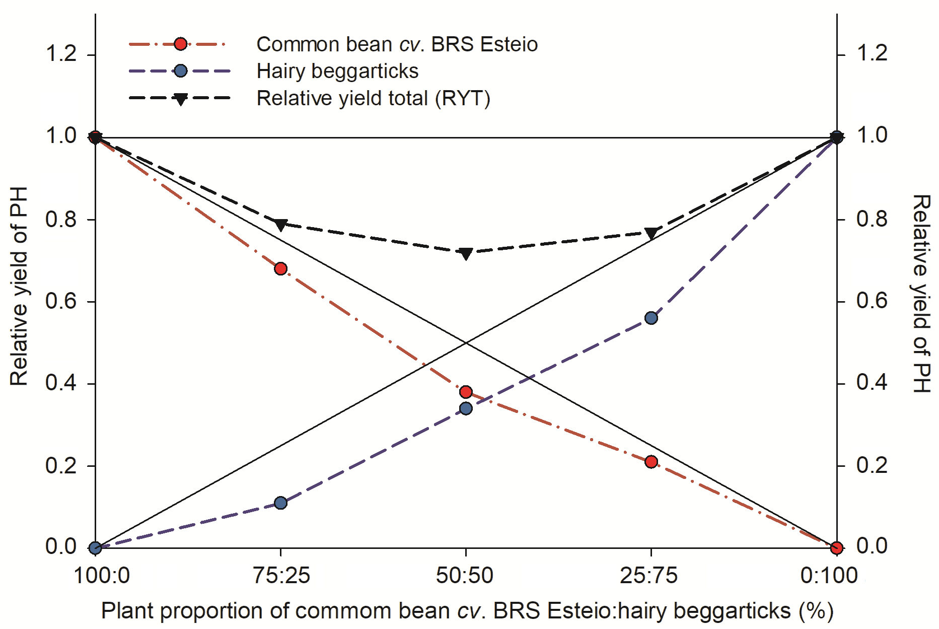
Fig. 2. Relative yield (RY) and relative yield total (RYT) for plant height of common bean cv. BRS Esteio under competition with hairy beggarticks. Continuous straight lines refer to as hypothetical relative yield whenever there is no interference of one specific-specie over another

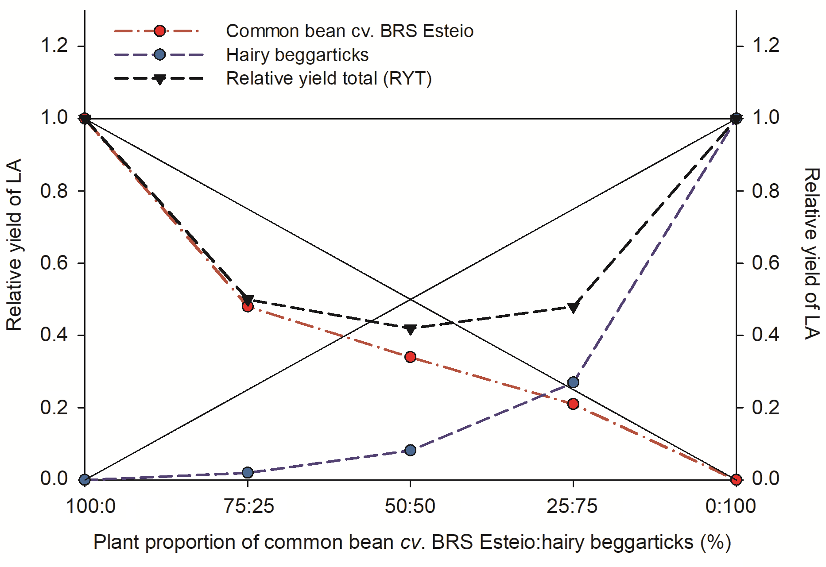
Fig. 3. Relative yield (RY) and relative yield total (RYT) for leaf area of common bean cv. BRS Esteio under competition with hairy beggarticks. Continuous straight lines refer to as hypothetical relative yield whenever there is no interference of one specific-specie over another
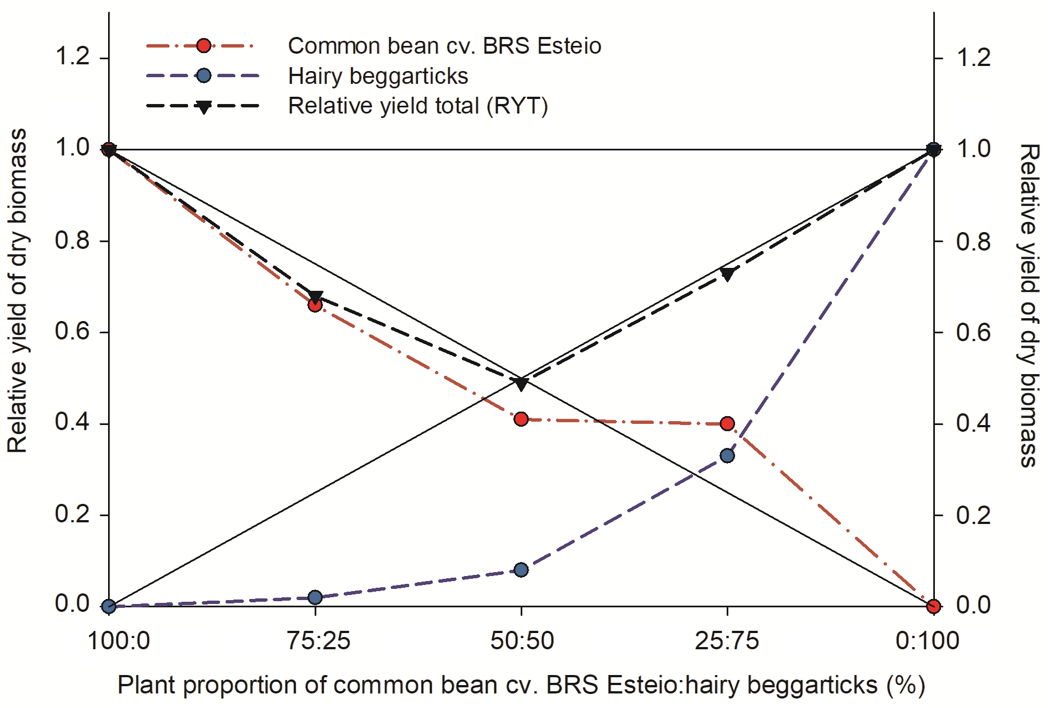
Fig. 4. Relative yield (RY) and relative yield total (RYT) for dry biomass accumulation of common bean cv. BRS Esteio under competition with hairy beggarticks. Continuous straight lines refer to as hypothetical relative yield whenever there is no interference of one specific-specie over another

