Original Research Article
A STUDY ON COINTEGRATION OF MONTHLY PRICES IN KADAPA AND DUGGIRALA MARKET OF ANDHRA PRADESH.

.
ABSTRACT

Aims: To estimate both short-run and long-run price elasticities and identify the long run uni-directional or bi-directional causality for the given markets.
Place and Duration of Study: In the present study, monthly price data for turmeric were collected over a period of 185 months, from January 2010 to May 2025, for the selected markets of Kadapa and Duggirala in Andhra Pradesh. The data was collected from the official Agmarknet website (https://agmarknet.gov.in).
Methodology: Augmented Dickey Fuller test is for detecting stationary of time series. Johansen cointegration test prior to Vector Error Correction specification is used to confirm that the variables are cointegrated and to determine the number of cointegrating equations. Vector Error Correction Model had been used to analyze the short-run and long-run dynamics in the model. Granger causality test had been used to detect the causal relationship between the price series of different markets
Results and Conclusion: Present study made an attempt on market integration it was found that the two markets were integrated of order one by using ADF test and Johansen’s Cointegration test, one prices cointegrating vector between the Kadapa and Duggirala market of turmeric, implies they share a long-run equilibrium relationship. From VECM estimates, Error Correction Term (ECT), it was identified that the price adjustment from short run disequilibrium to long run equilibrium by 24.6% per month respectively and in short run, the current month price of Kadapa market was influenced by one month lagged price of turmeric of its own. Granger Causality test revealed that there existed long run bi-directional causality for markets of Kadapa to Duggirala prices of turmeric.

Keywords: Market integration, Co-integration, ADF, VECM, Granger Causality

1. INTRODUCTION

Turmeric is an ancient spice derived from the rhizomes of Curcuma longa which is a member of ginger family also known as ‘Golden Spice of India’. It is an important commercial spice crop grown in India and known as “Indian saffron”. The largest turmeric market in Andhra Pradesh is located in Duggirala, Guntur district. Guntur district is a major turmeric-producing region in the state, and Duggirala serves as the main trading hub for turmeric. Kadapa district is a key turmeric producing region in Andhra Pradesh, known for its turmeric market within the Rayalaseema region.
2. material and methods

In the present study, monthly price data for turmeric were collected over a period of 185 months, from January 2010 to May 2025, for the selected markets of Kadapa and Duggirala in Andhra Pradesh. The data was collected from the official Agmarknet website (https://agmarknet.gov.in). The R software package was employed to analyse the data. Standard econometric techniques such as Ordinary Least Squares (OLS), Two-Stage Least Squares (2SLS), or Nerlovian-type specifications cannot be applied to this dataset, as they tend to produce spurious regression results and fail to accurately estimate both short-run and long-run price elasticities. The study uses the Augmented Dickey-Fuller (ADF) test to examine each of the variables for the presence of a unit root (an indication of non-stationary), since it can handle both first order and higher order auto-regressive processes, by including the first difference in lags in the test in such a way that the error term is distributed as white noise (Obayelu and Salau, 2010).
2.1 Test of stationary
The order of differencing can be assessed by performing unit root test. The most widely used test for detecting the unit root (non-stationary) of time series is Augmented Dickey Fuller (ADF) test. In conducting Dickey Fuller (DF) test, it has assumed that the error term is uncorrelated. But in most of cases error terms are correlated, hence Dickey-Fuller (1979) has developed another test, known popularly known as the ADF test. This test is conducted by augmenting the regression [e.g.: ($∆Y_{t}$=$β_{t}+ δY_{t-1}$+$e_{t}$)] equation, by adding the lagged values of dependent variable ($∆Y_{t}$). The ADF test consist of estimating, (Gujarathi et al. 2012) following regression,
$∆Y_{t}$=$β_{t}+ δY_{t-1}+\sum_{i=1}^{m}{α_{i}}∆Y_{t-1}+e_{t}$……….eq.1
Where m is number of lagged difference terms required so that the error term et is serially independent. The test can be carried out by performing a t (= τ) statistic of ‘δ ' with dickey fuller table values at 5% LOS. If absolute t (= τ) statistic of 'δ ' is greater than its table value, it indicates that the series is Stationary implies cointegration i.e long term relationship between the variables.

2.2 Johansen test
As the Vector Error Correction specification only applies to cointegrated series, it is necessary to run the Johansen cointegration test prior to Vector Error Correction specification. This allows us to confirm that the variables are cointegrated and to determine the number of cointegrating equations. The Johansen’s cointegration tests are very sensitive to the choice of lag length. Firstly, a VAR model is fitted to the time series data in order to find an appropriate lag structure. The Akaike Information Criterion (AIC), Schwartz Criterion (SC) and Hannan Quin (HQ) are used to select the number of lags required in the cointegration test. The lagged terms are included to ensure that the errors are uncorrelated. Unlike the Engle-Granger test, which is limited to detecting a single cointegrating relationship, the Johansen test is used to identify cointegrating relationships among multiple non-stationary time series. However, it relies on asymptotic properties and thus requires a large sample size for reliable results; small sample sizes may lead to inaccuracies. Using the Johansen test to examine cointegration among several time series also helps avoid issues related to the propagation of errors in subsequent modelling steps.
Johansen's test comes in two main forms, i.e., Trace tests and Maximum Eigenvalue test.
2.2.1 Trace tests
Trace tests evaluate the number of linear combinations in a time series data, i.e., K to be equal to the value Ko, and the hypothesis for the value K to be greater than Ko.
Ho: K = Ko ……….eq.2
H: K > Ko……….eq.3
When using the trace test to test for cointegration in a sample, we set Ko to zero to test whether the null hypothesis will be rejected. If it is rejected, we can deduce that there exists a cointegration relationship in the sample. Therefore, the null hypothesis should be rejected to confirm the existence of a cointegration relationship in the sample.
2.2.2 Maximum eigenvalue test
An Eigenvalue is defined as a non-zero vector which, when a linear transformation is applied to it, changes by a scalar factor. The Maximum Eigenvalue test is similar to the Johansen's trace test. The key difference between the two is the null hypothesis.
Ho: K=Ko ……….eq.4
H: K>= Ko+1……….eq.5
In a scenario where K= Ko and the null hypothesis is rejected; it means that there is only one possible outcome of the variable to produce a stationary process. However, in a scenario where Ko = m-1 and the null hypothesis is rejected, it means that there are M possible linear combinations. Such a scenario is impossible unless the variables in the time series are stationary.
2.3 Vector error correction model
Vector Error Correction Model-VECM (Johansen, 1988), had been used to analyze the short-run and long-run dynamics in the model.
It has two distinct characteristics:
first, an VECM is dynamic in the sense that it involves lags of the dependent and explanatory variables; it thus captures the short-run adjustments to changes of particular adjustments into past disequilibrium and contemporaneous changes in the explanatory variables. Second, the VECM is transparent in displaying the cointegrating relationship between or among the variables. This study relies on VECM approach which provides relative advantage over conventional ECM, as it is restricted to only a single equation with one variable designated as the dependent variable, explained by another variable that is assumed to be weakly exogenous for the parameters of interest.
The conventional VECM for cointegrated series can be written as:
……….eq.6

where, Y_{t} represents the price of a commodity in a particular market and X_{t} represent the corresponding price of the same commodity in another market and Z_{t-1} is the Error. A negative coefficient of Error Correction Term or adjustment coefficient, ϕ is used to determine the speed of adjustment as it measures the speed at which Y returns to equilibrium after a change in X.
Cointegration implies that time series will be connecting through an error correction model. The error correction model is important in time series analysis because it allows us to better understand long-run dynamics. Additionally, failing to properly model cointegrated variables can result in biased estimates. Reflects the long-run equilibrium relationships of variables.
Includes a short-run dynamic adjustment mechanism that describes how variables adjust when they are out of equilibrium. Uses adjustment coefficients to measure the forces that push the relationship towards long-run equilibrium.
2.4 Granger causality test
Granger causality test (Granger, 1987), had been used to detect the causal relationship between the price series of different markets. A time series X is said to Granger-cause Y if it can be shown, usually through a series of t-tests and F-tests on lagged values of X (and with lagged values of Y also included), that those X values provide statistically significant information about future values of Y.

For example,
m
n m
Yt = α1 + ∑αiYt −i + ∑βj Xt − j + et ……….eq.7
i=1 j=1
m
n m
Xt = α1 + ∑αi Xt −i + ∑βjYt − j + ut……….eq.8
i=1 j =1
for all possible pairs of (X,Y) series in the group. The reported F-statistics are the Wald test statistic for the joint hypothesis: (H0 : β1 = β2 = β3.....) for each equation. The null hypothesis is that x does not Granger-cause y in the first regression and that y does not Granger-cause x in the second regression.
3. results and discussion
The graph shows the average monthly values of turmeric prices in Duggirala and Kadapa markets over a period from Jan 2010 to May 2025. As per Table 1, Prices of Turmeric in the selected markets namely Kadapa and Duggirala were confirmed the presence of unit root (non-stationary at level) and became stationary at first difference i.e., I (1) as the p value obtained was less than 0.05. From this, it was inferred that the two markets were integrated of order one and thus, there is the possibility of the existence of a long-run relationship among the variables. The ACF and PACF plots are shown in fig 2 below for the stationary data at 1st differentiation.
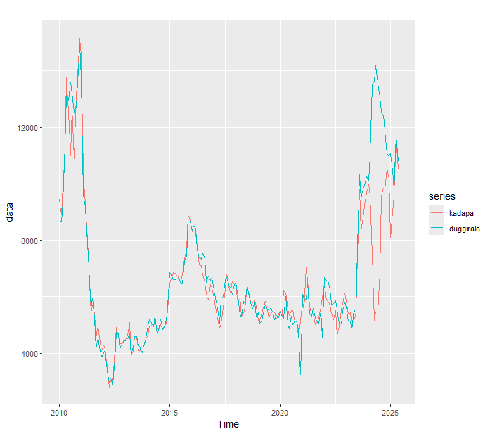
Fig.1. The average monthly turmeric prices in Duggirala and Kadapa markets

Table 1. Result of ADF test for the Prices of Turmeric in the Selected Markets
Turmeric | Data type | ADF statistic | Critical value  (P value) | Decision
Kadapa | ADF at level | -2.7874 | 0.2469 | Data Non-Stationary
Kadapa | ADF at 1st difference | -6.6126 | 0.01 | Data became Stationary
Duggirala | ADF at level | -2.9899 | 0.1623 | Data Non-Stationary
Duggirala | ADF at 1st difference | -5.6156 | 0.01 | Data became Stationary

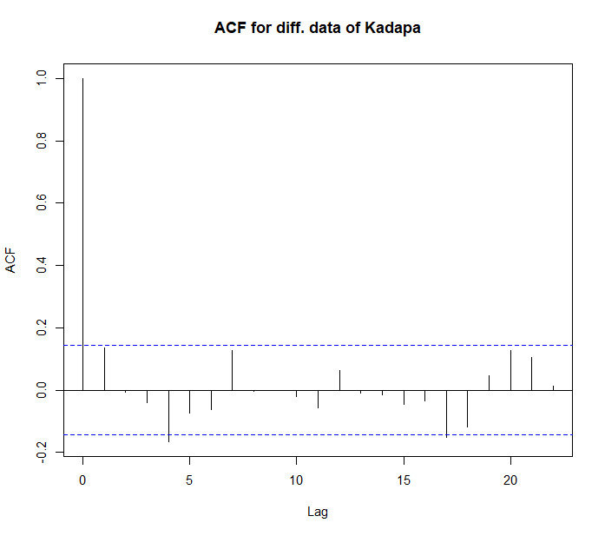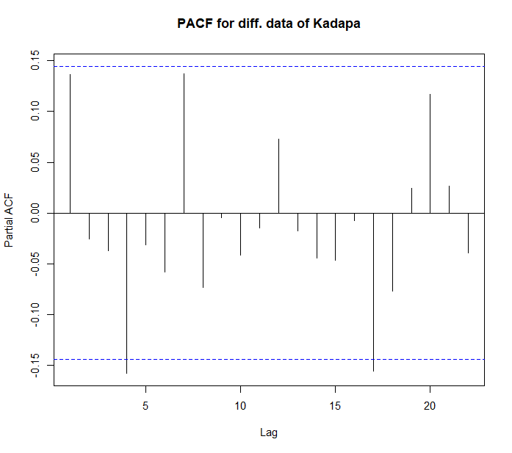
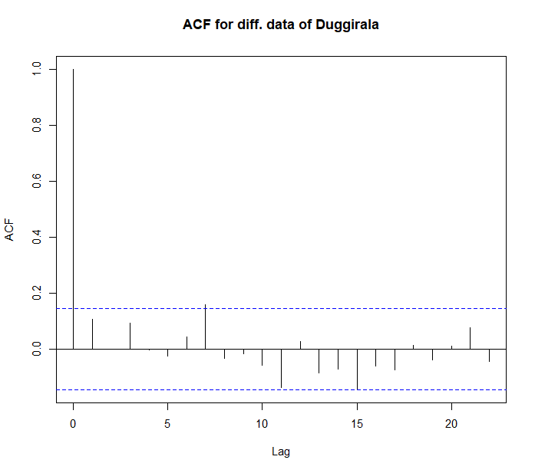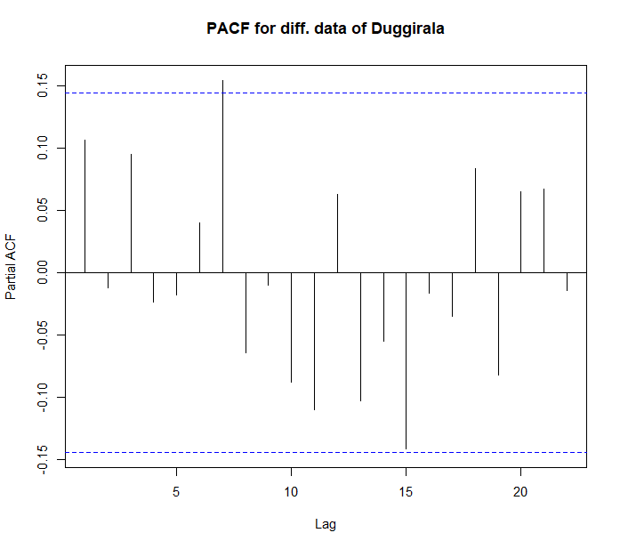
Fig. 2. ACF and PACF plots
In the study, Akaike Information Criterion (AIC), Schwartz Criterion (SC) and Hannan Quin (HQ) is used to select the optimal truncation lag length to ensure the errors are white noise in ADF. From Table 2, based on the lowest values of AIC, HQ and SC obtained through vector autoregressive model, the optimum number of lags were decided as two.

Table 2. Lag Length Selection Criteria
Lag | AIC | HQ | SC
1 | 25.81881 | 25.87797 | 25.96463
2 | 25.70276 | 25.7915 | 25.92149
3 | 25.74196 | 25.86028 | 26.0336
4 | 25.73535 | 25.88324 | 26.09989
5 | 25.76349 | 25.94096 | 26.20094

3.1 Johansen’s cointegration test
In the study, Johansen’s Cointegration test (trace statistics and maximum eigen value methods) was used to detect the existence of long run relations among the market prices, there by determining the number of cointegrating equations among these markets. Table 3 shows the summary results of the Johansen’s Maximum Likelihood co-integration test without linear trend and constant in cointegration. Based on the trace test statistic and maximum eigen value test statistic values, the null hypothesis was rejected at r = 0 which indicates at least one cointegration relationship exists between Kadapa and Duggirala market prices. But the Null hypothesis is accepted at r $≤$ 1, implies only one cointegration relationship between market prices of turmeric.
Table 3. Johansen’s Co-integration test for the Prices of Turmeric in the Kadapa and Duggirala Markets
Cointegration Test Using Trace Value
Null Hypothesis | Alternative Hypothesis | Trace Statistic | 5% Critical Value | Interpretation
r ≤ 1 | r$=2$ | 4.01 | 9.24 | Fail to reject H₀
r = 0 | r$=1$ | 30.75 | 19.96 | reject H₀
Cointegration Test Using Max-Eigen Value
r ≤ 1 | r$=2$ | 4.01 | 9.24 | Fail to reject H₀
r = 0 | r$=1$ | 26.74 | 15.67 | reject H₀

Table 4. Johansen’s Co-integration test eigen values and eigen vector for the Prices of Turmeric in the Kadapa and Duggirala Markets

Eigen values | 1.366 | 0.02 | 0
Eigen vector
Kadapa (lag3) | 1 | 1 | 1
Duggirala (lag3) | -0.73387 | 10.3158 | -5.604
constant | -1469.28 | -77267.6 | -235132.88

The eigen values indicate the strength of each cointegration relation. From the table 4. it was identified that the first eigen value is 0.1366 indicates relatively strong compared to other. Finally, the one cointegrating vector equation (also called the cointegrating vector or long-run equilibrium relationship) of form 1 as given below
Kadapa(lag3) - 0.73388*Duggirala (lag3) - 1469.28 = 0......eq 9
Kadapa(lag3) = 0.73388*Duggirala (lag3) + 1469.28.........eq 10
Thus, one prices cointegrating vector between the Kadapa and Duggirala market of turmeric, implies they share a long-run equilibrium relationship. Finally, shock in prices of one market, would influence the other market prices.
Table 5. Adjustment to cointegration
Adjustment to Cointegration$(α)$
Kadapa | -0.2467
Duggirala | +0.0076
The market prices of Kadapa have negative loading indicating, prices adjust more to restore equilibrium. Similarly, the Duggirala market prices are adjusts very little based on small value of $α$ (i.e., 0.0076) as shown in Table 5.
3.2 Vector error correction model estimates
In the present study, Vector Error Correction model was also built to analyse the short run dynamics of the selected Turmeric markets, concerned with ensuring the presence of long run equilibrium (cointegration). In this, Error Correction Term (ECT) was used to indicate the speed of adjustment among the variables before converging to equilibrium in a dynamic model i.e., as per these coefficient values.
From Table 6, Error Correction Term (ECT) for Kadapa was negative and significant, which confirmed that the series would be return to its previous long run equilibrium. The price adjustment (speed of recovery) from short run disequilibrium to long run equilibrium for Turmeric prices in Kadapa market was found to be 24.6% per month. It was also identified that there was no speed of adjustment for Duggirala market as the Error Correction Term (ECT) was positive and non-significant for that market prices of Turmeric. The short run cointegration were explained over different markets. The current monthly price of turmeric in Kadapa market was influenced by one month lagged price of its own only. The current month price of turmeric in Duggirala market was not influenced by one and two month lagged price of Kadapa and Duggirala.

Table 6. Results of VECM for Different Market Prices of Turmeric
 | Error Correction Term | Intercept | Kadapa  (-1) | Duggirala (-1) | Kadapa (-2) | Duggirala  (-2)
Kadapa | -0.2467 | 365.5629 | 0.2787 | -0.1283 | 0.1215 | -0.1383
Kadapa | [0.0567]*** | [101.4029] *** | [0.0876] ** | [0.0944] | [0.0899] | [0.0939]
Duggirala | 0.0076 | -5.8968 | 0.1537 | 0.0211 | 0.0069 | -0.0183
Duggirala | [0.0544] | [97.3393] | [0.0841] | [0.0906] | [0.0863] | [0.0902]
() =Lag length, [ ]=test statistic values, *** Significant at p=0.001, ** Significant at p=0.01, * Significant at p=0.05, ‘.’ Significant at p=0.1

3.3 Granger causality test
To identify the direction of causation among the Turmeric markets, Granger Causality test was applied. From Table 7, it was observed that there existed long run bi-directional causality for markets of Kadapa to Duggirala i.e., price transmission would occur in both directions. Where, it was unidirectional for Kadapa to Duggirala market, which indicated that the price information would reflect first in Kadapa and then later it transmitted to Duggirala market. It was also identified that there was no causal relationship between Duggirala to Kadapa markets.
Table 7. Results of Pair-wise Granger Causality test
Market-Pairs | F-stat. | P-value | Decision | Result
Kadapa to Duggirala | 5.5335 | 0.0197 | Unidirectional | Kadapa granger cause Duggirala
Duggirala to Kadapa | 0.5636 | 0.4538 | No causality  for Unidirectional | Duggirala does not granger cause Kadapa
Kadapa to Duggirala | 4.5044 | 0.0124 | Bidirectional | Kadapa granger cause Duggirala
Duggirala to Kadapa | 1.9731 | 0.1421 | No causality  for bidirectional | Duggirala does not granger cause Kadapa

4.1 Conclusion

In the present study, monthly price data for turmeric were collected over a period of 185 months, from January 2010 to May 2025, for the selected markets of Kadapa and Duggirala in Andhra Pradesh. From the ADF test, it was found that the two markets were integrated of order one and thus, there is the possibility of the existence of a long-run relationship among the variables. From Johansen’s Cointegration test, one prices cointegrating vector between the Kadapa and Duggirala market of turmeric, implies they share a long-run equilibrium relationship. From VECM estimates, Error Correction Term (ECT) was identified as negative and significant for Kadapa, which confirmed that these series would be return to its previous long run equilibrium with the price adjustment (speed of recovery) from short run disequilibrium to long run equilibrium by 24.6% per month respectively. It was also found that, in short run, the current month price of Kadapa market was influenced by one month lagged price of turmeric of its own. Granger Causality test revealed that there existed long run bi-directional causality for markets of Kadapa to Duggirala i.e., price transmission would occur in both directions. Where, it was unidirectional for Kadapa to Duggirala market and no causal relationship between Duggirala to Kadapa.

References

Agmarknet website (https://agmarknet.gov.in)
Obayelu, A.E. and Salau, A.S., 2010. Agricultural response to prices and exchange rate in Nigeria: Application of co-integration and Vector Error Correction Model (VECM). Journal of agricultural sciences, 1(2), pp.73-81.
Shireesha, M., Devi, I.B., Vani, N., Naidu, G.M. and Prasad, S.V., 2016. A study on integration of turmeric markets in India.
Dickey, D.A. and Fuller, W.A., 1979. Distribution of the estimators for autoregressive time series with a unit root. Journal of the American statistical association, 74(366a), pp.427-431.
Gujarathi, D.M. 2012. Gujarati: Basic Econometrics. McGraw-hill.
Johansen, S., 1988. Statistical analysis of cointegration vectors. Journal of economic dynamics and control, 12(2-3), pp.231-254.
Engle, R.F. and Granger, C.W., 1987. Co-integration and error correction: representation, estimation, and testing. Econometrica. journal of the Econometric Society, pp.251-276.
Nayak, A., Lokesha, H. and Gracy, C.P., 2020. Co-integration of groundnut markets in India with special reference to Karnataka State. Current Journal of Applied Science and Technology, 39(18), pp.14-20.

