Assessment of Genetic Diversity and Integrated Phenotypic and Genotypic Evaluation of Maize (Zea mays L.) for Resistance to Fusarium Stalk Rot Caused by Fusarium verticillioides

Abstract
Maize (Zea mays L.) is a globally significant cereal crop, but its production is severely affected by Fusarium stalk rot (Fusarium verticillioides), which reduces yield and grain quality. This study aimed to evaluate the genetic diversity and resistance of segregating maize populations derived from wide hybridization. A total of 54 F₂ lines (Kharif 2023) and 49 F_{2:3} lines (Rabi 2023-24) were assessed using an Alpha Lattice Design for agro-morphological and molecular characterization. Genetic variability was analyzed through Mahalanobis’ D² statistics, which classified genotypes into three distinct clusters based on key traits. To screen for resistance, a standardized toothpick inoculation method was employed in the pathological field, and disease severity was scored using a 1–9 scale. Molecular screening with 10 SSR markers identified resistant genotypes, with SSR93 and umc2059 proving effective in distinguishing resistance-associated alleles. Among 33 evaluated lines, six genotypes (2123859 X WS-5)^/4^-7, (2123426 X WS-5)^/6^-4, (2123401 X WS-5)^/10^-7, (2124008 X WS-1)^/5^-5, (2123792 X WS-1)^/10^-9, and (IC 0621166 X WS-5)^/5^-4 consistently exhibited resistance across both phenotypic and molecular evaluations. These findings highlight the genetic diversity within maize germplasm and provide valuable resources for breeding Fusarium stalk rot-resistant varieties. The identified resistant lines hold potential for use in maize improvement programs, ensuring sustainable production and enhanced disease resilience.
Introduction
Maize is the oldest and one of the most important crop species in the world. It is, after wheat and rice, the most important cereal grain in the world, providing nutrients for humans and animals and serving as a basic raw material for the production of starch, oil and protein, alcoholic beverages, food sweeteners and, more recently, fuel (HASAN et al., 2018). Although domesticated in Mexico, its landraces have spread across various continents, demonstrating extensive adaptability. Recent research has emphasized the genetic variability within maize germplasm, with molecular markers playing a crucial role in deciphering global diversity patterns. Breeding success in all plant species is determined by access to starting materials with possible high genetic diversity also in terms of disease resistance (Sobiech et al., 2022). In crop improvement programs, assessing genetic diversity is fundamental for selecting superior parental lines for hybridization (Ganesan et al., 2010). D² statistical analysis serves as an effective multivariate tool for distinguishing genotypes based on genetic divergence (Murthy & Arunachalam, 1966). Despite its agricultural significance, maize production is severely impacted by Fusarium stalk rot, a devastating disease caused by Fusarium verticillioides. The term “stalk rot” is often used to include stalk breakage, stalk lodging, premature death of plant and occasionally root lodging (Khokhar et al., 2014). The widespread occurrence of post-flowering stalk rot (PFSR), a soil-borne disease, imposes substantial limitations on maize yield in India. In India, the disease is prevalent in most of the maize growing areas, particularly in rainfed areas viz., Jammu and Kashmir, Punjab, Haryana, Delhi, Rajasthan, Madhya Pradesh, Uttar Pradesh, Bihar, West Bengal, Andhra Pradesh, Tamil Nadu and Karnataka, where water stress occurs after flowering stage of the crop (Singh et al, 2012). PFSR reduces maize yield by way of affecting the physiological activity of the plants and finally results in lodging, which is the main reason behind of monetary losses (Ledencan et al., 2003). PFSR complex was determined within the plant age group of 55 to 65 days which coincides with tasselling and silking and right away followed grain formation stage (Hooda et al., 2017). The disease not only reduces productivity but also compromises grain quality, making it imperative to identify resistant genotypes for sustainable cultivation. Notably, a major resistance gene for Fusarium stalk rot has been mapped to chromosome 6 (Yang et al., 2004). Evaluating segregating generations derived from wide hybridization offers valuable insights into the genetic diversity of maize and its resistance mechanisms against Fusarium verticillioides. These findings provide a strong foundation for developing resilient maize varieties through advanced breeding strategies.
Material and Method
The experimental study involved 54 segregating maize lines during the first season (F₂, Kharif 2023) and 49 F_{2:3} lines, cultivated in two replications using an Alpha Lattice Design for diversity analysis. Each genotype was sown in a single 2-meter row per replication, maintaining a spacing of 60 cm between rows and 20 cm between plants. Standard agronomic practices were followed for crop management. Comprehensive data were recorded on eleven quantitative traits, including Days to 50% Tasseling, Days to 50% Silking, Plant Height (cm), Tassel Length (cm), Ear Length (cm), Ear Diameter (cm), Ear Height (cm), Number of Kernel Rows per Cob, Number of Kernels per Row, Cob Weight (g), and Grain Yield (g).
In the subsequent Rabi 2023-24 season (F_{2:3} generation), 54 maize genotypes were selected for phenotypic and genotypic screening in a pathological field. However, only 33 genotypes successfully germinated, possibly due to adverse soil or environmental conditions. These 33 genotypes were then subjected to resistance trait analysis, the available genotypes provided sufficient data for meaningful phenotypic and genotypic evaluations. Despite the reduced sample size, the study yielded valuable insights into maize diversity and resistance characteristics. However, relying solely on marker-based results can lead to misleading conclusions if not supported by field trial validation. Therefore, this study aimed to assess maize germplasm diversity for Fusarium stalk rot resistance under controlled infection conditions, evaluate disease response using a severity scoring scale (SS) and stalk discoloration (SD) measurements, and investigate genetic variation among the lines using SSR markers (Qureshi et al., 2015).
Raising of genotypes
Thirty-three maize genotypes were collected from the F₂ season (Kharif 2023), Winter Nursery Centre (WNC), Rajendra nagar, Hyderabad.

List 1. Disease rating scale for FSR: (IIMR, New Delhi; Hooker 1956 and Payak and Sharma 1983).

Disease score Symptoms Disease reaction

1 Healthy or slight discoloration at the site of inoculation Highly resistant
2 Up to 50% of the inoculated internode is discoloured Resistant
3 Inoculated internode 51–75% were discolored Moderately resistant
4 Inoculated internode 76–100% were discolored Moderately susceptible
5 Less than 50% discoloration of the adjacent internode Susceptible
6 More than 50% discoloration of the adjacent internode Highly susceptible
7 Discolouration of three internodes Highly susceptible
8 Discolouration of four internodes Highly susceptible
9 9 Discolouration of five or more internodes and premature death of plant Highly susceptible

Toothpick inoculation and Screening of maize genotypes in field for Fusarium stalk rot.
Maize plants were inoculated with Fusarium isolates at 45 to 50 days old during the anthesis stage. Three plants were inoculated per isolate for the entire plot. The inoculation involved placing mycelial plugs on the lower internodes, particularly the second internode above the soil. The third and fourth internodes were then examined, and a cross-section was made using a razor blade with a screw in the center; agar-colonized stem cutters were placed diagonally to toothpicks in the holes created by jabber after penetrating the stem. Symptoms began to appear 20 to 25 days post-inoculation. Disease Intensity and Severity (PDI) were measured using Payack and Sharma's (1983) scale from I to IX during harvest.

Molecular characterization of the genotypes with specific markers
DNA isolation, quantification
The work area and tools were sterilized with 70% ethanol before starting the procedure. The seed was carefully sliced, and the yellow part was removed, leaving only the white embryo, which was transferred into a 1.5 ml Eppendorf tube. To this, 200 µL of CTAB buffer and a grinding bead were added, and the tissue was mechanically disrupted using a tissue lyser for 2-3 minutes. An additional 500 µL of CTAB buffer was added, and the tubes were incubated at 64°C for 45 minutes to facilitate cell lysis. Following this, 700 µL of chloroform: isoamyl alcohol (24:1) was added, mixed by inverting the tubes 100 times, and centrifuged at 12000 rpm for 15 minutes to separate the phases. The top aqueous layer was carefully transferred into a fresh tube, and 5 µL of RNAase was added before incubating at 37°C for 30 minutes to degrade RNA. DNA was then precipitated by adding an equal volume of chilled isopropanol, incubating at -20°C for 30 minutes, gently mixing, and centrifuging at 12000 rpm for 10-15 minutes. The supernatant was discarded, and the pellet was washed twice with 200 µL of 70% ethanol, followed by centrifugation at 12000 rpm for 5 minutes each time. After discarding the ethanol, the pellet was air-dried until no ethanol smell remained, and finally, the DNA was resuspended in 300 µL of 1x TAE buffer.

SSR analysis
To identify the resistant lines among the selected genotypes from the segregating lines (33), ten SSR markers were used and are enlisted in Table.

PCR amplification
A set of 10 SSR (Simple Sequence Repeat) markers were selected. Genomic DNA amplification was done by using Applied BiosystemsTM VeritiTM 96well thermal cycler. PCR amplifications were performed in a BIO-RAD Thermal Cycler with a final reaction volume of 10 μl having ~30-40 ng of genomic DNA.
The protocol for the PCR amplification consisted of an initial denaturation at 94°C for 5 min, followed by about 30 cycles of 94°C for 30 sec (denaturation), X°C for 30 sec (annealing), and 72°C for 1min followed by extension at 72°C for 7 min. The X°C refers to the annealing temperature which varied (ranging from 55- 58°C) with each primer.
Resolution of PCR amplified products and scoring of marker profiles
The PCR-amplified product for each SSR marker was resolved through gel electrophoresis in a horizontal gel system using 1.0X TBE buffer (Sambrook et al., 1989). Ethidium bromide (10 mg/ml) was used for staining, and 4% Biorose agarose gel was used. At both ends of the gel, a 100 bp DNA ladder (TAKARA) was loaded and images were recorded using a Gel Documentation System (BIO-RAD, BioRad Laboratories, India), followed by the scoring of marker profiles.

S. No | Primer | Sequence
1 | bnlg1621 | Forward sequence | CATCAGTGATCCTCCACCAT
1 | bnlg1621 | Reverse sequence | GGATCTTCGTTGCAGTTCTT
2 | umc2059 | Forward sequence | ACACGAGGCACTGGTACTAACG
2 | umc2059 | Reverse sequence | CTCTTCGATCTTTAAGAGAGAGAGAG
3 | umc2082 | Forward sequence | GTCGTGGCGTAGAGACTAGGGT
3 | umc2082 | Reverse sequence | TAGCTGCCCCTCTTCCGTCT
4 | bnlg1740 | Forward sequence | ACAGGCAGAGCTCTCACACA
4 | bnlg1740 | Reverse sequence | TTTTCTCCTTGAGTTCGTTCG
5 | SSRZ135 | Forward sequence | CCGATCCTCCTCCTTCAG
5 | SSRZ135 | Reverse sequence | CTGACGTAGTGCTGCGA
6 | umc2013 | Forward sequence | AGCGTGATCAGACGTACAATGCTA
6 | umc2013 | Reverse sequence | GGAAAAGGAGGAACAGTGTAAGCA
7 | SSR85 | Forward sequence | GTTGATGCATGTGACTCTGGAAAC
7 | SSR85 | Reverse sequence | GGGACGAGAGTCTGTTGTTGTTG
8 | SSR93 | Forward sequence | CACATGCTACGACTGCGATG
8 | SSR93 | Reverse sequence | CGCCGTACAGACTGCTATGA
9 | SSR105 | Forward sequence | CAGCCTTGCTTCTACACCAC
9 | SSR105 | Reverse sequence | GTTCATCCTGATTCCCATCC
10 | SSRZ319 | Forward sequence | CACCTTCCTCTTGCTGTC
10 | SSRZ319 | Reverse sequence | CTGCACCTGCTAGTCCTG
Table 1 List of SSR markers used in the study
Statistical analysis
Mahalanobis’s generalized distance (D²)
Mahalanobis (1928) used the D² statistic to determine the degree of group distance based on multiple traits, thereby assessing genetic divergence between genotypes.

D² values between i^{th} and j^{th} genotypes for ‘p’ characters were calculated as.
p _ _
D²_{ij} = Σ (Y_{it} - Y _{jt}) ²
t=1
Where,
Y_{it} = Uncorrelated mean values of ith genotype for ‘t’ character
Y_{jt} = Uncorrelated mean values of jth genotype for ‘t’ character
D ²_{ij} = D² between ith and jth genotypes
Average intra-cluster distance
For the measurement of intra-cluster distance, the formula used was Σ D²_{i}/n
Where,
ΣD²_{i} = Sum of distances between all possible combinations (n) of the populations included in a Cluster
n = Number of Clusters
Average inter-cluster distance
The square root of the average D² values was used to determine the genetic distance between the Clusters. The Cluster diagram was created using the Rao (1952) distance rating scale, which was based on D² values (inter-cluster distance).
Average inter-cluster distance = $\frac{ D^{2} }{n1×n2}$

Results and discussion
Genetic Diversity in Segregating Generations
The segregating families (F₂ and F_{2:3} generations) derived from wide hybridization involving wild species such as Zea luxurians and Zea mays ssp. parviglumis crossed with maize inbred lines. Analysis of variance revealed significant differences among genotypes for key agro-morphological traits, indicating substantial genetic variability. The Mahalanobis D² analysis categorized genotypes into three distinct clusters, suggesting a diverse genetic base that can be exploited for breeding purposes
Table: 2 Intra and inter-cluster distances (D² values) among 3 Clusters with 54 maize genotypes in F₂ generation.
Table: 3 Intra and inter-cluster distances (D² values) among 3 Clusters with 49 maize genotypes in F_{2:3} generation.
 | I | II | III
I | 497.58 | 1874.59 | 1830.89
II |  | 616.57 | 2198.75
III |  |  | 0.00

 | I | II | III
I | 230.68 | 936.59 | 1230.62
II |  | 0.00 | 2398.61
III |  |  | 0.00
Table: 2 Table: 3
Note: Intra-cluster distances are shown diagonally, and inter-cluster distances are shown off diagonally.
Cluster analysis of maize genotypes in F₂ and F_{2:3} generations demonstrated significant genetic diversity. Cluster I (F₂: 230.68) and Cluster II (F_{2:3}: 616.57) showed the highest intra-cluster distances, indicating substantial variability among genotypes. Conversely, Clusters II and III in F₂ and Cluster III in F_{2:3} had zero intra-cluster distance, meaning they contained only one genotype each.
For inter-cluster distances, Clusters II and III exhibited the highest values (F₂: 2398.61, F_{2:3}: 2198.75), suggesting they are the most genetically diverse and ideal for hybridization to maximize heterosis. The smallest inter-cluster distances were between Cluster I and Cluster II (F₂: 936.59) and Cluster I and Cluster III (F_{2:3}: 1830.89), indicating genetic similarity and lower potential for heterotic gains. Similar findings were reported by Azad, M.A.K (2012)
Table 4. Mean Values of Clusters values of F₂ and F_{2:3} generations
F_{2:3} generation | Cluster Ⅰ | Cluster Ⅱ | Cluster Ⅲ
DS | 75.47 | 72.92 | 73.50
DA | 79.40 | 76.96 | 77.50
ASI | 3.89 | 3.96 | 4.00
PH | 141.13 | 156.38 | 135.69
TL | 30.84 | 32.74 | 64.42
EL | 7.95 | 12.42 | 9.95
ED | 6.31 | 11.67 | 5.95
EH | 59.54 | 65.69 | 83.07
KRPE | 9.69 | 14.20 | 12.03
KPR | 10.79 | 22.73 | 16.89
CW | 22.23 | 91.28 | 42.55
GY | 14.75 | 78.52 | 30.89

F₂ generation | Cluster Ⅰ | Cluster Ⅱ | Cluster Ⅲ
DS | 75.52 | 75.50 | 80.50
DA | 79.34 | 82.00 | 83.50
ASI | 3.81 | 6.50 | 3.00
PH | 156.63 | 208.79 | 175.27
TL | 31.83 | 30.23 | 66.63
EL | 12.26 | 15.50 | 14.48
ED | 7.05 | 7.58 | 7.76
EH | 75.98 | 169.70 | 78.46
KRPE | 12.30 | 16.41 | 9.54
KPR | 11.58 | 10.97 | 10.74
CW | 41.84 | 78.72 | 40.60
GY | 27.67 | 60.05 | 25.07

Cluster mean values from F₂ and F_{2:3} generations are analyzed to reveal notable differences in agro-morphological parameters, offering information on genetic diversity and selection potential. One noteworthy feature is the generational shift in performance, where clusters that did well in F₂ did not necessarily continue to do well in F_{2:3} suggesting the possibility of genetic recombination or environmental influences. A decrease in these characteristics in F_{2:3} was observed in clusters with higher plant height, ear height, and tassel length in F₂, indicating an overall fall in vegetative development. However, several clusters in F_{2:3} exhibited increased values for yield-related variables, including Kernel Rows Per Ear, Kernels Per Row, Cob Weight, and Grain Yield, indicating the possibility of genetic gain through selection Similar findings were reported by Azad, M.A.K (2012)
In both generations, Cluster II continuously showed higher values for traits that contribute to yield, making it the most promising group for breeding program selection. Cluster I and Cluster III, on the other hand, showed lower yield-related qualities, suggesting that while they might not be as suitable for direct selection, they might be genetic sources for other desirable features. An increase in grain output in some clusters and a decrease in the Anthesis-Silking Interval (ASI) in F_{2:3} point to improved reproductive efficiency and adaptability. According to these findings, genetic variety is crucial in maize breeding, and Cluster II genotypes have the potential to be further assessed and selected to improve yield stability and performance.
Tocher method
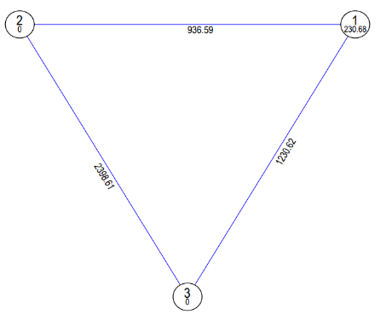
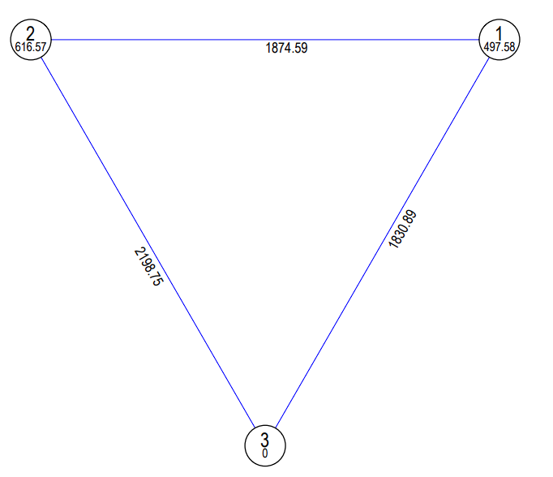
Fig 1. Fig 2.
Fig:1, and Fig: 2 show Intra- and inter-cluster distances of 54 maize genotypes, and 49 maize genotypes grouped into 3 Clusters using Tocher’s method in F₂ generation and F_{2:3} generation respectively.

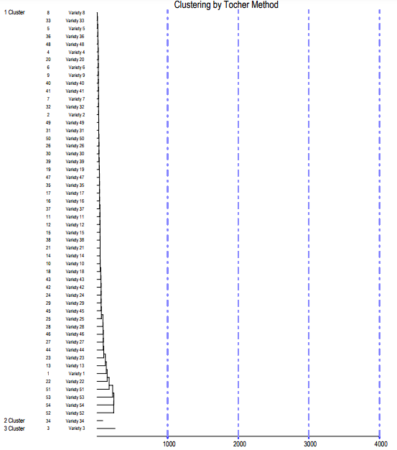
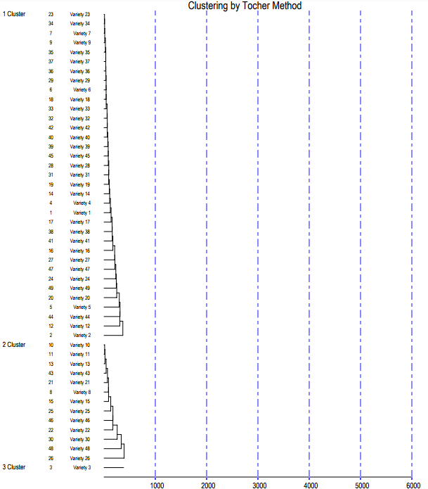
Fig: 3 Fig: 4.
Fig: 3, and Fig: 4 show Dendrogram illustrating the relationships among 54 maize genotypes, and 49 maize genotypes grouped into 3 Clusters based on Mahalanobis' D² values in F₂ generation and F_{2:3} generation respectively.
Phenotypic screening of Fusarium stalk rot
In the Rabi, 2023-24 season, i.e. (F_{2:3} generation), maize entries were artificially inoculated with fusarium pathogen using the toothpick method under field conditions. The disease reaction of 33 maize entries, along with a susceptible and resistant check CM-600 and JCY 2-7 was assessed using a 1-9 disease scale. Based on these assessments, the entries were classified into four categories:
Disease reaction | Disease scoring
Resistant | ≤ 3.0
Moderately Resistant | 3.1 to 5.0
Moderately Susceptible | 5.1 to 7
Susceptible | ≥ 7

Stalk rot symptoms typically appear between the post-flowering and pre-harvest stages (Lal and Singh, 1984). The infection spreads from the roots to the stalk, leading to early plant drying, stalk lodging, and ear drop, which in turn results in substantial yield losses in maize (Colbert et al., 1987). The severity of stalk rot infection is largely influenced by environmental conditions, the interaction between genotype and environment (GxE), and the level of resistance of the specific maize genotype to the pathogens (Szoke et al., 2007).
Table represents the Average disease reaction of different maize genotypes in F_{2:3} under field conditions.

Table 5. Phenotypic disease scoring on field condition
S.no | Genotype | Disease Mean Score  (1-9, Scale) | Disease Reaction | Origin
1 | (IC 0621166 X WS-5)^/4/^-3 | 3.3 | MR | IIMR, Ludhiana
2 | (IC 0612770 X WS-5)^/2/^-2 | 4.0 | MR | IIMR, Ludhiana
3 | (IC 0612832 X WS-5)^/3^-1 | 4.7 | MR | IIMR, Ludhiana
4 | (2124302 X WS-5)^/2^-5 | 3.3 | MR | IIMR, Ludhiana
5 | (IC 0621168 X WS-5)^/7^-8 | 5.0 | MS | IIMR, Ludhiana
6 | (2124218 X WS-5)^/5^-3 | 3.2 | MR | IIMR, Ludhiana
7 | (2123426 X WS-5)^/4^-1 | 2.5 | R | IIMR, Ludhiana
8 | (2124012 X WS-1)^/7^-10 | 4.0 | MR | IIMR, Ludhiana
9 | (IC 0620929 X WS-5)^/5^-9 | 2.0 | R | IIMR, Ludhiana
10 | (2123859 X WS-5)^/4^-7 | 2.3 | R | IIMR, Ludhiana
11 | (2123870 X WS-1)^/7^-7 | 3.3 | MR | IIMR, Ludhiana
12 | (2124317 X WS-5)^/2^-3 | 3.1 | MR | IIMR, Ludhiana
13 | (2124120 X WS-5)^/5^-4 | 4.0 | MR | IIMR, Ludhiana
14 | (2124082 X WS-5)^/1^-7 | 4.4 | MR | IIMR, Ludhiana
15 | (2124120 X WS-5)^/8^-8 | 4.0 | MR | IIMR, Ludhiana
16 | (2123776 X WS-5)^/7^-1 | 5.1 | MS | IIMR, Ludhiana
17 | (2123413 X WS-5)^/8^-2 | 3.0 | R | IIMR, Ludhiana
18 | (2123426 X WS-5)^/6^-4 | 2.2 | R | IIMR, Ludhiana
19 | (2123748 X WS-5)^/7^-3 | 1.5 | R | IIMR, Ludhiana
20 | (2124237 X WS-5)^/5^-5 | 3.5 | MR | IIMR, Ludhiana
21 | (2123401 X WS-5)^/10^-7 | 2.0 | R | IIMR, Ludhiana
22 | (IC 0621061 X WS-5)^/7^-3 | 2.3 | R | IIMR, Ludhiana
23 | (IC 0621159 X WS-5)^/9^-5 | 2.3 | R | IIMR, Ludhiana
24 | (IC 0620969 X WS-5)^/4^-4 | 4.0 | MR | IIMR, Ludhiana
25 | (IC 0612832 X WS-5)^/4^-3 | 3.3 | MR | IIMR, Ludhiana
26 | (IC 0612770 X WS-5)^/5^-1 | 4.0 | MR | IIMR, Ludhiana
27 | (IC 0621634 X WS-5)^/8^-1 | 6.0 | MS | IIMR, Ludhiana
28 | (2124008 X WS-1)^/5^-5 | 2.0 | R | IIMR, Ludhiana
29 | (2123792 X WS-1)^/10^-9 | 1.5 | R | IIMR, Ludhiana
30 | (IC 0612770 X WS-1)^/6^-5 | 3.1 | MR | IIMR, Ludhiana
31 | (IML 418-1)^/5^-2 | 4.1 | MR | IIMR, Ludhiana
32 | (IC 0621166 X WS-5)^/5^-4 | 1.0 | R | IIMR, Ludhiana
33 | (2123409 X WS-1)^/7^-5 | 6.5 | MS | IIMR, Ludhiana

- The symbol “^” denotes that the plants have been self-pollinated (selfed).
- The notation “/(number)” indicates that the plant was selected from the F₂ generation and F₂ derived F₃ generation.
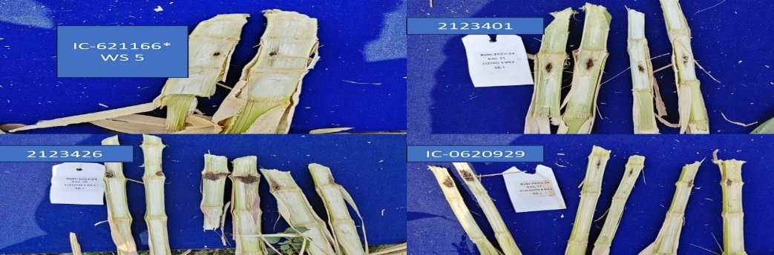
The resistant check exhibited a disease reaction of 1.0, while the susceptible check showed a reaction of 6.5. Gopala et al. (2016) reported similar findings using the toothpick inoculation method for the pathogen Fusarium verticilloides on an inbred line. Some differences and similarities were observed in the disease reactions of certain inbreds when compared to the studies by Sravya et al., (2023) and Banoth et al. (2021), likely due to variations in environmental and soil conditions.
Plate 1. Maize genotypes showing resistant reaction to Fusarium stalk rot under field conditions.
Molecular Characterization of Fusarium stalk rot
The markers bnlg1621, umc2059, umc2082, bnlg1740, umc2013, SSR85, SSR93, and SSR105 (Sobiech et al., 2022), along with SSRZ319 and SSRZ135 (Gopala et al., 2017), were used in this study. Among these, two markers (SSR93 and umc2059) showed polymorphism between the checks, while the remaining markers were monomorphic and did not distinguish between the checks.
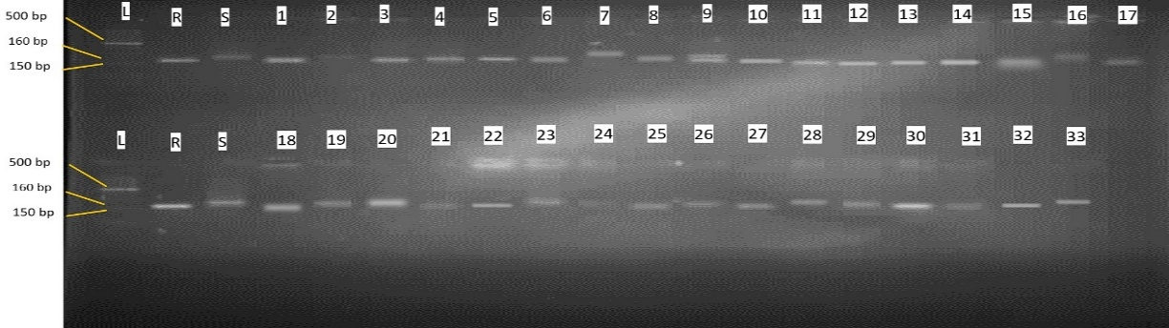
Plate 2 Amplification Profile of SSR marker SSR93

Identification of Fusarium stalk rot resistant inbred lines in maize (Zea mays L.)” by using SSR marker SSRZ 319.
L= 100 bp ladder, R= Resistant check, S= Susceptible check, 1 to 33 = maize inbred lines
Molecular screening using the SSR93 marker identified 23 resistant lines exhibiting a 150 bp PCR-amplified product, similar to the resistant check. These include (IC 0621166 X WS-5)^/4/^-3, (IC 0612832 X WS-5)^/3^-1, (2124302 X WS-5)^/2^-5, and others. In contrast, 10 susceptible lines showed a 160 bp PCR-amplified product, matching the susceptible check, including (IC 0612770 X WS-5)^/2/^-2, (2123426 X WS-5)^/4^-1, (2123776 X WS-5)^/7^-1, and others. These findings align with Sobiech et al. (2022), confirming the reliability of SSR93 in distinguishing resistant and susceptible genotypes.

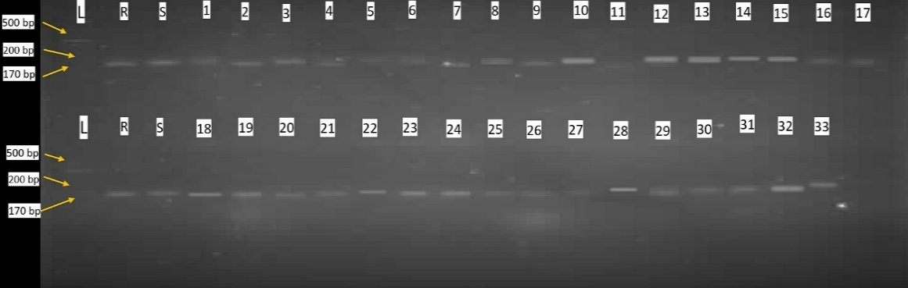
Plate 3 Amplification Profile of SSR marker UMC 2059

Identification of diverse Fusarium stalk rot resistant inbred lines in maize (Zea mays L.)” by using SSR marker umc2059.
L= 100 bp ladder, R= Resistant check, S= Susceptible check, 1 to 33 = maize inbred lines.
Molecular analysis using the umc2059 marker identified 19 resistant lines with a 200 bp PCR-amplified product, similar to the resistant check. These include (IC 0612770 X WS-5)^/2/^-2, (2124302 X WS-5)^/2^-5, (2123426 X WS-5)^/4^-1, and others. In contrast, 14 susceptible lines showed a 170 bp PCR-amplified product, matching the susceptible check. These include (IC 0621166 X WS-5)^/4/^-3, (IC 0612832 X WS-5)^/3^-1, (IC 0621168 X WS-5)^/7^-8, among others. These findings align with Sobiech et al. (2022), confirming the effectiveness of umc2059 in distinguishing resistant and susceptible genotypes.
Resistance to Fusarium verticillioides
Out of the 33 evaluated lines, 12 specific lines (2124302 X WS-5)^/2^-5, (2124012 X WS-1)^/7^-10, (2123859 X WS-5)^/4^-7, (2123870 X WS-1)^/7^-7, (2123426 X WS-5)^/6^-4, (2123401 X WS-5)^/10^-7, (IC 0612832 X WS-5)^/4^-3, (IC 0621634 X WS-5)^/8^-1, (2123792 X WS-1)^/10^-9, (IC 0612770 X WS-1)^/6^-5, (IML 418-1)^/5^-2, (IC 0621166 X WS-5)^/5^-4 displayed a banding pattern that matched the resistant check with both the markers umc2059 and SSR93. This indicates a potential genetic resistance to Fusarium verticilloides and among 33 lines, six lines viz, (2123859 X WS-5)^/4^-7, (2123426 X WS-5)^/6^-4, (2123401 X WS-5)^/10^-7, (2124008 X WS-1)^/5^-5, (2123792 X WS-1)^/10^-9, (IC 0621166 X WS-5)^/5^-4 consistently exhibited resistance to Fusarium verticillioides under both field conditions and molecular characterization using SSR markers (umc2059 and SSR93), indicating a promising level of genetic resistance. The presence of resistance-associated alleles in these lines makes them promising candidates for breeding programs aimed at improving Fusarium stalk rot resistance.
Summary and conclusion
Genetic diversity analysis using the Mahalanobis D² method grouped 54 genotypes into 3 clusters in F₂ and 49 genotypes into 3 clusters in F₂:₃. In both generations, Cluster I contained the most genotypes, while Clusters II and III had fewer, with the highest inter-cluster distances observed between Cluster II and Cluster III (2398.61 in F₂ and 2198.75 in F₂:₃), indicating significant genetic divergence.
Molecular screening using SSR93 and umc2059 markers identified 12 resistant lines, exhibiting banding patterns matching the resistant check. Among them, six lines (2123859 X WS-5)^/4^-7, (2123426 X WS-5)^/6^-4, (2123401 X WS-5)^/10^-7, (2124008 X WS-1)^/5^-5, (2123792 X WS-1)^/10^-9, (IC 0621166 X WS-5)^/5^-4 consistently demonstrated resistance under both field conditions and molecular characterization.
Conclusion
The genetic diversity assessment of maize segregating lines demonstrated substantial variability, with Clusters II and III exhibiting the greatest genetic divergence, highlighting their suitability for heterotic hybrid development. Molecular marker analysis validated six lines with strong resistance to Fusarium verticillioides, presenting valuable assets for resistance-focused breeding initiatives. Incorporating wild relatives into breeding programs introduces novel allelic variation, thereby enhancing resilience to both biotic and abiotic stresses while safeguarding genetic diversity. Collectively, these resistant lines hold considerable promise for the development of superior maize cultivars with improved Fusarium stalk rot resistance, thereby contributing to the advancement of sustainable maize cultivation.
References
Azad, M.A.K., Biswas, B.K., Alam, N and Alam, S.S. 2012. Genetic diversity in maize (Zea mays L.) inbred lines. The Agriculturists. 10(1): 64-70.
Banoth, M., Prabhavathi, K., Bhadru, D and Mallaiah, B. 2021. Breeding resistance for post flowering stalk rot (Macrophomina phaseolina) in maize identification of resistance against post flowering stalk rot (Macrophomina phaseolina) in maize. Journal of Experimental Agriculture International. 43(4): 44-55.
Colbert, T.R., Kang, M.S., Myers, O. and Zuber, M.S. (1987). General and specific combining ability estimates for pith cell death in stalk internodes of maize. Field Crop Research. 17:155–162
Ganesan, K.N., Nallathambi, G., Safawo, T., Senthil, N and Tamilarasi, P.M. 2010. Genetic divergence analysis in indigenous maize germplasms (Zea mays L.). Electronic Journal of Plant Breeding. 1(4): 1241-1243.
Gopala, R.G., Hooda, K., Rai, S., Kumar, A and Hossain, F.I.R.O.Z. 2016. Rapid screening technique for evaluation of maize genotypes against stalk rot complex caused by Macrophomina phaseolina and Fusarium verticilloides. Indian Journal of Agricultural Sciences. 86(8): 1024-30.
Gopala, Robin, G., Firoz, H and Hooda, K.S. 2017. Molecular Characterization of Maize Inbred Lines against Stalk Rot Complex of Maize (Zea mays L.). International Journal of Current Microbiology and Applied Sciences. 6(7): 230 237.
HASAN, M., 2018. Genetic variability and diversity studies in maize (Zea mays L.) inbred lines (Doctoral dissertation, Hajee Mohammad Danesh Science and Technology University, Dinajpur.).
Hooda, K.S., Khokhar, M.K., Sekhar, J.C., Bagaria, P.K., Sharma, S.S., Kaur, H., Gogoi, R. and Reddy, R.R., 2017. Identification of resistance sources against post flowering stalk rot in maize.
Khokhar, M.K., Sharma, S.S. and Gupta, R.E.N.U., 2014. Effect of plant age and water stress on the incidence of post flowering stalk-rot of maize caused by Fusarium verticillioides. Indian Phytopathology, 67(2), pp.143-146.
Lal, S. and Singh I. S. (1984). Breeding for resistance to downy mildews and stalk rots in maize. Theoretical and Applied Genetics. 69: 111-19.
Ledencan T, Simic D, Brkic I, Jambrovic A and Zdunic Z (2003) Resistance of maize inbreds and, their hybrids to Fusarium stalk rot. Czec. Journal of Genetics and Plant Breeding. 39: 15-20.
Mahalanobis, P.C. 1928. A statistical study at Chinese head measurement. Journal of Asiatic Society of Bengal. 25: 301-307.
Murty, B. R and Arunachalam, V. 1966. The nature of divergence in relation to breeding system in crop plants. Indian Journal of Genetics. 26: 188-198.
Payak, M.M and Sharma, R.C. 1983. Maize diseases and approaches to their management in India. International Journal of Pest Management. 31(4): 302 310.
Qureshi, S.H., Qayyum, A. and Fiers, W., 2015. Sources of genetic resistance in maize to Fusarium stalk rot andtheir variations at molecular level. Turkish Journal of Agriculture and Forestry, 39(3), pp.503-513.
Rao, C.R. 1952. Advanced Statistical Methods in Biometric Research.
Sambrook, J., Fritsch, E. R., & Maniatis, T. (1989). Molecular Cloning: A Laboratory Manual (2nd ed.). Cold Spring Harbor, NY: Cold Spring Harbor Laboratory Press.
Singh N, Rajendran A, Meena S, Mittal G, 2012. Bio chemical response and host-pathogen relation of stalk rot fungi in early stages of maize (Zea mays L) African Journal of Biotechnology 11(82): 14837-14843
Sobiech, A., Tomkowiak, A., Bocianowski, J., Nowak, B., Weigt, D., Kurasiak Popowska, D., Kwiatek, M., Mikołajczyk, S., Niemann, J and Szewczyk, K. 2022. Application marker-assisted selection (MAS) and multiplex PCR reactions in resistance breeding of maize (Zea mays L.). Agriculture. 12(9): 1412.
Sobiech, A., Tomkowiak, A., Nowak, B., Bocianowski, J., Wolko, Ł. and Spychała, J. 2022. Associative and physical mapping of markers related to Fusarium in maize resistance, obtained by next-generation sequencing (NGS). International Journal of Molecular Sciences. 23(11): 6105.
Sravya, T.L., Seshu, G., Goud, T.Y and Kumar, M.N. 2023. Screening of some maize cultivars for charcoal rot in Northern Region of Telangana, India. International Journal of Plant and Soil Science. 35(19): 1542-1548.
Szoke Cs., Árendás T., Rácz F., Pintér J., Nagy E. and Marton L. C. (2007). Correlation between maize genotypes and the stalk rot caused by maize Fusarium. Acta Agronomica Hungarica (4): 447-452.
Yang, D.E., Zhang, C.L., Zhang, D.S., Jin, D.M., Weng, M.L., Chen, S.J., Nguyen, H and Wang, B. 2004. Genetic analysis and molecular mapping of maize (Zea mays L.) stalk rot resistant gene Rfg 1.Theoretical and Applied Genetics. 108: 706-711.

