Morphological Diversity of 23 Ecotypes of Striga Collected in the five (5) Regions of Niger

Abstract
Striga hermonthica is a parasitic plant that significantly reduces millet crop yields worldwide. This species exhibits considerable genetic diversity, which contributes to its adaptability and resilience in various environments, particularly in the Sahel region. Understanding this genetic diversity is crucial for developing effective strategies to combat its impact on agriculture, as it informs breeding programs for resistant crop varieties and the design of targeted herbicides. In this study, we aimed to characterize the morphological diversity of Striga collected from five regions in the Niger Republic, where the commonly cultivated pearl millet variety serves as the host plant. We collected 23 ecotypes of Striga and conducted pot trials at the ICRISAT Sahelian Center in Niger between September and December 2022.
The study of the morphological diversity of Striga ecotypes revealed significant morphological variability, including qualitative (shape and color) and quantitative traits in the vegetative parts of Striga, suggesting strong phenotypic among ecotypes. Statistical analyses confirmed these observations, revealing significant differences in the studied traits across the regions.
These results provide valuable insights into understanding the morphological diversity of Striga originating from Niger and identifying potential targets for the development of biological control methods and their interactions with host species.
Keywords: Striga hermonthica, Ecotypes, diversity, Niger.

Introduction
Species of the genus Striga are epirhizal parasitic plants that cannot complete their life cycle in the absence of a herbaceous angiosperm (Raynal-Roques, 1993). Striga hermonthica (Del.) Benth. is the most widespread and destructive "witchweed" affecting cereals in sub-Saharan West and Central Africa. Approximately 40% of cereal-producing areas in sub-Saharan Africa are severely infested with Striga (Gurney et al., 2006). Grain yield losses of up to 100% have been reported in susceptible cereal cultivars under high infestation levels, particularly during drought conditions (Gurney et al., 2006; Ejeta, 2007; Amusan et al., 2008). Striga is thus considered one of the greatest biotic constraints to food production in Africa, negatively impacting the livelihoods of 300 million people, especially subsistence farmers, and exacerbating food insecurity and poverty (Pennisi, 2010). Consequently, Striga control is a crucial factor in ensuring food security in these regions (Ejeta, 2007; Rodenburg et al., 2005).
In Niger, five million hectares are infested with Striga (Gressel et al., 2004). Several control methods are employed to combat this parasite, including: manual weeding, field fertilization, particularly with organic manure, crop association (intercropping) and the use of trap crops or false hosts (Saidou et al., 2024).
A key factor contributing to S. hermonthica’s resilience is its obligate outcrossing nature, which fosters high genetic diversity within populations (Koyama, 2000). This genetic variability complicates resistance breeding, as cultivars effective against one ecotype may fail against others, underscoring why Striga remains a persistent threat to food security (Ref?).
Recommended management practices include manual weeding, herbicide application, trap cropping, soil fertility enhancement, intercropping, biological control, and resistant varieties (Haussmann et al., 2000; Badu-Apraku, 2010). However, despite partial success, these methods have not provided a sustainable solution (Ransom, 2000). The parasite’s genetic diversity and adaptability, coupled with varying agroecological conditions, continue to undermine control efforts.
To develop more effective strategies, a deeper understanding of Striga’s genetic and phenotypic variability is critical. This study characterizes the morphological diversity of 23 Striga ecotypes collected across five regions of Niger. By analyzing these traits, we aim to: elucidate the population structure of Striga in Niger, and identify potential targets for innovative control approaches. Here, we assessed the morphological variability of 23 Striga ecotypes from Niger’s five major regions using key phenotypic traits.

Materials and Methods

Plant Material
Twenty-three ecotypes of Striga, collected from the five regions of Niger (Figure 1) (Table 1), constituted the basic plant material for our study along with seeds of the local Striga-tolerant variety Zongo.
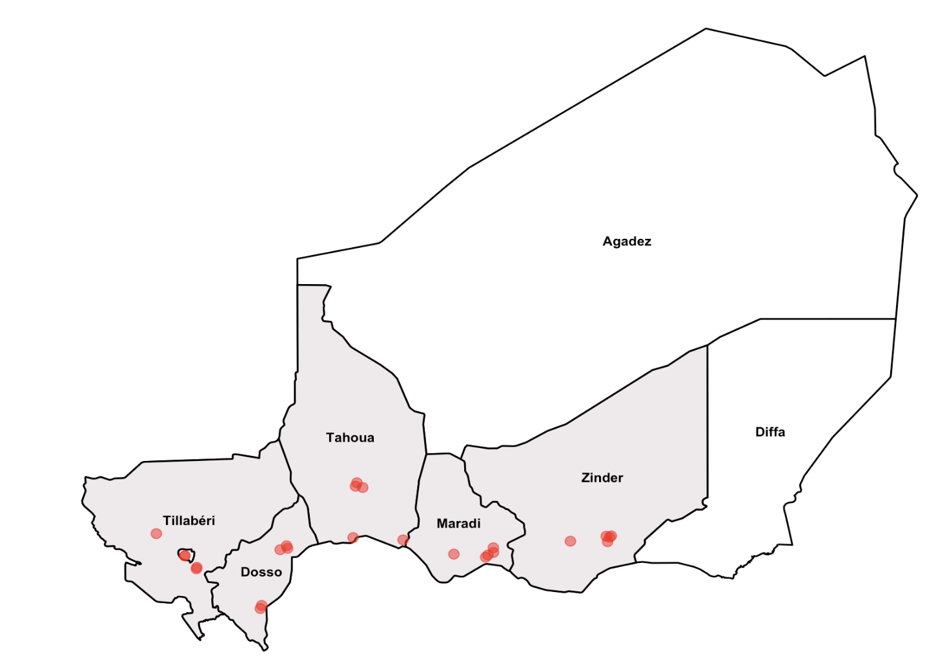

Figure 1: Striga collection sites in Niger. Red dots represent villages of collection within each region (Dosso, Maradi, Tahoua, Tillaberi, and Zinder) (Saidou et al.,2025)

Table 1: The 23 Striga hermonthica Ecotypes and Their Collection Sites
N | Striga Ecotype Abbreviations | Localities | Communes | Department | Regions | Date of Collection
1 | ED01 | Bozarawa | Dogondoutchi rula | Dogondoutchi | Dosso | 28/10/2021
2 | ED02 | Garin Sarki | Dogondoutchi rula | Dogondoutchi | Dosso | 27/10/2021
3 | ED03 | Hamdallaye | Dioundoun | Dioundoun | Dosso | 03/11/2021
4 | ED04 | Tagone | Dogondoutchi rula | Dogondoutchi | Dosso | 28/10/2021
5 | ED05 | Angoua Doka | Dioundoun | Dioundoun | Dosso | 01/11/2021
6 | EM06 | Galadantchi | Giratawa | Madaroufa | Maradi | 27/10/2021
7 | EM07 | Doramawa | Aguie | Aguie | Maradi | 24/10/2021
8 | EM08 | Kamdamka | Tessaoua | Tessaoua | Maradi | 24/10/2021
9 | EM09 | kottchi | Aguie | Aguie | Maradi | 24/10/2021
10 | EM10 | Dan Sa a | Tessaoua | Tessaoua | Maradi | 24/10/2021
11 | ETA11 | Kolloma | Tahoua Commune 1 | Tahoua | Tahoua | 16/11/2021
12 | ETA12 | Founkoye | Tahoua Commune 1 | Tahoua | Tahoua | 30/11/2021
13 | ETA13 | Dabagi | Tahoua Commune 3 | Tahoua | Tahoua | 18/11/2021
14 | ETA15 | Cerasa Gonni | Birni N Konni | Tahoua | Tahoua | 23/10/2021
15 | ETI16 | Lossa | Kourteye | Tillabéry | Tillabéry | 07/11/2021
16 | ETI17 | Dawel | Say | Say | Tillabéry | 14/11/2021
17 | ETI18 | Tatagounga | Youri | Kollo | Tillabéry | 14/11/2021
18 | ETI19 | Tiaguirire | Youri | Kollo | Tillabéry | 14/11/2021
19 | ETI20 | Dogal Banizoumbou | Youri | Kollo | Tillabéry | 14/11/2021
20 | EZ21 | Kalilla | Goure | Goure | Zinder | 09/11/2021
21 | EZ22 | Dan Gayza | Dungass | Dungass | Zinder | 26/10/2021
22 | EZ23 | Issoufouri | Goure | Goure | Zinder | 25/10/2021
23 | EZ25 | Magarawa | Goure | Goure | Zinder | 26/10/2021

Materials and Methods
Trial Conduct
The trials were conducted at the research station of the International Crops Research Institute for the Semi-Arid Tropics (ICRISAT) Sahelian Center, Niger. This station is located in Sadoré village (13°15' N 2°18' E), 40 km southeast of Niamey, 22 km northwest of Say, and 7 km west of the Niger River.
Two trials were conducted at the ICRISAT/Niger research station in September and December 2022. For the September trial, we observed Fusarium infestation in the soil which leads to the low germination rates of some Striga plants. The trials were conducted in pots (25 cm in diameter and 45 cm deep). A mixture of sand (70%), clay (15%), and organic manure (15%) was added to half of the pot. Striga hermonthica seeds (approximately 500 mg) were mixed with sand and deposited on the surface of the substrate, then covered with the rest of the mixture.
A total 69 pots were used in each trial, with a spacing of 50 cm between pots. Pearl millet seeds. Two holes were sown in two holes of 10 cm spacing in each pot. Four seeds of the susceptible millet variety (Zongo) were sown at 7 cm depth, distributed in two holes separated by 10 cm.
Regular weeding of weeds other than Striga was carried out throughout the experiment, and water was supplied as needed.

Morphological Characterization
Twelve descriptors were used, divided into 5 qualitative and 7 quantitative characteristics (Table 2).

Table 2: Qualitative and quantitative traits used for 23 Striga ecotypes characterization

Qualitative traits | Codes | Modality | Descriptions
Flower Color | CFL | 1- White  2- Pink  3- Dark Pink  4- Purple  5- Light Purple  6- Dark Purple | 90 DAS by flower/plant observation
Corolla Shape | FC | 1- Oval  2- Elliptical  3- Pentagon  4- Variable | 90 DAS by flower/plant observation
Intensity of the White Spot on the Flower | ITBFl | 1- Weak  2- Medium  3- Strong  4- Variable | 90 DAS by flower/plant observation
Degree of Plant Pubescence | DPP | 1- None  2- Weak  3- Medium  4- Strong | 70 DAS by plant observation
Intensity of the Red Spot on the Leaf | ITRF | 1- None  2- Weak  3- Medium  4- Strong  5- Very Strong | 70 DAS by leaf/plant observation

Quantitative traits | Code | Description | Unit
Plant Height | HTR | Measured from ground level to the tip of the main tiller’s spike, averaged from 2 plants | cm
Number of Stems | NT | Number of stems per plant | -
Leaf Length | LongF | Distance between the apex and base of the leaf | cm
Leaf Width | LargF | Measurement of the widest part of the leaf | cm
Flower Length | LongFl | Distance from the petal to the peduncle (measured from the peduncle to the tip of the petal) | cm
Flower Width | LargFl | Measurement of the widest part of the flower | cm
Number of Days to First Striga Emergence | DES NJ | Number of days until Striga appears above the soil surface (days after sowing/plant) | -

Statistical Analyses
Data analysis was performed using Rstudio version 4.4.1. Normality tests were done on the quantitative variables. Due to the non-compliance with the normality assumption (p < 0.05), non-parametric tests were chosen. The Kruskal-Wallis test was used to compare the means of the different groups. Chi-square tests were also performed to assess associations between qualitative variables. To explore the complex relationships between variables and reduce data dimensionality, a principal component analysis (PCA) was performed. This analysis identified the main axes of variation within the data. A hierarchical ascending classification (HAC) was then applied to group individuals with similar profiles based on the factorial axes derived from the PCA.

Results
Variability of Qualitative Traits
Morphological Characteristics of Identified Striga Ecotypes' Flowers
The morphological characterization of the flowers of each ecotype revealed a diversity of flowers, especially in size, color, and petal appearance. Based on the traits of color, shape, and intensity of the white spot at the center of the flower, we identified a total of 20 diverse Striga flower plants across the five regions of Niger. We classified the flowers in two main groups based on color and the intensity of the white spot (weak to strong intensity). The first subgroup consists of flowers with fused petals (Figure 2). The second group includes flowers with separated petals (Figure 3).

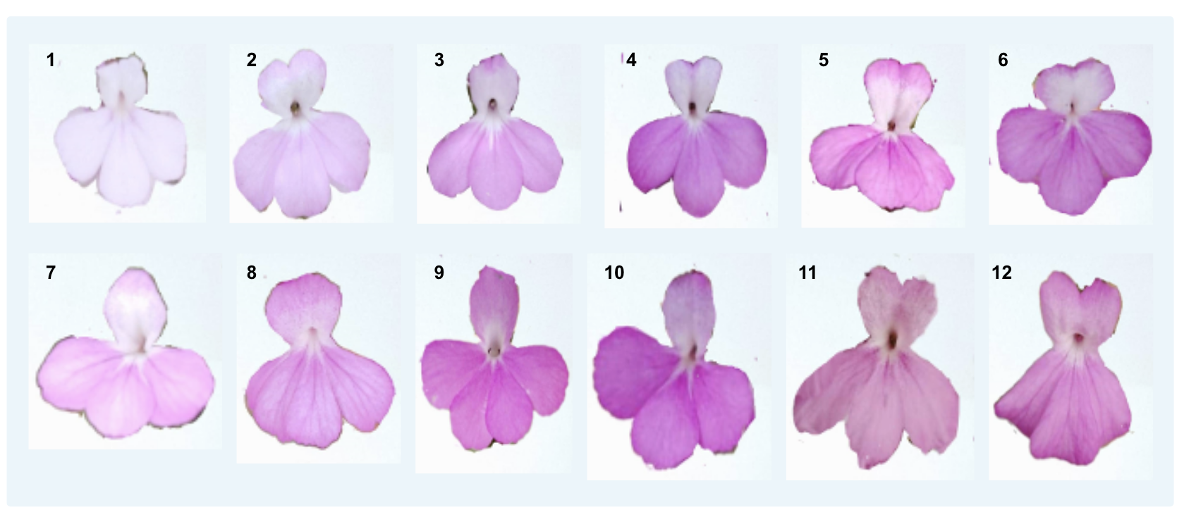
Figure 2: Different morphotypes of Striga hermonthica corollas with fused petals.
The edges of the flowers are delineated to highlight the morphotypes of the fused petals.

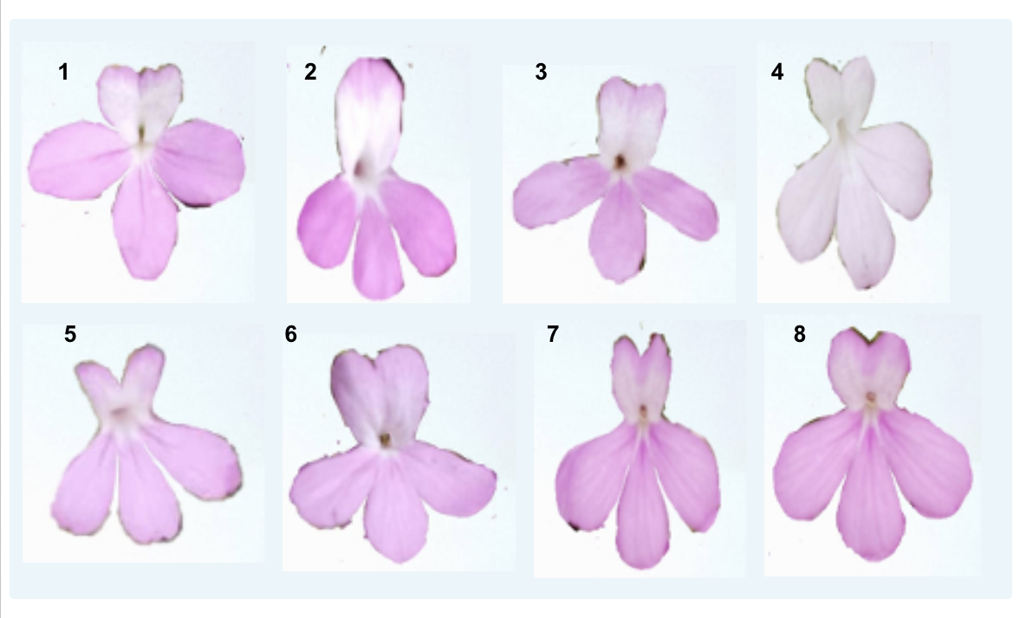
Figure 3: Different morphotypes of Striga hermonthica corollas with separated petals.
The edges of the flowers are delineated to highlight the morphotypes of the separated petals.

Distribution of phenotypic frequencies of qualitative traits
For the five qualitative traits studied, each have between four and six variables. The χ² test revealed that all phenotypic traits (p-value < 5%) have a distribution that depends on the collection region (Table 3).
Our study on Striga hermonthica revealed a remarkable diversity of calyx shapes within the Striga ecotypes from the Tahoua region. While the ecotypes from the Maradi, Tillabéry, and Zinder regions mainly exhibit oval and elliptical calyxes, those from Tahoua display a wider range, including pentagonal and variable shapes, representing 38%, 57%, 3%, and 2% of the sampled individuals, respectively.

The three phenotypes of the intensity of the white spot on the flower (ITBFL), namely weak, medium, and strong, were observed in all ecotypes from the different regions studied. The medium intensity of ITBFL was predominant among the ecotypes from the Dosso (51%), Tahoua (50%), Tillabéry (55%), and Zinder (52%) regions. In contrast, the weak intensity of ITBFL was predominant in the ecotypes from the Maradi region (55%).

The most frequently observed flower color was purple, with respective percentages of 80% for the ecotypes from the Dosso and Zinder regions, 89% for the ecotypes from the Maradi region, 72% for the ecotypes from the Tahoua region, and 87% for the ecotypes from the Tillabéry region. Dark pink flowers were observed only in the Dosso (5%) and Tillabéry (7%) regions. As for white flowers, they are exclusively present in the ecotypes from the Dosso region, with a very low percentage (3%).Leaves without red spots were observed in all the studied regions, with a particularly high frequency in the ecotypes from the Tillabéry region (87%), followed by the ecotypes from the Zinder (77%) and Tahoua (60%) regions. In contrast, very strong red spots on the leaves were observed in the four ecotypes from the Dosso, Maradi, Tillabéry, and Zinder regions with respective frequencies of 15%, 7%, 5%, and 8% (Figure 4).

The ecotypes from the Dosso and Tillabéry regions exhibit only three degrees of plant pubescence (DPP): weak (21%), medium (47%), and strong (32%). For the ecotypes from the Dosso region, and none (13%), weak (53%), and medium (33%) for the ecotypes from the Tillabéry region. In comparison, the ecotypes from the Tahoua region display greater diversity with five DPP: none (5%), weak (28%), medium (25%), strong (27%), and very strong (15%) (Figure 5).

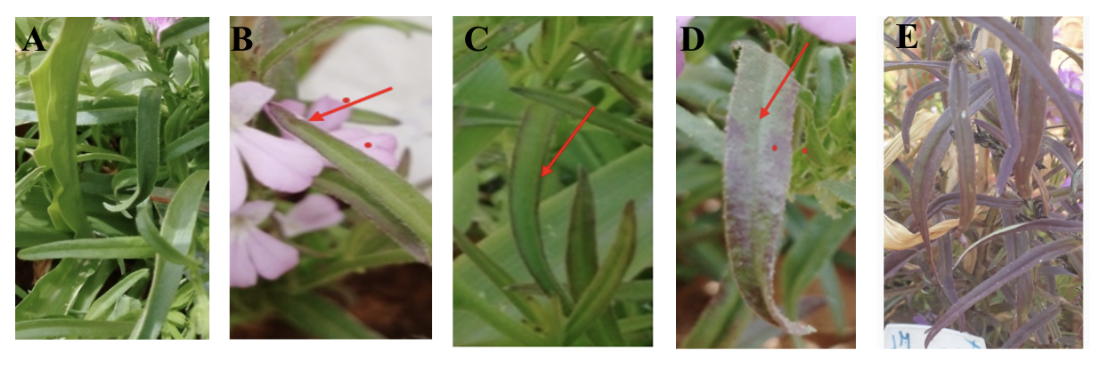
Figure 4: Intensity of the Red Spot on the Leaf (A) No pubescence. (B) Weak pubescence ;(C) Moderate pubescence and (D) Strong pubescence.

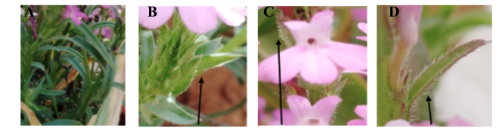
Figure 5: Plant pubescence degree (A) No pubescence degree; (B) Weak pubescence degree; (C) Medium pubescence degree and (D) Strong pubescence degree

Table 3: Distribution of Phenotypic Frequencies and χ² test of the 5 qualitative traits of Striga ecotypes collected in Niger.
Trait | Modality | Dosso | Maradi | Tahoua | Tillabéry | Zinder
Corolla Shape (FC)  p-value < 0.05 | 1-Oval | 69 | 45 | 38 | 81 | 88
Corolla Shape (FC)  p-value < 0.05 | 2-Elliptical | 28 | 55 | 57 | 19 | 12
Corolla Shape (FC)  p-value < 0.05 | 3-Pentagonal | - | - | 3 | - | -
Corolla Shape (FC)  p-value < 0.05 | 4-Variable | 3 | - | 2 | - | -
Intensity of the White Spot on the Flower ITBFL  p-value < 0.05 | 1-Weak | 12 | 55 | 25 | 29 | 37
 | 2-Medium | 51 | 39 | 50 | 55 | 52
 | 3-Strong | 35 | 7 | 25 | 16 | 12
 | 4-Variable | 3 | - | - | - | -
Flower Color (CFL)  p-value < 0.05 | 1-White | 3 | - | - | - | -
Flower Color (CFL)  p-value < 0.05 | 2-Pink | - | 3 | 12 | - | 3
Flower Color (CFL)  p-value < 0.05 | 3-Dark Pink | 5 | - | - | 7 | -
Flower Color (CFL)  p-value < 0.05 | 4-Purple | 80 | 89 | 72 | 87 | 80
Flower Color (CFL)  p-value < 0.05 | 5-Light Purple | 3 | 4 | 5 | 7 | -
Flower Color (CFL)  p-value < 0.05 | 6-Dark Purple | 9 | 4 | 12 | - | 17
Intensity of the Red Spot on the Leaf (ITRF)  p-value < 0.05 | 1-None | 20 | 55 | 60 | 87 | 77
Intensity of the Red Spot on the Leaf (ITRF)  p-value < 0.05 | 2-Weak | 28 | 23 | 13 | 8 | -
Intensity of the Red Spot on the Leaf (ITRF)  p-value < 0.05 | 3-Medium | 31 | 9 | 22 | - | 15
Intensity of the Red Spot on the Leaf (ITRF)  p-value < 0.05 | 4-Strong | 7 | 7 | 5 | -
Intensity of the Red Spot on the Leaf (ITRF)  p-value < 0.05 | 5-Very Strong | 15 | 7 | - | 5 | 8
Degree of Plant Pubescence (DPP)  p-value < 0.05 | 1-None | - | - | 5 | 13 | -
Degree of Plant Pubescence (DPP)  p-value < 0.05 | 2-Weak | 21 | 7 | 28 | 53 | 2
Degree of Plant Pubescence (DPP)  p-value < 0.05 | 3-Medium | 47 | 40 | 25 | 33 | 63
Degree of Plant Pubescence (DPP)  p-value < 0.05 | 4-Strong | 32 | 33 | 27 | - | 17
Degree of Plant Pubescence (DPP)  p-value < 0.05 | 5-Very Strong | - | 20 | 15 | - | 18

Analysis of Variance of the 7 Traits Studied in the 23 Ecotypes of S. hermonthica
The ecotypes of Maradi and Tahoua regions exhibit both similarities and morphological differences for the 7 traits studied. The results showed no significant differences were found for 4 traits (LongF, LargF, LongFl, and LargFl). However, significant differences were observed for number of stems (NT). For the following two traits (HTR and DES NJ), the mean values are higher in the ecotypes from the Maradi region (Table 4).
As for the ecotypes from the Tillabéry and Zinder regions, they exhibit 3 similarities for the following traits (LongFl, LargFl, and NT). The Tillabéry ecotypes are distinguished by higher mean values for the 6 traits studied (LongF, LargF, LongFl, NT, and DES NJ).

Table 4: Descriptive statistics of the 7 morphological traits evaluated in the Striga Ecotypes collected

Regions | LongF | LargF | LongFl | LargFl | HTR | NT | DES NJ
Dosso | 8.85^{c} | 0.72 ^{bc} | 2.50 ª | 1.85 ª | 67.02 ª | 11.01 ^{b} | 41.92 ^{c}
Maradi | 9.61^{bc} | 0.80 ^{ab} | 2.37 ^{b} | 1.59 ^{b} | 65.01 ^{ab} | 14.78 ª | 46.38 ^{b}
Tahoua | 8.78^{bc} | 0.66 ^{c} | 2.31 ^{b} | 1.59 ^{b} | 60 ^{b} | 10.73 ^{b} | 43.88 ^{bc}
Tilabery | 10.85ª | 0.77 ^{ab} | 2.62 ª | 1.82 ª | 61.32 ^{b} | 15.28 ª | 58.68 ª
Zinder | 9.74^{ab} | 0.81 ª | 2.51 ª | 1.87 ª | 53.68 ^{c} | 14.4 ª | 39.63 ^{d}
min | 4 | 0.4 | 2 | 1.1 | 21 | 4 | 29
max | 14.3 | 1.3 | 2.9 | 2.5 | 83 | 30 | 69
median | 9 | 0.8 | 2.5 | 1.9 | 63 | 12 | 43
mean | 9.18 | 0.74 | 2.48 | 1.84 | 60.32 | 13.30 | 43.533
SE.mean | 0.23 | 0.02 | 0.02 | 0.03 | 1.39 | 0.72 | 0.81
std.dev | 2.03 | 0.20 | 0.24 | 0.27 | 12.10 | 6.28 | 7.09
coef.var | 0.22 | 0.28 | 0.09 | 0.14 | 0.20 | 0.47 | 0.16
p-value | 5.12E-07 | 0.0001676 | 5.18E-12 | 4.93E-09 | 6.37E-09 | 4.70E-09 | 2.20E-16

LongF: leaf length; LargF: leaf width; LongFl: flower length; LargFl: flower width; HTR: plant height; NT: number of stems; DES NJ: number of days to first Striga emergence.

All morphological data allowed the identification of 2 dimensions using PCA. The two main axes, axis 1 and axis 2, explain 49.55% of the total variability (axis 1 with 27.7% and axis 2 with 21.8%) (Figure 6). The first axis, which explains the largest share of variability, is mainly influenced by four traits: flower length (LongFl), leaf length (LongF), flower width (LargFl), and leaf width (LargF). Among these traits, flower width (LargFl) contributes 75.87% to this axis, closely followed by flower length (LongFl) with 73.01%.
As for the second axis, it is influenced by three traits: plant height (HTR), number of stems (NT), and number of days to first Striga emergence (DES.NJ), leaf length (LongF). This second axis is dominated by the number of days to first Striga emergence, which contributes 70.63% (Table 5).
The principal component analysis was used to better understand the existing diversity within the ecotype based on the morphological traits. Three differentiated groups were identified. Axis 1 highlights an opposition between ecotypes (ET120) located on the right, characterized by large leaves and large flowers, and those on the left (e.g., ETA13), characterized by small leaves and small flowers. Axis 2 opposes tall ecotypes with a low number of stems and late Striga emergence (located at the bottom, such as ED03), to short ecotypes with a high number of stems and late Striga emergence (located at the top, such as ETI19). Groupings of ecotypes suggest the existence of different groups; for example, ecotypes ETI17, ETI18, and ETI19 form a distinct group (Figure 6).

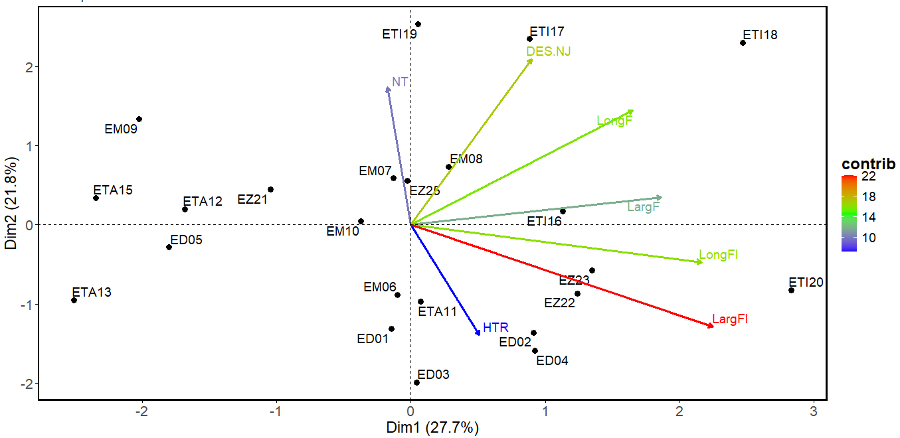Figure 6: Graphical Representation of the 23 Striga Ecotypes on the 1 and 2 dimensions of the principal component analysis.

Table 5: Contribution of Traits to Axes 1 and 2

Traits | Axis 1 | Axis 2
LongF | 0.55755289 | 0.4881616
LargF | 0.62905566 | 0.1187035
HTR | 0.17177929 | -0.4693339
NT | -0.05857449 | 0.5863953
LongFl | 0.73012354 | -0.1599211
LargFl | 0.75874819 | -0.433509
DES.NJ | 0.30269599 | 0.7063487

LongF: leaf length; LargF: leaf width; LongFl: flower length; LargFl: flower width; HTR: plant height; NT: number of stems; DES NJ: number of days to first Striga emergence.

Hierarchical Ascending Classification of Striga Ecotypes
The hierarchical classification based on the means of the 7 quantitative traits identified four groups with distinct morphological diversity (Figure 7).
- Group 1: This group includes 3 ecotypes from the Dosso and Tillabéry regions (ED02, ED03 and ETI20). These ecotypes are distinguished by tall plants (high HTR), large flowers, and wide leaves (significant FargF). However, they exhibit a relatively low number of stems (NT).
- Group 2: The largest group, composed of 11 ecotypes mainly from the Maradi region (ED05, EM06, EM07, EM08, EM09, EM10, ETA11, ETA12, ETA13, and ETI16), is subdivided into three subgroups. The ecotypes in this group are characterized by small leaves and flowers (LonF, LarF, LonFl, and LarFl).
- Group 3: This group includes 6 ecotypes, 4 of which are from the Zinder region (ED01, ETA15, EZ21, EZ22, EZ23, and EZ25). These ecotypes are characterized by a low number of days to first Striga emergence (DES NJ) and reduced plant height (HTR).
- Group 4: The smallest group is exclusively composed of 3 ecotypes from the Tillabéry region (ETI17, ETI18, and ETI19). These ecotypes are distinguished by a high flower length (LongF), a high number of stems (NT), and a high number of days to first Striga emergence (DES NJ).

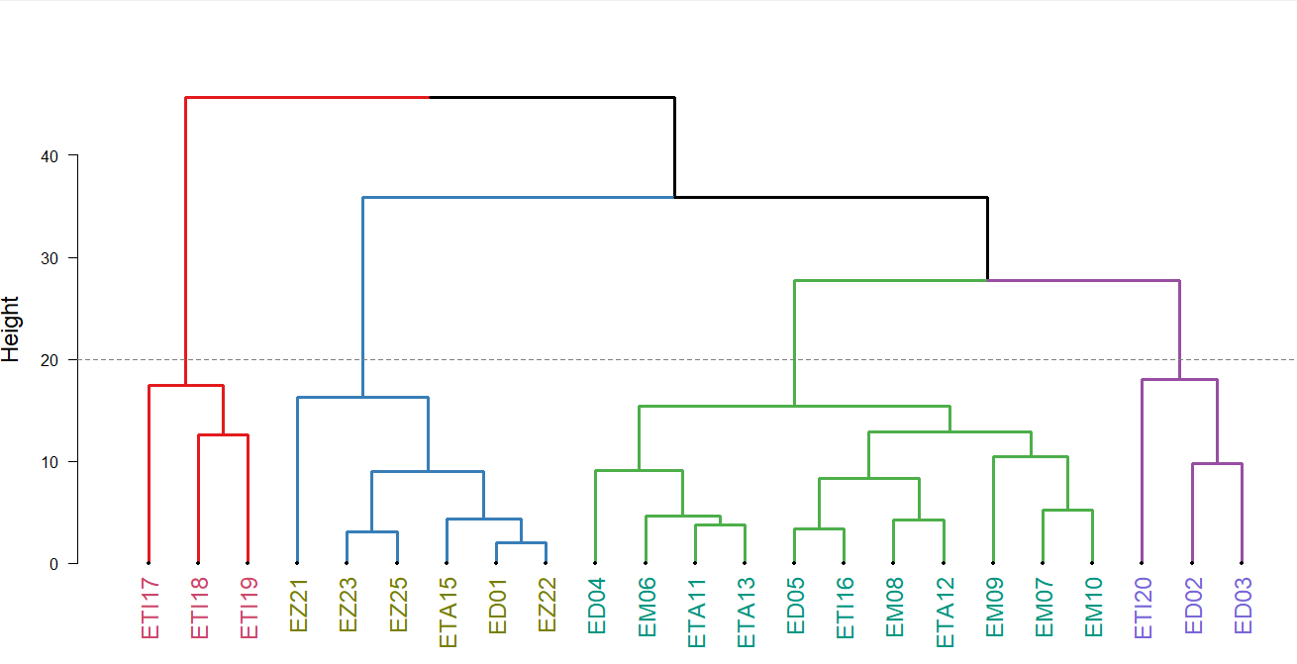

Figure 7: Classification of the 23 Striga Ecotypes Using the UPGMA Method

Discussion
The study of polymorphism in morphological traits within natural plant populations is an essential first step in understanding the origin and importance of the observed genetic variability (Lazrek Ben-friha, 2008).

Genetic diversity analysis of Striga ecotypes revealed significant morphological diversity in both qualitative and quantitative traits. From a qualitative perspective, the number and nature of expressed trait modalities demonstrate substantial phenotypic diversity among collected ecotypes, evidenced by variations in shape, appearance, and coloration of vegetative and reproductive organs (leaves and flowers). This variability may be explained by favorable ecological conditions for parasite development in Niger, where Striga thrives preferentially in semi-arid environments with soils depleted of organic matter and nitrogen, subject to low and irregular rainfall. As demonstrated by Husson et al. (2008), agricultural intensification (expanding croplands, reduced fallow periods, intensive tillage, monoculture, and slash-and-burn practices) accelerates soil degradation, thereby creating optimal conditions for Striga proliferation.
This phenotypic variability observed among studied ecotypes would undoubtedly stem from the expression of genetically distinct materials. Moreover, an uneven distribution of phenotypic frequencies for qualitative traits is recorded within each region, with certain phenotypes showing predominance.
Based on flower color, six colors were identified. Thus, there are plants with white, pink, dark pink, purple, light purple, and dark purple flowers. In terms of geographical distribution, certain flower colors are exclusive to specific regions. For example, white flowers are found mainly in the Dosso region. The Tahoua region is the region with the greatest phenotypic richness compared to all other regions

From a quantitative perspective, the analysis of morphological traits revealed great phenotypic heterogeneity among the studied ecotypes. The p-values (5.12E-07; 0.0001676……etc) suggest that there are significant differences in the mean values of all studied traits between the different regions. This implies that ecotypes from different regions exhibit distinct morphological characteristics
The analysis of variance showed that the ecotypes from Maradi and Tahoua share common characteristics at the level of leaves and flowers (LongF, LargF, LongFl, and LargFl). This suggests that the ecotypes have undergone similar selection pressures, leading to convergent morphological adaptationsThis suggests that Striga ecotypes have undergone similar selection pressures, leading to convergent morphological adaptations. The evolutionary principles of local selection and trade-offs described by Bellis et al. (2020) in the sorghum-Striga system support this hypothesis of adaptive convergence.
Furthermore, a clear morphological differentiation between the ecotypes from the five regions, particularly between those from Tillabéry and those from the other regions (Dosso, Maradi, Tahoua, and Zinder). This morphological differentiation, structured geographically, suggests a strong influence of ecological factors. Striga’s region-specific vegetative traits highlight the need for tailored control strategies against locally adapted ecotypes.
These results are consistent with previous studies on other annual species (Sorghum bicolor, Cicer arietinum, Manihot esculenta) (Upadhyaya, 2003; Githunguri et al., 2007; Barro-Kondombo et al., 2008), which showed a structuring of morphological diversity related to climatic conditions. This geographical structuring of morphological diversity in Striga underscores the importance of local adaptations in response to environmental constraints.
Please explicitly connect findings to implications

Conclusion
The study of the diversity of Striga hermonthica in Niger revealed significant morphological variability and among the first studies that cover many ecotypes from Niger. This parasitic species exhibits substantial morphological diversity, both qualitative and quantitative, reflecting adaptations to different environments. The results suggest an independent evolution of Striga hermonthica populations in the various regions of Niger, leading to the emergence and adaptation to different environments, allowing them to successfully colonize diverse habitats. This genetic diversity confers a high phenotypic plasticity to this species, explaining its persistence in the face of control strategies. A better understanding the morphological trait of the parsitic plant could shed light to the development of improved varieties resistant to striga in Africa.

References

Amusan, I. O., Rich, P. J., Menkir, A., Housley, T., & Ejeta, G. 2008. Resistance to Striga hermonthica in a maize inbred line derived from Zea diploperennis. New Phytologist, 178(1), 157–166.
Barro-Kondombo, C. P., Vom Brocke, K., Chantereau, J., Sagnard, F., & Zongo, J.-D. 2008. Variabilité phénotypique des sorghos locaux de deux régions du Burkina-Faso : la boucle du Mouhoun et le Centre-Ouest. Cahiers Agricultures, 17(2), 107–113.
Bellis, E. S., Kelly, E. A., Lorts, C. M., Gao, H., DeLeo, V. L., Rouhan, G., Budden, A., Bhaskara, G. B., Hu, Z., Muscarella, R., Timko, M. P., Nebie, B., Runo, S. M., Chilcoat, N. D., Juenger, T. E., Morris, G. P., dePamphilis, C. W., & Lasky, J. R. 2020. Genomics of sorghum local adaptation to a parasitic plant. Proceedings of the National Academy of Sciences (PNAS), 117(8), 4243–4251. https://doi.org/10.1073/pnas.1908707117
Ejeta, G. 2007. Breeding for Striga resistance in sorghum: exploitation of an intricate host–parasite biology. Crop Science, 47, S-216–S-217. https://doi.org/10.2135/cropsci2007.04.0011ipbs
Githunguri, C. M., Waithaka, K., Ekanayake, I. J., & Imungi, J. K. 2007. Influence of agroecological zones and plant age on the net assimilation, relative and crop growth rates of cassava. African Crop Science Conference Proceedings, 8, 1531–1533.
Gressel, J., Hanafi, A., Head, G., Marasas, W., Obilana, A. B., Ochanda, J., & Tzotzos, G. 2004. Major heretofore intractable biotic constraints to African food security that may be amenable to novel biotechnological solutions. Crop Protection, 23, 661–689. https://doi.org/10.1016/j.cropro.2003.11.014
Gurney, A. L., Slate, J., Press, M. C., & Scholes, J. D. 2006. A novel form of resistance in rice to the angiosperm parasite Striga hermonthica. New Phytologist, 169(1), 199–208.
Haussmann, B. I., Hess, D. E., Welz, H.‐G., & Geiger, H. H. 2000. Improved methodologies for breeding striga‐resistant sorghums. Field Crops Research, 66(3), 195–211. https://doi.org/10.1016/s0378-4290(00)00076-9
Husson, O., Michellon, R., Charpentier, H., Razanamparany, C., Moussa, N., Naudin, K., Razafintsalama, H., Rakotoarinivo, C., Andrianaivo, A., & Seguy, L. 2008. Le contrôle du Striga par les systèmes SCV (Semis direct sur Couverture Végétale permanente) (Rapport technique, Vol. 1, pp. 1–20).
Koyama, M. L. 2000. Genetic variability of Striga hermonthica and effect of resistant cultivars on Striga population dynamics. In Breeding for Striga Resistance in Cereals (pp. 1–15). Margraf Verlag.
Lazrek-Ben Friha, F. 2008. Analyse de la diversité génétique et symbiotique des populations naturelles tunisiennes de Medicago truncatula et recherche de QTLs liés au stress salin. [Doctoral dissertation, Université de Toulouse III].
Pennisi, E. 2010. Armed and dangerous. Science, 327(5967), 804–805. https://doi.org/10.1126/science.327.5967.804
Raynal-Roques, A. 1993. Contribution à la connaissance de la biologie des Striga (Scrophulariaceae): types biologiques et phénologie. Bulletin du Muséum National d'Histoire Naturelle, Paris, 4e série, 15, section B, Adansonia, 1-4, 3–31.
Rodenburg, J., Bastiaans, L., Weltzien, E., & Hess, D. E. 2005. How can field selection for Striga resistance and tolerance in sorghum be improved? Field Crops Research, 93(1), 34–50. https://doi.org/10.1016/j.fcr.2004.09.004
Saidou, S. S., Kountché, B., Amadou, H. I., Moussa, S., Laouali, A. M., Latif, H. N. A., & Yacoubou, B. 2024. Diversité d'usage de Striga hermonthica au Niger. International Journal of Innovation and Applied Studies, 42(4), 594-605.
Upadhyaya, H. D. (2003). Geographical patterns of variation for morphological and agronomic characteristics in the chickpea germplasm collection. Euphytica, 132(3), 343–352.

