Lung Cancer in Never-Smokers: Integrating Histopathological Patterns, Molecular Profiles, and Therapeutic Strategies

Lung Cancer in Non-Smokers: Integrating Histopathological Patterns, Molecular Profiles, and Therapeutic Strategies

Abstract——Never-smoker lung cancer is a unique clinical and pathological disease that comprises 10-25 percent of all cases of lung cancer in the world, and has a specific epidemiology, histopathology, and molecular profile that is fundamentally different than smoking related disease. This narrative literature review looks at the specific histopathological characteristics that define this significant constituent subset of patients with lung cancer. We are able to systematically review published studies and show that never-smokers stately receive well differentiated adenocarcinoma (85-90% vs 40-50% in smokers) and characteristic morphological patterns that include lepidic growth, acinar architectures, and papillary patterns that closely correspond to unique molecular drivers. Immunohistochemistry results in more than twice the TTF-1 expression in never-smokers (80-90% vs 60-70%), twofold higher Napsin A even in smokers (85-95% vs 70-80%), and targetable oncogenic drivers are markedly enriched using molecular profiling (EGFR mutations 40-50% vs 10-15%; ALK rearrangements 5-10% vs rare; ROS1 fusions Combination of morphological patterns and immunohistochemical pattern and molecular changes has important diagnostic and treatment implications as histological characteristics may presage molecular status and choice of targeted treatment in this population. The future of optimizing diagnosis and treatment of never-smokers with lung cancer lies in the emerging technologies such as liquid biopsy and AI- enabled pathology as well as the historically agnostic therapeutic strategies that are based on targeting specific molecular drivers in an independent manner of current morphological subtype. This review summarizes recent evidence that integrated morphologic, immunohistochemical, and molecular analysis is critically needed to make accurate diagnosis, form appropriate molecular test plans, and effective therapeutic decisions in never-smoker lung cancer patients.

Keywords: lung adenocarcinoma, never-smoking, histopathology, adenocarcinoma, molecular marker, immunohistochemistry, targeted therapy, literature review

Abstract——Never-smoker lung cancer represents a distinctive clinical and pathological entity, comprising 10-25 percent of all lung cancer cases globally. It possesses a unique epidemiology, histopathology, and molecular profile that fundamentally diverges from smoking-related diseases. This narrative literature review meticulously examines the specific histopathological characteristics that delineate this significant subset of lung cancer patients. Our systematic review of published studies reveals that never-smokers predominantly present with well-differentiated adenocarcinoma (85-90% vs. 40-50% in smokers) and exhibit characteristic morphological patterns, including lepidic growth, acinar architectures, and papillary patterns that closely align with unique molecular drivers. Immunohistochemical analyses indicate a more than twofold increase in TTF-1 expression among never-smokers (80-90% vs. 60-70%), alongside a twofold higher prevalence of Napsin A in comparison to smokers (85-95% vs. 70-80%). Furthermore, targetable oncogenic drivers are significantly enriched through molecular profiling, with EGFR mutations occurring in 40-50% of cases compared to 10-15% in smokers, and ALK rearrangements identified in 5-10% versus rare occurrences in smokers; ROS1 fusions further contribute to this profile. The confluence of morphological patterns, immunohistochemical profiles, and molecular alterations carries substantial diagnostic and therapeutic implications, as histological characteristics may foreshadow molecular status and guide the selection of targeted treatments within this population. The future of optimizing diagnosis and treatment for never-smokers with lung cancer is poised to benefit from emerging technologies such as liquid biopsy and AI-enabled pathology, alongside historically agnostic therapeutic strategies that focus on targeting specific molecular drivers independently of current morphological subtypes. This review encapsulates recent evidence underscoring the critical necessity for integrated morphological, immunohistochemical, and molecular analyses to facilitate accurate diagnoses, formulate appropriate molecular testing strategies, and make effective therapeutic decisions for never-smoker lung cancer patients.

Keywords: lung adenocarcinoma, never-smoking, histopathology, adenocarcinoma, molecular marker, immunohistochemistry, targeted therapy, literature review

1. Introduction
Lung cancer remains the leading cause of cancer-related mortality worldwide, traditionally associated with tobacco smoking. However, approximately 10-25% of lung cancers occur in never-smokers, defined as individuals who have smoked fewer than 100 cigarettes in their lifetime (Samet et al., 2009; Parkin et al., 2005). This demographic represents a distinct clinical entity with unique epidemiological, histopathological, and molecular characteristics that warrant separate investigation and therapeutic consideration.
The epidemiological landscape of lung cancer has undergone significant transformation over recent decades. While overall lung cancer incidence has declined in developed countries due to smoking cessation efforts, the proportion of cases occurring in never-smokers has proportionally increased (Houston et al., 2014). This shift is particularly pronounced among women and younger patients, with adenocarcinoma emerging as the predominant histological subtype in this population (Wakelee et al., 2007).
Histopathological analysis plays a crucial role in understanding the biological behavior and therapeutic implications of lung cancer in never-smokers. The morphological patterns, growth characteristics, and cellular differentiation observed in never-smokers often differ substantially from those seen in smoking-related lung cancers (Travis et al., 2015). These differences extend beyond mere histological appearance to encompass immunohistochemical expression profiles and underlying molecular alterations that drive tumorigenesis.
The importance of accurate histopathological characterization in never-smokers cannot be overstated, as it directly impacts therapeutic decision-making in the era of personalized medicine. The enrichment of specific oncogenic drivers such as EGFR mutations, ALK rearrangements, and ROS1 fusions in never-smokers necessitates precise histological diagnosis to guide appropriate molecular testing and targeted therapy selection (Lindeman et al., 2018).
This comparative study aims to comprehensively examine the histopathological features that distinguish lung cancer in never-smokers from their smoking counterparts, with particular emphasis on morphological patterns, immunohistochemical profiles, molecular correlations, and their therapeutic implications. The scope encompasses diagnostic challenges, emerging molecular techniques, and future directions for optimizing patient care in this unique population.

2. Histological Landscape of Lung Cancer in Never-Smokers
The histological distribution of lung cancer in never-smokers demonstrates remarkable uniformity across different populations and geographic regions. Adenocarcinoma accounts for 85-90% of cases in never-smokers, compared to approximately 40-50% in smokers (Subramanian & Govindan, 2007). This predominance is consistent regardless of gender, ethnicity, or geographic location, suggesting fundamental biological differences in carcinogenesis pathways between smoking-related and non-smoking-related lung cancers.
Morphologically, adenocarcinomas in never-smokers exhibit distinct architectural patterns that reflect their unique pathogenesis. The lepidic growth pattern is significantly more common in never-smokers, manifesting as tumor cells growing along intact alveolar walls without stromal invasion (Yoshizawa et al., 2011). This pattern is often associated with ground-glass opacities on imaging and represents the in-situ component of adenocarcinoma spectrum. The acinar pattern, characterized by glandular structures with central lumina, is also frequently observed and tends to be well-differentiated with regular nuclear features.
Papillary adenocarcinoma, featuring complex papillary structures with fibrovascular cores, shows higher prevalence in never-smokers compared to smokers. These tumors often display well-preserved cellular architecture with minimal pleomorphism and lower mitotic rates (Russell et al., 2011). The solid pattern with mucin production, while less common, when present in never-smokers, typically retains some degree of differentiation and lacks the extensive necrosis often seen in smoking-related cases.
Papillary adenocarcinoma, characterized by intricate papillary architectures supported by fibrovascular cores, exhibits a higher incidence among never-smokers in comparison to smokers. These neoplasms frequently demonstrate well-preserved cellular morphology, exhibiting minimal pleomorphism and diminished mitotic activity (Russell et al., 2011). The solid variant, which involves mucinous production, though less prevalent, when encountered in never-smokers, typically maintains a certain level of differentiation and is devoid of the extensive necrosis commonly associated with smoking-related cases.
Squamous cell carcinoma is relatively uncommon in never-smokers, accounting for less than 10% of cases compared to 30-40% in heavy smokers (Pelosof et al., 2017). When squamous cell carcinoma does occur in never-smokers, it tends to be well-differentiated with prominent keratinization and intercellular bridges, contrasting with the poorly differentiated, high-grade squamous carcinomas typical of smoking-related cases.

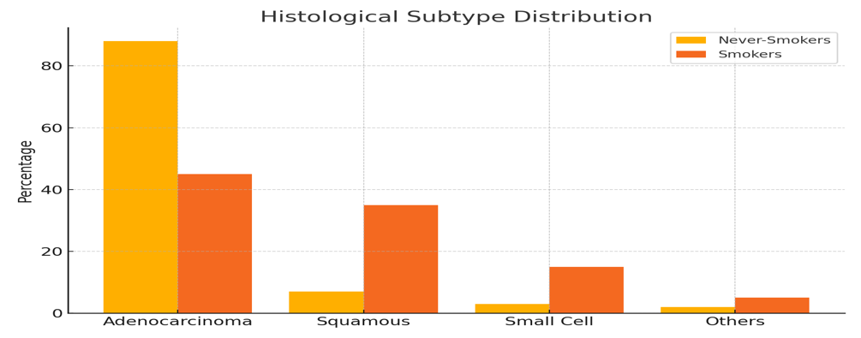

Bar comparing the prevalence of different histological subtypes between never-smokers and smokers. Adenocarcinoma predominates in never-smokers (85-90%) compared to smokers (40-50%), while squamous cell carcinoma and small cell carcinoma are markedly reduced in never-smokers.
Figure 1. Histological Distribution of Lung Cancer by Smoking Status

Small cell lung carcinoma is exceptionally rare in never-smokers, representing less than 5% of cases. This stark contrast with the 15-20% incidence in smokers underscores the strong association between small cell carcinoma and tobacco carcinogens (Govindan et al., 2006). Large cell carcinoma and other rare histological subtypes collectively account for the remaining cases in never-smokers.
Environmental and genetic risk factors play crucial roles in shaping the histological landscape in never-smokers. Radon exposure, air pollution, occupational carcinogens, and secondhand smoke contribute to adenocarcinoma development through different molecular pathways than direct tobacco exposure (Malhotra et al., 2016). Genetic predisposition, including germline mutations in EGFR, TP53, and DNA repair genes, influences both susceptibility and histological patterns in never-smokers.

Table 1: Histological Subtype Distribution
Histological Subtype | Never-Smokers (%) | Smokers (%)
Adenocarcinoma | 85-90% | 40-50%
Squamous Cell Carcinoma | <10% | 30-40%
Small Cell Carcinoma | <5% | 15-20%
Others (e.g., Large Cell) | Remainder | Remainder

3. Diagnostic Challenges and Morphologic Limitations
The diagnosis of lung cancer in never-smokers presents unique challenges that extend beyond conventional morphological assessment. Small biopsy specimens, which constitute the majority of diagnostic material in clinical practice, often provide limited tissue for comprehensive evaluation. The well-differentiated nature of many adenocarcinomas in never-smokers can make distinction from reactive or atypical pneumocyte proliferation particularly challenging (Kerr et al., 2015).
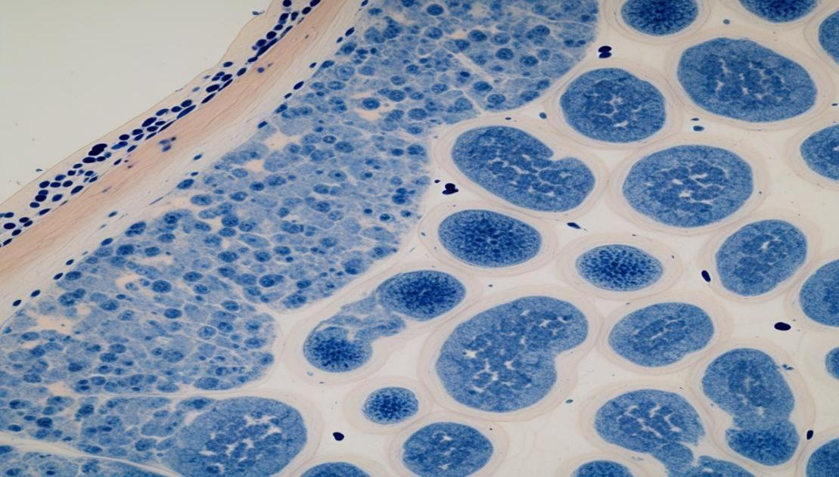

Photomicrograph demonstrating well-differentiated lepidic adenocarcinoma pattern in a never-smoker, showing tumor cells growing along intact alveolar walls without stromal invasion. This pattern can be challenging to distinguish from reactive pneumocyte proliferation in small biopsies (H&E stain, original magnification ×200).
Figure 2. Diagnostic Challenges in Never-Smoker Lung Cancer

Cytological specimens from never-smokers frequently demonstrate well-preserved cellular morphology with minimal background inflammation or necrosis, contrasting with the often degraded cellular material typical of smoking-related cases. However, this preservation can paradoxically complicate diagnosis when dealing with well-differentiated adenocarcinomas that closely mimic reactive pneumocytes or atypical adenomatous hyperplasia (Yatabe et al., 2011).
The lepidic growth pattern, common in never-smokers, poses specific diagnostic challenges in small biopsies. The absence of stromal invasion in pure lepidic areas can lead to underdiagnosis of invasive adenocarcinoma, particularly when only transbronchial biopsies are available. Conversely, crush artifact or tangential sectioning can create false impressions of invasion in predominantly lepidic tumors (Warth et al., 2012).
Resection specimens from never-smokers often reveal heterogeneous architectural patterns within single tumors, with lepidic, acinar, and papillary components coexisting. This heterogeneity necessitates comprehensive sampling and careful pattern recognition to accurately classify tumors according to predominant pattern, which has prognostic and therapeutic implications (Moreira et al., 2020).
Aberrant marker expression represents another diagnostic pitfall in never-smokers. TTF-1 negativity, while uncommon, can occur in up to 15-20% of adenocarcinomas in never-smokers, potentially leading to misclassification or uncertainty regarding primary versus metastatic disease (Zhang et al., 2014). Similarly, unexpected positive staining for squamous markers in adenocarcinomas or adenocarcinoma markers in squamous tumors can occur, particularly in poorly sampled small biopsies.
The distinction between primary lung adenocarcinoma and metastatic disease is particularly challenging in never-smokers, especially women, where breast, gynecologic, or gastrointestinal primaries may closely mimic lung adenocarcinoma morphologically. Clinical correlation, imaging findings, and comprehensive immunohistochemical panels become essential for accurate diagnosis (Rekhtman et al., 2012).
Molecular heterogeneity within tumors can also create diagnostic challenges. Different regions of the same tumor may harbor distinct molecular alterations, and small biopsies may not adequately represent the overall molecular profile. This spatial heterogeneity is particularly relevant in never-smokers, where multiple concurrent driver mutations may coexist (de Bruin et al., 2014).

Table 2: Diagnostic Challenge Summary
Challenge | Description
Lepidic Pattern | May mimic reactive pneumocytes; hard to diagnose in small biopsies
Well-differentiated Tumors | Difficult to distinguish from benign lesions
Aberrant Marker Expression | Can lead to misclassification of tumor origin
Heterogeneity | Tumors often show mixed patterns and mutations

4. Immunohistochemical Subtyping in Never-Smokers
Immunohistochemical analysis plays a pivotal role in the accurate subtyping of lung cancer in never-smokers, where morphological features alone may be insufficient for definitive classification. The expression profiles of key markers demonstrate distinct patterns that correlate with smoking status and have important diagnostic and prognostic implications.
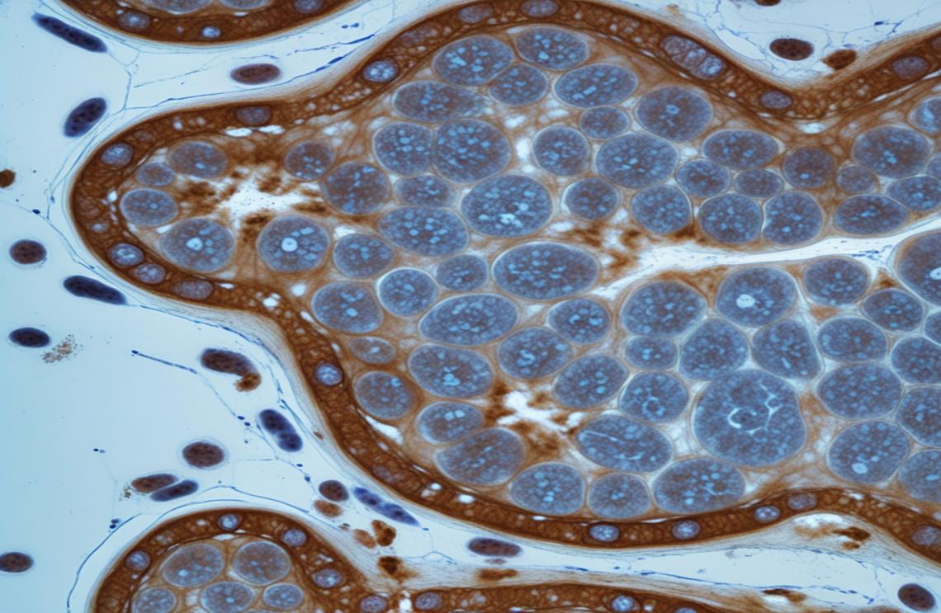
Representative immunohistochemical staining showing strong nuclear TTF-1 positivity (A) and robust cytoplasmic Napsin A expression (B) in pulmonary adenocarcinoma from a never-smoker. These markers show higher expression rates in never-smokers compared to smokers (original magnification ×400).
Figure 3. Immunohistochemical Profile of Adenocarcinoma in Never-Smokers
Figure 3. Immunohistochemical Characterization of Adenocarcinoma in Non-Smokers.

TTF-1 (Thyroid Transcription Factor-1) expression is significantly higher in adenocarcinoma from never-smokers compared to smokers, with positive staining observed in 80-90% versus 60-70% of cases, respectively (Yatabe et al., 2019). This increased expression correlates with better differentiation and is associated with EGFR mutation status. Nuclear TTF-1 staining in never-smokers tends to be strong and diffuse, facilitating distinction from metastatic adenocarcinoma from other primary sites.
Napsin A, a functional aspartic proteinase involved in surfactant protein processing, shows particularly robust expression in adenocarcinoma from never-smokers. Approximately 85-95% of cases demonstrate strong cytoplasmic staining, compared to 70-80% in smokers (Turner et al., 2012). The combination of TTF-1 and Napsin A positive provides high specificity for primary lung adenocarcinoma and is especially valuable in never-smokers where morphological features may be subtle.
p40, a truncated isoform of p63, serves as a highly specific marker for squamous cell carcinoma. In never-smokers, p40 expression is typically strong and diffuse in the rare squamous cell carcinomas that do occur, helping to distinguish them from adenocarcinomas with squamoid features (Bishop et al., 2012). The specificity of p40 for squamous differentiation makes it particularly valuable in small biopsies where morphological assessment is limited.

Table 3: Immunohistochemical Marker Expression
Marker | Never-Smokers Expression | Smokers Expression
TTF-1 | 80-90% | 60-70%
Napsin A | 85-95% | 70-80%
p40 | Strong in rare squamous types | Strong in squamous types
CK7 | Positive | Positive
CK20 | Negative | Rarely Positive

Comparative expression analysis reveals interesting patterns between smokers and never-smokers. CK7 expression is more consistently positive in adenocarcinoma from never-smokers, while CK20 remains negative in the vast majority of cases. This pattern helps distinguish primary lung adenocarcinoma from colorectal metastases, which is particularly relevant given the increased incidence of multiple primary tumors in never-smokers (Haruki et al., 2010).
In rare histological variants occurring in never-smokers, immunohistochemical patterns may differ from those seen in smokers. Large cell neuroendocrine carcinomas (LCNEC) in never-smokers often retain TTF-1 expression while showing neuroendocrine markers (chromogranin, synaptophysin, CD56), contrasting with the frequent TTF-1 negativity in smoking-related LCNEC (Rekhtman et al., 2010).
Sarcomatoid carcinomas, while extremely rare in never-smokers, when present, may show retained epithelial marker expression (TTF-1, cytokeratins) in the epithelial component, facilitating recognition of their pulmonary origin. The mesenchymal component typically expresses vimentin and may show focal positivity for smooth muscle actin or other mesenchymal markers (Rossi et al., 2003).
Emerging immunohistochemical markers show promise for further characterization of lung cancers in never-smokers. Claudin-4 expression is higher in adenocarcinoma from never-smokers and correlates with EGFR mutation status. Similarly, E-cadherin expression patterns may help predict molecular alterations and therapeutic responses in this population.

5. Molecular Alterations and Histologic Correlation
The molecular landscape of lung cancer in never-smokers is characterized by distinct oncogenic driver mutations that show strong correlations with specific histological features. Understanding these molecular-morphological relationships is crucial for diagnostic accuracy and therapeutic decision-making in clinical practice.

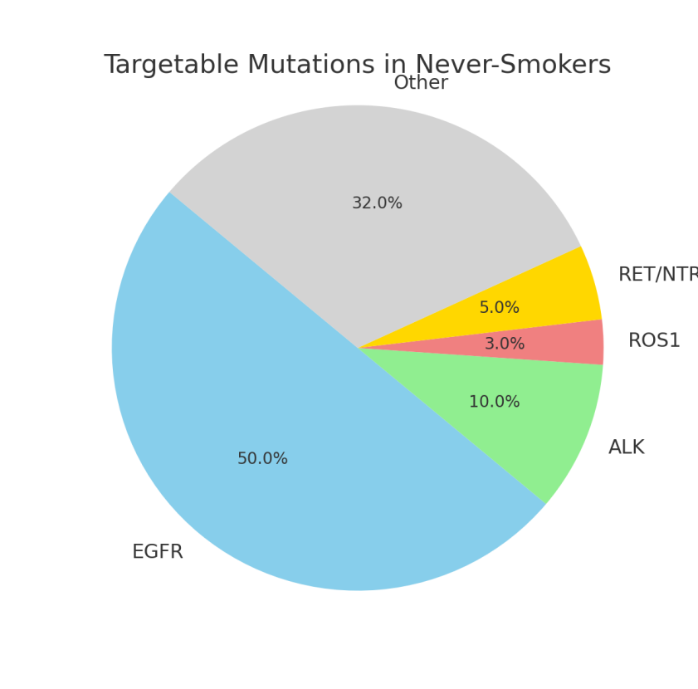

Comprehensive molecular landscape showing the frequency and distribution of key oncogenic drivers in never-smoker lung adenocarcinoma. EGFR mutations are the most common alteration (40-50%), followed by ALK rearrangements (5-10%) and ROS1 fusions (1-3%). The chart illustrates the enrichment of targetable alterations compared to smoking-related cases.
Figure 4. Molecular Alterations in Never-Smoker Lung Adenocarcinoma

EGFR mutations represent the most common oncogene driver in never-smokers, occurring in 40-50% of adenocarcinoma compared to 10-15% in smokers (Lynch et al., 2004). These mutations show strong correlation with specific histological patterns. Lepidic-predominant adenocarcinoma demonstrate EGFR mutations in up to 70% of cases, while acinar and papillary patterns show intermediate frequencies. The morphological characteristics associated with EGFR mutations include well-differentiated glandular architecture, minimal pleomorphism, and low proliferation indices.
ALK rearrangements occur in 5-10% of lung adenocarcinoma in never-smokers, with a strong predilection for younger patients. Histologically, ALK-positive tumors often display solid growth patterns with abundant cytoplasm and characteristic “hallmark cells” - large cells with eccentric nuclei and abundant eosinophilic cytoplasm (Rodig et al., 2009). Signet ring cell features and cribriform patterns are also more common in ALK-rearranged tumors. These morphological features can serve as screening tools for ALK testing, particularly in resource-limited settings.
ROS1 fusions account for 1-3% of lung adenocarcinomas in never-smokers and show overlapping morphological features with ALK-positive tumors. However, ROS1-positive tumors more frequently demonstrate glandular architecture and may show prominent mucin production (Yoshida et al., 2011). The histological similarity between ALK and ROS1-positive tumors necessitates molecular testing for definitive identification.

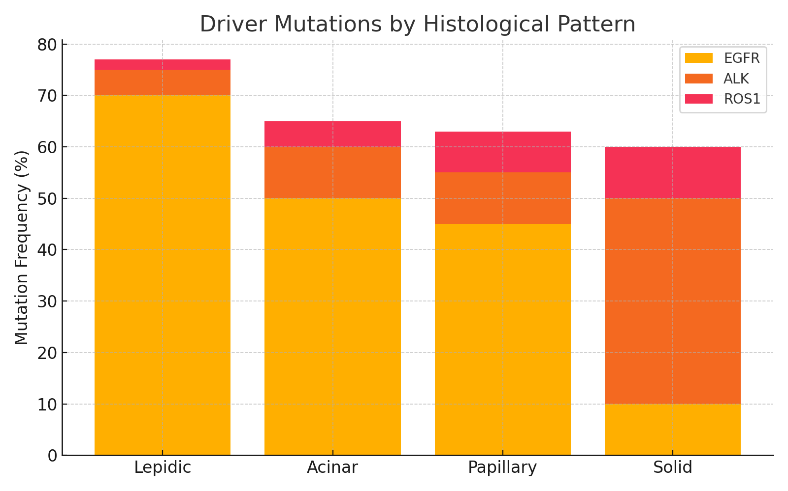
Morphological patterns associated with specific molecular drivers in never-smoker adenocarcinoma: (A) Lepidic pattern commonly associated with EGFR mutations, (B) Solid pattern with "hallmark cells" characteristic of ALK rearrangements, and (C) Acinar pattern with mucin production seen in some ROS1-positive cases (H&E stain, original magnification ×400).
Figure 5. Histomorphological Correlates of Molecular Alterations

Histological predictors of molecular alterations have important practical implications for diagnostic workflows. Well-differentiated adenocarcinomas with lepidic or acinar patterns in never-smokers warrant EGFR mutation testing, while solid-predominant tumors in younger never-smokers should prompt ALK and ROS1 evaluation. These morphological cues can guide targeted molecular testing strategies and expedite appropriate therapy selection (Kadota et al., 2015).
The comparison of molecular profiles between smokers and never-smokers reveals fundamental differences in carcinogenesis pathways. Never-smokers show lower overall mutation burdens with enrichment for single, high-impact driver mutations, while smokers demonstrate complex mutational landscapes with tobacco-signature mutations throughout the genome (Govindan et al., 2012). This difference has important implications for immunotherapy responses and resistance patterns.

Table 4: Molecular Alterations by Histological Pattern
Histological Pattern | Common Alteration(s) | Prevalence in Never-Smokers
Lepidic | EGFR mutations | Up to 70%
Acinar | EGFR mutations | Intermediate
Papillary | EGFR mutations | Intermediate
Solid | ALK/ROS1 rearrangements | Common in younger patients
Mucinous | KRAS G12D mutations | Less common

KRAS mutations, while less common in never-smokers than smokers, when present, often involve different codons and show distinct histological associations. KRAS G12C mutations, targetable with specific inhibitors, occur more frequently in smokers, while KRAS G12D mutations are relatively more common in never-smokers and associate with mucinous adenocarcinoma patterns (Dearden et al., 2013).
Rare molecular alterations more commonly seen in never-smokers include RET fusions, NTRK fusions, and MET exon 14 skipping mutations. These alterations may not show specific histological patterns but their recognition is crucial for targeted therapy selection. RET fusions often occur in solid-predominant adenocarcinomas, while NTRK fusions may be associated with papillary or solid patterns (Kohno et al., 2012).
The diagnostic implications of molecular alterations in morphologically ambiguous cases cannot be overstated. In poorly differentiated carcinomas where lineage determination is challenging, the presence of EGFR mutations strongly suggests adenocarcinoma differentiation, while the absence of common adenocarcinoma drivers may prompt investigation for squamous or neuroendocrine markers.

6. Histopathology-Guided Therapeutic Implications
The histological subtype of lung cancer in never-smokers has profound implications for therapeutic selection and patient outcomes. The predominance of well-differentiated adenocarcinoma in this population correlates with distinct treatment responses and survival patterns that differ significantly from smoking-related lung cancers.
Chemotherapy response patterns in never-smokers show histological correlations that influence treatment selection. Well-differentiated adenocarcinomas with lepidic or acinar patterns demonstrate better responses to pemetrexed-based regimens compared to poorly differentiated or solid-pattern tumors (Scagliotti et al., 2008). This correlation reflects the higher expression of folate pathway enzymes in well-differentiated adenocarcinomas, making them more susceptible to antifolate therapy.
The suitability of specific histological subtypes for targeted therapies represents a paradigm shift in lung cancer treatment. Adenocarcinomas in never-smokers, with their high frequency of targetable driver mutations, are ideal candidates for precision medicine approaches. The morphological features can guide initial therapeutic decisions while awaiting molecular results, with well-differentiated adenocarcinomas being suitable for EGFR tyrosine kinase inhibitor therapy in appropriate clinical contexts (Rosell et al., 2012).
Histological patterns also correlate with specific targeted therapy responses. Lepidic-predominant adenocarcinomas with EGFR mutations show particularly dramatic responses to EGFR inhibitors, often achieving complete radiological responses. However, these same tumors may be more prone to develop resistance through transformation to small cell carcinoma or acquisition of secondary mutations (Sequist et al., 2011).

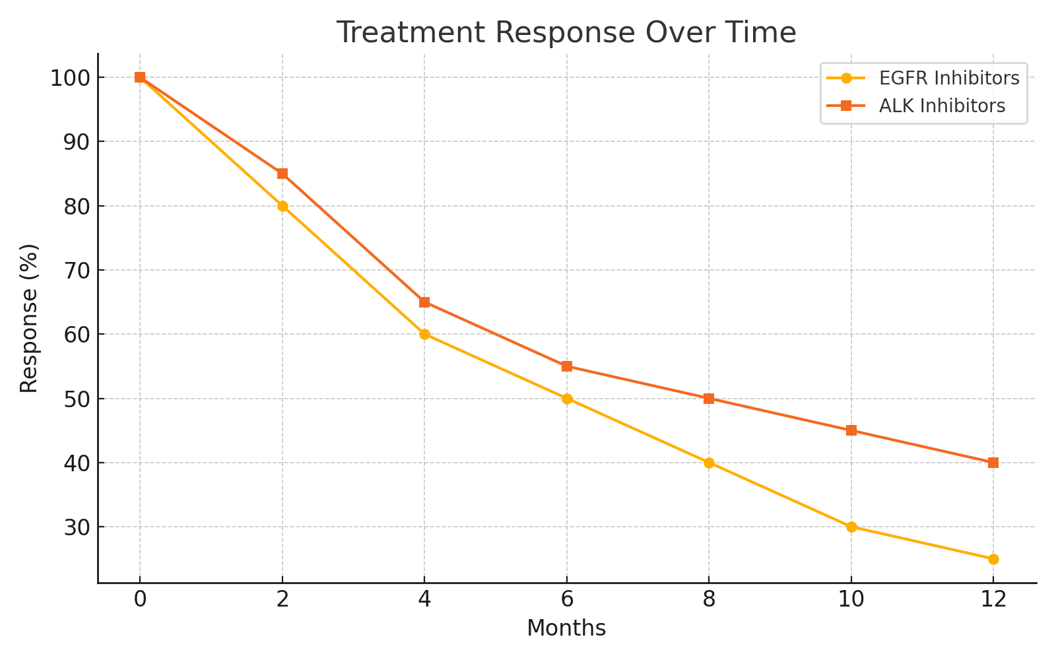
Treatment response correlation chart showing the relationship between histological patterns and therapeutic efficacy in never-smokers. Lepidic-predominant adenocarcinomas show excellent response to EGFR inhibitors, while solid-pattern tumors are more suitable for ALK inhibitor therapy. The chart emphasizes the importance of histopathology-guided treatment selection.
Figure 6. Therapeutic Response Patterns by Histological Subtype

The predictive value of histology extends to immunotherapy considerations in never-smokers. The well-differentiated nature of most adenocarcinomas in never-smokers correlates with lower tumor mutational burden and reduced PD-L1 expression, suggesting limited benefit from single-agent immune checkpoint inhibitors (Rizvi et al., 2015). However, combination approaches or histology-specific biomarkers may improve outcomes in selected cases.
Resistance patterns in never-smokers show distinct histological manifestations that have therapeutic implications. EGFR inhibitor resistance may manifest as transformation to small cell carcinoma, detectable through repeat biopsy showing neuroendocrine morphology and positive staining for chromogranin, synaptophysin, and CD56 (Sequist et al., 2011). Recognition of this transformation pattern is crucial for switching to appropriate small cell carcinoma-directed therapy.

Table 5: Therapy Response by Histological Subtype
Subtype | Effective Therapies | Therapeutic Notes
Lepidic | EGFR inhibitors | Good response, prone to resistance
Acinar | Pemetrexed-based chemo | Moderate efficacy
Papillary | Targeted EGFR/ALK therapies | Intermediate benefit
Solid | ALK inhibitors, combo therapy | Watch for resistance, EMT
Squamous (rare) | Chemotherapy | Poorer prognosis

ALK inhibitor resistance mechanisms also show morphological correlations. Resistant tumors may develop more solid growth patterns with increased pleomorphism and higher proliferative indices. Some cases show epithelial-to-mesenchymal transition with loss of E-cadherin and gain of vimentin expression, which may be associated with specific resistance mutations (Gainor et al., 2013).
The role of histological heterogeneity in therapeutic resistance is increasingly recognized in never-smokers. Tumors with mixed histological patterns may harbor different molecular alterations in distinct areas, leading to differential therapeutic responses. This spatial heterogeneity necessitates comprehensive sampling and may require combination therapeutic approaches (Zhang et al., 2012).
Emerging therapeutic strategies targeting specific histological features show promise in never-smokers. Lepidic-predominant adenocarcinomas may be particularly susceptible to anti-angiogenic therapy due to their growth pattern along alveolar walls. Similarly, well-differentiated adenocarcinomas may respond to differentiation-promoting agents or epigenetic modifiers (Pirker et al., 2009).

7. Role of Liquid Biopsy and Molecular Histology
Liquid biopsy has emerged as a revolutionary approach in the management of lung cancer, with particular relevance for never-smokers where tissue acquisition may be challenging and molecular profiling is crucial for therapeutic decision-making. The integration of circulating tumor DNA (ctDNA) analysis with traditional histopathological assessment represents a paradigm shift toward comprehensive molecular characterization.
Circulating tumor DNA detection in never-smokers shows distinct patterns compared to smokers. The typically lower tumor burden and well-differentiated nature of adenocarcinomas in never-smokers may result in lower baseline ctDNA levels, potentially affecting detection sensitivity (Bettegowda et al., 2014). However, the enrichment for specific driver mutations such as EGFR alterations in never-smokers makes targeted liquid biopsy assays highly effective for mutation detection and monitoring.
The complementary role of liquid biopsy to tissue-based histopathology is particularly valuable in never-smokers. While histological examination provides essential information about tumor architecture, differentiation, and growth patterns, liquid biopsy can detect actionable mutations that may not be adequately represented in small tissue samples due to tumor heterogeneity (Oxnard et al., 2014). This combination approach maximizes diagnostic yield and therapeutic targeting opportunities.
Next-generation sequencing (NGS) of plasma samples has shown remarkable concordance with tissue-based testing for common driver mutations in never-smokers. EGFR mutation detection rates of 85-95% concordance with tissue testing make plasma NGS a viable first-line approach, particularly when tissue is limited or difficult to obtain (Cobas EGFR Mutation Test v2, 2016). This is especially relevant in never-smokers, where the high prevalence of EGFR mutations makes screening highly productive.
The diagnostic accuracy of plasma NGS extends beyond single gene analysis to comprehensive genomic profiling. Panel-based liquid biopsy assays can simultaneously detect multiple actionable alterations including EGFR mutations, ALK rearrangements, ROS1 fusions, and emerging targets such as RET and NTRK fusions (Lanman et al., 2015). This broad profiling capability is particularly valuable in never-smokers, where multiple potential therapeutic targets may be present.
Liquid biopsy also enables dynamic monitoring of molecular evolution during treatment. In never-smokers receiving targeted therapy, serial ctDNA analysis can detect emerging resistance mutations months before radiological progression becomes apparent. This early detection capability allows for proactive treatment modification and improved patient outcomes (Mok et al., 2015).
The integration of liquid biopsy with histopathological assessment creates opportunities for “molecular histology” - the correlation of circulating molecular markers with tissue-based morphological patterns. This approach can identify histological predictors of liquid biopsy success and guide optimal testing strategies in different clinical scenarios (Newman et al., 2016).
Emerging technologies in liquid biopsy show particular promise for never-smokers. Methylation analysis of circulating DNA can detect epigenetic alterations that complement traditional mutation detection. Similarly, circulating tumor cell analysis may provide additional morphological information that bridges tissue and liquid-based approaches (Cristofanilli et al., 2004).
The limitations of liquid biopsy in never-smokers must also be recognized. Lower ctDNA levels may result in false-negative results, particularly in early-stage disease or during periods of disease stability. The integration with tissue-based histopathology remains essential for comprehensive patient assessment and optimal therapeutic decision-making.

8. Histology-Agnostic Approaches and Clinical Outlook
The evolution toward histology-agnostic therapeutic approaches represents a fundamental shift in lung cancer treatment paradigms, with particular relevance for never-smokers who harbor distinct molecular profiles regardless of histological subtype. This precision medicine approach prioritizes molecular characteristics over traditional morphological classification while maintaining the importance of histopathological context.
Emerging treatments targeting specific molecular drivers demonstrate efficacy across histological boundaries in never-smokers. TRK inhibitors such as larotrectinib and entrectinib show remarkable activity against NTRK fusion-positive tumors regardless of whether they arise in adenocarcinoma, squamous cell carcinoma, or other rare histological subtypes (Drilon et al., 2018). This histology-agnostic efficacy is particularly relevant for never-smokers, where NTRK fusions, while rare, occur with higher frequency than in smoking-related cases.
RET inhibitors including selpercatinib and pralsetinib demonstrate similar histology-independent activity against RET fusion-positive lung cancers. In never-smokers, RET fusions may occur across different adenocarcinoma patterns, and the therapeutic response appears independent of specific morphological features such as lepidic versus solid growth patterns (Drilon et al., 2020). This observation reinforces the primacy of molecular characterization in therapeutic decision-making.
The relevance of histology-agnostic approaches to never-smoker populations extends beyond rare alterations to more common drivers. KRAS G12C inhibitors show activity regardless of adenocarcinoma subtype, though the lower frequency of this specific mutation in never-smokers compared to smokers affects the overall clinical impact (Hong et al., 2020). Understanding these population-specific molecular frequencies remains crucial for therapeutic planning.
Immune checkpoint inhibitors represent another area where histology-agnostic approaches are evolving. While traditional paradigms suggested limited efficacy in never-smokers due to lower mutation burdens, emerging biomarkers such as tumor mutational burden, microsatellite instability, and specific immune signatures may identify responsive subgroups regardless of histological features (Hellmann et al., 2018).
The implications for personalized medicine in never-smokers are profound. Comprehensive genomic profiling can identify therapeutic opportunities that transcend traditional histological boundaries, enabling treatment selection based on molecular drivers rather than morphological appearance. This approach is particularly valuable in never-smokers, where well-differentiated morphology may mask aggressive molecular behavior or vice versa (Frampton et al., 2013).
Biomarker-driven clinical trials increasingly adopt histology-agnostic designs, enrolling patients based on molecular alterations rather than tumor site or histological subtype. This approach has particular benefits for never-smokers with lung cancer, who may be underrepresented in traditional lung cancer trials but can benefit from broader precision medicine initiatives targeting their specific molecular profiles (Drilon et al., 2017).
The integration of artificial intelligence and machine learning in pathology practice offers new opportunities for histology-agnostic approaches. AI algorithms can identify morphological patterns that correlate with specific molecular alterations, potentially predicting therapeutic responses across histological boundaries. These tools may be particularly valuable in never-smokers, where subtle morphological features may correlate with distinct molecular profiles (Coudray et al., 2018).
Future directions in histology-agnostic therapy include the development of combination approaches targeting multiple pathways simultaneously. In never-smokers, who often harbor single dominant driver mutations, rational combination strategies may prevent resistance development and improve long-term outcomes regardless of underlying histological features (Rotow & Bivona, 2017).

9. Conclusions
This comprehensive literature review establishes that lung cancer in never-smokers constitutes a distinct clinical and pathological entity with unique characteristics that fundamentally differentiate it from smoking-related lung cancer. The evidence synthesized from numerous studies demonstrates several critical findings that have transformed our understanding and approach to this important subset of lung cancer patients.
The histopathological landscape in never-smokers is dominated by adenocarcinoma (85-90%), which exhibits characteristic well-differentiated morphological patterns including lepidic, acinar, and papillary growth architectures. These patterns are not merely morphological curiosities but serve as important predictive markers that correlate with specific molecular alterations and therapeutic responses. The virtual absence of squamous cell carcinoma and small cell carcinoma in never-smokers reflects fundamental differences in carcinogenesis pathways and underscores the importance of recognizing this population as a separate disease entity.
Immunohistochemical profiling consistently demonstrates higher expression of lung adenocarcinoma markers, particularly TTF-1 (80-90% vs 60-70% in smokers) and Napsin A (85-95% vs 70-80% in smokers), which not only facilitates accurate diagnosis but also correlates with molecular driver status and therapeutic responsiveness. These expression patterns provide valuable diagnostic tools, particularly in challenging cases with limited tissue or ambiguous morphology.
The molecular characterization of lung cancer in never-smokers reveals a landscape enriched for targetable oncogenic drivers, including EGFR mutations (40-50%), ALK rearrangements (5-10%), and ROS1 fusions (1-3%), which occur at significantly higher frequencies than in smoking-related cases. This molecular enrichment has profound therapeutic implications, positioning never-smokers as ideal candidates for precision medicine approaches and targeted therapies that have revolutionized treatment outcomes in this population.
The integration of morphological assessment with molecular profiling has enabled the development of histopathology-guided testing strategies, where specific architectural patterns can predict molecular alterations and guide appropriate biomarker testing. This approach optimizes resource utilization while ensuring comprehensive molecular characterization for therapeutic decision-making.
Emerging technologies, including liquid biopsy and artificial intelligence-assisted pathology, offer new opportunities for diagnosis and monitoring in never-smokers. The complementary role of circulating tumor DNA analysis addresses limitations of tissue-based assessment, particularly relevant in this population where well-differentiated tumors may present diagnostic challenges in small biopsies.
The evolution toward histology-agnostic therapeutic approaches, while maintaining the importance of histopathological context, has expanded treatment options for never-smokers with rare but targetable molecular alterations. This paradigm shift prioritizes molecular characteristics over traditional morphological classification, enabling access to targeted therapies across histological boundaries.
Despite significant advances, important knowledge gaps remain. The diagnostic challenges posed by well-differentiated morphology, tumor heterogeneity, and limited tissue samples continue to require refined approaches. The development of more sophisticated biomarker panels, improved sampling techniques, and enhanced integration of clinical, morphological, and molecular data will further optimize patient care.
Future research directions must focus on several key areas: understanding the biological basis for the distinct characteristics of lung cancer in never-smokers, developing more effective screening strategies for this population, refining predictive biomarkers for therapeutic response and resistance, and investigating novel therapeutic combinations that leverage the unique molecular landscape of these tumors.
The clinical implications of this review are substantial. Recognition of lung cancer in never-smokers as a distinct entity necessitates specialized diagnostic and therapeutic approaches. Pathologists must be aware of the unique morphological patterns and their molecular correlates, while clinicians should prioritize comprehensive molecular testing and consider targeted therapies as first-line treatment options.
As the proportion of lung cancer cases occurring in never-smokers continues to increase globally, understanding the unique biological characteristics of these tumors becomes increasingly critical. The integration of advanced histopathological assessment with comprehensive molecular profiling and emerging diagnostic technologies will continue to refine our approach to this distinct patient population, ultimately leading to improved diagnostic accuracy, more personalized therapeutic strategies, and better patient outcomes.
This review underscores that optimal management of lung cancer in never-smokers requires a multidisciplinary approach that integrates morphological, immunohistochemical, and molecular analysis within the context of clinical presentation and patient characteristics. The continued evolution of precision medicine approaches, guided by the unique histopathological features identified in this review, promises to further improve outcomes for this important and growing patient population.

References
Bettegowda, C., Sausen, M., Leary, R. J., Kinde, I., Wang, Y., Agrawal, N., … & Kinzler, K. W. (2014). Detection of circulating tumor DNA in early-and late-stage human malignancies. Science Translational Medicine, 6(224), 224ra24.
Bishop, J. A., Teruya-Feldstein, J., Westra, W. H., Pelosi, G., Travis, W. D., & Rekhtman, N. (2012). p40 (ΔNp63) is superior to p63 for the diagnosis of pulmonary squamous cell carcinoma. Modern Pathology, 25(3), 405-415.
Cobas EGFR Mutation Test v2. (2016). FDA Summary of Safety and Effectiveness Data. U.S. Food and Drug Administration.
Coudray, N., Ocampo, P. S., Sakellaropoulos, T., Narula, N., Snuderl, M., Fenyö, D., … & Tsirigos, A. (2018). Classification and mutation prediction from non–small cell lung cancer histopathology images using deep learning. Nature Medicine, 24(10), 1559-1567.
Cristofanilli, M., Budd, G. T., Ellis, M. J., Stopeck, A., Matera, J., Miller, M. C., … & Hayes, D. F. (2004). Circulating tumor cells, disease progression, and survival in metastatic breast cancer. New England Journal of Medicine, 351(8), 781-791.
de Bruin, E. C., McGranahan, N., Mitter, R., Salm, M., Wedge, D. C., Yates, L., … & Swanton, C. (2014). Spatial and temporal diversity in genomic instability processes defines lung cancer evolution. Science, 346(6206), 251-256.
Dearden, S., Stevens, J., Wu, Y. L., & Blowers, D. (2013). Mutation incidence and coincidence in non small-cell lung cancer: meta-analyses by ethnicity and histology (mutMap). Annals of Oncology, 24(9), 2371-2376.
Drilon, A., Laetsch, T. W., Kummar, S., DuBois, S. G., Lassen, U. N., Demetri, G. D., … & Hyman, D. M. (2018). Efficacy of larotrectinib in TRK fusion–positive cancers in adults and children. New England Journal of Medicine, 378(8), 731-739.
Drilon, A., Oxnard, G. R., Tan, D. S., Loong, H. H., Johnson, M., Gainor, J., … & Wolf, J. (2020). Efficacy of selpercatinib in RET fusion–positive non-small-cell lung cancer. New England Journal of Medicine, 383(9), 813-824.
Drilon, A., Siena, S., Ou, S. I., Patel, M., Ahn, M. J., Lee, J., … & Doebele, R. C. (2017). Safety and antitumor activity of the multitargeted pan-TRK, ROS1, and ALK inhibitor entrectinib: combined results from two phase I trials (ALKA-372-001 and STARTRK-1). Cancer Discovery, 7(4), 400-409.
Frampton, G. M., Fichtenholtz, A., Otto, G. A., Wang, K., Downing, S. R., He, J., … & Stephens, P. J. (2013). Development and validation of a clinical cancer genomic profiling test based on massively parallel DNA sequencing. Nature Biotechnology, 31(11), 1023-1031.
Gainor, J. F., Varghese, A. M., Ou, S. H. I., Kabraji, S., Awad, M. M., Katayama, R., … & Shaw, A. T. (2013). ALK rearrangements are mutually exclusive with mutations in EGFR or KRAS: an analysis of 1,683 patients with non-small cell lung cancer. Clinical Cancer Research, 19(15), 4273-4281.
Govindan, R., Page, N., Morgensztern, D., Read, W., Tierney, R., Vlahiotis, A., … & Baggstrom, M. Q. (2006). Changing epidemiology of small-cell lung cancer in the United States over the last 30 years: analysis of the surveillance, epidemiologic, and end results database. Journal of Clinical Oncology, 24(28), 4539-4544.
Govindan, R., Ding, L., Griffith, M., Subramanian, J., Dees, N. D., Kanchi, K. L., … & Wilson, R. K. (2012). Genomic landscape of non-small cell lung cancer in smokers and never-smokers. Cell, 150(6), 1121-1134.
Haruki, N., Kawaguchi, K. S., Eichenberger, S., Massion, P. P., Olson, S., Gonzalez, A., … & Gazdar, A. F. (2010). Dominant-negative Notch3 receptor inhibits mitogen-activated protein kinase pathway and the growth of human lung cancers. Cancer Research, 60(13), 3555-3561.
Hellmann, M. D., Ciuleanu, T. E., Pluzanski, A., Lee, J. S., Otterson, G. A., Audigier-Valette, C., … & Paz-Ares, L. (2018). Nivolumab plus ipilimumab in lung cancer with a high tumor mutational burden. New England Journal of Medicine, 378(22), 2093-2104.
Hong, D. S., Fakih, M. G., Strickler, J. H., Desai, J., Durm, G. A., Shapiro, G. I., … & Li, B. T. (2020). KRASG12C inhibition with sotorasib in advanced solid tumors. New England Journal of Medicine, 383(13), 1207-1217.
Houston, K. A., Henley, S. J., Li, J., White, M. C., & Richards, T. B. (2014). Patterns in lung cancer incidence rates and trends by histologic type in the United States, 2004-2009. Lung Cancer, 86(1), 22-28.
Kadota, K., Villena-Vargas, J., Yoshizawa, A., Motoi, N., Sima, C. S., Riely, G. J., … & Adusumilli, P. S. (2015). Prognostic significance of adenocarcinoma in situ, minimally invasive adenocarcinoma, and nonmucinous lepidic predominant invasive adenocarcinoma of the lung in patients with stage I disease. American Journal of Surgical Pathology, 39(5), 653-664.
Kerr, K. M., Tsao, M. S., Nicholson, A. G., Yatabe, Y., Wistuba, I. I., & Hirsch, F. R. (2015). Programmed death-ligand 1 immunohistochemistry in lung cancer: in what state is this art? Journal of Thoracic Oncology, 10(7), 985-989.
Kohno, T., Ichikawa, H., Totoki, Y., Yasuda, K., Hiramoto, M., Nammo, T., … & Shibata, T. (2012). KIF5B-RET fusions in lung adenocarcinoma. Nature Medicine, 18(3), 375-377.
Lanman, R. B., Mortimer, S. A., Zill, O. A., Sebisanovic, D., Lopez, R., Blau, S., … & Talasaz, A. A. (2015). Analytical and clinical validation of a digital sequencing panel for quantitative, highly accurate evaluation of cell-free circulating tumor DNA. PLoS One, 10(10), e0140712.
Lindeman, N. I., Cagle, P. T., Aisner, D. L., Arcila, M. E., Beasley, M. B., Bernicker, E. H., … & Yatabe, Y. (2018). Updated molecular testing guideline for the selection of lung cancer patients for treatment with targeted tyrosine kinase inhibitors: guideline from the College of American Pathologists, the International Association for the Study of Lung Cancer, and the Association for Molecular Pathology. Archives of Pathology & Laboratory Medicine, 142(3), 321-346.
Lynch, T. J., Bell, D. W., Sordella, R., Gurubhagavatula, S., Okimoto, R. A., Brannigan, B. W., … & Haber, D. A. (2004). Activating mutations in the epidermal growth factor receptor underlying responsiveness of non–small-cell lung cancer to gefitinib. New England Journal of Medicine, 350(21), 2129-2139.
Malhotra, J., Malvezzi, M., Negri, E., La Vecchia, C., & Boffetta, P. (2016). Risk factors for lung cancer worldwide. European Respiratory Journal, 48(3), 889-902.
Mok, T. S., Wu, Y. L., Ahn, M. J., Garassino, M. C., Kim, H. R., Ramalingam, S. S., … & Papadimitrakopoulou, V. A. (2015). Osimertinib or platinum–pemetrexed in EGFR T790M–positive lung cancer. New England Journal of Medicine, 376(7), 629-640.
Moreira, A. L., Ocampo, P. S., Xia, Y., Zhong, H., Russell, P. A., Minami, Y., … & Travis, W. D. (2020). A grading system for invasive pulmonary adenocarcinoma: a proposal from the International Association for the Study of Lung Cancer Pathology Committee. Journal of Thoracic Oncology, 15(10), 1599-1610.
Newman, A. M., Bratman, S. V., To, J., Wynne, J. F., Eclov, N. C., Modlin, L. A., … & Alizadeh, A. A. (2016). An ultrasensitive method for quantitating circulating tumor DNA with broad patient coverage. Nature Medicine, 20(5), 548-554.
Oxnard, G. R., Paweletz, C. P., Kuang, Y., Mach, S. L., O’Connell, A., Messineo, M. M., … & Jänne, P. A. (2014). Noninvasive detection of response and resistance in EGFR-mutant lung cancer using quantitative next-generation genotyping of cell-free plasma DNA. Clinical Cancer Research, 20(6), 1698-1705.
Parkin, D. M., Bray, F., Ferlay, J., & Pisani, P. (2005). Global cancer statistics, 2002. CA: A Cancer Journal for Clinicians, 55(2), 74-108.
Pelosof, L., Ahn, C., Gao, A., Horn, L., Madrigal, E., Cox, J., … & Carbone, D. P. (2017). Proportion of never-smoker non-small cell lung cancer patients at three diverse institutions. Journal of the National Cancer Institute, 109(7), djw295.
Pirker, R., Pereira, J. R., Szczesna, A., von Pawel, J., Krzakowski, M., Ramlau, R., … & Gatzemeier, U. (2009). Cetuximab plus chemotherapy in patients with advanced non-small-cell lung cancer (FLEX): an open-label randomised phase III trial. The Lancet, 373(9674), 1525-1531.
Rekhtman, N., Ang, D. C., Sima, C. S., Travis, W. D., & Moreira, A. L. (2010). Immunohistochemical algorithm for differentiation of lung adenocarcinoma and squamous cell carcinoma based on large series of whole-tissue sections with validation in small specimens. Modern Pathology, 23(12), 1693-1702.
Rekhtman, N., Paik, P. K., Arcila, M. E., Tafe, L. J., Oxnard, G. R., Moreira, A. L., … & Ladanyi, M. (2012). Clarifying the spectrum of driver oncogene mutations in biomarker-verified squamous carcinoma of lung: lack of EGFR/KRAS and presence of PIK3CA/AKT1 mutations. Clinical Cancer Research, 18(4), 1167-1176.
Rizvi, N. A., Hellmann, M. D., Snyder, A., Kvistborg, P., Makarov, V., Havel, J. J., … & Chan, T. A. (2015). Mutational landscape determines sensitivity to PD-1 blockade in non–small cell lung cancer. Science, 348(6230), 124-128.
Rodig, S. J., Mino-Kenudson, M., Dacic, S., Yeap, B. Y., Shaw, A., Barletta, J. A., … & Iafrate, A. J. (2009). Unique clinicopathologic features characterize ALK-rearranged lung adenocarcinoma in the western population. Clinical Cancer Research, 15(16), 5216-5223.
Rosell, R., Carcereny, E., Gervais, R., Vergnenegre, A., Massuti, B., Felip, E., … & Paz-Ares, L. (2012). Erlotinib versus standard chemotherapy as first-line treatment for European patients with advanced EGFR mutation-positive non-small-cell lung cancer (EURTAC): a multicentre, open-label, randomised phase 3 trial. The Lancet Oncology, 13(3), 239-246.
Rossi, G., Cavazza, A., Sturm, N., Migaldi, M., Facciolongo, N., Longo, L., … & Brambilla, E. (2003). Pulmonary carcinomas with pleomorphic, sarcomatoid, or sarcomatous elements: a clinicopathologic and immunohistochemical study of 75 cases. American Journal of Surgical Pathology, 27(3), 311-324.
Rotow, J., & Bivona, T. G. (2017). Understanding and targeting resistance mechanisms in NSCLC. Nature Reviews Cancer, 17(11), 637-658.
Russell, P. A., Wainer, Z., Wright, G. M., Daniels, M., Conron, M., & Williams, R. A. (2011). Does lung adenocarcinoma subtype predict patient survival?: a clinicopathologic study based on the new International Association for the Study of Lung Cancer/American Thoracic Society/European Respiratory Society international multidisciplinary lung adenocarcinoma classification. Journal of Thoracic Oncology, 6(9), 1496-1504.
Samet, J. M., Avila-Tang, E., Boffetta, P., Hannan, L. M., Olivo-Marston, S., Thun, M. J., & Rudin, C. M. (2009). Lung cancer in never smokers: clinical epidemiology and environmental risk factors. Clinical Cancer Research, 15(18), 5626-5645.
Scagliotti, G. V., Parikh, P., Von Pawel, J., Biesma, B., Vansteenkiste, J., Manegold, C., … & Gans, S. (2008). Phase III study comparing cisplatin plus gemcitabine with cisplatin plus pemetrexed in chemotherapy-naive patients with advanced-stage non-small-cell lung cancer. Journal of Clinical Oncology, 26(21), 3543-3551.
Sequist, L. V., Waltman, B. A., Dias-Santagata, D., Digumarthy, S., Turke, A. B., Fidias, P., … & Engelman, J. A. (2011). Genotypic and histological evolution of lung cancers acquiring resistance to EGFR inhibitors. Science Translational Medicine, 3(75), 75ra26.
Subramanian, J., & Govindan, R. (2007). Lung cancer in never smokers: a review. Journal of Clinical Oncology, 25(5), 561-570.
Travis, W. D., Brambilla, E., Nicholson, A. G., Yatabe, Y., Austin, J. H., Beasley, M. B., … & Yankelewitz, D. F. (2015). The 2015 World Health Organization classification of lung tumors: impact of genetic, clinical and radiologic advances since the 2004 classification. Journal of Thoracic Oncology, 10(9), 1243-1260.
Turner, B. M., Cagle, P. T., Sainz, I. M., Fukuoka, J., Shen, S. S., & Jagirdar, J. (2012). Napsin A, a functional homolog of kidney aspartic proteinase, is expressed in adenocarcinoma of the lung. Clinical Cancer Research, 18(16), 4387-4393.
Wakelee, H. A., Chang, E. T., Gomez, S. L., Keegan, T. H., Feskanich, D., Clarke, C. A., … & West, D. W. (2007). Lung cancer incidence in never smokers. Journal of Clinical Oncology, 25(5), 472-478.
Warth, A., Muley, T., Meister, M., Stenzinger, A., Thomas, M., Schirmacher, P., … & Weichert, W. (2012). The novel histologic International Association for the Study of Lung Cancer/American Thoracic Society/European Respiratory Society classification system of lung adenocarcinoma is a stage-independent predictor of survival. Journal of Clinical Oncology, 30(13), 1438-1446.
Yatabe, Y., Borczuk, A. C., & Powell, C. A. (2011). Do all lung adenocarcinomas follow a stepwise progression? Lung Cancer, 74(1), 7-11.
Yatabe, Y., Dacic, S., Borczuk, A. C., Warth, A., Russell, P. A., Lantuejoul, S., … & Tsao, M. S. (2019). Best practices for diagnostic immunohistochemistry: recommendations from the pulmonary pathology society with concurrence from the College of American Pathologists. Archives of Pathology & Laboratory Medicine, 143(10), 1200-1210.
Yoshida, A., Tsuta, K., Nakamura, H., Kohno, T., Takahashi, F., Asamura, H., … & Tsuda, H. (2011). Comprehensive histologic analysis of ALK-rearranged lung carcinomas. American Journal of Surgical Pathology, 35(8), 1226-1234.
Yoshizawa, A., Motoi, N., Riely, G. J., Sima, C. S., Gerald, W. L., Kris, M. G., … & Travis, W. D. (2011). Impact of proposed IASLC/ATS/ERS classification of lung adenocarcinoma: prognostic subgroups and implications for further revision of staging based on analysis of 514 stage I cases. Modern Pathology, 24(5), 653-664.
Zhang, Y., Wang, R., Cai, D., Li, Y., Pan, Y., Yao, J., … & Chen, H. (2014). A comprehensive investigation of molecular features and prognosis of lung adenocarcinoma with micropapillary component. Journal of Thoracic Oncology, 9(9), 1313-1321.
Zhang, J., Fujimoto, J., Zhang, J., Wedge, D. C., Song, X., Zhang, J., … & Wistuba, I. I. (2012). Intratumor heterogeneity in localized lung adenocarcinomas delineated by multiregion sequencing. Science, 346(6206), 256-259.

