Review Article

Silkworm Antimicrobial Peptides: Biochemical Insights and Applications

.
ABSTRACT

Silkworms rely on a well-developed innate immune system to defend against microbial threats, and a central component of this defense is the production of antimicrobial peptides. These short, cationic molecules provide broad protection through multiple mechanisms, including disrupting microbial membranes, binding to surface structures, and interfering with intracellular processes. Families such as cecropins, defensins, gloverins, moricins, attacins, and seroins exhibit distinct biochemical structures, amino acid compositions, and mechanisms of action that reflect both functional diversity and evolutionary adaptation. Their expression is tightly regulated through pathogen recognition and signaling pathways, with stage-specific and tissue-specific patterns that highlight their ecological relevance. Recent research emphasizes the promise of silkworm antimicrobial peptides in medicine, agriculture, and aquaculture, where they are being developed as alternatives to conventional antibiotics and pesticides. Advances in genetic engineering, peptide design, and nanotechnology-based delivery systems are expanding their practical applications. At the same time, challenges related to stability, toxicity, production, and regulatory approval remain critical barriers to large-scale use. This review synthesizes current insights into the biochemical diversity, regulation, and applied potential of silkworm antimicrobial peptides, underscoring their value as natural models for next-generation antimicrobial strategies .

Keywords: Silkworm antimicrobial peptides, Innate immunity, Nanotechnology, Toll signaling pathway

- INTRODUCTION

Silkworms, integral to sericulture, have evolved a sophisticated innate immune system to combat a diverse array of microbial pathogens (Makwana et al., 2023; Sangma et al., 2023). A cornerstone of this defense mechanism is the production of antimicrobial peptides (AMPs), small cationic molecules synthesized in response to infections (Dutta & Das, 2024; Nesa et al., 2020). These AMPs exhibit broad-spectrum activity against bacteria, fungi, and viruses, highlighting their potential as natural alternatives to conventional antibiotics (Mastore et al., 2021; Muhammad et al., 2024).
The diversity of AMPs in silkworms includes families such as cecropins, defensins, gloverins, moricins, and attacins, each with distinct molecular structures and mechanisms of action (Dong et al., 2023; Ghani et al., 2025). Cecropins and moricins, for instance, disrupt microbial membranes, whereas defensins and gloverins compromise cell wall integrity and essential microbial processes (Makwana et al., 2023; Nesa et al., 2020). AMP expression is tightly regulated by pathogen recognition through pattern recognition receptors, which activate immune signaling pathways such as Toll (Toll-like receptor pathway), Imd (immune deficiency pathway), and JAK/STAT (Janus kinase/signal transducer and activator of transcription) pathways (Dutta & Das, 2024; Muhammad et al., 2024).
Beyond their role in innate immunity, silkworm AMPs have attracted attention for applications in medicine, agriculture, and biotechnology. They are being explored as novel antimicrobial agents to combat drug-resistant pathogens (Sangma et al., 2023; Mastore et al., 2021), as natural pesticides in crop protection (Dong et al., 2023), and in aquaculture to reduce reliance on chemical antibiotics (Ghani et al., 2025). Additionally, incorporating AMPs into silk-based biomaterials offers opportunities for advanced wound dressings, antimicrobial coatings, and targeted drug delivery systems (Dong et al., 2023; Muhammad et al., 2024).
Understanding the biochemical properties, expression mechanisms, and applications of silkworm AMPs is essential to harness their full potential. This review provides a comprehensive overview of current knowledge on silkworm AMPs, highlighting their significance in innate immunity and exploring their diverse applications in various fields (Makwana et al., 2023; Dutta & Das, 2024; Dong et al., 2023).
- TYPES AND BIOCHEMICAL PROPERTIES OF SILKWORM AMPS
Silkworms produce a diverse arsenal of antimicrobial peptides (AMPs) as part of their innate humoral response. Major families reported across lepidopterans include cecropins, defensins, gloverins, moricins, attacins, lebocins, and seroins. These families differ in sequence, length and biochemical features, and together they provide broad protection against Gram-positive and Gram-negative bacteria, fungi and some viruses (Makwana et al., 2023; Nesa et al., 2020). Reviews summarizing this diversity show that multiple paralogs often coexist in a single species and that family composition can vary between silkworm species and developmental stages.

  - Molecular structure and amino-acid composition
Each AMP family has characteristic structural motifs:
- Cecropins are usually about 35 to 40 amino acids (aa) long, strongly cationic and form amphipathic α-helices when they contact membranes. That helix and the amphipathic nature are central to their activity. They tend to be rich in basic residues and lack cysteines (Makwana et al., 2023; Brady et al., 2019).
- Defensins are small, approximately 30–45 aa long but stabilized by disulfide bonds. The cysteine pattern gives them a compact, β-sheet or cysteine-stabilized fold and makes them more protease-resistant than many linear peptides (Nesa et al., 2020).
- Gloverins are glycine-rich, largely unstructured (random coil) in solution, and lack extensive secondary structure until they interact with microbial surfaces or membranes; their flexible backbone is thought to let them bind to specific bacterial surface components such as rough LPS. This glycine content also correlates with thermal stability in some recombinant studies (Wang et al., 2018).
- Moricins are linear, cationic peptides that adopt α-helical conformations and can act via membrane perturbation and intracellular effects (Ahmad et al., 2023; Ye et al., 2024).
- Seroins are silk-associated small proteins with antimicrobial activity localized in cocoons and eggs; they are structurally distinct from classical insect AMPs but contribute to barrier protection (Zhu et al., 2020).
Across families, common biochemical themes are short chain length (usually <100 aa), net positive charge (to target negatively charged microbial membranes), and amphipathicity (to interact with lipid bilayers). Physicochemical properties such as hydrophobic moment, charge density, and structural flexibility predict activity spectra and selectivity for microbes versus host cells (Brady et al., 2019; Zhou et al., 2024).
  - Mechanisms of antimicrobial action
Silkworm AMPs act through a limited set of biochemical strategies, sometimes in combination. Membrane interaction and disruption is the most common mode, many cecropins and moricins accumulate on microbial membranes, forming carpet-like layers, inserting helices, or creating transient pores that dissipate ion gradients and cause lysis (Makwana et al., 2023; Brady et al., 2019). Different peptides may adopt carpet, toroidal pore, or barrel-stave models, depending on their sequence and concentration.
Binding to surface glycoconjugates represents another strategy. Glycine-rich gloverins can attach to rough LPS or other exposed surface molecules, blocking essential surface functions or indirectly promoting membrane destabilization (Nesa et al., 2020; Wang et al., 2018).
Some AMPs achieve intracellular targeting and enzyme inhibition. They translocate across membranes and interfere with DNA, RNA, or protein synthesis, or directly inhibit key enzymes. Evidence for such intracellular effects is increasing, especially for peptides that do not cause rapid lysis (Zhou et al., 2024).
Induction of reactive oxygen species (ROS) is an additional mechanism. Recent studies indicate that certain moricin-type peptides trigger ROS production in target cells, contributing to microbial killing but also explaining cytotoxicity in non-microbial cells at high doses (Ahmad et al., 2023).
Finally, barrier and structural protection in silk is provided by seroins and some cocoon-localized peptides, which safeguard silk and eggs from microbial degradation rather than acting systemically (Zhu et al., 2020).
The specific mechanism often depends on peptide concentration, target membrane composition, ionic conditions, and whether the peptide is free in hemolymph or bound within a matrix such as silk. These biochemical differences explain why some AMPs are broad-spectrum while others remain selective for particular classes of microbes (Makwana et al., 2023; Zhou et al., 2024). A summary of these antimicrobial strategies is illustrated in Figure 1, highlighting how different classes of AMPs and seroins contribute to silkworm defense.
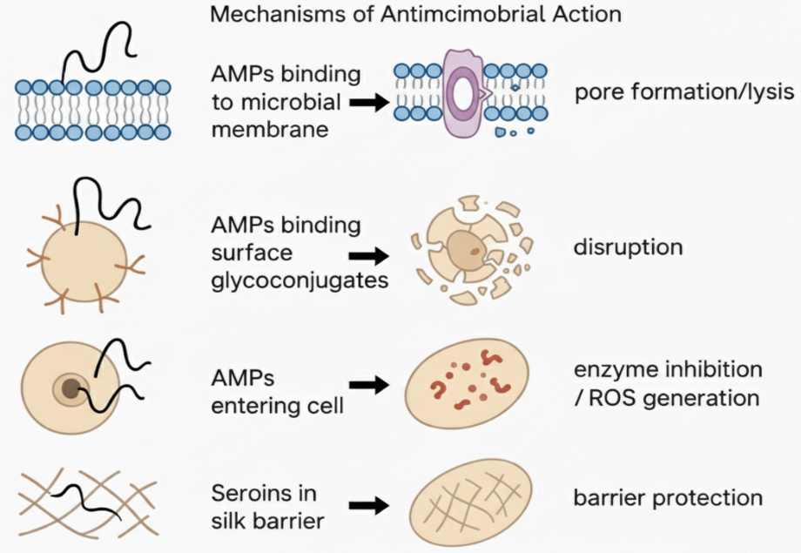
Figure 1. Mechanisms of silkworm antimicrobial peptides (AMPs): membrane disruption, surface binding, intracellular targeting with ROS induction, and silk barrier protection by seroins.
  - Short synthesis and relevance
Biochemically, silkworm AMPs are a compact toolkit, short, often cationic sequences that either punch holes in membranes or subvert essential microbial processes. Their structural simplicity makes them attractive templates for engineering. At the same time, family-specific features such as disulfide bonds in defensins, glycine-richness in gloverins, and silk localization of seroins offer distinct functional advantages that can be exploited for different biotech applications such as antimicrobial coatings, therapeutic leads, and transgenic resistance in animals and plants (Makwana et al., 2023; Nesa et al., 2020; Zhou et al., 2024). A consolidated overview of the major silkworm AMP families, their structural characteristics, and biochemical properties is summarized in Table 1.

Table 1. Classification and Biochemical Properties of Silkworm AMPs

AMP Family | Length (aa) | Structural Features | Mechanism of Action | Spectrum of Activity | References
Cecropins | ~35–40 aa | Linear, amphipathic α-helices, cationic | Membrane disruption (carpet/toroidal pore) | Broad (Gram-positive / Gram-negative, some fungi) | Makwana et al., 2023; Brady et al., 2019
Defensins | ~30–45 aa | β-sheet stabilized by disulfide bonds | Membrane disruption, enzyme inhibition | Gram-positive, fungi | Nesa et al., 2020; Zhou et al., 2024
Gloverins | ~150–180 aa | Glycine-rich, largely unstructured coils | Binding to LPS, membrane destabilization | Gram– bacteria | Wang et al., 2018; Nesa et al., 2020
Moricins | ~40–42 aa | Linear, amphipathic α-helices | Membrane disruption, ROS induction | Broad-spectrum | Ahmad et al., 2023; Ye et al., 2024
Attacins | ~20–23 kDa (≈190–220 aa) | Glycine-rich, heat-stable | Inhibit outer membrane protein synthesis | Gram– bacteria | Dong et al., 2023
Seroins | ~100–120 aa | Silk/cocoon proteins | Barrier protection, antimicrobial in silk | Environmental microbes | Zhu et al., 2020

- REGULATION AND EXPRESSION OF AMPS IN SILKWORMS

  - How AMPs are induced by pathogens
AMP production is an inducible, frontline response triggered when pattern-recognition receptors (PRRs) detect pathogen-associated molecular patterns (PAMPs) such as peptidoglycan, lipopolysaccharide (LPS), β-glucan and viral nucleic acids. Recognition by PRRs initiates proteolytic cascades and signaling that rapidly upregulate AMP genes in immune tissues (Manniello et al., 2021; Feng et al., 2020). Different classes of microbes trigger different pathways, fungal and many Gram-positive challenges preferentially stimulate Toll signaling, whereas Gram-negative bacteria activate the Imd pathway; viral infection engages JAK/STAT and RNA-interference components alongside humoral responses (Zhou et al., 2024; Manniello et al., 2021; Li et al., 2023). Pathogen load, type, and route of entry (gut vs hemocoel) also shape timing and magnitude of AMP induction (Zhou et al., 2024).

  - Key signaling pathways (Toll, Imd, JAK/STAT)
- Toll pathway
Activated mainly by fungal and some Gram-positive signals after extracellular recognition and protease cascades. Toll signaling culminates in nuclear translocation of NF-kB-type transcription factors that drive expression of many AMPs. Toll can interact with other pathways, so its output may change with context. (Manniello et al., 2021; Liu, 2024).

- Imd pathway
Responds strongly to Gram-negative bacteria via PGRP receptors and leads to Relish/NF-kB activation and rapid AMP gene transcription. Imd is crucial for antibacterial peptides found in hemolymph and gut secretions. (Manniello et al., 2021; Li et al., 2023).

- JAK/STAT pathway
Plays roles in antiviral defense, hemocyte regulation and also contributes to AMP expression under certain bacterial challenges. JAK/STAT often coordinates cellular and humoral arms and is important where systemic signaling or tissue repair is required. (Zhou et al., 2024; Feng et al., 2020).
Cross-talk between these pathways is common. For example, overexpression or perturbation of one receptor can modulate Imd and JAK/STAT outputs, so AMP expression is the result of integrated signals rather than single linear cascades (Li et al., 2023; Liu, 2024). The integration of these signaling cascades in regulating AMP production across different tissues is summarized in Figure 2.

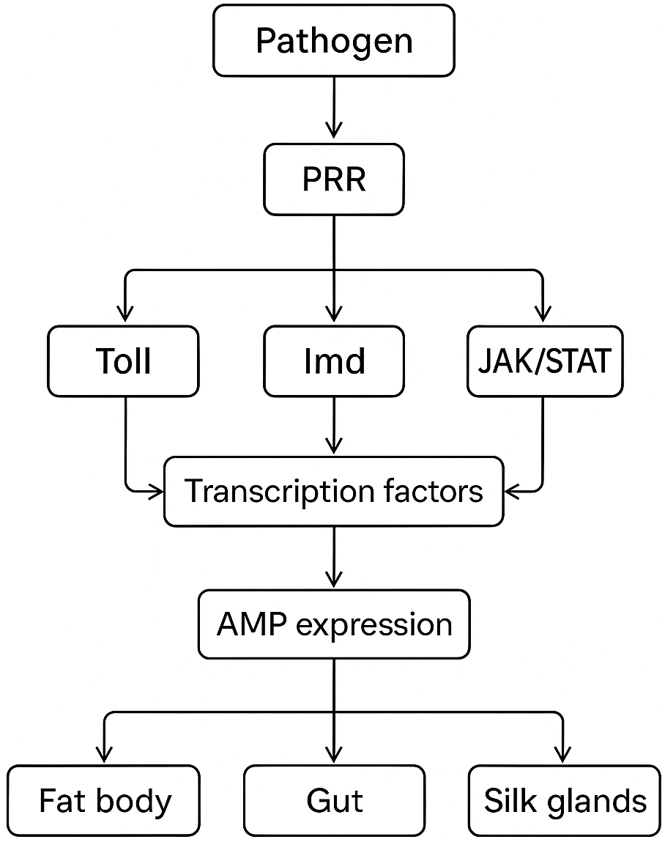
Figure 2. Toll, Imd, and JAK/STAT pathways regulating antimicrobial peptide (AMP) expression in silkworm tissues.
  - Stage-specific and tissue-specific expression patterns
- Fat body is the principal AMP factory. It behaves like the insect liver, after systemic infection, fat-body cells rapidly transcribe and secrete AMPs into haemolymph for whole-body protection (Zhou et al., 2024; Manniello et al., 2021).
- Gut epithelium expresses a distinct set of AMPs tuned for microbiota management and oral pathogens. Gut expression is often constitutive at low levels and highly inducible when ingested microbes breach epithelial defenses (Li et al., 2023; Liu, 2024).
- Cuticle, eggs and silk/cocoon matrices may be enriched in specialized peptides (e.g., seroin-type proteins) that provide local, barrier-level antimicrobial protection rather than systemic defense (Zhou et al., 2024; Deng et al., 2023).
- Developmental timing matters. Larvae, pupae and adults have different exposure risks and hormonal milieus, so AMP repertoires and baseline expression shift across stages. Juvenile-hormone and nutritional signals can indirectly modulate immune gene expression and thus AMP levels (Muhammad et al., 2024; Zhou et al., 2024).
  - Dynamic regulation

- Pathogen type, dose and route determine which pathway dominates and how fast AMPs appear in hemolymph or local tissues (Zhou et al., 2024; Li et al., 2023).
- Microbiota interactions shape basal AMP expression and can prime or dampen responses to pathogens (Liu, 2024).
- Transgenic and overexpression studies show that targeted AMP expression in specific tissues (e.g., midgut) can enhance resistance to particular pathogens without systemic fitness costs, which demonstrates practical routes for applied sericulture improvements (Deng et al., 2023).
- BIOTECHNOLOGICAL AND THERAPEUTIC APPLICATIONS
Silkworm AMPs are attractive for applied use because they are short, potent, and often active against drug-resistant microbes. That combination makes them promising leads across three broad application areas, human/animal medicine, agriculture (plant protection), and aquaculture (disease control) (Makwana et al., 2023; Mastore et al., 2021). Beyond direct use as therapeutics, AMPs can be used as additives, coatings, or fused to biomaterials such as silk for localized antimicrobial function (Zhou et al., 2024; Maximiano et al., 2022).
  - Medicine and human/animal health
Several reviews emphasize AMPs’ potential as alternatives or adjuvants to conventional antibiotics because they rapidly kill microbes and often evade common resistance mechanisms (Mastore et al., 2021; Huan et al., 2020). In practice, silkworm-derived peptides or their synthetic analogs have been tested in vitro for antibacterial and antifungal activity and show promise for topical wound dressings, antiseptic coatings and even immunomodulatory roles (Mastore et al., 2021; Zhou et al., 2024). Challenges remain in serum stability, toxicity to host cells, and cost of manufacture. Delivery strategies such as nanocarriers and immobilization on silk matrices can improve stability and reduce systemic exposure (Maximiano et al., 2022; Nazarian-Firouzabadi et al., 2023).
  - Agriculture and crop protection
AMPs can reduce reliance on chemical pesticides by acting as bio-pesticides or by being expressed in transgenic plants or endophytic microbes to suppress phytopathogens (Nazarian-Firouzabadi et al., 2023; Tang et al., 2023). Reviews show increasing interest in deploying peptide-based sprays, engineered microbes, or peptide-coated materials as targeted, low-resistance plant protection tools (Tang et al., 2023). Silkworm AMPs themselves are a logical source of templates because many are active against fungi and Gram-positive bacteria that threaten crops (Makwana et al., 2023).
  - Aquaculture and feed supplementation
Aquaculture needs alternatives to antibiotics because of resistance and human-health concerns. AMPs (including, insect-derived peptides) are being evaluated as feed additives, bath treatments, or coatings to reduce bacterial and fungal outbreaks in farmed fish and shrimp. Early work indicates AMPs can reduce pathogen loads and improve survival, but salinity, proteases in the gut and cost are technical hurdles. Comparative reviews recommend screening AMPs for salt tolerance and low haemolytic activity before aquaculture use (García-Beltrán et al., 2023; Debbarma et al., 2024).
  - Enhancing disease resistance in sericulture (applied breeding)
One directly relevant application is boosting silkworm resistance by expressing AMPs in the host. Transgenic expression studies show that midgut- or systemic expression of heterologous AMPs can raise resistance to entomopathogenic bacteria in vivo (Deng et al., 2023; Xu et al., 2020). These experiments demonstrate feasibility as targeted AMP expression mitigates specific infections with limited fitness costs if expression is tissue-restricted. This approach also provides a model for integrating AMPs into sericulture management to lower crop losses.
  - Production platforms and delivery strategies
For real applications, scalable production matters. Common platforms include microbial fermentation (E. coli, yeast), plant expression systems, insect cell culture, and cell-free synthesis; each has tradeoffs in yield, cost and post-translational processing (Nazarian-Firouzabadi et al., 2023; Cruz & Reyes, 2025). Delivery and stabilization techniques such as nanoparticles, peptide-polymer conjugates, and silk matrix immobilization improve half-life and reduce toxicity, while nanoAMP strategies have shown promise for agriculture and biomaterial coatings (Maximiano et al., 2022; Nazarian-Firouzabadi et al., 2023). The diverse application areas of silkworm AMPs, along with their reported benefits, modes of use, and limitations, are summarized in Table 2.

Table 2. Biotechnological and Therapeutic Applications of Silkworm AMPs

Application Area | Example AMP(s) | Mode of Use | Reported Benefits | Limitations / Challenges | References
Medicine & Healthcare | Cecropins, Defensins, Moricins | Topical antimicrobials, wound dressings, silk scaffolds | Broad-spectrum antimicrobial activity, potential against drug-resistant pathogens | Short half-life, cytotoxicity at high doses, production cost | Mastore et al., 2021; Zhou et al., 2024
Agriculture (Crop Protection) | Moricins, Attacins | Biopesticide sprays, transgenic plants | Control of phytopathogenic fungi and bacteria | Delivery challenges, environmental persistence | Makwana et al., 2023; Tang et al., 2023
Aquaculture | Gloverins, Moricins | Feed additives, water treatments | Reduced microbial outbreaks, improved survival in farmed fish/shrimp | Salt sensitivity, protease degradation | García-Beltrán et al., 2023; Debbarma et al., 2024
Sericulture Enhancement | Heterologous AMPs | Transgenic expression in silkworms | Increased pathogen resistance, reduced crop loss | Fitness costs if systemic expression | Deng et al., 2023; Xu et al., 2020
Biomaterials & Nanotech | Cecropins, Defensins, Seroins | AMP-functionalized silk matrices, coatings | Antimicrobial textiles, wound-healing scaffolds, implant coatings | Release control, durability of peptide activity | Maximiano et al., 2022; Babu & Suamte, 2024

  - Challenges, safety and future prospects
Key barriers are production cost, proteolytic degradation, potential cytotoxicity, and regulatory pathways for peptide-based products (Makwana et al., 2023; Zhou et al., 2024). Practical routes forward are rational peptide design such as less toxic analogs, targeted expression through tissue-specific transgenics, and hybrid approaches that combine AMPs with nanocarriers or silk matrices to maximize efficacy while minimizing dose and off-target effects (Maximiano et al., 2022; Nazarian-Firouzabadi et al., 2023). Overall, silkworm AMPs are not a turnkey replacement for antibiotics yet, but they are a strong, realistic candidate pool for next-generation antimicrobials across medicine, agriculture and aquaculture.

- CHALLENGES AND FUTURE DIRECTIONS

  - Limitations in stability, bioavailability, and scalable production
Antimicrobial peptides from silkworms show strong, broad-spectrum activity in lab tests, but translating that into usable products hits three recurring roadblocks. First, many AMPs are chemically fragile; they’re rapidly degraded by proteases in biological fluids and lose activity under physiological salt, pH, or temperature conditions. That reduces their effective half-life in vivo and on material surfaces. Second, some AMPs have off-target effects, cytotoxicity or hemolysis at higher doses which narrows the therapeutic window and complicates dosing. Third, practical production is still a bottleneck. Chemical synthesis of longer or modified peptides is costly at scale, and biological expression systems must balance yield, correct folding/modification, and downstream purification costs. Together, these factors limit real-world application beyond laboratory or niche antimicrobial coatings. (Makwana et al., 2023; Ma et al., 2024; de Oliveira et al., 2024).

  - Challenges in large-scale application and regulatory hurdles
Even where stability and safety are addressed, formulating AMPs into deliverable products creates new problems. Topical or textile coatings require durable binding without losing antimicrobial function; implant coatings and wound dressings need controlled release and accepted biocompatibility. Regulatory paths for peptide antimicrobials are still evolving, and clinical translation has been slow because of demonstrable efficacy, manufacturing consistency, and cost-benefit versus small-molecule antibiotics. These system-level constraints are as important as the peptides themselves. (Ma et al., 2024; Bucataru & Ciobanasu, 2024).

  - Emerging design strategies: synthetic peptides and rational modifications
To overcome instability and toxicity, researchers are redesigning natural AMPs. Approaches include shortening sequences to active cores, substituting D-amino acids or non-natural residues to resist proteases, cyclization to increase structural rigidity, and lipidation or PEGylation to tune pharmacokinetics. Rational design and machine learning also let teams prioritize sequences that keep antimicrobial potency while reducing mammalian cytotoxicity. These molecular edits routinely improve serum stability and reduce degradation, making silkworm-derived motifs more druggable. (Ma et al., 2024; Lombardi & Williams, 2024).

  - Nanotechnology and advanced delivery systems
Nanocarriers and polymer matrices are proving essential for real-world AMP use. Encapsulation in nanoparticles, liposomes, or polymeric hydrogels shields peptides from proteases, allows controlled release, and can localize activity to infected tissues or material surfaces. Metal-organic frameworks, peptide self-assemblies, and surface-grafted nanocoatings also permit multi-modal action, for example, combining a peptide with a slow-releasing antimicrobial ion. These platforms reduce systemic exposure and help keep effective concentrations at the target site for longer. Many recent reviews emphasize nanoformulation as the most promising route to clinical or industrial use. (de Oliveira et al., 2024; Fadaka et al., 2021).

  - Integration with silk-based biomaterials: opportunities and caveats
Silk fibroin and sericin offer a natural, biocompatible scaffold for decorating or delivering AMPs. Silk can be processed into films, sponges, fibers, and coatings that act as carriers or surface reservoirs for peptides. Studies show silk-based matrices can sustain AMP release, enhance wound healing, and combine mechanical strength with antimicrobial function. But integration must preserve peptide activity. Covalent grafting can immobilize AMPs yet may reduce mobility needed for membrane-disrupting action, while adsorptive loading risks rapid leaching. Designing the silk–peptide interface (linker chemistry, orientation, density) is therefore crucial. Recent progress in functionalizing silk with bioactive agents makes this a practical path, but optimization is still required for durability, activity retention, and manufacturability. (Babu & Suamte, 2024; Lombardi & Williams, 2024; Ilic-Tomic et al., 2024).

  - Future Directions and Opportunities
Future research on silkworm AMPs should focus on developing short, protease-resistant consensus motifs and exploring D-amino acid or cyclized analogs to enhance stability and bioavailability (Ma et al., 2024). Nanotechnology-based formulations appear especially promising for systemic and wound-healing applications, while silk-based matrices hold potential in textiles and implantable biomaterials, provided that release kinetics are carefully optimized (Babu & Suamte, 2024; de Oliveira et al., 2024; Fadaka et al., 2021). At the same time, rigorous benchmarking of cytotoxicity and hemolysis, followed by evaluation in standardized animal models, will be essential to generate regulatory-ready datasets and establish safety profiles (Ma et al., 2024; Bucataru & Ciobanasu, 2024).
Looking ahead, silkworm AMPs stand out as a compelling natural resource, but their translation to commercial or clinical use depends on solving challenges of stability, delivery, toxicity, and large-scale production in parallel. The next few years are likely to bring optimized synthetic analogs, advanced nanoformulations, and functional silk-based composites, along with the first translational studies in realistic biological settings. These converging strategies suggest that peptide engineering, materials science, and regulatory innovation will collectively determine how far silkworm-derived AMPs progress from laboratory promise to practical impact (Makwana et al., 2023; de Oliveira et al., 2024; Lombardi & Williams, 2024).
- CONCLUSION
Silkworm antimicrobial peptides represent a versatile and powerful component of innate immunity with relevance far beyond sericulture. Their biochemical diversity, ranging from helical cecropins to cysteine-stabilized defensins and glycine-rich gloverins, offers a natural toolkit of mechanisms against bacteria, fungi, and viruses. At the same time, their inducible expression through Toll, Imd, and JAK-STAT pathways demonstrates how insects fine-tune immune responses across tissues and developmental stages. The translational promise of these peptides is evident in medicine, where they can serve as antibiotic alternatives, in agriculture as eco-friendly bio-pesticides, and in aquaculture as sustainable disease-control agents. Integration with silk biomaterials and advances in nanotechnology further expand the possibilities for real-world applications. However, limitations in stability, bioavailability, large-scale production, and safety must be addressed before widespread adoption is possible. Looking forward, rational design of synthetic analogs, peptide modifications, and functional silk–peptide composites offer promising directions. Continued research that bridges molecular biology, material science, and applied biotechnology will be crucial for realizing the full potential of silkworm antimicrobial peptides as part of future antimicrobial solutions.

References

- Ahmad, I., Pal, S., Singh, R., Ahmad, K., Dey, N., Srivastava, A., et al. (2023). Antimicrobial peptide moricin induces ROS mediated caspase-dependent apoptosis in human triple-negative breast cancer via suppression of notch pathway. Cancer Cell International, 23(1), 121.
- Babu, P. J., & Suamte, L. (2024). Applications of silk-based biomaterials in biomedicine and biotechnology. Engineered Regeneration, 5(1), 56-69.
- Brady, D., Grapputo, A., Romoli, O., & Sandrelli, F. (2019). Insect cecropins, antimicrobial peptides with potential therapeutic applications. International journal of molecular sciences, 20(23), 5862.
- Bucataru, C., & Ciobanasu, C. (2024). Antimicrobial peptides: Opportunities and challenges in overcoming resistance. Microbiological research, 286, 127822.
- Cruz, J. C., & Reyes, L. H. (2025). Biological platforms for the production of antimicrobial peptides: Bacterial, yeast, and cell-free systems. In Antimicrobial Peptides (pp. 131-163). Elsevier.
- de Oliveira, K. B. S., Leite, M. L., Melo, N. T. M., Lima, L. F., Barbosa, T. C. Q., Carmo, N. L., et al. (2024). Antimicrobial Peptide Delivery Systems as Promising Tools Against Resistant Bacterial Infections. Antibiotics, 13(11), 1042.
- Debbarma, S., Narsale, S. A., Acharya, A., Singh, S. K., Mocherla, B. P., Debbarma, R., et al. (2024). Drawing immune-capacity of fish-derived antimicrobial peptides for aquaculture industry: a comprehensive review. Comparative Immunology Reports, 6, 200150.
- Deng, X., Liu, L., Deng, J., & Zha, X. (2023). Specific expression of antimicrobial peptides from the black soldier fly in the midgut of silkworms (Bombyx mori) regulates silkworm immunity. Insects, 14(5), 443.
- Dong, Z., Xia, Q., & Zhao, P. (2023). Antimicrobial components in the cocoon silk of silkworm, Bombyx mori. International Journal of Biological Macromolecules, 224, 68-78.
- Dutta, A., & Das, M. (2024). Antimicrobial Peptides from Silkworm and Their Therapeutic Application. In Evolution of Antimicrobial Peptides: From Self-Defense to Therapeutic Applications (pp. 275-303). Cham: Springer Nature Switzerland.
- Fadaka, A. O., Sibuyi, N. R. S., Madiehe, A. M., & Meyer, M. (2021). Nanotechnology-based delivery systems for antimicrobial peptides. Pharmaceutics, 13(11), 1795.
- Feng, M., Fei, S., Xia, J., Labropoulou, V., Swevers, L., & Sun, J. (2020). Antimicrobial peptides as potential antiviral factors in insect antiviral immune response. Frontiers in immunology, 11, 2030.
- García-Beltrán, J. M., Arizcun, M., & Chaves-Pozo, E. (2023). Antimicrobial peptides from photosynthetic marine organisms with potential application in aquaculture. Marine Drugs, 21(5), 290.
- Ghani, M. U., Liu, G., Zhang, Q., Liu, C., Li, S., Yang, Y., et al. (2025). A Comprehensive Review of Humoral Immune Defense in the Silkworm, Bombyx mori: Mechanistic Insights and Responses to Microbial Pathogens. Developmental & Comparative Immunology, 105418.
- Huan, Y., Kong, Q., Mou, H., & Yi, H. (2020). Antimicrobial peptides: classification, design, application and research progress in multiple fields. Frontiers in microbiology, 11, 582779.
- Ilic-Tomic, T., Kramar, A., Kostic, M., Vojnovic, S., Milovanovic, J., Petkovic, M., et al. (2024). Functionalization of silk with actinomycins from Streptomyces anulatu s BV365 for biomedical applications. Frontiers in bioengineering and biotechnology, 12, 1466757.
- Li, J., Mao, Y., Yi, J., Lin, M., Xu, H., Cheng, Y., et al. (2023). Induced expression modes of genes related to Toll, Imd, and JAK/STAT signaling pathway-mediated immune response in Spodoptera frugiperda infected with Beauveria bassiana. Frontiers in Physiology, 14, 1249662.
- Liu, Q. (2024). Reviews in insect immune responses: 2022. Frontiers in Immunology, 15, 1414382.
- Lombardi, L., Li, J., & Williams, D. R. (2024). Peptide-based biomaterials for combatting infections and improving drug delivery. Pharmaceutics, 16(11), 1468.
- Ma, X., Wang, Q., Ren, K., Xu, T., Zhang, Z., Xu, M., et al. (2024). A review of antimicrobial peptides: Structure, mechanism of action, and molecular optimization strategies. Fermentation, 10(11), 540.
- Makwana, P., Rahul, K., Ito, K., & Subhadra, B. (2023). Diversity of antimicrobial peptides in silkworm. Life, 13(5), 1161.
- Manniello, M. D., Moretta, A., Salvia, R., Scieuzo, C., Lucchetti, D., Vogel, H., et al. (2021). Insect antimicrobial peptides: potential weapons to counteract the antibiotic resistance. Cellular and Molecular Life Sciences, 78(9), 4259-4282.
- Mastore, M., Quadroni, S., Caramella, S., & Brivio, M. F. (2021). The silkworm as a source of natural antimicrobial preparations: efficacy on various bacterial strains. Antibiotics, 10(11), 1339.
- Maximiano, M. R., Rios, T. B., Campos, M. L., Prado, G. S., Dias, S. C., & Franco, O. L. (2022). Nanoparticles in association with antimicrobial peptides (NanoAMPs) as a promising combination for agriculture development. Frontiers in Molecular Biosciences, 9, 890654.
- Muhammad, A., Sun, C., & Shao, Y. (2024). The humoral immune response of the lepidopteran model insect, silkworm Bombyx mori L., to microbial pathogens. Current research in insect science, 6, 100097.
- Nazarian-Firouzabadi, F., Torres, M. D. T., & de la Fuente-Nunez, C. (2024). Recombinant production of antimicrobial peptides in plants. Biotechnology advances, 71, 108296.
- Nesa, J., Sadat, A., Buccini, D. F., Kati, A., Mandal, A. K., & Franco, O. L. (2020). Antimicrobial peptides from Bombyx mori: a splendid immune defense response in silkworms. RSC advances, 10(1), 512-523.
- Sangma, J. A., Baroowa, B. P., Singh, Y. R., & Choudhury, P. (2023). Antimicrobial Peptides: Principal Defense Constituents of Silk Worms-A Review. Indian Journal of Entomology, 85(3), 808-819.
- Tang, R., Tan, H., Dai, Y., Li, L. A., Huang, Y., Yao, H., et al. (2023). Application of antimicrobial peptides in plant protection: making use of the overlooked merits. Frontiers in Plant Science, 14, 1139539.
- Wang, Q., Guo, P., Wang, Z., Liu, H., Zhang, Y., Jiang, S., et al. (2018). Antibacterial mechanism of gloverin2 from silkworm, Bombyx mori. International journal of molecular sciences, 19(8), 2275.
- Xu, J., Luo, X., Fang, G., Zhan, S., Wu, J., Wang, D., et al. (2020). Transgenic expression of antimicrobial peptides from black soldier fly enhance resistance against entomopathogenic bacteria in the silkworm, Bombyx mori. Insect Biochemistry and Molecular Biology, 127, 103487.
- Ye, B., Li, S., Fan, Q., Zhao, Z., Li, P., Yue, D., et al. (2024). Antimicrobial activity of a novel moricin-like peptide from the Chinese oak silkworm against Vibrio pathogens in sea cucumbers. Aquaculture Reports, 35, 102010.
- Zhou, L., Meng, G., Zhu, L., Ma, L., & Chen, K. (2024). Insect antimicrobial peptides as guardians of immunity and beyond: a review. International journal of molecular sciences, 25(7), 3835.
- Zhu, H., Zhang, X., Lu, M., Chen, H., Chen, S., Han, J., et al. (2020). Antibacterial mechanism of silkworm seroins. Polymers, 12(12), 2985.

