Original Research Article
PRELIMINARY STUDY OF BEDBUG INFESTATION IN A HOSTEL AT AWKA

ABSTRACT
Bedbugs are nocturnal obligate blood sucker that can invaded human habitation. Their bite causes sleep disturbances, skin reactions, loss of concentration and social stigmatization. Nigeria has recently experienced a high bedbug infestation rate, especially in homes, hotels, and hostels. Therefore, this preliminary investigation was primarily conducted to document bedbug infestation for the first time in a university hostel at Awka. Sensitization of hostel management personnel and four occupants of the inspected room done to obtain their consent prior to commencement of the investigation, which was allowed to take place between 5-6pm on 14th August 2024. Convenient sampling was used to collect bed bugs from beddings in the suspected room. Collected bedbugs were transferred to the Entomology Unit of the Department of Parasitology and Entomology Laboratory for identification using standard entomological keys. Blood-stained bed spreads, obnoxious odor of bed bug feces, dead shriveled bedbugs and molted skins of bedbugs were observed during the inspection, an indication of chronic bedbug infestation of the room. A total of seventy bedbugs, with a preponderance of nymphs, followed by adult females and then males were recovered within one hour allowed for the investigation. Bedbug identified belong the species Cimex lectularius. Findings from this work will help in evidence-based pest management policy on periodic fumigation of offices, lounges, rooms and conveniences in students’ hostels and other facilities in the university so as to tackle bed bug infestation on campus.
Keywords: Bedbugs, hostel, infestation, skin reaction, stigmatization.
INTRODUCTION
Bed bugs (Hemiptera: Cimicidae) are small, blood-feeding insects that live in close association with humans and other vertebrates (Mbuta et al., 2022). They are nocturnal obligate blood suckers (Oboh et al., 2022); and had invaded human habitation from time immemorial. The prevalence of bed bug infestations has increased significantly since the early 2000s, partly due to increased international travel, resistance to pesticides, and changes in pest control practices (Doggett et al., 2012). Worldwide resurgence of bedbugs has renewed public and scientific interest pest control practices (Humphreys, 2025). Moreover, nuisance effects and pathogen transmission potential of bed bugs make their study an indispensable public health and pest control priority (Mbuta et al., 2025; USEPA, 2023; Bern et al., 2011). Bedbugs are commonly found in homes, hotels, dormitories, shelters, and public transportation systems, and their bites cause several skin manifestations (Tielemans et al., 2022; Deku et al., 2021) which can lead to stigmatization and depression (Amiri et al., 2018). The well-known species of bedbugs which are of cosmopolitan distribution are Cimex lectularius L. and Cimex hemipterus F (Akhoundi et al., 2023; Hamlili et al., 2023).
A general increase in C. hemipterus infestation of residential dwellings, hotels, hostels, and transport systems has been recently noticed in Africa (Deku et al. (2022; Fourie and Crafford, 2018). Reports from many communities in Nigeria also indicate a high bed bug infestation rate (Oduola et al., 2017; Omudu and Kuse, 2010; Okwa and Omoniyi, 2008). Bonnefoy et al. (2008) especially in mattresses, pillows, rugs, wooden furniture, curtains, cracks in floors and walls (Onah et al., 2014), where female bedbugs lay hundreds of eggs that eventually hatch out nymphs that are young adults. It was reported that increasing poor attitude to housekeeping and insanitary conditions are responsible for this high infestation rates in many parts of Nigeria (Omudu, 2008).
Recently, Nigeria has heightened surveillance at all points of entry, following the news of outbreak of bed bug infestation in France and other parts of Europe. News Express (Nigerian Tribune 20th October, 2023) reported that Ministry of health has developed a draft sheet, which will strengthen awareness and health education on the control of bed bugs, urging members of the public to cooperate with Port Health Officers in their surveillance activities at points of entry. The Health Ministry also alerted that small, flat reddish-brown wingless bed bugs are insects that infest beds, sofas, luggage and other furniture, which often crawl into peoples’ body or luggage to travel to new surroundings. Therefore people should be aware of the possibility of contracting bedbug while in transit (Mbuta et al., 2025). This preliminary investigation of bed bug infestation was therefore done during late rainy season in 2024, primarily to document bedbug infestation for the first time in a university hostel at Awka. The result of this work will help in evidence-based pest management policy on periodic fumigation of offices, lounges, rooms and conveniences in students’ hostels and other facilities in the university so as to tackle bed bug infestation on campus.

MATERIALS AND METHODS
The preliminary investigation was carried out in a room occupied by four female undergraduates of Awka Campus of Nnamdi Azikiwe University. Sensitization of hostel management personnel and room occupants concerned was completed within seven days and their consent obtained prior to commencement of the investigation, allowed to take place between 5-6pm. Using convenient sampling method (Punchihewa et al. 2019), a total of seventy (70) bed bugs at their different stages of development were recovered from beddings (Fig. 1) in the students’ room sampled on 14th August, 2024. Collected bedbugs (Fig. 2) were transferred to the Entomology Unit of the Department of Parasitology and Entomology Laboratory in properly-labelled containers. Identification was made based on morphological characteristics viewed under a stereomicroscope (Fig. 3) and according to published keys by Pratt and Smith (2005). Key identification features observed were bedbug’s characteristic reddish-brown coloration, anteriorly-placed clypeus, antenna, bulbous head, pronotum, prominent wing pad, robust legs and segmented abdomen devoid of wing-covering (Fig. 4). Relative sizes (length in mm) of some collected bedbugs were compared by placing a transparent calibrated ruler alongside displayed specimen photographed (Fig 5).
RESULTS AND DISCUSSION
Blood-stained bed spreads, obnoxious odor of bed bug feces, dead shriveled bedbugs and molted skins of bedbugs (Fig. 1) were observed during the inspection, an indication of chronic bedbug infestation of the room. A total of seventy bedbugs (Fig. 2) with a preponderance of nymphs, followed by adult females and then adult males were recovered within one hour allowed for the investigation. Bedbugs identified belong to the species Cimex lectularius as shown in Figs. 3 and 4. The relative sizes of the preserved bedbug specimens (Fig. 5) indicates that an adult bedbug could grow up to 5mm.
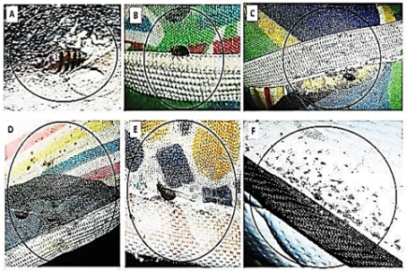
Fig. 1: Bed bugs, skin casts, feces, and blood-stains on beddings inspected
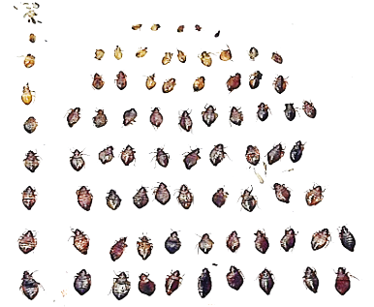
Fig. 2: Different growing phases of engorged bed bugs recovered beddings inspected

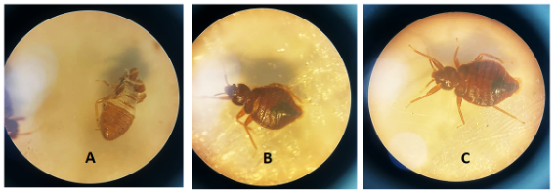
Fig. 3. Microscopic views of Engorged Bedbugs [A, B, C] at different stages of development
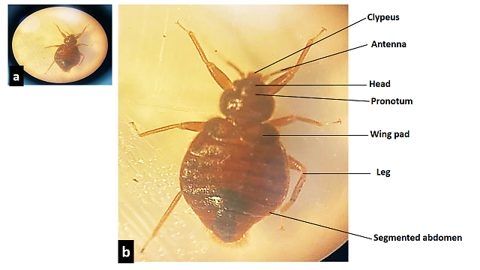
Fig. 4. Bedbug (Cimex lectularius) showing characteristic identification features

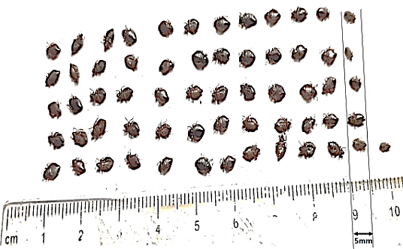
Fig. 5. Relative sizes of recovered nymphs and adults bugs (length ≡ 5mm) bedbugs
Different growth phases of engorged bed bugs, especially nymphs, were recovered from mattresses, pillows and bedspreads in the room investigated. This corroborates the findings from a similar survey of bed bug infestation in some homes and hostels Benue State Nigeria by Onah et al. (2014) who inspected bed frames, bunks, mattresses, pillows, chairs, and clothes. These authors (Onah et al., 2014) reported a preponderance of nymphs followed by males and females bedbugs and attributed the high number of infestation recorded in the hostels to poor hygiene, lack of adequate knowledge of the best control practices and the high population density. Four occupants of the room in our study constituted overcrowding, which may be a risk factor for the spread of bed bugs. Nuisance caused by bedbugs’ infestation globally (Kweka et al., 2009) may result into sleeplessness and anxiety, which, in this study could affect concentration of affected students in school work. Other authors have also associated bed bug bite with stigmatization and psychological distress (Emmanuel et al., 2014; Berenji et al., 2019). The high numbers of bed bugs recorded in this study under one hour could probably be due to observed overcrowding, improper housekeeping and poor hygiene which was also reported from other hostels investigated in Gboko, Nigeria (Omudu, 2008). The World Health Organization had earlier suggested that poor housekeeping encourages bedbug breeding (WHO, 2009).
Attendance by members of the public to major activities like matriculation, convocation and several conferences which regularly take place on campus could be a means of distribution of bed bugs in our university environment. Noticeable bustling economic activity on campus may also be a risk factor for bed bug introduction. It has been proven that tourists, travelers, and migrant workers often bring bed bugs with them inadvertently, facilitating the establishment of the pest in the local environment (Delaunay and Pharm, 2012). There is concentrated human housing in Awka, and this increases the likelihood of bed bug infestations since C. lectularius is known for its adaptability to urban environment (Fung et al., 2020).
CONCLUSION
High rate of bedbug infestation recorded in the room inspected is no doubt a reflection of overcrowding, poor hygiene and lack of adequate knowledge of bedbug. It is therefore imperative that proactive approach should be taken to educate the public, especially students on awareness of bedbug. The result of this work will help in evidence-based pest management policy on periodic fumigation of offices, lounges, rooms and conveniences in students’ hostels and other facilities in the university so as to tackle bed bug infestation on campus. Similar exercise could be initiated by concerned stakeholders like property owners, and pest management outfits to keep the larger community to be free from bed bug infestation.
REFERENCES
Akhoundi, M.; Zumelzu, C.; Sereno, D.; Marteau, A.; Brun, S.; Jan, J.; Izri, A. Bedbugs (Hemiptera: Cimicidae): A Global challenge for public health and control management. Diagnostics 2023, 13, 2281.
Amiri, P.; Rahimi, B.; Khalkhali, H.R. Electronic physician. Electron. Physician 2018, 10, 6201–6207.
Berenji F, Moshaverinia A, Jadidoleslami A, Shamsian A, Doggett SL, Moghaddas E. Evaluation of the Common Bed Bug, Cimex lectularius (Insecta: Hemiptera: Cimicidae) Susceptibility to λ-Cyhalothrin, Malathion, and Diazinon in Northeastern Iran. J Med Entomol. 2019; 56:903– 906. https://doi.org/10.1093/jme/tjz011
Bonnefoy X, Kampen H, Sweeney K. Public Health Significance of Urban Pests. World Health Organization. 2008. https://doi.org/10.1007/978-3-319-13884-8_31
Deku, G.; Combey, R.; Doggett, S.L. Morphometrics of the tropical bedbug (Hemiptera: Cimicidae) from Cape Coast, Ghana. J. Med. Entomol. 2022, 59, 1534.
Deku Godwin , Combey Rofela, Doggett Stephen L, and Mensah Benjamin A. Assessment of Tropical Bed Bug (Hemiptera: Cimicidae), Infestations in Cape Coast, Ghana: Household Control Practices and Efficacy of Commercial Insecticides and Long-Lasting Insecticidal Nets Against Field Bed Bugs. J Med Entomol. 2021, 16;58(4):1788-1797. DOI: 10.1093/jme/tjab042
Delaunay, P.; Pharm, D. Human travel and traveling bedbugs. J. Travel Med. 2012, 19, 373–379.
Doggett, S.L., Dwyer, D.E., Penas, P.F. and Russell, R.C. (2012). “Bed bugs: Clinical relevance and control options.” Clinical Microbiology Reviews. 25(1), 164 192. https://doi.org/10.1128/CMR.05015-11
Emmanuel OI, Cyprian A, Agbo OE. A survey of bedbug (Cimex lectularius) infestation in some homes and hostels in Gboko, Benue State, Nigeria. Psyche (London). 2014. https://doi.org/10.1155/2014/762704
Fourie, J.; Crafford, D. The bed bug resurgence in Africa. In Advances in the Biology and Management of Modern Bed Bugs; Wiley: Hoboken, NJ, USA, 2018; pp. 87–94.
Fung HC, E.; Wong, H.; Chiu, S.W.; Hui JH, L.; Lam, H.M.; Chun, R.Y.; Wrong, S.Y.; Chan, S. Risk factors associated with bedbug (Cimex spp.) infestations among Hong Kong households: A cross-sectional study. J. Hous. Built. Environ. 2020, 37, 1411–1429.
Hamlili, F.Z.; Bérenger, J.M.; Parola, P. Cimicids of medical and veterinary importance. Insects 2023, 14, 392.
Humphreys, G. Public health round-up. Bull. World Health Organ. 2025, 103, 3–4.
Kweka E, Mwang′onde B, Kimaro E, Msangi S, Tenu F, Mahande A. Insecticides susc ceptibility status of the bedbugs ( Cimex lectularius ) in a rural area of Magugu, Northern Tanzania. J Glob Infect Dis. 2009; 1(2):102.
Mbuta, D.M. Sokame, B.M. Khamis, F.M. and Akutse, K.S. Know Where You Go: Infestation Dynamics and Potential Distribution of Two Bed Bug Species (Hemiptera: Cimicidae) in Africa. Insects 2025, 16, 395. https://doi.org/10.3390/ insects16040395
Mbuta, D.M.; Khamis, F.M.; Sokame, B.M.; Ng’ong’a, F.; Akutse, K.S. Household perception and infestation dynamics of bedbugs among residential communities and its potential distribution in Africa. Sci. Rep. 2022, 12, 19900. [CrossRef] [PubMed]
Oboh Mary Aigbiremom, Olusegun-Joseph Taiye Shade, Awoniyi Adedayo Michael, Ileaboya Maureen Ihinosen, Lawal Bukola Tawakalitu, Fagbohun Ifeoluwa Kayode. Susceptibility and fecundity of Bedbugs (Cimex hemipterus) from Yaba College of Technology Lagos exposed to Selected Classes of Insecticides: A short report Pan African Journal of Life Sciences (2022): 6(2): 472-476 DOI: 10.36108/pajols/2202/60.0250
Oduola AO, Omotayo AI, Adelaja OJ, Obembe A. Bedbug (Cimex lectularius) infestation and its control practices in two selected settlements in Ilorin, Kwara State, Nigeria. Animal Res Int. 2017; 14(3):2818-2
Okwa OO, Omoniyi AO. The prevalence of headlice (Pediculus humanus capitis) and bedbug (Cimex hemipterus) in selected human settlement areas in south-west Lagos state, Nigeria. J Parasitol Vector Biol. 2008; 2(2): 8– 13.
Omudu E.A, “A survey of bedbug (Hemiptera: Cirnicidae infestations in some homes and hostels in Makurdi and Otupkpo, Benue State, Nigeria, with notes on public health implications,” The Nigerian Journal of Pure and Applied Sciences, vol. 1, pp. 84–91, 2008.
Omudu EA, Kuse CN. Bedbug infestation and its control practices in Gbajimba: a rural settlement in Benue state, Nigeria. J Vector Borne Dis. 2010; 47(4):222.
Onah Isegbe Emmanuel, Alu Cyprian, and Omudu Edward Agbo. A Survey of Bedbug (Cimex lectularius) Infestation in Some Homes and Hostels in Gboko, Benue State, Nigeria. Psyche: Journal of Entomology Volume 2014, Article ID 762704, 5 pageshttp://dx.doi.org/10.1155/2014/762704
Pratt H.D and Smith J.W, “Arthropods of public health importance,” in Diagnostic Procedure for Mycotic and Parasitic Infections, B. B. Wentworth, Ed., American Public Health Association, Washington, Wash, USA, 2005.
Punchihewa R, de Silva WPP, Weeraratne TC, Karunaratne SP. Insecticide resistance mechanisms with novel ‘kdr’type gene mutations in the tropical bed bug Cimex hemipterus. Parasites and Vectors. 2019; 12(1): 310.
Tielemans, E.; Rautenbach, C.; Besselaar, J.F.; Beugnet, F. Efficacy of a topical product combining esafoxolaner, eprinomectin and praziquantel against bedbug (Cimex lectularius) experimental infestations in cats. Parasite 2022, 29, 59. [CrossRef] [PubMed]
US Environmental Protection Agency (EPA). Bed Bugs: A Public Health Issue. 2023. Available online: https://www.epa.gov/ bedbugs/bed-bugs-public-health-issue (accessed on 22 June 2024).
World Health Organization (WHO), Public Health Significance of Urban Pests, 2009.

