Larvicidal and dengue virus inhibitory potential of terpenoids from Bryophyllum pinnatum: an in silico study

.
ABSTRACT

Aim: Bryophyllum pinnatum is a medicinal plant used in treatment of diseases. This study investigates the larvicidal and dengue virus inhibitory potential of B. pinnatum phytoconstituents through computational approaches.
Methodology: A library of terpenoids from B. pinnatum was constructed. Molecular docking was performed against Aedes aegypti, dengue NS5 polymerase and NS2B/NS3 protease followed by 150 ns molecular dynamics simulation.
Results: 24-ethyl-desmosterol (-10.6 kcal/mol) and clerosterol (-10.5 kcal/mol) were identified as hit molecule against Aedes aegypti, taraxasterol (-9.7 kcal/mol) and bryophynol (-9.6 kcal/mol), and 25-Methylstigmast-24(28)-enol (-8.9 kcal/mol) and clerosterol (-8.9 kcal/mol). The 150 ns simulation of the complexes showed that the chemical compounds are considerably stable. The ADMET studies showed that the compounds exhibit good druggable properties. The binding affinity and interactions established by the 24-ethyl-desmosterol and clerosterol agaist Aedes aegypti, taraxasterol and bryophynol against NS5 polymerase, and 25-Methylstigmast-24(28)-enol and clerosterol against NS2B/NS3 protease showed that the chemical constituent possesses promising therapeutic efficacy against the spread of dengue virus.
Conclusion: The terpenoids from Bryophyllum pinnatum possesses larvicidal and dengue virus inhibitory potential.

Keywords: Bryophyllum pinnatum; dengue virus; Aedes aegypti; molecular docking; molecular dynamics simulation; ADMET

1. INTRODUCTION

Parasitic diseases still pose a great threat to human health and life (Cholewinski et al., 2015). Some parasitic diseases are vector-borne with certain vectors identified in their transmission. Aedes aegypti is among the mosquitoes that are identified as major vector of viral diseases (Näslund et al., 2021). The mosquito is found in the tropical countries of the world and its female specie has been identified as one of the highest carrier of transmissible deadly diseases, notably dengue, chikungunya and zika (Sukhralia et al., 2019).
Dengue fever is categorized among the neglected tropical disease and has become a major health concern globally(Lin et al., 2019). The mosquito-borne viral infection transmitted by mosquito of the genus aedes specifically Aedes aegypti (Näslund et al., 2021). Currently, over 40% of the total world populace are at risk of getting infected with dengue, while more than 390 million cases are reported yearly (Dehghani and Kassiri, 2021; Haider et al., 2025). The infection also known as break bone fever occurs in 3 phases which include the febrile, critical, and recovery stages (Ng et al., 2016). Dengue fever is caused by any of the 4 distinct serotypes (DENV-1 to DENV-4) of single-stranded RNA viruses belonging to the genus Flavivirus such that infection by one serotype confers lifelong immunity to that serotype but not to others (Zerfu et al., 2023; Maia et al., 2019).
The genetic make-up of the dengue virus encodes a poly-protein precursor which can be divided into several segments by host peptidases and viral proteases (Chappell et al., 2008). A trypsin-like protease makes up the N-terminal segment of the non-structural protein 3 called the NS3 and this NS3 has its proteolytic activity increased up to 3300-6600 folds by the NS2B cofactor (Li et al.2014; Chen et al., 2014). The combination of these two components is integral to the viral lifecycle capacity to process protein precursor and thus viral survival (Singh et al., 2025). An approach to treating the dengue virus infection is to inhibit its NS2B-NS3 protease. In the infected cell, DENV2 NS5 is known to interact with NS3 and also to shuttle between the cytoplasm and nucleus (Norshidah et al., 2023; Starvaggi et al., 2024).
Medicinal plants have played a huge role in the drug discovery as natural sources of lead compounds (Süntar, 2020). The vast majority of the therapeutic compounds are classified as terpenoids, flavonoids, essential oil, alkaloids and tannins (Roaa, 2020). Terpenoids are a class of phytochemicals with excellent therapeutic properties (Yang et al., 2020). The class is made of isoprene unit (C₅H₈)_{n} (Mabou and Yossa, 2021). Bryophyllum pinnatum (Lam.) Kurz (Crassulaceae), also known as miracle leaf, a medicinal plant is a perennial herb growing widely and used in folkloric medicine in tropical Africa, tropical America, India, China and Australia (Elufioye et al., 2022). In China, the plant is called da bus i, and it is majorly used among the Red-headed Yao inhabitants in Jinping area of Yunnan Province of the country (Long and Li, 2004; Sadhana et al., 2018). Traditionally, B. pinnatum is used to treat rheumatoid atritis, bruises, ulcer, tummy bug and numbness of the limbs (Bassey et al., 2021). Also, the plant flourishes throughout the Southern part of Nigeria and majorly used in the management of metabolic and cardiovascular diseases like diabetes mellitus and hypertension (Ibitoye et al., 2018). Pharmacologically, the antidiabetic, antihypertensive, anti-inflammatory, antioxidant and antimicrobial activities of B. pinnatum have been studied (Ibitoye et al., 2018; Ojewole, 2002; Daniel et al., 2020; Akinsulire et al., 2007). The presence of terpenoids has been attributed to the rich pharmacological potentials of B. pinnatum (Kamboj and Saluja 2009; Selvakumar, 2002).
Computer aided drug design has recently been utilized for effective identification and optimisation of lead compounds in drug discovery and development, reducing cost and time (Niazi and Mariam, 2023). Molecular docking is a kind of computational modelling used in computer aided drug design to facilitate the prediction of preferred binding orientation of one molecule to another, particularly when both interact with each other to form a stable complex (Tiwari and Singh, 2022; Bhagat et al., 2021). It can predict different binding modes of ligand in the groove of target molecule and knowledge gained from such type of investigations may be employed to develop more potent, selective and efficient analogues (Bhagat et al., 2021; Jakhar et al., 2020). Molecular dynamics simulations predict the physics basis for the movement of every atom in a protein or as well as the structure and function of biological macromolecules (Shukla and Tripathi, 2020). These simulations could include a wide range of important biomolecular processes, including conformational change, ligand binding, and protein folding, revealing the positions of all atoms (Badar et al., 2022).
Synthetic compounds have been explored as larvicidal agent while there is no approved drug for dengue virus (Obi et al., 2021). However, most of the larvicides are presented with episodes of side effects when human subjects are exposed to them for a prolonged time (Zhou et al., 2020; Vieira et al., 2017). Despite the rich pharmacological studies on B. pinnatum, the potential larvicidal compounds against Aedes aegypti and dengue virus is yet to be identified. Herein, this study investigates the potential larvicidal efficacy of B. pinnatum compounds against Aedes aegypti as well as their inhibitory effect against dengue virus using extensive computational approaches.

2.0 material and methods
2.1 Molecular docking
2.1.1 Protein and ligand preparation
The three-dimensional crystallographic structure of sterol carrier protein-2 of Aedes aegypti L. larvae (PDB ID: 1PZ4), dengue NS5 polymerase (PDB ID: 2J7U) and NS2B/NS3 protease (PDB ID: 2FOM) was downloaded from the protein database (www.rcsb.org). The protein was prepared by removing the water molecules, co-factors and ions, retaining the native ligand to predict the amino acid residues resident in the receptor’s active site within 5 Å. Later on, the co-crystallized ligand was removed and the resulting bare protein was saved in PDB format for docking purpose.
A library of 55 compounds from Bryophyllum pinnatum was constructed. The chemical structures of the compounds were built with ChemDraw 12.0 software. Then their energy was minimized and structure was saved in PDB format.
2.1.2 Molecular docking studies
To study how ligands bind to Aedes aegypti sterol carrier protein-2 (PDB ID: 1PZ4), dengue NS5 polymerase (PDB ID: 2J7U), and NS2B/NS3 protease (PDB ID: 2FOM), we conducted a molecular docking analysis. First, we prepared the proteins using MGL Tools by adding polar hydrogens and saving them in PDBQT format. Simultaneously, the ligands were converted to PDBQT files with the Open Babel interface in PyRx 0.8. Then, both the protein and ligand files were loaded into the Autodock interface (Trott and Olson, 2010) of PyRx 0.8. The docking site was defined by selecting amino acids within a 5 Å radius, and the grid box was set as appropriate. After running the docking simulation with an exhaustiveness of 50, the ligands were sorted based on their binding affinity. Only those with a stronger affinity than the reference drugs were chosen for a more detailed analysis using Discovery Studio Visualizer.
2.1.3 Molecular dynamics simulation
Molecular dynamics (MD) simulations of the docked complexes were conducted using the academic version of Desmond, developed by D.E. Shaw Research (Schrödinger Release 2022-4, 2023b). The System Builder tool facilitated system preparation, employing the TIP3 water model in an orthorhombic box with a 10 × 10 × 10 Å buffer region. To achieve system neutrality, ions were added, followed by salt placement and volume minimization. The OPLS4 force field was utilized for energy minimization of the complete system. The MD simulation was run for 150 ns, capturing 1,000 frames at 100 ps intervals. The system was maintained at 300 K and 1.01325 bar within the NPT ensemble to ensure equilibrium conditions. The resulting trajectories were analyzed using the Simulation Interaction Diagram tool (Famuyiwa et al., 2023; Famuyiwa et al., 2025).

3.0 results
3.1 Molecular docking analysis
In this study, molecular docking was performed on phytochemicals previously isolated from Bryophyllum pinnatum. This chemical compounds were previously screened with Lipinski’s rule adherence before subjecting to molecular docking. The results obtained from the molecular docking studies are presented in Table 1.
24-ethyl-desmosterol emerged as the best binder against the odorant enzyme with a binding affinity of -10.6 kcal/mol. The triterpene formed hydrophobic and pi interactions with Ala10, Ala13 and Lys14, while no hydrogen bond interaction was established between the phytochemical and the receptor (Figure 1a). Also, clerosterol was selected as the second best inhibitor based on its high binding affinity of -10.5 kcal/mol. The terpenoid participated in hydrogen bond interaction with Glu17 at 1.99 Å. However, no hydrophobic and pi-interactions were formed between the ligand and the receptor (Figure 1b).
In the molecular docking of the phytochemicals against the dengue NS5 polymerase, taraxasterol were selected as the best inhibitor of the enzyme with a binding affinity of -9.7 kcal/mol. One of the hydrogen atoms of phytochemical established strong hydrogen bond interaction with Glu834. No hydrophobic and pi interactions were observed between the enzyme and the ligand (Figure 1c). Bryophynol was selected as the second best inhibitor against the dengue NS5 polymerase with a binding affinity of -9.6 kcal/mol. The phytochemical established only hydrogen bond interaction with Glu834 at 2.77 and 2.90 Å, and Arg856 at 2.18 Å (Figure 1d).
The inhibition potential of B. pinnatum phytochemicals was predicted with molecular docking against NS2B/NS3 protease. 25-Methylstigmast-24(28)-enol and clerosterol was identified as the best binders against the enzyme with a binding affinity of -8.9 kcal/mol. The hydrogen atom of clerosterol formed hydrogen bond interaction with Trp89 at 1.85 Å, while clerosterol formed hydrogen bond interaction with Glu88 at 1.86 Å. Also, 25-Methylstigmast-24(28)-enol formed hydrophobic interactions with Trp69, Lys74, Leu76, Trp83 and Ala166, while clerosterol formed hydrophobic and pi interactions with Lys74, Ile123, Val154 and Ala164 (Figure 1e and 1f).
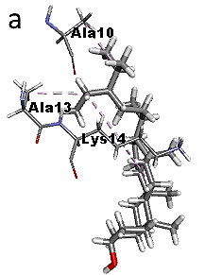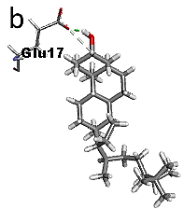
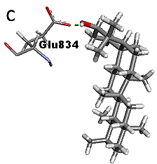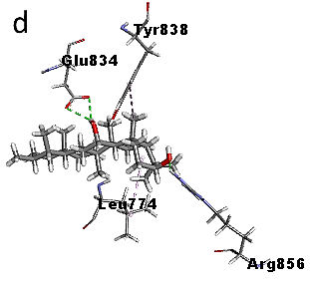
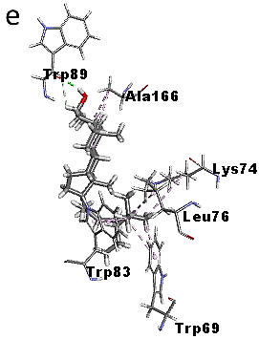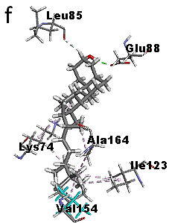
Fig 1: Interaction diagram of clerosterol-1PZ4 (a), 24-ethyl-desmosterol-1PZ4 (b), 25-Methylstigmast-24(28)-enol-2FOM (c), clerosterol-2FOM (d), taraxasterol-2J7U (e), and bryophynol-2J7U (f)
Analysis of Molecular Dynamics Simulation
The molecular dynamics simulation of the protein-ligand complexes was performed to understand their stability at the receptor’s binding pocket. In the MD simulation of clerosterol-1PZ4 complex, the root mean square deviation (RMSD) plot showed that the ligand was largely stable throughout the 150 ns with slight deviation observed at 38 and 42 ns (Figure 2a). The root mean square fluctuation plot showed that the receptor was stable and ranged from 0.6 – 1.8 Å (Figure 2a). Also, the interaction plot showed the formation of hydrogen bonds with Ala22 and Asn23 as well as hydrophobic interaction with Ile19 and Phe105 (Figure 2a). Similarly, RMSD plot of 24-ethyl-desmosterol-1PZ4 showed that the phytochemical was fairly stable for the 150 ns with slight deviation at 60 and 80 ns (Figure 2b). Also, the RMSF plot showed stability and ranged from 0.5 – 2.8 Å (Figure 2b). Furthermore, the interaction plot showed that hydrogen bonds exist between Arg15, Ser108 and Lys110, hydrophobic interaction with Ile19 and Leu109, and water bridge interaction with Lys11, Lys14, Arg15, Ser108 and Lys110 (Figure 2b).
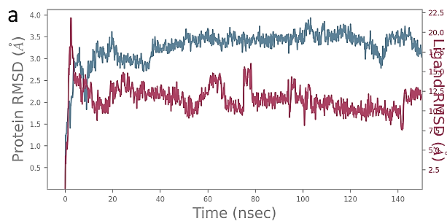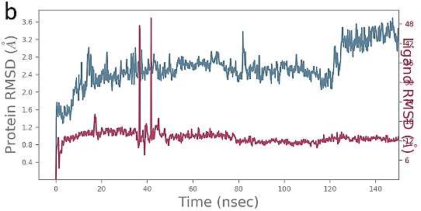
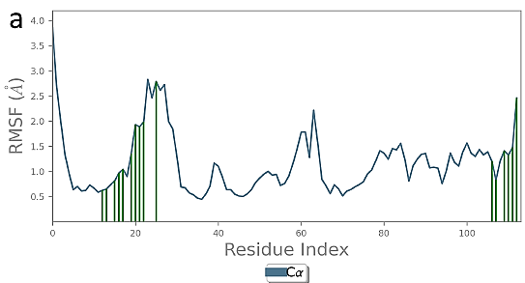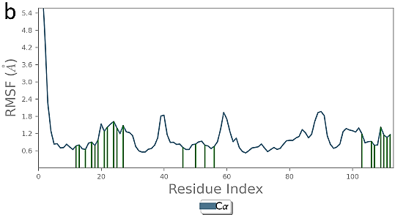
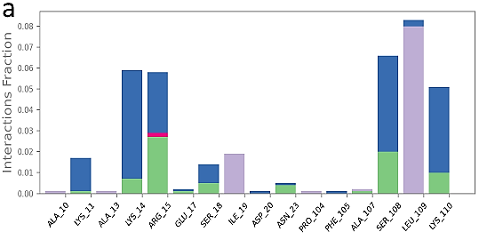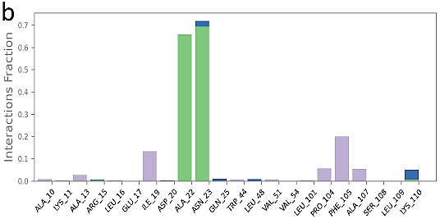
Fig 2: RMSD plot of clerosterol-1PZ4 (a), RMSD plot of 24-ethyl-desmosterol-1PZ4 (b), RMSF plot of clerosterol-1PZ4 (a), RMSF plot of 24-ethyl-desmosterol-1PZ4 (b), interaction plot of clerosterol-1PZ4 (a), interaction plot of 24-ethyl-desmosterol-1PZ4 (b)
The RMSD plot generated from the molecular dynamics simulation of the docked complex of 25-Methylstigmast-24(28)-enol-2FOM showed that the terpenoid was stable from 1-59 ns followed by a deviation from 60 – 70 ns and became stable with slight fluctuation 80 – 150 ns (Figure 3a). The RMSF plot generated from the 25-Methylstigmast-24(28)-enol-2FOM MD simulation showed that the protein was fairly stable and its value ranged between 0.5 – 3.8 Å (Figure 3a). In the interaction plot obtained for the complexes, hydrogen bond interactions were observed between the ligand and Asn119, Asn152, Gly153, hydrophobic interaction with Trp69, Leu76, Trp83, Ile123, Val154, Ala164, and Ala166, and water bridge interaction with Asp75, Asn119, Thr120, Asn152, Gly153 and Val155 (Figure 3a). The MD simulation of clerosterol-2FOM was performed and the RMSD plot showed that the phytochemical was stable from 0 – 44 ns followed by a slight deviation at 55 ns, then became stable up to 100 ns. The plot also showed a slight deviation from 101 to 105 ns and eventually became stable till 150 ns (Figure 3b). The RMSF plot showed that the protein was stable and ranged between 0.6 – 3.5 Å (Figure 3b). The interaction plot of the complex showed that the ligand formed hydrogen bond interaction with Trp83 and Leu149, hydrophobic interaction with Leu76, Ile123, Val154 and Ile1Bryophynol, and water bridge Leu85, Glu86, Val146, Val147 and Ile1Bryophynol (Figure 3b).
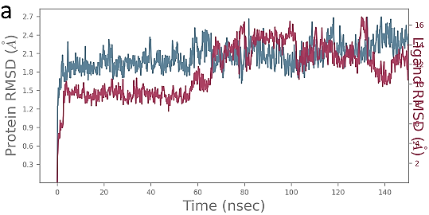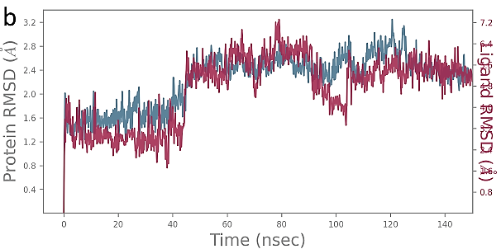
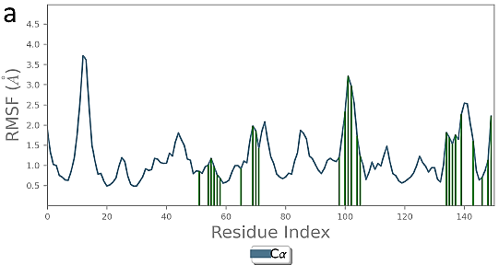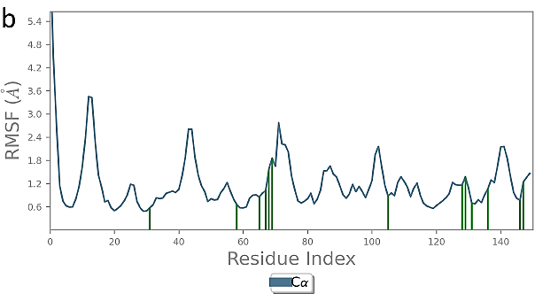
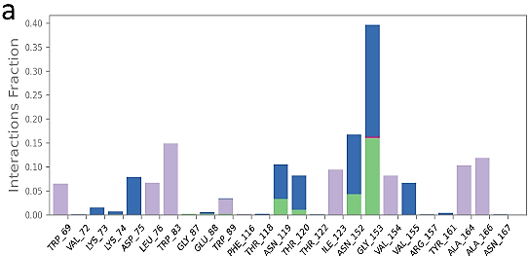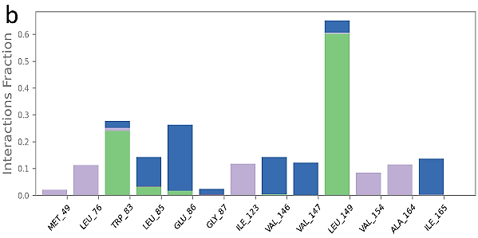
Fig 3: RMSD plot of taraxasterol-2J7U (a), RMSD plot of bryophynol-2J7U (b), taraxasterol-2J7U (a), RMSF plot of bryophynol-2J7U (b), taraxasterol-2J7U (a), interaction plot of bryophynol-2J7U (b)
In the MD simulation of taraxasterol-2J7U complex, the RMSD plot showed that a conspicuous deviation between 0-18 ns followed by a consistent stability up to 150 ns (Figure 4a). The RMSF plot showed the protein was stable with slight fluctuation and ranged between 0.5 – 5.0 Å (Figure 4a). The interaction diagram showed that appreciable hydrophobic interactions were observed between the phytochemical and Ile320, Val337, Ala341, Met342, Pro347, Phe324-ethyl-desmosterol, and Pro582, hydrogen bond interaction with Gly586, and water bridge Ser317, Ser318, Ala341, Gln580, Arg581, Thr583, Gly586, Thr587 and Val588 (Figure 4a). Also, the RMSD plot obtained from the 150 ns MD simulation of bryophynol-2J7U complex showed that the ligand initially deviated from 0 – 18 ns and became stable up to 90 ns. However, fluctuations were observed between 91 – 103 ns and 138 to 150 ns (Figure 4b). The RMSF plot showed that the protein was stable and its value ranged between 0.8 to 5.4 Å (Figure 4b). In the interaction plot, hydrogen bond interactions were observed between the ligand and Arg770, Arg773, Trp833 and Tyr838, hydrophobic interactions with Leu774, Ile867 and Met883, and water bridge interactions with Arg770, Arg773, Trp833, Glu834, Tyr838, and Arg856 (Figure 4b).

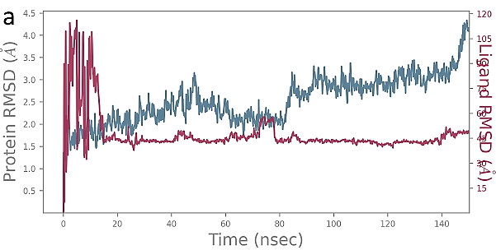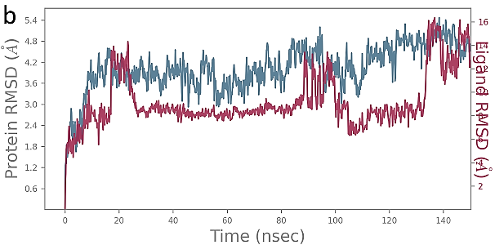
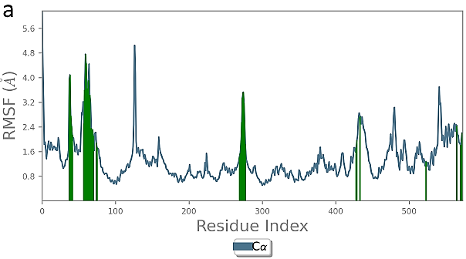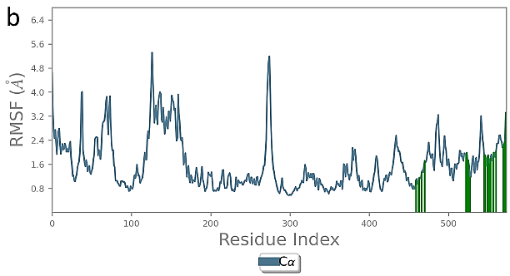
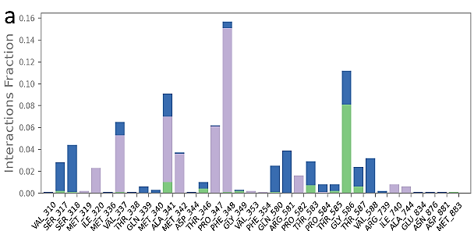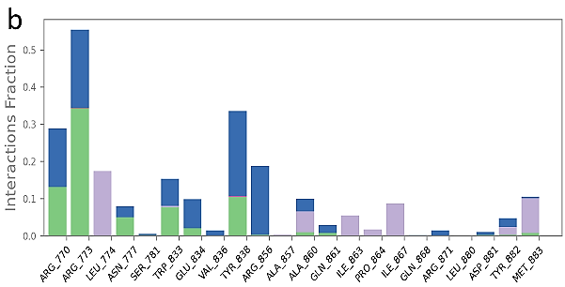
Fig 4: RMSD plot of 25-Methylstigmast-24(28)-enol-2FOM (a), RMSD plot of clerosterol-2FOM (b), 25-Methylstigmast-24(28)-enol-2FOM (a), RMSF plot of clerosterol-2FOM (b), 25-Methylstigmast-24(28)-enol-2FOM (a), interaction plot of clerosterol-2FOM (b)

4.0 Discussion
Parasitic disease is a major health burden particularly in the developing countries ( Torgerson et al., 2015). While some of them are categorized as neglected tropical diseases, others have received considerable attention from researchers across the globe (Miltra and Mawson, 2017). Currently, most of the health challenges recorded all over the world arises from vector borne diseases. Of the over 7 million deaths are caused by vector borne diseases, mosquito borne diseases has been identified as the most dangerous and they have been identified as both carrier and transmitter of the diseases (Socha et al., 2022; Anoopkumae and Aneesh, 2022). Dengue virus is one of the diseases majorly transmitted by Aedes aegypti (Powell et al., 2018). Currently, a lot of the world’s inhabitants are infected by dengue fever and this disease is transmitted by both Aedes albopictus and Aedes aegypti mosquitoes (Näslund et al.,2021). Dengue fever can lead to death of any carrier due to its prolong existence in the host (Khetarpal and Khanna, 2016). The treatment of dengue fever has been challenging due to non-availability of reliable vaccine or efficient therapeutic agent administered for the treatment of the disease (Shridhar Pattar et al., 2024). Therefore, there has been consistent effort to identify new drug lead that can both terminate the growth of Aedes aegypti mosquitoes from larva to pupa and to adult as well as the treatment of dengue fever. Hence, this study focuses extensively on the identification of new drug candidate that can inhibit the growth of Aedes aegypti larva and effectively treat dengue fever.
Medicinal plants have proven its effectiveness in the treatment of diseases. One of the major businesses of these plants is to synthesize phytochemicals which are not only beneficial to their existence and adaptation to environmental pressure, but also vital for the overall wellbeing of humans (Sharma, 2024; Santhirave et al., 2022). Notably, medicinal plant and their compounds have been identified as potential candidate as larvicides and the treatment of parasitic diseases. So far, several successes have been recorded in the treatment of plant derived drugs in the treatment of parasitic disease like malaria. However, considerable attention has not been placed on other parasitic disease like dengue fever and the control of its carrier (Aedes aegypti) due to the fact that they are mostly prevalent in developing or poor countries (Benelli and Mehlhorn, 2016; Segura et al., 2021). Furthermore, pharmaceutical industries have also invested little resources in the discovery of therapeutic agents against these neglected tropical diseases because majority of the inhabitants of the developing countries cannot afford the drugs (Weng et al., 2018; Mukherjee, 2023). Hence, most of the patients of dengue fever depend on the use of medicinal plants as remedy for the disease (Saleh and Kamisah, 2021). While some of these plants and their compounds have been assayed for their effectiveness as larvicides, only little has been done to explore their ability to perform dual action as larvicide and anti-dengue fever agent. Therefore, this study identified the chemical constituents that can effectively act as larvicide and also inhibit dengue virus majorly transmitted by Aedes aegypti.
Molecular docking has become a unique strategy for identifying potent drug candidates that can effectively treat various life-threatening diseases (Famuyiwa et al., 2023). This method is not only useful in identifying therapeutic agents but also helps in drug repurposing and elucidating the mechanism of action of potential drug candidates (Famuyiwa et al., 2025). In this study, molecular docking studies were performed on Aedes aegypti receptor as well as two isoforms of dengue virus. In the docking studies of the phytochemicals against Aedes aegypti, Clerosterol and 24-ethyl-desmosterol elicited the best inhibitory potential with high binding affinity compared to other phytochemicals of B. pinnatum and the reference drug. Also, hydrophobic and pi interactions were observed with the amino acid residues at the receptor’s active site. For dengue NS5 polymerase, taraxasterol and bryophynol were identified as the best inhibitor with binding affinity of -9.7 and -9.6 kcal/mol. Furthermore, the two terpenoids formed common hydrogen bond interactions with the Glu834, while bryophynol was stabilized at dengue NS5 polymerase binding site by participating in hydrophobic and pi-interactions. In the molecular docking studies of the phytoconstituents against dengue NS2B/NS3 protease, 25-Methylstigmast-24(28)-enol and clerosterol gave the highest binding affinity of -8.9 kcal/mol. Both compounds interacted with the residues of the dengue NS2B/NS3 through pi, hydrophobic and hydrogen bond. The binding affinity obtained for 25-Methylstigmast-24(28)-enol and clerosterol is higher than those of pinostrobin, panduratin A, agathisflavone (Bhattarai et al., 2022). Terpenoids has been identified as good larvicidal agents due to their non-polar nature which enhance their ability to penetrate into the exoskeleton of the larva (Mandal and Chandra, 2024). In this study, the hit molecules selected against Aedes aegypti are terpenoids and could effectively terminate the metamorphosis of the larva to pupa. Similarly, terpenoids has demonstrated excellent pharmacological potential due to their unique scaffold. In this study, the potential dengue virus inhibitors identified are typically terpenoids. Also, their clerosterol was identified as potential therapeutic agent that can perform dual action as a larvicide and dengue virus inhibitor.
Molecular dynamics simulation is a well-established computational method of studying the binding mode and interactions of phytoconstituents in the receptor’s binding pocket (Stany et al., 2024). In this study, the selected hit molecules were simulated for 150ns in order to understand their stability and interactions. The RMSD plot is acquired from a typical simulated system to understand the ligand’s stability at the receptor’s binding pocket. In this study, the ligands exhibited good stability at the receptor’s binding pocket thereby indicating that they could effectively bind to the receptor in order to perform their therapeutic actions. Similarly, the RMSF plot is used in studying the changes that occurs in protein chain during simulation. Generally, the proteins were stable with slight fluctuation throughout the entire 150 ns simulation period. Important interactions like hydrogen bond, hydrophobic and water bridge are crucial to ligand’s binding and therapeutic properties. Hydrogen bond plays crucial role in ligand binding to protein’s active site, drug specificity, absorption and metabolism. Similarly, hydrophobic interaction and water bridge contributes significantly to the binding affinity and drug candidacy of phytochemicals.

Conclusion

The study examined the larvicidal property of Bryophyllum pinnatum as well as its dengue virus inhibitory property targeting the dengue NS2B/NS3 protease and NS5 polymerase. Clerosterol and 24-ethyl-desmosterol were identified as the potential larvicidal agent, while taraxasterol and bryophynol were selected as potential inhibitor against dengue NS2B/NS3 protease, and 25-Methylstigmast-24(28)-enol and clerosterol as good inhibitors of dengue NS5 polymerase. The 150 ns MD simulation showed that the chemical compounds were considerably stable at the receptor’s binding pocket. Therefore, clerosterol and 24-ethyl-desmosterol may be responsible for larvicidal property of B. pinnatum when assayed in vitro. Also, taraxasterol, bryophynol, 25-Methylstigmast-24(28)-enol and clerosterol may be a good inhibitor of dengue virus. Generally, the identification of these phytochemical as larvicides and inhibitors indicated that B. pinnatum may be a good larvicide against Aedes aegypti as well as good inhibitor of dengue virus. Comprehensive in vitro and in vivo are recommended for further validation.

Consent
Not applicable

Ethical approval (where ever applicable)

Not applicable

References

- Cholewinski, M., Derda, M., & Hadas, E. (2015). Parasitic diseases in humans transmitted by vectors. Annals of parasitology, 61(3).
- Näslund, J., Ahlm, C., Islam, K., Evander, M., Bucht, G., & Lwande, O. W. (2021). Emerging mosquito-borne viruses linked to Aedes aegypti and Aedes albopictus: global status and preventive strategies. Vector-Borne and Zoonotic Diseases, 21(10), 731-746.
- Sukhralia, S., Verma, M., Gopirajan, S., Dhanaraj, P. S., Lal, R., Mehla, N., & Kant, C. R. (2019). From dengue to Zika: the wide spread of mosquito-borne arboviruses. European Journal of Clinical Microbiology & Infectious Diseases, 38(1), 3-14.
- Lin, Y., Fang, K., Zheng, Y., Wang, H. L., & Wu, J. (2022). Global burden and trends of neglected tropical diseases from 1990 to 2019. Journal of Travel Medicine, 29(3), taac031.
- Dehghani, R., & Kassiri, H. (2021). A review on epidemiology of dengue viral infection as an emerging disease. Research Journal of Pharmacy and Technology, 14(4), 2296-2301.
- Haider, N., Hasan, M.N., Onyango, J., Billah, M., Khan, S., Papakonstantinou, D., Paudyal, P. and Asaduzzaman, M., 2025. Global Dengue Epidemic Worsens with Record 14 Million Cases and 9,000 Deaths Reported in 2024. International Journal of Infectious Diseases, p.107940.
- Ng, D. H., Wong, J. G., Thein, T. L., Leo, Y. S., & Lye, D. C. (2016). The significance of prolonged and saddleback fever in hospitalised adult dengue. PLoS One, 11(12), e0167025.
- Zerfu, B., Kassa, T., & Legesse, M. (2023). Epidemiology, biology, pathogenesis, clinical manifestations, and diagnosis of dengue virus infection, and its trend in Ethiopia: a comprehensive literature review. Tropical Medicine and Health, 51(1), 11.
- Maia, L.M.S., Bezerra, M.C.F., Costa, M.C.S., Souza, E.M., Oliveira, M.E.B., Ribeiro, A.L.M., Miyazaki, R.D. and Slhessarenko, R.D., 2019. Natural vertical infection by dengue virus serotype 4, Zika virus and Mayaro virus in Aedes (Stegomyia) aegypti and Aedes (Stegomyia) albopictus. Medical and veterinary entomology, 33(3), pp.437-442.
- Chappell, K. J., Stoermer, M. J., Fairlie, D. P., & Young, P. R. (2008). West Nile Virus NS2B/NS3 protease as an antiviral target. Current medicinal chemistry, 15(27), 2771-2784.
- Li, H., Zhu, L., Hou, S., Yang, J., Wang, J., & Liu, J. (2014). An inhibition model of BPTI to unlinked dengue virus NS2B-NS3 protease. FEBS letters, 588(17), 2794-2799.
- Chen, W. N., Loscha, K. V., Nitsche, C., Graham, B., & Otting, G. (2014). The dengue virus NS2B–NS3 protease retains the closed conformation in the complex with BPTI. FEBS letters, 588(14), 2206-2211.
- Singh, A., Roy, R., Singh, K., Sokhal, P., Afroj, S., Phadnis, S., YS, R.K. and Verma, B., 2025. Dengue virus life cycle and host protein interactions: focus on RNA binding proteins and therapeutic advances. Reviews in Medical Virology, 35(2), p.e70025.
- Norshidah, H., Leow, C. H., Ezleen, K. E., Wahab, H. A., Vignesh, R., Rasul, A., & Lai, N. S. (2023). Assessing the potential of NS2B/NS3 protease inhibitors biomarker in curbing dengue virus infections: in silico vs. in vitro approach. Frontiers in cellular and infection microbiology, 13, 1061937.
- Starvaggi, J., Previti, S., Zappalà, M., & Ettari, R. (2024). The inhibition of NS2B/NS3 protease: A new therapeutic opportunity to treat dengue and Zika virus infection. International Journal of Molecular Sciences, 25(8), 4376.
- Süntar, I. (2020). Importance of ethnopharmacological studies in drug discovery: role of medicinal plants. Phytochemistry Reviews, 19(5), 1199-1209.
- Roaa, M. H. (2020). A review article: The importance of the major groups of plants secondary metabolism phenols, alkaloids, and terpenes. International Journal for Research in Applied Sciences and Biotechnology (IJRASB), 7(5), 354-358.
- Yang, W., Chen, X., Li, Y., Guo, S., Wang, Z., & Yu, X. (2020). Advances in pharmacological activities of terpenoids. Natural Product Communications, 15(3), 1934578X20903555.
- Mabou, F. D., & Yossa, I. B. N. (2021). TERPENES: Structural classification and biological activities. IOSR J Pharm Biol Sci, 16, 25-40.
- Elufioye, T. O., Oyedeji, A. O., & Habtemariam, S. (2022). A review of the traditional uses, phytochemistry and pharmacology of Bryophyllum pinnatum (Lam.)(Crassulaceae). Journal of Biologically Active Products from Nature, 12(3), 190-222.
- Long, C. L., & Li, R. (2004). Ethnobotanical studies on medicinal plants used by the Red-headed Yao People in Jinping, Yunnan Province, China. Journal of ethnopharmacology, 90(2-3), 389-395.
- Sadhana, D., Parveen, S., Bukhari, N.I., Shehzadi, N., Qamar, S., Ijaz, A., Niazi, S.U., Naheed, S. and Latif, A., 2018. Bryophyllum pinnatum: botanical description, vernacular names, parts used, traditional uses, phytochemical and phrmacological activities. Pakistan Journal of Pharmacy, 30(1).
- Bassey, I. E., Udo, E. F., & Adesite, S. O. (2021). Effect of crude aqueous leaves extract of Bryophyllum pinnatum on antioxidant status, blood glucose, lipid profile, liver and renal function indices in albino rats. Global Journal of Pure and Applied Sciences, 27(2), 231-241.
- Ibitoye, O. B., Olofinsan, K. A., Teralı, K., Ghali, U. M., & Ajiboye, T. O. (2018). Bioactivity‐guided isolation of antidiabetic principles from the methanolic leaf extract of Bryophyllum pinnatum. Journal of Food Biochemistry, 42(5), e12627.
- Ojewole, J. A. (2002). P-2: Antihypertensive properties of Bryophyllum pinnatum {(Lam) Oken} leaf extracts. American Journal of Hypertension, 15(S3), 34A.
- Daniel, I. E., Akpan, E. I., & Utam, E. C. (2020). Phytochemical evaluation, antioxidant and antimicrobial activities of various extracts from leaves and stems of Bryophyllum pinnatum. Nepal Journal of Biotechnology, 8(1), 17-28.
- Akinsulire, O. R., Aibin, I. E., Adenipekun, T., Adelowotan, T., & Odugbemi, T. (2007). In vitro antimicrobial activity of crude extracts from plants Bryophyllum pinnatum and Kalanchoe crenata. African Journal of Traditional, Complementary and Alternative Medicines, 4(3), 338-344.
- Kamboj, A., & Saluja, A. (2009). Bryophyllum pinnatum (Lam.) Kurz.: phytochemical and pharmacological profile: a review. Pharmacognosy Reviews, 3(6), 364.
- Selvakumar, P. (2022). Phytochemical and pharmacological profile review of Bryophyllum pinnatum. Biomedical and Biotechnology Research Journal (BBRJ), 6(3), 295-301.
- Niazi, S. K., & Mariam, Z. (2023). Computer-aided drug design and drug discovery: a prospective analysis. Pharmaceuticals, 17(1), 22.
- Tiwari, A., & Singh, S. (2022). Computational approaches in drug designing. In Bioinformatics (pp. 207-217). Academic Press.
- Bhagat, R. T., Butle, S. R., Khobragade, D. S., Wankhede, S. B., Prasad, C. C., Mahure, D. S., & Armarkar, A. V. (2021). Molecular docking in drug discovery. J Pharm Res Int, 33(30B), 46-58.
- Jakhar, R., Dangi, M., Khichi, A., & Chhillar, A. K. (2020). Relevance of molecular docking studies in drug designing. Current Bioinformatics, 15(4), 270-278.
- Shukla, R., & Tripathi, T. (2020). Molecular dynamics simulation of protein and protein–ligand complexes. In Computer-aided drug design (pp. 133-161). Singapore: Springer Singapore.
- Badar, M. S., Shamsi, S., Ahmed, J., & Alam, M. A. (2022). Molecular dynamics simulations: concept, methods, and applications. In Transdisciplinarity (pp. 131-151). Cham: Springer International Publishing.
- Obi, J. O., Gutierrez-Barbosa, H., Chua, J. V., & Deredge, D. J. (2021). Current trends and limitations in dengue antiviral research. Tropical Medicine and Infectious Disease, 6(4), 180.
- Zhou, G., Lo, E., Githeko, A. K., Afrane, Y. A., & Yan, G. (2020). Long-lasting microbial larvicides for controlling insecticide resistant and outdoor transmitting vectors: a cost-effective supplement for malaria interventions. Infectious diseases of poverty, 9(06), 83-90.
- Vieira Santos, V. S., Caixeta, E. S., Campos Júnior, E. O. D., & Pereira, B. B. (2017). Ecotoxicological effects of larvicide used in the control of Aedes aegypti on nontarget organisms: Redefining the use of pyriproxyfen. Journal of Toxicology and Environmental Health, Part A, 80(3), 155-160.
- Trott, O., & Olson, A. J. (2010). AutoDock Vina: improving the speed and accuracy of docking with a new scoring function, efficient optimization, and multithreading. Journal of computational chemistry, 31(2), 455-461.
- Famuyiwa, S.O., Ahmad, S., Fakola, E.G., Olusola, A.J., Adesida, S.A., Obagunle, F.O., Raza, K., Ugwo, J.P., Oyelekan, E.I. and Faloye, K.O., 2023. Comprehensive computational studies of naturally occurring kuguacins as antidiabetic agents by targeting visfatin. Chemistry Africa, 6(3),1415-1427.
- Famuyiwa, S.O., Ahmad, S., Olufolabo, K.O., Olanudun, E.A., Bano, N., Oguntimehin, S.A., Adesida, S.A., Oyelekan, E.I., Raza, K. and Faloye, K.O., 2025. Investigating the multitargeted anti-diabetic potential of cucurbitane-type triterpenoid from Momordica charantia: An LC-MS, docking-based MM\GBSA and MD simulation study. Journal of Biomolecular Structure and Dynamics, 43(3),1159-1170.
- Torgerson, P.R., Devleesschauwer, B., Praet, N., Speybroeck, N., Willingham, A.L., Kasuga, F., Rokni, M.B., Zhou, X.N., Fèvre, E.M., Sripa, B. and Gargouri, N., 2015. World Health Organization estimates of the global and regional disease burden of 11 foodborne parasitic diseases, 2010: a data synthesis. PLoS medicine, 12(12), p.e1001920.
- Mitra, A. K., & Mawson, A. R. (2017). Neglected tropical diseases: epidemiology and global burden. Tropical medicine and infectious disease, 2(3), 36.
- Socha, W., Kwasnik, M., Larska, M., Rola, J., & Rozek, W. (2022). Vector-borne viral diseases as a current threat for human and animal health—One Health perspective. Journal of Clinical Medicine, 11(11), 3026.
- Anoopkumar, A. N., & Aneesh, E. M. (2022). A critical assessment of mosquito control and the influence of climate change on mosquito-borne disease epidemics. Environment, Development and Sustainability, 24(6), 8900-8929.
- Powell, J. R. (2018). Mosquito-borne human viral diseases: why Aedes aegypti?. The American journal of tropical medicine and hygiene, 98(6), 1563.
- Khetarpal, N., & Khanna, I. (2016). Dengue fever: causes, complications, and vaccine strategies. Journal of immunology research, 2016(1), 6803098.
- Shridhar Pattar, S. S., Panda, P. K., & Rijal, P. (2023). Dengue as an emerging infection and co-infections: An update. Biomedical Research, 34(3), 1-15.
- Sharma, M. K. (2024). Exploring the biochemical profiles of medicinal plants cultivated under stressful environmental conditions. Current Agriculture Research Journal, 12(1), 81-103.
- Santhiravel, S., Bekhit, A. E. D. A., Mendis, E., Jacobs, J. L., Dunshea, F. R., Rajapakse, N., & Ponnampalam, E. N. (2022). The impact of plant phytochemicals on the gut microbiota of humans for a balanced life. International journal of molecular sciences, 23(15), 8124.
- Benelli, G., & Mehlhorn, H. (2016). Declining malaria, rising of dengue and Zika virus: insights for mosquito vector control. Parasitology research, 115(5), 1747-1754.
- Segura, N. A., Muñoz, A. L., Losada-Barragán, M., Torres, O., Rodríguez, A. K., Rangel, H., & Bello, F. (2021). Minireview: Epidemiological impact of arboviral diseases in Latin American countries, arbovirus-vector interactions and control strategies. Pathogens and disease, 79(7), ftab043.
- Weng, H. B., Chen, H. X., & Wang, M. W. (2018). Innovation in neglected tropical disease drug discovery and development. Infectious diseases of poverty, 7(03), 1-9.
- Mukherjee, S. (2023). The United States Food and Drug Administration (FDA) regulatory response to combat neglected tropical diseases (NTDs): A review. PLOS Neglected Tropical Diseases, 17(1), e0011010.
- Saleh, M. S., & Kamisah, Y. (2021). Potential medicinal plants for the treatment of dengue fever and severe acute respiratory syndrome-coronavirus. Biomolecules, 11(1), 42.
- Bhattarai, B.R., Adhikari, B., Basnet, S., Shrestha, A., Marahatha, R., Aryal, B., Rayamajhee, B., Poudel, P. and Parajuli, N., 2022. In silico elucidation of potent inhibitors from natural products for nonstructural proteins of dengue virus. Journal of Chemistry, 2022(1), p.5398239.
- Mandal, P., & Chandra, G. (2024). Casearia tomentosa fruit extracts exposed larvicidal activity and morphological alterations in Culex quinquefasciatus and Aedes albopictus under in vitro and semi field conditions. BMC Research Notes, 17(1), 6.
- Stany, B., Mishra, S., & Rao, K. B. (2024). Pharmacokinetic studies, molecular docking, and molecular dynamics simulations of phytochemicals from Morus alba: a multi receptor approach for potential therapeutic agents in colorectal cancer. Medical Oncology, 41(6), 156.

