Original Research Article
Optimizing Mycorrhizal Inoculation in Mahogany: Insights from Germination and Early Growth Trials

Abstract
Background and Aim:The production of quality planting material (QPM) is a major constraint in forestry, where enhanced germination and early seedling vigor is critical for nursery success. Arbuscular Mycorrhizal Fungi (AMF) are widely recognized for improving nutrient uptake, stress tolerance and growth in many crops, but their role in tree seedling establishment remains variable. This study evaluated the influence of AMF inoculation on germination and early growth of Swietenia macrophylla (mahogany).
Methodology:Mahogany seeds were sown in a coir pith + farmyard manure (FYM) substrate, either uninoculated (Control) or inoculated with a consortium of Glomus mosseae, G. etunicatum, and G. fasciculatum. Germination parameters were monitored daily for 90 days and destructive seedling traits (leaf, shoot, root, biomass and leaf area) were assessed thereafter. Data were analyzed using Welch’s t-tests for germination traits (arcsine transformation applied to percentages) and Student’s t-test for seedling traits, depending on distribution and variance assumptions.
Results: Results showed that AMF did not significantly alter final germination percentage (Control = 0.693; AMF = 0.674; p = 0.756). However, germination kinetics were affected: mean germination time increased (29.6 vs. 32.2 days; p = 0.005), mean germination rate decreased (0.034 vs. 0.031; p = 0.014), and the coefficient of velocity of germination was lower in AMF (3.38 vs. 3.10; p = 0.005), indicating slower and less synchronous emergence. In contrast, seedling growth parameters viz.,total leaflets, shoot and root length, stem girth, biomass allocation, root volume, and leaf area—showed no significant differences between treatments (all p > 0.05).
Conclusion:These findings suggest that under coir–FYM substrate conditions, AMF inoculation delayed germination without enhancing early seedling growth, likely due to poor colonization. The results highlight the importance of substrate choice, inoculum placement and nutrient environment in achieving effective AMF establishment. For forestry nurseries, AMF benefits in mahogany may only be realized under optimized inoculation protocols or at later developmental stages.
Keywords:Swietenia macrophylla, arbuscular mycorrhizal fungi, germination kinetics, seedling growth, nursery management
- Introduction
Forestry plantations worldwide face the dual challenge of meeting increasing demands for quality timber, while ensuring ecological sustainability. The productivity of these systems depends heavily on the availability of Quality Planting Material (QPM), which directly influences survival, growth rates, adaptability to stress and the quality of harvested wood. Conventional approaches to improving tree performance, such as genetic improvement and large-scale clonal propagation, are often resource-intensive and time-consuming, limiting their applicability at scale. Consequently, there is a growing interest in biological and eco-friendly alternatives that can enhance seed germination, seedling vigor, and resilience to stress cost-effectively.
Among the promising strategies, the use of Arbuscular Mycorrhizal Fungi (AMF) has received significant attention. AMF form symbiotic associations with plant roots, improving nutrient uptake particularly phosphorus and conferring tolerance to drought and other abiotic stresses. They also modulate host hormonal pathways and defense responses, contributing to improved plant establishment. Previous studies have shown that AMF inoculation enhances seedling growth, chlorophyll content and stress resilience in forestry and horticultural crops (Nayak and Santhoshkumar, 2020; Rajan et al., 2020). In tropical hardwoods such as Swietenia macrophylla (mahogany), AMF have been proposed as a potential climate adaptation strategy, improving establishment under water-limited and stress-prone nursery environments (Rajan et al., 2020). Broader analyses also confirm that AMF enhance biomass, nutrient uptake and water relations across diverse crops under stress (Chandrasekaran, 2022; Tang et al., 2022; Ye et al., 2022)
However, the benefits of AMF are highly situation-specific. Germination and early growth responses vary with host species, substrate conditions, inoculum quality and method of application. While, some reports highlight positive effects, others describe delayed germination or negligible early growth responses, raising uncertainty about their consistency in operational nursery practice. For example, Varga (2015) and Maighal et al. (2016) documented slower germination rates in AMF-treated seeds despite subsequent seedling benefits, underscoring the importance of methodological precision in inoculation.
In this study, seeds were directly sown into a coir pith + farmyard manure (FYM) substrate pre-mixed with an AMF consortium (Glomus mosseae, G. etunicatum, and G. fasciculatum). This method was tested because it is simple, easy to handle, and reduces the labour associated with transplanting seedlings into AMF-inoculated media or applying inoculum directly to the root zone. When scaled up in nursery practice, such a direct-sowing approach could substantially lower labour costs and operational complexity, while ensuring early root contact with AMF propagules.
The objective was to determine whether AMF inoculation alters germination percentage, speed and uniformity and whether it contributes to improved seedling traits such as shoot and root growth, biomass allocation and leaf area. The study provides insights into the scope and limitations of AMF application in forestry nurseries, identifying methodological factors that may constrain colonization and offering practical recommendations for optimizing inoculation strategies in tropical hardwood species.
- Materials and Methods
2.1. Seed Source and study area
Mature, viable seeds of Swietenia macrophylla King (mahogany) were collected from the Kerala Forest Research Institute (KFRI), Peechi, Kerala, India. Prior to sowing, they were soaked overnight in distilled water, a widely adopted pre-sowing treatment aimed at softening the seed coat and improving imbibition, thereby enhancing germination efficiency (Kumar et al., 2015).The experimental work was conducted at the College of Forestry, Kerala Agricultural University, Kerala, India (10°32′N, 76°26′E). The study involved both nursery and laboratory based evaluations, with different stages of the research carried out in collaboration with multiple departments within the university.
2.2. Arbuscular Mycorrhizal Fungi (AMF) Inoculum
The AMF inoculum consisted of a consortium of three species: Glomus mosseae, Glomus etunicatum, and Glomus fasciculatum, collected from the College of Agriculture, Vellayani, Kerala. The inoculum was mass-multiplied on maize (Zea mays) roots in a vermiculite–sand medium (1:1, v/v) following standard procedures.

2.3. Growth Medium and Experimental Setup
A mixture of coir pith and farmyard manure (FYM) in 1:1 proportion (v/v) was used as the growth substrate. This mixture was chosen for its good aeration, water-holding capacity and nutrient content. To test the labour saving approach, seeds were directly sown in AMF inoculated substrate, thereby avoiding the additional step of transplanting into AMF-treated media or root-dip inoculation. For the AMF treatment, the medium was amended with 10 g of the AMF consortium inoculum per seed, mixed into 20 g of sterilized coir pith + FYM. In the Control treatment, an equal quantity of sterilized inoculum (autoclaved at 121 °C for 2 h) was added to maintain substrate uniformity.The experiment followed a Completely Randomized Design (CRD) with six replications per treatment, each replication consisting of 50 seeds (n = 300 per treatment).
2.4 Germination Monitoring and Parameters
Seeds were monitored daily for a period of 50 days and germination was defined as the emergence of a visible radicle measuring at least 2 mm in length. To evaluate germination dynamics, a series of indices were calculated using established formulas (Maguire, 1962; Czabator, 1962). Germination percentage (G%) was determined as the ratio of the number of germinated seeds to the total number of seeds sown, expressed as a percentage. Mean germination time (MGT) was computed as the sum of the products of the number of seeds germinated on a given day and the corresponding day, divided by the total number of germinated seeds, while mean germination rate (MGR) was expressed as the reciprocal of MGT. The coefficient of velocity of germination (CVG) was obtained as the percentage ratio of the total number of seeds germinated to the sum of the products of seeds germinated per day and the time taken. Germination index (GI) was calculated as the sum of the daily germination percentages divided by the time in days and the time to 10% germination (T10) was recorded as the number of days required for 10% of the seeds to germinate. Mean daily germination (MDG) was expressed as the final germination percentage divided by the total days to the last germination. Peak value (PV) was derived from the ratio of the maximum daily germination to the time taken to reach that maximum, while the germination value (GV) was obtained as the product of peak value and mean daily germination.
2.5 Seedling Growth Measurements
At the end of the one-year growth period, destructive sampling was carried out on randomly selected seedlings to evaluate their morphological and biomass attributes. Root length was measured from the root collar to the tip of the longest root, while shoot length was recorded from the root collar to the apex of the tallest shoot. The number of leaves was counted for each seedling, and stem girth was determined at the root collar using a digital calliper. For biomass estimation, roots were carefully washed toremove adhering particles, oven-dried at 70 °C until a constant weight was achieved and weighed to obtain root biomass, while shoots were similarly oven-dried at 70 °C for 48 hours to determine shoot biomass. Total biomass was calculated as the sum of root and shoot biomass. Root volume was assessed using the water displacement method and leaf area was measured with a digital leaf area meter to quantify the photosynthetic surface area available to the seedling.
2.6 Statistical Analysis
All statistical analyses were performed using SPSS and Microsoft Excel. Germination percentage values were subjected to arcsine square-root transformation before analysis to stabilize variance. Germination traits were compared between Control and AMF treatments using Welch’s t-test, as this method is robust to unequal variances. For seedling growth traits, data were first tested for normality using the Shapiro–Wilk test and for homogeneity of variances using Levene’s test. Traits that satisfied both assumptions were analyzed using Student’s t-test, while Welch’s t-test was employed in cases where variances were unequal. For parameters that did not conform to normality, the non-parametric Mann–Whitney U test was applied. Results are presented as means ± standard error (SE), and statistical significance was determined at p< 0.05.
Results
3.1 Germination Parameters
Analysis of germination parameters revealed contrasting responses of mahogany seeds to AMF inoculation. The final germination percentage (G%), after arcsine square-root transformation, did not differ significantly between treatments, with values of 0.693 for Control and 0.674 for AMF (Welch’s t = 0.334, p = 0.756; Table 1). This indicates that AMF colonization did not affect the overall proportion of seeds that were able to germinate during the 50-day observation period. In contrast, germination kinetics were significantly influenced by AMF. The mean germination time (MGT) was markedly prolonged in AMF-treated seeds (32.23 days) compared to the Control (29.59 days), a statistically significant difference (Welch’s t = –4.416, p = 0.005). This delay was further reflected in the mean germination rate (MGR), which declined from 0.034 in Control to 0.031 in AMF (Welch’s t = 3.667, p = 0.014), confirming that germination proceeded more slowly when AMF was present. Similarly, the coefficient of velocity of germination (CVG) was significantly lower in AMF (3.104) compared to Control (3.382) (Welch’s t = 4.461, p = 0.005). The reduction in CVG demonstrates that germination under AMF treatment was not only delayed but also less synchronous, with seeds germinating over a wider time interval.
Other vigor-related indices did not show significant treatment effects. The germination index (GI) remained statistically similar between Control (0.37) and AMF (0.33) (p = 0.406). The time to 10% germination (T10) was slightly longer in AMF (15.68 days) compared to Control (15.08 days), but this difference was not significant (p = 0.393). Likewise, the mean daily germination (MDG) (0.548 vs. 0.520), peak value (1.062 vs. 0.880) and germination value (GV) (0.602 vs. 0.462) did not differ significantly between treatments (p> 0.05). Overall, these results demonstrate that while AMF inoculation did not influence the total germination percentage, it significantly altered the tempo and synchrony of germination, delaying emergence and reducing the uniformity of the germination process. This suggests that AMF exerted a suppressive effect on the rate and coordination of seed germination, although the eventual germination capacity of mahogany seeds remained unaffected.

Table 1. Germination parameters of mahogany under Control and AMF treatments (Welch’s t-test).
Parameter | Control Mean | AMF Mean | t-value | p-value | Significance
Germination % (arcsine sqrt) | 0.693 | 0.674 | 0.334 | 0.756 | ns
Mean germination time (MGT) | 29.59 | 32.23 | -4.416 | 0.005 | **
Mean germination rate (MGR) | 0.034 | 0.031 | 3.667 | 0.014 | *
Coefficient of velocity (CVG) | 3.382 | 3.104 | 4.461 | 0.005 | **
Germination index (GI) | 0.37 | 0.33 | 0.943 | 0.406 | ns
Time to 10% germination (T10) | 15.08 | 15.68 | -0.926 | 0.393 | ns
Mean daily germination (MDG) | 0.548 | 0.520 | 0.375 | 0.728 | ns
Peak value (PV) | 1.062 | 0.880 | 1.693 | 0.172 | ns
Germination value (GV) | 0.602 | 0.462 | 1.020 | 0.373 | ns
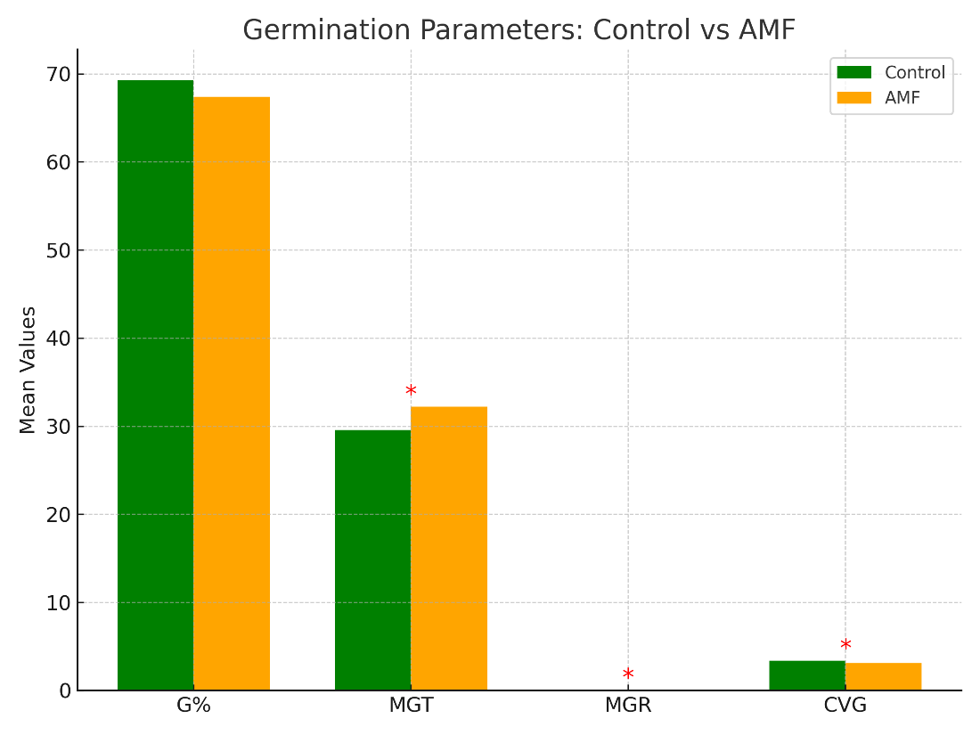
Figure 1. Effect of AMF inoculation on germination parameters of mahogany.

3.2 Seedling Growth Parameters
Destructive seedling growth analysis performed one year after sowing indicated that AMF inoculation did not lead to statistically significant differences in any of the measured morphological or biomass traits, when compared to the Control (Table 2). The total number of leaflets was higher in the Control seedlings (17.17) relative to AMF-treated seedlings (11.75). Although this difference suggested a numerical reduction in leaf production under AMF, the variation was not statistically significant (Student’s t = 2.153, p = 0.064). Similarly, shoot length values were comparable between Control (53.5 cm) and AMF (52.3 cm) (p = 0.710), showing that vertical growth was not influenced by inoculation. The root length also exhibited a small reduction in AMF treated seedlings (16.0 cm) compared to Control (18.8 cm), but this difference was not significant, when tested using the Mann–Whitney U test (U = 7.5, p = 0.392).
With regard to stem thickness, AMF seedlings recorded a slightly higher stem girth (6.28 mm) compared to the Control (5.35 mm). Despite this trend suggesting a potential thickening effect, the difference was not statistically validated (Student’s t = –1.432, p = 0.190). Similarly, biomass allocation showed no significant treatment effects. Total biomass was higher in Control seedlings (20.5 g) compared to AMF (15.8 g), though not statistically significant (Student’s t = 1.542, p = 0.162). A similar pattern was observed for shoot biomass (15.8 g in Control vs. 11.0 g in AMF; p = 0.129). Interestingly, root biomass values were nearly identical (4.67 g in Control vs. 4.75 g in AMF; p = 0.919), highlighting that AMF inoculation did not improve belowground biomass accumulation.
Other structural traits followed the same non-significant trend. Root volume, assessed by the water displacement method, was slightly higher in Control seedlings (6.5 ml) than AMF (5.8 ml), but differences were not significant (U = 8.0, p = 0.440). The leaf area, a key indicator of photosynthetic capacity, was marginally higher in AMF seedlings (561.3 cm²) compared to the control (481.4 cm²); however, this variation did not reach statistical significance (Student’s t = –0.888, p = 0.400). Collectively, these results suggest that AMF inoculation, under the coir + FYM substrate conditions used in this experiment, did not significantly affect the morphological development or biomass accumulation of mahogany seedlings at the early growth stage. Although certain traits, such as stem girth and leaf area, showed a numerical increase under AMF, the absence of statistical significance indicates that AMF colonization was either ineffective or inconsistent under the tested conditions.

Table 2. Destructive seedling growth parameters of mahogany under Control and AMF treatments.
Parameter | Control | AMF | p-value | Significance
Total leaflets | 17.17 | 11.75 | 0.064 | ns
Shoot length (cm) | 53.5 | 52.3 | 0.710 | ns
Root length (cm) | 18.8 | 16.0 | 0.392 | ns
Stem girth (mm) | 5.35 | 6.28 | 0.190 | ns
Total biomass (g) | 20.5 | 15.8 | 0.162 | ns
Shoot biomass (g) | 15.8 | 11.0 | 0.129 | ns
Root biomass (g) | 4.67 | 4.75 | 0.919 | ns
Root volume (ml) | 6.5 | 5.8 | 0.440 | ns
Leaf area (cm²) | 481.4 | 561.3 | 0.400 | ns

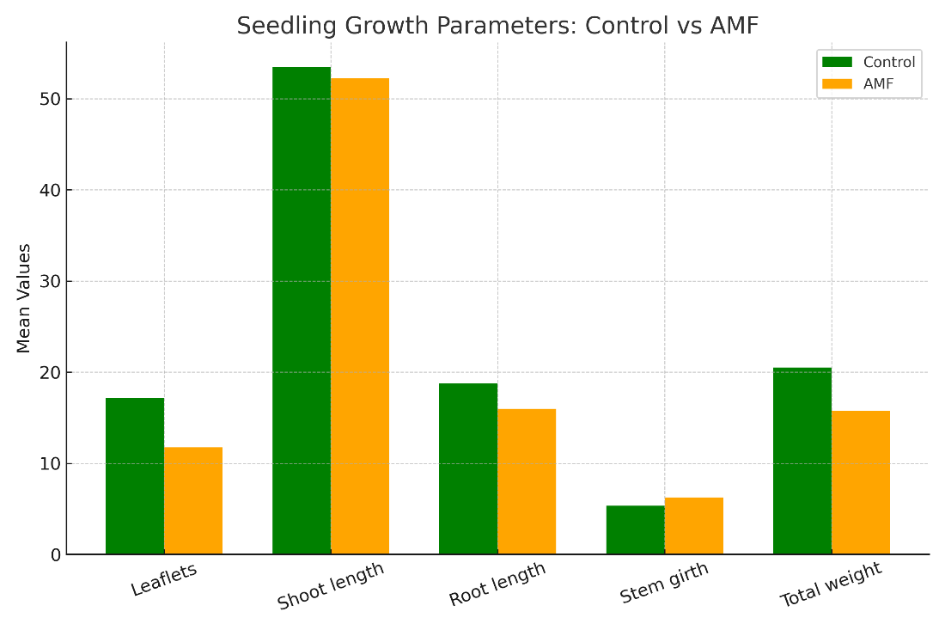
Figure 2. Effect of AMF inoculation on destructive seedling growth parameters of mahogany seedlings.

4. Discussion
4.1 Germination Parameters
The results of this study demonstrate that AMF inoculation did not enhance the final germination percentage of Swietenia macrophylla seeds, as both inoculated and non-inoculated treatments exhibited statistically similar germination proportions. However, AMF had a marked effect on germination dynamics, with treated seeds showing delayed emergence, longer mean germination time (MGT), and reduced mean germination rate (MGR) and coefficient of velocity of germination (CVG) compared to the Control (Table 1; Figure 1). These findings suggest that while AMF colonization does not impair the eventual ability of seeds to germinate, it modifies the tempo and synchrony of the process, leading to slower and less uniform germination.
This outcome is consistent with the “early cost–later benefit” model frequently described in the mycorrhizal literature. According to this model, the establishment of a functional symbiosis between seeds/seedlings and AMF may impose an initial physiological cost, often manifested as delayed or reduced germination rates, which can later be compensated by enhanced seedling vigor and stress tolerance once colonization is established (Varga, 2015; Maighal et al., 2016). Several mechanisms may underlie the delayed germination observed in this study. One likely explanation involves phytohormonal cross-talk mediated by AMF during the pre-symbiotic phase. Germination is tightly regulated by the antagonistic balance between abscisic acid (ABA), which maintains dormancy and gibberellic acid (GA), which promotes radicle protrusion. Mycorrhizal signaling has been shown to alter ABA–GA dynamics, particularly by suppressing GA biosynthesis or promoting ABA accumulation, thereby prolonging germination time (Miura et al., 2024). Such hormonal reprogramming may represent an adaptive mechanism by which AMF regulate host physiology to synchronize seedling development with fungal colonization.
Another plausible factor is the influence of fungal exudates and secondary metabolites released by AMF propagules into the rhizosphere. These bioactive compounds may interfere with germination cues by altering seed coat permeability, modifying chemical signals or producing allelopathic effects that delay radicle emergence. Evidence from parasitic and crop species indicates that AMF-derived exudates can modulate seed germination behaviour, either by suppressing germination or altering its timing (Maighal et al., 2016). In the case of mahogany, such exudate-mediated interactions could explain the observed reduction in germination velocity and rate despite unchanged final percentages. Taken together, these findings highlight that AMF inoculation affects how and when seeds germinate rather than whether they germinate. The biological significance of this delayed germination requires further exploration. While slower and less synchronous germination may be disadvantageous in operational nursery systems that rely on rapid and uniform emergence, it may also reflect an investment into establishing a symbiotic relationship that could yield longer-term benefits at the seedling stage.
4.2 Seedling Growth Parameters
The destructive sampling of mahogany seedlings at 90 days revealed that AMF inoculation did not produce significant differences in shoot, root, or biomass traits compared to the uninoculated Control. Although descriptive means showed a tendency for greater leaflet number and total biomass in Control seedlings and slightly higher stem girth and leaf area in AMF-treated seedlings, none of these variations reached statistical significance (Table 2; Figure 2). These findings suggest that, under the conditions of the present study, AMF colonization either did not occur effectively or failed to exert a measurable influence on early seedling development. Such neutral responses are not unprecedented. While numerous studies report significant improvements in seedling growth with AMF inoculation — for example, enhanced biomass and nutrient uptake in Swietenia macrophylla under nursery conditions (Ajeesh et al., 2024), or improved root architecture and photosynthetic development in S. mahagoni seedlings inoculated with AMF across different substrates (Falcón Oconor et al., 2023) — others highlight the context-dependent nature of AMF benefits. Host species identity, fungal strain compatibility and importantly, substrate characteristics strongly influence whether symbiosis translates into growth promotion.
In the present experiment, the use of a coir pith + farmyard manure (FYM) substrate may have limited effective AMF colonization. FYM and coir are rich in organic matter and harbor indigenous microbial populations that could outcompete or suppress introduced AMF propagules. Moreover, high levels of readily available phosphorus in FYM are known to inhibit AMF colonization by reducing plant dependency on the symbiosis (Smith & Read, 2008; Ezawa et al., 2018; Zhang et al., 2021). Without effective colonization, the expected benefits of AMF — improved nutrient acquisition, root foraging efficiency and biomass accumulation would not be expressed.
Another factor is the method of inoculum application. In this study, AMF inoculum was mixed into the growth substrate, which may not have ensured direct propagule–root contact during the early growth stages. In contrast, methods that place inoculum directly at the root zone — such as layering beneath seedlings at transplant (Ajeesh et al., 2024), root-dip inoculation (Babu et al., 2019), or seed coating (Falcón Oconor et al., 2023) — have been shown to result in higher colonization rates and stronger growth responses. This highlights the critical importance of inoculation technique for realizing the benefits of AMF in nursery systems. The absence of significant growth effects after one year also underscores the temporal dimension of AMF benefits. Several studies have shown that AMF-mediated improvements in growth and nutrient uptake become more apparent at later developmental stages, particularly under field or stress conditions (de la Cruz-Ortiz et al., 2020; Qiang et al., 2012). Thus, while early-stage seedlings in the present study did not benefit from AMF inoculation, longer-term trials might reveal cumulative advantages in growth, survival, or stress tolerance.
In summary, the lack of significant effects on seedling traits in this study can be attributed to a combination of factors: substrate composition, nutrient environment, and inoculation method likely limited AMF colonization, while the short duration of the experiment may not have allowed sufficient time for symbiotic benefits to manifest. These results reinforce the notion that AMF effects are highly context-specific and emphasize the need for optimized nursery practices tailored to host species, substrate conditions, and operational objectives.
5. Conclusion and Recommendations
This study assessed the influence ofAMF inoculation on germination and early seedling growth of Swietenia macrophylla (mahogany). The findings revealed that AMF did not alter final germination percentage, but significantly delayed germination kinetics by increasing mean germination time and reducing germination rate and synchrony. Seedling growth traits, including shoot and root dimensions, biomass accumulation, and leaf area, were not significantly improved, suggesting that AMF colonization was ineffective under the coir + FYM substrate conditions used. Although the direct-sowing method tested here is operationally attractive for large-scale nurseries because it reduces labour inputs, it does not guarantee effective colonization or measurable growth benefits without further refinements. To enhance success, nursery practices should employ sterilized or solarized substrates, place inoculum directly in the root zone and maintain low to moderate phosphorus fertility to promote symbiosis. Where rapid, uniform germination is required, inoculation may be applied after seedling emergence. Overall, the study highlights that AMF application in mahogany is context-dependent, and its benefits can only be realized through optimized nursery protocols and validation under field conditions.

References
Ajeesh, R., Kamalolbhavan, B.N., Santosh Kumar, A.V. & Gopal, S., 2024. Native arbuscular mycorrhizal fungi improves growth and quality of exotic Swietenia macrophylla King seedlings in nursery. Journal of Horticulture, 13(4).
Babu, A.G., Shea, P.J., Oh, B.T. &Sathiyavani, M., 2019. Influence of arbuscular mycorrhizal fungi on early establishment and nutrient uptake in tree seedlings: a root-dip inoculation approach. Forests, 10(6), 497. https://doi.org/10.3390/f10060497
Chandrasekaran, M., 2022. Arbuscular mycorrhizal fungi mediated drought stress alleviation: a meta-analysis of plant growth, root traits, and nutrient uptake. Journal of Fungi, 8(7), 660. https://doi.org/10.3390/jof8070660
de la Cruz-Ortiz, V., Ferrera-Cerrato, R., Alarcón, A. & Lara, L., 2020. Temporal effects of arbuscular mycorrhizal fungi on biomass accumulation and nutrient uptake in tropical tree seedlings. Agroforestry Systems, 94, pp.2127–2138. https://doi.org/10.1007/s10457-020-00508-1
Ezawa, T., Smith, S.E. & Smith, F.A., 2018. Dynamic phosphate uptake in arbuscular mycorrhizal roots under high and low phosphorus. Frontiers in Environmental Science, 6, 159. https://doi.org/10.3389/fenvs.2018.00159
Falcón Oconor, E., Cobas López, A., Bonilla Vichot, M. & Rodríguez Leyva, O., 2023. Growth and photosynthetic development of Swieteniamahagoni seedlings produced in substrates inoculated with arbuscular mycorrhizal fungi. Bosque (Valdivia), 44(2), pp.329–338. https://doi.org/10.4067/S0717-92002023000200329
Gill, S.S., Gill, R., Trivedi, D.K., Anjum, N.A., Sharma, K.K., Ansari, M.W., Ansari, A.A., Johri, A.K., Prasad, R., Pereira, E., Varma, A. & Tuteja, N., 2016. Piriformospora indica: Potential and significance in plant stress tolerance. Frontiers in Microbiology, 7, 332. https://doi.org/10.3389/fmicb.2016.00332
Krishnan, L.R., Johnson, J.M., Radhika, N.S., Thara, S.S., Alex, S. & Sreekala, G.S., 2022. Beneficial fungal root endophyte Piriformospora indica protects black pepper plants from Piper yellow mottle virus infection. Focus on Pepper, XII(1), pp.33–54.
Kumar, V., Ajeesh, R. &Jijeesh, C.M., 2015. Chemical pre-sowing treatments for better germination and seedling growth of Swietenia macrophylla King. Journal of Environment and Biosciences. [Incomplete — add volume, issue, pages, DOI/URL when available].
Maighal, M., Salem, M., Kohler, J. &Rillig, M.C., 2016. Arbuscular mycorrhizal fungi negatively affect soil seed bank viability. Ecology and Evolution, 6(21), pp.7683–7689. https://doi.org/10.1002/ece3.2491
Mensah, R.A., Li, D., Liu, F., Tian, N., Sun, X., Hao, X., Lai, Z. & Cheng, C., 2020. Versatile Piriformospora indica and its potential applications in horticultural crops. Horticultural Plant Journal, 6(2), pp.111–121. https://doi.org/10.1016/j.hpj.2020.01.002
Miura, C., Furui, Y., Yamamoto, T., Kanno, Y., Honjo, M., Yamaguchi, K., Suetsugu, K., Yagame, T., Seo, M., Shigenobu, S. & Yamato, M., 2024. Autoactivation of mycorrhizal symbiosis signaling through gibberellin deactivation in orchid seed germination. Plant Physiology, 194(1), pp.546–563. https://doi.org/10.1093/plphys/kiae309
Nayak, S. & Santhoshkumar, A.V., 2020. Effect of arbuscular mycorrhizal fungi on the growth of mahogany (Swietenia macrophylla King.) seedlings under nursery condition. Indian Journal of Pure and Applied Biosciences, 8(6), pp.124–129. https://doi.org/10.18782/2582-2845.8241
Qiang, X., Weiss, M., Kogel, K.H. & Schäfer, P., 2012. Piriformospora indica—a mutualistic basidiomycete with an exceptionally large plant host range. Molecular Plant Pathology, 13(5), pp.508–518. https://doi.org/10.1111/j.1364-3703.2011.00764.x
Rajan, L.J., Murthy, V.K., Bhat, N.S., Anandan, R. & Sreekanth, A.B., 2020. Arbuscular mycorrhizal fungi inoculation as a climate adaptation strategy for establishment of Swietenia macrophylla King seedlings. Forests, 11(5), 488. https://doi.org/10.3390/f11050488
Saleem, S., Sekara, A. & Pokluda, R., 2022. Serendipitaindica—A review from agricultural point of view. Plants, 11(24), 3417. https://doi.org/10.3390/plants11243417
Smith, S.E. & Read, D.J., 2008. Mycorrhizal symbiosis. 3rd edn. London: Academic Press.
Tang, H., Chen, X., Zhao, L., Wang, Y. & Ma, X., 2022. The critical role of arbuscular mycorrhizal fungi in improving plant water and nutrient uptake and drought resilience. Frontiers in Plant Science, 13, 929855. https://doi.org/10.3389/fpls.2022.929855
Varga, S., 2015. Effects of arbuscular mycorrhizal fungi and maternal plant sex on seed germination and early plant establishment. American Journal of Botany, 102(2), pp.358–366. https://doi.org/10.3732/ajb.1400361
Varga, S. &Kytöviita, M.M., 2016. Faster acquisition of symbiotic partner by common mycorrhizal networks in early plant life stage. Ecosphere, 7(1), e01222. https://doi.org/10.1002/ecs2.1222
Ye, Q., Zhang, L., Li, X., Wu, J., Duan, W. & Li, S., 2022. Arbuscular mycorrhizal fungi alleviate the negative effects of drought stress on grapevines by improving photosynthetic performance and leaf water status. Agronomy, 12(7), 1563. https://doi.org/10.3390/agronomy12071563
Zhang, L., Fan, J., Ding, X., He, X., Zhang, F. & Feng, G., 2021. Contribution of arbuscular mycorrhizal fungi, phosphate-solubilizing bacteria, and silicon to phosphorus uptake by plants. Frontiers in Plant Science, 12, 699. https://doi.org/10.3389/fpls.2021.00699

