Case report
Successful management of a rare incidence of inadvertent concentrated potassium chloride extravasation in a dog receiving intermittent hemodialysis

Abstract
Aims- To ensure the safe administration of intravenous potassium chloride in patients with hypokalemia, emphasizing the prompt identification and management of extravasation to prevent serious complications.
Presentation of Case- A 08 year-old male Labrador Retriever was presented with a 4-day history of anorexia, lethargy, severe vomiting, abdominal pain, weight loss, polyuria, polydipsia, and melena. Based on clinical findings and diagnostic evaluations, the dog was diagnosed acute kidney injury (AKI) and managed using intermittent hemodialysis (IHD). Following the first session of hemodialysis, the patient developed hypokalemia, and a constant rate infusion (CRI) of potassium chloride (Kcl) was initiated to correct the electrolyte imbalance. However, due to dislodgement of the intravenous cannula, a portion of the potassium chloride was inadvertently administered subcutaneously. This led to extensive swelling of the left hind-limb, indicative of extravasation. To manage the localized tissue reaction and minimize further damage, diluted lignocaine in normal saline was administered subcutaneously over the affected area.
Discussion and Conclusion- Extravasation of potassium chloride is a serious complication that can result in localized tissue necrosis and significant damage to surrounding structures. In this case, inadequate monitoring of the intravenous site led to the accidental subcutaneous administration of potassium chloride, causing soft tissue swelling and a risk of necrosis. This incident underscores the critical importance of vigilant observation during intravenous infusions, especially when administering irritant solutions like potassium chloride. To prevent such occurrences, it is essential to implement strict monitoring protocols and ensure that all clinical staff is adequately trained in the safe handling and administration of intravenous medications.
Keywords: Acute kidney injury, Parenteral Drug Administration, Extravasation, Lignocaine, Pancreatitis, Potassium chloride, subcutaneous,
- INTRODUCTION
Potassium is a vital electrolyte essential for numerous physiological processes in dogs. In case of severe hypokalemia, intravenous administration of potassium chloride is commonly employed to restore normal plasma levels (Rodan, 2017). Although effective, this route carries the risk of extravasation (Reason of high risk of extravasation?), a complication that should not be overlooked. Potassium chloride solutions are hypertonic and highly irritant to tissues, potentially disrupting the balance between intracellular and extracellular compartments (Le and Patel, 2014; Al-Benna et al., 2013). Extravasation can lead to intense localized pain, progressive tissue necrosis, and, in severe instances, limb dysfunction or even amputation (Ghanem et al., 2015). Such complications not only increase the patient’s suffering morbidity but also contribute to prolonged hospitalization and higher treatment costs as studied in humans. Due to the limited efficacy of treatment once damage occurs, prevention through close monitoring and early intervention is critical (Le and Patel, 2014). Delays in recognizing extravasation or initiating appropriate measures may necessitate surgical management, including reconstructive procedures or amputation (Goutos et al., 2014). The following case report was undertaken in response to a clinical incident involving potassium chloride extravasation resulting in localized tissue injury. To the best of our knowledge, this is the first reported case in canines where potassium chloride extravasation was successfully managed to prevent further tissue damage.
- PRESENTATION OF CASE
An eight-year-old intact male Labrador Retriever dog was presented to the dialysis unit of the Multispecialty Veterinary Hospital at Guru Angad Dev Veterinary and Animal Sciences University, Ludhiana. A detailed history indicated that the dog had been exhibiting signs of anorexia, lethargy, repeated episodes of vomiting, abdominal discomfort, weight loss, polyuria, polydipsia, and melena for the preceding four days. On physical examination, the dog had a body condition score (BCS) of 2.5 out of 5, congested mucous membranes, dull mentation, and signs of moderate dehydration estimated at 6–8%. The rectal temperature was recorded at 101.4°F, with a heart rate of 70 beats per minute, a respiratory rate of 28 breaths per minute, normal superficial lymph nodes, and a systolic blood pressure of 140 mmHg as measured by a Doppler blood pressure monitor (Vet BP Mano Medical, France). Hematological evaluation indicated a hemoglobin concentration of 15.3 g/dL and a significantly elevated total leukocyte count (TLC) of 35,000/µL, consistent with neutrophilic leukocytosis and a mild shift to left. Serum biochemistry findings included markedly increased levels of blood urea nitrogen (BUN) at 171 mg/dL and creatinine at 6.5 mg/dL, with normal sodium (147 mEq/L), potassium (4.1 mEq/L), and chloride (97 mEq/L) levels. Phosphorus was elevated at 10.1 mg/dL. Urinalysis revealed a specific gravity of 1.050, a urine protein-to-creatinine ratio (UPCR) of 0.3, and an acidic pH of 5.0. Abdominal ultrasonography showed revealed both kidneys having increased cortical echogenicity and mild loss of cortico-medullary definition, suggestive of acute kidney injury (AKI). Initial management included intensive fluid therapy along with supportive care involving diuretics (Inj. 2mg/kg I/V bid), anti-emetics (Inj. Maropitant 2ml S/C od), which was continued for two days. Despite treatment, the serum creatinine level further increased to 7.2 mg/dL, prompting to shift the dog on IHD. Following aseptic preparation of the catheterization site, a dedicated 19 cm, 11.5 Fr double-lumen temporary dialysis catheter (DLC) was inserted into the left jugular vein to establish vascular access. The catheter tip was meticulously positioned at the junction of the cranial vena cava and the right atrium (Figure 1) to ensure optimal and uninterrupted blood flow.
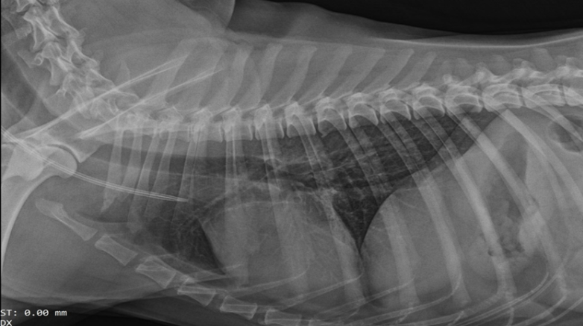
Fig. 1. Correct placement of central venous catheter tip at the junction of right atrium and cranial venacava
Intermittent hemodialysis (IHD) was subsequently initiated using a Fresenius Medical Care 4008S dialysis machine. During ongoing dialysis, continuous monitoring of patient vital signs (rectal temperature, electrocardiogram, and arterial oxygen saturation) was achieved using a multi-parameter monitor (Phillips G30E, USA). Blood pressure monitoring was conducted every 15 minutes using a Doppler sphygmomanometer (Doppler Vet BP mano medical, France).
Following the first session of IHD, the patient developed severe hypokalemia with serum potassium concentration dropping to 2.1 mEq/L, likely due to potassium removal during dialysis, rapid correction of metabolic acidosis, and intracellular shifting of potassium (Table. 1).
Table 1. Comparative analysis of the hemato-biochemical profile during pre- and post-hemodialysis period
Parameter | IHD  (Session time: 120 minute)
Parameter | Pre-IHD | Post-IHD
Hemoglobin (g/dL) | 15.3 | 15.1
TLC (ul) | 35000 | 32000
PCV (%) | 44 | 42
Platelet (10³/ul) | 373 | 119
ALT (U/L) | 62 | 57
GGT (U/L) | 26 | 15
Total Protein (g/dL) | 8.3 | 8.5
Albumin (g/dL) | 3.9 | 3.3
BUN (mg/dL) | 171 | 66
Creatinine (mg/dL) | 7.4 | 4.4
Phosphorus (mg/dL) | 11.2 | 4.1
Sodium (mEq/L) | 147 | 145
Potassium (mEq/L) | 4.1 | 2.1
Chloride (mEq/L) | 97 | 99
Glucose (mg/dL) | 105 | 98
Calcium (mg/dL) | 10.7 | 12
As a result, a venous infusion of potassium chloride (Kcl) was initiated to correct the electrolyte imbalance. The patient had both a central venous catheter placed in the right internal jugular vein and a 22-gauge peripheral catheter inserted in lateral saphenous vein of the right hind limb. A diluted potassium chloride solution was prepared with a final concentration of 15 mEq in 250 ml NSS and administered using a CRI at a rate of 8 mL/kg/hr through peripheral catheter in the saphenous vein. However, due to accidental catheter dislodgement from inside the vein during ongoing infusion, the solution was inadvertently delivered into the subcutaneous tissue instead of the vein. Approximately half an hour after the beginning of infusion begun, the owner observed extensive swelling and erythema over the left hind limb was observed. The infusion was immediately discontinued, and the peripheral intravenous catheter was removed. The potassium infusion was then redirected through the central venous catheter.
In anticipation of progressive tissue injury, alternative therapy was considered. After obtaining informed consent from the owner and explaining the potential for subcutaneous hemorrhage, necrosis, and further swelling, local subcutaneous infiltration with lidocaine hydrochloride (100 mg in 5 mL) diluted in 10 mL of normal saline was administered around the affected area. The first perivascular injection was given around the site of extravasation (Figure 2). Twelve hours later, there was a noticeable reduction in the swelling was observed along with improved skin discoloration in a gradual manner and the skin discoloration gradually improved, indicating positive tissue recovery. A second round of subcutaneous lidocaine and saline infiltration was performed 12 hours after the initial extravasation (Figure 3). At 24 hours post-injury, the affected limb showed no further swelling (Figure 4).The patient demonstrated complete recovery within 24 hours of injury and was discharged without any residual discomfort or functional limitations. Further renal support therapy includes Tablet mirtazapine (@0.6 mg/kg od), Tablet sodium bicarbonate (Nodiosis @ 10mg/kg po bid) and syrup+capsule Nephrasin (Sinder K) [@1ml/5kg o od and 1 capsule po od] with properties as phosphate binder, anti-fibrotic, optimises blood pressure, as probiotics and support kidney function properties.
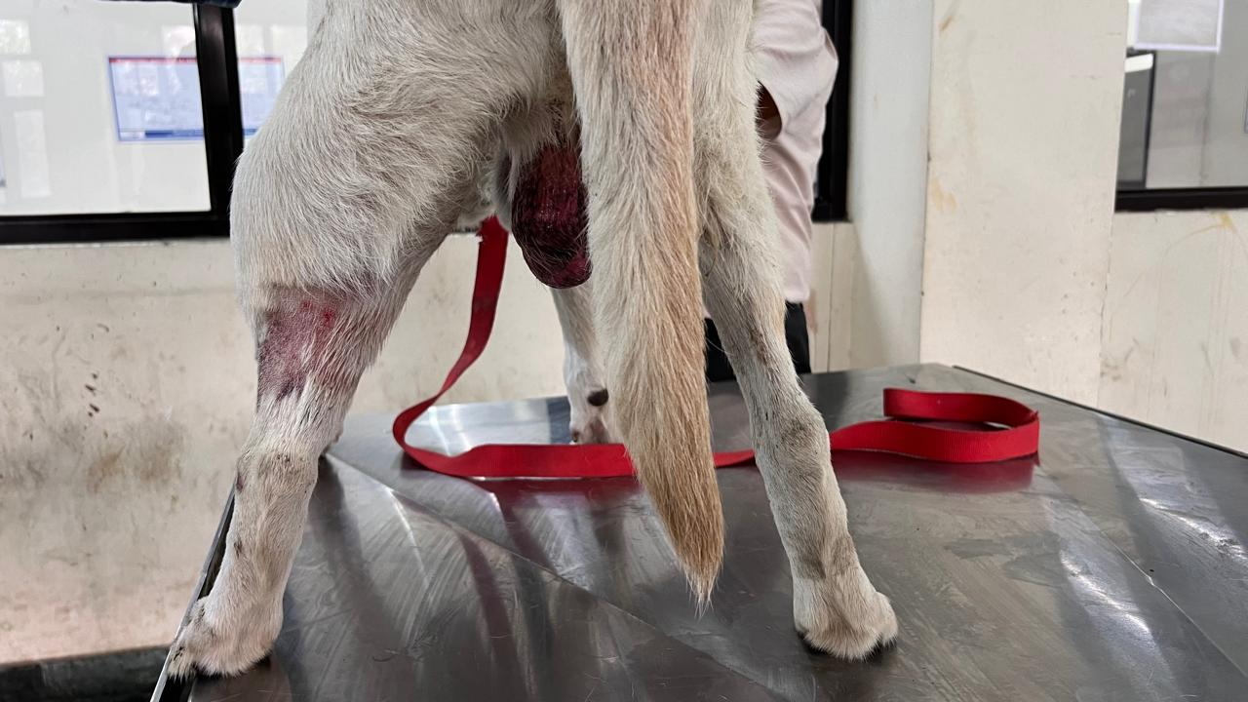
Fig. 2. Extensive swelling over left hind limb due to inadvertent KCL extravasation
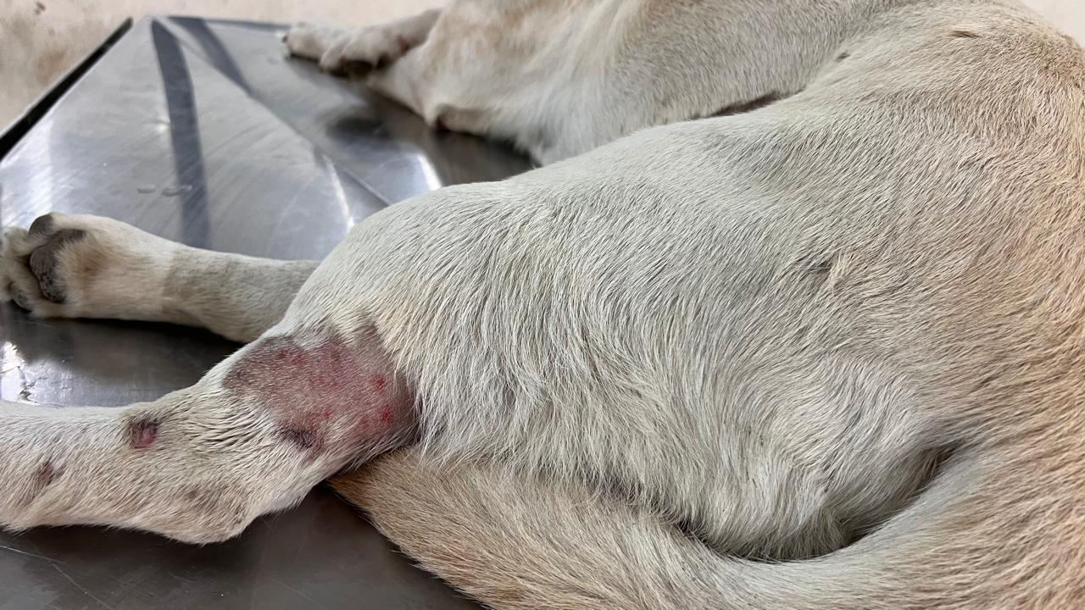
Fig. 3. Noticeable reduction in swelling and skin discoloration after 12 hours of initial lidocaine infiltration
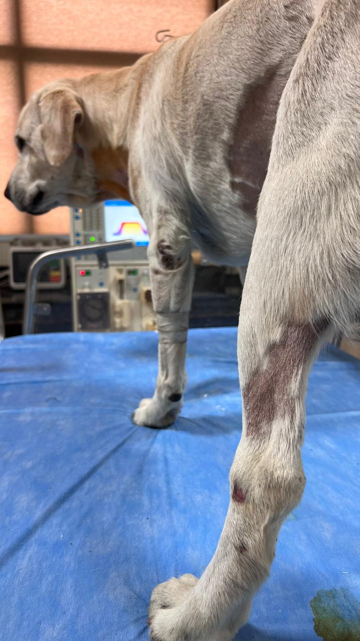
Fig. 4. Complete remission of swelling and skin discoloration after 24 hours.

- DISCUSSION
Potassium chloride (Kcl) is a commonly administered electrolyte in veterinary and human medicine, especially in the management of hypokalemia. However, its intravenous administration must be carefully monitored due to the risk of local tissue injury resulting from extravasation. Potassium chloride is a hyperosmotic and highly irritant solution that can cause significant damage to surrounding tissues when infused outside the vascular space, leading to complications such as cellulitis, tissue necrosis, ulceration, and, in severe cases, limb dysfunction or amputation (Yan,2021; Kim et al., 2020). In the present case, a Labrador retriever dog undergoing IHD developed hypokalemia (serum potassium: 2.1 mEq/L) following dialysis, which is a well-documented consequence of potassium removal during the hemodialysis process (Choi and Ha, 2022). Additional contributing factors may have included intracellular potassium shifting due to correction of acidosis and use of diuretics (Kardalas et al., 2020). To correct the hypokalemia, Kcl was administered via a peripheral vein using an infusion pump. However, unnoticed displacement of the intravenous catheter led to subcutaneous infusion of the potassium solution, resulting in localized swelling, erythema, and risk of tissue necrosis. Potassium chloride extravasation is particularly concerning due to its high osmolarity and the potential for direct cytotoxic effects. Clinical reports in human medicine highlight that tissue injury from potassium extravasation can occur within a short duration and may progress rapidly without appropriate intervention (Gabriel, 2007). In veterinary literature, however, detailed documentation of Kcl extravasation and its successful management is sparse, making this report one of the first of its kind in canines.
The management approach in this case emphasized rapid recognition and prompt intervention. After immediate cessation of the infusion and catheter removal, local subcutaneous infiltration of diluted lidocaine hydrochloride and normal saline was employed to dilute the extravagated KCl and minimize tissue irritation. This strategy aligns with recommendations from human medicine, where early local tissue irrigation and dilution have been shown to reduce the severity of soft tissue injury following vesicant extravasation (Gopalakrishnan et al., 2017; Alexander et al., 2009). Lidocaine, apart from providing local analgesia, may also offer vasodilation, potentially enhancing the clearance of the irritant solution from the site of injury (Mattsson et al., 2000). Clinical monitoring over the following 24 hours and 9 days revealed progressive resolution of inflammation, absence of necrosis, and eventual gradual healing of the affected skin area. The decision to avoid surgical intervention or topical magnesium sulfate therapy after signs of recovery appeared was based on clinical judgment and the positive response to conservative management. Similar conservative approaches have been validated in human extravasation cases involving irritants like calcium, hypertonic glucose, and Kcl (Corbett et al., 2018).This case also highlights the importance of using secure, well-monitored intravenous access, particularly when administering high-risk infusates. Central venous catheters are often preferable for delivering hyperosmolar solutions due to the larger vessel diameter and reduced risk of extravasation. In veterinary critical care settings, staff training, continuous infusion line monitoring, and the use of infusion pumps with pressure alarms may reduce the likelihood of such complications.
- Conclusion
This case report documents the successful conservative management of potassium chloride extravasation in a dog undergoing hemodialysis, utilizing local infiltration of lidocaine and saline to prevent tissue damage. It emphasizes the necessity for close intravenous site monitoring and highlights an effective, minimally invasive treatment strategy for early-stage extravasation injuries in veterinary patients. To our knowledge, this is the first canine case report demonstrating recovery from inadvertent Kcl extravasation managed without surgical intervention.
NOTE: include few references between 2021- 2024.
References
Al-Benna, S., O’boyle, C., & Holley, J. (2013). Extravasation injuries in adults. International Scholarly Research Notices, 2013(1), 856541.
Alexander, M., Corrigan, A., Gorski, L., Hankins, J., & Perucca, R. (2009). Infusion nursing: An evidence-based approach. Elsevier Health Sciences.
Choi, H. Y., & Ha, S. K. (2013). Potassium balances in maintenance hemodialysis. Electrolytes & Blood Pressure: E & BP, 11(1), 9.
Corbett, M., Marshall, D., Harden, M., Oddie, S., Phillips, R., & McGuire, W. (2018). Treatment of extravasation injuries in infants and young children: a scoping review and survey. Health technology assessment, 1-112.
Gabriel, J. (2007). Vesicant Extravasation Part II: Evidence-Based Management and Continuing Controversies. Journal of the Association for Vascular Access, 12(2), 68-68.
Ghanem, A. M., Mansour, A., Exton, R., Powell, J., Mashhadi, S., Bulstrode, N., & Smith, G. (2015). Childhood extravasation injuries: improved outcome following the introduction of hospital-wide guidelines. Journal of Plastic, Reconstructive & Aesthetic Surgery, 68(4), 505-518.
Gopalakrishnan, P. N., Goel, N., & Banerjee, S. (2017). Saline irrigation for the management of skin extravasation injury in neonates. Cochrane Database of Systematic Reviews, (7).
Goutos, I., Cogswell, L. K., & Giele, H. (2014). Extravasation injuries: a review. Journal of hand surgery (European volume), 39(8), 808-818.
Kardalas, E., Paschou, S. A., Anagnostis, P., Muscogiuri, G., Siasos, G., & Vryonidou, A. (2018). Hypokalemia: a clinical update. Endocrine connections, 7(4), R135-R146.
Kim, J. T., Park, J. Y., Lee, H. J., & Cheon, Y. J. (2020). Guidelines for the management of extravasation. Journal of educational evaluation for health professions, 17.
Le, A., & Patel, S. (2014). Extravasation of noncytotoxic drugs: a review of the literature. Annals of Pharmacotherapy, 48(7), 870-886.
Mattsson, U., Cassuto, J., Tarnow, P., Jönsson, A., & Jontell, M. (2000). Intravenous lidocaine infusion in the treatment of experimental human skin burns—digital colour image analysis of erythema development. Burns, 26(8), 710-715.
Rodan, A. R. (2017). Potassium: friend or foe?. Pediatric Nephrology, 32(7), 1109-1121.
Yan, G. (2021). Extravasation of concentrated potassium chloride: a case report. Current Therapeutic Research, 95, 100646.

