**Organic manure and biochar with inorganic fertilizer’s effect on growth dynamics and yield performance of rice (*Oryza sativa* L.)**

ABSTRACT

The study investigates the effects of organic manure, inorganic fertilizers and biochar on the yield attributes and yield of rice (*Oryzasativa* L.). The primary aim was to evaluate the comparative effectiveness of these soil amendments in improving rice production and their potential roles in sustainable agriculture. Organic manure, such as biochar and farmyard manure, was applied to enhance soil fertility, promoting beneficial soil microbial activity. Inorganic fertilizers, primarily nitrogen, phosphorus, and potassium (NPK), were used to supply essential nutrients directly, thus improving plant growth and development. Field trials were conducted over a growing season, with rice plants subjected to different treatment combinations: Organic manure alone, Inorganic fertilizers alone, Biochar alone, and various integrated combinations of these amendments. The parameters assessed included plant height, number of tillers, dry matter accumulation, panicle length, numberof grains panicle-1, and grain yield.The results showed that using both organic manure and inorganic fertilizers together significantly improved the growth parameters and yield attributes of rice, in comparison to using either treatment alone. Specifically, the synergistic effect of biochar with farmyard manure showed promising results in improving soil texture, increasing nutrient retention, and enhancing rice yield.The findings suggest that integrated soil management practices involving organic manure, inorganic fertilizers, and biochar could offer a sustainable alternative to conventional agricultural practices, fostering higher yields while mitigating environmental impacts.

**Keywords:**Organic manure,Biochar, Inorganic fertilizer, Rice, Sustainable agriculture.

**Introduction**

Rice (Oryza sativa L.) is a member of the grass family, Gramineae (Poaceae). As one of the three key food crops globally, it constitutes the staple diet for roughly half of the world's populace. Rice has been cultivated in India for a long time (Sangeetha et al., 2020). Rice serves as the principal food crop globally, providing the main dietary staple for roughly four billion individuals approximately half of all people on Earth. Its agricultural activities span about 160 million hectares across different climatic zones, ranging from 44°N in North Korea to 35°S in Australia. Rice is cultivated in regions that vary greatly in elevation, from about 2.7 meters below sea level, such as Kuttanad in India’s Kerala, to altitudes of 2,700 feet ASL in the foothills of the Himalayas. Rice is essential not just for agriculture; it holds a crucial role in the cultural and historical contexts of many Asian countries, as it is deeply intertwined with their traditions and heritage (NRRI-Bulletin, 2020).Application of organic manure has shown positive effects on rice yield by enhancing nutrient availability and promoting microbial activity. The use of organic manure raises the soil’s organic matter content, which enhances its ability to retain water and nutrients (Ghorbani et al., 2023). Inorganic fertilizers, including Nitrogen (N), Phosphorus (P), and Potassium (K) varieties, offer nutrients that are immediately accessible to plants. Proper application of inorganic fertilizers has shown significant increases in rice yield, especially when nutrient deficiencies are addressed (Bhatt et al., 2019). Biochar is produced through pyrolysis of waste plant materials. Application of Biochar to rice fields has yielded encouraging results regarding enhancement of soil fertility and enhancing crop productivity (Oladele et al., 2019). Biochar helps in keeping nutrients in the soil and lowering nutrient leaching, which enhances nutrient availability for rice plants. Due to its porous structure, biochar promotes helpful microbial activity in the soil, which enhances nutrient cycling and overall soil health. In the view of above facts, the present study entitled “organic manure and biochar with inorganic fertilizer’s effect on growth dynamics and yield performance of rice (Oryza sativa L.)’’.Impact of biochar on rice quality characteristic is limited, but its positive impact on soil fertility can indirectly contribute to improved grain quality (Hussain et al., 2017).

**MATERIALS AND METHODS**

This field experiment was conducted at the Agronomy Research Farm in Nawabganj, part of the Department of Soil Science at Chandra Shekhar Azad University of Agriculture & Technology in Kanpur, during the Kharif season of 2023 and 2024. The soil of experimental field is classified within the soil order of Inceptisols. It is sandy loam in texture and neutral to alkaline in soil reaction. The sixteen treatments were used with three replicates and each consisted of a **T1–** Control**T2** - 50% RDF**T3** - 75% RDF**T4** - 100% RDF**T5** - 50%RDF +5.0 tonnes ha-1 FYM + 5.0 kg Zinc **T6** - 75%RDF +5.0 tonnes ha-1 FYM + 5.0 kg Zinc**T7** - 100%RDF +5.0 tonnes ha-1 FYM + 5.0 kg Zinc**T8** - 50%RDF +5.0 tonnes ha-1 FYM + Biochar **T9** - 75% RDF +5.0 tonnes ha-1FYM + Biochar**T10** - 100%RDF +5.0 tonnes ha-1FYM + Biochar**T11** - 50%RDF +5.0 tonnes ha-1FYM + 5.0 kg Zinc + Biochar**T12** - 75%RDF +5.0 tonnes ha-1FYM + 5.0 kg Zinc + Biochar**T13** - 100%RDF +5.0 tonnes ha-1 FYM + 5.0 kg Zinc + Biochar**T14** - 5.0 tonnes ha-1FYM + 5.0 kg Zinc**T15** - 5.0 tonnes ha-1FYM + Biochar**T16** - 5.0 tonnesha-1 FYM + 5.0 kg Zinc + Biochar, with Rice (27P37) crop having a plot size 4 x 5 m. Each treatment was replicated three times and organized using a Randomized Block Design (RBD). After thorough field preparation, initial soil samples were collected to analyze the initial soil properties. The available major nutrients in the initial soil sample were analyzed; N, P, K, Zn, OC, pH and EC. The field used for the experiment had a pH of 8.09, EC 0.32 dSm-1, CEC (Cmol (p+) kg-1) 39.38 and0.40% organic carbon. The experimental field had a low N status (203 kg ha-1), medium available P(12.80 kg ha-1), lower available K (195 kg ha-1) and Zn (0.63 mg kg-1).All treatments, including Biochar and FYM were assigned to the plots at random and uniformly mixed into the soil to a depth of 10 cm 15 days prior to transplanting the rice seedlings, after which submergence occurred. Prior to puddling, one-third of the nitrogen (from urea) was applied as a basal treatment, together with full doses of potash and phosphorus. This was mixed into the soil to a depth of 15 cm. The remaining nitrogen was supplied as a top-dressing in two applications of urea, during the tillering and panicle initiation stages. The trial utilized the rice variety 27P37, planted with a spacing of 20 × 10 cm. The crop was manually harvested from each plot once the grains had attained physiological maturity. When around 85% of the panicles contained about 85% ripened spikelets and the upper part of the spikelets had changed to a straw colour, harvesting was carried out with serrated-edge sickles. During the harvest, yields of straw and seed were noted. Plant samples were gathered for the chemical analysis of nitrogen, phosphorus, potassium, and zinc in both seed and straw samples. N was assessed by Alkaline Permagnate method (Subbiah and Asija, 1956), for the available P soil samples were taken using 0.5 M NaHCO3 (pH = 8.5) as per Olsen et al. (1954) and the P content in the extracts was measured by vanado - molybdo phosphoric acid yellow colour method Jackson's method (1973). K that is available was determined by Flame photometer method (Toth and Prince, 1949) and Available Zn was determined by DTPA method (Lindsay and Norvell, 1978).

**RESULTS AND DISCUSSION**

**Crop Growth Characters:** The data presented in the tables (1, 2, 3) that the analysis of crop growth parameters in rice across different treatments revealed significant variations, with treatment T13 (100% RDF + 5 t ha-1 FYM + 5 kg Zn + Biochar) consistently outperforming other treatments. The highest plant height (115.32 cm in 2023 and 116.87 cm in 2024) and pooled basis is 116.09 cm, number of tillers (401.13 m-2 in 2023 and 404.45 m-2in 2024 at 90 DAT)number of tillers pooled basis is 402.79 m-2 and dry matter accumulation (874.36 g m-2in 2023 and 880.03 g m-2in 2024)and pooled basis is 877.19 g m-2were recorded under T13. These findings indicate that integrated nutrient management combining organic, inorganic, and biochar inputs promotes superior vegetative growth in rice.

The observed increase in plant height and tiller number can be attributed to improved nutrient availability and soil health due to the synergistic effect of FYM, zinc, and biochar (Singh et al., 2021). Organic amendments enhance microbial activity and nutrient cycling, while biochar improves soil structure, nutrient use efficiency and water retention (Yadav et al., 2020). Moreover, the substantial rise in dry matter accumulation under T13 suggests better photosynthetic efficiency and biomass partitioning, as supported by Kumar et al. (2019), who reported similar trends under integrated nutrient treatments. These results align with Patel et al. (2022), who emphasized that integrated use of nutrients not only sustains growth parameters but also ensures long-term soil productivity and crop resilience.

**Yield and Yield attributes:**

The data presented in the table 4 clearly reveal that the integrated application of organic (FYM), inorganic (RDF and zinc), and biochar significantly influenced all the yield attributes of the crop over the two-year study (2023–2024). Panicle length, number of grains panicle-1, test weight and effective tillers showed a consistent increasing trend with the progressive integration of nutrient management. The maximum panicle length (35.10 cm in 2023 and 35.34 cm in 2024) and pooled basis is 35.22 cm, number of grains per panicle-1 (179 in 2023 and 182in 2024) and pooled basis is 181.50, test weight(23.54gin 2023 and 23.64 g in 2024) test weight on the pooled basis is 23.59gand effective tillers (354m-2in 2023 and 358 m-2in 2024) and pooled basis is 356m-2 were recorded in treatment T13 (100% RDF + 5 t ha-1 FYM + 5 kg Zn + biochar), which was significantly higher than the control (T1). This result demonstrates the beneficial role of combined nutrient sources in improving the reproductive growth of the crop. The two-year study period (2023–2024), corroborating findings by Yadav et al. (2020), who reported similar enhancements in yield components under integrated nutrient management. The application of RDF alone (T4) improved the attributes over the control but was still inferior to treatments involving organic supplements and micronutrients.Among the integrated treatments, T12 and T11 (involving 75% and 50% RDF with FYM, Zn, and biochar) also performed considerably well, indicating that even partial substitution of RDF with organic and micronutrient inputs can enhance grain formation and quality (Patel et al., 2022).

**Biological Yield and Harvest Index**

The data presented in the table 5that the biological yield increased progressively with nutrient enrichment, reaching a maximum in treatment T13(143.84 q ha-1in 2023 and 144.64 q ha-1in 2024) and pooled data is 144.24q ha-1, significantly outperforming the control T1 (75.72 q ha-1in 2023 and 76.22 q ha-1 in 2024)) and pooled basis is 75.97q ha-1.This improvement can be attributed to the synergistic effect of inorganic and organic inputs, especially when enriched with biochar and micronutrients like zinc, which enhance plant growth and productivity (Yadav et al., 2017). Similarly, treatments T12 and T10 also recorded high biological yields (140.95 and 136.12 q ha-1, respectively), showing the beneficial role of integrated nutrient supply.

The harvest index (HI), which reflects the efficiency of biomass conversion to economic yield, ranged from 46.93% in control to 48.79% in T10. While the HI did not vary as much as biological yield, the slight increase under integrated treatments indicates better partitioning of assimilates towards grain production, consistent with findings by Choudhary et al. (2016). The highest HI was observed in T13 (49.06%), followed closely by T12, T11, and T09, indicating positive contributions from organic amendments and biochar.

**CONCLUSION**

The present study clearly demonstrates that integrated nutrient management (INM), involving a combination of chemical fertilizers (RDF), farmyard manure (FYM), zinc, and biochar, significantly enhances crop performance and improves soil health. Among all treatments, the application of 100% RDF + 5.0 tonnes ha-1 FYM + 5.0 kg ha-1Zn + biochar (T13) consistently recorded the highest values for key yield attributes such as panicle length, grain number, grain and test weight, biological yield (144.64 q ha-1), and harvest index (48.35%). These findings suggest that biochar, when combined with RDF, FYM, and zinc, enhances nutrient use efficiency, boosts yield potential, and contributes to sustainable soil management. The improved performance under INM treatments validates the synergy of organic and inorganic inputs, making it a viable approach for achieving long-term productivity and ecological balance in rice-based cropping systems. Thus, adopting integrated strategies is essential for enhancing agricultural sustainability and resource-use efficiency.

**REFERENCES**

Bhatt, M. K., Labanya, R., & Joshi, H. C. (2019). Influence of long-term chemical fertilizers and organic manures on soil fertility-A review. Universal Journal of Agricultural Research, 7(5), 177-188.

Choudhary, A. K., Suri, V. K., & Chaudhari, S. K. (2016). Integrated nutrient management for sustainable agriculture and soil health. Indian Journal of Agronomy, 61(4), 265–273.

Ghorbani, M., Neugschwandtner, R. W., Konvalina, P., Asadi, H., Kopecký, M., &Amirahmadi, E. (2023). Comparative effects of biochar and compost applications on water holding capacity and crop yield of rice under evaporation stress: A two-years field study. Paddy and Water Environment, 21(1), 47-58.

Hussain, M., Farooq, M., Nawaz, A., Al-Sadi, A. M., Solaiman, Z. M., Alghamdi, S. S & Siddique, K. H. (2017). Biochar for crop production: potential benefits and risks. Journal of Soils and Sediments, 17, 685-716.

NRRIResearchBulletinNo.22(2020)https://icar-nrri.in/wpcontent/uploads/2020/05/NRRI-Research-Bulletin-22.

Kumar, P., Sharma, S., & Verma, A. (2019). Role of zinc and organic amendments in enhancing rice productivity. Indian Journal of Agronomy, 64(4), 398–404.

Nandy, S.N., Dhyani, P.P. and Samal, P.K., 2006. Resource information database of the Indian Himalaya (pp. 27-30). Almora: Environmental Information System on Himalayan Ecology, GP Institute of Himalayan Environment and Development.

Oladele, S. O., Adeyemo, A. J., &Awodun, M. A. (2019). Influence of rice husk biochar and inorganic fertilizer on soil nutrients availability and rain-fed rice yield in two contrasting soils. Geoderma, 336, 1-11.

Patel, D., Jat, R.K., & Solanki, N.S. (2022). Optimizing nutrient use in rice through integrated approaches. International Journal of Agriculture Sciences, 14(3), 22-28.

Riaz, M., Khalid, M., Batool, A., Abbas, A., Amjad, I., Kashif, M., & Shakeel, A. (2024). Hybrid rice suitability and future prospects. Journal of Physical, Biomedical and Biological Sciences, 2024(1), 32-32.

Sangeetha, J., Thangadurai, D., Fayeun, L. S., Akinwale, J. A., Habeeb, J., Maxim, S. S., ... & Islam, S. (2020). Origin and evolution of rice as domesticated food crop. Rice Research for Quality Improvement: Genomics and Genetic Engineering: Volume 1: Breeding Techniques and Abiotic Stress Tolerance, 1-14.

Yadav, R.K., Meena, V.S., & Lal, B. (2020). Integrated nutrient management in rice for improving yield and soil fertility. Journal of Plant Nutrition, 43(2), 245-255.

Yadav, R. L., Dwivedi, B. S., & Prasad, K. (2017). Integrated nutrient management for sustaining crop productivity and improving soil health in intensively cultivated systems. Indian Journal of Fertilisers, 13(6), 40–52.

|  |  |  |  |  |  |  |  |  |  |  |  |  |  |
| --- | --- | --- | --- | --- | --- | --- | --- | --- | --- | --- | --- | --- | --- |
| Treatments | | **Plant height (cm)** | | | | | | | | | | | |
| **2023** | **2024** | **Mean** | **2023** | **2024** | **Mean** | **2023** | **2024** | **Mean** | **2023** | **2024** | **Mean** |
| **30 DAT** | **30 DAT** | **60 DAT** | **60 DAT** | **90 DAT** | **90 DAT** | **At Harvest** | **At Harvest** |
| **T1** | Control | 47.90 | 49.70 | 48.8 | 80.74 | 81.74 | 81.24 | 92.92 | 93.92 | 93.42 | 92.96 | 96.06 | 94.51 |
| **T2** | 50% RDF | 48.58 | 50.45 | 49.51 | 81.74 | 82.34 | 82.04 | 93.02 | 94.02 | 93.52 | 93.04 | 97.24 | 95.14 |
| **T3** | 75% RDF | 50.15 | 51.15 | 50.65 | 82.05 | 83.15 | 82.60 | 93.47 | 95.47 | 94.47 | 93.95 | 98.05 | 96 |
| **T4** | 100%RDF | 51.70 | 52.40 | 52.05 | 83.66 | 83.66 | 83.66 | 94.66 | 96.60 | 95.63 | 94.87 | 99.97 | 97.42 |
| **T5** | 50% RDF +5.0 tonnes ha-1 FYM + 5.0 kg Zinc | 52.25 | 53.25 | 52.75 | 84.76 | 84.76 | 84.76 | 96.46 | 97.46 | 96.96 | 97.21 | 99.21 | 98.21 |
| **T6** | 75% RDF +5.0 tonnes ha-1 FYM + 5.0 kg Zinc | 51.81 | 52.81 | 52.31 | 85.00 | 85.80 | 85.40 | 98.93 | 100.93 | 99.93 | 99.01 | 101.01 | 100.01 |
| **T7** | 100% RDF +5.0 tonnes ha-1 FYM + 5.0 kg Zinc | 52.35 | 53.38 | 52.86 | 86.96 | 87.96 | 87.46 | 99.88 | 103.88 | 101.88 | 101.00 | 104.00 | 102.5 |
| **T8** | 50% RDF +5.0 tonnes ha-1 FYM + Biochar | 53.50 | 54.56 | 54.03 | 88.06 | 88.56 | 88.31 | 100.43 | 105.43 | 102.93 | 103.51 | 106.51 | 105.01 |
| **T9** | 75% RDF +5.0 tonnes ha-1 FYM + Biochar | 54.05 | 54.65 | 54.35 | 91.89 | 91.69 | 91.79 | 101.13 | 107.13 | 104.13 | 105.44 | 109.14 | 107.29 |
| **T10** | 100% RDF +5.0 tonnes ha-1 FYM + Biochar | 55.62 | 56.84 | 56.23 | 93.68 | 94.66 | 94.17 | 102.64 | 109.94 | 106.29 | 107.83 | 111.33 | 109.58 |
| **T11** | 50% RDF +5.0 tonnes ha-1 FYM + 5.0 kg Zinc + Biochar | 56.01 | 57.31 | 56.66 | 95.98 | 95.00 | 95.49 | 103.11 | 110.91 | 107.01 | 109.37 | 112.95 | 111.16 |
| **T12** | 75% RDF +5.0 tonnes ha-1 FYM + 5.0 kg Zinc + Biochar | 55.62 | 57.62 | 56.62 | 97.68 | 97.89 | 97.78 | 104.21 | 112.21 | 108.21 | 112.34 | 114.74 | 113.54 |
| **T13** | 100% RDF +5.0 tonnes ha-1 FYM + 5.0 kg Zinc + Biochar | 57.35 | 58.27 | 57.81 | 100.68 | 101.98 | 101.33 | 106.13 | 113.13 | 109.63 | 115.32 | 116.87 | 116.09 |
| **T14** | 5.0 tonnes ha-1 FYM + 5.0 kg Zinc | 48.20 | 49.70 | 48.95 | 81.24 | 81.74 | 81.49 | 93.02 | 93.92 | 93.47 | 93.76 | 96.06 | 94.91 |
| **T15** | 5.0 tonnes ha-1 FYM + Biochar | 49.32 | 50.32 | 49.82 | 82.74 | 83.04 | 82.89 | 93.92 | 94.09 | 94.005 | 94.34 | 96.74 | 95.54 |
| **T16** | 5.0 tonnes ha-1 FYM + 5.0 kg Zinc + Biochar | 51.22 | 51.82 | 51.52 | 83.55 | 84.45 | 84.00 | 95.18 | 95.87 | 95.525 | 96.24 | 97.54 | 96.89 |
|  | C.D. | 6.25 | 5.05 | 4.95 | 4.95 | 9.57 | 8.34 | 9.03 | 11.85 | 10.57 | 10.39 | 9.68 | 11.61 |
|  | SEM | 2.16 | 1.75 | 1.72 | 1.72 | 3.31 | 2.89 | 3.12 | 4.10 | 3.66 | 3.60 | 3.35 | 4.02 |
|  | SED | 3.06 | 2.47 | 2.43 | 2.43 | 4.69 | 4.08 | 4.42 | 5.80 | 5.18 | 5.09 | 4.74 | 5.68 |
|  | C.V. | 7.17% | 5.67% | 5.62% | 5.62% | 6.52% | 5.70% | 5.52% | 7.00% | 6.35% | 6.19% | 5.60% | 6.82% |

**Table 1:- Effect of organic manure, inorganic fertilizer and biochar on plant height (cm) at various growth stages of rice during 2023 and 2024**

**Table 2:-Effect of organic manure, inorganic fertilizer and biochar on number of tillers (m-2) at 30, 60, 90 DAT and at harvest of riceduring 2023 and 2024**

|  |  |  |  |  |  |  |  |  |  |  |  |  |  |
| --- | --- | --- | --- | --- | --- | --- | --- | --- | --- | --- | --- | --- | --- |
| Treatments | | **Number of tillers (m-2)** | | | | | | | | | | | |
| **2023** | **2024** | **Mean** | **2023** | **2024** | **Mean** | **2023** | **2024** | **Mean** | **2023** | **2024** | **Mean** |
| **30 DAT** | **30 DAT** | **60 DAT** | **60 DAT** | **90 DAT** | **90 DAT** | **At Harvest** | **At Harvest** |
| **T1** | Control | 180.43 | 181.63 | 181.03 | 256.37 | 258.07 | 257.22 | 264.78 | 266.88 | 265.83 | 252.43 | 255.43 | 253.93 |
| **T2** | 50% RDF | 184.65 | 186.45 | 185.55 | 260.14 | 262.32 | 261.23 | 269.72 | 271.52 | 270.62 | 257.32 | 259.22 | 258.27 |
| **T3** | 75% RDF | 188.07 | 190.17 | 189.12 | 274.03 | 276.03 | 275.03 | 283.21 | 285.21 | 284.21 | 273.47 | 276.07 | 274.77 |
| **T4** | 100%RDF | 191.23 | 193.23 | 192.23 | 292.63 | 294.62 | 293.62 | 299.01 | 301.21 | 300.11 | 291.84 | 293.24 | 292.54 |
| **T5** | 50% RDF +5.0 tonnes ha-1 FYM + 5.0 kg Zinc | 189.60 | 191.90 | 190.75 | 278.82 | 280.72 | 279.77 | 298.11 | 300.21 | 299.16 | 276.61 | 278.71 | 277.66 |
| **T6** | 75% RDF +5.0 tonnes ha-1 FYM + 5.0 kg Zinc | 196.67 | 198.47 | 197.57 | 301.18 | 303.28 | 302.23 | 311.12 | 312.12 | 311.62 | 299.31 | 301.81 | 300.56 |
| **T7** | 100% RDF +5.0 tonnes ha-1 FYM + 5.0 kg Zinc | 199.54 | 201.24 | 200.39 | 307.26 | 309.26 | 308.26 | 320.02 | 322.02 | 321.02 | 304.28 | 306.28 | 305.28 |
| **T8** | 50% RDF +5.0 tonnes ha-1 FYM + Biochar | 196.20 | 198.20 | 197.2 | 302.87 | 304.37 | 303.62 | 318.33 | 320.63 | 319.48 | 301.20 | 303.24 | 302.22 |
| **T9** | 75% RDF +5.0 tonnes ha-1 FYM + Biochar | 201.42 | 203.32 | 202.37 | 310.57 | 312.27 | 311.42 | 329.76 | 331.56 | 330.66 | 306.48 | 308.88 | 307.68 |
| **T10** | 100% RDF +5.0 tonnes ha-1 FYM + Biochar | 208.11 | 210.41 | 209.26 | 316.98 | 318.98 | 317.98 | 337.84 | 339.84 | 338.84 | 312.67 | 315.17 | 313.92 |
| **T11** | 50% RDF +5.0 tonnes ha-1 FYM + 5.0 kg Zinc + Biochar | 219.10 | 221.10 | 220.1 | 336.43 | 338.47 | 337.45 | 364.63 | 366.74 | 365.68 | 329.30 | 331.35 | 330.32 |
| **T12** | 75% RDF +5.0 tonnes ha-1 FYM + 5.0 kg Zinc + Biochar | 226.20 | 229.20 | 227.7 | 351.34 | 354.34 | 352.84 | 384.31 | 387.31 | 385.81 | 350.61 | 353.61 | 352.11 |
| **T13** | 100% RDF +5.0 tonnes ha-1 FYM + 5.0 kg Zinc + Biochar | 235.36 | 238.36 | 236.86 | 376.38 | 380.65 | 378.51 | 401.13 | 404.45 | 402.79 | 375.51 | 378.34 | 376.92 |
| **T14** | 5.0 tonnes ha-1 FYM + 5.0 kg Zinc | 182.54 | 184.24 | 183.39 | 255.37 | 257.32 | 256.34 | 270.02 | 273.22 | 271.62 | 254.28 | 256.38 | 255.33 |
| **T15** | 5.0 tonnes ha-1 FYM + Biochar | 187.45 | 189.45 | 188.45 | 263.57 | 266.51 | 265.04 | 283.53 | 285.13 | 284.33 | 261.20 | 264.22 | 262.71 |
| **T16** | 5.0 tonnes ha-1 FYM + 5.0 kg Zinc + Biochar | 192.12 | 195.12 | 193.62 | 273.66 | 273.66 | 273.66 | 285.34 | 288.34 | 286.84 | 271.13 | 272.46 | 271.79 |
|  | C.D. | 17.03 | 18.33 | 18.73 | 36.27 | 26.66 | 27.90 | 27.10 | 28.18 | 30.65 | 32.08 | 36.47 | 29.38 |
|  | SEM | 5.90 | 6.35 | 6.49 | 15.56 | 9.23 | 9.66 | 9.38 | 9.76 | 10.61 | 11.11 | 12.63 | 10.17 |
|  | SED | 8.34 | 8.98 | 9.17 | 17.76 | 13.06 | 13.66 | 13.27 | 13.80 | 15.01 | 15.71 | 17.86 | 14.38 |
|  | C.V. | 5.14% | 5.48% | 5.63% | 7.32% | 5.34% | 5.61% | 5.18% | 5.35% | 5.84% | 6.51% | 7.36% | 5.95% |

|  |  |  |  |  |  |  |  |  |  |  |  |  |  |
| --- | --- | --- | --- | --- | --- | --- | --- | --- | --- | --- | --- | --- | --- |
| Treatments | | **Dry matter accumulation (g m-2)** | | | | | | | | | | | |
| **2023** | **2024** | **Mean** | **2023** | **2024** | **Mean** | **2023** | **2024** | **Mean** | **2023** | **2024** | **Mean** |
| **30 DAT** | **30 DAT** | **60 DAT** | **60 DAT** | **90 DAT** | **90 DAT** | **At Harvest** | **At Harvest** |
| **T1** | Control | 243.29 | 245.29 | 244.29 | 341.56 | 344.50 | 343.03 | 458.34 | 462.34 | 460.34 | 668.02 | 675.02 | 671.52 |
| **T2** | 50% RDF | 256.23 | 258.23 | 257.23 | 359.06 | 361.26 | 360.16 | 467.65 | 470.21 | 468.93 | 674.06 | 679.06 | 676.56 |
| **T3** | 75% RDF | 260.67 | 262.07 | 261.37 | 364.75 | 367.25 | 366.00 | 478.51 | 482.51 | 480.51 | 683.53 | 689.13 | 686.33 |
| **T4** | 100%RDF | 268.47 | 270.57 | 269.52 | 379.52 | 382.12 | 380.82 | 501.47 | 505.07 | 503.27 | 703.27 | 709.37 | 706.32 |
| **T5** | 50% RDF +5.0 tonnes ha-1 FYM + 5.0 kg Zinc | 266.79 | 268.79 | 267.79 | 376.70 | 379.30 | 378.00 | 490.34 | 494.24 | 492.29 | 701.29 | 707.00 | 704.14 |
| **T6** | 75% RDF +5.0 tonnes ha-1 FYM + 5.0 kg Zinc | 274.24 | 276.93 | 275.58 | 386.63 | 389.60 | 388.11 | 523.34 | 527.32 | 525.33 | 738.08 | 744.21 | 741.14 |
| **T7** | 100% RDF +5.0 tonnes ha-1 FYM + 5.0 kg Zinc | 287.96 | 289.35 | 288.65 | 428.27 | 431.62 | 429.94 | 608.76 | 612.26 | 610.51 | 789.56 | 795.01 | 792.28 |
| **T8** | 50% RDF +5.0 tonnes ha-1 FYM + Biochar | 276.34 | 278.04 | 277.19 | 400.80 | 403.20 | 402.00 | 601.60 | 604.50 | 603.05 | 761.66 | 767.05 | 764.35 |
| **T9** | 75% RDF +5.0 tonnes ha-1 FYM + Biochar | 293.70 | 295.36 | 294.53 | 448.23 | 451.33 | 449.78 | 622.62 | 624.22 | 623.42 | 821.42 | 826.02 | 823.72 |
| **T10** | 100% RDF +5.0 tonnes ha-1 FYM + Biochar | 300.36 | 302.21 | 301.28 | 416.67 | 419.23 | 417.95 | 648.33 | 652.13 | 670.5 | 856.21 | 862.01 | 859.11 |
| **T11** | 50% RDF +5.0 tonnes ha-1 FYM + 5.0 kg Zinc + Biochar | 294.69 | 296.28 | 295.48 | 403.62 | 406.12 | 404.87 | 646.70 | 650.10 | 648.4 | 845.59 | 851.50 | 848.54 |
| **T12** | 75% RDF +5.0 tonnes ha-1 FYM + 5.0 kg Zinc + Biochar | 310.58 | 312.58 | 311.58 | 456.56 | 459.64 | 458.10 | 639.49 | 643.40 | 641.44 | 857.12 | 863.36 | 860.24 |
| **T13** | 100% RDF +5.0 tonnes ha-1 FYM + 5.0 kg Zinc + Biochar | 326.39 | 328.23 | 327.31 | 472.73 | 475.01 | 473.87 | 668.79 | 672.21 | 650.23 | 874.36 | 880.03 | 877.19 |
| **T14** | 5.0 tonnes ha-1 FYM + 5.0 kg Zinc | 252.41 | 254.01 | 253.21 | 363.52 | 366.47 | 364.99 | 463.47 | 467.24 | 465.35 | 670.48 | 676.40 | 673.44 |
| **T15** | 5.0 tonnes ha-1 FYM + Biochar | 261.39 | 263.17 | 262.28 | 370.32 | 373.02 | 371.67 | 472.29 | 476.15 | 474.22 | 685.59 | 691.32 | 688.45 |
| **T16** | 5.0 tonnes ha-1 FYM + 5.0 kg Zinc + Biochar | 264.57 | 266.02 | 265.29 | 379.63 | 382.24 | 380.93 | 478.65 | 482.15 | 480.4 | 696.18 | 701.06 | 698.62 |
|  | C.D. | 28.49 | 30.76 | 20.59 | 35.50 | 43.26 | 37.37 | 49.56 | 58.45 | 53.31 | 70.61 | 73.70 | 82.11 |
|  | SEM | 9.87 | 10.65 | 9.24 | 12.29 | 14.98 | 12.94 | 17.16 | 20.24 | 18.46 | 24.45 | 25.52 | 28.43 |
|  | SED | 13.95 | 15.06 | 13.07 | 17.38 | 21.18 | 18.30 | 24.27 | 28.62 | 26.10 | 34.58 | 36.08 | 40.21 |
|  | C.V. | 6.16% | 6.61% | 5.75% | 5.37% | 6.49% | 5.63% | 5.42% | 6.45% | 5.81% | 5.63% | 5.84% | 6.53% |

**Table 3:- Effect of organic manure, inorganic fertilizer and biochar on dry matter accumulation (g m-2) at various growth stages of rice during 2023 and 2024**

|  |  |  |  |  |  |  |  |  |  |  |  |  |  |
| --- | --- | --- | --- | --- | --- | --- | --- | --- | --- | --- | --- | --- | --- |
| Treatments | | **Yield Attributes** | | | | | | | | | | | |
| **Panicle length (cm)** | | **Mean** | **Number of grainspanicle-1** | | **Mean** | **Test weight (g)** | | **Mean** | **Number of effective tillers (m-2)** | | **Mean** |
| **2023** | **2024** | **2023** | **2024** | **2023** | **2024** | **2023** | **2024** |
| **T1** | Control | 30.10 | 30.18 | 30.14 | 105 | 106 | 105.50 | 20.10 | 20.15 | 20.125 | 235 | 237 | 236 |
| **T2** | 50% RDF | 30.62 | 30.76 | 30.69 | 119 | 123 | 121.00 | 21.20 | 21.26 | 21.23 | 249 | 253 | 251 |
| **T3** | 75% RDF | 31.20 | 31.33 | 31.26 | 128 | 132 | 130.00 | 21.42 | 21.48 | 21.45 | 276 | 278 | 277 |
| **T4** | 100%RDF | 32.10 | 32.15 | 32.12 | 135 | 138 | 136.50 | 21.61 | 21.67 | 21.64 | 279 | 281 | 280 |
| **T5** | 50% RDF +5.0 tonnes ha-1 FYM + 5.0 kg Zinc | 31.30 | 31.45 | 31.37 | 132 | 136 | 134.00 | 21.58 | 21.64 | 21.61 | 281 | 283 | 282 |
| **T6** | 75% RDF +5.0 tonnes ha-1 FYM + 5.0 kg Zinc | 31.60 | 31.87 | 31.73 | 141 | 144 | 142.50 | 21.86 | 21.92 | 21.89 | 297 | 299 | 298 |
| **T7** | 100% RDF +5.0 tonnes ha-1 FYM + 5.0 kg Zinc | 32.32 | 32.78 | 32.55 | 148 | 152 | 150.00 | 22.04 | 22.11 | 22.075 | 300 | 302 | 301 |
| **T8** | 50% RDF +5.0 tonnes ha-1 FYM + Biochar | 32.21 | 32.45 | 32.33 | 142 | 147 | 144.50 | 22.00 | 22.18 | 22.09 | 305 | 308 | 306.5 |
| **T9** | 75% RDF +5.0 tonnes ha-1 FYM + Biochar | 32.78 | 32.97 | 32.87 | 152 | 156 | 154.00 | 22.25 | 22.35 | 22.3 | 316 | 319 | 317.5 |
| **T10** | 100% RDF +5.0 tonnes ha-1 FYM + Biochar | 33.50 | 33.67 | 33.58 | 159 | 163 | 161.00 | 22.64 | 22.69 | 22.665 | 330 | 336 | 333 |
| **T11** | 50% RDF +5.0 tonnes ha-1 FYM + 5.0 kg Zinc + Biochar | 33.40 | 33.89 | 33.64 | 157 | 160 | 158.50 | 22.87 | 22.97 | 22.92 | 339 | 343 | 341 |
| **T12** | 75% RDF +5.0 tonnes ha-1 FYM + 5.0 kg Zinc + Biochar | 34.32 | 34.65 | 34.48 | 168 | 171 | 169.50 | 23.12 | 23.21 | 23.165 | 347 | 351 | 349 |
| **T13** | 100% RDF +5.0 tonnes ha-1 FYM + 5.0 kg Zinc + Biochar | 35.10 | 35.34 | 35.22 | 179 | 182 | 180.50 | 23.54 | 23.64 | 23.59 | 354 | 358 | 356 |
| **T14** | 5.0 tonnes ha-1 FYM + 5.0 kg Zinc | 30.50 | 30.78 | 30.64 | 108 | 112 | 110.00 | 20.97 | 21.02 | 20.995 | 290 | 296 | 293 |
| **T15** | 5.0 tonnes ha-1 FYM + Biochar | 30.89 | 31.09 | 30.99 | 117 | 119 | 118.00 | 21.20 | 21.25 | 21.225 | 302 | 307 | 304.5 |
| **T16** | 5.0 tonnes ha-1 FYM + 5.0 kg Zinc + Biochar | 31.54 | 31.86 | 31.70 | 126 | 128 | 127.00 | 21.88 | 21.98 | 21.93 | 311 | 316 | 313.5 |
|  | C.D. | 3.56 | 4.73 | 3.63 | 14.95 | 12.28 | 14.67 | 2.73 | 2.05 | 2.34 | 43.63 | 31.33 | 37.55 |
|  | SEM | 1.23 | 1.64 | 1.26 | 5.18 | 4.46 | 6.88 | 0.96 | 0.71 | 0.81 | 15.11 | 10.85 | 13.00 |
|  | SED | 1.74 | 2.31 | 1.78 | 7.32 | 6.31 | 7.25 | 1.36 | 1.00 | 1.15 | 21.37 | 15.34 | 18.39 |
|  | C.V. | 6.65% | 8.77% | 6.75% | 6.47% | 5.45% | 6.48% | 7.63% | 5.60% | 6.40% | 8.70% | 6.18% | 7.45% |

**Table 4:-Effect of organic manure, inorganic fertilizer and Biochar on Yieldattributes of rice during 2023 and 2024**

|  |  |  |  |  |  |  |  |  |  |  |  |  |  |
| --- | --- | --- | --- | --- | --- | --- | --- | --- | --- | --- | --- | --- | --- |
| Treatments | | **Yield Studies** | | | | | | | | | | | |
| **Grain yield (q ha-1)** | | **Mean** | **Straw yield (q ha-1)** | | **Mean** | **Biological yield**  **(q ha-1)** | | **Mean** | **Harvest Index**  **(%)** | | **Mean** |
| **2023** | **2024** | **2023** | **2024** | **2023** | **2024** | **2023** | **2024** |
| **T1** | Control | 35.11 | 35.98 | 35.545 | 40.12 | 40.24 | 40.18 | 75.23 | 76.22 | 75.72 | 46.67 | 47.20 | 46.93 |
| **T2** | 50% RDF | 45.75 | 46.11 | 45.93 | 50.32 | 51.08 | 50.7 | 96.07 | 97.19 | 96.63 | 47.62 | 47.44 | 47.53 |
| **T3** | 75% RDF | 54.76 | 55.06 | 54.91 | 58.98 | 60.30 | 59.64 | 113.74 | 115.36 | 114.55 | 48.14 | 47.72 | 47.93 |
| **T4** | 100%RDF | 62.56 | 63.34 | 62.95 | 67.01 | 68.35 | 67.68 | 129.57 | 131.69 | 130.63 | 48.28 | 48.09 | 48.18 |
| **T5** | 50% RDF +5.0 tonnes ha-1 FYM + 5.0 kg Zinc | 53.80 | 54.53 | 54.165 | 58.28 | 59.03 | 58.65 | 112.08 | 113.56 | 112.82 | 48.00 | 48.01 | 48.00 |
| **T6** | 75% RDF +5.0 tonnes ha-1 FYM + 5.0 kg Zinc | 62.12 | 62.20 | 62.16 | 66.59 | 67.50 | 67.04 | 128.71 | 129.7 | 129.20 | 48.26 | 48.11 | 48.18 |
| **T7** | 100% RDF +5.0 tonnes ha-1 FYM + 5.0 kg Zinc | 63.27 | 64.17 | 63.72 | 67.87 | 68.54 | 68.20 | 131.14 | 132.71 | 131.92 | 48.19 | 48.35 | 48.27 |
| **T8** | 50% RDF +5.0 tonnes ha-1 FYM + Biochar | 57.30 | 58.10 | 57.7 | 61.51 | 62.37 | 61.94 | 118.81 | 120.47 | 119.64 | 48.42 | 48.22 | 48.32 |
| **T9** | 75% RDF +5.0 tonnes ha-1 FYM + Biochar | 64.83 | 65.09 | 64.96 | 68.16 | 69.20 | 68.68 | 132.99 | 134.29 | 133.64 | 48.74 | 48.46 | 48.60 |
| **T10** | 100% RDF +5.0 tonnes ha-1 FYM + Biochar | 66.22 | 66.62 | 66.42 | 69.20 | 70.20 | 69.70 | 135.42 | 136.82 | 136.12 | 48.89 | 48.69 | 48.79 |
| **T11** | 50% RDF +5.0 tonnes ha-1 FYM + 5.0 kg Zinc + Biochar | 61.84 | 63.74 | 62.79 | 65.08 | 66.98 | 66.03 | 126.92 | 130.72 | 127.77 | 48.72 | 48.76 | 48.74 |
| **T12** | 75% RDF +5.0 tonnes ha-1 FYM + 5.0 kg Zinc + Biochar | 68.84 | 70.44 | 69.64 | 72.10 | 73.32 | 72.71 | 140.94 | 143.76 | 140.95 | 48.84 | 48.99 | 48.91 |
| **T13** | 100% RDF +5.0 tonnes ha-1 FYM + 5.0 kg Zinc + Biochar | 71.55 | 72.35 | 71.95 | 74.29 | 75.10 | 74.69 | 145.84 | 147.45 | 146.64 | 49.06 | 49.06 | 49.06 |
| **T14** | 5.0 tonnes ha-1 FYM + 5.0 kg Zinc | 44.23 | 45.43 | 44.83 | 49.42 | 50.68 | 50.05 | 93.65 | 96.11 | 94.88 | 47.22 | 47.26 | 47.24 |
| **T15** | 5.0 tonnes ha-1 FYM + Biochar | 47.12 | 48.56 | 47.84 | 52.40 | 53.10 | 52.75 | 99.52 | 101.66 | 100.59 | 47.34 | 47.76 | 47.55 |
| **T16** | 5.0 tonnes ha-1 FYM + 5.0 kg Zinc + Biochar | 52.87 | 54.07 | 53.47 | 57.35 | 58.05 | 57.70 | 110.22 | 112.12 | 111.17 | 47.96 | 48.22 | 48.09 |
|  | C.D. | 5.79 | 5.67 | 6.22 | 5.29 | 6.35 | 6.51 | 10.23 | 11.32 | 11.81 | 6.10 | 6.34 | 6.14 |
|  | SEM | 2.00 | 1.96 | 2.15 | 1.83 | 2.20 | 2.25 | 3.54 | 3.92 | 4.09 | 2.11 | 2.20 | 2.13 |
|  | SED | 2.83 | 2.78 | 3.04 | 2.59 | 3.11 | 3.19 | 5.01 | 5.54 | 5.78 | 2.99 | 3.11 | 3.01 |
|  | C.V. | 6.11% | 5.92% | 6.52% | 5.18% | 6.13% | 6.33% | 5.20% | 5.67% | 5.96% | 7.61% | 7.92% | 7.67% |

**Table 5:-Effect of organic manure, inorganic fertilizer and Biochar on Yield Studies of rice during 2023 and 2024**

**Figure1:- Effect of organic manure, inorganic fertilizer and biochar on plant height (cm) at various growth stages of rice during 2023 and 2024**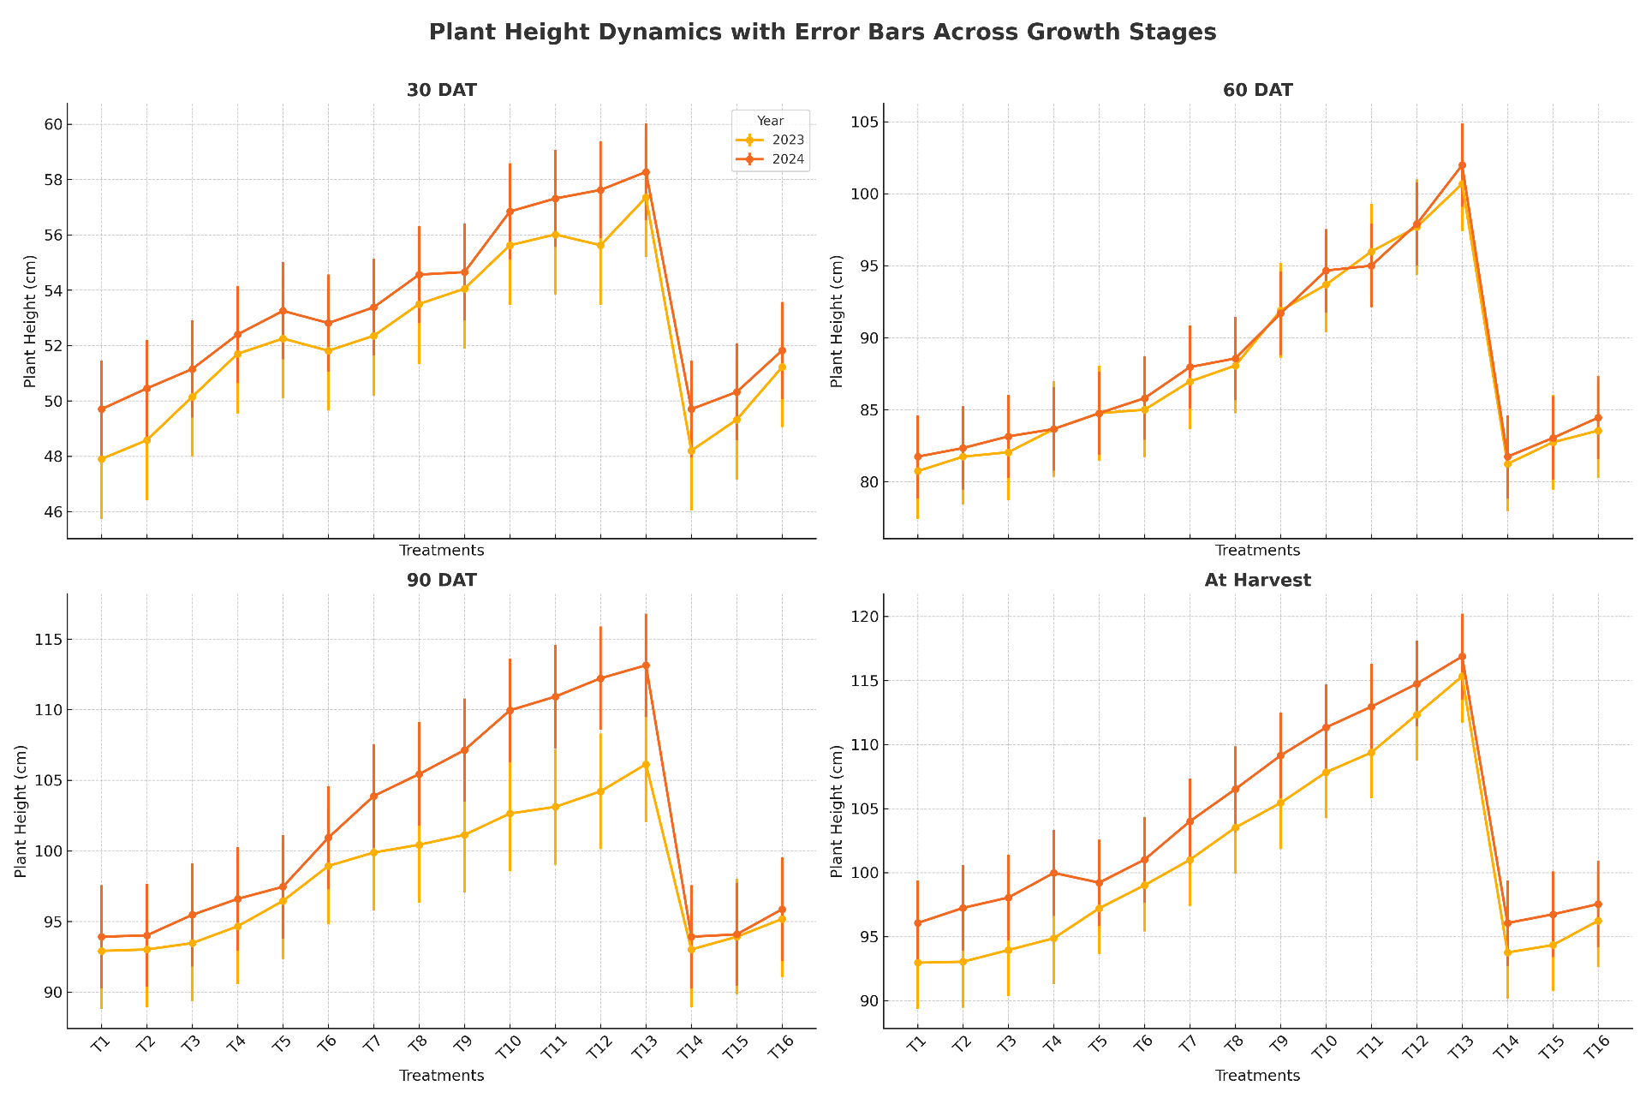

**Figure 2:-Effect of organic manure, inorganic fertilizer and biochar on number of tillers (m-2) at 30, 60, 90 DAT and at harvest of riceduring 2023 and 2024**

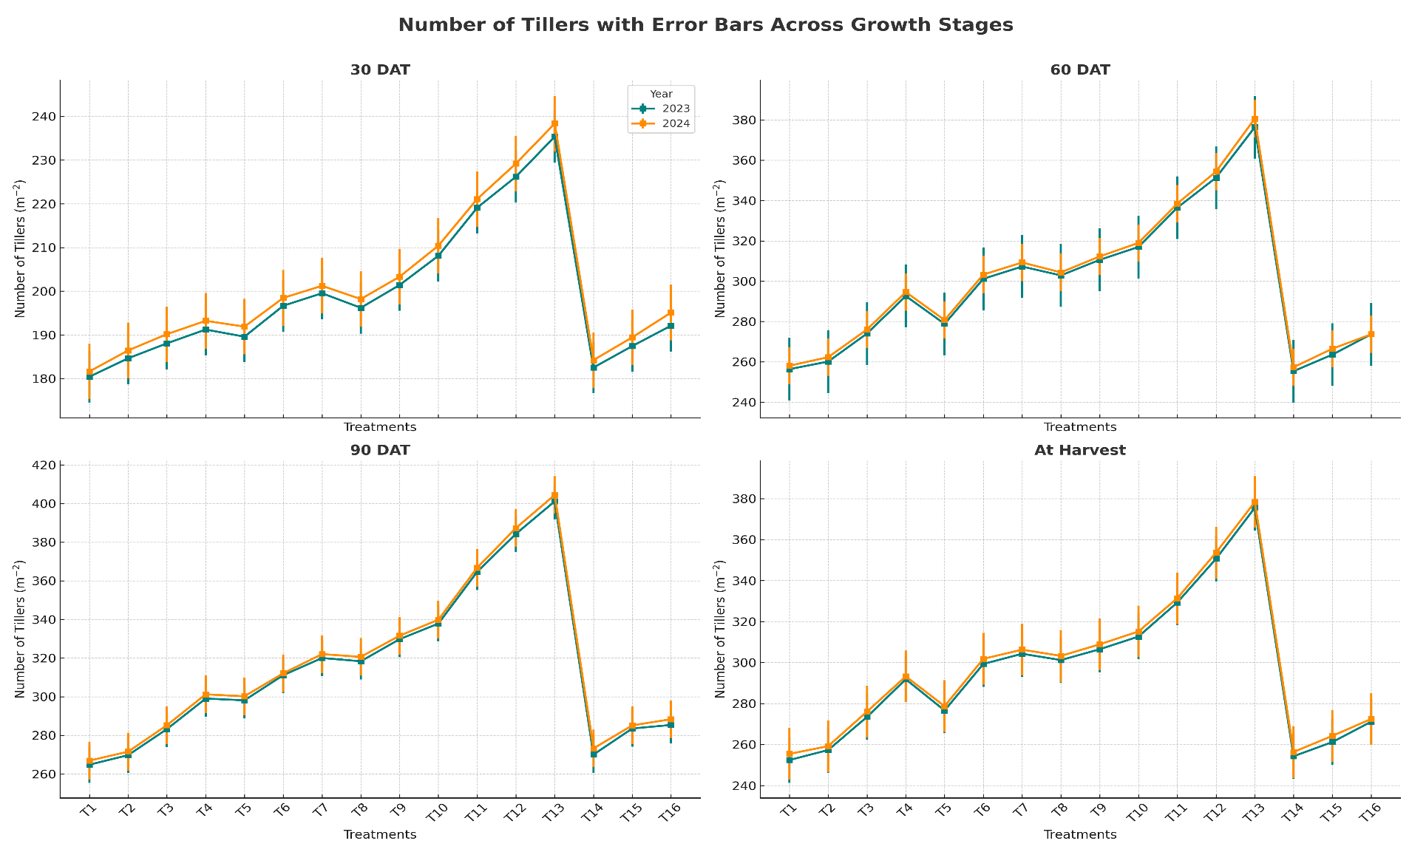

**Figure 3:- Effect of organic manure, inorganic fertilizer and biochar on dry matter accumulation (g m-2) at various growth stages of rice during 2023 and 2024**

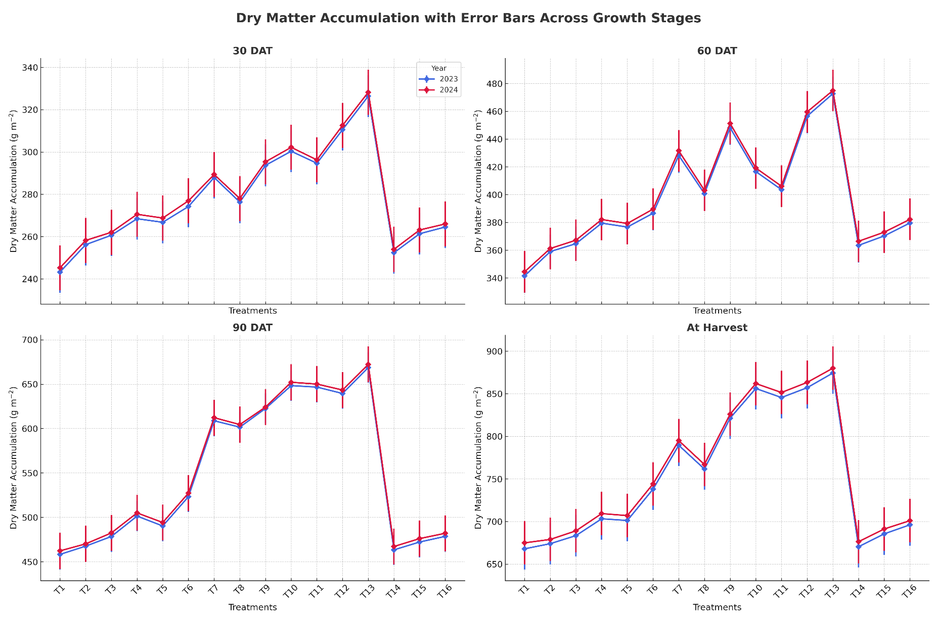

**Figure 4:-Effect of organic manure, inorganic fertilizer and Biochar on Yieldattributes of rice during 2023 and 2024**

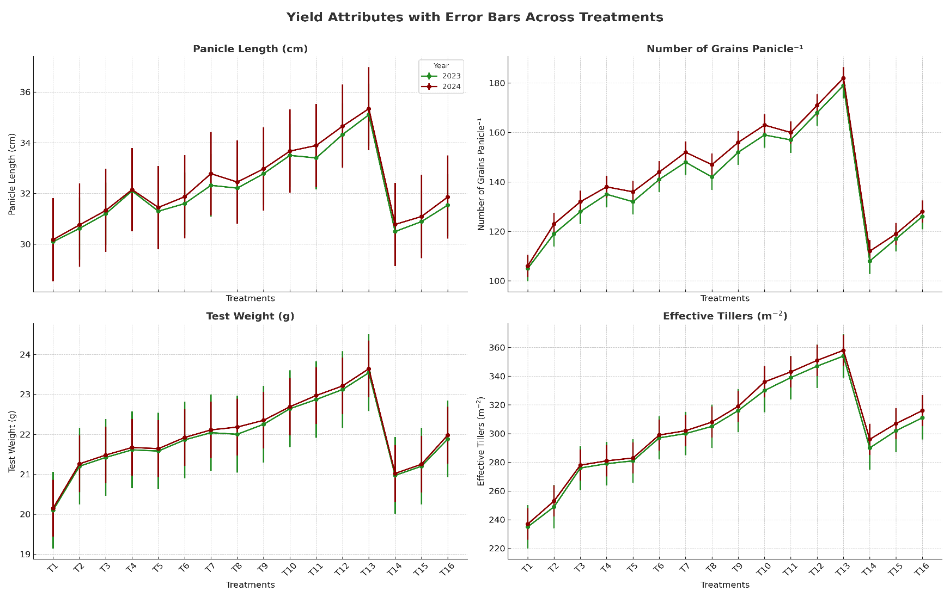

**Figure 5:-Effect of organic manure, inorganic fertilizer and Biochar on Yield Studies of rice during 2023 and 2024**

