Original Research Article
Harnessing the antifungal potential of garlic (Allium sativum) bulbs and garlic creeper (Mansoa alliacea) leaves against Rhizoctonia solani inciting collar rot and web blight of yard long bean (Vigna unguiculata subsp sesquipedalis (L.) Verdcourt)

ABSTRACT
Collar rot and web blight caused by Rhizoctonia solani is a major soil borne disease adversely affecting the growth and pod yield of yard long bean (Vigna unguiculata subsp. sesquipedalis (L.) Verdcourt). The disease is very difficult to control due to the prolonged survival capacity of pathogen in soil as sclerotia. The fungicides used for disease management are very expensive and their non-judicious use poses severe threat to the environment and beneficial microorganisms. Soil biofumigation is an emerging method for the inhibition of soil borne plant pathogens and can be utilised for the management of collar rot and web blight of yard long bean incited by R. solani. In the present study, nine botanicals were evaluated for their biofumigation and antifungal potential against R. solani by paired plate and poisoned food technique respectively under laboratory conditions. Among the different botanicals tested, paired plate technique using 1g and 5g, each of Allium sativum (bulbs) and Mansoa alliacea (leaves) resulted in complete inhibition of the mycelial growth of R. solani under in vitro conditions. The bulb extract of A. sativum and leaf extract of M. alliacea at 10, 15 and 20 per cent, when tested by poisoned food technique resulted in cent per cent inhibition of the mycelial growth of the pathogen, revealing the antifungal potential of both botanicals.
Keywords: Rhizoctonia solani, Biofumigation, In vitro study, Collar rot and web blight

- INTRODUCTION
Yard long bean (Vigna ungiculata ssp. sesquipedalis (L.) Verdcort) is a major leguminous vegetable crop widely grown in South East Asia and is characterized by its long pods. It is the most important vegetable crop cultivated in Kerala over an area of 6714 ha (FIB, 2019). The pods are rich in proteins, vitamins, minerals, carbohydrates and fibre content. The crop is suitable for cultivation in tropical regions. However, the production and yield of the crop is adversely affected by diseases, especially those caused by soil borne pathogens.
Collar rot and web blight incited by Rhizoctonia solani is a major soil borne disease of the crop. Collar rot is the most common symptom of disease compared to web blight, which initiates as brown to black coloured lesions on the collar region near to the soil which later girdles the stem causing yellowing and dropping of the leaves. It affects the development of roots often resulting in rotting of the roots. The initial symptom of web blight is the appearance of small circular greyish brown water soaked lesion, which later enlarges to form oblong or irregular ones. When the atmospheric humidity is high the spots coalesce and cover the entire lamina resulting in shedding of the leaves (Lakshmanan et al., 1957).
The use of synthetic fumigants for the management of soil borne disease adversely affects environment, human health and beneficial microbes. Methyl bromide was the most effective fumigant used for the management of soil borne fungi, insects, nematodes and weeds. However, it was withdrawn due to its drastic effect on the depletion of ozone layer (Watson et al., 1992). Due to the highly expensive nature and inconsistency of other methods viz., soil solarisation and hot water treatments (Goud et al., 2004), there exists an utmost need for natural, plant derived compounds as alternative means for disease control to reduce harm to the environment and living organisms. Hence, development of sustainable, ozone friendly and safe alternative disease control options has become a necessity.
Biofumigation is an emerging, eco-friendly and effective method, which refers to the use of glucosinolate containing crops particularly, Brassicacea that release isothiocyanates on hydrolysis (Kirkegaard et al., 1993). These isothiocyanates are chemically similar to methyl isothiocyanate, the active agent of metam sodium which is a synthetic fumigant and a substitute for methyl bromide (Smelt and Leistra, 1974; Matthiessen and Kirkegaard, 2006). In addition to Brassicacea members, several other crops have also been reported to be effective for biofumigation. The crops belonging to Alliacea that contains large amount of sulphur compounds are found to be useful against several soil borne pathogens (Arnault et al., 2004).
- MATERIALS AND METHODS
2.1 Evaluation of botanicals for biofumigation potential against Rhizoctonia solani
The culture of R. solani maintained at the Department of Plant Pathology, College of Agriculture, Vellayani was used for the study. The biofumigation potential of nine botanicals (Table 1) was evaluated by using paired plate technique (Charron and Sams, 1999). Fresh samples of the biofumigant plants were collected and washed in running tap water. From each of the selected plants, 1 g and 5 g samples were weighed separately and used for the study. Two equal sized bottoms of sterilized Petri plates were used for paired plate technique. 20 ml of autoclaved and molten potato dextrose agar (PDA) medium was poured into one of the plates and allowed to solidify. Five millimetre mycelial discs from seven day old fungal culture were aseptically transferred to the solidified PDA medium. To the second plate, 1g and 5g of the macerated plant samples (using mortar and pestle) were transferred separately. Then the plate, inoculated with the fungal mycelial bit was placed over the Petri plate containing the macerated plant tissues. It was sealed at the joining portion using parafilm to prevent the loss of volatiles (Fig.1). The control treatment consisted of the upper plate containing PDA medium inoculated with the culture disc of the pathogen and the base plate without any macerated plant sample. The plates were incubated at room temperature and daily observations were taken until the control plates of the pathogen attained full growth. The per cent inhibition of mycelial growth of the pathogen was calculated using the formula given by Vincent (1947).
Inhibition percentage %= C-T
C
˟ 100

Where,
C- Growth of the pathogen in control plate
T- Growth of the pathogen in treatment plate
Table 1. List of plants and the parts used for the in vitro study
Sl. No | Biofumigant | Part used
1 | Allium sativum | Bulb
2 | Mansoa alliacea | Leaf
3 | Coleus aromaticus | Leaf
4 | Ocimum tenuiflorum | Leaf
5 | Lantana camara | Leaf
6 | Brassica oleracea var botrytis | Leaf
7 | Brassica oleracae var capitata | Leaf
8 | Acorus calamus | Leaf
9 | Tagetes sp | Leaf, root

2.2 Evaluation of antifungal potential of botanicals against R. solani
The antifungal potential of the botanicals was evaluated using the poisoned food technique. The plant samples collected were washed thoroughly. The plant extracts were prepared as per the method described by Paul and Sharma (2002). One hundred grams of each plant samples were weighed and ground with an equal quantity of sterile distilled water in a 1:1 ratio (w/v). It was then filtered using sterile muslin cloth and centrifuged at 6000 rpm for 25 minutes. The supernatant collected was filtered through Whatman No. 42 filter paper. The resultant extract was maintained as the standard (100 % concentration). One millilitre of each plant extract was mixed with 49 ml of sterile distilled water and then added to 50 ml of the molten sterile double strength PDA medium to get one per cent concentration. Poisoned media of 5,10,15 and 20 per cent concentrations were prepared following the same procedure. Fifteen ml of each concentration of the poisoned mediums were poured into the sterile Petri plate separately and allowed to solidify. About 5 millimetre mycelial disc of seven day old pathogen culture was placed at the centre of the poisoned PDA medium. The control plates consisted of PDA medium, not poisoned with plant extracts. The treatments were replicated thrice and incubated at room temperature (28±2ºC). The mycelial growth of the pathogen in Petri plates was recorded when the control plates of the pathogen attained complete growth. The per cent inhibition of the pathogen over control was calculated as described in 2.1.

- RESULTS AND DISCUSSION
3.1 Evaluation of botanicals for biofumigation potential against Rhizoctonia solani
Among the different botanicals tested for their biofumigation potential against R. solani by paired plate technique, 1g of Allium sativum and Mansoa alliacea exhibited complete (100%) inhibition of mycelial growth of the pathogen under in vitro conditions (Table 1). It was followed by 1 g of Coleus aromaticus and Brassica oleracea var capitata which resulted in 57.96 and 30.00 per cent inhibition of the pathogen respectively (Fig 2). Biofumigation with 5g of Allium sativum and Mansoa alliacea also resulted in cent per cent inhibition of the pathogen, followed by C. aromaticus and Brassica oleracea var capitata which recorded 82.96 and 77.40 per cent inhibition of the pathogen (Fig 3).
Table 2. In vitro evaluation of biofumigation potential of botanicals against R. solani
Sl  No. | Treatments | Quantity of botanical tested
Sl  No. | Treatments | 1g |  | 5g
Sl  No. | Treatments | Mycelial growth of R. solani (cm) * | % inhibition* | Mycelial growth R. solani (cm)* | % inhibition*
T₁ | Allium sativum | 0.00 ª | 100.00(90.00) ª | 0.00 ª | 100.00(90.00) ª
T₂ | Mansoa alliacea | 0.00 ª | 100.00(90.00) ª | 0.00 ª | 100.00(90.00) ª
T₃ | Coleus aromaticus | 3.78 ^{b} | 57.96(49.58) ^{b} | 1.53 ^{b} | 82.96(65.62) ^{b}
T₄ | Ocimum tenuiflorum | 6.46 ^{d} | 28.14(32.04) ^{d} | 2.66 ^{e} | 70.37(57.02) ^{e}
T₅ | Lantana camara | 8.56 ^{g} | 4.81(12.65) ^{g} | 7.53 ^{h} | 16.29(23.80) ^{h}
T₆ | Brassica oleracea var botrytis | 7.46e | 17.03(24.37) ^{e} | 2.13 ^{d} | 76.29(60.86) ^{d}
T₇ | Brassica oleracae var capitata | 6.30^{c} | 30.00(33.21) ^{c} | 2.03 ^{c} | 77.40(61.62) ^{c}
T₈ | Acorus calamus | 8.33^{f} | 7.40(15.78) ^{f} | 5.53 ^{g} | 38.51(38.36) ^{g}
T₉ | Tagetes sp | 8.36^{f} | 7.03(15.37) ^{f} | 5.06 ^{f} | 43.70 (41.38) ^{f}
 | Control | 9.00 ^{h} | 0.00(0.00) ^{h} | 9.00 ^{i} | 0.00(0.00) ^{i}
 | SE (m) | 0.024 | 0.268 | 0.028 | 0.31
 | CD (0.05%) | 0.071 | 0.792 | 0.082 | 0.914
* Mean of three replications. Values in parenthesis are arc sine transformed values, values followed by similar superscripts are not significantly different at 5% level

Sajeena et al. (2024) reported that paired plate technique using 2.5 g bulbs of A. sativum resulted in complete inhibition of the mycelial growth of R. solani causing collar rot and web blight. Similarly, biofumigation with 1g of garlic extract resulted in complete inhibition of Sclerotium rolfsii inciting basal stem rot of vegetable cowpea under in vitro conditions (Sri et al., 2020). The antimicrobial property of garlic is attributed to the presence of allicin which is a phytoanticipin, and has antimicrobial properties against bacteria, oomycetes and fungi (Portz et al., 2008; Leontiev et al., 2018; Sarfraz et al., 2020).
a
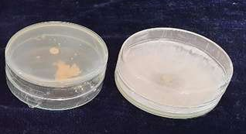
b
a
Fig 1. Paired plate technique to evaluate the biofumigation potential of botanicals a) Complete inhibition of mycelia of R. solani by garlic bulbs b) Pathogen control
T4
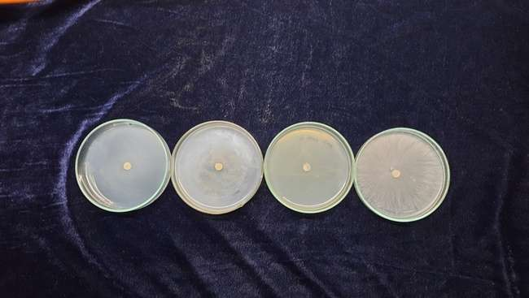
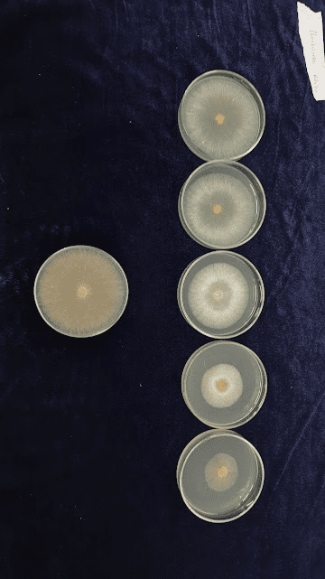
a
b
c

Fig 2. Biofumigation potential of botanicals (1g each) against R. solani a) Allium sativum b) Mansoa alliacea, c) Control
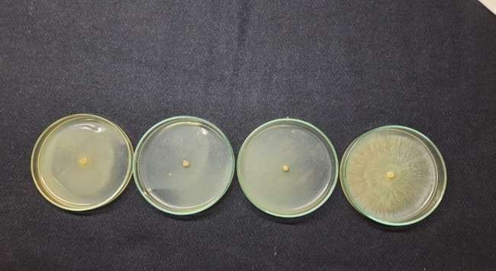
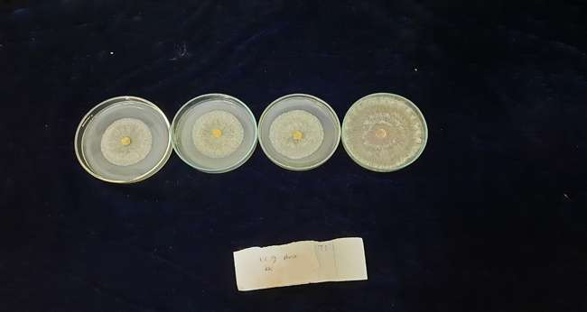
a
b
c

Fig 3. Evaluation of biofumigation potential of botanicals (5g each) against R. solani a) Allium sativum b) Mansoa alliacea, c) Control
Allicin is a volatile compound produced following the decompartmentalization of cells. Upon tissue damage, allicin is produced from alliin (S-allylcysteine sulfoxide) which is catalysed by the enzyme alliinase (Granroth, 1970). Allicin, a reactive sulphur species interacts with thiol groups in proteins and they can diffuse across the lipid bilayers (Rabinkov et al., 1998; Miron et al., 2000). Allicin is reported to have toxic effects against fungi and inhibits the mycelial growth and spore germination (Curtis et al., 2004). It inhibits the activity of enzymes like succinic dehydrogenase, alcohol dehydrogenase and hexokinase (Wills, 1956). Diallyl disulphide (DADS) which is produced from the decomposition of allicin is also having antimicrobial properties. The mycelial cell membrane integrity of Phytophthora nicotianae was inhibited by DADS, which resulted in increased cell permeability and cell death. The application of DADS also reduced the population of the pathogen present in rhizosphere soil and thereby reduced the incidence of black shank in tobacco incited by P. nicotianae (Wang et al., 2019).
  - Evaluation of antifungal potential of botanicals against R. solani
The bulb extract of A. sativum and leaf extract of M. alliacea at 10, 15 and 20 per cent concentration resulted in complete inhibition of the mycelial growth of the pathogen (Table 3, Table 4). Poisoned food technique with the extract of Brassica oleracea var capitata at 15 and 20 per cent concentration exhibited 43.70 and 50.37 per cent inhibition of the pathogen growth. It was also found that 20 per cent extract of Coleus aromaticus exhibited 50.37 per cent inhibition of the pathogen (Fig. 4).
The presence of allicin in garlic extract contributed to their antifungal properties and was comparable to the reference drug, fluconazole (Li et al., 2022). There are reports of its antifungal potential against Botrytis cinerea, Penicillium expansum, Fusarium spp. and Rhizopus species (Daniel et al., 2015; Kutawa et al., 2018). It was also reported to be effective against Alternaria brassicicola and Magnaporthe grisea both under in vitro and in vivo conditions (Curtis et al., 2004; Perello et al., 2013). The methanolic garlic extract at 5mg/ml resulted in 77.43 and 69.35 per cent inhibition of Pythium aphanidermatum and R. solani respectively (Mostafa et al., 2013).
Similarly, Mansoa alliacea leaf extract was revealed to inhibit the mycelial growth, spore formation and spore germination of Colletotrichum acutatum. The mycelial growth of Drechslera oryzae was completely inhibited by M. alliacea extract (Chaturvedi et al., 1987). The plant pathogens like Colletotrichum capsici, Curvularia lunata, Alternaria alternata, A. brassicae, A. brassicola, A. carthami, Fusarium oxysporum and F. udum were also inhibited by the aqueous leaf extract of M. alliacea in 1:1 (extract: water) dilution (Rana et al., 1999). Sudirga et al. (2019) found that the phenols and alkaloids present in the leaf extract of M. alliacea contributed to the antifungal activity against the pathogen.
Table 3. In vitro evaluation of antifungal potential of plant extracts against R. solani
Sl. No. | Treatments | Quantity of plant extract for antifungal potential against R. solani (g)
Sl. No. | Treatments | 1 | 5 | 10 | 15 | 20
Sl. No. | Treatments | Mycelial growth of the pathogen* (cm)
T₁ | Allium sativum | 3.76 ª | 2.28 ª | 0.00 ª | 0.00 ª | 0.00 ª
T₂ | Mansoa alliacea | 6.48 ^{b} | 4.16 ^{b} | 0.00 ª | 0.00 ª | 0.00 ª
T₃ | Coleus aromaticus | 9.00 ^{g} | 8.06 ^{g} | 6.38 ^{d} | 5.33 ^{c} | 4.46 ^{b}
T₄ | Ocimum tenuiflorum | 8.76 ^{e} | 8.45^{h} | 8.03 ^{g} | 6.31 ^{f} | 5.06 ^{c}
T₅ | Lantana camara | 8.73 e | 8.51 ^{i} | 6.95 ^{e} | 7.03 ^{h} | 6.46 ^{g}
T₆ | Brassica oleracea var botrytis | 8.36 ^{d} | 7.53 ^{d} | 6.36 ^{d} | 6.06 ^{e} | 6.03 ^{e}
T₇ | Brassica oleracae var capitate | 8.06 ^{c} | 7.35 ^{c} | 6.06 ^{b} | 5.06 ^{b} | 4.46 ^{b}
T₈ | Acorus calamus | 8.03 ^{c} | 7.81 e | 6.26 ^{c} | 5.78 ^{d} | 5.36 ^{d}
T₉ | Tagetes sp | 8.86 ^{f} | 7.98 ^{f} | 7.06 ^{f} | 6.50 ^{g} | 6.23 ^{f}
T₁₀ | Control | 9.00 ^{g} | 9.00 ^{j} | 9.00 ^{h} | 9.00 ^{i} | 9.00 ^{h}
 | SE (m) | 0.028 | 0.025 | 0.026 | 0.022 | 0.026
 | CD (0.05%) | 0.084 | 0.073 | 0.076 | 0.066 | 0.078

*Mean of three replications, values followed by similar superscripts are not significantly different at 5% level

Table 4. Evaluation of plant extracts for inhibition of R. solani at different concentrations
Sl. No. | Treatments | Quantity of plant extract for antifungal potential against R. solani (%)
Sl. No. | Treatments | 1 | 5 |  | 10 | 15 | 20
Sl. No. | Treatments | PI (%) | PI (%) | PI (%) |  | PI (%) | PI (%)
T₁ | Allium sativum | 58.14 ^{a *}  (49.69) | 74.63 ª  (59.75) |  | 100.00 ª  (90.00) | 100.00 ª  (90.00) | 100.00 ª  (90.00)
T₂ | Mansoa alliacea | 27.96 ^{b}  (31.92) | 53.70 ^{b}  (47.12) |  | 100.00 ª  (90.00) | 100.00 ª  (90.00) | 100.00 ª  (90.00)
T₃ | Coleus aromaticus | 0.00 ^{g}  (0.00) | 10.37 ^{g} (18.78) |  | 29.07 ^{d}  (32.62) | 40.74 ^{c}  (39.66) | 50.37 ^{b}  (45.21)
T₄ | Ocimum tenuiflorum | 2.59 ^{e}  (9.22) | 6.11 ^{h}  (14.30) |  | 10.74 ^{g}  (19.12) | 29.81 ^{f}  (33.09) | 43.70 ^{c}  (41.38)
T₅ | Lantana camara | 2.96 ^{e}  (9.87) | 37.00 ^{i}  (13.39) |  | 22.77 ^{e}  (28.50) | 21.85 ^{h}  (27.86) | 28.14 ^{g}  (32.04)
T₆ | Brassica oleracea var botrytis | 7.03 ^{d}  (15.37) | 16.29 ^{d} (23.80) |  | 29.25 ^{d}  (32.74) | 32.59 ^{e}  (34.81) | 32.96 ^{e}  (35.03)
T₇ | Brassica oleracae var capitata | 10.37 ^{c}  (18.78) | 18.33 ^{c} (25.35) |  | 32.59 ^{b}  (34.81) | 43.70 ^{b}  (41.38) | 50.37 ^{b}  (45.21)
T₈ | Acorus calamus | 10.74 ^{c}  (19.12) | 13.14 ^{e} (21.25) |  | 30.37 ^{c}  (33.44) | 35.74 ^{d}  (36.71) | 40.37 ^{d}  (39.44)
T₉ | Tagetes sp | 1.48 ^{f}  (6.89) | 11.29 ^{f} (19.63) |  | 21.48 ^{f}  (27.61) | 27.77 ^{g}  (31.80) | 30.74 ^{f}  (33.67)
T₁₀ | Control | 0.00 ^{g}  (0.00) | 0.00 ^{j}  (0.00) |  | 0.00 ^{h}  (0.00) | 0.00 ^{i}  (0.00) | 0.00 ^{h}  (0.00)
 | SE (m) | 0.31 | 0.27 |  | 0.28 | 0.24 | 0.29
 | CD (0.05%) | 0.93 | 0.81 |  | 0.84 | 0.73 | 0.86
* Mean of three replications, Values in parenthesis are arcsine transformed values, values followed by similar superscripts are not significantly different at 5% level, PI: Per cent inhibition
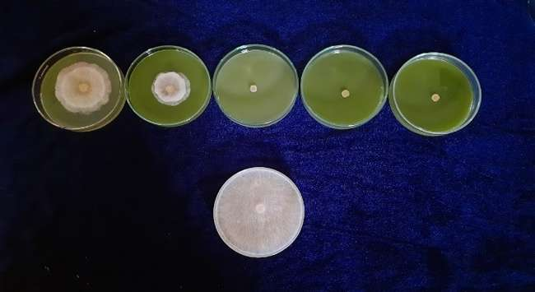
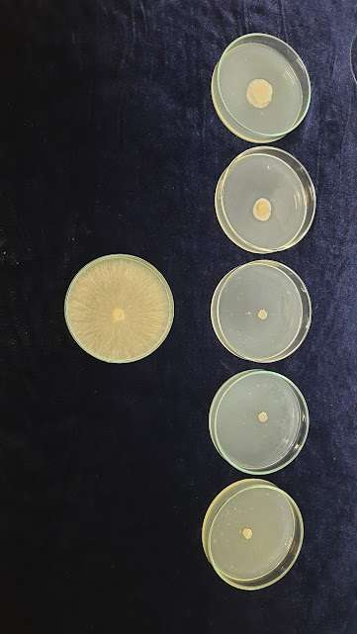
1% 5% 10% 15% 20%
Control
b
1% 5% 10% 15% 20%
Control
a

Fig 4. Evaluation of antifungal potential of plant extracts against R. solani under in vitro conditions a) Allium sativum extract b) Mansoa alliacea extract
Control
T6
- CONCLUSION
Rhizoctonia solani inciting collar rot and web blight causes severe economic losses. Even though chemical fungicides can be used for the management of soil borne diseases, they result in adverse effects on environment and beneficial microorganisms. Biofumigants can be used as an eco-friendly alternative for fungicides for the management of collar rot and web blight disease incited by R. solani. In the present study, Allium sativum and M. alliacea were found to be effective against the pathogen under in vitro conditions. Both exhibited biofumigation and antifungal properties against the tested pathogen which implies their importance as alternatives to synthetic fumigants.

DISCLAIMER (ARTIFICIAL INTELLIGENCE)
Authors hereby declare that No generative AI technologies such as Large Language Models (ChatGPT, COPILOT etc) and text to image generators have been used during writing or editing of this manuscript.

COMPETING INTERESTS
Authors have declared that no competing interests exists.

REFERENCES.
- Arnault, I., Mondy, N., Diwo., S., & Auger, J. (2004). Soil behaviour of natural sulfur fumigants used as methyl bromide substitutes. International Journal of Environmental Analytical Chemistry, 84, 75–82.
- Charron, C. S., & Sams, C. E. (1999). Inhibition of Pythium ultimum and Rhizoctonia solani by shredded leaves of Brassica species. Journal of American Society of Horticultural Science, 124, 462-467
- Chaturvedi, R., Dikshit, A., & Dixit, S. N. (1987). Adenocalymma alliacea, a new source of a natural fungitoxicant. Tropical Agriculture, 64, 150–155.
- Curtis, H., Noll, U., Stormann, J., & Slusarenko, A. (2004). Broad- spectrum activity of the volatile phytoanticipin allicin in extracts of garlic (Allium sativum L.) against plant pathogenic bacteria, fungi and oomycetes, Physiological and Molecular Plant Pathology, 65(2):79-89.
- Daniel, C.K., Lennox, C.L., & Vries, F.A. (2015). In vivo application of garlic extracts in combination with clove oil to prevent postharvest decay caused by Botrytis cinerea, Penicillium expansum and Neofabraea alba on apples. Postharvest Biology and Technology, 99, 88–92.
- FIB (Farm Information Bureau). (2019). Farm Guide. Department of Agriculture, Government of Kerala, pp. 352.
- Goud, J. K. C., Termorshuizen , A. J., Blok , W. J., & Van Bruggen , A. H. C. ( 2004 ). Long-term effect of biological soil disinfestation on Verticillium wilt. Plant Disease, 88, 688- 694.
- Granroth, B. (1970). Biosynthesis and decomposition of cysteine derivatives in onion and other Allium species. Annales Academiae Scientiarum Fennicae, Series A, Chemica,154, 4–71.
- Kirkegaard J.A., Gardner P.A., Desmarchelier J.M & Angus J.F. (1993). Biofumigation – using Brassica species to control pests and diseases in horticulture and agriculture. Proc. 9th Australian Research Assembly on Brassicas. N. Wratten & R.J. Mailer (eds). Agricultural Research Institute, Wagga Wagga. pp 77-82.
- Kutawa, A. B., Danladi, M. D., & Haruna, A. (2018). Antifungal activity of garlic (Allium sativum) extract on some selected fungi. Journal of Medicinal herbs and Ethnomedicine, 4, 12-14.
- Lakshmanan, P., Nair, M. C., & Menon, M. R. (1979). Collar rot and web blight of cowpea caused by Rhizoctonia solani in Kerala, India. Plant Disease Reporter, 63(5), 410-413.
- Leontiev, R., Hohaus, N., Jacob, C., Gruhlke, M.C.H., & Slusarenko, A. J (2018) A comparison of the antibacterial and antifungal activities of thiosulfinate analogues of allicin. Scientific Reports, 8,1–19.
- Li, Z., Li, Z., Yang, J., Lu, C., Li, Y., Luo, Y., Cong, F., Shi, R., Wang, Z., Chen, H., Li, X., & Ye, F. (2022). Allicin shows antifungal efficacy against Cryptococcus neoformans by blocking the fungal cell membrane. Frontiers in Microbiology, 13, 1012516.
- Matthiessen, J. N., & Kirkegaard, J. A. (2006). Biofumigation and enhanced biodegradation: Opportunity and challenge in soil borne pest and disease management. Critical Reviews in Plant Sciences, 25(3), 235-265. https://doi.org/10.1080/07352680600611543.
- Miron, T., Rabinkov, A., Mirelman, D., Wilchek, M., & Weiner, L. (2000). The mode of action of allicin: Its ready permeability through phospholipid membranes may contribute to its biological activity. Biochimica et Biophysica Acta, 1463, 20- 30.
- Mostafa, A. A., Al- Rahmah, A. N., Yakout, S. M., & Abd- Alrahman, S. H. (2013). Bioactivity of garlic bulb extract compared with fungicidal treatment against tomato phytopathogenic fungi, Journal of pure and applied microbiology, 7(3):1925-1932.
- Paul, P. K., &Sharma, P. D. (2002). Azadirachta indica leaf extract induces resistance in barley against leaf stripe disease. Physiological and Molecular Plant Pathology,61(1), 3-13.
- Perello, A., Noll, U., & Slusarenko, A. J. (2013). In vitro efficacy of garlic extract to control fungal pathogens of wheat. Journal of Medicinal Plants Research, 7(24), 1809-1817.
- Portz, D., Koch, E., & Slusarenko, A. J. (2008). Effects of garlic (Allium sativum) juice containing allicin on Phytophthora infestans and downy mildew of cucumber caused by Pseudoperonospora cubensis. European Journal of Plant Pathology, 122, 197-206
- Rabinkov, A., Miron, T., Konstantinovski, L., Wilchek, M., Mirelman, D., & Weiner, L. (1998). The mode of action of allicin: trapping of radicals and interaction with thiol containing proteins. Biochimica et Biophysica Acta, 1379, 233–244.
- Rana, B. K., Taneja, V., & Singh, U. P. (1999). Antifungal activity of an aqueous extract of leaves of garlic creeper (Adenocalymma alliaceum Miers). Pharmaceutical Biology, 37, 13-16.
- Sajeena, A ., Pathrose, B., John, J., Mathew, D., Visakh, N. U., Betsy, S., Sri, P. T., Meera, A. V., Shanas, S., & Bindhu, J. S. (2024). Emerging trends in the management of soil borne diseases of and . 2024. yard long bean vegetable crop. Journal of Mycology and Plant Pathology, 54(4), 341-349.
- Sarfraz, M., Nasim, M. J., Jacob, C., & Gruhlke, C. H. (2020). Efficacy of allicin against plant pathogenic fungi and unveiling the underlying mode of action employing yeast based chemogenetic profiling approach. Journal of Applied Sciences, 10(7), 2563. https://doi.org/10.3390/app10072563
- Smelt, J. H., & Leistra, M. (1974). Conversion of metham-sodium to methyl isothiocyanate and basic data on the behaviour of methyl isothiocyanate in soil. Pesticide Science 5, 401–407.
- Sri, P. T., Sajeena, A., Johnson, J. M., John, J., & Radhika, N. S. (2020). Factors influencing the incidence of basal stem rot and blight disease caused by Sclerotium rolfsii in vegetable cowpea and its management using botanicals. Journal of Biological Control, 34(3), 215-222.
- Sudirga, S, K., Ginantra, I. K., & Darmayasa, B. G. (2019). Antifungal activity of leaf extract of M. alliacea against Colletotrichum acutatum the cause of anthracnose disease on chilli pepper. IOP Conference Series: Earth and Environment Science, 347, 012058.
- Vincent, J. M. (1947). Distortion of fungal hyphae in the presence of certain inhibitors. Nature 159: 850
- Wang, Y., Keke, W., Han, X., Zhao, D., Zheng, Y., & Chao, J. (2019). The antifungal effect of garlic essential oil on Phytophthora nicotianae and the inhibitory component involved. Biomolecules, 9(10), 632.
- Watson, R. T., Albritton, D. L., Anderson, S .O., & Lee- Bapty, S. (1992). Methyl bromide: Its atmospheric science, technology and economics, montreal protocol Assessment suupl., United Nations Environmental Programme on Behalf of the contracting parties to the montreal protocol, Nairobi, Kenya
- Wills, E. D. Enzyme inhibition by allicin, the active principle of garlic. Biochemical Journal, 63(3), 514-520.

