Comparative Performance of CARI- Nirbheek,Vanaraja and Native Bird under Backyard System of Rearing in Chandel district of Manipur

Abstract
The present study has been undertaken to evaluate comparative production efficiency of improved chicken varieties viz, CARI - Nirbheek and Vanaraja birds in compare with local bird to see the comparative performance of CARI- Nirbheek bird with exhisting improved Vanaraja birds in body weight gain and in egg production and also with native birds avail in the district. The improved variety of CARI- Nirbheek had significantly lower body weight compare to exhisting improved breed of Vanaraja bird but significantly higher body weight gain than native bird. The total of 300 nos of birds comprising 100 each nos of CARI Nirbheek,Vanaraja and Native birds were distributed to five farm women providing 60 each birds of one month old each of different breeds of twenty nos each per farmer.The body weight of all the birds at 4,8,12,16,20 , 24,32 and 40 th week were recorded , The initial body weight at 4 week of the three breeds was found to be as324.32± 3.78, 438.89±4.83 and 210.34±2.97 whereas final body weight was recorded as 2278.50±30.67, 3182.50± 30.24 and 1698±28.21respectively in CARI –Nirbheek,Vanaraja and Native birds,The age of first laying was no significant differences among the three breeds of poultry birds under scavenging system as 165± 9.11, 169.00± 8.59 and 178.6± 9.19 though egg size was biggest in Vanaraja bird as 60g and lowest size in native bird as 42 g respectively.Overall performance in body weight gain was observed in Vanaraja bird as compare to CARI -Nirbheek and Native birds,The backyard poultry farming with improved birtds provide a solution to food security to the rural farmers for sustainable livestock production in India.
Keywords: Body weight, CARI -Nirbheek,Native bird, Vanaraja backyard system, Egg production

Introduction

Poultry farming plays a pivotal role in enhancing rural livelihoods, especially in remote and economically underdeveloped regions of India such as the northeastern states. Poultry farming is among the fastest-growing sectors in Indian agriculture. It holds a crucial place in the present Indian economy and has transformed into a highly business-oriented enterprise (Sreenivas et al., 2013).. Backyard poultry contributes about 19.8% to the country’s total egg production. India is endowed with a wide range of poultry breeds possessing the potential to support both poverty reduction and food security, particularly benefiting the 30.3 million rural poor families directly engaged in this sector. Various poultry strains developed for backyard farming are being evaluated for their adaptability to local agro-climatic conditions to promote their wider adoption.Among the various forms of poultry farming, backyard poultry rearing has emerged as a low-investment, high-return enterprise particularly suited to the socio-economic conditions of small and marginal farmers. It acts as a vital source of supplementary income, nutritional security through egg and meat production, and employment—especially for women and landless farmers,The Chandel district of Manipur, located in the hilly and tribal-dominated southern region of the state, is characterized by its remote terrain, limited infrastructure, and relatively low agricultural productivity. Traditional animal husbandry practices—especially backyard poultry rearing—are an integral component of rural livelihoods in this region. However, the poultry sector in Chandel continues to be dominated by non-descript indigenous birds, which, despite being well-adapted to local environmental conditions, suffer from poor productivity in terms of growth rate, egg production, and survivability under disease stress.In this context, the introduction of improved dual-purpose poultry strains such as CARI Nirbheek and Vanaraja, developed by the Indian Council of Agricultural Research (ICAR), presents a promising strategy to enhance productivity in backyard poultry systems. CARI Nirbheek, a crossbred strain developed from the indigenous Aseel and CARI Red lines, is known for its strong disease resistance, better survivability, and reasonable egg and meat output under low-input conditions. Similarly, Vanaraja, developed by ICAR-Directorate of Poultry Research, is widely recognized for its faster growth rate, adaptability to free-range systems, and improved egg-laying capacity compared to indigenous birds.Despite their proven performance in several regions of India, there is a significant dearth of location-specific studies evaluating the comparative productivity and adaptability of these improved strains under the agro-climatic and socio-economic conditions of Chandel district. Factors such as climate, scavenging feed availability, disease prevalence, and traditional management practices may all influence the performance of these breeds differently in this context.Therefore, the present study was undertaken with the objective of evaluating and comparing the growth performance, egg production, survivability, and economic viability of CARI Nirbheek, Vanaraja, and native birds reared under traditional backyard systems in Chandel district.

Materials and Methods

The present study has been undertaken at Krishi Vigyan Kendra, Chandel ,Manipur to evaluate production efficiency of three types of poultry varieties (Cari Nirbheek, Vanaraja and Native bird 100 nos each) upto 40 weeks of age during September 2022 till October 2023.. The CARI Nirbheek chicks were procured from fertile eggs from CARI –Bareliy and Vanaraja from KVK farm and native birds from farmers field of same age group at one month old were provided to five farm women who are already trained in poultry farming Each of the farm women received 60 nos of one month old birds each of the three varieties 20 nos each comprising 60 each birds per farm woman. In the backyard system the birds were reared under extensive as well as semi intensive care under same feeding regime.. The birds were kept in wooden made house for night shelter .All the birds were allow for scavenging in daytime and allow for night shelter. There were lots of similarities in feeding habits of all these birds like forage and scratch feed from vast backyard with green leafy vegetables, insects , grains and gras., birds were fed with these feeds both morning and evening with provision of wholesome water. Except offering supplementary feed grains in small quantity no extra care was given to them. The birds were vaccinated against Ranikhet diseases by following standard vaccination method. Body weight of birds and age of the birds at first egg stage was recorded. Observations were also recorded for other parameters viz. total egg production, first egg weight and mortality of birds. Performance of these birds was evaluated using various tests. Means and standard errors of various traits were calculated using standard statistical procedures (Snedecor and Cochran, 1989).
Managemental practices during the study period
Housing: Birds were provided with locally constructed night shelters made of wooden with GI roofing .The shelters were cleaned weekly and disinfected once every month using lime and locally available herbal solutions. Birds were allowed to free-range during the day.
Feeding: All birds scavenged during the daytime and were supplemented with locally available feed resources, including broken rice, kitchen waste, rice bran, and small quantity of crushed maize in the evenings. No commercial feed was used. However, during the brooding period (0–4 weeks), chicks were provided with a standard commercial starter mash.
Watering: Clean drinking water was provided twice daily in earthen or plastic containers. In winter, lukewarm water was offered to avoid cold stress.
Health Care: All birds were vaccinated against Newcastle Disease (ND) as per standard schedules. Periodic deworming was carried out once every two months using albendazole.
Record Keeping: Data on growth (body weight), age at first egg laying, egg production, egg weight, and survivability were recorded monthly basis.

Results and Discussion
The comparative performance of Vanaraja, CARI Nirbheek, and Native birds under the backyard rearing system in Chandel district revealed significant differences in several growth and reproductive parameters.Body weight performance (Table 1) clearly indicated that both improved varieties—Vanaraja and CARI Nirbheek exhibited significantly higher body weights at various stages of growth when compared to Native birds (p < 0.05). Among the three, Vanaraja birds consistently outperformed both CARI Nirbheek and local birds, recording the highest body weight at all observed growth intervals. This superior growth performance of Vanaraja could be attributed to its better genetic potential for feed conversion efficiency and enhanced adaptability to semi-scavenging conditions, which aligns with findings by Islam and Nath (2015), who observed significantly higher growth rates in Vanaraja under backyard system , Both the improved varieties of Cari Nirbheek and Vanaraja birds had significantly higher body weight (Table 1) than native birds. Among these two improved varieties when we considered, Vanaraja birds was significantly heavier than the Cari Nirbheek and native bird .Though there were no significant difference in Age of first laying among the m (Table 2) though significantly higher in egg weight in Vanaraja and CARI Nirbheek than the native birds. Among three varieties Vanaraja bird got highest body weight gain than other two varieties and thus proved its better genetic potential to convert available feed into quality animal protein. . Haunshi et al. (2007) observed significant effect of sex on fourth to eighteen weeks body weight of Vanaraja chickens under intensive system More or less average growth rate in different breeds/ strains has amply been documented by Haunshi et al. (2009) under different agro climatic conditions. Mahapatra et al. (1988) reported that age at sexual maturity was 171 days for Kadaknath chicken.Ameeta Devi et.al(2025) reported that age at first lay egg in Srinidhi bird was recorded at 170 days under semi In tensive syatem of rearing. . However, Malik and Singh (2010) reported lower mortality for CARI Nirbheek chickens under field conditions of Tripura region.
Table.1 Mean body weight (g) of birds at different age (wks) of birds

Age in
weeks Cari Nirbheek Vanaraja Native bird
4  8  12 |  | 324.32± 3.78  528.12± 6.33  776.75± 6.33 |  | 438.89±4.83 210.34±2.97  765.67 ±8.23 402.25±4.58  1054.50 ±10.23 370.00±6.58
16 |  | 954.50 ±10.23 |  | 1327.00± 14.82 646.50±9.52
20 |  | 1458.50± 21.55 |  | 1748.50± 31.92 1068.00±25.64
24 |  | 1794.50± 23.00 |  | 2107.00± 30.52 1347.00±14.46
32 |  | 2031.75± 26.14 |  | 2580.00 ±35.06 1579.50±19.59
40 |  | 2278.50 ±30.67 |  | 3182.50± 30.24 1698±28.21

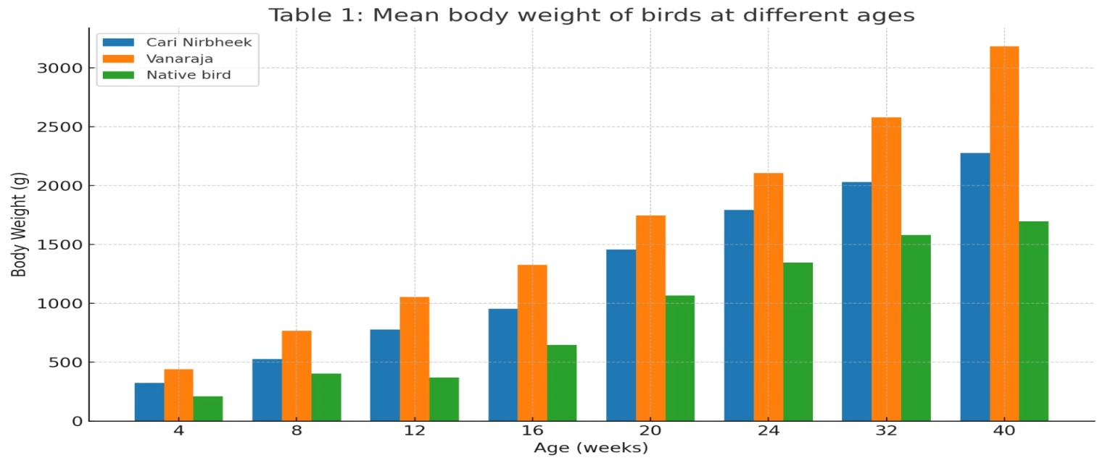
Fig 1 : Mean body weight of birds at different

Relatively lower body weights was observed in native birds and higher age at sexual maturity of improved varieties observed in studies may be attributed to the environmental reasons prevailed to the study area. no statistically significant differences were observed in the age at first egg laying among the three groups (Table 2). This early sexual maturity, although not statistically significant, could translate to better lifetime productivity in field conditions if coupled with improved management practices. Mahapatra et al. (1988) reported that the age at sexual maturity in Kadaknath chicken was approximately 171 days, which is consistent with the maturity ages observed in the present study, particularly for improved breeds.In terms of egg characteristics, egg weight was found to be significantly higher (p < 0.05) in Vanaraja and CARI Nirbheek hens as compared to the local birds. This is an important trait, as higher egg weights are associated with better hatchability and chick vigor, which are crucial for sustainability in backyard poultry. The results of the present study are in consonance with the finding in Nirbheek by Malik and Singh(2010), in Gramapriya, Vanaraja and Miri type (Haunshi et al., 2009), in White Nicobari .Significant genetic variation for shape index in different breeds or strains was reported by Chatterjee et al. (2007).
Table.2 Average age of first egg, egg production and egg weight
Parameters CariNirbheek Vanaraja Native bird
Age of first egg (d) | 165± 9.11 | 169.00± 8.59 | 178.6± 9.19
Total eggs upto 40 weeks of age (No.) | 41.33± 0.54 | 35.40 ±1.06 | 22.20± 0.88
Total eggs upto 60 weeks of age (No.) | 108 .27 ±1.60 | 100.87± 2.51 | 73.60± 1.74
First egg weight (g) | 42.87 ±0.70 | 48.47 ±0.97 | 34.07 ±0.75
Egg wt at 40 wks of age (g) | 53± 3.14 | 60± 3.89 | 42±2.41

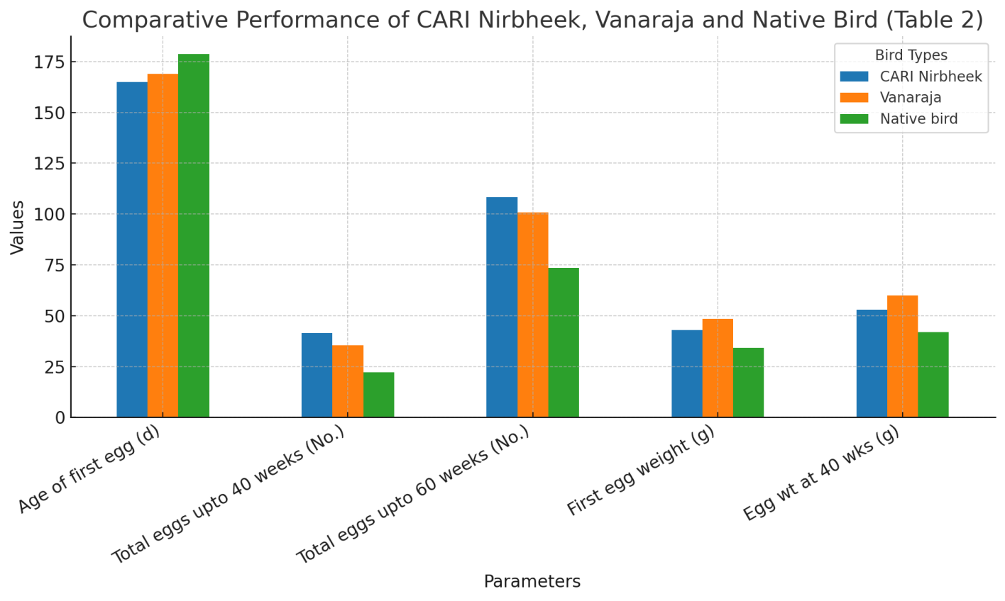

Fig 2 : Comparative Performance of Cari Nirbheek, Vanaraja and native bird

The performance of Vanaraja and Nirbheek was much better in comparison to native birds in rural areas. The birds had adaptability in the local climatic conditions of hilly district of Manipur..It can be concluded that performance of Vanaraja and Cari Nirbheek birds in terms of egg production and body weight was much better in comparison to native birds under backyard system of poultry rearing in hilly terrain in Manipur . .The average age at first egg lay was observed to be 170.85$and 178.65$ in Srinidhi birds reared under Semi Intensive and Scavenging system reported by A A Devi et.al (2025),So the farmers from rural areas of Chandel district can rear both Vanaraja and Cari Nirbheek birds for their livelihood and nutritional security.
Conclusion

The present study evaluated the comparative performance of Vanaraja, CARI Nirbheek, and local indigenous poultry birds under a traditional backyard rearing system.Among the three bird types studied, the Vanaraja breed emerged as the most promising performer. It consistently exhibited significantly higher body weight gains throughout the growth period, as well as superior egg weight, indicating its strong genetic potential for both meat and egg production. Its adaptability to scavenging-based backyard systems, coupled with a relatively early onset of laying and higher market acceptability, makes it highly suitable for rural poultry improvement initiatives in Chandel and similar agro-climatic zones.CARI Nirbheek also showed commendable performance, particularly in terms of egg production traits and disease resistance. Native birds significantly lower in both body weight and egg production , CARI –Nirbheek bird slightly inferior to Vanaraja in terms of growth rate. From an economic and nutritional standpoint, the introduction of Vanaraja and CARI Nirbheek into backyard poultry systems can contribute significantly to enhancing rural household income, improving food and nutritional security, and empowering women and marginal farmers through a sustainable, low-cost livelihood option. In conclusion, this study confirms that Vanaraja is the most suitable breed for enhancing poultry productivity in backyard systems of Chandel district, followed closely by CARI Nirbheek, both of which outperform traditional indigenous birds by a significant margin.

References

Asem Ameeta Devi,Khumlo Levish ,K Sonamani Singh (2025).Growth and Reproductive Performance of Srinidhi birds under Semi Intensive system of Rearing.Journal of Applied Life Sciences International.28(5).26-31.
Chatterjee, R.N., Rai, R.B., Kundu, A., Senani, S. and Sunder, J. (2007). Egg quality traits of indigenous breeds of chicken of Andaman. Indian Veterinary Journal 84: 206–208. Hamilton, R.M.G. (1982). Methods and factors that affect the management of egg shell quality. Poultry Science 61: 2022-2039,

.Haunshi, S., Sexana, S.C., Biswajit, D. and Bujarbaruah, K.M. (2007). Comparative performance of Vanarajachicken under backyard and intensive system at climatic condition of Meghalaya. Indian Journal ofAnimal Sciences 77:99-102

Haunshi, S., Doley, S. and Shakuntala, I. (2009). Production performance of indigenous chicken of north eastern region and improved varieties developed for backyard farming. Indian Journal of Animal Sciences 79: 901-905.

Mahapatra, C.M., Panda, B., Maitra, D.N. and Pandey, N.K. (1988). Physico-chemical evaluation of egg quality of native and farm-bred chicken. . Indian J. Anim. Sci. 59 (7): 865-870.

Malik, S. and Singh, S.P. (2010). Performance of CARI Nirbheek in agroclimatic condition of Tripura. Indian Journal of Animal Sciences 80:1213-1216.

