COMPARATIVE Valvular anatomy and valVulometry OF THE PULMONARY VALVE in sheep AND GOAT

ABSTRACT

The pulmonary valve in sheep and goat had three semilunar cusps viz., left, right and posterior that were attached to a ring like annulus at the base of the pulmonary root. Each of the cusp in both species had a hinge, belly and a free margin. The free edge comprised a nodule of Arantius in its middle and lunula on either sides. These cusps formed three commissures; left-right, right-posterior and posterior-left placed at the sino-tubular junction. The mean annular diameter was significantly different between the two species and was 1.3 ± 0.02 cm and 1.4 ± 0.04 cm in sheep and goat respectively. The free edge mean length of left, right and posterior cusps was significantly higher in goat and measured 2.2 ± 0.04 cm, 2.0 ± 0.03 cm and 1.9 ± 0.06 cm respectively. The right-posterior commissural mean height was significantly higher in goat and was 0.8 ± 0.04 cm while the left-right commissural mean height was higher in sheep and was 0.8 ± 0.06cm. The mean depth of these cusps and the mean height of the Posterior-left commissure was without significant difference between species.
The cusps in both species were connected by annulus made of densely arranged connective tissue to the ventricular myocardium. All the culsps in both species possessed lamina spongiosa supported by loosely arranged collagen bundles, few elastic and reticular fibers towards the right ventricular side. Lamina radialis was formed of dense, radial and regularly arranged collagen bundles with few elastic fibers. Lamina fibrosa was seen towards the pulmonary trunk and was formed of dense, regularly arranged collagen bundles, few elastic, reticular fibers and was lined by endothelial cells. The differential mean thickness of left, right and posterior leaflets were insignificant between sheep and goat. Histochemical studies revealed that the histological layers of these cusps showed PAS activity, AB activity, AKP activity and ACP activity at different intensities. No positive reaction for Oil red O and cholesterol was observed in both species.

Key words: Pulmonary valve, morphology, morphometry, histology, histochemistry

INTRODUCTION

Pulmonary valve form part of the fibrous skeleton of heart in all domestic animals (Dyce et al., 2010). They guard the pulmonary orifice situated at the summit of the conus arteriosus (Getty, 1975). This semilunar valves are passive structures that can open, close and ensures that the blood from the right ventricle flows in one direction ie., towards the pulmonary artery and not in the opposite direction (Frandson et al., 2009). This valve of the pulmonary trunk consists of right, left and intermediate semilunar cusps, or valvulae (Evans and Lahunta., 2013). Their convex surface face the ventricular side while the concave surface is towards the pulmonary side (Frandson et al., 2009)
The extent of development of these valves depends mainly on the blood pressure levels (Evans and Lahunta, 2013). Pregnancy, ageing, developmental anomalies and heart diseases can cause valvular dysfunction and failure leading to Valvular Heart Disease. Pathologies associated with pulmonary valve include pulmonary stenosis, pulmonary regurgitation and pulmonary atresia. Pulmonary valve stenosis is one that prevents blood flow from the right ventricle to the lungs. It accounts 5.1% of Congenital heart disease (CHD) in humans (Yadav, 2015) and is one of the most common cause of CHD in dogs (Markovic, 2020). It is often due to fusion or dysplasia of the cusps of the pulmonary valve. Affected valves are to be repaired and or replaced for proper functioning. In humans, pulmonary valve is used as a substitute for aortic valve replacements (Ross procedure) for its suitability (Supadevi and Subramaniam 2019).
Ovines has been traditionally used as an experimental animal model for preclinical testing of pulmonary valve implants (Flameng et al., 2006). However, Ovine models have a disadvantage to undergo ventricular fibrillation even with minor cardiac intervention (Shofti et al., 2004) and rapid calcification (Schoen et al., 1994; Flameng et al., 2006). Porcines are also considered unsuitable for long term studies due to their rapid growth. (Hecke et al., 2023)
Species specific variation in the outcomes of preclinical valvular repair and replacement trials in animal models is still challenging. The search for most suitable, feasible and manageable animal model for valvular research is still continuing. Further, the choice for an appropriate animal model depends on the research problem. This study is a detailed histological interspecies comparison of the pulmonary valve in sheep and goat to better understand their valvular anatomy, similarities and differences that will help assess the relative suitability of this species in preclinical studies.

MATERIALS AND METHODS

The heart of sheep and goat for the present study were collected from apparently healthy animals that were slaughtered in the nearby slaughter houses of Rajendranagar, Hyderabad. The hearts immediately after their collection were carefully removed of their outer peritoneal covering and were washed thoroughly to remove blood and blood clots on their surfaces. The hearts were then gently dissected for the pulmonary artery and valves. The sinuses of the valves were packed with cotton wool to maintain the valvular geometry and the contour of its cusps. The valves were then subjected to gross morphologic and morphometric observations such as shape, location, relations of the cusps, size, annular diameter, valvular free edge, cusp/leaflet depth, commissural height etc., by using vernier caliper, and scale - thread method (Vijay et al., 2025).
The hearts were then carefully dissected and washed in normal saline before fixing them in 10% Neutral Buffered Formalin (Singh and Sulochana, 1997) for paraffin embedded tissue sectioning. Each leaflet of the pulmonary valve was cut from the center of its free edge to its base/attached border at the annulus for processing and histomorphological observations. Paraffin sections of 4-5µm thickness were processed for staining by routine and special stains to record their microanatomical features. This include the Hematoxylin & Eosin method for micro-architecture, Van Gieson‟s method for collagen fibers and Wilder‟s method for reticular fibers (Singh and Sulochana 1997), Verhoeff‟s method for identification of elastic fibers (Culling 1974), Masson‟s trichrome method to differentiate muscle and CT (Luna, 1968). The thickness of the valves were recorded by micrometry.
For histochemical analysis, fresh frozen sections of 10 – 15 µm and paraffin sections were utilized. These sections were subjected to PAS reaction to demonstration glycogen, PAS–AB method for acid and neutral muco polysaccharides, Gomori‟s method for localization of ACP enzyme, Oil red-O in propylene glycol method for demonstration of fats, Tris Buffer (Gomori) Method for demonstration of succinic dehydrogenase enzyme (Singh and Sulochana 1997) and Schutz‟s method for cholesterol (Carleton et al., 1980) respectively.
RESULTS AND DISCUSSION

The pulmonary or right semilunar or right arterial valve in sheep and goat was seen at the right atrio-ventricular orifice and it separated the right ventricle from the pulmonary trunk as reported in other farm animals (Frandson et al., 2009). It was seen cranial and towards the left of the aortic valve as reported by (Evans and Lahunta 2013) in dog. It comprised a pulmonary root, annulus and three cusps (Fig. 1). The annulus was placed more towards the right ventricle and gave attachments to three cusps while the ventriculo-arterial junction was placed above the annulus and separated the right ventricle from pulmonary root in both the species (Fig.1) as reported by Getty (1975) and Dyce et al., (2010) in other domestic animals. In contrary, Stamm et al., (1998) and Stradins et al., (2004) reported that the annulus marked the ventriculo-arterial junction between free-standing right ventricular myocardium and the fibroelastic walls of pulmonary sinuses in humans. The root of the pulmonary valve does not have a circular form and was not a well defined fibrous structure in humans (Misfeld and Sievers, 2007).
This pulmonary cusps based on their topology were identified as right, left and intermediate/posterior cusps or valvulae in both the species (Fig: 1). Each of these valvulae had a hinge, belly and free margin. The free edge in all cusps comprised a thick circular fibrous nodule or nodule of Arantius in its middle, which provided the coapation area to the neighboring valve leaflets. These observations are akin to the description made by various authors (Getty 1975 and Dyce et al., 2010 in domestic animals; Misfeld and Sievers 2007, and Akthar et al. 2011 in humans. On either side of this nodule lunula was present.
The PV sinuses were three in the region of pulmonary root and were bounded proximally by the basal attachment of the cusps and distally by sino-tubular junction. The later inturn was a ridge which defined the upper part of sinuses and ran through upper part of commissures forming inter-leaflet triangles. This feature is similar to the human PV as described by Misfeld and Sievers (2007) and Akthar et al . (2011) who also stated that these triangles played a dynamic role in opening and closing of the valve. The commissures were the highest point where two neighboring cusps met and were placed at sino-tubular junction. Based on the location of commissure, they were identified as left-right, right-posterior and posterior-left. The inter-leaflet triangles between the leaflets were formed with in the right ventricle (Fig. 1).
The mean annular diameter in sheep and goat was 1.3 ± 0.02 cm and 1.4 ± 0.04 cm respectively and the difference was highly significant between the two species (P<0.01) (Table. 1). But, Schmitt (2016) in his study found that the mean pulmonary valve diameter in sheep was 24.6±2.5 mm. The free edge mean length of left, right and posterior cusps was significantly higher in goat 2.2 ± 0.04 cm, 2.0 ± 0.03 cm and 1.9 ± 0.06 cm respectively. Akthar et al., (2011) mentioned in bovines that free edge mean length of right cusp was greater than the posterior cusp while the left cusp was the shortest and this length increased with age in all the cusp in bovines. The right and posterior commissural mean height was significantly higher in goat which was 0.8 ± 0.04 cm and in sheep measured 0.7 ± 0.06 cm while the left and right commissural mean height was higher in sheep and it was 0.8 ± 0.06cm and in goat it measured 0.4 ± 0.05 cm (P<0.05) (Table 1).
In this study, PV annulus in both sheep and goat was in loose contact with myocardium and was characterized by densely arranged connective tissue adjacent to the ventricular myocardium. In contrary, Misfeld and Sievers (2007) described that there was no well-defined fibrous annulus that characterized the line of attachment of pulmonary leaflets. The cusps of the PV in both species was made up of three distinct layers; lamina spongiosa, lamina radialis, lamina fibrosa apart from the endothelial lining (Fig 2,3) and is in accordance with Misfeld and Sievers (2007) who described that the pulmonary valve is histologically formed of five layers between the ventricular and arterial endothelial layers of the leaflet and they were lamina ventricularis, lamina radialis, lamina spongiosa, lamian fibrosa and lamina arterialis in humans.
The lamina spongiosa was towards the ventricle and comprised loosely arranged collagen bundles with few elastic and reticular fibers. In humans, the spongiosa showed loose collagen fibers that are oriented parallel and in a circumferential direction. This layer was largest in the younger age (Gumpangseth et al., 2020). Lamina radialis was comprised of dense regularly and radially arranged collagen bundles with few elastic fibers. Lamina fibrosa was seen towards the pulmonary trunk side and comprised tight network of dense and regularly arranged collagen bundles with few elastic and reticular fibers (Fig 2,3). These findings are similar to Broom (1978) and Misfeld and Sievers (2007) who mentioned that the collagen and elastic fibers arrangement is important for the leaflet load bearing in humans. There was no evidence of muscle fibers in the pulmonary leaflet of both the species in the present study.
The performance of the valves can be assessed based on their histological components viz., cellularity and thickness of the valves (Quinn et al., 2011). The performance of transplanted tissue engineered heart valves in pulmonary position has already been carried out in sheep and goat models. The density of collagen fibers increased and their orientation/arrangement was irregular with advancing age in valves. This structural alteration resulted in stiffness, reduced extensibility and caused functional impairements (Gumpangseth et al., 2020). The general morphology of all the three cusps of the pulmonary valve was similar in both the species. The differential mean thickness of left, right and posterior leaflets were insignificant between sheep and goat (Table 1)
Our histochemical analysis revealed a moderate PAS activity in lamina spongiosa while it was weak in lamina fibrosa and radialis (Fig. 4). A strong AB activity was observed in ventricular endothelium and lamina spongiosa were as a weak activity was noticed in lamina radialis and arterial endothelium which indicated the distribution of acid mucopolysaccharides (Fig. 4). The amount of mucopolysaccharides decreases with age (Mc Donald et al., 2002). AKP activity was intense in arterial surface, mild in subendothelial region, moderate in lamina radialis and weak in lamina fibrosa. The activity for ACP was intense in the arterial surface, weak in radialis and moderate in the ventricular surface. The valves were negative for Oil red O and cholesterol activity. Lipid accumulation in the valves increases with age (Mc Donald et al., 2002).

CONCLUSION
Understanding the macro and micromorphology of the valves will help to improvise techniques in the treatment of valvular diseases. Histological assessment is an essential step to determine the quality, suitability and adaptability of the bioprosthetic valves and it helps to engineer them for better performance. Morphometric parameters are critical components in developing these valves and to test cardiovascular devices for their performance in this animal models. This comparative study in goat with sheep details the valvular anatomy that may be of interest in considering the suitability of this species as one among the other available large animal models like swine, canine and ovine in valvular research.

COMPETING INTERESTS DISCLAIMER:
Authors have declared that they have no known competing financial interests OR non-financial interests OR personal relationships that could have appeared to influence the work reported in this paper.
REFERENCES

Akhtar, S., Hossain, F.M.A., Siddique, M.S.I., Alam, M. and Islam, M.N. (2011). Morphology and Morphometrical studies on semilunar heart valves of indigenous Cattle. International Journal of Natural Sciences 1(1):7-11.

Broom, N.D. (1978). The observations of collagen and elastin structures in wet whole mounts of pulmonary and aortic leaflets. Journal of Thoracic and Cardiovascular Surgery. 75, 121-130.

Carleton, H.M., Drury, R. and Wallington, E.A. (1980). Carleton‟s Histological Techniques, Fifth Edition, Oxford Medical Publications, U.K.

Culling. (1974). Handbook of Histopathological and Histochemical Techniques, Third Edition, Elsevier limited.

Dyce, K.M., Sack, W.O. and Wensing, C.J.G. (2010). Text book of Veterinary Anatomy. 4th edition. Philadelphia: Saunders publications ,227-231.

Evans, H.E. and Lahunta A,D. (2013) Miller’s Anatomy of the dog. 4th edn. Elsevier Saunders, China.

Flameng, W., Meuris, B., Yperman, J,, de Visscher, G., Herijgers, P. and Verbeken, E. (2006). Factors influencing calcification of cardiac bioprostheses in adolescent sheep. Journal of Thoracic and Cardiovascular Surgery. 132:89–98.

Frandson, R.D., Wilke, W.L. and Fails, A.D. (2009) Anatomy and physiology of farm animals. 7th edn, Wiley-Blackwell.

Getty, R (1975). The Anatomy of the domestic animals. Vol. 1, 5th edition. W.B Saunders company, Philadelphia, USA.

Gumpnagseth, T., Lekawanvijit, S. and Mahakkanukrauh, P. (2020). Histological assessment of the human heart valves and its relationship with age. Anatomy and Cell Biology 53:261-271

Hecke, M.V., Langenaeken, T., Rega, F., Roskams, T. and Meuris, B. (2024). Validation of large animal models in mechanical valve research: a histologic comparison. Interdisciplinary CardioVascular and Thoracic Surgery. doi:10.1093/icvts/ivae070

Luna, L.G. (1968). Manual of Histological Staining methods of the armed forces Institute of pathology. 3rd edtn. McGraw Hill Book Co., New York.

Markovic, L.E., Whipp, C., Morgan, K., Almeida, D. and Hiremath, G. (2020). Transpulmonary Stent Implantation for Dysplastic Pulmonary Valve Stenosis with a Single Left Coronary Ostium and Anomalous Prepulmonary Right Coronary Artery in an English Bulldog. CASE: Cardiovascular Imaging Case Reports. 4(6):540-545.

McDonald, P.C., Wilson, J.E., McNeill, S., Gao, M., Spinelli, J.J., Rosenberg, F., Wiebe, H. and McManus, B. M. (2002). The challenge of defin ing normality for human mitral and aortic valves: geometrical and compositional analysis. Cardiovascular Pathology. 11:193 209.

Misfeld, M. and Sievers, H.H. (2007). Heart valve macro and microstructure. Philosophical Transactions of the Royal Society B. 362, 1421-1436.

Quinnn, R.W., Hilbert, S.L., Bert, A.A., Drake, B.W., Bustamante, J.N., Fenton, J.E., Moriarty, S.J., Neighbors, S.L., Lofland, G.K. and Hopkins, R.A. (2011). Performance and morphology of decellularised pulmonary valves implanted in juvenile sheep. The Annals of Thoracic Surgery. 92:131–7

Schmitt, B., Spriestersbach, H., Icí, D.O., Radtke, T., Bartosch, M., Peters, H., Sigler, M., Frese, L., Dijkman, P.E., Baaijens, F.P.T., Hoerstrup, S.P. and Berger, F. (2016). Percutaneous pulmonary valve replacement using completely tissue-engineered off-the-shelf heart valves: six-month in vivo functionality and matrix remodelling in sheep. Eurointervention. 12:62-70

Schoen, F.J., Hirsch, D., Bianco, R.W. and Levy, R.J. (1994). Onsetandprogressionofcalcificationin porcine aorticbio prosthetic valves implanted as orthotopic mitral valve replacements in juvenile sheep. Journal of Thoracic and Cardiovascular Surgery. 1994; 108(5):880–7.

Shofti, R., Zaretzki, A., Cohen, E., Engel, A. and Bar-El, Y. (2004). The sheep as a model for coronary artery bypass surgery. Laboratory Animals. 38:149–57.

Singh, U.B. and Sulochana, S. (1997). Handbook of histological and histochemical techniques. Premier publishing house, Hyderabad.

Stamm, C., Anderson, R.H. and Ho, S.Y. (1998). Clinical anatomy of the normal pulmonary root compared with that in isolated pulmonary valve stenosis. Journal of the American College of Cardiology. 31, 1420-1425.

Stradins, P., Lacis, R., Ozolanta, I., Purina, B., Ose, V., Feldmane, L. and Kasyanov, V. (2004). Comparision of biochemical and structural properties between human aortic and pulmonary valve. European Journal of Cardiothoracic Surgery. 26, 634-639.

Supadevi, S., and Subramaniam, R.K., (2019) Comparison of morphology and morphometry of human pulmonary and porcine pulmonary heart valves. MedPulse – International Journal of Anatomy. 10(2): 27-31

Vijay, K,R., Senthamil Selvan, P., Rajendranath N. and Purushotham, G. (2025). “Valvular Morphology and Morphometry of the Tricuspid Valves in Sheep and Goat”. Journal of Advances in Biology & Biotechnology. 28 (8):309-17.

Yadav, S.K. (2015). The diagnosis and treatment of pulmonary valve stenosis in children. Asian Journal of Medical Sciences. 6(6) 1-5.

FIGURES 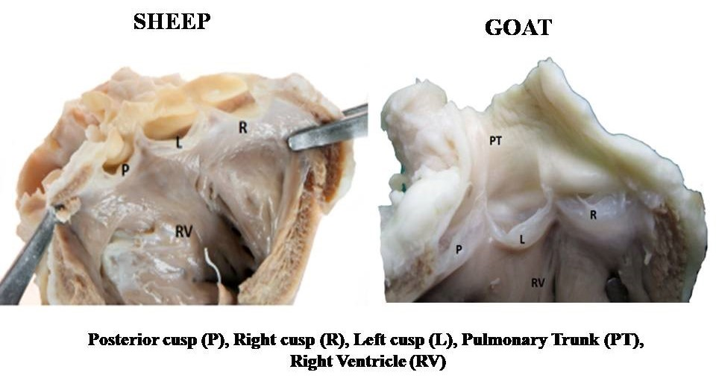
Fig.1. Photograph showing the gross anatomical features of the pulmonary valve in sheep and goat.

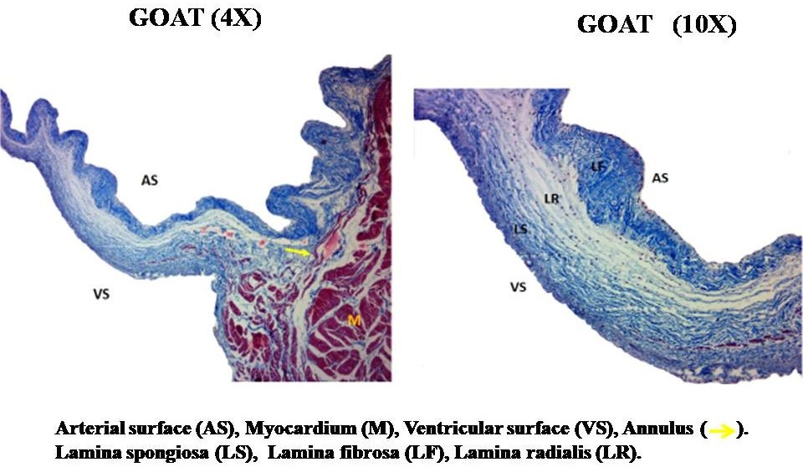
Fig. 2. Photomicrograph of the pulmonary valve in goat showing the differences in distribution and density of collagen fibers in its histological layers (Masson’s trichrome – 4X and 10X)

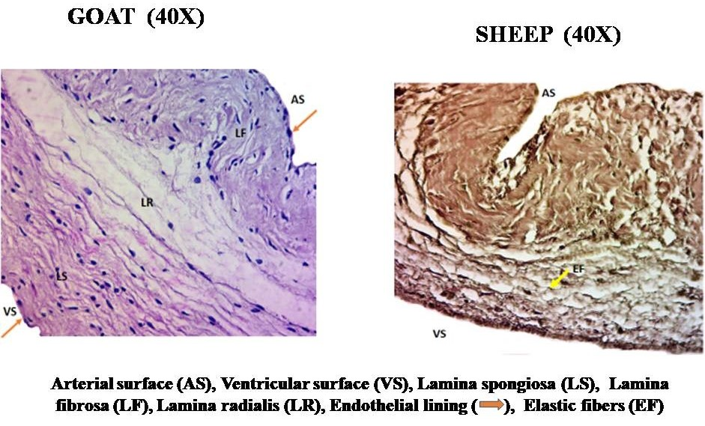
Fig. 3. Photomicrograph of the pulmonary valve in Goat (H & E- 40X) showing its laminae and Sheep (Verhoeff”s – 40X) showing the distribution of elastic fibers

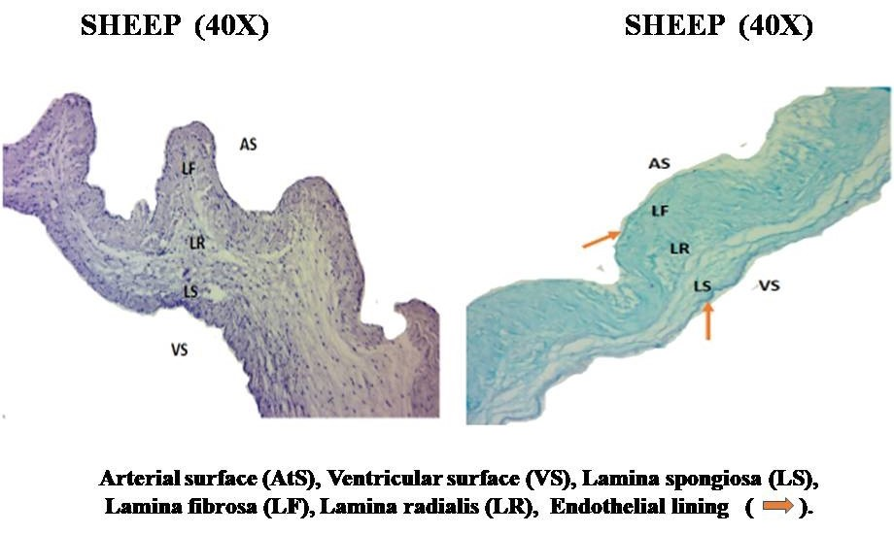
Fig. 4. Photomicrograph of the pulmonary valve in Sheep showing positive reaction for mucopolysaccharides (PAS – 40X) and (PAS -AB– 40X)

Tables:
Table.1. Morphometric measurements of the pulmonary valve in Sheep and Goat
Sl.No | Parameter |  | Sheep |  | Goat
Sl.No | Parameter |  | mean | SE | mean | SE
1 | Annular Mean Diameter (cm) |  | 1.3** | 0.02 | 1.48* | 0.04
2 | Free Edge Mean Length (cm) | Left | 2.0** | 0.05 | 2.2** | 0.04
2 | Free Edge Mean Length (cm) | Right | 1.6** | 0.03 | 2.0** | 0.03
2 | Free Edge Mean Length (cm) | posterior | 1.7** | 0.04 | 1.9** | 0.06
3 | Leaflet Mean Depth (cm) | Left | 1.0 | 0.05 | 1.1 | 0.04
3 | Leaflet Mean Depth (cm) | Right | 1.1 | 0.05 | 1.1 | 0.03
3 | Leaflet Mean Depth (cm) | Posterior | 1.0 | 0.07 | 1.1 | 0.04
4 | Commissure Mean Height (cm) | Right-Posterior | 0.7* | 0.06 | 0.8* | 0.04
4 | Commissure Mean Height (cm) | Left-Right | 0.8* | 0.06 | 0.4* | 0.05
4 | Commissure Mean Height (cm) | Posterior-Left | 0.7 | 0.05 | 0.7 | 0.05
5 | Pulmonary valve Mean Thickness (µm) | Left | 450.5 | 7.4 | 467.0 | 6.8
5 | Pulmonary valve Mean Thickness (µm) | Right | 443.7 | 5.1 | 457.4 | 5.8
 |  | Posterior | 435.5 | 5.8 | 450.5 | 4.7

NOTE: **indicates significance at 0.01 level &* indicates significance at 0.05 level.

