Acute Oral Toxicity Assessment of Xlivpro premix in Wistar Rats: A Liver protective Herbal Premix

ABSTRACT
Aims: To evaluate the acute oral toxicity and safety profile of Xlivpro Premix in accordance with OECD-423 guidelines.
Study Design: Experimental study involving the assessment of toxic effects and mortality in adult Wistar rats following oral administration of Xlivpro Premix.
Place and Duration of Study: the study was conducted at the Department of Veterinary Pharmacology and Toxicology, Post Graduate Institute of Veterinary and Animal Sciences (PGIVAS), Akola, Maharashtra, India over a period of 14 days.
Methodology: Six healthy adult Wistar rats (113–134 grams) were administered Xlivpro Premix orally at doses of 300 mg/kg and 2000 mg/kg body weight. Observations for toxic effects and mortality were recorded for 14 days. Blood biochemical parameters i including AST, ALT, ALP, and creatinine were measured. At the end of the study,histopathological examinations of vital organs including the heart, liver, kidneys, and lungs were performed.
Results: No toxic effects or mortality were observed in Xlivpro-treated rats during the experimental period. Changes in body weight over the 14-day period remained within normal limits. Biochemical parameters and histopathological evaluations indicated no significant abnormalities. The LD50 of Xlivpro Premix exceeded 2000 mg/kg, confirming the safety of formulation.
Conclusion: The study outcome demonstrated that Xlivpro Premix at tested dose levels did not induce acute oral toxicity in wistar rats, supporting its safety for poultry, fish and shrimpuse
Keywords: Xlivpro Premix; acute; OECD-423; poultry; Wistar rat

- INTRODUCTION:

Livestock is vital to India's agriculture and economy, providing essential nutrients, income, and employment, especially in rural areas. Poultry holds significant economic importance by generating employment, providing livelihood to small farmers by generation of regular income from the sale of eggs and meat, enhancing food security with high-quality protein, and boosting exports. According to the 20th Livestock Census of India, the total livestock population was 535.78 million, and the total poultry population was 851.81 million in 2019. India is the world's fifth-largest producer of chicken and third-largest producer of eggs (BAHS 2023, DAHD-Govt. of India). The health and productivity of poultry rely on optimal feed utilization, increased body weight, absence of disease, and low mortality rates (Singh et al., 2009). Seasonal changes pose disease risks, with the liver being the most affected organ. Achieving optimal growth with efficient feed utilization is crucial for profitable broiler production, as feed accounts for approximately 70% of the total expenditure on poultry farming.
In poultry, the liver, along with other vital organs, plays a crucial role in laying the groundwork for birds to achieve optimal productivity and maximum profitability (Dhumal et al., 2018). The rising demand for poultry meat has led to the growing use of synthetic compounds in feed. However, these compounds come at a high cost, which, in turn, raises the overall cost of poultry feed. Moreover, concerns regarding the safety of such practices have recently surfaced, leading to restrictions on their use in various parts of the world. As a result, there is a strong renewed interest in developing natural alternative supplements to ensure the productivity, performance and wellbeing of animals (Chattopadhyay et al., 2006).
Over the years, the use of chemicals as drugs and antibiotics at sub-therapeutic levels to promote growth and immunity in birds has become increasingly limited due to the risk of developing resistant bacteria and other drug related side effects. As an alternative, the use of phytobiotics in poultry feeding is emerging as a novel approach to enhance neonatal growth and immunocompetence traits in birds. Phytobiotics, which are plant derivatives such as herbs, plant extracts, or spices, offer a wide range of benefits, including stimulating feed intake, growth, and endogenous secretions in the gut. They serve as immunomodulators, resulting in reduced mortality rates and possessing coccidiostatic, antimicrobial, anthelmintic, and anti-inflammatory properties (Abbas et al., 2010; Grashorn, 2010).
There is increasing evidence that plants and their extracts, due to their phytoconstituents, are valuable in various aspects of medicine and overall wellbeing. In the poultry industry, specialized feed ingredients are added to boost growth performance and improve feed conversion ratios (FCR) (Babazadeh et al., 2011; Mirza et al., 2016). Since the 1990s, with the global ban on antibiotic use, researchers have been focusing on phytogenic growth promoters to achieve better animal performance. Today, growth promoters derived from herbal sources are commonly used (Gong et al., 2014; Dhama et al., 2015).
In broilers, the liver must contend with high-energy diets, the use of coccidiostats, and chemotherapeutic agents, which pose health risks and create complex prognostic situations. Researchers are actively seeking viable alternatives to replace antibiotics due to the ban on their use and growing concerns over antimicrobial resistance. One promising class of alternatives is herbs and medicinal plants. Herbal liver tonics protect the liver from toxins and stimulate liver function, thereby enhancing growth and production performance (Hajare et al., 2020).
Good liver health is crucial for layer birds as it supports the immune system by producing immune factors and filtering pathogens, and regulates hormones necessary for consistent egg laying and reproductive health. Additionally, the liver stores glycogen for energy regulation, metabolizes fats vital for egg yolk formation, and enhances disease resistance, helping birds withstand infections and stresses. Thus, maintaining liver health is essential for optimizing productivity, improving egg quality, and ensuring overall wellbeing. Integrating liver-supporting herbs and supplements into their diet can significantly contribute to the health and performance of layer birds.
Xlivpro Premix contains herbs such as Andrographis paniculata, Azadirachta indica, and Boerhaaviadiffusa, which possess hepatoprotective, choleretic, immunomodulatory, immunostimulatory, and free radical scavenging activities.
Andrographis paniculata, commonly known as Kalmegh contains andrographolide as primary active component. Among its many benefits, its liver protective properties are particularly significant for poultry wellbeing. Andrographis paniculata has been found to exhibit liver protective effects by enhancing the activity of antioxidant enzymes such as superoxide dismutase, catalase, glutathione peroxidase, and decreasing lipid peroxidase activity. These actions help mitigate the generation of free radicals that can damage liver cells and thus making it a valuable addition to poultry feed for enhancing liver health and overall wellbeing(Shukla et al.,1992 and Trivedi et al., 2001).
Azadirachta indica, commonly known as Neem, belongs to the Meliaceae family. The dried leaves of Neem contain triterpenoids, sterols, and bitter principles such as nimbin and nimbiol. Neem bark, with its cooling, bitter, astringent, acrid and refrigerant properties, is highly beneficial. For poultry wellbeing, Neem leaves are particularly valuable for their benefits in addressing various disorders and infections, making them a viable alternative to antibiotics for promoting the health and productivity of poultry.
Boerhaaviadiffusa, also known as Spreading Hog Weed. It contains bioactive compounds such as Boeravinones G and H, which contribute to its various health benefits. Boerhaaviadiffusa has demonstrated significant antioxidant and hepatoprotective properties, enhancing the activity of antioxidant enzymes and reducing oxidative stress. This is particularly beneficial for poultry liver health. The plant also possesses diuretic properties, helping manage fluid balance, and has shown antibacterial activity against Gram-negative bacteria, which aids in preventing infections and making it a valuable addition to poultry liver premixes (Somvanshi et al., 2020).
Xlivpro Premix may also act as a depurative, enhancing erythropoiesis and the immune system. Xlivpro Premix in poultry is recommended for mitigating the damaging effects of aflatoxins, restoring reduced feed intake, improving liver function, and optimizing feed utilization, growth, and production. In a study, Xlivpro Premix was found to improve feed efficiency, body weight, breast muscle mass, and reduce fat pad size, suggesting an enhancement of muscle protein synthesis and a reduction of fat deposition through the inhibition of lipogenesis or the increase of the lipolysis process. Considering the high commercial value of Xlivpro Premix the present study aimed at studing its safety by determining the acute oral toxicity potential of Xlivpro Premix.

2. MATERIALS AND METHODS
The study was conducted at the Department of Veterinary Pharmacology and Toxicology, Post Graduate Institute of Veterinary and Animal Sciences (PGIVAS), Akola, Maharashtra, India. The institute is situated at a latitude of 20.70⁰ N and a longitude of 77.070⁰ E, with an elevation between 287 and 316 meters above sea level, and experiences a tropical climate. Six healthy young adults female Wistar rats, weighing 113 to 134 g, were used in this study.The study was conducted from 13th April to 26th April 2022. The animals were acquired from the Laboratory Animal Resource Section at PGIVAS, Akola. A total of four animals in one cage with corn cob as bedding material were used for ease of monitoring. Picric acid was used for animal identification. During the experiment the ambient temperature of 25±2 ⁰ C was maintained and humidity was in the range of 50-70% during the experiment period. The animals were kept under a 12hour light-dark cycle and had access to standard pelleted feed and water ad libitum. The animals were housed in polypropylene cages 5 days prior to experimentation as a period of acclimatization (OECD, 2001).

Table 1: Design of acute oral toxicity study
Group No. | Type of Study Used | Number of Animals | Dose (mg/kg body weight)
I  II  III | Step 1: Sighting study  Step 2: Sighting study  Main study | 01  01  04 | 300  2000  2000

The rats were divided into three distinct experimental categories (Table 1) and were deprived of food, but not water, overnight prior to dosing. Post-fasting, the weights of all the rats were recorded. The Xlivpro Premix test substance (provided by M/s Zenex Animal Health India Private Limited) was dissolved in distilled water and administered to one rat each from Group I and Group II, at doses of 300 mg/kg and 2000 mg/kg of body weight, respectively. Observations were made to note any signs of toxicity. Since no toxic symptoms were observed in the sighting study for Group I and Group II, the main study commenced, in which all four rats in Group III were given the test substance at a dose of 2000 mg/kg of body weight. After dosing, rats in Groups I, II, and III were deprived of food for an additional 1-2 hours.
The animals were monitored for any signs of mortality, convulsions, tremors, labored breathing, piloerection, salivation, lethargy, coma, or any other abnormal behaviors. Any changes in body weight, coat condition, eyes, mucous membranes, and behavior were documented. After a 14-day observation period, the animals were euthanized using high thiopental sodium and vital organs (heart, liver, kidneys, and lungs) were collected and preserved in 10% neutral buffered formalin for histopathological examination. Sections of 4-6 µm were prepared using a rotary microtome and stained with H&E stain for histopathological analysis, as per Luna (1968). A sample of 1-2 ml of blood was drawn from the retro-orbital plexus with a capillary tube and collected in EDTA vials for biochemical estimation of alanine transaminase (ALT), aspartate aminotransferase (AST), alkaline phosphatase (ALP)and creatinine.

3. RESULT AND DISCUSSION
The body weights of each rat were recorded individually on days 0, 7, and 14 of the study. During this period, rats in the main test group (Group III) exhibited a normal increase in body weight (Table 2). Biochemical analysis indicated that the levels of ALT, AST, ALP, and creatinine remained within their respective normal ranges (Table 3). Xlivpro Premix orally at a dosage of 2000 mg/kg did not result in any mortality among the rats, establishing the LD50 of the compound to be greater than 2000 mg/kg of body weight. Furthermore, no abnormal symptoms such as tremors, labored breathing, piloerection, convulsions, salivation, lethargy, or coma were observed over the experimental duration of 14days. Additionally, there were no significant gross or histological abnormalities detected in the heart, liver, kidney, or lungs that could be attributed to the toxicity of the test substance (Fig. 1).

Table 2: Weekly body weight of rats received XlivPro Premix @ 2000mg/kg
Dose of XlivPro Premix | Rat No. | Body Weight (g) on Day
Dose of XlivPro Premix | Rat No. | 0 | 7 | 14
2000mg/kg | 1 | 138 | 152 | 164
2000mg/kg | 2 | 117 | 129 | 135
2000mg/kg | 3 | 120 | 134 | 152
2000mg/kg | 4 | 126 | 141 | 155
 | Total | 125.25±4.64 | 139±4.98 | 151.5±6.06
Key: F= Female, Total values are expressed asMean±SE (standard error )

Table 3: AST, ALT, ALP and creatinine values in experimental rats treated with XlivPro Premix@2000mg/kg
Dose of XlivPro Premix | Rat No. | Biochemical parameters
 |  | AST | ALT | ALP | Creatinine
2000mg/kg | 1 | 62.79 | 26.09 | 82.06 | 0.55
2000mg/kg | 2 | 40.52 | 20.11 | 79.25 | 0.51
2000mg/kg | 3 | 56.60 | 27.43 | 67.44 | 0.57
2000mg/kg | 4 | 47.92 | 22.70 | 86.32 | 0.46
 | Total | 51.95±4.88 | 24.08±1.65 | 78.76±4.04 | 0.52±0.02
Rat No. 1, 2 3 and 4 are from main test group III, Total values are expressed as Mean±SE (standard error)

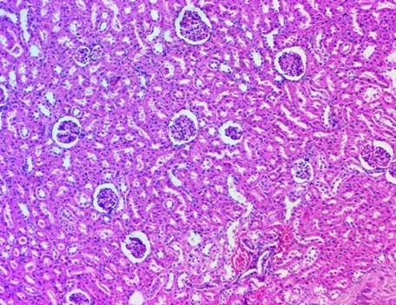
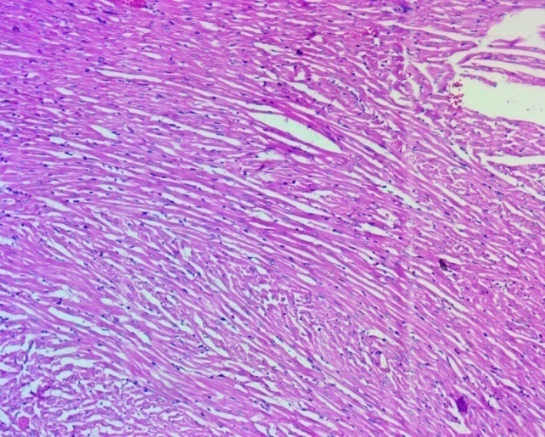
B
A

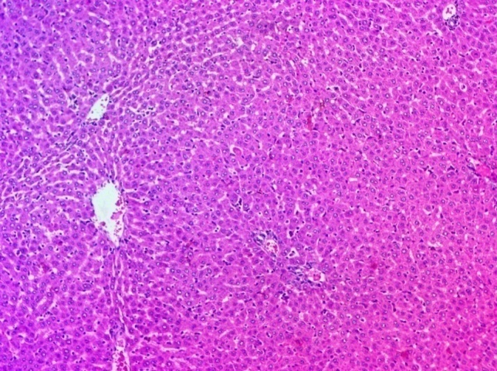..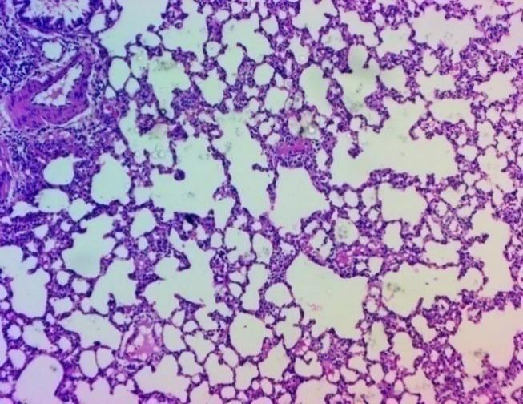
C
D
Fig 1 Histopathological observations of tissue sections showing normal histoarchitecture of Heart (A), Kidney(B), Liver(C) and Lung (D)from group III rats received XlivPro Premix formulation @2000mg/kg BW

4. CONCLUSION:

The present study concludes that Xlivpro Premix, a liver-protective herbal formulation intended for poultry, does not elicit any signs of acute toxicity, behavioral abnormalities, or mortality when administered orally at a limit dose of 2000 mg/kg body weight in Wistar rats. The absence of clinical signs, gross pathological lesions, and mortality strongly indicates a wide margin of safety of product. Based on these findings, Xlivpro Premix can be considered non-toxic under acute oral exposure conditions, supporting its safe use as an oral feed supplement in poultry.

DISCLAIMER (ARTIFICIAL INTELLIGENCE)
Author(s) hereby declares that no generative AI technologies such as Large Language Models (ChatGPT,COPILOT, etc.) and text-to-image generators have been used during the writing or editing of this manuscript.
REFERENCES
Abbas, R.Z., Iqbal, Z., Khan, M.N., Zafar, M.A. and Zia, M.A. 2010. Anticoccidial activity of Curcuma longa L. in broilers. Brazilian Archives of Biology and Technology, 53: 63-67.
Babazadeh, D., Vahdatpour, T., Nikpiran, H., Jafargholipour, M. A., &Vahdatpour, S. (2011). Effects of probiotic, prebiotic and synbiotic intake on blood enzymes and performance of Japanese quails (Coturnix japonica). The Indian Journal of Animal Sciences, 81(8).
Basic Animal Husbandry Statistics for the year 2023, published by the Department of Animal Husbandry and Dairying (DAHD), Government of India.https://dahd.gov.in/sites/default/files/2024-05/BAHS2023.pdf
Chattopadhyay K., Mondal M.K. and Roy (2006). Comparative efficacy of DL methionine and herbal methionine on performance of chicken. Int. J. Poult. Sci. 5:1034-1039
Dhumal, M. V., Nikam, M. G., Nandedkar, P. V., Majee, S. B., & Kotagiri, R. (2018). Efficacy of herbal liver tonic (superliv) in improving growth performance, nutrient utilization, carcass traits and economics of broiler chicken. International Journal of Livestock Research, 8(6), 266-278.
Gong, J., Yin, F., Hou, Y., & Yin, Y. (2014). Chinese herbs as alternatives to antibiotics in feed for swine and poultry production: potential and challenges in application. Canadian Journal of Animal Science, 94(2), 223-241.
Grashorn, M.A. 2010. Use of phytobiotics in broiler nutrition- An alternative to infeed antibiotics? Journal of Animal and Feed Sciences, 19: 338-47.
Hajare, S., Ingole, R. S., Kotagiri, R., & Ganguly, B. (2020). Evaluation of acute oral toxicity of a polyherbal liver tonic for poultry. Biosciences Biotechnology Research Asia, 17(1), 85.
Kapoor LD. CRC Handbook of Ayurvedic Medicinal Plants. Boca Raton (FL): CRC Press. 1990.
Mirza, M. W., & Mukhtar, N. (2016). Use of organic acids as potential feed additives in poultry production. Journal of World's Poultry Research, 6(3), 105-116.
Shukla, B., Visen, P. K. S., Patnaik, G. K., & Dhawan, B. N. (1992). Choleretic effect of andrographolide in rats and guinea pigs1. Planta medica, 58(02), 146-149.
Singh, V. K., Chauhan, S. S., Ravikanth, K., Maini, S., &Rekhe, D. S. (2009). Effect of dietary supplementation of polyherbal liver stimulant on growth performance and nutrient utilization in broiler chicken. Veterinary World, 2(9).
Somvanshi, S. P. S., Gupta, R., Kaur, N., Kumar, A., & Pandey, N. K. (2020). Effect of herbal liver stimulants on growth and performance of broiler chicks. Indian Journal of Extension Education, 56(1), 69-72.
The Ayurvedic pharmacopoeia of India, Government of India, Ministry of Health and Family Welfare, Department of Ayush. Part-I, Vol-I, 6, 27, 38, 39, 60, 63, 70, 79.https://dravyagunatvpm.wordpress.com/wp-content/uploads/2019/10/api-part-1-vol-6-monographs.pdf
Trivedi, N. P., & Rawal, U. M. (2001). Hepatoprotective and antioxidant property of Andrographis paniculata (Neem) in BHC induced liver damage in mice.

