ANALYSIS OF GRAIN YIELD AND YIELD CONTRIBUTING TRAITS IN MAIZE INBRED LINES THROUGH CORRELATION AND PATH COEFFICIENT APPROACHES

Green colour modified & CHECK COMMENTS FROM VIEW TAB
Red colour check and delete

ABSTRACT
The present study aimed to dissect the relationships among yield contributing traits and identify key determinants of grain yield in maize inbred lines through correlation and path coefficient analysis. A set of 50 diverse maize inbred lines was evaluated during the Rabi, 2024–25 at the Regional Agricultural Research Station, Lam, Guntur, in an Alpha Lattice Design with two replications. Data were recorded on thirteen traits, including days to 50% anthesis, days to 50% silking, anthesis-silking interval, days to maturity, plant height, ear height, ear length, ear girth, number of kernel rows per ear, number of kernels per row, 100-kernel weight, SPAD chlorophyll meter readings (SCMR) and grain yield per plant. Genotypic and phenotypic correlation analysis revealed significant positive associations of days to maturity, plant height, ear height, ear length, ear girth, number of kernel rows per ear, number of kernels per row, 100-kernel weight and SPAD Chlorophyll Meter Reading (SCMR) with grain yield per plant, indicating their potential utility for indirect selection. Path coefficient analysis indicated that anthesis-silking interval, plant height, 100-kernel weight and SPAD Chlorophyll Meter Reading (SCMR) exhibited positive direct effects on grain yield per plant at both genotypic and phenotypic levels, highlighting their importance in breeding programs. These findings provide critical insights for maize breeders to enhance grain yield through the strategic selection of key traits.
Keywords: Maize, SPAD chlorophyll, Correlation analysis, Path coefficient analysis, Association studies.

1. INTRODUCTION
Maize (Zea mays L.) is the third most important cereal crop in India, following rice and wheat, and plays a pivotal role in ensuring food, feed, fodder, and energy security. It serves as a crucial raw material for diverse industries, including starch, oil, protein, alcoholic beverages, sweeteners, cosmetics and biofuels. As a C₄ species, maize demonstrates superior photosynthetic efficiency, high yield potential and remarkable adaptability across a wide range of agro-climatic conditions. Owing to its multifaceted utilization, contemporary maize breeding programs are directed towards the development of superior inbred lines and hybrids that outperform existing cultivars with a primary focus on enhancing grain yield which remains the most critical agronomic trait (Pandey et al.,) [1].
Grain yield in maize is a complex quantitative trait that is highly influenced by environmental conditions and governed by intricate interactions among multiple yield-contributing characters. The complexity arises from both genetic and environmental factors making direct selection for yield challenging. Hence, analyzing genotypic and phenotypic correlation coefficients among various agronomic traits is essential to elucidate the nature and extent of their association with grain yield. Such information is invaluable for breeders to identify key traits for indirect selection, thereby improving breeding efficiency and enhancing overall productivity in maize.
The association between two traits can be quantified as phenotypic correlation, which encompasses both genetic and environmental influences, while genotypic correlation reflects the true genetic relationship between traits, independent of environmental effects. Genotypic correlations often result from pleiotropy or genetic linkage and provide critical insights into the underlying genetic covariance structure. Such information is pivotal for identifying interrelated traits that can be targeted in indirect selection strategies, thereby enhancing the efficiency of breeding programs and facilitating the genetic improvement of complex traits.
Path coefficient analysis serves as an effective biometrical approach to dissect the associations among traits by partitioning correlation coefficients into direct and indirect effects. This method provides a deeper understanding of the causal relationships among yield-contributing traits, allowing breeders to quantify both the direct influence of individual traits on grain yield and their indirect effects via other interrelated traits. Such analyses complement correlation studies and offer critical insights for identifying key traits to target in selection strategies (Varalakshmi et al.,) [2]. In the present investigation, 50 maize inbred lines were evaluated to assess genotypic and phenotypic correlations and path coefficients among major yield-related traits, with the objective to identify the relationship between yield and its attributing traits for facilitating indirect selection and enhancing breeding efficiency in maize improvement programs.
2. MATERIAL AND METHODS
The experiment was conducted at the Regional Agricultural Research Station, Lam, Guntur, during the Rabi season of 2024–25 using 50 maize inbred lines in an Alpha Lattice Design with two replications. Each genotype was sown in two rows of 4 m length, maintaining a spacing of 60 cm between rows and 20 cm between plants. Recommended agronomic practices were followed throughout the crop growth period. Data were recorded on thirteen traits, including days to 50% anthesis, days to 50% silking, anthesis-silking interval, days to maturity, plant height, ear height, ear length, ear girth, number of kernel rows per ear, number of kernels per row, 100-kernel weight, grain yield per plant and SPAD Chlorophyll Meter Reading (SCMR). Phenotypic and genotypic correlation coefficients were computed as per Falconer (1964) [3] and path coefficient analysis was performed following the methodology of Wright (1921) [4] and Dewey and Lu (1959) [5] . Statistical analysis were carried out using INDOSTAT version 9.1.
3. RESULTS AND DISCUSSION
Correlation
Correlation coefficients between grain yield and other related component characters, as well as among those component characters themselves are estimated and are presented in Table 1. Furthermore, genotypic and phenotypic shaded correlation matrices were visually represented in Fig. 1 and Fig. 2, respectively to provide a clearer understanding of the relationships between the traits. The results indicated that significant positive phenotypic and genotypic association of days to maturity (r_{p} = 0.248*, r_{g} = 0.442**), plant height (r_{p} = 0.442**, r_{g} = 0.558**), ear height (r_{p} = 0.419**, r_{g} = 0.439**), ear length (r_{p} = 0.450**, r_{g} = 0.702**), ear girth (r_{p} = 0.442**, r_{g} = 0.629**), number of kernel rows per ear (r_{p} = 0.299**, r _{g} = 0.435**), number of kernels per row (r_{p} = 0.392**, r_{g} = 0.503**), 100-kernel weight (r_{p} = 0.513**, r_{g} = 0.560**) and SPAD Chlorophyll Meter Reading (SCMR) (r_{p} = 0.375**, r_{g} = 0.473**) with grain yield per plant. Hence, these traits can be utilized in indirect selection to improve the yield per plant. These results are in accordance with reports of Akshaya et al., [6] for plant height, ear height, ear length, ear girth, number of kernel rows per ear, number of kernels per row and 100-kernel weight.
The trait, days to 50% anthesis showed a significant positive association with days to 50% silking (r_{p} = 0.926**, r_{g} = 0.734**). Similar positive associations of days to 50% anthesis with days to 50% silking were reported by Kinfe and Tsehaye [7] , Begum et al., [8] , Patil et al., [9] , Rajitha et al., [10] and Akshaya et al., [6] . In contrast days to 50% anthesis showed significant negative association with ear length (r_{p} = -0.210*, r_{g} = -0.366**), ear girth (r_{p} = -0.236*, r_{g} = -0.630**), 100-kernel weight (r_{p} = -0.290**, r_{g} = -0.429**) and SPAD Chlorophyll Meter Reading (SCMR) (r_{p} = -0.258**, r_{g} = -0.597**) at both phenotypic and genotypic levels respectively and with days to maturity (r_{g}= -0.526**), number of kernel rows per ear (r_{g} = -0.244*) and number of kernels per row (r_{g} = -0.267**) at genotypic level only. The results are in accordance with the reports of Reddy et al., [11], Rajitha et al., [10] and Akshaya et al., [6] for ear length; Sesay et al., [12] and Akshaya et al., [6] for 100- kernel weight.
The trait days to 50% silking showed a significant positive association with anthesis-silking interval (r_{p} = 0.199* ) at phenotypic level. On the contrary, days to 50% silking showed a significant negative association with ear length (r_{p} = -0.222*, r_{g} = -0.364**), ear girth ( r_{p} = -0.277**, r_{g} = -0.518**), 100-kernel weight ( r_{p} = -0.336**, r_{g} = -0.404**) and SPAD Chlorophyll Meter Reading (SCMR) at both phenotypic and genotypic levels respectively and with days to maturity (r_{g} = -0.485**), plant height (r_{g} = -0.231*) and number of kernels per row (r_{g} = -0.230*) at genotypic level only. The results are in accordance with the reports of Reddy et al., [11] and Sesay et al., [12] for 100-kernel weight.
The trait anthesis-silking interval showed a significant negative association with 100-kernel weight (r_{p} = -0.239*, r_{g} = -0.348**) at both phenotypic and genotyic levels respectively and with days to maturity (r_{g} = -0.295**) and ear length ( r_{g} = -0.214*) at genotypic level only. The results are in accordance with the reports of Chaurasia et al., [13] for ear length.
The trait days to maturity showed significant positive association with plant height (r_{p} = 0.216*, r_{g} = 0.528**), ear height (r_{p} = 0.214*, r_{g} = 0.411**), ear girth (r_{p} = 0.244*, r_{g} = 0.433**), 100-kernel weight (r_{p} = 0.314**, r_{g} = 0.558**), SPAD Chlorophyll Meter Reading (SCMR) (r_{p} = 0.248*, r_{g} = 0.519**) . The results are in accordance with the reports of Beulah et al., [14] for ear girth and Akshaya et al., [6] for 100-kernel weight.
The trait plant height showed significant positive association with ear height (r_{p} = 0.742**, r_{g} = 0.842**), ear length (r_{p} = 0.367**, r_{g} = 0.613**), ear girth (r_{p} = 0.363**, r_{g} = 0.651**), number of kernel rows per ear (r_{p} = 0.258**, r_{g} = 0.299**), number of kernels per row (r_{p} = 0.415**, r_{g} = 0.550**), 100-kernel weight (r_{p} = 0.242*, r_{g} = 0.315**), SPAD Chlorophyll Meter Reading (SCMR) (r_{p} = 0.349**, r_{g} = 0.403**). These results are in accordance with the reports of Akshaya et al., [6] for ear height, ear length, ear girth, number of kernel rows per ear, number of kernels per row, 100-kernel weight and grain yield per plant; Sesay et al., [12] for ear length; Patil et al., [9] for number of kernels per row; Rajitha et al., [10] for ear length, number of kernel rows per ear and 100-kernel weight ; Kinfe and Tsehaye [7] for number of kernel rows per ear; Raghu et al., [15] and Reddy et al., [11] for 100-kernel weight.
The trait ear height showed significant positive associations with ear length (r_{p} = 0.315**, r_{g} = 0.435**), ear girth (r_{p} = 0.303**,r_{g} = 0.394**), number of kernels per row (r_{p} = 0.319**, r_{g} = 0.396**), 100-kernel weight (r_{p} = 0.224*, r_{g} = 0.227*), SPAD Chlorophyll Meter Reading (SCMR) (r_{p} = 0.258**, r_{g} = 0.331**) at both genotypic and phenotypic levels respectively and with number of kernel rows per ear (r_{g} = 0.210*) at genotypic level. Similar findings were recorded by Akshaya et al., [6] for ear length, ear girth, number of kernels per row, 100-kernel weight at both phenotypic and genotypic levels but only at genotypic level for number of kernel rows per ear.
The character ear length showed a significant positive associations with ear girth (r_{p} = 0.689**, r_{g} = 0.805**), number of kernel rows per ear (r_{p} = 0.524**, r_{g} = 0.632**), number of kernels per row (r_{p} = 0.650**, r_{g} = 0.748**), 100-kernel weight (r_{p} = 0.457**, r_{g} = 0.660**), SPAD Chlorophyll Meter Reading (SCMR) (r_{p} = 0.386**, r_{g} = 0.480**) . Similar findings were recorded by Begum et al., [8] and Patil et al., [9] for number of kernels per row; Akshaya et al., [6] for ear girth, number of kernel rows per ear, number of kernels per row and 100-kernel weight.
The character ear girth showed a significant positive associations with number of kernel rows per ear (r_{p}=0.452**, r_{g}=0.873**), number of kernels per row (r_{p}=0.492**, r_{g}=0.691**), 100-kernel weight (r_{p} = 0.527**, r_{g} = 0.692**) and SPAD Chlorophyll Meter Reading (SCMR) (r_{p} = 0.428**, r_{g} = 0.578**). Similar significant positive associations of ear girth with number of kernel rows per ear and 100-kernel weight were reported by Akshaya et al.,[6].
The trait number of kernel rows per ear showed a significant positive associations with number of kernels per row (r_{p} = 0.535**, r_{g} = 0.500**) at both phenotypic and genotypic levels respectively, with 100-kernel weight at genotypic level (r_{g} = 0.306**) and SPAD Chlorophyll Meter Reading (SCMR) at phenotypic level. These findings are in conformity with the reports of Akshaya et al., [6] and Saritha et al., [16] for number of kernels per row.
The trait number of kernels per row showed a significant positive associations with 100-kernel weight (r_{p} = 0.211*, r_{g} = 0.311**) and SPAD Chlorophyll Meter Reading (SCMR) (r_{p} = 0.306**, r_{g} = 0.380**). Similar significant positive associations of number of kernels per row with 100-kernel weight were reported by Akshaya et al., [6] and Saritha et al., [16] . The trait 100-kernel weight showed positive significant associations with SPAD Chlorophyll Meter Reading (SCMR) (r_{p} = 0.340**, r_{g} = 0.470**).
Include one small paragraph indicating the most important traits based on the combination of both genotypic and phenotypic correlation. Ultimately, those traits which can be rewarding to select.

Table 1. Correlation coefficients for grain yield per plant and its component traits in inbred lines of maize (Zea mays L.)
CHARACTER |  | DFA | DFS | ASI (days) | DM | PH (cm) | EH (cm) | EL (cm) | EG (cm) | NKPE | NKPR | HKW (g) | SCMR | GYPP (g)
DFA | r_{p} | 1 | 0.926** | 0.0957 | -0.1488 | -0.1628 | -0.0808 | -0.210* | -0.236* | -0.0687 | -0.0881 | -0.290** | -0.258** | -0.1717
DFA | r_{g} | 1 | 0.734** | -0.1228 | -0.526** | -0.1739 | -0.1215 | -0.366** | -0.630** | -0.244* | -0.267** | -0.429** | -0.597** | -0.1921
DFS | r_{p} |  | 1 | 0.199* | -0.1698 | -0.129 | -0.07 | -0.222* | -0.277** | -0.1035 | -0.1155 | -0.336** | -0.308** | -0.1853
DFS | r_{g} |  | 1 | 0.0834 | -0.485** | -0.231* | -0.1048 | -0.364** | -0.518** | -0.1611 | -0.230* | -0.404** | -0.482** | -0.1813
ASI (days) | r_{p} |  |  | 1 | -0.1318 | 0.0046 | 0.0487 | -0.1188 | -0.1262 | -0.0636 | -0.1031 | -0.239* | -0.0699 | -0.0968
ASI (days) | r_{g} |  |  | 1 | -0.295** | -0.1162 | 0.0764 | -0.214* | -0.1107 | -0.0469 | -0.1833 | -0.348** | -0.239* | -0.063
DM | r_{p} |  |  |  | 1 | 0.216* | 0.214* | 0.1681 | 0.244* | 0.0121 | 0.1254 | 0.314** | 0.248* | 0.248*
DM | r_{g} |  |  |  | 1 | 0.528** | 0.411** | 0.0545 | 0.433** | -0.1359 | -0.024 | 0.558** | 0.519** | 0.442**
PH(cm) | r_{p} |  |  |  |  | 1 | 0.742** | 0.367** | 0.363** | 0.258** | 0.415** | 0.242* | 0.349** | 0.442**
PH(cm) | r_{g} |  |  |  |  | 1 | 0.842** | 0.613** | 0.651** | 0.299** | 0.550** | 0.315** | 0.403** | 0.558**
EH(cm) | r_{p} |  |  |  |  |  | 1 | 0.315** | 0.303** | 0.1597 | 0.319** | 0.224* | 0.258** | 0.419**
EH(cm) | r_{g} |  |  |  |  |  | 1 | 0.435** | 0.394** | 0.210* | 0.396** | 0.227* | 0.331** | 0.439**
EL (cm) | r_{p} |  |  |  |  |  |  | 1 | 0.689** | 0.524** | 0.650** | 0.457** | 0.386** | 0.450**
EL (cm) | r_{g} |  |  |  |  |  |  | 1 | 0.805** | 0.632** | 0.748** | 0.660** | 0.480** | 0.702**
EG (cm) | r_{p} |  |  |  |  |  |  |  | 1 | 0.452** | 0.492** | 0.527** | 0.428** | 0.442**
EG (cm) | r_{g} |  |  |  |  |  |  |  | 1 | 0.873** | 0.691** | 0.692** | 0.578** | 0.629**
NKPE | r_{p} |  |  |  |  |  |  |  |  | 1 | 0.535** | 0.1616 | 0.212* | 0.299**
NKPE | r_{g} |  |  |  |  |  |  |  |  | 1 | 0.500** | 0.306** | 0.1864 | 0.435**
NKPR | r_{p} |  |  |  |  |  |  |  |  |  | 1 | 0.211* | 0.306** | 0.392**
NKPR | r_{g} |  |  |  |  |  |  |  |  |  | 1 | 0.311** | 0.380** | 0.503**
HKW (g) | r_{p} |  |  |  |  |  |  |  |  |  |  | 1 | 0.340** | 0.513**
HKW (g) | r_{g} |  |  |  |  |  |  |  |  |  |  | 1 | 0.470** | 0.560**
SCMR | r_{p} |  |  |  |  |  |  |  |  |  |  |  | 1 | 0.375**
SCMR | r_{g} |  |  |  |  |  |  |  |  |  |  |  | 1 | 0.473**
GYPP (g) | r_{p} |  |  |  |  |  |  |  |  |  |  |  |  | 1
GYPP (g) | r_{g} |  |  |  |  |  |  |  |  |  |  |  |  | 1
*Significant at 5% level ** Significant at 1% level
DFA- Days to 50% anthesis, DFS-Days to 50% silking, ASI-Anthesis-silking interval (days), DM-Days to maturity, PH-Plant height (cm), EH-Ear height (cm), EL-Ear length (cm), EG-Ear girth (cm), NKPE-Number of kernel rows per ear, NKPR-Number of kernels per row, HKW-100-kernel weight (g), SCMR - SPAD Chlorophyll Meter Reading, GYPP-Grain yield per plant (g)
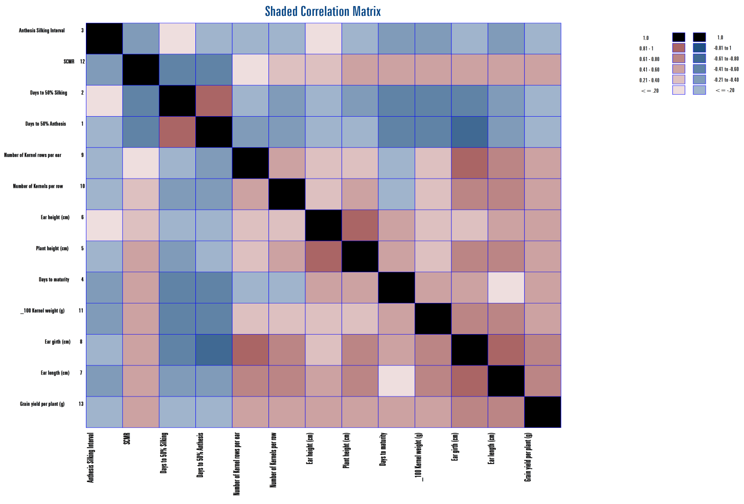

Fig. 1 . Genotypic shaded correlation matrix for all the characters studied in maize (Zea mays L.) inbred lines

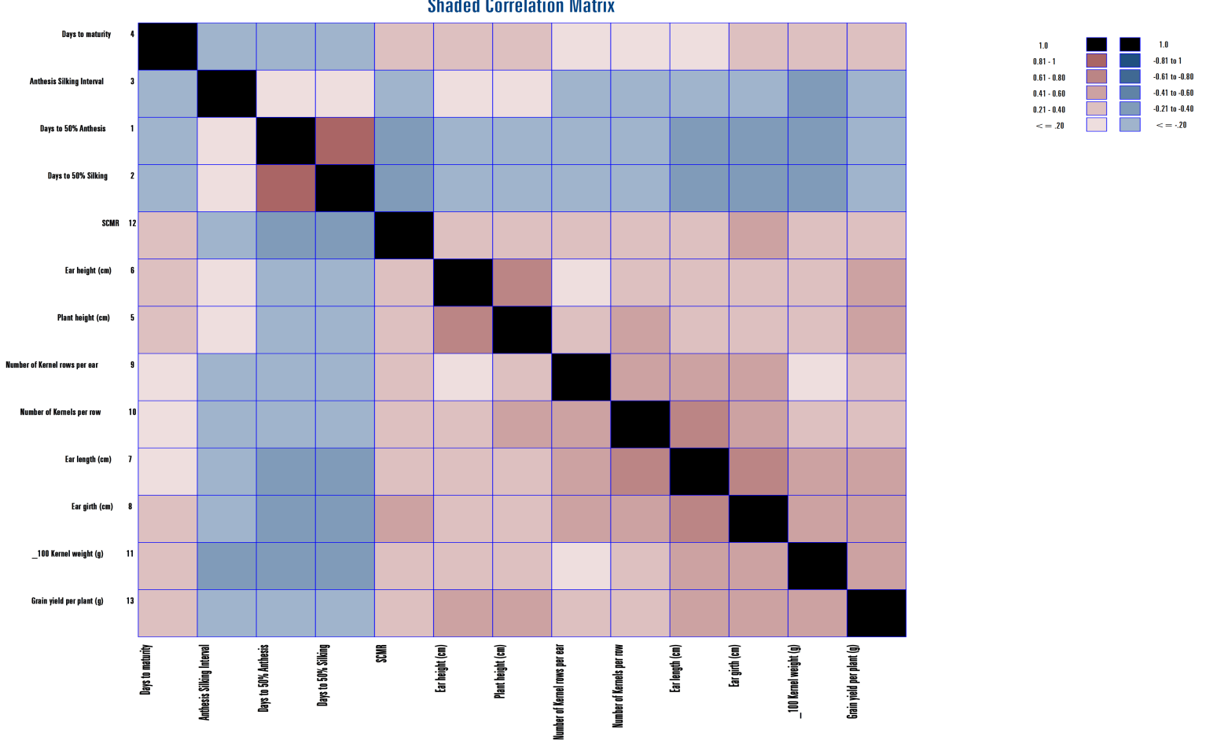

Fig. 2. Phenotypic shaded correlation matrix for all the characters studied in maize (Zea mays L.) inbred lines
Path coefficient analysis
The correlation coefficients were subjected to path coefficient analysis, which enabled the partitioning of correlations into direct and indirect effects via different yield related traits. The detailed estimates of direct and indirect effects of the traits influencing grain yield are presented in Table 2, Fig 3 and Fig 4.
The path coefficient analysis revealed that days to 50% silking (P = 0.0804), days to maturity (P = 0.0343), ear height (P = 0.1636), ear length (P = 0.0283), number of kernel rows per ear (P = 0.0886) and number of kernels per row (P = 0.1213) showed positive direct effect at phenotypic level on grain yield per plant. These results are in close conformity with the findings of Pandey et al., [1] for ear length and number of kernels per row; Lakshmi et al., [17] for days to 50% silking; Varalakshmi et al., [2] for ear height; Rani et al.,[18] for number of kernel rows per ear. Days to 50% anthesis (G = 0.0413) and ear girth (G = 0.6449) showed positive direct effect at genotypic level on grain yield per plant. Similar results were reported by Akshaya et al., [6] for days to 50% anthesis and ear girth. Anthesis-silking interval (G = 0.0108 and P = 0.0040), plant height (G = 1.2403 and P = 0.1064), 100-kernel weight (G = 1.1492 and P = 0.362) and SPAD Chlorophyll Meter Reading (SCMR) (G = 0.4072 and P = 0.108) showed positive direct effect at both genotypic and phenotypic levels on grain yield per plant. These results are in accordance with the reports of Pandey et al., [1] and Saritha et al.,[16] for 100-kernel weight; Varalakshmi et al.,[2] for plant height; Rani et al., [18] for anthesis-silking interval.
Days to 50% silking (G = - 0.0741), days to maturity (G = -1.2852), ear height (G = - 0.1237), ear length (G = -1.1360), number of kernel rows per ear (G = - 0.2958) and number of kernels per row (G = -0.1258) showed negative direct effect at genotypic level on grain yield per plant. Similar results were reported by Pandey et al., [1] for ear length and number of kernels per row; Lakshmi et al., [17] for days to 50% silking; Gazal et al., [19] for ear height; Akshaya et al., [6] for days to maturity. Days to 50% anthesis and ear girth showed negative direct effect at phenotypic level on grain yield per plant. These findings were in accordance with the results of Rajitha et al.,[10] and Akshaya et al., [6] for days to 50% anthesis and Roy et al., [20] for ear girth.
The residual effect at genotypic level is 0.22 indicating that the characters included in present investigation are contributing around 78% of variability pertaining to dependent variable i.e., yield. Only 22 % of contribution is from the few other characters which were not included in present study. Residual effect at phenotypic level is 0.25 indicating that the characters included in present investigation are contributing around 75% of variability pertaining to dependent variable. About 25 % of contribution is from other characters which were not included in present study.
Path analysis revealed that plant height, 100 kernel weight and SPAD Chlorophyll Meter Reading (SCMR) had true relationship with grain yield per plant by establishing significant positive association and positive direct effect. Hence, these traits can be considered important during selection for obtaining high yielding genotypes.

Table 2. Estimates of direct and indirect effects on grain yield per plant in maize (Zea mays L.) inbred lines.
CHARACTER |  | DFA | DFS | ASI (days) | DM | PH (cm) | EH (cm) | EL (cm) | EG (cm) | NKPE | NKPR | HKW (g) | SCMR | GYPP (g)
DFA | G | 0.0413 | -0.0861 | -0.0013 | 0.6759 | -0.2157 | 0.0150 | 0.4153 | -0.4061 | 0.0722 | 0.0336 | -0.4932 | -0.2431 | -0.1921
 | P | -0.0553 | 0.0744 | 0.0004 | -0.0051 | -0.0173 | -0.0132 | -0.0059 | 0.0002 | -0.0061 | -0.0107 | -0.1051 | -0.0279 | -0.1717
DFS | G | 0.0480 | -0.0741 | 0.0009 | 0.6232 | -0.2869 | 0.0130 | 0.4130 | -0.3340 | 0.0477 | 0.0289 | -0.4645 | -0.1964 | -0.1813
 | P | -0.0512 | 0.0804 | 0.0008 | -0.0058 | -0.0137 | -0.0115 | -0.0063 | 0.0002 | -0.0092 | -0.0140 | -0.1218 | -0.0332 | -0.1853
ASI (days) | G | -0.0051 | -0.0062 | 0.0108 | 0.3790 | -0.1441 | -0.0094 | 0.2432 | -0.0714 | 0.0139 | 0.0231 | -0.3996 | -0.0972 | -0.0630
 | P | -0.0053 | 0.0160 | 0.0040 | -0.0045 | 0.0005 | 0.0080 | -0.0034 | 0.0001 | -0.0056 | -0.0125 | -0.0864 | -0.0076 | -0.0968
DM | G | -0.0217 | 0.0359 | -0.0032 | -1.2852 | 0.6546 | -0.0509 | -0.0619 | 0.2791 | 0.0402 | 0.0030 | 0.6414 | 0.2111 | 0.442**
 | P | 0.0082 | -0.0137 | -0.0005 | 0.0343 | 0.0230 | 0.0350 | 0.0048 | -0.0002 | 0.0011 | 0.0152 | 0.1138 | 0.0268 | 0.248*
PH (cm) | G | -0.0072 | 0.0171 | -0.0013 | -0.6783 | 1.2403 | -0.1042 | -0.6961 | 0.4196 | -0.0885 | -0.0692 | 0.3615 | 0.1639 | 0.558**
 | P | 0.0090 | -0.0104 | 0.0000 | 0.0074 | 0.1064 | 0.1214 | 0.0104 | -0.0002 | 0.0229 | 0.0503 | 0.0876 | 0.0377 | 0.442**
EH (cm) | G | -0.0050 | 0.0078 | 0.0008 | -0.5287 | 1.0447 | -0.1237 | -0.4940 | 0.2539 | -0.0622 | -0.0499 | 0.2603 | 0.1349 | 0.439**
 | P | 0.0045 | -0.0056 | 0.0002 | 0.0073 | 0.0789 | 0.1636 | 0.0089 | -0.0002 | 0.0142 | 0.0386 | 0.0812 | 0.0278 | 0.419**
EL (cm) | G | -0.0151 | 0.0269 | -0.0023 | -0.0701 | 0.7601 | -0.0538 | -1.1360 | 0.5189 | -0.1869 | -0.0941 | 0.7588 | 0.1953 | 0.702**
 | P | 0.0116 | -0.0178 | -0.0005 | 0.0058 | 0.0390 | 0.0515 | 0.0283 | -0.0004 | 0.0464 | 0.0788 | 0.1653 | 0.0417 | 0.450**
EG (cm) | G | -0.0260 | 0.0384 | -0.0012 | -0.5563 | 0.8071 | -0.0487 | -0.9141 | 0.6449 | -0.2583 | -0.0870 | 0.7951 | 0.2353 | 0.629**
 | P | 0.0131 | -0.0223 | -0.0005 | 0.0084 | 0.0386 | 0.0496 | 0.0195 | -0.0006 | 0.0400 | 0.0596 | 0.1908 | 0.0462 | 0.442**
NKPE | G | -0.0101 | 0.0119 | -0.0005 | 0.1747 | 0.3710 | -0.0260 | -0.7176 | 0.5630 | -0.2958 | -0.0630 | 0.3518 | 0.0759 | 0.435**
 | P | 0.0038 | -0.0083 | -0.0003 | 0.0004 | 0.0275 | 0.0261 | 0.0148 | -0.0003 | 0.0886 | 0.0648 | 0.0585 | 0.0228 | 0.299**
NKPR | G | -0.0110 | 0.0170 | -0.0020 | 0.0309 | 0.6823 | -0.0490 | -0.8493 | 0.4456 | -0.1480 | -0.1258 | 0.3573 | 0.1548 | 0.503**
 | P | 0.0049 | -0.0093 | -0.0004 | 0.0043 | 0.0441 | 0.0521 | 0.0184 | -0.0003 | 0.0474 | 0.1213 | 0.0763 | 0.0331 | 0.392**
HKW (g) | G | -0.0177 | 0.0299 | -0.0038 | -0.7174 | 0.3902 | -0.0280 | -0.7501 | 0.4462 | -0.0906 | -0.0391 | 1.1492 | 0.1914 | 0.560**
 | P | 0.0161 | -0.0271 | -0.0009 | 0.0108 | 0.0257 | 0.0367 | 0.0129 | -0.0003 | 0.0143 | 0.0256 | 0.3620 | 0.0367 | 0.513**
SCMR | G | -0.0247 | 0.0357 | -0.0026 | -0.6664 | 0.4992 | -0.0410 | -0.5447 | 0.3727 | -0.0551 | -0.0478 | 0.5403 | 0.4072 | 0.473**
 | P | 0.0143 | -0.0247 | -0.0003 | 0.0085 | 0.0371 | 0.0422 | 0.0109 | -0.0003 | 0.0187 | 0.0371 | 0.1230 | 0.1080 | 0.375**
Diagonal effects - Direct effects, off-diagonal values - indirect effects * Significant at 5% level ** Significant at 1% level. DFA - Days to 50% anthesis, DFS - Days to 50% silking, ASI – Anthesis-silking interval, DM - Days to maturity, PH - Plant height (cm), EH - Ear height, EL - Ear length (cm), EG - Ear girth (cm), NKPE - Number of kernel rows per ear, NKPR - Number of kernels per row, HKW -100-kernel weight (g), SCMR-SPAD Chlorophyll Meter Reading, GYPP – Grain yield per plant (g)
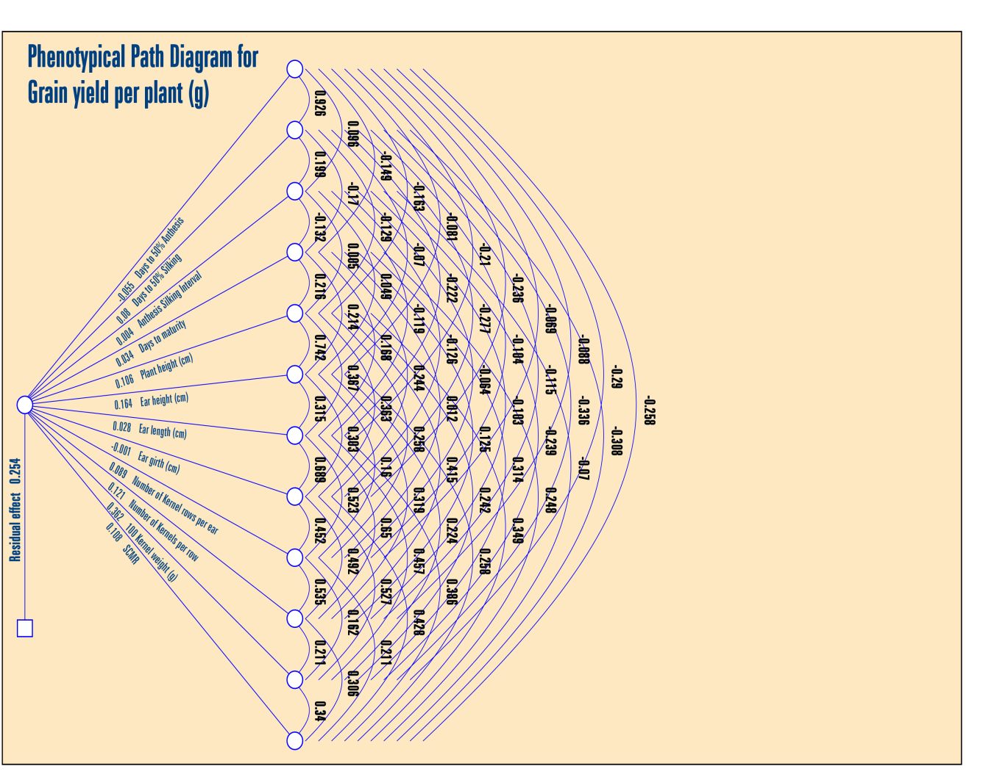

Fig. 3. Phenotypic path diagram showing direct and indirect effects of yield components on grain yield per plant in inbred lines of maize (Zea mays L.)

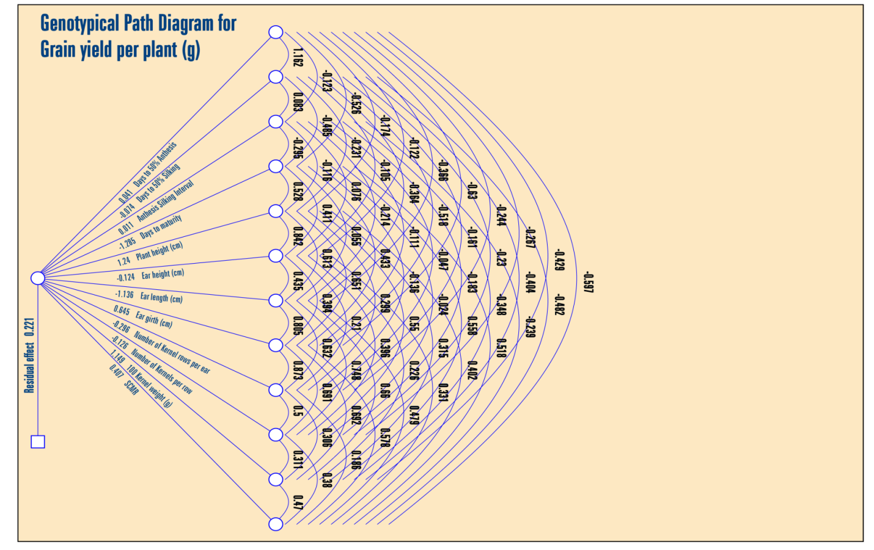

Fig. 4. Genotypic path diagram showing direct and indirect effects of yield components on grain yield per plant in inbred lines of maize (Zea mays L.)

CONCLUSION
The study revealed significant positive associations of traits such as days to maturity, plant height, ear height, ear length, ear girth, number of kernel rows per ear, number of kernels per row, 100-kernel weight and SPAD Chlorophyll Meter Reading (SCMR) with grain yield per plant, suggesting their potential use in indirect selection for yield improvement. The path coefficient analysis revealed that traits such as anthesis-silking interval, plant height, 100-kernel weight and SPAD Chlorophyll Meter Reading (SCMR) exhibited positive direct effects on grain yield per plant at both genotypic and phenotypic levels, indicating their importance in yield improvement. Conversely, days to maturity and ear length showed negative direct effects at the genotypic level. These findings highlight the potential of selecting for key yield-contributing traits to enhance grain yield in maize inbred lines.
COMPETING INTERESTS
The authors affirm that there are no competing interests.

REFERENCES
[1] Pandey Y, Vyas RP, Kumar J, Singh L, Singh HC, Yadav PC. Heritability, correlation and path coefficient analysis for determining interrelationships among grain yield and related characters in maize (Zea mays L.). International Journal of Pure & Applied Bioscience. 2017;5(2):595-603.

[2] Varalakshmi S, Wali MC, Deshpande SK, Harlapur SI. Correlation and path coefficient analysis of single cross hybrids in maize (Zea mays L.). International Journal of Current Microbiology and Applied Science. 2018;7(4):1840-1843.

[3] Falconer DS. An Introduction to Quantitative Genetics. Edinburgh: Oliver and Boyd; 1964:312-324.

[4] Wright S. Correlation and causation. Journal of Agricultural Research. 1921;20:557-585.

[5] Dewey DR, Lu KH. A correlation and path coefficient analysis of components of crested wheat grass seed production. Agronomy Journal. 1959;51(9):515-518.

[6] Akshaya M, Shantakumar G, Sridevi O, Sangamesh N. Correlation and path coefficient analysis for determining interrelationships among grain yield and yield related characters in maize hybrids (Zea mays L.). The Pharma Innovation Journal. 2022;11(3):1343-1346.

[7] Kinfe H, Tsehaye Y. Studies of heritability, genetic parameters, correlation and path coefficient in elite maize hybrids. Academic Research Journal of Agricultural Science and Research. 2015;3(10):296-303.

[8] Begum S, Ahmed A, Omy SH, Rohman MM, Amiruzzamam M. Genetic variability, character association and path analysis in maize (Zea mays L.). Bangladesh Journal of Agricultural Research. 2016;41(1):173-182.

[9] Patil SM, Kumar K, Jakhar DS, Rai A, Borle UM, Singh P. Studies on variability, heritability, genetic advance and correlation in maize (Zea mays L.). International Journal of Agriculture, Environment and Biotechnology. 2016;9(6):1103-1108.

[10] Rajitha A, Babu DR, Ahamed ML, Rao VS. Character association and path analysis of grain yield and its components in maize (Zea mays L.). The Andhra Agricultural Journal. 2016;63(1):83-87.

[11] Reddy VR, Jabeen F, Sudarshan MR, Rao AS. Studies on genetic variability, heritability, correlation and path analysis in maize (Zea mays L.) over locations. International Journal of Applied Biology and Pharmaceutical Technology. 2013;4(1):195-199.

[12] Sesay S, Kolawole D, Ariyo OJ, Silvestro M, Stephen Lawrence FL, Ayoola OO, Adebiyi OO. Correlation and path coefficient analysis of top cross and three-way cross hybrid maize populations. African Journal of Agricultural Research. 2017;12(10):780-789.

[13] Chaurasia NK, Nirala RBP, Singh B, Mandal SS. Trait association and path coefficient analysis in maize (Zea mays L.) for grain yield and its attributes. Journal of Pharmacognosy and Phytochemistry. 2020;9(6):527-531.

[14] Beulah G, Marker S, Rajasekhar D. Assessment of quantitative genetic variability and character association in maize (Zea mays L.). Journal of Pharmacognosy and Phytochemistry. 2018;7(1):2813-2816.

[15] Raghu B, Suresh J, Kumar SS, Saidaiah P. Character association and path analysis in maize (Zea mays L.). Madras Agricultural Journal. 2011;98(1-3):7-9.

[16] Saritha A, Ramanjaneyulu AV, Umarani E. Studies on character association and path coefficient analysis for grain yield and its contributing characters in maize (Zea mays L.). International Journal of Environment and Climate Change. 2022;12(12):102-109.

[17] Lakshmi MS, Jagadev PN, Das S, Lenka D, Swain D, Tripathy SK. Genetic variability and association analysis of maize hybrids under excessive soil moisture condition. International Journal of Current Microbiology and Applied Science. 2018;7(9):2935-2941.

[18] Rani M, Anusha C, Lavanya GR, Kiran MS. Genetic variability and interrelationship in maize (Zea mays L.) genotypes for grain yield and yield component characters. International Journal of Environment and Climate Change. 2022;12(11):3264-3271.

[19] Gazal A, Dar ZA, Lone AA, Yousuf N, Gulzar S. Studies on maize yield under drought using correlation and path coefficient analysis. International Journal of Current Microbiology and Applied Sciences. 2018;7(1):516-521.

[20] Roy PR, Haque MA, Ferdausi A, Bari MAA. Genetic variability, correlation and path coefficient analyses of selected maize (Zea mays L.) genotypes. Fundamental and Applied Agriculture. 2018;3(1):382-389.

