Effect of non-linear temperature on the determination of the precise pH of buffers

ABSTRACT
In the article, we have reported a non-linear temperature effect on the determination of a precise pH value of buffer solutions. Knowing, a buffer solution resists the changes in pH when small amounts of acid or base are added, although this pH may still change with respect to temperatures. The temperature effect on buffer solutions is not always constant, and reveals how pH properties change in a way that is not directly proportional to temperature variations. This contrasts with changes in a linearity where a change in temperature results in an expectable proportional change in the pH of buffer solutions. This is due to the temperature-dependent nature of the equilibrium constant of reaction rates, leading to non-linear pH shifts. Graphically, the plot of linear temperature against pH shows a straight line, either upward sloping (positive correlation), or downward (negative correlation), and a plot for non-linear, as often sigmoidal.
Keywords: Henderson-Hasselbalch equation, non-linear temperature, pH, buffer solutions.

[1]- INTRODUCTION:
A buffer solution contains either a weak acid and its salt with a strong base, or a weak base and its salt with a strong acid. The buffer solution is a solution that can resist pH change by the addition of acidic or basic substances. Because of the presence of the common ion effect in buffer solutions and it obey the Le Chatelier’s principle ¹, which is the suppression of the degree of dissociation of a weak electrolyte by the addition of a strong electrolyte having a common ion with that of the weak electrolyte ^{2, 3}. A literature survey has been reported about the determination of pH of buffer solutions and effect of temperature behavior as well ⁴⁻⁶. Generally, the pH relationship, which was given by Peter Sorensen in 1909 is as,
pH = - log [H⁺] = log 1 / [H⁺] …………. (1)
Here, the log is the base-10 logarithm, and the [H⁺] stands for the concentration of H+ ions in solution, as given in moles per litre. The pH or concentration of H⁺ ions in solution is a measure of the acidity or basicity of the solution. From equation (1), the pH is the negative logarithm of hydrogen (H⁺) or hydronium (H₃O⁺) ions concentration. In this article, we have reported a non-linear effect of temperature on the determination of the precise pH value for buffer solutions. According to the mass law, the ionization reaction of a pure solution for a weak acid is as HA = H⁺ + A⁻, the equilibrium conditions are defined by the equation of the concentration law, K (HA) = (H⁺) (A⁻). Where the enclosed quantities stand for concentrations of the respective substances, and K is the ionization constant of the acid or the change in pH. This relation may be written in a more convenient form is (H⁺) = K (HA) / (A⁻) ^{7, 8}. For buffer solutions, we can apply the Henderson equation, which is modified as follows,
pH = pKa + log [ salt/acid] ……………… (2)
Equation 2 is known as the Henderson-Hasselbalch equation, and it is applicable for all buffer solutions. where the [salt] and [acid] are the concentrations of the salt and acid in the buffer, respectively ⁹. And, the pKa is the thermodynamic value of the pK of an acid. When the concentration of acid and the salt is equal, then the pH of the buffer solution is equal to the pKa (pH = pKa). By applying equation (2), we can calculate the pH value of a given buffer solution ¹⁰. For buffer solutions, the above equation (2) can be written as,
pH = pKa + log₁₀ ([A⁻]/[HA]) ………..(3)
Where [A⁻] and [HA] are the concentrations of a weak acid with its salt or conjugated acid-base pair in buffer solutions.

[2]- THEORETICAL APPROACH:
[2.1]- Buffer Solutions and Their Behavior:
Indeed, buffer solutions resist changes in pH when small amounts of acid or base are added. However, their pH can still shift with any temperature changes. The buffering agents or buffer solutions are a solution of a weak acid (HA) or base (A⁻) in equilibrium with its corresponding base or acid ¹¹⁻¹³. HA = H⁺ + A⁻, the equilibrium conditions are defined by the equation of the mass law,
K (HA) = (H⁺) (A⁻)……………….(4)
The equilibrium constant is referred to as the acid dissociation constant, Ka or ionization constant ¹⁴⁻¹⁷. It relates to the degree of ionization or dissociation constant of the acid, and generally, it is calculated based on the concentrations of the reacting species.
Ka = [H⁺] [A⁻] / [HA]…………...(5)
Notably, the negative logarithm of the hydrogen ion activity to base is considered pH, represented as –log 10 [H⁺] or [H₃O⁺], and the activity of hydrogen ions is a close approximation of their concentration. Practically, the pH scale is characterized as follows,
pH = pH0 + [(E – E0) / k] ……………(6)
Here, E is the measured potential where the pH meter contains the solution under test (pH), E0 is the measured potential where the pH meter contains the appropriate buffer solution for calibration (pH0), and k is the change in potential or unit change in pH and is derived from the application Nernst equation ¹⁸,
k = log (10) $×$ (RT / nF) …………….(7)
Where R = 8.314 J/mole/˚K; T is the temperature (in Kelvin); n is the number of moles, and F is the Faraday constant (96485 Coulomb /mole), respectively.
[2.2]- Thermodynamic Linear and Non-Linear Approximation:
The effect of temperature on buffer solutions does not always remain constant ¹⁹. Many buffer systems exhibit a linear relationship between pH and temperature can be a reasonable approximation within a limited temperature range. While some other buffer systems show more complex and predictable non-linear pH changes uniformly with temperature, especially over or wider temperature ranges or when approaching extremes of temperature, ^{20, 21}. This is due to the temperature-dependent nature of equilibrium constants with enthalpy effect and the potential for selective precipitation of buffer components at low or high temperatures. Any changes in heat capacity or temperature can affect the enthalpy of the protonation or deprotonation reactions within the buffer, leading to non-linear pH shifts. In buffer solutions, the chemical reactions with activation energies or complex reaction mechanisms may show non-linear temperature dependency in equilibrium constants and reaction rates ^{22, 23}.
In the dissociation process, the thermodynamic parameters have been reported at standard conditions ²⁴. These thermodynamic parameters are expressed in terms of entropy (S), heat content or enthalpy (H), and Gibbs free energy (G) with respect to temperature and pressure. For buffer reactions, the pH-dependent equilibrium constant (K) is related to the standard Gibbs free energy change by the equation,
∆G˚ = ∆H˚ - T∆S˚ = - RT ln K ...........(8)
Since pH affects ∆G˚, it also affects the equilibrium constant. The standard free energy change (∆G˚) for a reaction is often different under standard conditions (pH 0 or 1 mole H⁺) compared to other specific conditions or states. Thus, the difference highlights how pH influences the thermodynamic favorability of the reactions in solution. The change in pH may alter the effective ∆G and thus the spontaneity of the reactions as well.

[3]- RESULTS AND DISCUSSION:

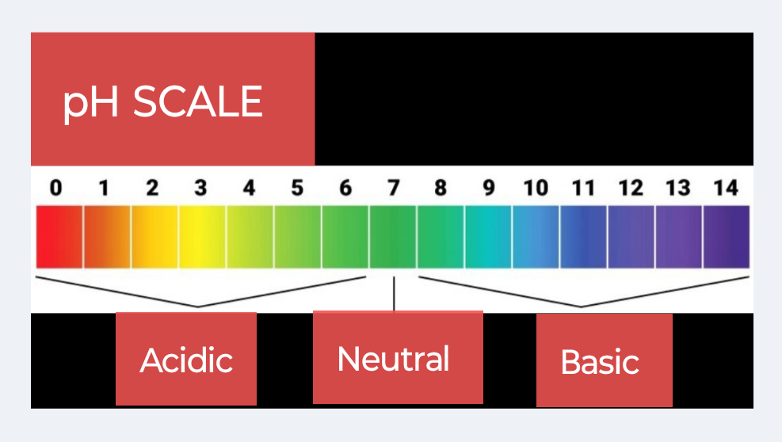
Figure 1. The pH scale with pH scale range from 0 to 14.

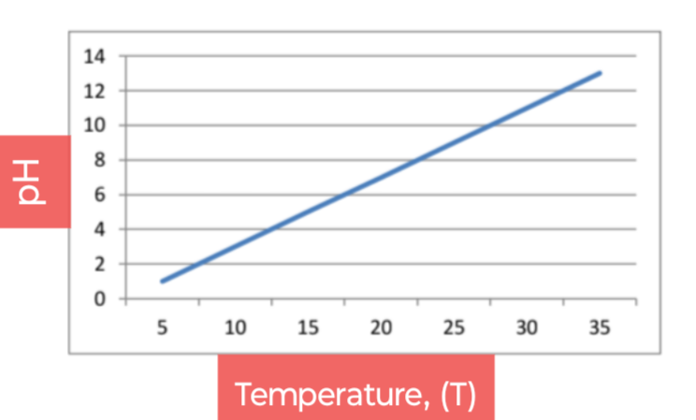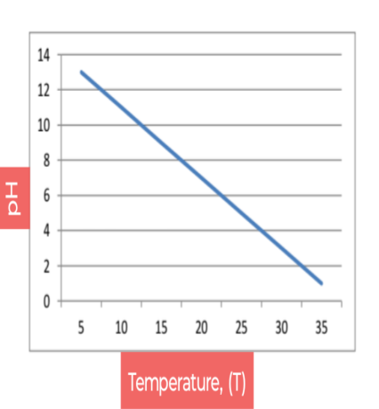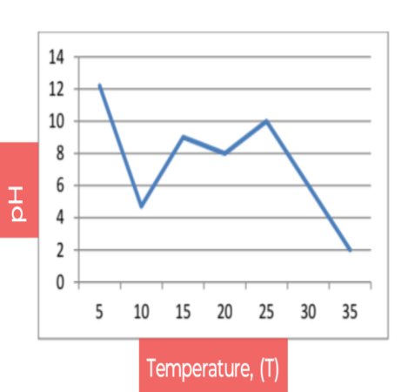
(a) (b) (c)
Figure 2. The plot of linear temperature against pH shows a straight line, either upward sloping (positive correlation;(a), or downward (negative correlation;(b), and a non-linear plot as sigmoidal (c).

Indeed, there are various factors that influence the pH of buffer solutions, like as the temperature, ionic strength, activity of H⁺ ions, dilution of buffer, and addition of electrolyte substances (acids, bases, or salts), etc. Although temperature plays a key role in pH measurements of buffer solutions, as temperature increases, the pH level drops. However, this does not mean that the sample of solution becomes more acidic. A solution is considered only acidic if there are more hydrogen (H⁺) ions than the hydroxyl ions (OH⁻) ions. Figure 1 elucidates the pH scale, with their pH scale range from 0 to 14. The pH scale is a measure of the concentration of hydrogen ions (H⁺) in a solution. Although we can calculate the pH of any solution by taking the negative logarithm of the hydrogen or hydronium ion concentration, or pH = -log[H⁺] or [H₃O⁺], respectively. At 25 ˚C, the pH values below < 7 indicate acidic, with an equal as = 7 being neutral, and a value above > 7 is basic. A buffer can prevent a sudden drop or increase in the pH of a solution after the addition of a strong base or acid up to its buffering capacity ²⁵.
A non-linear heat capacity behavior is often observed in physical and chemical systems, which describes how properties change in a way that is not directly proportional to temperature variations. This contrasts with linearity deviation, where a change in temperature results in a predictable proportional change in the pH properties of buffer solutions. The thermodynamic pKa value, which is the negative logarithm of the acid dissociation constant (K), is temperature dependent. The changes in temperature can shift the pKa, which in turn may affect the effectiveness of buffers. The pH of a buffer solution might change slightly or rapidly with respect to temperature changes at certain points. If the pH change is due to a chemical reaction of the buffer solution, the reaction kinetics (rate and mechanism) will play a major role ²⁴.
By the addition of the salts of a conjugate acid-base pair to a solution, an increase in the pH range occurs due to the common ion effect. For example, when a pH meter was used in a buffer solution of acetic acid-sodium acetate there was the pH value of the sample solution is suddenly decreased before in fast and then gradually increased. Practically, at 25 ˚C temperature, the pH value has been measured for CH₃COOH-CH₃COONa buffer solution, where an initial reading was observed to be 4.0, and it rose to 3.1 to 4.7 with 5.0 N NaOH base ²⁶⁻²⁸. Herein, a quite fluctuation may occur when so much acid or base is added to the buffer solution, they become the excess reactants. If a preparing buffer has more acid than base, more H⁺ ions are likely to be present, and then pH falls, and if a buffer has more base than acid, more OH⁻ ions are present, thus pH rises. The acetic acid-sodium acetate buffer is a buffer that can resist in changing of pH in a certain pH range. In phosphate buffers the pH increases instantaneously with a decrease in temperature; the magnitude of these changes can vary depending on concentration and influence of the temperature range. At 4 ˚C, a buffer will have slightly higher pH than the same buffer at 25 ˚C. Similarly, at 37 $˚$C, a buffer will have a lower pH as compared to one at 25 ˚C ²⁹.
Graphically, the plot would reveal how the pH of a buffer solution changes non-linearly and might not be a straight line with respect to temperature variations. For example, the temperature of a heated buffer might initially increase rapidly, then slow down as it approaches a steady state. Similarly, the cooling of a buffer solution might be initially fast, then gradually slow down. In Figure 2 (a, b, and c), a plot of linear temperature against pH shows a straight line, either upward sloping (positive correlation) or downward (negative correlation), indicating the changes in a constant rate between pH and temperature, respectively. For linear, the equation of the form can be expressed as: pH = xT + b, where ‘x’ is the slope (rate of change) and ‘b’ is the y-intercept. From Figure 2 (c), a graph plot of non-linear temperature versus pH would typically depict a curve, rather than a straight line, and is often sigmoidal or S-shaped. It means the rate of change between pH and temperature is not constant, and the curve could be logarithmic, exponential, or any other non-linear shape. The non-linear relation requires a more complex equation to represent it. Thus, the straight or curved shape of the graph plots depends upon the specific co-relationship in between of temperature and pH for a given buffer ¹⁷.

[4]- CONCLUSIONS:
In conclusion, we have reported an effect of non-linear temperature on the determination of a precise pH value of buffer solutions. The buffer solutions is resist the changes in pH with the addition of small amounts of acids or bases, although these pH levels may still shift with respect to changes in temperature. The effect of temperature on buffer solutions does not always remain constant. Although the effect of non-linear temperature is often observed in physical and chemical systems, it reveals how properties change in a way that is not directly proportional to temperature variations. This contrasts with changes in a linearity where a change in temperature results in a predictable proportional change in the pH of buffer solutions. This is due to the temperature-dependent nature of the equilibrium constant with the rate of reactions these leading to non-linear pH changes. In a graph, the plot of linear temperature against pH, showing a straight line, either upward sloping (positive correlation), or downward (negative correlation), and a plot for non-linear versus temperature is often sigmoidal in type.

REFERENCES:
1. J. Arthur Campbell, Le Chatelier’s principle, temperature effects, and entropy, J. Chem. Educ., 1985;62(3):231-232.
2. F. A. Cotton, G. Wilkinson, C. A. Murillo and M. Bochmann, Advanced Inorganic Chemistry, 6th Edition, John Welly and Sons, Inc., (1999).
3. I. L. Finar, Organic Chemistry, Vol-1, 6th Edition, Dorling Kindersley (India) Pvt. Ltd., (2007).
4. S. P. Mishra, Introducing of thermodynamic Van’t Hoff equation in aqueous solubility and dissociation process of benzoic acid at ordinary temperature range, Chem.Sci. Int. J., 2022;31(1):8-14.
S. P. Mishra and R. P. Singh, Gibbs free energy change in aqueous dissociation of benzoic acid at temperature ‘K’ : A thermodynamic study, Chem. Sci. Int. J. 2022;31(2):44-52.
6. S. P. Mishra, Titrimetric study of solubility of solute benzoic acid and their partition in water and benzene solvents, Chemical Sci. Int. J., 2021;30(3):40-45.
7. S. P. Mishra, Concentration effect of sodium chloride salt on benzoic acid solubility and dissociation into water at 298K temperature, Int. Res. J. Pure & Appl. Chem., 2021;22(6):47-52.
8. S. P. Mishra, Phenolphthalein indicator in titrimetric estimation of benzoic acid solubility and distribution in water and benzene-buffer solutions, Asian J. of Chemical Sciences, 2022;11(4):1-7.
9. Lawrence J. Henderson, Concerning the relationship between the strength of acids and their capacity to preserve neutrality, Am. J. Physiol., 1908;21(2):173-179.
10. Henry N, Po and N. M. Senozan, The Henderson-Hasselbalch equation: Its history and limitations, J. Chem. Educ., 2001;78(11):1499.
11. R. Q. Blackwell, Verification of the Henderson-Hasselbalch equation, J. Chem. Educ., 1954;31(3):138.
12. Charles A. Lucy, Is your Henderson-Hasselbalch calculation of buffer pH correct?, J. Chem. Educ., 2023;100(6):2418-2422.
13. M. Hayert, J.-M. P.-Cornet, and P. Gervais, A simple method for measuring the pH of acid solutions under high pressure, J. Phys. Chem. A, 1999;103(12):1785-1789.
14. S. E. Kulevich, R. S. Herrick, and K. V. Mills, A discovery Chemistry experiment on buffers, J. Chem. Educ., 2014;91(8):1207-1211.
15. K. R. Harris, The determination of pH of standard buffer solutions: a laboratory experiment, J. Chem. Educ., 1985;62(4):350.
16. Adon A. Gordus, Chemical equilibrium: VI. Buffer solutions, J. Chem. Educ., 1991;68(8):656.
17. J. H. Jordon, H. S. Ashbaugh, J. T. Mague and B. C. Gibb, Buffer and salt effects in aqueous host-guest system: screening, competitive binding, or both ?, J. Am. Chem. Soc., 2021;143(44):18605-18616.
18. Bruce M. Thompson and Michael A. Kessick, On the preparation of buffer solutions, J. Chem. Educ., 1981;58(9):743.
19. A. Pergantis, L. Saridakis, A. Lyratzakis, L. Mavroudakis, and T. Montagnon, Buffer squares: A graphical approach for the determination of buffer pH using logarithmic concentration diagrams, J. Chem. Educ., 2019;96(5):936-943.
20. W. Nernst, Z. Phys. Chem., 1891;8:110-139.
21. M. Tanase, A. Soare, V. David, and S. C. Moldoveanu, Sources of nonlinear van’t Hoff temperature dependence in high-performance liquid chromatography, ACS Omega, 2019;4(22):19808-19817.
22. X. Lu, H. Xing, B. Su, and Q. Ren, Effect of buffer solution and temperature on the stability of penicillin G, J. Chem. Eng. Data, 2008;53(2):543-547.
23. S. Brudar, and B. H.-Lee, Effect of buffer on protein stability in aqueous solutions: A simple protein aggregation model, J. Phys. Chem. B, 2021;125(10):2504-2512.
24. E. T. Urbansky, and M. R, Schock, Understanding, deriving and computing buffer capacity, J. Chem. Educ., 2000;77(12):1640-1643.
25. H. Yamamoto and K. Sugano, Effect of pH and buffer capacity of physiological bicarbonate buffer on precipitation of drugs, Mol. Pharmaceutics, 2025;22(3):1318-1328.
26. A. G. Rajan, J. M. P. Martirez, and E. A. Carter, Coupled effects of temperature, pressure, and pH on water oxidation thermodynamics and kinetics, ACS Catalysis, 2021;11(18):11305- 11319.
27. F. Tollini, S, Di Bartolo, G. Storti, M. Sponchioni, and D. Moscatelli, Influence of pH and temperature on the kinetics of polylactic acid hydrolysis, Ind. Eng. Chem. Res., 2025;64(24):11733-11747.
28. S. P. Mishra and R. P. Singh, A pH Measurement of Acetic Acid-Sodium Acetate Buffer Solutions Using a pH Meter at Ambient Temperature, J. Applied Chemical Science International, (IK Press), 2024;15(2):30-35.
29. S. P. Mishra, V. K. Pandey, A. S. Yadav, and R. P. Singh, pH determination of Acetic Acid-Sodium Acetate Buffer: An Application of Henderson-Hasselbalch Equation at Room Temperature, Chem. Sci. Int. J. 2024;33(6):32-38.
30. Vogel A. Textbook of Quantitative Chemical Analysis, 5th Edition, Longman, Harlow, London, (1989).
31. A. A. Green, The preparation of acetate and phosphate buffer solutions of known pH and ionic strength, J. Am. Chem. Soc., 1933;55(6):2331-2336.

