Baseline Study of Soil Radioactivity and Gamma Radiation in Historical Monument of Narnaul, Haryana, India.

ABSTRACT
It is a systematic study of the radioactivity concentration in building materials from two historical monuments located in Narnaul, Haryana, India.The survey initiated in April 2024, aimed to establish reliable baseline data on soil radiation level of the region. Countrywide, many areas have been found with elevated background gamma radiation, leading to several types of disorders in human beings effecting human health. Therefore, this study was undertaken as a precautionary measure to highlights the importance of radiation monitoring even in non-industrial areas where hidden health hazards may exist.
In present study a radiation survey meter (NaI) was employed to measure gamma radiation levels both indoors and outdoors. All dose rate peaks were recorded and from these the activity concentration was calculated of ²²⁶ Ra, ²³²Th, ⁴⁰K. Average of total activity concentration ( for Jal Mahal is 518.08 Bq/kg, and for ChorGhumbad 632.9993 Bq/kg ) expressed as sum of ²²⁶Ra and ²³²Th and ⁴⁰K concentrations is higher than the world average of total activity concentration of these radionuclides in building material samples (420 Bq/kg). The average value of Req for Jal Mahal is 130.775833 Bq/kg and for ChorGhumbad is 149.86944Bq/kg. It has been inferred that the radium equivalent activity (Ra_{eq}) lies in the permissible limit of 370 Bq/kg set by United Nations Scientific Committee on the Effects of Atomic Radiation. Average Absorbed dose rate (ADR) for Jal Mahal value is 60.635 nGy/h and for ChorGhumbad is 69.570611nGy/h. . “The values were found to be higher than the world average of 59 nGy/h.”
The radiological evaluation of Jal Mahal and ChorGhumbad indicates that AED, ELCR, Dorgan, AUI, Iγ, and AGDE values remain well below international safety thresholds, with only a few samples approaching permissible limits. These findings demonstrate minimal radiological risk.

INTRODUCTION
Natural background radiation is a pervasive aspect of our environment, arising from sources like the Earth’s crust, cosmic rays, and atmospheric radioactive isotopes. This radiation is crucial for health studies, radiation protection, and risk assessment (Rühm et al., 2018). It serves as a baseline exposure that constantly affects human health, aiding in understanding the risks associated with additional radiation sources and establishing safety standards. This knowledge helps in formulating guidelines and setting protection measures for various occupational and environmental settings. Studies have explored the potential health effects linked to high natural background radiation areas, emphasizing the need for comprehensive epidemiological studies (Shankramma, Nagaraja, Sathish, & Kumar, 2022).
Understanding the contribution of natural background radiation is important in assessing the overall radiological risk for the population within different geographical regions. This knowledge is vital for resource allocation and priority setting in radiation protection. Educating the public about the relative risks of various radiation sources is essential to ensure informed decision making, especially in regions with high variability in Naturally Occurring Radioactive Material (NORM) (Egidi, 1997; Bossew& Cinelli 2017) and other potential exposure instances (Al-khawlany et al., 2020). Although natural radiation exposure generally poses low health risks, it contributes to setting safety standards and guidelines for radiation use in various applications. Additionally, there is a need for a regulatory framework to mitigate radiological risks. It is essential to account for potential accidents, involving radioactive substances in various sectors, including medical, civil, and military fields, and the potential risks associated with nuclear energy use and nuclear waste management (Alwaeli& Mannheim, 2022; Johansson & Steen, 2022; Khan &Alshukri, 2020; Menon & Kumar, 2019; Sahoo & Joseph, 2021).
The spatial distribution of natural radioactivity in various countries is a topic of interest in environmental science and radiation protection. Natural radioactivity primarily arises from the presence of primordial radioactive elements such as ²³⁸U, ²³²Th, and ⁴⁰K in the Earth’s crust (Kant & Gupta 2015; Kovler& Friedmann 2017; Lolila&Mazunga 2023; Rene &Akitsu 2017). The distribution of these elements can vary significantly from one region to another and depends on the geological composition of a specific region. Certain rocks, soils, and minerals contain these radioactive elements (Abbasi &Turhan 2020; Malikova&Strakhovenko 2020; Missimer&Teaf 2019; Patel &Sharma 2023; Zanin&Zamirailova 2016). Areas with higher concentrations of these elements tend to exhibit higher natural background radiation levels. Radionuclides from the ²³⁸U and ²³²Th decay series in the Earth’s ^{crust} undergo beta or alpha decay and may leave the residual nucleus in an excited state. In such instances, the nucleus can emit one or more gamma rays to transition to the ground state. These gamma rays contribute to background radiation. For instance, gamma rays emitted by radon and its decay products, along with those from ²³⁸U and ²³²Th decay chain, contribute significantly to natural background radiation. The actual exposure to gamma rays can vary widely based on geographical location. Some regions have higher natural background radiation due to geological factors, while others have lower levels (Al-khawlany et al., 2018). Certain human activities can also influence local radiation levels. Mining, construction materials sourced from specific geological formation, or areas with higher levels of radioactive minerals can elevate background radiation. Radiation exposure is measured in units called sieverts (Sv). The millisievert (mSv) is a smaller unit used to express doses from natural sources, medical procedures, or occupational exposures. The annual average dose from natural background radiation varies globally, but it typically falls within the range of 1 to 10 mSv per year. Therefore, populations could be exposed to an annual effective dose reaching a maximum of 10 mSv per year, this maximum is equivalent to a dose rate of 1.14 μSv·h −1. Assuming an annual effective dose of let us say 2.4 mSv per year for a person life time of 70 years is around 168 mSv (UNSCEAR 2020.) The latter is only an estimate since measurements have revealed a larger interval of values, i.e., 70–800 mSv, which is a justification supporting the present study (Till et al., 2008).
Environmental radiation studies are carried out by monitors, nuclear spectroscopy, radon measurements, and geological surveys to quantify the levels of natural radiation levels (Al-khawlanyet al., 2018; Tye&Milodowski 2017; Marques & Vale 2021; Musa 2019; Omori 2016). The information obtained from these studies often is reported as maps; the values of the radiation levels and dose gradients are crucial for assessing potential health risks, establishing radiation protection guidelines, and developing strategies for managing areas with elevated natural radioactivity (Delacroix et al., 2002; Martin 2006; Shapiro 2002).
Human population is exposed by radiation comes from diverse sources, some sources are natural ; others are the consequences / Product of human activities. It means living things are continually and inevitably exposed to varying levels of ionizing radiation on a daily basis. Natural sources of radiation include cosmic radiation, external radiation originating from radionuclides present in the Earth's crust, and internal radiation resulting from radionuclides that are inhaled, ingested, and retained within the body. Potency of natural exposure depends on the geographical location and on human activity. There are two natural sources of ionizing gamma radiation cosmic (solar or galactic) & terrestrial radiation. Isotopes of heavy elements & their decay products present in the earth’s crust are the major sources of terrestrial radiation.
In this context, the present research was conducted in Narnaul, Haryana to evaluate radioactivity in ancient building materials and to measure gamma dose rates in translating from activity concentrations in Becquerels (Bq/kg) In summary, this study underscores the ubiquitous presence of natural radioactivity in the environment, its diverse sources, and the importance of assessing radiation levels to ensure safety and mitigate potential health risks. It supports the development of public health guides for safe access and ancient building usage.

MATERIAL AND METHOD
The primary aim of this study was to determine indoor and outdoor background radiation dose rates and to estimate the Radium Equivalent Activity (Raeq), Absorbed Dose Rate (ADR), Annual Effective Dose (AED), Activity Utilization Index (AUI), Gamma Index, Excess Cancer Risk, Effective Dose Rate (ELCR) to whole body organ, Annual gonadal dose equivalent to the residents of their nearby area in Narnaul.
STUDY AREA
Haryana located in north-western region of India (27°39′–30°35′N latitude and 74°28′–77°28′ longitude),served as the study site. Two ancient monuments, Jal Mahal andChorGhumbad, wereselected from Narnaul (28.1920 °N, 76.6191°E). Narnaul is histrocially significant town, established during the 12th century, situated near the Aravalli mountain range. The region is characterized by a hot, dry climate and sandy plains with numerous dunes. Local construction materials traditionally include stone, bricks, lime and wood.

MEASUREMENT TECHNIQUE
For radiation measurement, samples from ancient buildings were analyzed using a NaI (sodium iodide) gamma-ray spectrometer. The detector was specifically chosen to assess the health impacts of ancient building material decay radiation.
CHART 1.

Sampling

Collection
Grinding
Powdering
Drying
Homogenization

Sample preparation for analysis
Calculation of Radiological indices and doses

NaI Gamma ray Spectrometry

Measurement of activity concentrations of radionuclides

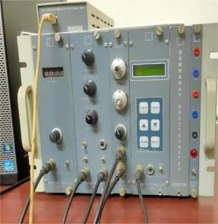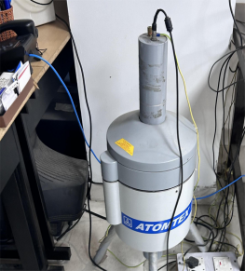
Figure 1: Representing the NaI Gamma Ray Spectrometer.
The Major Specification of NaI detector used for these materials are-
The detector size (63mm×63mm), offered an efficiency of <20%, resolution 7% for ¹³⁷Cs at 661keV ( 9kBq activity), and an Energy detection 50keV – 3MeV. The minimum detectable activity of ²²⁶Ra, ²³²Th, ⁴⁰K: 3, 3, 30 Bq/kg respectively. Each measurement was performed for 10,800 seconds using S/W SPTR-ATC (AT-1315) spectral analysis software.
SAMPLE PREPARATION
Samples of different construction materials- white marble, soapstone, brick and lime were collected, ground, powdered, dried and homogenized before measurement. Each sample was then placed in sealed containers for gamma spectrometry analysis.
Research potential of NaI Detector are as follows-
1. Regulatory Bodies – Evaluation of radionuclide concentrations (²²⁶Ra, ²³²Th, ⁴⁰K) in soils and corresponding construction material.
2. Cement Industry – Assessment of fly ash addition in cement.
3. Food Industry – Measurement of natural radionuclides in dry, powdered food products.
All dose rates were recorded from detector display and used to calculate activity concentration.
The Radium Equivalent Dose (Raeq) of background radiation was estimated as
$Raeq=0.077Ak+ARa+1.43ATh$ (Bq/kg)
The total Absorbed Dose Rate (ADR) was estimated as
ADR = 0.0417 A_{K} + 0.462 A_{Ra}+ 0.604 A_{Th}(nGy/h)
Here, Ra_{eq} (Bq/kg) is expression of the specific activities of ²²⁶Ra,²³²Th, and ⁴⁰K by a single quantity ,which takes into account the radiation hazards associated with radon and its progeny. The ADR is total Absorbed Dose Rate calculations are expressed in nGy/h per 1 Bq/kg , A_{k} is
the activity of ⁴⁰K of the analyzed material, measured as the number of spontaneous nuclear transformations of the ⁴⁰K radionuclide per sec. The A_{Ra} is the activity of ²²⁶A_{Ra} of the analyzed material, measured as the number of spontaneous nuclear transformations of the ²²⁶A_{Ra} radionuclide per sec. TheA_{Th} is the activity of ²³²A_{Th} of the analyzed material, measured as the number of spontaneous nuclear transformations of the ²³²A_{Th} radionuclide per sec.
The Annual Effective dose (AED) was estimated by using the formula
AED (mSv/y) = ADR×8760×10⁻⁶×0.2×0.7 (SvGy⁻¹)
The annual effective dose equivalent is used to estimate the health risk associated with exposure of an individual. To calculate the AED the conversion factor (0.7) and occupancy factor has been used to convert absorbed dose rate to human effective dose equivalent with an occupancy of 20 %. The calculated Radium Equivalent Dose (Raeq) , total Absorbed Dose Rate (ADR), and annual effective dose rate for all the samples (both historic places) are given in table 2 ,3 with their mean values. The world average value of ADR is 84nGy/h and the world average value of AED is 0.52mSv/y. The International Commission on Radiological Protection (ICRP) has recommended the annual effective dose equivalent limit of 1 mSv/yr for the individual members of the public and 20 mSv/yr for radiation workers [International Commission on Radiological Protection (ICRP) , 1993].

Sr.no | Name of sample | Types of sample | Initialization of samples
1 | Jal Mahal -1 | White Marble | JMN-1
2 | Jal Mahal -2 | Soap Stone | JMN-2
3 | Jal Mahal -3 | Brick | JMN-3
4 | Jal Mahal -4 | Lime | JMN-4
5 | Chor Ghumbad-5 | Lime | CGN-5
6 | Chor Ghumbad-6 | White stone | CGN-6
7 | Chor Ghumbad-7 | Brick | CGN-7

Table 1: Introduction of Types of Samples.

Sample |  | Activity Concentration (Bq/kg) |  | Radium equivalent activity (R_{eq}) (Bq/kg) | Absorbed Dose Rate (ADR) (nGy/h) | Annual Effective Dose (AED)*10⁻⁶ (SvGy⁻¹)
 | Ra | Th | K
 | 25 | 21 | 325 | 80.055 | 37.7865 | 46341.3636
JMN-1 | 28 | 24 | 329 | 87.653 | 41.1513 | 50467.9543
 | 32 | 27 | 332 | 96.174 | 44.9364 | 55110.001
 | 30 | 58 | 798 | 174.386 | 82.1686 | 100771.571
JMN-2 | 33 | 61 | 801 | 181.907 | 85.4917 | 104847.021
 | 36 | 64 | 805 | 189.505 | 88.8565 | 108973.612
 | 28 | 35 | 268 | 98.686 | 45.2516 | 55496.5622
JMN-3 | 30 | 39 | 270 | 106.56 | 48.675 | 59695.0200
 | 33 | 42 | 273 | 114.081 | 51.9981 | 63770.4698
 | 43 | 48 | 357 | 139.129 | 63.7449 | 78176.7454
JMN-4 | 45 | 51 | 359 | 145.573 | 66.5643 | 81634.4575
 | 49 | 55 | 363 | 155.601 | 70.9951 | 87068.3906
MEAN | 34.33 | 43.75 | 440 | 130.775833 | 60.635 | 74362.764
Table : 2 Sample Calculation of Jal Mahal Building Material Req ,ADR ,AED By Using Activity Concentrations.
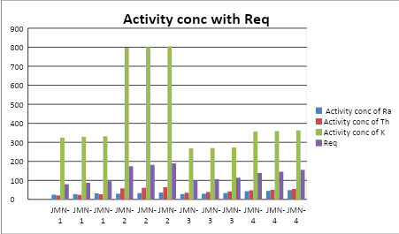
Figure 2: Graphical Representation of Jal Mahal Activity concentrations with Radium equivalent activity(Req).
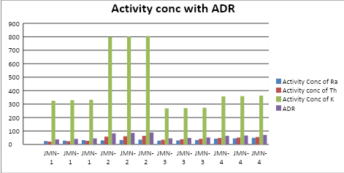
Figure 3: Graphical Representation of Jal Mahal Activity concentrations with Absorbed Dose Rate(ADR).

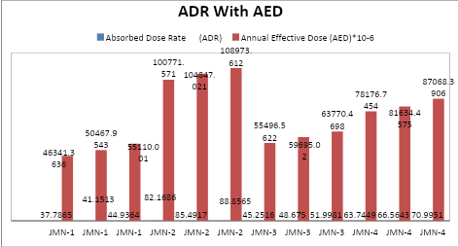
Figure 4 : Graphical Representation of Jal Mahal Absorbed Dose Rate (ADR) with Annual Effective Dose(AED.

Sample |  | Activity Concentration (Bq/kg) |  | Radium equivalent activity (R_{eq}) (Bq/kg) | Absorbed Dose Rate (ADR)  (nGy/h) | Annual Effective Dose (AED)×10⁻⁶ (SvGy⁻¹)
 | Ra | Th | K
 | 34 | 39 | 348 | 116.566 | 53.7756 | 65950.3958
CGN-5 | 37 | 41 | 351 | 122.657 | 56.4947 | 69285.1001
 | 40 | 44 | 355 | 130.255 | 59.8595 | 73411.6908
 | 31 | 59 | 801 | 177.047 | 83.3597 | 102232.336
CGN-6 | 35 | 62 | 803 | 185.491 | 87.1031 | 106823.242
 | 38 | 65 | 806 | 193.012 | 90.4262 | 110898.692
 | 19 | 54 | 488 | 133.796 | 61.7436 | 75722.351
CGN-7 | 22 | 57 | 490 | 141.24 | 65.025 | 79746.66
 | 25 | 60 | 493 | 148.761 | 68.3481 | 83822.1098
MEAN | 31.22222 | 53.44444 | 548.33333 | 149.86944 | 69.570611 | 85321.3975
Table : 3 Sample calculation of ChorGhumbad building material Req ,ADR ,AED by using Activity concentrations.

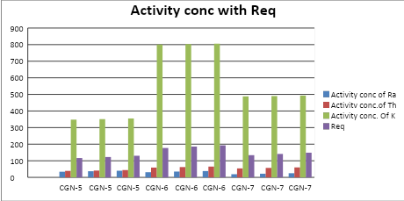
Figure 5: Graphical Representation of ChorGhumbad Activity concentrations with Radium equivalent activity (Req).
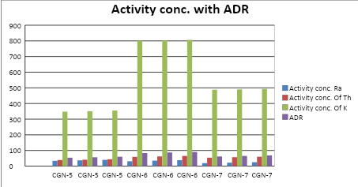
Figure 6: Graphical Representation of ChorGhumbad Activity concentrations with Absorbed Dose Rate (ADR).

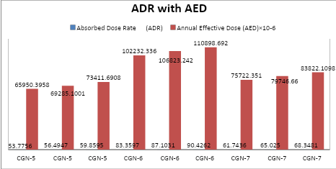
Figure 7: Graphical Representation of ChorGhumbad Activity concentrations with Annual Effective dose (AED).

The Excess Life Time cancer Risk (ELCR) was estimated by using the formula
ELCR = AED× LE × RE
ELCR = AED× 70× 0.05
The Effective dose rate Dorgans (Dorg) was derived by equation
Dorgans = AED × f
Dorgans (whole body) = AED× 0.68
The excess life time cancer risk is estimation of the potential of cancer development over a lifetime , caused by irradiation from historic building materials .ELCR was calculated based upon values of AED , LE and RE ; where LE is life expectancy (70) years and RF is fatal risk factor per Sievert ,that is 0.05 . The annual effective dose equivalent represents the degree of genetic significance of the annual dose that the reproductive organs of a population receive.
Organs with rapidly dividing cells, such as gonads,active bone marrow cells, lungs, testes ,ovaries and bone surface cells, are considered interesting by the UN Scientific Committee on the Effects of Atomic Radiation. The effective dose rate Dorgans is delivered to a particular organ the mean energy absorbed per unit mass averaged over the entire tissue or organ can be calculated using the formula. Where f is the conversion factor of organ dose from air dose. The conversion factor for lungs , ovaries ,bone marrow ,testes and the whole body are 0.64 ,0.58 , 0.69 , 0.82 , 0.68 , respectively .
Sample | Annual Effective Dose (AED)×10⁻⁶ | Excess Lifetime Cancer Risk (ELCR))×10⁻⁶ | Dose Rate of Body Organs (D_{organ})×10⁻⁶
 | 46341.3636 | 162194.773 | 31512.1272
JMN-1 | 50467.9543 | 176637.84 | 34318.2089
 | 55110.001 | 192885.004 | 37474.8007
 | 100771.571 | 352700.4985 | 68524.6683
JMN-2 | 104847.021 | 366964.574 | 71295.9743
 | 108973.612 | 381407.642 | 74102.0562
 | 55496.5622 | 194237.968 | 37737.6623
JMN-3 | 59695.020 | 208932.57 | 40592.6136
 | 63770.4698 | 223196.644 | 43363.9195
 | 78176.7454 | 273618.609 | 53160.1869
JMN-4 | 81634.4575 | 285720.601 | 55511.4311
 | 87068.3906 | 304739.367 | 59206.5091
MEAN | 74362.764 | 260269.674 | 50566.67984
Table: 4 AED, ELCR, D_{organ} calculated values of Jal Mahal.
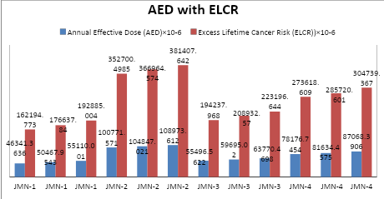
Figure 8: Graphical Representation of JalMahal Annual Effective Dose (AED) with Excess Life Time Cancer Risk (ELCR).

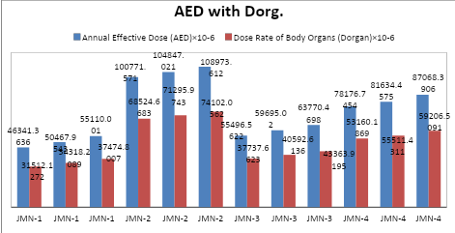
Figure 9: Graphical Representation of Jal Mahal Annual Effective Dose (AED) with Dose rate of Body Organ (Dorg).

Sample | Annual Effective Dose (AED)×10⁻⁶ | Excess Lifetime Cancer Risk (ELCR)×10⁻⁶ | Dose Rate of Body Organs (D_{organ})×10⁻⁶
 | 65950.3958 | 230826.385 | 44846.2691
CGN-5 | 69285.1001 | 242497.85 | 47113.8681
 | 73411.6908 | 256940.918 | 49919.9497
 | 102232.336 | 357813.176 | 69517.9885
CGN-6 | 106823.242 | 373881.347 | 72639.8046
 | 110898.692 | 388145.422 | 75411.1106
 | 75722.351 | 265028.229 | 51491.1987
CGN-7 | 79746.66 | 279113.31 | 54227.7288
 | 83822.1098 | 293377.384 | 56999.0347
MEAN | 85321.3975 | 298624.891 | 58018.5503
Table :5 AED, ELCR ,D_{organ}calculated values of ChorGhumbad.

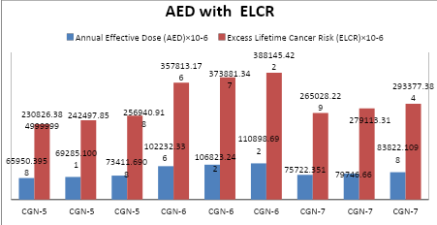
Figure 10: Graphical Representation of ChorGhumbad Annual Effective Dose (AED) with Excess Life Time Cancer Risk (ELCR).

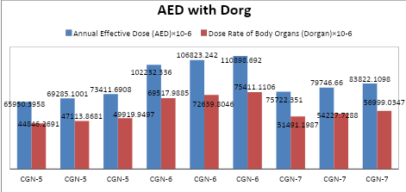
Figure 11: Graphical Representation of ChorGhumbad Annual Effective Dose (AED) with Dose Rate of Body Organ (Dorg.)

The Activity Utilization index (AUI) estimation of total dose rates in air from naturally occurring radionuclides in building materials, calculated from activity concentration measurements of the material Activity Utilization index (AUI) was estimated by using the formula
$$AUI=\frac{ARa}{50 Bq/kg}×0.0809+\frac{ATh}{50 Bq/kg}×0.4798+\frac{AK}{500 Bq/kg}×0.4392$$
where the values 0.0809, 0.4798, and 0.4392 represent fractional percentages of the total dose from ²²⁶Ra, ²³²Th, and ⁴⁰K (f_{Ra} = 8.09%, f_{Th} = 47.98%, and f_{K} = 43.92%)
The gamma activity concentration Iγestimation of the gamma radiation hazard associated with the radionuclides inside of the building materials, calculated from activity concentration measurements of the material has been defined by the European Commission according to Formula
$$Iγ=\frac{AK}{3000 Bq/kg}+\frac{ARa}{300 Bq/kg}+\frac{ATh}{200 Bq/kg}$$
The Annual Gonadal dose equivalent (AGDE) in µSv/y is evaluation for the potential effects of the specific activities of ²²⁶ Ra, ²³² Th, and ⁴⁰K on certain important organs ,such as reproductive organs (gonads), bone marrow, and bone cells. A_{k} is the activity of ⁴⁰K of the analyzed material, measured as the number of spontaneous nuclear transformations of the ⁴⁰K radionuclide per sec. The A_{Ra} is the activity of ²²⁶A_{Ra} of the analyzed material, measured as the number of spontaneous nuclear transformations of the ²²⁶A_{Ra} radionuclide per sec. The A_{Th} is the activity of ²³²A_{Th} of the analyzed material, measured as the number of spontaneous nuclear transformations of the ²³²A_{Th} radionuclide per sec.
AGDE = 3.09 A_{Ra} + 4.18 A_{Th} + 0.314 A_{k} (µSv/y)

Sample |  | Activity concentration (Bq/kg) |  | Activity Utilization Index (AUI) | Gamma Index Factor (Iγ) | Annual Gonadal Dose Equivalent (AGDE) µSv/y
 | Ra | Th | K
 | 25 | 21 | 325 | 0.527446 | 0.29666667 | 267.08
JMN-1 | 28 | 24 | 329 | 0.5646016 | 0.323 | 290.146
 | 32 | 27 | 332 | 0.6024968 | 0.3523333 | 315.988
 | 30 | 58 | 798 | 1.3060712 | 0.656 | 585.712
JMN-2 | 33 | 61 | 801 | 1.3423484 | 0.682 | 608.464
 | 36 | 64 | 805 | 1.379504 | 0.7083333 | 631.53
 | 28 | 35 | 268 | 0.6165752 | 0.35766667 | 316.972
JMN-3 | 30 | 39 | 270 | 0.659952 | 0.385 | 340.5
 | 33 | 42 | 273 | 0.6962292 | 0.411 | 363.252
 | 43 | 48 | 357 | 0.8437708 | 0.50233333 | 445.608
JMN-4 | 45 | 51 | 359 | 0.8775516 | 0.52466667 | 464.956
 | 49 | 55 | 363 | 0.9259212 | 0.55933333 | 495.292
MEAN | 34.3333 | 43.7500 | 440.000 | 0.861872333 | 0.479861033 | 427.1245
Table :6 AUI ,Iγ, AGDE calculated data of Jal Mahal.
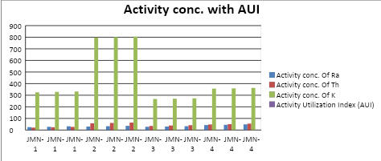Figure 12: Graphical Representation of Jal Mahal Activity concentrations with Activity Utilization Index(AUI).

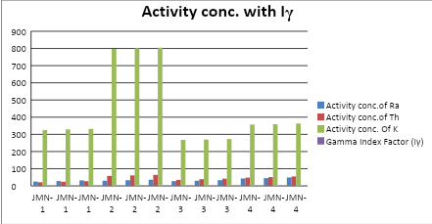
Figure 13: Graphical Representation of Jal Mahal Activity concentrations with Gamma Index Factor(Iγ).

Sample |  | Activity Concentration (Bq/Kg) |  | Activity Utilization Index (AUI) | Gamma Index Factor (Iγ) | Annual Gonadal Dose Equivalent (AGDE) µSv/y
 | Ra | Th | K
 | 34 | 39 | 348 | 0.7349392 | 0.42433333 | 377.352
CGN-5 | 37 | 41 | 351 | 0.7616204 | 0.4453333 | 395.924
 | 40 | 44 | 355 | 0.798776 | 0.47166667 | 418.99
 | 31 | 59 | 801 | 1.3199204 | 0.66533333 | 593.924
CGN-6 | 35 | 62 | 803 | 1.3569372 | 0.6943333 | 619.452
 | 38 | 65 | 806 | 1.3932144 | 0.7203333 | 642.204
 | 19 | 54 | 488 | 0.9775852 | 0.496 | 437.662
CGN-7 | 22 | 57 | 490 | 1.012984 | 0.52166667 | 460.1
 | 25 | 60 | 493 | 1.0492612 | 0.54766667 | 473.582
MEAN | 31.2222 | 53.4444 | 548.3333 | 1.04502644 | 0.55407403 | 491.021111
Table :7 AUI ,Iγ ,AGDE calculated data ChorGhumbad.

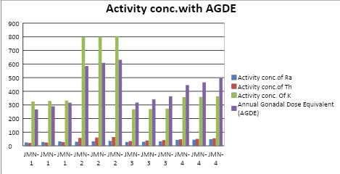
Figure 14: Graphical Representation of Jal Mahal Activity concentrations with Annual Gonadal Dose Equivalent (AGDE).

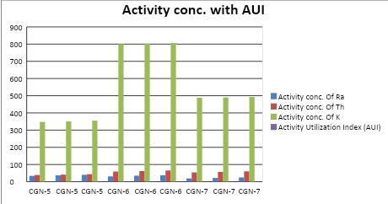
Figure 15: Graphical Representation of ChorGhumbad Activity concentrations with Activity Utilization Index(AUI).

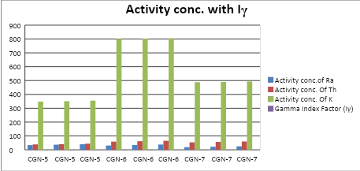
Figure 16: Graphical Representation of ChorGhumbad Activity concentrations with Gamma Index Factor(Iγ).

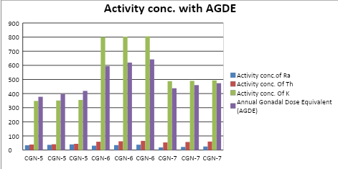
Figure 17: Graphical Representation of ChorGhumbad Activity concentrations with Annual Gonadal Dose Equivalent (AGDE).

RESULTS
For Jal Mahal, activity concentration of radionuclides ranged between 25-49 Bq/kg for ²²⁶Ra,21-64 Bq/kg for ²³²Th and 268-805 Bq/kg for ⁴⁰K, with mean values of 34.33, 43.75 and 440 Bq/kg, respectively. The mean radium equivalent activity (Raeq) was 130.78 Bq/kg, the absorbed dose rate (ADR) was 60.63 nGy/h, and the annual effective dose (AED) was 0.074 mSv/y.ForChorGhumbad, radionuclide activity ranged from 19–40 Bq/kg for ²²⁶Ra, 39–65 Bq/kg for ²³²Th, and 348–806 Bq/kg for ⁴⁰K, with mean values of 31.22, 53.44, and 548.33 Bq/kg, respectively. The mean Raeq was 149.87 Bq/kg, ADR 69.57 nGy/h, and AED 0.085 mSv/y.The Excess Lifetime Cancer Risk (ELCR) ranged from 1.62×10⁻⁴ to 3.81×10⁻⁴, with a mean of 2.60×10⁻⁴ for Jal Mahal. For ChorGhumbad, the ELCR ranged from 2.30×10⁻⁴ to 3.88×10⁻⁴, with a mean of 2.99×10⁻⁴. Both averages are lower than the global mean value of 1.45×10⁻³ reported by UNSCEAR.

The effective organ dose (Dorgan) for Jal Mahal samples ranged between 3.15×10⁻² mSv/y and 7.41×10⁻² mSv/y, with a mean of 5.06×10⁻² mSv/y. For ChorGhumbad, the values ranged from 4.48×10⁻² mSv/y to 7.54×10⁻² mSv/y, with a mean of 5.80×10⁻² mSv/y. These are considerably below the ICRP recommended annual limit of 1 mSv/y for the general public.The Activity Utilization Index (AUI) for Jal Mahal ranged between 0.52–1.38 (mean: 0.86), while for ChorGhumbad it ranged from 0.73–1.39 (mean: 1.05), both values being below the recommended safe limit of 2. Similarly, the Gamma Index (Iγ) values for Jal Mahal (0.30–0.71, mean: 0.48) and ChorGhumbad (0.42–0.72, mean: 0.55) did not exceed the restricted limit of 1.

The Annual Gonadal Dose Equivalent (AGDE) ranged from 267.08–631.53 µSv/y (mean: 427.12 µSv/y) for Jal Mahal, and 377.35–642.20 µSv/y (mean: 491.02 µSv/y) for ChorGhumbad. These values fall within the reported global range of 300–520 µSv/y for building materials.In summary, while the total activity concentrations in Jal Mahal (518.08 Bq/kg) and ChorGhumbad (632.99 Bq/kg) exceed the world average of 420 Bq/kg, all calculated radiological indices—including Raeq, ADR, AED, ELCR, AUI, Iγ, and AGDE—remain within internationally accepted safety limits.
DISCUSSION
The radiological assessment of Jal Mahal and ChorGhumbad reveals that the average Annual Effective Dose (AED) values, 0.074 mSv/y and 0.085 mSv/y respectively, are substantially lower than the global average of 0.52 mSv/y and remain well within the ICRP-60 recommended threshold. Correspondingly, the Excess Lifetime Cancer Risk (ELCR) and Dorgan indices also fall below worldwide reference levels, affirming negligible radiological health hazards. The mean Activity Utilization Index (AUI) values, 0.862 for Jal Mahal and 1.045 for ChorGhumbad, remain below the prescribed safety limit, although select samples (JMN-2 and CGN-6) approach the permissible boundary. Similarly, the mean gamma index (Iγ) values, 0.480 and 0.554, are within the acceptable restriction of Iγ = 1, with isolated readings nearing the critical threshold. Furthermore, the mean Annual Gonadal Dose Equivalent (AGDE) values of 427.12 µSv/y (Jal Mahal) and 491.02 µSv/y (ChorGhumbad) reinforce the overall compliance with international radiological safety standards.
Comparison with World Averages
The results reveal that radionuclide activity concentrations in both Jal Mahal and ChorGhumbad exceed the global average value of 420 Bq/kg for building materials. However, the calculated radiological indices remain within internationally accepted safety limits. The mean Raeq values of 130.78 Bq/kg (Jal Mahal) and 149.87 Bq/kg (ChorGhumbad) are well below the UNSCEAR threshold of 370 Bq/kg. Similarly, the mean AED values of 0.074 mSv/y and 0.085 mSv/y are significantly lower than the ICRP recommended annual exposure limit of 1 mSv/y for the public. These findings confirm that both sites are radiologically safe despite elevated activity concentrations.
Health Implications
The slightly higher absorbed dose rates compared to the world average of 59 nGy/h (60.63 nGy/h for Jal Mahal and 69.57 nGy/h forChorGhumbad) suggest the need for continued monitoring. Nevertheless, the estimated Excess Lifetime Cancer Risk (ELCR) values are substantially below the global average of 1.45×10⁻³, indicating minimal long-term health risks. The effective organ dose values also remain far below the safety criterion, reinforcing the conclusion that exposure to radiation from these monuments does not pose significant hazards to visitors or residents in the surrounding areas.
Significance for Heritage Sites
The assessment of radiological indices, including AUI, Iγ, and AGDE, further demonstrates that the building materials of these historic monuments pose no notable radiological hazard. This outcome is vital for both public health and cultural preservation. Since Narnaul’s monuments are of historical and cultural importance, establishing baseline radiation levels contributes to their safe usage, sustainable conservation, and enhanced public awareness of environmental radiation. Regular monitoring of such sites is recommended to safeguard community health, ensure responsible use of natural resources, and protect heritage structures for future generations.
CONCLUSION
This study establishes important baseline data on natural radioactivity levels in the historic monuments of Narnaul, Haryana. Although the activity concentrations of radionuclides in Jal Mahal and ChorGhumbad were found to be higher than the global average, the calculated radiological indices—including Raeq, ADR, AED, ELCR, AUI, Iγ, and AGDE—remained within internationally permissible limits. These results indicate that the monuments do not pose any immediate health risks to visitors or residents in the surrounding areas.

The significance of this work lies not only in its scientific contribution but also in its practical importance for society. Radiation is an invisible environmental factor that can affect human health, and therefore continuous monitoring of such sites is essential. By linking public safety with cultural preservation, this study underscores the value of responsible environmental management. Ultimately, the findings provide guidance for ensuring safe living conditions while safeguarding historical monuments for future generations.

DISCLAIMER (ARTIFICIAL INTELLIGENCE)
Authors hereby declare that NO generative AI technologies such as Large Language Models (ChatGPT, COPILOT, etc) and text-to-image generators have been used during writing or editing of this manuscript.

COMPETING INTERESTS
Authors have declared that no competing interests exist.
COMPETING INTERESTS DISCLAIMER:
Authors have declared that they have no known competing financial interests OR non-financial interests OR personal relationships that could have appeared to influence the work reported in this paper.

REFERENCES
1. Abbasi, A., Kurnaz, A., Turhan, Ş., &Mirekhtiary, F. (2020).Radiation hazards and natural radioactivity levels in surface soil samples from dwelling areas of North Cyprus. Journal of Radioanalytical and Nuclear Chemistry, 324(1), 203–210. https://doi.org/10.1007/s10967-020-07027-y
2. Al-Khawlany, A. H., Khan, A., & Pathan, J. (2018). Review on studies in natural background radiation. Radiation Protection and Environment, 41(4), 215–222. https://doi.org/10.4103/rpe.RPE_50_18
3. Al-khawlany, A. H., Khan, A., Pathan, J., & Fatema, I. (2020). Assessment of potential radiological risks due to natural gamma radiations in some selected rock samples using γ-ray spectrometry. Journal of Physics: Conference Series, 1644(1), 012004. https://doi.org/10.1088/1742-6596/1644/1/012004
4. Alwaeli, M., & Mannheim, V. (2022).Investigation into the current state of nuclear energy and nuclear waste management—Astate-of-the-art review.Energies, 15(11), 4275. https://doi.org/10.3390/en15114275
5.Bossew, P.,Cinelli, G., Hernández-Ceballos, M., Cernohlawek, N., Gruber, V., Dehandschutter, B., Menneson, F., Bleher, M., Stöhlker, U., Hellmann, I., & et al. (2017).Estimating the terrestrial gamma dose rate by decomposition of the ambient dose equivalent rate. Journal of Environmental Radioactivity, 166, 296–308. https://doi.org/10.1016/j.jenvrad.2016.05.015
6. Darwish, D. A. E., Abul-Nasr, K. T. M., & El-Khayatt, A. M. (2015). Assessment of natural radioactivity and its associated radiological hazards and dose parameters in granite samples from South Sinai, Egypt. Journal of Radiation Research and Applied Sciences, 8(1), 17–25. https://doi.org/10.1016/j.jrras.2014.10.002
7. Delacroix, D., Guerre, J. P., Leblanc, P., & Hickman, C. (2002).Radionuclide and radiation protection data handbook 2002. Radiation Protection Dosimetry, 98(1), 1–168. https://doi.org/10.1093/oxfordjournals.rpd.a006700
8. Egidi, P. (1997).Introduction to naturally occurring radioactive material (Technical Report).Oak Ridge National Laboratory.
9. Johansson, T. B., & Steen, P. (2022).Radioactive waste from nuclear power plants. University of California Press.
10. Kant, K., Gupta, R., Kumari, R., Gupta, N., & Garg, M. (2015).Natural radioactivity in Indian vegetation samples. International Journal of Radiation Research, 13(2), 143–150.
11. Khan, H. A. A., &Alshukri, A. S. (2020). Evaluation of environmental and health risks related with the management of medical waste in Al Najaf City Journal of Engineering Science and Technology, 15(5), 4383–4391.
12.Kovler, K., Friedmann, H., Michalik, B., Schroeyers, W., Tsapalov, A., Antropov, S., Bituh, T., & Nicolaides, D. (2017).Basic aspects of natural radioactivity. In W. Schroeyers (Ed.), Naturally occurring radioactive materials in construction (pp. 13–36).Elsevier. https://doi.org/10.1016/B978-0-08-102009-8.00002-6
13.Lolila, F., &Mazunga, M. S. (2023). Measurements of natural radioactivity and evaluation of radiation hazard indices in soils around the Manyoni uranium deposit in Tanzania.Journal of Radiation Research and Applied Sciences, 16(1),100524. https://doi.org/10.1016/j.jrras.2023.100524
14.Malikova, I., Strakhovenko, V., & Ustinov, M. (2020).Uranium and thorium contents in soils and bottom sediments of Lake BolshoyeYarovoye, western Siberia. Journal of Environmental Radioactivity,211, 106048. https://doi.org/10.1016/j.jenvrad.2019.106048
15. Martin,J. E. (2006). Physics for radiation protection: A handbook.John Wiley & Sons.
16. Menon,S., & Kumar, L. S. V. (2019). Weaponizing radioactive medical waste—The looming threat. International Journal of Nuclear Security,5(1),4. https://doi.org/10.7290/ijns050104
17.Missimer, T. M., Teaf, C., Maliva, R. G., Danley-Thomson, A., Covert, D., & Hegy, M. (2019).Natural radiation in the rocks, soils, and groundwater of Southern Florida with a discussion on potential health impacts.International Journal of Environmental Research and Public Health, 16(11), 1793. https://doi.org/10.3390/ijerph16111793
18.Musa, I. S. M. (2019).Environmental radiation: Natural radioactivity monitoring. In M. H. Abdel-Dayem(Ed.), Ionizing and non-ionizing radiation.IntechOpen. https://doi.org/10.5772/intechopen.84643
19.Omori, Y., Tokonami, S., Sahoo, S. K., Ishikawa, T., Sorimachi, A., Hosoda, M., Kudo, H., Pornnumpa, C., Nair, R. R. K., Jayalekshmi, P. A., & et al. (2016).Radiation dose due to radon and thoron progeny inhalation in high-level natural radiation areas of Kerala, India. Journal of Radiological Protection, 37(1), 111–122. https://doi.org/10.1088/1361-6498/37/1/111
20.Patel, K. S., Sharma, S., Maity, J. P., Martín-Ramos, P., Fiket, Ž., Bhattacharya, P., & Zhu, Y. (2023). Occurrence of uranium, thorium and rare earth elements in the environment: A review. Frontiers in Environmental Science,10, 1058053. https://doi.org/10.3389/fenvs.2022.1058053.
21. René, M., &Akitsu, T. (2017).Nature, sources, resources,and production of thorium. In Descriptive inorganic chemistry researches of metal compound 201–212.
22.Rühm, W., Azizova, T., Bouffler, S., Cullings, H. M., Grosche, B., Little, M. P., Shore, R. S., Walsh, L., &Woloschak, G. E. (2018). Typical doses and dose rates in studies pertinent to radiation risk inference at low doses and low dose rates. Journal of Radiation Research, 59(suppl_2) ,ii1–ii10. https://doi.org/10.1093/jrr/rry001
23. Sahoo, P., &Joseph, J. (2021). Radioactive hazards in utilization of industrial by-products: Comprehensive review. Journal of Hazardous, Toxic, and Radioactive Waste,25(4),03121001. https://doi.org/10.1061/(ASCE)HZ.2153-5515.0000586
24. Shankramma, K., Nagaraja, K., Sathish, L. A., & Kumar, K. C. (2022).A review on natural gamma radiation dose levels and its health effects. International Journal of Health and Allied Sciences 11(1),1.
25.Shapiro,J. (2002). Radiation protection: A guide for scientists, regulators, and physicians. La Editorial UPR.Till, J. E., & Grogan, H. A. (2008).Radiological risk assessment and environmental analysis.Oxford University Press.
26.Tye, A., Milodowski, A., & Smedley, P. (2017).Distribution of natural radioactivity in the environment.British Geological Survey.
27. United Nations Scientific Committee on the Effects of Atomic Radiation (UNSCEAR). (2020). Sources and effects of ionizing radiation: Report to the General Assembly, with scientific annexes (E.00.IX.3) United Nations.
28.Zanin, Y. N., Zamirailova, A., & Eder, V. (2016).Uranium, thorium, and potassium in black shales of the Bazhenov Formation of the West Siberian marine basin. Lithology and Mineral Resources, 51(1), 74–85. https://doi.org/10.1134/S0024490216010124

