Original Research Article

GROWTH, YIELD AND QUALITY RESPONSE OF APPLICATION OF BIO-STIMULANTS IN RADISH (Raphanus sativus L.)

ABSTRACT
Radish (Raphanus sativus L.) is a root crop grown primarily because of its edible fleshy roots. In the context of sustainable agriculture, reducing chemical fertilizer use and integrating bio-stimulants can offer an environmentally sound approach to improve crop performance. The experiment was carried out to determine the effect of bio-stimulants and chemical fertilizers on the development, production, and nutritional value of radish. A field experiment was carried out during Rabi 2023–24 at DAV University, Jalandhar, to find out the impact of bio stimulants on the growth, yield, and quality of radish. The study included two varieties (Punjab Safed Mooli-2 and Mino Early) and ten treatments comprising the recommended dose of fertilizers (NPK), Azotobacter, and seaweed extract. The experiment was done in a factorial randomized block design with three replicates. The results showed that the combination of NPK + Azotobacter + seaweed extract (T₅) significantly improved the plant height, length of leaves, width of leaves, length of root, diameter of root, root weight, root yield, TSS, and ascorbic acid content. Punjab Safed Mooli-2 showed better performance compared to Mino Early. Thus, integrated use of bio stimulants proved effective in enhancing radish productivity and quality.
Keywords: Radish, Bio-stimulants, Azotobacter, Seaweed extract, Growth parameters, Yield and quality

INTRODUCTION
Radish is a vegetable crop, grown due to its edible roots and tender pods. It belongs to the family Brassicaceae (2n = 2x = 18) (Preeti et al., 2024). The Latin word Raphanos, which means "fast-growing plant," is the source of the name Raphanus. Around the world, radish is a popular root vegetable that is grown in both tropical and temperate climates. Although some sources place its origin in the Mediterranean and Black Sea regions, it is thought to have originated in central or western China and the Indo-Pak subcontinent (Gill, 1993; Kitamura, 1958). Originally from areas of Asia and Europe, this winter crop is a member of the Brassicaceae family. In its natural habitat, a number of radish species can be found, such as Raphanus sativus, R. raphanistrum, R. microcarpus, R. rostras, R. landra, and R. maritimus. Raphanus sativus var. radicula (or sativus) and Raphanus sativus var. niger are the two botanical varieties that make up the majority of the cultivated radish (Singh, 2021). Radishes can have white, red, or purple roots; anthocyanin pigments give them their red hue (Sami et al., 2019). Radish is a great source of bioactive chemicals that have been shown to have anti-inflammatory, anti-cancer, antioxidant, anti-diabetic, antibacterial, and kidney-protective properties (Riya et al., 2024). Antioxidants including flavonoids, phenolic compounds, and vitamin C are abundant in it. Radish is high in micronutrients such as potassium (233 mg), vit-C (14.8 mg), calcium, magnesium, iron, and B-complex vitamins. It also has 16 Kcal of calories, 3.4 g of carbs, 1.6 g of dietary fiber, and 0.68 g of protein per 100 g (Tripathi et al., 2017). Radish qualitative and quantitative can be greatly improved by applying different fertilizers, the combination of chemical fertilizers with bio-stimulants also improves soil health. Since nitrogen is an essential component of proteins, amino acids, and chlorophyll, inorganic fertilizers, especially those containing nitrogen (N), phosphorous (P), and potassium (K), are essential external sources of nutrition. Although the best use of nitrogen promotes development and yield, overuse can damage soil ecosystems and perhaps lower productivity (Kondal et al., 2024; Gomasta et al., 2024). Both organic and bio-stimulants are becoming more and more well-liked due to their capacity to increase yield and encourage plant development. Besides improving physical and biological features of soil consortia, they promote plant physiological functions and enhance the general well-being for superior yield with acceptable quality (Bashir et al., 2021; Apu et al., 2022; Kayesh et al., 2023). Among these, free-living nitrogen-fixing bacteria called Azotobacter species stand out for their ability to produce growth-promoting compounds including gibberellic acid, IAA, and other vitamins (Kaur et al., 2021). It is becoming more widely accepted that inoculating soil with these biofertilizers is crucial for vegetable farming.
Another powerful bio-stimulant is seaweed extracts, which are abundant in bioactive substances such as vitamins, minerals, amino acids, polysaccharides, and phytohormones. These increase soil organic carbon, photosynthesis, chlorophyll content, and nutrient availability (Khan et al., 2009; Mancuso et al., 2006; Dobromilska et al., 2008). Under the agroclimatic conditions of Jalandhar, Punjab, this study aimed to assess the combined impacts of chemical and biofertilizers on radish growth and production. It also aims to educate farmers, researchers, and agricultural workers on sustainable farming methods.
MATERIALS AND METHODS
Experimental Site: The field experiment took place during the Rabi season of 2023-24 at the experimental farm of the Faculty of Agricultural Sciences, DAV University, Jalandhar, Punjab (31°33′N latitude, 75°37′E longitude; 220 m above mean sea level). The region has a subtropical climate, with chilly winters.
Plant material: Two types of radishes, Punjab Safed Mooli-2 and Mino Early, were used in this investigation. The Department of Vegetable Science at Punjab Agricultural University in Ludhiana provided the seeds for Punjab Safed Mooli-2, while the Jalandhar vegetable seed market provided the seeds for Mino Early.
Chemical Fertilizers and bio-stimulants: Inorganic fertilizers and biofertilizer formulations of NPK, Azotobacter (IFFCO), and seaweed extract (Biovita) were procured from the local market in Jalandhar, Punjab, India, and tested alongside the experimental formulations.

Treatment combination | Treatments
V₁T₁ | Punjab Safed mooli-2 + No fertilizer
V₁T₂ | Punjab Safed mooli-2 + N:P:K (25:12:0, kg/acre, N:P: K, respectively)
V₁T₃ | Punjab Safed mooli 2+N:P:K +Azotobacter
V₁T₄ | Punjab Safed mooli-2+N:P:K + Seaweed extract
V₁T₅ | Punjab Safed mooli 2+N:P:K+ Azotobacter+ Seaweed extract
V₂T₁ | Mino early + No fertilizer
V₂T₂ | Mino early + N:P: K (25:12:0, kg/acre, N, P, K, respectively)
V₂T₃ | Mino early + N:P: K+ Azotobacter
V₂T₄ | Mino early + N:P: K + Seaweed extract
V₂T₅ | Mino early + N:P:K + Azotobacter +Seaweed
Experimental Design: The experiment was carried out in the Factorial Complete Randomized Design, having three replications and ten treatment combinations with two varieties.levels of factor A (Variety), viz., V₁: Punjab Safed mooli-2, V₂: Mino early and five levels of factor A (treatment), viz., T₁: Control, T₂: NPK, T₃: NPK+ Azotobacter, T₄: NPK + Seaweed extract, and T₅: NPK+ Azotobacter + Seaweed extract. The whole area was 250 m², and the seeds of radish at 4-5 kg/acre were manually broadcast at 1-2 cm depth and spaced 45 cm between rows and 7 cm between plants.
Preparation and Application of bio stimulants: The bio-stimulants Azotobacter spp. and seaweed extract were used in their commercially available form and were put in the soil near the plants' roots, following the manufacturer's treatment information and directions. Inorganic fertilizers were used in split doses throughout the cropping season. Crop growth and yield observations were made during the growing season.
Collection of experimental data
Table 1: Treatment Details
The morphological observations were taken at the harvest stage. From each plot, five plants were selected. All observations, viz., height of plant, number of leaves, width of leaves, and length of leaves, were recorded from these plants. Various observations were recorded viz., length of root, diameter of root, weight of root, root yield per plot/per hectare. Several quality attributes (viz., TSS, ascorbic acid content) were measured as performed previously by Kaur et al. (2024). TSS were calculated by using a handheld refractometer (MA871 Digital Refractometer, Milwaukee, Europe). In radish, ascorbic acid was measured using the 2, 6-dichlorophenol-indophenol titration method (Rekha et al., 2012).
Ascorbic acid (mg/g FW) = $\frac{Titre reading × dye factor ×Volume made up}{Aliquot of extract taken × Weight of sample}× 100$
Statistical analysis:
OPSTAT and SPSS (version 15.0) were used to statistically evaluate the recorded data. Following procedures by Sheoran et al. (1998) and Gomez and Gomez (1984), analysis of variance (ANOVA) was carried out in a Randomized Block Design (RBD), and treatment means were compared using Fisher's post-hoc test to identify the critical difference (CD) at the 5% significance level (p≤0.05).

RESULTS
The vegetative parameters of radish were markedly influenced by different combinations of bio stimulants and varieties. The application of Azotobacter and seaweed extract, with NPK, substantially enhanced growth and foliage dimensions.
Impact of varieties and bio-stimulants on growth parameters of radish
The effects of treatments and types on radish growth and maturity are shown in Figure 1 (a-e) and Table 2. There were notable variations. Punjab Safed Mooli-2 (V₁) far better than Mino Early (V₂) in terms of plant height (44.22 cm), number of leaves (12.78), leaf length (26.13 cm), and leaf breadth (11.69 cm).
T₅ had the greatest growth outcomes among the treatments, with the maximum plant height (48.63 cm), leaf length (28.33 cm), leaf breadth (13.66 cm), and leaf count (15.6). On the other hand, T₁ had the lowest numbers across the board. V₁ and T₁ took the longest (64.66 and 62.8 days, respectively), whereas T₅ also produced the fastest maturity (59 days), followed by V₁ (61.2 days).
Table 2: Impact of bio-stimulants and radish varieties on plant height, length of leaf, width of leaf, and number of leaves
Variety (V) | Plant height (cm) | Length of leaf (cm) | Width of leaf (cm) | No. of leaves | Days to harvest
V₁ | 44.22ª | 26.13ª | 11.69ª | 12.78ª | 61.2ª
V₂ | 43.18^{b} | 25.60^{b} | 11.20^{b} | 12.32^{b} | 62.8^{b}
SE(m) ± | 0.078 | 0.04 | 0.03 | 0.035 | 0.257
CD0.05 | 0.235 | 0.12 | 0.089 | 0.106 | 0.769
T₁ | 34.60^{c} | 23.30^{b} | 7.36^{d} | 7.23^{d} | 64.66^{d}
T₂ | 38.60^{b} | 28.16ª | 9.36^{c} | 9.26^{c} | 63^{c}
T₃ | 48.30ª | 28.23ª | 13.36^{b} | 15.20^{b} | 61.83^{b}
T₄ | 48.40ª | 28.33ª | 13.50ª | 15.46ª | 61.5^{b}
T₅ | 48.63ª | 0.063 | 13.63ª | 15.60ª | 59ª
SE(m) ± | 0.124 | 0.19 | 0.047 | 0.056 | 0.406
CD0.05 | 0.371 | 0.19 | 0.141 | 0.167 | 1.216

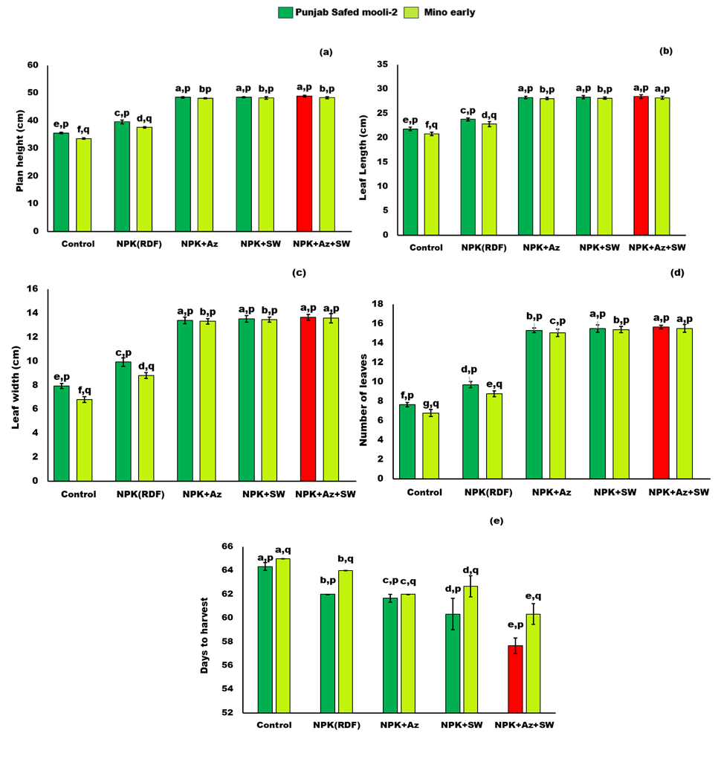
Fig.1: The bar graphs show the interaction effect of bio-stimulants and two radish varieties (Punjab Safed mooli-2 and Mino early) on a) plant height (cm) b) length of leaf (cm) c) width of leaf (cm) d) Number of leaves e) days to harvest under bio stimulants. Graphs showed mean value, ± SE with different letters (a, b, c, d, e and p, q) are significantly different from each other (p ≤ 0.05). The red-colored bar represents the maximum improvement in growth parameters in radish under bio-stimulant.
Impact of varieties and bio-stimulants on yield parameters of radish
The effects of treatments and varieties on the yield and characteristics of radish roots are displayed in Table 3 and Figure 2(a-e). Root diameter, weight, length, and total yield all showed notable variations. The longer roots (18.10 cm), a larger diameter (4.91 cm), and a higher weight (123.33 g), Safed Mooli-2 (V₁) performed better than Mino Early (V₂). For every root parameter, T₅ had the greatest values among the treatments, whereas T₁ had the lowest. Additionally, V₁ produced the highest yield (3.86 kg/plot, 64.33 q/ha), which was marginally greater than V₂. Root yields were lowest in T₁ (2.82 kg/plot, 47.08 q/ha) and highest in T₅ (4.66 kg/plot, 77.80 q/ha).
Variety (V) | Length of root (cm) | Diameter of root (cm) | Weight of root (g) | Root yield (kg/plot) | Root yield  (q/ha)
V₁ | 18.10ª | 4.91ª | 123.33ª | 3.86ª | 64.33ª
V₂ | 17.60^{b} | 4.58^{b} | 121.58^{b} | 3.75^{b} | 62.61^{b}
SE(m) ± | 0.042 | 0.027 | 0.191 | 0.007 | 0.111
CD_{0.05} | 0.127 | 0.08 | 0.573 | 0.02 | 0.333
Treatments
T₁ | 13.30^{c} | 3.14^{d} | 96.16e | 2.82e | 47.08e
T₂ | 15.30^{b} | 3.84^{c} | 118.63^{d} | 3.20^{d} | 53.48^{d}
T₃ | 20.13ª | 5.05^{b} | 127.86^{c} | 3.84^{c} | 64.01^{c}
T₄ | 20.20ª | 5.79ª | 133.73^{b} | 4.49^{b} | 74.97^{b}
T₅ | 20.33ª | 5.90ª | 135.90ª | 4.66ª | 77.80ª
SE(m) ± | 0.067 | 0.042 | 0.302 | 0.011 | 0.176
CD_{0.05} | 0.201 | 0.126 | 0.905 | 0.031 | 0.527
Table 3: Impact of Varieties and bio stimulants on Length of root, Diameter of root, Weight of root and Root yield.

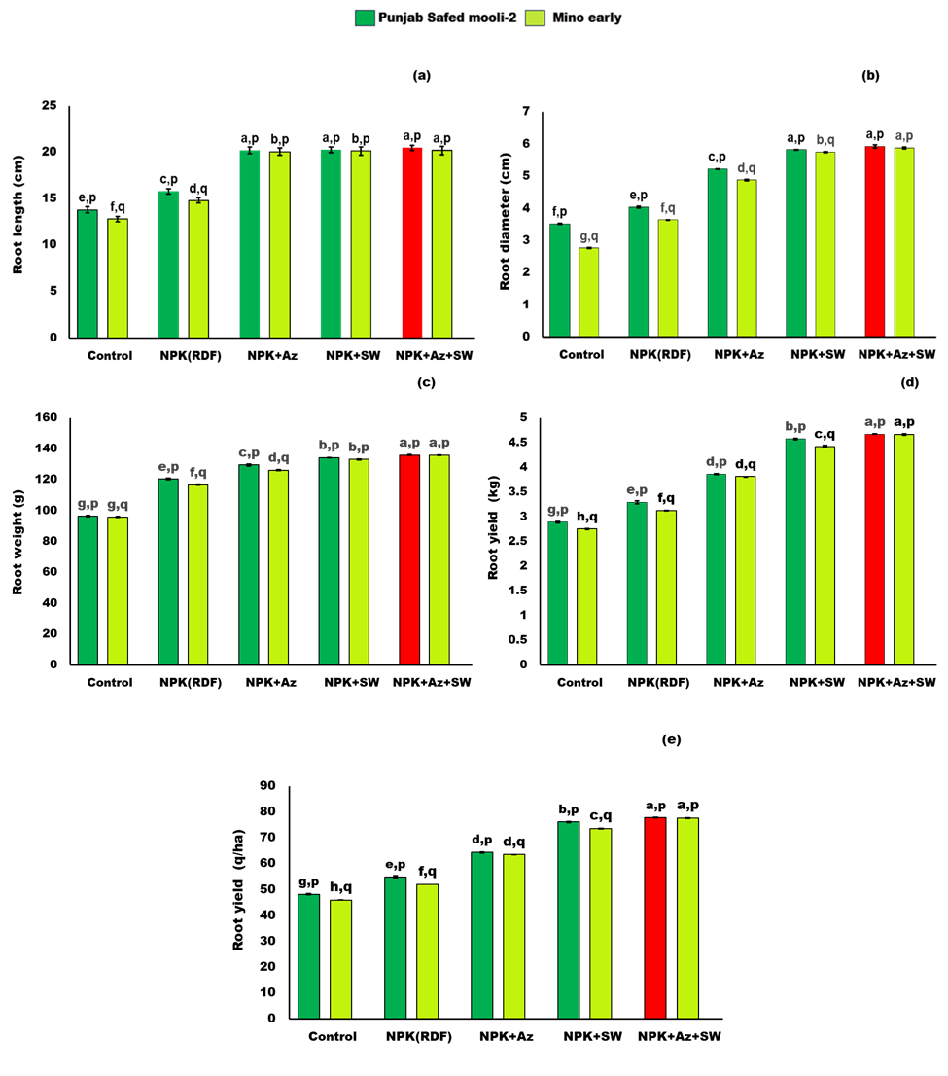Fig.2: The bar graphs show the interaction effect of bio-stimulants and two radish varieties (Punjab Safed mooli-2 and Mino early) on a) length of root (cm) b) diameter of root (cm) c) weight of root (g) d) Root yield (kg/plot) e) Root yield (q/ha) under bio stimulants. Graphs showed mean value, ± SE with different letters (a, b, c, d, e and p, q) are significantly different from each other (p ≤ 0.05). The red- colored bar represents the maximum improvement in yield parameters in radish under bio-stimulant.

Impact of varieties and bio-stimulants on quality parameters

The data pertaining to quality attributes of radish, including TSS and ascorbic acid, as impacted by varieties and treatments, are shown in Table 4 and illustrated in Figure 3 (a-b). A significant impact of varieties and treatments was found on the TSS and ascorbic acid content of radish roots during harvest. Among the varieties, Punjab Safed Mooli-2 (V₁) recorded higher quality parameters, with a maximum TSS (5.45 °Brix), compared to Mino Early (V₂), which recorded a lower TSS (5.04 °Brix). Similarly, V₁ also exhibited higher ascorbic acid (17.38 mg/g FW) than V₂, which recorded lower ascorbic acid (16.90 mg/g FW). Among the treatments, application of T₅ significantly improved the quality profile of radish. It recorded the highest TSS content (6.3 °Brix) as well as maximum ascorbic acid content (18.30 mg/g FW). Whereas, the lowest values for these two parameters were found under T₁, where TSS content was lower (3.5 °Brix) and ascorbic acid was also lower (15.16 mg/g FW).
Table 4: Impact of Varieties and bio stimulants on TSS and Ascorbic acid.

Variety (V) | TSS  (Brix⁰) | Ascorbic Acid  (mg/g FW)
V₁ | 5.45ª | 17.38ª
V₂ | 5.04^{b} | 16.90^{b}
SE(m) ± | 0.032 | 0.032
CD_{0.05} | 0.097 | 0.097
Treatments
T₁ | 3.50^{d} | 15.16^{d}
T₂ | 4.30^{c} | 16.20^{c}
T₃ | 5.96^{b} | 17.90^{b}
T₄ | 6.16ª | 18.16ª
T₅ | 6.30ª | 18.30ª
SE(m) ± | 0.051 | 0.051
CD_{0.05} | 0.154 | 0.154

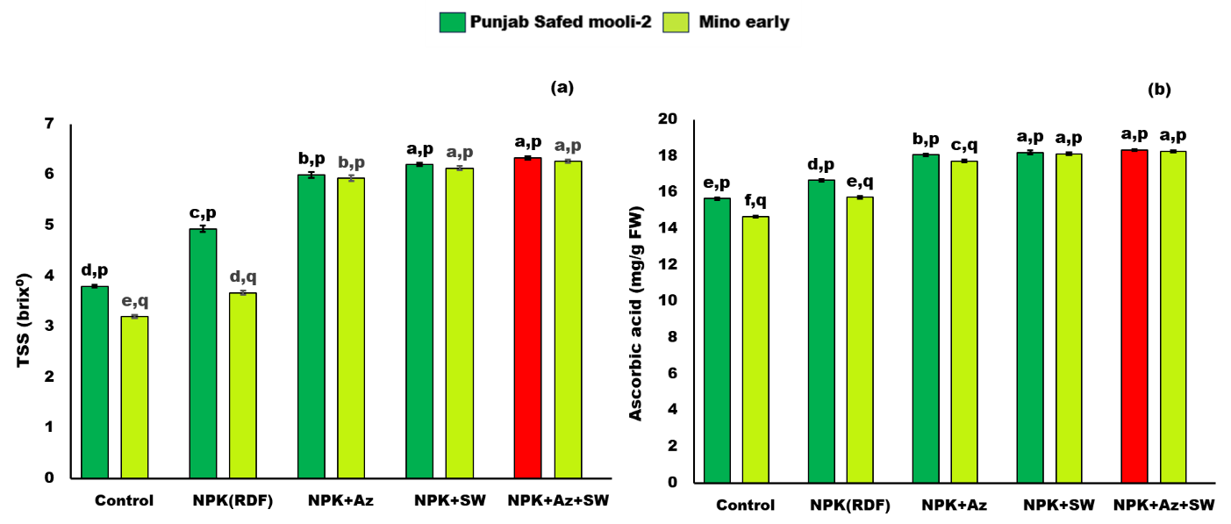

Fig.3: The bar graphs show the interaction effect of bio-stimulants and two radish varieties (Punjab Safed mooli-2 and Mino early) on a) TSS b) Ascorbic acid under bio stimulants. Graphs showed mean value, ± SE with different letters (a, b, c, d, e and p, q) are significantly different from each other (p ≤ 0.05). The red- colored bar represents the maximum improvement in quality parameters in radish under bio-stimulant.

DISCUSSION
Effect of Azotobacter and Seaweed extract on vegetative attributes
The improvement in plant height may be because of the availability of readily accessible nitrogen from both inorganic nutrients and bio stimulants. In addition, the incorporation of bio stimulants may have had an important impact on the improvement of soil physiochemical parameters. Similar influence on the improvement in plant growth by height after bio-stimulant application was also noticed by Ray et al. (2023) in onion and Khanam et al (2023) in broccoli under subtropical weather conditions. Additionally, it could be attributed to the rapid growth of cells and the multiplication in the availability of nitrogen (Berman et al., 2014; Kumar et al., 2014; Shani et al., 2016 in radish; and Bhattarai and Maharjan, 2013, in carrot). Likewise, Rahman et al (2023) argued that nitrogen has the ability to promote plant growth as the nutrient element is directly associated with enhanced cell division and formation of more tissues resulting in profuse vegetative growth and thereby increased plant height. Furthermore, bio-fertilizers have been shown to promote the growth of Hibiscus sabdariffa and okra (Kaur et al., 2021), in addition to radish. Another possible reason for the increase in plant height is the secretion of growth-promoting substances secreted by bio stimulants such as Azotobacter and Seaweed, which could have resulted in greater root development, water transportation, nutrient uptake, and deposition. These findings are comparable to those of Mali et al. (2018) in radish. Integration of organic and chemical fertilizer inputs for enhanced plant height was examined by Howlader et al. (2019) in tomato and Apu et al (2022) in strawberry.
A greater number of leaves is a desirable trait in radish, because more leaves aid in the development of ample photosynthates, which increase yield. It might be due to the application of seaweed, which enhances the growth-promoting hormones in plants, ultimately increasing the number of leaves (Ahmad et al., 2022). More leaves per plant could have been caused by seed inoculation with biofertilizers, which may have increased the availability of phosphorus and biological nitrogen fixation needed for robust growth. The same results were partially consistent with those obtained by Kirad et al. (2010), Singh et al. (2017), Subramani et al. (2011), and Mani and Anburani (2018).
The highest length of leaf (28.33 cm) was obtained with the use of NPK + Azotobacter + seaweed extract. This might be because using Azotobacter along with NPK raised the rate of mineralization, resulting in the rapid release of nutrients (Ramana et al., 2010). The presence of nutrients and phytohormones in seaweed extract may be the reason for its ability to increase leaf length. Furthermore, hormones present in seaweed may help in delaying leaf senescence, allowing leaves to grow and attain length (Melo et al., 2020). These results are fairly similar to those of Mali et al. (2018) in radish and Yadav et al. (2021) in turnip. The possible reason behind the boost in breadth could be due to the availability of nitrogen from chemical fertilizers and bio stimulants, which aids in the assimilation of dietary components by plants, leading to enhanced meristematic activity. Similar results were reported by Kumar et al. (2014), Shani et al. (2016), Rao et al. (2010) and Koly et al. (2024).
Effect of Azotobacter and Seaweed extract on yield attributes
The observed improvement in root length may be because of adequate application of NPK, which is required for plant metabolism and the production of essential compounds like purines, pyrimidines, enzymes, coenzymes, and alkaloids. These nutrients enhance photosynthesis and improve the C:N ratio, promoting carbohydrate storage in both root and shoot, ultimately increasing root yield (Chang and Chang, 2000). Similar findings were found by Ahmed et al. (2004) and Gethe (2006) in radish. Seaweed extract may also promote root growth because it improves nutrient absorption and support vegetative growth, such as increased leaf size and number (Podsedek, 2007). Mrkovacki and Milic (2001) noted that bio stimulants like Azotobacter and seaweed extract help improve soil fertility and enhance traits like root length and diameter. These results align with the recordings of Ingole et al. (2018) in beetroot and Singh et al. (2019) and Nisar et al. (2019) in radish.
The improvement in root diameter could be because RDF provides readily available nutrients such as NPK to the crop. The findings are consistent with Bloom's (2006) finding that N's growth-promoting impact boosts cytokinin production, which influences cellular wall flexibility, meristematic cell number, and development of cells. In contrast, enhanced soil N treatment gave more nitrogen to the plants, resulting in the greatest diameter. These findings correspond with the results presented by Sharma et al. (2013), Mohammad et al. (2015), Verma et al. (2017), and Kushwaha et al. (2020) in radish. Seaweed extract contains not only macro- and micronutrients, vitamins, and antibiotics but also a good quantity of plant growth hormones by stimulating protein synthesis, cell differentiation, and cell division. Hormones also influence the uptake of nutrient-dissolved water and the distribution of nutrients and sugars within the plant body. This in turn increased the diameter of treated plants. The findings of this study agree with those of Raghunandan et al. (2019). Seed treatment with Azotobacter may have boosted nutrients in the plant, particularly nitrogen and phosphorus, and plant nutrient uptake, resulting in increased root diameter. The increase in root diameter might be attributed to the solubilization of plant nutrients caused by the application of chemicals and biofertilizers, which leads to higher NPK uptake. These results are consistent with those of Singh et al. (2019), Patel et al. (2019) in radish, and Nisar et al. (2019) in carrot.
Root weight is a crucial horticultural characteristic that has a direct impact on radish output because the root is the crop's most valuable component. According to Kiran et al. (2016), increased root weight is a result of better nutrient availability and uptake, particularly for phosphate, nitrogen, and potassium. Due to their abundance of nutrients and growth hormones, including as auxins, cytokinins, and gibberellins, which encourage cell division, protein synthesis, and nutrient translocation, seaweed extracts increase root weight. As a result, roots accumulate more dry matter (Ramulu and Rao, 2003). The application of Azotobacter to seeds also increases the availability of nitrogen and phosphorus, which promotes root growth and productivity. These findings are consistent with those of Kataria (2009), Kumar et al. (2016), and Mali et al. (2018) for radish.
Maximizing yield is the main objective of crop cultivation in order to improve financial returns. Seaweed extract has a good impact on root length, nutrient uptake, and translocation, all of which may lead to higher root yield in radish. Seaweed, which is abundant in minerals, growth hormones, and bioactive chemicals, promotes root development and controls hormone levels (Ahmad et al., 2022). Higher yields are also a result of improved plant characteristics like height, leaf width, and root dimensions. Auxin activity and metabolism are improved by balanced phosphorus and continuous nitrogen availability from chemical and biofertilizers. Combination of organic, inorganic and biofertilizers might have created an ideal soil environment and enhance the availability of nutrients to plant resulting greater uptake and assimilation for maximized yield in radish. According to similar results, balanced nutrient application greatly increased root yield in radish by encouraging vigorous growth and effective nutrient use (Shani et al., 2016; Naveen et al., 2018; Kiran et al., 2016; Jat et al., 2017).
Effect of Azotobacter and Seaweed extract on quality attributes
Total soluble solids (TSS), which are essential for evaluating the quality of radish, show the amount of dissolved sugars present. The rise in TSS could be caused by seaweed extract, which, because of its abundance of hormones and bioactive chemicals, promotes photosynthesis, sugar buildup, and stress tolerance (Ahmad et al., 2022). It also enhances nutrient uptake, taste, and root growth. Increased doses of nutrients also improve growth features by improving TSS and vitamin C levels, as well as photosynthate translocation and carbohydrate storage (Rayorath et al., 2008). Furthermore, combining biofertilizers with chemical fertilizers enhances nutrient availability, enzyme activity, and soil health, enabling better metabolic and quality attributes. Similar results have been reported by Sharma et al. (2013), Pathak et al. (2018), Tripathi et al. (2017), Nargave et al. (2018), and Mishra et al. (2020) in radish; Sunandarani and Mallareddy (2007) in carrot; Mullaimaran and Haripriya (2016) in tomato; Kopta and Pokluda (2013) in radish; Khanam et al. (2023) in broccoli and Koly et al. (2024) in strawberry.
Ascorbic acid is an essential constituent of radish roots. It is significantly affected by various treatments. The improvement in ascorbic acid may be attributed to the fact that biofertilizers boosted photosynthetic and metabolic activity, resulting in higher acid, metabolite, and glucose production. The created reserves may be used to synthesize ascorbic acid. Another reason for the rise in ascorbic acid content with added biofertilizers could be its capacity to fix ambient nitrogen and boost carbohydrate synthesis. These findings are similar to those of Kumar et al. (2016) and Mali et al. (2018) in radish.
CONCLUSION
According to the present investigation, it can be found that the combination of inorganic fertilizers, bio stimulants and biofertilizers results in good vegetative development, production, and radish quality. The continued use of inorganic fertilizers in larger amounts has an adverse effect on soil health and water quality, even though the treatment that received the recommended dose of fertilizer produced more. As a result, applying chemical fertilizers more frequently is not recommended. In addition to increasing crop yield and quality, using both chemical fertilizers and biofertilizers helps to reduce soil and water pollution. Root yield was observed to be higher (77.80 q/ha) in the T₅ (NPK + Azotobacter + seaweed extract) treatment and is suggested for radish cultivation. Therefore, based on the current investigation’s findings, it can be said that the bio stimulant can synchronize nutrient supply and crop nutrient requirements, which can enhance the nutrient use efficiency and thus increase the yield.

COMPETING INTERESTS DISCLAIMER:
Authors have declared that they have no known competing financial interests OR non-financial interests OR personal relationships that could have appeared to influence the work reported in this paper.
REFERENCES:
Ahmad, F., Sarwar, S., & Khan, B. M., (2004). Effect of different combinations of NPK fertilizers on the growth and yield of turnip (Brassica rapa L.) at the northern areas of Pakistan. Pak J Soil Sci, 23, 43-47.
Ahmad, S., Cui, W., Kamran, M., Ahmad, I., Meng, X., & Wu, X. (2022). Exogenous application of melatonin induces tolerance to salt stress by improving the photosynthetic efficiency and antioxidant defense system of maize seedling. Journal of Plant Growth Regulation, 40, 1270–1283.
Apu, S. C., Biswas, M. S., Bhuiyan, M. A. B., Gomasta, J., Easmin, S., & Kayesh, E. (2022). Effect of organic amendments and arbuscular mycorrhizal fungi on plant growth, yield and quality of strawberry. Annals of Bangladesh Agriculture, 26(2), 71-82.
Bashir, M. A., Rehim, A., Raza, Q.U.A., Muhammad, A. R., Zhai, L., & Liu, H. (2021). Bio stimulants as plant growth stimulators in modernized agriculture and environmental sustainability. Technology in Agriculture, 3, 100003.
Beijerinck, M. W. (1901). Über Ligonlkophile Microbes. Zentralblatt für Bakteriologie, Parasitenkunde, Infektionskrankheiten und Hygiene Abteilung II, 7, 561–582.
Berman, K. S., Ram, B., & Verma, R. B. (2014). Effect of integrated nutrient management on growth and tuber yield of potato (Solanum tuberosum cv. Kufri Ashoka). Trends in Biosciences, 7, 185–1.
Bhattarai, B. P., & Maharjan, A. (2013). Effect of organic nutrient management on the growth and yield of carrot (Daucus carota L.) and soil fertility status. Nepalese Journal of Agricultural Sciences, 11, 16–25.
Bloom, A. J. (2006). Influence of inorganic nitrogen and pH on the elongation of maize seminal roots. Annals of Botany, 97, 867–873.

Chang, L., & Chang, J. (2000). Effect of potassium on yield quality of radish (Raphanus sativus L.). Journal of Hebei Agricultural University, 23, 20–24.
Dobromilska, R., Małgorzata, M., & Kamila, G. (2008). Evaluation of cherry tomato yielding and fruit mineral composition after using of Bio-algeen S-90 preparation. Journal of Elementology, 13, 491–499.
Gethe, R. M., Pawar, V. S., Pathan, S. H., Sonawane, D. A., & Kadlag, A. D. (2006). Influence of planting layouts, irrigation regimes and fertilizer levels on growth and yield of onion under micro-sprinkler. Journal of Maharashtra Agricultural Universities, 3, 272.
Gill, M. S., Rana, D. S., & Narang, R. S. (1993). Response of maize, wheat and gobhi sarson to balanced fertilization and Azotobacter inoculation in sub-humid Punjab. Indian Journal of Agronomy, 38, 463–465.
Gomasta, J., Hassan, J., Sultana, H., & Kayesh, E. (2024). Interactive plant growth regulator and fertilizer application dataset on growth and yield attributes of tomato (Solanum lycopersicum L.). Data in Brief, 57, 111136.
Gomez, K. A., & Gomez, A. A. (1984). Statistical procedures for agricultural research. John Wiley and Sons.
Howlader, M. I. A., Gomasta, J., & Rahman, M. M. (2019). Integrated nutrient Management for Tomato in the southern region of Bangladesh. International Journal of Innovative Research, 4(3), 55-58.

Ingole, V. S., Wagh, A. P., Nagre, P. K., & Bharad, S. G. (2018). Effect of combination of organic manures and biofertilizer for better growth and yield of beetroot (Beta vulgaris L.). International Journal of Chemical Studies, 6, 1222–1225.
Jat, P. K., Singh, S. P., Devi, S., Mahala, P., & Rolaniya, M. K. (2017). Performance of organic manures, inorganic fertilizer and plant density of yield and quality of radish. International Journal of Agricultural Science and Research, 7, 261–266.
Kayesh, E., Gomasta, J., Bilkish, N., Koly, K. A., & Mallick, S. R. (2023). A holistic approach of organic farming in improving the productivity and quality of horticultural crops. In Organic Fertilizers-New Advances and Applications. IntechOpen.
Kataria, M. (2009). Effect of different plant growth regulators in combination with bio-fertilizers on growth and yield of radish cv. Japanese White (M.Sc. thesis, Jawaharlal Nehru Krishi Vishwa Vidyalaya, Jabalpur, India).
Kaur, K., Singh, N., Maurya, V., Sharma, A., & Kumar, R. (2021). Integrated nutrient management in okra [Abelmoschus esculentus (L.) Moench] using bio-fertilizers. Biological Forum – An International Journal, 13(4), 116–122.
Kaur, R., Kondal, P., Singh, N., Maurya, V., Sharma, A., & Kumar, R. (2024). Effect of spacing and sowing dates on growth, yield and quality of pea (Pisum sativum L.). International Journal of Research in Agronomy, 7(2), 238–251.
Khan, W., Rayirath, U. P., Subramanian, S., Jithesh, M. N., Rayorath, P., & Hodges, D. M. (2009). Seaweed extracts as bio stimulants of plant growth and development. Journal of Plant Growth Regulation, 28, 386–399.
Khanam, S., Gomasta, J., Rahman, M. M., Amin, M. R., Mallick, S. R., & Kayesh, E. (2023). Chitosan and probiotic bacteria promotion of yield, post-harvest qualities, antioxidant attributes and shelf life of broccoli heads. Agriculture and Natural Resources, 57(4), 709-720.
Kirad, K. S., Barch, S., & Singh, D. B. (2010). Integrated nutrient management on growth, yield and quality of carrot. Karnataka Journal of Agricultural Sciences, 23, 542–543.
Kiran, M., Jilani, M. S., Waseem, K., & Sohail, M. (2016). Effect of organic manures and inorganic fertilizers on growth and yield of radish (Raphanus sativus L.). Pakistan Journal of Agricultural Research, 29, 363–372.
Kitamura, S. (Ed.). (1958). Varieties and transitions of Japanese radish. Japan Science Society, 1–9.
Koly, K. A., Gomasta, J., Kabir, K., Mallick, S. R., Sultana, H., & Kayesh, E. (2024). Yield and quality promotion of strawberries through chitosan and potassium combined spray under fluctuating sub-tropical winter. Journal of Central European Agriculture, 25(4), 1065-1075.
Kondal, P., Kaur, R., Singh, N., Maurya, V., Sharma, A., & Kumar, R. (2024). Effect of organic and inorganic fertilizers on the growth, yield and quality of beetroot (Beta vulgaris L.). International Journal of Research in Agronomy, 7, 180–186.
Kopta, T., & Pokluda, R. (2013). Yields, quality and nutritional parameters of radish (Raphanus sativus) cultivars when grown organically in the Czech Republic. Horticultural Science, 40, 16–21.
Kumar, S., Kumar, S., Maji, S., & Pandey, V. K. (2016). Effect of inorganic fertilizers and bio-fertilizers on growth, yield and quality of radish (Raphanus sativus L.). International Journal of Plant Sciences, 11, 71–74.
Kumar, S., Maji, S., Kumar, S., & Singh, H. D. (2014). Efficacy of organic manures on growth and yield of radish (Raphanus sativus L.) cv. Japanese white. International Journal of Plant Sciences, 9, 57–60.
Kushwah, L., Sharma, R. K., Kushwah, S. S., & Singh, O. P. (2020). Influence of organic manures and inorganic fertilizers on growth, yield and profitability of radish (Raphanus sativus L.). Annals of Plant and Soil Research, 22, 28–31.
Mali, D. L., Singh, V., Sarolia, D. K., Teli, S. K., Chittora, A., & Dhakar, R. (2018). Effect of organic manures and bio-fertilizers on growth and yield of radish (Raphanus sativus L.) cv. Japanese White. International Journal of Chemical Studies, 6, 1095–1098.
Mancuso, S., & Stefano, C. (2006). Marine bioactive substances (IPA extract) improve foliar ion uptake and water stress tolerance in potted Vitis vinifera plants. Advances in Horticultural Science, 20, 156–161.
Mani, A. P., & Anburani, A. (2018). Organic nutrient management technique for enhancing growth and physiological parameters in radish (Raphanus sativus L.). Journal of Phytology, 10, 40–42.
Melo, P., Abreu, C., Bahcevandziev, K., Araujo, G., & Pereira, L. (2020). Bio stimulant. Applied Sciences, 10, 4051–4052.
Mishra, A., Singh, S., & Greene, A. (2020). Effect of integrated fertilization on qualitative and quantitative traits of radish (Raphanus sativus L.). International Journal of Current Microbiology and Applied Sciences, 9, 987–995.
Mohammad, K., Yadav, B. K., & Yadav, M. P. (2015). Studies on the effect of integrated nutrient management on growth and yield attributes of radish (Raphanus sativus L.). Annals of Horticulture, 8, 81–83.
Mrkovacki, N., & Milic, V. (2001). Use of Azotobacter chroococcum as potentially useful in agricultural application. Annals of Microbiology, 51, 145–158.
Mullaimaran, S., & Haripriya, K. (2016). Effect of bulky and concentrated organic manures on the growth, yield, quality enhancement and soil properties of tomato. International Journal of Current Research, 8, 41978–41984.
Nargave, K., Sharma, R. K., Kushwah, S. S., & Singh, A. (2018). Influence of varieties and fertility levels on growth, yield and quality of radish (Raphanus sativus L.) under Malwa region of Madhya Pradesh. International Journal of Agriculture, 10, 5371–5374.
Naveen, Y., Syam, S. R., Syed, S., Srinivasarao, G., Deepthi, K., & Lalitha, K. (2018). Influence of organic and inorganic sources of nitrogen on growth and yield of radish (Raphanus sativus L.). International Journal of Current Microbiology and Applied Sciences, 7, 4499–4507.
Nisar, F., Mufti, S., Afroza, B., Khan, F. A., Din, S., Andrabi, N., et al., (2019). Effect of integrated nutrient management on growth and yield attributes of black carrot (Daucus carota). International Journal of Chemical Studies, 7, 2019–2020.
Patel, R., Sharma, S., & Jain, P. K. (2019). Effect of nutrient management on growth, yield and quality of radish (Raphanus sativus L.) cultivars. International Journal of Pure and Applied Sciences, 7, 70–75.
Pathak, M., Tripathy, P., Dash, S. K., Sahu, G. S., & Pattanayak, S. K. (2018). Efficacy of bio-fertilizer, organic and inorganic fertilizer on yield and quality of radish (Raphanus sativus L.). International Journal of Chemical Studies, 6, 1671–1673.
Podsedek, A. (2007). Natural antioxidants and antioxidant capacity of Brassica vegetables: A review. Food Science and Technology, 40, 1–11.
Preeti, Singh, N., Maurya, V., Sharma, S., Kumar, R., & Sharma, A. (2024). Effect of seed priming by nano-urea and nano-zinc on growth and yield of rat-tailed radish (Raphanus sativus var. caudatus). International Journal of Research in Agronomy, 7(4), 79–90.
Raghunandan, B. L., Vyas, R.V., Patel, H. K., Jhala, Y. K. (2019). Perspectives of seaweed as organic fertilizer in agriculture. Soil Fertility Managament for Sustaintainable Development. Singapore: Springer, 2, 267-289.
Rahman, A., Salma, U., Gomasta, J., Ali, M. K., Bari, A. A., Alam, M. N., Rahman, M. M., Promi, R. J., & Kayesh, E. (2023). Degree and frequency of nitrogen amendments influencing the off-season okra production in the semi-arid north-western Bangladesh. Plant Archives, 23(2), 93-103.

Ramana, V., Ramakrishna, M., Purushotham, K., & Reddy, K. B. (2010). Effect of biofertilizers on growth, yield attributes and yield of French bean (Phaseolus vulgaris). Legume Research, 33, 178–183.
Ramulu, P., and Rao, P. U. (2003). Total, insoluble and soluble dietary fiber contents of Indian fruits. J Food Compo Anal 16, 677-685.
Rao, K. R., Mushan, L. C., Mulani, A. C., Khatavkar, R. S., Parlekar, G. Y., & Shah, N. V. (2010). Effect of vermicompost on the growth and yield of onion (Allium cepa). Karnataka Journal of Agricultural Sciences, 23, 361–363.
Ray, T., Gomasta, J., Hassan, J., Hossain, M. S., & Kayesh, E. (2023). Foliar application of chitosan and plant probiotic bacteria influencing the growth, productivity and bulb storage life of onion. Australian Journal of Crop Science, 17(10), 776-788.
Rayorath, P., Jithesh, M. N., Farid, A., Khan, W., & Palanisamy, R. (2008). Rapid bioassays to evaluate the plant growth promoting activity of Ascophyllum nodosum (L.) Le Jol. using a model plant, Arabidopsis thaliana (L.) Heynh. Journal of Applied Phycology, 20, 423–429.
Rekha, C., Poornima, G., Manasa, M., Abhipsa, V., Devi, J. P., Kumar, H. T. V., et al., (2012). Ascorbic acid, total phenol content and antioxidant activity of fresh juices of four ripe and unripe citrus fruits. Chemical Science Transactions, 1, 303–310.
Riya, Vohra, S., Singh, N., Maurya, V., Sharma, A., & Kumar, R. (2024). Vermiwash mediated salt stress amelioration in Brassicaceae crops. Russian Journal of Plant Physiology, 71, 204.
Sami, H. M., Dina, M. S., Ahmed, M. M. E.-T., Emad, H., & Abd El-Samad. (2019). Utilization of seaweed (Sargassum vulgare) extract to enhance growth, yield and nutritional quality of red radish plants. Annals of Agricultural Sciences, 64, 167–175.
Shani, K., Sanjay, K., Sutanu, M., & Pandey, V. K. (2016). Effect of inorganic fertilizers and bio-fertilizers on growth, yield and quality of radish. International Journal of Plant Sciences, 11, 71–74.
Sharma, D., Singh, R. K., & Parmar, A. S. (2013). Effect of doses of biofertilizers on the growth and production of cabbage (Brassica oleracea). Journal of Multidisciplinary Advanced Research, 2, 30–33.
Sharma, U. G., Vihol, N. J., & Chavda, J. C. (2013). Influence of plant density and nutrient management on growth, yield and quality of radish (Raphanus sativus L.) cv. Pusa Chetki. Asian Journal of Horticulture, 8, 671–676.
Sheoran, O. P., Tonk, D. S., Kaushik, L. S., Hasija, R. C., & Pannu, R. S. (1998). Statistical software package for agricultural research workers. In D. S. Hooda & R. C. Hasija (Eds.), Recent advances in information theory, statistics & computer applications (pp. 139–143). Department of Mathematics & Statistics, CCS HAU, Hisar.
Singh, B. K. (2021). Radish (Raphanus sativus L.) breeding for higher yield, better quality and wider adaptability. In Advances in Plant Breeding Strategies: Vegetable Crops: Bulbs, Roots and Tubers, 8, 275–304.
Singh, D. P., Kumar, S., Sutanu, M., & Vijay, P. K. (2017). Studies on integrated nutrient management on growth, yield and quality of carrot (Daucus carota L.). International Journal of Agricultural Sciences, 51, 2187–2188.
Singh, J., Gandhi, N., Singh, K., Tinna, D., & Singh, S. (2019). Effect of the organic manure, inorganic fertilizers and their combination on growth, yield and quality of radish (Raphanus sativus L.). Journal of Pharmacognosy and Phytochemistry, 4, 57–59.
Subramani, A., Anuburani, A., & Gayathiri, M. (2011). Response of growth parameters of radish (Raphanus sativus L.) to various organic nutrients and bio stimulants. Asian Journal of Horticulture, 6, 32–34.
Sunandarani, N., & Mallareddy, K. (2007). Effect of different organic manures and inorganic fertilizers on growth, yield and quality of carrot (Daucus carota L.). Karnataka Journal of Agricultural Sciences, 20, 686–688.
Tripathi, A. K., Ram, R. B. R., Kumar, S. A., & Patra, S. S. (2017). Studies on the effect of nitrogen levels and spacing on quality traits of radish (Raphanus sativus L.) cv. Kashi Sweta. International Journal of Chemical Studies, 5, 537–540.
Verma, U. K., Kumar, R., Kumar, A., Kumar, S., & Prajapati, M. K. (2017). Integrated effect of organic manures and inorganic fertilizers on growth, yield and yield attributes of radish cv. Kalyanpur Safed. Journal of Pharmacognosy and Phytochemistry, 6, 826–828.

Yadav, C., Mishra, S. K., Singh, M. K., Roy, S., & Tiwari, P. (2021). Effect of integrated nutrient management on growth, yield and shelf life of turnip (Brassica rapa L.) cv. Purple Top White. Journal of Pharmacognosy and Phytochemistry, 10, 100–110.

