Assessment of micronutrients in soils of Agriculture College Farm, Pune based on GPS - GIS

ABSTRACT
Present soil survey in College of Agriculture, Pune (Maharashtra) India was carried out during 2024 by using Global Positioning System (GPS) and Geographical Information System (GIS). was undertaken with 160 geo-referenced soil samples collected by randomized method. Out of 160 soil samples, 127 samples from Agronomy Farm and 33 samples were collected from Modi Baugh and Pathology Farm by using standard soil sampling procedure and were analysed for chemical properties at College of Agriculture, Pune with an objective to study assess the soil nutrient status, delineate soil fertility maps of College of Agriculture farm, Pune. The pH and EC of soils of Agronomy Farm was found in between 7.63 to 8.96 (mean 8.11) and 0.20 to 0.78 dS m⁻¹ with mean 0.41 dS m⁻¹ respectively. The organic carbon and calcium carbonate content of the Agronomy Farm was ranged from 0.10 to 0.73 per cent with mean 0.39 per cent and 10.25 to 27.5 per cent with mean 18.53 per cent respectively. The DTPA extractable micronutrients viz., iron, manganese, zinc and copper in soils ranged from 3.02 to 10.26 mg kg⁻¹ (mean 4.71 mg kg⁻¹), 3.61 to 11.47 mg kg⁻¹(mean 7.06 mg kg⁻¹), 0.66 to 3.58 mg kg⁻¹ (mean 1.92 mg kg⁻¹), 1.65 to 3.98 mg kg⁻¹ (mean 3.00 mg kg⁻¹) respectively.
The soils of Modi Baugh and Pathology Farm showed pH and EC between from 7.52 to 8.45 with mean 7.85, and 0.21 to 0.64 dS m⁻¹ with mean 0.45 dS m⁻¹ respectively. The organic carbon content and calcium carbonate ranged from 0.17 to 0.62 per cent with mean 0.32 and 8.5 to 25.5 per cent with mean 14.1 per cent respectively. The DTPA extractable micronutrients viz, iron, manganese, zinc and copper present in soil ranged from 2.08 to 6.94 mg kg⁻¹ (mean 4.51 mg kg⁻¹), 3.25 to 10.28 mg kg⁻¹ (mean 8.10 mg kg⁻¹), 0.55 to 3.98 mg kg⁻¹ (mean 2.15 mg kg⁻¹), 2.25 to 3.91 mg kg⁻¹ (mean 2.98 mg kg⁻¹) respectively.
Based on the GPS locations of samples and soil test results, soil fertility maps of College of Agriculture Farm, Pune were prepared by using Arc-GIS 10.8.2 for soil pH, EC, OC, CaCO₃ and DTPA extractable micronutrients i.e Fe, Mn, Zn, Cu.
Keywords: GIS, GPS, micronutrients, soil fertility maps
- INTRODUCTION
Soil is a natural mix of organic matter and weathered rock that forms on the Earth’s surface. It is a basic or foundation for all crop production. It is biologically active and capable and home to a large range of living organisms including earthworm, soil microbes, and growing plant roots. In general, a country’s socioeconomic development and life support system capacity are determined by how well its land is used. The greatest possible production of food, fiber and fuel from each farmed land area per unit of time is
necessary to address the nation’s severe population crises. To be compared to the total number of farms in a given area, the results of a soil test conducted on a single farm must be comprehensive. Although sampling every farm to assess the soil fertility status of every farm would be ideal, this is not feasible due to the significant cost, difficulty, and time required, particularly considering the vast number of small farms found in many developing countries. Therefore, we require systematic soil sample from data to gather knowledge about the entire region.
Crop availability is significantly impacted by the parent material, organic matter, calcium carbonate, soil response, texture, and mineralogical composition. According to Nayyar et al., 1999, calcareous soils with high pH and little organic matter are more likely to have micronutrient shortages. The term “micronutrient” refers to certain vital nutrients that are needed in extremely small amounts for the development of microbes and plants. Micronutrients include Fe, Mn, Zn, Cu, B, Mo and Cl. Of the micronutrients discovered thus far, B, Mo, and Cl act as anions in soil, whereas Fe, Mn, Zn and Cu act as cations. During the past few years, when widespread micronutrient deficiencies were found in the majority of our nations’s soils, wherever intensive agriculture was practiced, the significance of micronutrient has come to light. Numerous factors, including soil, environment, crop conditions and management, affect the availability of nutrients in soil.
Global Positioning System (GPS) and Geographic Information Systems (GIS) are also essential tools for determining the soil’s spatial variability. Spatial data can be collected, stored, retrieved, transformed, and shown using a powerful set of tools known as GIS (Das et al., 2004). GPS- assisted soil sample collection is crucial for creating thematic soil fertility maps. Anywhere in the world, a GPS device can accurately determine the latitude and longitude of the location, it provide soil nutrient status of various site for the future supervision, it is extremely important in agriculture (Mishra et al., 2014). The Global Positioning System (GPS) technology is a satellite-based navigation system that uses signals from satellite in orbit to tell users where they are. Locating satellites that transmit signals to the device is how a GPS system operates. After that, they locate your on earth based on the positions of satellites. Geographic Information System (GIS), gathers information about the earth’s surface and transforms it into information that can be shared, analyzed, and understood. GIS is mostly used for predicting, weather patterns, land information management, and resource exploitation. The preparation of soil fertility maps is now possible through the applications of modern technologies such as GPS and GIS. The United States military administrated the Global Positioning System, a space-based navigation and tracking system that accurately determines the location of the object on earth's surface using geographical coordinates. A Geographic Information System (GIS) is a computer system used for capturing, querying and displaying geographic data. It is easy to change the data regarding to fertility status of an area even after the soil fertility maps are prepared.

2. MATERIALS AND METHODS
2.1 Location of the Study Area
The campus of Agriculture College Farm, Pune is located in between latitude N 180 32’17.268’’ and longitude E 73050’37.2084’’and it covers total area of 42 ha. The elevation is 557.7 m above mean sea level. The College of Agriculture, Pune is situated at the Ganeshkhind Road, Shivaji Nagar, Pune. The Research Farm is under culturable command area since 1907 and present study was, therefore, undertaken to prepare detailed soil survey of College of Agriculture Farm, Pune. The base map of Agriculture College Farm, Pune was depicted in Fig. 1.
2.2 Soil Sample Preparation and Laboratory Analysis
Geo-referenced surface (0 - 22.5 cm) soil samples were collected randomly from College of Agriculture Farm, Pune. The latitude and longitude of sampling sites were recorded with the help of Differential Global Positioning System. The soil samples were collected by using randomization method i.e 100 m apart. From 160 locations soil samples were collected and evaluated. Record of surveyed field i.e latitude, longitude were taken using GPS. The soil samples were collected with the help of wooden and plastic instruments to avoid iron contamination. After collecting the soil samples, they were brought to the laboratory. These samples were dried under shade, pounding completed by using wooden pestle and morter and passed through sieve 2 mm and 0.5 mm. The sieved samples were preserved in clean plastic bags for further analytical work with the proper labelling. All the precautions were followed as per the procedure described by Jackson (1973) and standard procedure outlined by Page et al., (1982) was used to estimate chemical properties of soil. Soil samples were analyzed for pH, EC, organic carbon, calcium carbonate and DTPA extractable micronutrients viz, iron, manganese, zinc and copper. The geospatial analysis of the study area was carried out using ArcGIS 10.8.2.
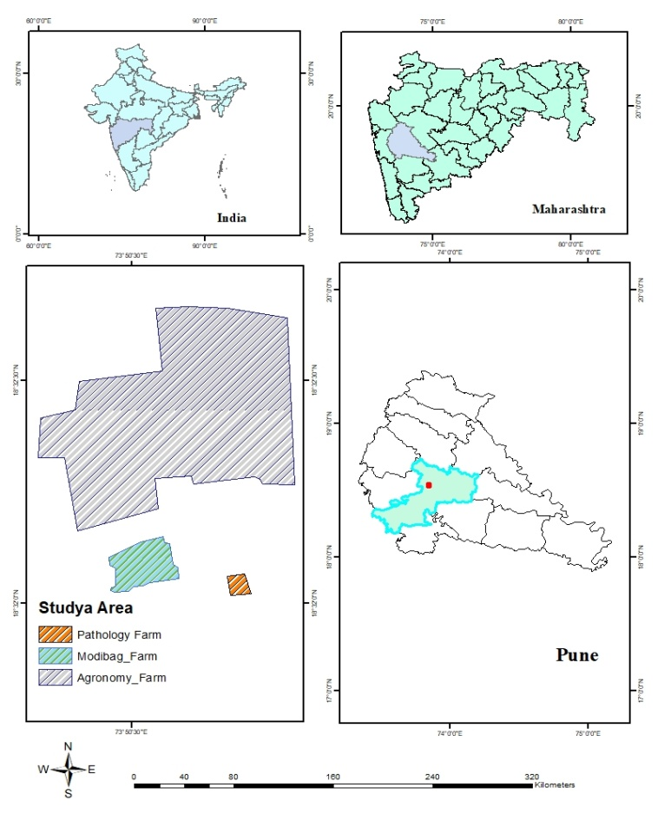
Fig.1 Study area of College of Agriculture Farm, Pune
3. RESULTS AND DISCUSSION
3.1 Soil reaction
Soil pH data are presented in Table 1. A total of 127 soil samples from the Agronomy Farm were analyzed, revealing a pH range of 7.63 - 8.96, with a mean of 8.11. Among these, 9.44 per cent of samples were slightly alkaline, 87.42 per cent moderately alkaline and 3.14 per cent strongly alkaline. The spatial variability across the farm is illustrated in Figure 2.
27 samples from Modi Baugh Farm and 6 from Pathology Farm were analyzed, with pH values ranging from 7.52 - 8.45 and an average of 7.85 pH evaluations are presented in table 2. According to the results of the analysed soils, 75.75 per cent of samples were slightly alkaline, and 24.25 per cent were moderately alkaline. Figure 3 depicts the geographic distribution of pH for these farms.
Most soils across the Agriculture College Farm, Pune, are moderately alkaline, likely influenced by parent material, rainfall, topography, and prolonged irrigation of medium-deep black soils. Similar findings were reported by Nalawade and Palwe (2014) at ARS, Savale Vihir Farm, MPKV, Rahuri. The elevated pH is possibly due to basaltic parent material rich in basic cations (Patil et al., 2019).

3.2 Electrical Conductivity (EC)
The soil Electrical Conductivity (EC) data are presented in Table 1. A total of 127 samples from the Agronomy Farm showed EC values ranging from 0.20 to 0.78 dS m⁻¹, with an average of 0.41 dS m⁻¹. These values fall within the normal range, suitable for healthy plant growth. The highest EC recorded was 0.78 dS m⁻¹, and the lowest was 0.20 dS m⁻¹. Spatial variability across the farm is depicted in Figure 4, showing most soils with EC within the normal range.
For the Modi Baugh and Pathology Farms, 33 soil samples exhibited EC ranging from 0.21 to 0.64 dS m⁻¹, with a mean of 0.45 dS m⁻¹ (Table 2). All samples from these farms also fell within the normal EC range, indicating favorable conditions for plant development. Figure 5 illustrates spatial variability across these farms.
The normal EC values are likely due to careful irrigation management and the non-saline nature of the soils, as indicated by low soluble salt content. Excessive leaching of salts to lower soil horizons and removal of bases through percolation and drainage help maintain normal EC levels (Satish et al., 2018). Similar findings were reported by Golhar and Chaudhari (2013) in Jalgaon district and by (Salma et al., 2019), who noted that low EC prevents salt accumulation at greater depths.

3.3 Organic Carbon
Organic carbon content in Agronomy Farm soils ranged from 0.10 % to 0.73 %, with a mean of 0.39 % (Table 1). Among 127 samples, 13.39 per cent were very low, 39.37 per cent low, 38.58 per cent moderate and 8.66 per cent moderately high in organic carbon. Higher and lower values were 0.73 % and 0.10 %, respectively. Figure 6 highlights spatial variability, showing predominantly low organic carbon in the western zone.
There were 27 samples taken from the Modi Baugh Farms and the 6 samples taken from the Pathology Farm. The organic carbon ranged from 0.17 % to 0.62 %, averaging 0.32 % (Table 2). Out of these, 18.18 per cent very low, 57.58 per cent low, and 24.24 per cent moderate organic carbon content. Figure 7 demonstrates spatial variability, with most soils showing low organic carbon.
Low organic carbon may be due to minimal FYM and crop residue application, rapid decomposition under high temperatures, and low vegetation cover. These findings align with reports by (Naiknaware et al., 2020) and Gosavi and Chaudhari (2016) from similar agro-climatic zones in Maharashtra.
3.4 Calcium carbonate
Calcium carbonate content in Agronomy Farm soils ranged from 10.25 per cent to 27.5 per cent, with a mean of 18.53 per cent (Table 1). Among samples, 36.22 per cent fell into the moderate category, while 63.78 per cent exhibited very high CaCO₃ levels. Figure 8 depicts the spatial distribution, showing higher CaCO₃ in the western zone.
From Modi Baugh and Pathology Farms, CaCO₃ ranged from 8.5 per cent to 25.5 per cent, with an average of 14.10 per cent (Table 2). Among these, 57.58 per cent showed high, 24.24 per cent very high, and 18.18 per cent moderate CaCO₃ content. Figure 9 illustrates spatial variability, with most areas classified as high.
These patterns align with findings by (Patil et al., 2017) and (Magare et al., 2023). The semi-arid climate, characterized by low rainfall and high evaporation, promotes CaCO₃ precipitation. The soils’ basaltic origin further contributes to these levels (Verma et al., 2012).
Table 1: Chemical properties of soils from Agronomy Farm
Particulars | pH (1:2.5) | EC (dS m⁻¹) | Organic carbon (%) | CaCO₃ (%)
Range | 7.63 - 8.96 | 0.20 - 0.78 | 0.10 - 0.73 | 10.25 - 27.5
Mean | 8.11 | 0.41 | 0.39 | 18.53
Categories | Slightly alkaline  12  (9.44%) | Normal  127  (100%) | Very Low  17  (13.39%) | Moderate  46  (36.22%)
Categories | Moderately alkaline  111  (87.42%) | Normal  127  (100%) | Low  50  (39.37%) | Very high  81  (63.78%)
Categories | Strongly alkaline  4  (3.14%) | Normal  127  (100%) | Moderate  49  (38.58%) | Very high  81  (63.78%)
Categories | Strongly alkaline  4  (3.14%) | Normal  127  (100%) | Moderately High  11  (8.66%) | Very high  81  (63.78%)
Table 2: Chemical properties of soils from Modi Baugh and Pathology Farm
Particulars | pH (1:2.5) | EC (dS m⁻¹) | Organic carbon (%) | CaCO₃ (%)
Range | 7.52 - 8.45 | 0.21 - 0.64 | 0.17 - 0.62 | 8.5 - 25.5
Mean | 7.85 | 0.45 | 0.32 | 14.1
Categories | Slightly alkaline  25  (75.75%) | Normal  33  (100%) | Very Low  6  (18.18%) | Moderate  6  (18.18%)
Categories | Moderately alkaline  8  (24.25%) | Normal  33  (100%) | Low  19  (57.58%) | High  19  (57.58%)
Categories | Moderately alkaline  8  (24.25%) | Normal  33  (100%) | Moderate  8  (24.24%) | Very high  8  (24.24%)

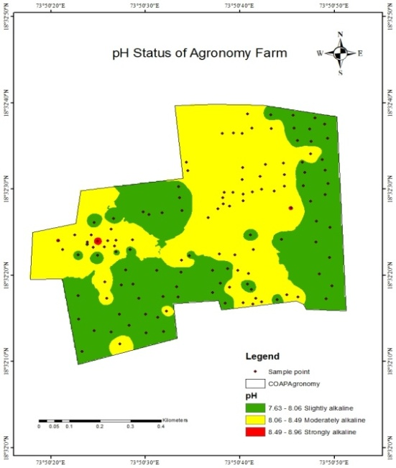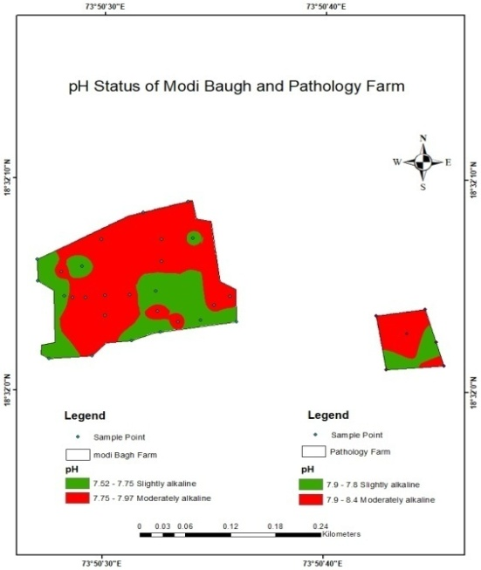

pH of Modi Baugh and Pathology Farm
pH of Agronomy Farm

pHofAgronomyFarm

Fig 2: pH of Agronomy Farm Fig 3: pH of Modi Baugh and Pathology Farm

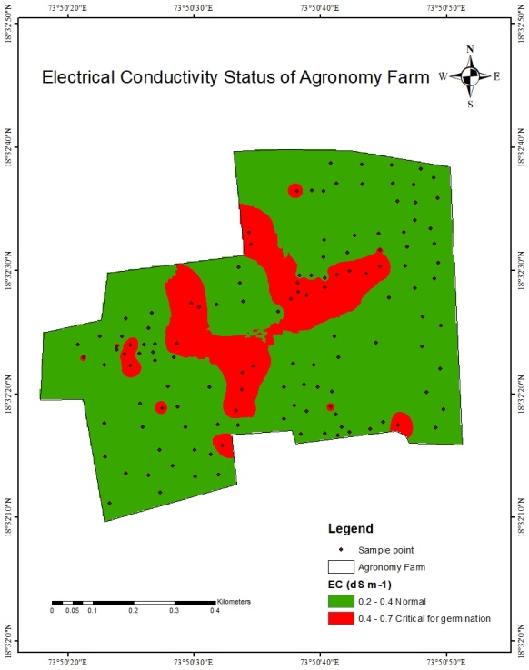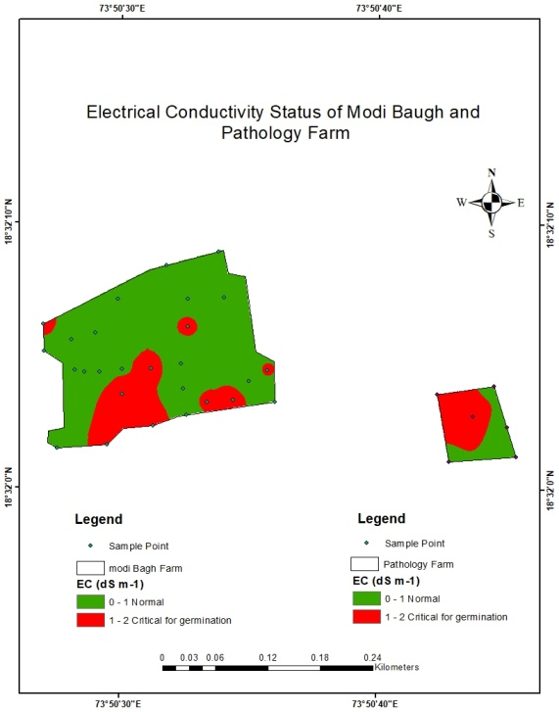
Electrical Conductivity of Modi Baugh and Pathology Farm

Electrical Conductivity of Agronomy Farm
Fig 4: EC of Agronomy Farm Fig 5: EC of Modi Baugh and Pathology Farm

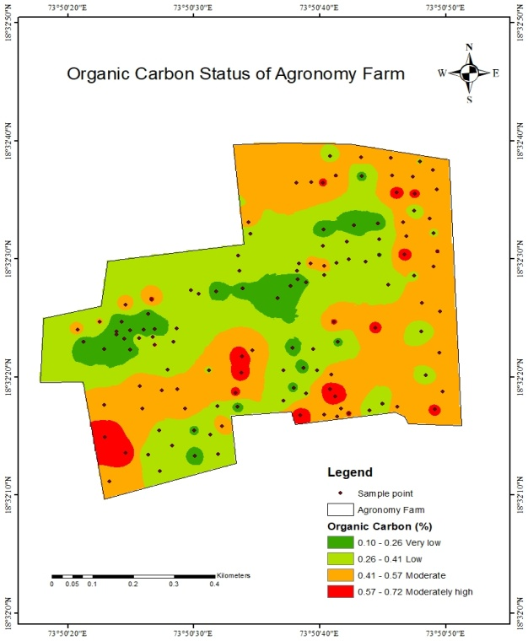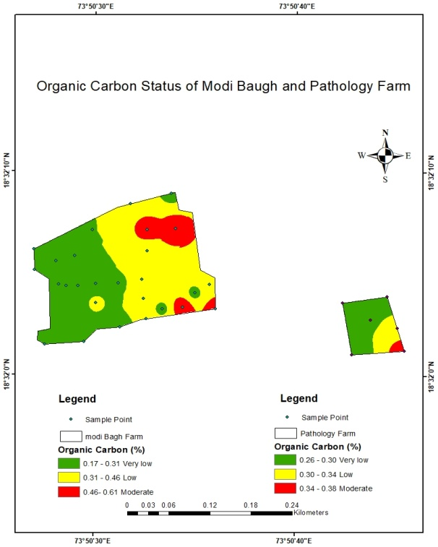
Fig 7: Organic carbon status of Modi Baugh and Pathology Farm
Fig 6: Organic carbon status of Agronomy Farm

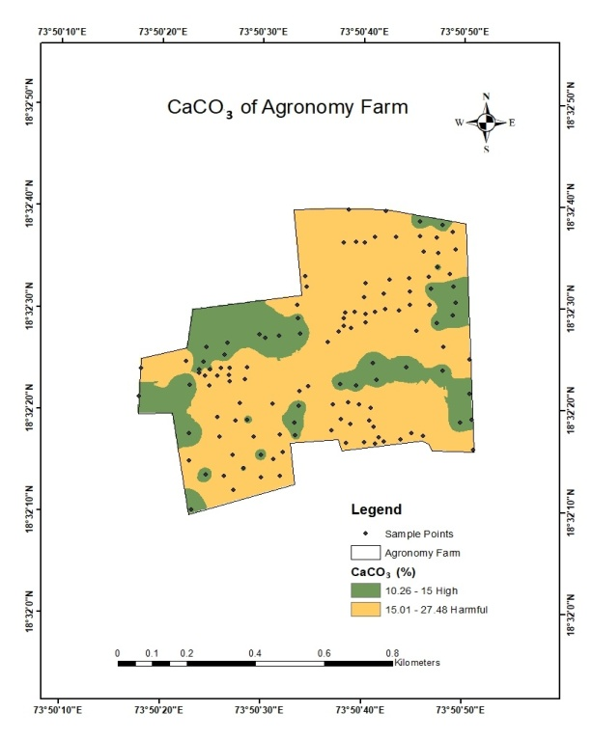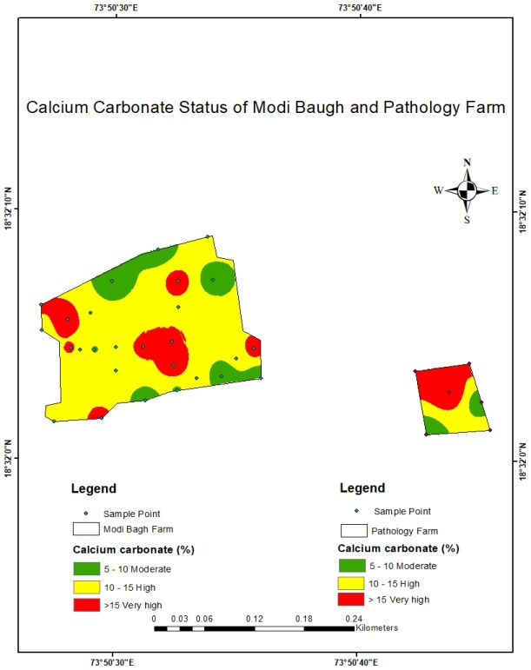
Very high

Calcium Carbonate status of Agronomy Farm

Fig. 8: CaCO₃ status of Agronomy Farm Fig 9: CaCO₃ status of Modi Baugh and
Pathology Farm
3.5 Available Macronutrient Status of Soil
A total of 160 soil samples were collected from the College of Agriculture Farm, Pune, to evaluate the status of essential micronutrients - iron (Fe), manganese (Mn), zinc (Zn), and copper (Cu). These samples were taken from two key areas: 127 samples from the Agronomy Farm and 33 samples from the Pathology and Modi Baugh Farms.
The available iron content in the Agronomy Farm varied from 3.02 to 10.26 mg kg⁻¹, with an average of 4.71 mg kg⁻¹. Among these, 59.05 per cent of the samples were categorized as low in iron, while 40.95 per cent showed moderate levels. Spatial variability (Figure 10) revealed that most of the farm was under the low iron category, particularly in the central and western zones, with the eastern region showing moderate levels. In the Pathology and Modi Baugh Farms showed a range of 2.08 to 6.94 mg kg⁻¹, with average of 4.51 mg kg⁻¹. Of these samples, 51.52 per cent exhibited moderate iron content, 42.42 per cent were low, and 6.06 per cent were categorized as very low. As seen in Figure 11, the moderate iron levels were mainly concentrated in the northern zone. The lower availability of iron in these soils is attributed to high soil pH and the presence of calcium carbonate, which leads to iron precipitation. These findings are consistent with earlier reports by (Nagawade et al., 2014)
The available manganese content in the Agronomy Farm ranged from 3.61 to 11.47 mg kg⁻¹, with a mean of 7.06 mg kg⁻¹. A majority of the samples 66.14 per cent were in the moderately high category, 33.07 per cent were high, and only 0.78 per cent were moderate. Figure 12 indicates generally sufficient manganese levels across the farm. In the Pathology and Modi Baugh Farms, manganese levels ranged from 3.25 to 10.28 mg kg⁻¹, with an average of 8.10 mg kg⁻¹. Here, 54.55 per cent of the samples were high, 36.36 per cent moderately high, and 9.09 per cent moderate (Figure 13). The adequacy of manganese is likely due to higher organic matter content and optimal soil pH, as reported by (Vijaykumar et al., 2011) and Gosavi and Chaudhari (2016).
Zinc content in the Agronomy Farm ranged from 0.66 to 3.58 mg kg⁻¹, with a mean of 1.92 mg kg⁻¹. Very high zinc levels were observed in 36.22 per cent of the samples, while 28.35 per cent were moderately high, 22.05 per cent moderate and 13.38 per cent high. Spatial mapping (Figure 14) showed the northern part of the farm with the highest zinc availability. In the Pathology and Modi Baugh Farms, zinc ranged from 0.55 to 3.98 mg kg⁻¹, with a mean of 2.15 mg kg⁻¹. A large portion of the samples showed very high 39.39 per cent and moderate 33.34 per cent zinc content (Figure 15). High organic carbon and optimal pH contributed to sufficient zinc availability, consistent with (Patil et al., 2016).
Copper content was found to be uniformly very high across all farms. In the Agronomy Farm, ranged from 1.65 to 3.98 mg kg⁻¹ (mean 3.00 mg kg⁻¹), while in the other farms it ranged from 2.25 to 3.91 mg kg⁻¹ (mean 2.98 mg kg⁻¹). Spatial maps (Figures 16 and 17) showed high copper availability may be due to adequate organic matter, favorable pH, and soil moisture, as supported by Mahashabde and Patel (2012) and (Vaddepally et al., 2016).
Table 3: Status of available micronutrients (Fe, Mn, Zn, Cu) in soils of Agronomy Farm
Particulars | Fe (mg kg⁻¹) | Mn (mg kg⁻¹) | Zn (mg kg⁻¹) | Cu (mg kg⁻¹)
Range | 3.02 - 10.26 | 3.61 - 11.47 | 0.66 - 3.58 | 1.65 - 3.98
Mean | 4.71 | 7.06 | 1.92 | 3.00
Categories | Low  75  (59.05%) | Moderate  1  (0.78%) | Moderate  28  (22.05%) | Very High  127  (100%)
Categories | Moderate  52  (40.95%) | Moderately high  84  (66.14%) | Moderately high  36  (28.35%) | Very High  127  (100%)
Categories | Moderate  52  (40.95%) | High  42  (33.07%) | High  17  (13.38%) | Very High  127  (100%)
Categories | Moderate  52  (40.95%) | High  42  (33.07%) | Very High  46  (36.22%) | Very High  127  (100%)

Table 4: Status of micronutrients (Fe, Mn, Zn, Cu) in soils of Modi Baugh and Pathology Farm
Particulars | Fe (mg kg⁻¹) | Mn (mg kg⁻¹) | Zn (mg kg⁻¹) | Cu (mg kg⁻¹)
Range | 2.08 - 6.94 | 3.25 - 10.28 | 0.55 - 3.98 | 2.25 - 3.91
Mean | 4.51 | 8.10 | 2.15 | 2.98
Categories | Very low  2  (6.06%) | Moderate  3  (9.09%) | Low  2  (6.06%) | Very High  33  (100%)
Categories | Low  14  (42.42%) | Moderately high  12  (36.36%) | Moderate  11  (33.34%) | Very High  33  (100%)
Categories | Moderate  17  (51.52%) | High  18  (54.55%) | Moderately high  2  (6.06%) | Very High  33  (100%)
Categories | Moderate  17  (51.52%) | High  18  (54.55%) | High  5  (15.15%) | Very High  33  (100%)
Categories | Moderate  17  (51.52%) | High  18  (54.55%) | Very High  13  (39.39%) | Very High  33  (100%)

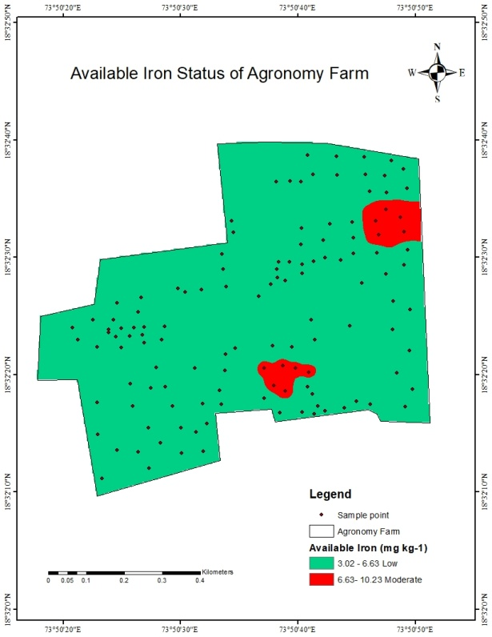 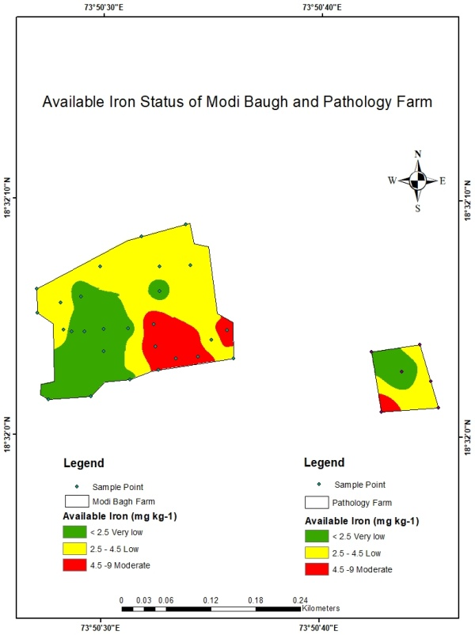F

Available Iron content of Modi Baugh and Pathology Farm
Available Iron content of Agronomy Farm

Fig10: Available Iron content of Agronomy Farm
Fig 11: Available Iron content of Modi Baugh and Pathology Farm

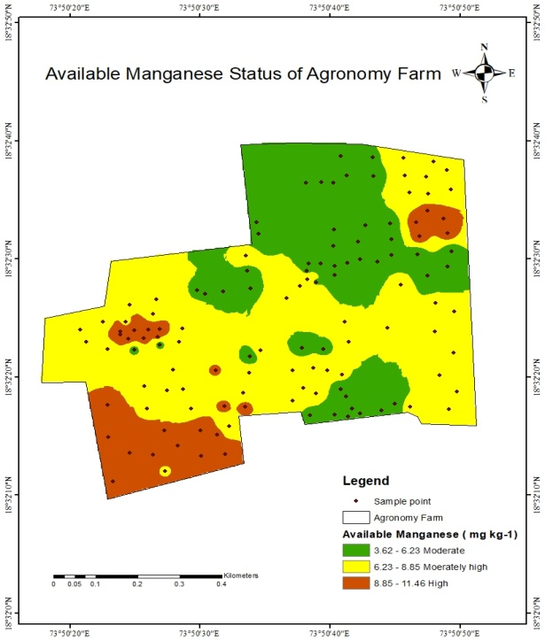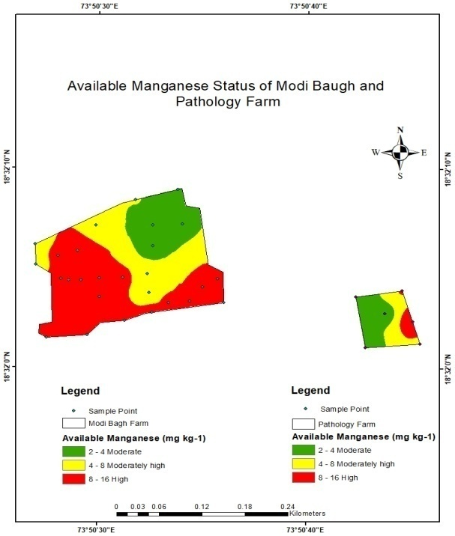
Available Manganese content of Modi Baugh and Pathology Farm

Available Manganese content of Agronomy Farm

Fig12: Available Manganese content of Fig 13: Available Manganese content of Modi
Agronomy Farm Baugh and Pathology Farm

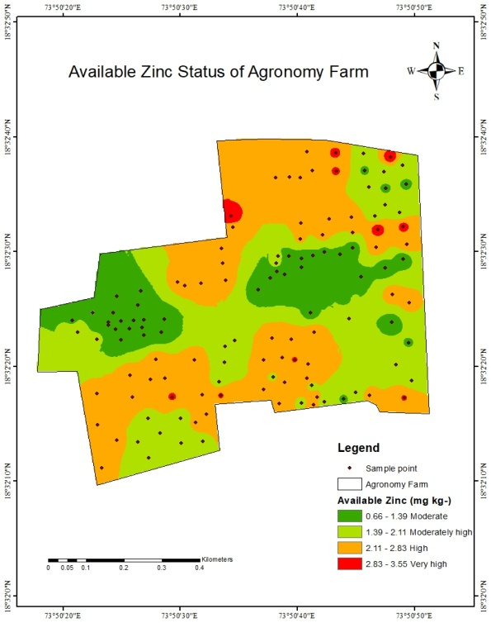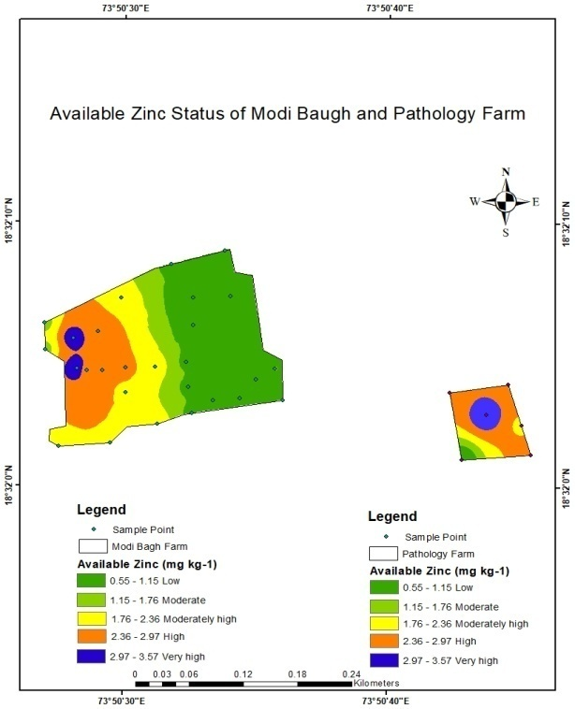
Available Zinc content of Modi Baugh and Pathology Farm

Available Zinc content of Agronomy Farm

Fig 14: Available Zinc content of Agronomy Fig 15: Available Zinc content of Modi Baugh and
Farm Pathology Farm

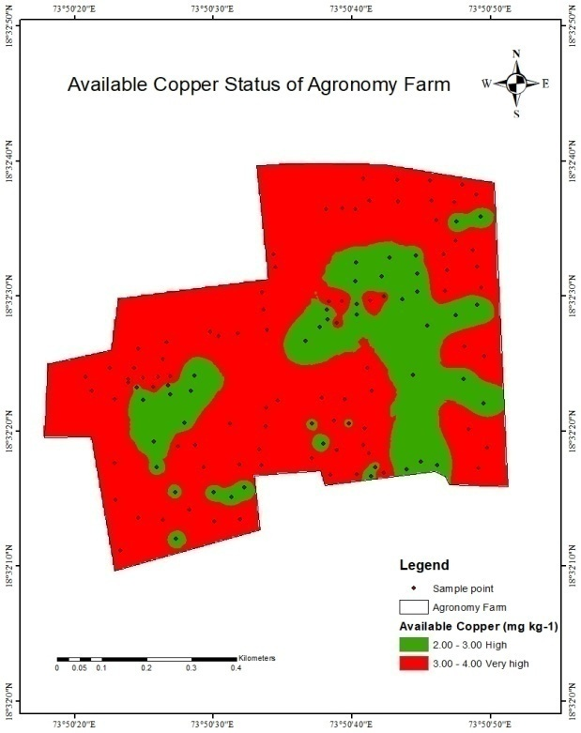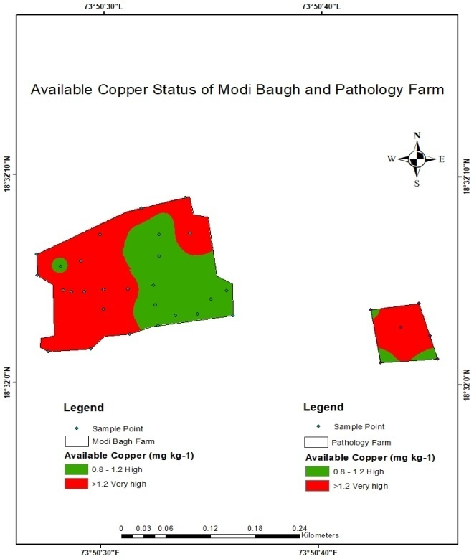
Available Copper content of Modi Baugh and Pathology Farm

Available Copper content of Agronomy Farm

Fig16: Available Copper content of Agronomy Fig17: Available Copper content of Modi Baugh
Farm and Pathology Farm
4. CONCLUSION
It is concluded that the soils of the Agronomy Farm were slightly alkaline to strongly alkaline in reaction, normal in electrical conductivity, very low to moderately high in organic carbon content, the calcium carbonate was categorized under moderate to very high content, DTPA-extractable iron was low to moderate, manganese was moderate to high, zinc was moderate to very high and copper was in very high category.
The soil samples from Modi Baugh and Pathology Farm were slightly alkaline to moderately alkaline in reaction, normal in electrical conductivity, organic carbon content was very low to moderate, the calcium carbonate content was categorized under moderate to very high, DTPA-extractable iron was very low to moderate, manganese was in moderate to high, zinc was low to very high and copper was in very high category.

COMPETING INTERESTS DISCLAIMER:
Authors have declared that they have no known competing financial interests OR non-financial interests OR personal relationships that could have appeared to influence the work reported in this paper.

REFERENCES
- Das, D. K. (2004) Role of geo-informatics in sustainable agriculture: Research, extension and service to the farmers. Chairman’s address- In Proceedings of the symposium Geo informatics Applications for Sustainable Development pp. 1-11.
- Golhar, N. P. and Chaudhari, P. R. (2013) Level of significance of various physical and chemical parameters of soils through Electrical Conductivity, Journal of Chemical, Biological and Physical Science 3, 2051-2057.
- Gosavi, N. I. and Chaudhari, R. D. (2016) GPS-GIS based soil fertility maps of Shirpur tehsil of Dhule District (M.S.), India. Asian Journal of Soil Science 11, 353 357.
- Jackson, M. L. (1973) Soil Chemical Analysis. Prentice Hall Pvt. Ltd., New Delhi 69-182.
- Magare, P. N., Charjan, Y. D., Wankhade, R. S. and Lawhale, A. S. (2023) Assessment of nutrients and heavy metal status in soils of Akola, Maharashtra. The Pharma Innovation Journal 12, 1690-1694.
- Mahashabde, J. P. and Patel, S. (2012) DTPA-Extractable micronutrients and fertility status of soil in Shirpur tehsil Region. International Journal of Chemical Technology Research 4, 1681-1685.
- Mishra, A., Pattnaik, T., Das, D. and Das, M. (2014) Soil fertility maps preparation using GPS and GIS in Dhenkanal District, Odisha, India. International Journal of Plant and Soil Science 3, 986-994.
- Nagawade, S. G. (2014) GPS-GIS based Soil Fertility Map of Central Farm of MPKV, Rahuri (M.S.) Master thesis, MPKV, Rahuri.
- Naiknaware, V. V. and Abed, S. (2020) Physico-Chemical Analysis of Soil Samples from Beed District, Maharashtra. Chemistry Journal 6, 2581-7507.
- Nalawade, A. S. and Palwe, C. R. (2014) Assessment of GIS-GPS based soil fertility map of Agriculture Research Station, Savalevihir Farm, M.P.K.V., Rahuri, Maharashtra. Bioinfolet 11, 300-301.
- Nayyar, V. K. Takkar, P. N., Bansal, R. L., Singh, S. P., Kaur, N. P. and Sadana., U. S. (1990). Micronutrients in soils and crops of Punjab department of soils. Research Bulletin, Department of Soils, Punjab Agricultural University, Ludhiana, 146.
- Page, A. L., Millar, R. H. and Kenny, D. R. (1982) Methods of Soil Analysis. American Society of Agronomy Madison, Wisconsin, United States of America. pp. 1159.
- Patil, A. H., Kumbhar, A.V. and Nale, V. N. (2017) GIS-GPS Based Soil Fertility Maps of Agriculture College Farm, Kadegaon District Sangli Maharashtra. International Journal of Engineering Science and Computing. 7, 15426-15430.
- Patil, P. B., Jatkar, P. R. and Adsul, P. B. (2019). Physico-chemical properties in soils from Washi tahsil of Osmanabad district. Journal of Pharmacognosy and Phytochemistry 8, 149-151.
- Patil, P. L., Kuligod, V. B., Gundlur, S. S., Jahnavi, K., Nagaral, I. N., Shikrashetti, P., Geethanjali, H. M. and Dasog., G. S. (2016) Soil fertility mapping in Dindur sub-watershed of Karnataka for site specific recommendations. Journal of the Indian Society of Soil Science 64, 311- 318.
- Salma, D., Munaswamy, V., Giridhara, K. T., Sumathi, V. and Reddy, B. R. (2019) GPS and GIS based Soil Fertility Maps and Identification of Soil Related Constraints for Chickpea Growing Soils of Owk Mandal, Kurnool District (A.P), India. International Journal of Current Microbiology and Applied Sciences 8, 1241-1247.
- Satish, S., Naidu, M. V. S. and Ramana, K.V. (2018) Genesis and classification of Bengal gram growing soils in Brahmanakotkur watershed of Andhra Pradesh. International Journal of Pure and Applied Biosciences 6, 614-624.
- Vaddepally, P. (2016) GPS based soil fertility maps of village Baragaon Nandur, taluka Rahuri, Dist-Ahmednagar (MS) Doctoral dissertation, Mahatma Phule Krishi Vidyapeeth, Rahuri.
- Verma, T. P., Singh, S. P, Ramgopal, R. P Dhankar, Rao R. V. S. and Lal., T. (2012) Characterization and evaluation of soils of Trans Yamuna area in Etawah district, Uttar Pradesh for sustainable land use. Agropedology 22, 26-34.
- Vijaykumar, R., Arokiaraj, A. and Martin Deva Prasath, P. (2011) Micronutrients and their relationship with soil properties of natural disaster proned coastal soils. Research Journal of Chemical Science 27, 567-571.

