Microgreens: Cultivation, Nutrition, Journey to Space and Market Trends

Abstract
Microgreens have gained immense popularity in recent years due to their high nutritional value, diverse flavors and adaptability to small scale and urban farming. These tender greens, larger than sprouts but smaller than baby vegetables or greens, are packed with densely concentrated nutrients and health-promoting compounds. They are favored by high-end chefs and health-conscious consumers as garnishing elements in salads, soups, and sandwiches. Vegans also appreciate microgreens for their nutrient-enriched dietary value. Cultivating microgreens is feasible in small spaces, making them a viable option for urban farming. Various substrates, such as soilless, aeroponics, hydroponics, and aquaponics, are being explored for their cultivation. Microgreens are not only rich in ascorbic acid, vitamins, and micro and macro elements, but they also show promise for space exploration. Their unique properties and compact growth make them an alternative food source for astronauts. Additionally, the market for microgreens is booming, with India and North America showing promising growth. The global microgreens market is projected to reach a value of USD 2.6 billion by 2031, fueled by the increasing demand and versatile cultivation methods. With their exceptional nutritional profile and versatile cultivation options, microgreens are an attractive option for both consumers and growers, offering a bright future ahead.
Keywords: Microgreens, Babygreens, Culinary, Nutritional, Cultivation, Vitamins, Space

Introduction
In the field of nutrition and culinary innovation, a fascinating phenomenon known as "microgreens" has emerged as miniature nutritional powerhouses. These young plants, typically no taller than a few inches, are garnering increasing attention for their intense flavors, vibrant colors, and remarkable health benefits. This comprehensive review delves into the captivating world of microgreens, exploring their cultivation, health advantages, and diverse applications in the culinary landscape. The main motive of this review paper is to offer a deep exploration of microgreens from multiple dimensions. By synthesizing existing research and knowledge, this paper aims to provide a comprehensive resource for understanding the cultivation techniques of microgreens, their wide-ranging health benefits, and their versatile applications in the culinary realm. Microgreens have transcended the role of mere garnishes to become nutritional powerhouses that pack a flavorful punch. With vitamins, minerals, and antioxidants in abundance, these minuscule greens are now being recognized as an essential addition to a balanced diet. This review paper bridges the gap between scientific research and practical understanding, making the benefits of microgreens accessible to a wider audience, including health-conscious individuals, chefs, and researchers. Looking ahead, the insights presented in this review paper pave the way for exciting future developments. As research on microgreens continues to evolve, there is potential for further exploration into their specific health-promoting compounds and culinary potential. Furthermore, the paper encourages ongoing investigations into optimal cultivation methods, facilitating the availability of fresh and nutrient-dense microgreens to broader communities.
1. Micro/Baby greens
Microgreens, defined as young veggies harvested between 5 - 21 days (about 3 weeks) after germination, exhibit a unique profile that distinguishes them from their mature counterparts. Unlike sprouts, which include seeds, roots, and stems, microgreens are harvested without their roots, allowing for the development of delicate textures and a kaleidoscope of flavors. These culinary gems are characterized by a central stem, cotyledon leaves, and a pair of juvenile true leaves(Fig.1) contributing to their diminutive yet striking appearance (Partap et al.,2023).
What truly sets microgreens apart is their precise harvest time. Unlike their counterparts, such as baby greens that take 20 to 40 days to mature, microgreens are plucked at the nascent stage of their true leaflet development. This early harvest ensures that microgreens possess a distinctive flavor profile and tender texture that distinguishes them from both sprouts and baby greens. In the case of sprouts, their harvest precedes that of microgreens and encompasses not just leaves but also seeds, roots, and stems – a stark contrast to the rootless nature of microgreens (Sharma et al., 2022; Partap et al.,2023).
1.1 History
The history of young vegetables, including microgreens, began as a culinary trend closely linked to upscale restaurants seeking distinctive, locally sourced, and heirloom offerings (Bliss, 2014). While immature vegetables have played a role in our diets for a long time, the recent surge in shipping fresh micro products across long distances is a noteworthy development. A prominent player in the US micro product market is A Chef’s Garden, a farm that traces its roots back to the 1980s (Lubow, 2006). Nevertheless, the cultivation of microgreens has expanded across the globe, taking place in both small and large greenhouse operations.
Starting from the 2000s, microgreens have transitioned into the mainstream, mirroring the heightened interest in functional foods that contribute to well-being and longevity (Kyriacou et al., 2016). They are now widely advocated for production within diverse, small-scale agricultural setups (Treadwell et al., 2013; Alexander, 2016), at times being grouped alongside other specialty items like edible flowers and sprouts (Eber, 2012). This evolution underscores their growing prominence in contemporary culinary and health-conscious landscapes.
2. Cultivation Techniques
Microgreens are cultivated using a range of techniques, differing in complexity and accuracy. This diversity of systems, as outlined in this segment, proves adaptable to Controlled Environment Agriculture (CEA) setups. These CEA facilities offer meticulous regulation of climate, nutrients, and light throughout all seasons and locations. In contrast to traditional open-field farming, CEA presents the advantage of energy efficiency and the ability to grow crops year-round. This lead to enhanced yields, consistency, nutritional content, quality, and safety in the produce (Shamshiri et al., 2018).
2.1 Soilless Substrate
Soilless substrate-based cultivation stands out as an accessible method for small-scale environments like home gardens. These setups utilize substrates like coconut coir, peat moss, rock wool, hemp mat or similar porous materials (Di Gioia et al., 2017; Thuong & Minh, 2020). The effects of various substrates are mentioned in Table.1. Top-down spraying or bottom-up wicking is used to deliver the water. This approach draws parallels to hydroponics for mature plants, but microgreens hold a distinction. Unlike other crops, microgreens don't always require nutrient solutions; instead, the substrates themselves can serve as nutrient sources (El-Nakhel et al., 2021; Thuong & Minh, 2020).
In recent times, user-friendly growth kits centered around soil-less substrate have gained traction among home gardeners. An instance is the Microgreens Growing Kit, by Satopradhan that comes with two fabrics grow bag trays 8"x2", dried cocopeat mix 400g in a reusable cotton bag, two varieties of organic seeds (10gm each), a how to grow guide (Fig 4) All products inside the kit are ethically sourced and are made from eco-friendly material. This setup ensures microgreens thrive with adequate water, generally ready for harvesting within two weeks. These can be easily accessed from an online marketplace called” Amazon” used worldwide. There are many more growing kits with variations according to the need of the consumers.
2.2 Aeroponics Substrate
Aeroponics employs atomization techniques to disperse a nutrient solution as fine aerosol droplets, typically ranging from 10 to 100 μm (Eldridge et al., 2020). These tiny droplets confer few notable advantages: they achieve the high level of water efficiency across all growth methods and facilitate exceptional oxygen in the root zone. Nonetheless, aeroponic setups necessitate advanced instrumentation to meticulously control the environment, and they remain susceptible to challenges like power interruptions or suboptimal nutrient formulations. The application of aeroponic methods has extended to the realm of commercial micro green production, with emerging ventures like AeroFarms adopting these techniques. Furthermore, reports have surfaced regarding the utilization of mini aeroponic-microgreen growth tower & experimental rooting chambers (Gnauer et al., 2019).
2.3 Hydroponics Substrate
Hydroponic methodologies, including deep-water culture and nutrient film technique, showcase heightened water planning while incurring higher costs in terms of instruments, energy, and space. In DWC setups, seeds are introduced onto an immobile substrate that floats atop a deep tank of circulated nutrient solution or water. In this environment, the roots develop as they search for sustenance. Active aeration of the reservoir is necessary for DWC systems. Recent research underscores the positive impact of proper aeration on wheat and lentil microgreen’s productivity, revealing that insufficient presence of air results in root hypoxia and stunted growth (Grishin et al., 2021). Conversely, more than required agitation and aeration were linked to damage in root and decreased Swiss chard yield (Baiyin et al., 2021).
2.4 Aquaponics
Aquaponic systems offer an unique approach, combining the cultivation of fish (aquaculture) and plants (hydroponics). These systems capitalize on the natural conversion of fish waste into plant nutrients through the action of microbes (Yep & Zheng, 2019). Subsequently, the water utilized by plants is cleansed and recirculated. This setup stands out for its remarkable water and nutrient efficiency. It enhances plant growth by virtue of its distinctive breakdown organic matter and microbiota (Nicoletto et al., in 2018).
3. Nutritional content
One of the defining attributes of microgreens is their exceptional nutrient density. These miniature plants, in their short growth span, manage to accumulate an impressive array of minerals and micronutrients, often surpassing the content found in fully grown plants. Research indicates that microgreens boast high levels of elements such as calcium, magnesium, iron, manganese, zinc, selenium, and molybdenum (Pinto et al., 2015). Of note, studies highlight the consistent presence of these minerals across different varieties, despite variations in soil properties and composition (Xiao et al.,2016).
Vitamins and their precursors further amplify the nutritional value of microgreens. Variability in vitamin content is evident across different species and cultivars, with significant amounts of β-carotene, α-tocopherol, phylloquinone and ascorbic acid reported in recent studies (Xiao et al, 2012; Xiao et al.,2014).

3.1 Ascorbic Acid (Vitamin C)
Vitamin C or ascorbic acid is particularly abundant in microgreens, especially during their microgreen growth stage. Consuming microgreens rich in ascorbic acid can benefit individuals by boosting their immune system, promoting healthy skin, and aiding in wound healing. Additionally, as an antioxidant, it helps combat free radicals and reduces the risk of chronic diseases (Pannico et al., 2020).

3.2 Phylloquinone (Vitamin K)
Phylloquinone, a form of vitamin K found consistently in various microgreen species, contributes to maintaining proper blood clotting and bone health. Consuming microgreens with phylloquinone helps support these essential bodily functions (Xiao et al., 2012).

3.3 α-Tocopherol (Vitamin E)
Microgreens are rich sources of α-tocopherol, or vitamin E, which plays a crucial role in nerve impulses, muscle function, and immune system enhancement. Incorporating microgreens into one's diet can contribute to improved overall health and vitality (Paradiso et al., 2018).

3.4 β-Carotene (Pro-Vitamin A)
Microgreens such as fennel, radish, and mustard contain significant amounts of β-carotene, a precursor to vitamin A which is essential for maintaining boosting the immune system, good vision, and promoting healthy skin. Consuming these microgreens helps support these vital functions (Ghoora et al., 2020).

3.5 Phenolic Antioxidants
Microgreens are rich in phenolic antioxidants, which offer a wide range of benefits, including improved metabolic activity, reduced inflammation, and enhanced glucose homeostasis. Regular consumption of microgreens with phenolic antioxidants can contribute to better overall health and well-being (Kumar & Goel, 2019).

3.6 Anthocyanins
Anthocyanins found in microgreens provide several health benefits, such as antioxidant properties that protect cells from damage, anti-inflammatory effects, and potential anti-cancer properties. Including microgreens with anthocyanins in your diet may help reduce the risk of chronic diseases (Bhaswant et al., 2023).

3.7 Micro and Macro elements
Microgreens are packed with essential minerals like copper (Cu), sodium (Na), calcium (Ca), manganese (Mn), potassium (K), magnesium (Mg), iron (Fe) and zinc (Zn). These minerals are vital for various metabolic processes, energy production, and overall health. Consuming a diverse range of microgreens can help individuals maintain a balanced intake of these important nutrients, promoting overall well-being and potentially reducing the risk of nutrient deficiencies (Renna et al., 2020).
4. Scientific Research and Future Directions: A Journey from Plate to Space
The prospect of enabling prolonged human space travel hinges on the successful cultivation of fresh vegetation beyond Earth's atmosphere. NASA, the renowned National Aeronautics and Space Administration, has embarked on a series of experiments aimed at nurturing leafy greens to sustain astronauts stationed aboard the International Space Station (Hummerick et al., 2021; Johnson et al., 2021; Massa et al., 2016). Nevertheless, the endeavor of cultivating plants in the weightlessness of space presents an array of formidable technical hurdles, including limited cultivation areas and crew time, coupled with ht levels of radiation exposure. Notably, in the realm of space horticulture, microgreens have emerged as a subject of profound interest. NASA is actively investigating the feasibility of microgreens as a potential alternative to conventional leafy plants for astronauts (Johnson et al., 2021).
4.1 Importance of Microgreens in Space
The distinctive merits of microgreens, as expounded in the prior sections, render them as an ideal culinary component for space missions. Their abbreviated growth cycle and simplified cultivation procedures afford astronauts the luxury of dedicating their primary attention to vital mission tasks, while expending minimal effort on tending to the plants. Their modest requirements for both light and water prove advantageous in the confined and resource-constrained environment of spacecraft, where electrical and waterpower for artificial lighting are in limited supply. Furthermore, the spatial constraints within spacecraft and habitats align seamlessly with the diminutive dimensions of microgreens. These miniature greens can be harvested fresh and with proper sanitation measures in place, are immediately consumable. Their vibrant colors and robust flavors could elevate the presentation of space cuisine and, in turn, tantalize the appetites of astronauts.
Moreover, microgreens boast a high conc. of nutrients and are enriched with additional bioactive compounds that have the potential to bolster the well-being of crew members. They offer robust antioxidant properties and possess antiproliferative attributes, which counters the oxidative stress and toxicity in genes induced by the in outer space.
However, it's important to acknowledge the drawbacks of employing microgreens in space farming. Firstly, these diminutive plants are incapable of producing progeny, leading to a substantial net consumption of seeds. Secondly, when compared to cultivating larger plants, microgreens exhibit lower biomass fixation and oxygen generation, which can pose challenges in sustaining life support systems aboard spacecraft (Kyriacou et al., 2017; Wheeler et al., 2008).
5. Consumer Awareness and Market Trends
Due to their numerous health benefits and rich nutritional value, and with the increasing popularity of indoor farming in cities, the global microgreens market is on the rise. According to Pattnaik et al., (2020), it is predicted that the global microgreens market will grow by 7.6% annually by 2025, reaching a value of around 17,039.742 billion USD (approximately 17000000000 Indian rupees) as reported by Al-Kodmany in 2018. Microgreens are gaining widespread attention worldwide due to their positive effects on human health and their visual appeal. These tiny greens are packed with nutrients, boasting nutrient levels that are 40 times higher than those found in fully grown vegetables, as highlighted in the study by Muchjajib et al., in 2015. Notably, broccoli has a significant role in boosting the microgreens industry due to its many health benefits and nutritional value. In 2017, China and India were the top producers of broccoli microgreens, yielding around 10.4 and 8.4 million metric tonnes respectively. In contrast, the United States, Spain, Mexico, and Italy combined produced less than 1 million metric tonnes (Parr et al., 2017). Microgreens, particularly indoor crops, have proven to be highly profitable, with a 60% profit margin. Among indoor crops, microscale vegetables showed the highest profit margin at 40%. The cultivation of microgreens has grown by 26% in large indoor farms and 10% in smaller operations, indicating a rising trend. It is expected to continue growing by 6% annually in the coming years. In 2020, the Southern and Northern regions of the United States were the leading areas for microgreens cultivation in greenhouses, with profit margins of 71% and 59%, respectively. However, the full growth potential of the microgreens market depends on consumer behavior and income levels (Paraschivu et al., 2021).
6. Conclusion
This review has provided a comprehensive overview of microgreens, from their historical significance to their cultivation methods, nutritional values, and potential applications in space exploration. The differentiation between microgreens, sprouts, and mature plants underscores their unique qualities and benefits. The diverse substrates used for microgreens cultivation, apart from traditional soil, highlight the adaptability and versatility of this crop. The exploration of microgreens' nutritional constituents emphasizes their potential to contribute to a healthy diet. These tiny greens pack a powerful punch of vitamins, minerals, and antioxidants, making them a valuable addition to our daily nutrition. Additionally, the journey of microgreens into space as a viable alternative to traditional leafy vegetables for astronauts underscores the importance of these crops in challenging environments. Their rapid growth and nutrient density make them an ideal choice for future space missions.
Lastly, the discussion of consumer and market trends reveals a growing demand for microgreens, especially in the northern regions of the United States and India. As more consumers become health-conscious and environmentally aware, microgreens' popularity is expected to rise. This trend not only signals a promising future for microgreens but also reinforces the notion that these tiny plants have a big role to play in our evolving culinary and agricultural landscapes.

COMPETING INTERESTS DISCLAIMER:
Authors have declared that they have no known competing financial interests OR non-financial interests OR personal relationships that could have appeared to influence the work reported in this paper.

References
Alexander, L.(2016) How to tap into the latest trends.American Vegetable Grower,64.

Al-Kodmany K.(2018) The vertical farm: A review of developments and implications for the vertical city.Buildings,8 24 10.3390/buildings8020024.

Baiyin, B.,Tagawa,K.,Yamada,M.,Wang, X.,Yamada,S.,Yamamoto, S., & Ibaraki, Y.(2021) Study on plant growth and nutrient uptake under different aeration intensity in hydroponics with the application of particle image velocimetry.Agriculture,11, 1140.10.3390/agriculture11111140.

Bhaswant, M., Shanmugam, D.K, Miyazawa T., Abe, C., & Miyazawa T. (2023) Microgreens- A comprehensive review of bioactive molecules and health benefits. Molecules, 28, 867. https://doi.org/ 10.3390/molecules28020867.

Bliss, R.M.(2014) Specialty greens pack a nutritional punch. Agricultural Research, (Jan), 10-11.

D’Imperio,M.,Montesano F.F, Montemurro N., & Parente, A.(2021) Posidonia natural residues as growing substrate component: An ecofriendly method to improve nutritional profile of brassica microgreens. Frontiers in Plant Science,12,580596 .https://doi: .org/10.3389/fpls.2021.580596.

Di Gioia, F.,De Bellis, P.,Mininni, C., Santamaria,P., & Serio, F.(2017). Physicochemical, agronomical and microbiological evaluation of alternative growing media for the production of Rapini (Brassica rapa L.) microgreens. Journal of the Science of Food and Agriculture, 97, 1212–1219. https://doi.org/ 10.1002/jsfa.7852.

Eber A. (2012) Sprouts, microgreens, and edible flowers: The potential high value specialty produce. In SEAVEG 2012 Regional Symposium, 24-26 January 2012: AVRDC – The World Vegetable Center, Publication No. 12-758:216–227.

Eldridge, B.M., Manzoni, L.R,Graham, C.A., Rodgers, B., Farmer, J.R.,& Dodd, A.N.(2020) Getting to the roots of aeroponic indoor farming. New Phytologist, 228, 1183-1192.https://doi.org/ 10.1111/nph.16780.

El-Nakhel, C., Pannico, A.,Graziani, G., Kyriacou, M.C.,Gaspari, A., Ritieni, A.,De Pascale, S., & Rouphael,Y.(2021) Nutrient supplementation configures the bioactive profile and production characteristics of three brassica microgreens species grown in peat-based media.Agronomy,11, 346. https://doi.org/ 10.3390/agronomy11020346.

Ghoora, M.D., Babu, D.R. & Srividya, N.(2020) Nutrient composition, oxalate content and nutritional ranking of ten culinary microgreens. Journal of Food Composition and Analysis, 91, 103495.https://doi.org/10.1016/j.jfca.2020.103495.

Gnauer, C., Pichler H.,Tauber M,, Schmittner C.,Christl K., Knapitsch, J.,& Parapatits, M. (2019) Towards a secure and self-adapting smart indoor farming framework. e & i Elektrotechnik und Informationstechnik,136, 341-344.https://doi.org/ 10.1007/s00502-019-00745-0.

Grishin, A., Semenova, N.,Grishin, V., Knyazeva, I., & Dorochov, A.(2021) The effect of dissolved oxygen on microgreen productivity. BIO Web of Conferences,30, 05002.https://doi.org/ 10.1051/bioconf/20213005002.

Hummerick, M.E., Khodadad, C.L.M., Dixit, A. R., Spencer, L. E., Maldonado-Vasquez, G. J. ,Gooden , J . L , Spern, C. J, Fischer, J.A., Dufour, N., Wheeler R.M , Romeyn, M.W., Smith, T.M., Massa, G.D., .& Zhang, Y. (2021) Spatial characterization of microbial communities on multi-species leafy greens grown simultaneously in the vegetable production systems on the international space station.Life,11, 1060.https://doi.org/ 10.3390/life11101060.

Johnson, C.M., Boles, H.O., Spencer L.E., Poulet, L., Romeyn, M., Bunchek, J. M., Fritsche, R., Massa, G. D., O’Rourke, A., & Wheeler, R. M.(2021). Supplemental food production with plants: A review of NASA research. Frontiers in Astronomy and Space Sciences,8, 734343.https://doi.org/ 10.3389/fspas.2021.734343.

Kumar, N., & Goel N. (2019) Phenolic acids: Natural versatile molecules with promising therapeutic applications. Biotechnology Reports, 24, e00370 https:doi: 10.1016/j.btre.2019.e00370.

Kyriacou M.C, De Pascale, S., Kyratzis, A., & Rouphael, Y.(2017). Microgreens as a component of space life support systems: A cornucopia of functional food. Frontiers in Plant Science, 8, 1587.https://doi.org/ 10.3389/fpls.2017.01587.

Kyriacou, M. C., El Nakhel, C., Pannico, A., Graziani, G., Soteriou, G.A., Giordano, M., Palladino, M., Ritieni, A., De Pascale, S. & Rouphael, Y. (2020) Phenolic constitution, phytochemical and macronutrient content in three species of microgreens as modulated by natural fiber and synthetic substrates.Antioxidants, 9, 252.https://doi.org/ 10.3390/antiox9030252.

Kyriacou, M.C., Rouphael, Y., Di Gioia, F., Kyratzis, A., Serio, F., Renna, M., De Pascale, S., & Santamaria, P. (2016) Micro-scale vegetable production and the rise of microgreens. Trends in Food Science and Technology,57, 103-115. https:// doi.org/. 10.1016/j.tifs.2016.09.005.
Li, T., Lalk, G.T,,Arthur, J. D., Johnson, M.H., & Bi G. (2021) Shoot production and mineral nutrients of five microgreens as affected by hydroponic substrate type and post-emergent fertilization. Horticulturae,7, 129.https://doi.org/ 10.3390/horticulturae7060129.

Lubow A.(2006) The squash blossom solution. Inc. Magazine, October 2006, 108-115.

Massa, G. D., Wheeler R.M., Morrow R.C., & Levine, H.G.(2016). Growth chambers on the international space station for large plants. Acta Horticulturae, 1134, 215–222. https://doi.org/ 10.17660/ActaHortic.2016.1134.29.

Muchjajib,U., Muchjajib, S., Suknikom, S., & Butsai J. (2015) Evaluation of organic media alternatives for the production of microgreens in Thailand. Acta Horticulturae, 1102, (157–162) . https://doi.org/ 10.17660/ActaHortic.2015.1102.19.

Negri, M., Bulgari, R., Santoro, P., & Ferrante A.(2021). Evaluation of different growing substrates for microgreens production. Acta Horticulturae, 1305, 109–114. https;//.doi.org 10.17660/ActaHortic.2021.1305.16.

Nicoletto, C., Maucieri, C., Mathis, A.,Schmautz, Z., Komives, T., Sambo P. & Junge R.(2018) Extension of aquaponic water use for NFT baby-leaf production: Mizuna and rocket salad. Agronomy,8, 75. https://doi.org 10.3390/agronomy8050075.

Pannico, A., Graziani, G., EL, Nakhel, C.,Giordano, M.,Ritieni, A.,Kyriacou, M.C., & Rouphael, Y. (2020). Nutritional stress suppresses nitrate content and positivel y impacts ascorbic cacid concentration and phenolic acids profile of lettuce microgreens. Italus Hortus, 27, 41–52. https;//doi.org/ 10.26353/j.itahort/2020.3.4152.

Paradiso, V.M., Castellino, M., Renna, M., Gattullo, C.E, Calasso, M., Terzano, R., Allegretta, I., Leoni, B., Caponio,F., & Santamaria, P.(2018). Nutritional characterization and shelf-life of packaged microgreens. Food and Function, 9, 5629–5640.https: // .doi: 10.1039/c8fo01182f.

Paraschivu, M. & Cotuna O.(2021). Microgreens-current status, global market trends and forward statements. Scientific Papers Series Management, Economic Engineering in Agriculture & Rural Development, 21, 633–639.

Parr, B., Bond, J. K., & Minor T. (2017). Vegetables and Pulses Outlook (No. 1495-2017- 5363).

Partap,M., Sharma, D., Hn, D., Thakur, M.,Verma, V., Ujala & Bhargava, B.(2023). Microgreen: A tiny plant with superfood potential. Journal of Functional Foods, 107, 105697. https://doi.org/ 10.1016/j.jff.2023.105697.

Pattnaik, P., Kumar, B., & Mishra, D. (2020) Emerging trend of microgreens-potential nutrient enhancer in human diet. Agriculture & Food,16.
Pinto, E., Almeida, A. A., Aguiar, A. A.& Ferreria, I.M.P.L.V.O.(2015).Comparison between the mineral profile and nitrate content of microgreens and mature lettuces. Journal of Food Composition and Analysis,37, 38–43.https://doi.org/10.1016/j.jfca.2014.06.018.

Renna, M., Stellacci A.M., Corbo, F., & Santamaria P. (2020) The use of a nutrient quality score is effective to assess the overall nutritional value of threeb rassica microgreens. Foods, 9, 1226 https://doi: 10.3390/foods9091226.

Shamshiri, R., Kalantari, F, Ting, K, Thorp, K. R,,Hameed I. A.,.(2018). Advances in greenhouse automation and controlled environment agriculture: A transition to plant factories and urban agriculture. International Journal of Agricultural Biology 11, 1–22.

Sharma,S., Shree, B., Sharma, D., Kumar, S., Kumar, V., Sharma, R., & Saini, R.(2022) Vegetable microgreens: The gleam of next generation superfoods, their genetic enhancement, health benefits and processing approaches. Food Research International, 155, 111038 https://.doi.org/ 10.1016/j.foodres.2022.111038.

Thuong, V.T., & Minh H.G.(2020) Effects of growing substrates and seed density on yield and quality of radish (Raphanus sativus) microgreens..Research on Crops,21, 579–586.

Treadwell, D.D., Hochmuth, R., Landrum, L., & Laughlin, W. (2013). Microgreens: A New Specialty Crop. HS1164. Horticultural Sciences Department, UF/IFAS Extension, pp. 1–3.

Wheeler, R.M., Stutte, G.W., Mackowiak, C. L,Yorio, N.C.,Sager, J .C., & Knott, W., M. (2008) Gas exchange rates of potato stands for bioregenerative life support. Advances in Space Research,41, 798–806 https://doi.org/ 10.1016/j.asr.2007.07.027.

Wieth, A. R, Pinheiro, W. D.& Duarte, T.D.S.(2020). Purple cabbage microgreens grown in different substrates and nutritive solution concentrations. Revista Caatinga, 32, 976–985.https:// doi.org/ 10.1590/1983-21252019v32n414rc.

Xiao, Z., Codling, E.E., Luo Y., Nou, X., Lester, G.E., & Wang, Q. (2016) Microgreens of Brassicaceae: Mineral composition and content of 30 varieties.Journal of Food Composition and Analysis,49, 87–93.https://doi.org/ 10.1016/j.jfca.2016.04.006.

Xiao, Z., Lester, G. E., Luo, Y., Xie, Z., Yu, L.L., & Wang, Q.(2014). Effect of light exposure on sensorial lquality, concentrations of bioactive compounds and antioxidant capacity of radish microgreens during low temperature storage. Food Chemistry,151, 472–479 .doi: 10.1016/j.foodchem.2013.11.086.

Xiao, Z., Lester, G.E., Luo, Y., &Wang, Q. (2012) Assessment of vitamin and carotenoid concentrations of emerging food products: Edible microgreens.Journal of Agricultural and Food Chemistry, 60, 7644–7651. https://doi.org/ 10.1021/jf300459b.

Yep, B., & Zheng, Y. (2019). Aquaponic trends and challenges: A review. Journal of Cleaner Production, 228, 1586–1599. https://doi.org/ 10.1016/j.jclepro.2019.04.290.

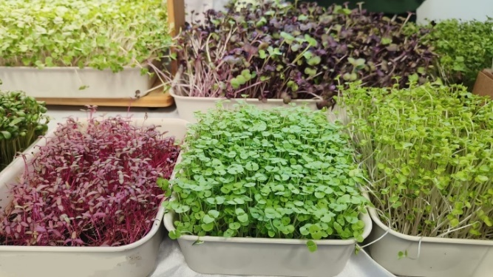
Fig.1 Beetroot, Cabbage, Fenugreek andRadish.
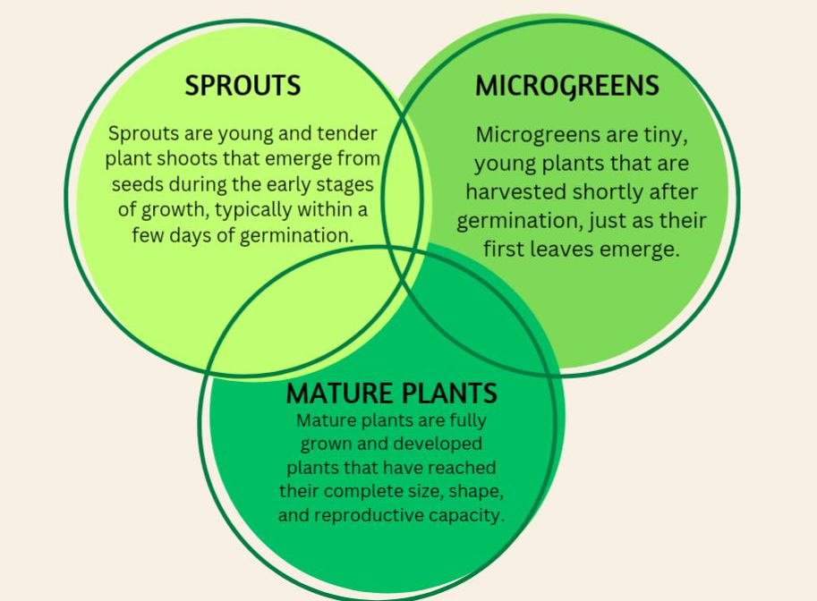
Fig.2 Difference between Microgreens, Sprouts and Mature plants
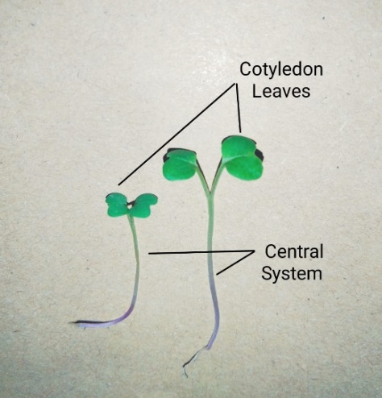
Fig.3 Babygreen(Left) and Microgreen (Right)
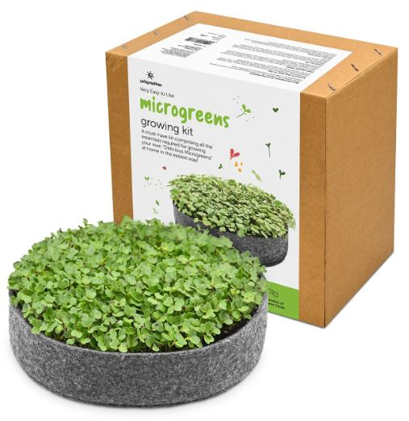
Fig.4 . Satopradhan Microgreens growing kit b. Kit contents including a direction manual
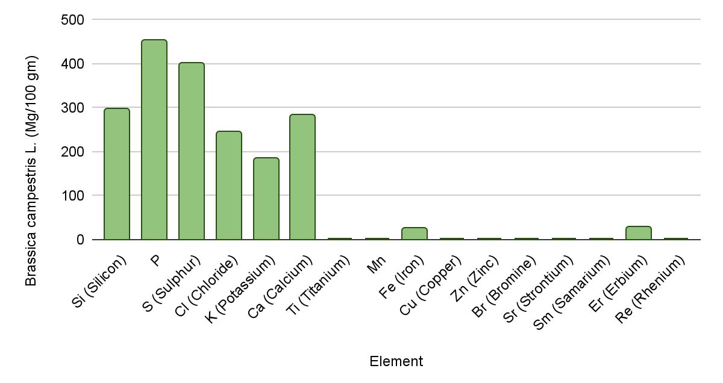
Fig.5 Elements found in Brassica campestris L.

Table 1. Effects of various substates for cultivation of microgreens
Plant | Substrate | Effect of Substate | Sources
Green basil, rocket, and red basil | Vermiculite  Jute  Coconut coir | Vermiculiteand coconut fiberworkthe best for red basil and green respectively. Nutritionand yield depend on both species and substrates. | Negri et al. (2021)
Mizuna and rapini | Posidonia natural residue and peat | Addition of fibers or Posidonia leaves without negatively affecting the yield | D'Imperio et al. (2021)
Kohlrabi ,pak choi, and coriander | Agave fiber,  capillary mat,  cellulose sponge,  Coconut fiber,  peat moss | Natural fiber substrates increase macromineral and nitrate levels. Peat moss provided the best fresh &dry yield but low dry matter content and phenolic content. | Kyriacou et al. (2020)
Broccoli, cabbage, kale,mustard, and radish | Biostrate (felt fiber),  hemp mat  , jutemat,  Micro -Mats  (wood fiber) | Microgreens in the hemp mat showed highest shoot ht and weight and K concentration but lowest N conc.Substrate type altered fresh, dry shoot wt and mineral nutrients in tested microgreens. | T. Li et al. (2021)
Radish | Sphagnum peat  Coconut coir | Microbial load within legal limit.Sphagnum peat needs less fertilizer than coconut coir to gainthe same yield. | Thuong &Minh (2020)
Purple cabbage | Beifiur,  CSC® vermiculite,  CarolinaSoil organic  Carolina Soil seedling, | No effect of substrate type on ht and wt | Wieth et al. (2020)

