Original Research Article
Effect of Sowing Windows and Nutrient Management on Growth and Productivity of Greengram (Vigna radiata L.)

.
ABSTRACT

A field experiment was conducted to examine the effects of sowing windows and nutrient management over two consecutive summer seasons (2022-23 and 2023-24) at the Agricultural Research Farm, Banaras Hindu University. The treatments consisted of four sowing windows for greengram D₁: 1st Sowing (8th March and 14th March), D₂: 2nd Sowing (15th March and 21st March), D₃: 3rd Sowing (22nd March and 28th March), D₄: 4th Sowing (29th March and 4th April) in 2022-23 and 2023-24, respectively and five nutrient management practices N₁: 100% RDF (15, 40, 20 kg NPK ha⁻¹), N₂: 70% RDF+ 15% RDN through Poultry manure + Consortia of biofertilizers, N₃: 70% RDF+ 15% RDN through Poultry manure + Panchagavya @ 30 ml L⁻¹ (2-spray), N₄: 70% RDF+ 15% RDN through Poultry manure + Seaweed extract @ 2 ml L⁻¹ (2-spray), N₅: 70% RDF+15% RDN through Poultry manure + Consortia of biofertilizers + Panchagavya @ 30 ml L⁻¹ & Seaweed extract @ 2 ml L⁻¹ both as tank mix (2-spray) thereby making twenty treatment combinations were tested in split plot design with three replications. Results revealed that the crop sown on March 8 and March 14 over two consecutive years yielded higher plant height (41.3 and 42.4 cm at harvest), number of primary branches plant⁻¹ (5.60 and 5.74 at harvest), AGR (g day⁻¹), CGR (g m⁻² land area day⁻¹), RGR (g g⁻¹ day⁻¹), NAR (g m⁻² day⁻¹) and grain yield (9.82 and 9.98 q ha⁻¹). Furthermore, under nutrient management application of 70% RDF+15% RDN through Poultry manure + Consortia of biofertilizers + Panchagavya @ 30 ml L⁻¹ & Seaweed extract @ 2 ml L⁻¹ both as tank mix (2-spray) exhibited significantly higher in growth parameters such as plant height (40.0 and 41.2 cm at harvest), number of primary branches plant⁻¹ (5.60 and 5.78 at harvest), CGR (g m⁻² land area day⁻¹), RGR (g g⁻¹ day⁻¹) and grain yield (9.40 and 9.59 q ha⁻¹).

Keywords: Growth rate; Panchagavya; Seaweed extract; Sowing dates; Yield

1. INTRODUCTION

Pulses represent the second most significant category of food crops following cereals and serve as the primary source of vegetable protein. These crops are recognized for enhancing the physical properties of soil through their tap root systems, which penetrate deeper soil layers, and their capacity to utilize atmospheric nitrogen via biological nitrogen fixation, a process that is both economically viable and environmentally sustainable. Pulses exhibit drought resistance and contribute to the prevention of soil erosion due to their deep root systems and effective ground cover. Furthermore, pulses engage in symbiotic relationships to fix atmospheric nitrogen. In India, pulses are cultivated over an area of 28.90 million hectares, yielding a total production of 26.06 million tonnes, with an average productivity of 902 kg ha⁻¹ (Agricultural Statistics at a Glance, 2023).
Greengram [Vigna radiata (L.) Wilczek], commonly referred to as mungbean, is a self-pollinated leguminous crop cultivated during both the Kharif (July-October) and Summer (March-June) seasons in the arid and semi-arid regions of India. Its cultivation across various seasons and cropping systems is facilitated by its shorter growth duration and reduced sensitivity to photoperiod and thermal variations. The adoption of greengram cultivation during the summer season has gained widespread acceptance due to the availability of new varieties, which contribute to additional income, enhance soil fertility, and promote efficient land utilization (Dodwadia and Sharma, 2012). The greengram plants residue can be utilized as green fodder or green manure. In India, greengram ranks as the third most important pulse crop after chickpea and pigeon pea, with significant cultivation in the states of Rajasthan, Madhya Pradesh, Punjab, Haryana, Uttar Pradesh, Maharashtra, Karnataka, Andhra Pradesh, and Tamil Nadu. It is a rich source of protein and vitamin B, offering an excellent protein content of 24.5%, along with high-quality lysine (460 mg g N⁻¹) and tryptophan (60 mg g N⁻¹). Additionally, it contains notable quantities of ascorbic acid and riboflavin (0.21 mg 100 g⁻¹) (Azadi et al., 2013).
Planting time constitutes a critical non-monetary factor in realizing the yield potential of improved crop varieties, as it facilitates optimal synchronization between the vegetative and reproductive phases of the crop (Kumar et al., 2015; Kumar et al., 2016). Greengram is frequently cultivated on marginal lands and is typically provided with suboptimal fertilizer doses in local varieties, resulting in low productivity. The indiscriminate application of inorganic fertilizers leads to multi-nutrient deficiencies, thereby reducing yield (Sahoo et al., 2024). Consequently, maintaining nutrient balance is essential for enhancing crop yields. To optimize green gram production, it is imperative to employ a balanced and efficient fertilizer strategy that integrates inorganic, organic, and biofertilizers, along with foliar application, to achieve higher yields and reduce production costs. There is an urgent need to decrease the reliance on chemical fertilizers and instead increase the use of organic manures, which are known to enhance the physico-chemical properties of soil and supply nutrients to plants. Foliar application is advantageous due to its rapid and efficient nutrient utilization, prevention of losses through leaching and fixation, and regulation of nutrient uptake by plants.

2. materials and methods
The study was conducted on Gangetic Alluvial soil (Inceptisols) characterized by a sandy clay loam texture, slight alkalinity, and low levels of organic carbon and nitrogen, at the Agricultural Research Farm, Banaras Hindu University, during the winters of 2022-23 and 2023-24. During green gram cultivation, the mean maximum temperatures recorded were 36.3°C and 37.8°C, while the mean minimum temperatures were 19.6°C and 21.1°C, with average temperatures of 28.0°C and 29.4°C for the years 2022-23 and 2023-24, respectively. The total rainfall was 21.4 mm and 5.6 mm, with average relative humidity levels of 52.8% and 52.6%. Wind speeds were recorded at 3.62 and 4.01 km hr-1, with daily sunshine hours averaging 8.78 and 8.59, and evaporation rates of 6.39 and 6.61 mm day⁻¹ during both years. Under conditions of assured irrigation, where moisture was consistently available, the increased duration of sunshine, greater temperature variation, and reduced humidity likely created a more favorable environment for photosynthesis, nutrient uptake, and overall crop metabolism. The treatments consisted of four sowing windows for greengram D₁: 1st Sowing (8th March and 14th March), D₂: 2nd Sowing (15th March and 21st March), D₃: 3rd Sowing (22nd March and 28th March), D₄: 4th Sowing (29th March and 4th April) in 2022-23 and 2023-24, respectively and five nutrient management practices N₁: 100% RDF (15, 40, 20 kg NPK ha⁻¹), N₂: 70% RDF+ 15% RDN through Poultry manure + Consortia of biofertilizers, N₃: 70% RDF+ 15% RDN through Poultry manure + Panchagavya @ 30 ml L⁻¹ (2-spray), N₄: 70% RDF+ 15% RDN through Poultry manure + Seaweed extract @ 2 ml L⁻¹ (2-spray), N₅: 70% RDF+15% RDN through Poultry manure + Consortia of biofertilizers + Panchagavya @ 30 ml L⁻¹ & Seaweed extract @ 2 ml L⁻¹ both as tank mix (2-spray) thereby making twenty treatment combinations were tested in split plot design with three replications. Three irrigations were administered in accordance with standard crop management practices. The weather conditions in the second year were more favorable for greengram cultivation. Growth parameters such as plant height (cm), the number of primary and secondary branches per plant, AGR, CGR, RGR and NAR at intervals of 30-60 DAS and 60-90 DAS, as well as seed yield (q ha⁻¹), were recorded during the two years of experimentation. The AGR, CGR, RGR, and NAR were computed using the following formula
2.1 Absolute growth rate (AGR)
It indicates at what rate the crop is growing. It is expressed in g day⁻¹.
AGR= $\frac{W_{2}-W_{1}}{t_{2}-t_{1}}$
Where, W₁ and W₂ are dry matter at times t₁ and t₂ respectively.
2.2 Crop growth rate (CGR)
It is the rate of growth of crop per unit area. It is expressed in g m⁻² day⁻¹.
CGR =$\frac{1}{S}$ $\frac{W_{2}-W_{1}}{t_{2}-t_{1}}$
Where, S is the plant spacing in square meter
2.3 Relative growth rate (RGR)
It is the increase in dry weight over time per unit weight of the plant and is defined as the amount of dry matter produced by one gram of existing dry matter in a day.
RGR (g g ⁻¹ day ⁻¹) = $\frac{ln{ W}_{2}-ln{ W}_{1}}{t_{2}-t_{1}}$
Where, ln W₂ and ln W₁ are the natural logarithm of total dry weight of the plant at the time of t₂ and t₁ respectively.
2.4 Net assimilation rate (NAR)
It indirectly indicates the rate of net photosynthesis. It is expressed as gram of dry matter produced per m² of leaf area in a day.
NAR (g m ⁻² day ⁻¹) = $\frac{\left(W_{2}-W_{1}\right) (ln{ L}_{2}-ln{ L}_{1})}{\left(t_{2}-t_{1}\right) ({ L}_{2}-{ L}_{1})}$
Where, L₁ and W₁ are leaf area and dry weight of plants at time t₁, and L₂ and W₂ are leaf area and dry weight of plants at time t₂.

The collected data were subjected to statistical analysis as outlined by Gomez and Gomez (1984). The interpretation of treatment effects was conducted using Fisher’s critical difference at the P=0.05 significance level.

3. results

3.1 Plant height (cm)
The plant height exhibited a rapid increase with the progression of the crop's phenophases up to harvest, after which growth nearly ceased (Table 1).
The data indicated that the plant height of greengram was significantly enhanced by sowing windows. The plant height was recorded taller by sowing the crop on 8th and 14th March (D₁) at all dates of observation, although this was statistically comparable to the crop sown on 15th and 21st March (D₂) during both the years. The shortest plants were observed from the crop sown on 29th March and 4th April (D₄).
The results further indicated that plant height (40.0 and 41.2 cm at harvest) was markedly increased with application of 70% RDF (10.5, 28, 14 kg NPK ha⁻¹) + 15% RDN-poultry manure (2.25 N kg ha⁻¹) + consortia of biofertilizers + Panchagavya @ 30 ml lit⁻¹ & seaweed extract @ 2 ml lit⁻¹ both as tank mix (2-spray) (N₅), which was statistically similar to N₃ treatment, involving 70% RDF + 15% RDN-poultry manure + Panchagavya @ 30 ml lit⁻¹ (2-spray) and N₄, involving 70% RDF + 15% RDN-poultry manure + seaweed extract @ 2 ml lit⁻¹ (2-spray) at 50 DAS and at harvest during both years of the experimentation. In contrast, the treatment receiving 100% RDF (N₁) produced shorter plants at all dates of observation.

Table 1. Effect of sowing windows and nutrient management on plant height of greengram
Treatments | Plant height (cm)
Treatments | 25 DAS |  | 50 DAS |  | At harvest
Treatments | 2022-23 | 2023-24 | 2022-23 | 2023-24 | 2022-23 | 2023-24
Sowing windows
D₁: 1st Sowing | 12.3 | 12.7 | 34.1 | 34.7 | 41.3 | 42.4
D₂: 2nd Sowing | 11.7 | 12.1 | 32.6 | 33.1 | 39.7 | 40.8
D₃: 3rd Sowing | 10.9 | 11.5 | 31.1 | 32.2 | 38.3 | 39.1
D₄: 4th Sowing | 10.0 | 10.8 | 29.5 | 30.6 | 36.2 | 37.1
SEm± | 0.23 | 0.25 | 0.66 | 0.73 | 0.76 | 0.79
LSD (P=0.05) | 0.80 | 0.85 | 2.30 | 2.52 | 2.63 | 2.75
Nutrient management
N₁: 100% RDF | 11.2 | 11.7 | 30.3 | 31.4 | 37.3 | 38.2
N₂: 70% RDF + 15% RDN-Poultry manure + Consortia of biofertilizers | 11.6 | 12.1 | 31.6 | 32.4 | 38.4 | 39.3
N₃: 70% RDF + 15% RDN-Poultry manure + Panchagavya @ 30 ml lit⁻¹ (2-spray) | 10.9 | 11.4 | 32.4 | 33.1 | 39.6 | 40.5
N₄: 70% RDF + 15% RDN-Poultry manure + Seaweed extract @ 2 ml lit⁻¹ (2-spray) | 10.7 | 11.3 | 32.0 | 32.8 | 39.0 | 40.1
N₅: 70% RDF + 15% RDN-Poultry manure + Consortia of biofertilizers + Panchagavya @ 30 ml lit⁻¹ & Seaweed extract @ 2 ml lit⁻¹ both as tank mix (2-spray) | 11.7 | 12.2 | 32.8 | 33.6 | 40.0 | 41.2
SEm± | 0.17 | 0.20 | 0.46 | 0.51 | 0.49 | 0.61
LSD (P=0.05) | 0.49 | 0.57 | 1.33 | 1.46 | 1.40 | 1.75

3.2 Primary branches plant⁻¹
Branching increased rapidly with the progression of the crop's phenophases up to 50 days after sowing (DAS), thereafter it seized (Table 2).
A detailed analysis of the data revealed that among the sowing windows, the higher number of primary branches plant⁻¹ was observed by sowing crop on 8th and 14th March (5.60 and 5.74 at harvest). However, this was statistically comparable to 15th and 21st March sowing at all dates of observation during both the years. The lower branching was recorded on 29th March and 4th April sowing.
Regarding nutrient management, the treatment N₅, comprising 70% RDF + 15% RDN-poultry manure + consortia of biofertilizers + Panchagavya @ 30 ml lit⁻¹ & seaweed extract @ 2 ml lit⁻¹ both as tank mix (2-spray), resulted in the higher number of primary branches plant⁻¹ (5.60 and 5.78 at harvest). This was statistically comparable to 70% RDF + 15% RDN-poultry manure + Panchagavya @ 30 ml lit⁻¹ (2-spray) (N₃) treatment at harvest during both years of the study. The lowest branching plant⁻¹ was observed in N₁ involving 100% RDF throughout the study period.

Table 2. Effect of sowing windows and nutrient management on primary branches plant⁻¹ of greengram
Treatments | Primary branches plant⁻¹
Treatments | 25 DAS |  | 50 DAS |  | At harvest
Treatments | 2022-23 | 2023-24 | 2022-23 | 2023-24 | 2022-23 | 2023-24
Sowing windows
D₁: 1st Sowing | 3.30 | 3.40 | 5.14 | 5.32 | 5.60 | 5.74
D₂: 2nd Sowing | 3.12 | 3.28 | 5.00 | 5.12 | 5.46 | 5.60
D₃: 3rd Sowing | 2.90 | 3.01 | 4.70 | 4.82 | 5.08 | 5.20
D₄: 4th Sowing | 2.88 | 2.92 | 4.34 | 4.42 | 4.74 | 4.82
SEm± | 0.07 | 0.08 | 0.11 | 0.11 | 0.12 | 0.14
LSD (P=0.05) | 0.25 | 0.27 | 0.37 | 0.39 | 0.41 | 0.47
Nutrient management
N₁: 100% RDF | 3.05 | 3.15 | 4.43 | 4.50 | 4.68 | 4.78
N₂: 70% RDF + 15% RDN-poultry manure + consortia of biofertilizers | 3.18 | 3.24 | 4.73 | 4.80 | 5.13 | 5.23
N₃: 70% RDF + 15% RDN-poultry manure + Panchagavya @ 30 ml lit⁻¹ (2-spray) | 2.95 | 3.06 | 4.93 | 5.08 | 5.43 | 5.58
N₄: 70% RDF + 15% RDN-poultry manure + seaweed extract @ 2 ml lit⁻¹ (2-spray) | 2.85 | 2.95 | 4.85 | 4.95 | 5.28 | 5.35
N₅: 70% RDF + 15% RDN-poultry manure + consortia of biofertilizers + Panchagavya @ 30 ml lit⁻¹ & seaweed extract @ 2 ml lit⁻¹ both as tank mix (2-spray) | 3.23 | 3.36 | 5.05 | 5.28 | 5.60 | 5.78
SEm± | 0.06 | 0.06 | 0.07 | 0.07 | 0.08 | 0.09
LSD (P=0.05) | 0.17 | 0.18 | 0.19 | 0.21 | 0.24 | 0.26

3.3 Growth rate
The findings demonstrated that both sowing windows and nutrient management significantly impacted the growth rates at various dates (Table 3 and 4).
Among the sowing windows, the crop sown on 8th and 14th March (D₁) exhibited a significantly higher AGR and CGR during the periods of 25-50 DAS and from 50 DAS to harvest, comparable to the results observed in the second sowing. Additionally, RGR and NAR were also reported significantly higher in the same treatment but the treatments were failed to reach the level of significance during 25-50 DAS. The lower values were recorded on 29th March and 4th April (D₄) during both the years.
Further analysis of the data revealed that the AGR and CGR during 25-50 DAS and from 50 DAS to harvest increased markedly with the application of 70% RDF + 15% RDN-poultry manure + consortia of biofertilizers + Panchagavya @ 30 ml lit⁻¹ & seaweed extract @ 2 ml lit⁻¹ both as tank mix (2-spray) (N₅), which was found on par with 70% RDF + 15% RDN-poultry manure + Panchagavya @ 30 ml lit⁻¹ (2-spray) (N₃) and 70% RDF + 15% RDN-poultry manure + seaweed extract @ 2 ml lit⁻¹ (2-spray) (N₄) during 25-50 DAS. Similarly, the RGR and NAR also registered significantly higher in N₅ treatment and remained statistically superior over other treatments. The lowest values were observed with the application of 100% RDF (N₁) during the two-year trial.
Table 3. Effect of sowing windows and nutrient management on absolute and crop growth rate of greengram
Treatments | Absolute Growth Rate (AGR; g day⁻¹) |  |  |  | Crop Growth Rate (CGR; g m⁻² land area day⁻¹)
Treatments | 25-50 DAS |  | 50-At harvest |  | 25-50 DAS |  | 50-At harvest
Treatments | 2022-23 | 2023-24 | 2022-23 | 2023-24 | 2022-23 | 2023-24 | 2022-23 | 2023-24
Sowing windows
D₁: 1st Sowing | 0.28 | 0.31 | 0.108 | 0.121 | 9.38 | 10.26 | 3.60 | 4.02
D₂: 2nd Sowing | 0.25 | 0.28 | 0.106 | 0.116 | 8.36 | 9.27 | 3.53 | 3.87
D₃: 3rd Sowing | 0.24 | 0.26 | 0.088 | 0.087 | 7.84 | 8.71 | 2.93 | 2.91
D₄: 4th Sowing | 0.22 | 0.24 | 0.074 | 0.071 | 7.26 | 8.00 | 2.46 | 2.37
SEm± | 0.01 | 0.01 | 0.002 | 0.003 | 0.21 | 0.26 | 0.06 | 0.07
LSD (P=0.05) | 0.03 | 0.03 | 0.006 | 0.009 | 0.74 | 0.91 | 0.22 | 0.25
Nutrient management
N₁: 100% RDF | 0.22 | 0.24 | 0.087 | 0.090 | 7.22 | 8.02 | 2.91 | 2.99
N₂: 70% RDF + 15% RDN-Poultry manure + Consortia of biofertilizers | 0.24 | 0.26 | 0.090 | 0.091 | 8.00 | 8.78 | 2.99 | 3.03
N₃: 70% RDF + 15% RDN-Poultry manure + Panchagavya @ 30 ml lit⁻¹ (2-spray) | 0.26 | 0.29 | 0.099 | 0.104 | 8.61 | 9.56 | 3.31 | 3.48
N₄: 70% RDF + 15% RDN-Poultry manure + Seaweed extract @ 2 ml lit⁻¹ (2-spray) | 0.26 | 0.28 | 0.092 | 0.097 | 8.60 | 9.39 | 3.06 | 3.22
N₅: 70% RDF + 15% RDN-Poultry manure + Consortia of biofertilizers + Panchagavya @ 30 ml lit⁻¹ & Seaweed extract @ 2 ml lit⁻¹ both as tank mix (2-spray) | 0.26 | 0.29 | 0.102 | 0.112 | 8.61 | 9.56 | 3.40 | 3.74
SEm± | 0.01 | 0.01 | 0.002 | 0.002 | 0.17 | 0.18 | 0.05 | 0.06
LSD (P=0.05) | 0.02 | 0.02 | 0.005 | 0.006 | 0.49 | 0.53 | 0.15 | 0.18

Table 4. Effect of sowing windows and nutrient management on relative growth rate and net assimilation rate of greengram
Treatments | Relative Growth Rate (RGR; g g⁻¹ day⁻¹) |  |  |  | Net Assimilation Rate (NAR; g m⁻² day⁻¹)
Treatments | 25-50 DAS |  | 50-At harvest |  | 25-50 DAS |  | 50-At harvest
Treatments | 2022-23 | 2023-24 | 2022-23 | 2023-24 | 2022-23 | 2023-24 | 2022-23 | 2023-24
Sowing windows
D₁: 1st Sowing | 0.055 | 0.056 | 0.0095 | 0.0095 | 7.37 | 7.42 | 1.66 | 1.79
D₂: 2nd Sowing | 0.053 | 0.054 | 0.0087 | 0.0090 | 7.19 | 7.36 | 1.63 | 1.57
D₃: 3rd Sowing | 0.051 | 0.053 | 0.0087 | 0.0079 | 7.07 | 7.11 | 1.55 | 1.35
D₄: 4th Sowing | 0.051 | 0.053 | 0.0081 | 0.0072 | 6.90 | 6.98 | 1.44 | 1.24
SEm± | 0.001 | 0.001 | 0.0002 | 0.0002 | 0.15 | 0.16 | 0.03 | 0.03
LSD (P=0.05) | NS | NS | 0.0006 | 0.0006 | NS | NS | 0.10 | 0.11
Nutrient management
N₁: 100% RDF | 0.049 | 0.051 | 0.0083 | 0.0078 | 6.63 | 6.54 | 1.42 | 1.35
N₂: 70% RDF + 15% RDN-Poultry manure + Consortia of biofertilizers | 0.050 | 0.051 | 0.0084 | 0.0082 | 6.94 | 7.00 | 1.46 | 1.35
N₃: 70% RDF + 15% RDN-Poultry manure + Panchagavya @ 30 ml lit⁻¹ (2-spray) | 0.054 | 0.057 | 0.0089 | 0.0086 | 7.39 | 7.56 | 1.53 | 1.48
N₄: 70% RDF + 15% RDN-Poultry manure + Seaweed extract @ 2 ml lit⁻¹ (2-spray) | 0.051 | 0.052 | 0.0089 | 0.0086 | 7.15 | 7.25 | 1.52 | 1.40
N₅: 70% RDF + 15% RDN-Poultry manure + Consortia of biofertilizers + Panchagavya @ 30 ml lit⁻¹ & Seaweed extract @ 2 ml lit⁻¹ both as tank mix (2-spray) | 0.057 | 0.059 | 0.0092 | 0.0089 | 7.54 | 7.73 | 1.94 | 1.86
SEm± | 0.001 | 0.001 | 0.0002 | 0.0002 | 0.12 | 0.12 | 0.03 | 0.03
LSD (P=0.05) | 0.002 | 0.002 | 0.0005 | 0.0005 | 0.34 | 0.36 | 0.08 | 0.08

3.4 Grain yield (q ha⁻¹)
Significant variation in grain yield was observed among the different treatments Figure 1 (A & B). A perusal of the data demonstrated that among the sowing windows, the first sowing i.e. on 8th and 14th March (D₁) achieved the highest grain yield (9.82 and 9.98 q ha⁻¹), which was significantly greater than the yields from other sowing windows. This was followed by the second sowing i.e. on 15th and 21st March (D₂) with yields of 9.07 and 9.21 q ha⁻¹. The lowest grain yield (7.40 and 7.50 q ha⁻¹) was observed in the fourth sowing i.e. on 29th March and 4th April (D₄) during the study period.
Further results indicated that among nutrient management, the N₅ recorded the highest grain yield (9.40 and 9.59 q ha⁻¹). This was followed by the N₃ treatment with yields of 8.74 and 8.90 q ha⁻¹. In contrast, the N₁ resulted in the lowest grain yield (7.93 and 8.01 q ha⁻¹).

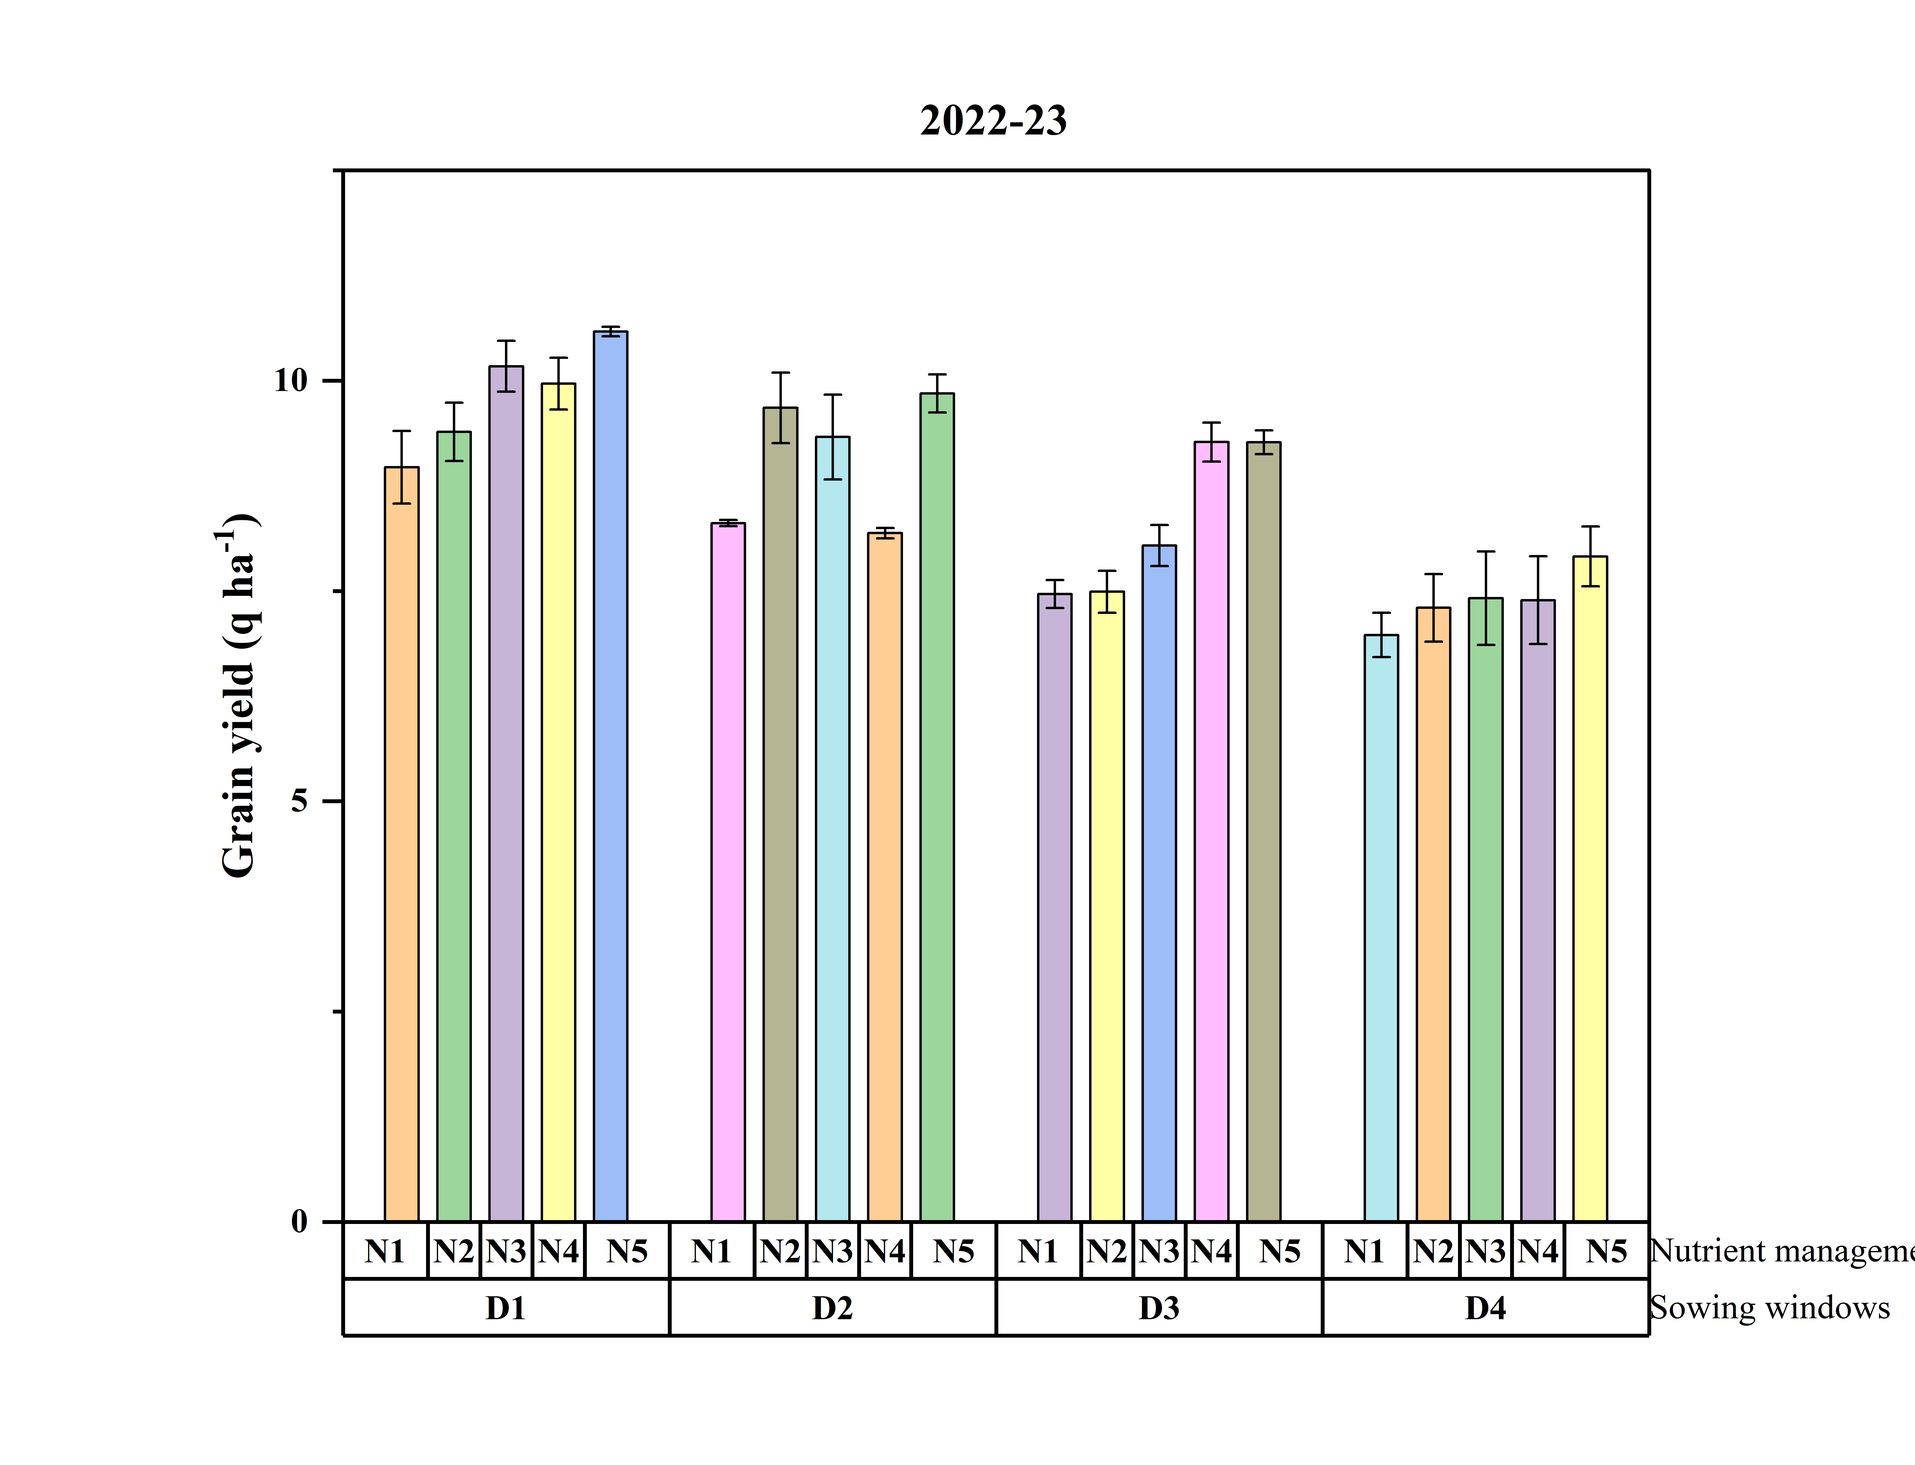

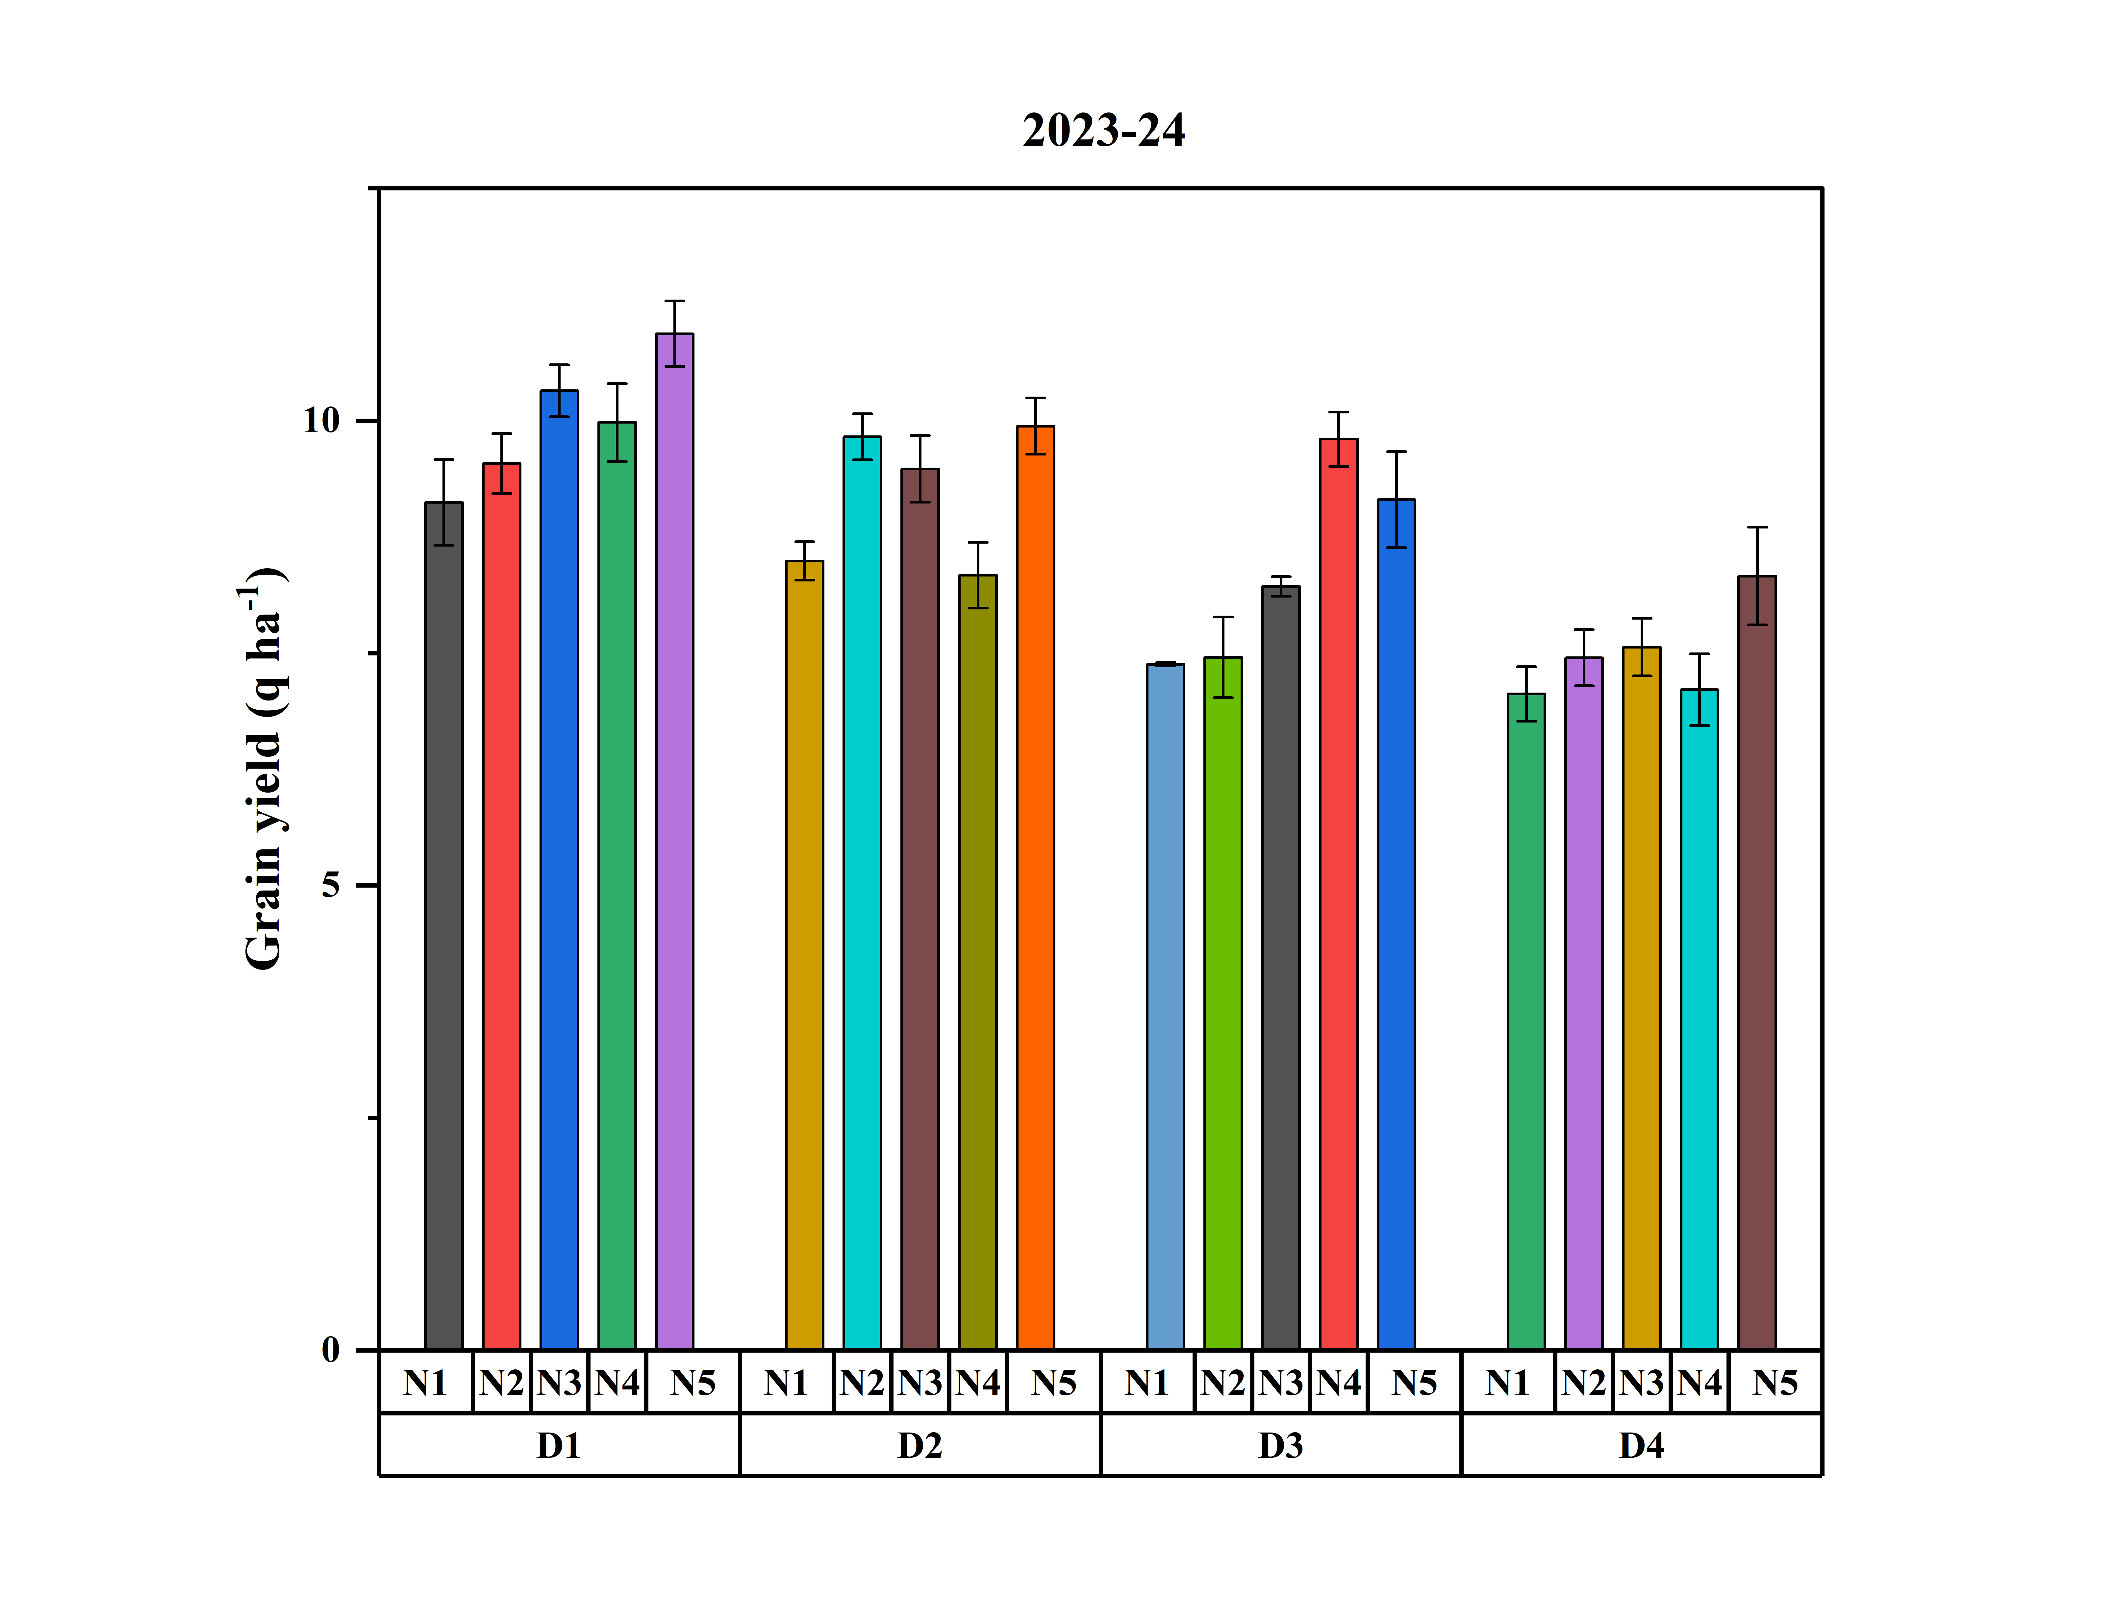
Fig. 1 (A & B) Effect of sowing windows and nutrient management on seed yield (q ha⁻¹) of greengram during both the years

4. DISCUSSION
Among the various sowing windows, the crop sown on 8th and 14th March (D₁) exhibited the highest values for growth parameters and grain yield. The observed enhancement in growth parameters associated with the initial sowing can be attributed to the extended days to maturity, which prolong the growth period. This extension facilitates optimal utilization of available resources and creates favorable conditions for timely and adequate plant development. Consequently, the timing of sowing is considered a critical factor in enhancing growth parameters. In contrast, the second, third, and fourth sowings of greengram required fewer days to maturity, thereby limiting the crop's capacity to effectively utilize the available resources and environmental conditions. This limitation may be due to the significantly higher dry matter production, which results in a larger source for photosynthesis and consequently more translocation of photosynthates to the sink, as reported by Kumar et al. (2015). Mukherjee (2021) noted that the increase in seed yield with an early sowing date might be due to higher yield attributes, as seed yield is known to have a positive association with these parameters. The higher yield obtained in timely sowing was due to favourable temperature and humidity during the growth period and nodulation formation stage, resulting in better growth (Sahu et al., 2019).
Application of 70% RDF + 15% RDN-poultry manure + consortia of biofertilizers + Panchagavya @ 30 ml lit⁻¹ & seaweed extract @ 2 ml lit⁻¹ both as tank mix (2-spray) (N₅), resulted in the highest recorded values for plant height, number of primary branches per plant, growth rate and grain yield. The beneficial effects of poultry manure, when used in conjunction with the recommended fertilizer dosage, can be attributed to its role in enhancing the physical, chemical, and biological properties of the soil, thereby promoting plant growth. This observation is consistent with the findings of Patel and Gangwar, (2023), who demonstrated that organic manures and fertilizers enhance cell production, promote plant vigor, and accelerate leaf growth, thereby improving growth parameters. According to Rahul et al. (2022), Panchagavya not only supplies nutrients but also hydrates leaf cells and enhances chlorophyll content, thereby increasing photosynthetic activity. The direct application of Panchagavya solution onto the foliage allows for immediate nutrient absorption (Behera et al., 2024). Foliar application of seaweed sap contributes to the altered partitioning of photosynthates, favoring either shoot biomass synthesis or grain synthesis (Raverkar et al., 2016). Consequently, nutrients positively influence vegetative growth and, as a result, positively affect the crop (Sahoo et al., 2025). Jadhav and Kulkarni (2016) found that foliar application of Panchagavya significantly improved greengram productivity. Similarly, Shariff et al. (2017) asserted that the use of organic manures and an organic foliar spray is instrumental in augmenting seed yield.

5. Conclusion
Based on two years of experimentation, it can be concluded that crops sown on March 8 and March 14 exhibited superior growth parameters and yield. In terms of nutrient management, the application of 70% RDF + 15% RDN-poultry manure + consortia of biofertilizers + Panchagavya @ 30 ml lit⁻¹ & seaweed extract @ 2 ml lit⁻¹ both as tank mix (2-spray), enhanced the growth and productivity of greengram.

DISCLAIMER (ARTIFICIAL INTELLIGENCE)
The authors declare that no generative AI technologies, including large language models such as ChatGPT and COPILOT, or text-to-image generators, were utilized in the writing or editing of this manuscript.

COMPETING INTERESTS DISCLAIMER:
Authors have declared that they have no known competing financial interests OR non-financial interests OR personal relationships that could have appeared to influence the work reported in this paper.

References
Agricultural Statistics at a Glance, Government of India, Ministry of Agriculture and Farmers Welfare, Department of Agriculture and Farmers Welfare, Directorate of Economics & Statistics, pp: 40-41, 2023.
Azadi, E., Rafiee, M., and Hadis, N. (2013). The effect of different nitrogen levels on seed yield and morphological characteristic of mungbean in the climate condition of Khorramabad, Annals of Biological Research, 4, 51-55.
Behera, S.R., Pandey, R., Golui, K., Sahoo, S., Jakhwal, R., & Pal, R., (2024). Application of Panchagavya, a Cow-based Liquid Formulation, as a Lever for Sustainable and Enhanced Vegetable Crop Production: A Review, International Journal of Environment and Climate Change, 14(5), 214-232. https://doi.org/10.9734/ijecc/2024/v14i54183
Dodwadia, K.S., & Sharma, A.R. (2012). Effect of tillage and methods of sowing on performance of greengram (Vigna radiata) varieties during summer and rainy season. Indian Journal of Agricultural Sciences, 82(5), 462-475.
Gomez, K. A., & Gomez, A. A. (1984). Statistical procedures for agricultural research (2nd ed.). New York: John Wiley and Sons.
Jadhav, R.L., & Kulkarni, S., (2016). Effect of foliar spray of nutrients on productivity of greengram (Vigna radiata) in North Eastern transitional zone of Karnataka, India, Legume Research, 39 (5), 817-819.
Kumar, M., Panwar, G.S., & Kushwaha, S. (2016). Effect of planting date, seed rate and row spacing on nodulation efficiency of bold seeded spring mungbean [Vigna radiata (L.) Wilczek] in Bundelkhand region of India, Legume Research, 39 (2), 293-296. 10.18805/lr.v0iOF.6783
Kumar, R., Deka, B.C., & Ngachan, S.V. (2015). Response of summer mungbean to sowing time, seed rates and integrated nutrient management, Legume Research, 38 (3), 348-352. 10.5958/0976-0571.2015.00119.8
Mukherjee, D. (2021). Production potential of greengram (Vigna radiata) under various sowing dates and weed control measures, Annals of Agricultural Research, 42(1), 46-53, 2021.
Patel, M., & Gangwar, B. (2023). Effect of organic nutrient management on growth and yield of greengram (Vigna radiata L.,) under semi-arid region, International Journal of Plant & Soil Science, 35(19), 514-523.
Rahul, Singh, S., & Meshram, M.R. (2022). Effect of organic sources of nutrient management on growth, yield and economics of greengram (Vigna radiata L.), Environment and Ecology, 40 (3D), 1939-1943, 2022.
Raverkar, K.P., Pareek, N., Chandra, R., Chauhan, S., Zodape, S.T., & Ghosh, A. (2016). Impact of foliar application of seaweed saps on yield, nodulation and nutritional quality in green gram (Vigna radiata L), Legume Research, 39 (2), 315-318.
Sahoo, S., Dash, R., Jena, S., Satapathy, M., Kar, I., Mishra, J., & Panda, N. (2024). Weed dynamics and crop productivity as influenced by weed management practices and fertility levels in groundnut (Arachis hypogaea L.). Legume Research, 47(9): 1606-1612. 10.18805/LR-5197
Sahoo, S., Jena, S., Dash, R., Mohapatra, K.K., & Barla, S. (2025). Effect of weed management practices and fertility levels on growth, nutrient uptake and yield of groundnut (Arachis hypogaea L.). Plant Science Today, 12(2):1-8. https://doi.org/10.14719/pst.7018
Sahu, R, Sharda, K and Mandal, SK. (2019). Sowing date and weed management effects on weeds, nutrient uptake and productivity of summer greengram, Indian Journal of Weed Science 51(3), 302–305.
Shariff, A.F., Sajjan, A.S., Babalad, H.B, Nagaraj, L.B., & Palankar, S.G. (2017). Effect of organics on seed yield and quality of green gram (Vigna radiata L.), Legume Research, 40 (2), 388-392.

