Case report

Cervicothoracic Cellulitis Complicated by Descending Mediastinitis in a Diabetic Patient: A Case Report from the Military Hospital of Rabat

Abstract
Aims:
To present a rare case of cervicothoracic cellulitis complicated by descending mediastinitis in a diabetic patient, emphasizing the importance of early diagnosis, surgical management, and reconstructive intervention.
Presentation of Case:
A 66-year-old man with an 8-year history of non-insulin-dependent diabetes mellitus presented with fever, asthenia, and an anterior cervicothoracic swelling with cutaneous ulceration discharging pus. Laboratory tests showed hyperleukocytosis (27,300/µl), elevated C-reactive protein (479 mg/L), and diabetic ketoacidosis. CT scan revealed phlegmonous infiltration of the anterior cervicothoracic soft tissues extending retro-manubrially, with bilateral pleural effusions and passive atelectasis. Emergency cervicotomy with wide debridement and drainage was performed. Bacteriology identified multisensitive Staphylococcus aureus, prompting targeted antibiotic therapy. Due to extensive tissue loss, reconstructive surgery with a pedicled pectoralis major muscle flap was required. The postoperative course was favorable with full recovery.
Discussion:
Cervicothoracic cellulitis is a life-threatening infection that can rapidly spread to the mediastinum, particularly in immunocompromised patients. Computed tomography is essential for assessing the extent of infection. Prompt surgical debridement combined with appropriate antibiotic therapy is the cornerstone of treatment. In advanced cases with major tissue loss, reconstructive surgery such as the pedicled pectoralis major flap plays a critical role in ensuring soft tissue coverage and functional recovery.
Conclusion:
Cervicothoracic cellulitis complicated by descending mediastinitis requires urgent medico-surgical management. CT imaging guides surgical planning, while timely debridement, tailored antibiotics, and reconstructive techniques are key to favorable outcomes.
Keywords: Cervicothoracic cellulitis; Descending necrotizing mediastinitis; Deep neck infection; Surgical drainage; Diabetes mellitus; Computed tomography

Introduction
Cervical cellulitis, also known as necrotizing cervical fasciitis, is a severe infection of the soft tissues with a risk of rapid extension to the mediastinum if not recognized early. Descending necrotizing mediastinitis represents the most feared complication, often associated with significant morbidity and mortality. We report the case of a diabetic patient who developed cervicothoracic cellulitis of cutaneous origin complicated by mediastinitis, successfully managed through multidisciplinary care.

Case Presentation
A 66-year-old male with a medical history of non-insulin-dependent diabetes mellitus for 8 years presented to the emergency department with fever, asthenia, and an anterior cervicothoracic mass. Clinical examination revealed erythematous induration extending from the cervical to thoracic region, with a cutaneous ulceration discharging pus and an associated scratch lesion in the submental area.
Laboratory evaluation demonstrated leukocytosis (27,300/µl), elevated C-reactive protein (479 mg/L), and diabetic ketoacidosis.
Imaging: Cervicothoracic CT scan showed diffuse phlegmonous infiltration of the anterior cervical and thoracic soft tissues, extending through the superior sternal orifice into the retro-manubrial space. Bilateral pleural effusions and passive atelectasis were also noted.
Treatment: The patient was started on empiric broad-spectrum intravenous antibiotics. Emergency cervicotomy was performed with wide incision, drainage of the phlegmon, and extensive tissue debridement. Samples were taken for culture, which grew multisensitive Staphylococcus aureus. Antibiotic therapy was subsequently tailored.
Due to extensive tissue loss, reconstructive surgery was required. A pedicled pectoralis major muscle flap was performed to cover the exposed musculature, ensuring adequate vascularized coverage and preventing secondary infection.
Outcome: The patient’s condition improved progressively, with resolution of infection and normalization of inflammatory markers. He was discharged following a favorable recovery.

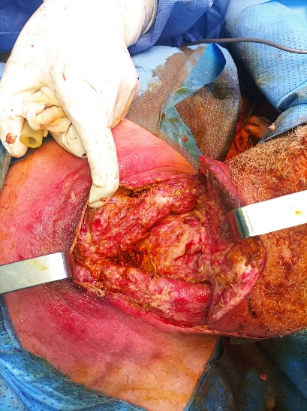
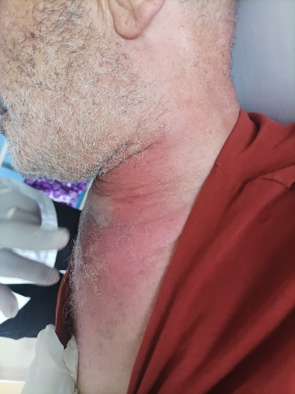
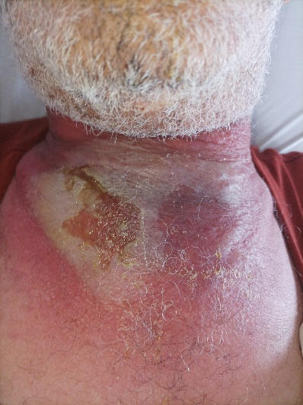

Fig .1 cervicothoracic cellulitis in the throat
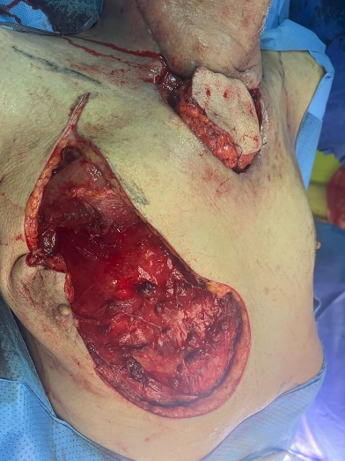
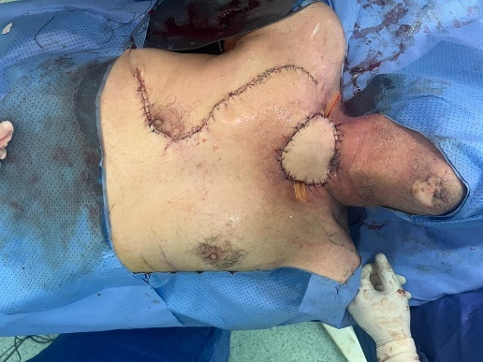
Fig .2 cervicothoracic cellulitis in the chest
Discussion
Cervical cellulitis encompasses a spectrum of infections involving the dermis, subcutaneous tissue, and deep cervical fascia. Its progression can be fulminant, necessitating urgent intervention. Without timely surgery, infection may descend into the mediastinum in over 20% of cases, resulting in descending necrotizing mediastinitis — a distinct clinical entity with high mortality.
Immunocompromised states such as diabetes, alcoholism, malignancy, or corticosteroid therapy are recognized risk factors. In our case, poorly controlled diabetes with ketoacidosis was a major predisposing factor.
CT scanning with contrast remains the gold standard for diagnosis, enabling identification of the infectious source, evaluation of tissue infiltration, fluid collections, and possible gas formation.
The cornerstone of treatment is aggressive and often repeated surgical debridement combined with targeted intravenous antibiotics. Hyperbaric oxygen therapy has been proposed as an adjuvant but remains controversial, with limited evidence supporting its widespread use.
In cases of extensive tissue necrosis, reconstructive procedures are often required. The pedicled pectoralis major flap is a reliable option for cervicothoracic reconstruction due to its robust vascularization, proximity, and versatility. In our patient, its use provided durable coverage, reduced the risk of reinfection, and facilitated functional recovery.

Conclusion
Cervicothoracic cellulitis is a rapidly progressive and life-threatening infection requiring urgent multidisciplinary management. Contrast-enhanced CT is critical for assessing the extent of disease and planning surgery. Definitive management relies on timely debridement, broad-spectrum antibiotics adjusted to microbiology, and, when indicated, reconstructive techniques such as pedicled muscle flaps. Delayed or insufficient treatment can lead to descending mediastinitis, associated with increased mortality.

Consent
Written informed consent was obtained from the patient for publication of this case report and any accompanying images.

Ethical Approval
This case report did not require formal ethical approval according to institutional policies, as it describes a single clinical case with patient consent obtained.

References
- Prado-Calleros HM, Jiménez-Fuentes E, Jiménez-Escobar I. Descending necrotizing mediastinitis: systematic review on its treatment in the last 6 years, 75 years after its description. Head Neck. 2016;38 Suppl 1:E2275–E2283.
- Brook I. Microbiology and management of deep facial infections and lemierre syndrome. Otolaryngol Head Neck Surg. 2003;128(5):633–8.
- Marty-Ane CH, Berthet JP, Alric P, et al. Management of descending necrotizing mediastinitis: an aggressive treatment for an aggressive disease. Ann Thorac Surg. 1999;68(1):212–7.
- Estrera AS, Landay MJ, Grisham JM, et al. Descending necrotizing mediastinitis. Surgery. 1983;93(3):367–72.
- Wheatley MJ, Stirling MC, Kirsh MM, et al. Descending necrotizing mediastinitis: transcervical drainage is not enough. Ann Thorac Surg. 1990;49(5):780–4.
- Haute Autorité de Santé. Recommandations sur l’oxygénothérapie hyperbare. HAS, 2007.
- Vinh VQ, Ogawa R, Van Anh T, Hyakusoku H. Reconstruction of cervical and thoracic defects after deep neck infection using pectoralis major flaps. Ann Plast Surg. 2007;59(6):632–6.

