Review Article

ENHANCING CLIMATE RESILIENCE AND FISH FOOD SECURITY THROUGH SMART AQUACULTURE TECHNOLOGIES

ABSTRACT
This paper examines the impacts of climate change on fish production within the agrifood supply chain and its implications for food security. It reviews smart aquaculture technologies as key adaptation and mitigation strategies for sustainable fish production and resilient food security. Adaptation measures include data-driven tools for site and species selection, as well as automated monitoring systems and predictive models that enable proactive risk management under climate variability. Mitigation strategies focus on reducing the sector’s carbon footprint through optimized feed utilization, waste reduction, and the integration of renewable energy sources. Findings suggest that smart aquaculture not only strengthens production efficiency and reduces environmental impacts but also enhances agrifood supply chain resilience by stabilizing fish supply, improving resource use across value chain logistics, and supporting reliable market distribution. By harnessing smart technologies, the aquaculture sector can adapt to climate change, mitigate environmental pressures, and ensure a resilient agrifood supply chain that underpins sustainable fish production and long-term food security.

Key Words: Smart Aquaculture, Sustainable Fish Production, Climate Change, Food Security, Agrifood Supply Chain

INTRODUCTION
Aquaculture is among the fastest-growing sectors in global food production, currently providing more than half of the fish consumed worldwide (FAO, 2022). Despite its rapid growth, the industry faces increasing risks from climate change, including fluctuations in water quality, disease outbreaks, and shifts in aquatic habitats. To address these challenges, the adoption of smart aquaculture technologies such as Internet of Things (IoT) devices, automated feeding systems, and climate monitoring tools offers opportunities to enhance resilience, operational efficiency, and sustainability (Zhuhua et al., 2019). These technologies enable real-time monitoring of environmental conditions, optimization of resource use, and improved fish health and welfare. However, while the combination of ‘smart farming’ technology improves operational performance through information exchange and real-time decision-making, regulatory constraints limit applications of fully automated operations on farms (Lowenberg-DeBoer et al., 2022).
Additionally, regenerative farming is anchored on maintaining biodiversity and reducing carbon footprints (Burns, 2021; Newton et al., 2020), eco-friendly practices such as integrated multi-trophic aquaculture (IMTA) and improved feed management can reduce environmental impacts and contribute to climate mitigation objectives. Beyond environmental and operational benefits, smart aquaculture plays a crucial role in strengthening the agrifood supply chain and ensuring food security by stabilizing fish supply, improving value chain efficiency, and supporting sustainable nutrition for growing populations.
This review explores how smart aquaculture can simultaneously address climate change challenges and advance resilient, sustainable, and food-secure aquaculture systems.

SCOPE OF THE STUDY
This study focuses on how climate change affects aquaculture and fish production and examines the role of smart aquaculture technologies in addressing these challenges. It considers tools and practices such as automated monitoring, predictive modeling, improved feed management, and renewable energy integration to enhance efficiency, reduce environmental impact, and strengthen the resilience of the agrifood supply chain. The research highlights the potential of these technologies to support stable fish supply and contribute to long-term food security. The study is limited to aquaculture systems and does not cover other agricultural sectors or non-fish food production.

CAUSES OF CLIMATE CHANGE IN AQUATIC ECOSYSTEMS
Climate change in ecosystems can result from both natural processes and human activities. Natural influences include geological and astronomical factors, such as shifts in the Earth’s orbit, the arrangement of continents, changes in axial tilt, and variations in solar radiation. Volcanic eruptions also contribute to climate variability. Human activities, however, are the primary drivers of recent climate change, mainly through the release of greenhouse gases (GHGs) such as carbon dioxide (CO₂), methane (CH₄), nitrous oxide (N₂O), and chlorofluorocarbons (CFCs). Key contributors include industrialization, the burning of fossil fuels, gas flaring, urban expansion, and intensive agricultural practices. Human-induced reductions in natural carbon sinks, through deforestation, land-use changes, water pollution, and certain farming methods, further exacerbate climate change.
The accumulation of GHGs in the atmosphere alters the Earth’s energy balance by trapping longwave radiation, which increases heat within the climate system. This enhanced greenhouse effect has led to observable warming, making anthropogenic climate change one of the most pressing environmental challenges of our time. The resulting changes affect aquatic ecosystems by altering water temperatures, acidity, salinity, and currents, as well as contributing to sea-level rise. Such shifts directly influence the health and productivity of aquatic organisms, including fish and invertebrates, which are highly sensitive to environmental changes due to their reliance on external temperatures for metabolic regulation. Fish, for example, often migrate to maintain suitable body temperatures, a phenomenon known as behavioral thermoregulation, leading to shifts in species distributions.
Primary productivity in aquatic systems is also impacted, as nutrient availability, freshwater runoff, light penetration, and temperature influence the growth of phytoplankton and other foundational organisms. Climate change is expected to reduce productivity in lower-latitude regions, where many small-scale fisheries are concentrated. Additionally, extreme weather events such as storms, floods, and heatwaves pose risks to fishers, infrastructure, and coastal ecosystems, including mangroves and coral reefs.
Aquaculture, while partly protected through human management, is not immune to climate impacts. Water availability, quality, seed stock, feed, and energy resources are all vulnerable to changes in rainfall patterns, rising sea levels, and salinization of freshwater sources. Excess runoff from agriculture or sewage can trigger algal blooms, causing oxygen depletion and fish mortality. Rising temperatures reduce dissolved oxygen, increase metabolic rates, and elevate disease risks, which can diminish production and raise feeding costs. Coastal aquaculture is particularly exposed to extreme events and phenomena such as red tides, which are projected to become more frequent and severe. Nonetheless, some regions may benefit from climate-induced changes, as flooding and salinization could create favorable conditions for aquaculture, even if traditional agriculture becomes less viable.
Overall, climate change represents a major threat to food security, biodiversity, and aquatic ecosystem health. Rising temperatures, ocean acidification, and intensified weather events challenge the sustainability of fisheries and aquaculture. Integrating smart technologies and adaptive practices into aquaculture systems offers a pathway to enhance resilience, maintain productivity, and support sustainable food systems in the face of these environmental pressures.

ADAPTATION STRATEGIES IN AQUACULTURE
One of the primary adaptation strategies is selecting climate-resilient species, such as Catfish (Clarias magur), Pejerrey (Odontesthes bonariensis), Zebrafish, and Atlantic Salmon, which can tolerate temperature fluctuations and resist disease outbreaks. Improving water management and monitoring water quality helps maintain optimal growth conditions for aquatic organisms. Integrated Multi-Trophic Aquaculture (IMTA), which involves cultivating multiple species from different trophic levels in the same system, can reduce environmental impacts while enhancing resilience and sustainability.

MITIGATION STRATEGIES FOR CLIMATE CHANGE
Mitigation efforts are essential to reduce greenhouse gas emissions and slow global warming. Transitioning from fossil fuels to renewable energy sources such as solar, wind, hydroelectric, and geothermal power can significantly lower carbon footprints. Jacobson et al. (2017) found that a complete shift to renewable energy in the U.S. could prevent millions of deaths and save trillions of dollars through improved public health and reduced climate impacts. Increasing energy efficiency in industries, buildings, and transportation is also crucial. As Rishabh et al. (2019) highlight, energy-efficient technologies can cut emissions while supporting economic growth, especially when combined with government incentives and public awareness campaigns.
In agriculture, sustainable practices like agroforestry, cover cropping, and organic farming can both reduce emissions and enhance carbon sequestration. Smith et al. (2014) report that such methods can lower emissions per unit of output by 20–35%, supporting food security while mitigating climate change. Reforestation and afforestation further enhance carbon sinks, with studies by Canadell and Raupach (2008) showing that restoring forest cover can play a key role in global carbon management.
Smart aquaculture practices integrate both adaptation and mitigation strategies to ensure the long-term sustainability of the sector. These practices use technology to optimize resource use, improve fish health, enhance feeding efficiency, and minimize environmental impact. Key measures include precision feeding, automated monitoring systems, and advanced data management platforms, all of which help producers make informed decisions that benefit both productivity and ecological sustainability.

CLIMATE CHANGE ON AQUACULTURE
It is now widely accepted that climate change is no longer simply a potential threat, it is unavoidable; a consequence of 200 years of excessive greenhouse gas (GHG) emissions from fossil fuel combustion in energy generation, transport and industry, deforestation and intensive agriculture (IPCC, 2007a). IFAD and other development agencies have recognized climate change as one the greatest threats facing mankind today (IFAD, 2007; World Bank, 2010) and have highlighted the fact that the poorest and most vulnerable will be disproportionately affected by its impacts (IFAD, 2008).
Climate change has profound effects on aquaculture, influencing water quality, species distribution, and overall productivity. Rising water temperatures and changing precipitation patterns have profound effects on aquaculture. Higher temperatures can lower dissolved oxygen levels, disrupt metabolic processes, and interfere with breeding cycles, ultimately reducing fish yields. Sudden temperature spikes can disturb aquatic ecosystems, altering species distributions, food webs, and overall water quality. Prolonged dry periods, shifts in water availability, and declines in water quality can increase fish mortality and reduce the abundance of wild stocks. Climate change also introduces new predators and pathogens, while altering the availability of prey species, further challenging fish populations and the productivity of fisheries.

CLIMATE-SMART AQUACULTURE (CSA)
Climate-Smart Aquaculture (CSA) is designed to strengthen food security while addressing both the need for climate change adaptation and the potential for mitigation. The concept emphasizes creating synergies between three interrelated goals: reducing emissions, enhancing adaptive capacity, and increasing productivity and income, all while minimizing trade-offs that could undermine sustainability. According to Zhou et al. (2019), CSA in fisheries and aquaculture requires more efficient use of natural resources in food production, maintaining the resilience of aquatic ecosystems and dependent communities, and reducing the vulnerability of those most at risk from climate impacts.
Practical measures to achieve CSA objectives include reducing excess fishing capacity, promoting sustainable fisheries management to maintain healthy stocks, and improving aquaculture productivity through integrated systems. Enhancing feed efficiency, lowering disease-related losses, cutting down postharvest waste, and strengthening regional trade are also key strategies. The shift toward CSA must occur across all levels from individuals and businesses to communities, governments, and regional institutions and over varying timeframes. Both public and private stakeholders play a crucial role in tailoring context-specific solutions that ensure the fisheries and aquaculture sector becomes climate-resilient and sustainable.
For the transition to be effective, it is vital that the most vulnerable production systems, communities, and states are given the capacity to adopt CSA approaches. Well-functioning markets and regional trade networks can help absorb shocks from production changes, stabilize consumer prices, and reduce supply-demand imbalances. At the same time, it is important to better understand how climate change and related policy measures affect the entire supply and value chain. Crafting and implementing appropriate policies will therefore be essential to ensure that CSA contributes meaningfully to sustainable development and global food security.
FIG 1. Smart Agriculture
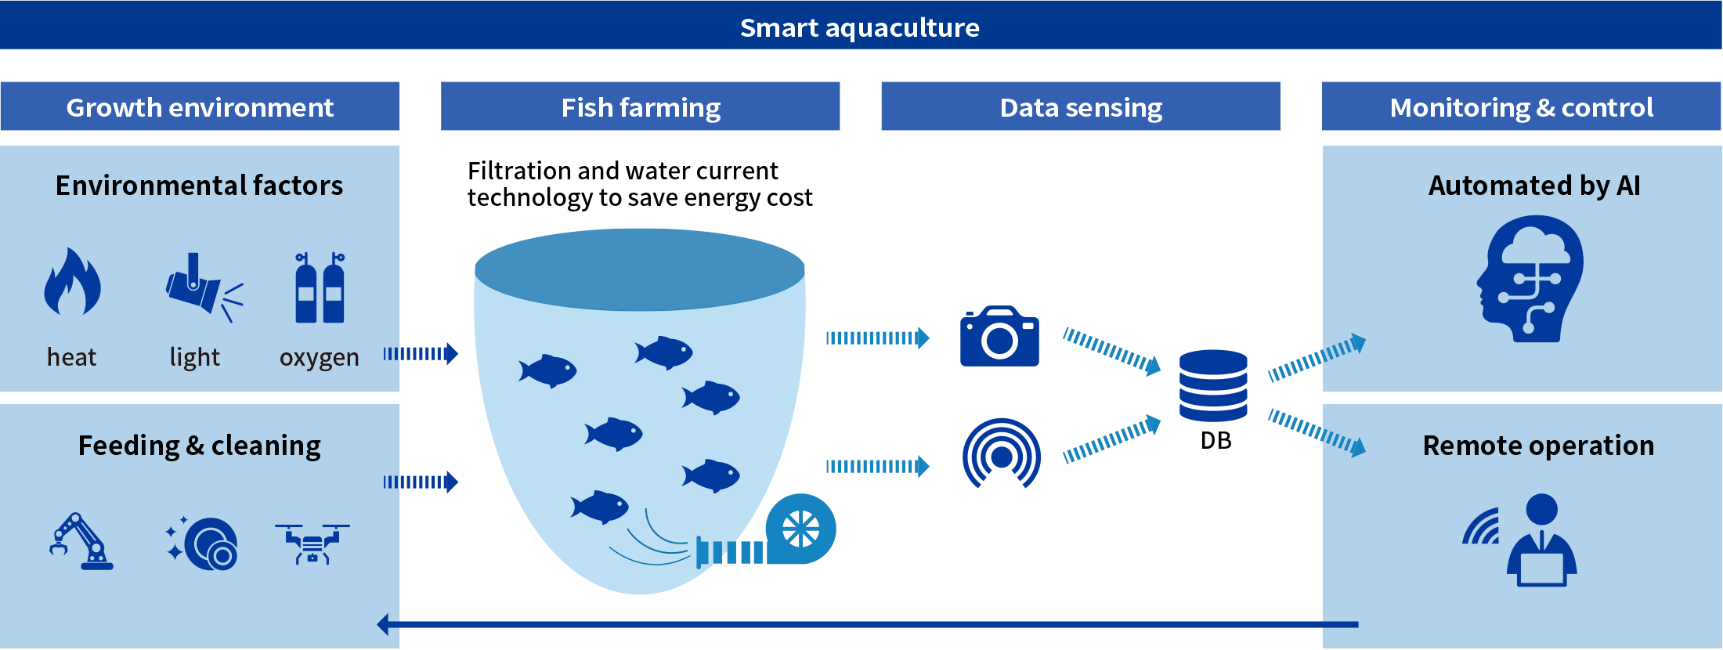
Source: https://regional.fish/en/farming/
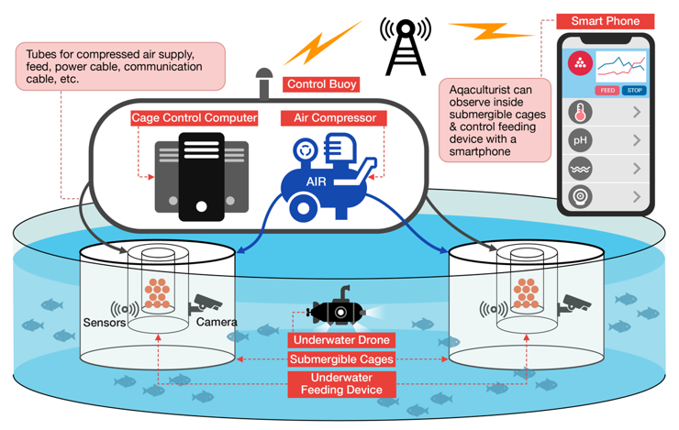Source: https://www.mdpi.com/1370442
FIG 2. Smart aquaculture system using underwater via smartphone

ENVIRONMENTAL SUSTAINABILITY IN SMART AQUACULTURE
One of the most pressing issues facing aquaculture today is the challenge of sustainability. The expansion of fish farming has often raised concerns about its environmental footprint, particularly with regard to waste discharge, nutrient loading, and water use. Smart aquaculture offers practical ways to address these concerns. For example, precision feeding systems can help farmers minimize feed losses, which directly lowers nitrogen and phosphorus emissions from ponds and cages, thereby reducing the risk of eutrophication in nearby rivers and lakes (Zhou et al., 2019).
In addition to better feeding strategies, smart practices can also improve how resources are used. By promoting more efficient water management, reducing energy demand, and integrating systems such as Integrated Multi-Trophic Aquaculture (IMTA), farmers are able to create production models that recycle nutrients and make fuller use of available resources (Naylor et al., 2021). Collectively, these approaches move aquaculture closer to an environmentally sustainable path while also supporting long-term productivity.

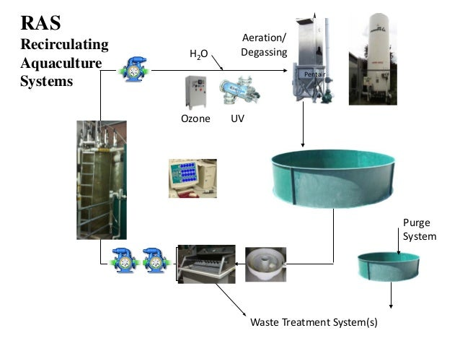
Source: https://www.agrotechnomarket.com/2018/10/recirculating-aquaculture-system-ras.html
FIG 3. Recirculating Agriculture systems
SUSTAINABLE AGRICULTURE AND AQUACULTURE PRACTICES FOR FISH FOOD SECURITY
Farming is the oldest sector of economic activity and has gone through various evolutionary phases driven by industrialisation, technological innovation, and market forces. Today, farming and food represents 12% of global GDP mainly dominated by smallholders and supports 40% of employment in a context where global shocks call for urgent action to strengthen the farming and food system (WEF, 2023). Low productivity, climate change, heightened global competition and increasing consumers’ concerns about food quality and safety alongside a fast-growing population are among the major challenges (FAO/OECD 2012; FAO, 2018). Seventy percent more food is needed by 2050 to meet the needs of over 9 billion population worldwide. Under current industry practices, this will result in 65% increase in irrigation water, 67% increase in land, and 87% increase in greenhouse gas emissions (FAO, 2018).
The links between fisheries and their ecosystems are deeper and more significant than those that exist in mainstream agriculture (FAO, 2008b), and the productivity of a fishery is tied to the health and functioning of the ecosystems on which it depends for food, habitat and even seed dispersal (MAB, 2009).
Sustainable agricultural practices for fish food security entails applying responsible fisheries management with the sustainable expansion of aquaculture to suffice the increasing demand for fish food, while protecting ecological and economic stability. Sustainability can be facilitated by improving fisheries management and governance, investing in modern and sustainable aquaculture practices, propagating innovations in feed and farming techniques, reducing post-harvest losses, and empowering small-scale fishers with basic training and providing market access. Addressing these multifaceted challenges is crucial for ensuring a consistent supply of nutritious fish and supporting the livelihoods.
It is important to reiterate that agriculture plays a dual role in climate change: it is both a major source of greenhouse gas emissions and a sector highly sensitive to its impacts. Adopting sustainable agricultural practices, such as agroforestry, cover cropping, and organic farming, can reduce emissions while enhancing carbon sequestration. Smith et al. (2014) found that such practices can lower emissions by 20–35% per unit of agricultural output, supporting food security while mitigating climate change. Complementary measures, such as reforestation and afforestation, further strengthen carbon sinks by absorbing significant amounts of carbon dioxide from the atmosphere. Canadell and Raupach (2008) emphasize that restoring and maintaining forested areas can play a crucial role in global carbon management, with even short-term increases in forest cover helping to limit climate change.
In addition to agricultural measures, smart aquaculture practices represent an important approach for integrating both adaptation and mitigation strategies within the aquaculture sector. These practices rely on technology to optimize resource use, improve fish health monitoring, increase feeding efficiency, and reduce environmental impact. Key strategies include precision feeding, automated monitoring systems, and advanced data management platforms, all of which allow producers to make informed decisions that enhance fish welfare, improve productivity, and ensure the long-term sustainability of aquaculture operations.

CONCLUSION
In conclusion, smart aquaculture technologies play a vital role in enhancing climate resilience and food security. By leveraging advanced technologies such as IoT sensors, AI, and data analytics, aquaculture operations can become more efficient, productive, and sustainable. These technologies enable real-time monitoring, predictive analytics, and optimized management, ultimately contributing to increased food production, improved food quality, and reduced environmental impacts. As the global demand for food continues to rise, the adoption of smart aquaculture technologies will be crucial in ensuring a food-secure future and promoting sustainable aquaculture practices which will largely contribute to global food security and human well-being.

RECOMMENDATIONS
To advance climate-smart aquaculture in Nigeria, several measures are recommended:
1. Data Infrastructure – Establish regional, national, and local repositories for climate-related data to enhance the capacity for modeling, forecasting, and decision-making. Easy access to reliable data will be crucial for building resilience.
2. Site-Specific Strategies – Adaptation and mitigation plans should be tailored to local conditions, particularly with regard to rainfall patterns and temperature changes. A “one-size-fits-all” approach is unlikely to succeed.
3. Sustainable Management Models – Develop frameworks for sustainable fisheries management and aquatic resource conservation, including the regeneration of fish stocks and ecosystems. Such models will be critical to maintaining long-term productivity while protecting biodiversity.

By combining these actions with continued awareness-building, Nigeria can create a fisheries and aquaculture sector that is more resilient, environmentally responsible, and capable of supporting future generations.

DISCLAIMER (ARTIFICIAL INTELLIGENCE)

Author(s) hereby declare that NO generative AI technologies such as Large Language Models (ChatGPT, COPILOT, etc) and text-to-image generators have been used during writing or editing of this manuscript.

COMPETING INTERESTS DISCLAIMER:
Authors have declared that they have no known competing financial interests OR non-financial interests OR personal relationships that could have appeared to influence the work reported in this paper.

REFERENCES
Adesina, O. A., Agbeja, Y. E., Akinwole, A. O., Adesina, B. T., Adeosun, F. I., & Akinwande, A. A. (2024). Aquaponics: Lead way to a Sustainable Bio integrated Safety Production of Plant and Fish in Aquaculture. Nigerian Journal of Animal Production, 51(2). 976-980.
Anna-Stiina Heiskanen, Torsten Berg, Laura Uusitalo and Heliana Teixeira (2016). Biodiversity in Marine Ecosystems-European Developments toward Robust Assessments. 3(96). DOI:10.3389/fmars.2016.00184. (Check where to use full names and where to use initials).
Benjamin, E. O., Ola, O., & Buchenrieder, G. R. (2022). Feasibility Study of a Small-Scale Recirculating Aquaculture System for Sustainable (Peri-)Urban Farming in Sub-Saharan Africa: A Nigerian Perspective. Land, 11(11), 2063.

Burns, E.A. (2021). Placing regenerative farming on environmental educators’ horizons. Australian Journal of Environmental Education, 37, 29–3

Cochrane, K., De Young, C., Soto, D., & Bahri, T. (2009). Climate change implications for fisheries and aquaculture: Overview of current scientific knowledge. FAO Fisheries and Aquaculture Technical Paper number 530, 212.
Cunningham, W. P., & Cunningham, M. A. (2004). Principles of environmental science: Inquiry and applications (2nd ed.). McGraw-Hill.
Canadell, J.G., & Raupach, M.R. (2008). "Managing forests for climate change mitigation." Geophysical Research Letters, 35(18), L18801.
De Silva, S. S., and Soto, D. (2009). “Climate change and aquaculture: potential impacts, adaptation and mitigation,” in Climate Change Implications for Fisheries and Aquaculture: Overview of Current Scientific Knowledge. FAO Fisheries and Aquaculture Technical Paper. No. 530, eds K. Cochrane, C. De Young, D. Soto, and T. Bahri (Rome: FAO), 151–212.
Diersing, N. (2009) Phytoplankton Blooms: The Basics. Florida Keys National Marine Sanctuary, Key West, Florida, USA, 2 pp. Available at: http://floridakeys.noaa.gov/pdfs/wqpb.pdf. Date accessed: Easterling, W.E., P.K. Aggarwal, P. Batima, K.M. Brander, L. Erda, S.M. Howden, A. Kirilenko, J. Morton, J.-F. (Check on this reference).
Easterling, W.E P.K. Aggarwal, P. Batima, K.M. Brander, L. Erda, S.M. Howden, A. Kirilenko, J. Morton, J.-F. Soussana, J. Schmidhuber and F.N. Tubiello, 2007: Food, fibre and forest products. Climate Change 2007: Impacts, Adaptation and Vulnerability. Contribution of Working Group II to the Fourth Assessment Report of the Intergovernmental Panel on Climate Change, M.L. Parry, O.F. Canziani, J.P. Palutikof, P.J. van der Linden,C.E. Hanson, Eds., Cambridge University Press, Cambridge, UK, 273-313.
FAO/OECD (2012). Building Resilience for Adaptation to Climate Change in the Agriculture Sector. Organization for Economic Co-Operation and Development & Foods and Agriculture Organization of the United Nations Rome: Rome, Italy, 2012.

FAO (2018). Emissions due to Agriculture. Available at chrome-extension://efaidnbmnnnibpcajpcglclefindmkaj/https://www.fao.org/3/cb3808en/cb3808en.pdf. Accessed on December 22,2023.
FAO (2008). Climate change implications for fisheries and aquaculture. In: The State of Fisheries and Aquaculture 2008. FAO, Rome, Italy, pp. 87–91.
FAO (2022). The state of world fisheries and aquaculture. Towards blue transformation.
Food and Agriculture Organization of the United Nations (2022). The State of World Fisheries and Aquaculture ISBN: 978-92-5-136364-5. https://www.fao.org/3/cc0461en/cc0461en.pdf.
Hagemann, M., & Wiersma, B. (2015). "The Paris Agreement: An Early Assessment." Environmental Politics, 24(6), 951-956.
IFAD (2007) IFAD Strategic Framework 2007–2010. IFAD, Rome, Italy, 35 pp. Available at: http://www.ifad.org/sf/strategic_e.pdf. Date accessed: 6 December 2010.
IFAD (2008) Climate Change: A Development Challenge. IFAD, Rome, Italy, 4 pp. Available: http://www.ifad.org/climate/factsheet/climate_e_web.pdf. Date accessed: 6 December 2010.
IPCC (2007a) Climate Change 2007: Synthesis Report – Contribution of Working Groups I, II, and III to the Fourth Intergovernmental Panel on Climate Change. Core Writing Team: R.K. Pauchauri and A. Reisinger, eds. IPCC, Geneva, Switzerland, 8 pp.
December 2010.IPCC (2007) Climate Change 2007: Synthesis Report – Contribution of Working Groups I, II, and III to the Fourth Intergovernmental Panel on Climate Change. Core Writing Team: R.K. Pauchauri and A. Reisinger, eds. IPCC, Geneva, Switzerland, 8 pp – Check if this reference is well done.
Jacobson, M. Z., Delucchi, M. A., Bauer, Z. A. F., Goodman, S. C., Chapman, W. E., Cameron, M. A., ... & Yachanin, A. S. (2017). 100% Clean and Renewable Wind, Water, and Sunlight All-Sector Energy Roadmaps for U.S.A." Electrochemical Society Interface, 26(1), 35-40.
Lowenberg-DeBoer, J., Franklin, K., Behrendt, K. and Godwin, R. (2021). Economics of autonomous equipment for arable farms. Precision Agriculture 22: 1992–2006. (Use same referencing style).

MAB (Multi-Agency Brief) (2009). Fisheries and Aquaculture in a Changing Climate. FAO, Rome, Italy, 6 pp. Available at: ftp://ftp.fao.org/FI/brochure/climate_change/policy_brief.pdf. Date accessed: 6 December 2010.

Newton, P., Civita, N., Frankel-Goldwater, L., Bartel, K., Johns, C. (2020). What is regenerative agriculture? A review of scholar and practitioner definitions based on processes and outcomes. Frontiers in Sustainable Food Systems 4 (October), 1–11.
Rishabh, G., & Hoornaert, K. (2019). "Energy Efficiency Investments in Emerging Economies: An Empirical Analysis." Journal of Cleaner Production, 219, 424-434.
Roessig, J.M., Woodley, C.M., Cech, J.J. and Hansen, L.J. (2004) Effects of global climate change on marine and estuarine fishes and fisheries. Reviews in Fish Biology and Fisheries 14(2), 251–275
Rosamond L. Naylor, Ronald W. Hardy, Alejandro H. Buschmann, Simon R. Bush, Ling Cao, Dane H. Klinger, David C. Little, Jane Lubchenco, Sandra E. Shumway & Max Troel. (2021). A 20-year retrospective review of global aquaculture. Nature, 592(7855), 551-557.
Smith, P., Bustamante, M., Ahammad, H., Clark, H. and Dong, H. (2014). "Agricultural mitigation of greenhouse gas emissions: How can it be achieved?" Global Change Biology, 20(1), 321-332.
WEF (2023). This is the State of the Food Security in 2023. Available at https://www.weforum.org/agenda/2023/08/food-security-hunger-global/. Accessed on December 22, 2023.
World Bank (2010) World Development Report 2010: Development and Climate Change. The World Bank, Washington, DC, USA, 424 pp.
Zhuhua Hu, Ruoqing Li, Xin Xia, Chuang Yu, Xiang Fan, and Yaochi Zhao. (2019). Smart aquaculture: A review of the current state and future prospects. Aquaculture Environment Interactions, 11, 447-458

