Original Research Article

STUDY OF THE EFFECTS OF SORGHUM BICOLOR (POACEAE) ON DUODENAL MOTILITY IN RABBITS

Abstract
In this study,carried out to evaluate the gastrointestinal tolerance of the aqueous extract of Sorghum bicolor leaf sheath used in the treatment of anemia in Côte d'Ivoire.
A aqueous extract of whole Sorghum bicolor seeds was prepared using cold maceration method. Segments of rabbit duodenum were used for the experiment.
Aqueous extracts of Sorghum bicolor induce a dose-dependent reduction in duodenal muscle contractions.
Aqueous extracts of Sorghum bicolor inhibit acetylcholine-induced tonic concentrations by 94% at a concentration of 1000 µg/mL.
The aqueous extract of S. bicolor had intestinal muscle relaxant properties.
These results support its pharmacological potential as an antispasmodic agent.
Keywords: Sorghum bicolor, duodenum, rabbit
INTRODUCTION
The concurrent use of modern and traditional medicine is a common practice worldwide, particularly in developing countries. In sub-Saharan Africa, medicinal plants play a major role in primary health care, both in rural and urban areas. This situation can be explained particularly by the low purchasing power of the population, the high cost of conventional medicines, and the inadequate coverage of health facilities (Kamanyi et al., 1993; WHO, 2013).
In many Africa countries, plants are often the first and sometimes the only accessible of source of therapy. Sofowora (1996) reported that more than 80% of the African population regularly uses herbal medicine. Africa is characterized by rich biodiversity, including more than 5,000 plant species recognized for their medicinal uses (Adjanohoun et al., 1990; Pousset, 1992). Van et al. (2015) reported that more than 5,400 plant species are used in traditional medicine in Africa. In Côte d'Ivoire, 761 medicinal species and more than 1,400 traditional recipes have been identified in local pharmacopoeias (Aké, 1991).

Among the most common diseases in developing countries, anemia is a major public health problem, affecting more than 2 billion people worldwide (WHO, 2000). Its prevalence is particularly high in Africa, where it affects up to 50% of children and pregnant women, largely due to malnutrition, malaria, and hemoglobinopathies (De Mayer et al., 1985; Petry et al., 2016).
In Côte d'Ivoire, Sorghum bicolor (L.) Moench, which belongs to the family Poaceae, it is a cereal crop grown for both food and medicinal uses, and is commonly used in traditional treatments for anemia. The most frequently used preparations include decoctions or aqueous macerations of the leaf sheaths, administered orally. Several recent studies have highlighted the richness of this plant in polyphenols, flavonoids, and tannins, bioactive compounds with antioxidant, anti-inflammatory, and potentially hematopoietic properties (Dykes and Rooney, 2006; Joseph and Rooney, 2004).
The empirical use of plant extracts raises safety concerns, particularly with regard to their gastrointestinal side effects. Some natural substances, although beneficial therapeutically, can interact with intestinal smooth muscles and cause spasms, motor inhibition, or digestive disorders (Ammon and Wahl, 1991; Gilani and Rahman, 2005). The use of the aqueous extract is motivated by its documented biological effects, particularly its anti-inflammatory, antioxidant, and immunomodulatory properties demonstrated in vitro and in vivo (Amy et al., 2010).
It is therefore imperative to characterize the physiological effects of these extracts before any pharmacological evaluation.
This study aims to evaluate the gastrointestinal tolerance of the aqueous extract of Sorghum bicolor leaf sheath by assessing its effect on duodenal motility in rabbit and

compare its effects to those of acetylcholine, a reference myostimulant agent of the digestive tract.

MATERIAL AND METHODS
1. Material
1.1. Plant material
The husks of Sorghum bicolor (Poaceae) harvested in the northern region of Côte d'Ivoire, sun dried for two weeks, and then ground using an electric grinder. The aqueous extract was prepared using a cold maceration extraction method modified by Zirihi et al. (2003).
1.2. Animals
The study was conducted on adult rabbits (Oryctolagus cuniculus), both male and female, weighing between 1.5 and 2 kg. The rabbits obtained from the commercial farm (Yopougon, Ivory Coast), were acclimatized for one week under standard laboratory conditions: controlled ambient temperature, 12 hours light/dark cycle. The diets and water were ad libitum thought out of experimental.
2. Methods
2.1. Preparation of the total aqueous extract of Sorghum bicolor
Adding 80g of Sorghum bicolor powder to 2 L of distilled water was a step one for extraction. Then mixture was stirred for 24 hours using a magnetic stirrer (IKAMAG-RCT). After filtration through cotton wool and then Whatman filter paper, the filtrate was evaporated under vacuum at 50°C using a rotary evaporator (Rotavapor Büchi). The reddish powder obtained was stored at +4°C and used to prepare the various experimental concentrations.
2.2. Method for recording duodenal contractile activity
2.2.1. Isolation and preparation of duodenal fragments
Ethical approval
After fasting for 24 hours, the rabbits were stunned by the nape of the neck and bled by bilateral sectioning of the carotid arteries. A median laparotomy allowed rapid extraction of the duodenum, 3 cm segments of which were stored at 37°C in Mac Ewen's fluid. Each fragment was fixed in the tank between a hook and the recording stylus. An equilibration during 30 minutes was observed before recording.
2.2.2. Dose-response study of acetylcholine on duodenal contractility
Increasing doses of acetylcholine (4, 10, 20 µg/mL) were added to the organic bath containing the duodenum fragment to cause increasingly stronger contractions of the tissue. Each dose was applied for 3 minutes, followed by washing with Mac Ewen's fluid at 37°C, allowing the trace to return to baseline. After each wash, the preparation was left for 20 to 30 minutes before moving on to a higher dose. The process was repeated with increasing doses of acetylcholine until maximum activity in terms of 100% effective dose (ED100) was achieved on the duodenum.
2.2.3. Dose-response study of the aqueous extract of Sorghum bicolor
The aqueous extract was tested at increasing concentrations (200, 400, 600, 800, 1000 µg/mL). The contractile responses were recorded, analyzed, and compared to those induced by acetylcholine. These tests are based on studies demonstrating dose-dependent pharmacological effects of the extract on similar biological models (Nwinyi and Kwanashie, 2009).
2.2.4. Study of the extract's antagonistic effect on acetylcholine-induced contraction
The effect of the extract (600 and 1000 µg/mL) was studied on the maximum contraction of the duodenum induced by acetylcholine (20 µg/mL). The extract was added at the peak of contraction, and the relaxing effect was observed. A return to baseline was noted within 2 minutes of administration.
II. RESULTS
1. Dose-response effect of acetylcholine on duodenal contractile activity
Figure 1 illustrates the effect of increasing doses of acetylcholine (4, 10, and 20 µg/mL) on the contractility of the rabbit duodenum. The application of these concentrations induced a gradual, dose-dependent increase in spontaneous contractions and muscle tone. The maximum concentration tested, 20 µg/mL, caused the strongest contraction, corresponding to a maximum contractile tone of 3.5 g, which served as a reference for subsequent experiments.
Analysis of the dose-response curve (Figure 2) allowed us to calculate a median effective dose (DE50) of 13 µg/mL, indicating the concentration of acetylcholine required to achieve 50% of maximum contractile activity.

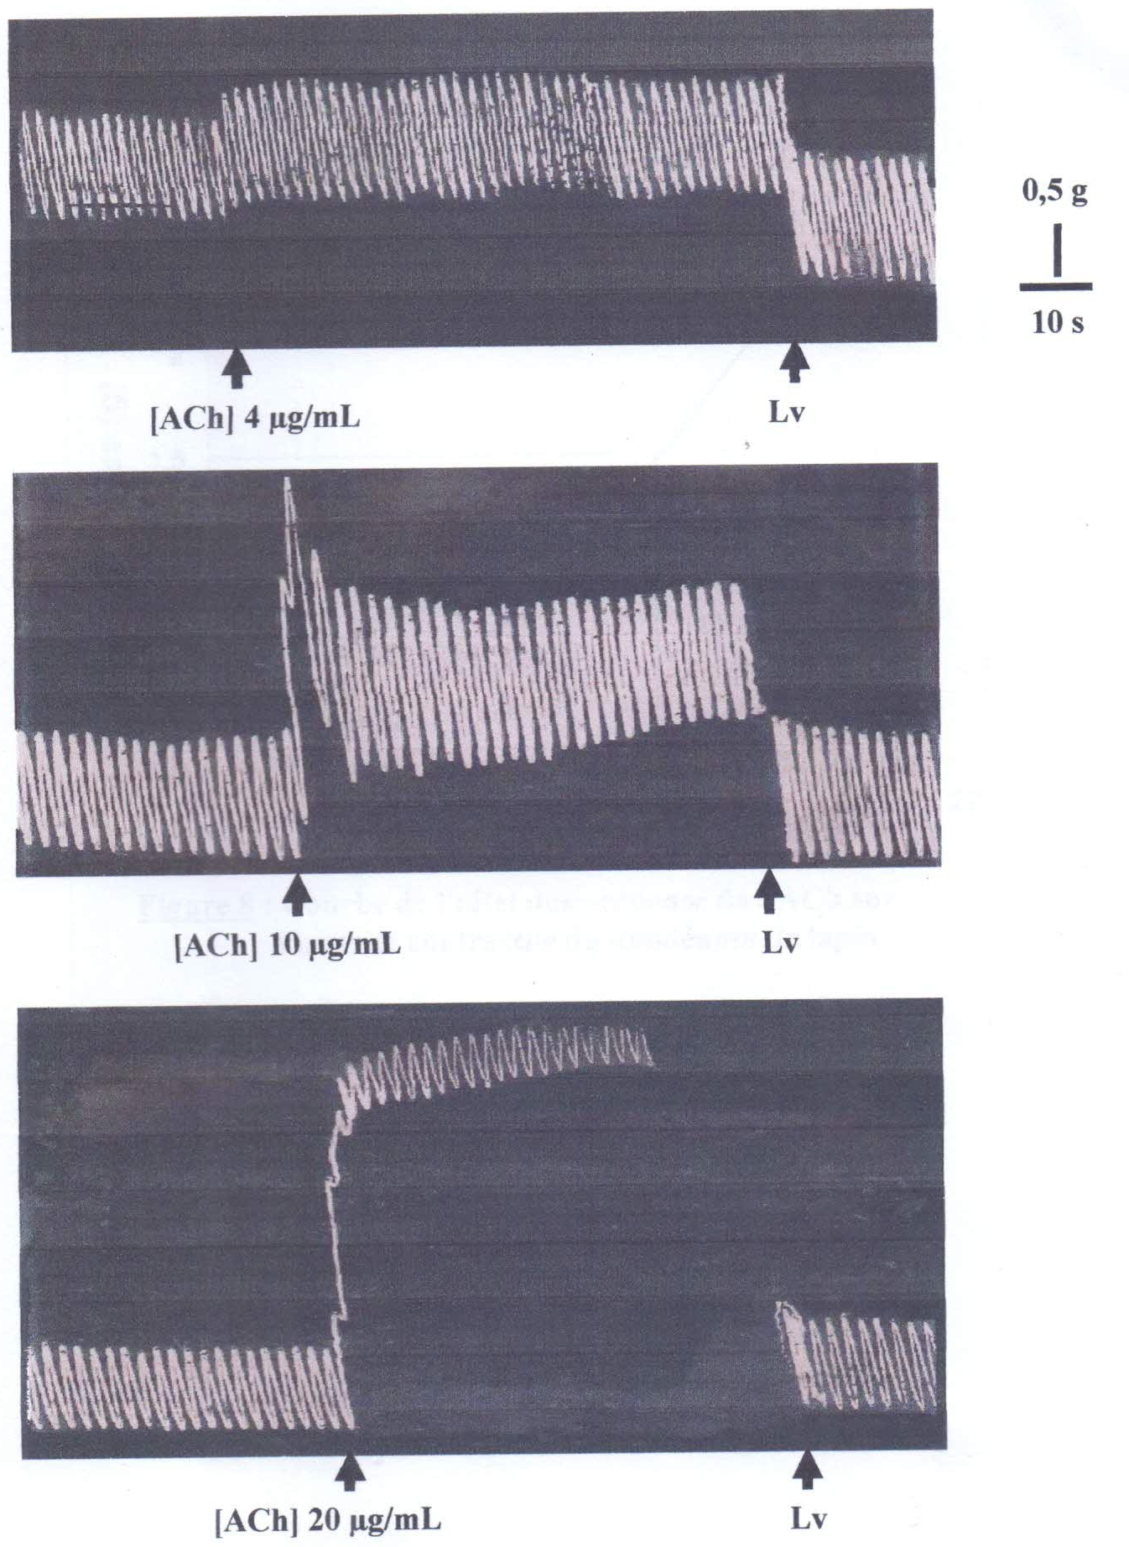

Figure 1: Dose-response effect of acetylcholine on the contractile activity of the rabbit duodenum

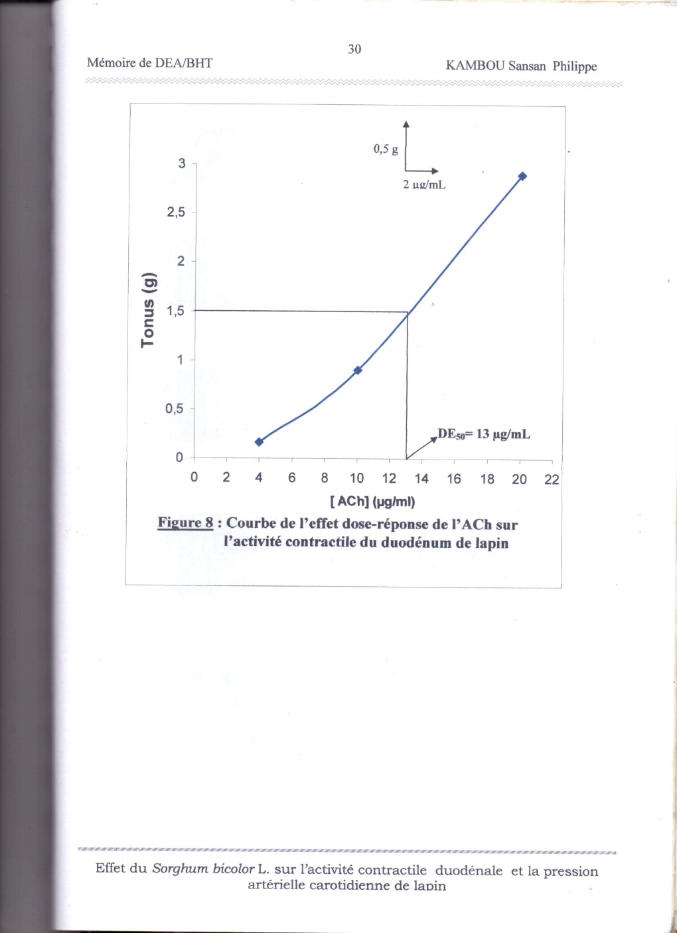

Figure 2: Dose-response curve of acetylcholine on the contractile activity of the
rabbit duodenum

2- Dose-response effect of aqueous extract of Sorghum bicolor on the contractile activity of the rabbit duodenum
Figure 3 illustrates the effect of different concentrations of Sorghum bicolor aqueous extract (from 200 to 1000 µg/mL) on the contractile activity of rabbit duodenum. A gradual, dose-dependent decrease in the amplitude of spontaneous contractions is observed, leading to complete relaxation of the duodenal muscle at the maximum concentration tested (1000 µg/mL).
Unlike acetylcholine, which stimulates contractility with a maximum at 20 µg/mL, the aqueous extract of Sorghum bicolor has a relaxing effect, inducing maximum inhibition of intestinal motility at the highest dose.
Analysis of the dose-response curve (Figure 4) allows us to estimate a median effective dose (ED50) of 520 µg/mL, corresponding to the concentration required to reduce spontaneous contractile activity by half.

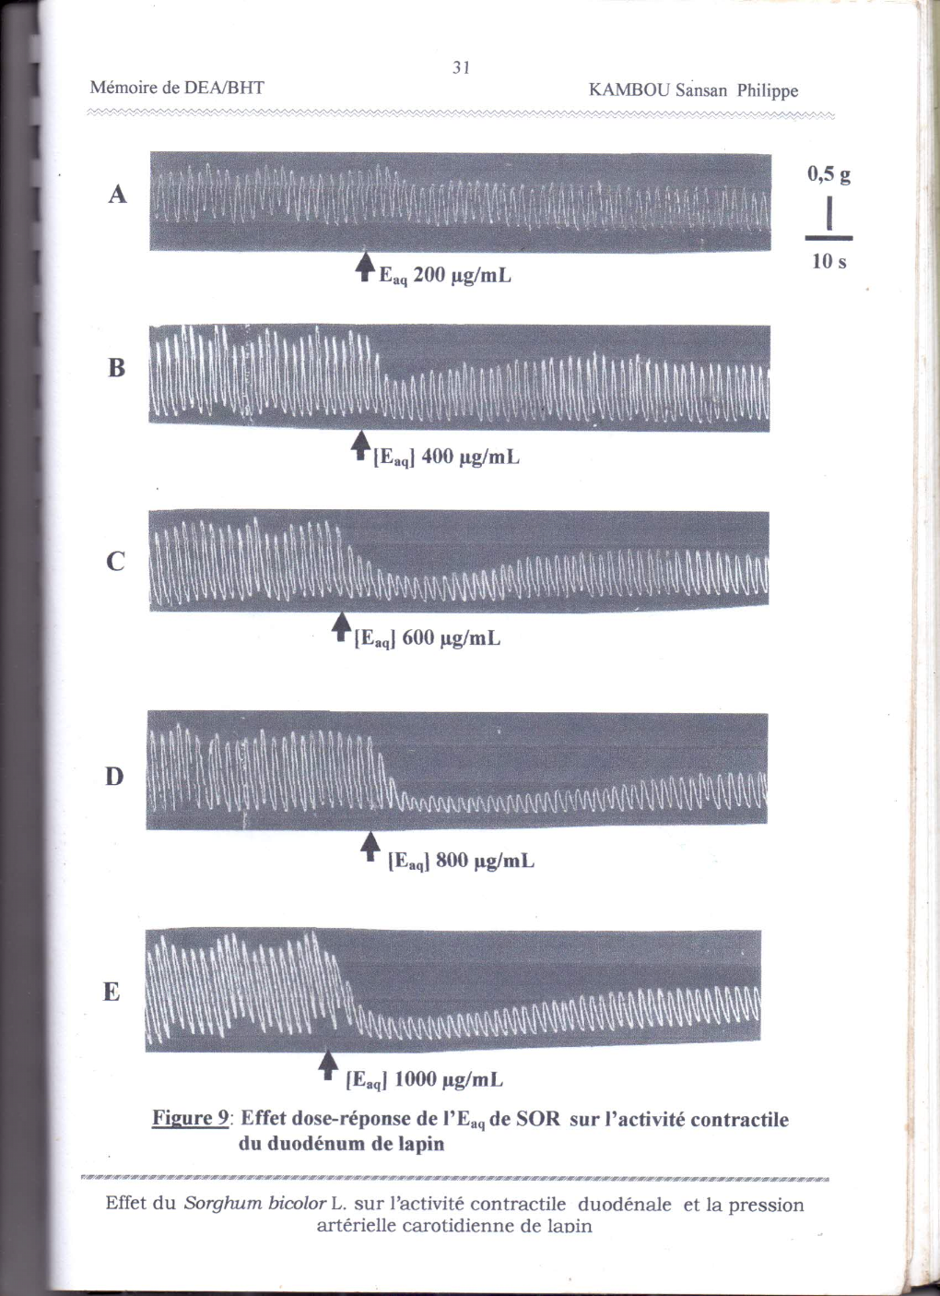

Figure 3: Dose-response effect of the aqueous extract of Sorghum bicolor on the contractile activity of the rabbit duodenum

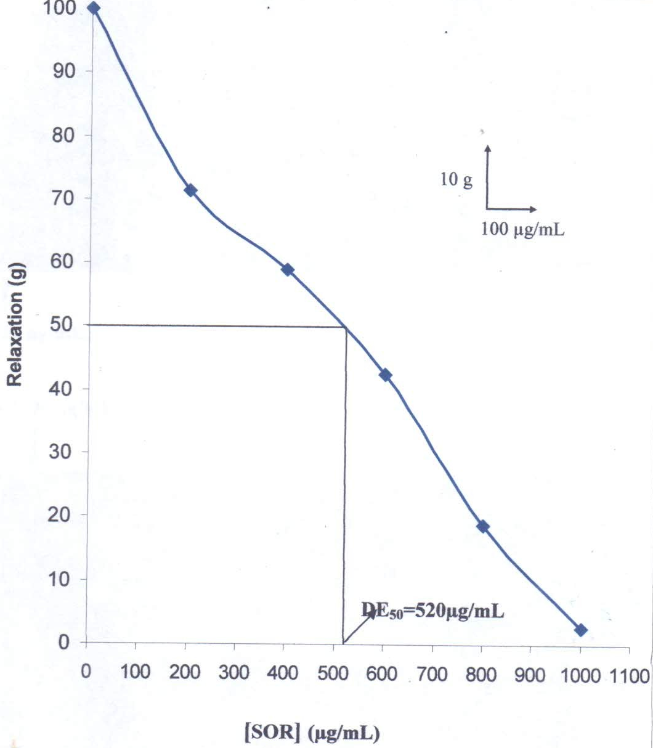

Figure 4: Dose-response curve of Sorghum bicolor on the contractile activity of the rabbit duodenum

3- Antagonistic effect and dose-response of the aqueous extract of Sorghum bicolor on acetylcholine-induced contractile activity in rabbit duodenum

Figure 5 shows the antagonistic and dose-dependent effect of the aqueous extract of Sorghum bicolor on acetylcholine-induced contractile activity.
High concentrations of Sorghum bicolor aqueous extract (600 and 1000 µg/mL) progressively reduce the tonic contractile activities initiated by acetylcholine (20 µg/mL). These reductions are 93% and 94%, respectively.

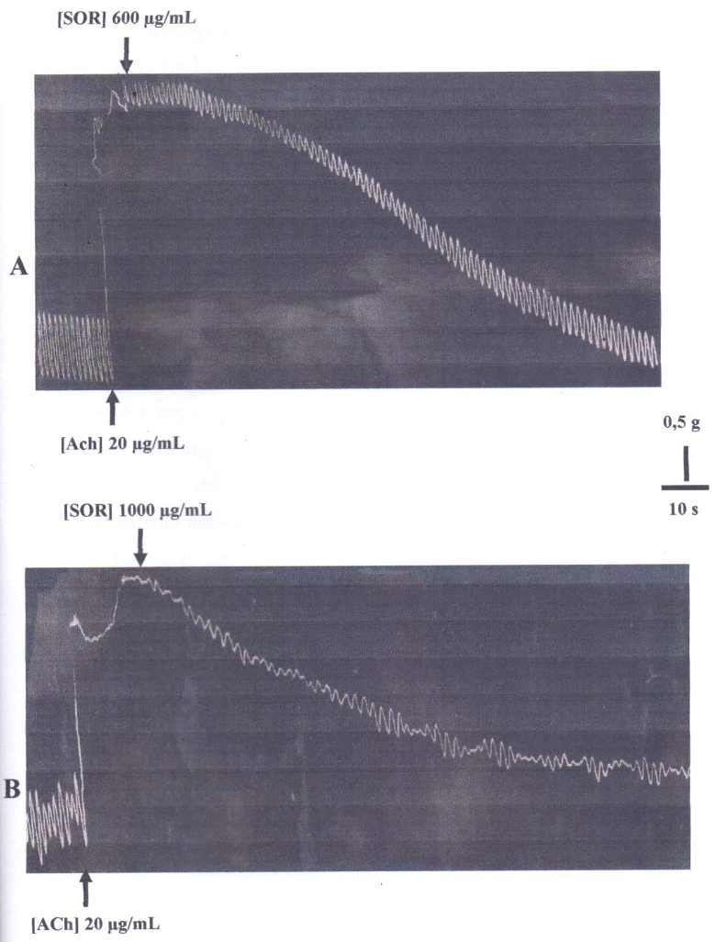

Figure 5: Antagonistic and dose-dependent effect of acetylcholine and Sorghum bicolor

DISCUSSION
The aim of our study was to evaluate the gastrointestinal tolerance of the aqueous extract of Sorghum bicolor leaf sheath on the contractile activity of the rabbit duodenum.
The myorelaxant action of the aqueous extract of Sorghum bicolor on the contractile and tonic activities of the duodenum and its inhibitory effect on the same contractions generated by the action of acetylcholine were demonstrated. This muscle relaxant action is expressed with an effective dose for 50% activity equal to 520 µg/mL.
These results suggest that the aqueous extract of Sorghum bicolor antagonizes the action of acetylcholine on cholinergic receptors.
Furthermore, the inhibitory action of Sorghum bicolor generated by acetylcholine leads us to believe that 94% of the receptors mobilized by acetylcholine would be available for Sorghum bicolor.
Pharmacological agents acting on duodenal smooth muscles can exert their effects via several pathways:
- By directly activating specific receptors (e.g., muscarinic M₂/M₃ for acetylcholine, or NK₁/NK₂ for tachykinins), causing muscle contraction (Tolessa and Lördal, Hellström, 1996).
- By modulating the release of endogenous relaxing substances, particularly nitric oxide through activation of guanylate cyclase, or purines (ATP or β NAD) acting on P2Y₁ receptors and inducing hyperpolarization (Kenton et al., 2012).
In a bimodal or non-specific manner, as observed with bradykinin (BK₁/BK₂ receptors) or histamine via Gq-coupled H₁ activating PLC/IP₃, which can cause contraction and relaxation respectively depending on the context (Skidgel et al., 2010).
Substances that act on smooth muscles such as the duodenum can act either on contractile elements through the action of mobilized receptors, or on the production and mobilization of endogenous substances that stimulate these receptors, or act non-specifically to initiate contraction or relaxation (Ticku et al. 1976).
However, it should be remembered that muscle contractions, and more specifically smooth muscle contractions, depend on an increase in free cytosolic calcium, which activates contractile structures via the calcium-calmodulin complex by stimulating myosin light-chain kinase (MLCK) (Yusuke et al., 2008).
The contribution of this intracellular calcium to contraction varies depending on the type of smooth muscle tissue and the nature of the myostimulant (neurotransmitter, pharmacological agonist, etc.) (Van and Saida, 1989).
The spontaneous movements of the duodenum are regulated by cycles of depolarization and repolarization, in which depolarization is caused by a rapid influx of calcium through voltage-dependent L-type calcium channels (CaV1.2), mainly under the influence of interstitial Cajal cells, which act as pacemakers in the digestive tract (Sanders et al., 2014; Brigitte et al., 2007).
In researching the therapeutic properties of our product, we compared it to acetylcholine, a reference stimulant for gastrointestinal muscle movements. Its muscle relaxant action leads us to attribute probable therapeutic properties to it. Pending further studies of our product, which is traditionally used to treat anemia, it could also be attributed with anti-diarrheal properties.

Conclusion
It could be concluded that
aqueous extracts of Sorghum bicolor exert a muscle relaxant effect on the rabbit duodenum. These same extracts inhibit 94% of the tonic contractile activity initiated by acetylcholine.
Aqueous extracts of Sorghum bicolor antagonize the action of acetylcholine on its own receptors. They exert a cholinolytic action.
In our further investigations, we will focus on the effect of Sorghum bicolor on blood count, given that this product is traditionally used to treat anemia. We could also evaluate it on the catalytic activity of acetylcholinesterase, an enzyme that hydrolyzes acetylcholine. This study will enable us to establish the biochemical mechanisms underlying its muscle relaxant effect.

References
1. Adjanohoun, E. J. (1990). Contribution to the inventory and study of medicinal plants in Africa. FAO, Rome.
2. Aké, A. (1991). Inventory of medicinal plants in Côte d’Ivoire. Félix Houphouët-Boigny University, Abidjan.
3. Ammon, H. P. T., & Wahl, M. A. (1991). Pharmacology of Curcuma longa. Planta Medica, 57(01), 1–7. https://doi.org/10.1055/s-2006-960004
4. Amy Burdette, Pamela L. Garner, Eugene P. Mayer, James L. Hargrove, Diane K. Hartle, Phillip Greenspan (2010). Anti-inflammatory activity of selected sorghum (Sorghum bicolor) brans. J Med Food, 13(4), 879-87. doi:10.1089/jmf.2009.0147
5. Brigitte H., Volodymyr T., Marcel M., et al. (2007). Ca²⁺ channel currents and contraction in CaVβ3-deficient ileum smooth muscle from mice. Journal, 42(4–5), 477–487.
6. De Mayer, E., Robert, A., & Lebel, J. (1985). Prevalence of anemia in adolescents: A comparative study. International Journal of Epidemiology, 14(3), 416–421.
7. Dykes, L., & Rooney, L.W. (2006). Sorghum and millet phenols and antioxidants. Journal of Cereal Science, 44(3), 236–251. https://doi.org/10.1016/j.jcs.2006.06.007
8. Gilani, A. H., & Rahman, A. (2005). Trends in ethnopharmacology. Journal of Ethnopharmacology, 100(1–2), 43–49. https://doi.org/10.1016/j.jep.2005.06.001
9. Joseph M. Awika, Lloyd W. Rooney (2004). Sorghum phytochemicals and their potential impact on human health. Phytochemistry, 65(9), 1199–122.
10. Kamanyi, A., Ateba, S., & Ngouana, V. (1993). Affordability of treatment in sub-Saharan Africa: The role of traditional medicine. Health and Development, 9(2), 45–50.
11. Kenton, M., Sang, D., Seungil, R., & Sean, M. (2012). Regulation of gastrointestinal motility—insights from smooth muscle biology. Nature Reviews Gastroenterology & Hepatology, 9(11), 633–645. doi:10.1038/nrgastro.2012.168
12. Nwinyi, F. C., & Kwanashie, H. O. (2009). Evaluation of aqueous methanolic extract of Sorghum bicolor leaf base for antinociceptive and anti-inflammatory activities. African Journal of Biotechnology, 8(18), 4642–4649.
13. World Health Organization , WHO (2000). Global anemia control: Strategies and recommendations. World Health Organization, Geneva.
14. Petry, N., Olofin, I., Hurrell, R.F., Boy, E., Wirth, J.P., Moursi, M., Angel, M.D., & Rohner, F. (2016). The proportion of anemia associated with iron deficiency in low, medium, and high Human Development Index countries: A systematic analysis of national surveys. Nutrients, 8(11), 693. https://doi.org/10.3390/nu8110693
15. Pousset, J. L. (1992). The African Pharmacopoeia: Wealth and Perspectives. Afrique Médicale, 10(2), 79–87.
16. Sanders, K. M., Ward, S. M., & Koh, S. D. (2014). Interstitial cells: regulators of smooth muscle function. Physiological Reviews, 94(3), 859–907. doi:10.1152/physrev.00037.2013
17. Skidgel, R. A., Kaplan, A. P., & Erdös, E. G. (2010). Histamine, Bradykinin, and Their Antagonists. In L. L. Brunton, B. A. Chabner, & B. C. Knollmann (Eds.), Goodman & Gilman's The Pharmacological Basis of Therapeutics (12th ed., chap. 32). McGraw Hill.
18. Sofowora, A. (1996). Medicinal plants and traditional medicine in Africa (2nd ed.). Spectrum Books Ltd, Ibadan.
19. Tolessa, T., Lördal, Hellström, P. (1996). Contractile responses of rat duodenum caused by transmural nerve stimulation: interaction between tachykininergic and cholinergic mechanisms. Acta Physiologica Scandinavica, 158(2), 135–142. https://doi.org/10.1046/j.1365-201X.1996.539297000.x
20. Van B. & Saida K. (1989). Cellular mechanisms regulating [Ca²⁺] in smooth muscle. Annual Review of Physiology, 51, 315–329.doi:10.1146/annurev.ph.51.030189.001531
21. Van Wyk, B. E., van Oudtshoorn, B., & Gericke, N. (2015). A review of commercially important African medicinal plants. Journal of Ethnopharmacology, 176, 118–134. https://pubmed.ncbi.nlm.nih.gov/26498493/
22. World Health Organization (WHO). (2013). WHO Traditional Medicine Strategy: 2014–2023. Geneva: WHO. ISBN 978-92-4-150609-0.
23. Yusuke Mizuno, Eiji Isotani, Jian Huang, Hailei Ding, James T. Stull, & Kristine E. Kamm (2008). Myosin light chain kinase activation and calcium sensitization in smooth muscle in vivo. Am J Physiol Cell Physiol, 295, P358–364. doi:10.1152/ajpcell.90645.2007.
24. Zirihi, G., Kra, A., & Guédé-Guina, F. (2003). Evaluation of the antifungal activity of Microglossa pyrifolia (Lamarck O. Kuntze Asteraceae) PYMI on the in vitro growth of Candida albicans. Journal of African Medicine and Pharmacopoeias, 17, 11

