Original Research Article
Diversity and in situ conservation value of the flora of the Marahoué ranch in the sub-Sudanese forest-savanna contact zone in Côte d'Ivoire.

Abstract
Background: Plant formations such as ranches play a major role in the conservation of woody biodiversity. However, there is little data on the floristic composition and biodiversity conservation value of these ecosystems in Côte d'Ivoire.
Aim: The aim of this study is to assess the plant diversity of the Marahoué ranch in the context of biodiversity conservation.
Methodology: Floristic inventories carried out in surface units of 2500 m² (50 m x 50 m) installed in three types of biotopes and using the itinerant method were used to characterise the richness, floristic composition and adaptation to the dissemination of diaspores of the species analysed.
Results: A total of 308 species (riparian forest: 97 species; open forest: 137 species; savannah: 153 species) were inventoried in 231 genera and 82 families. Fabaceae, Rubiaceae and Euphorbiaceae are the most abundant families. Floristic compositions show an abundance of microphanerophytes and transitional species from the Sudanese sector. Most species have sarcochore-type diaspores spread by animals or zoochory (46.93%). The flora of these classified forests is also characterised by the presence of 109 species of special status, including one that is almost threatened (Milicia excelsa). The biotopes are moderately diverse, with Shannon diversity indices ranging from 2.80 bits (savannah) to 3.13 bits (riparian forest).
Conclusion: This study highlighted the floristic particularities of the Marahoué ranch and its role as a refuge for special-status species, which constitute a sufficient indicator to justify the protection and sustainable management of the ranch with a view to conserving biodiversity in west-central Côte d'Ivoire.
Key words: Floristic richness, method of dissemination, conservation value, Ivory Coast.

- INTRODUCTION
Biodiversity is an important feature of ecosystems and a vital component in maintaining their health and stability (Huang et al. 2019). However, despite its ethical, aesthetic, ecological and economic importance, biodiversity is currently undergoing an unprecedented process of erosion (Daouda 2021). The main causes of biodiversity loss, commonly recognised by the scientific community, are habitat fragmentation, biological invasions, environmental pollution, overexploitation of resources and climate change (Huang et al. 2019). Thus, it is essential today to seek solutions to restore the ecosystems on which we depend and create resilient and hospitable places for wildlife and humans (WWF, 2016).
In Sub-Saharan Africa, and more particularly in West Africa, forest ecosystems are being degraded by unprecedented population growth, leading to increased expansion of agricultural land (OSS, 2022). Against this backdrop, biodiversity conservation remains a major challenge, especially in a context marked by strong anthropogenic pressure and a recurring series of political instability and the abusive and uncontrolled use of forest resources (Andji & Etien 2020).
Côte d'Ivoire, whose development is based on agriculture, is not immune to deforestation and forest degradation. Annual losses in forest cover were estimated at 1.8% over the period 2000 to 2010 (Adingra, 2017). The area of dense rainforest in Côte d'Ivoire is now estimated at around 2.7 million hectares, compared with 16 million in 1960 (N'guessan & N'dja 2018). The creation and management of protected areas is part of the Ivorian government's desire to protect the environment, particularly the forest cover, which is in sharp decline, and certain rare or endangered animal species. These protected areas cover a total surface area of only 2,100,000 ha, or 6.5% of the national territory. It is clear that these protected ecosystems, which have long been regarded as the cornerstone of conservation, are not sufficient on their own to achieve conservation objectives, and must be supplemented by effective conservation management of other areas. It therefore seems essential to adopt an integrated approach to conservation that is not limited to the management of protected areas alone. This is the case of the Séguéla cattle station, better known as the Marahoué ranch, which was set up in 1975 to distribute N'Dama breeding stock to farmers (Bongo, 1998). This vast area of forest could contain a significant diversity of flora, helping to conserve biodiversity and providing ecological and landscape benefits (Kouadio et al., 2016).
With the aim of preserving this forest heritage, it is therefore important to make an inventory of the flora and vegetation in order to take appropriate and sustainable protection measures (Koffi et al., 2015). However, very little work has focused on the flora of the Marahoué ranch even though this site contributes, in the same way as formally established protected areas, to biodiversity conservation and climatic balance in Côte d'Ivoire. It was to remedy this shortcoming that the present study was carried out, the general objective of which is to provide information on the state and particular status of the flora of the Marahoué ranch. Specifically, the aim is (i) to determine the richness and diversity of the flora and (ii) to assess the conservation value for the biodiversity of the ranch.

- MATERIALS AND METHODS
2.1 Description of the study area
The study was carried out on the Marahoué Ranch in the Department of Séguéla (Worodougou Region) in central-western Côte d'Ivoire. The ranch is located between northern latitudes 105,000 and 14,700 and western longitudes 903,000 and 924,000 and covers an area of 100,000 ha (Figure 1). The climate of the area is tropical Sudanian with two seasons and belongs to the sub-Sudanese phytogeographical zone according to the subdivisions of the regional endemism zones (Guillaumet & Adjanohoun, 1971). This zone is characterised by natural vegetation consisting mainly of savannah dotted with patches of open forest and riparian forest along watercourses (Guillaumet 1967; Kouamé 2010). Temperatures range from a high of 35°C to a low of 25°C, with an average annual rainfall of 1,040 mm. The relief is generally made up of plateaux and a few peaks at altitudes of between 350 and 400 m. The soils are ferralitic, generally shallow with a sandy-clay texture, interspersed with plateaux made up of granitic soils in places (Silué et al. 2024). The area's hydrographic network is made up of numerous seasonal watercourses, the most important of which is the Marahoué river.

2.2 Data collection
The data on the flora was collected using surface survey and roving inventory methods. The first was based on stratified sampling, which consisted in first classifying the ranch area into different types of formations using the dynamics of land use derived from satellite images. This preliminary stage identified three types of plant formations: open forest, riparian forest and savannah. Next, a floristic inventory was carried out in 186 randomly selected plots of 2,500 m² (50 m x 50 m), based on points chosen within each type of plant formation and distributed throughout the study area (Figure 2). In each of the plots, all the plant species encountered were inventoried. The woody species in particular, with a diameter at breast height greater than or equal to 5 cm, were counted (Adou Yao 2005). The surface survey method was supplemented by an itinerant inventory, carried out outside the plots and in all the cardinal directions of the ranch, in order to take new species into account. This method was used to complete the list of plant species from the surface surveys. All the species were identified by comparison with those present in the herbarium of the Centre Suisse de Recherches Scientifiques in Côte d'Ivoire. The nomenclature adopted is that of the APG IV phylogenetic classification (2016).
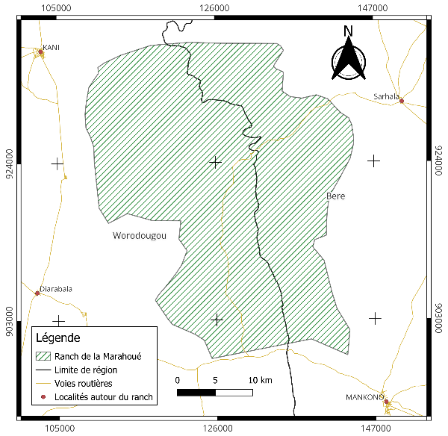
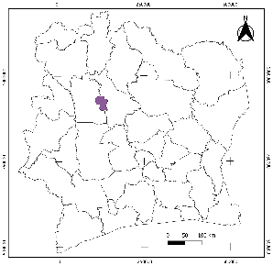
Fig. 1. Map showing the location of the study area

2.3 Data analysis
2.3.1 Floristic richness and composition
Floristic richness and composition were determined from the survey list. Floristic richness involved determining the number of species, genera and families. Analysis of the floristic composition involved recording the biological types and chorological affinity. The biological types of all the species recorded were determined with reference to the work of Raunkiaer (1934) and Aké Assi (2002). Chorology was determined using the major phytogeographical subdivisions of White (1983) and the catalogue of vascular plants of Côte d'Ivoire (Aké Assi, 2001; Aké Assi, 2002).

2.3.2 Mode of diaspore dispersal in plant species
In order to assess the mode of regeneration and conservation of the vegetation on the Marahoué ranch, a classification of species according to the types of diaspores and their modes of dissemination (seeds, fruits or any other part of the plant used to disseminate the species) was carried out. This classification follows that defined by Dansereau & Lems (1957) and is inspired by the work of Masharabu (2011), Kimpouni et al (2013) and Beina (2011), which distinguishes between sarcochores and desmochores, which are grouped together under zoochory, sclerochores, pterochores and pogonochores, which are grouped together under anemochory, and ballochores and barochores, which make up autochory.

2.3.3 Conservation value of phytodiversity

To estimate the conservation value of the flora in the area, two categories of special-status species were selected: endemic species whose range is clearly defined and which characterise a given region, and rare species threatened with extinction or endangered species whose frequency of occurrence at local, regional and international level is very low. The data concerning special-status species was established by referring to the lists drawn up by Aké Assi (1984) and the IUCN (2024). In terms of endemic species, we distinguish between species endemic to the Ivorian flora (GCi) and those of the West African forest block (GCW).

2.3.4 Quantitative diversity of the flora
The quantitative floristic diversity was determined using the following diversity indices: Shannon's Diversity Index (H'), Simpson's Index and Piélou's Equitability Index (E).
- Shannon diversity index (H'): this reflects the stability of communities and the relative richness and abundance of species. It is calculated using the following mathematical formula :
$$H=-\sum{(\frac{ni}{N}}×ln\frac{ni}{N})$$
ni is the number of individuals of species i and N is the total number of individuals of all species.
- Simpson index (D): measures the way in which individuals are distributed between the species in a community. It provides an indication of the abundance of one or a few species. This index is highly dependent on the number of rare species (Simpson 1949). It is calculated using the following mathematical formula:
$$\text{D=1-}\sum{\text{(}{\frac{\text{ni}}{\text{N}}\text{)}}^{\text{2}}}$$
ni is the number of individuals of species i and N is the total number of individuals of all species.
- Piélou (1966) Equitability Index (E): this measures the distribution of individuals within species. This is a more rigorous parameter, which is very useful for comparing potential dominance between sites, as it is independent of species richness. It therefore reflects the degree of diversity achieved by a stand and is calculated as follows
$$\text{E=}\frac{\text{H}}{\text{lnS}}$$

H is the Shannon diversity index and S is the total number of species in the plot.

- RESULTS AND DISCUSSION
3.1 Results
3.1.1 Floristic richness

The itinerant and surface inventories enabled 4,912 individuals to be counted, divided into 308 species grouped into 231 genera and 82 botanical families (Table 1). This flora is characterised by an abundance of Dicotyledons (248 species; 80.26%) and a low representation of Pteridophytes (4 species; 1.29%).
In terms of plant formations, the savannah was the most species-rich biotope, with 153 species in 125 genera and 52 families, while the riparian forest was the least species-rich biotope, with 97 species in 81 genera and 40 families. Analysis of the flora of the three biotopes reveals the preponderance of Dicotyledons, with 133 species (86.93%) in the savannah, 116 species (85.29%) in the open forest and 77 species (78.57%) in the riparian forest. Pteridophytes are poorly represented and are found in riparian forest (2.04%) and open forest (1.47%) (Table 1).
The botanical families best represented in terms of number of species differ from one biotope to another. The Fabaceae family has the largest number of species in all biotopes. It is followed by Cyperaceae in the riparian forest, Rubiaceae in the open forest and Malvaceae in the savannah (Figure 2).

Table 1. Taxonomic structure of the flora of the Marahoué ranch
Taxonomic Units | Riparian forest |  | Open forest |  | Savannah |  | General Flora
Taxonomic Units | Nb | % | Nb | % | Nb | % |  | Nb | %
Species | 97 | 31,49 | 137 | 44,48 | 153 | 49,67 |  | 308 | 100
Genera | 81 | 35,06 | 121 | 52,38 | 125 | 54,11 |  | 231 | 100
Families | 39 | 47,56 | 52 | 63,41 | 52 | 63,41 |  | 82 | 100
Dicotyledons | 77 | 78,57 | 116 | 85,29 | 133 | 86,93 |  | 248 | 80,26
Monocotyledons | 19 | 19,39 | 18 | 13,24 | 20 | 13,07 |  | 57 | 18,45
Pteridophytes | 2 | 2,04 | 2 | 1,47 | 0 | 0 |  | 4 | 1,29
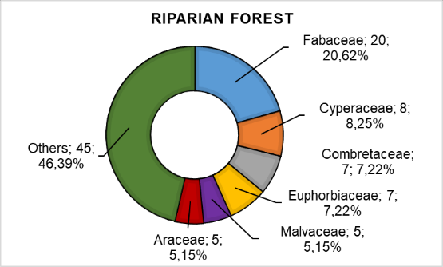
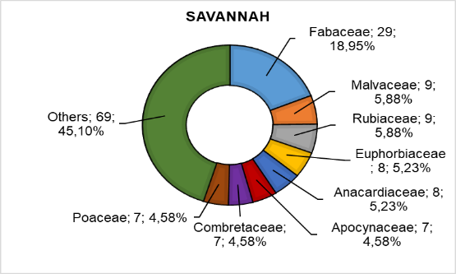
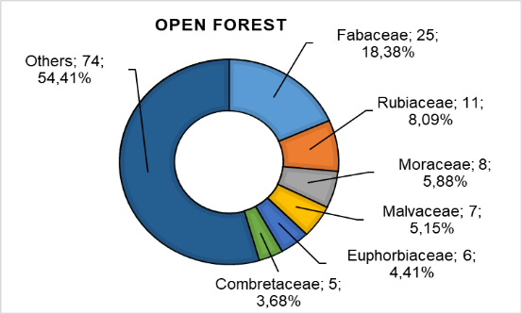
Fig. 2. Spectrum of families according to the biotopes of the Marahoué ranch

3.1.2 Floristic Composition
The biological spectrum of species inventoried highlights nine biological types characterized by an abundance of microphanerophytes in all biotopes, with proportions of over 50% (Figure 3A). These are followed by mesophanerophytes in forest formations, with proportions above 10%, and nanophanerophytes in savannah, with a proportion of 21.05%. This trend in the different biotopes reflects that of the general flora of the Marahoué ranch. Analysis of the chorological spectrum revealed four chorological types (Figure 3B). The general flora is characterized by an abundance of species from the transition zone (GC-SZ), with a proportion of 41.56%, followed by species from the Guineo-Congolian zone (GC), with a proportion of 34.74%.Introduced species (i) are the least represented biological type, with 9 species (3.45%). At biotope level, the flora shows different trends. The riparian forest and savannah are dominated, at over 40%, by species from the transition zone, while the open forest is dominated by Guineo-Congolian species, at 34.56%. Sudano-Zambezian species take second place in these ranch biotopes, with proportions in excess of 15%. Introduced species were the least represented biological type in all three biotopes, with proportions ranging from 1.02% (riparian forest) to 5.26% (savannah).

3.1.3 Quantitative diversity of the ranch's flora
The mean value of the Shannon index ranges from 2.80 bits to 3.13 bits for savannah and riparian forest respectively (Table 2). Statistically, the mean values of this index do not differ significantly between the biotopes studied (p = 0.78). The Pielou’s evenness index tends towards 1 across all biotopes, with values ranging from 0.91 (open forest and savannah) to 0.92 (riparian forest). There is no significant difference between the values of this index (p = 0.72). For the Simpson index, riparian forest recorded a relatively higher value (0.82), while the relatively lower value (0.711) was obtained in open forest (p = 0.76).
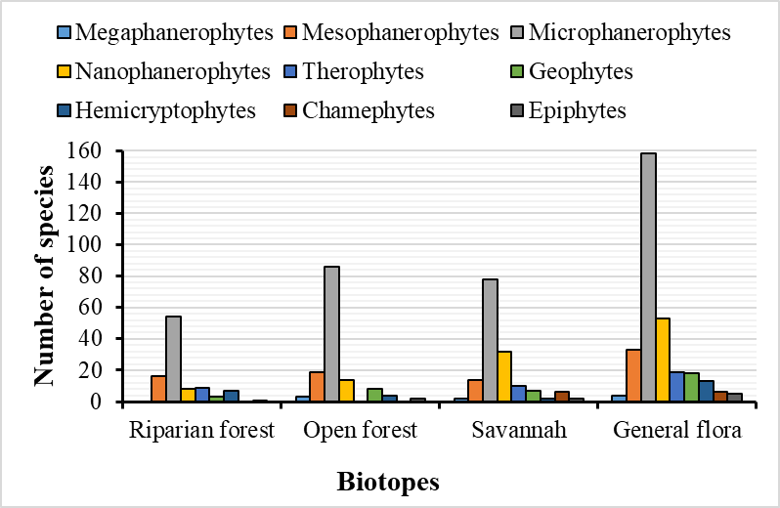
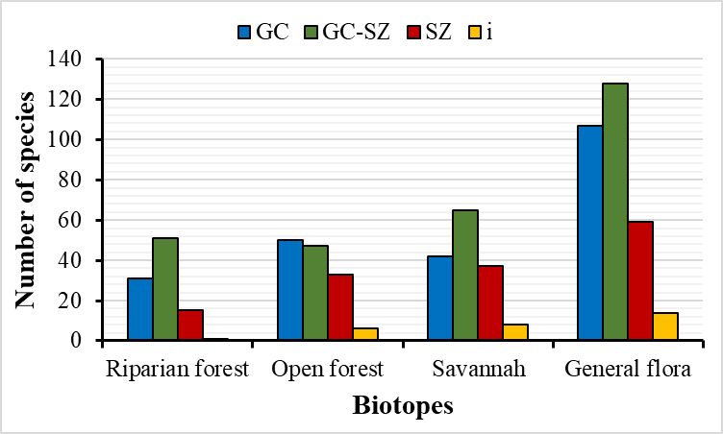
A
B
Fig. 3. Spectrum of biological (A) and chorological (B) types of flora on the Marahoué ranch

3.1.4 Floristic similarity between the different dams
Analysis of Sorensen's coefficient values reveals a floristic similarity between biotope floras (Table 3).The value of this index is highest between open forest and savannah (0.68) and lowest between open forest and riparian forest (0.51). As for the Venn diagram, it shows that only 28 species, or 9.10% of the total flora, are common to all three biotopes (Figure 4). The highest number of infaunal species is found in the savannah, with 105 species, or 34.10%, while the lowest number of infaunal species is found in the riparian forest. The highest number of common species was recorded between open forest and savannah, with 20 species (6.49%), while no common species were observed between riparian forest and savannah.

Table 2 : Average values of flora diversity indices on the Marahoué ranch
Biotopes | Shannon | Evenness | Simpson
Riparian forest | 3,13ª | 0,92ª | 0,73ª
Open forest | 3,06ª | 0,91ª | 0,82ª
Savannahs | 2,80ª | 0,91ª | 0,71ª
General flora | 3,25 | 0,94 | 0,71
Statistical Test | k = 0,487 ; p = 0,78 | k = 0,648 ; p = 0,72 | k = 0,547 ; p = 0,76

Table 3 : Sorensen's similarity coefficient values between the biotopes of the Marahoué ranch
 | Riparian forest | Open forest | Savannah
Riparian forest | 1 | 0,51 | 0,58
Open forest |  | 1 | 0,68
Savannah |  |  | 1

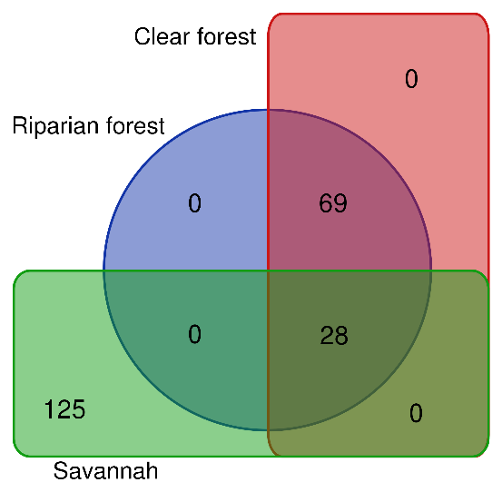
Fig. 4. Floristic similarity between the biotopes of the Marahoué ranch

3.1.5 Morphologies and modes of dissemination of species diaspores
The flora of the Marahoué ranch is dominated by species with partially or totally fleshy fruits, namely the sarcochores (Figure 6A), with 136 species (44.16%). Next come the ballochores, with 62 species (20.13%) and the pterochores, with 22 species (7.14%). Pogonochores are the least species-rich type of diaspora morphology, with 14 species (4.54%). In terms of biotopes, species with sarcochore and ballochore fruits were equally represented, with 80 species (58.39%) and 22 species (16.05%) respectively for open forest; 61 species (39.87%) and 37 species (24.18%) for savannah; and 29 species (38.14%) and 24 species (24.74%) for riparian forest.

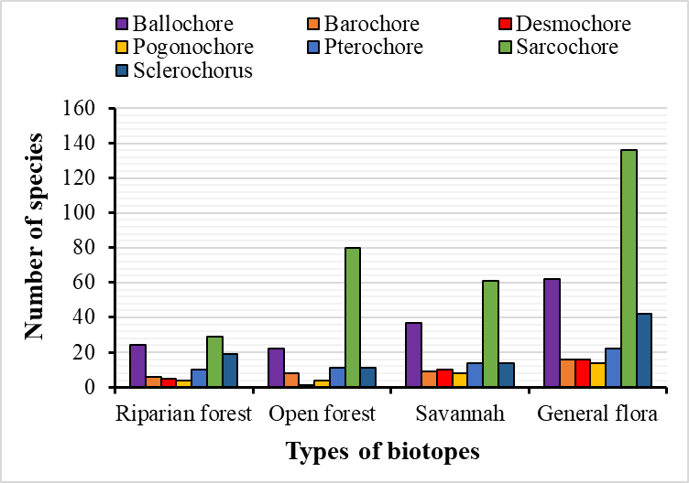
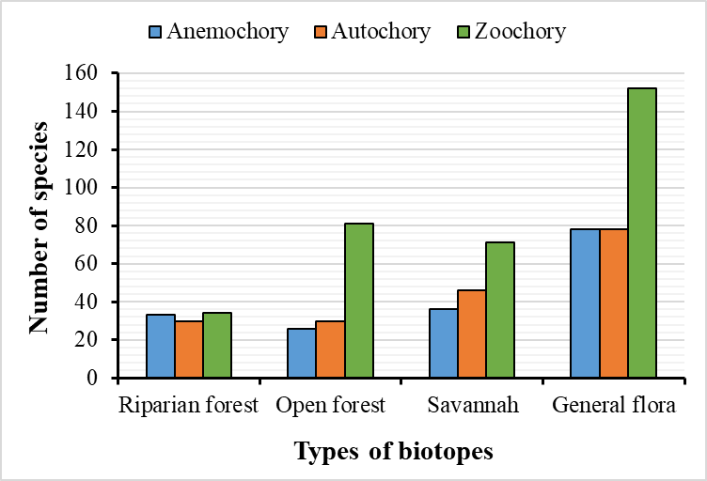
A
B
Fig. 5. Spectra of morphology (A) and dissemination (B) of the diaspores of species from the Marahoué ranch

3.1.6 Conservation value of plant diversity
3.1.6.1 Species with special ecological status
The flora of the Marahoué ranch is rich in 120 species of special ecological status, representing 38.64% of the total flora (Table 4). As regards the level of endemism, seven species are endemic to the West African forest block (GCW), such as Anthocleista nobilis, Dialium aubreville, Tetracera alnifolia and three species are endemic to Côte d'Ivoire (GCi), namely Hibiscus comoensis, Sapium aubrevillei, and Uvaria tortilis. The riparian forest and the clear forest are the biotopes that concentrate the greatest number of these species. As for rare or endangered species, 115 have been identified, of which 111 are on the IUCN red list and four are recognised as rare or endangered species of Ivorian flora, according to Aké-Assi. On the IUCN list, the majority of species are of Least Concern (LC), four species are Vulnerable (Afzelia africana, Khaya senegalensis, Pavetta lasioclada and Sapium aubrevillei), two are Endangered (Pterocarpus erinaceus and Raphia sudanica), one is Near Threatened (Milicia excelsa) and one is Critically Endangered (Acridocarpus smeathmannii). Species such as Landolphia togolana, Syzygium guineense and Uvaria tortilis have been identified as rare and endangered plants in Côte d'Ivoire. In terms of biotopes, open forest is the biotope with the greatest number of these species (66 species, or 55%), while riparian forest is the biotope with the fewest (43 species, or 43.83%).

Table 4. Categories of species with special ecological status on the Marahoué ranch
Special status categories | Riparian forest | Open forest | Savannah | General flora
Least Concern (LC) | 39 | 56 | 44 | 102
Vulnerable (VU) | 3 | 3 | 2 | 4
Endangered (EN) | 1 | 1 | 1 | 2
Near Threatened (NT) | 0 | 1 | 0 | 1
Critically Endangered (CR) | 0 | 1 | 0 | 1
Data Deficient (DD) | 0 | 2 | 1 | 2
Rare and Endangered Plant (PRE) | 0 | 4 | 4 | 6
Endemic to Côte d'Ivoire (GCi) | 1 | 1 | 1 | 3
Endemic to the West African Forest Block (GCW) | 4 | 4 | 1 | 7
Total species | 46 | 68 | 53 | 119

3.1.6.2 Species of ethnobotanical value
The flora analysis identified 106 species (33.42%) with ethnobotanical value (Table 5). This specific flora is rich in 82 species (77.36%) used in pharmacopoeia, 27 species (25.67%) used in food, 23 species (21.70%) with fodder value, 24 species (22.64%) used in handicrafts and 16 species (15.09%) used in other fields. Open forest, with 57 species (60.64%) and savannah, with 53 species (56.38%), are the biotopes with the highest concentration of these ethnobotanical species, while riparian forest, with 35 species (37.23%), has the fewest.

Table 5: Specific wealth of ethnobotanical taxa on the Marahoué ranch
 | Types of biotopes
Use Categories | Riparian forest | Open forest | Savanah | General flora
Pharmacopoeia | 32 | 48 | 49 | 82
Food | 7 | 13 | 17 | 27
Fodder | 8 | 4 | 10 | 21
Handicraft | 13 | 17 | 13 | 24
Other fields | 6 | 8 | 11 | 16
Total species | 38 | 57 | 53 | 94

3.1.6.3 Species of commercial value
The floristic inventory of the three biotopes identified 14 species of commercial value used as raw materials in the timber industry, corresponding to 4.54% of the total number (Table 6). Of these species, described as main species, six are first category species (P1), three are second category species (P2) and five are species to be promoted (P3). Open forest (9 species, 64.29%) and riparian forest (7 species, 50%) are the biotopes that harbour the majority of these species, while savannah harbours fewer, with three species (21.43%).

Table 6: Species richness of commercially valuable species on the Marahoué ranch
N° | List of species | Categories | Riparian forest | Open forest | Savannah
1 | Afzelia africana | P1 | + | + | +
2 | Albizia ferruginea | P2 | + |  | -
3 | Amphimas pterocarpoides | P3 | - | + | -
4 | Antiaris toxicaria | P1 | - | + | -
5 | Ceiba pentandra | P1 | + | + | +
6 | Celtis zankeri | P3 | + | - | -
7 | Detarium senegalense | P3 | + | - | -
8 | Funtumia africana | P2 | - | + | -
9 | Milicia excelsa | P1 | - | + | -
10 | Pouteria altissima | P1 | - | + | -
11 | Pterocarpus santalinoides | P3 | + |  | -
12 | Ricinodendron heudelotii | P2 | - | + | -
13 | Terminalia superba | P1 | - | ° | +
14 | Uapaca guineensis | P3 | + | - | -

3.2 Discussion
The floristic inventory identified 308 species divided into 231 genera and 82 botanical families. These results make it possible to draw up an initial outline of a floristic catalogue for the Marahoué ranch, valid for the sub-Sudanese zone of west-central Côte d'Ivoire. In fact, the floristic richness of the ranch remains higher than that obtained in similar plant formations in Côte d'Ivoire (Silué et al. 2021; Gboze et al. 2020). These floristic differences are the result of the size and diversity of the habitats or environmental heterogeneity, or even the proximity of certain areas of the ranch to the Guineo-Congolian zone, which is more humid, since according to Kouassi (2007), humidity is one of the determining factors for floristic diversity. The savannah zone recorded the greatest richness, unlike the forest formations. These results corroborate those of Yao et al (2018) obtained in the sub-Sudanese zone in north-west Côte d'Ivoire, but are contrary to those of Sambou (2004), who states that savannahs are relatively less diverse ecosystems than forest areas. This difference in results may be due to the greater heterogeneity of micro-habitats (grassy areas, groves, more or less wet or dry land, etc.) observed in the ranch savannah (David 2003). The most represented botanical families common to all three biotopes are Fabaceae, Rubiaceae, Euphorbiaceae and Malvaceae. The dominance of these families can be explained by the fact that they are among the majority families in tropical forests (Guillaumet & Adjanohoun, 1971). Indeed, this assertion has been reported by authors who have worked in ecosystems in the sub-Sudanese sector, such as Yao et al. (2018). The high proportion of Rubiaceae indicates that the Marahoué ranch ecosystem has not yet reached the climax stage (Chevalier 1951).
The flora of the ranch is characterised by the abundance of phanerophytes, also observed in the various biotopes that make up this ecosystem. This abundance of phanerophytes can be explained by the fact that these plant formations are tropical ecosystems (Le Coeur et al. 2008). The subdivision of these phanerophytes reveals an abundance of microphanerophytes in each biotope. This predominance could be explained by the fact that the microphanerophyte biological type is considered an innate character of the Sudanese sector, which reveals the preponderance of shrub formations and the presence of forest formations as islands included in these shrub formations (Silué et al. 2024; Yao et al. 2018). The abundance of transitional species (GC-SZ) in the general flora confirms that the study area belongs to the sub-Sudanese sector. This result corroborates that of Tiébré et al. (2016) obtained in the Foungbesso region in the forest-savanna transition zone, which belongs to the same phytogeographic sector as the ranch. However, there was an abundance of Guineo-Congolian (GC) species in the open forest and an abundance of transitional species in the riparian forest and savannah. These results can be explained by the fact that the open forest, which is often the intermediate zone between the riparian forest and the savannah, has a fairly good reconstitution capacity.
The dissemination of species seeds in the different biotopes is dominated by sarcochores (fleshy diaspores) which, coupled with desmochores, make zoochory the main mode of species dissemination on the Marahoué ranch. This would imply that the formation studied resembles a secondary formation where the most frequent mode of spread is zoochory (Bangirinama et al. 2009). This mode of dissemination allows seeds to reach habitats that are suitable and favourable for the development of future shoots and to create new populations by colonising new environments (Shukla 2020). The importance of zoochory, which is thought to involve birds and some frugivorous mammals, has been noted in most studies of the forests of Côte d'Ivoire (Kassi et al. 2012).
The presence of 106 special-status species shows the value and conservation importance of the plant formations where they are found (Tiébré et al. 2016). These particular species show the qualitative importance of the flora of the Marahoué ranch and the associated biotopes because, as Adou Yao (2005) points out, an ecosystem with special-status species requires particular attention for its conservation.
The biocenotic indices (Shannon, Evenness and Simpson indices) show that the three biotopes have similar specific diversity. These relatively high indices show that disturbance, although visible on the ranch, does not have a strong influence on species diversity, particularly in the open forest, which has the highest index. This is because the ranch's protected status means that it is not subject to human disturbance, such as bush fires and indiscriminate logging. This less disturbed environment is confirmed by the relatively high values of Sorensen's similarity index. Furthermore, the stability of the ecological conditions in the ranch landscape would be conducive to good biotope resilience. The relatively high floristic similarity observed between the open forest and the savannah confirms the open forest's status as an included formation in the Sudan savannah of Côte d'Ivoire. Similar results were obtained by Silué et al (2024) in the Poro region of northern Côte d'Ivoire.

- CONCLUSION
The study carried out on the Marahoué ranch in the Worodougou region contributed to a better understanding of its biodiversity and conservation value through the characteristics of its richness and floristic composition. The inventory identified a total of 308 species, divided into 231 genera and 82 botanical families, with Fabaceae and Rubiaceae predominating. The savannah proved to be the richest biotope in terms of species. Analysis of the biological spectra confirms the dominance of phanerophytes, with a predominance of microphanerophytes in Ivorian plant formations. With regard to phytogeographical analysis, the flora of the ranch, which is remarkable for the preponderance of transitional species, reflects the local floristic history, including plant endemism, despite infiltration and illegal human activity.The dominance of zoochory, which makes it possible to specify the specific role of animals in the dissemination and indirectly in the regeneration of these forests. All the biotopes on the ranch are characterised by species of special status with a low level of endemism. However, their presence is of particular interest for the conservation of this ecosystem located on the edge of the 8th parallel. This study, which constitutes a first exploratory botanical sketch, has highlighted floristic characteristics that represent ecological and conservation values, which alone are sufficient justification for enhanced preservation of the Marahoué ranch.

WARNING (ARTIFICIAL INTELLIGENCE)
The authors hereby declare that NO generative AI technologies such as large linguistic models (ChatGPT, COPILOT, etc.) and text-image generators were used when writing or reviewing this manuscript.

REFERENCES
Adingra, M. M. A. O. (2017). Population dynamics and carbon stock in the vegetation mosaic of the Bamo classified forest (Côte d'Ivoire). Doctoral thesis, Félix Houphouët-Boigny University, Côte d'Ivoire.
Adou Yao, C. Y. (2005). Peasant practices and biodiversity dynamics in the Monogaga classified forest (Côte d'Ivoire). Single doctoral thesis, Department of Human Nature and Society, MNHN University, Paris, France.
Aké Assi, L. (2001). Flora of Côte d'Ivoire 1, catalog, systematics, biogeography and ecology. Conservatory and Botanical Garden, Geneva, Switzerland, Boissiera, 57, 1-396.
Aké Assi, L. (2002). Flora of Côte d'Ivoire 2, catalog, systematics, biogeography and ecology. Conservatory and Botanical Garden of Geneva. Geneva (Switzerland), Boissieria, 58, 1-441.
Aké Assi, L., (1984). The flora of Côte d'Ivoire: A descriptive and biogeographical study, with some ethnobotanical notes. Volumes I, II, and III. Doctorate of Science thesis, National University of Côte d'Ivoire.
Andji, H. N., & Etien, D. T. (2020). Evaluation of the flora and carbon stocks in a private forest in Allany (Rubino-Cote d'Ivoire). African Agronomy, 32, 475-488. https://www.ajol.info/index.php/aga/article/view/205507
APG IV. (2016). An update of the Angiosperm Phylogeny Group classification for the orders and families of flowering plants. Botanical Journal of the Linnean Society, 181, 1-20.
Bangirinama, F., Bigendako, M. J., Lejoly, J., Noret, N., De Cannière, C. & Bogaert, J. (2009). Indicators of post-cropping dynamics of fallow vegetation in the savannah section of the Kigwena Forest Nature Reserve (Burundi). Plant Ecology and Evolution, 143, 138-147.
Beina, D. (2011). Floristic diversity of the dense semi-deciduous forest of Mbaïki, Central African Republic: Experimental study of the impact of two types of silvicultural intervention. Doctoral thesis, University of Picardie Jules Verne, France.
Bongo, A. N. B. (1998). The profitability of the Marahoué ranch (cattle breeding - N'Dama breed). Master's thesis, National Veterinary School of Alfort, Montpellier, France.
Chevalier, A. (1951). On the existence of a dry virgin forest over large areas on the borders of the Oubangui, Upper Chari, and Nile basins (Bahr-el-Ghazal). International Journal of Applied Botany and Tropical Agriculture, 31, 135–136.
Dansereau, P., & Lems, K. (1957). The grading of dispersal types in plant communities and their ecological significance. Contribution of the Institute of Botany of the University of Montreal, 71, 1–52.
Daouda, N. (2021). Biodiversity, ecological restoration, and ecological intensification: what overlaps? VertigO - the electronic journal in environmental sciences [Online], Debates and Perspectives.
David, J. A. (2003). Spatial heterogeneity in the herbaceous layer of a semi-arid savanna ecosystem. Plant Ecology 167, 319–332.
Densereaux, P., & Lems K. (1957). The grading of dispersal types in plant communities and their ecological significance. Botanical Institute of the University of Montreal.
Etien, D. T.,, Vroh, B. T. A., Adou, Y. C. Y., & N’Guessan, K. E. (2018). Diversity of herbaceous and liana species in the Haut-Sassandra Classified Forest (Central-West, Ivory Coast) after several years of logging. Forestry. European Scientific Journal, 14, 247-263.
Gboze, A. E., Adingra, O. M. M. A., Sanogo, A., & Kassi, J. N. (2020). Systematic and Phytogeographic Analysis of the Badénou Classified Forest (Korhogo, Ivory Coast). International Journal of Biological and Chemical Sciences, 14(9), 3156-3167. DOI:10.4314/ijbcs.v14i9.15
Guillaumet, J. L. (1967). Research on the Vegetation and Flora of the Lower Cavaly Region (Ivory Coast), ORSTOM, Paris.
Guillaumet, J. L., & Adjanohoun, E. (1971). The Vegetation of Ivory Coast. In: Avenard J.-M., Eldin, M., Girard G., Sircoulon J., Touchebeuf de Lussigny P., Guillaumet J. L.,
Huang, C., Zhou, Z., Peng, C., Teng, M., & Wang P. (2019). How is biodiversity changing in response to ecological restoration in terrestrial ecosystems? A meta-analysis in China. Science of the Total Environment, 650, 1-9.
Kassi, J. N., Kouassi, R. H., & Yongo D. O. (2012). Analysis of the flora of the Sanaimbo classified forest in Bongouanou-Dimbokro. International Journal of Biological and Chemical Sciences, 6, 2139-2148. DOI:10.4314/ijbcs.v6i5.21
Kimpouni, V., Apani, E., & Motom, M. (2013). Phytoecological analysis of the woody flora of the Upper Sangha (Republic of Congo). Adansonia, ser. 3, 35, 107-134.
Koffi, K. A. D., Adou, Y. C. Y., Vroh, B. T. A., Gnabgo, A., & N’guessan, K. E. (2015). Floristic and Structural Diversity of Formerly Cultivated Areas in Azagny National Park (Southern Côte d’Ivoire). European Journal of Scientific Research, 134, 415-427.
Kouadio, Y. J. C., Vroh, B. T. A., Gone Bi, Z. B., Adou Yao, C. Y., & N’guessan, K. E. (2016). Diversity Assessment and Estimation of the Biomass of street trees in the Plateau and Cocody communes (Abidjan, Ivory Coast). Journal of Applied Biosciences, 97, 9141-9151.
Kouame, N. F. (2010). Phytogeographic territories. In: Konaté S. & Kampmann D. (eds). Atlas of West African Biodiversity. Volume III, Ivory Coast, pp. 132-139.
Kouassi, K. E. (2007). Flora of the Haut-Dodo classified forest, in southwestern Ivory Coast. Study of some commercial species: Garcinia afzelii (Clusiaceae), rattans (palm lianas) of the genera Calamus, Eremospatha, and Laccosperma (Arecaceae). Doctoral thesis, University of Cocody-Abidjan, Ivory Coast.
Masharabu, T. (2011). Flora and Vegetation of Ruvubu National Park in Burundi: Diversity, Structure, and Implications for Conservation. Doctoral Dissertation, Université Libre de Bruxelles, Belgium.
N’guessan, A. E., & N’Dja, K. J. (2018). Analysis of the Floristic Diversity of the Agbo I Classified Forest (Côte d’Ivoire). European Scientific Journal 14, 346-357.
OSS. (2020). African Ecosystems Between Degradation and Restoration. www.oss-oline.org
Piélou, E. C., 1966.- Species Diversity and Pattern Diversity in the Study of Ecological Succession. Journal of Theoretical Biology, 10, 370-383.
Raunkiaer, C. (1934). The Life Forms of Plants and Statistical Plant Geography. Oxford University Press, London (UK).
Sambou, B. (2004). Assessment of the status, dynamics, and evolutionary trends of woody flora and vegetation in the Sudanian and Sub-Guinean domains of Senegal. Doctoral thesis, Cheikh Anta Diop University, Senegal.
Shukla, U. (2020). Epizoochorous seed dispersal by wild ungulates in changing landscapes: the red deer as a case study. Doctoral thesis, University of Orléans, France.
Silué P. A., Koffi, A. B., Soro S., Kouassi K. E., & Kouakou, A. A. M. (2024). Conservation value of natural vegetation in an anthropogenic environment: the case of the Lokoli Ecofarm in Sinématiali, northern Côte d'Ivoire. Journal of Applied Biosciences, 195, 20677-20691.
Silué, A. P., Kouassi, K. E., Soro D., Kouakou, A. M. & Soro, D. (2018). Landscape dynamics and floristic features of the Pouniakélé classified forest (Northwestern Côte d'Ivoire). Rev. Mar. Sci. Agron. Vét. 11, 185-192.
Silué, P. A., Soro, D., Kouassi K. E., & Soro, D. (2021). Land use dynamics and floristic diversity of the Palé classified forest (Côte d'Ivoire). European Scientific Journal, 17, 1-17.
Simpson, E. H. (1949). Measurement of Diversity. Nature, 163, 688. http://dx.doi.org/10.1038/163688a0.
Tiébré, M. S., Ouattara D., Vroh B., Gnagbo A. & N’Guessan K. E. (2016). Floristic diversity and availability of useful plants in the Sudanian zone of Côte d’Ivoire. Journal of Applied Biosciences, 102, 9699-9707.
Tiébré, M. S., Ouattara, D., Vroh, B. T. A., Kpangui, K. B., Kouassi, D. F. & N’Guessan K. E. (2016). Floristic diversity of the Foungbesso region in the forest-savannah transition zone of western Côte d’Ivoire. International Journal of Biological and Chemical Sciences, 10, 1007-1016.
IUCN. (2024). IUCN Read List of Treatement Species. www.iucnreadlist.org.
White, F. (1983). The vegetation of Africa, a descriptive memoir to accompany the UNESCO AETFAT-UNSO vegetation map of Africa. Natural Resources Research, UNESCO, Paris.
World Wildlife Fund (WWF). (2016). Living Planet Report 2016.
Yao, N. O., N’guessan, A. E., Egnankou, W. M., Sangare M., & N’guessan, K. E. (2018). Vegetation structure and composition in the sub-Sudanese zone (Dianra Department, Northwestern Côte d’Ivoire): A descriptive and comparative study. Africa Science 14, 304–315.

